Métodos Matriciais e Análise de Clusters - Atividade Individual - I

# **Descrição da Atividade**

**Tema:** Cadeias de Markov.

Em um dado e-commerce, a matriz de transição para uma dada operação é a representada abaixo:

|  |  |  |  |  |  |
| --- | --- | --- | --- | --- | --- |
|  | Site | Hotpage | Call Center | Venda | Saída |
| Site | 0.00 | 0.10 | 0.10 | 0.20 | 0.60 |
| Hotpage | 0.15 | 0.00 | 0.05 | 0.35 | 0.45 |
| Call Center | 0.20 | 0.10 | 0.00 | 0.13 | 0.57 |
| Venda | 0.00 | 0.00 | 0.00 | 1.00 | 0.00 |
| Saída | 0.00 | 0.00 | 0.00 | 0.00 | 1.00 |

Responda as atividades abaixo:

# **Atividades**

## a) Com base nela, se existe um cliente que inicia sua interação pela Hotpage, qual a probabilidade de ele estar no Site, na Hotpage, no Call Center, ter resultado em Venda e ter dado Saída no passo seguinte? E no passo logo em seguida?

Primeiramente iniciamos com a criação da matriz de transição fornecida no enunciado do exercício:

tm <- matrix(c(0.00, 0.10, 0.10, 0.20, 0.60,  
 0.15, 0.00, 0.05, 0.35, 0.45,  
 0.20, 0.10, 0.00, 0.13, 0.57,  
 0.00, 0.00, 0.00, 1.00, 0.00,  
 0.00, 0.00, 0.00, 0.00, 1.00),  
 nrow = 5,  
 byrow = TRUE)   
tm

## [,1] [,2] [,3] [,4] [,5]  
## [1,] 0.00 0.1 0.10 0.20 0.60  
## [2,] 0.15 0.0 0.05 0.35 0.45  
## [3,] 0.20 0.1 0.00 0.13 0.57  
## [4,] 0.00 0.0 0.00 1.00 0.00  
## [5,] 0.00 0.0 0.00 0.00 1.00

Com a matriz de transição criada criamos um objeto MarkovChain usando o package markovchain

library(markovchain)  
  
mkv_chain <- new("markovchain",   
 transitionMatrix = tm,  
 states = c("Site", "Hotpage", "Call Center", "Venda", 'Saida'),  
 name = "MarkovChain para o e-commerce")   
mkv_chain

## MarkovChain para o e-commerce   
## A 5 - dimensional discrete Markov Chain defined by the following states:   
## Site, Hotpage, Call Center, Venda, Saida   
## The transition matrix (by rows) is defined as follows:   
## Site Hotpage Call Center Venda Saida  
## Site 0.00 0.1 0.10 0.20 0.60  
## Hotpage 0.15 0.0 0.05 0.35 0.45  
## Call Center 0.20 0.1 0.00 0.13 0.57  
## Venda 0.00 0.0 0.00 1.00 0.00  
## Saida 0.00 0.0 0.00 0.00 1.00

Podemos desenhar o diagrama de Grafo da matriz de transição.

plot(mkv_chain, edge.arrow.size = 0.5)

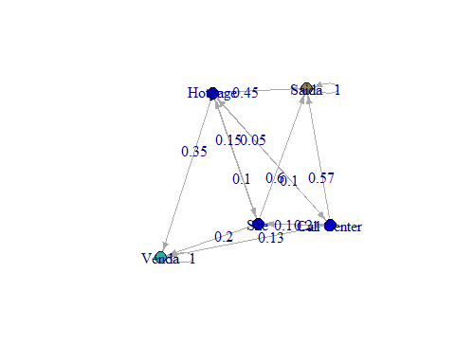

Para responder as próximas questões vou utilizar uma função customizada a parte do pacote marcokchain e ggplot para recuperar o histórico de transição entre os estados em cada período e desenhar algumas visualizações destes dados.

get_transition_states <- function(initial_state, steps, mkv_chain) {  
  
 states <- initial_state  
  
 for (step in seq(1, steps, 1)) {  
 final_state <- initial_state * (mkv_chain ^ step)  
 states <- rbind(states, final_state)  
 }  
  
 states <- as_tibble(states)  
 states$step <- as.numeric(row.names(states)) - 1  
 states <- select(states, step, everything())  
  
 output = list()  
  
 output$transition_states <- states  
  
 states <- gather(states, 'state', 'prob', -step)  
  
 output$transition_states_plot_1 <- ggplot(data = states,  
 aes(x = step,  
 y = log(prob),  
 color = state)) +  
 geom_line(size = 1) +  
 geom_label(data = filter(states, step == max(step)),  
 aes(label = paste(format(prob * 100, digits = 2), '%'))) +  
 geom_label(data = filter(states, step == min(step)),  
 aes(label = paste(format(prob * 100, digits = 2), '%'))) +  
 theme(legend.position = 0,  
 axis.title.y = element_blank(),  
 axis.ticks.y = element_blank(),  
 axis.text.y = element_blank(),  
 panel.background = element_blank()) +  
 facet_wrap( ~ state, nrow = 7)  
  
 output$transition_states_plot_2 <- ggplot(data = states,  
 aes(y = prob,  
 x = step,  
 stratum = state,  
 alluvium = state,  
 fill = state)) +  
 scale_fill_brewer(type = "qual", palette = "Set2") +  
 geom_flow(stat = "alluvium", lode.guidance = "frontback",  
 color = "darkgray") +  
 geom_stratum() +  
 theme(legend.position = "bottom") +  
 ggtitle("Transições de estados entre steps")  
  
 return(output)  
  
}

initial_state <- c(0, 1, 0, 0, 0)  
steps <- 2  
  
kable(get_transition_states(initial_state, steps, mkv_chain)['transition_states'])

|  |  |  |  |  |  |
| --- | --- | --- | --- | --- | --- |
| step | Site | Hotpage | Call Center | Venda | Saida |
| 0 | 0.00 | 1.00 | 0.000 | 0.0000 | 0.0000 |
| 1 | 0.15 | 0.00 | 0.050 | 0.3500 | 0.4500 |
| 2 | 0.01 | 0.02 | 0.015 | 0.3865 | 0.5685 |

get_transition_states(initial_state, steps, mkv_chain)['transition_states_plot_1']

## $transition_states_plot_1

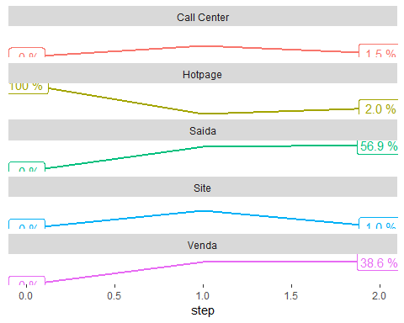

get_transition_states(initial_state, steps, mkv_chain)['transition_states_plot_2']

## $transition_states_plot_2

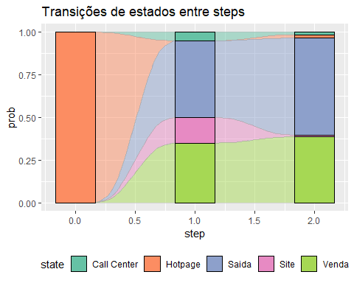

## b) Use o software para calcular qual a probabilidade de venda final (isto é, na condição de estabilidade) de um cliente que interagiu pela primeira vez com a empresa usando: Coloque aqui apenas o resultado.

-**i. O Site.**

initial_state <- c(1, 0, 0, 0, 0)  
steps <- 15  
  
kable(get_transition_states(initial_state, steps, mkv_chain)['transition_states'])

|  |  |  |  |  |  |
| --- | --- | --- | --- | --- | --- |
| step | Site | Hotpage | Call Center | Venda | Saida |
| 0 | 1.0000000 | 0.00e+00 | 0.0000000 | 0.0000000 | 0.0000000 |
| 1 | 0.0000000 | 1.00e-01 | 0.1000000 | 0.2000000 | 0.6000000 |
| 2 | 0.0350000 | 1.00e-02 | 0.0050000 | 0.2480000 | 0.7020000 |
| 3 | 0.0025000 | 4.00e-03 | 0.0040000 | 0.2591500 | 0.7303500 |
| 4 | 0.0014000 | 6.50e-04 | 0.0004500 | 0.2615700 | 0.7359300 |
| 5 | 0.0001875 | 1.85e-04 | 0.0001725 | 0.2621360 | 0.7373190 |
| 6 | 0.0000623 | 3.60e-05 | 0.0000280 | 0.2622607 | 0.7376131 |
| 7 | 0.0000110 | 9.00e-06 | 0.0000080 | 0.2622894 | 0.7376826 |
| 8 | 0.0000030 | 1.90e-06 | 0.0000016 | 0.2622958 | 0.7376978 |
| 9 | 0.0000006 | 5.00e-07 | 0.0000004 | 0.2622972 | 0.7377013 |
| 10 | 0.0000001 | 1.00e-07 | 0.0000001 | 0.2622976 | 0.7377021 |
| 11 | 0.0000000 | 0.00e+00 | 0.0000000 | 0.2622976 | 0.7377023 |
| 12 | 0.0000000 | 0.00e+00 | 0.0000000 | 0.2622976 | 0.7377023 |
| 13 | 0.0000000 | 0.00e+00 | 0.0000000 | 0.2622976 | 0.7377023 |
| 14 | 0.0000000 | 0.00e+00 | 0.0000000 | 0.2622976 | 0.7377023 |
| 15 | 0.0000000 | 0.00e+00 | 0.0000000 | 0.2622977 | 0.7377023 |

get_transition_states(initial_state, steps, mkv_chain)['transition_states_plot_1']

## $transition_states_plot_1

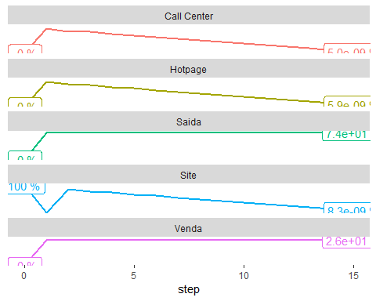

get_transition_states(initial_state, steps, mkv_chain)['transition_states_plot_2']

## $transition_states_plot_2

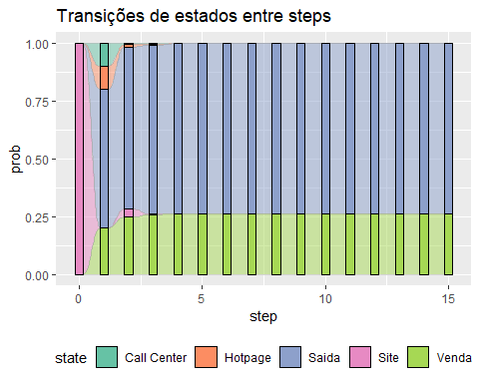

-**ii. A Hotpage.**

initial_state <- c(0, 1, 0, 0, 0)  
  
steps <- 15  
  
kable(get_transition_states(initial_state, steps, mkv_chain)['transition_states'])

|  |  |  |  |  |  |
| --- | --- | --- | --- | --- | --- |
| step | Site | Hotpage | Call Center | Venda | Saida |
| 0 | 0.00e+00 | 1.00e+00 | 0.0000000 | 0.0000000 | 0.0000000 |
| 1 | 1.50e-01 | 0.00e+00 | 0.0500000 | 0.3500000 | 0.4500000 |
| 2 | 1.00e-02 | 2.00e-02 | 0.0150000 | 0.3865000 | 0.5685000 |
| 3 | 6.00e-03 | 2.50e-03 | 0.0020000 | 0.3974500 | 0.5920500 |
| 4 | 7.75e-04 | 8.00e-04 | 0.0007250 | 0.3997850 | 0.5979150 |
| 5 | 2.65e-04 | 1.50e-04 | 0.0001175 | 0.4003142 | 0.5991532 |
| 6 | 4.60e-05 | 3.83e-05 | 0.0000340 | 0.4004350 | 0.5994467 |
| 7 | 1.25e-05 | 8.00e-06 | 0.0000065 | 0.4004620 | 0.5995109 |
| 8 | 2.50e-06 | 1.90e-06 | 0.0000017 | 0.4004682 | 0.5995258 |
| 9 | 6.00e-07 | 4.00e-07 | 0.0000003 | 0.4004696 | 0.5995291 |
| 10 | 1.00e-07 | 1.00e-07 | 0.0000001 | 0.4004699 | 0.5995298 |
| 11 | 0.00e+00 | 0.00e+00 | 0.0000000 | 0.4004700 | 0.5995300 |
| 12 | 0.00e+00 | 0.00e+00 | 0.0000000 | 0.4004700 | 0.5995300 |
| 13 | 0.00e+00 | 0.00e+00 | 0.0000000 | 0.4004700 | 0.5995300 |
| 14 | 0.00e+00 | 0.00e+00 | 0.0000000 | 0.4004700 | 0.5995300 |
| 15 | 0.00e+00 | 0.00e+00 | 0.0000000 | 0.4004700 | 0.5995300 |

get_transition_states(initial_state, steps, mkv_chain)['transition_states_plot_1']

## $transition_states_plot_1

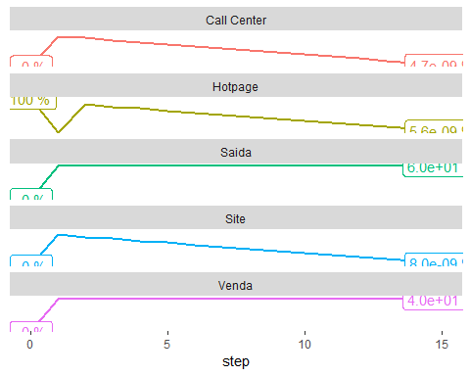

get_transition_states(initial_state, steps, mkv_chain)['transition_states_plot_2']

## $transition_states_plot_2

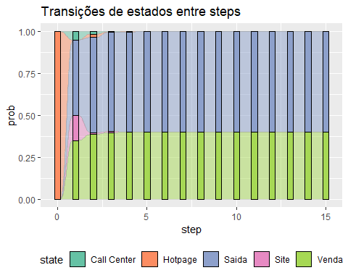

-**iii. O Call Center.**

initial_state <- c(0, 0, 1, 0, 0)  
  
steps <- 15  
  
kable(get_transition_states(initial_state, steps, mkv_chain)['transition_states'])

|  |  |  |  |  |  |
| --- | --- | --- | --- | --- | --- |
| step | Site | Hotpage | Call Center | Venda | Saida |
| 0 | 0.0000000 | 0.00e+00 | 1.0000000 | 0.0000000 | 0.0000000 |
| 1 | 0.2000000 | 1.00e-01 | 0.0000000 | 0.1300000 | 0.5700000 |
| 2 | 0.0150000 | 2.00e-02 | 0.0250000 | 0.2050000 | 0.7350000 |
| 3 | 0.0080000 | 4.00e-03 | 0.0025000 | 0.2182500 | 0.7672500 |
| 4 | 0.0011000 | 1.05e-03 | 0.0010000 | 0.2215750 | 0.7752750 |
| 5 | 0.0003575 | 2.10e-04 | 0.0001625 | 0.2222925 | 0.7769775 |
| 6 | 0.0000640 | 5.20e-05 | 0.0000463 | 0.2224586 | 0.7773791 |
| 7 | 0.0000171 | 1.10e-05 | 0.0000090 | 0.2224956 | 0.7774673 |
| 8 | 0.0000035 | 2.60e-06 | 0.0000023 | 0.2225041 | 0.7774876 |
| 9 | 0.0000008 | 6.00e-07 | 0.0000005 | 0.2225060 | 0.7774921 |
| 10 | 0.0000002 | 1.00e-07 | 0.0000001 | 0.2225064 | 0.7774932 |
| 11 | 0.0000000 | 0.00e+00 | 0.0000000 | 0.2225065 | 0.7774934 |
| 12 | 0.0000000 | 0.00e+00 | 0.0000000 | 0.2225065 | 0.7774935 |
| 13 | 0.0000000 | 0.00e+00 | 0.0000000 | 0.2225065 | 0.7774935 |
| 14 | 0.0000000 | 0.00e+00 | 0.0000000 | 0.2225065 | 0.7774935 |
| 15 | 0.0000000 | 0.00e+00 | 0.0000000 | 0.2225065 | 0.7774935 |

get_transition_states(initial_state, steps, mkv_chain)['transition_states_plot_1']

## $transition_states_plot_1

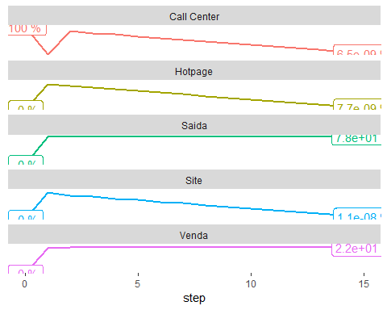

get_transition_states(initial_state, steps, mkv_chain)['transition_states_plot_2']

## $transition_states_plot_2

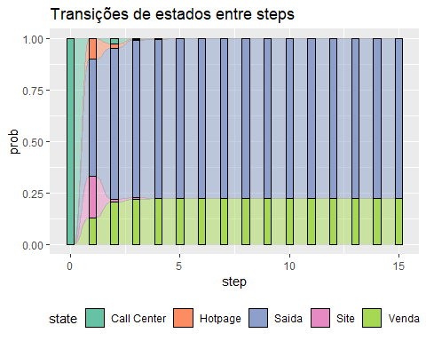

## c) De acordo com o resultado de b), qual o melhor “canal de entrada”: Site, Hotpage ou Call Center? Justifique.

O melhor canal de entrada é a hotpage pois tem a maior taxa de conversão em vendas **40%**

## d) Caso 50% dos clientes sejam “originados” por procura orgânica no Site, 20% pela Hotpage e 30% pelo Call Center, qual seria a taxa de conversão assintótica final?

initial_state <- c(0.5, 0.2, 0.3, 0, 0)  
  
steps <- 15  
  
kable(get_transition_states(initial_state, steps, mkv_chain)['transition_states'])

|  |  |  |  |  |  |
| --- | --- | --- | --- | --- | --- |
| step | Site | Hotpage | Call Center | Venda | Saida |
| 0 | 0.5000000 | 0.2000000 | 0.3000000 | 0.0000000 | 0.0000000 |
| 1 | 0.0900000 | 0.0800000 | 0.0600000 | 0.2090000 | 0.5610000 |
| 2 | 0.0240000 | 0.0150000 | 0.0130000 | 0.2628000 | 0.6852000 |
| 3 | 0.0048500 | 0.0037000 | 0.0031500 | 0.2745400 | 0.7137600 |
| 4 | 0.0011850 | 0.0008000 | 0.0006700 | 0.2772145 | 0.7201305 |
| 5 | 0.0002540 | 0.0001855 | 0.0001585 | 0.2778186 | 0.7215834 |
| 6 | 0.0000595 | 0.0000413 | 0.0000347 | 0.2779549 | 0.7219096 |
| 7 | 0.0000131 | 0.0000094 | 0.0000080 | 0.2779858 | 0.7219837 |
| 8 | 0.0000030 | 0.0000021 | 0.0000018 | 0.2779927 | 0.7220003 |
| 9 | 0.0000007 | 0.0000005 | 0.0000004 | 0.2779943 | 0.7220041 |
| 10 | 0.0000002 | 0.0000001 | 0.0000001 | 0.2779947 | 0.7220050 |
| 11 | 0.0000000 | 0.0000000 | 0.0000000 | 0.2779948 | 0.7220052 |
| 12 | 0.0000000 | 0.0000000 | 0.0000000 | 0.2779948 | 0.7220052 |
| 13 | 0.0000000 | 0.0000000 | 0.0000000 | 0.2779948 | 0.7220052 |
| 14 | 0.0000000 | 0.0000000 | 0.0000000 | 0.2779948 | 0.7220052 |
| 15 | 0.0000000 | 0.0000000 | 0.0000000 | 0.2779948 | 0.7220052 |

get_transition_states(initial_state, steps, mkv_chain)['transition_states_plot_1']

## $transition_states_plot_1

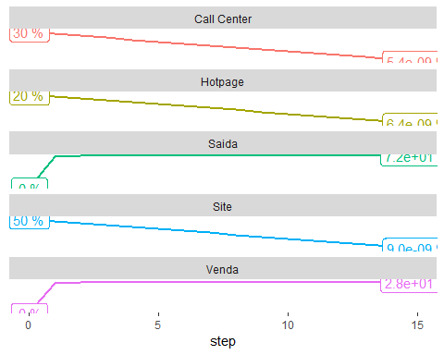

get_transition_states(initial_state, steps, mkv_chain)['transition_states_plot_2']

## $transition_states_plot_2

