**ATIVIDADE INDIVIDUAL 1**

**Disciplina: Métodos Matriciais e Análise de Clusters.**

**Professor responsável: Rodrigo Togneri.**

|  |  |
| --- | --- |
| **Matrícula** | **Nome Completo** |
|  |  |

**Tema: Cadeias de Markov.**

Em um dado e-commerce, a matriz de transição para uma dada operação é a representada abaixo:

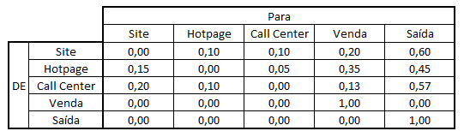

1. Com base nela, se existe um cliente que inicia sua interação pela Hotpage, qual a probabilidade de ele estar no Site, na Hotpage, no Call Center, ter resultado em Venda e ter dado Saída no passo seguinte? E no passo logo em seguida?

Primeiramente iniciamos com a criação da matriz de transição fornecida no enunciado do exercício:

tm <- **matrix**(**c**(0.00, 0.10, 0.10, 0.20, 0.60,

0.15, 0.00, 0.05, 0.35, 0.45,

0.20, 0.10, 0.00, 0.13, 0.57,

0.00, 0.00, 0.00, 1.00, 0.00,

0.00, 0.00, 0.00, 0.00, 1.00),

nrow = 5,

byrow = TRUE)

tm

## [,1] [,2] [,3] [,4] [,5]

## [1,] 0.00 0.1 0.10 0.20 0.60

## [2,] 0.15 0.0 0.05 0.35 0.45

## [3,] 0.20 0.1 0.00 0.13 0.57

## [4,] 0.00 0.0 0.00 1.00 0.00

## [5,] 0.00 0.0 0.00 0.00 1.00

Com a matriz de transição criada criamos um objeto MarkovChain usando o package markovchain

**library**(markovchain)

mkv_chain <- **new**("markovchain",

transitionMatrix = tm,

states = **c**("Site", "Hotpage", "Call Center", "Venda", 'Saida'),

name = "MarkovChain para o e-commerce")

mkv_chain

## MarkovChain para o e-commerce

## A 5 - dimensional discrete Markov Chain defined by the following states:

## Site, Hotpage, Call Center, Venda, Saida

## The transition matrix (by rows) is defined as follows:

## Site Hotpage Call Center Venda Saida

## Site 0.00 0.1 0.10 0.20 0.60

## Hotpage 0.15 0.0 0.05 0.35 0.45

## Call Center 0.20 0.1 0.00 0.13 0.57

## Venda 0.00 0.0 0.00 1.00 0.00

## Saida 0.00 0.0 0.00 0.00 1.00

Podemos desenhar o diagrama de Grafo da matriz de transição.

**plot**(mkv_chain, edge.arrow.size = 0.5)

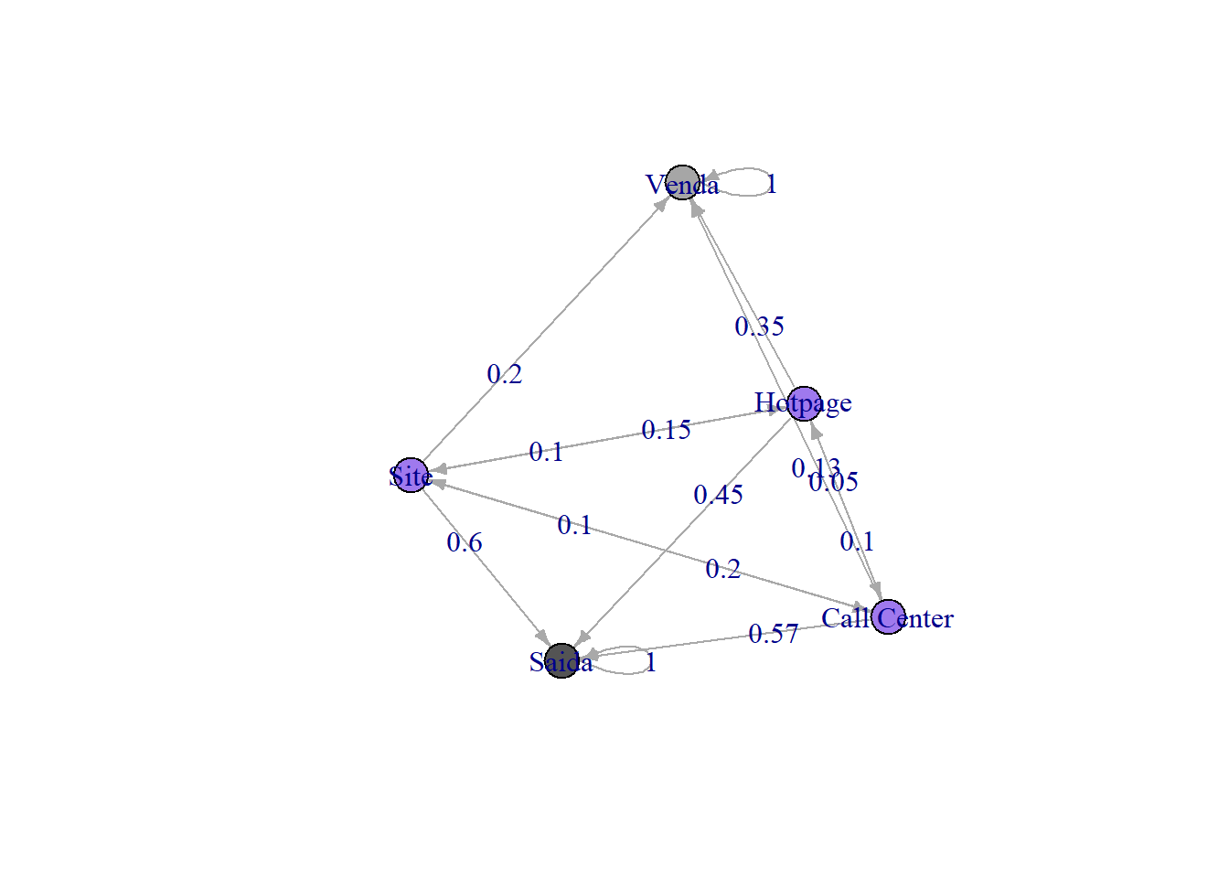

Para responder as próximas questões vou utilizar uma função customizada a parte do pacote marcokchain e ggplot para recuperar o histórico de transição entre os estados em cada período e desenhar algumas visualizações destes dados.

get_transition_states <- **function**(initial_state, steps, mkv_chain) {

states <- initial_state

**for** (step **in** **seq**(1, steps, 1)) {

final_state <- initial_state **\*** (mkv_chain **^** step)

states <- **rbind**(states, final_state)

}

states <- **as_tibble**(states)

states**$**step <- **as.numeric**(**row.names**(states)) **-** 1

states <- **select**(states, step, **everything**())

output = **list**()

output**$**transition_states <- states

states <- **gather**(states, 'state', 'prob', **-**step)

output**$**transition_states_plot_1 <- **ggplot**(data = states,

**aes**(x = step,

y = **log**(prob),

color = state)) **+**

**geom_line**(size = 1) **+**

**geom_label**(data = **filter**(states, step **==** **max**(step)),

**aes**(label = **paste**(**format**(prob **\*** 100, digits = 2), '%'))) **+**

**geom_label**(data = **filter**(states, step **==** **min**(step)),

**aes**(label = **paste**(**format**(prob **\*** 100, digits = 2), '%'))) **+**

**theme**(legend.position = 0,

axis.title.y = **element_blank**(),

axis.ticks.y = **element_blank**(),

axis.text.y = **element_blank**(),

panel.background = **element_blank**()) **+**

**facet_wrap**( **~** state, nrow = 7)

output**$**transition_states_plot_2 <- **ggplot**(data = states,

**aes**(y = prob,

x = step,

stratum = state,

alluvium = state,

fill = state)) **+**

**scale_fill_brewer**(type = "qual", palette = "Set2") **+**

**geom_flow**(stat = "alluvium", lode.guidance = "frontback",

color = "darkgray") **+**

**geom_stratum**() **+**

**theme**(legend.position = "bottom") **+**

**ggtitle**("Transições de estados entre steps")

**return**(output)

}

initial_state <- **c**(0, 1, 0, 0, 0)

steps <- 2

**kable**(**get_transition_states**(initial_state, steps, mkv_chain)['transition_states'])

|  |  |  |  |  |  |  |  |  |  |  |  |  |  |  |  |  |  |  |  |  |  |  |  |  |
| --- | --- | --- | --- | --- | --- | --- | --- | --- | --- | --- | --- | --- | --- | --- | --- | --- | --- | --- | --- | --- | --- | --- | --- | --- |
| | **step** | **Site** | **Hotpage** | **Call Center** | **Venda** | **Saida** | | --- | --- | --- | --- | --- | --- | | 0 | 0.00 | 1.00 | 0.000 | 0.0000 | 0.0000 | | 1 | 0.15 | 0.00 | 0.050 | 0.3500 | 0.4500 | | 2 | 0.01 | 0.02 | 0.015 | 0.3865 | 0.5685 | |

**get_transition_states**(initial_state, steps, mkv_chain)['transition_states_plot_1']

## $transition_states_plot_1

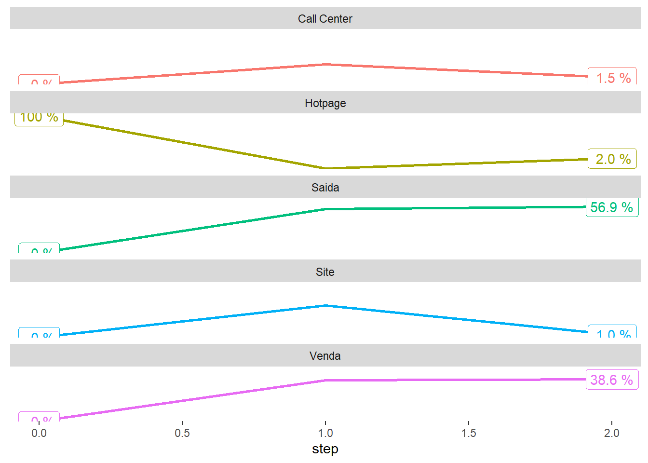

**get_transition_states**(initial_state, steps, mkv_chain)['transition_states_plot_2']

## $transition_states_plot_2

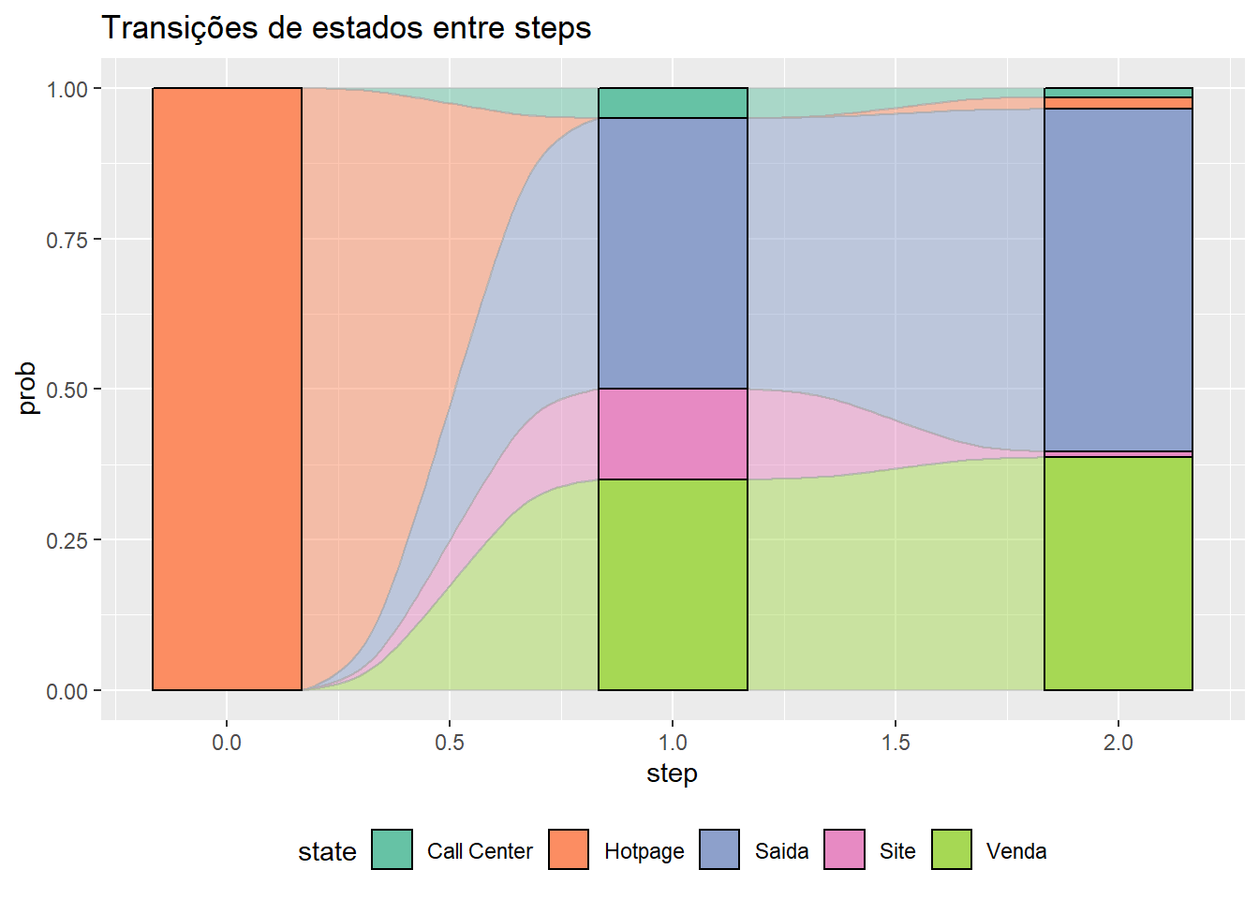

1. Use o software para calcular qual a probabilidade de venda final (isto é, na condição de estabilidade) de um cliente que interagiu pela primeira vez com a empresa usando:
2. O Site.

initial_state <- **c**(1, 0, 0, 0, 0)

steps <- 15

**kable**(**get_transition_states**(initial_state, steps, mkv_chain)['transition_states'])

|  |  |  |  |  |  |  |  |  |  |  |  |  |  |  |  |  |  |  |  |  |  |  |  |  |  |  |  |  |  |  |  |  |  |  |  |  |  |  |  |  |  |  |  |  |  |  |  |  |  |  |  |  |  |  |  |  |  |  |  |  |  |  |  |  |  |  |  |  |  |  |  |  |  |  |  |  |  |  |  |  |  |  |  |  |  |  |  |  |  |  |  |  |  |  |  |  |  |  |  |  |  |  |
| --- | --- | --- | --- | --- | --- | --- | --- | --- | --- | --- | --- | --- | --- | --- | --- | --- | --- | --- | --- | --- | --- | --- | --- | --- | --- | --- | --- | --- | --- | --- | --- | --- | --- | --- | --- | --- | --- | --- | --- | --- | --- | --- | --- | --- | --- | --- | --- | --- | --- | --- | --- | --- | --- | --- | --- | --- | --- | --- | --- | --- | --- | --- | --- | --- | --- | --- | --- | --- | --- | --- | --- | --- | --- | --- | --- | --- | --- | --- | --- | --- | --- | --- | --- | --- | --- | --- | --- | --- | --- | --- | --- | --- | --- | --- | --- | --- | --- | --- | --- | --- | --- | --- |
| | **step** | **Site** | **Hotpage** | **Call Center** | **Venda** | **Saida** | | --- | --- | --- | --- | --- | --- | | 0 | 1.0000000 | 0.00e+00 | 0.0000000 | 0.0000000 | 0.0000000 | | 1 | 0.0000000 | 1.00e-01 | 0.1000000 | 0.2000000 | 0.6000000 | | 2 | 0.0350000 | 1.00e-02 | 0.0050000 | 0.2480000 | 0.7020000 | | 3 | 0.0025000 | 4.00e-03 | 0.0040000 | 0.2591500 | 0.7303500 | | 4 | 0.0014000 | 6.50e-04 | 0.0004500 | 0.2615700 | 0.7359300 | | 5 | 0.0001875 | 1.85e-04 | 0.0001725 | 0.2621360 | 0.7373190 | | 6 | 0.0000623 | 3.60e-05 | 0.0000280 | 0.2622607 | 0.7376131 | | 7 | 0.0000110 | 9.00e-06 | 0.0000080 | 0.2622894 | 0.7376826 | | 8 | 0.0000030 | 1.90e-06 | 0.0000016 | 0.2622958 | 0.7376978 | | 9 | 0.0000006 | 5.00e-07 | 0.0000004 | 0.2622972 | 0.7377013 | | 10 | 0.0000001 | 1.00e-07 | 0.0000001 | 0.2622976 | 0.7377021 | | 11 | 0.0000000 | 0.00e+00 | 0.0000000 | 0.2622976 | 0.7377023 | | 12 | 0.0000000 | 0.00e+00 | 0.0000000 | 0.2622976 | 0.7377023 | | 13 | 0.0000000 | 0.00e+00 | 0.0000000 | 0.2622976 | 0.7377023 | | 14 | 0.0000000 | 0.00e+00 | 0.0000000 | 0.2622976 | 0.7377023 | | 15 | 0.0000000 | 0.00e+00 | 0.0000000 | 0.2622977 | 0.7377023 | |

**get_transition_states**(initial_state, steps, mkv_chain)['transition_states_plot_1']

## $transition_states_plot_1

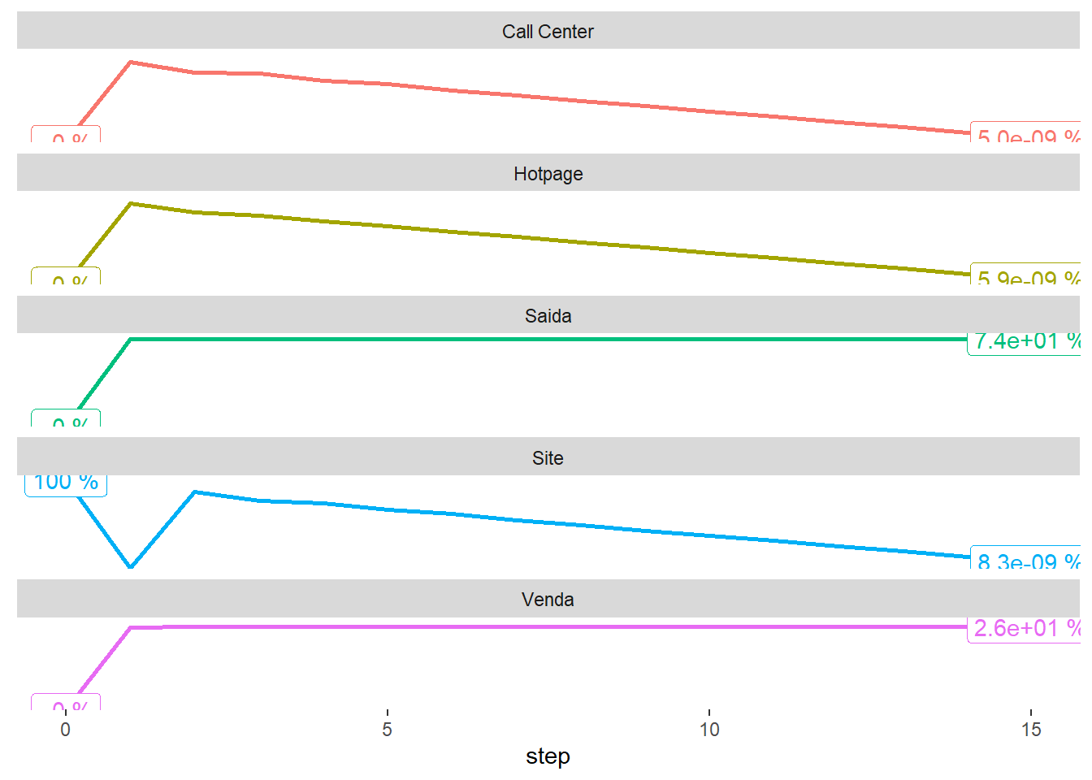

**get_transition_states**(initial_state, steps, mkv_chain)['transition_states_plot_2']

## $transition_states_plot_2

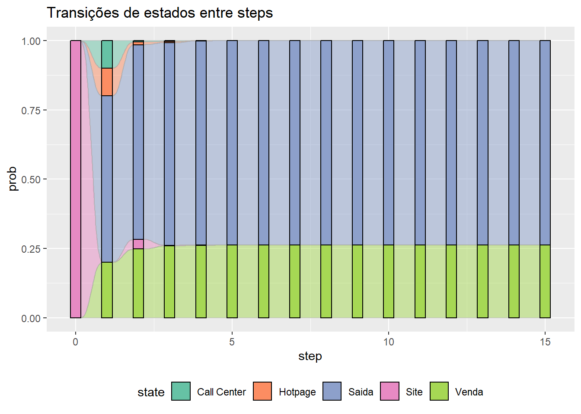

1. A Hotpage.

initial_state <- **c**(0, 1, 0, 0, 0)

steps <- 15

**kable**(**get_transition_states**(initial_state, steps, mkv_chain)['transition_states'])

|  |  |  |  |  |  |  |  |  |  |  |  |  |  |  |  |  |  |  |  |  |  |  |  |  |  |  |  |  |  |  |  |  |  |  |  |  |  |  |  |  |  |  |  |  |  |  |  |  |  |  |  |  |  |  |  |  |  |  |  |  |  |  |  |  |  |  |  |  |  |  |  |  |  |  |  |  |  |  |  |  |  |  |  |  |  |  |  |  |  |  |  |  |  |  |  |  |  |  |  |  |  |  |
| --- | --- | --- | --- | --- | --- | --- | --- | --- | --- | --- | --- | --- | --- | --- | --- | --- | --- | --- | --- | --- | --- | --- | --- | --- | --- | --- | --- | --- | --- | --- | --- | --- | --- | --- | --- | --- | --- | --- | --- | --- | --- | --- | --- | --- | --- | --- | --- | --- | --- | --- | --- | --- | --- | --- | --- | --- | --- | --- | --- | --- | --- | --- | --- | --- | --- | --- | --- | --- | --- | --- | --- | --- | --- | --- | --- | --- | --- | --- | --- | --- | --- | --- | --- | --- | --- | --- | --- | --- | --- | --- | --- | --- | --- | --- | --- | --- | --- | --- | --- | --- | --- | --- |
| | **step** | **Site** | **Hotpage** | **Call Center** | **Venda** | **Saida** | | --- | --- | --- | --- | --- | --- | | 0 | 0.00e+00 | 1.00e+00 | 0.0000000 | 0.0000000 | 0.0000000 | | 1 | 1.50e-01 | 0.00e+00 | 0.0500000 | 0.3500000 | 0.4500000 | | 2 | 1.00e-02 | 2.00e-02 | 0.0150000 | 0.3865000 | 0.5685000 | | 3 | 6.00e-03 | 2.50e-03 | 0.0020000 | 0.3974500 | 0.5920500 | | 4 | 7.75e-04 | 8.00e-04 | 0.0007250 | 0.3997850 | 0.5979150 | | 5 | 2.65e-04 | 1.50e-04 | 0.0001175 | 0.4003142 | 0.5991532 | | 6 | 4.60e-05 | 3.83e-05 | 0.0000340 | 0.4004350 | 0.5994467 | | 7 | 1.25e-05 | 8.00e-06 | 0.0000065 | 0.4004620 | 0.5995109 | | 8 | 2.50e-06 | 1.90e-06 | 0.0000017 | 0.4004682 | 0.5995258 | | 9 | 6.00e-07 | 4.00e-07 | 0.0000003 | 0.4004696 | 0.5995291 | | 10 | 1.00e-07 | 1.00e-07 | 0.0000001 | 0.4004699 | 0.5995298 | | 11 | 0.00e+00 | 0.00e+00 | 0.0000000 | 0.4004700 | 0.5995300 | | 12 | 0.00e+00 | 0.00e+00 | 0.0000000 | 0.4004700 | 0.5995300 | | 13 | 0.00e+00 | 0.00e+00 | 0.0000000 | 0.4004700 | 0.5995300 | | 14 | 0.00e+00 | 0.00e+00 | 0.0000000 | 0.4004700 | 0.5995300 | | 15 | 0.00e+00 | 0.00e+00 | 0.0000000 | 0.4004700 | 0.5995300 | |

**get_transition_states**(initial_state, steps, mkv_chain)['transition_states_plot_1']

## $transition_states_plot_1

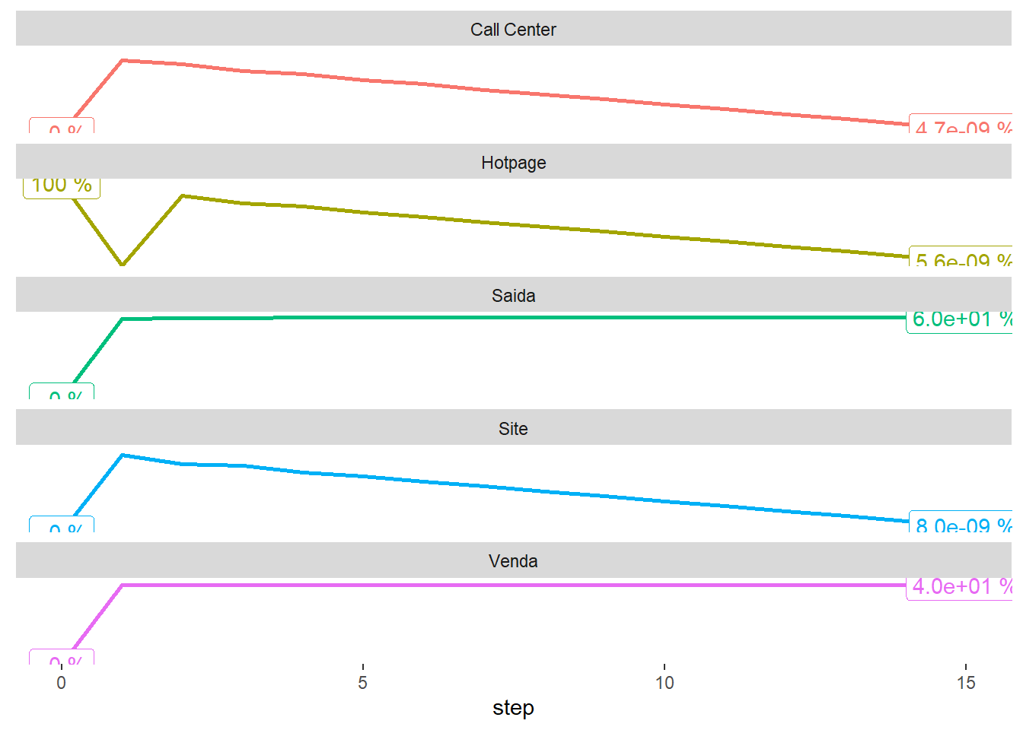

**get_transition_states**(initial_state, steps, mkv_chain)['transition_states_plot_2']

## $transition_states_plot_2

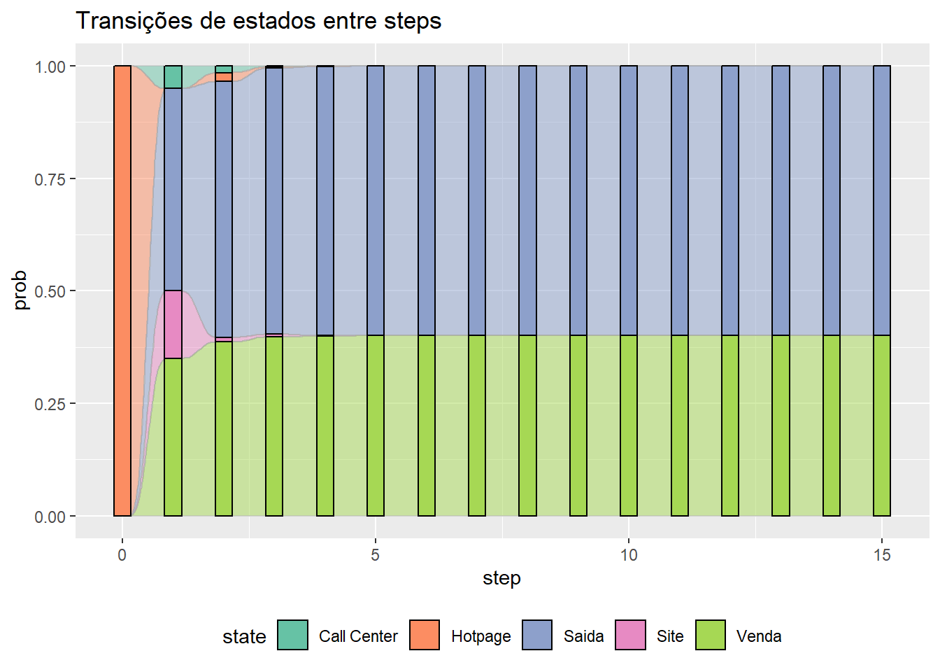

1. O Call Center.

initial_state <- **c**(0, 0, 1, 0, 0)

steps <- 15

**kable**(**get_transition_states**(initial_state, steps, mkv_chain)['transition_states'])

|  |  |  |  |  |  |  |  |  |  |  |  |  |  |  |  |  |  |  |  |  |  |  |  |  |  |  |  |  |  |  |  |  |  |  |  |  |  |  |  |  |  |  |  |  |  |  |  |  |  |  |  |  |  |  |  |  |  |  |  |  |  |  |  |  |  |  |  |  |  |  |  |  |  |  |  |  |  |  |  |  |  |  |  |  |  |  |  |  |  |  |  |  |  |  |  |  |  |  |  |  |  |  |
| --- | --- | --- | --- | --- | --- | --- | --- | --- | --- | --- | --- | --- | --- | --- | --- | --- | --- | --- | --- | --- | --- | --- | --- | --- | --- | --- | --- | --- | --- | --- | --- | --- | --- | --- | --- | --- | --- | --- | --- | --- | --- | --- | --- | --- | --- | --- | --- | --- | --- | --- | --- | --- | --- | --- | --- | --- | --- | --- | --- | --- | --- | --- | --- | --- | --- | --- | --- | --- | --- | --- | --- | --- | --- | --- | --- | --- | --- | --- | --- | --- | --- | --- | --- | --- | --- | --- | --- | --- | --- | --- | --- | --- | --- | --- | --- | --- | --- | --- | --- | --- | --- | --- |
| | **step** | **Site** | **Hotpage** | **Call Center** | **Venda** | **Saida** | | --- | --- | --- | --- | --- | --- | | 0 | 0.0000000 | 0.00e+00 | 1.0000000 | 0.0000000 | 0.0000000 | | 1 | 0.2000000 | 1.00e-01 | 0.0000000 | 0.1300000 | 0.5700000 | | 2 | 0.0150000 | 2.00e-02 | 0.0250000 | 0.2050000 | 0.7350000 | | 3 | 0.0080000 | 4.00e-03 | 0.0025000 | 0.2182500 | 0.7672500 | | 4 | 0.0011000 | 1.05e-03 | 0.0010000 | 0.2215750 | 0.7752750 | | 5 | 0.0003575 | 2.10e-04 | 0.0001625 | 0.2222925 | 0.7769775 | | 6 | 0.0000640 | 5.20e-05 | 0.0000463 | 0.2224586 | 0.7773791 | | 7 | 0.0000171 | 1.10e-05 | 0.0000090 | 0.2224956 | 0.7774673 | | 8 | 0.0000035 | 2.60e-06 | 0.0000023 | 0.2225041 | 0.7774876 | | 9 | 0.0000008 | 6.00e-07 | 0.0000005 | 0.2225060 | 0.7774921 | | 10 | 0.0000002 | 1.00e-07 | 0.0000001 | 0.2225064 | 0.7774932 | | 11 | 0.0000000 | 0.00e+00 | 0.0000000 | 0.2225065 | 0.7774934 | | 12 | 0.0000000 | 0.00e+00 | 0.0000000 | 0.2225065 | 0.7774935 | | 13 | 0.0000000 | 0.00e+00 | 0.0000000 | 0.2225065 | 0.7774935 | | 14 | 0.0000000 | 0.00e+00 | 0.0000000 | 0.2225065 | 0.7774935 | | 15 | 0.0000000 | 0.00e+00 | 0.0000000 | 0.2225065 | 0.7774935 | |

**get_transition_states**(initial_state, steps, mkv_chain)['transition_states_plot_1']

## $transition_states_plot_1

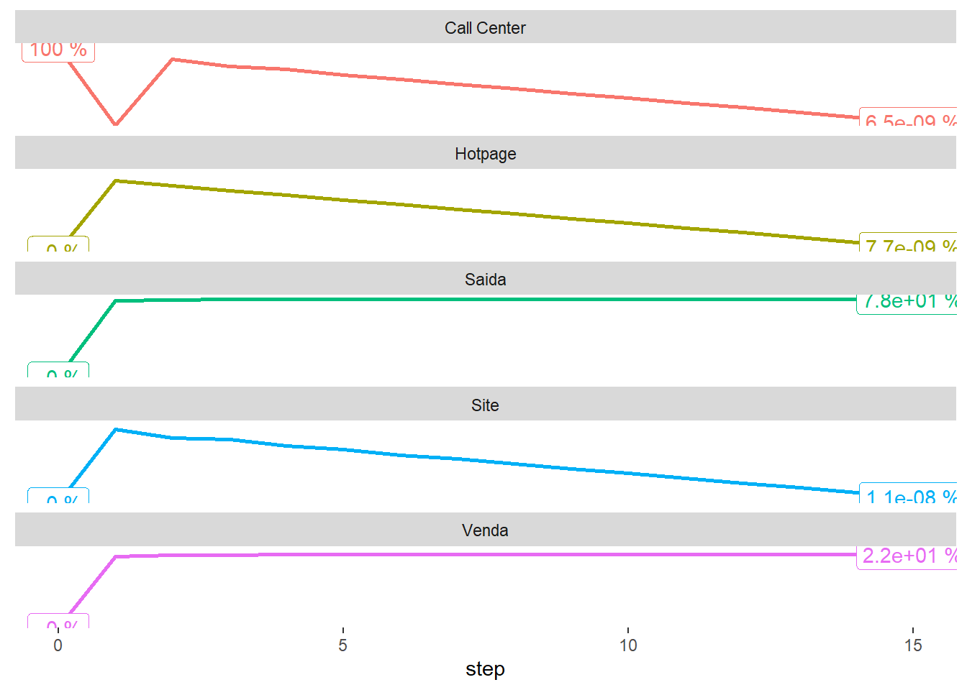

**get_transition_states**(initial_state, steps, mkv_chain)['transition_states_plot_2']

## $transition_states_plot_2

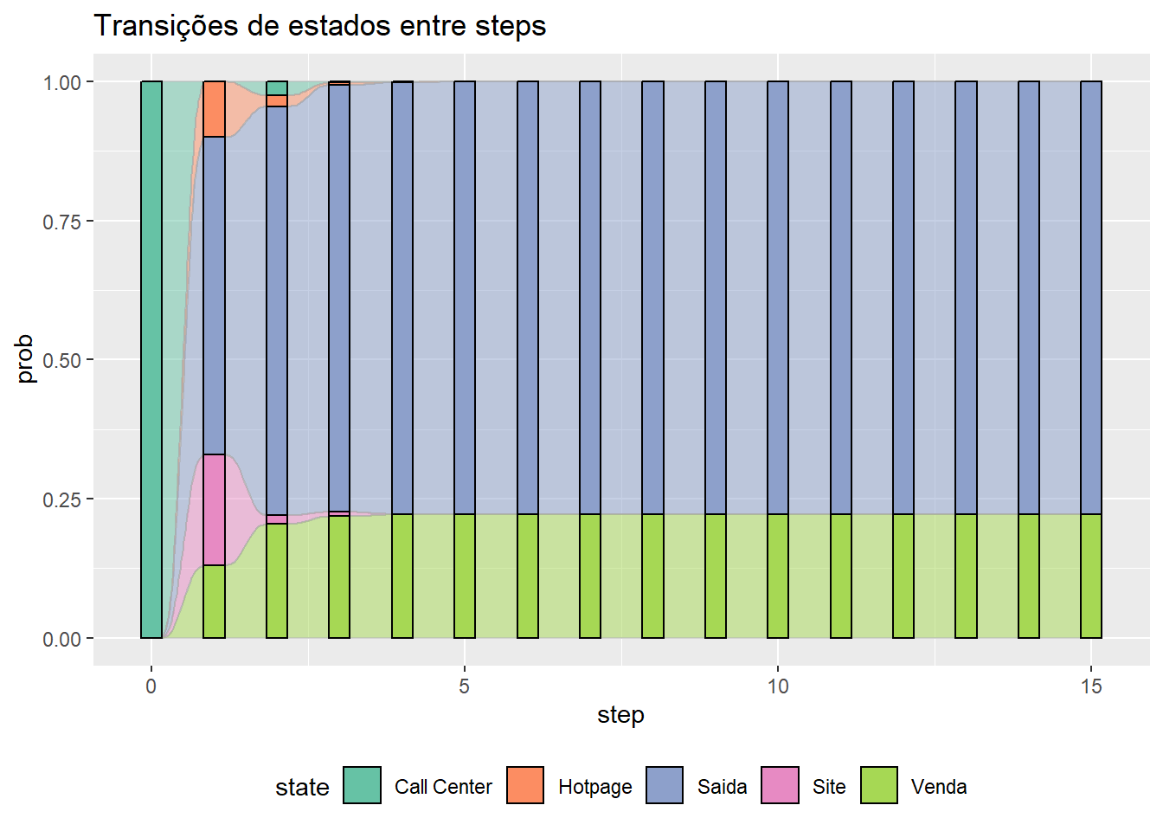

1. De acordo com o resultado de b), qual o melhor “canal de entrada”: Site, Hotpage ou Call Center? Justifique.

O melhor canal de entrada é a hotpage pois tem a maior taxa de conversão em vendas **40%**

1. Caso 50% dos clientes sejam “originados” por procura orgânica no Site, 20% pela Hotpage e 30% pelo Call Center, qual seria a taxa de conversão assintótica final?

initial_state <- **c**(0.5, 0.2, 0.3, 0, 0)

steps <- 15

**kable**(**get_transition_states**(initial_state, steps, mkv_chain)['transition_states'])

|  |  |  |  |  |  |  |  |  |  |  |  |  |  |  |  |  |  |  |  |  |  |  |  |  |  |  |  |  |  |  |  |  |  |  |  |  |  |  |  |  |  |  |  |  |  |  |  |  |  |  |  |  |  |  |  |  |  |  |  |  |  |  |  |  |  |  |  |  |  |  |  |  |  |  |  |  |  |  |  |  |  |  |  |  |  |  |  |  |  |  |  |  |  |  |  |  |  |  |  |  |  |  |
| --- | --- | --- | --- | --- | --- | --- | --- | --- | --- | --- | --- | --- | --- | --- | --- | --- | --- | --- | --- | --- | --- | --- | --- | --- | --- | --- | --- | --- | --- | --- | --- | --- | --- | --- | --- | --- | --- | --- | --- | --- | --- | --- | --- | --- | --- | --- | --- | --- | --- | --- | --- | --- | --- | --- | --- | --- | --- | --- | --- | --- | --- | --- | --- | --- | --- | --- | --- | --- | --- | --- | --- | --- | --- | --- | --- | --- | --- | --- | --- | --- | --- | --- | --- | --- | --- | --- | --- | --- | --- | --- | --- | --- | --- | --- | --- | --- | --- | --- | --- | --- | --- | --- |
| | **step** | **Site** | **Hotpage** | **Call Center** | **Venda** | **Saida** | | --- | --- | --- | --- | --- | --- | | 0 | 0.5000000 | 0.2000000 | 0.3000000 | 0.0000000 | 0.0000000 | | 1 | 0.0900000 | 0.0800000 | 0.0600000 | 0.2090000 | 0.5610000 | | 2 | 0.0240000 | 0.0150000 | 0.0130000 | 0.2628000 | 0.6852000 | | 3 | 0.0048500 | 0.0037000 | 0.0031500 | 0.2745400 | 0.7137600 | | 4 | 0.0011850 | 0.0008000 | 0.0006700 | 0.2772145 | 0.7201305 | | 5 | 0.0002540 | 0.0001855 | 0.0001585 | 0.2778186 | 0.7215834 | | 6 | 0.0000595 | 0.0000413 | 0.0000347 | 0.2779549 | 0.7219096 | | 7 | 0.0000131 | 0.0000094 | 0.0000080 | 0.2779858 | 0.7219837 | | 8 | 0.0000030 | 0.0000021 | 0.0000018 | 0.2779927 | 0.7220003 | | 9 | 0.0000007 | 0.0000005 | 0.0000004 | 0.2779943 | 0.7220041 | | 10 | 0.0000002 | 0.0000001 | 0.0000001 | 0.2779947 | 0.7220050 | | 11 | 0.0000000 | 0.0000000 | 0.0000000 | 0.2779948 | 0.7220052 | | 12 | 0.0000000 | 0.0000000 | 0.0000000 | 0.2779948 | 0.7220052 | | 13 | 0.0000000 | 0.0000000 | 0.0000000 | 0.2779948 | 0.7220052 | | 14 | 0.0000000 | 0.0000000 | 0.0000000 | 0.2779948 | 0.7220052 | | 15 | 0.0000000 | 0.0000000 | 0.0000000 | 0.2779948 | 0.7220052 | |

**get_transition_states**(initial_state, steps, mkv_chain)['transition_states_plot_1']

## $transition_states_plot_1

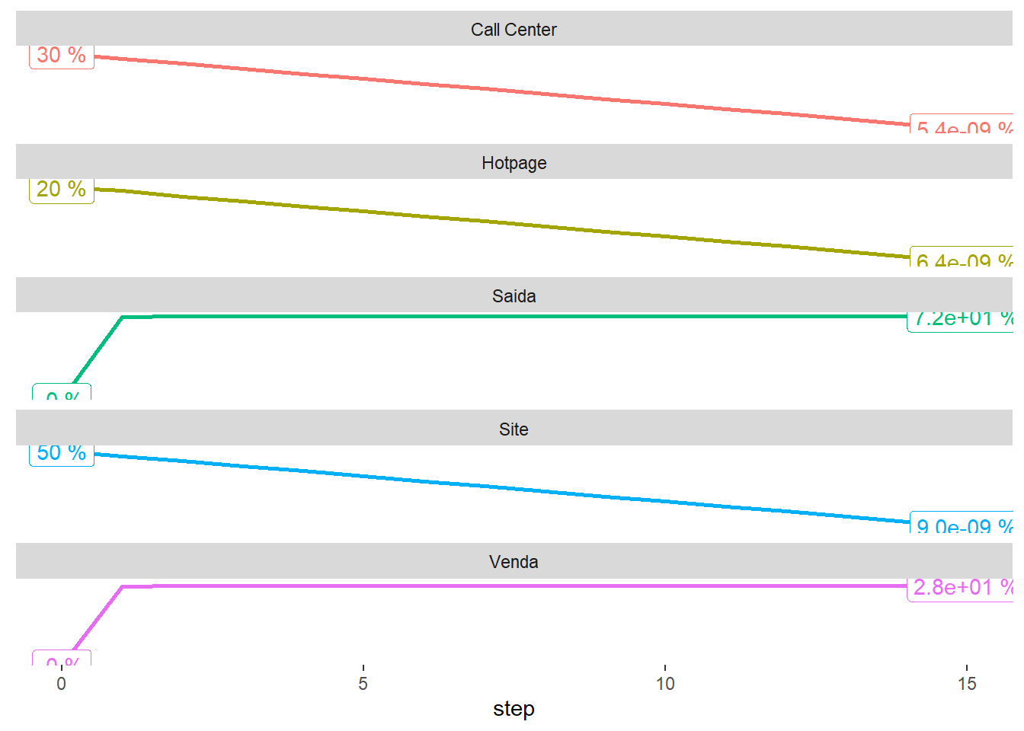

**get_transition_states**(initial_state, steps, mkv_chain)['transition_states_plot_2']

## $transition_states_plot_2

