EduERP
An Integrated Microservices ERP System for Educational Institutions
Academic | Marketing & Finance | Administration & Human Resources
PROJECT REPORT AND SOFTWARE REQUIREMENTS SPECIFICATION
Requirements structured after ISO/IEC/IEEE 29148
Student name: ________________________________
Matricule number: ________________________________
Supervisor: ________________________________
Institution / Department: ________________________________
Date: 25 September 2026

Abstract
EduERP is a web-based Enterprise Resource Planning (ERP) system for an educational institution. It brings the three areas that a school or university runs every day - academic administration, marketing and finance, and administration and human resources - into one platform. The system is built as a set of independent microservices behind an API Gateway: an Academic Service, a Marketing & Finance Service and an Administration & HR Service, each with its own PostgreSQL database, plus a React web application. The services cooperate synchronously over HTTP and asynchronously through a RabbitMQ message broker: when a student enrolls in a course, the Academic Service publishes an event and the Finance Service automatically creates the tuition invoice. Access is protected with JWT authentication and four user roles (student, staff, admin, super admin). The complete system runs in nine Docker containers started with a single command. This report describes the purpose, requirements, architecture, design and implementation of the system, and documents its known limitations.

Table of Contents
Abstract 2
Table of Contents 3
1. Introduction 5
1.1 Background 5
1.2 Problem statement 5
1.3 Objectives 5
1.4 Scope 6
1.5 Intended audience 6
1.6 Definitions and acronyms 6
1.7 References 6
2. System Description 8
2.1 What EduERP is 8
2.2 Users and roles 8
2.3 Modules and functions 8
2.4 How the system is used: typical scenarios 10
2.5 Operating environment 10
2.6 Assumptions, dependencies and constraints 11
3. System Architecture 12
3.1 Architectural style 12
3.2 Components 12
3.3 Deployment 12
4. Software Requirements Specification 14
4.1 Functional requirements 14
4.2 Non-functional requirements 18
4.3 External interface requirements 20
5. System Design and Modelling 22
5.1 Use-case diagrams 22
5.2 Class diagrams 26
5.3 Entity relationship diagrams 29
5.4 Sequence diagrams 32
6. Implementation and Testing 35
6.1 Technologies 35
6.2 Project structure 35
6.3 Security measures 35
6.4 Testing 36
6.5 How to run the system 36
7. Traceability and Consistency Audit 37
7.1 Requirement traceability matrix 37
7.2 Implementation consistency audit 42
8. Limitations and Future Work 44
8.1 Limitations (Planned / Not implemented) 44
8.2 Future work 44
9. Conclusion 45
References 46

1. Introduction

1.1 Background
Educational institutions run several kinds of activity at the same time. Registrars manage students, courses, grades and attendance. Bursars manage tuition fees, receipts and expenses. Human-resources officers manage employees, payroll, leave and equipment. In many institutions each of these areas uses a separate tool or paper records, so the same information (for example, a student's enrollment) has to be re-entered in several places.
EduERP was developed as an academic project to show how these areas can be combined in a single, secure, modern system built with the architecture that large organisations use today: independent services that own their data and talk to each other through well-defined interfaces. The system is designed for the local context of the institution: amounts are in FCFA, students pay tuition with mobile money (MTN MoMo or Orange Money), and payroll includes CNPS and PAYE deductions.

1.2 Problem statement
The project addresses the following problems:
- Separate tools for academics, finance and HR lead to duplicated data entry and delays. A student who enrolls in a course must then be billed manually.
- Staff need different levels of access. A student must not see payroll screens and a clerk must not be able to create administrators, so access control must be built in.
- A single large application is hard to change: a fault or a change in the payroll code should not stop enrollment. The institution needs parts that can be developed, tested and deployed separately.
- Financial actions such as payments must be consistent: a payment must never be recorded without the matching invoice update and receipt.

1.3 Objectives
The objectives of the project are to:
- Provide one integrated platform for academic, marketing and finance, and administration and HR operations.
- Apply a microservices architecture: separate services, one database per service, one public entry point (API Gateway).
- Secure the system with JWT authentication, refresh-token rotation, account lockout and role-based authorization.
- Automate tuition billing: enrolling a student must trigger invoice creation in the Finance Service through a message broker, without manual work.
- Support simulated mobile-money payments (MTN MoMo and Orange Money) with receipts.
- Support HR processes: employee records, recruitment, payroll calculation, QR-code attendance, leave requests, performance reviews and asset tracking.
- Make the system easy to run and verify: one-command container deployment, automated tests and a continuous-integration pipeline.

1.4 Scope

Included in the system
- Web application for four roles: student, staff, admin and super admin.
- Academic: students, courses and prerequisites, enrollment, grades and GPA, attendance, exam scheduling, grade appeals, at-risk detection.
- Marketing & Finance: automatic tuition invoices, simulated payments, receipts, expenses, financial reports, marketing campaigns with conversion rate and ROI.
- Administration & HR: employees, recruitment, payroll, QR attendance, leave, performance reviews, assets, HR dashboard.

Not included (Planned / Not implemented)
- Real payment processing: the mobile-money gateway is simulated inside the Finance Service.
- PDF export of transcripts and reports (data is available as JSON only).
- E-mail or SMS notifications.
- HTTPS/TLS, high availability and load testing.

1.5 Intended audience
This report is written for the project examiners and supervisor, and for developers who will maintain or extend the system. Part 2 explains what the system does in plain language; parts 4 and 5 contain the formal requirements and the design models.

1.6 Definitions and acronyms
Term | Meaning
ERP | Enterprise Resource Planning: one system that supports several business functions
Microservice | A small, independently deployable program responsible for one business area and its own data
API Gateway | The single public entry point that checks requests and forwards them to the right service
REST API | Web interface in which programs exchange JSON messages over HTTP
JWT | JSON Web Token: a signed digital pass proving who the user is and which role they have
RBAC | Role-based access control: what a user may do depends on their role
RabbitMQ / event | A message broker; an event is a message announcing that something happened (for example a student enrolled)
FCFA | Central African CFA franc, the currency of all amounts
CNPS / PAYE | Social-security and income-tax deductions applied in payroll
MTN MoMo / Orange Money | Mobile-money payment services (simulated in this project)
UML / ERD | Unified Modeling Language / Entity Relationship Diagram
SRS | Software Requirements Specification

1.7 References
- ISO/IEC/IEEE 29148:2018, Systems and software engineering - Life cycle processes - Requirements engineering.
- Project source repository: docker-compose.yml, api-gateway/, services/academic-service, services/finance-service, services/hr-service, frontend/, .github/workflows/ci.yml.
- Swagger/OpenAPI documentation served at /docs by the gateway and by each service.

2. System Description

2.1 What EduERP is
EduERP is a web application that lets an educational institution run its academic, financial and human-resource activities from one place. Users open the application in a web browser, log in, and see a menu that depends on their role. Behind the screens, the work is done by three business services and one gateway, described in section 3.
The name of each business area corresponds to one service: the Academic Service, the Marketing & Finance Service (called finance-service in the code) and the Administration & HR Service (hr-service). Marketing is represented by the campaign tracking that lives inside the Finance Service.

2.2 Users and roles
The system has four roles. The role is stored with the account and is placed inside the login token, so each service can decide what the user may do.
Role | What the role does | Web menu
Student | Registers an account, enrolls in courses, views own courses, grades, GPA and attendance, sees at-risk status, views invoices, pays tuition by simulated mobile money, submits grade appeals. | Menu: My Dashboard, My Courses, My Invoices & Payments, Grade Appeals
Staff | Runs day-to-day academic operations (students, courses, grades, attendance, exams, appeals), scans QR attendance and handles leave requests in the web interface. | Menu: 7 entries
Admin | Academic functions like staff, plus finance (invoices, expenses, reports) and HR (employees, recruitment, payroll, leave) screens, deletions and deactivations, payroll-rate updates and creation of staff accounts. | Menu: 12 entries
Super Admin | All admin screens, plus QR attendance, marketing campaigns, asset management, creation of admin and super-admin accounts and a service-health view. | Menu: 15 entries
The API allows more than the web menus show for some roles; see the limitations in section 8.

2.3 Modules and functions

2.3.1 Academic module (Academic Service)
The Academic Service manages the academic life of the institution and also hosts the login system, because every user is a member of the institution.
- Student records: staff create and update students (student number, name, e-mail, programme, level, status) and admins can deactivate them. A student who registers online gets a profile automatically.
- Courses: each course has a code, title, credits and a capacity. A course can have prerequisite courses.
- Enrollment: a student can enroll only if the prerequisites are passed, the course is not full and the student is not already enrolled. A successful enrollment publishes an event to the Finance Service. Students can also drop a course.
- Grades: staff enter a score from 0 to 100; the system assigns the letter grade (A from 90, B from 80, C from 70, D from 60, E from 50, F below) and marks 50 and above as passing. A credit-weighted GPA is calculated.
- Attendance: staff record present, absent or late for each student, course and date; the attendance percentage is calculated.
- At-risk detection: a student is flagged when attendance is below 75% or when two failing grades occur in a row.
- Examinations: staff schedule exams; the system refuses a room that is already booked for an overlapping time.
- Grade appeals: a student can appeal one of their own grades; staff approve or reject each appeal once.

2.3.2 Marketing & Finance module (Finance Service)
The Finance Service handles money coming in and going out, and also the marketing campaigns of the institution.
- Automatic invoicing: when the Academic Service announces a new enrollment, the Finance Service creates an invoice numbered INV-year-number. The amount is the course credits multiplied by a per-credit rate (15,000 FCFA by default) and it is due in 30 days.
- Payments: a student pays an invoice through a simulated MTN MoMo or Orange Money charge. Partial payments are allowed; an amount larger than the balance is refused. The invoice status becomes partially paid or paid.
- Receipts: every successful payment produces a numbered receipt (RCT-year-number).
- Overdue invoices: staff can mark unpaid invoices past their due date as overdue.
- Expenses: staff record, edit and delete institutional expenses by category.
- Reports: daily and monthly income and expense summaries, outstanding fees and an expense report, all in FCFA.
- Marketing campaigns: staff record a campaign with dates and budget and update its leads, conversions and revenue; the system calculates the conversion rate and the return on investment (ROI).

2.3.3 Administration & HR module (HR Service)
The HR Service manages the people who work for the institution and the equipment they use.
- Employees: records with department, position, salary and status. Each employee receives a unique QR token.
- Recruitment: candidates are tracked through the stages applied, interview, selected and rejected.
- Payroll: for a chosen employee and month the system computes gross pay (basic salary plus allowances), the CNPS and PAYE deductions from configurable rates, and the net pay. Admins can change the rates.
- QR attendance: scanning an employee's QR token records a check-in, once per employee per day.
- Leave: requests are submitted and then approved or rejected by staff.
- Performance reviews: a score from 0 to 10 with comments can be recorded for an employee.
- Assets: equipment is recorded with category, value and status, and can be assigned to an employee.
- Dashboard: a summary of active employees, check-ins today, pending leave, average performance and number of assets.

2.3.4 Authentication and administration
Login and access control are provided by the Academic Service and enforced everywhere.
- Registration: anyone can register, but a public registration always creates a student account. Staff-level accounts can only be created by a logged-in admin (staff accounts) or super admin (any role).
- Login: passwords are checked against a bcrypt hash. After five wrong attempts the account is locked for 15 minutes. The system returns a 15-minute access token and a 7-day refresh token.
- Token refresh and logout: refresh tokens are stored only as hashes, are replaced each time they are used, and are revoked on logout.
- Authorization: the API Gateway and every service each verify the token and check the user's role on every protected route.
- Service health: the super admin can see whether the three services are running.

2.4 How the system is used: typical scenarios

Scenario 1: from enrollment to receipt
- A new student registers on the web page and logs in.
- The student opens My Courses and enrolls in a course. The Academic Service checks prerequisites and capacity and saves the enrollment.
- The Academic Service publishes a STUDENT_ENROLLED event to RabbitMQ and immediately confirms the enrollment to the student.
- The Finance Service receives the event and creates a tuition invoice (credits x 15,000 FCFA) without any human action.
- The student opens My Invoices & Payments, chooses MTN MoMo or Orange Money, enters a phone number and pays. The invoice is updated and a receipt is issued.

Scenario 2: teaching staff and grades
- Staff record attendance for a class and enter grades for enrolled students.
- The system calculates letter grades and GPA and flags students who fall below 75% attendance or fail twice in a row.
- A student who disagrees with a grade submits an appeal; staff approve or reject it.

Scenario 3: HR and payroll
- An admin registers an employee; the system generates a QR token.
- Each day the employee is checked in by scanning the QR token.
- At month end an admin runs payroll for the employee and the system stores gross pay, CNPS, PAYE and net pay for that month.

2.5 Operating environment
The system runs in Docker containers on one host: node:20-alpine for the services, nginx 1.27 for the web application, PostgreSQL 16 for data and RabbitMQ 3.13 for messaging. Users need only a modern web browser.

2.6 Assumptions, dependencies and constraints

Assumptions
- Tuition is billed at a flat rate per credit (15,000 FCFA by default).
- Mobile-money payments are simulated; payroll rates are placeholders.
- All services are started with the same JWT secret so that tokens issued by the Academic Service are accepted everywhere.
- The system is deployed on a single host for development and demonstration.

Dependencies
- The databases and RabbitMQ must be healthy before the services that use them start (enforced with Docker health checks).
- The Finance Service depends on RabbitMQ and its database; the Academic Service on its database and RabbitMQ; the HR Service on its database only.
- The web application depends on the gateway being reachable inside the Docker network.

Constraints
- Academic project: the whole system is written in JavaScript (Node.js 20) with plain SQL and no ORM.
- One database per service; no foreign keys between databases.
- Single host, no replication, no Kubernetes, no TLS.
- Development fallback secrets exist in the code; real secrets must be supplied through environment variables.
- Limited project time: several production features are listed as Planned / Not implemented in section 8.

3. System Architecture

3.1 Architectural style
EduERP follows a microservices architecture. Instead of one large program, the back end is split into small services, each responsible for one business area and each owning its own database. A service never reads another service's database; it either receives requests over HTTP or receives events from the message broker.
The browser loads the React application from an nginx web server. All data requests go to one address, /api/v1. nginx passes them to the API Gateway, which is the only public entry point to the back end. The gateway limits the request rate, checks the user's token and forwards the request to the right service: /api/v1/auth and /api/v1/academic go to the Academic Service, /api/v1/finance to the Finance Service and /api/v1/hr to the HR Service.
Two kinds of communication exist. Synchronous communication is a normal HTTP request and answer, used for almost every screen. Asynchronous communication uses RabbitMQ and is used for the one workflow that crosses services: enrollment creating an invoice. Asynchronous messaging means the enrollment does not have to wait for, or fail because of, the billing system.
Identity is centralised in the Academic Service, which issues the JSON Web Tokens. The Finance and HR services do not store passwords; they verify the token signature with a shared secret, so each service remains safe even if it is called directly without the gateway.

3.2 Components
Container | Responsibility | Port(s)
frontend | nginx serving the React application and forwarding /api/v1/ to the gateway | 5173 (host) -> 80
api-gateway | Single entry point: token check, rate limiting, routing, health aggregation, Swagger docs | 4000
academic-service | Login and identity, academic functions, publishes enrollment events | 4001
finance-service | Invoices, payments, receipts, expenses, reports, campaigns; consumes enrollment events | 4002
hr-service | Employees, recruitment, payroll, attendance, leave, performance, assets | 4003
academic-db | PostgreSQL 16, database academic_db | 5433 -> 5432
finance-db | PostgreSQL 16, database finance_db | 5434 -> 5432
hr-db | PostgreSQL 16, database hr_db | 5435 -> 5432
rabbitmq | Message broker with management page | 5672, 15672

3.3 Deployment
Figure 1 shows how the containers are deployed with Docker Compose, which ports they use and which way they communicate. The Academic Service publishes messages to RabbitMQ and the Finance Service consumes them; the HR Service has no connection to the broker.
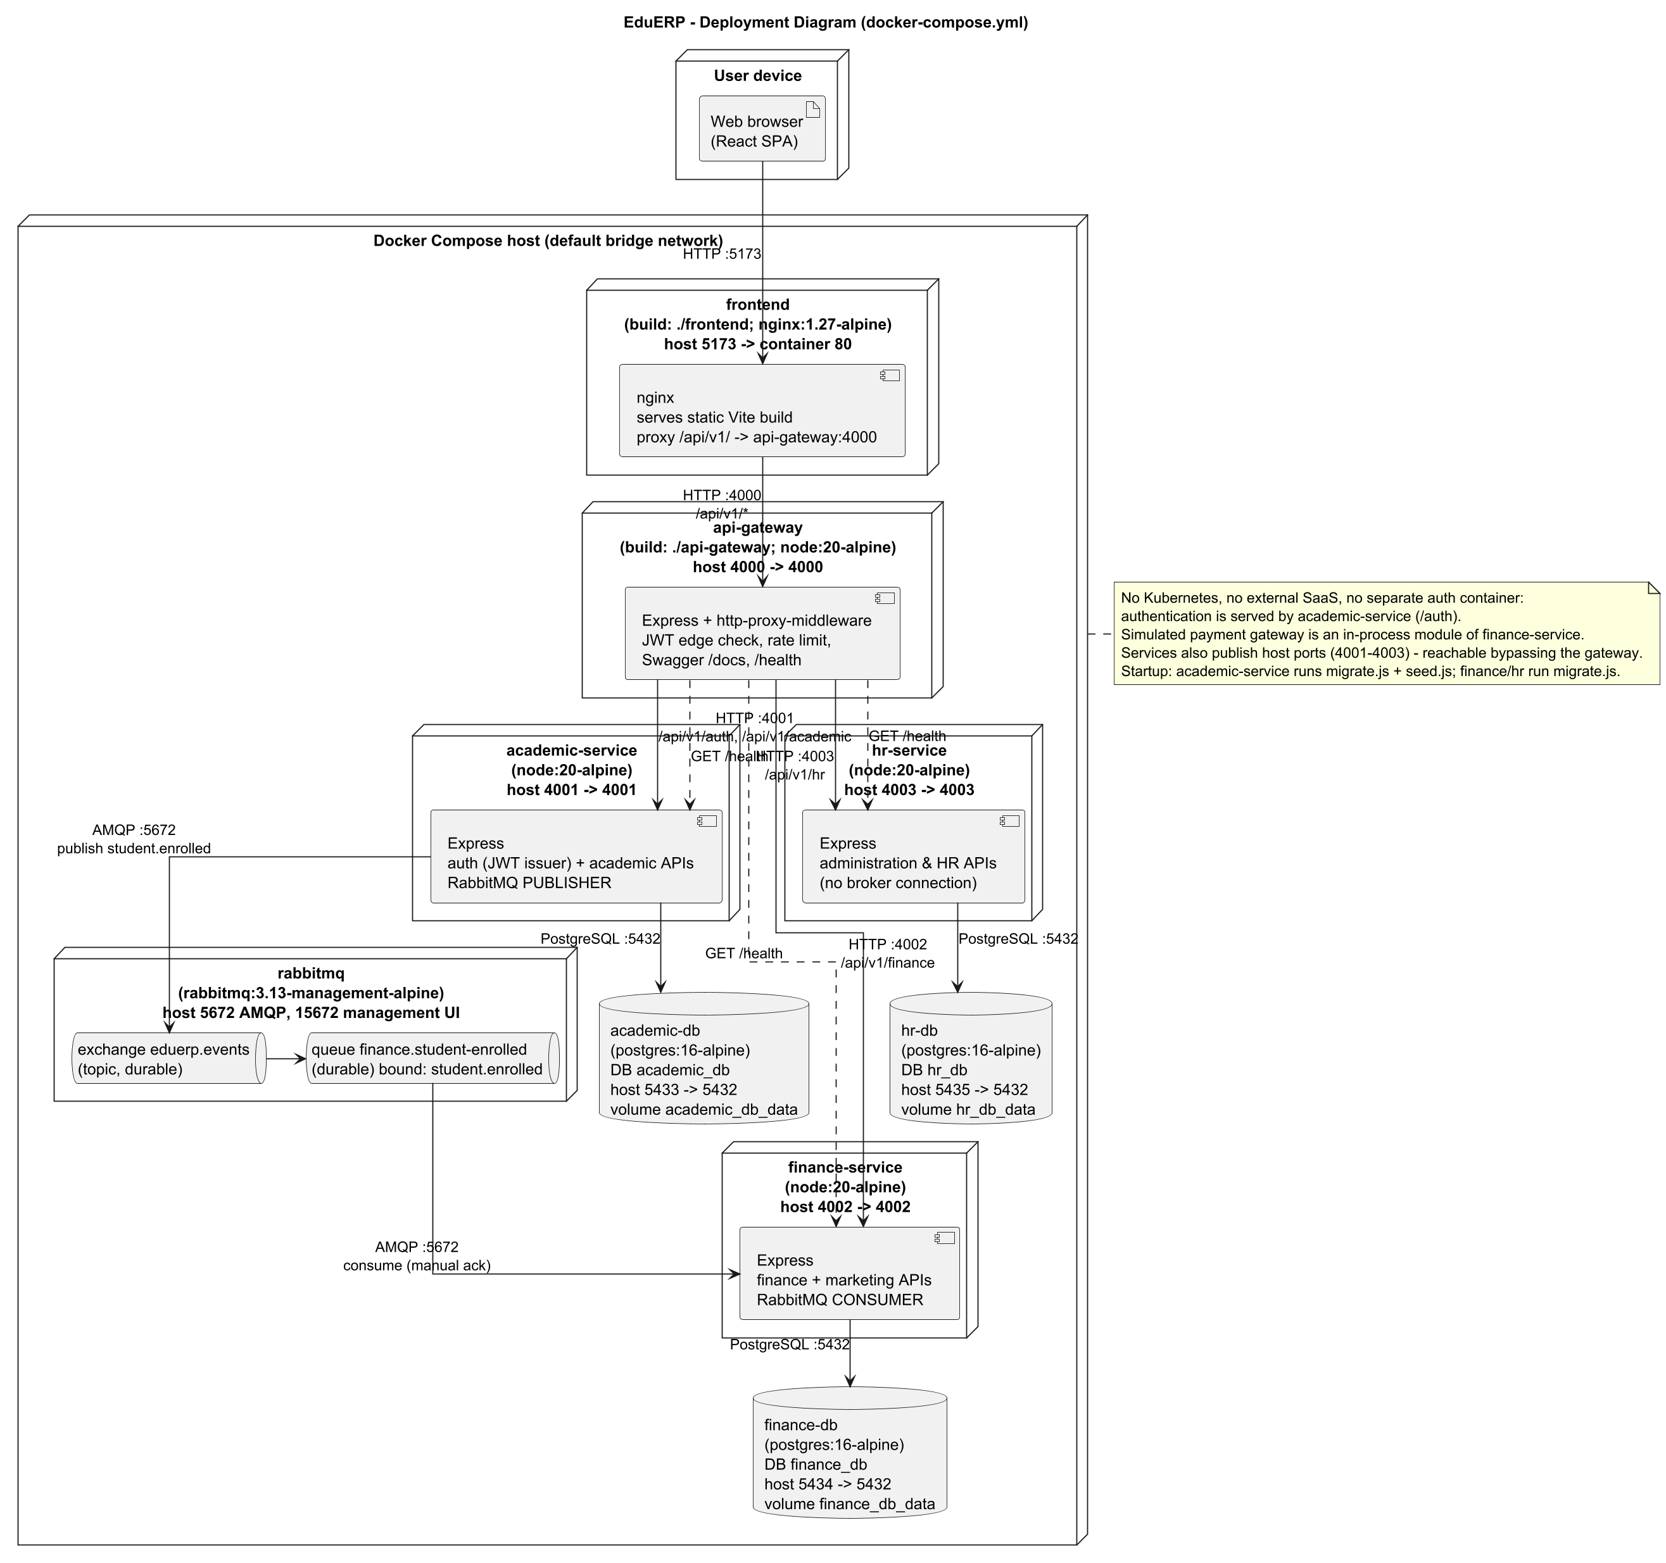
Figure 1: Deployment Diagram - Docker Compose
Nine containers on one Compose network: nginx frontend, gateway, three services, RabbitMQ and three PostgreSQL databases, with ports, protocols and communication direction.
Implementation: docker-compose.yml, Dockerfiles, nginx.conf. No Kubernetes and no external systems.

4. Software Requirements Specification
This part lists what the system must do (functional requirements) and how well it must do it (non-functional requirements). Each requirement has a unique identifier and cites the code that implements it. "STAFF" means the roles staff, admin and super_admin; API paths are relative to /api/v1.

4.1 Functional requirements

4.1.1 Authentication / Authorization (Academic Service /auth + API Gateway)
ID | Requirement | Actor / service | Preconditions | Expected result | Priority | Implementation evidence
FR-001 | A visitor shall self-register; this always creates a student account and a linked student profile in one transaction. | Visitor / academic-service | Email not already used; password meets rule in authRoutes.js | 201 with user + accessToken + refreshToken; 409 if email exists | High | authController.register  POST /api/v1/auth/register
FR-002 | An authenticated admin or super_admin shall create staff-level accounts; only a super_admin may create admin or super_admin accounts. | Admin, Super Admin / academic-service | Valid JWT with role admin or super_admin | 201 new user; 403 if admin requests admin/super_admin role; 409 duplicate email | Medium | authRoutes register-staff; authController.registerStaff  POST /api/v1/auth/register-staff
FR-003 | The system shall authenticate users by email and bcrypt-verified password and return a short-lived access token and a refresh token. | All users / academic-service | Account exists, active, not locked | 200 {user, accessToken, refreshToken}; generic 401 for unknown email or wrong password | High | authController.login; authService  POST /api/v1/auth/login
FR-004 | The system shall lock an account for LOCKOUT_DURATION_MINUTES (15) after MAX_FAILED_LOGIN_ATTEMPTS (5) consecutive failed logins. | academic-service | Repeated wrong passwords | 423 while locked; counter reset on success | High | authController.login; users.failed_login_attempts, locked_until  POST /api/v1/auth/login
FR-005 | The system shall reject login for deactivated accounts. | academic-service | users.is_active = false | 403 Account is deactivated | Low | authController.login  POST /api/v1/auth/login
FR-006 | The system shall rotate refresh tokens: a valid refresh token is revoked and a new access/refresh pair issued; refresh tokens are stored only as SHA-256 hashes. | All users / academic-service | Unrevoked, unexpired refresh token | 200 new token pair; 401 if revoked/unknown/expired | High | authController.refresh; authService.hashToken  POST /api/v1/auth/refresh
FR-007 | The system shall revoke a presented refresh token on logout. | All users / academic-service | - | 204 No Content | Medium | authController.logout  POST /api/v1/auth/logout
FR-008 | The system shall return the caller identity claims from a valid access token. | All users / academic-service | Valid JWT | 200 {user:{id,email,role,fullName}} | Low | authController.me  GET /api/v1/auth/me
FR-009 | Every microservice shall independently verify the JWT (shared JWT_ACCESS_SECRET) and enforce role checks (requireRole) per route; missing/invalid token gives 401, insufficient role gives 403. | academic, finance, hr services | - | 401 / 403 responses as specified | High | */src/middleware/auth.js  All protected routes
FR-010 | The API Gateway shall reject requests to /api/v1/academic, /finance, /hr and /health/* that lack a valid Bearer JWT before proxying. | api-gateway | - | 401 Missing or malformed / Invalid or expired token | High | gateway middleware/verifyToken.js; app.js  /api/v1/{academic,finance,hr,health}
FR-011 | The API Gateway shall route /api/v1/auth and /api/v1/academic to academic-service, /api/v1/finance to finance-service and /api/v1/hr to hr-service, stripping the prefix, and answer 502 when the upstream is unreachable and 404 for unknown routes. | api-gateway | - | Proxied response / 502 / 404 | High | gateway routes/proxyRoutes.js; app.js  /api/v1/*
FR-012 | The API Gateway shall rate-limit clients to 200 requests/minute on /api/v1 and 20 requests per 15 minutes on /api/v1/auth/login. | api-gateway | - | 429 when exceeded | Medium | gateway middleware/rateLimit.js  /api/v1, /api/v1/auth/login
FR-013 | The API Gateway shall aggregate the /health endpoint of each service (3 s timeout each) for authenticated users. | Super Admin (UI) / api-gateway | Valid JWT | 200 {gateway, allHealthy, services{...}} | Low | gateway routes/healthRoutes.js  GET /api/v1/health/services

4.1.2 Academic Service
ID | Requirement | Actor / service | Preconditions | Expected result | Priority | Implementation evidence
FR-014 | Staff shall list students with search (name, number, email), status filter and pagination. | staff, admin, super_admin | Valid JWT | 200 {data,total} | High | studentController.list  GET /academic/students
FR-015 | A student shall retrieve their own linked student profile. | student | Account linked to a students row | 200 profile; 404 if none linked | High | studentController.getMe  GET /academic/students/me
FR-016 | Staff and students shall retrieve a student by id (no ownership check is implemented for the student role). | staff roles, student | Valid JWT | 200 / 404 | Medium | studentController.getById  GET /academic/students/:id
FR-017 | Staff shall create students (unique student number and email) and update student data. | staff, admin, super_admin | Valid JWT | 201 / 409 duplicate; 200 update | High | studentController.create/update  POST /academic/students; PUT /academic/students/:id
FR-018 | Admin and super_admin shall deactivate a student (status set to inactive; row is kept). | admin, super_admin | Valid JWT | 200 student with status inactive | Medium | studentController.deactivate  DELETE /academic/students/:id
FR-019 | The system shall report a student as at-risk when overall attendance is below 75% or there are two consecutive failing grades. | staff roles, student / RiskService | Valid JWT | 200 {atRisk, reasons[]} | Medium | studentController.riskStatus; riskService  GET /academic/students/:id/risk-status
FR-020 | Any authenticated user shall list and view courses (with prerequisites). | All roles | Valid JWT | 200 | High | courseController.list/getById  GET /academic/courses[/:id]
FR-021 | Staff shall create (unique code) and update courses; admin and super_admin shall delete courses (blocked with 409 if enrollments exist). | staff, admin, super_admin (delete: admin, super_admin) | Valid JWT | 201 / 200 / 204 / 409 | High | courseController  POST/PUT/DELETE /academic/courses
FR-022 | Staff shall assign prerequisite courses; a course cannot be its own prerequisite. | staff, admin, super_admin | Valid JWT | 201 / 400 | Medium | courseController.assignPrerequisite  POST /academic/courses/:id/prerequisites
FR-023 | The system shall enroll a student in a course only if the student and course exist, every prerequisite has a passing grade, the course is below capacity and the student is not already enrolled. | Any authenticated user / academic-service | Valid JWT | 201 enrollment; 404 / 400 / 409 | High | enrollmentController.enroll  POST /academic/enrollments
FR-024 | The system shall list a student's enrollments and allow an enrollment to be dropped (status = dropped). | Any authenticated user | Valid JWT | 200 / 404 | Medium | enrollmentController.listForStudent/drop  GET /academic/enrollments/student/:id; PATCH /academic/enrollments/:id/drop
FR-025 | Staff shall enter and update grades (0-100); the system derives letter grade (A>=90, B>=80, C>=70, D>=60, E>=50, F) and is_passing (score >= 50). | staff, admin, super_admin | Enrollment exists | 201 / 200; 404 if grade missing | High | gradeController.enter/update  POST /academic/grades; PUT /academic/grades/:id
FR-026 | The system shall return a student's grades with a credit-weighted GPA (A=4, B=3, C=2, D=1, E=0.5, F=0). | Any authenticated user | Valid JWT | 200 {data, gpa} | High | gradeController.listForStudent  GET /academic/grades/student/:id
FR-027 | Staff shall record attendance (present/absent/late) per student, course and date; a repeat for the same key updates the status. | staff, admin, super_admin | Valid JWT | 201 record (upsert) | High | attendanceController.record  POST /academic/attendance
FR-028 | The system shall return a student's attendance records and attendance percentage (present + late). | Any authenticated user | Valid JWT | 200 {data, attendancePercentage} | Medium | attendanceController.listForStudent  GET /academic/attendance/student/:id
FR-029 | Staff shall schedule examinations; the system shall reject an exam whose room and date overlap an existing exam time window. | staff, admin, super_admin | Valid JWT | 201 / 409 conflict | Medium | examController.schedule  POST /academic/exams
FR-030 | Any authenticated user shall list scheduled examinations. | All roles | Valid JWT | 200 | Low | examController.list  GET /academic/exams
FR-031 | A student shall submit a grade appeal only for their own grade; staff may submit for any grade. | student, staff roles | Grade exists | 201 pending appeal; 403 for another student's grade | Medium | appealController.submit  POST /academic/appeals
FR-032 | Staff shall list appeals and approve or reject a pending appeal once. | staff, admin, super_admin | Appeal pending | 200 / 404 if already reviewed | Medium | appealController.review/list  GET /academic/appeals; PATCH /academic/appeals/:id/review

4.1.3 Marketing & Finance Service
ID | Requirement | Actor / service | Preconditions | Expected result | Priority | Implementation evidence
FR-033 | The system shall automatically create a tuition invoice (INV-YYYY-NNNNN, credits x PER_CREDIT_TUITION_FCFA, default 15000 FCFA, due in 30 days) when a STUDENT_ENROLLED event is consumed. | finance-service (consumer) | Event delivered on queue finance.student-enrolled | invoices row with source_enrollment_id | High | invoiceService.createInvoiceFromEnrollmentEvent  AMQP queue finance.student-enrolled
FR-034 | Staff shall list invoices with status/student filters and pagination and mark overdue invoices (pending or partially_paid past due date). | staff, admin, super_admin | Valid JWT | 200 / {updated:n} | Medium | invoiceController.list/markOverdue  GET /finance/invoices; POST /finance/invoices/sweep-overdue
FR-035 | Any authenticated user shall retrieve an invoice by id and the invoices of a student (no ownership check is implemented). | All roles | Valid JWT | 200 / 404 | High | invoiceController.getById/forStudent  GET /finance/invoices/:id; GET /finance/invoices/student/:studentId
FR-036 | The system shall process a simulated MTN MoMo / Orange Money payment against an invoice, rejecting amounts above the outstanding balance or payments on paid invoices, inside a transaction that locks the invoice row. | Any authenticated user (student in UI) / finance-service | Invoice exists; phone 9-15 digits | 201 {payment, invoice, receipt}; 400 / 404 | High | paymentController.pay  POST /finance/payments
FR-037 | The simulated gateway shall decline a phone number ending in 0000; the failed payment is recorded and the API answers 402. | finance-service / mockPaymentGateway | - | 402 {error, payment} with payments.status = failed | Medium | mockPaymentGateway.simulateMobileMoneyCharge  POST /finance/payments
FR-038 | The system shall issue a numbered receipt (RCT-YYYY-NNNNN) for every successful payment and let users retrieve receipts by id or invoice. | finance-service; all roles (read) | Successful payment | receipts row; 200 on read | High | paymentController.pay; receiptController  GET /finance/receipts/:id; GET /finance/receipts/invoice/:invoiceId
FR-039 | Staff shall create, list, update and delete expenses. | staff, admin, super_admin | Valid JWT | 201 / 200 / 204 | Medium | expenseController  GET/POST/PUT/DELETE /finance/expenses
FR-040 | Staff shall obtain daily and monthly income/expense summaries, an outstanding-fees report and an expense report (FCFA). | staff, admin, super_admin | Valid JWT | 200 JSON | Medium | reportController  GET /finance/reports/{daily-summary,monthly-summary,outstanding-fees,expenses}
FR-041 | Staff shall create and list marketing campaigns and update leads, conversions, revenue and budget; the API derives conversionRate and ROI. | staff, admin, super_admin | Valid JWT | 201 / 200 with conversionRate, roi | Medium | campaignController  GET/POST /finance/campaigns; PUT /finance/campaigns/:id

4.1.4 Administration & HR Service
ID | Requirement | Actor / service | Preconditions | Expected result | Priority | Implementation evidence
FR-042 | Staff shall list, view, create and update employees (unique number and email; a unique QR token is generated). | staff, admin, super_admin | Valid JWT | 200 / 201 | High | employeeController  GET/POST /hr/employees; GET/PUT /hr/employees/:id
FR-043 | Admin and super_admin shall deactivate an employee (status inactive). | admin, super_admin | Valid JWT | 200 | Medium | employeeController.deactivate  DELETE /hr/employees/:id
FR-044 | Staff shall list candidates, add candidates and move them through applied, interview, selected, rejected. | staff, admin, super_admin | Valid JWT | 200 / 201 | Low | recruitmentController  GET/POST /hr/recruitment; PATCH /hr/recruitment/:id/status
FR-045 | Staff shall read the payroll rates; only admin and super_admin shall update the CNPS and PAYE rates (configurable placeholders). | staff, admin, super_admin (update: admin, super_admin) | Valid JWT | 200 config row | Medium | payrollController.getConfig/updateConfig  GET/PUT /hr/payroll/config
FR-046 | Staff shall run payroll for an employee and period (YYYY-MM): gross = basic + allowances; CNPS and PAYE = gross x configured rates; net = gross - deductions; a rerun for the same period updates the record. | staff, admin, super_admin | Employee exists | 201 payroll_runs row (FCFA) | High | payrollController.runPayroll; payrollService  POST /hr/payroll/run
FR-047 | The system shall list an employee's payroll history (any authenticated user; no ownership check is implemented). | All roles | Valid JWT | 200 {currency, data} | Low | payrollController.listForEmployee  GET /hr/payroll/employee/:employeeId
FR-048 | The system shall record an employee's daily attendance from a QR token (one check-in per employee per day; unknown token or inactive employee is rejected). | Any authenticated user / hr-service | Employee active | 201 / 404 / 409 | High | attendanceController.checkIn  POST /hr/attendance/check-in
FR-049 | Staff shall list HR attendance for a date. | staff, admin, super_admin | Valid JWT | 200 | Low | attendanceController.listForDate  GET /hr/attendance
FR-050 | The system shall accept leave requests (end date not before start date), list an employee's requests, list pending requests and let staff approve or reject a pending request once. | submit/list-own: any authenticated user; review, pending: staff, admin, super_admin | Valid JWT | 201 / 200 / 404 | Medium | leaveController  POST /hr/leave; GET /hr/leave/pending; GET /hr/leave/employee/:id; PATCH /hr/leave/:id
FR-051 | Staff shall record performance reviews (score 0-10); any authenticated user can list an employee's reviews. Backend only: the web UI has no performance page. | staff, admin, super_admin | Valid JWT | 201 / 200 | Low | performanceController  POST /hr/performance; GET /hr/performance/employee/:id
FR-052 | Staff shall list, create and update assets and assign them to employees. | staff, admin, super_admin | Valid JWT | 200 / 201 | Low | assetController  GET/POST /hr/assets; PUT /hr/assets/:id
FR-053 | Staff shall obtain an HR dashboard summary (active employees, check-ins today, pending leave, average performance, asset count). | staff, admin, super_admin | Valid JWT | 200 summary | Low | dashboardController.summary  GET /hr/dashboard/summary

4.1.5 Inter-service communication and Web front-end
ID | Requirement | Actor / service | Preconditions | Expected result | Priority | Implementation evidence
FR-054 | After a successful enrollment insert, academic-service shall publish STUDENT_ENROLLED to the durable topic exchange eduerp.events with routing key student.enrolled (persistent, JSON). | academic-service (producer) | Enrollment persisted | Message on exchange; if publishing fails the error is logged and HTTP 201 is still returned | High | eventPublisher.js; config/rabbitmq.js  AMQP publish student.enrolled
FR-055 | finance-service shall consume queue finance.student-enrolled (durable, bound to student.enrolled, prefetch 1), ack after success, and nack without requeue on failure. | finance-service (consumer) | RabbitMQ reachable | Invoice created; message acked / discarded | High | finance config/rabbitmq.js consumeStudentEnrolled  AMQP consume
FR-056 | The consumer shall be idempotent: a redelivered event for the same enrollmentId shall not create a second invoice. | finance-service | Duplicate delivery | Second delivery acked, no new invoice | High | processed_events key student.enrolled:<enrollmentId>  AMQP consume
FR-057 | finance-service shall retry the RabbitMQ connection at start-up up to 10 times at 5 s intervals. | finance-service | RabbitMQ not ready | Consumer starts once broker is reachable | Medium | finance server.js startConsumerWithRetry  AMQP
FR-058 | Services shall share identity by trust in JWTs signed by academic-service; finance and hr hold no credentials and do not call academic-service. | all services | Same JWT_ACCESS_SECRET | Independent token verification | High | finance/hr middleware/auth.js; docker-compose.yml  n/a
FR-059 | The React web application shall call only the API Gateway path /api/v1 (through nginx), attach the Bearer token, refresh it once on a 401, and log the user out if refresh fails. | Browser / frontend | - | Transparent token refresh | High | frontend/src/api/client.js; nginx.conf  /api/v1/*
FR-060 | The web application shall show role-specific navigation and dashboards (super_admin, admin, staff, student) and guard pages with ProtectedRoute role lists (some pages are stricter than the APIs). | Browser / frontend | Logged in | Pages and menus limited by role | Medium | App.jsx; navConfig.js; DashboardRouter.jsx  n/a

4.2 Non-functional requirements
ID | Category | Requirement | Implementation evidence | Verification
NFR-001 | Security | User passwords shall be stored only as bcrypt hashes with 12 salt rounds. | authService.js SALT_ROUNDS = 12 | authService.test.js
NFR-002 | Security | Access tokens shall expire after 15 minutes (JWT_ACCESS_EXPIRES_IN) and refresh tokens after 7 days; refresh tokens shall be stored only as SHA-256 hashes and be revoked on rotation and logout. | authService.js; refresh_tokens table | authService.test.js
NFR-003 | Security | An account shall be locked for 15 minutes after 5 consecutive failed logins. | authController.login; env MAX_FAILED_LOGIN_ATTEMPTS, LOCKOUT_DURATION_MINUTES | Manual
NFR-004 | Security | The gateway shall accept at most 200 requests/minute per client on /api/v1 and 20 requests per 15 minutes on /api/v1/auth/login; each service shall accept at most 300 requests/minute. | rateLimit.js; each service app.js | Manual
NFR-005 | Security | All HTTP services shall send security headers (helmet) and restrict CORS to FRONTEND_ORIGIN; request bodies shall be limited to 1 MB. | app.js in gateway and services | Manual
NFR-006 | Security | Request bodies on mutating routes shall be validated (express-validator) and all reviewed SQL statements shall use parameterized queries. | routes/*.js; controllers | authController.test.js (weak password rejected)
NFR-007 | Data integrity | Each service shall keep its data in its own PostgreSQL database with primary keys, foreign keys, UNIQUE and CHECK constraints (status enums, score ranges, amounts >= 0). | db/schema.sql (3 files) | Schema review
NFR-008 | Data integrity | A payment shall be applied atomically: invoice row locked (FOR UPDATE), payment, invoice update and receipt committed in one transaction; a rollback shall leave no partial change. | paymentController.pay | paymentController.test.js
NFR-009 | Data integrity | Processing of one STUDENT_ENROLLED event shall be exactly-once in effect: at most one invoice per enrollmentId. | processed_events; invoiceService | invoiceService.test.js
NFR-010 | Reliability | The exchange and queue shall be durable, messages persistent, consumer acknowledgement manual with prefetch 1. | rabbitmq.js (both services) | Code review
NFR-011 | Fault tolerance | An enrollment shall still succeed (HTTP 201) when RabbitMQ is unavailable; the publish failure is logged. (Known gap: no outbox, so the invoice is not created later.) | enrollmentController.enroll | Code review
NFR-012 | Fault tolerance | The gateway shall answer 502 when a downstream service is unreachable; health checks time out after 3 seconds per service. | proxyRoutes.js onError; healthRoutes.js | gateway.test.js (partial)
NFR-013 | Availability | Start-up ordering shall be enforced by Docker health checks: PostgreSQL pg_isready every 5 s (5 retries) and RabbitMQ ping every 10 s (5 retries) before dependent services start. | docker-compose.yml | Compose file review
NFR-014 | Scalability | Services shall be stateless (JWT, no server sessions) and separately containerised so each can be replicated independently. Replication is not configured or load-tested. | Dockerfiles; docker-compose.yml | Not measured
NFR-015 | Observability | Every HTTP service shall log each request (ISO timestamp, method, URL, status, response time, user id) and expose GET /health and Swagger UI at /docs. | morgan config; app.js | gateway.test.js (/health)
NFR-016 | Maintainability | Each backend service shall separate routes, controllers, services and configuration, and ship automated tests (44 Jest tests: gateway 5, academic 19, finance 10, HR 10; all passing on 2026-09-25). | services/*/tests; api-gateway/tests | npx jest in each package
NFR-017 | Maintainability | GitHub Actions shall run all backend tests, build the frontend and build all Docker images on each push to main and each pull request. | .github/workflows/ci.yml | CI file review
NFR-018 | Portability | The full system shall start with one command (docker compose up --build) on any Docker host, using Node.js 20 Alpine images, PostgreSQL 16 and RabbitMQ 3.13. | docker-compose.yml; Dockerfiles | Compose file review
NFR-019 | Usability | The web UI shall show each role only the menu entries defined for it (student 4 entries; staff 7; admin 12; super_admin 15). | navConfig.js | Code review
NFR-020 | Auditability | The user id of the grader, attendance recorder, appeal reviewer and leave reviewer shall be stored with the record. | graded_by, recorded_by, reviewed_by columns | Schema review
NFR-021 | Performance | Response-time and throughput targets: Planned / Not implemented (no performance objective is coded or measured). | none | None

4.3 External interface requirements

User interface
A React single-page application served at http://localhost:5173. Pages: Login; a dashboard for each role; Students, Courses & Enrollment, Examinations, Grade Appeals, My Courses; Invoices, My Invoices & Payments, Expenses, Financial Reports, Marketing Campaigns; Employees, Recruitment, Payroll, QR Attendance, Leave Management, Assets. There is no page for performance reviews.

REST APIs
Public prefix (through the gateway) | Target | Endpoint groups
/api/v1/auth | academic-service /auth | register, register-staff, login, refresh, logout, me
/api/v1/academic | academic-service :4001 | students, courses, enrollments, grades, attendance, exams, appeals
/api/v1/finance | finance-service :4002 | invoices, payments, receipts, expenses, reports, campaigns
/api/v1/hr | hr-service :4003 | employees, recruitment, payroll, attendance, leave, performance, assets, dashboard
/api/v1/health/services | gateway | combined health of the three services (login required)
/health and /docs | gateway and each service | liveness check and Swagger documentation
Requests carry the header Authorization: Bearer <access token>. Errors are JSON of the form {error}; validation errors add a details list.

Databases
Service | Database | Host port | Access
academic-service | academic_db (PostgreSQL 16) | 5433 | pg connection pool from DATABASE_URL; schema applied by src/db/migrate.js
finance-service | finance_db (PostgreSQL 16) | 5434 | pg connection pool from DATABASE_URL; migrate.js
hr-service | hr_db (PostgreSQL 16) | 5435 | pg connection pool from DATABASE_URL; migrate.js

Message broker
Item | Value
Broker | RabbitMQ 3.13 over AMQP, port 5672 (amqplib)
Exchange | eduerp.events - type topic, durable
Event / routing key | STUDENT_ENROLLED / student.enrolled
Producer | academic-service, after the enrollment is saved
Queue and consumer | finance.student-enrolled (durable) consumed by finance-service, prefetch 1, manual acknowledgement
Payload | eventType, enrollmentId, studentId, studentName, studentEmail, courseId, courseCode, courseTitle, credits, occurredAt
On failure | negative acknowledgement without requeue; no dead-letter queue (Planned / Not implemented); duplicates ignored through the processed_events table

External systems
None. The MTN MoMo / Orange Money gateway is a simulation inside finance-service/src/services/mockPaymentGateway.js.

5. System Design and Modelling
The diagrams in this part were drawn with PlantUML from the source code (the .puml files are in docs/final/puml). Each figure is followed by an explanation and its link to the implementation.

5.1 Use-case diagrams
The actors are the four real roles. Admin is shown as a specialisation of staff and super admin of admin, because every API that accepts staff also accepts admin and super admin. The include and extend relationships are only used where the code does this: enrolling always checks prerequisites and capacity, paying always issues a receipt, and a lockout extends the login.
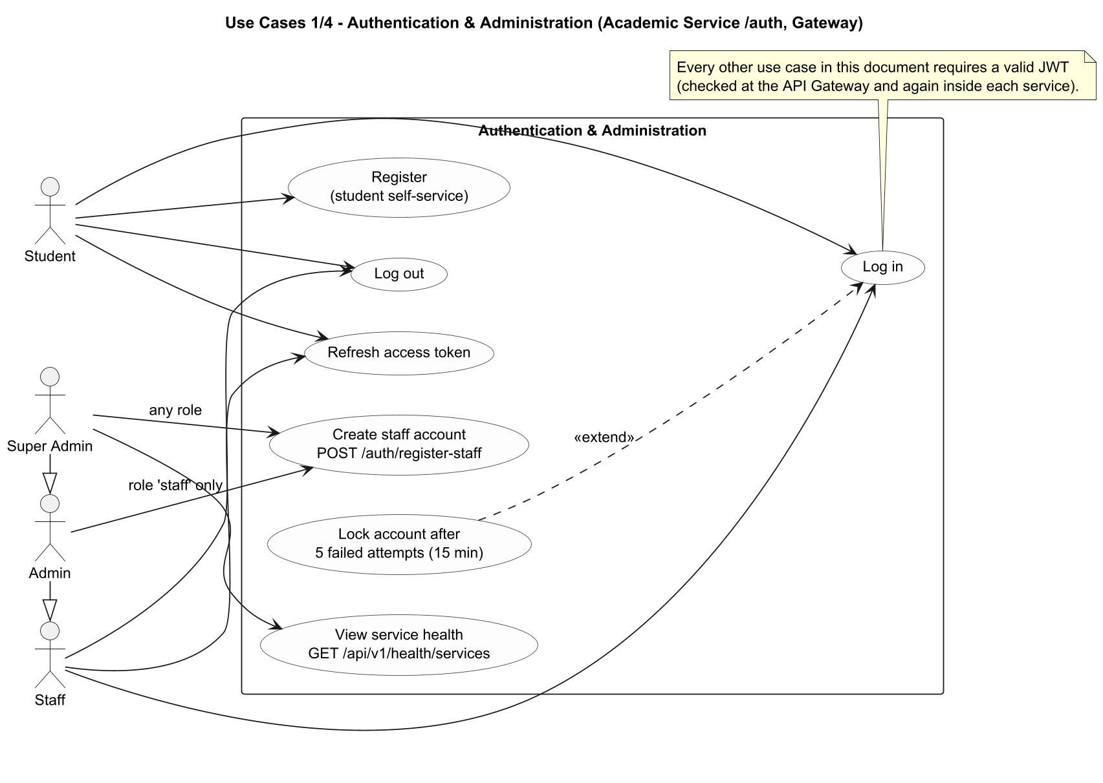
Figure 2: Use-Case Diagram 1/4 - Authentication & Administration
Actors are the four real roles (student, staff, admin, super_admin). Generalization admin > staff and super_admin > admin reflects the API role lists. "Lock account" extends "Log in" (5 failed attempts).
Implementation: authRoutes.js, authController.js, healthRoutes.js. Admin may create staff only; super_admin may create any staff-level role.

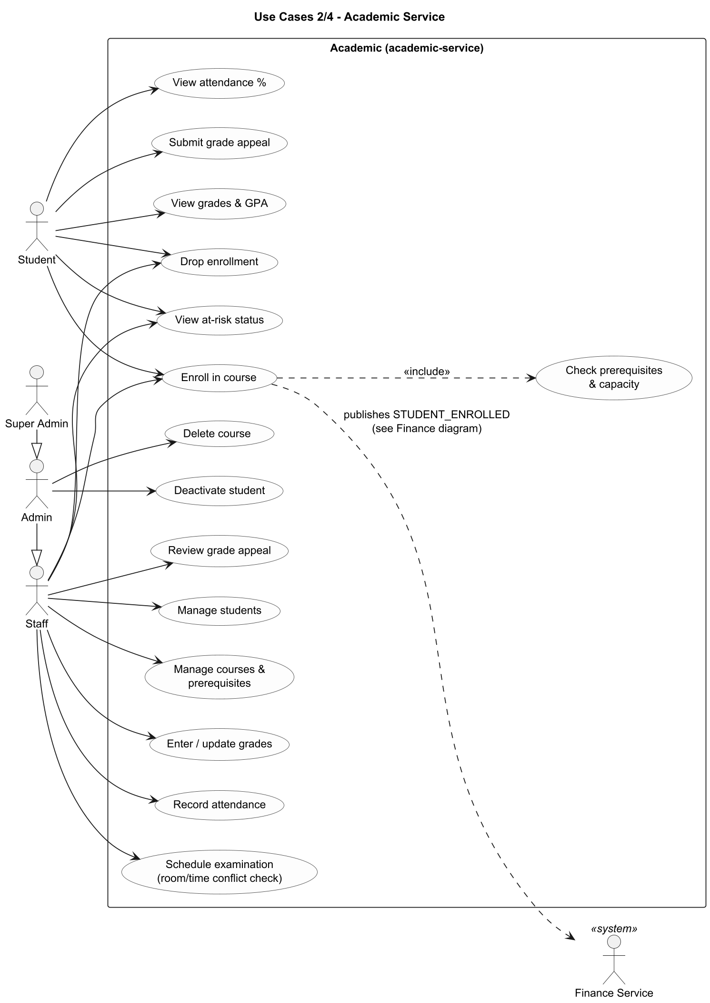
Figure 3: Use-Case Diagram 2/4 - Academic Service
Enrolling includes the prerequisite/capacity check and triggers the STUDENT_ENROLLED event consumed by the Finance Service.
Implementation: Routes under /academic (students, courses, enrollments, grades, attendance, exams, appeals). Delete course and deactivate student are admin-only.

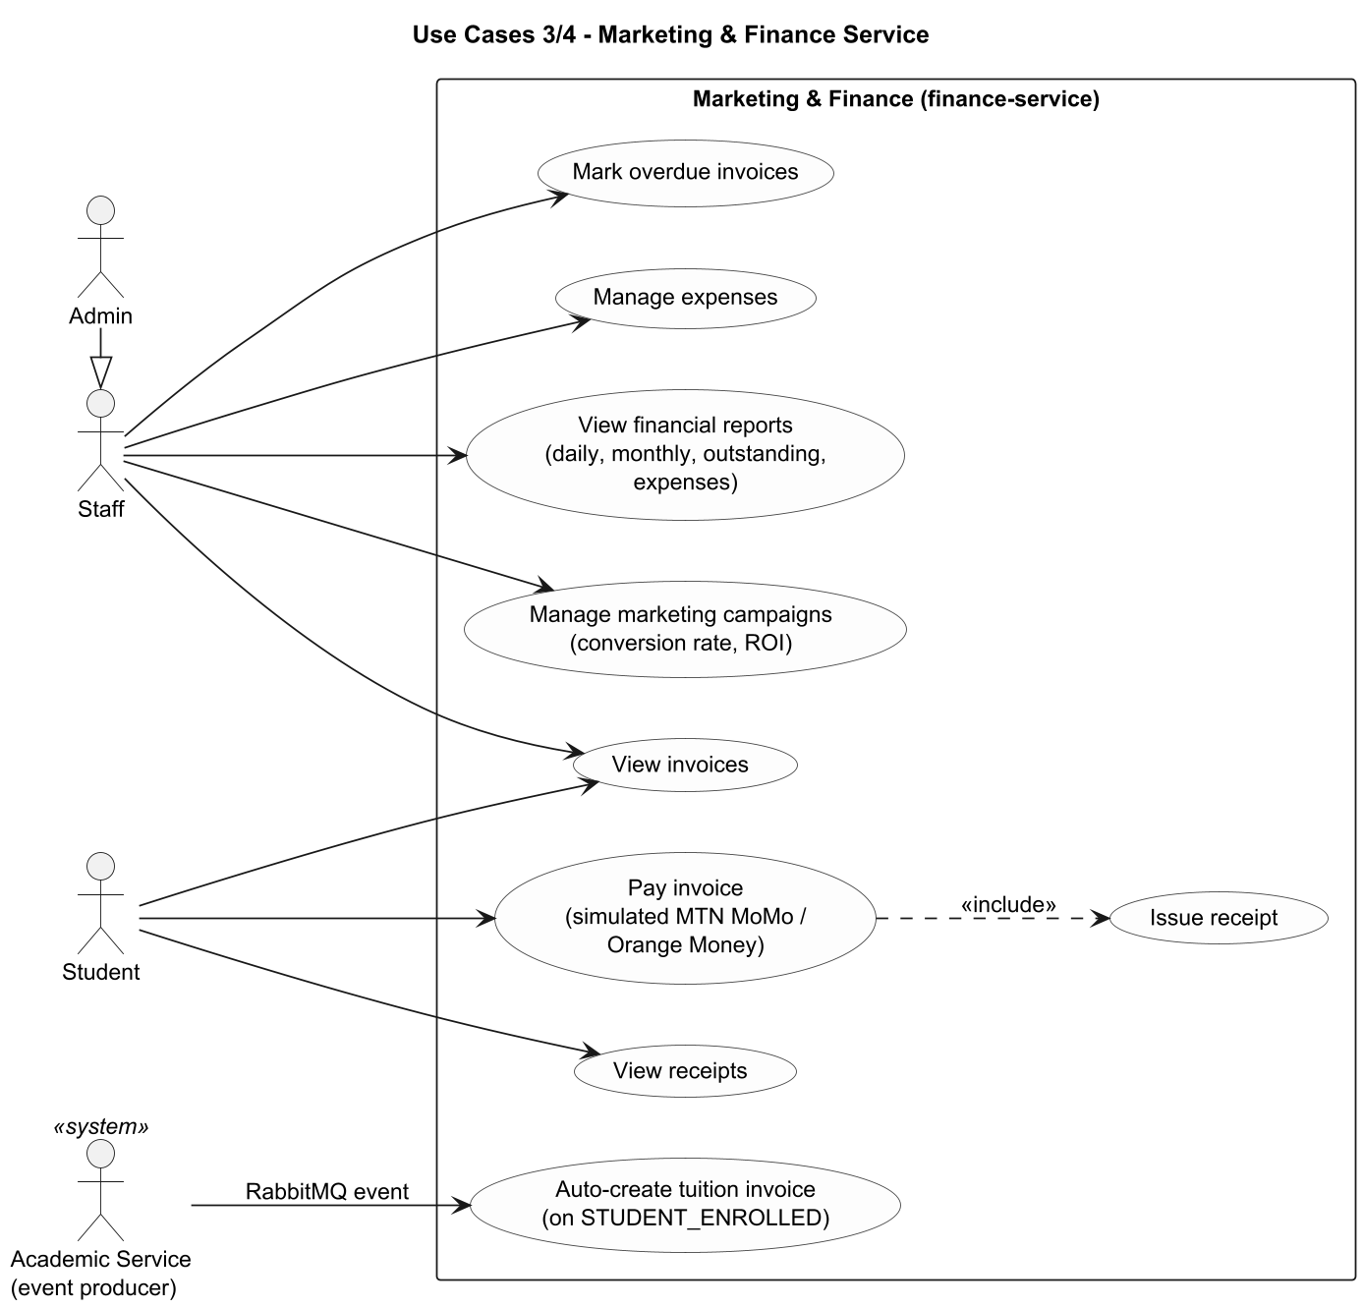
Figure 4: Use-Case Diagram 3/4 - Marketing & Finance Service
The invoice is created by the Finance Service itself from a RabbitMQ event; paying an invoice includes issuing a receipt.
Implementation: invoiceService.js, paymentController.js, expense/report/campaign controllers. Marketing = campaigns only.

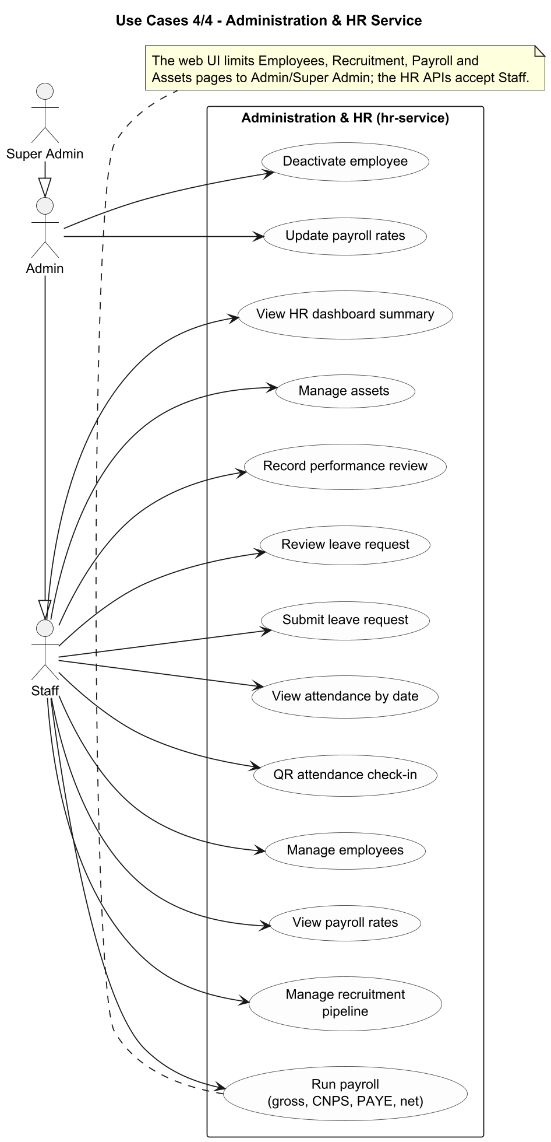
Figure 5: Use-Case Diagram 4/4 - Administration & HR Service
All HR functions are available to staff-level roles at API level; updating payroll rates and deactivating employees are admin-only.
Implementation: Routes under /hr. The web UI restricts several pages to admin/super_admin.

5.2 Class diagrams
One class diagram is given per service because each service has its own separate domain model. Classes correspond to database tables plus the main service and controller classes. There are no relationships between the three models: services share information only through the enrollment event and copied identifiers.
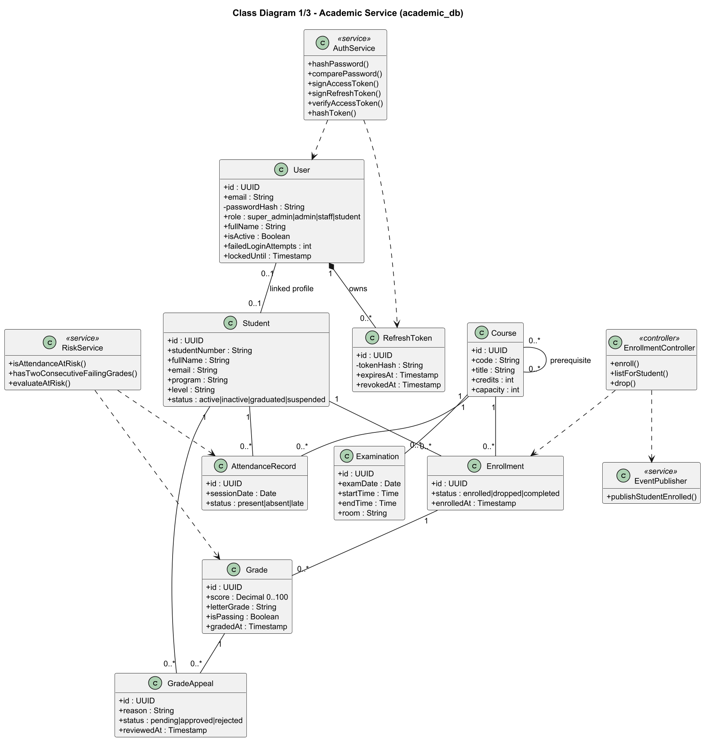
Figure 6: Class Diagram 1/3 - Academic Service
Domain classes mirror the academic_db tables; service and controller classes show the main application logic (authentication, at-risk evaluation, enrollment and event publishing).
Implementation: schema.sql (academic), authService.js, riskService.js, enrollmentController.js, eventPublisher.js. Composition User-RefreshToken reflects ON DELETE CASCADE.

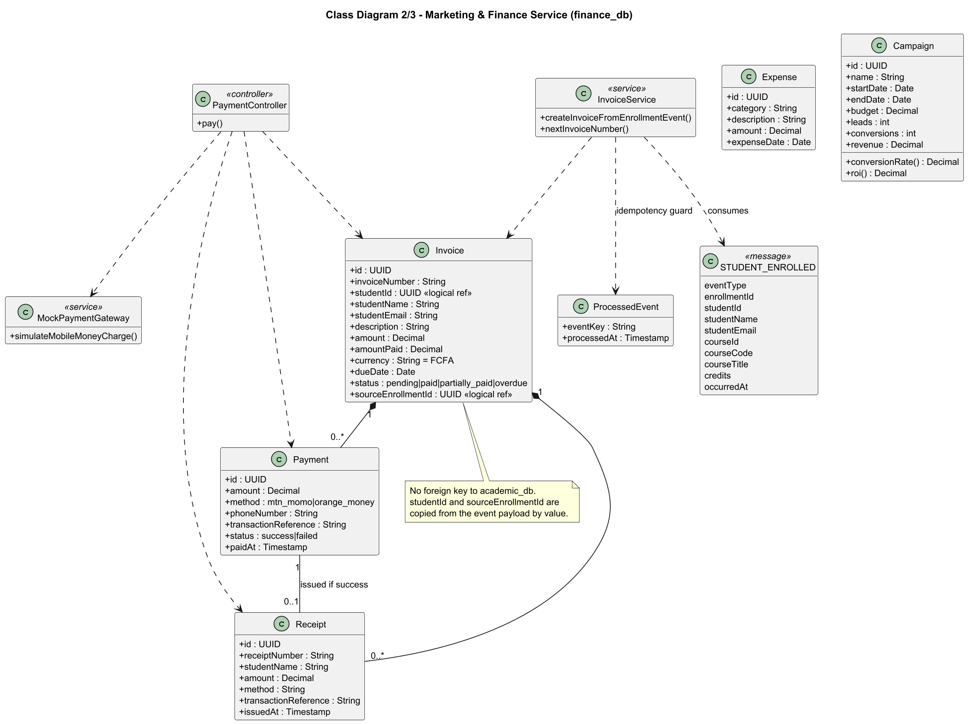
Figure 7: Class Diagram 2/3 - Marketing & Finance Service
Invoice aggregates payments and receipts. studentId and sourceEnrollmentId are logical references to academic data, copied from the event.
Implementation: schema.sql (finance), invoiceService.js, paymentController.js, mockPaymentGateway.js, campaignController.js (conversionRate and roi are derived).

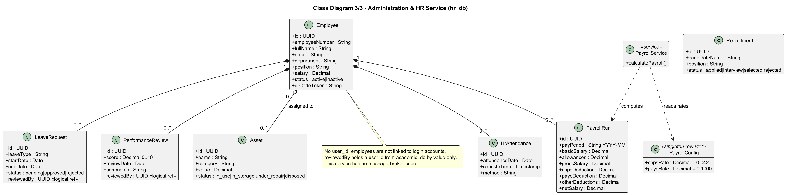
Figure 8: Class Diagram 3/3 - Administration & HR Service
Employee is the aggregate root for payroll runs, attendance, leave and performance reviews; assets may be assigned to an employee.
Implementation: schema.sql (hr), payrollService.js. PayrollConfig is a singleton row read during payroll calculation.

5.3 Entity relationship diagrams
Each microservice has its own PostgreSQL database and the diagrams are drawn from the schema.sql files. No foreign key connects two databases. The fields invoices.student_id and invoices.source_enrollment_id in finance_db hold identifiers from academic_db by value (logical references), copied from the enrollment event.
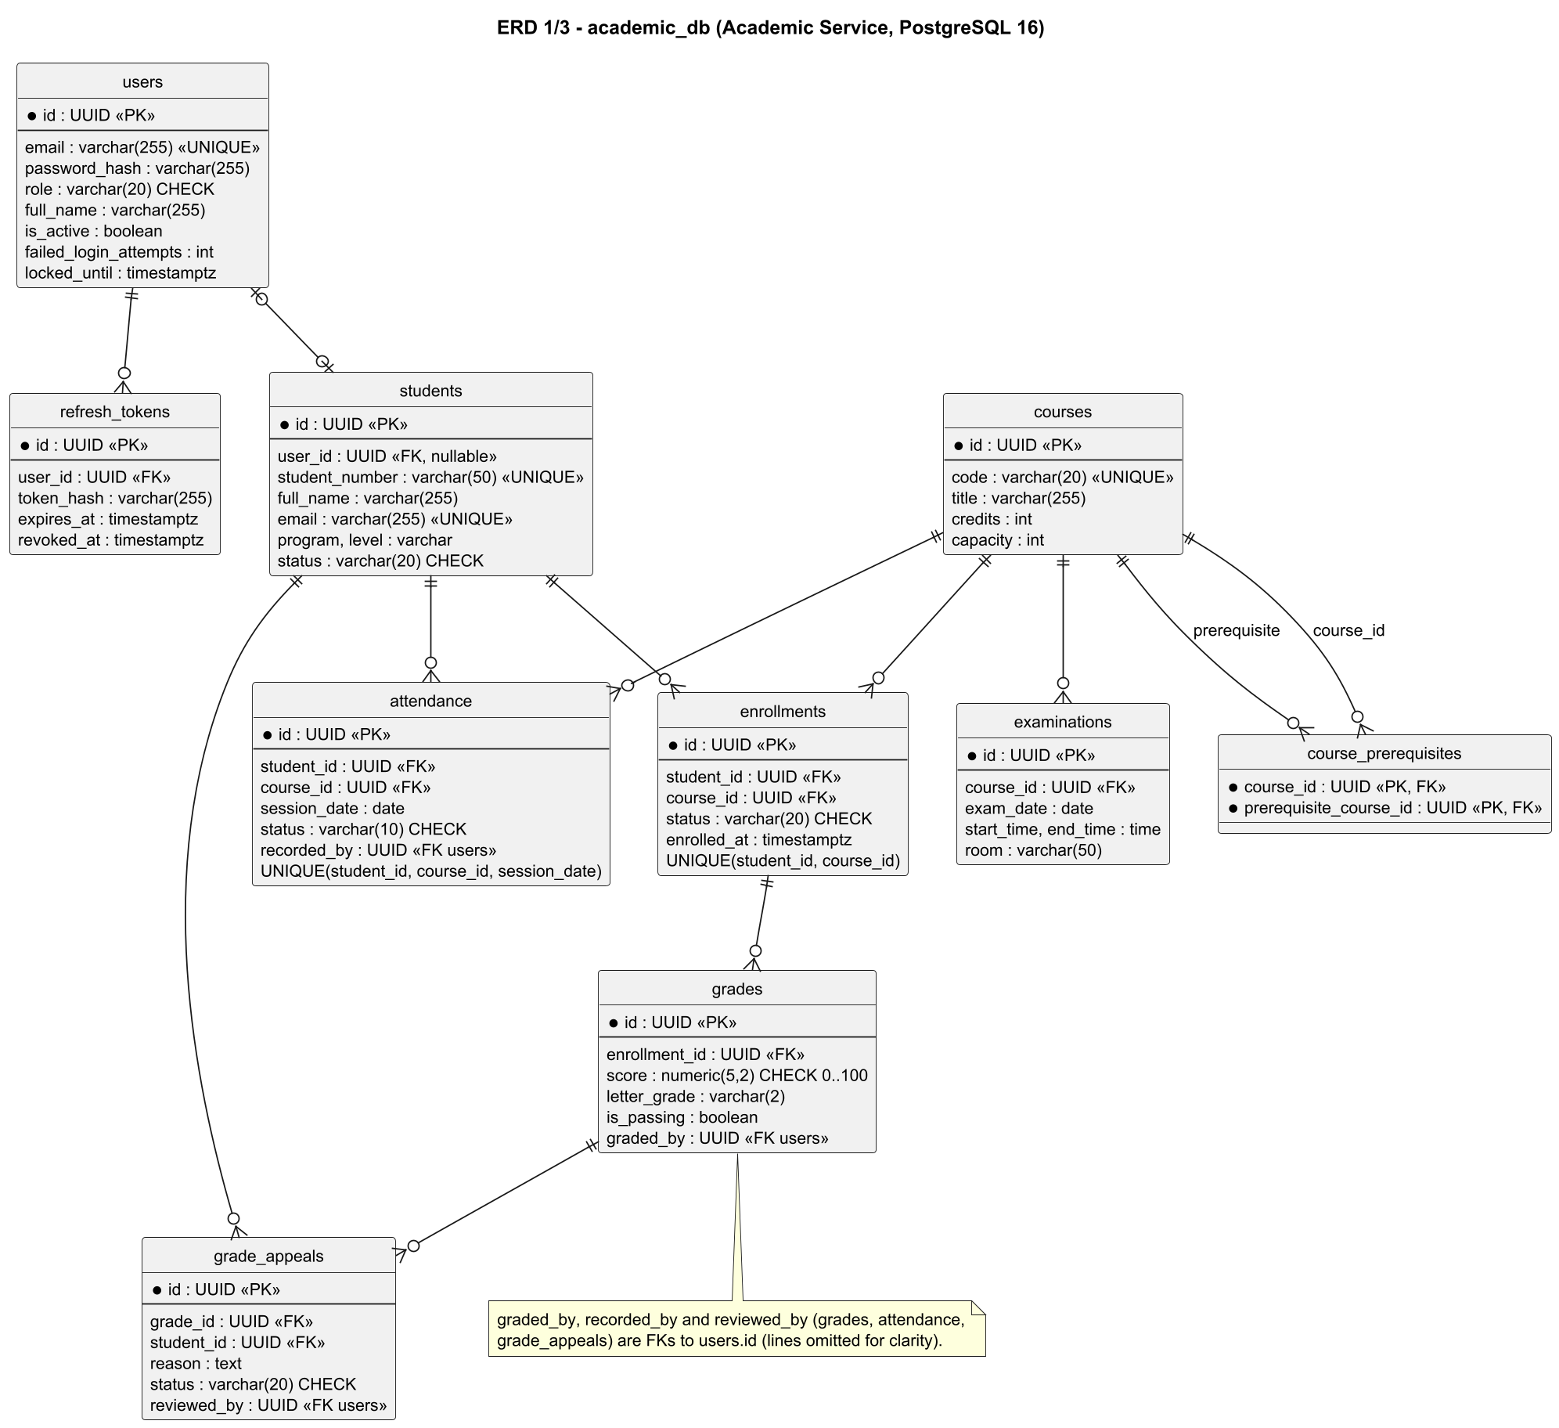
Figure 9: ERD 1/3 - academic_db (Academic Service)
Ten tables including the identity tables (users, refresh_tokens). Audit columns graded_by, recorded_by and reviewed_by reference users.
Implementation: services/academic-service/src/db/schema.sql.

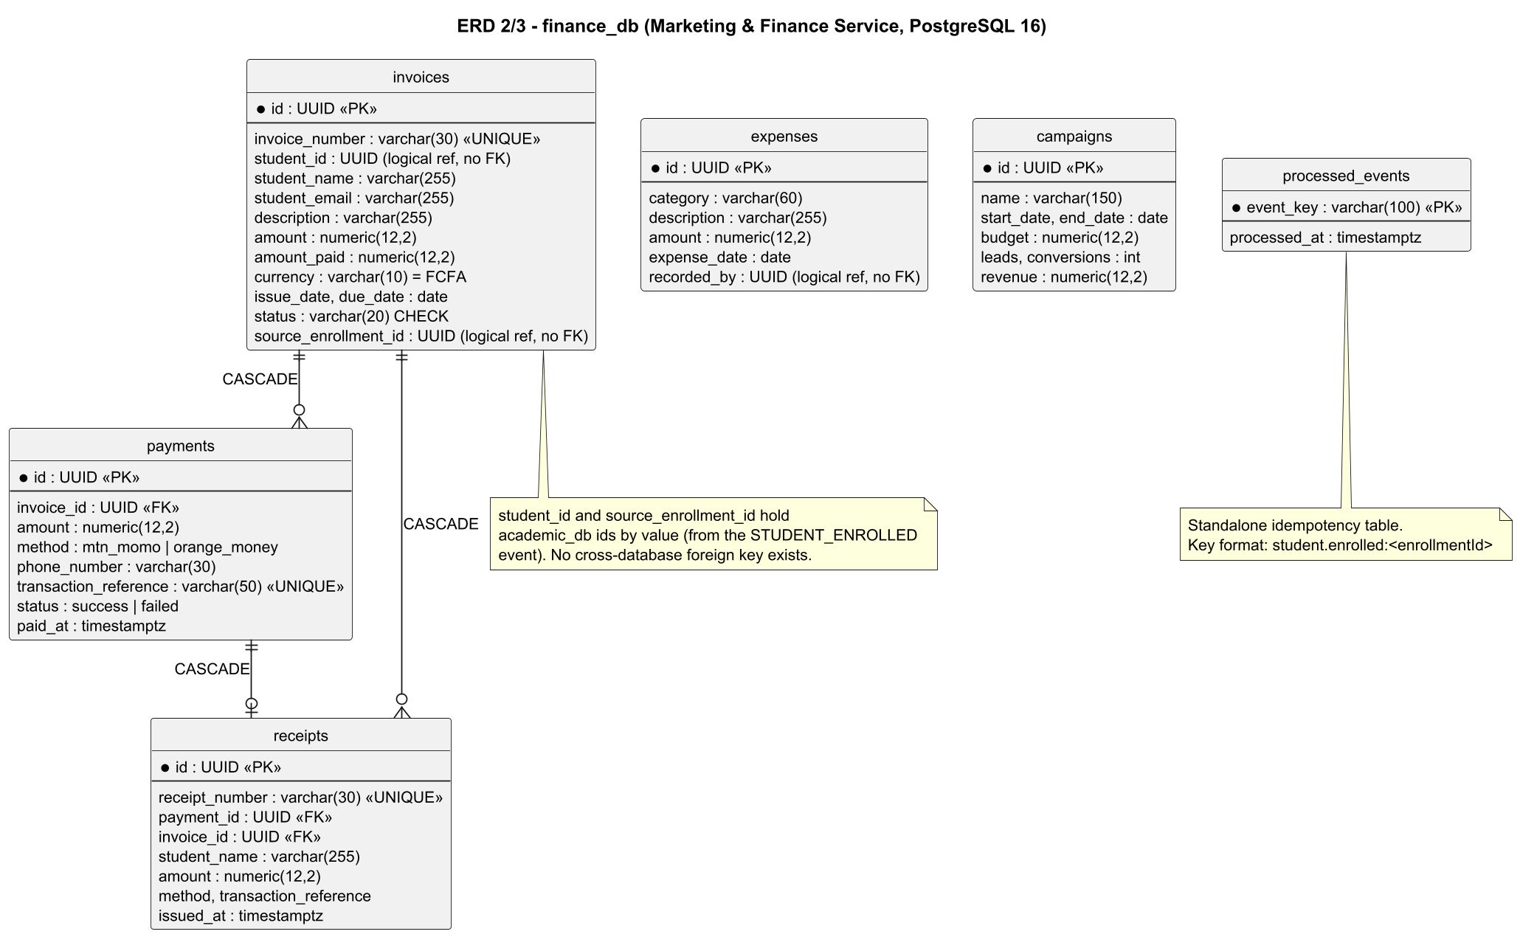
Figure 10: ERD 2/3 - finance_db (Marketing & Finance Service)
Invoices, payments, receipts, expenses, campaigns and the processed_events idempotency table. No foreign key leaves this database.
Implementation: services/finance-service/src/db/schema.sql.

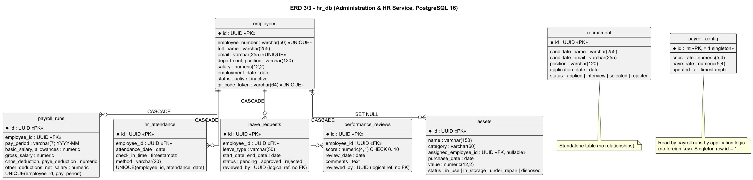
Figure 11: ERD 3/3 - hr_db (Administration & HR Service)
Employees and their payroll runs, attendance, leave and performance reviews; assets optionally assigned to an employee; payroll_config singleton; recruitment standalone.
Implementation: services/hr-service/src/db/schema.sql.

5.4 Sequence diagrams
Two workflows that really exist in the code are shown: a synchronous one (paying an invoice) and the asynchronous cross-service one (enrollment creating an invoice through RabbitMQ).

Sequence Diagram - Synchronous workflow: paying an invoice
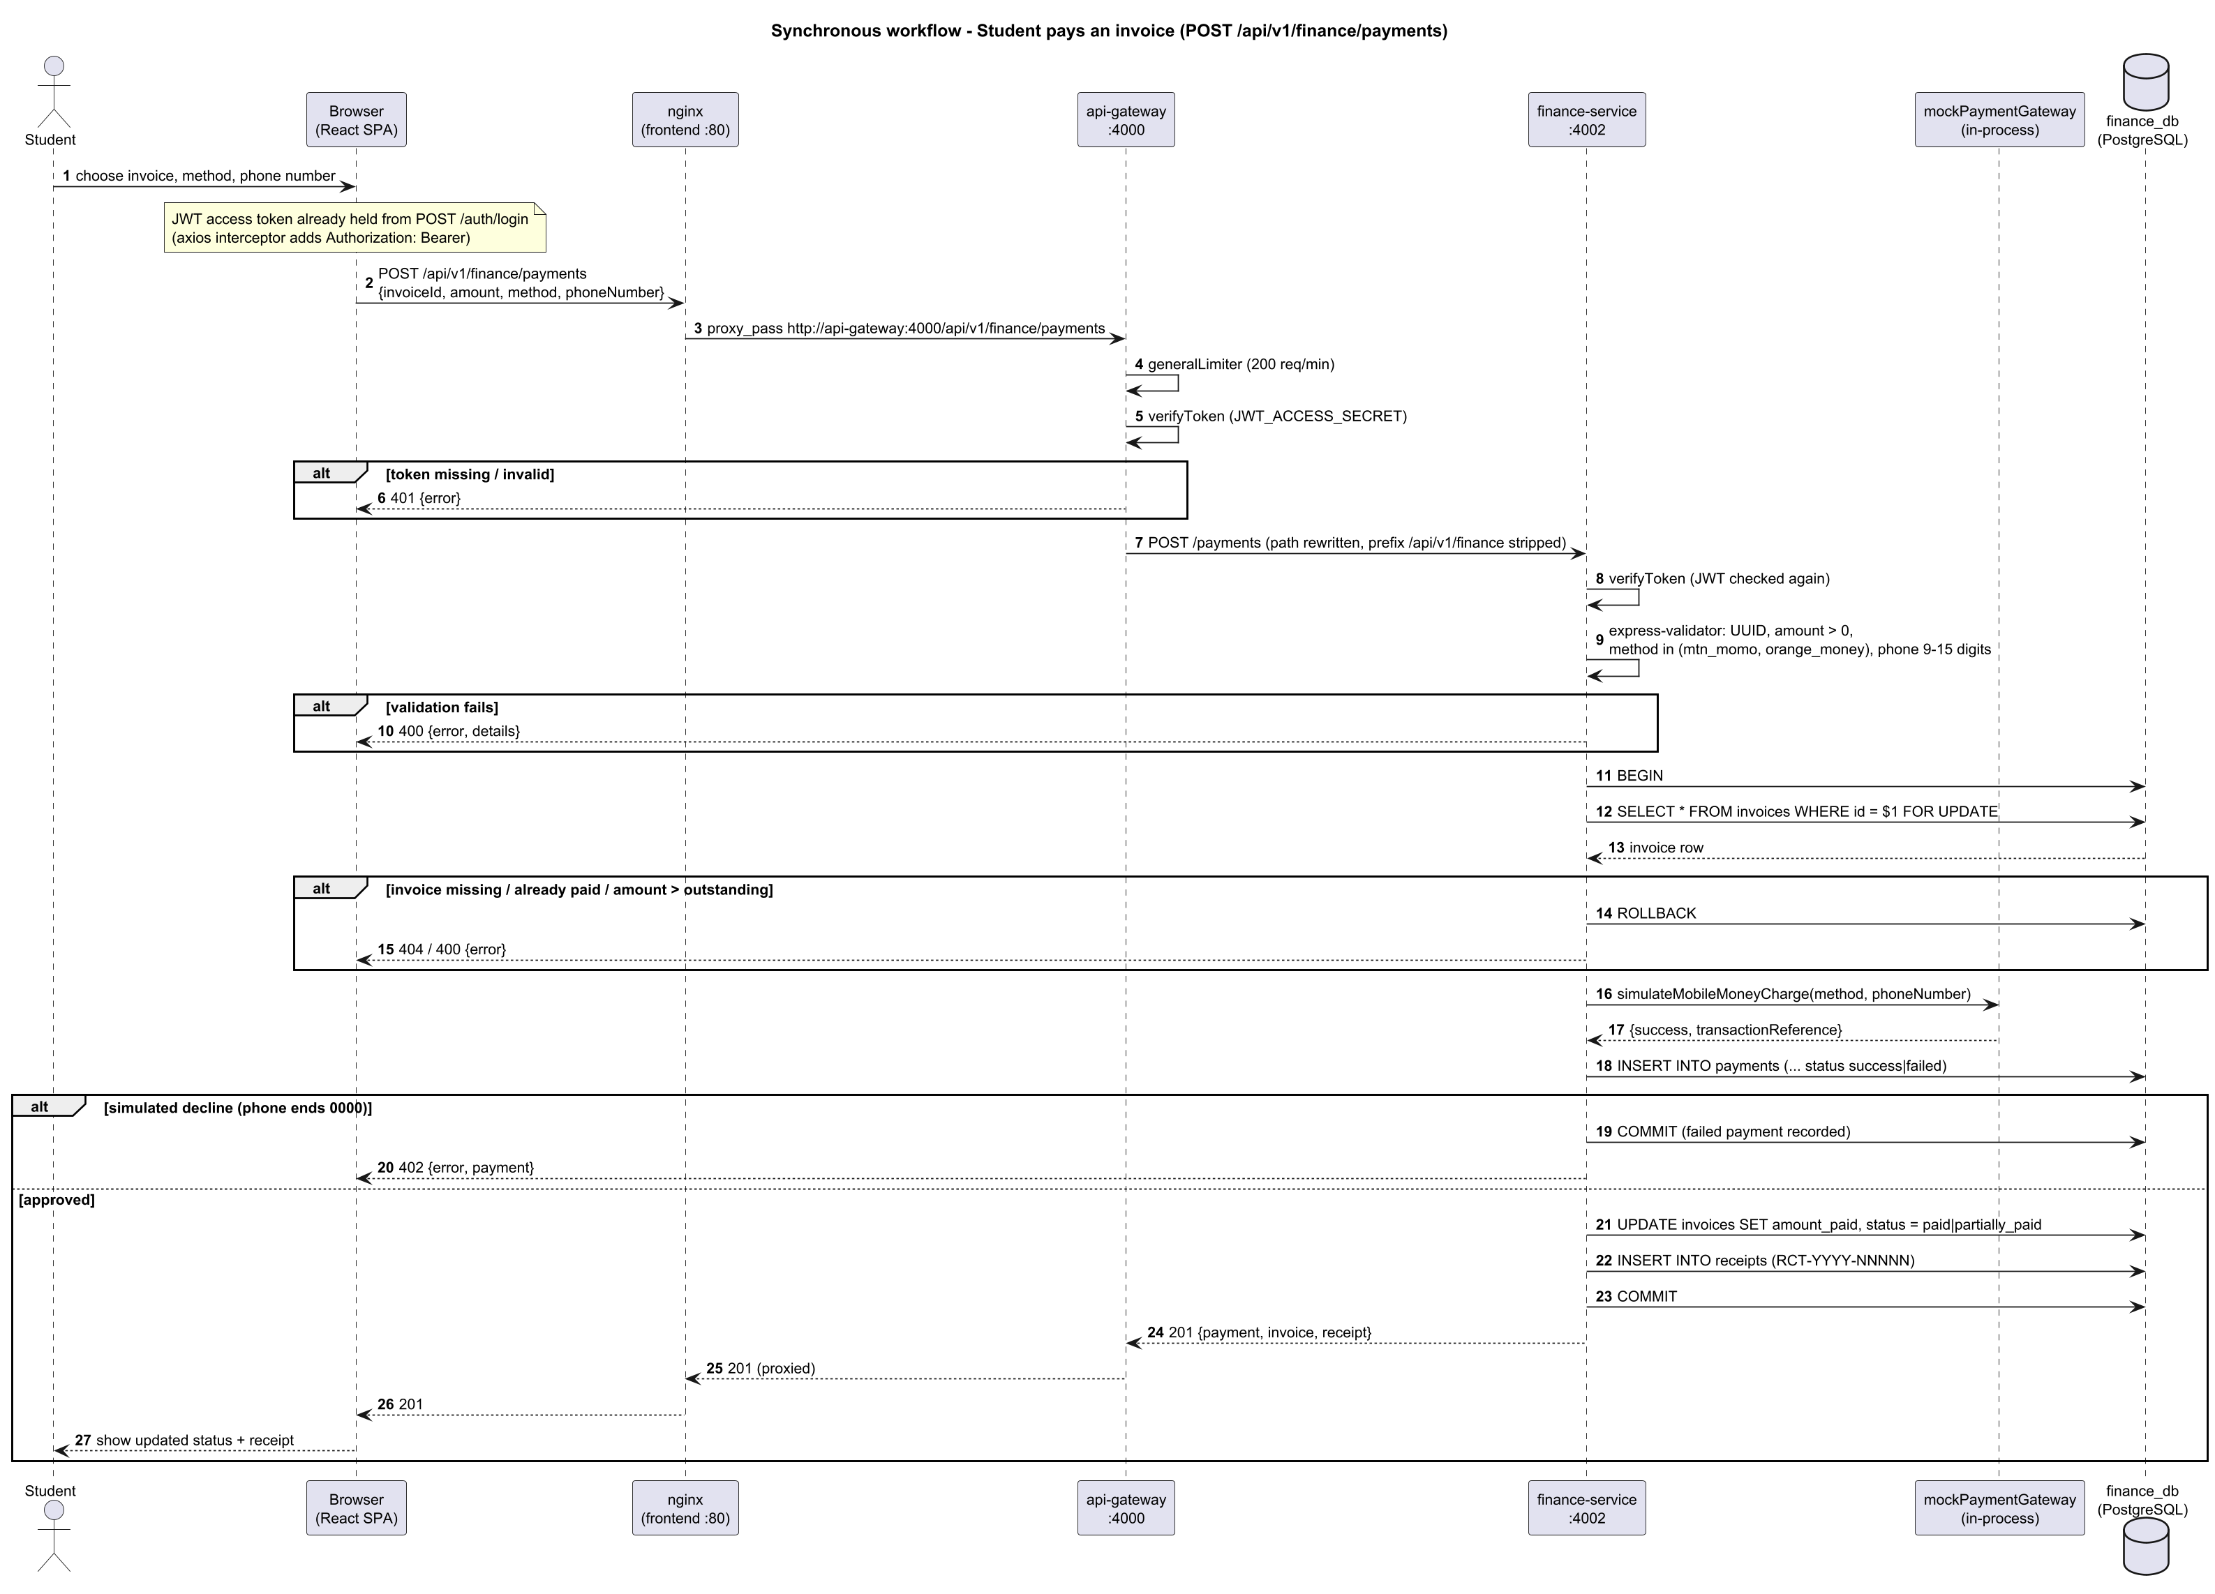
Figure 12: Sequence Diagram - Synchronous workflow: paying an invoice
Explanation: Browser to nginx to API Gateway to finance-service to finance_db and back, with JWT verification at the gateway and in the service, validation, a row-locked transaction and the simulated payment gateway.
Implementation: client.js, nginx.conf, gateway app.js/proxyRoutes.js, paymentRoutes.js, paymentController.js. Status codes 201, 402, 400, 404 are from the controller.

Sequence Diagram - Asynchronous workflow: STUDENT_ENROLLED
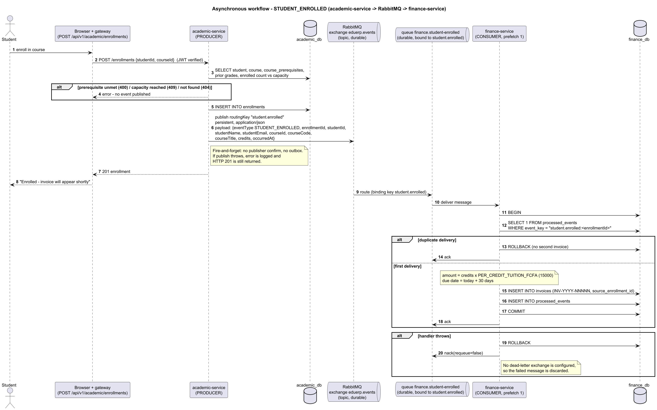
Figure 13: Sequence Diagram - Asynchronous workflow: STUDENT_ENROLLED
Explanation: academic-service publishes to exchange eduerp.events with key student.enrolled; queue finance.student-enrolled delivers it to finance-service, which creates the invoice idempotently and acks. Failures are nacked without requeue.
Implementation: enrollmentController.js, eventPublisher.js, academic and finance rabbitmq.js, finance server.js and invoiceService.js. No dead-letter queue or outbox exists.

6. Implementation and Testing

6.1 Technologies
Layer | Technology actually used
Backend | Node.js 20 (Alpine), Express 4, pg (raw SQL), amqplib, jsonwebtoken, bcryptjs, helmet, express-rate-limit, express-validator, swagger-ui-express
Gateway | Express + http-proxy-middleware, JWT edge verification, rate limiting
Frontend | React 18, Vite 5, react-router 6, axios, served by nginx 1.27
Data | PostgreSQL 16 (three instances), RabbitMQ 3.13 (topic exchange)
Delivery | Docker, Docker Compose, GitHub Actions CI, Jest + Supertest

6.2 Project structure
Folder / file | Content
api-gateway/ | Express gateway: proxy routes, JWT check, rate limiting, health aggregation
services/academic-service/ | Routes, controllers, services, middleware, database schema, migration and seed scripts, tests
services/finance-service/ | Same layout; includes the RabbitMQ consumer and the simulated payment gateway
services/hr-service/ | Same layout; includes the payroll calculation service
frontend/ | React application (pages by domain, API client, authentication context) and nginx configuration
docker-compose.yml | Starts all nine containers with their networks, ports, volumes and health checks
.github/workflows/ci.yml | Continuous integration: tests, front-end build, Docker image build
Inside each service the code is organised in layers: routes declare the endpoints and role checks, controllers implement the use cases, services hold reusable logic (for example the payroll formula and the at-risk rules) and the db folder holds the schema and migration.

6.3 Security measures
- Passwords hashed with bcrypt (12 rounds); never stored or logged in plain text.
- Short-lived access tokens (15 minutes); refresh tokens stored as SHA-256 hashes, rotated on use and revoked on logout.
- Account lockout after 5 failed logins for 15 minutes; the same message is returned for unknown e-mail and wrong password.
- Role-based authorization on every protected route, at the gateway and again in each service.
- Rate limiting: 200 requests per minute at the gateway, 20 login attempts per 15 minutes, 300 per minute in each service.
- Security headers (helmet), CORS restricted to the front-end address, input validation with express-validator, parameterized SQL queries, request size limit of 1 MB.
- Database integrity: foreign keys, unique and check constraints; payments applied in one locked transaction.

6.4 Testing
- Automated tests use Jest and Supertest, with the database and RabbitMQ replaced by mocks so they run anywhere.
- Result on 25 September 2026: 44 tests pass - API Gateway 5, Academic Service 19, Finance Service 10, HR Service 10.
- Covered: registration and password rules, password hashing and tokens, enrollment with event publishing and capacity, at-risk rules, invoice creation and idempotency, simulated payments and receipts, campaign metrics, payroll calculation, leave workflow, QR attendance and gateway authentication.
- A GitHub Actions pipeline runs all backend tests, builds the front end and builds every Docker image on each push and pull request.
- Screens and the remaining endpoints were checked manually; they have no automated tests.

6.5 How to run the system
- Install Docker Desktop, copy .env.example to .env (optional; safe development defaults are built in).
- From the project folder run: docker compose up --build
- Open the web application at http://localhost:5173
- API documentation (Swagger) is at http://localhost:4000/docs; the RabbitMQ management page is at http://localhost:15672.
- Development accounts (one per role) are created automatically: superadmin@eduerp.test, admin@eduerp.test, staff@eduerp.test, student@eduerp.test. Their password is set in services/academic-service/src/db/seed.js and is for development only.

7. Traceability and Consistency Audit

7.1 Requirement traceability matrix
The matrix links every functional requirement to the service, the API or component, the database entity, the diagrams and the test or evidence. Diagram codes: UC-n use case, CL-n class, ERD-n entity relationship, SEQ-S synchronous sequence, SEQ-A asynchronous sequence, DEP deployment. Non-functional requirements trace to the evidence column of section 4.2.
Requirement ID | Requirement | Service | API / component | Database entity | Diagram | Test / evidence
FR-001 | A visitor shall self-register; this always creates a student account and a linked student profile in one transaction. | Authentication + Gateway | POST /api/v1/auth/register | users, students, refresh_tokens | UC-1, CL-1, ERD-1 | authController.test.js (3 tests)
FR-002 | An authenticated admin or super_admin shall create staff-level accounts; only a super_admin may create admin or super_admin accounts. | Authentication + Gateway | POST /api/v1/auth/register-staff | users | UC-1, ERD-1 | No automated test (manual / UI)
FR-003 | The system shall authenticate users by email and bcrypt-verified password and return a short-lived access token and a refresh token. | Authentication + Gateway | POST /api/v1/auth/login | users, refresh_tokens | UC-1, CL-1, ERD-1 | authService.test.js (4 tests)
FR-004 | The system shall lock an account for LOCKOUT_DURATION_MINUTES (15) after MAX_FAILED_LOGIN_ATTEMPTS (5) consecutive failed logins. | Authentication + Gateway | POST /api/v1/auth/login | users | UC-1, ERD-1 | No automated test (manual / UI)
FR-005 | The system shall reject login for deactivated accounts. | Authentication + Gateway | POST /api/v1/auth/login | users | UC-1 | No automated test (manual / UI)
FR-006 | The system shall rotate refresh tokens: a valid refresh token is revoked and a new access/refresh pair issued; refresh tokens are stored only as SHA-256 hashes. | Authentication + Gateway | POST /api/v1/auth/refresh | refresh_tokens | UC-1, CL-1, ERD-1 | authService.test.js (hashToken)
FR-007 | The system shall revoke a presented refresh token on logout. | Authentication + Gateway | POST /api/v1/auth/logout | refresh_tokens | UC-1 | No automated test (manual / UI)
FR-008 | The system shall return the caller identity claims from a valid access token. | Authentication + Gateway | GET /api/v1/auth/me | none (JWT claims) | UC-1 | No automated test (manual / UI)
FR-009 | Every microservice shall independently verify the JWT (shared JWT_ACCESS_SECRET) and enforce role checks (requireRole) per route; missing/invalid token gives 401, insufficient role gives 403. | Authentication + Gateway | All protected routes | none | UC-1, SEQ-S | enrollment.test.js (no token), leaveAndAttendance.test.js (student rejected)
FR-010 | The API Gateway shall reject requests to /api/v1/academic, /finance, /hr and /health/* that lack a valid Bearer JWT before proxying. | Authentication + Gateway | /api/v1/{academic,finance,hr,health} | none | SEQ-S, DEP | gateway.test.js (5 tests)
FR-011 | The API Gateway shall route /api/v1/auth and /api/v1/academic to academic-service, /api/v1/finance to finance-service and /api/v1/hr to hr-service, stripping the prefix, and answer 502 when the upstream is unreachable and 404 for unknown routes. | Authentication + Gateway | /api/v1/* | none | SEQ-S, DEP | gateway.test.js
FR-012 | The API Gateway shall rate-limit clients to 200 requests/minute on /api/v1 and 20 requests per 15 minutes on /api/v1/auth/login. | Authentication + Gateway | /api/v1, /api/v1/auth/login | none | SEQ-S | No automated test (manual / UI)
FR-013 | The API Gateway shall aggregate the /health endpoint of each service (3 s timeout each) for authenticated users. | Authentication + Gateway | GET /api/v1/health/services | none | UC-1, DEP | No automated test (manual / UI)
FR-014 | Staff shall list students with search (name, number, email), status filter and pagination. | Academic Service | GET /academic/students | students | UC-2, CL-1, ERD-1 | No automated test (manual / UI)
FR-015 | A student shall retrieve their own linked student profile. | Academic Service | GET /academic/students/me | students | UC-2, ERD-1 | No automated test (manual / UI)
FR-016 | Staff and students shall retrieve a student by id (no ownership check is implemented for the student role). | Academic Service | GET /academic/students/:id | students | UC-2 | No automated test (manual / UI)
FR-017 | Staff shall create students (unique student number and email) and update student data. | Academic Service | POST /academic/students; PUT /academic/students/:id | students | UC-2, CL-1, ERD-1 | No automated test (manual / UI)
FR-018 | Admin and super_admin shall deactivate a student (status set to inactive; row is kept). | Academic Service | DELETE /academic/students/:id | students | UC-2 | No automated test (manual / UI)
FR-019 | The system shall report a student as at-risk when overall attendance is below 75% or there are two consecutive failing grades. | Academic Service | GET /academic/students/:id/risk-status | attendance, grades | UC-2, CL-1 | riskService.test.js (9 tests)
FR-020 | Any authenticated user shall list and view courses (with prerequisites). | Academic Service | GET /academic/courses[/:id] | courses, course_prerequisites | UC-2, ERD-1 | No automated test (manual / UI)
FR-021 | Staff shall create (unique code) and update courses; admin and super_admin shall delete courses (blocked with 409 if enrollments exist). | Academic Service | POST/PUT/DELETE /academic/courses | courses | UC-2, CL-1, ERD-1 | No automated test (manual / UI)
FR-022 | Staff shall assign prerequisite courses; a course cannot be its own prerequisite. | Academic Service | POST /academic/courses/:id/prerequisites | course_prerequisites | UC-2, ERD-1 | No automated test (manual / UI)
FR-023 | The system shall enroll a student in a course only if the student and course exist, every prerequisite has a passing grade, the course is below capacity and the student is not already enrolled. | Academic Service | POST /academic/enrollments | enrollments, course_prerequisites, grades | UC-2, CL-1, SEQ-A, ERD-1 | enrollment.test.js (capacity, no token)
FR-024 | The system shall list a student's enrollments and allow an enrollment to be dropped (status = dropped). | Academic Service | GET /academic/enrollments/student/:id; PATCH /academic/enrollments/:id/drop | enrollments | UC-2, ERD-1 | No automated test (manual / UI)
FR-025 | Staff shall enter and update grades (0-100); the system derives letter grade (A>=90, B>=80, C>=70, D>=60, E>=50, F) and is_passing (score >= 50). | Academic Service | POST /academic/grades; PUT /academic/grades/:id | grades | UC-2, CL-1, ERD-1 | No automated test (manual / UI)
FR-026 | The system shall return a student's grades with a credit-weighted GPA (A=4, B=3, C=2, D=1, E=0.5, F=0). | Academic Service | GET /academic/grades/student/:id | grades, enrollments, courses | UC-2 | No automated test (manual / UI)
FR-027 | Staff shall record attendance (present/absent/late) per student, course and date; a repeat for the same key updates the status. | Academic Service | POST /academic/attendance | attendance | UC-2, ERD-1 | No automated test (manual / UI)
FR-028 | The system shall return a student's attendance records and attendance percentage (present + late). | Academic Service | GET /academic/attendance/student/:id | attendance | UC-2 | No automated test (manual / UI)
FR-029 | Staff shall schedule examinations; the system shall reject an exam whose room and date overlap an existing exam time window. | Academic Service | POST /academic/exams | examinations | UC-2, ERD-1 | No automated test (manual / UI)
FR-030 | Any authenticated user shall list scheduled examinations. | Academic Service | GET /academic/exams | examinations, courses | UC-2 | No automated test (manual / UI)
FR-031 | A student shall submit a grade appeal only for their own grade; staff may submit for any grade. | Academic Service | POST /academic/appeals | grade_appeals | UC-2, CL-1, ERD-1 | No automated test (manual / UI)
FR-032 | Staff shall list appeals and approve or reject a pending appeal once. | Academic Service | GET /academic/appeals; PATCH /academic/appeals/:id/review | grade_appeals | UC-2, ERD-1 | No automated test (manual / UI)
FR-033 | The system shall automatically create a tuition invoice (INV-YYYY-NNNNN, credits x PER_CREDIT_TUITION_FCFA, default 15000 FCFA, due in 30 days) when a STUDENT_ENROLLED event is consumed. | Marketing & Finance Service | AMQP queue finance.student-enrolled | invoices, processed_events | UC-3, CL-2, SEQ-A, ERD-2, DEP | invoiceService.test.js (3 tests)
FR-034 | Staff shall list invoices with status/student filters and pagination and mark overdue invoices (pending or partially_paid past due date). | Marketing & Finance Service | GET /finance/invoices; POST /finance/invoices/sweep-overdue | invoices | UC-3, ERD-2 | No automated test (manual / UI)
FR-035 | Any authenticated user shall retrieve an invoice by id and the invoices of a student (no ownership check is implemented). | Marketing & Finance Service | GET /finance/invoices/:id; GET /finance/invoices/student/:studentId | invoices | UC-3, ERD-2 | No automated test (manual / UI)
FR-036 | The system shall process a simulated MTN MoMo / Orange Money payment against an invoice, rejecting amounts above the outstanding balance or payments on paid invoices, inside a transaction that locks the invoice row. | Marketing & Finance Service | POST /finance/payments | payments, invoices, receipts | UC-3, CL-2, SEQ-S, ERD-2 | paymentController.test.js (3 tests)
FR-037 | The simulated gateway shall decline a phone number ending in 0000; the failed payment is recorded and the API answers 402. | Marketing & Finance Service | POST /finance/payments | payments | CL-2, SEQ-S | mockPaymentGateway.test.js (2 tests)
FR-038 | The system shall issue a numbered receipt (RCT-YYYY-NNNNN) for every successful payment and let users retrieve receipts by id or invoice. | Marketing & Finance Service | GET /finance/receipts/:id; GET /finance/receipts/invoice/:invoiceId | receipts | UC-3, CL-2, ERD-2 | paymentController.test.js
FR-039 | Staff shall create, list, update and delete expenses. | Marketing & Finance Service | GET/POST/PUT/DELETE /finance/expenses | expenses | UC-3, ERD-2 | No automated test (manual / UI)
FR-040 | Staff shall obtain daily and monthly income/expense summaries, an outstanding-fees report and an expense report (FCFA). | Marketing & Finance Service | GET /finance/reports/{daily-summary,monthly-summary,outstanding-fees,expenses} | payments, invoices, expenses | UC-3, ERD-2 | No automated test (manual / UI)
FR-041 | Staff shall create and list marketing campaigns and update leads, conversions, revenue and budget; the API derives conversionRate and ROI. | Marketing & Finance Service | GET/POST /finance/campaigns; PUT /finance/campaigns/:id | campaigns | UC-3, CL-2, ERD-2 | campaignController.test.js (2 tests)
FR-042 | Staff shall list, view, create and update employees (unique number and email; a unique QR token is generated). | Administration & HR Service | GET/POST /hr/employees; GET/PUT /hr/employees/:id | employees | UC-4, CL-3, ERD-3 | No automated test (manual / UI)
FR-043 | Admin and super_admin shall deactivate an employee (status inactive). | Administration & HR Service | DELETE /hr/employees/:id | employees | UC-4 | No automated test (manual / UI)
FR-044 | Staff shall list candidates, add candidates and move them through applied, interview, selected, rejected. | Administration & HR Service | GET/POST /hr/recruitment; PATCH /hr/recruitment/:id/status | recruitment | UC-4, ERD-3 | No automated test (manual / UI)
FR-045 | Staff shall read the payroll rates; only admin and super_admin shall update the CNPS and PAYE rates (configurable placeholders). | Administration & HR Service | GET/PUT /hr/payroll/config | payroll_config | UC-4, CL-3, ERD-3 | No automated test (manual / UI)
FR-046 | Staff shall run payroll for an employee and period (YYYY-MM): gross = basic + allowances; CNPS and PAYE = gross x configured rates; net = gross - deductions; a rerun for the same period updates the record. | Administration & HR Service | POST /hr/payroll/run | payroll_runs, payroll_config, employees | UC-4, CL-3, ERD-3 | payrollService.test.js (3 tests)
FR-047 | The system shall list an employee's payroll history (any authenticated user; no ownership check is implemented). | Administration & HR Service | GET /hr/payroll/employee/:employeeId | payroll_runs | UC-4 | No automated test (manual / UI)
FR-048 | The system shall record an employee's daily attendance from a QR token (one check-in per employee per day; unknown token or inactive employee is rejected). | Administration & HR Service | POST /hr/attendance/check-in | hr_attendance, employees | UC-4, CL-3, ERD-3 | leaveAndAttendance.test.js (3 tests)
FR-049 | Staff shall list HR attendance for a date. | Administration & HR Service | GET /hr/attendance | hr_attendance | UC-4 | No automated test (manual / UI)
FR-050 | The system shall accept leave requests (end date not before start date), list an employee's requests, list pending requests and let staff approve or reject a pending request once. | Administration & HR Service | POST /hr/leave; GET /hr/leave/pending; GET /hr/leave/employee/:id; PATCH /hr/leave/:id | leave_requests | UC-4, CL-3, ERD-3 | leaveAndAttendance.test.js (4 tests)
FR-051 | Staff shall record performance reviews (score 0-10); any authenticated user can list an employee's reviews. Backend only: the web UI has no performance page. | Administration & HR Service | POST /hr/performance; GET /hr/performance/employee/:id | performance_reviews | UC-4, ERD-3 | No automated test (manual / UI)
FR-052 | Staff shall list, create and update assets and assign them to employees. | Administration & HR Service | GET/POST /hr/assets; PUT /hr/assets/:id | assets | UC-4, ERD-3 | No automated test (manual / UI)
FR-053 | Staff shall obtain an HR dashboard summary (active employees, check-ins today, pending leave, average performance, asset count). | Administration & HR Service | GET /hr/dashboard/summary | employees, hr_attendance, leave_requests, performance_reviews, assets | UC-4 | No automated test (manual / UI)
FR-054 | After a successful enrollment insert, academic-service shall publish STUDENT_ENROLLED to the durable topic exchange eduerp.events with routing key student.enrolled (persistent, JSON). | Inter-service / Front-end | AMQP publish student.enrolled | enrollments | SEQ-A, CL-1, DEP | enrollment.test.js (publishes event)
FR-055 | finance-service shall consume queue finance.student-enrolled (durable, bound to student.enrolled, prefetch 1), ack after success, and nack without requeue on failure. | Inter-service / Front-end | AMQP consume | invoices | SEQ-A, DEP | invoiceService.test.js
FR-056 | The consumer shall be idempotent: a redelivered event for the same enrollmentId shall not create a second invoice. | Inter-service / Front-end | AMQP consume | processed_events | SEQ-A, CL-2, ERD-2 | invoiceService.test.js (idempotent)
FR-057 | finance-service shall retry the RabbitMQ connection at start-up up to 10 times at 5 s intervals. | Inter-service / Front-end | AMQP | none | DEP | No automated test (manual / UI)
FR-058 | Services shall share identity by trust in JWTs signed by academic-service; finance and hr hold no credentials and do not call academic-service. | Inter-service / Front-end | n/a | none | DEP | leaveAndAttendance.test.js
FR-059 | The React web application shall call only the API Gateway path /api/v1 (through nginx), attach the Bearer token, refresh it once on a 401, and log the user out if refresh fails. | Inter-service / Front-end | /api/v1/* | none | SEQ-S, DEP | No automated test (manual / UI)
FR-060 | The web application shall show role-specific navigation and dashboards (super_admin, admin, staff, student) and guard pages with ProtectedRoute role lists (some pages are stricter than the APIs). | Inter-service / Front-end | n/a | none | UC-1..UC-4 | No automated test (manual / UI)

7.2 Implementation consistency audit
The documentation was compared with the source code, database schemas, API routes, message-broker code, UML diagrams and docker-compose.yml. Test run of 25 September 2026: 44 of 44 automated tests passed.
Item | Documentation | Implementation | Consistent? | Correction required
Service list | gateway + academic, finance (marketing & finance), hr (administration & HR); no separate auth or marketing service | docker-compose.yml: api-gateway, academic-service, finance-service, hr-service, frontend, rabbitmq, 3 x postgres | Yes | None
Container ports | Gateway 4000; academic 4001; finance 4002; hr 4003; frontend 5173->80; RabbitMQ 5672/15672; PostgreSQL 5433/5434/5435->5432 | Same in docker-compose.yml | Yes | None
Database per service | academic_db, finance_db, hr_db | Three postgres:16-alpine containers with those DB names | Yes | None
Gateway routes | /api/v1/auth and /academic -> 4001; /finance -> 4002; /hr -> 4003 | proxyRoutes.js and app.js | Yes | None
Front-end to gateway | Browser -> nginx -> gateway (/api/v1/) | nginx.conf proxy_pass; client.js baseURL /api/v1 | Yes | None
Synchronous workflow endpoint | POST /api/v1/finance/payments -> POST /payments; body invoiceId, amount, method, phoneNumber; 201/402/400/404 | paymentRoutes.js, paymentController.js | Yes | Validation error body corrected to {error, details} in the diagram
Event name | STUDENT_ENROLLED (eventType) with routing key student.enrolled | eventPublisher.js | Yes | None
Exchange / queue | Exchange eduerp.events (topic, durable); queue finance.student-enrolled (durable) | rabbitmq.js in both services | Yes | None
Event payload | eventType, enrollmentId, studentId, studentName, studentEmail, courseId, courseCode, courseTitle, credits, occurredAt | eventPublisher.publishStudentEnrolled | Yes | None
Producer / consumer | academic-service produces; finance-service consumes; hr-service has no broker code | No amqplib use in hr-service; compose gives hr no RABBITMQ_URL | Yes | None
Acknowledgement / retry / DLQ | Manual ack; nack requeue=false; no dead-letter; 10 x 5 s start-up connect retry | rabbitmq.js, server.js (finance) | Yes | Documented as Planned / Not implemented (DLQ, outbox, confirms)
Queue declaration | Queue is declared and bound only by finance-service | academic-service asserts only the exchange | Yes | Documented: events published before finance-service first starts have no queue and are dropped
Idempotency | processed_events guard, key student.enrolled:<enrollmentId> | invoiceService.js, finance schema.sql | Yes | None
ERD tables | 10 academic, 6 finance, 8 hr tables | schema.sql in each service | Yes | None
Cross-database keys | None; invoices.student_id and source_enrollment_id, expenses.recorded_by and hr reviewed_by are logical references by value | No REFERENCES across databases | Yes | None
Payment-to-receipt cardinality | Payment 1 - 0..1 Receipt | Schema does not enforce; controller creates one receipt per successful payment | Yes | Stated as application-level rule
User roles | student, staff, admin, super_admin | users.role CHECK constraint | Yes | None
Role generalization (use cases) | super_admin > admin > staff for API access | Every role list is [staff, admin, super_admin] or narrower subsets of it | Yes | None
Staff-account creation rule | Admin may create staff only; only super_admin may create admin/super_admin | authController.registerStaff | Yes | None
Web UI vs API permissions | UC and FR tables follow the API | App.jsx limits Employees, Recruitment, Payroll, Assets, Expenses, Reports, Campaigns pages to admin/super_admin, while the APIs also allow staff | No (implementation) | Documented in FR/UC notes; align UI or API if stricter access is wanted
Ownership checks | FRs state that no ownership check exists | Student-role calls to /students/:id, /grades|attendance|enrollments|invoices/student/:id, /receipts, POST /payments, POST /enrollments are not tied to the caller; GET /hr/payroll|leave|performance/employee/:id are open to any authenticated user | Yes (doc) / gap in code | Listed under Planned / Not implemented; fix in code if required
Refresh-token lifetime | Refresh JWT expires per JWT_REFRESH_EXPIRES_IN (7d default) | refresh_tokens.expires_at is always now + 7 days regardless of the variable | Partly | Minor code inconsistency, noted
Transport security | HTTP only (no TLS configured) | docs/architecture.md (earlier draft) labels the browser link "HTTPS in prod" | No (earlier draft) | Earlier draft corrected here: this suite states HTTP only
Marketing scope | Campaigns only, hosted inside finance-service | campaignController, campaigns table | Yes | None
Campaign metrics | conversionRate and roi derived on read | campaignController.withMetrics (not stored) | Yes | Shown as derived operations in the class diagram
Number sequences | Invoice and receipt numbers unique | Numbers built from COUNT(*)+1 with UNIQUE constraint; concurrent creation could collide | Yes (doc) | Observation recorded; not a documentation error
Simulated payment gateway | In-process module, not an external system | mockPaymentGateway.js | Yes | None
External systems | None | No outbound integrations in code or compose | Yes | None
Kubernetes | Not used | Only docker-compose.yml exists | Yes | None
CI | GitHub Actions is a build pipeline, not a runtime node | .github/workflows/ci.yml | Yes | Excluded from deployment diagram
Automated tests | 44 tests pass | npx jest: gateway 5, academic 19, finance 10, hr 10 | Yes | None
Default JWT secrets | Secrets come from environment | Code falls back to dev-access-secret / dev-refresh-secret when unset; compose supplies placeholder defaults | Yes | Documented as constraint (replace secrets in real deployments)

Audit conclusions
- No invented services, endpoints, tables, events, queues or actors were found; every name was matched against the code.
- Corrected during the audit: the validation-error body in the synchronous sequence diagram, the container count and the "HTTPS in prod" wording of an earlier draft (docs/architecture.md).
- Gaps in the implementation itself (not documentation errors): missing ownership checks, web interface stricter than the API, fixed 7-day refresh expiry, no dead-letter queue and no outbox.

8. Limitations and Future Work

8.1 Limitations (Planned / Not implemented)
- Payments are simulated: a phone number ending in 0000 is declined, every other valid number succeeds. No real telecom API is called.
- Tuition is a flat rate per credit; a real fee schedule per programme is not modelled.
- Payroll rates (CNPS 4.20%, PAYE 10.00%) are configurable placeholders, not verified legal rates.
- Enrollment events are sent fire-and-forget: if RabbitMQ is down at that moment, the enrollment succeeds but the invoice is not created later (no outbox).
- A message that fails in the Finance Service is discarded; there is no dead-letter queue. The queue is created by the Finance Service, so events sent before it first starts are lost.
- Ownership is not checked on several student-facing endpoints, and HR payroll, leave and performance lookups are open to any logged-in user.
- The web interface restricts some pages (for example Employees, Payroll, Expenses) to admin roles, while the APIs also accept staff.
- Traffic is HTTP only; there is no TLS, replication or load testing.
- The refresh-token expiry stored in the database is always 7 days, whatever the configuration says.

8.2 Future work
- Connect a real mobile-money provider and add payment webhooks.
- Add a transactional outbox and a dead-letter queue so no event can be lost.
- Enforce ownership rules so students see only their own data and HR employee data is limited to HR roles.
- Add PDF transcripts, receipts and reports, and e-mail or SMS notifications.
- Link employees to login accounts and add a screen for performance reviews.
- Add HTTPS, service replication, monitoring dashboards and performance tests.

9. Conclusion
EduERP demonstrates how the academic, financial and human-resource work of an educational institution can be handled by one system built from independent, cooperating services. Each service owns its data, the API Gateway provides a single secured entry point, and RabbitMQ links enrollment to billing so that a student is invoiced automatically.
The system is complete enough to be run and demonstrated end to end with one command, is protected by role-based security, and is backed by 44 automated tests and a continuous-integration pipeline. The documentation in this report was checked against the source code; where the implementation falls short of a production system, this is stated openly in the limitations section together with the improvements that would close each gap.

References
- ISO/IEC/IEEE 29148:2018, Systems and software engineering - Life cycle processes - Requirements engineering.
- S. Newman, Building Microservices, 2nd ed., O'Reilly Media, 2021.
- RabbitMQ documentation: https://www.rabbitmq.com/documentation.html
- PostgreSQL 16 documentation: https://www.postgresql.org/docs/16/
- IETF RFC 7519, JSON Web Token (JWT).
- Express, React and Docker Compose official documentation.

