EduERP
Software Requirements Specification and Design Documentation
Microservices ERP: Academic | Marketing & Finance | Administration & HR
Structure aligned with ISO/IEC/IEEE 29148
Version 1.0 | 25 September 2026
Prepared by: ______________________________
This document describes the system as implemented in the source repository. Anything planned but not built is marked "Planned / Not implemented".

Contents
- Part A - Software Requirements Specification (sections 1 to 7)
- Part B - UML and architecture diagrams: use cases (4), classes (3), synchronous and asynchronous sequences, ERD (3), deployment
- Part E - Requirement traceability matrix
- Part F - Implementation consistency audit
- Appendix - Planned / Not implemented

1. Introduction

1.1 Purpose
This SRS specifies the functional and non-functional requirements of EduERP, a production-style ERP built on a microservices architecture, and documents its design with UML, ERD and deployment diagrams. Every requirement cites the source file that implements it.

1.2 Scope
EduERP covers three business domains: Academic (students, courses, enrollment, grades, attendance, exams, appeals), Marketing & Finance (tuition invoices, simulated mobile-money payments, receipts, expenses, reports, marketing campaigns) and Administration & HR (employees, recruitment, payroll, QR attendance, leave, performance, assets). Authentication is provided by the Academic Service. Out of scope: real payment processing, PDF export, e-mail or SMS notifications.

1.3 Intended audience
Course examiners, project supervisors, and developers who maintain or extend the system.

1.4 Definitions and acronyms
Term | Meaning
API Gateway | Express service on port 4000 that verifies JWTs, rate-limits and proxies /api/v1 requests to the services
JWT | JSON Web Token; signed access token (15 min) carrying sub, email, role, fullName
RBAC | Role-based access control; roles student, staff, admin, super_admin
STAFF (role set) | staff, admin, super_admin (constant used in the route files)
Event | STUDENT_ENROLLED message published to RabbitMQ
FCFA | Central African CFA franc, the currency used for money amounts
CNPS / PAYE | Social-security and income-tax deductions; rates are configurable placeholders
Logical reference | An ID copied between services by value, with no database foreign key
SRS / ERD / UML | Software Requirements Specification / Entity Relationship Diagram / Unified Modeling Language

1.5 References
- ISO/IEC/IEEE 29148:2018, Requirements engineering.
- Repository: docker-compose.yml, api-gateway/, services/academic-service, services/finance-service, services/hr-service, frontend/, .github/workflows/ci.yml.
- Per-service Swagger UI at /docs on each service and on the gateway.

2. Overall Description

2.1 Product perspective
EduERP is a self-contained web system. A React single-page application is served by nginx and talks only to the API Gateway. The gateway forwards requests to three Express microservices, each with its own PostgreSQL database. One asynchronous workflow crosses services through RabbitMQ. There are no external systems; the mobile-money gateway is an in-process simulation.

2.2 System architecture
Layer | Technology actually used
Backend | Node.js 20 (Alpine), Express 4, pg (raw SQL), amqplib, jsonwebtoken, bcryptjs, helmet, express-rate-limit, express-validator, swagger-ui-express
Gateway | Express + http-proxy-middleware, JWT edge verification, rate limiting
Frontend | React 18, Vite 5, react-router 6, axios, served by nginx 1.27
Data | PostgreSQL 16 (three instances), RabbitMQ 3.13 (topic exchange)
Delivery | Docker, Docker Compose, GitHub Actions CI, Jest + Supertest

Component | Role | Port(s)
frontend | nginx serving the React build; proxies /api/v1/ to api-gateway:4000 | 5173 -> 80
api-gateway | Routing, JWT edge check, rate limiting, health aggregation, Swagger | 4000
academic-service | Identity (users, tokens) and academic functions; RabbitMQ producer | 4001
finance-service | Finance and marketing functions; RabbitMQ consumer | 4002
hr-service | Administration and HR functions; no broker connection | 4003
academic-db / finance-db / hr-db | PostgreSQL 16: academic_db, finance_db, hr_db | 5433 / 5434 / 5435 -> 5432
rabbitmq | Broker 3.13 with management UI | 5672 (AMQP), 15672

2.3 Major system functions
- Authentication with access/refresh tokens, lockout and role-based authorization.
- Academic management: students, courses with prerequisites and capacity, enrollment, grades and GPA, attendance, exam scheduling, grade appeals, at-risk detection.
- Finance: automatic tuition invoicing from enrollment events, simulated MTN MoMo / Orange Money payments, receipts, expenses, reports, marketing campaign metrics.
- HR: employees, recruitment pipeline, payroll runs, QR-code attendance, leave workflow, performance reviews, assets, dashboard.

2.4 User classes and characteristics
Role | Characteristics | Created by
student | Sees own courses, grades, attendance, invoices and payments; enrolls in courses; submits grade appeals | Self-registration (POST /auth/register) or seed
staff | Runs academic operations, finance and HR functions permitted by the APIs; UI menu has 7 entries | admin or super_admin
admin | All staff functions plus deletions/deactivations and payroll-rate updates; UI menu has 12 entries | super_admin
super_admin | Everything admin can do, creates admin/super_admin accounts, views service health; UI menu has 15 entries | super_admin or seed
A development seed creates one account per role (see services/academic-service/src/db/seed.js); it must not be used in production.

2.5 Operating environment
Docker Engine with Docker Compose on a single host; containers based on node:20-alpine, nginx:1.27-alpine, postgres:16-alpine and rabbitmq:3.13-management-alpine. Clients use a modern web browser.

2.6 Assumptions
- Tuition is billed as a flat rate per credit (default 15000 FCFA, PER_CREDIT_TUITION_FCFA); a real fee schedule is out of scope.
- Mobile-money payments are simulated; a phone number ending in 0000 simulates a decline.
- CNPS (4.20%) and PAYE (10.00%) rates are demonstration placeholders, not verified legal rates.
- Every service is started with the same JWT_ACCESS_SECRET so tokens issued by the Academic Service verify everywhere.
- The deployment is local or single-host; TLS termination, if any, is outside this repository.

2.7 Dependencies
- PostgreSQL and RabbitMQ containers must be healthy before dependent services start (Compose health checks).
- finance-service depends on RabbitMQ and finance-db; academic-service on academic-db and RabbitMQ; hr-service on hr-db only.
- The frontend depends on the gateway being reachable at api-gateway:4000 inside the Compose network.

2.8 Constraints
- Academic project: JavaScript (Node.js 20) throughout, no ORM, raw SQL with the pg driver.
- One database per service; no cross-database foreign keys.
- Single Docker host with no replication, no Kubernetes and no TLS.
- Default fallback secrets exist in code for development (dev-access-secret, dev-refresh-secret); real secrets must be supplied via environment variables.
- Time-boxed delivery: several production features are Planned / Not implemented (see Appendix).

3. Functional Requirements
Roles: STAFF = staff, admin, super_admin. API paths are shown relative to /api/v1. "Any authenticated user" means a valid JWT of any role.

3.1 Authentication / Authorization (Academic Service /auth + API Gateway)
ID | Requirement | Actor / service | Preconditions | Expected result | Priority | Implementation evidence
FR-001 | A visitor shall self-register; this always creates a student account and a linked student profile in one transaction. | Visitor / academic-service | Email not already used; password meets rule in authRoutes.js | 201 with user + accessToken + refreshToken; 409 if email exists | High | authController.register  POST /api/v1/auth/register
FR-002 | An authenticated admin or super_admin shall create staff-level accounts; only a super_admin may create admin or super_admin accounts. | Admin, Super Admin / academic-service | Valid JWT with role admin or super_admin | 201 new user; 403 if admin requests admin/super_admin role; 409 duplicate email | Medium | authRoutes register-staff; authController.registerStaff  POST /api/v1/auth/register-staff
FR-003 | The system shall authenticate users by email and bcrypt-verified password and return a short-lived access token and a refresh token. | All users / academic-service | Account exists, active, not locked | 200 {user, accessToken, refreshToken}; generic 401 for unknown email or wrong password | High | authController.login; authService  POST /api/v1/auth/login
FR-004 | The system shall lock an account for LOCKOUT_DURATION_MINUTES (15) after MAX_FAILED_LOGIN_ATTEMPTS (5) consecutive failed logins. | academic-service | Repeated wrong passwords | 423 while locked; counter reset on success | High | authController.login; users.failed_login_attempts, locked_until  POST /api/v1/auth/login
FR-005 | The system shall reject login for deactivated accounts. | academic-service | users.is_active = false | 403 Account is deactivated | Low | authController.login  POST /api/v1/auth/login
FR-006 | The system shall rotate refresh tokens: a valid refresh token is revoked and a new access/refresh pair issued; refresh tokens are stored only as SHA-256 hashes. | All users / academic-service | Unrevoked, unexpired refresh token | 200 new token pair; 401 if revoked/unknown/expired | High | authController.refresh; authService.hashToken  POST /api/v1/auth/refresh
FR-007 | The system shall revoke a presented refresh token on logout. | All users / academic-service | - | 204 No Content | Medium | authController.logout  POST /api/v1/auth/logout
FR-008 | The system shall return the caller identity claims from a valid access token. | All users / academic-service | Valid JWT | 200 {user:{id,email,role,fullName}} | Low | authController.me  GET /api/v1/auth/me
FR-009 | Every microservice shall independently verify the JWT (shared JWT_ACCESS_SECRET) and enforce role checks (requireRole) per route; missing/invalid token gives 401, insufficient role gives 403. | academic, finance, hr services | - | 401 / 403 responses as specified | High | */src/middleware/auth.js  All protected routes
FR-010 | The API Gateway shall reject requests to /api/v1/academic, /finance, /hr and /health/* that lack a valid Bearer JWT before proxying. | api-gateway | - | 401 Missing or malformed / Invalid or expired token | High | gateway middleware/verifyToken.js; app.js  /api/v1/{academic,finance,hr,health}
FR-011 | The API Gateway shall route /api/v1/auth and /api/v1/academic to academic-service, /api/v1/finance to finance-service and /api/v1/hr to hr-service, stripping the prefix, and answer 502 when the upstream is unreachable and 404 for unknown routes. | api-gateway | - | Proxied response / 502 / 404 | High | gateway routes/proxyRoutes.js; app.js  /api/v1/*
FR-012 | The API Gateway shall rate-limit clients to 200 requests/minute on /api/v1 and 20 requests per 15 minutes on /api/v1/auth/login. | api-gateway | - | 429 when exceeded | Medium | gateway middleware/rateLimit.js  /api/v1, /api/v1/auth/login
FR-013 | The API Gateway shall aggregate the /health endpoint of each service (3 s timeout each) for authenticated users. | Super Admin (UI) / api-gateway | Valid JWT | 200 {gateway, allHealthy, services{...}} | Low | gateway routes/healthRoutes.js  GET /api/v1/health/services

3.2 Academic Service
ID | Requirement | Actor / service | Preconditions | Expected result | Priority | Implementation evidence
FR-014 | Staff shall list students with search (name, number, email), status filter and pagination. | staff, admin, super_admin | Valid JWT | 200 {data,total} | High | studentController.list  GET /academic/students
FR-015 | A student shall retrieve their own linked student profile. | student | Account linked to a students row | 200 profile; 404 if none linked | High | studentController.getMe  GET /academic/students/me
FR-016 | Staff and students shall retrieve a student by id (no ownership check is implemented for the student role). | staff roles, student | Valid JWT | 200 / 404 | Medium | studentController.getById  GET /academic/students/:id
FR-017 | Staff shall create students (unique student number and email) and update student data. | staff, admin, super_admin | Valid JWT | 201 / 409 duplicate; 200 update | High | studentController.create/update  POST /academic/students; PUT /academic/students/:id
FR-018 | Admin and super_admin shall deactivate a student (status set to inactive; row is kept). | admin, super_admin | Valid JWT | 200 student with status inactive | Medium | studentController.deactivate  DELETE /academic/students/:id
FR-019 | The system shall report a student as at-risk when overall attendance is below 75% or there are two consecutive failing grades. | staff roles, student / RiskService | Valid JWT | 200 {atRisk, reasons[]} | Medium | studentController.riskStatus; riskService  GET /academic/students/:id/risk-status
FR-020 | Any authenticated user shall list and view courses (with prerequisites). | All roles | Valid JWT | 200 | High | courseController.list/getById  GET /academic/courses[/:id]
FR-021 | Staff shall create (unique code) and update courses; admin and super_admin shall delete courses (blocked with 409 if enrollments exist). | staff, admin, super_admin (delete: admin, super_admin) | Valid JWT | 201 / 200 / 204 / 409 | High | courseController  POST/PUT/DELETE /academic/courses
FR-022 | Staff shall assign prerequisite courses; a course cannot be its own prerequisite. | staff, admin, super_admin | Valid JWT | 201 / 400 | Medium | courseController.assignPrerequisite  POST /academic/courses/:id/prerequisites
FR-023 | The system shall enroll a student in a course only if the student and course exist, every prerequisite has a passing grade, the course is below capacity and the student is not already enrolled. | Any authenticated user / academic-service | Valid JWT | 201 enrollment; 404 / 400 / 409 | High | enrollmentController.enroll  POST /academic/enrollments
FR-024 | The system shall list a student's enrollments and allow an enrollment to be dropped (status = dropped). | Any authenticated user | Valid JWT | 200 / 404 | Medium | enrollmentController.listForStudent/drop  GET /academic/enrollments/student/:id; PATCH /academic/enrollments/:id/drop
FR-025 | Staff shall enter and update grades (0-100); the system derives letter grade (A>=90, B>=80, C>=70, D>=60, E>=50, F) and is_passing (score >= 50). | staff, admin, super_admin | Enrollment exists | 201 / 200; 404 if grade missing | High | gradeController.enter/update  POST /academic/grades; PUT /academic/grades/:id
FR-026 | The system shall return a student's grades with a credit-weighted GPA (A=4, B=3, C=2, D=1, E=0.5, F=0). | Any authenticated user | Valid JWT | 200 {data, gpa} | High | gradeController.listForStudent  GET /academic/grades/student/:id
FR-027 | Staff shall record attendance (present/absent/late) per student, course and date; a repeat for the same key updates the status. | staff, admin, super_admin | Valid JWT | 201 record (upsert) | High | attendanceController.record  POST /academic/attendance
FR-028 | The system shall return a student's attendance records and attendance percentage (present + late). | Any authenticated user | Valid JWT | 200 {data, attendancePercentage} | Medium | attendanceController.listForStudent  GET /academic/attendance/student/:id
FR-029 | Staff shall schedule examinations; the system shall reject an exam whose room and date overlap an existing exam time window. | staff, admin, super_admin | Valid JWT | 201 / 409 conflict | Medium | examController.schedule  POST /academic/exams
FR-030 | Any authenticated user shall list scheduled examinations. | All roles | Valid JWT | 200 | Low | examController.list  GET /academic/exams
FR-031 | A student shall submit a grade appeal only for their own grade; staff may submit for any grade. | student, staff roles | Grade exists | 201 pending appeal; 403 for another student's grade | Medium | appealController.submit  POST /academic/appeals
FR-032 | Staff shall list appeals and approve or reject a pending appeal once. | staff, admin, super_admin | Appeal pending | 200 / 404 if already reviewed | Medium | appealController.review/list  GET /academic/appeals; PATCH /academic/appeals/:id/review

3.3 Marketing & Finance Service
ID | Requirement | Actor / service | Preconditions | Expected result | Priority | Implementation evidence
FR-033 | The system shall automatically create a tuition invoice (INV-YYYY-NNNNN, credits x PER_CREDIT_TUITION_FCFA, default 15000 FCFA, due in 30 days) when a STUDENT_ENROLLED event is consumed. | finance-service (consumer) | Event delivered on queue finance.student-enrolled | invoices row with source_enrollment_id | High | invoiceService.createInvoiceFromEnrollmentEvent  AMQP queue finance.student-enrolled
FR-034 | Staff shall list invoices with status/student filters and pagination and mark overdue invoices (pending or partially_paid past due date). | staff, admin, super_admin | Valid JWT | 200 / {updated:n} | Medium | invoiceController.list/markOverdue  GET /finance/invoices; POST /finance/invoices/sweep-overdue
FR-035 | Any authenticated user shall retrieve an invoice by id and the invoices of a student (no ownership check is implemented). | All roles | Valid JWT | 200 / 404 | High | invoiceController.getById/forStudent  GET /finance/invoices/:id; GET /finance/invoices/student/:studentId
FR-036 | The system shall process a simulated MTN MoMo / Orange Money payment against an invoice, rejecting amounts above the outstanding balance or payments on paid invoices, inside a transaction that locks the invoice row. | Any authenticated user (student in UI) / finance-service | Invoice exists; phone 9-15 digits | 201 {payment, invoice, receipt}; 400 / 404 | High | paymentController.pay  POST /finance/payments
FR-037 | The simulated gateway shall decline a phone number ending in 0000; the failed payment is recorded and the API answers 402. | finance-service / mockPaymentGateway | - | 402 {error, payment} with payments.status = failed | Medium | mockPaymentGateway.simulateMobileMoneyCharge  POST /finance/payments
FR-038 | The system shall issue a numbered receipt (RCT-YYYY-NNNNN) for every successful payment and let users retrieve receipts by id or invoice. | finance-service; all roles (read) | Successful payment | receipts row; 200 on read | High | paymentController.pay; receiptController  GET /finance/receipts/:id; GET /finance/receipts/invoice/:invoiceId
FR-039 | Staff shall create, list, update and delete expenses. | staff, admin, super_admin | Valid JWT | 201 / 200 / 204 | Medium | expenseController  GET/POST/PUT/DELETE /finance/expenses
FR-040 | Staff shall obtain daily and monthly income/expense summaries, an outstanding-fees report and an expense report (FCFA). | staff, admin, super_admin | Valid JWT | 200 JSON | Medium | reportController  GET /finance/reports/{daily-summary,monthly-summary,outstanding-fees,expenses}
FR-041 | Staff shall create and list marketing campaigns and update leads, conversions, revenue and budget; the API derives conversionRate and ROI. | staff, admin, super_admin | Valid JWT | 201 / 200 with conversionRate, roi | Medium | campaignController  GET/POST /finance/campaigns; PUT /finance/campaigns/:id

3.4 Administration & HR Service
ID | Requirement | Actor / service | Preconditions | Expected result | Priority | Implementation evidence
FR-042 | Staff shall list, view, create and update employees (unique number and email; a unique QR token is generated). | staff, admin, super_admin | Valid JWT | 200 / 201 | High | employeeController  GET/POST /hr/employees; GET/PUT /hr/employees/:id
FR-043 | Admin and super_admin shall deactivate an employee (status inactive). | admin, super_admin | Valid JWT | 200 | Medium | employeeController.deactivate  DELETE /hr/employees/:id
FR-044 | Staff shall list candidates, add candidates and move them through applied, interview, selected, rejected. | staff, admin, super_admin | Valid JWT | 200 / 201 | Low | recruitmentController  GET/POST /hr/recruitment; PATCH /hr/recruitment/:id/status
FR-045 | Staff shall read the payroll rates; only admin and super_admin shall update the CNPS and PAYE rates (configurable placeholders). | staff, admin, super_admin (update: admin, super_admin) | Valid JWT | 200 config row | Medium | payrollController.getConfig/updateConfig  GET/PUT /hr/payroll/config
FR-046 | Staff shall run payroll for an employee and period (YYYY-MM): gross = basic + allowances; CNPS and PAYE = gross x configured rates; net = gross - deductions; a rerun for the same period updates the record. | staff, admin, super_admin | Employee exists | 201 payroll_runs row (FCFA) | High | payrollController.runPayroll; payrollService  POST /hr/payroll/run
FR-047 | The system shall list an employee's payroll history (any authenticated user; no ownership check is implemented). | All roles | Valid JWT | 200 {currency, data} | Low | payrollController.listForEmployee  GET /hr/payroll/employee/:employeeId
FR-048 | The system shall record an employee's daily attendance from a QR token (one check-in per employee per day; unknown token or inactive employee is rejected). | Any authenticated user / hr-service | Employee active | 201 / 404 / 409 | High | attendanceController.checkIn  POST /hr/attendance/check-in
FR-049 | Staff shall list HR attendance for a date. | staff, admin, super_admin | Valid JWT | 200 | Low | attendanceController.listForDate  GET /hr/attendance
FR-050 | The system shall accept leave requests (end date not before start date), list an employee's requests, list pending requests and let staff approve or reject a pending request once. | submit/list-own: any authenticated user; review, pending: staff, admin, super_admin | Valid JWT | 201 / 200 / 404 | Medium | leaveController  POST /hr/leave; GET /hr/leave/pending; GET /hr/leave/employee/:id; PATCH /hr/leave/:id
FR-051 | Staff shall record performance reviews (score 0-10); any authenticated user can list an employee's reviews. Backend only: the web UI has no performance page. | staff, admin, super_admin | Valid JWT | 201 / 200 | Low | performanceController  POST /hr/performance; GET /hr/performance/employee/:id
FR-052 | Staff shall list, create and update assets and assign them to employees. | staff, admin, super_admin | Valid JWT | 200 / 201 | Low | assetController  GET/POST /hr/assets; PUT /hr/assets/:id
FR-053 | Staff shall obtain an HR dashboard summary (active employees, check-ins today, pending leave, average performance, asset count). | staff, admin, super_admin | Valid JWT | 200 summary | Low | dashboardController.summary  GET /hr/dashboard/summary

3.5 Inter-service communication and Web front-end
ID | Requirement | Actor / service | Preconditions | Expected result | Priority | Implementation evidence
FR-054 | After a successful enrollment insert, academic-service shall publish STUDENT_ENROLLED to the durable topic exchange eduerp.events with routing key student.enrolled (persistent, JSON). | academic-service (producer) | Enrollment persisted | Message on exchange; if publishing fails the error is logged and HTTP 201 is still returned | High | eventPublisher.js; config/rabbitmq.js  AMQP publish student.enrolled
FR-055 | finance-service shall consume queue finance.student-enrolled (durable, bound to student.enrolled, prefetch 1), ack after success, and nack without requeue on failure. | finance-service (consumer) | RabbitMQ reachable | Invoice created; message acked / discarded | High | finance config/rabbitmq.js consumeStudentEnrolled  AMQP consume
FR-056 | The consumer shall be idempotent: a redelivered event for the same enrollmentId shall not create a second invoice. | finance-service | Duplicate delivery | Second delivery acked, no new invoice | High | processed_events key student.enrolled:<enrollmentId>  AMQP consume
FR-057 | finance-service shall retry the RabbitMQ connection at start-up up to 10 times at 5 s intervals. | finance-service | RabbitMQ not ready | Consumer starts once broker is reachable | Medium | finance server.js startConsumerWithRetry  AMQP
FR-058 | Services shall share identity by trust in JWTs signed by academic-service; finance and hr hold no credentials and do not call academic-service. | all services | Same JWT_ACCESS_SECRET | Independent token verification | High | finance/hr middleware/auth.js; docker-compose.yml  n/a
FR-059 | The React web application shall call only the API Gateway path /api/v1 (through nginx), attach the Bearer token, refresh it once on a 401, and log the user out if refresh fails. | Browser / frontend | - | Transparent token refresh | High | frontend/src/api/client.js; nginx.conf  /api/v1/*
FR-060 | The web application shall show role-specific navigation and dashboards (super_admin, admin, staff, student) and guard pages with ProtectedRoute role lists (some pages are stricter than the APIs). | Browser / frontend | Logged in | Pages and menus limited by role | Medium | App.jsx; navConfig.js; DashboardRouter.jsx  n/a

4. Non-Functional Requirements
ID | Category | Requirement | Implementation evidence | Verification
NFR-001 | Security | User passwords shall be stored only as bcrypt hashes with 12 salt rounds. | authService.js SALT_ROUNDS = 12 | authService.test.js
NFR-002 | Security | Access tokens shall expire after 15 minutes (JWT_ACCESS_EXPIRES_IN) and refresh tokens after 7 days; refresh tokens shall be stored only as SHA-256 hashes and be revoked on rotation and logout. | authService.js; refresh_tokens table | authService.test.js
NFR-003 | Security | An account shall be locked for 15 minutes after 5 consecutive failed logins. | authController.login; env MAX_FAILED_LOGIN_ATTEMPTS, LOCKOUT_DURATION_MINUTES | Manual
NFR-004 | Security | The gateway shall accept at most 200 requests/minute per client on /api/v1 and 20 requests per 15 minutes on /api/v1/auth/login; each service shall accept at most 300 requests/minute. | rateLimit.js; each service app.js | Manual
NFR-005 | Security | All HTTP services shall send security headers (helmet) and restrict CORS to FRONTEND_ORIGIN; request bodies shall be limited to 1 MB. | app.js in gateway and services | Manual
NFR-006 | Security | Request bodies on mutating routes shall be validated (express-validator) and all reviewed SQL statements shall use parameterized queries. | routes/*.js; controllers | authController.test.js (weak password rejected)
NFR-007 | Data integrity | Each service shall keep its data in its own PostgreSQL database with primary keys, foreign keys, UNIQUE and CHECK constraints (status enums, score ranges, amounts >= 0). | db/schema.sql (3 files) | Schema review
NFR-008 | Data integrity | A payment shall be applied atomically: invoice row locked (FOR UPDATE), payment, invoice update and receipt committed in one transaction; a rollback shall leave no partial change. | paymentController.pay | paymentController.test.js
NFR-009 | Data integrity | Processing of one STUDENT_ENROLLED event shall be exactly-once in effect: at most one invoice per enrollmentId. | processed_events; invoiceService | invoiceService.test.js
NFR-010 | Reliability | The exchange and queue shall be durable, messages persistent, consumer acknowledgement manual with prefetch 1. | rabbitmq.js (both services) | Code review
NFR-011 | Fault tolerance | An enrollment shall still succeed (HTTP 201) when RabbitMQ is unavailable; the publish failure is logged. (Known gap: no outbox, so the invoice is not created later.) | enrollmentController.enroll | Code review
NFR-012 | Fault tolerance | The gateway shall answer 502 when a downstream service is unreachable; health checks time out after 3 seconds per service. | proxyRoutes.js onError; healthRoutes.js | gateway.test.js (partial)
NFR-013 | Availability | Start-up ordering shall be enforced by Docker health checks: PostgreSQL pg_isready every 5 s (5 retries) and RabbitMQ ping every 10 s (5 retries) before dependent services start. | docker-compose.yml | Compose file review
NFR-014 | Scalability | Services shall be stateless (JWT, no server sessions) and separately containerised so each can be replicated independently. Replication is not configured or load-tested. | Dockerfiles; docker-compose.yml | Not measured
NFR-015 | Observability | Every HTTP service shall log each request (ISO timestamp, method, URL, status, response time, user id) and expose GET /health and Swagger UI at /docs. | morgan config; app.js | gateway.test.js (/health)
NFR-016 | Maintainability | Each backend service shall separate routes, controllers, services and configuration, and ship automated tests (44 Jest tests: gateway 5, academic 19, finance 10, HR 10; all passing on 2026-09-25). | services/*/tests; api-gateway/tests | npx jest in each package
NFR-017 | Maintainability | GitHub Actions shall run all backend tests, build the frontend and build all Docker images on each push to main and each pull request. | .github/workflows/ci.yml | CI file review
NFR-018 | Portability | The full system shall start with one command (docker compose up --build) on any Docker host, using Node.js 20 Alpine images, PostgreSQL 16 and RabbitMQ 3.13. | docker-compose.yml; Dockerfiles | Compose file review
NFR-019 | Usability | The web UI shall show each role only the menu entries defined for it (student 4 entries; staff 7; admin 12; super_admin 15). | navConfig.js | Code review
NFR-020 | Auditability | The user id of the grader, attendance recorder, appeal reviewer and leave reviewer shall be stored with the record. | graded_by, recorded_by, reviewed_by columns | Schema review
NFR-021 | Performance | Response-time and throughput targets: Planned / Not implemented (no performance objective is coded or measured). | none | None

5. External Interface Requirements

5.1 User interfaces
React single-page application (Vite build) served by nginx at http://localhost:5173. Pages: Login; role dashboards (super_admin, admin, staff, student); Students, Courses & Enrollment, Examinations, Grade Appeals, My Courses; Invoices, My Invoices & Payments, Expenses, Financial Reports, Marketing Campaigns; Employees, Recruitment, Payroll, QR Attendance, Leave Management, Assets. There is no page for performance reviews.

5.2 REST APIs
Public prefix (via gateway) | Target | Endpoint groups
/api/v1/auth | academic-service /auth | register, register-staff, login, refresh, logout, me
/api/v1/academic | academic-service :4001 | students, courses, enrollments, grades, attendance, exams, appeals
/api/v1/finance | finance-service :4002 | invoices, payments, receipts, expenses, reports, campaigns
/api/v1/hr | hr-service :4003 | employees, recruitment, payroll, attendance, leave, performance, assets, dashboard
/api/v1/health/services | gateway | aggregated health of the three services (JWT required)
/health, /docs | gateway and each service | liveness and Swagger UI
Authentication: Authorization: Bearer <access token>. Errors are JSON {error} (validation errors add details). Services also listen on host ports 4001-4003 and can be called directly with the same JWT.

5.3 Database interfaces
Service | Database | Host port | Access
academic-service | academic_db (PostgreSQL 16) | 5433 | pg pool via DATABASE_URL; schema.sql applied by src/db/migrate.js
finance-service | finance_db (PostgreSQL 16) | 5434 | pg pool via DATABASE_URL; migrate.js
hr-service | hr_db (PostgreSQL 16) | 5435 | pg pool via DATABASE_URL; migrate.js

5.4 Message broker interface
Item | Value
Broker | RabbitMQ 3.13, AMQP 5672 (amqplib)
Exchange | eduerp.events, type topic, durable
Routing key / event | student.enrolled / eventType STUDENT_ENROLLED
Producer | academic-service (after INSERT INTO enrollments)
Queue / consumer | finance.student-enrolled (durable), finance-service, prefetch 1, manual ack
Payload | eventType, enrollmentId, studentId, studentName, studentEmail, courseId, courseCode, courseTitle, credits, occurredAt
Failure handling | nack without requeue; no dead-letter exchange (Planned / Not implemented); duplicate deliveries ignored via processed_events

5.5 External systems
None. The MTN MoMo / Orange Money gateway is simulated in finance-service/src/services/mockPaymentGateway.js.

6. Assumptions
See section 2.6; the same assumptions apply to the implementation as built.

7. Constraints
See section 2.8. Additional technical constraints: JWT secrets are shared between services; the event queue is declared only by the consumer, so events published before finance-service has first started are not queued; invoice and receipt numbers are derived from row counts and protected only by UNIQUE constraints.

Part B - UML and Architecture Diagrams
Diagrams were drawn with PlantUML from the source files in docs/final/puml/ and are embedded as high-resolution images.

Use-Case Diagram 1/4 - Authentication & Administration
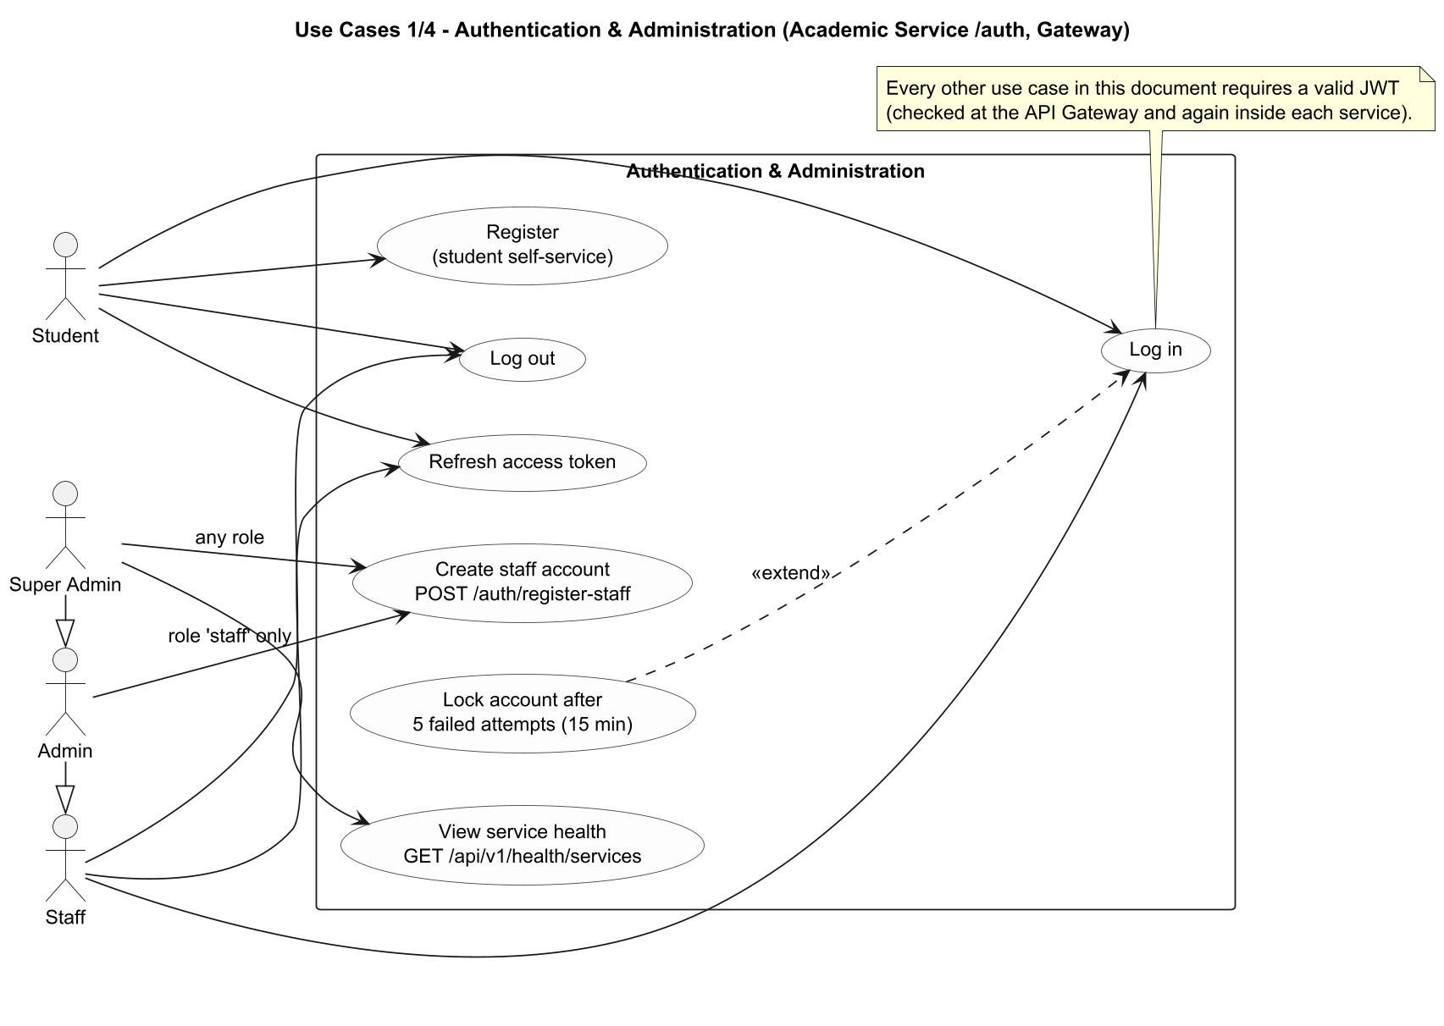
Explanation: Actors are the four real roles (student, staff, admin, super_admin). Generalization admin > staff and super_admin > admin reflects the API role lists. "Lock account" extends "Log in" (5 failed attempts).
Implementation: authRoutes.js, authController.js, healthRoutes.js. Admin may create staff only; super_admin may create any staff-level role.

Use-Case Diagram 2/4 - Academic Service
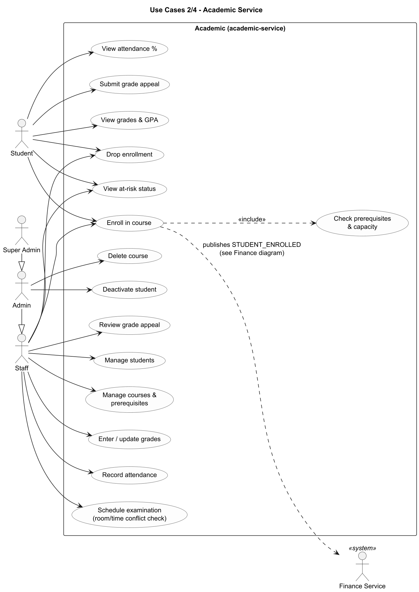
Explanation: Enrolling includes the prerequisite/capacity check and triggers the STUDENT_ENROLLED event consumed by the Finance Service.
Implementation: Routes under /academic (students, courses, enrollments, grades, attendance, exams, appeals). Delete course and deactivate student are admin-only.

Use-Case Diagram 3/4 - Marketing & Finance Service
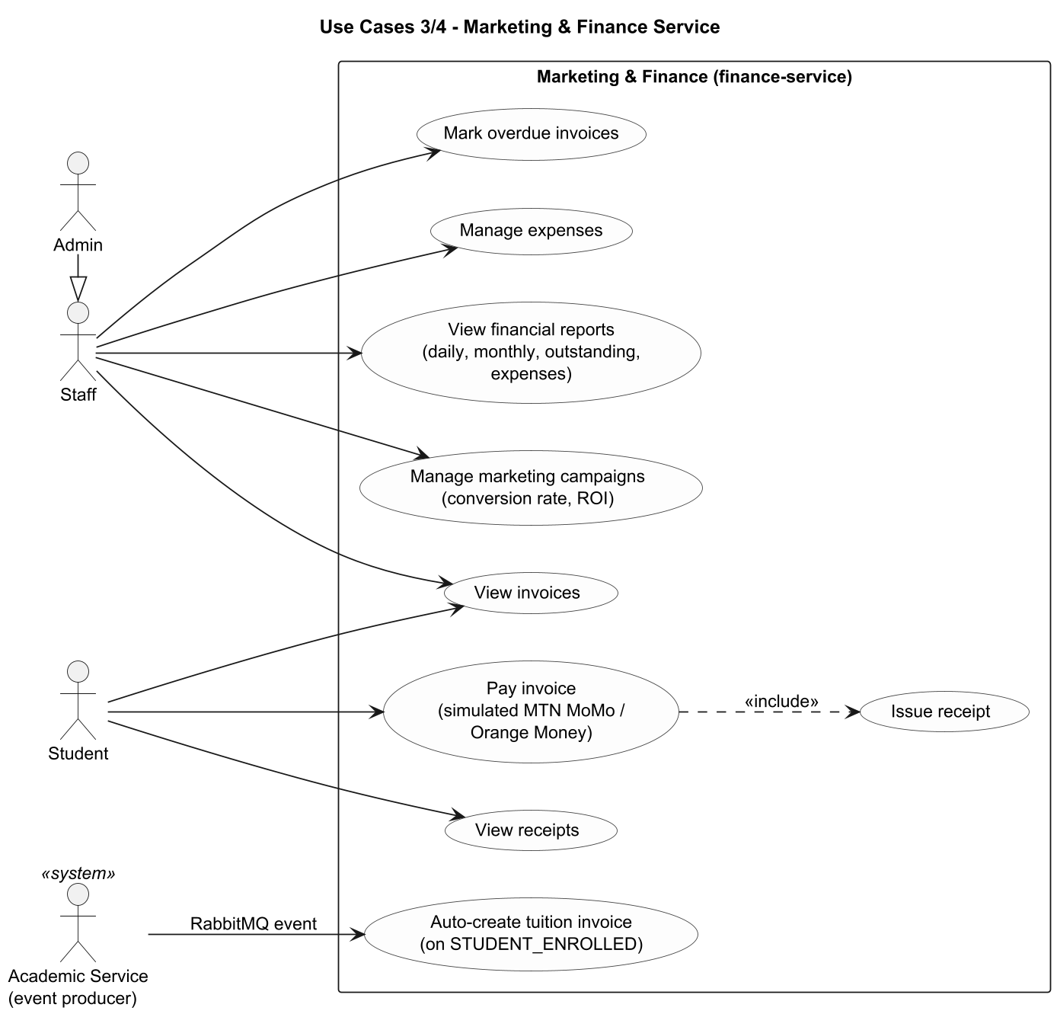
Explanation: The invoice is created by the Finance Service itself from a RabbitMQ event; paying an invoice includes issuing a receipt.
Implementation: invoiceService.js, paymentController.js, expense/report/campaign controllers. Marketing = campaigns only.

Use-Case Diagram 4/4 - Administration & HR Service
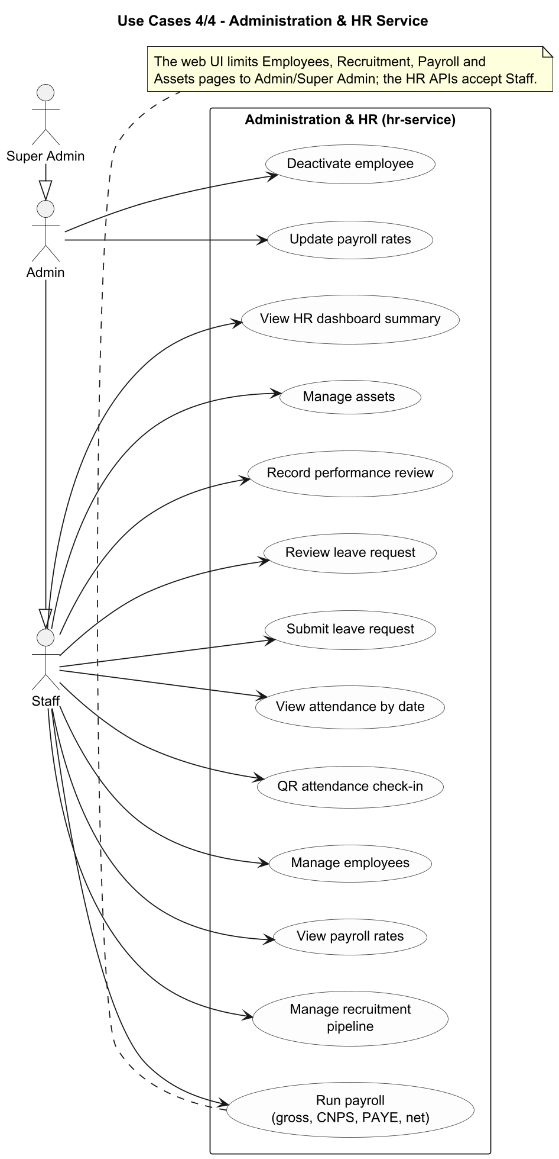
Explanation: All HR functions are available to staff-level roles at API level; updating payroll rates and deactivating employees are admin-only.
Implementation: Routes under /hr. The web UI restricts several pages to admin/super_admin.

Class Diagram 1/3 - Academic Service
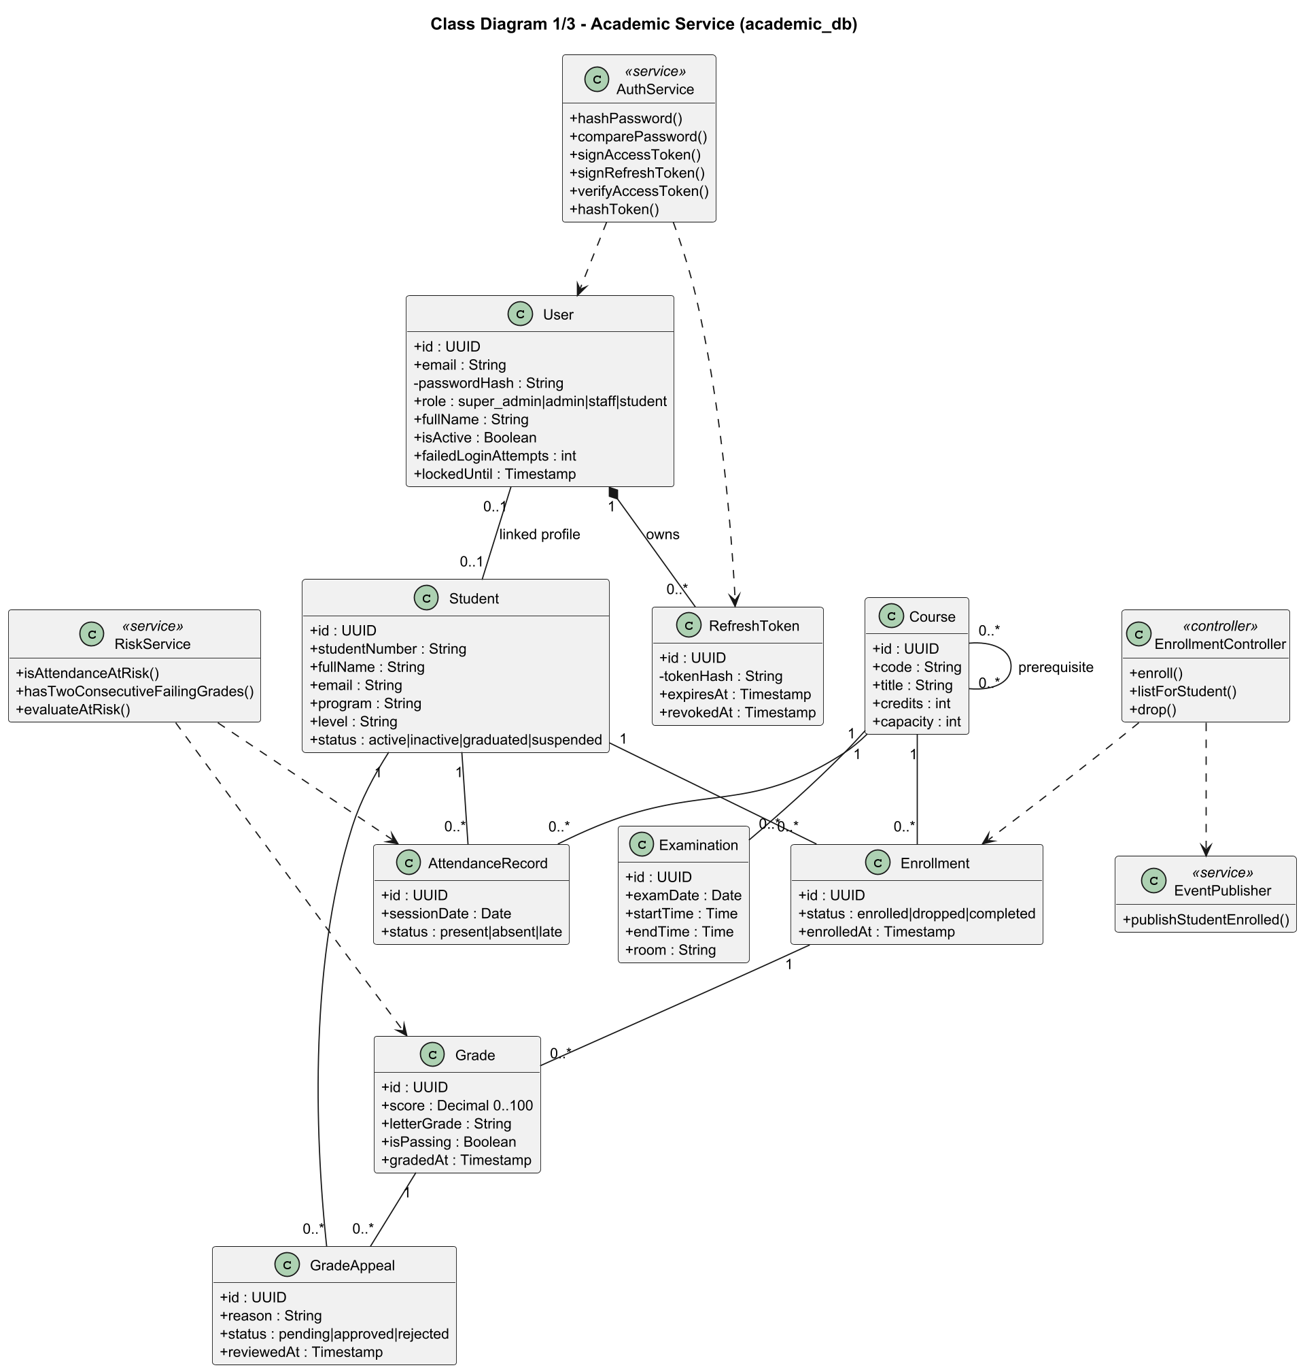
Explanation: Domain classes mirror the academic_db tables; service and controller classes show the main application logic (authentication, at-risk evaluation, enrollment and event publishing).
Implementation: schema.sql (academic), authService.js, riskService.js, enrollmentController.js, eventPublisher.js. Composition User-RefreshToken reflects ON DELETE CASCADE.

Class Diagram 2/3 - Marketing & Finance Service
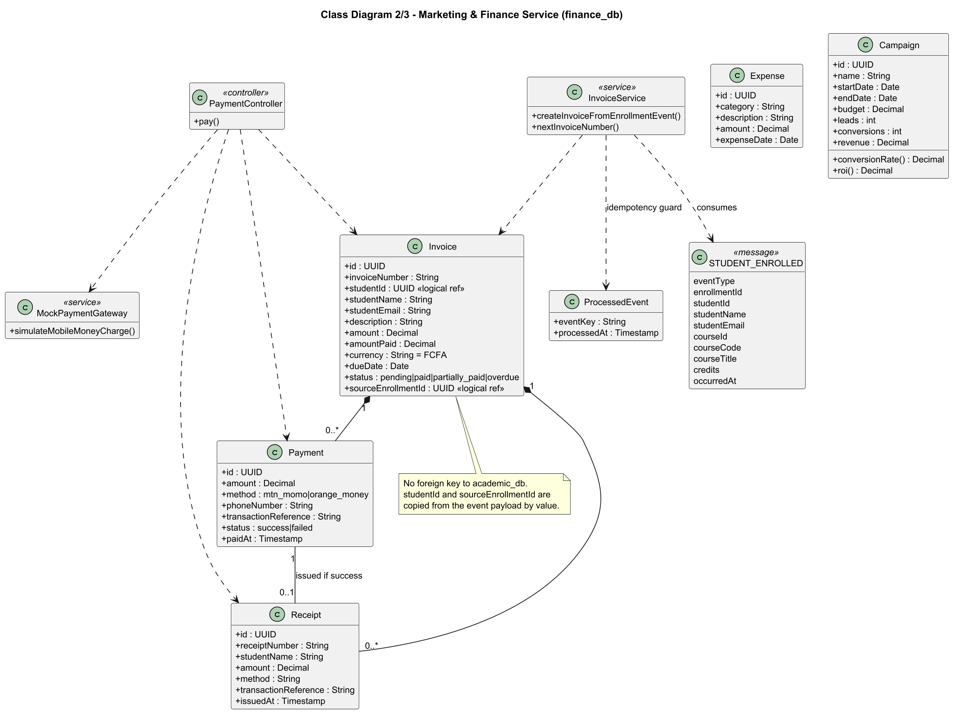
Explanation: Invoice aggregates payments and receipts. studentId and sourceEnrollmentId are logical references to academic data, copied from the event.
Implementation: schema.sql (finance), invoiceService.js, paymentController.js, mockPaymentGateway.js, campaignController.js (conversionRate and roi are derived).

Class Diagram 3/3 - Administration & HR Service
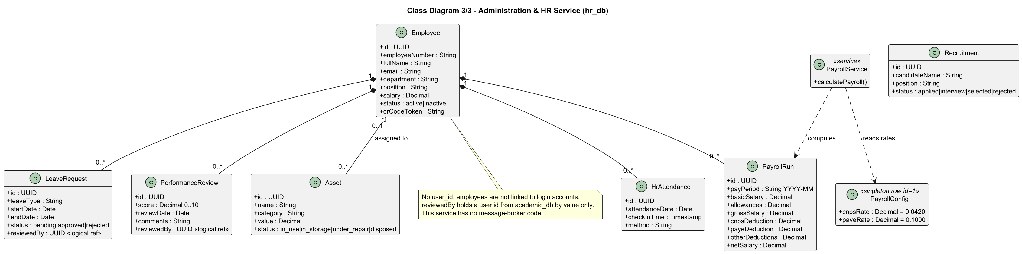
Explanation: Employee is the aggregate root for payroll runs, attendance, leave and performance reviews; assets may be assigned to an employee.
Implementation: schema.sql (hr), payrollService.js. PayrollConfig is a singleton row read during payroll calculation.

ERD 1/3 - academic_db (Academic Service)
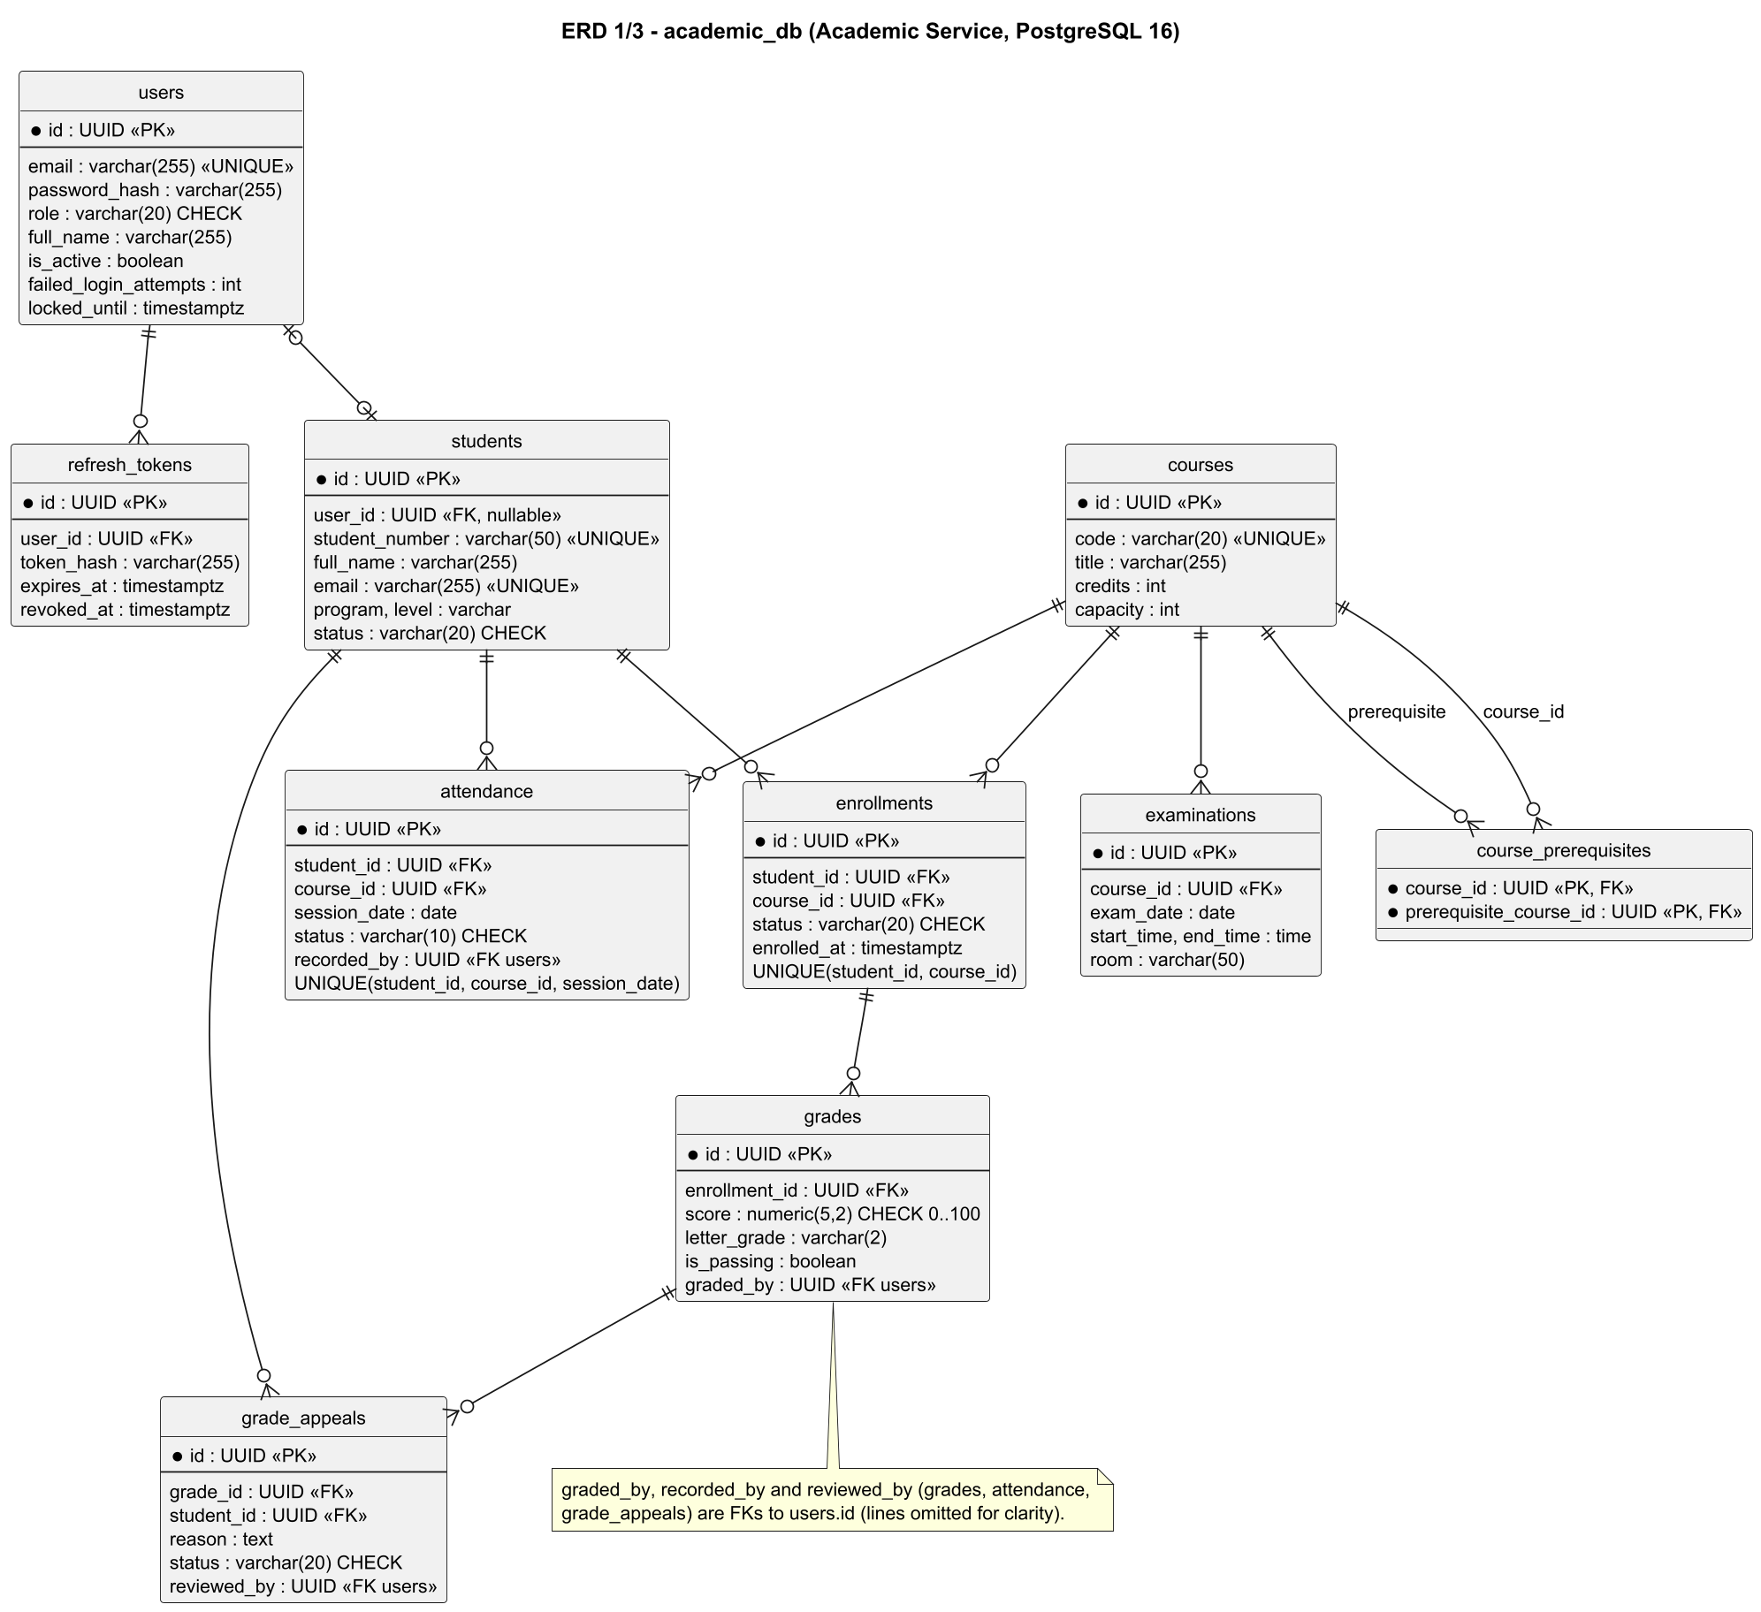
Explanation: Ten tables including the identity tables (users, refresh_tokens). Audit columns graded_by, recorded_by and reviewed_by reference users.
Implementation: services/academic-service/src/db/schema.sql.

ERD 2/3 - finance_db (Marketing & Finance Service)
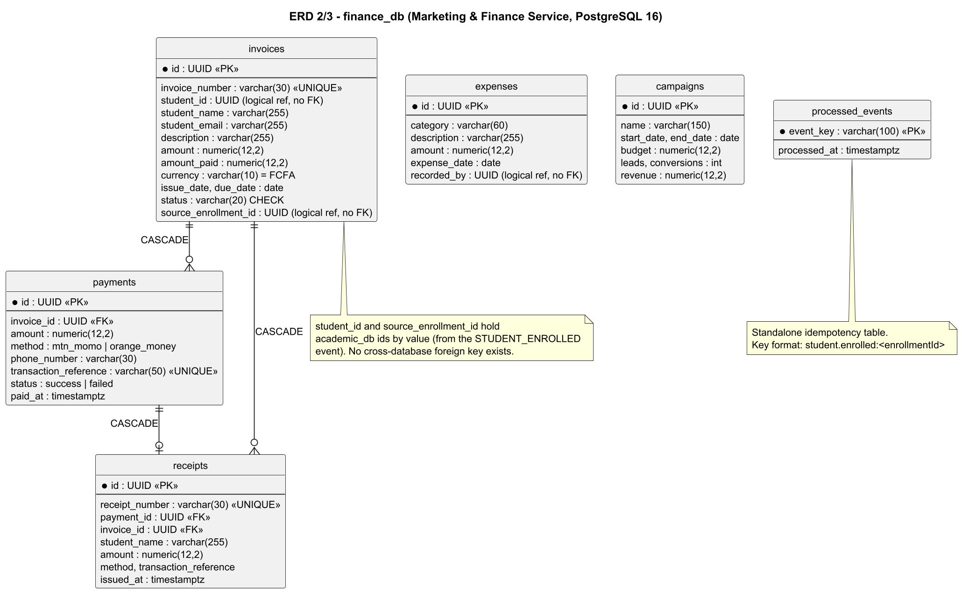
Explanation: Invoices, payments, receipts, expenses, campaigns and the processed_events idempotency table. No foreign key leaves this database.
Implementation: services/finance-service/src/db/schema.sql.

ERD 3/3 - hr_db (Administration & HR Service)
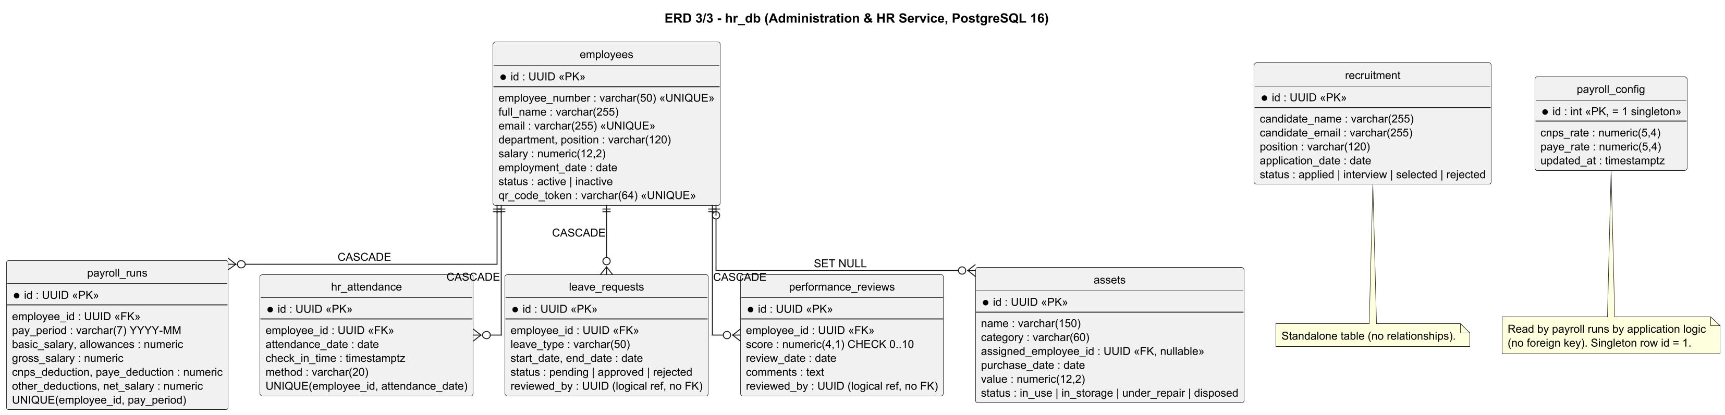
Explanation: Employees and their payroll runs, attendance, leave and performance reviews; assets optionally assigned to an employee; payroll_config singleton; recruitment standalone.
Implementation: services/hr-service/src/db/schema.sql.

Deployment Diagram - Docker Compose
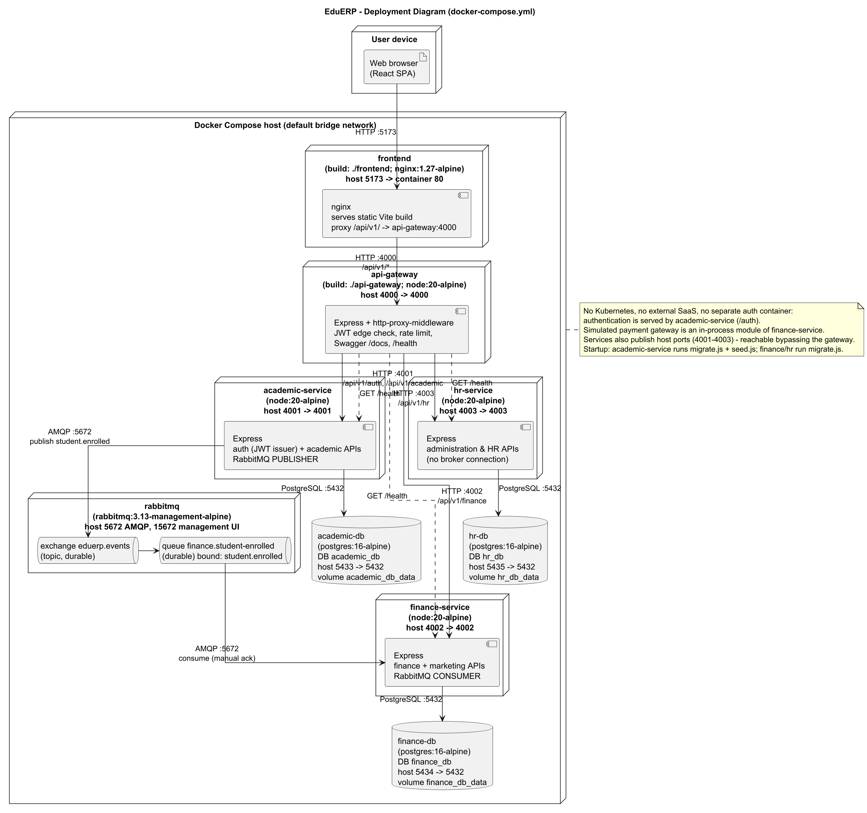
Explanation: Nine containers on one Compose network: nginx frontend, gateway, three services, RabbitMQ and three PostgreSQL databases, with ports, protocols and communication direction.
Implementation: docker-compose.yml, Dockerfiles, nginx.conf. No Kubernetes and no external systems.

Sequence Diagram - Synchronous workflow: paying an invoice
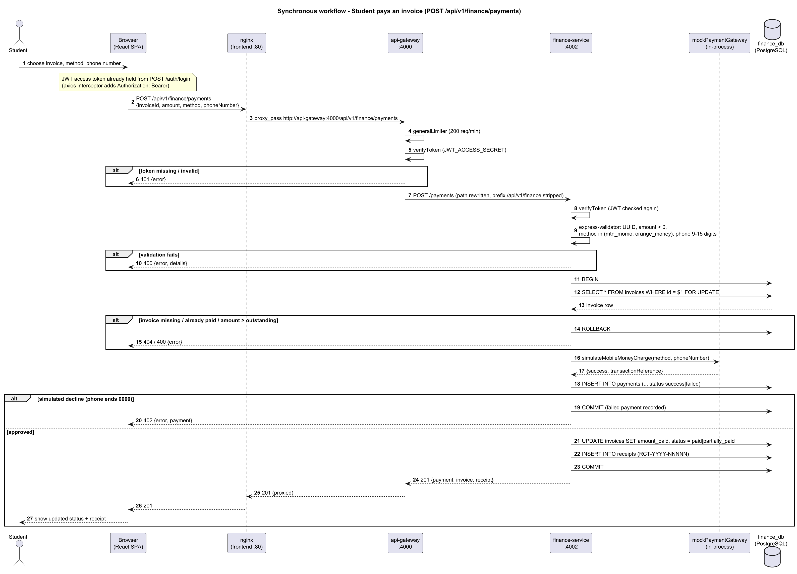
Explanation: Browser to nginx to API Gateway to finance-service to finance_db and back, with JWT verification at the gateway and in the service, validation, a row-locked transaction and the simulated payment gateway.
Implementation: client.js, nginx.conf, gateway app.js/proxyRoutes.js, paymentRoutes.js, paymentController.js. Status codes 201, 402, 400, 404 are from the controller.

Sequence Diagram - Asynchronous workflow: STUDENT_ENROLLED
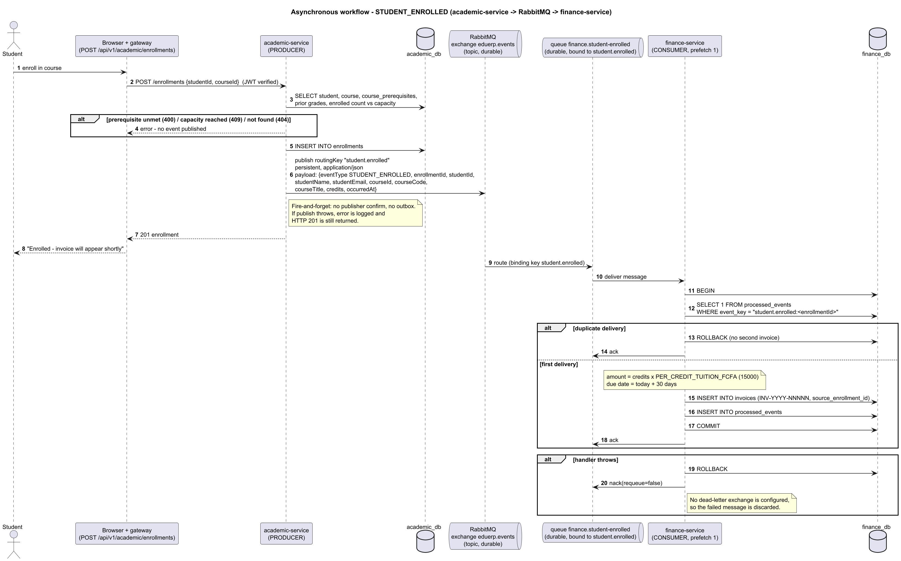
Explanation: academic-service publishes to exchange eduerp.events with key student.enrolled; queue finance.student-enrolled delivers it to finance-service, which creates the invoice idempotently and acks. Failures are nacked without requeue.
Implementation: enrollmentController.js, eventPublisher.js, academic and finance rabbitmq.js, finance server.js and invoiceService.js. No dead-letter queue or outbox exists.

Part E - Requirement Traceability Matrix
Requirement ID | Requirement | Service | API / component | Database entity | Diagram | Test / evidence
FR-001 | A visitor shall self-register; this always creates a student account and a linked student profile in one transaction. | Auth (academic-service) + Gateway | POST /api/v1/auth/register | users, students, refresh_tokens | UC-1, CL-1, ERD-1 | authController.test.js (3 tests)
FR-002 | An authenticated admin or super_admin shall create staff-level accounts; only a super_admin may create admin or super_admin accounts. | Auth (academic-service) + Gateway | POST /api/v1/auth/register-staff | users | UC-1, ERD-1 | No automated test (manual / UI)
FR-003 | The system shall authenticate users by email and bcrypt-verified password and return a short-lived access token and a refresh token. | Auth (academic-service) + Gateway | POST /api/v1/auth/login | users, refresh_tokens | UC-1, CL-1, ERD-1 | authService.test.js (4 tests)
FR-004 | The system shall lock an account for LOCKOUT_DURATION_MINUTES (15) after MAX_FAILED_LOGIN_ATTEMPTS (5) consecutive failed logins. | Auth (academic-service) + Gateway | POST /api/v1/auth/login | users | UC-1, ERD-1 | No automated test (manual / UI)
FR-005 | The system shall reject login for deactivated accounts. | Auth (academic-service) + Gateway | POST /api/v1/auth/login | users | UC-1 | No automated test (manual / UI)
FR-006 | The system shall rotate refresh tokens: a valid refresh token is revoked and a new access/refresh pair issued; refresh tokens are stored only as SHA-256 hashes. | Auth (academic-service) + Gateway | POST /api/v1/auth/refresh | refresh_tokens | UC-1, CL-1, ERD-1 | authService.test.js (hashToken)
FR-007 | The system shall revoke a presented refresh token on logout. | Auth (academic-service) + Gateway | POST /api/v1/auth/logout | refresh_tokens | UC-1 | No automated test (manual / UI)
FR-008 | The system shall return the caller identity claims from a valid access token. | Auth (academic-service) + Gateway | GET /api/v1/auth/me | none (JWT claims) | UC-1 | No automated test (manual / UI)
FR-009 | Every microservice shall independently verify the JWT (shared JWT_ACCESS_SECRET) and enforce role checks (requireRole) per route; missing/invalid token gives 401, insufficient role gives 403. | Auth (academic-service) + Gateway | All protected routes | none | UC-1, SEQ-S | enrollment.test.js (no token), leaveAndAttendance.test.js (student rejected)
FR-010 | The API Gateway shall reject requests to /api/v1/academic, /finance, /hr and /health/* that lack a valid Bearer JWT before proxying. | Auth (academic-service) + Gateway | /api/v1/{academic,finance,hr,health} | none | SEQ-S, DEP | gateway.test.js (5 tests)
FR-011 | The API Gateway shall route /api/v1/auth and /api/v1/academic to academic-service, /api/v1/finance to finance-service and /api/v1/hr to hr-service, stripping the prefix, and answer 502 when the upstream is unreachable and 404 for unknown routes. | Auth (academic-service) + Gateway | /api/v1/* | none | SEQ-S, DEP | gateway.test.js
FR-012 | The API Gateway shall rate-limit clients to 200 requests/minute on /api/v1 and 20 requests per 15 minutes on /api/v1/auth/login. | Auth (academic-service) + Gateway | /api/v1, /api/v1/auth/login | none | SEQ-S | No automated test (manual / UI)
FR-013 | The API Gateway shall aggregate the /health endpoint of each service (3 s timeout each) for authenticated users. | Auth (academic-service) + Gateway | GET /api/v1/health/services | none | UC-1, DEP | No automated test (manual / UI)
FR-014 | Staff shall list students with search (name, number, email), status filter and pagination. | Academic Service | GET /academic/students | students | UC-2, CL-1, ERD-1 | No automated test (manual / UI)
FR-015 | A student shall retrieve their own linked student profile. | Academic Service | GET /academic/students/me | students | UC-2, ERD-1 | No automated test (manual / UI)
FR-016 | Staff and students shall retrieve a student by id (no ownership check is implemented for the student role). | Academic Service | GET /academic/students/:id | students | UC-2 | No automated test (manual / UI)
FR-017 | Staff shall create students (unique student number and email) and update student data. | Academic Service | POST /academic/students; PUT /academic/students/:id | students | UC-2, CL-1, ERD-1 | No automated test (manual / UI)
FR-018 | Admin and super_admin shall deactivate a student (status set to inactive; row is kept). | Academic Service | DELETE /academic/students/:id | students | UC-2 | No automated test (manual / UI)
FR-019 | The system shall report a student as at-risk when overall attendance is below 75% or there are two consecutive failing grades. | Academic Service | GET /academic/students/:id/risk-status | attendance, grades | UC-2, CL-1 | riskService.test.js (9 tests)
FR-020 | Any authenticated user shall list and view courses (with prerequisites). | Academic Service | GET /academic/courses[/:id] | courses, course_prerequisites | UC-2, ERD-1 | No automated test (manual / UI)
FR-021 | Staff shall create (unique code) and update courses; admin and super_admin shall delete courses (blocked with 409 if enrollments exist). | Academic Service | POST/PUT/DELETE /academic/courses | courses | UC-2, CL-1, ERD-1 | No automated test (manual / UI)
FR-022 | Staff shall assign prerequisite courses; a course cannot be its own prerequisite. | Academic Service | POST /academic/courses/:id/prerequisites | course_prerequisites | UC-2, ERD-1 | No automated test (manual / UI)
FR-023 | The system shall enroll a student in a course only if the student and course exist, every prerequisite has a passing grade, the course is below capacity and the student is not already enrolled. | Academic Service | POST /academic/enrollments | enrollments, course_prerequisites, grades | UC-2, CL-1, SEQ-A, ERD-1 | enrollment.test.js (capacity, no token)
FR-024 | The system shall list a student's enrollments and allow an enrollment to be dropped (status = dropped). | Academic Service | GET /academic/enrollments/student/:id; PATCH /academic/enrollments/:id/drop | enrollments | UC-2, ERD-1 | No automated test (manual / UI)
FR-025 | Staff shall enter and update grades (0-100); the system derives letter grade (A>=90, B>=80, C>=70, D>=60, E>=50, F) and is_passing (score >= 50). | Academic Service | POST /academic/grades; PUT /academic/grades/:id | grades | UC-2, CL-1, ERD-1 | No automated test (manual / UI)
FR-026 | The system shall return a student's grades with a credit-weighted GPA (A=4, B=3, C=2, D=1, E=0.5, F=0). | Academic Service | GET /academic/grades/student/:id | grades, enrollments, courses | UC-2 | No automated test (manual / UI)
FR-027 | Staff shall record attendance (present/absent/late) per student, course and date; a repeat for the same key updates the status. | Academic Service | POST /academic/attendance | attendance | UC-2, ERD-1 | No automated test (manual / UI)
FR-028 | The system shall return a student's attendance records and attendance percentage (present + late). | Academic Service | GET /academic/attendance/student/:id | attendance | UC-2 | No automated test (manual / UI)
FR-029 | Staff shall schedule examinations; the system shall reject an exam whose room and date overlap an existing exam time window. | Academic Service | POST /academic/exams | examinations | UC-2, ERD-1 | No automated test (manual / UI)
FR-030 | Any authenticated user shall list scheduled examinations. | Academic Service | GET /academic/exams | examinations, courses | UC-2 | No automated test (manual / UI)
FR-031 | A student shall submit a grade appeal only for their own grade; staff may submit for any grade. | Academic Service | POST /academic/appeals | grade_appeals | UC-2, CL-1, ERD-1 | No automated test (manual / UI)
FR-032 | Staff shall list appeals and approve or reject a pending appeal once. | Academic Service | GET /academic/appeals; PATCH /academic/appeals/:id/review | grade_appeals | UC-2, ERD-1 | No automated test (manual / UI)
FR-033 | The system shall automatically create a tuition invoice (INV-YYYY-NNNNN, credits x PER_CREDIT_TUITION_FCFA, default 15000 FCFA, due in 30 days) when a STUDENT_ENROLLED event is consumed. | Marketing & Finance Service | AMQP queue finance.student-enrolled | invoices, processed_events | UC-3, CL-2, SEQ-A, ERD-2, DEP | invoiceService.test.js (3 tests)
FR-034 | Staff shall list invoices with status/student filters and pagination and mark overdue invoices (pending or partially_paid past due date). | Marketing & Finance Service | GET /finance/invoices; POST /finance/invoices/sweep-overdue | invoices | UC-3, ERD-2 | No automated test (manual / UI)
FR-035 | Any authenticated user shall retrieve an invoice by id and the invoices of a student (no ownership check is implemented). | Marketing & Finance Service | GET /finance/invoices/:id; GET /finance/invoices/student/:studentId | invoices | UC-3, ERD-2 | No automated test (manual / UI)
FR-036 | The system shall process a simulated MTN MoMo / Orange Money payment against an invoice, rejecting amounts above the outstanding balance or payments on paid invoices, inside a transaction that locks the invoice row. | Marketing & Finance Service | POST /finance/payments | payments, invoices, receipts | UC-3, CL-2, SEQ-S, ERD-2 | paymentController.test.js (3 tests)
FR-037 | The simulated gateway shall decline a phone number ending in 0000; the failed payment is recorded and the API answers 402. | Marketing & Finance Service | POST /finance/payments | payments | CL-2, SEQ-S | mockPaymentGateway.test.js (2 tests)
FR-038 | The system shall issue a numbered receipt (RCT-YYYY-NNNNN) for every successful payment and let users retrieve receipts by id or invoice. | Marketing & Finance Service | GET /finance/receipts/:id; GET /finance/receipts/invoice/:invoiceId | receipts | UC-3, CL-2, ERD-2 | paymentController.test.js
FR-039 | Staff shall create, list, update and delete expenses. | Marketing & Finance Service | GET/POST/PUT/DELETE /finance/expenses | expenses | UC-3, ERD-2 | No automated test (manual / UI)
FR-040 | Staff shall obtain daily and monthly income/expense summaries, an outstanding-fees report and an expense report (FCFA). | Marketing & Finance Service | GET /finance/reports/{daily-summary,monthly-summary,outstanding-fees,expenses} | payments, invoices, expenses | UC-3, ERD-2 | No automated test (manual / UI)
FR-041 | Staff shall create and list marketing campaigns and update leads, conversions, revenue and budget; the API derives conversionRate and ROI. | Marketing & Finance Service | GET/POST /finance/campaigns; PUT /finance/campaigns/:id | campaigns | UC-3, CL-2, ERD-2 | campaignController.test.js (2 tests)
FR-042 | Staff shall list, view, create and update employees (unique number and email; a unique QR token is generated). | Administration & HR Service | GET/POST /hr/employees; GET/PUT /hr/employees/:id | employees | UC-4, CL-3, ERD-3 | No automated test (manual / UI)
FR-043 | Admin and super_admin shall deactivate an employee (status inactive). | Administration & HR Service | DELETE /hr/employees/:id | employees | UC-4 | No automated test (manual / UI)
FR-044 | Staff shall list candidates, add candidates and move them through applied, interview, selected, rejected. | Administration & HR Service | GET/POST /hr/recruitment; PATCH /hr/recruitment/:id/status | recruitment | UC-4, ERD-3 | No automated test (manual / UI)
FR-045 | Staff shall read the payroll rates; only admin and super_admin shall update the CNPS and PAYE rates (configurable placeholders). | Administration & HR Service | GET/PUT /hr/payroll/config | payroll_config | UC-4, CL-3, ERD-3 | No automated test (manual / UI)
FR-046 | Staff shall run payroll for an employee and period (YYYY-MM): gross = basic + allowances; CNPS and PAYE = gross x configured rates; net = gross - deductions; a rerun for the same period updates the record. | Administration & HR Service | POST /hr/payroll/run | payroll_runs, payroll_config, employees | UC-4, CL-3, ERD-3 | payrollService.test.js (3 tests)
FR-047 | The system shall list an employee's payroll history (any authenticated user; no ownership check is implemented). | Administration & HR Service | GET /hr/payroll/employee/:employeeId | payroll_runs | UC-4 | No automated test (manual / UI)
FR-048 | The system shall record an employee's daily attendance from a QR token (one check-in per employee per day; unknown token or inactive employee is rejected). | Administration & HR Service | POST /hr/attendance/check-in | hr_attendance, employees | UC-4, CL-3, ERD-3 | leaveAndAttendance.test.js (3 tests)
FR-049 | Staff shall list HR attendance for a date. | Administration & HR Service | GET /hr/attendance | hr_attendance | UC-4 | No automated test (manual / UI)
FR-050 | The system shall accept leave requests (end date not before start date), list an employee's requests, list pending requests and let staff approve or reject a pending request once. | Administration & HR Service | POST /hr/leave; GET /hr/leave/pending; GET /hr/leave/employee/:id; PATCH /hr/leave/:id | leave_requests | UC-4, CL-3, ERD-3 | leaveAndAttendance.test.js (4 tests)
FR-051 | Staff shall record performance reviews (score 0-10); any authenticated user can list an employee's reviews. Backend only: the web UI has no performance page. | Administration & HR Service | POST /hr/performance; GET /hr/performance/employee/:id | performance_reviews | UC-4, ERD-3 | No automated test (manual / UI)
FR-052 | Staff shall list, create and update assets and assign them to employees. | Administration & HR Service | GET/POST /hr/assets; PUT /hr/assets/:id | assets | UC-4, ERD-3 | No automated test (manual / UI)
FR-053 | Staff shall obtain an HR dashboard summary (active employees, check-ins today, pending leave, average performance, asset count). | Administration & HR Service | GET /hr/dashboard/summary | employees, hr_attendance, leave_requests, performance_reviews, assets | UC-4 | No automated test (manual / UI)
FR-054 | After a successful enrollment insert, academic-service shall publish STUDENT_ENROLLED to the durable topic exchange eduerp.events with routing key student.enrolled (persistent, JSON). | Inter-service / Front-end | AMQP publish student.enrolled | enrollments | SEQ-A, CL-1, DEP | enrollment.test.js (publishes event)
FR-055 | finance-service shall consume queue finance.student-enrolled (durable, bound to student.enrolled, prefetch 1), ack after success, and nack without requeue on failure. | Inter-service / Front-end | AMQP consume | invoices | SEQ-A, DEP | invoiceService.test.js
FR-056 | The consumer shall be idempotent: a redelivered event for the same enrollmentId shall not create a second invoice. | Inter-service / Front-end | AMQP consume | processed_events | SEQ-A, CL-2, ERD-2 | invoiceService.test.js (idempotent)
FR-057 | finance-service shall retry the RabbitMQ connection at start-up up to 10 times at 5 s intervals. | Inter-service / Front-end | AMQP | none | DEP | No automated test (manual / UI)
FR-058 | Services shall share identity by trust in JWTs signed by academic-service; finance and hr hold no credentials and do not call academic-service. | Inter-service / Front-end | n/a | none | DEP | leaveAndAttendance.test.js
FR-059 | The React web application shall call only the API Gateway path /api/v1 (through nginx), attach the Bearer token, refresh it once on a 401, and log the user out if refresh fails. | Inter-service / Front-end | /api/v1/* | none | SEQ-S, DEP | No automated test (manual / UI)
FR-060 | The web application shall show role-specific navigation and dashboards (super_admin, admin, staff, student) and guard pages with ProtectedRoute role lists (some pages are stricter than the APIs). | Inter-service / Front-end | n/a | none | UC-1..UC-4 | No automated test (manual / UI)
Diagram codes: UC-n use case n/4, CL-n class n/3, SEQ-S synchronous sequence, SEQ-A asynchronous sequence, ERD-n entity-relationship n/3, DEP deployment. Non-functional requirements trace to the evidence column of section 4.

Part F - Implementation Consistency Audit
Documentation was compared with the source code, database schemas, API routes, message-broker code, UML diagrams and docker-compose.yml. Test run on 2026-09-25: gateway 5, academic 19, finance 10, HR 10 - all 44 passing.
Item | Documentation | Implementation | Consistent? | Correction required
Service list | gateway + academic, finance (marketing & finance), hr (administration & HR); no separate auth or marketing service | docker-compose.yml: api-gateway, academic-service, finance-service, hr-service, frontend, rabbitmq, 3 x postgres | Yes | None
Container ports | Gateway 4000; academic 4001; finance 4002; hr 4003; frontend 5173->80; RabbitMQ 5672/15672; PostgreSQL 5433/5434/5435->5432 | Same in docker-compose.yml | Yes | None
Database per service | academic_db, finance_db, hr_db | Three postgres:16-alpine containers with those DB names | Yes | None
Gateway routes | /api/v1/auth and /academic -> 4001; /finance -> 4002; /hr -> 4003 | proxyRoutes.js and app.js | Yes | None
Front-end to gateway | Browser -> nginx -> gateway (/api/v1/) | nginx.conf proxy_pass; client.js baseURL /api/v1 | Yes | None
Synchronous workflow endpoint | POST /api/v1/finance/payments -> POST /payments; body invoiceId, amount, method, phoneNumber; 201/402/400/404 | paymentRoutes.js, paymentController.js | Yes | Validation error body corrected to {error, details} in the diagram
Event name | STUDENT_ENROLLED (eventType) with routing key student.enrolled | eventPublisher.js | Yes | None
Exchange / queue | Exchange eduerp.events (topic, durable); queue finance.student-enrolled (durable) | rabbitmq.js in both services | Yes | None
Event payload | eventType, enrollmentId, studentId, studentName, studentEmail, courseId, courseCode, courseTitle, credits, occurredAt | eventPublisher.publishStudentEnrolled | Yes | None
Producer / consumer | academic-service produces; finance-service consumes; hr-service has no broker code | No amqplib use in hr-service; compose gives hr no RABBITMQ_URL | Yes | None
Acknowledgement / retry / DLQ | Manual ack; nack requeue=false; no dead-letter; 10 x 5 s start-up connect retry | rabbitmq.js, server.js (finance) | Yes | Documented as Planned / Not implemented (DLQ, outbox, confirms)
Queue declaration | Queue is declared and bound only by finance-service | academic-service asserts only the exchange | Yes | Documented: events published before finance-service first starts have no queue and are dropped
Idempotency | processed_events guard, key student.enrolled:<enrollmentId> | invoiceService.js, finance schema.sql | Yes | None
ERD tables | 10 academic, 6 finance, 8 hr tables | schema.sql in each service | Yes | None
Cross-database keys | None; invoices.student_id and source_enrollment_id, expenses.recorded_by and hr reviewed_by are logical references by value | No REFERENCES across databases | Yes | None
Payment-to-receipt cardinality | Payment 1 - 0..1 Receipt | Schema does not enforce; controller creates one receipt per successful payment | Yes | Stated as application-level rule
User roles | student, staff, admin, super_admin | users.role CHECK constraint | Yes | None
Role generalization (use cases) | super_admin > admin > staff for API access | Every role list is [staff, admin, super_admin] or narrower subsets of it | Yes | None
Staff-account creation rule | Admin may create staff only; only super_admin may create admin/super_admin | authController.registerStaff | Yes | None
Web UI vs API permissions | UC and FR tables follow the API | App.jsx limits Employees, Recruitment, Payroll, Assets, Expenses, Reports, Campaigns pages to admin/super_admin, while the APIs also allow staff | No (implementation) | Documented in FR/UC notes; align UI or API if stricter access is wanted
Ownership checks | FRs state that no ownership check exists | Student-role calls to /students/:id, /grades|attendance|enrollments|invoices/student/:id, /receipts, POST /payments, POST /enrollments are not tied to the caller; GET /hr/payroll|leave|performance/employee/:id are open to any authenticated user | Yes (doc) / gap in code | Listed under Planned / Not implemented; fix in code if required
Refresh-token lifetime | Refresh JWT expires per JWT_REFRESH_EXPIRES_IN (7d default) | refresh_tokens.expires_at is always now + 7 days regardless of the variable | Partly | Minor code inconsistency, noted
Transport security | HTTP only (no TLS configured) | docs/architecture.md (earlier draft) labels the browser link "HTTPS in prod" | No (earlier draft) | Earlier draft corrected here: this suite states HTTP only
Marketing scope | Campaigns only, hosted inside finance-service | campaignController, campaigns table | Yes | None
Campaign metrics | conversionRate and roi derived on read | campaignController.withMetrics (not stored) | Yes | Shown as derived operations in the class diagram
Number sequences | Invoice and receipt numbers unique | Numbers built from COUNT(*)+1 with UNIQUE constraint; concurrent creation could collide | Yes (doc) | Observation recorded; not a documentation error
Simulated payment gateway | In-process module, not an external system | mockPaymentGateway.js | Yes | None
External systems | None | No outbound integrations in code or compose | Yes | None
Kubernetes | Not used | Only docker-compose.yml exists | Yes | None
CI | GitHub Actions is a build pipeline, not a runtime node | .github/workflows/ci.yml | Yes | Excluded from deployment diagram
Automated tests | 44 tests pass | npx jest: gateway 5, academic 19, finance 10, hr 10 | Yes | None
Default JWT secrets | Secrets come from environment | Code falls back to dev-access-secret / dev-refresh-secret when unset; compose supplies placeholder defaults | Yes | Documented as constraint (replace secrets in real deployments)

Audit conclusions
- No invented services, endpoints, tables, events, queues or actors were found in this suite; all names were matched against the code.
- Corrected during the audit: validation-error body in the synchronous sequence diagram; container count in the deployment explanation; HTTPS wording from the earlier draft in docs/architecture.md.
- Implementation gaps (not documentation errors): missing ownership checks, UI stricter than API, fixed 7-day refresh expiry, no dead-letter queue, no outbox.

Appendix - Planned / Not implemented
- PDF export of transcripts and reports (JSON only).
- Transactional outbox for enrollment events and publisher confirms (fire-and-forget publish).
- Dead-letter exchange/queue for failed messages (failed messages are nacked without requeue and discarded).
- Real mobile-money gateway (payments are simulated in-process).
- HTTPS/TLS (all traffic is HTTP inside Docker and on localhost).
- Ownership checks on student-facing data endpoints and on HR employee-specific reads.
- Link between HR employees and login accounts (employees have no user_id).
- Web UI page for performance reviews (API exists).
- Kubernetes, replicas, high availability, performance testing.
- Verified statutory payroll rates (CNPS/PAYE are configurable placeholders).

