Oplab

* Suppose you're working with 3 people on a project. What would be **the** ideal software development process?

Agile-Scrum, because it is a flexible and dynamic model. It would take a few weeks to develop a necessary minimum that is useful and usable.

* How do you think an entity relationship diagram for *Instagram* would be like?

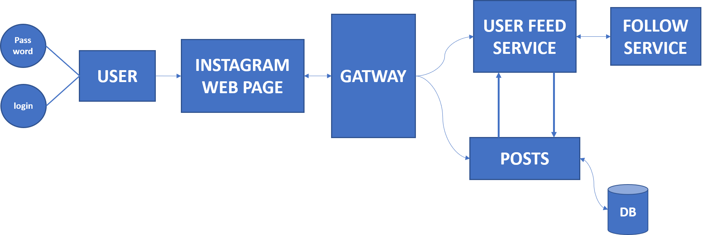

* Now that you have imagined the ER diagram, **how** would you build *Instagram* from scratch?

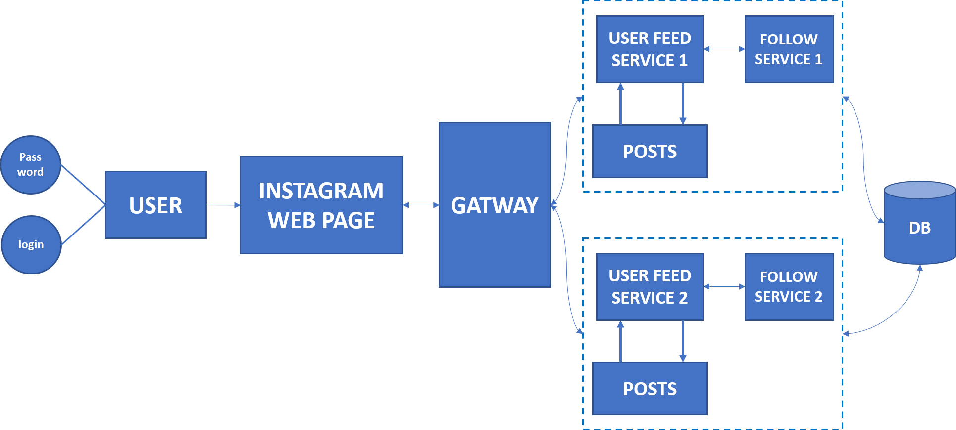

Service redundancy improves system performance because more data can be processed and maintenance can be performed more easily.