We recognize and acknowledge that McMaster University meets and learns on the traditional territories of the Mississauga and Haudenosaunee nations, and within the lands protected by the “Dish With One Spoon” wampum, an agreement amongst all allied Nations to peaceably share and care for the resources around the Great Lakes.

CHEM 799 - AI Tools for Materials Science

2026 Winter Term
Instructor: Rodrigo A. Vargas-Hernández| E-mail: vargashr@mcmater.ca | Office: ABB 266

Instructional Assistant: Alexandre de Camargo | E-mail: decamara@mcmaster.ca

Section | C01
Instructor | Rodrigo A. Vargas-Hernández
Contact Info | vargashr@mcmater.ca
Class Schedule | Tuesday 3:30AM - 4:2 0PM  Thursday 2:30AM - 4:20 PM
Location | ABB A204
Office Hours | TBD
Location | ABB 266

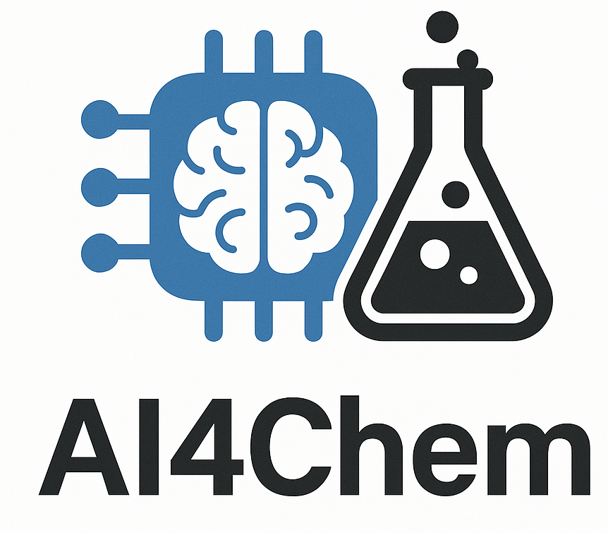
Course Description
This course covers an introduction of topics and tools which serve as the basic for data modeling in materials science. The course aims to cover from supervised learning for property prediction, image recognition and graph-based models to introductory unsupervised algorithms for data compression and reconstruction. The course assumes a basic knowledge of Python, specifically Numpy, Pandas, Scipy, and Matplotlib.

- One of the main focuses of the course is the development of coding skills, specifically Python.
- Instruction on the associated programming skills will be provided in a tutorial style.

Course and Learning Objectives

At the end of the course, the student will have elementary programming skills using modern machine learning libraries tailored to model chemical systems.

Materials & Fees

Required Materials
You will need your personal computers to for the in-class coding exercises.

Resources
This course does not follow a specific book as it designed to be a collection of topics that are relevant for a common undergraduate program in chemistry. However, if the student wants to consult here are some recommended books:
- Pattern Recognition and Machine Learning, C. M. Bishop.
- Probabilistic Machine Learning: An Introduction, K. P. Murphy.
- Deep Learning for Molecules & Materials, A. D. White.
- The internet!!

Notes from previous years wrote by profs. Randy Dumont and Paul Ayers will also be shared.
All content will be posted on the course website,
https://chemai-lab.github.io/AI4Chem/intro.html

Course Overview and Assessment
Week | Dates | Topic
1 | Jan. 5-9 | Linear models
2 | Jan. 12-16 | Kernel models
3 | Jan. 19-23 | Neural Networks
4 | Jan. 26-30 | Gradient descent and differentiable programming
5 | Feb. 2-6 | Molecular representations
6 | Feb. 9-13 | Graph Neural networks
7 | Feb. 16-20 | Reading week break. No classes this week!!
8 | Feb. 23-27 | MACE or PySCF tutorial

Evaluation
Assessment Method | Weight
Final Project | 100%
Total | 100%
Modifications to this evaluation scheme may happen during the term but will be communicated to the class.

Final Project:

Grading scheme for the final project.
Assessment Method | Weight
Oral presentation | 30%
Code | 40%
Written Report | 30%
Total | 100%

What is to be expected for the final project?
You must work on your final project since day 1.
It should look like a research paper

Important Dates:
- Written Report deadline: March 15th
- Oral Presentation: TBD

Written Report is 4 Pages long.
- Page 1: Introduction
- Page 2: Methodology
- Pages 3-4: Results, Discussion and Summary.
- Extra pages include references, and additional data and results.

Code:
- Jupyter notebook file (.ipynb) deployable in Google Colab.
- It should run smoothly and self-explanatory for other students.

Oral Presentation: (conference style)
- 20 min long.
- Clearly state what is the goal of the project
- Methodology description
- Some results discussion
- Conclusion

Requests for Relief for Missed Academic Term Work
McMaster Student Absence Form (MSAF): In the event of an absence for medical or other reasons, students should review and follow the Academic Regulation in the Undergraduate Calendar “Requests for Relief for Missed Academic Term Work”.

Academic Accommodation of Students with Disabilities
Students with disabilities who require academic accommodation must contact Student Accessibility Services (SAS) at 905-525-9140 ext. 28652 or sas@mcmaster.ca to make arrangements with a Program Coordinator. For further information, consult McMaster University’s Academic Accommodation of Students with Disabilities policy.

Academic Integrity
You are expected to exhibit honesty and use ethical behaviour in all aspects of the learning process. Academic credentials you earn are rooted in principles of honesty and academic integrity.
It is your responsibility to understand what constitutes academic dishonesty.
Academic dishonesty is to knowingly act or fail to act in a way that results or could result in unearned academic credit or advantage. This behaviour can result in serious consequences, e.g. the grade of zero on an assignment, loss of credit with a notation on the transcript (notation reads: “Grade of F assigned for academic dishonesty”), and/or suspension or expulsion from the university. For information on the various types of academic dishonesty please refer to the Academic Integrity Policy.

The following illustrates only three forms of academic dishonesty:
- plagiarism, e.g. the submission of work that is not one’s own or for which other credit has been obtained.
- improper collaboration in group work.
- copying or using unauthorized aids in tests and examinations.

Academic Integrity in the era of Generative AI
As a researcher in the field of machine learning and AI, I recognize the significant potential of these modern tools to enhance the learning process. I support their responsible use, with the understanding that the author who submits the work is ultimately accountable for its content and any potential repercussions.
In this course, where the primary objective is to develop students' mathematical and coding skills, it is essential to ensure that all work reflects genuine analysis and understanding.

The instructor and TA will be vigilant in identifying any instances of "copy-paste" answers, particularly those that appear to be generated by AI without sufficient student comprehension. If the instructor or TA suspects that an answer has been directly copied from a chatbot, the student will be required to explain their reasoning. Responses such as "this is what ChatGPT told me" will not be tolerated. Based on the explanation provided, appropriate consequences may be determined.

Authenticity / Plagiarism Detection
Some courses may use a web-based service (Turnitin.com) to reveal authenticity and ownership of student submitted work. For courses using such software, students will be expected to submit their work electronically either directly to Turnitin.com or via an online learning platform (e.g. A2L, etc.) using plagiarism detection (a service supported by Turnitin.com) so it can be checked for academic dishonesty.

Students who do not wish their work to be submitted through the plagiarism detection software must inform the instructor before the assignment is due. No penalty will be assigned to a student who does not submit work to the plagiarism detection software. All submitted work is subject to normal verification that standards of academic integrity have been upheld (e.g., on-line search, other software, etc.). For more details about McMaster’s use of Turnitin.com please go to the McMaster Office of Academic Integrity’s webpage.

Conduct Expectations
As a McMaster student, you have the right to experience, and the responsibility to demonstrate, respectful and dignified interactions within all our living, learning and working communities. These expectations are described in the Code of Student Rights & Responsibilities (the “Code”). All students share the responsibility of maintaining a positive environment for the academic and personal growth of all McMaster community members, whether in person or online.

It is essential that students be mindful of their interactions online, as the Code remains in effect in virtual learning environments. The Code applies to any interactions that adversely affect, disrupt, or interfere with reasonable participation in University activities. Student disruptions or behaviours that interfere with university functions on online platforms (e.g. use of Avenue 2 Learn, WebEx or Zoom for delivery), will be taken very seriously and will be investigated. Outcomes may include restriction or removal of the involved students’ access to these platforms.

Copyright, Recording & Research Ethics
Students are advised that lectures, demonstrations, performances, and any other course material provided by an instructor include copyright protected works. The Copyright Act and copyright law protect every original literary, dramatic, musical and artistic work, including lectures by University instructors.

The recording of lectures, tutorials, or other methods of instruction may occur during a course. Recording may be done only by the instructor for the purpose of improvement. Please speak with the instructor if this is a concern for you.

Extreme Circumstances
The University reserves the right to change the dates and deadlines for any or all courses in extreme circumstances (e.g., severe weather, labour disruptions, etc.). Changes will be communicated through regular McMaster communication channels, such as McMaster Daily News, A2L and/or McMaster email.

