Report 1.4: Empirical assesment of an *International Technological Subordination (ITS)*

Rodrigo BR

2024-12-18

# Introduction to the empirical assesment of an *International Technological Subordination* (ITS)

The concept of *International Technological Subordination* (ITS) is a theoretical framework that seeks to explain the hierarchical relation between countries in the Global Economy (GE), based on the control and ownership of technologies in key sectors of the global capitalist system. In this part, we aim to prove the empirical usefulness of this framework to select and interpret data that could reveal the relative position of a country in the GE with a focus on key Agricultural and Mining capital goods. For this purpose, and following the principles of parsimonia[1] and accesibility of the data gathered through internet sources -to provide an analytical framework easy to reproduce and test around the world-, we constructed a dataset that contains three major indicators:

1. Technological Dependency Ratio (TIDR) to be applied in the agriculture and mining sectors, as a first step to empirically assess the ITS in a global perspective. This ratio is built using a formula developed by the Food and Agriculture Organization (FAO) to characterize the dependency of a country on cereal imports, and is adapted to the construction of the TIDR for agriculture and mining capital goods such as machinery, teleoperation devices and related technologies.
2. Count of internationalized patents[2] in agriculture, mining and data processing technologies per year, as a proxy to measure the innovation and technology production of a country in the global economy (for a more detailed analysis of this use of patent data, see Acs, Anselin, and Varga (2002)). This indicator should allow to position a country in the global intellectual property system, and to identify the relative importance of its inventive activity in the sectors of interest. Data processing technologies patents are added to assess the current importance of the 4.0 industry in the global economy.
3. Foreign Direct Investment (FDI) as percentage of Gross Capital Formation **in general**, as a proxy for the financial subordination of a country in the global economy. Data specifically for agriculture and mining sectors is not publicly available at the time in the data source used (United Nations Conference on Trade and Development - UNCTAD), so this indicator is used as a general proxy for the financial subordination of a country in the global economy. In future works that follow this path of research, the authors suggest to gather data specifically for the sectors of interest, so the financial subordination can be assessed in a more precise way.

Therefore, the operationalization of the ITS in this report is as follows:

| **Concept** | **Dimension** | **Empirical_Proxy** | **Reason_for_Selection** |
| --- | --- | --- | --- |
| International Technological Subordination (ITS) | Logistical Subordination | Trade balance (imports - exports) of technified capital goods | Using CIDR formula, extreme cases of import dependency and export proficiency were expected to be addressed. |
| Technological Development Subordination | Internationalized patents ownership (count) | Internationalized patents, as the manifestation of certain patentees to protect their know-how in the global arena. |
| Financial Subordination | Foreign Direct Investment as a percentage of Gross Fixed Capital Formation | The measure comes from a reliable source (UNCTAD) and is widely used to assess economic relations across global economy. |

## About the Data Retrieval (DR) and Data Processing (DP) methods

The data used in this report was gathered from the following sources:

1. UNCTAD’s *FDI as percentage of the stock of Fixed Gross Capital Formation* (GFCF) in general (not specified by sector nor country of origin), for all countries and time periods available in the public dataset (around 211 countries and 34 years). This data was downloaded directly from the UNCTAD’s Data Centre without further complications[3];
2. UNCTAD’s *COMTRADE* database, for the trade operations of a few technified capital goods in the agriculture and mining sectors, for all countries and time periods available in the public dataset (around 204 countries and 35 years) Given the complexity of the business-to-business products traded in these sectors (ranging from sophisticated machines to rare raw materials), the authors decided to track a sample of key commodities that could be more easily identified as capital goods key to the sectors of interest. The download process was done through the R package *comtradr* (Bochtler et al. 2024), and it took around a week and a half of intermittent download through multiple free API keys.
3. Google’s *Patents Public Dataset*, a massive dataset contained in Google Cloud that has to be accessed through their online service BigQuery[4] and contains detailed and tidly categorized patent registers from all around the world, from the 19th century to the present. The dataset is updated regularly and is free to access through Google’s BigQuery interface, which requires a Google Cloud account and some basic knowledge of SQL. The authors prepared two queries to gather and process the data necessary for the analysis, which are available in the first appendix of this paper (see Appendix A[5]).

## Technological Import Dependency Ratio (TIDR) as a proxy to logistical vulnerability

The formula applied for constructing the TIDR for mining and agriculture was based on the Cereal Import Dependency Ratio (CIDR), which is a measure created by the FAO to characterize the dependency of a country on cereal imports (Food and Agriculture Organization of the United Nations (FAO) 2023). The formula for the CIDR is as follows:

Following the principle of parsimonia, we will use the CIDR formula as the foundation for the construction of the TIDR in agriculture and mining but adapted to the available data in the source, which is the full volume of trade operations (imports and exports) of specific technologies in these sectors accross the globe. Therefore, the formula for the TIDR will be as follows:

This approach has the main advantage of being easily replicable, adaptable and interpretable, as it is based on the simple comparison of the volume of technology imports and exports in a given sector. On the other hand, it has the disadvantage of not taking into account production data, which could be relevant for a more comprehensive analysis of the technological industry emergent development in agriculture and mining; specially in a temporal dimension (because if a country develops internal technologies that are not traded internationally, its wouldn’t be visible in the TIDR until said country trades that innovation globally).

The trade operations gathered refer to the following technologies in the agriculture and mining sectors, whose HS codes are used to identify them in the COMTRADE database:

| **HS_Code** | **Description** |
| --- | --- |
| 841710 | Furnaces and ovens for roasting, melting or other heat-treatment of ores, pyrites or of metals |
| 842320 | Weighing machinery (excluding balances of a sensitivity of 5 cg or better), including weight-operated counting or checking machines; weighing machine weights of all kinds |
| 842441 | Agricultural or horticultural sprayers |
| 842482 | Agricultural or horticultural appliances for projecting, dispersing or spraying liquids or powders |
| 8427 | Fork-lift trucks; other works trucks fitted with lifting or handling equipment |
| 8428 | Other lifting, handling, loading or unloading machinery (for example, lifts, escalators, conveyors, teleferics) |
| 8429 | Self-propelled bulldozers, angledozers, graders, levellers, scrapers, mechanical shovels, excavators, shovel loaders, tamping machines and road rollers |
| 843031 | Machinery for soil preparation or cultivation; lawn or sports-ground rollers |
| 843039 | Other machinery for soil preparation or cultivation |
| 8432 | Agricultural, horticultural or forestry machinery for soil preparation or cultivation; lawn or sports-ground rollers |
| 8433 | Harvesting or threshing machinery, including straw or fodder balers; grass or hay mowers; machines for cleaning, sorting or grading eggs, fruit or other agricultural produce, other than machinery of heading 8437 |
| 8434 | Milking machines and dairy machinery |
| 8435 | Presses, crushers and similar machinery used in the manufacture of wine, cider, fruit juices or similar beverages |
| 8436 | Agricultural, horticultural, forestry, poultry-keeping or bee-keeping machinery, including germination plant fitted with mechanical or thermal equipment; poultry incubators and brooders |
| 8437 | Machines for cleaning, sorting or grading seed, grain or dried leguminous vegetables; machinery used in the milling industry or for the working of cereals or dried leguminous vegetables, other than farm-type machinery |
| 847410 | Machinery for sorting, screening, separating, washing, crushing, grinding, mixing or kneading earth, stone, ores or other mineral substances, in solid (including powder or paste) form |
| 847420 | Machinery for agglomerating, shaping or moulding solid mineral fuels, ceramic paste, unhardened cements, plastering materials or other mineral products in powder or paste form; machines for forming foundry moulds of sand |
| 8701 | Tractors (other than tractors of heading 8709) |
| 8704 | Motor vehicles for the transport of goods |
| 8709 | Works trucks, self-propelled, not fitted with lifting or handling equipment, of the type used in factories, warehouses, dock areas or airports for short distance transport of goods |
| 9015 | Surveying (including photogrammetrical surveying), hydrographic, oceanographic, hydrological, meteorological or geophysical instruments and appliances, excluding compasses; rangefinders |

We suggest that the COMTRADE dataset is a powerful tool to set the ground for an empirical analysis of the ITS in general, because it provides enough data to identify the very extremes of technological trade’s dependence: net exporter countries (whose TIDR value is expected to be negative and lower than -100, because they export more technology than they import) and net importer countries (whose TIDR value is expected to be 100 or near, because they import more technology than they export) [6].

TIDR values will be considered as a proxy for a logistical kind of ITS, because it allows to identify economies whose capital accumulation is based at least at some extent on its import rather than its production. With this in consideration, the authors suggest that a TIDR value above 50 is a sign of a high dependency on technology imports.

## The patent data as a proxy for an innovation and development subordination

Datasets available through the World International Patents Office (WIPO) and other global stakeholders about the International Patents Systems offer valuable information about patents around the world, but these registers are not directly aggregated or ready to be analyzed in a categorical manner through their web interfaces, which means that the *surface* data isn’t directly suited for analyzing inventive activity with the specific aim of this article (that is, the search for indicators of sustained hierarchies among countries in particular technologies). To gather the data necessary for the analysis (that is, at least a count of patents granted per country for agricultural and mining technologies through time), a programmatic approach is taken based on *The WIPO Patent Analytics Handbook* (Oldham 2022) applied to the *Google Patents Public Dataset* (Google Cloud 2024). Following the suggestions of the handbook, the data is gathered taking advantage of four columns offered by Google’s dataset: patent_number, country_code, publication_date, family_id and cpc_code. Respectivelly, these columns offer the patent identifier number, the country of origin, the publication date, the patent family identifier number and the Cooperative Patent Classification (CPC) code of the patent; the latter being a classification system used to categorize patents by field and/or technology by the European Patent Office and other global stakeholders. Given the interest in looking for patents of global relevance in agriculture and mining, during the data download and processing a column is created to confirm that each observation is a patent associated with a patent family (that is, that ‘family_id’ isn’t 0 or null).

To identify the patents of interest in agriculture and mining , the CPC codes are used to filter the patents in the dataset according to the general field of appliance of the patented technology. In order to take into account the elements of the 4.0 revolution in the innovation landscape, CPC codes for data process technologies are also considered. The CPC codes identified through the search engine provided by the European Patents Office (European Patent Office 2024) and used for this purpose are the following:

| **CPC_Code** | **Description** | **CPC_broad_class** |
| --- | --- | --- |
| A01 | Agriculture; forestry; animal husbandry; hunting; trapping; fishing | Agriculture patents and related |
| E21 | Earth or rock drilling; mining | Mining patents and related |
| G05 | Controlling; regulating systems | Data process patents and related |
| G06 | Computing; calculating or counting systems | Data process patents and related |
| G08 | Signalling systems | Data process patents and related |
| G11 | Information storage systems | Data process patents and related |
| G16Y | Information and communication technology specially adapted for the internet of things [IoT] | Data process patents and related |

With this approach to patent data, the authors aim to describe global trends of intellectual property accumulation in the agriculture, mining and data processing sectors, as a way to complement the TIDR analysis and to provide a more comprehensive view of the ITS as global inequality in technified capital development.

## Financial subordination through net FDI labeled as Fixed Gross Capital Formation

As stated above, the stock FDI as percentage of GFCF data per year is a easily available, but rather general metric. Gross Fixed Capital Formation (GFCF) was selected as a proxy over FDI in USD because it is a more direct measure of the capital accumulation in a given country and year, for which it better suits the longitudinal perspective of this analysis. For this article, the data was processed in a similar manner to the TIDR data (that is, input - output of an economy):

The resulting value follows a similar logic to the TIDR: positive values indicate a net inflow of FDI (that is, receiving more FDI than sending out), while negative values indicate a net outflow of FDI (that is, sending more FDI than receiving). While a net inflow isn’t necessarily a sign of subordination, and the abscence of a measurement of local fixed capital financed by national investment limits the possibility to identify autarky, this ratio allows for two things: (1) to identify extreme cases of financial subordination or dominance, and (2) to keep the principles of parsimonia and data accesibility in the construction of the dataset.

## Final dataset constructed for the analysis of the ITS in mining and agriculture globally

To merge all datasets together into a single file that can be used for the analysis and then make it available to the public use, the authors use the years and country names as *main keys* (that is, the columns that will be used to track each case across datasets). The *countrycode* R package developed by Arel-Bundock, Enevoldsen, and Yetman (2023) is used to standardize the country names across datasets, and the *dplyr* R package developed by Wickham et al. (2023) is used to merge and clean the datasets together. The final dataset is then exported to a *.csv* file that can be used by other researchers to replicate or further the analysis, and is available along with the necessary documentation in a public repository curated by one of the authors [7] (R. 2024).

The composition of the final dataset is as follows:

| **Column** | **Description** | **Interpretation** |
| --- | --- | --- |
| year | Year of observation | Year of observation |
| country | Country of observation | Country of observation |
| IDIT | Proxy for logistical subordination (LS) in agriculture and mining | Values closer to 100 indicate a high dependency on technology imports, negative values indicate a net exporter |
| IDIT_China | LS related to China | Values closer to 100 indicate a high dependency on technology imports, negative values indicate a net exporter |
| IDIT_USA | LS related to USA | Values closer to 100 indicate a high dependency on technology imports, negative values indicate a net exporter |
| main_tech_capital_source | Main source of technological capital imports | Main source of LS in agriculture and mining technologies |
| agr_pat | Proxy for intellectual property subordination in agriculture | High values indicate a high relative position in the global intellectual property system |
| dat_pat | Proxy for intellectual property subordination in mining | High values indicate a high relative position in the global intellectual property system |
| min_pat | Proxy for intellectual property subordination in data processing | High values indicate a high relative position in the global intellectual property system |
| Net_GFCF | Net FDI as percentage of GFCF | Positive values indicate a net inflow of FDI as GFCF, negative values indicate a net outflow of FDI as GFCF |
| ECI | Economy Complexity Index (ECI) | A measure of the productive capabilities of a country, higher values may indicate a more diverse (or expanded) economy |
| ECI_rank | ECI ranking within the available global economy data | Ranking of each country according to ECI indicator. A country in top 10 ranking can be considered as a country that its economy have expanded greatly respective to the rest of the world |

This dataset contains information for 199 countries and 34 years, but not necessarily continuous; for example, a country may have full data for TIDR but not for patents, or partial data of both (for a complete summary of the final dataset composition, see Appendix b). The authors suggest that the dataset is a powerful tool for a first approach to creating an ITS set of indicators that can be used for multiple purposes. Among other things, the authors suggest that the dataset can be used to identify the relative position of a country in the global economy of the sectors analyzed, and to aggregate (for example, by size in USD or location of the economy) or complement the data with other sources to test hypotheses about the global development of imperialism and subordination in specific countries. In this line, ECI indicators ar added to test the capability of the ITS dataset to understand global division of labour, and other researchers are encouraged to incorporate metrics into the data set that will enrich the debate on the measurement of development in a global perspective. Therefore, the dataset wil be used to test the following hypotheses that emerge from the historical analysis behind the ITS framework.

# First approach to the ITS dataset and impressions

## Hypotheses to be tested

1. **Hypothesis 1:** An international technological subordination (ITS) reproduces historical patterns of imperialism and subordination in the global economy, with certain countries that perform better in the selected indicators. In other words, it was expected that certain countries would appear closer to a “dominance” position in the GE rather than a “subordination” position, based on the mean values they’ve had accross time in the indicators [8]. For this reason, the ITS indicators are expected to be related to the historical development of imperialism and subordination in the global economy, as the specialized literature on the topic indicates.
2. **Hypothesis 2:** Latin American economies can be understood as a peripherical or subordinate region in the global economy, based on the historical analysis developed through local Marxist Dependency Theory. In this line, it was expected that the countries in the region would have a high dependency on technology imports, a low relative position in the global intellectual property system and a net inflow of FDI in relation to their capital formation. This is based on the historical analysis of the region, which has been characterized by the extraction of raw materials and the import of capital goods, and the lack of a strong local industry that can compete in the global market.

## First hypothesis testing

*Hypothesis 1* is tested by making a multiple-lines plot (of a type commonly known as “spaggethi plots”) for each indicator across each country and year, but grouped by continent. This allows to see two patterns of interest: (a) which regions of the world host the most dominant countries in the global economy, and (b) how the relative positions of countries in the global landscape has evolved through time. Therefore, below are the graphs for the three key indicators: TIDR, net GFCF and patent count. The analysis of each plot is written below it.

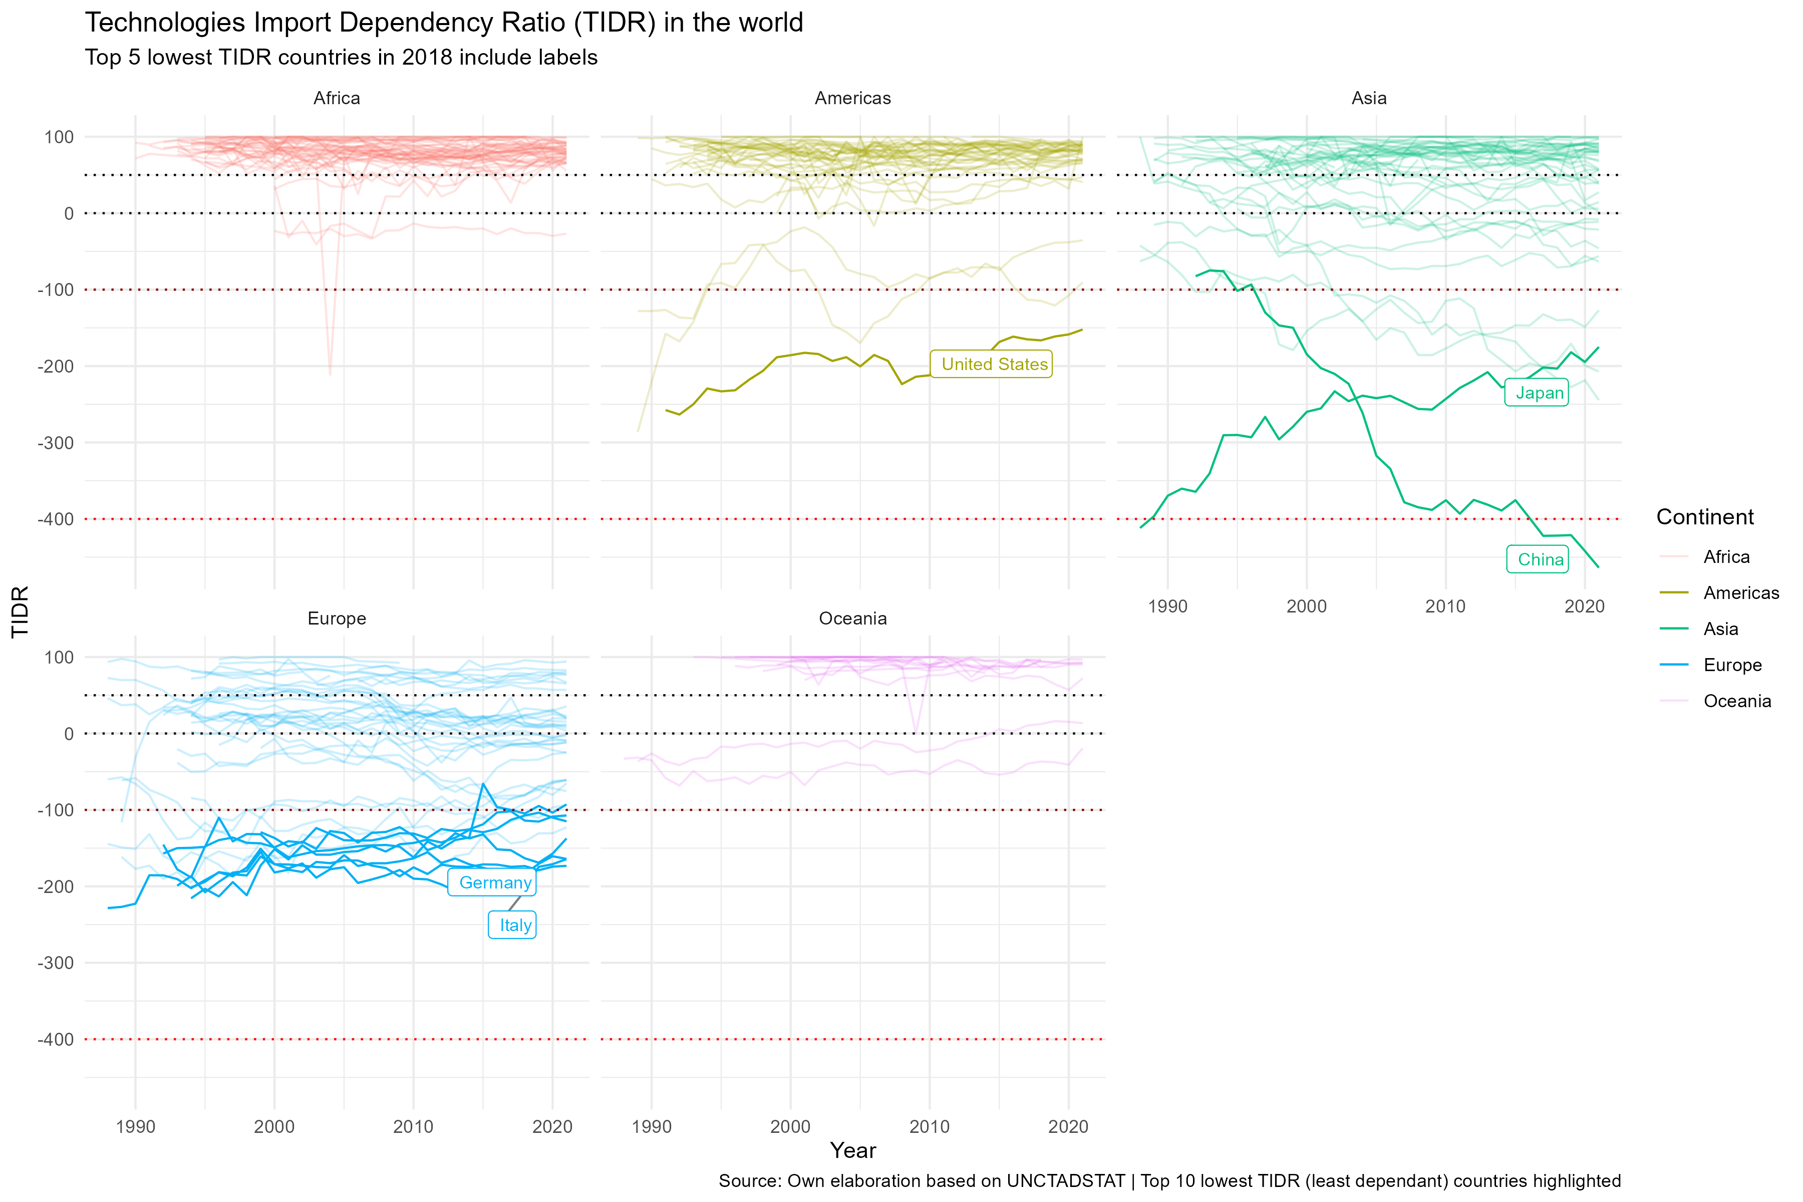

Figure 1: TIDR Plot

As shown in Figure @ref(fig:TIDR_plot), the authors suggest to consider -100 value or lower as an indicator of a country that has become a strong net exporter of technified capital in agriculture and mining; while a 100 value or closer indicates a country that has developed a high dependency on technology imports in these sectors.

In this line, some trends are immediately evident. First, most countries in the world’s regions are in a situation of dependence on imports of these capital goods (except in Europe, where the situation is a little more dynamic), insofar as most lines are concentrated over value 0 (equivalent to autarky in this context of analysis). Second, in the 30+ years of records, the tendency of the top 10 most dominant countries is to loose dominance, not to previously subordinate countries, but to other dominant countries that are improving their position. A clear example of this is seen in Asia, where Japan has seen its position as the strongest exporter in the economic sector weakened to give way to China as the most important exporter. Finally, if the -100 limit is considered as an indicator of countries that consolidate their position as net exporters, it is possible to say that in the Americas only three countries have reached this category: USA, Canada and Brazil, but only the first one has managed to maintain its position as a net exporter (although it has consistently worsened over time). Meanwhile, in Africa, no country has managed to be a net exporter of these products (even when the operations compiled consider the sale of used capital goods or those not produced in the country, which leads Kenya to have a record as a net exporter in 2004). Therefore, according to the data the real competition for global domination in the market for these capital goods is found over time between some European states (e.g. Germany, UK, Italy, Belgium or Spain), some Asian states (e.g. Japan, South Korea, India, Turkey or China) and the USA, with China leading over the last decade.

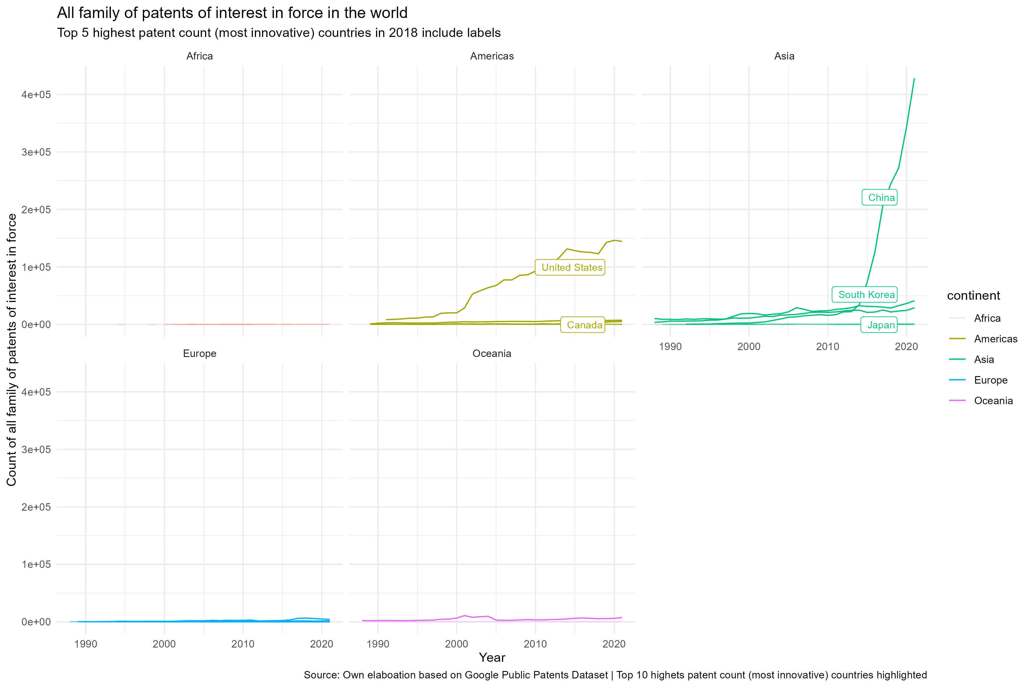

Figure 2: PATS Plot

The plot in Figure @ref(fig:pats_plot) displays the count of total patents of interests (that is, the sum of patents in agriculture, mining and data processing technologies) owned per country, and from it two observations can be drawn. First, that the main global intellectual property owners [9] in this sector of the economy have always been the USA and China, with a minor participation of South Korea, Japan, Russia (just recently), Canada and Australia. Second, that this field of global power dynamics doesn’t have the same historical inertia as the TIDR (where european nations had a relatively good situation over time), because despite the top 10 most innovative countries overlap in some cases with the biggest capital goods exporters (identified through TIDR), just the USA and China are in a position clerly dominant over the rest of the world -that can be considered as a “subordinate” in the global intellectual property system. Given the lack of historical inertia (because the incredible patents boom for China starts around 2015), the authors suggest this may be well considered as an emergent form of imperialism in the global economy.

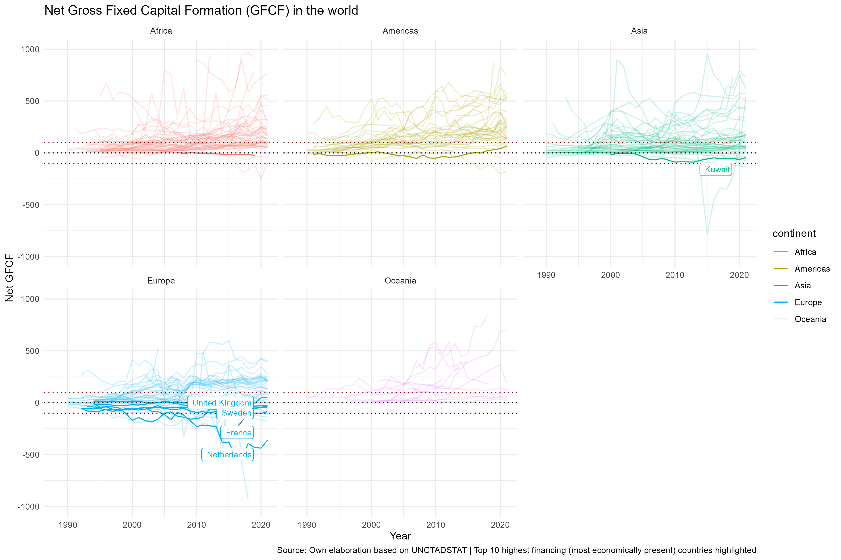

Figure 3: GFCF Plot

To understand the Figure @ref(fig:GFCF_plot), the authors suggest to consider the 0 value as an indicator of a country that has a balanced relation between FDI inflows and outflows in relation to its capital formation. Therefore, and remebering that the FDIas GFCF data is measured as percentage instead of USD, the authors also suggest to interpret a value over 100 of net GFCF as a sign of a country that is receiving more than double the FDI it is sending out in relation to its capital formation. In the other hand, a value under -100 is a sign of a country that is sending more than double the FDI it is receiving in relation to its capital formation, and therefore is able to acces a position of financial domination in the global economy by investing in other territories.

First, it must be appointed that massive private capital uses certain countries like bridges between economies to avoid taxes and other financial obligations according to international organizations (see Parliament (2017) or Oxfam (2016)), and this phenomena may explain why the data doesn’t immediately shows the patterns previously registered (or even if it is capable of showing such patterns). For example, there are countries like Luxembourg or Cyprus that appear as huge net senders of FDI in relation to their capital formation, but to this point haven’t appeared as imperialistic in the indicators nor the historical analysis (like, for example, USA or some european states, who are commonly associated with imperialistic dynamics). Therefore, the authors suggest that the international financial system may require a more detailed tracking of the FDI flows to identify the true territorial origin of the capital in movement; or to probe if this form of capital can even be localized at all, when transnational corporations are the ones making use of these *tax havens* that end up hiding the territorial origin of the capital.

Second, of the five continents, only Europe seems to have a relatively diverse set of countries involved in investing in other territories, with a strong presence of G20 nations but also smaller economies like Switzerland or Denmark. In the rest of the world, the data suggest that some of the main net investors in the global economy currently are the Netherlands, Japan, Canada and South Africa. This considers that some countries are pointed to possibly operate as *tax havens* (like Cyprus or Luxembourg, that rank 14 and 10 in the Corporate Tax Haven Index (CTHI) by the Tax Justice Network (Network 2024)) and therefore shouldn’t be considered in the analysis; or be considered as *administrative centers* for the economic power of global corporations, and therefore should be observed in detail as key nation-states that intertwine with imperialistic dynamics performed by privately owned capital. From the main net investors recognized, Japan seems to be the only steadily but slowly growing in time, while Canada and South Africa show volatile yet very positive trends.

## Second hypothesis testing

# A subsample of latin american countries as case study for the ITS indicators

A sample of countries within Latin America is selected for an in depth analysis of the ITS indicators and testing of the second hypothesis. The countries selected are Argentina, Brazil, Bolivia, Chile, Colombia, Nicaragua, Mexico, Paraguay, Peru, Uruguay and Venezuela, and the analysis will be focused on describing the historical trends of these countries rather than proving subordination per se. The authors suggest this analysis as a way to show and evaluate the potential of the dataset and its construction logic for further research in the field of ITS.

The structure of this analysis is as follows: first, the authors will present the financial and *knowhow capital* data proxies (respectively, net GFCF and patents count) for the selected countries, and then the TIDR data for the same countries. The data will be displayed in longitudinal linear plots for each indicator, and the analysis will be written below each plot.

## Patterns of financial and innovation stratification across the Latin American subsample

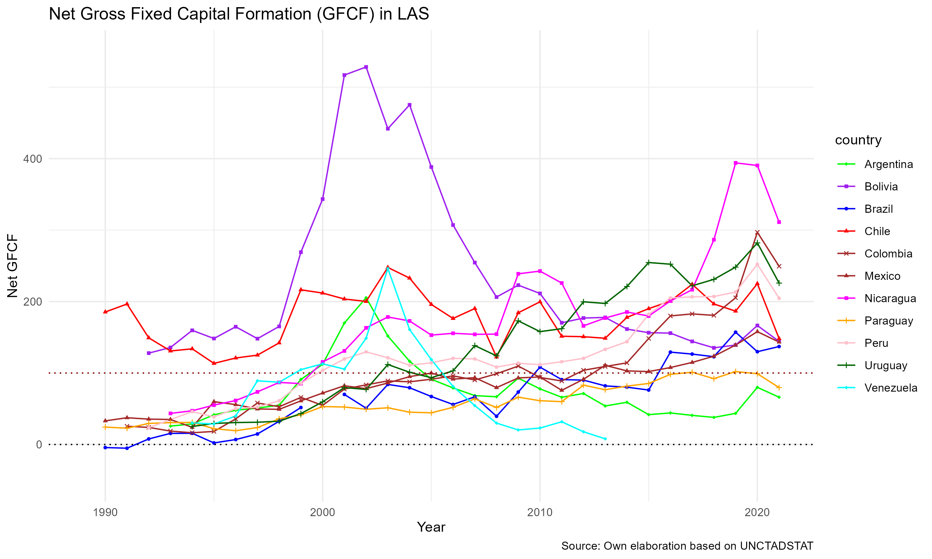

Figure 4: GFCF LAS Plot

First, it could be stated that all subsampled Latin American economies shown in Figure @ref(fig:GFCF_LAS) are net receivers of FDI, given that all of them (except Brazil in 1990) have a positive net GFCF value; but the size of this ratio (that is, how much more FDI as percentage of local Capital is being received rather than sent by the country) changes over time and across the subregion, with a few nuances.

In one hand, Chile and Bolivia share that in the data they have always received not less than a 100% more than they are sending out as stock of Gross Fixed Capital Formation[10], with a peak in foregin investment between approximately 1998 and 2008 slighly shared with Argentina, Peru, Venezuela and Nicaragua. The later became the country with most foreign investment in the last year of available data (2021).

On the other hand, countries like Brazil, Uruguay, Paraguay, Mexico, and specially Peru and Colombia, show a deepening of their foreign financialization accross time, if one is to consider that an upwards trajectory in the net GFCF ratio is a sign of a country continously receiving more FDI in relation to static or lower outflows of FDI. Therefore, it could be said that the data suggests that a process of growing financial subordination in the Latin American subsample as a dynamic processs, with some countries like Chile and Bolivia having a clear position as net receivers of FDI with peaks in certain periods, and others like Brazil, Colombia and Peru deepening their overall position as net receivers of FDI.

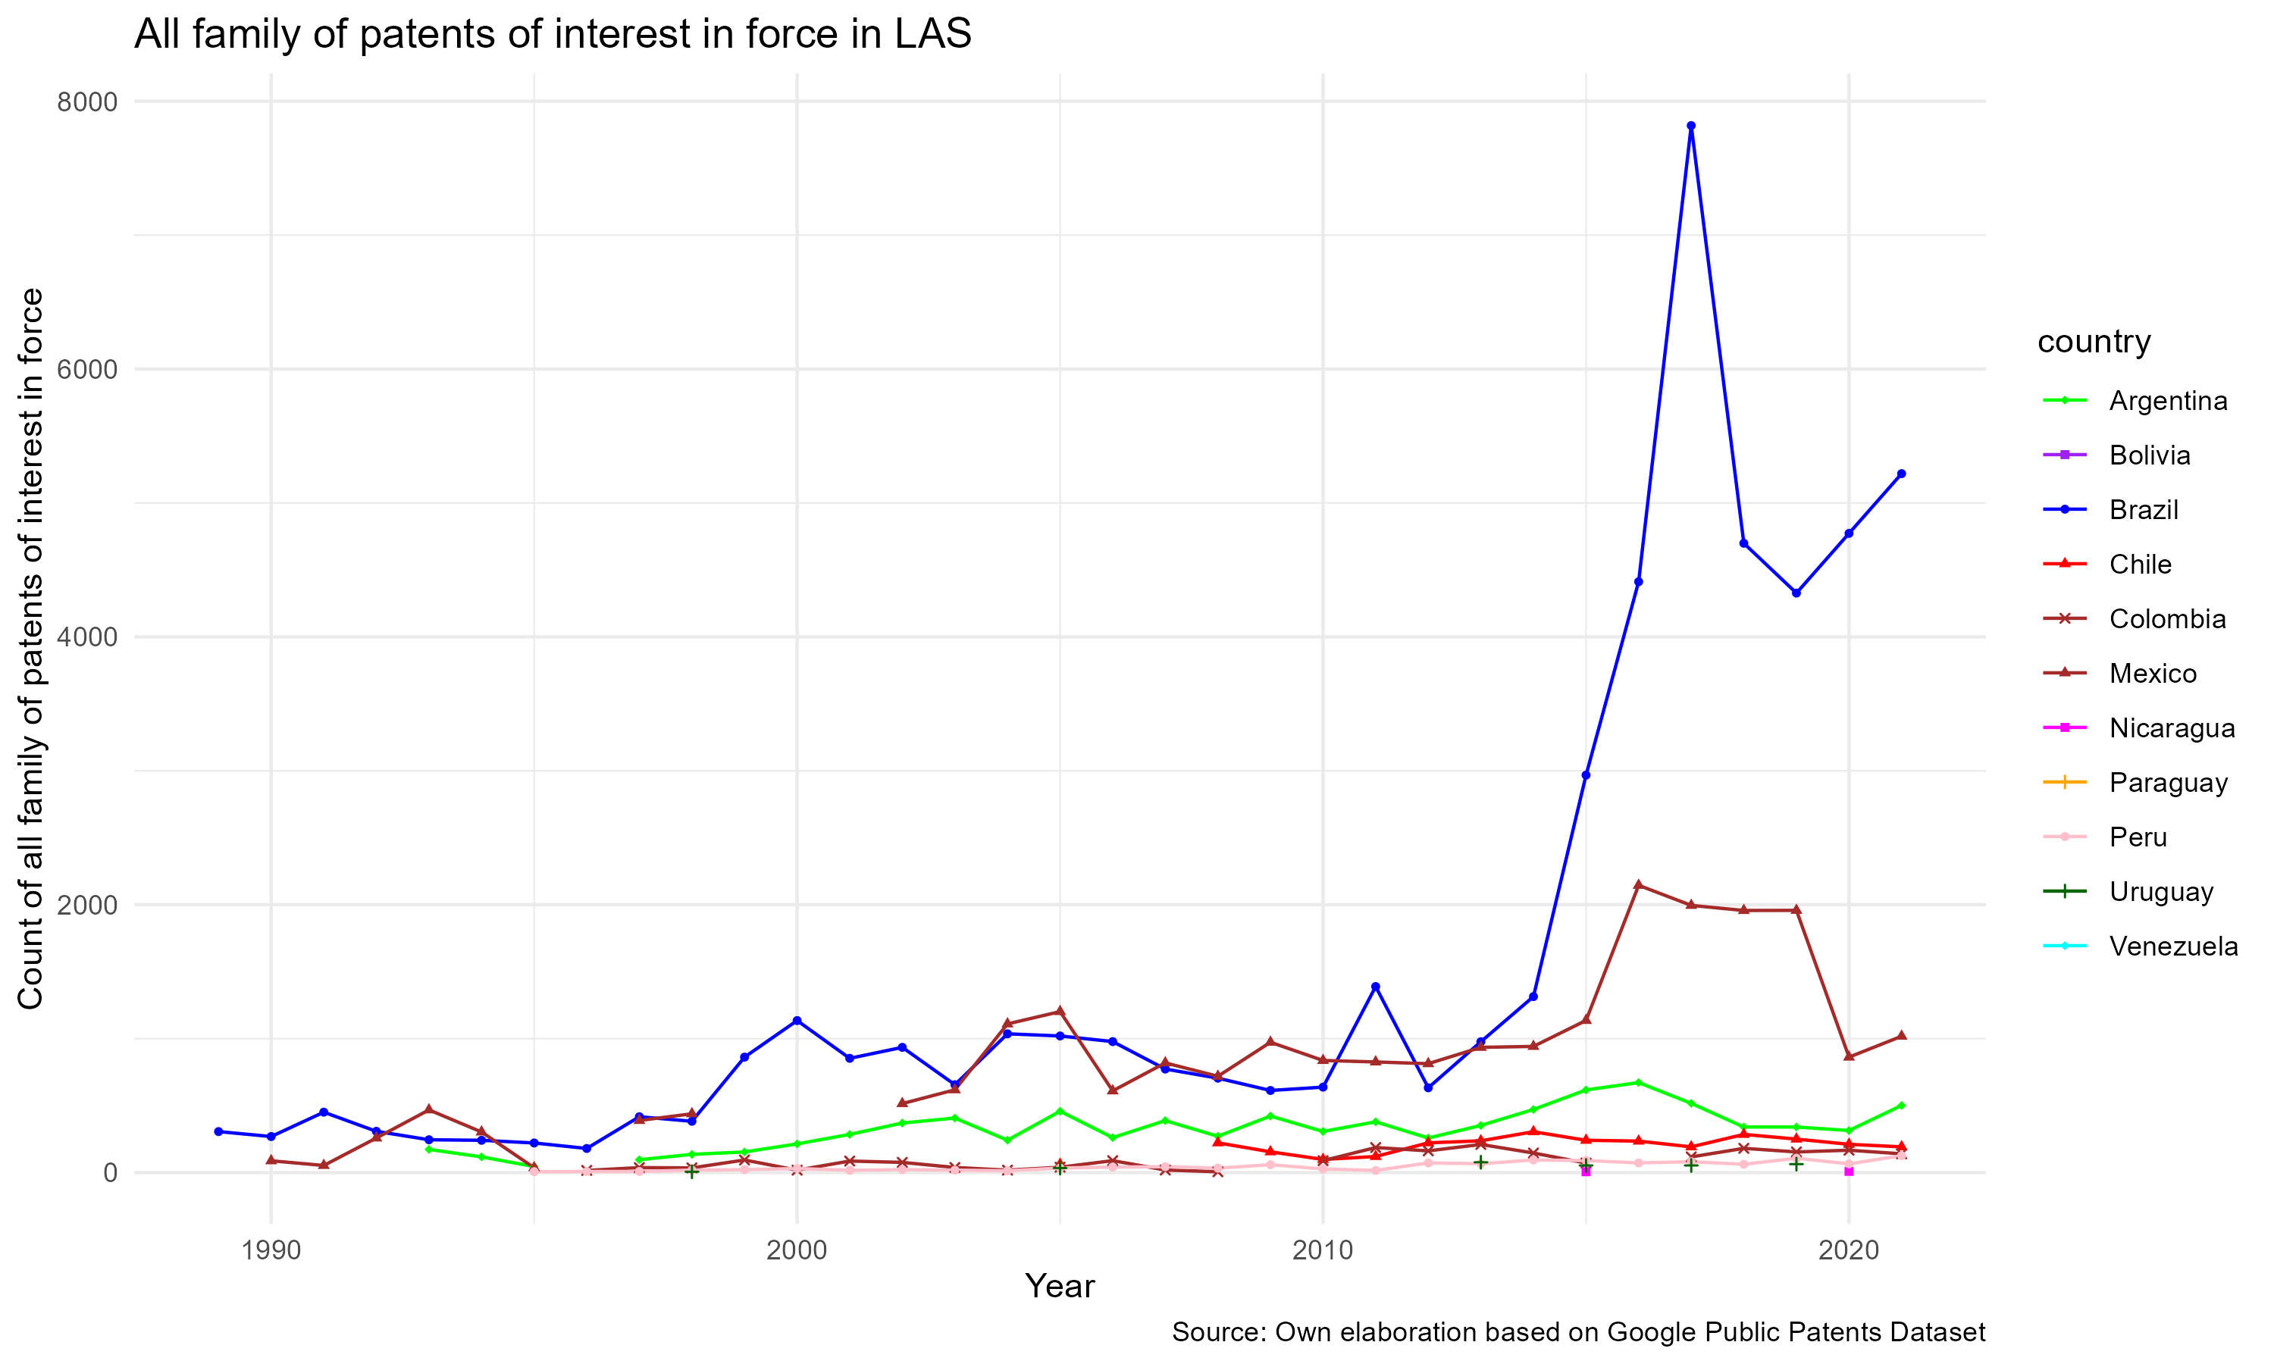

Figure 5: PATS LAS Plot

Just as in the Global Economy data, the Figure @ref(fig:PATS_LAS) with Latin American subsample data shows two clear groups of countries. Brazil and Mexico appear as the only countries that register at least 1 year with 1000 or more internationalized patents in force, with a clear dominance of Brazil in the region; while the rest of the countries in the subsample show a very low level of inventive activity in the sectors of interest.

## TIDR among selected Latin American countries and the Brazilian case

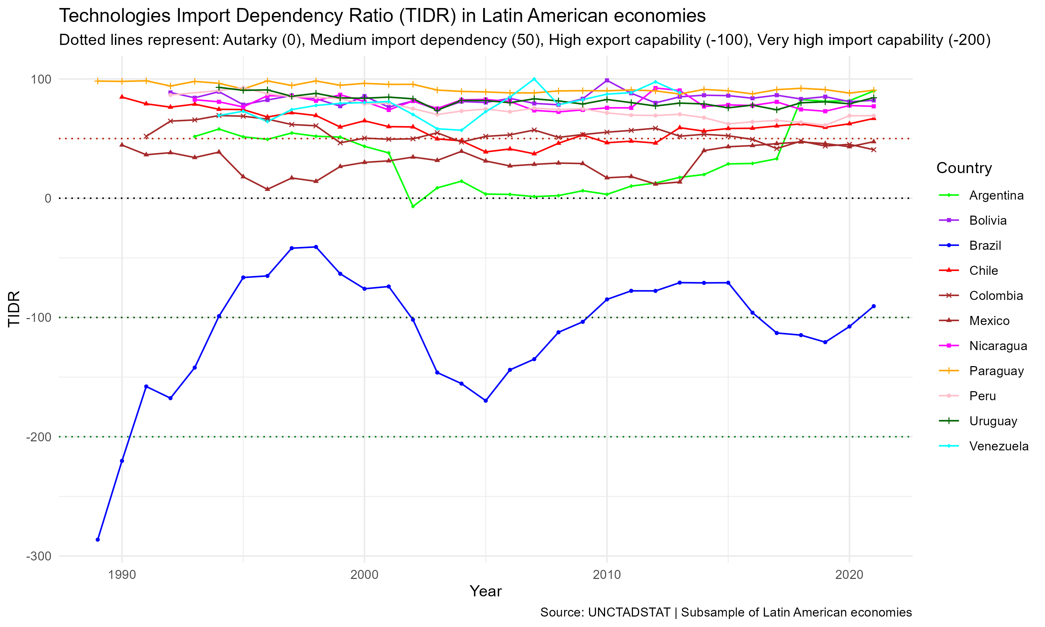

Figure 6: TIDR LAS Plot

In Figure @ref(fig:TIDR_LAS) two patterns are evident. First, the data suggests that some countries in the subsample have had high dependency on technology imports in the sectors of agriculture and mining through time, with values that are always above 50 (medium-high dependency) and in some cases near 100 (i.e. Paraguay, Peru, Venezuela, Uruguay, Nicaragua and Bolivia). Second, there are a set of countries composed by Colombia, Chile, Mexico and Argentina that have had a more dynamic relationship with technology imports, registering values below 50 in some years and (specially the last two).

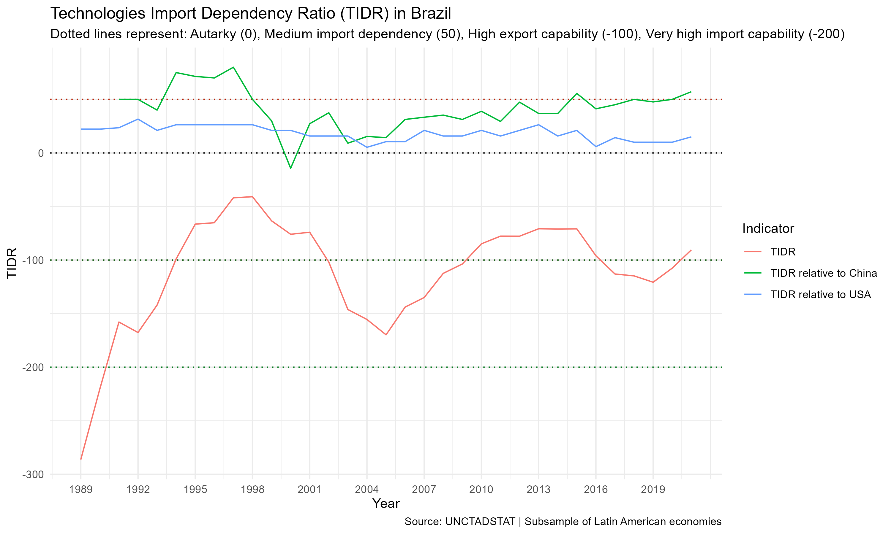

Figure 7: TIDR BRA Plot

Brazil’s data in Figure @ref(fig:TIDR_BRA) is the only in the Latin American subsample that shows a dramatic change over time, showing that the country once was a very highly capable exporter of these technologies that have seen its capability contracted in in the global technified capital market through time (although between 2001 and 2005 it showed signs of improvement). To the authors, this is a sign of a country that has lost some of its capacity to produce and trade these technologies, and therefore should be further explored as a case of a kind of *middle economy* that, even when it has a strong local industry compared to its neighbors, still gets weakened in the global economy of technified capital.

# Appendix A: Data Retrieval and Processing queries for the Google Patents Public Dataset

SELECT publication_number AS patent_id, country_code, cpc[SAFE_OFFSET(0)].code AS patent_cpc_class, SUBSTR(CAST(publication_date AS STRING), 1, 4) AS pub_year, – Extract year from the date IF(family_id IS NOT NULL, TRUE, FALSE) AS is_global_patent – Logical column to check family_patent_id presence FROM patents-public-data.patents.publications WHERE (cpc[SAFE_OFFSET(0)].code LIKE ‘A01%’ OR cpc[SAFE_OFFSET(0)].code LIKE ‘E21%’ OR cpc[SAFE_OFFSET(0)].code LIKE ‘G05%’ OR cpc[SAFE_OFFSET(0)].code LIKE ‘G06%’ OR cpc[SAFE_OFFSET(0)].code LIKE ‘G08%’ OR cpc[SAFE_OFFSET(0)].code LIKE ‘G11%’ OR cpc[SAFE_OFFSET(0)].code LIKE ‘G16Y%’) AND family_id IS NOT NULL – Filter rows where family_patent_id is present

# Appendix B: Years of data available for each variable and country in the final dataset

| Country | TIDR | TIDR relative to China | TIDR relative to USA | Agricultural patents count | Mining patents count | Data processing patents count | Net_FDI_GFCF | Economy Complexity Index | Period with observations |
| --- | --- | --- | --- | --- | --- | --- | --- | --- | --- |
| Australia | 34 | 34 | 34 | 34 | 34 | 34 | 32 | 34 | 1988 - 2021 |
| Germany | 34 | 34 | 34 | 0 | 0 | 0 | 32 | 34 | 1988 - 2021 |
| Finland | 34 | 34 | 34 | 34 | 34 | 34 | 32 | 34 | 1988 - 2021 |
| Greece | 33 | 33 | 33 | 33 | 15 | 33 | 31 | 33 | 1988 - 2021 |
| Iceland | 34 | 29 | 34 | 27 | 9 | 20 | 32 | 0 | 1988 - 2021 |
| India | 34 | 32 | 34 | 28 | 17 | 24 | 32 | 34 | 1988 - 2021 |
| Japan | 34 | 34 | 34 | 34 | 34 | 34 | 32 | 34 | 1988 - 2021 |
| Portugal | 34 | 34 | 34 | 34 | 31 | 34 | 32 | 34 | 1988 - 2021 |
| South Korea | 34 | 33 | 34 | 34 | 34 | 34 | 32 | 34 | 1988 - 2021 |
| Switzerland | 34 | 34 | 34 | 34 | 33 | 34 | 32 | 34 | 1988 - 2021 |
| Thailand | 34 | 34 | 34 | 0 | 0 | 0 | 32 | 34 | 1988 - 2021 |
| Bangladesh | 24 | 23 | 24 | 0 | 0 | 0 | 24 | 25 | 1988 - 2021 |
| Brazil | 33 | 31 | 33 | 33 | 33 | 33 | 31 | 33 | 1988 - 2021 |
| Canada | 33 | 33 | 33 | 33 | 33 | 33 | 32 | 33 | 1988 - 2021 |
| Cyprus | 33 | 33 | 33 | 21 | 13 | 14 | 32 | 33 | 1988 - 2021 |
| Denmark | 32 | 32 | 32 | 32 | 32 | 32 | 31 | 32 | 1988 - 2021 |
| Indonesia | 65 | 65 | 65 | 12 | 12 | 16 | 64 | 65 | 1988 - 2021 |
| Malaysia | 33 | 33 | 33 | 33 | 33 | 32 | 32 | 33 | 1988 - 2021 |
| New Zealand | 33 | 33 | 33 | 33 | 33 | 33 | 32 | 33 | 1988 - 2021 |
| Oman | 32 | 31 | 32 | 0 | 0 | 0 | 32 | 33 | 1988 - 2021 |
| Paraguay | 33 | 22 | 33 | 0 | 0 | 0 | 32 | 33 | 1988 - 2021 |
| Romania | 33 | 32 | 33 | 32 | 23 | 25 | 32 | 33 | 1988 - 2021 |
| Singapore | 33 | 33 | 33 | 33 | 33 | 33 | 32 | 33 | 1988 - 2021 |
| Spain | 33 | 33 | 33 | 33 | 33 | 33 | 32 | 33 | 1988 - 2021 |
| Turkey | 33 | 32 | 33 | 33 | 25 | 33 | 32 | 33 | 1988 - 2021 |
| Chile | 32 | 32 | 32 | 15 | 15 | 15 | 32 | 32 | 1988 - 2021 |
| Madagascar | 32 | 32 | 32 | 0 | 0 | 0 | 32 | 32 | 1988 - 2021 |
| Malawi | 27 | 24 | 27 | 1 | 0 | 0 | 30 | 30 | 1988 - 2021 |
| Mexico | 32 | 32 | 32 | 31 | 28 | 28 | 32 | 32 | 1988 - 2021 |
| Sri Lanka | 27 | 27 | 27 | 0 | 0 | 0 | 27 | 27 | 1988 - 2021 |
| Macao SAR China | 31 | 31 | 31 | 0 | 0 | 0 | 31 | 0 | 1988 - 2021 |
| Colombia | 31 | 31 | 31 | 27 | 25 | 25 | 31 | 31 | 1988 - 2021 |
| Ecuador | 31 | 30 | 31 | 23 | 20 | 21 | 31 | 31 | 1988 - 2021 |
| Guyana | 27 | 27 | 27 | 0 | 0 | 0 | 27 | 0 | 1988 - 2021 |
| Jamaica | 29 | 27 | 29 | 0 | 0 | 0 | 29 | 29 | 1988 - 2021 |
| Saudi Arabia | 30 | 30 | 30 | 18 | 18 | 17 | 30 | 30 | 1988 - 2021 |
| Trinidad & Tobago | 31 | 31 | 30 | 0 | 0 | 0 | 31 | 31 | 1988 - 2021 |
| Tunisia | 31 | 31 | 31 | 26 | 21 | 20 | 31 | 31 | 1988 - 2021 |
| United States | 31 | 31 | 0 | 31 | 31 | 31 | 31 | 31 | 1988 - 2021 |
| United Arab Emirates | 26 | 26 | 26 | 0 | 0 | 0 | 26 | 26 | 1988 - 2021 |
| Algeria | 26 | 26 | 26 | 5 | 6 | 5 | 26 | 26 | 1988 - 2021 |
| Belize | 30 | 29 | 30 | 0 | 0 | 0 | 30 | 0 | 1988 - 2021 |
| Bolivia | 30 | 30 | 30 | 0 | 0 | 0 | 30 | 30 | 1988 - 2021 |
| Brunei | 25 | 25 | 25 | 0 | 0 | 0 | 25 | 0 | 1988 - 2021 |
| China | 60 | 44 | 60 | 60 | 60 | 60 | 60 | 60 | 1988 - 2021 |
| Croatia | 30 | 30 | 30 | 28 | 24 | 25 | 30 | 30 | 1988 - 2021 |
| Hungary | 30 | 30 | 30 | 30 | 24 | 30 | 30 | 30 | 1988 - 2021 |
| Ireland | 30 | 30 | 30 | 30 | 28 | 30 | 30 | 30 | 1988 - 2021 |
| Kenya | 23 | 22 | 22 | 0 | 0 | 0 | 23 | 23 | 1988 - 2021 |
| Myanmar (Burma) | 14 | 14 | 14 | 0 | 0 | 0 | 14 | 14 | 1988 - 2021 |
| Netherlands | 30 | 30 | 30 | 30 | 30 | 30 | 30 | 30 | 1988 - 2021 |
| Peru | 29 | 29 | 29 | 27 | 27 | 27 | 29 | 29 | 1988 - 2021 |
| St. Lucia | 29 | 21 | 29 | 0 | 0 | 0 | 8 | 0 | 1988 - 2021 |
| Sweden | 30 | 30 | 30 | 30 | 30 | 30 | 30 | 30 | 1988 - 2021 |
| Argentina | 29 | 29 | 29 | 28 | 28 | 28 | 29 | 29 | 1988 - 2021 |
| Bhutan | 12 | 8 | 10 | 0 | 0 | 0 | 12 | 0 | 1988 - 2021 |
| Burundi | 29 | 28 | 29 | 0 | 0 | 0 | 29 | 0 | 1988 - 2021 |
| Central African Republic | 29 | 26 | 29 | 0 | 0 | 0 | 29 | 0 | 1988 - 2021 |
| Hong Kong SAR China | 29 | 29 | 29 | 28 | 27 | 29 | 29 | 29 | 1988 - 2021 |
| Congo - Brazzaville | 18 | 17 | 18 | 0 | 0 | 0 | 18 | 18 | 1988 - 2021 |
| Czechia | 28 | 28 | 28 | 28 | 27 | 28 | 28 | 28 | 1988 - 2021 |
| Dominica | 25 | 17 | 25 | 0 | 0 | 0 | 7 | 0 | 1988 - 2021 |
| Gabon | 28 | 26 | 27 | 0 | 0 | 0 | 28 | 28 | 1988 - 2021 |
| Grenada | 29 | 21 | 29 | 0 | 0 | 0 | 9 | 0 | 1988 - 2021 |
| Guatemala | 29 | 29 | 29 | 24 | 0 | 12 | 29 | 29 | 1988 - 2021 |
| Mauritius | 29 | 29 | 29 | 0 | 0 | 0 | 29 | 29 | 1988 - 2021 |
| Morocco | 29 | 29 | 29 | 28 | 22 | 24 | 29 | 29 | 1988 - 2021 |
| Nicaragua | 29 | 28 | 29 | 15 | 2 | 8 | 29 | 29 | 1988 - 2021 |
| Norway | 29 | 29 | 29 | 29 | 29 | 29 | 29 | 29 | 1988 - 2021 |
| St. Kitts & Nevis | 24 | 12 | 24 | 0 | 0 | 0 | 5 | 0 | 1988 - 2021 |
| St. Vincent & Grenadines | 28 | 20 | 28 | 0 | 0 | 0 | 9 | 0 | 1988 - 2021 |
| United Kingdom | 29 | 29 | 29 | 0 | 0 | 0 | 29 | 29 | 1988 - 2021 |
| Vanuatu | 8 | 8 | 8 | 0 | 0 | 0 | 6 | 0 | 1988 - 2021 |
| Austria | 28 | 28 | 28 | 28 | 28 | 28 | 28 | 28 | 1988 - 2021 |
| Costa Rica | 28 | 28 | 28 | 25 | 4 | 19 | 28 | 28 | 1988 - 2021 |
| Egypt | 28 | 28 | 28 | 22 | 22 | 18 | 28 | 28 | 1988 - 2021 |
| El Salvador | 27 | 27 | 27 | 17 | 2 | 3 | 27 | 27 | 1988 - 2021 |
| France | 28 | 28 | 28 | 0 | 0 | 0 | 28 | 28 | 1988 - 2021 |
| Greenland | 25 | 13 | 20 | 0 | 0 | 0 | 0 | 0 | 1988 - 2021 |
| Honduras | 26 | 26 | 26 | 14 | 0 | 2 | 26 | 26 | 1988 - 2021 |
| Italy | 28 | 28 | 28 | 28 | 28 | 28 | 28 | 28 | 1988 - 2021 |
| Jordan | 27 | 27 | 27 | 8 | 16 | 12 | 27 | 27 | 1988 - 2021 |
| Latvia | 28 | 26 | 28 | 16 | 5 | 15 | 28 | 28 | 1988 - 2021 |
| Lithuania | 28 | 25 | 28 | 23 | 12 | 24 | 28 | 28 | 1988 - 2021 |
| Malta | 28 | 26 | 28 | 0 | 0 | 0 | 28 | 0 | 1988 - 2021 |
| Martinique | 2 | 1 | 2 | 0 | 0 | 0 | 0 | 0 | 1988 - 2021 |
| Mozambique | 26 | 24 | 26 | 0 | 0 | 0 | 27 | 27 | 1988 - 2021 |
| Nepal | 18 | 18 | 18 | 0 | 0 | 0 | 18 | 18 | 1988 - 2021 |
| North Macedonia | 28 | 24 | 28 | 0 | 0 | 0 | 28 | 28 | 1988 - 2021 |
| Poland | 28 | 28 | 28 | 28 | 28 | 28 | 28 | 28 | 1988 - 2021 |
| Moldova | 28 | 23 | 27 | 25 | 3 | 17 | 28 | 28 | 1988 - 2021 |
| Seychelles | 28 | 28 | 28 | 0 | 0 | 0 | 28 | 0 | 1988 - 2021 |
| Slovakia | 28 | 28 | 28 | 28 | 25 | 28 | 28 | 28 | 1988 - 2021 |
| Slovenia | 28 | 27 | 28 | 28 | 21 | 27 | 28 | 28 | 1988 - 2021 |
| Suriname | 26 | 24 | 26 | 0 | 0 | 0 | 11 | 0 | 1988 - 2021 |
| Togo | 27 | 27 | 27 | 0 | 0 | 0 | 27 | 27 | 1988 - 2021 |
| Uganda | 28 | 28 | 28 | 0 | 0 | 0 | 28 | 28 | 1988 - 2021 |
| Uruguay | 28 | 28 | 28 | 28 | 6 | 26 | 28 | 28 | 1988 - 2021 |
| Venezuela | 20 | 16 | 20 | 0 | 0 | 0 | 20 | 20 | 1988 - 2021 |
| Andorra | 26 | 26 | 10 | 0 | 0 | 0 | 0 | 0 | 1988 - 2021 |
| Bermuda | 19 | 17 | 19 | 0 | 0 | 0 | 18 | 0 | 1988 - 2021 |
| Burkina Faso | 27 | 27 | 27 | 0 | 0 | 0 | 27 | 27 | 1988 - 2021 |
| Cameroon | 27 | 27 | 27 | 0 | 0 | 0 | 27 | 27 | 1988 - 2021 |
| Chad | 1 | 1 | 1 | 0 | 0 | 0 | 1 | 1 | 1988 - 2021 |
| Comoros | 27 | 18 | 3 | 0 | 0 | 0 | 27 | 0 | 1988 - 2021 |
| Côte d’Ivoire | 27 | 27 | 27 | 0 | 0 | 0 | 27 | 27 | 1988 - 2021 |
| Estonia | 27 | 26 | 27 | 24 | 7 | 24 | 27 | 27 | 1988 - 2021 |
| Ethiopia | 52 | 52 | 52 | 0 | 0 | 0 | 52 | 52 | 1988 - 2021 |
| Gambia | 27 | 27 | 27 | 0 | 0 | 0 | 27 | 0 | 1988 - 2021 |
| Guinea | 17 | 16 | 17 | 0 | 0 | 0 | 17 | 17 | 1988 - 2021 |
| Israel | 27 | 27 | 27 | 27 | 27 | 27 | 27 | 27 | 1988 - 2021 |
| Kazakhstan | 26 | 24 | 24 | 0 | 0 | 0 | 26 | 26 | 1988 - 2021 |
| Kiribati | 22 | 17 | 19 | 0 | 0 | 0 | 17 | 0 | 1988 - 2021 |
| Kyrgyzstan | 24 | 24 | 23 | 0 | 0 | 0 | 24 | 24 | 1988 - 2021 |
| Maldives | 27 | 22 | 25 | 0 | 0 | 0 | 27 | 0 | 1988 - 2021 |
| Niger | 27 | 25 | 27 | 0 | 0 | 0 | 27 | 27 | 1988 - 2021 |
| Panama | 27 | 27 | 27 | 11 | 3 | 10 | 27 | 27 | 1988 - 2021 |
| Sudan | 48 | 48 | 46 | 0 | 0 | 0 | 48 | 48 | 1988 - 2021 |
| Tanzania | 27 | 27 | 27 | 0 | 0 | 0 | 27 | 27 | 1988 - 2021 |
| Zambia | 27 | 27 | 25 | 0 | 0 | 0 | 27 | 27 | 1988 - 2021 |
| Zimbabwe | 23 | 23 | 23 | 1 | 0 | 0 | 23 | 23 | 1988 - 2021 |
| Albania | 26 | 25 | 26 | 0 | 0 | 0 | 26 | 26 | 1988 - 2021 |
| Azerbaijan | 26 | 23 | 25 | 0 | 0 | 0 | 26 | 26 | 1988 - 2021 |
| Bulgaria | 26 | 26 | 26 | 21 | 13 | 26 | 26 | 26 | 1988 - 2021 |
| Dominican Republic | 21 | 21 | 21 | 19 | 4 | 11 | 23 | 23 | 1988 - 2021 |
| Faroe Islands | 14 | 12 | 14 | 0 | 0 | 0 | 0 | 0 | 1988 - 2021 |
| French Polynesia | 26 | 26 | 26 | 0 | 0 | 0 | 26 | 0 | 1988 - 2021 |
| Georgia | 26 | 23 | 26 | 23 | 7 | 17 | 26 | 26 | 1988 - 2021 |
| Ghana | 25 | 25 | 25 | 0 | 0 | 0 | 25 | 25 | 1988 - 2021 |
| Mali | 20 | 19 | 20 | 0 | 0 | 0 | 20 | 20 | 1988 - 2021 |
| Mongolia | 20 | 20 | 20 | 0 | 0 | 0 | 21 | 21 | 1988 - 2021 |
| Nigeria | 24 | 24 | 24 | 0 | 0 | 0 | 24 | 24 | 1988 - 2021 |
| Philippines | 26 | 26 | 26 | 23 | 11 | 12 | 26 | 26 | 1988 - 2021 |
| Russia | 26 | 26 | 26 | 26 | 26 | 26 | 26 | 26 | 1988 - 2021 |
| Rwanda | 25 | 24 | 25 | 0 | 0 | 0 | 25 | 25 | 1988 - 2021 |
| Senegal | 26 | 26 | 26 | 0 | 0 | 0 | 26 | 26 | 1988 - 2021 |
| Solomon Islands | 18 | 18 | 18 | 0 | 0 | 0 | 18 | 0 | 1988 - 2021 |
| Ukraine | 26 | 26 | 26 | 26 | 24 | 24 | 26 | 26 | 1988 - 2021 |
| Armenia | 24 | 22 | 24 | 0 | 0 | 0 | 24 | 24 | 1988 - 2021 |
| Bahamas | 25 | 13 | 25 | 0 | 0 | 0 | 25 | 0 | 1988 - 2021 |
| Barbados | 25 | 23 | 25 | 0 | 0 | 0 | 25 | 0 | 1988 - 2021 |
| Cape Verde | 25 | 24 | 25 | 0 | 0 | 0 | 25 | 0 | 1988 - 2021 |
| Iran | 21 | 21 | 15 | 0 | 0 | 0 | 21 | 21 | 1988 - 2021 |
| Lebanon | 25 | 25 | 25 | 0 | 0 | 0 | 25 | 25 | 1988 - 2021 |
| Turkmenistan | 4 | 2 | 4 | 0 | 0 | 0 | 4 | 4 | 1988 - 2021 |
| Tuvalu | 9 | 2 | 0 | 0 | 0 | 0 | 6 | 0 | 1988 - 2021 |
| Belarus | 24 | 24 | 24 | 0 | 0 | 0 | 24 | 24 | 1988 - 2021 |
| Benin | 24 | 24 | 24 | 0 | 0 | 0 | 24 | 24 | 1988 - 2021 |
| Papua New Guinea | 11 | 11 | 11 | 0 | 0 | 0 | 11 | 11 | 1988 - 2021 |
| Antigua & Barbuda | 18 | 16 | 18 | 0 | 0 | 0 | 9 | 0 | 1988 - 2021 |
| Belgium | 23 | 23 | 23 | 23 | 19 | 23 | 20 | 23 | 1988 - 2021 |
| Cuba | 11 | 11 | 8 | 9 | 1 | 7 | 0 | 11 | 1988 - 2021 |
| Luxembourg | 23 | 21 | 23 | 19 | 5 | 22 | 20 | 0 | 1988 - 2021 |
| Montserrat | 22 | 11 | 22 | 0 | 0 | 0 | 9 | 0 | 1988 - 2021 |
| New Caledonia | 17 | 17 | 17 | 0 | 0 | 0 | 16 | 0 | 1988 - 2021 |
| São Tomé & Príncipe | 23 | 13 | 16 | 0 | 0 | 0 | 23 | 0 | 1988 - 2021 |
| Turks & Caicos Islands | 13 | 0 | 13 | 0 | 0 | 0 | 0 | 0 | 1988 - 2021 |
| Anguilla | 8 | 3 | 8 | 0 | 0 | 0 | 0 | 0 | 1988 - 2021 |
| Aruba | 22 | 20 | 22 | 0 | 0 | 0 | 22 | 0 | 1988 - 2021 |
| Bahrain | 22 | 22 | 22 | 0 | 0 | 0 | 22 | 22 | 1988 - 2021 |
| Botswana | 22 | 22 | 22 | 0 | 0 | 0 | 22 | 22 | 1988 - 2021 |
| Cambodia | 22 | 22 | 22 | 0 | 0 | 0 | 22 | 22 | 1988 - 2021 |
| Eswatini | 22 | 17 | 18 | 0 | 0 | 0 | 22 | 22 | 1988 - 2021 |
| Fiji | 22 | 22 | 22 | 0 | 0 | 0 | 22 | 0 | 1988 - 2021 |
| Kuwait | 19 | 19 | 19 | 0 | 0 | 0 | 20 | 20 | 1988 - 2021 |
| Lesotho | 22 | 13 | 13 | 0 | 0 | 0 | 22 | 0 | 1988 - 2021 |
| Mauritania | 22 | 19 | 22 | 0 | 0 | 0 | 22 | 22 | 1988 - 2021 |
| Namibia | 22 | 22 | 22 | 0 | 0 | 0 | 22 | 22 | 1988 - 2021 |
| Qatar | 20 | 20 | 20 | 0 | 0 | 0 | 21 | 21 | 1988 - 2021 |
| Sierra Leone | 7 | 7 | 7 | 0 | 0 | 0 | 7 | 0 | 1988 - 2021 |
| South Africa | 22 | 22 | 22 | 22 | 22 | 22 | 22 | 22 | 1988 - 2021 |
| Tajikistan | 7 | 6 | 7 | 1 | 0 | 0 | 7 | 7 | 1988 - 2021 |
| Tonga | 15 | 12 | 15 | 0 | 0 | 0 | 15 | 0 | 1988 - 2021 |
| Vietnam | 22 | 22 | 22 | 4 | 0 | 0 | 22 | 22 | 1988 - 2021 |
| Wallis & Futuna | 7 | 5 | 7 | 0 | 0 | 0 | 0 | 0 | 1988 - 2021 |
| Cook Islands | 9 | 7 | 8 | 0 | 0 | 0 | 0 | 0 | 1988 - 2021 |
| Samoa | 20 | 18 | 20 | 0 | 0 | 0 | 20 | 0 | 1988 - 2021 |
| Syria | 10 | 10 | 10 | 0 | 0 | 0 | 10 | 0 | 1988 - 2021 |
| Bosnia & Herzegovina | 19 | 19 | 19 | 0 | 0 | 0 | 19 | 19 | 1988 - 2021 |
| Eritrea | 1 | 1 | 1 | 0 | 0 | 0 | 1 | 0 | 1988 - 2021 |
| Guinea-Bissau | 8 | 5 | 4 | 0 | 0 | 0 | 8 | 0 | 1988 - 2021 |
| Pakistan | 19 | 19 | 19 | 0 | 0 | 0 | 19 | 19 | 1988 - 2021 |
| Angola | 18 | 18 | 18 | 0 | 0 | 0 | 18 | 18 | 1988 - 2021 |
| Timor-Leste | 8 | 8 | 7 | 0 | 0 | 0 | 8 | 0 | 1988 - 2021 |
| Yemen | 14 | 14 | 14 | 0 | 0 | 0 | 14 | 14 | 1988 - 2021 |
| Montenegro | 16 | 16 | 16 | 11 | 2 | 8 | 16 | 0 | 1988 - 2021 |
| Serbia | 16 | 16 | 16 | 16 | 13 | 16 | 16 | 16 | 1988 - 2021 |
| Libya | 8 | 8 | 8 | 0 | 0 | 0 | 8 | 8 | 1988 - 2021 |
| Palau | 12 | 12 | 12 | 0 | 0 | 0 | 12 | 0 | 1988 - 2021 |
| Palestinian Territories | 15 | 15 | 15 | 0 | 0 | 0 | 15 | 0 | 1988 - 2021 |
| Afghanistan | 9 | 9 | 7 | 0 | 0 | 0 | 9 | 9 | 1988 - 2021 |
| Djibouti | 2 | 2 | 2 | 0 | 0 | 0 | 1 | 0 | 1988 - 2021 |
| Laos | 12 | 12 | 12 | 0 | 0 | 0 | 12 | 12 | 1988 - 2021 |
| Cayman Islands | 4 | 3 | 4 | 0 | 0 | 0 | 4 | 0 | 1988 - 2021 |
| Iraq | 1 | 1 | 1 | 0 | 0 | 0 | 1 | 1 | 1988 - 2021 |
| Congo - Kinshasa | 7 | 7 | 7 | 0 | 0 | 0 | 7 | 7 | 1988 - 2021 |
| Curaçao | 4 | 4 | 4 | 0 | 0 | 0 | 3 | 0 | 1988 - 2021 |
| Liberia | 5 | 5 | 5 | 0 | 0 | 0 | 5 | 5 | 1988 - 2021 |
| Uzbekistan | 5 | 5 | 5 | 0 | 0 | 0 | 5 | 5 | 1988 - 2021 |

# References

Acs, Zoltan J, Luc Anselin, and Attila Varga. 2002. “Patents and Innovation Counts as Measures of Regional Production of New Knowledge.” *Research Policy* 31 (7): 1069–85. https://doi.org/<https://doi.org/10.1016/S0048-7333(01)00184-6>.

Arel-Bundock, Vincent, Nils Enevoldsen, and CJ Yetman. 2023. *Countrycode: Convert Country Names and Country Codes*. <https://CRAN.R-project.org/package=countrycode>.

Bochtler, Paul, Harriet Goers, Chris Muir, and Alicia Schep. 2024. *Comtradr: Interface with the United Nations Comtrade API*. <https://cran.r-project.org/package=comtradr>.

European Patent Office. 2024. “Espacenet Patent CPC Search.” <https://worldwide.espacenet.com/patent/cpc-browser>.

Food and Agriculture Organization of the United Nations (FAO). 2023. “Cereals Imports Dependency Ratio.” <https://www.fao.org/faostat/en/#data/FS>.

Google Cloud. 2024. “Google Patents Public Data.” <https://console.cloud.google.com/marketplace/product/google_patents_public_datasets/google-patents-public-data?project=global-patents-analysis>.

Martinez, Catalina. 2010. “Insight into Different Types of Patent Families.” https://doi.org/<https://doi.org/https://doi.org/10.1787/5kml97dr6ptl-en>.

Network, Tax Justice. 2024. “Corporate Tax Haven Index Full List.” <https://cthi.taxjustice.net/countries>.

Oldham, Paul. 2022. *The WIPO Patent Analytics Handbook*. <https://wipo-analytics.github.io/>.

Oxfam. 2016. “Race to the Bottom: How Corporate Tax Dodging Is Destroying the World.” <https://www-cdn.oxfam.org/s3fs-public/bp-race-to-bottom-corporate-tax-121216-en.pdf>.

Parliament, European. 2017. “Foreign Direct Investment in the EU: Opportunities and Challenges.” <https://www.europarl.europa.eu/RegData/etudes/BRIE/2017/614633/EPRS_BRI(2017)614633_EN.pdf>.

R., Rodrigo B. 2024. “Public ITS Repository.” <https://github.com/RodrigoBR1/Public_ITS>.

Varoufakis, Y. 2023. *Technofeudalism: What Killed Capitalism*. Bodley Head. <https://books.google.cl/books?id=tbqazwEACAAJ>.

Wickham, Hadley, Romain François, Lionel Henry, and Kirill Müller. 2023. *Dplyr: A Grammar of Data Manipulation*. <https://CRAN.R-project.org/package=dplyr>.

1. That is, the idea that a model, theory or framework should be constructed and tested with the least amount of variables possible and still achieve the desired level of explanation.
2. An *internationalized patent* is a patent that has been granted a family id in the international patent system, which basically means that it has been recognized as a patent in force globally. For a more detailed explanation of internationalization in the patent system and its analysis, see Martinez (2010).
3. Data freely available at https://unctadstat.unctad.org/datacentre/.
4. The private ownership (despite being open to public consultation) of the Google Patents Public Dataset reminds of the argument pointed by Varoufakis about how the tech industry is becoming a new force of rentier feudalism, where the control of the data infrastructure is a key element of power (Varoufakis 2023).
5. For more information on how to access and explore the Google Patents Public Dataset, see the official documentation at https://cloud.google.com/blog/topics/public-datasets/google-patents-public-dataset-now-available-bigquery.
6. Using the adapted FAO’s cereal dependency formula interpretation.
7. The repository is available at https://github.com/RodrigoBR1/Public_ITS.git, for further information on the data and the analysis.
8. Mean values often hide the variance of the data, which in this case would be evolution of the TIDR, patent ownership and net FDI of a country through time. Nevertheless, for this paper the mean values are a good starting point to assess the relative position of a country in the global economy through time.
9. Which the authors suggest are the biggest owners of “patent families”, as it points to patents that give ownership over innovation in at least 2 countries at the same time (hence they are “related” as family), and allow for the inventor to protect the technology from reproduction without permission (or commision).
10. FDI as net stock of GFCF can be a complex measure to use, but the authors suggest its number highlights two key factors in the global economy: first, the capacity of a country to attract capital from other territories (that is, the measure allows to track stock of FDI in a country in a given time) in contrast to its capacity to invest abroad (which is represented by the sign that the result of the ratio gives, if positive it means it receives more than gives); and second, the idea that FDI becomes problematic when it is at the base of the fixed capital of a country, and therefore gives the investor a certain level structural of control over the local economy.