


Nom : COELHO FERNANDES

Master 2 SD Prénom : Rodrigo César

Reinforcement Learning

Séance de TP 3
Méthodes de Monte Carlo, Différence Temporelle

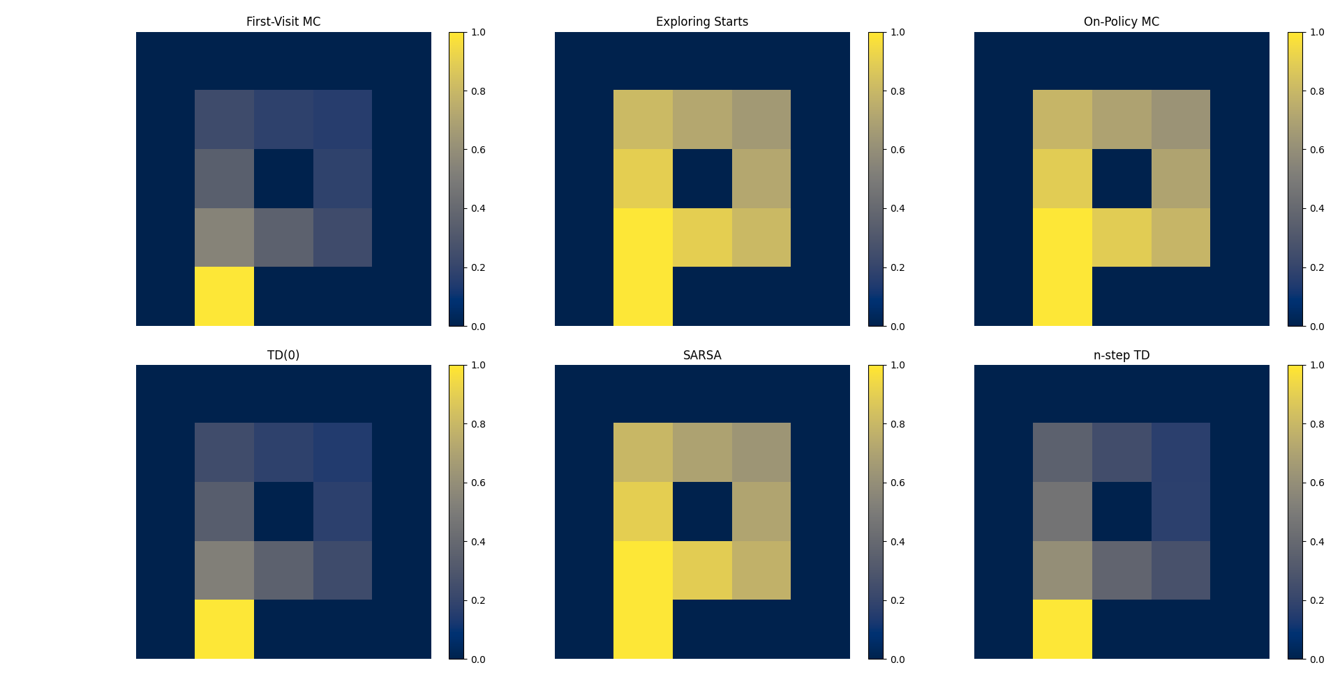

 | Exec Times (s) | Average Value Score
First-Visit MC | 16.7263s | 0.3590
Exploring Starts | 5.5229s | 0.8356
On-Policy MC | 4.7264s | 0.8213
TD(0) | 7.3774s | 0.3537
SARSA | 5.1245s | 0.8223
n-step TD | 8.1829s | 0.4056

Monte Carlo Exploring Starts, On-Policy MC Control, and SARSA emerged as the most effective approaches in terms of value estimation quality, exhibiting superior performance relative to the other methods. Thise is surely related to the policy improvement capability.

From a computational perspective, Those three methods demonstrated good balance between speed and performance, with very similar results. In contrast, First-Visit Monte Carlo and TD(0) showed comparatively weaker value estimation performance while also not providing a proportional advantage in execution time.

