**Table of contents:**

* **Application url (via cpanel)**
* **Links for the JSON and JS script files**
* **JSON validation**
* **SDLC methodology used in this assignment**
* **Cpanel Access details**

**Application url:**

<https://9971358.2022.labnet.nz/newScp/>

**Links to JSON and JS Files**

**JSON - File**

<https://cpanel.labnet.nz/cpsess6790631455/frontend/jupiter/filemanager/editit.html?file=scp.json&fileop=&dir=%2Fhome%2Fa9971358%2Fpublic_html%2FnewScp&dirop=&charset=&file_charset=utf-8&baseurl=&basedir=&edit=1>

**JS Script File**

<https://cpanel.labnet.nz/cpsess6790631455/frontend/jupiter/filemanager/editit.html?file=speak.js&fileop=&dir=%2Fhome%2Fa9971358%2Fpublic_html%2FnewScp&dirop=&charset=&file_charset=utf-8&baseurl=&basedir=&edit=1>

**JSON Validation:**

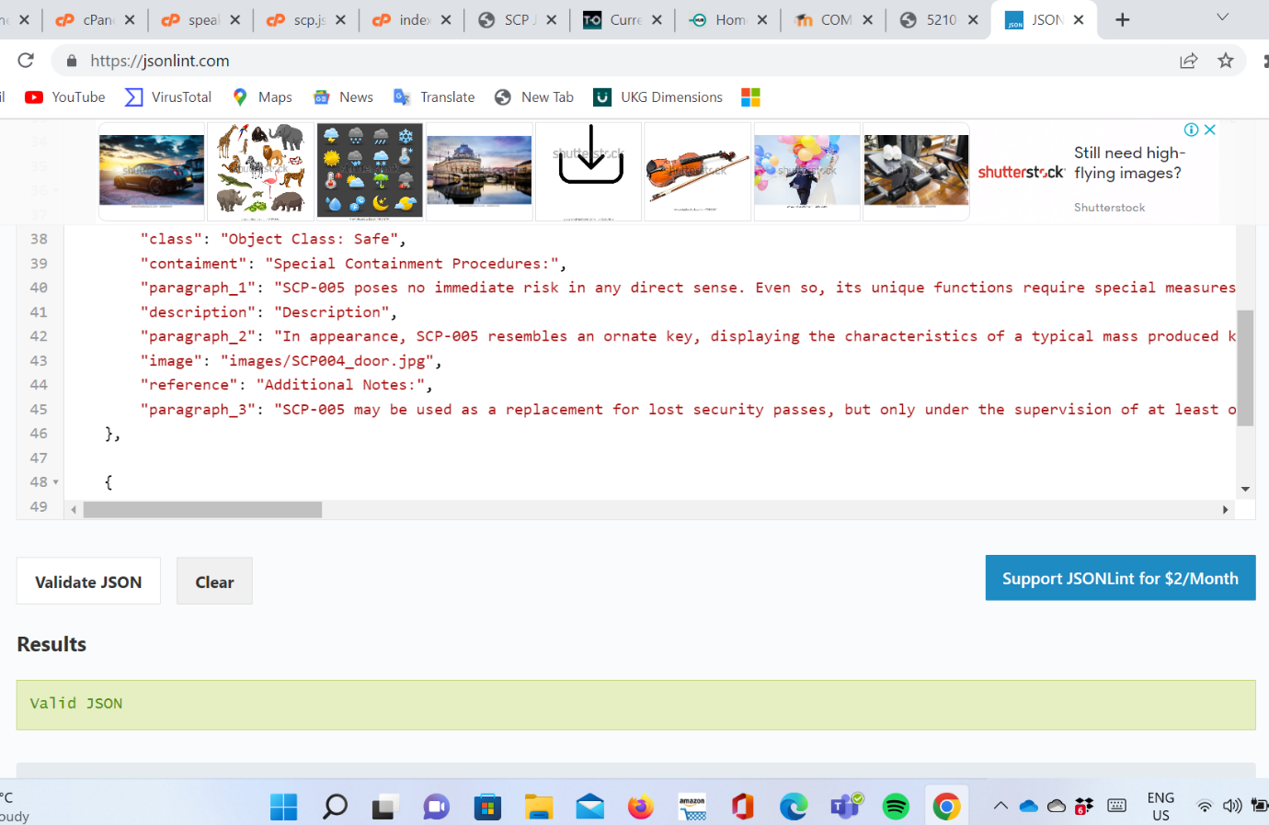

**SDLC methodology used in this assignment:**

The project starts by converting the 5 subjects HTML-files to JSON format then secondly developing a PHP program to read and display the data in JSON file by using a foreach loop to display all the elements inside of a <div> then create a button that will literally read back the content for each SCP subject using the speech browser API.

The layout was implementing by using Bootstrap classes.

**Cpanel Access details:**

**Username:** a9971358

**Password:** Toiohomai1234