SupplyChain Dapp
This Dapp was created to track an item from the time it was produced to the consumer. This Dapp allows to track the state and ownership of the product.

UML
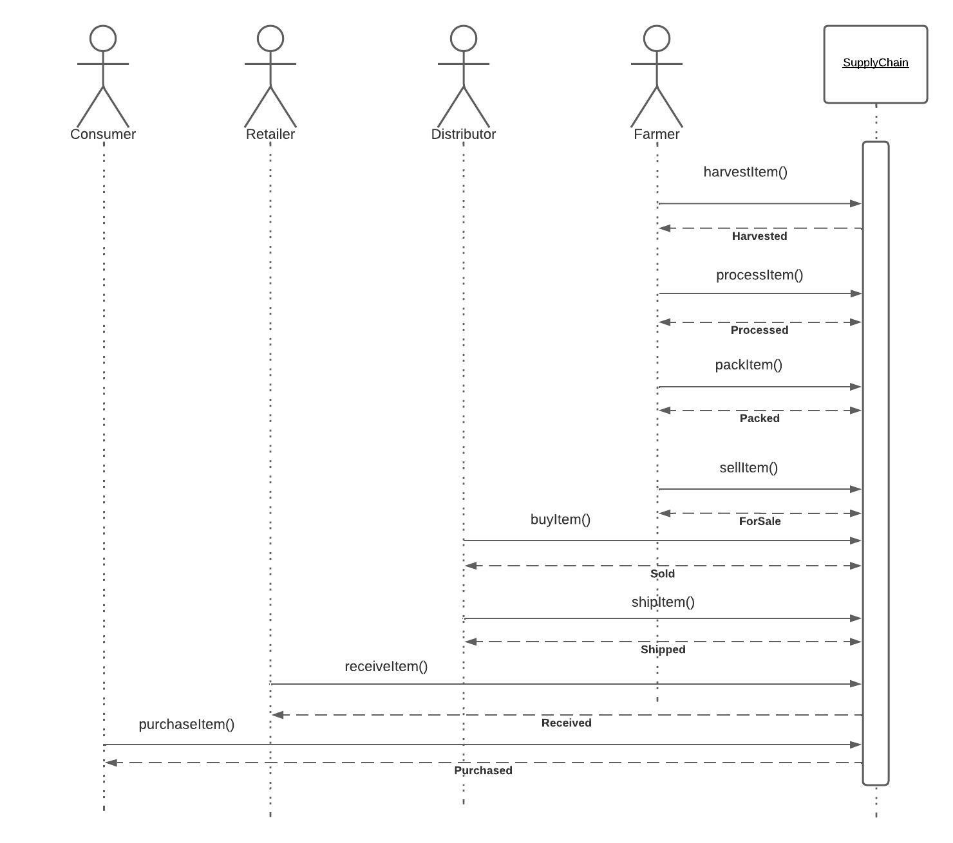
1 - Sequence Diagram

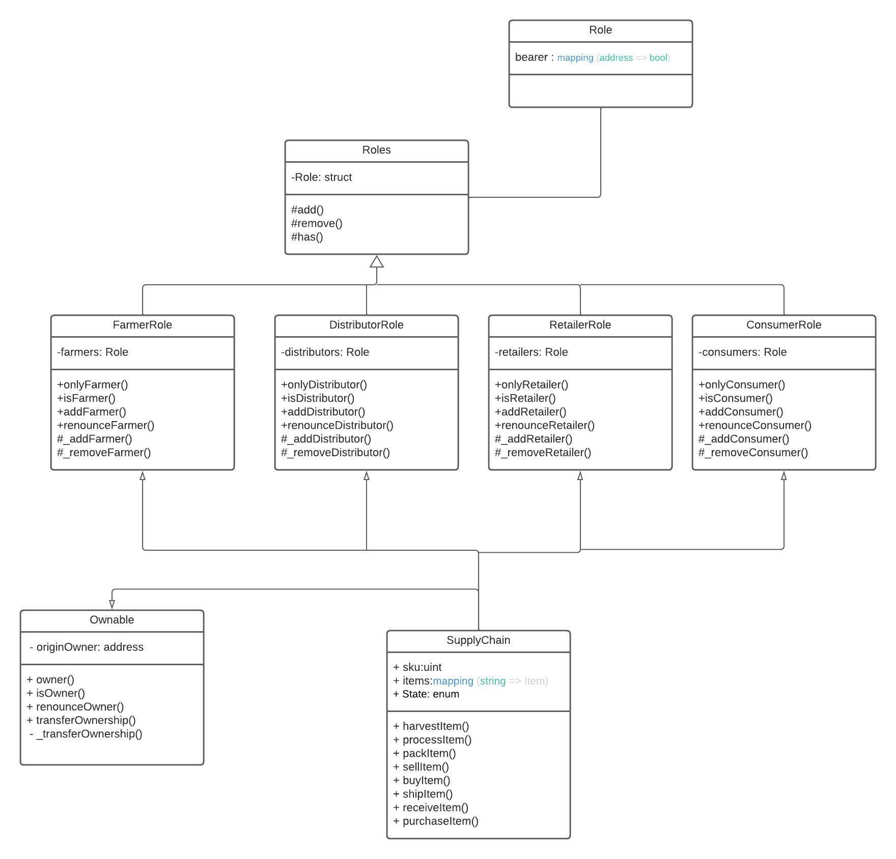
2 - Class Diagram

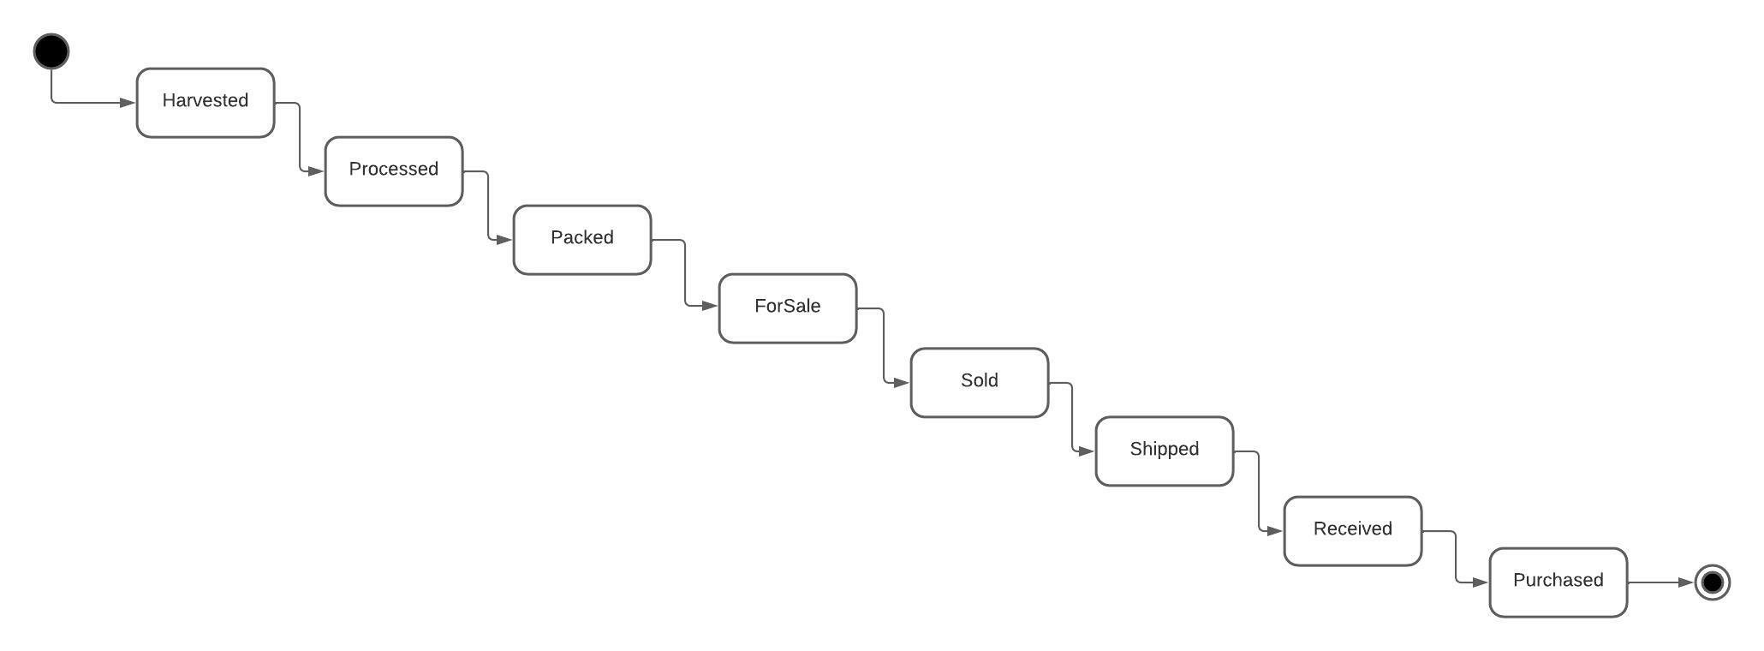
3 - State Diagram

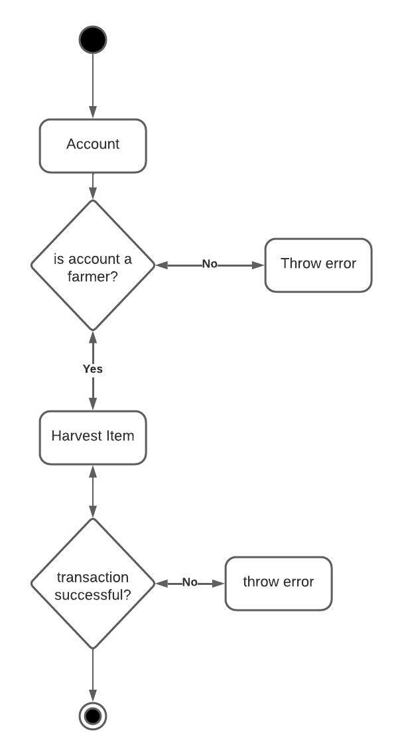
4 - Harvest Item - Activity Diagram
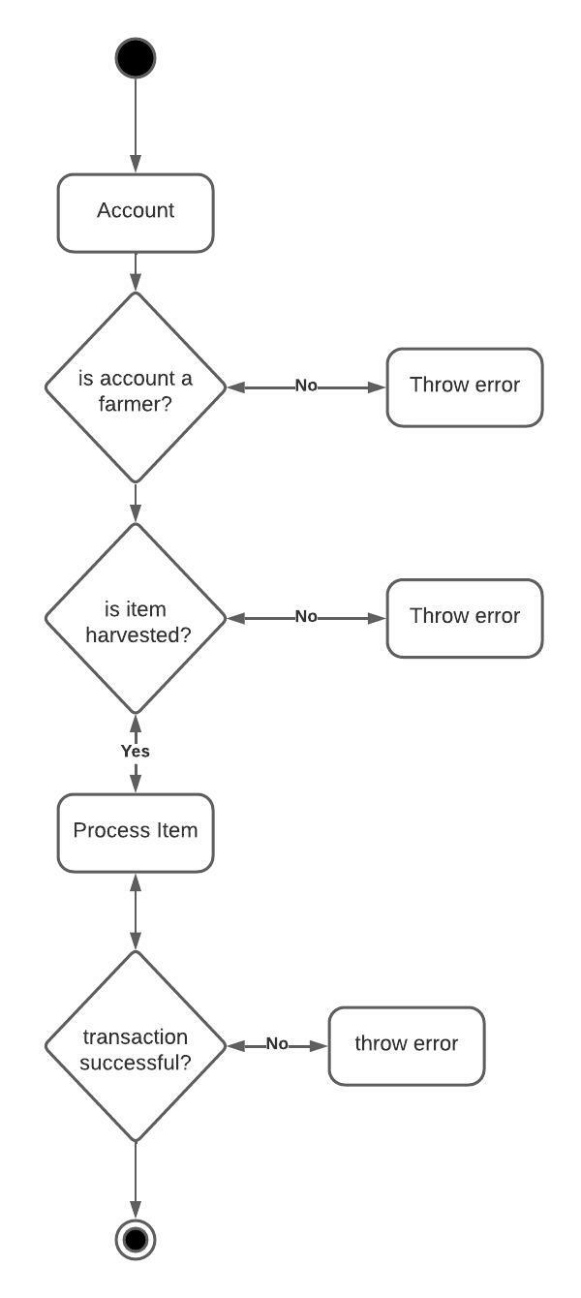
5 - Process Item - Activity Diagram

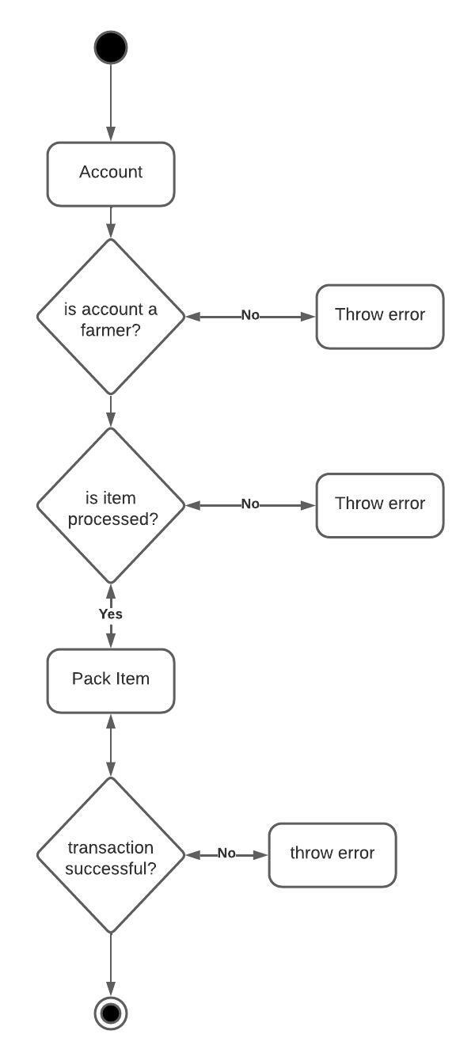
6 - Pack Item - Activity Diagram

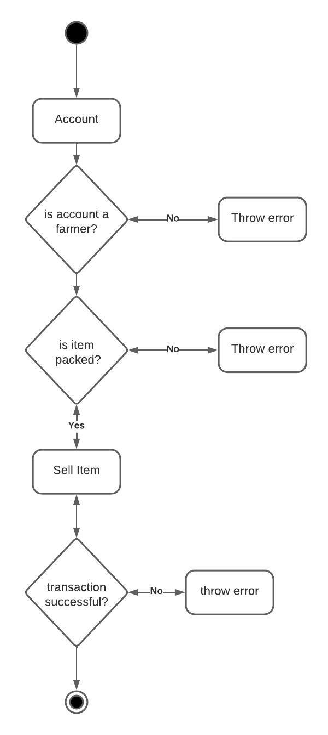
7 - Sell Item - Activity Diagram
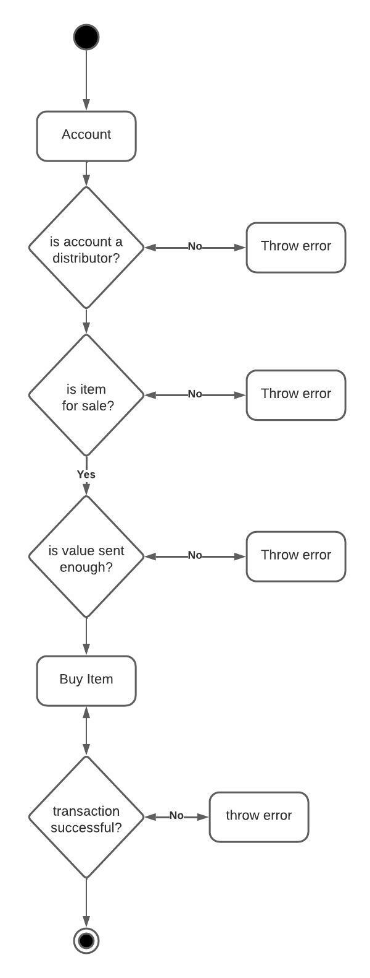
8 - Buy Item - Activity Diagram
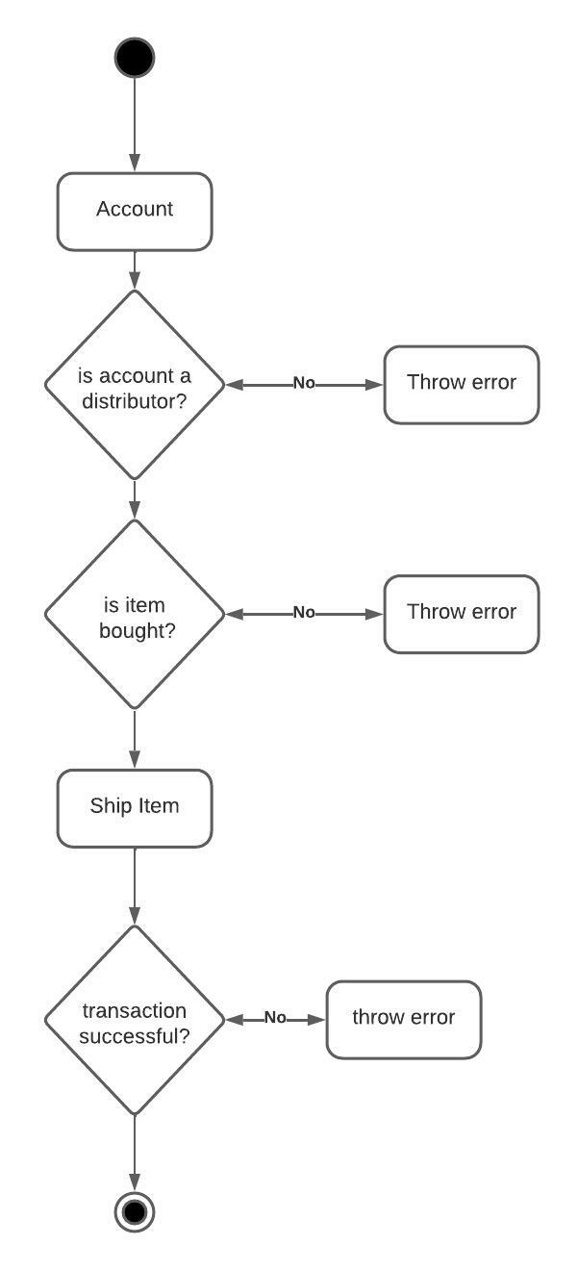
9 - Ship Item - Activity Diagram

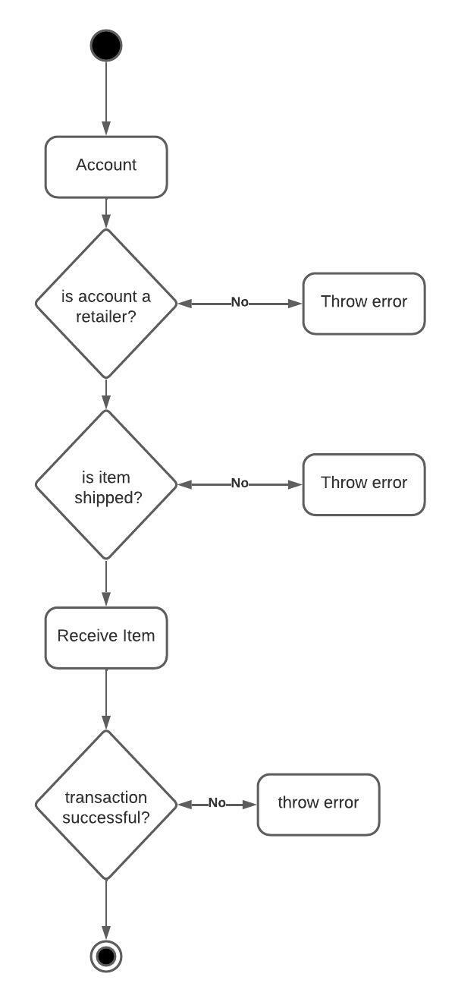
10 - Receive Item - Activity Diagram

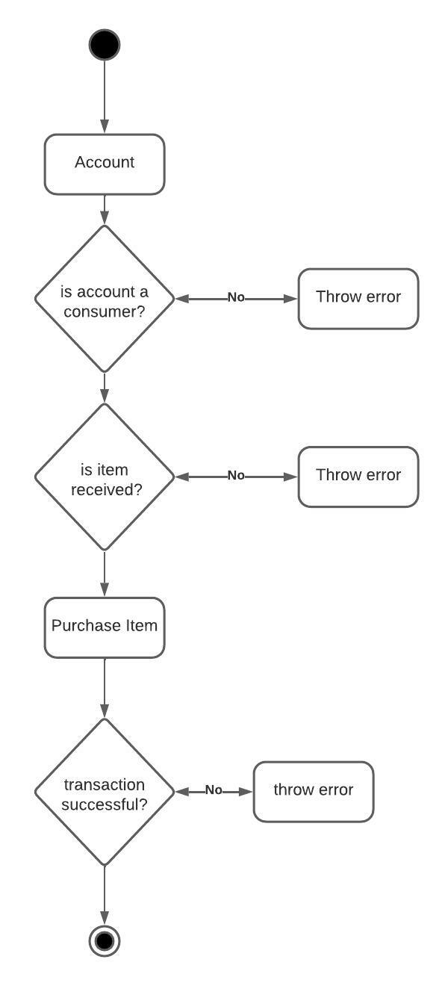
11 - Purchase Item - Activity Diagram

How to use the SupplyChain Dapp
HarvestItem
The first step in the supply chain is to create an item and harvest it. To do this we first new to fill out the form with the product details:
- UPC;
- Farm Name;
- Farm Information;
- Farm Longitude;
- Farm Latitude;
- Product Notes
To harvest an item it is a requirement for the account holder to have a Farmer Role.
After harvesting a ProductID will be generated, which is a string like “UPC-SKU”. This ProductID will be used to perform the other operations.
ProcessItem
Next, we need to process the created Item, to do this we write the ProductID of the desired Item in the appropriate box and select Process Item. The account requires a Farmer Role.
PackItem
After processing the item, we need to pack it. The process is the same as before, write the ProductID and select Pack Item. The account requires a Farmer Role.
Sell Item
To sell an Item we need to write the ProductID and a Product Price, in Wei, in the appropriate box and then select Sell Item. The account requires a Farmer Role.
Buy Item
To buy the item, an account with the Distributor role, needs to select a ProductID and a Product Price with a value more or equal than the item’s product price.
Ship Item
After buying the item, the Distributor can ship the item by choosing the correct ProductID and selecting Ship Item.
Receive Item
When a Distributor ships an Item, a Retailer can mark a product as received by choosing the ProductID and selecting Receive Item.
Purchase Item
After the Retailer receives the Item, a Consumer can Purchase the item by choosing the correct ProductID and selecting Purchase Item.
Fetch Item Details
By choosing a ProductID and selecting Fetch Item Details it is possible to check all the information about that Item.
Get All Roles
By choosing an address you can get all the roles available in the supply chain, this is for testing purposes.

Libraries
In this project the Strings.sol contract from the open-zeppeling framework was used.

