ENGLISH AUSTRALIA

Member Management System
Eau System v1.51.64

Complete System Presentation

Developed by: Platty / Rodrigo Zillesg
12/15/2025

System Overview
The Eau System is a comprehensive member management platform developed specifically for English Australia. The system centralizes all operations related to members, partner institutions, events, and Continuous Professional Development (CPD).

• Complete management of individual and institutional members
• CPD (Continuous Professional Development) activity tracking system
• Event platform with online registrations and payments
• Membership system with different levels and benefits
• Native integration with OpenLearning for online courses
• Financial module with payment and invoice management
• Customized dashboard by user type
• Reports and CSV data export

Current System Statistics
• 6,188 members registered in the system
• 128 active partner institutions
• 16,333 registered CPD activities
• 55 courses available on the OpenLearning platform
• 9 scheduled events

User Types
The system implements a permission hierarchy with 4 distinct access levels, each with specific functionalities appropriate to their role:

User Type | Description | Main Responsibilities
Super Admin | Master administrator with unrestricted access | System settings, complete management, bulk deletion
Admin | English Australia administrator | Member, institution, event and payment management
Institution Admin | Partner institution administrator | Management of members linked to their institution
Member | Individual organization member | Access to own profile, CPDs and courses

1. Super Admin (Master Administrator)
The Super Admin has unrestricted access to all system functionalities. This profile is intended for technical administrators and main managers of English Australia.

Main capabilities:
• Complete access to all system modules
• Management of all user types
• Advanced settings and bulk deletion
• View global statistics
• Merge duplicate records

Main Dashboard
The Super Admin Dashboard presents a complete system overview with real-time statistics. Cards display: Total Members (6,188), Total Institutions (128), CPD Activities (16,333), Upcoming Events (9), CPD Points Awarded, Pending Payments and Pending Approvals.
The "Share Registration Page" section allows sharing the registration link via QR Code or social networks (WhatsApp, LinkedIn, X, Email). OpenLearning courses are displayed at the bottom.

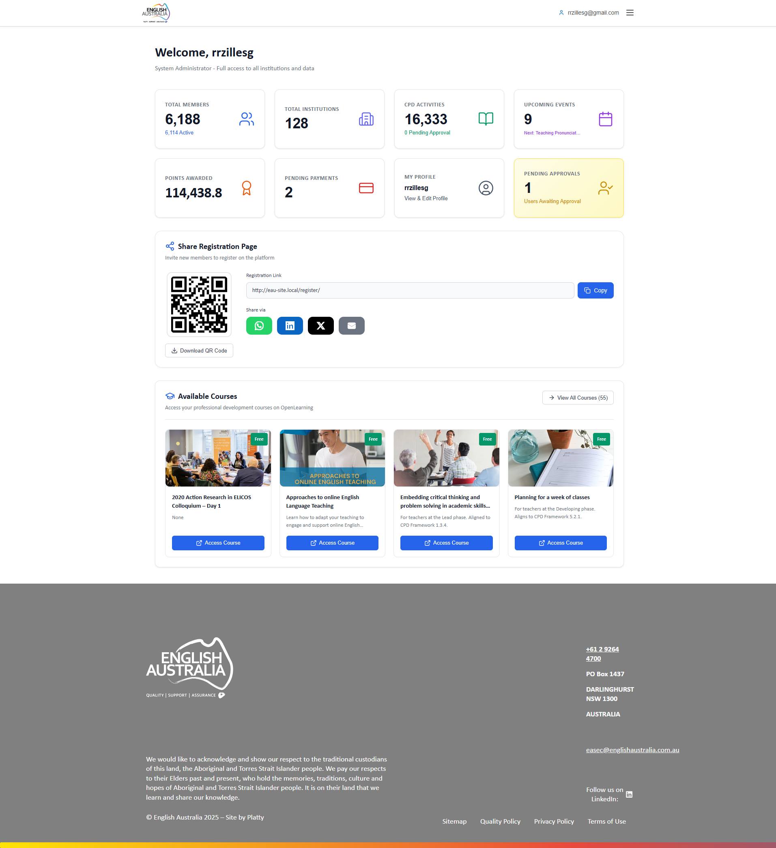
Figure: Main Dashboard

Members Management
Central page for managing all system members. Offers a complete table with advanced search by name, email or phone, and multiple filters by Status, User Type, Institution, Registration Date and Membership Type.
Available functionalities: "Delete Selected", "Delete All Filtered" (Super Admin exclusive), "Export CSV", "Merge Duplicates", and "Add Member". Each row has View, Edit and Delete actions.

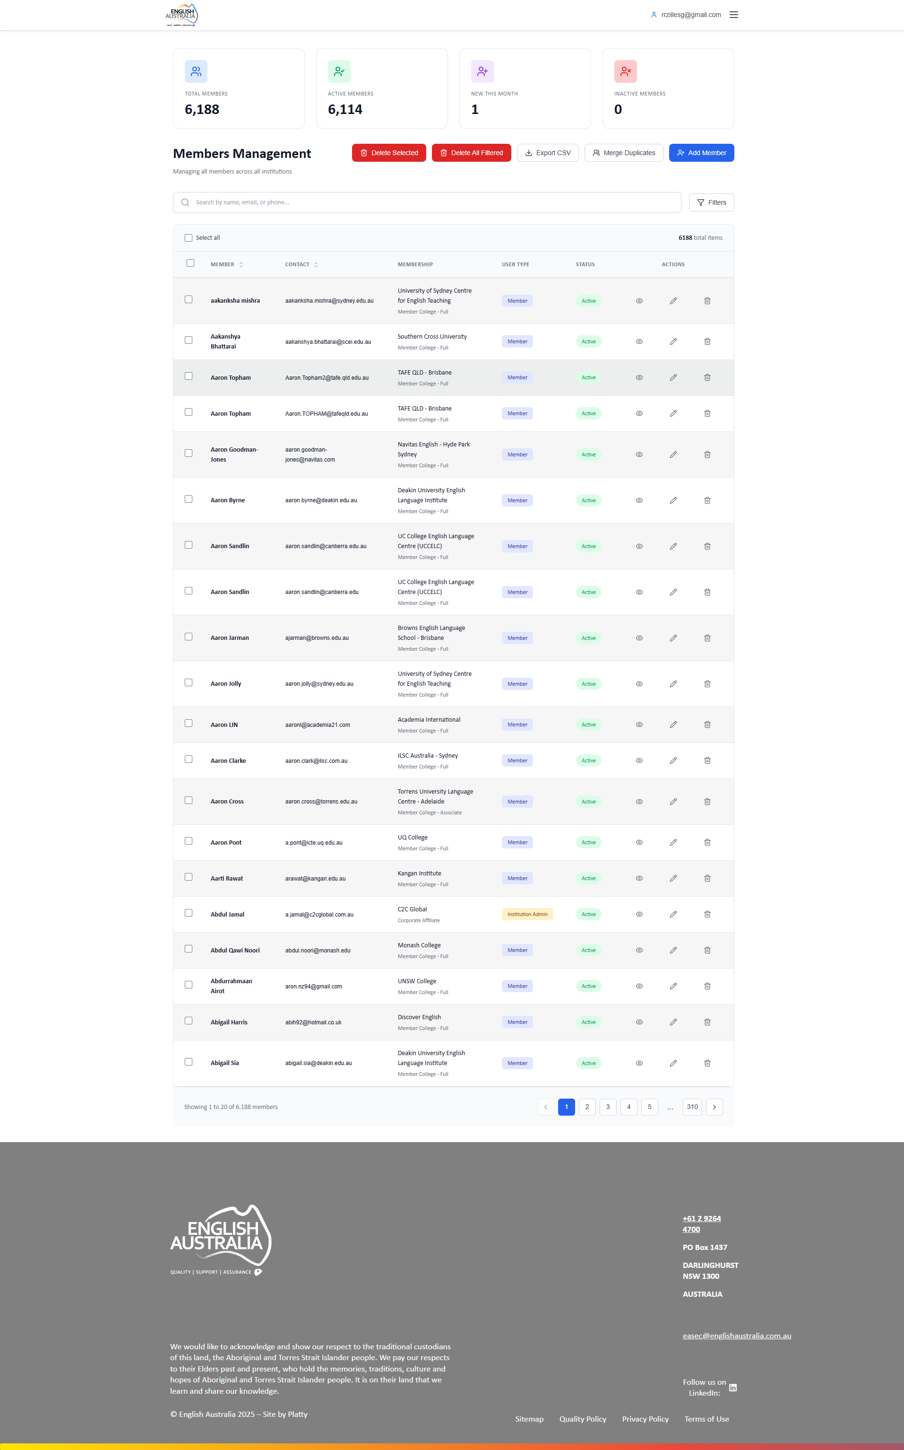
Figure: Members Management

Institutions Management
Module for managing English Australia's 128 partner institutions. Displays complete information for each institution including name, primary contact, membership status and linked members.
Allows creating new institutions, editing information, linking/unlinking members and managing partnership status.

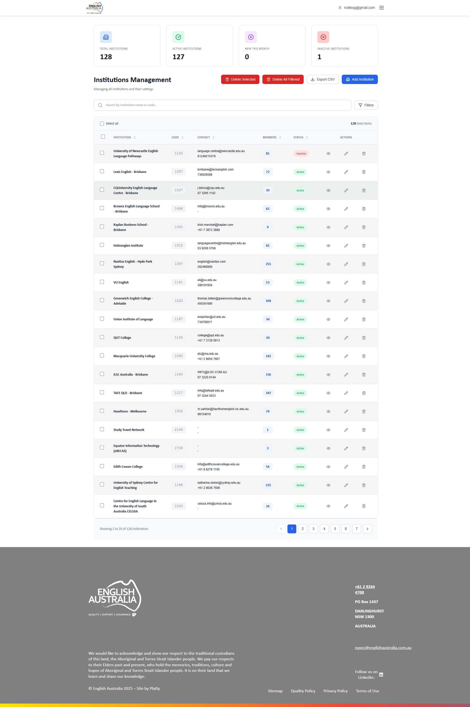
Figure: Institutions Management

CPD Activities Management
Central management of Continuous Professional Development activities. Lists all 16,333 activities with member information, category, points and approval status.
Administrators can approve or reject pending activities, view details including attached evidence, and export CPD reports.

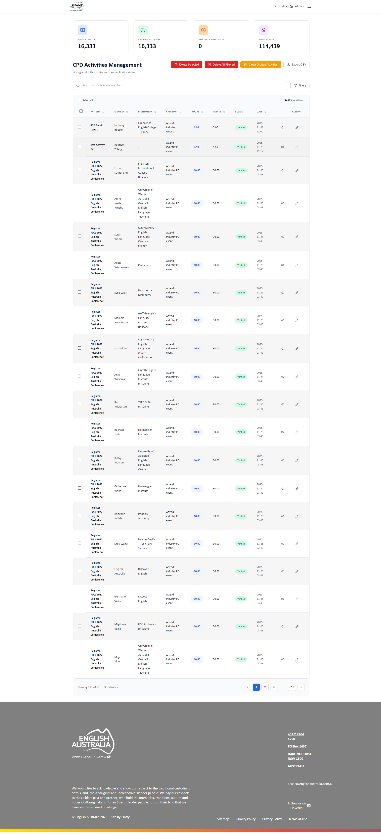
Figure: CPD Activities Management

CPD Categories Management
Configuration of CPD activity categories. Defines categorization structure and points assigned to each type of professional development activity.
Super Admin exclusive functionality. Allows creating, editing and organizing categories used by members when registering CPD activities.

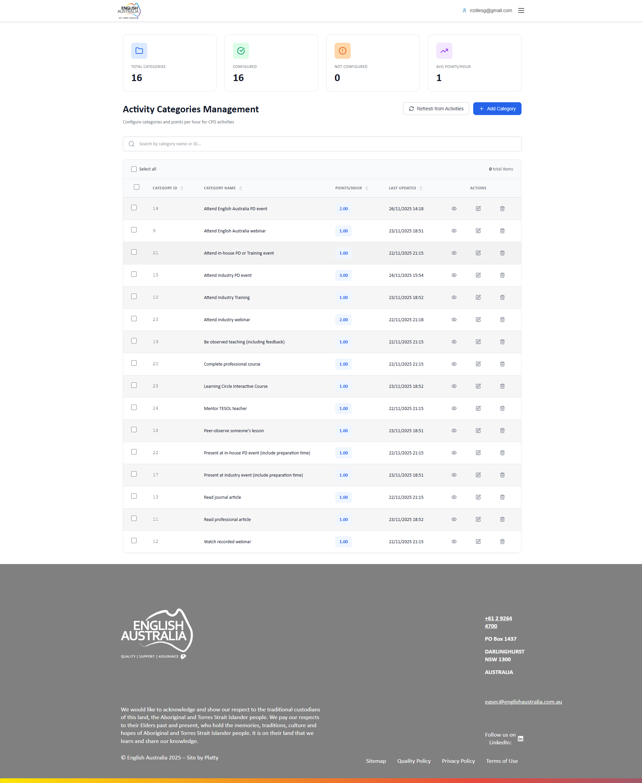
Figure: CPD Categories Management

Events Management
Complete administrative panel for event management. Allows creating events with detailed settings for date, location, capacity, differentiated prices and CPD points.
Includes: event creation with multiple sessions, registration management, payment control, communications to registrants, and publishing/unpublishing.

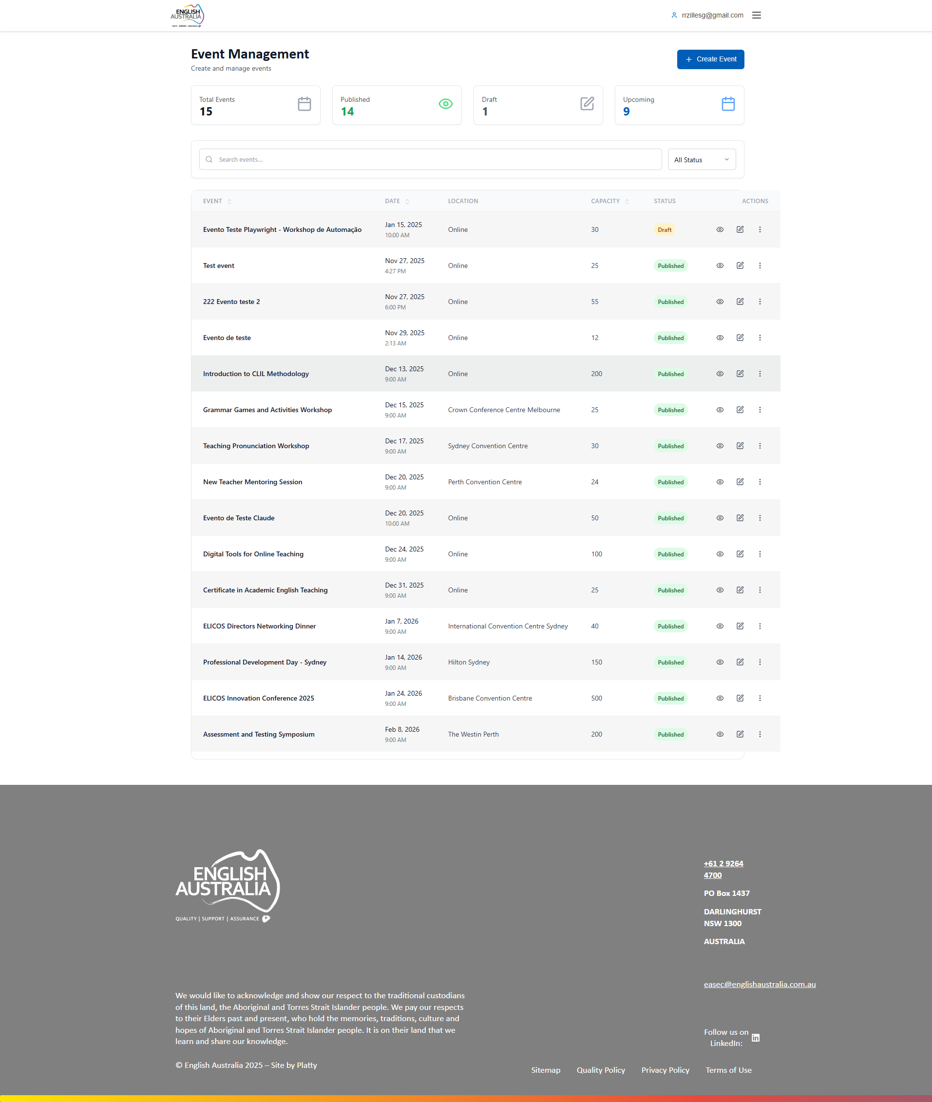
Figure: Events Management

Payments Management
Financial module for controlling all system transactions. Displays invoices for events, memberships and services with payment status (Paid, Pending, Overdue).
Filter by period, payment status and transaction type. Detailed view of each invoice and payment history.

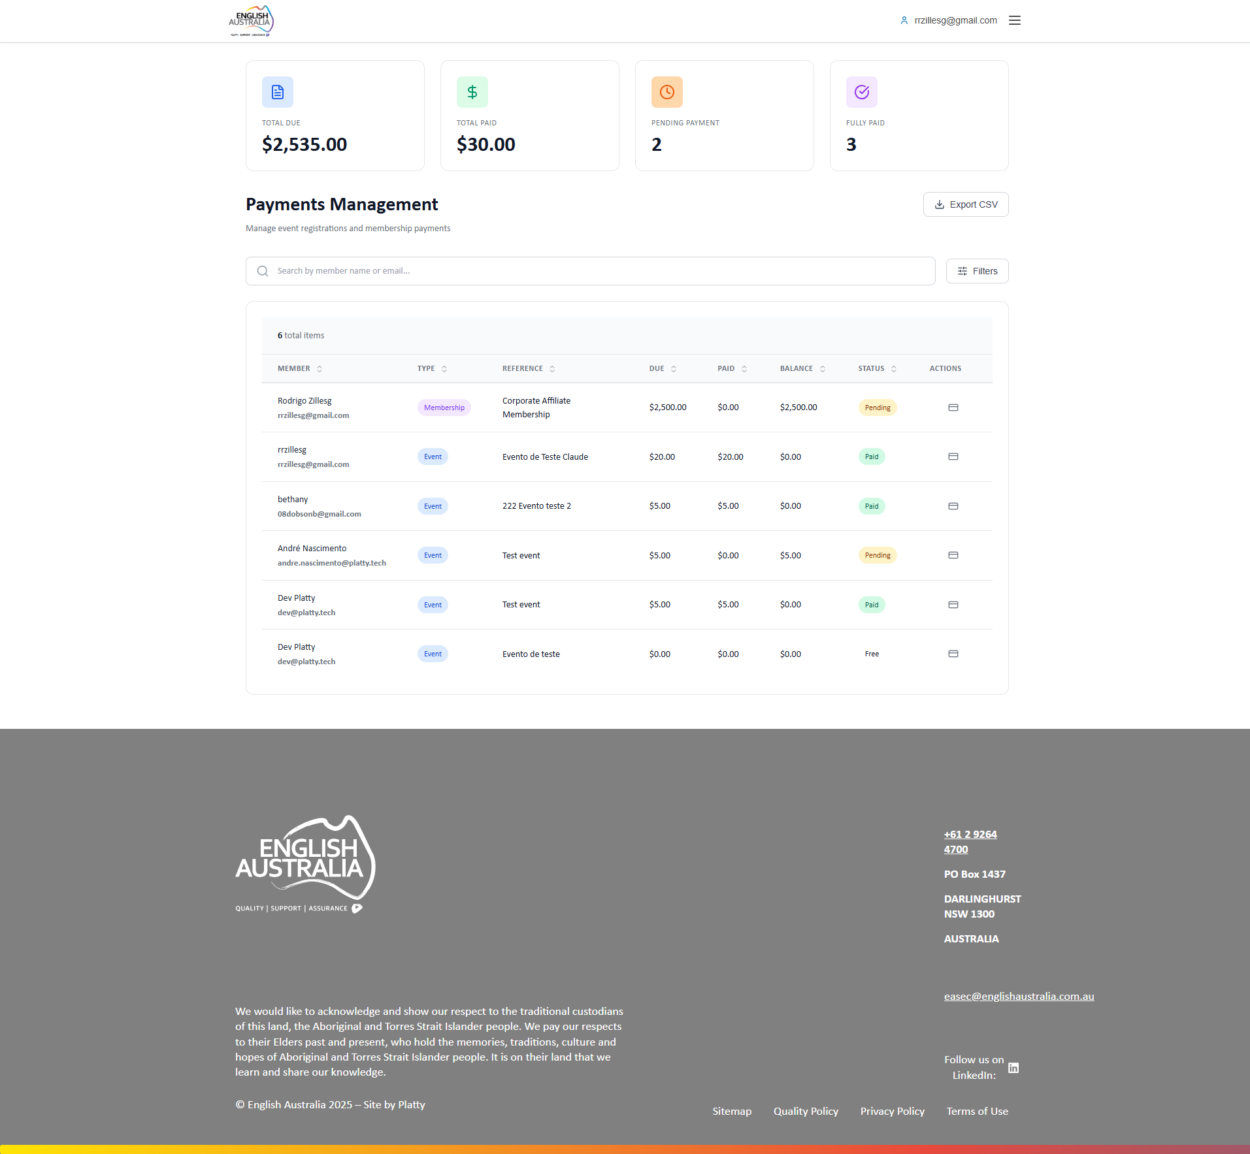
Figure: Payments Management

Membership Applications
Management of received membership applications. Lists all pending applications with applicant information, chosen membership type and attached documentation.
Administrators can approve or reject applications, request additional documentation and track processed applications history.

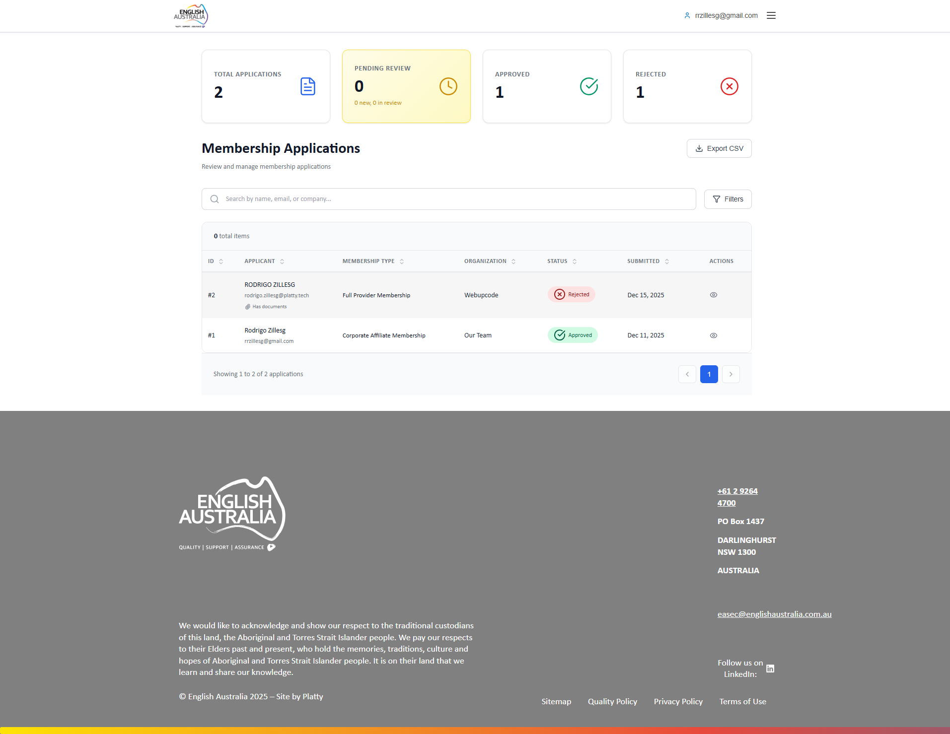
Figure: Membership Applications

My Profile
Personal profile page. Allows viewing and editing personal information, contact details, communication preferences and account settings.
Includes profile photo upload, password update and platform activity history.

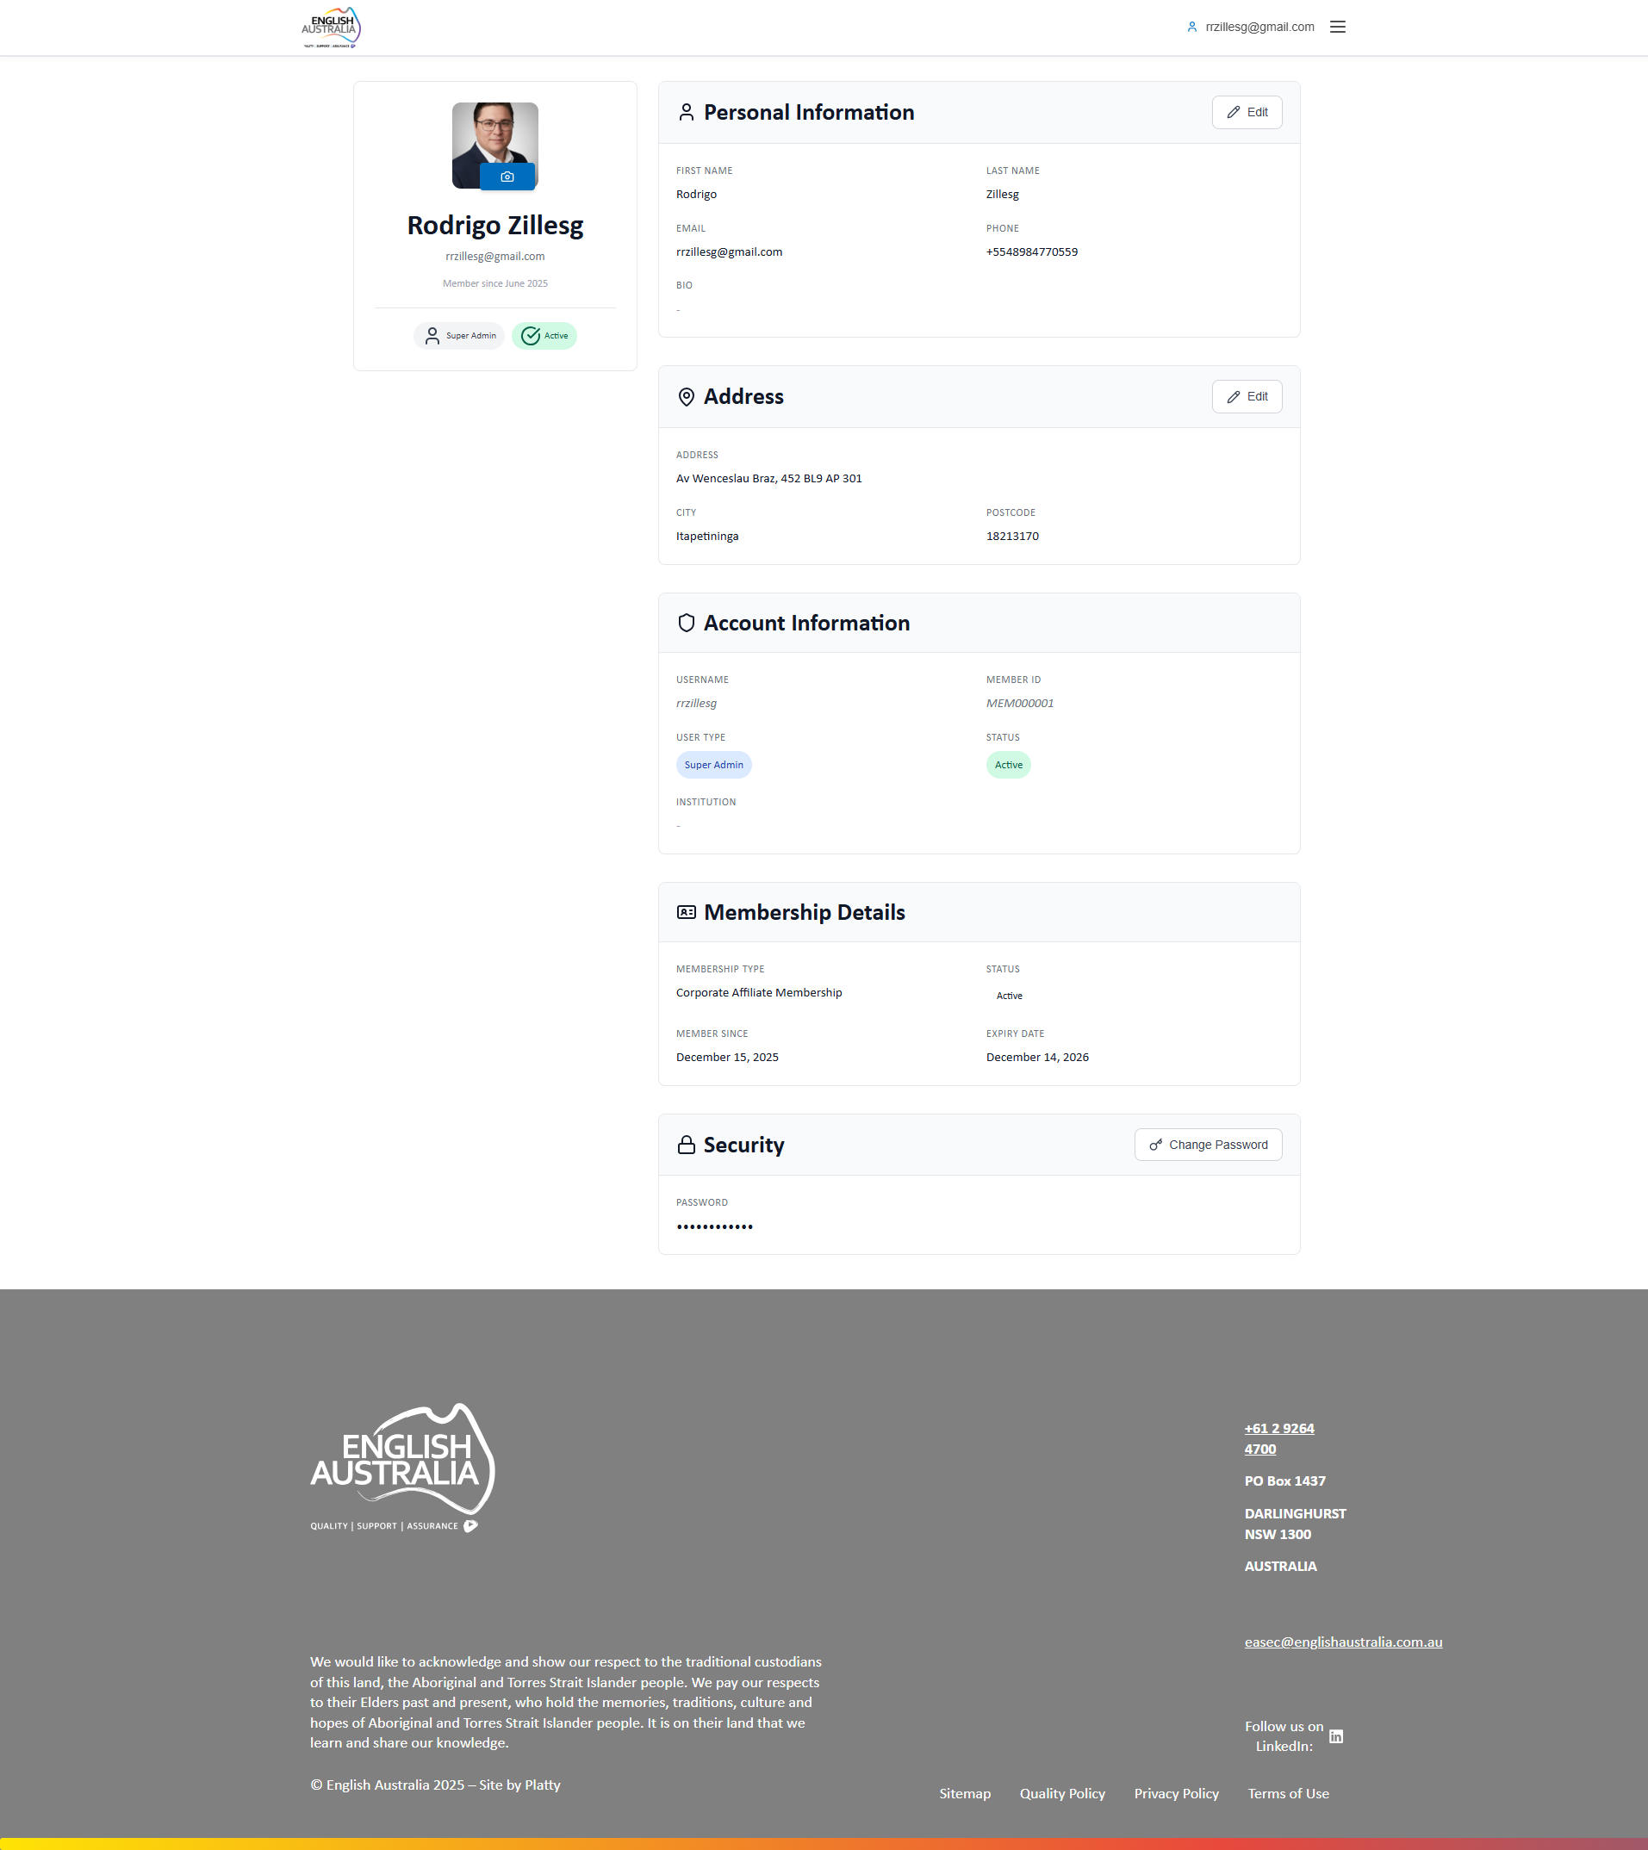
Figure: My Profile

My CPDs
Personal record of Continuous Professional Development activities. Displays complete history with accumulated score and status of each record.
Submit new CPD activities with evidence upload, track approval status and view progress towards professional development goals.

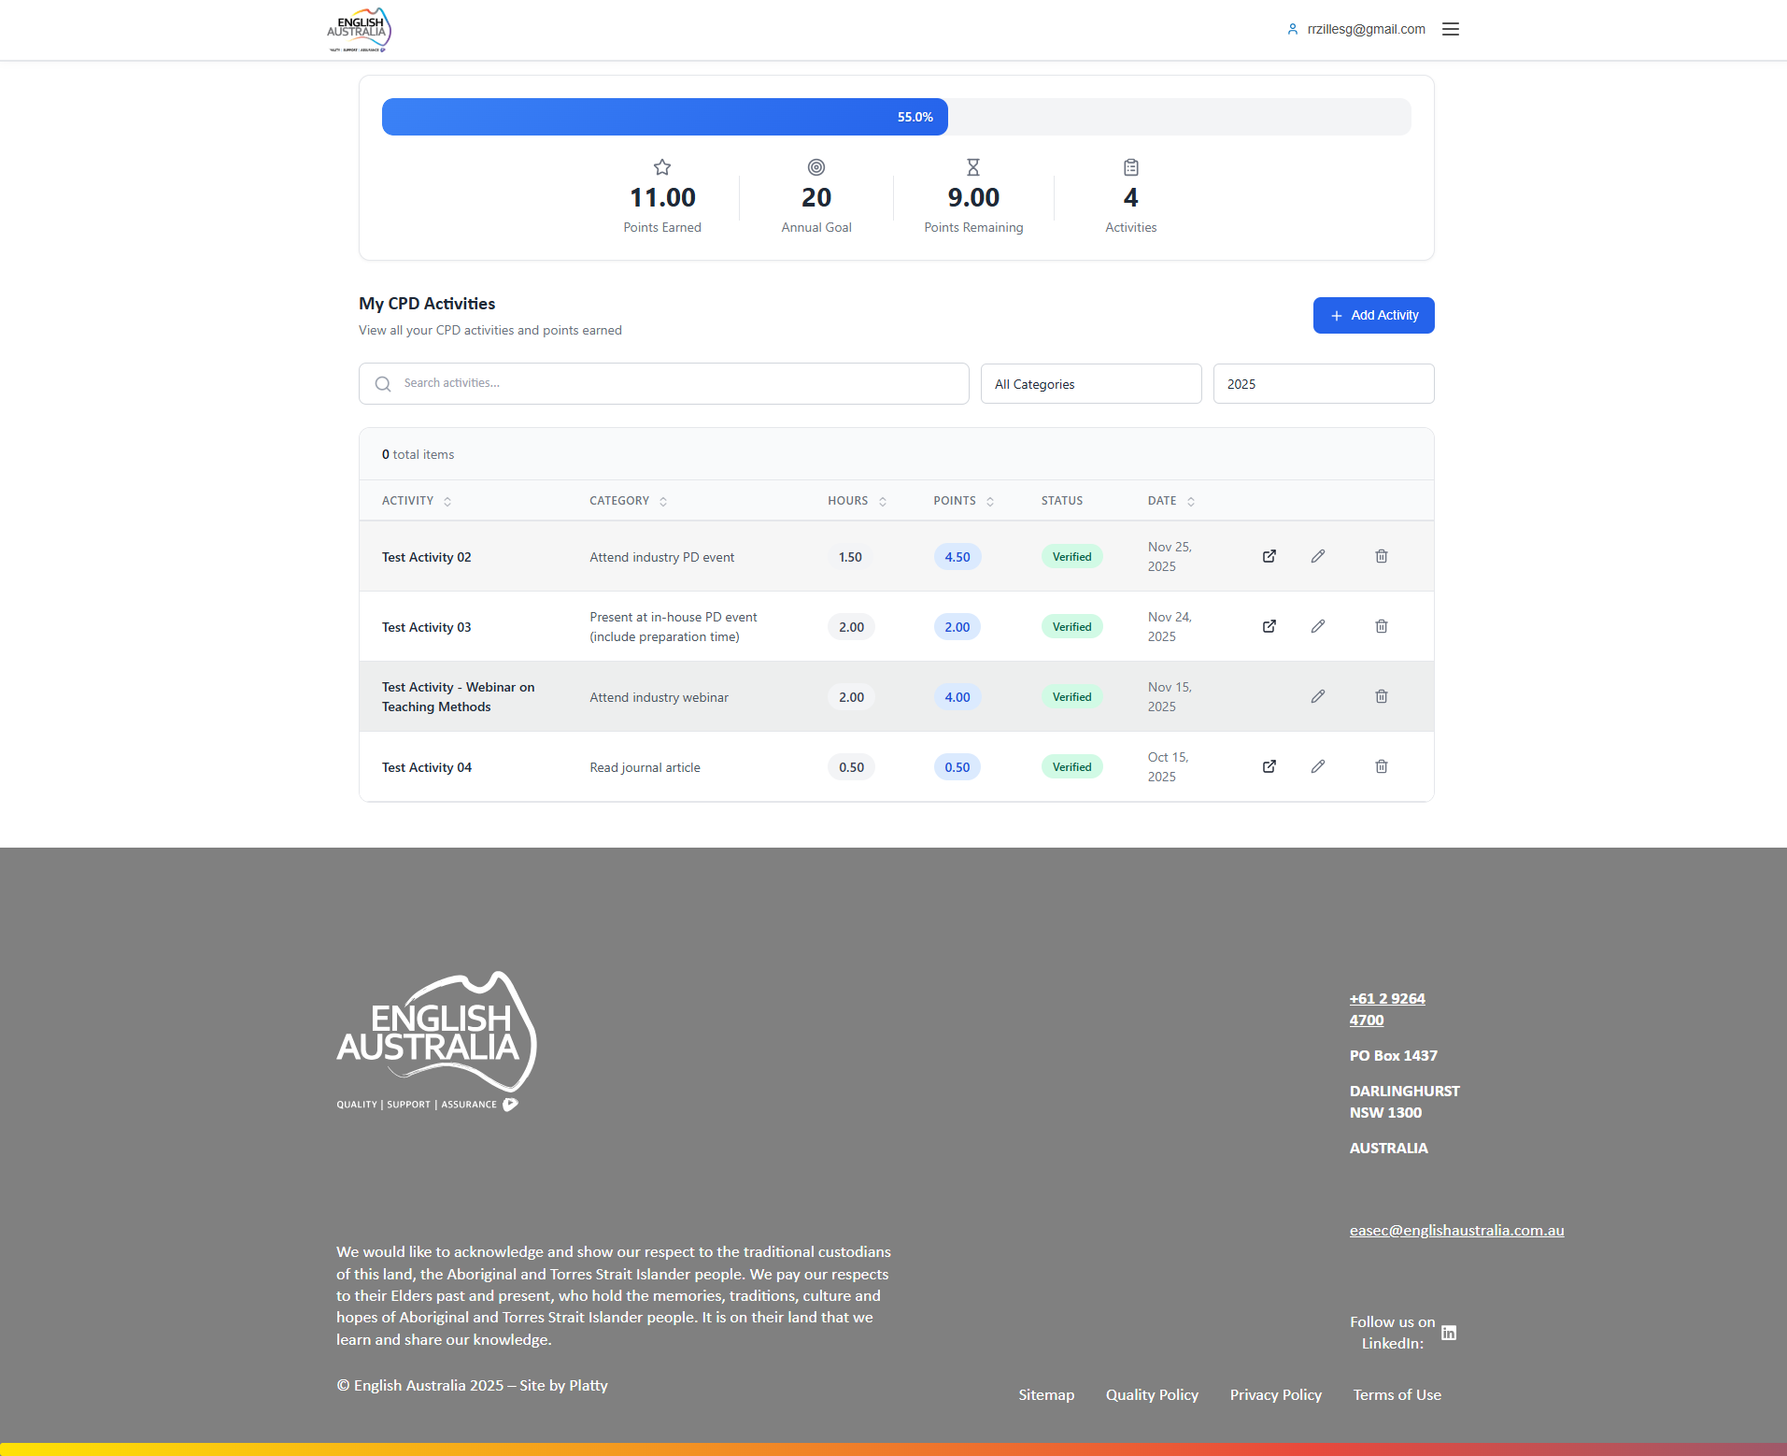
Figure: My CPDs

Events (Public Page)
Public page listing all available English Australia events. Presents events in card format with essential information: title, date, location, price and availability.
Filters by category and period. Click on an event for full details and registration.

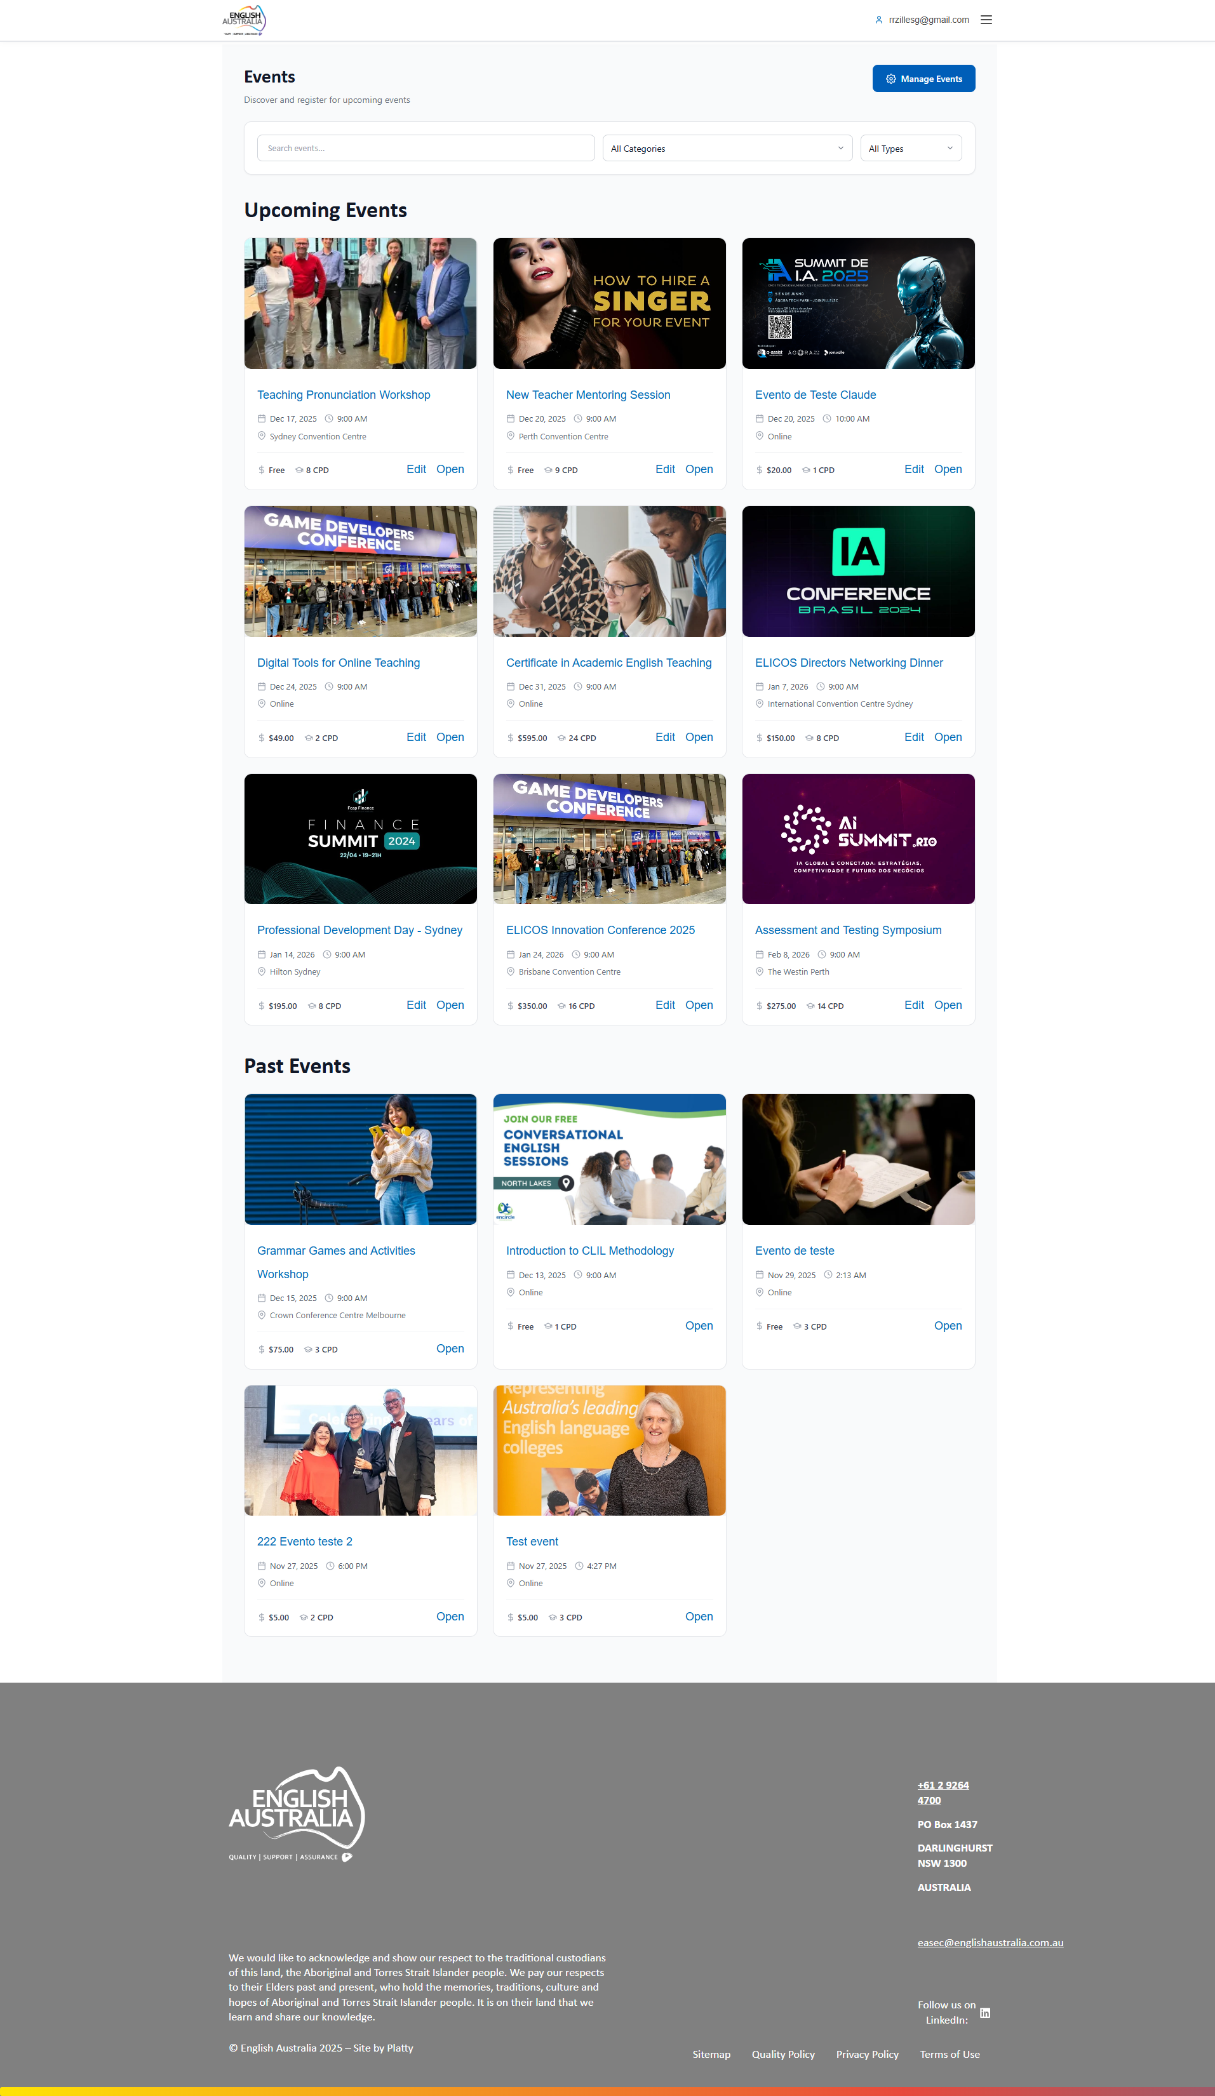
Figure: Events (Public Page)

OpenLearning Courses
Integration with OpenLearning platform displaying 55 courses available to members. Each course shows image, title, description and free/paid indication.
"Access Course" button redirects to OpenLearning platform. Completed courses can automatically generate CPD points.

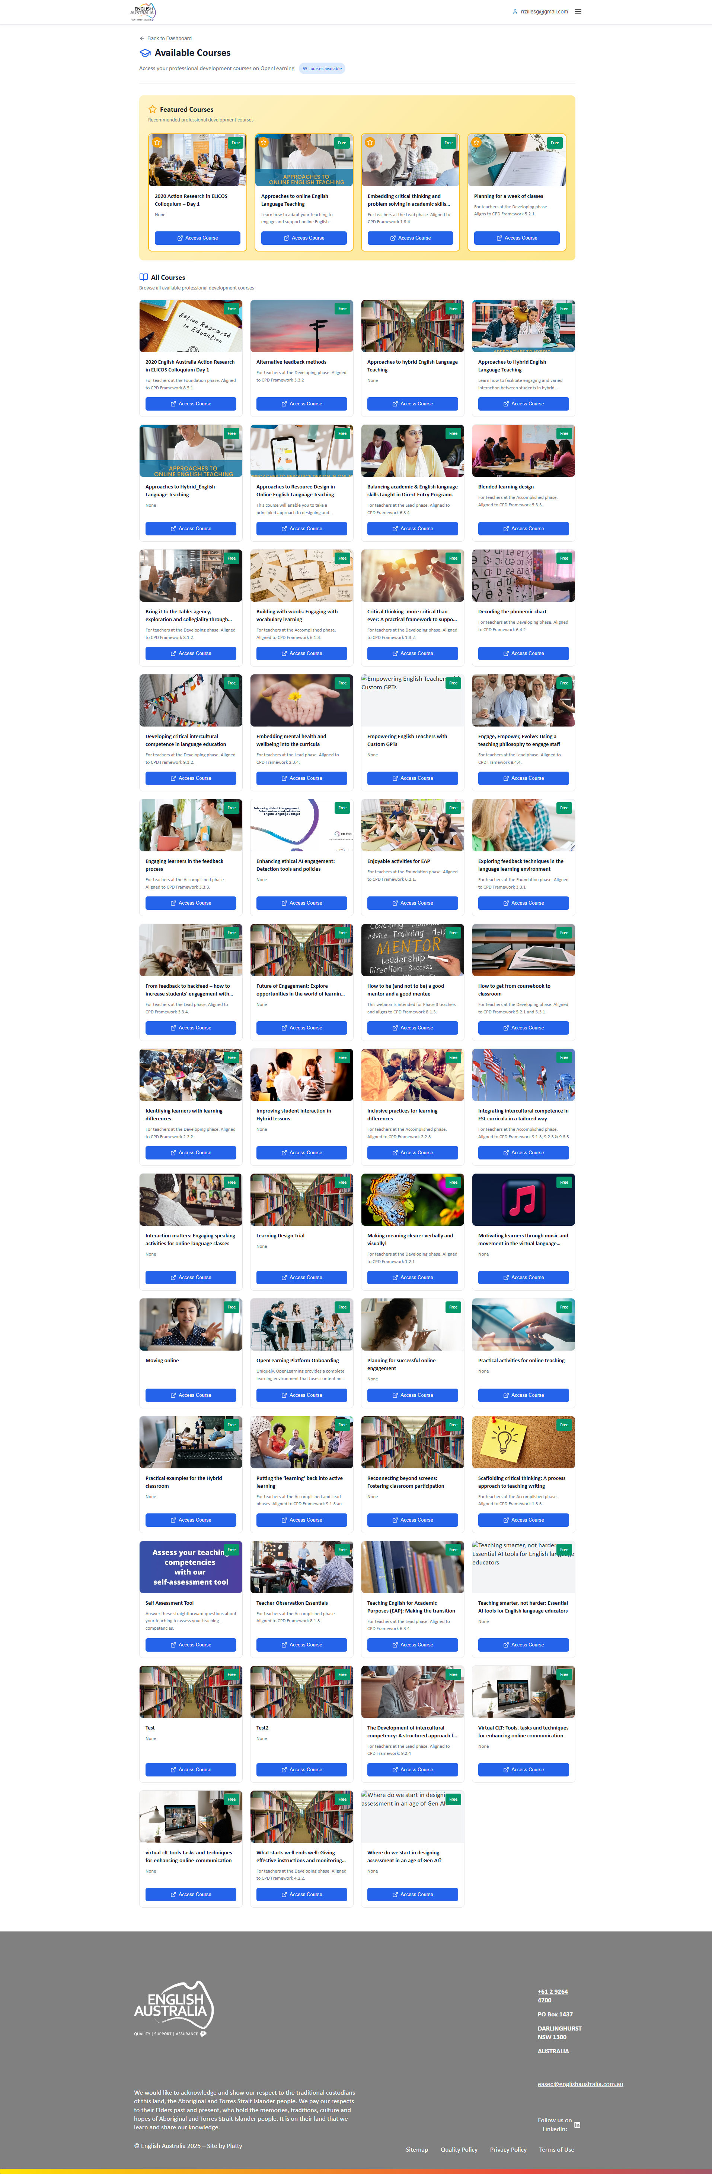
Figure: OpenLearning Courses

2. Admin (Administrator)
The Admin profile is for English Australia staff responsible for day-to-day operational management. Has access to most administrative functionalities, except advanced settings and bulk deletion.

Main capabilities:
• Complete management of members and institutions
• Approval of CPD activities and memberships
• Event and payment management
• Report export

Main Dashboard
Dashboard similar to Super Admin with same general statistics. Welcome message indicates "Here's what's happening with your membership today".
All viewing functionalities available including QR Code sharing and OpenLearning courses.

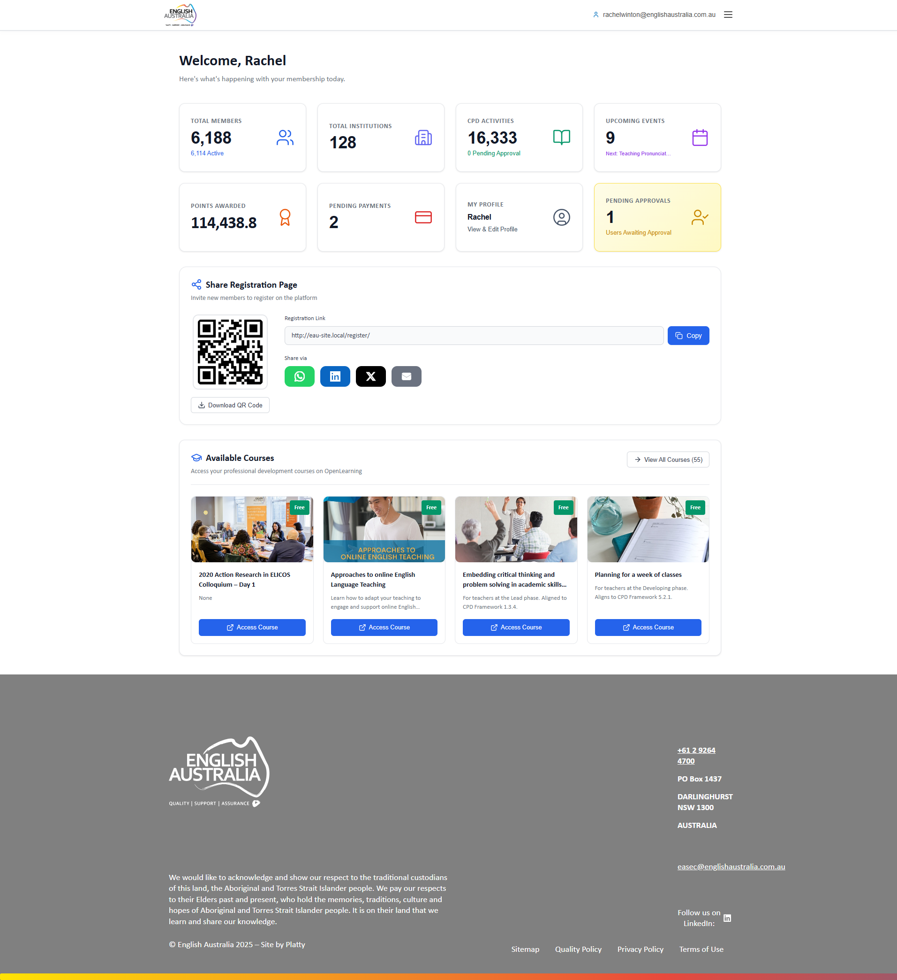
Figure: Main Dashboard

Members Management
Full member management access without "Delete All Filtered" button (Super Admin exclusive).
Create, edit, view and delete members individually, export data and merge duplicates.

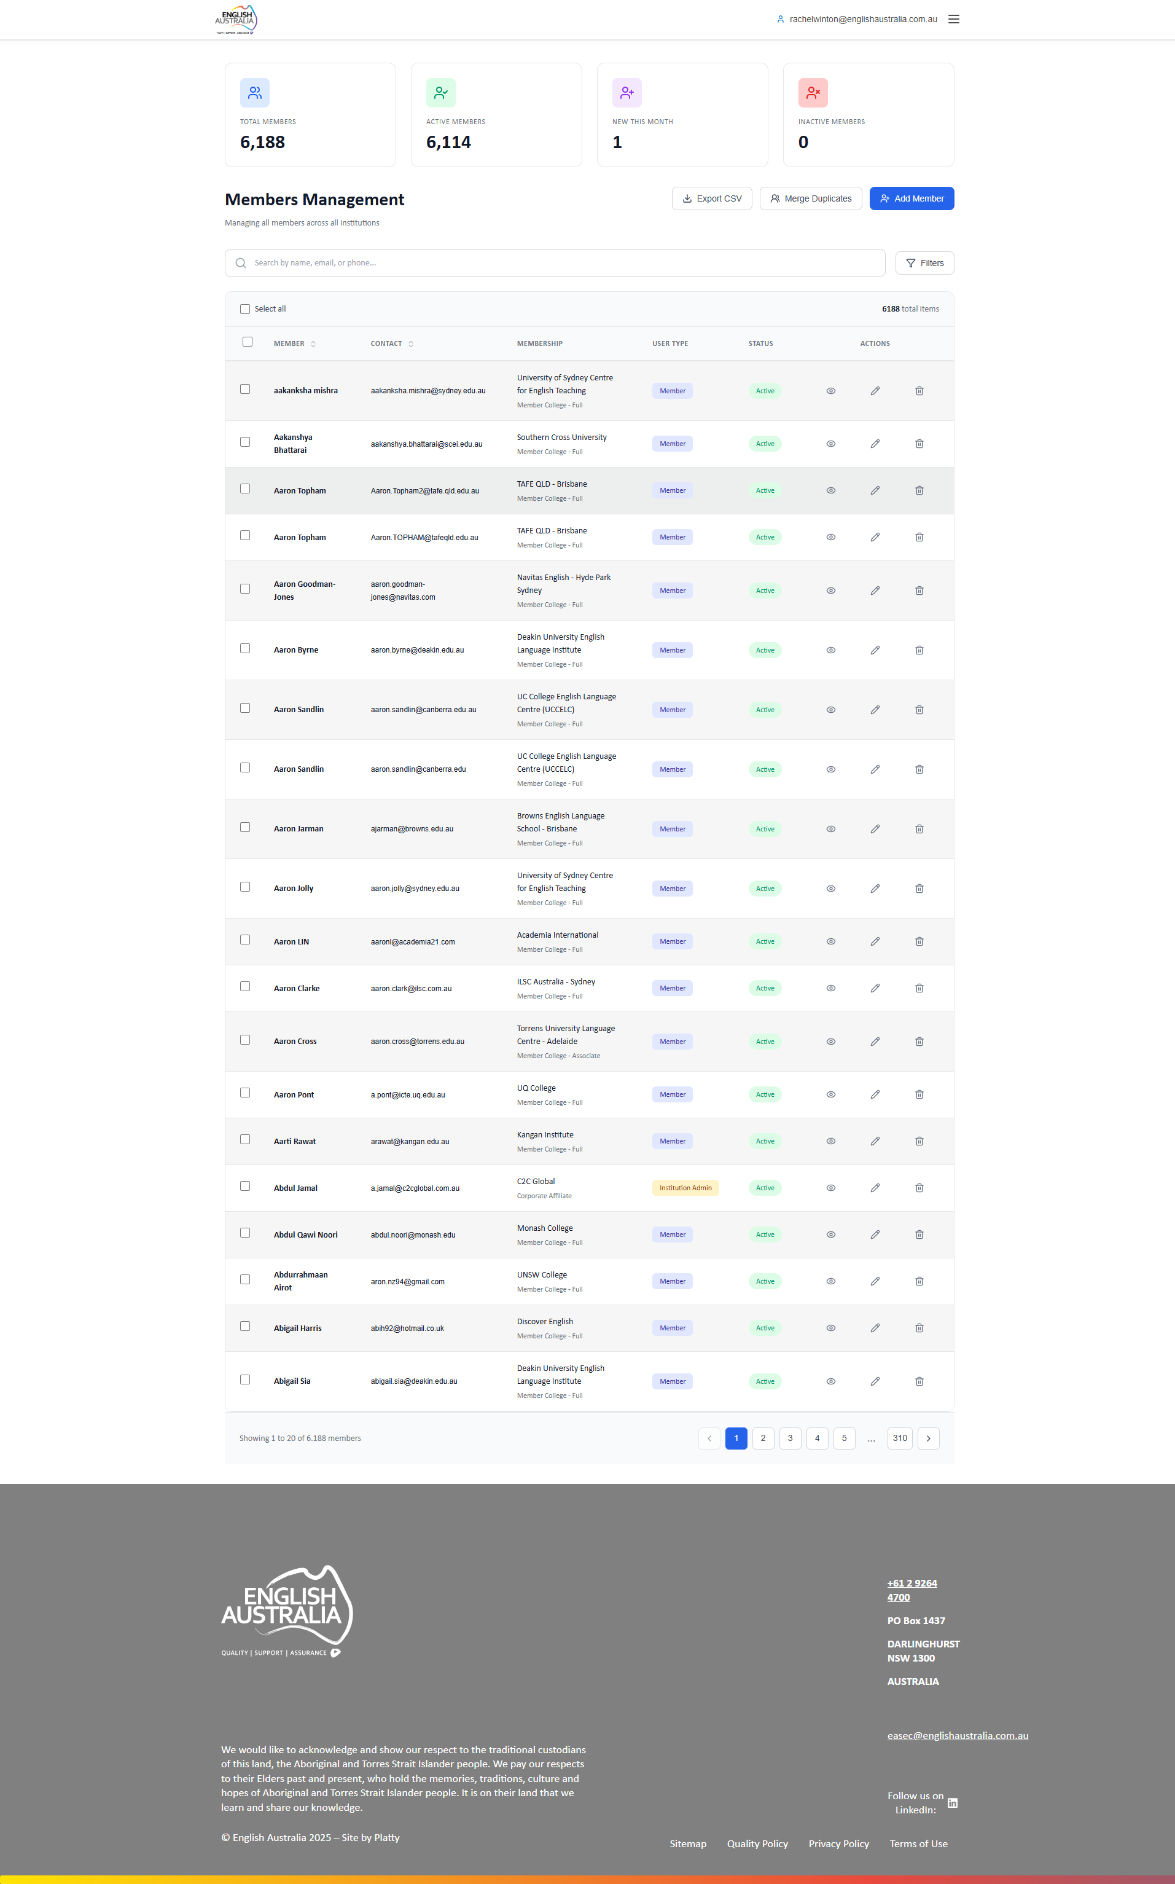
Figure: Members Management

Institutions Management
Complete partner institution management.
Create new institutions, edit information and manage member links.

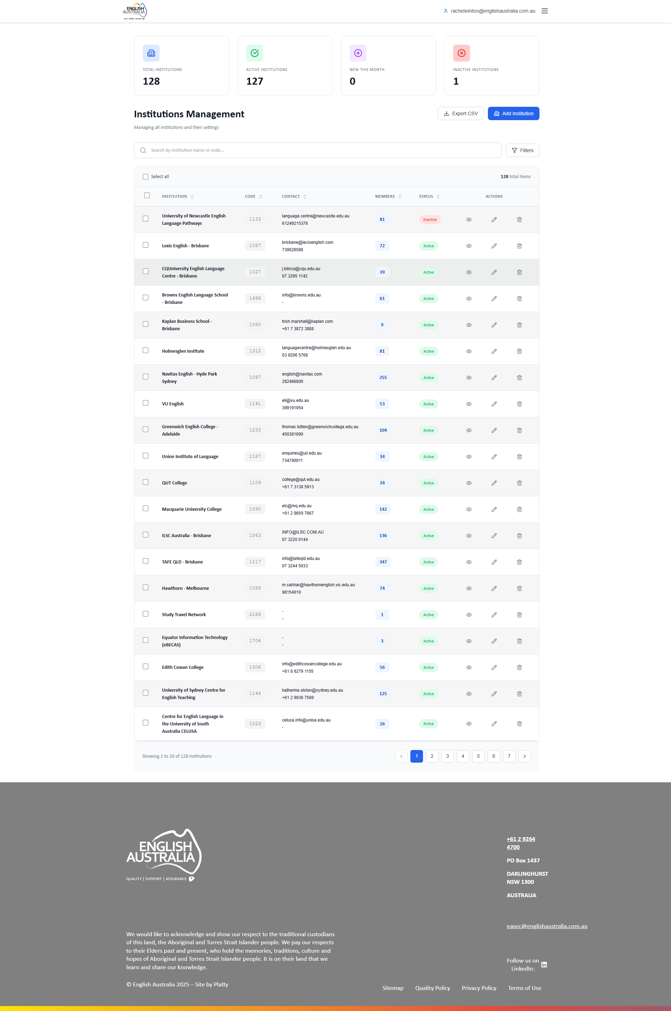
Figure: Institutions Management

CPD Activities Management
Full CPD activities management, approve or reject submissions.
Functionalities identical to Super Admin.

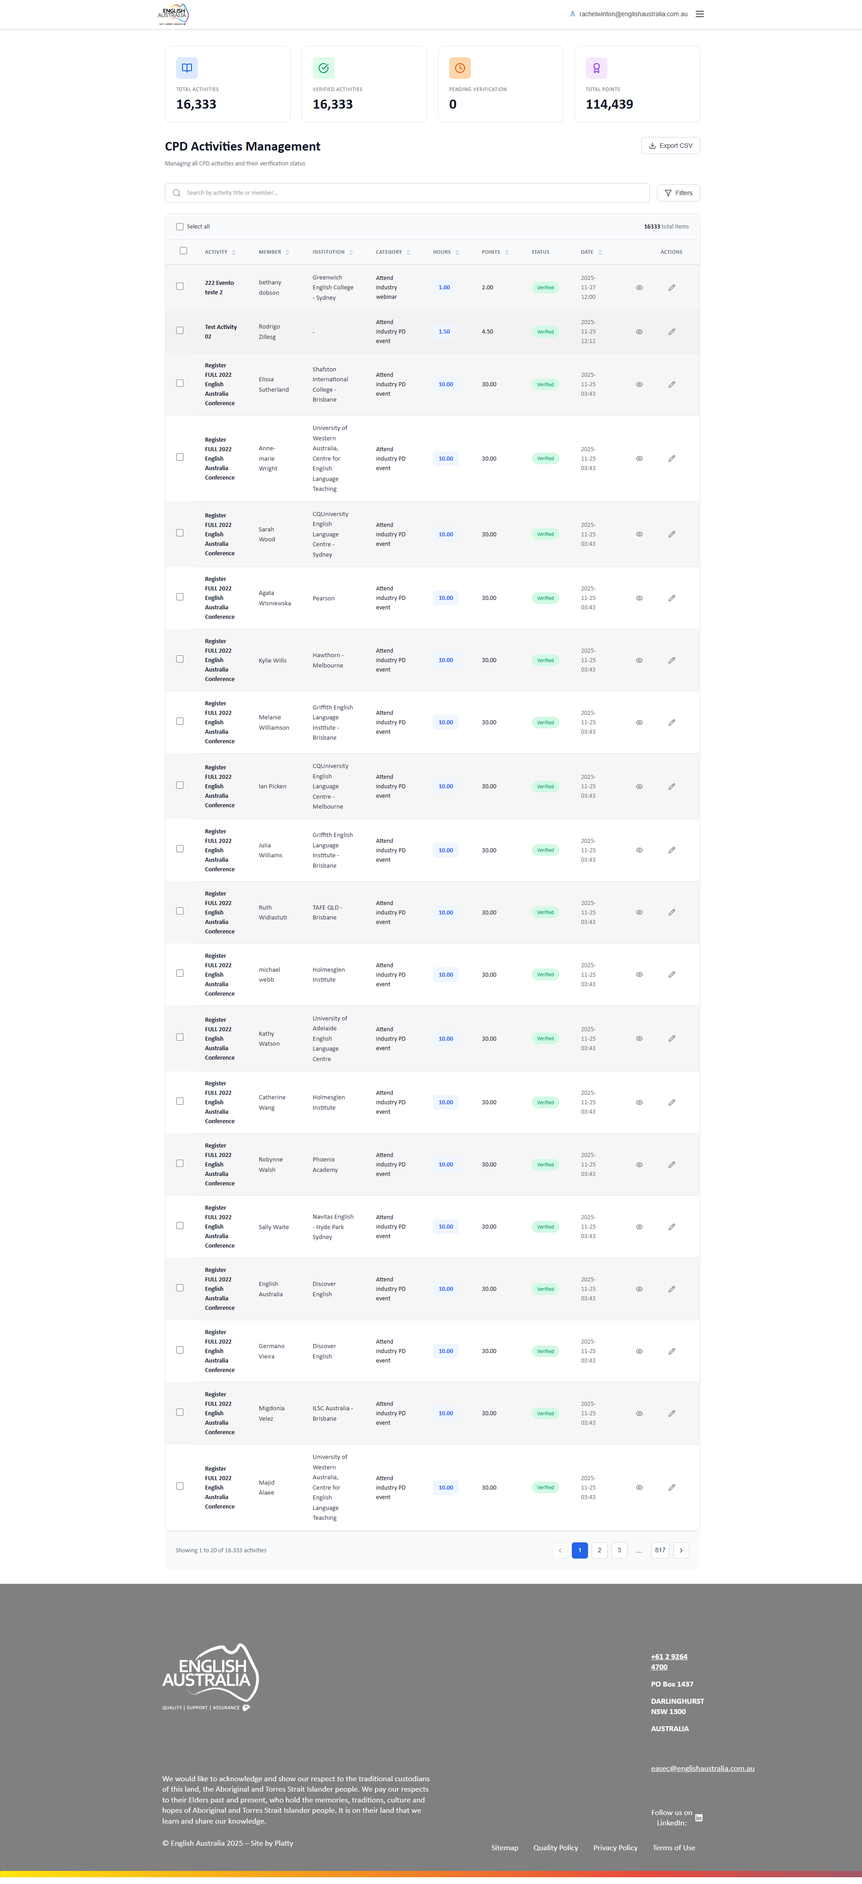
Figure: CPD Activities Management

Events Management
Complete event management with all creation and registration functionalities.
Create events, manage participants and control payments.

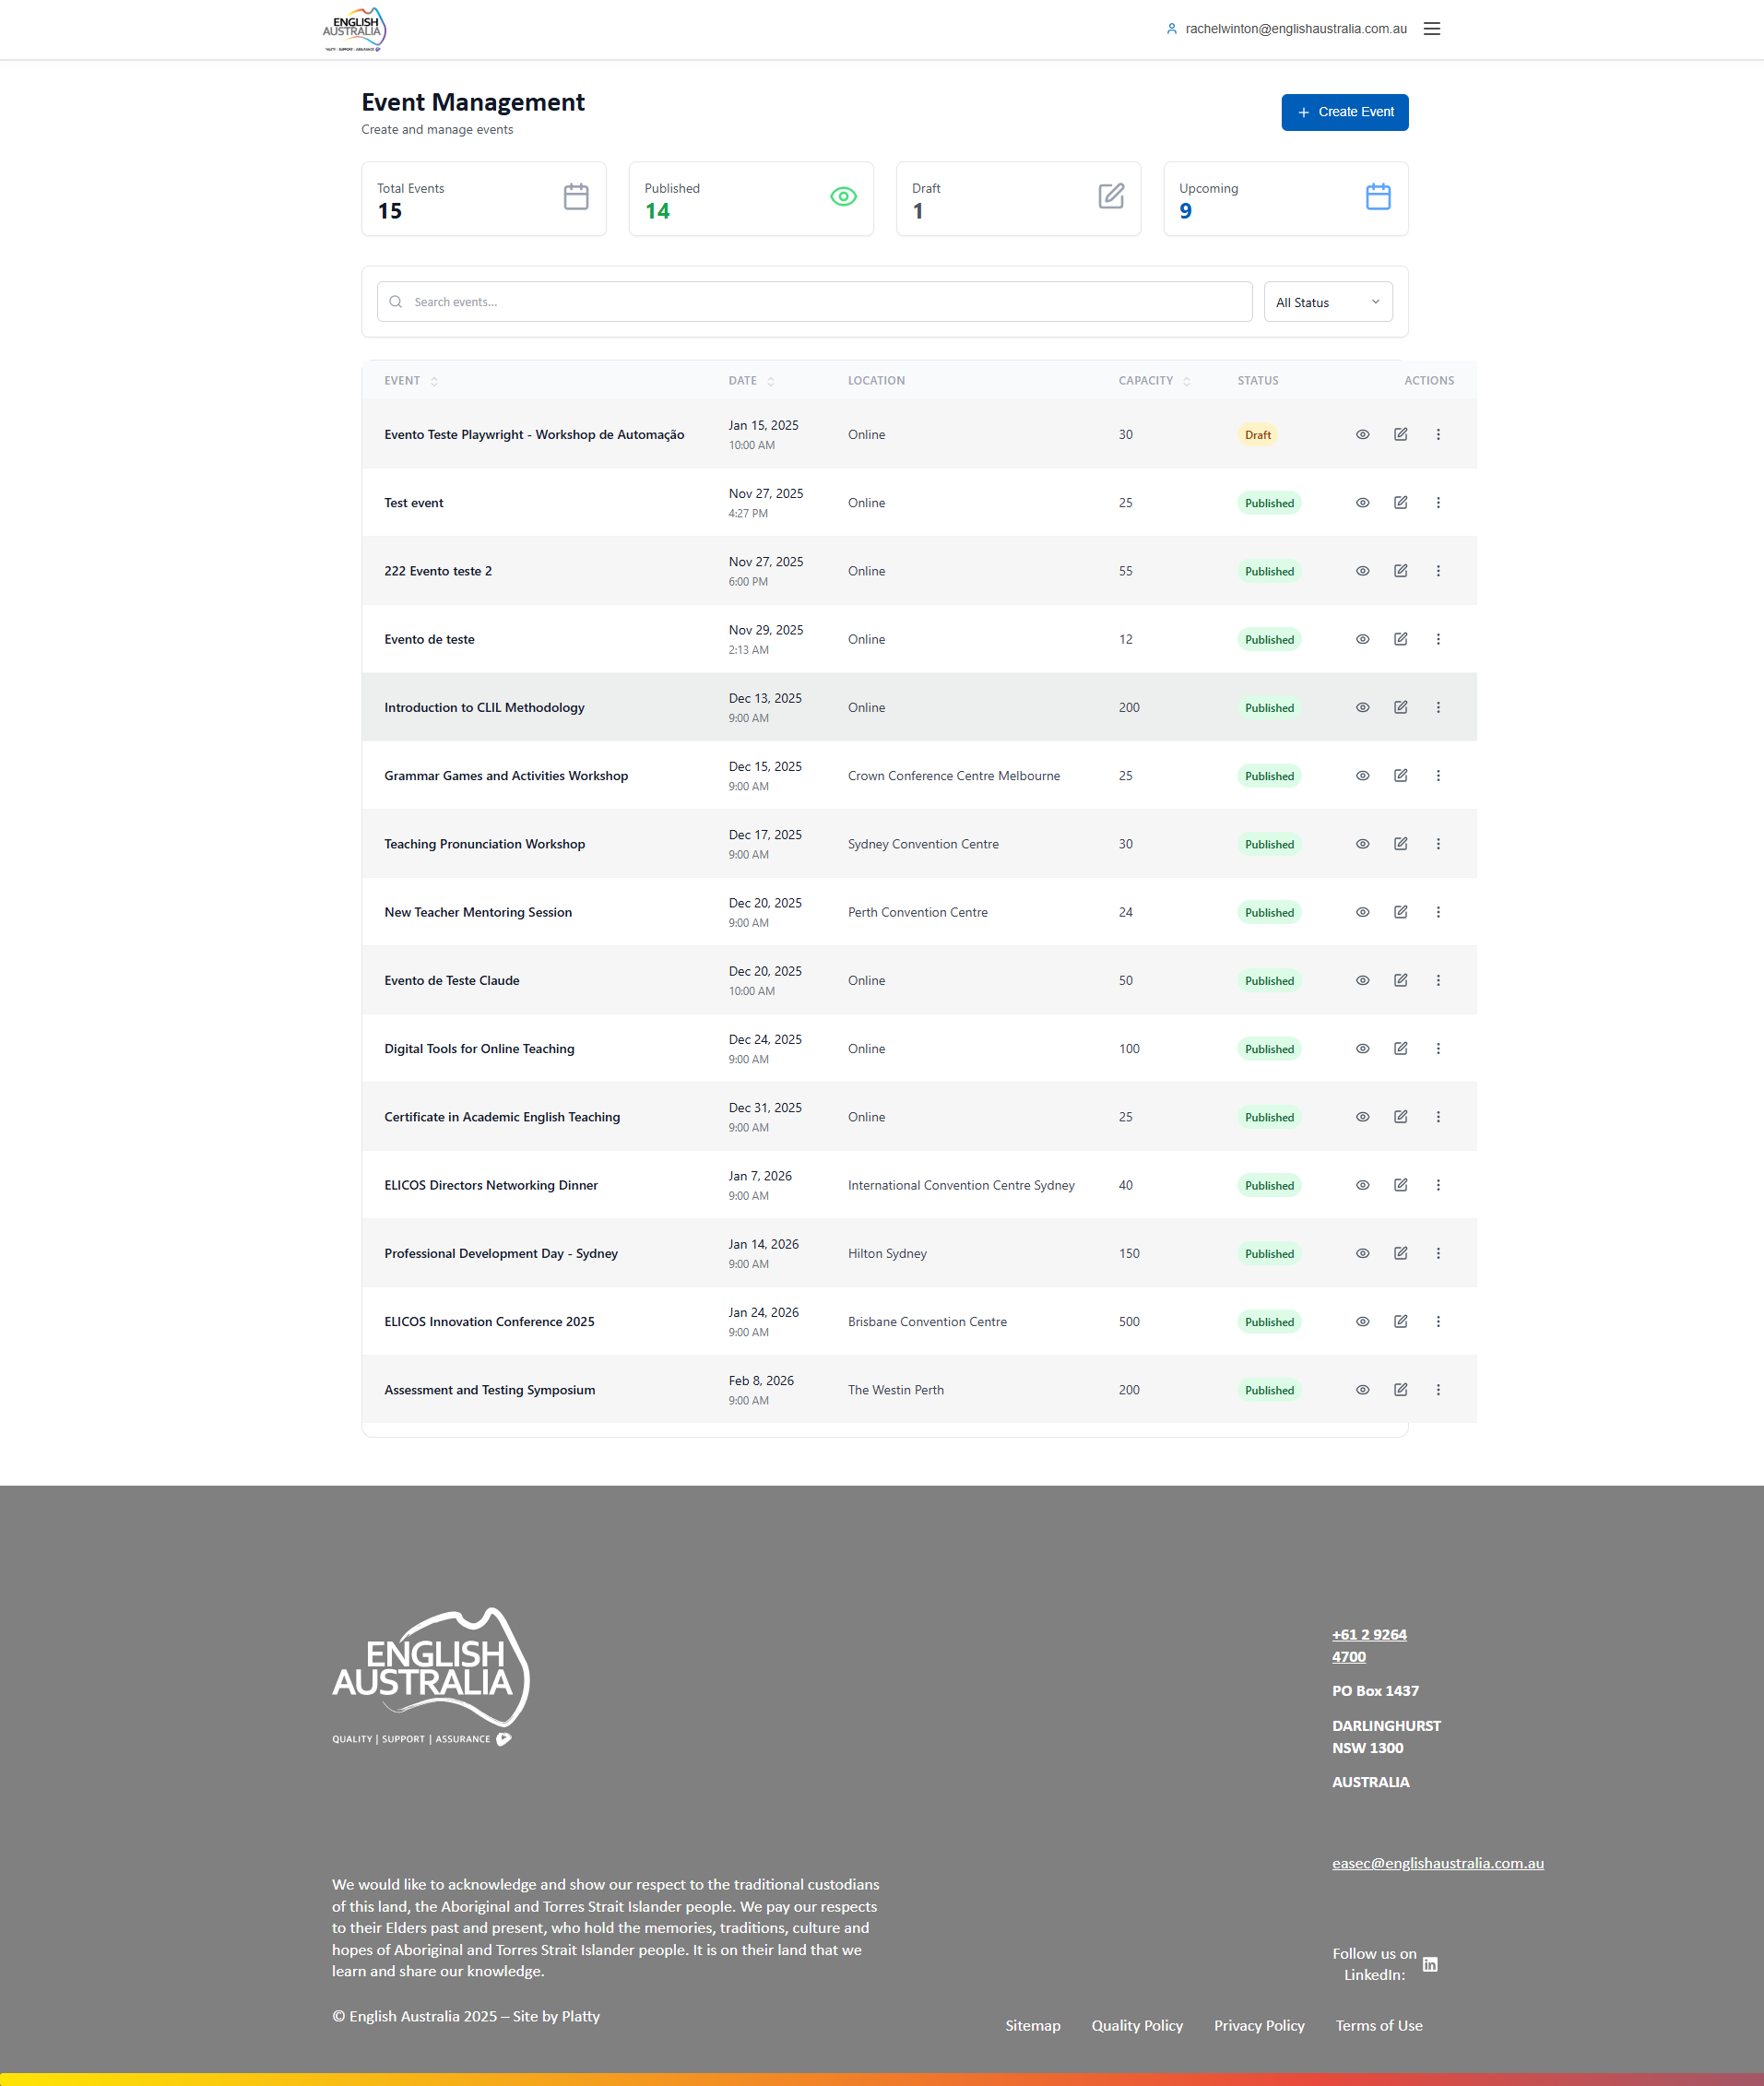
Figure: Events Management

Payments Management
Financial module access for payment viewing and management.
View invoices, filter by status and generate reports.

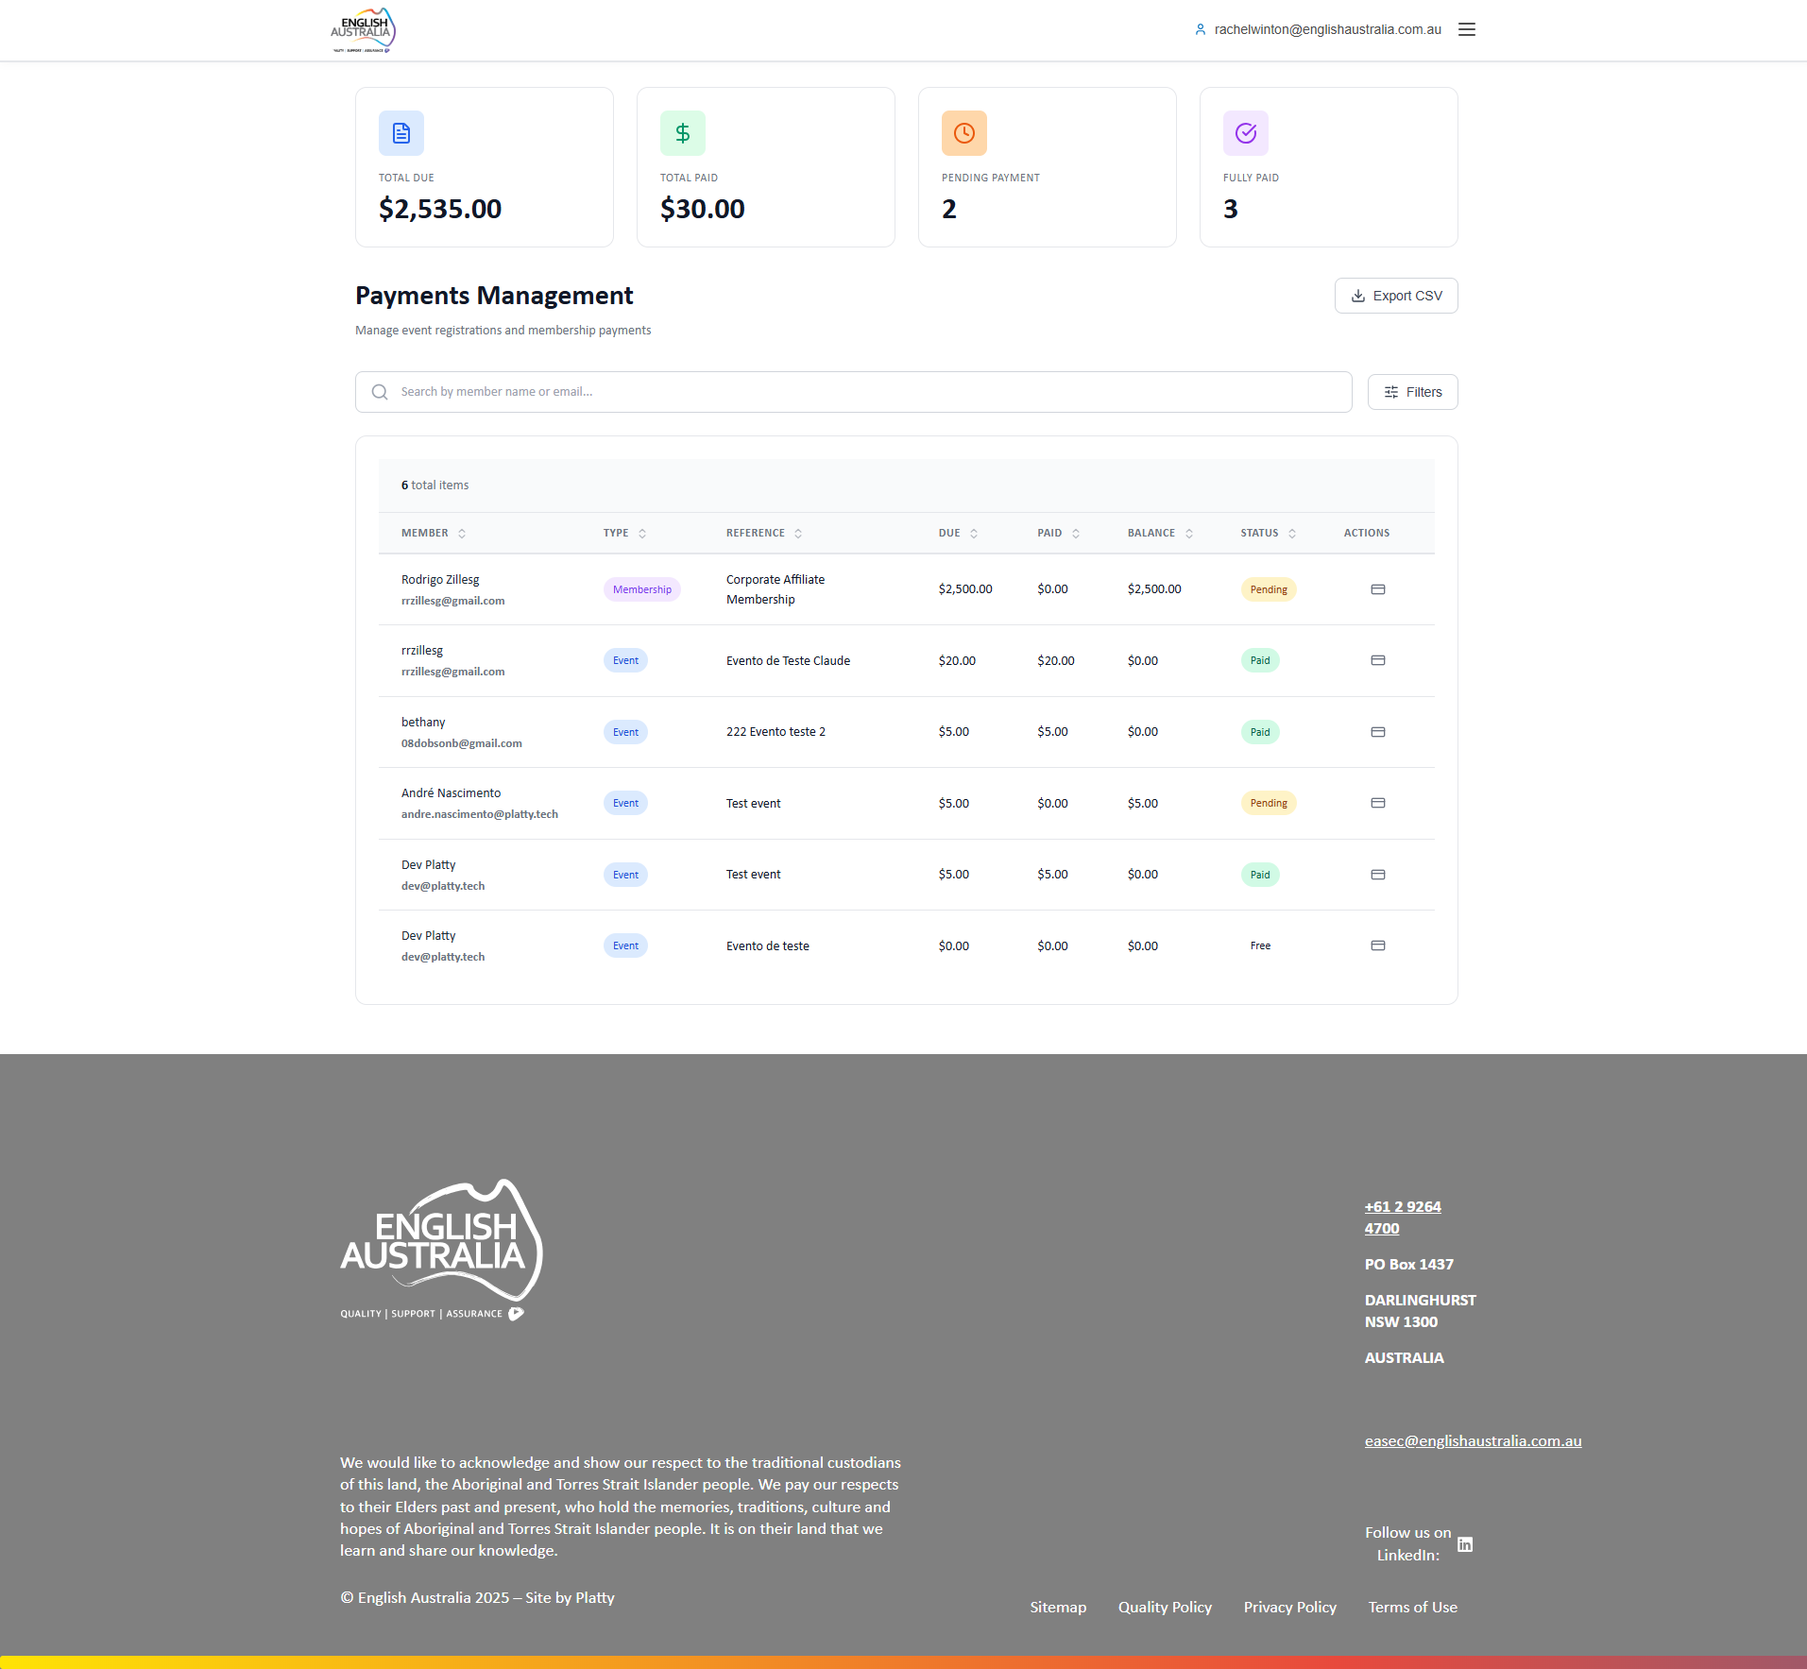
Figure: Payments Management

Membership Applications
Membership applications management with approval/rejection power.
Process identical to Super Admin.

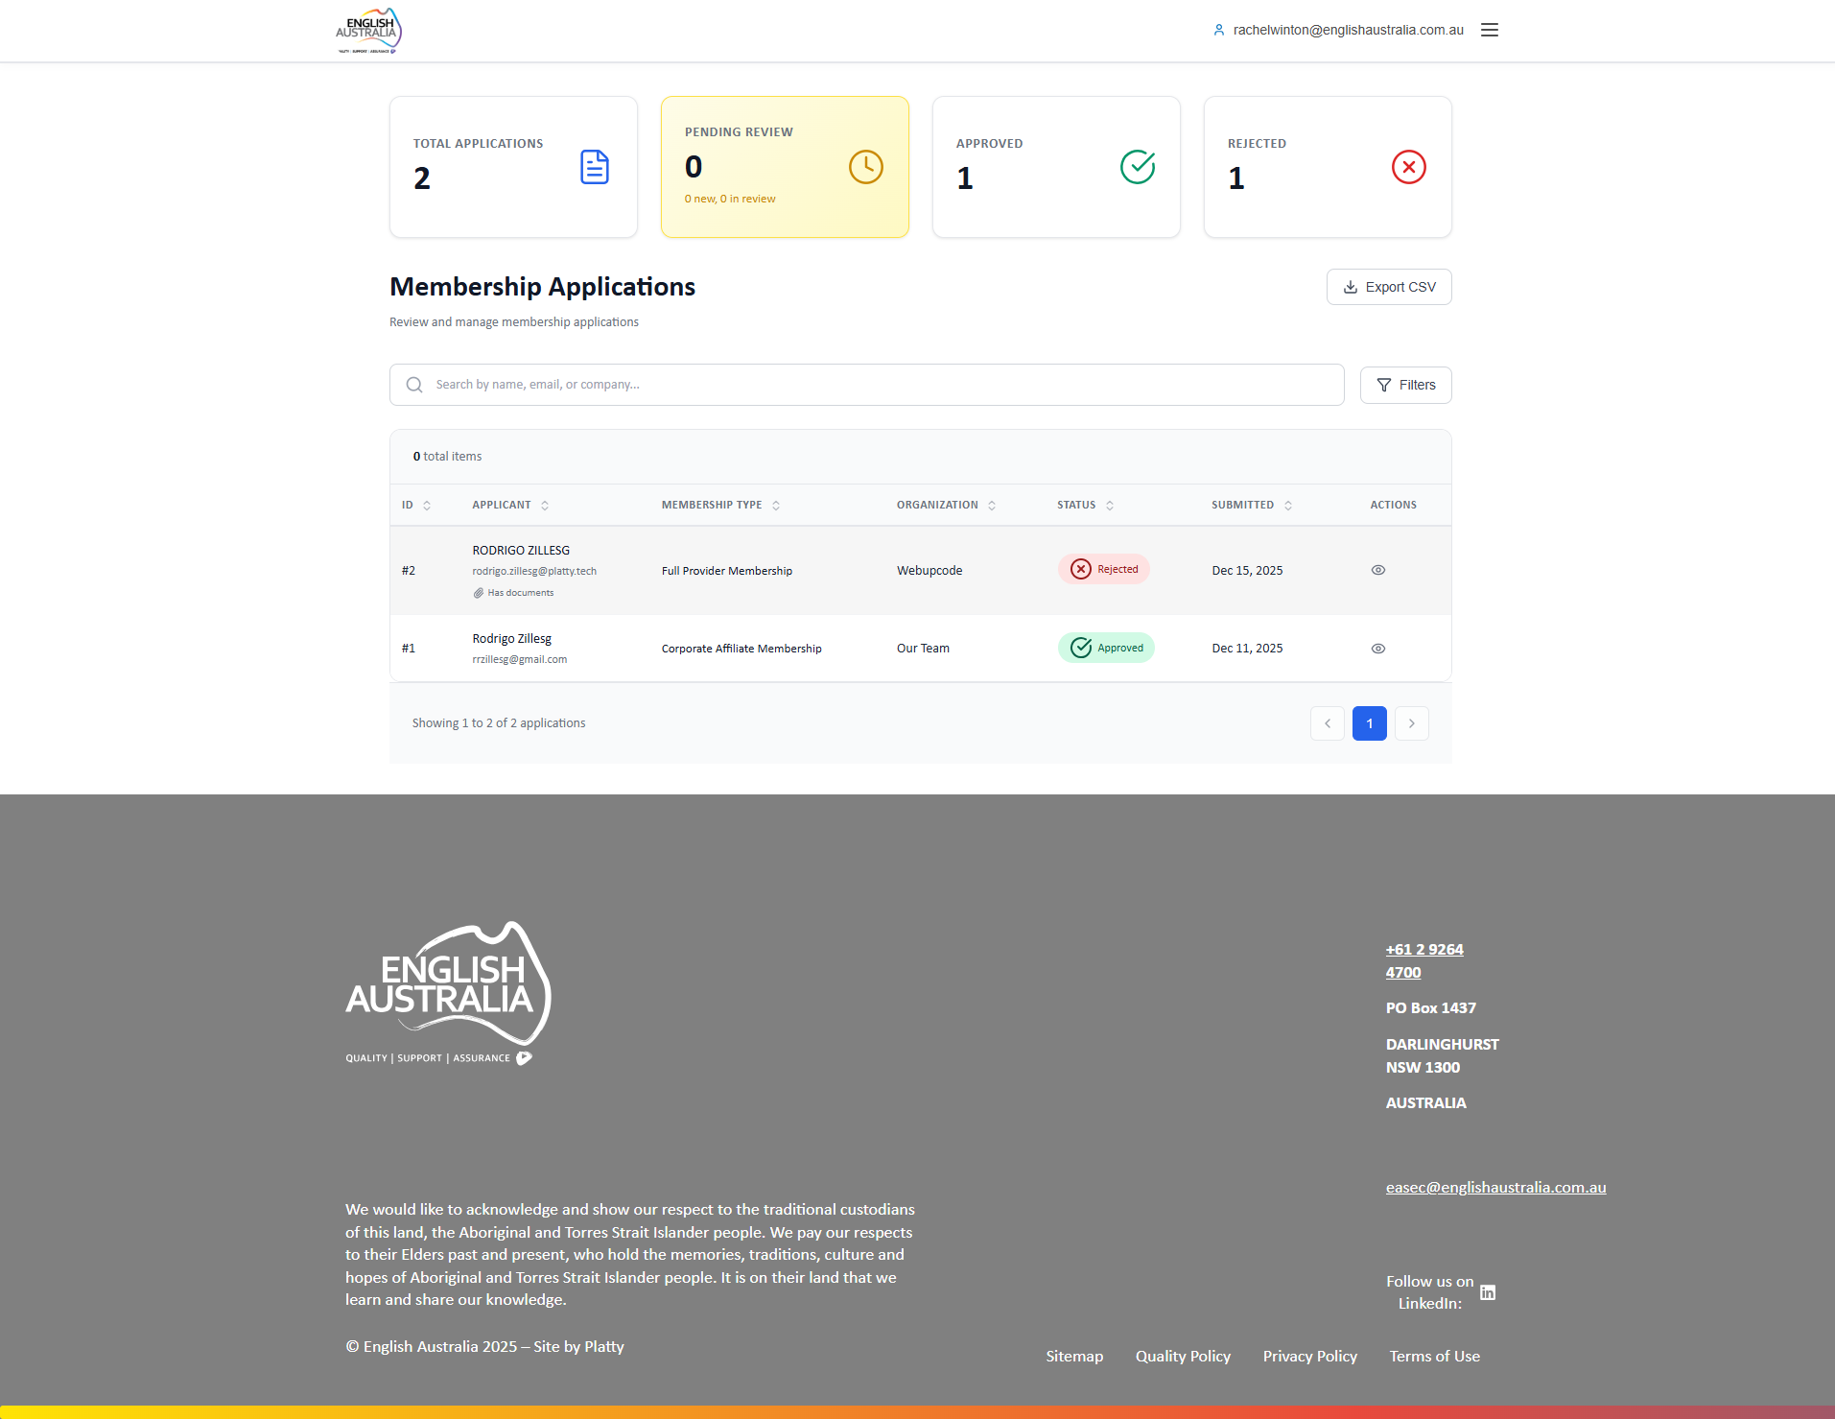
Figure: Membership Applications

My Profile
Personal profile with data editing options.
Standard user profile functionalities.

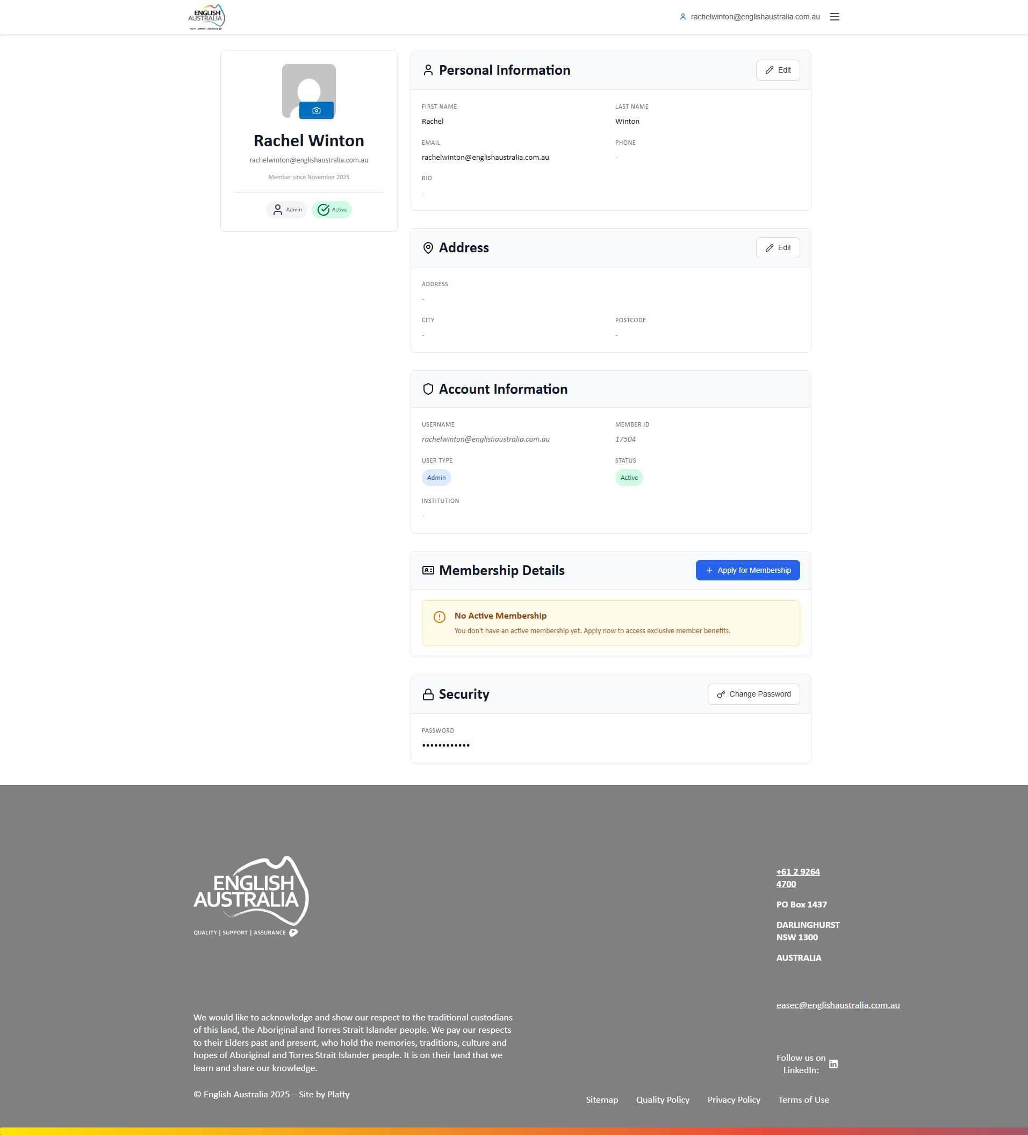
Figure: My Profile

Events (Frontend)
Public events page view.
Same view available to all users.

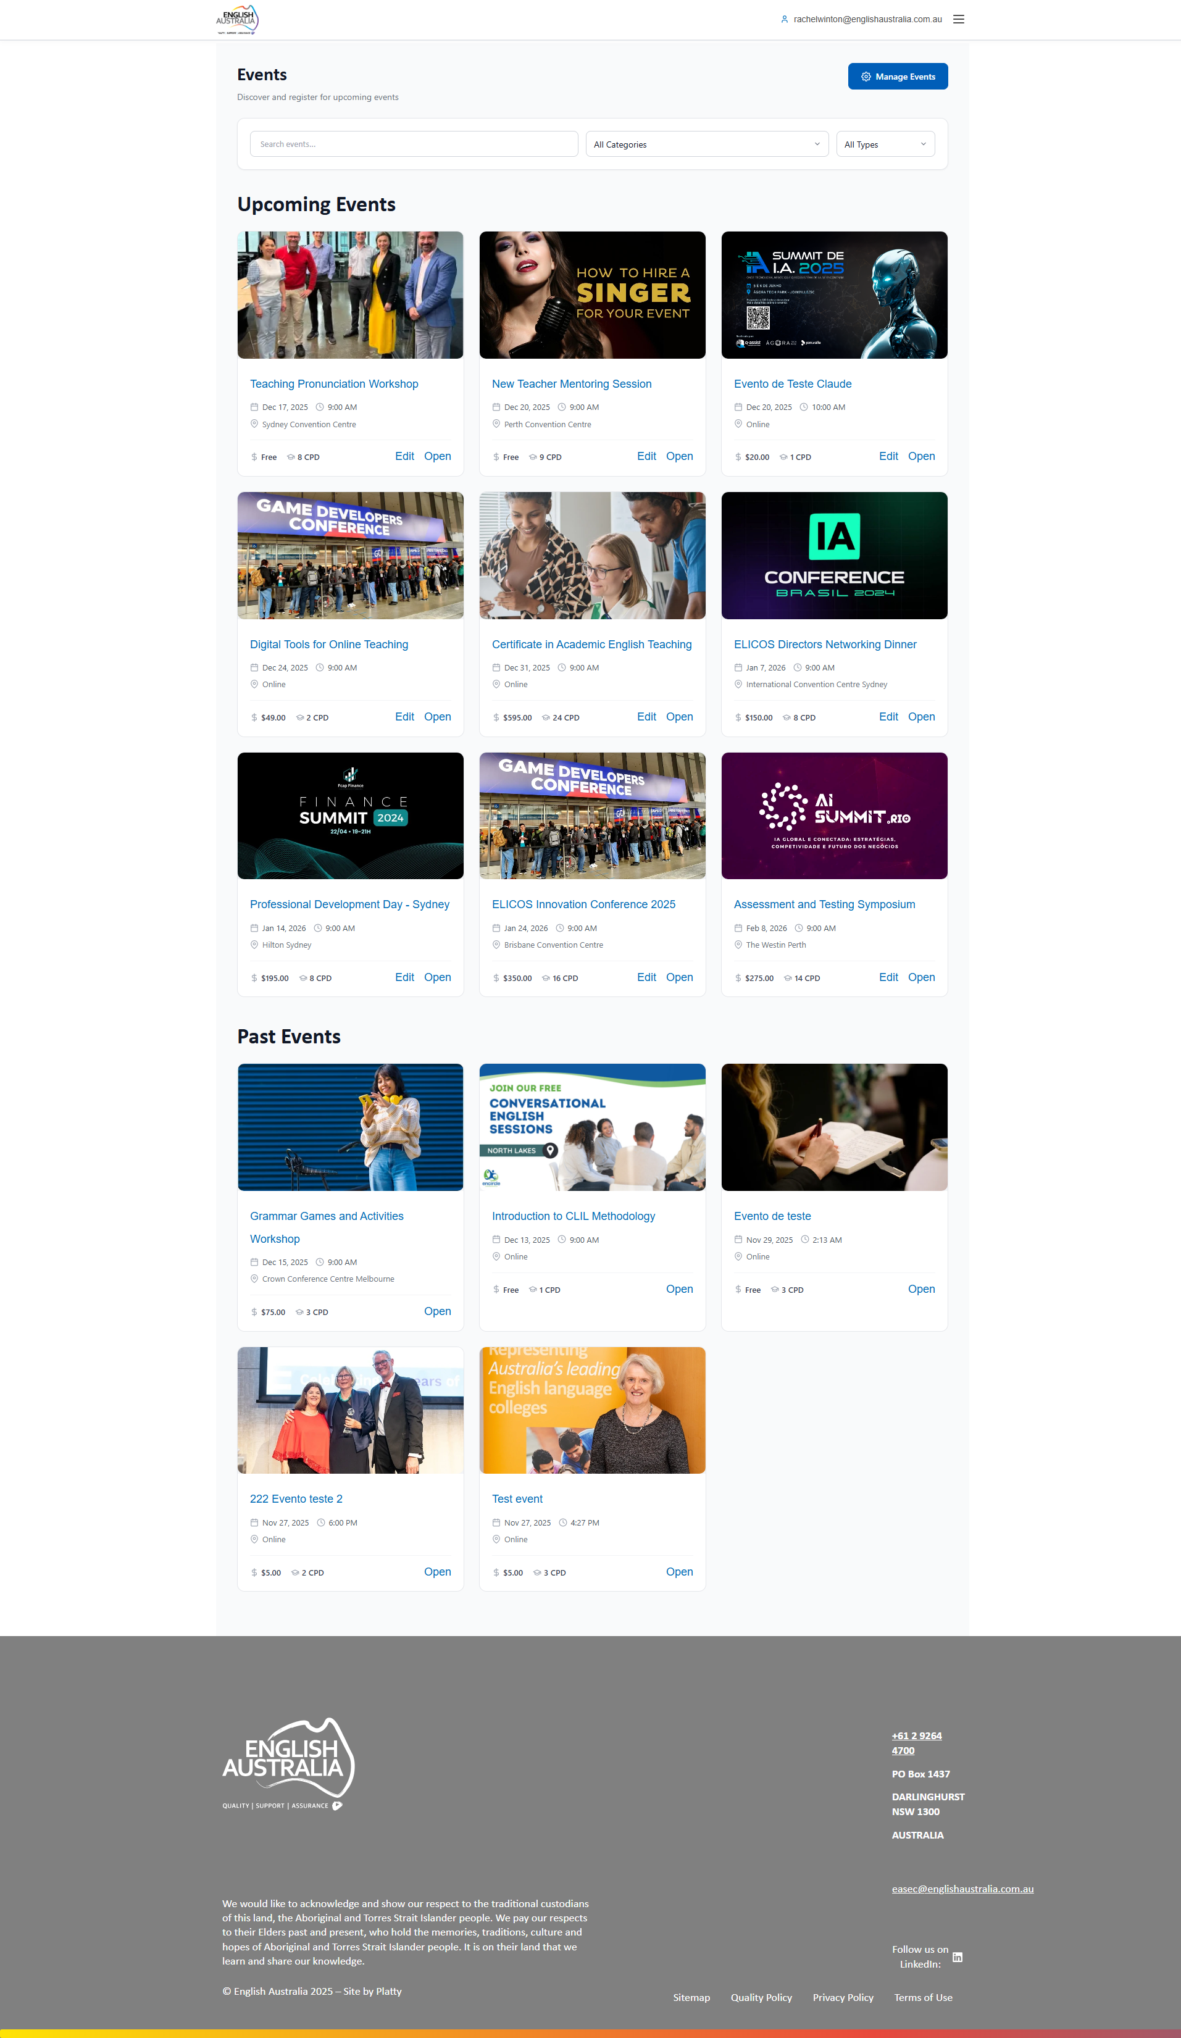
Figure: Events (Frontend)

3. Institution Admin
Profile for English Australia partner institution representatives. Access limited to information and members linked to their specific institution.

Main capabilities:
• View and manage their institution's members
• Edit institutional information
• Approve new members for the institution
• Personal CPD and course access

Main Dashboard
Customized dashboard showing: pending member requests, upcoming events, profile and membership status.
Identification "Institution Administrator for [Institution Name]" shown below greeting.

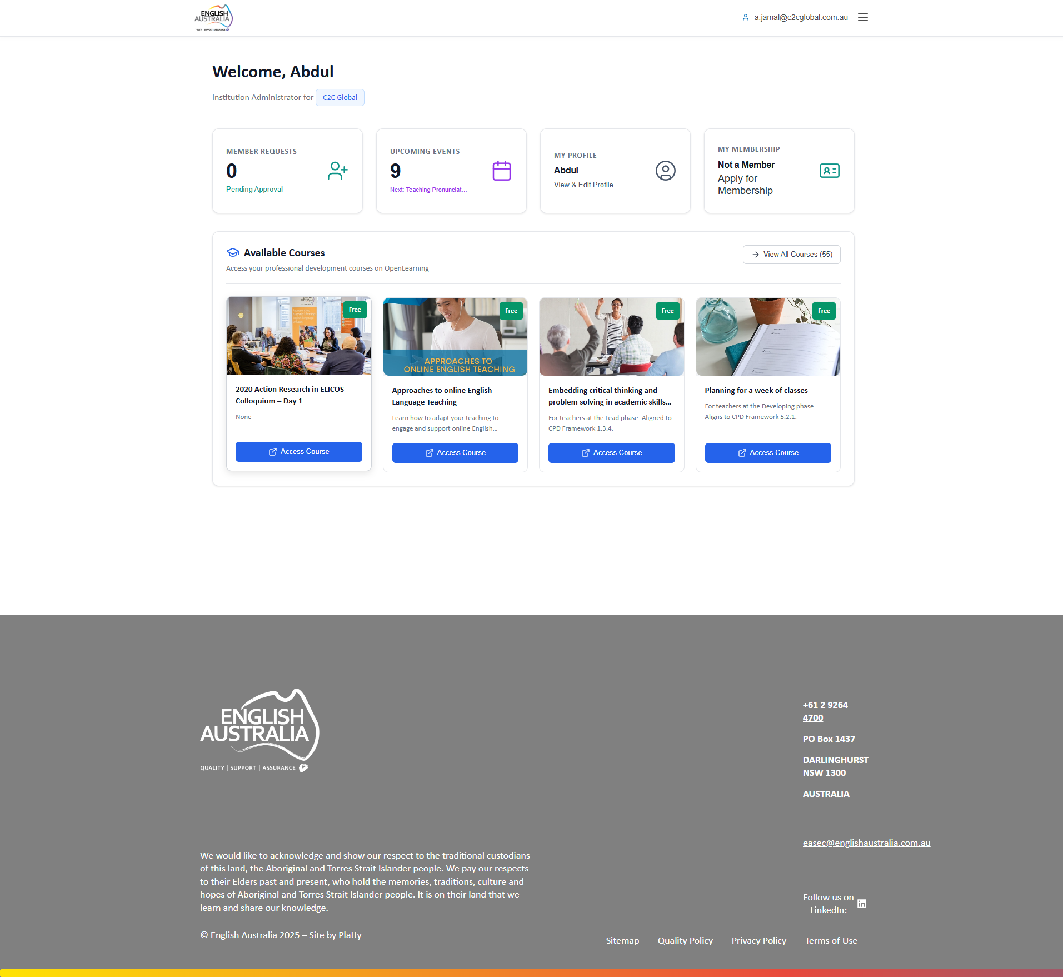
Figure: Main Dashboard

My Institution
Page for managing user's institution. Shows institution info, linked members and pending member requests.
Edit institution info, approve/reject new member link requests, view statistics.

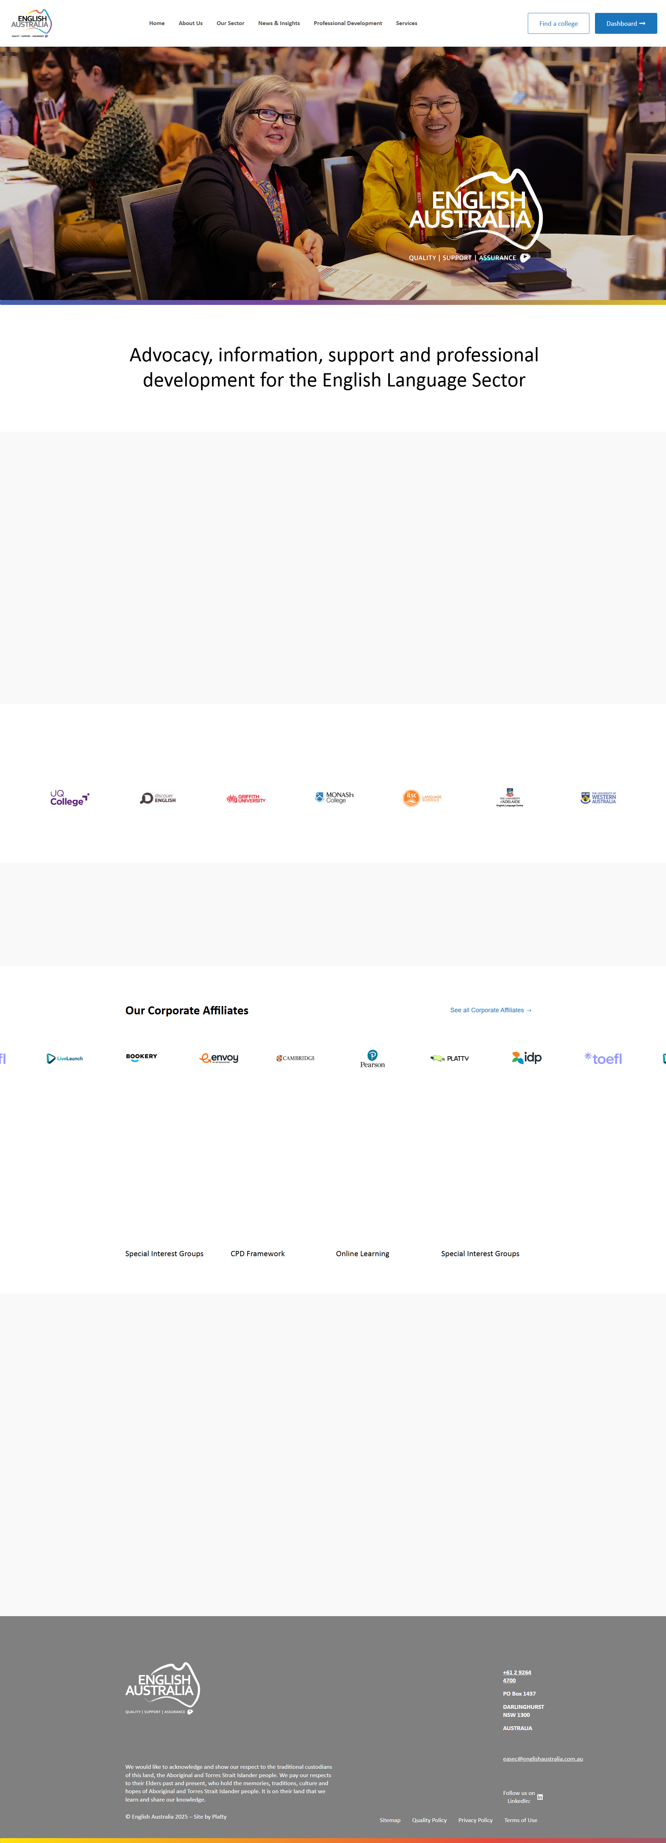
Figure: My Institution

My Profile
Personal profile page.
Edit personal data and account settings.

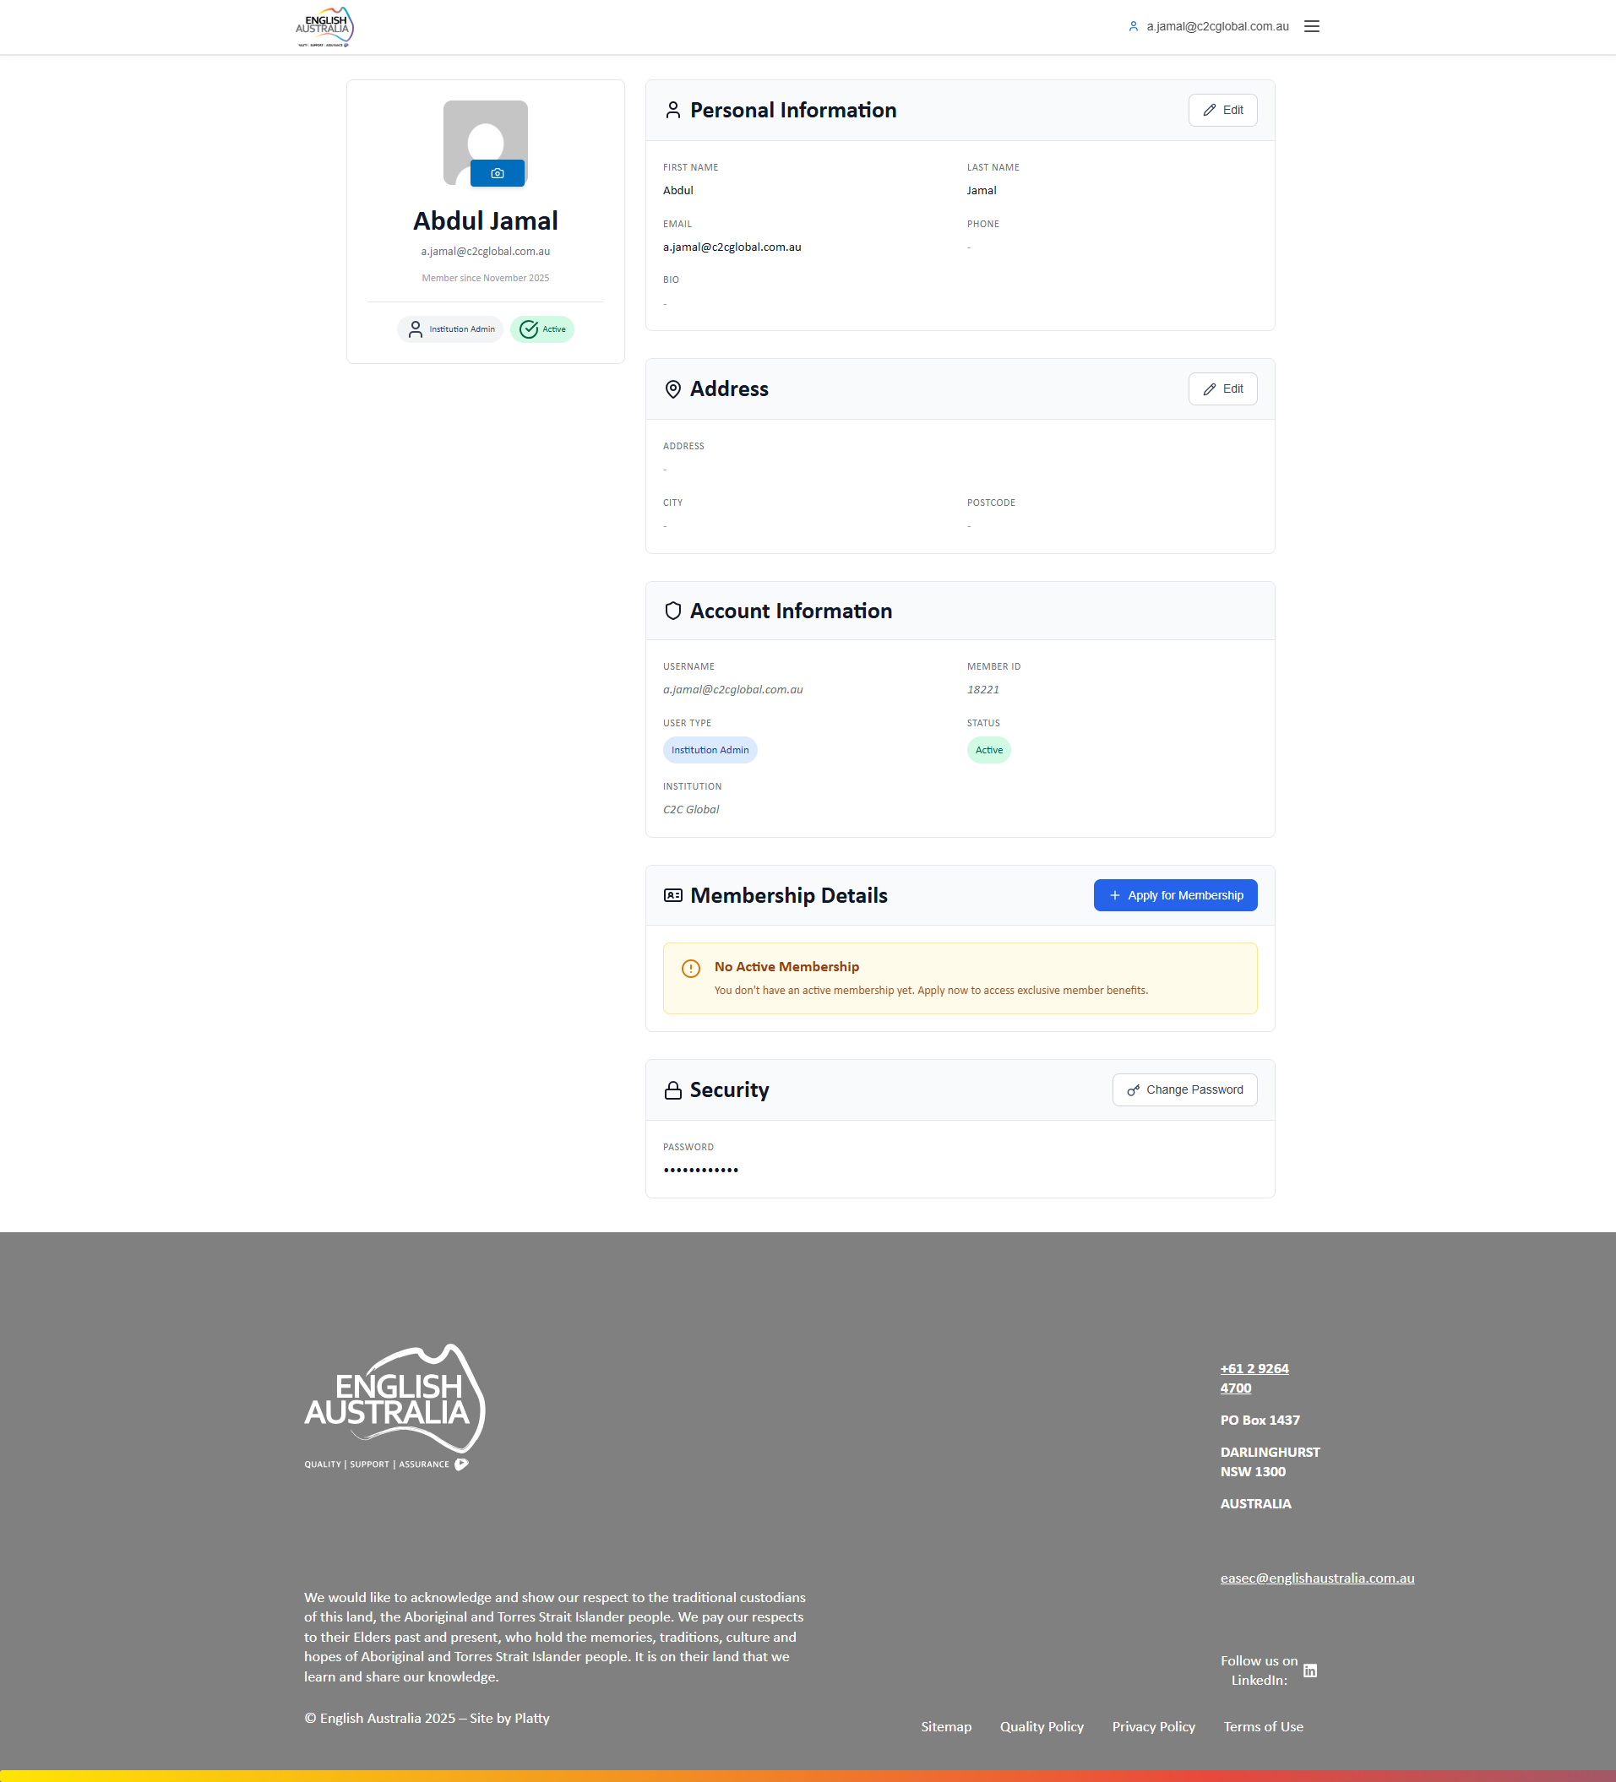
Figure: My Profile

My CPDs
Personal CPD activity record.
Register professional development activities and track score.

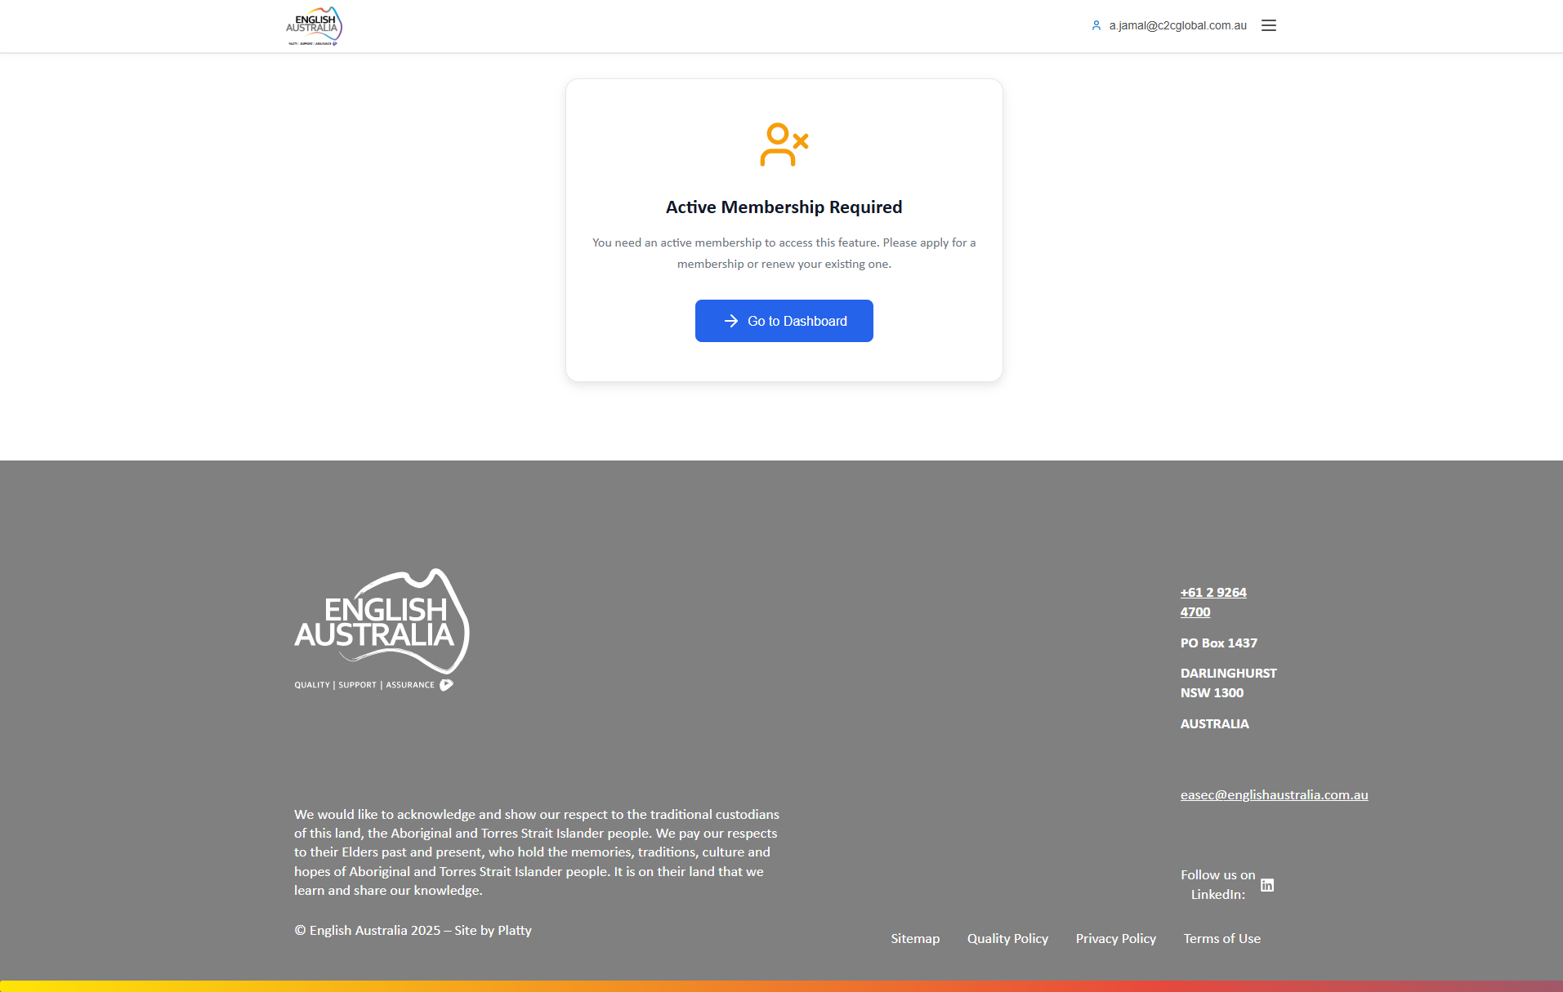
Figure: My CPDs

Events
Public events page for viewing and registration.
View all available events and register.

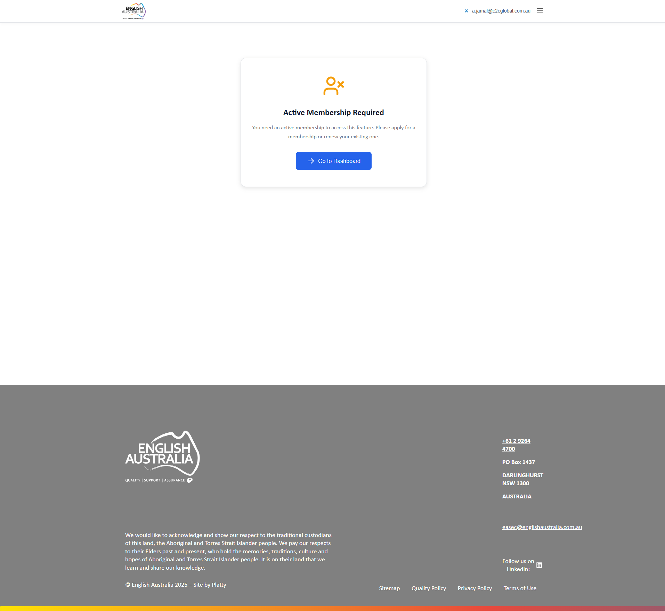
Figure: Events

Courses
Access to OpenLearning courses.
Access and take available courses.

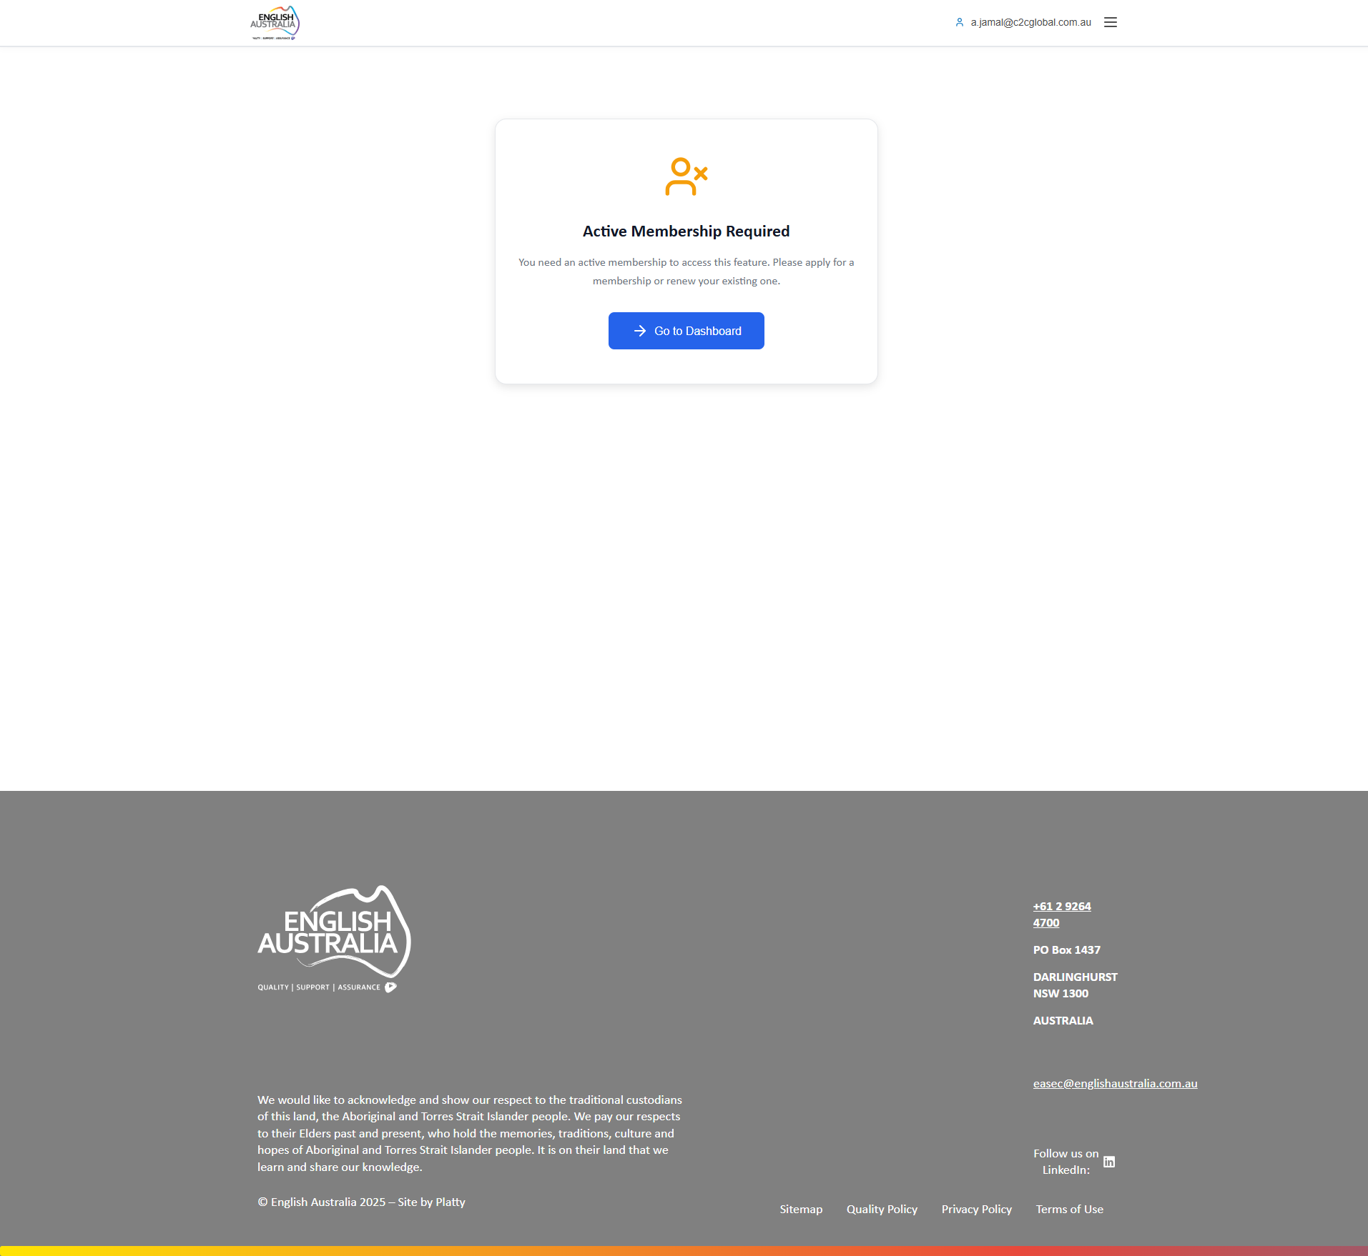
Figure: Courses

4. Member
Basic profile for individual English Australia members. Access limited to personal functionalities for managing professional development and participating in organization activities.

Main capabilities:
• Personal profile management
• CPD activity registration and tracking
• Event registration
• Online course access
• Membership application

Main Dashboard
Simplified dashboard focused on individual member needs: upcoming events, profile access, membership status and recommended courses.
Cards: Upcoming Events, My Profile, My Membership and Available Courses.

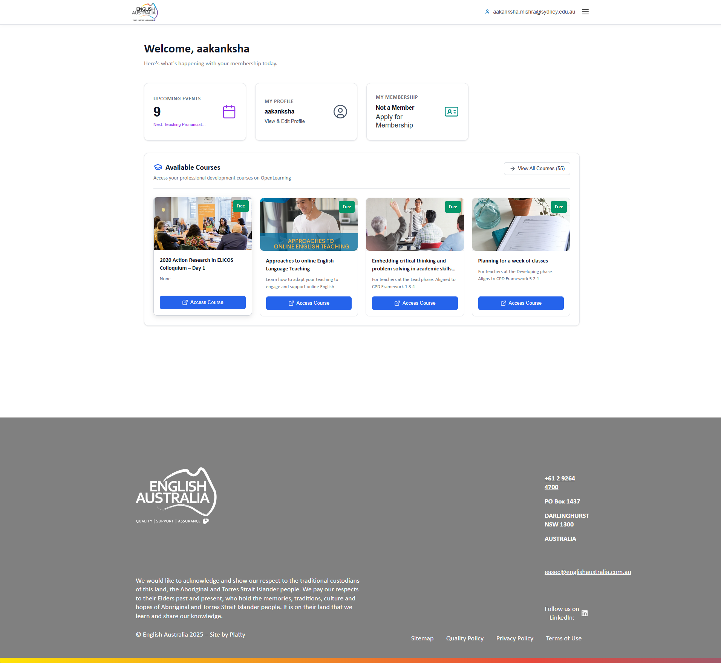
Figure: Main Dashboard

My Profile
Complete personal profile page for viewing and editing registration information.
Personal data, contact info, profile photo, notification settings and activity history.

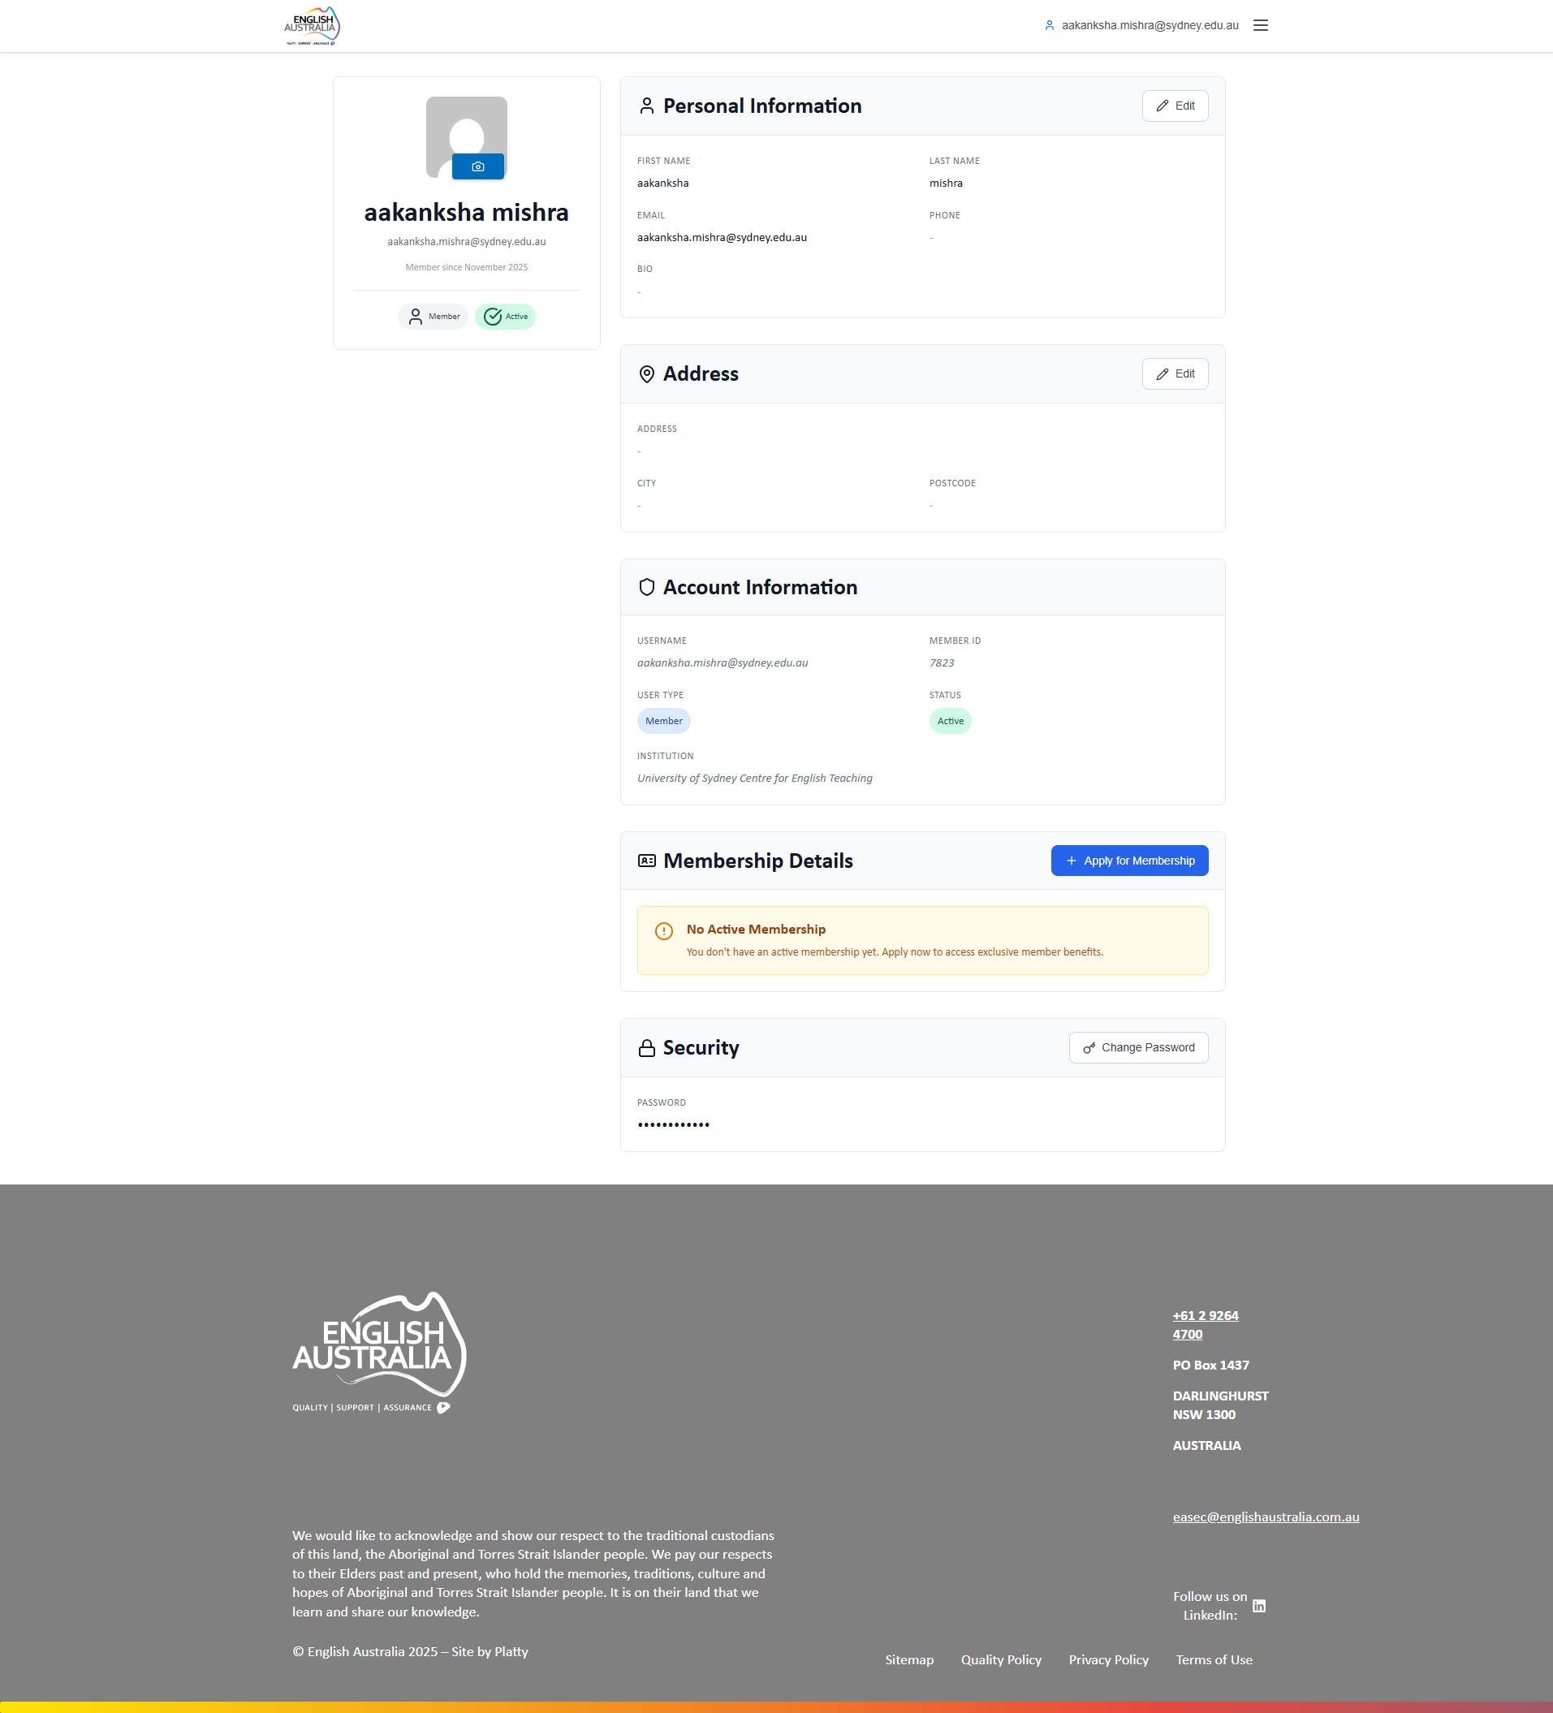
Figure: My Profile

My CPDs
CPD activity management central. Register new activities and track complete history.
Submit CPD activities with evidence upload, track approval status, view accumulated score.

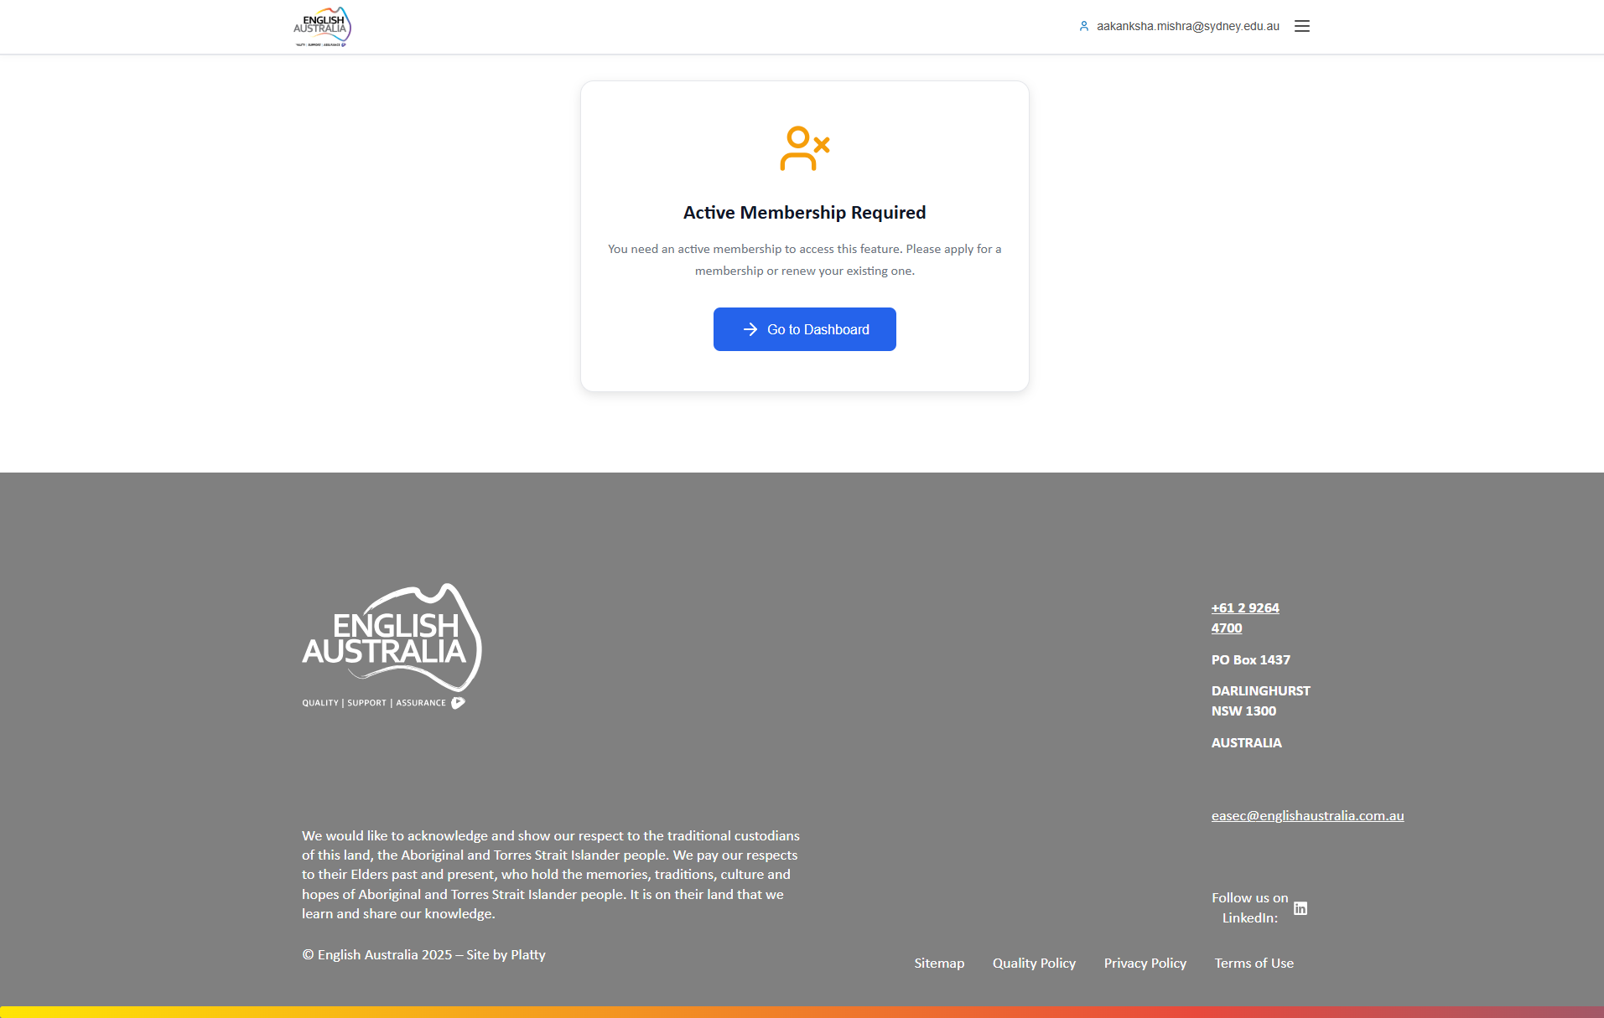
Figure: My CPDs

Membership Selection
Page for selecting and purchasing membership plans. Shows available options with benefits and values.
Compare membership types, select plan and proceed to payment.

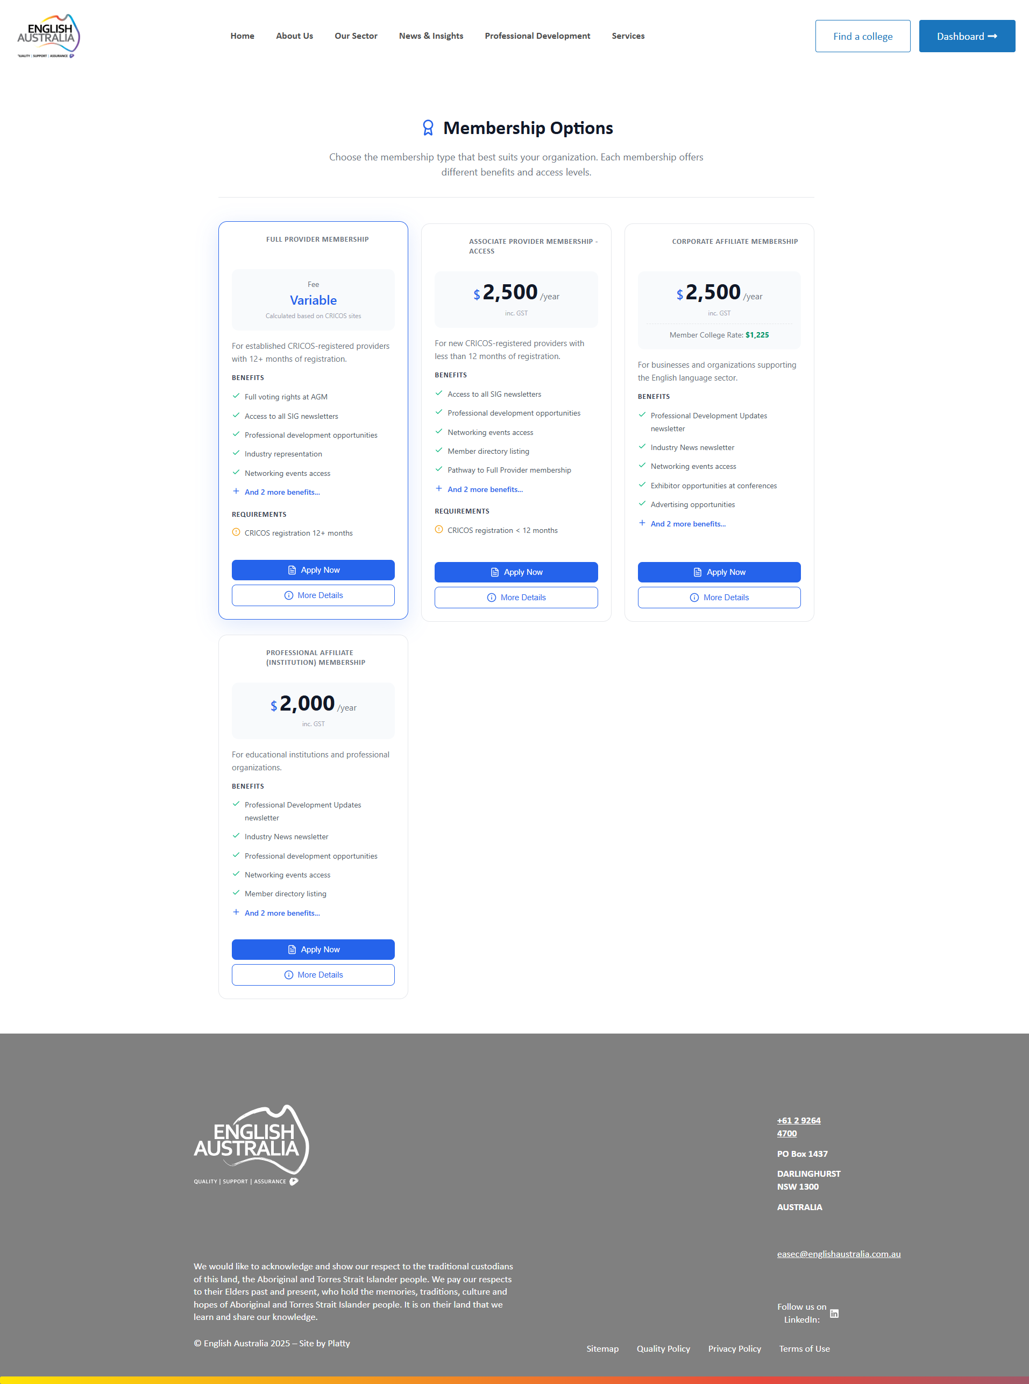
Figure: Membership Selection

Events
Public events page for discovering and registering for English Australia events.
List events with filters, direct registration with payment if applicable.

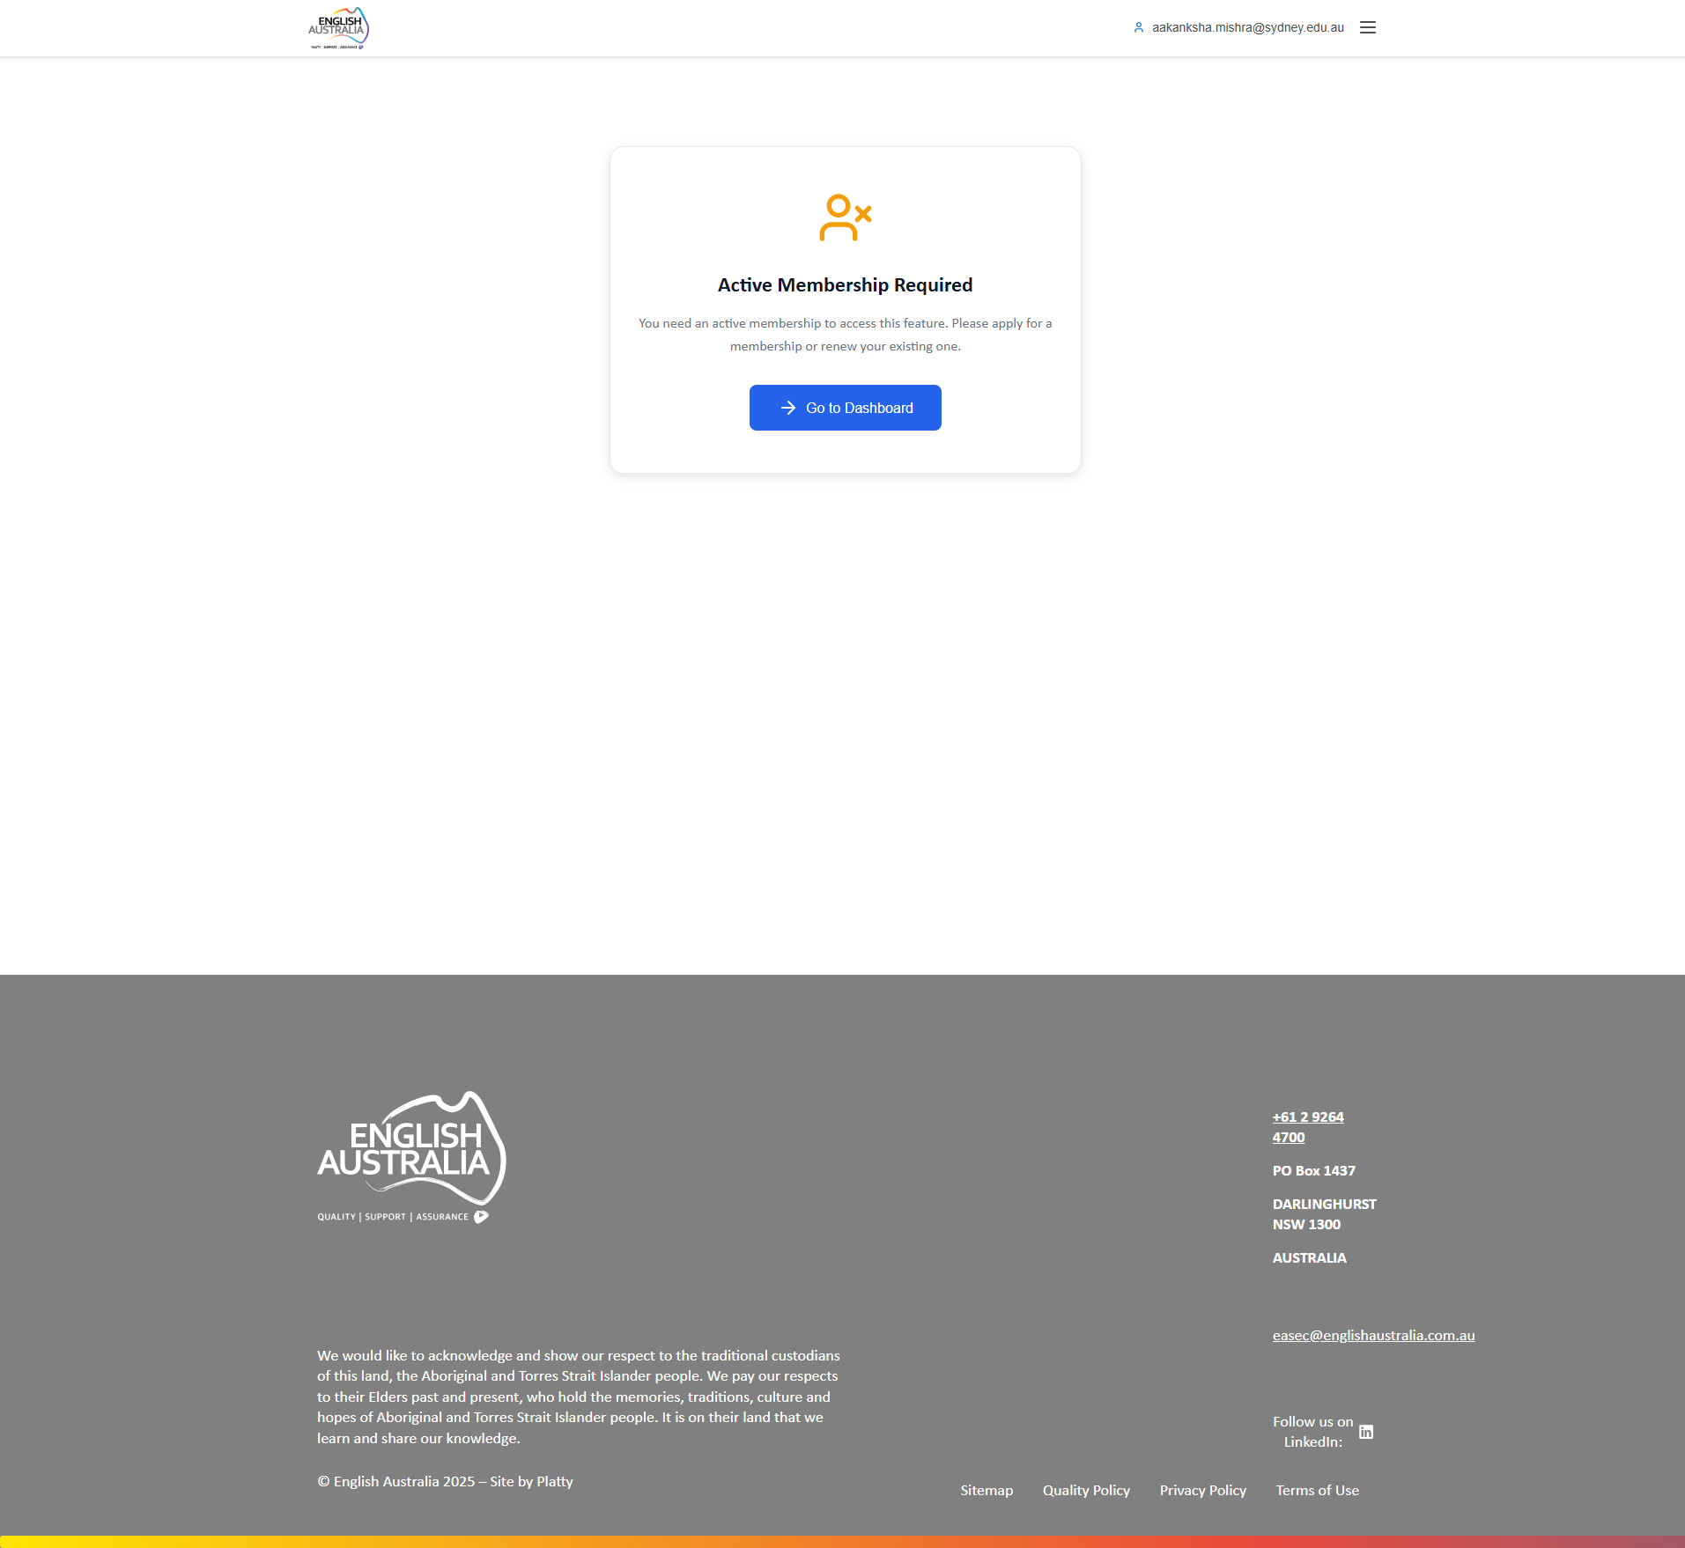
Figure: Events

Courses
Catalog of courses via OpenLearning integration. Shows 55 available courses with free course indication.
Course cards with image, title, description and "Access Course" button.

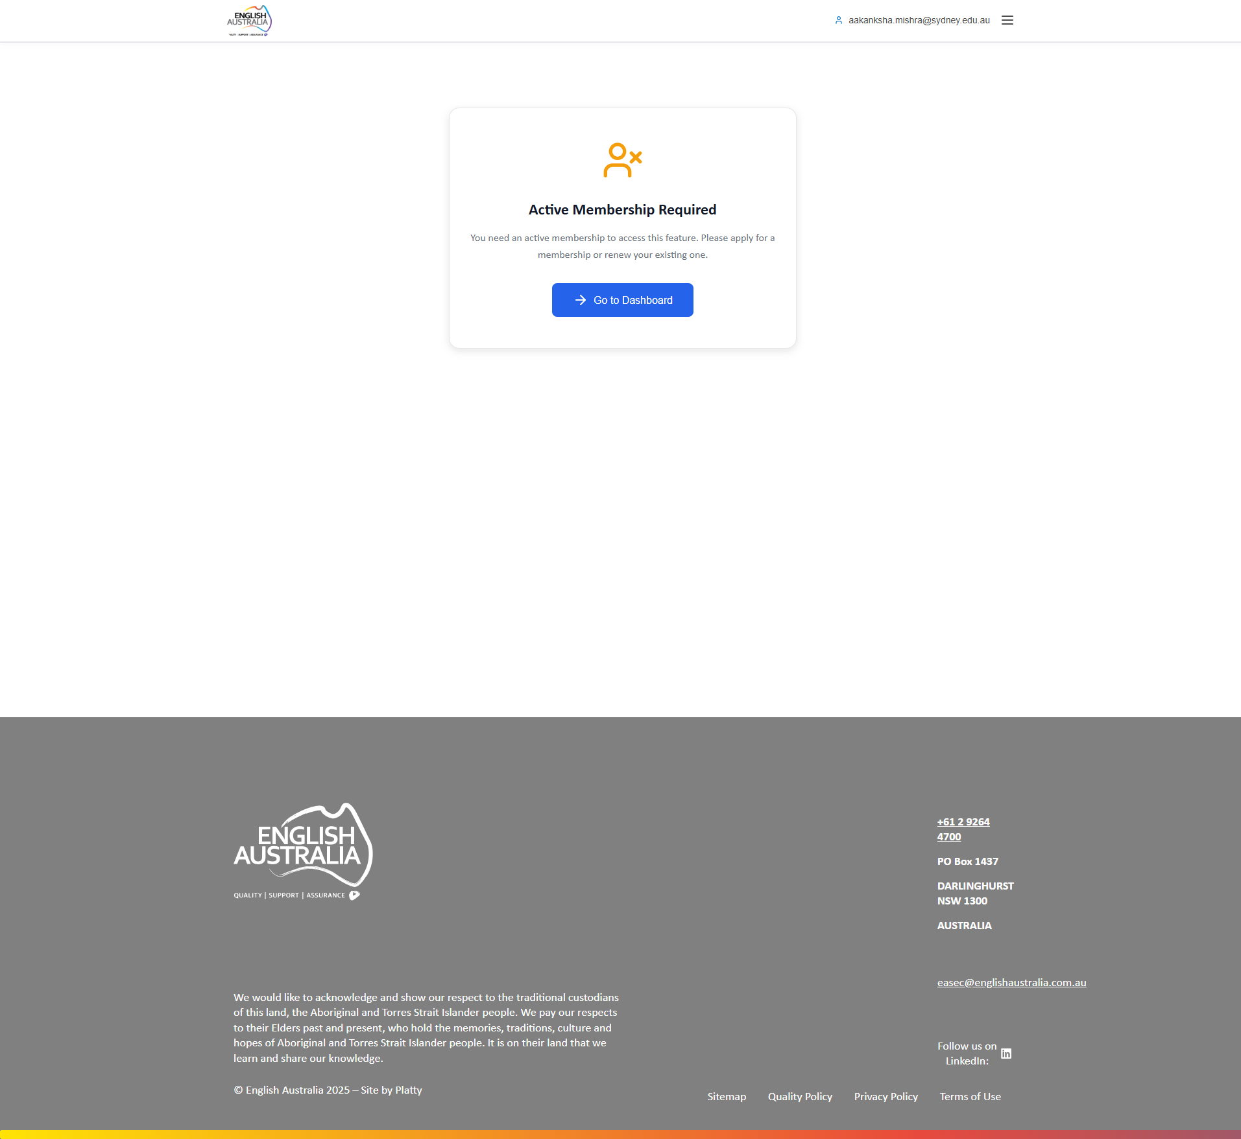
Figure: Courses

Permissions Matrix
The table below presents a complete summary of functionalities available for each user type:

Functionality | Super Admin | Admin | Inst. Admin | Member
Administrative Dashboard | ✓ | ✓ | — | —
Members Management | ✓ | ✓ | — | —
Institutions Management | ✓ | ✓ | — | —
CPD Activities Management | ✓ | ✓ | — | —
CPD Categories Management | ✓ | — | — | —
Events Management | ✓ | ✓ | — | —
Payments Management | ✓ | ✓ | — | —
Membership Approval | ✓ | ✓ | — | —
My Institution | — | — | ✓ | —
Personal Profile | ✓ | ✓ | ✓ | ✓
My CPD Activities | ✓ | ✓ | ✓ | ✓
Public Events | ✓ | ✓ | ✓ | ✓
OpenLearning Courses | ✓ | ✓ | ✓ | ✓
Bulk Deletion | ✓ | — | — | —

Next Steps
The items below represent features that will be developed in the next project phases:

• Fix for viewing activity evidence imported from the legacy system
• Access control adjustment for "Merge Duplicates" button for institution administrators
• Fix for password recovery functionality
• Fix for CPD activities export button
• Complete data import from legacy system (payments, memberships, receipts, and expiration dates)
• Preservation of original member registration dates during import
• Automatic update of all related fields when a member is approved at a new institution
• Configuration of official English Australia emails (SMTP) - awaiting DNS access
• Mailchimp integration for automatic email list synchronization - awaiting access
• Tag system for member segmentation in email lists
• Payment gateway integration for automatic status updates (to be confirmed)
• Configuration of automatic task scheduling system (Cron)
• Integration with the new institutional website developed by the team
• Dynamic content configuration on the website
• Replacement of event certificate signature with the official signature
• Configuration of the official system domain
• Content editing plugin for management autonomy (scope to be confirmed)

Test Access
Use the credentials below to access the system and test the functionalities:

System URL | https://eaudevapp.platty.tech/
Email | rrzillesg@gmail.com
Password | Pl@ttyPl@tty

Note: This access is for testing purposes only. Please do not share these credentials.

Conclusion
The Eau System represents a complete and integrated solution for English Australia's member management. With its well-defined permission architecture, intuitive interface, and comprehensive functionalities, the system meets the needs of all organization stakeholders.

• Well-structured and secure permission hierarchy
• Modern, responsive, and user-friendly interface
• Centralized management of members, institutions, and events
• Complete CPD system for professional development tracking
• Integrations with external platforms (OpenLearning, payments)
• Detailed reports and data export

Version: 1.51.64
Date: 12/15/2025

