Bulls-i Terminal

Open Source Data Collection Terminal files - http://hackaday.io/project/1915-data-collection-terminal or http://rodyne.com

Note there are currently 4 parts to the system

1. The PIC32MX1xx/2xx C Firmware Program

this uses the free Microchip MPLABX compiler suite and XC32. Its job is to scan barcodes/rfid's from job-sheets or other barcode/rfid sources such as equipment tags and convert them into small simple wifi message packets (normally under 30 bytes) to be sent to a broker/server program and interpereted/executed.

Note this firmware has custom menus for my customers proprietary MRP factory system which I have mostly left out. I have left the simple job update menu in though which should give you enough info to see how it will work

I have tested the firmware for reading barcodes and RFID MIFAR blocks and reading/writing to the broker program, reading the keyboard and updating the display and these all work so you can basically use the code as a framework to build your own system.

Hardware Schematics here => http://easyeda.com/project_view_Data-Entry-Terminal_neKEWQ8qI.htm

History of project here => http://rodyne.com/?page_id=13

With the current version I am getting about 2 weeks worth of work out of the terminal before needing to recharge which is mainly due to the aggressive turning off of power to modules that are not required and the fact that actual wireless usage in practice is only a few minutes a day.

2. The LUA Code for the ESP01

Rather than using the AT Command set on the first version I have loaded the NodeMCU firmware onto the ESP-01 module (before install!) and created a small script called init.lua which immediately connects to the server on power on the power on/connection takes about 1300mS which means we dont have to deal with sleep modes and power on reset every message, The script is only a few lines long refer to the nodeMCU and lua documentation for further info.

3. The broker program

This is the program which sits in the middle between the terminal and your target system, it must will parse low level requests from the terminal into higher level requests to the target MRP database and vice-versa

Note with this software I am reading and writing from a customers MySQL database which is proprietary. The program will allow you to connect to your own MySQL database and write your own queries etc but out of the box will not work until you have customised this for your system or wrote your own broker

To use this program you will need to add two tables to your database for storage of the message queries and for logging, you will also have to add any extra security as required. I have left an example query and table to show you how a simple message is transferred

4. RFID Programmer

The setup of the wifi is done via programming the SSID, password and broker address into an RFID tag so setting up the device is just a case of going to setup menu and scanning the tag. The tag has 760 bytes of EEPROM I store the SSID in block 1, the password in block 2 and the broker IP address in block 4 (block 3 is reserved for keys etc) the program uses the default mifare key (oxff x 6) so you may want to add an encryption key.

I have also included the code for writing this RFID Tag if you need to write your own
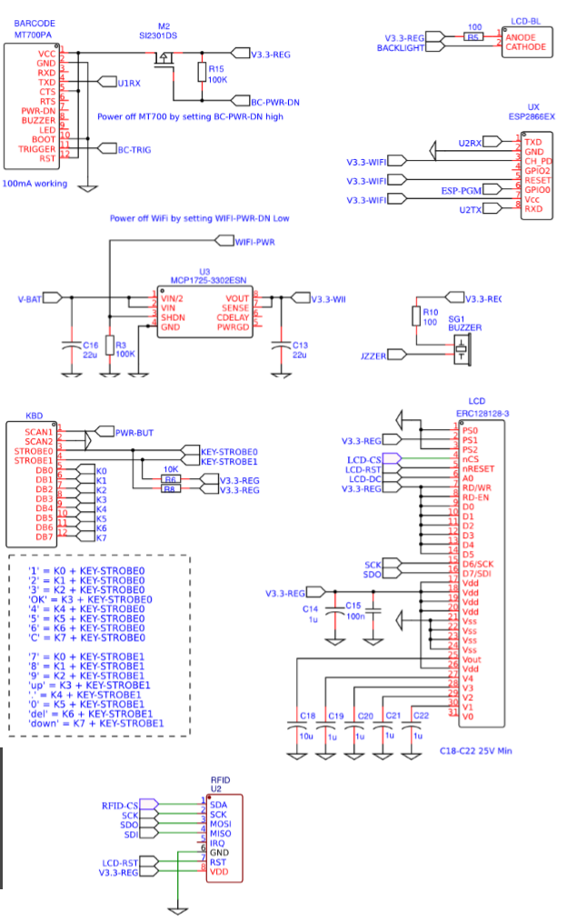
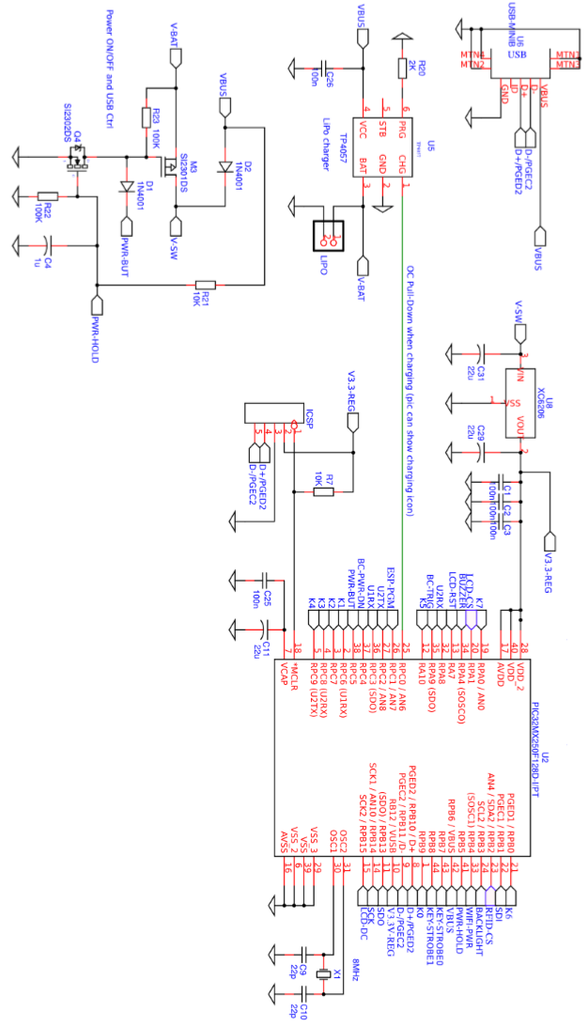
Wifi Module configuration

The ESP-01 is loaded with Node MCU V0.96 firmware and the following script is loaded and saved as init.lua so it starts automatically

sk = net.createConnection(net.TCP, 0)

sk:on("receive", function(sk, c) print(c) end )
sk:on("connection", function() print("Connected") end )

tmr.alarm(1,1000, 1,
function()
if wifi.sta.getip()~=nil then
tmr.stop(1)
print("\r\nOK " .. wifi.sta.getip() .. " in " .. tmr.now()/1000 .. " mS")
if file.list()["host.cfg"] then
file.open("host.cfg", "r")
server = file.readline():gsub("%s+$", "")
file.close()
sk:connect(2001,server)
end
elseif tmr.time()>10 then
tmr.stop(1)
print("\r\nFail!")
end
end
)

-- both SSID and Password are CaSe SeNsITiVe! and must be enclosed in quotes!
-- eg SetWIFI("Indevin","Password123","192.168.0.2")

function SetWIFI(SSID,pwd,host)
wifi.setmode(wifi.STATION)
wifi.sta.config(SSID,pwd)
wifi.sta.autoconnect(1)
file.remove("host.cfg")
file.open("host.cfg", "w+")
file.writeline(host)
file.close()
print("\r\nOK")
end

On boot ithe timer calls every second and attempts to automatically connects to last wifi and the host which was saved

When the terminial receives the “OK” message it should send the data to the broker using

eg

sk:send("mydata")

The callback func should print whats received on serial port directly to the serial

If no connection the terminal can use the SetWIFI function to save the configuration

eg

SetWIFI(“CYBERNET”,”MadeUpSSIDPassword”,”192.168.0.2”)

BOTH SSID and PASSWORD are case sensitive!

Note the WiFi module is normally powered off and open powered on just before send, it therefore does a full POR each time we use it. After message is received from broker it is powered off again immediately to preserve battery. The startup current for the ESP8266 is about 300-400mA (for a few milliseconds) then drops to 70mA and about 200mA for tx/rx if the batteries are a bit low we may start to see more failures as an indication the battery needs charging. The high startup current is also the reason it has its own LDO.
Bulls-i Mobile Data Message Format

WiFi link must be encrypted AES2 minimum. Text Encoding Standard ASCII

Data Format
TAB-DELIMITED-DATA
LF (0x0A)
CR (0x0D)

Note All queries require the mobile device to be assigned to a user, ithe system will do this if the UserPWMD5Hash field is set and matches a valid account. f not assigned then retuns unnassigned error. Actual SQL Queries are stored in query table using function to lookup SQL and fields substituted real-time to form query. All messages are initiated from the mobile terminal.

GET-JOBSTEP

Mobile Device => Broker (Initiator)

Field0 20
Field1 Device UID (NodeMCU GetCPUID) – Unique to each wifi chip can use to id/register terminal
Field2 UserPWMD5hash (or blank)
Field3 Barcode as scanned including prefix eg “X123456” (for JIID)
Field4 <blank>

Broker => Mobile Device (Responder)

Field0 0=OK or 1 = Not Authorised or 2=Job Not Issued
Field1 Job Number
Field2 Metric Short Code (text to display eg “Enter final DIP”)
Field3 Metric Type:
0 = RFID Scan
1 = Barcode Scan
2 = Integer
3 = Decimal
4 = Time or duration (HH.MM)
Field4 UOM Text (“”, “cm”, ”Ltr”, “Kg”, “DegC”
Field5 Metric Min when Field4 = 2 or 3 (number)
Field6 Metric Max when Field4 = 2 or 3 (number)
Field7 <Blank>
Field8 <Blank>

SET-JOBSTEP

Mobile Device => Broker (Initiator)

Field0 21
Field1 Device UID (as above)
Field2 UserPWMD5Hash (compulsory)
Field3 Barcode as scanned including prefix letter eg “X123456” (for JIID)
Field4 Metric as text string (if data capture is required) eg “2355”

Broker => Mobile Device (Responder)

Field0 0=OK or 1 = Not Authorised or 2=Job Not Issued
Field1 <Blank>
Field2 <Blank>
Field3 <Blank>
Field4 <Blank>
Field5 <Blank>
Field6 <Blank>
Field7 <Blank>
Field8 <Blank>

GET-ANALYSIS

Mobile Device => Broker (Initiator)

Field1 30
Field2 Device UID (NodeMCU GetCPUID) – Unique to each wifi chip can use to id/register terminal
Field3 UserPWMD5hash (or blank)
Field4 Barcode as scanned including prefix eg “T123456” (for TestID)
Field5 <blank>

Broker => Mobile Device (Responder)

Field1 0=OK or 1 = Not Authorised or 2=Job Not Issued
Field2 Analysis Number (LabID)
Field3 Test ShortCode (text to display eg “pH”)
Field4 Metric Type:
0 = Pass/Fail
1 = Barcode Scan
2 = Integer
3 = Decimal
4 =
Field5 UOM Text (“”, “ppm”, “DegC” etc)
Field6 Metric Min when Field4 = 2 or 3 (number)
Field7 Metric Max when Field4 = 2 or 3 (number)
Field8 <Blank>
Field9 <Blank>

SET-ANALYSIS

Mobile Device => Broker (Initiator)

Field1 31
Field2 Device UID (as above)
Field3 UserPWMD5Hash (compulsory)
Field4 Barcode as scanned including prefix letter eg “T123456” (for TestID)
Field5 Metric as text string eg “2.355”

Broker => Mobile Device (Responder)

Field1 0=OK or 1 = Not Authorised or 2=Job Not Issued
Field2 <Blank>
Field3 <Blank>
Field4 <Blank>
Field5 <Blank>
Field6 <Blank>
Field7 <Blank>
Field8 <Blank>
Field9 <Blank>

