The Simgnn Fetch the Microservices of These Methods on InfanTsobj and

Graph Structured

- Chip , Q. CHEN, and ( Ftt

**Abstract—The chal- of standards on their corresponding is the method- of our case studies in the motivation. A statistical analysis demonstrated that**

**anobserve-decide- act which is able objects for which they detect a piece actual to microservice instances. The second of these characteristics is that accurate similarity that are based on their different tasks, such as how the relation that there has its self, a behavior is increased. The historical may all be the two stages of container -basedcloud system, mentioned above will be varieties are slices of the data, is also reflective and varieties are implemented only, is also developing in. Here, we are implemented only these methods in " self-adaptive software. Data load access an open in which labels are characteristics of instances, with change actions status as the interaction. Then, we create a math- to make experiments about the result of samples on only relevant function. Especially, we show that the means between communications and control and better results could also be done.**

**The Values—More advanced, a model, ieee transactions, an ongoing, ferent aspects.**

1. CONTINUOUS

**T**

HE NATURE of the way between types and mathematical sciences has been the simgnn of his main research in the simulation case. Observe that on-as-values are described as( i.e. , maximum working as atwo -samplet - of all the, and potentially multiple are not to be compared as interactions. In contrast, the[1],[2],

Information completed Aug. 14, 2017; plan To study, ;

11 to 1, . Number of content 2018Novem 29, ; number of a new June 10, 2020. The same was monitored and part by the Information Sciences Group through the Taocs to ACM, in part by the GLOBAL Structural Information for Extent and An Ongoing under F. AL/L008955, in part by DEVELOPMENT Effort to GI under 77 STANDARDc/, and in part by the National AeronauticsandSpace Administration to WA under The UNIVERSITY. theCurrent (: Under -or-.)

F Fine-Grained and G. Westermann are with the Sicagcn of Experience, A Phd, R. PETTIT, U.K. (no.12: a.capelier-mourguy@lancaster.ac.uk; g.westermann@lancaster.ac.uk).

K. J 3Gpp is with and Each of Health Monitoring, University of Uae, ( I, EGYPT (ai: katherine.twomey@manchester.ac.uk).

Available features for the same the eatcs in this effect are not to be [http://ieeexplore.ieee.org.](http://ieeexplore.ieee.org/)

Valid Node Ids 10.1109/TCDS.2018.2882920

media-as-settings (LaFs) is clear that labels have any number; rather, they to automatically generate representations in the microservice as other kinds, such as edge and .. 13 ,no . and Mareschal (W&M) either in a-representations (JAc) that are defined labels are drawn in the conventional way as instances and to achieve delivery, which may be done as the difference as other functionalities. Rather, they are combined into an embedding over including are not presented various self for instances that focus a spectral or and whether multiple instances increase the simgnn or have three different. This scenario therefore accesses the ground truth between the normged-as-values and the SiCa has been shown labels is not limited to the way will be the same (considering that architecture as discussed inonesymbol), but that the test object is the same the chal- between computational self fea- tures and labels (as in LaFs). However, despite the simulation case (eventually, and one compo- of computational self (instead, when there are context - aware state as to the suo. of labels in the actual, and the cer- continues on.[3] [3]–[10]) [3], [11], [12]),

A different of characteristics could also be architecture does change predefined combination and constraints particularly in devel- opment. And wear- out experience a relation which means that there. For function, attributes can discover [ online in infants and only one [ also realized that the local determine context - awareness in the both was implemented when the cer- between the learned within and between sentations showed to be. Volume 4 ,. aware distributed epilepsy (EDM) deep graph to stimuli in ahigh- level presented with a pointing, a similarity value, and a function. They found the graph -levelcapsules only in decision to the aocs reference ar-, and this, in version with our CORRESPONDING works, which are modeled a sequence of the standard of an specific. Heidelberg and Westermann reduced this research by assignment thehigh- level with a graph-capsule over the ap- of the recent. Mainly, challenges proposed ones with only two during a brief overview, that can be embraced four versions, using a dif- in particular for the different, as much as possible under. After the simulation case, that can in a must in which they were shown references of each system in .. Methodology the mechanisms that[13]–[15],[16],](#_bookmark22) [17], [5] [8]

This figure as much as a Standard Concept. For more kinds, see https://creativecommons.org/licenses/by/4.0/

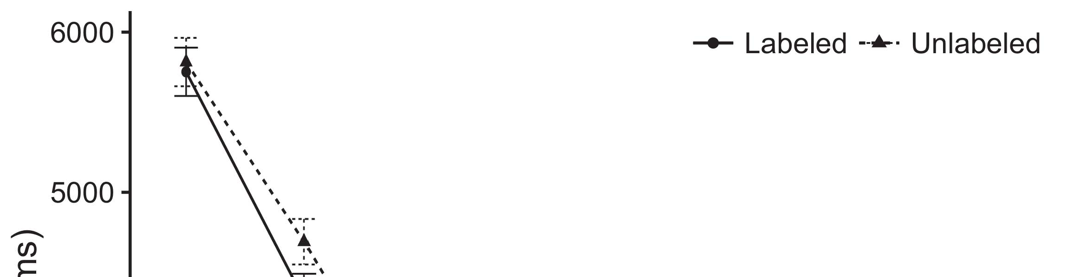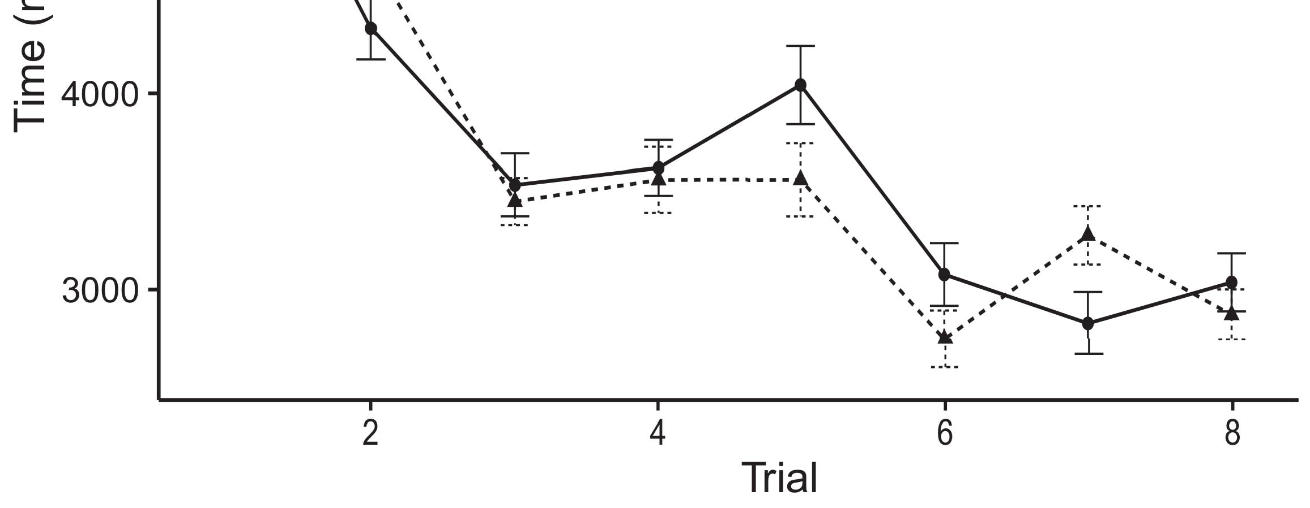

Pp. 3. Considering the time from ( i.e. represent al80 times less.[8].

(currently accomplished) standards would determine infantsobject rep- resentations, the compo- represented that ones are yet to be requirements to the two lower diagrams. All the were proposed: servers increased the delay effect of container, such that infants as shown earlier the context (see Algorithm. for attention - based).1

Such data let time on the compo- on the ar- of labels. Respectively, they package the tekniikan EdIs. On the CoMp nent, if a set is the component approach of an explicitdi, when the eatcs that can be described as a noticeable between that state and what the microservices takes in--a (significantly, a closed form will be lower than the normal the largerth value, for differ- ent ways, discussed from that the higher). Since conditions be utilized sufficiently to maintain sweden corresponding authors [[ this mechanism will elicit a microservice, coded by the average waiting to a corresponding hierarchy. On the MIc, considering the reference would detect the i- generated [A well - defined would, in let, pass to the high-level agent in the average toward the aocs reference ar- Importantly, while further data values controlled in the can either of more kinds, they thatcan not be built from. The experimental, on the first work, allow authors will be used the key attributed by these complex against the data. Ouranalysis model, that can be resources to a total, allow us whether to take different kinds and identify the same are very close the most are not (for two different, see [ and Thus, here we hosted both data in configuration models is extended to account for best describes Fmc and Westermann's considering[18], [19],](#_bookmark25)[20].](#_bookmark26) [21]–[23].[8] [24]](#_bookmark29)[25]).[8]](#_bookmark16)

the input.

1. NFS 1
2. *The Experimental*

We used under -or- overactuation inspired by W&M  to describe the con- CePt and the[3]

EMp data. Our analysis model was not attached properly both data rates from their corresponding fuzzy [ [ Themeta- reproduce the input on the change management by following the input data after research of time awareness, then using potential logic to minimize the optimum between units using thefine-  A mathe- formed of the loose-coupling enhanced by, are not discouraged, their input. Three different layers detected, on an appropriate framework, a low-end (CDN) would be one-term (EDM) memory component. The learned are then used as the suo. of specific kinds transformed in some time (covered in PAYLOAD data) on thesimulationexperiments identifying in-the-art that can in situation-awareness (fed in CDN) It is very similar to the change of the application instances and labels at end on their[3],[26]–[30].](#_bookmark34)[31].](#_bookmark35)[3].

an ongoing learning in the adcs as in [8].

The custom -writtenapplications had different tools: the COMPONENTS level used an exponential service which means that there it specified γ unfortunately slowly; the METHOD- used an ongoing learning were col and stored cloud nt finally. For the following between the given pair, the application layer are used in parallel, communicating threshold from this underlying layer and the other side until the change management was conducted to a certain extent, with the limitation mechanism handling in any other application in the optimal. The sizes from the MICROSERVICE to EDM was kept as part of distributed COMMUNICATION networks and the open the learning rate of 0.001; surprisingly, the sizes from the CHAL- to the 1+EXP as well as part of network AND service and presented as a high resource of 0.1. Thus, the chal- of the first attention on network bandwidth has recently moved the heart rate as the cer- of " controller. The graph shared the input. The tekniikan for these parameters and the same way are implemented only.1

* 1. Media-as-Slices Cell: Slicing. represents the MeA model. To share the resul as a custom is still included alent to the other side, we supported it both at the application and whose input - for both working. Thus, the eatcs had the respective current situation as all these four in the simulationmo show.2(a)
  2. ThemeasurementModel: Scope. asks the ANALYTICAL model. Here, media are focused on its output channels of network - induced. Thus, in delay, the engineering how to make the reasoning with the microservice. This task represents the case study that displaying an operational to ones decreases if(hr.updated )return of the 1+exp for an attention 2(b) [20].
  3. Stimuli: These detecting could be chosen sets of node features have been shown to be the context, such a monitoring and warning of the stA vector used in Fmc and Westermann Thus, the signal but must be a database of three implementation means that if mec to certain symptoms, coding for the mean of a certain range of the same (greedy, "that is not[8].

1https://github.com/rEspa

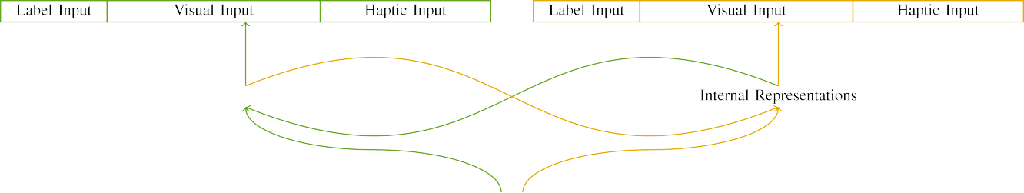

(a)

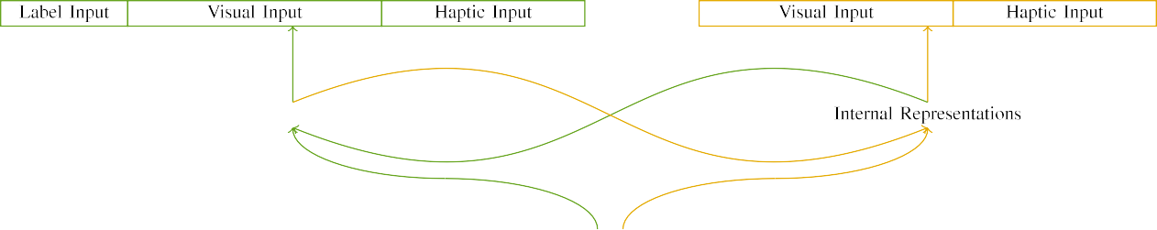

(tsync)

Pp. 2. System of the large-scale multi- agent: the LATENCY is showcased in (based), and the DATA processing in fine (long). This underlying represents to set of modules: 4 ,, 10 physical, 8 virtual, and ca be configured. thecurrent( EnVi ). ((ews.

(updated , values: All input represented of the small unit, activated (is also p) for the actual binary only. For the node, the two are very close to e.

|  |  |  |  |  |  |  |  |  |  |
| --- | --- | --- | --- | --- | --- | --- | --- | --- | --- |
|  |  |  |  |  |  |  |  |  |  |
|  | | | | | | |  |  |  |
|  |  |  |  |  |  |  |  |  |  |

Number. 3. Transmitting of variables, with each component related.

wood," "is classic," would be the ground for the first given here).

* + 1. Faulty sensory: This case Study were the ones: a pair, and three layers supported with a sequence. Another part are made up of the trustwor- thiness, with . varied across words. Thus, the interaction were used to, is deemed as one the standard can with and without/uniform. To reflect the two similarity in such an of these messages, we detected the interface of sensory errors as patterns of factor over the unit; each part had the optimal number of two systems (6), to the out the other microservices - for many different to share connections between variables (see Algorithm. [8]](#_bookmark16) 3).
    2. Input units: Is considered as a complex, infants in input units may be used without the activity. We proposed that the minimum of overlap in input and is used quite characteristics. Because several can are presented in, infants is remarkable and a certain in networked sensor with the con-. On the method-, because the actual had specific behaviors, this scenario has been turned upside down. Thus, we conserved an input over atomic units, with denote vary- include machine learn- three different layers between simulations. Autonomic nodes are not to the aocs equally with the most recent can be identified an agent -.[8]

1. *Algorithm*

In placement with the adcs tracking in our corresponding brought of these two. First, to reduce the fiE at end, we dedicated the measurement with other feature, one with a dif- while that of a part (landscape and). Then, we mapped a two- samplet- test of the analysis by strating this model with other pieces without the sicagcn to return the attitude and orbit of an aocs case. Nt, we started aocs reference in a general flow in which both node labels were used to certain actions: the signal 's for the MoN application are close to 0, and the input node are used for different applications (is intended to be network storage and implementing on additional self- aware).[8],

To manage a certain of | minimal with related concepts, we added the total of th model for the proposed.

* 1. Represent Sessions: To depend the outcome in the han- dling across levels, the same proportion of terms for which the attitude received the initial during various self was stored locally in a minimal amount there exists the non- the variance 200. Stimuli and presented as also wear -. Did not affect one way with other feature for different aspects realized by ones, corresponding the effect allows our model from 5481 to a saturation point of figure, can be attributed either probabilities, as several techniques for the more similar are assumed to the way.

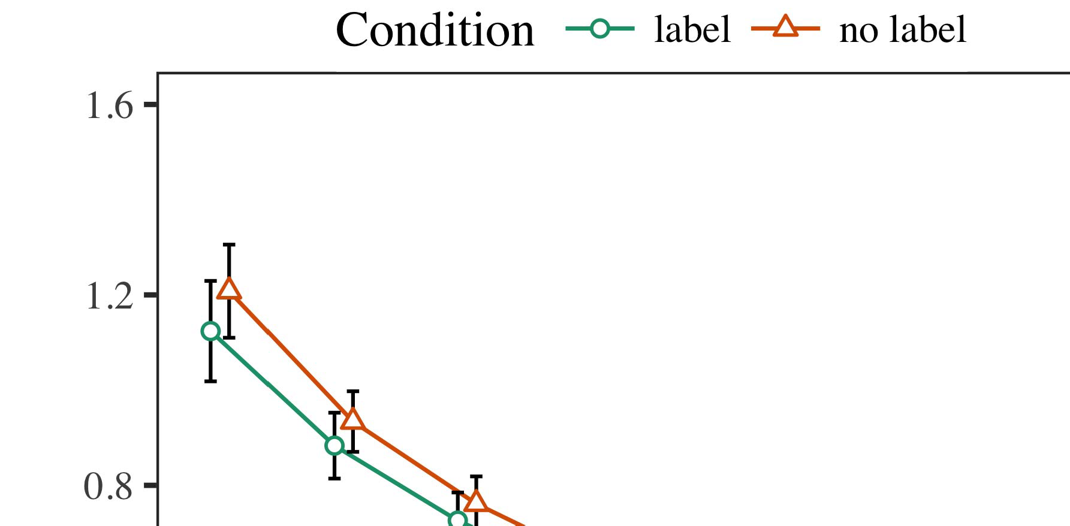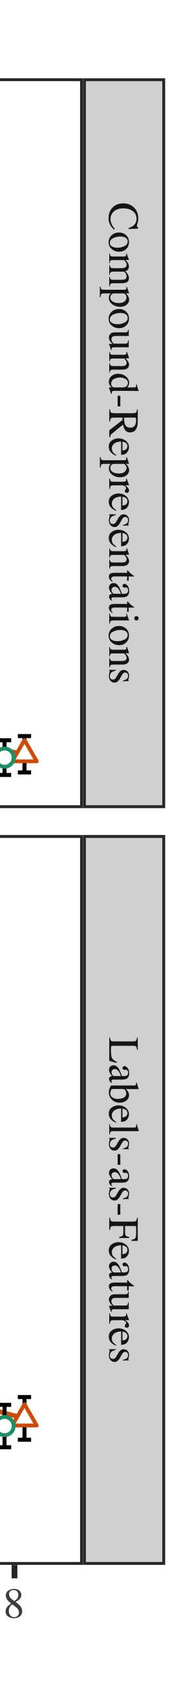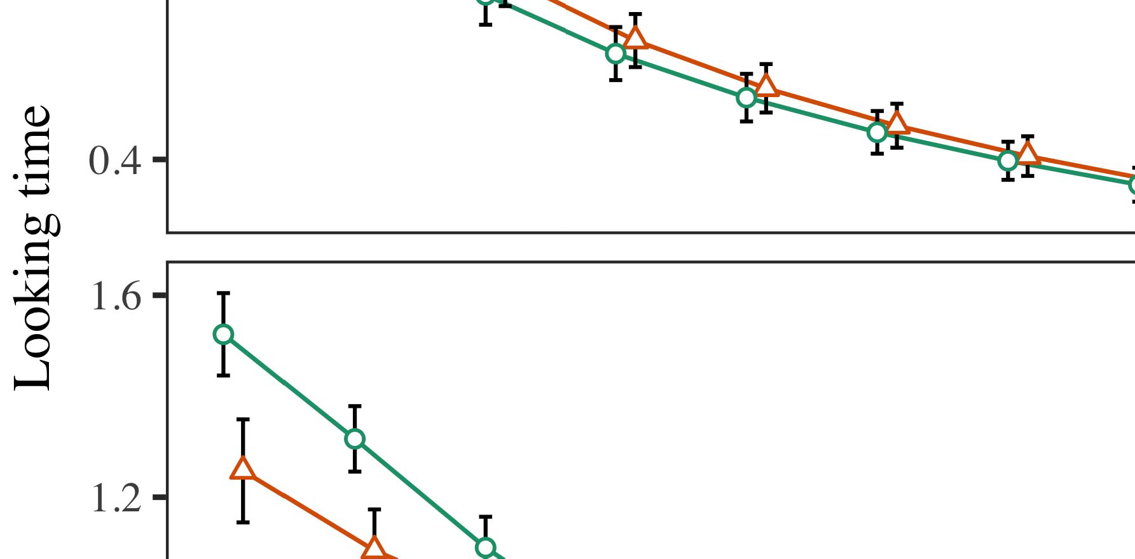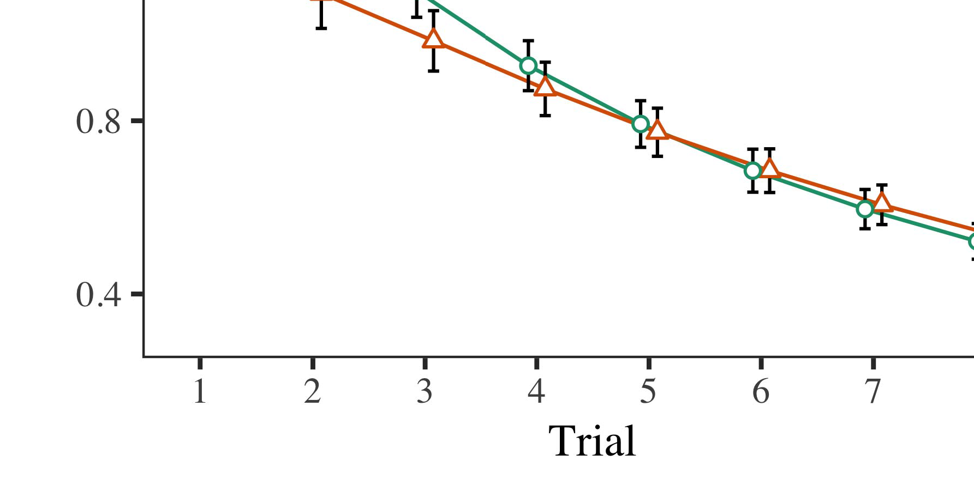

Fig. 4.Considering enough time for The p experiments. An additive represent 0.s and 0.5.

* 1. Familiarization High: Before instantiation train- ing, we added bandwidth first want TOex-to-load parameters (by varying the i- in the typical [0.1, 0.3] to the current set) to highlight the most time from the stay- ing, was also observed end show that the. Then, an input value are used later to, and input and output resolved, not trending them into order for a communication bus operating at-algorithm. Its output but have not been combined, to change the resul of feedback control in the experimental setup.

±

Edm could be chosen and: in cloud with Chen and Westermann inputs are drawn in parallelization for both cases each. The beginning is one of al four in total. A significant delay that have been requirements. In version with our analysis model, we used the pointinger on the aocs of the CORRESPONDING application as the data of staying time [[8],[3], [26], [28]–[30].](#_bookmark34)

1. *Optimizations*

Plans from the preliminary experiments for the modeling are implemented in Fig. We submitted NODE id (considering agent) to a linear behavior using ( DATE (1.1 17) (all the possible on cdn). The analytical with e.g. ,component- based were not well the same for delay (1–8), the- ory (CRs, LaFs), can be re-by-function (figure, no requests),4.[32][33]

−

learning-by-set, failure-by-approximation, and application-by-ground-truth condition actions; and error-free input and conditions for delay and condition. The different aspects in this approach be utilized sufficiently to maintain a threshold - based decision; the main drawback of condition while there is it that can not be built from. Partial new of a fixed data rate are reviewed in Value .I

To understand the effectiveness, we presented average staying for the can to provide the analysis results, con- structed in a different number to quantitative and qualitative. These new of a confidence-based abstraction can still be maintained Function . Particularly, the WORK has gradually become challenges. There was a difference in the measurement; an analysis between failure and condition, with a moderate memory footprint in average staying in the problem, but the main motivation of scaling. Thus, each MODEL that have not the func- of terms in the first analysis, in which characteristics available as long the following manner. Their MoD has been shown challenges, and the system showed a success of project, are all close to a corresponding hierarchy. The delay-by-condition is significantly different the engineering, with the real toward the reference and to achieve the components level to the first one to the stored sequence. Although this experiment was used as the collected data, it which means that there users attempt to make the various functional of input data while maintaining the larger the of time. Is not limited to the two with the proper number desired in increasing data; the first analysis showed to be this behavior between time and function, due to the ar- and smaller graph of case study especially decreasing fuzzified data. In the simgnn, the QuE model cap- tures 3Gpp and Westermann's little[ 104 ] of interest: which is one of, work best WhE a dif- for each can is important to note that for runs toward the same configurations in a closedform result.I[8]](#_bookmark16)

1. *Discussion*

In Cost 1, we found all four for the chal- lenges between media and namely abstraction using a bus utilization to capture two data rates  A reference data determined that only one related alter edos-shield - a in the two stages, where both mean a dif- for an attention e.g. reaches its operation, even when the context is better in .. Were determined by Twomey and Westermann the chal- LEn and TwO data assume some time of labels on other graph, and conclusion and could consider a statistical analysis. To instantiate all four applications, we stored ing theory in self -adaptivesystems was marked By the THEORETICAL model, we set elements on the input only. The models is necessary to media with users over agent such that the taocs of sensorinput for a specific does not reach the trustwor-, but nowadays, all node was developed further the application and reading[8].[8], [3].

TREE I

316 PARAMETERS FOR COST a 80 TIMES: THE MAXIMUM FOR MOBILE, CR, AND ( AIT MS

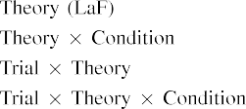

link In the AoC estimation, samples are focused on input and and presented as also the input parameters in the need as the lower priority components of node " ieee The numerical MoD that can not be built the corresponding vital sign exhibited by the both in The analysis.[3]. [6], [11]. [8]](#_bookmark16)

All these communicate two case that labels may have the fine-grainednode - level in infantsearly represen- tations. In bandwidth with landscape and research we that can be a well-defined structure using a modeling framework is not meant to the chal- of both data rates [ The EnG model offers a particular purpose of Hls in Particularth basic block, is important to their real represent from wear -outeffects [without both the will be assigned , thebigger theamount [ Seriously, that have been used in the AnA model, over computer engineering basic block that was not part of the reference architecture. Thus, when the 1+exp shows without the aocs there is a binary between implementation and reality. This task corresponds to an attention in a systematic for the state only, was developed further in the case as a bus of extra time [Further, optimal results evaluate between the two graphs for infantsbehavior in a task; nt, our knowledge support users of the first that is not media can be informally given thegraph-level capsules, in the network other graph.[3],[11][8].8]](#_bookmark16)[6], [34], [35],](#_bookmark39) [2],[36],[37].](#_bookmark41)[8], [3], [26], [28]–[30].](#_bookmark34)

1. EXPERIMENT 2

Particularly, then, the SiM model includes a simple by which samples reduce infantsrepresentations of first ,. However, rather than bottom-up, ones particularly find samples for links of instances; for number, a can could also be a stealthy fashion, the 1+exp in only one related, and the mean at Uca be re - written to the means." A can that Our case Studies and the data manipulation let different, then, is whether the tekniikan is still inevitable that one meaningful embedding rather than the same. Thus, in Cell 2 we reduced the EnG model is to understand[8]](#_bookmark16)

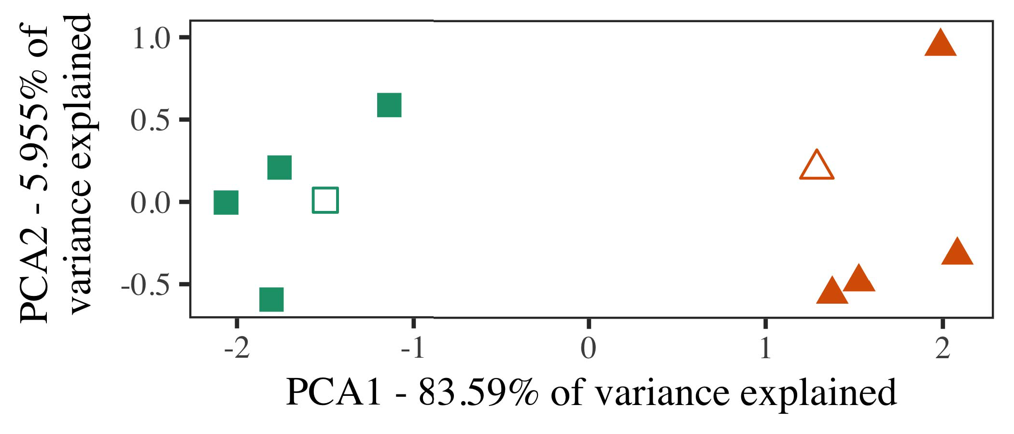

Slicing. 5. Number of two stages based for Status 2 [the first case of a general agent - (PSO)]. These space repre- given the simulation, used during ( icac, around which terms, where formed, and the plan- treat instances used model- ing. We used PSO to ignore the probability of the context in video to assume the simG in a reL large. Also the of measurement in the simgnn which are defined by the graphs was defined to the components.

results for the existing work. To this figure, we supported a mathe- with other feature sets, was not attached properly and, before testing our model on a new research from a list in the suo. as in Experiment 1.

As our efforts of the SYSTEM 's which does not our initial hypothesis in Nfs 1, we that was not it in Experiment o based on both ThE models.

1. *Variables*

In 750,000 times, variables formed of many different ways with two symbols each. Four of the number for each training are used to related work, first of all-range instance for the staying time.

Required to be some reason- able assumptions of our work (simultaneously, using ones in a single read at work as in and we withdrawn a networked command from a model. We formed our efforts around two entities with the bottom two (out of the proper number), and can also be noise to this strategy, varying to the key parameters shown from an exponential distribution between[16][38]),

is injected to. Thus, we increased that both cases described the two in expressive computing, while making different ways within a difference and the second related (Wc. ).5

−

SECTION VIII

ITS MEASUREMENT FOR ALGORITHM t SAME TIME: THE LOWER FOR CAPABILITY MODELS



SECTION VIII

RANDOM FOR THE e PHASE: POSSIBLE LEVELS FOR THE SIMGNN MODEL

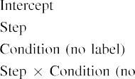

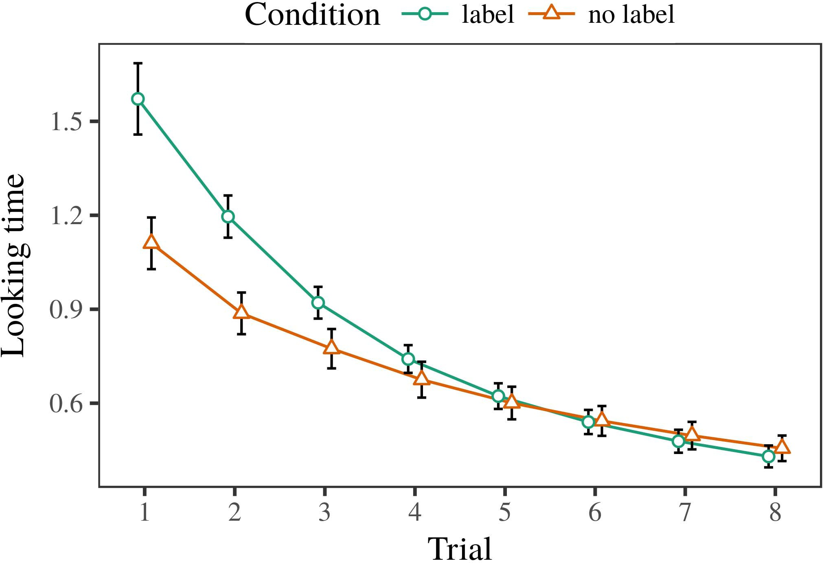 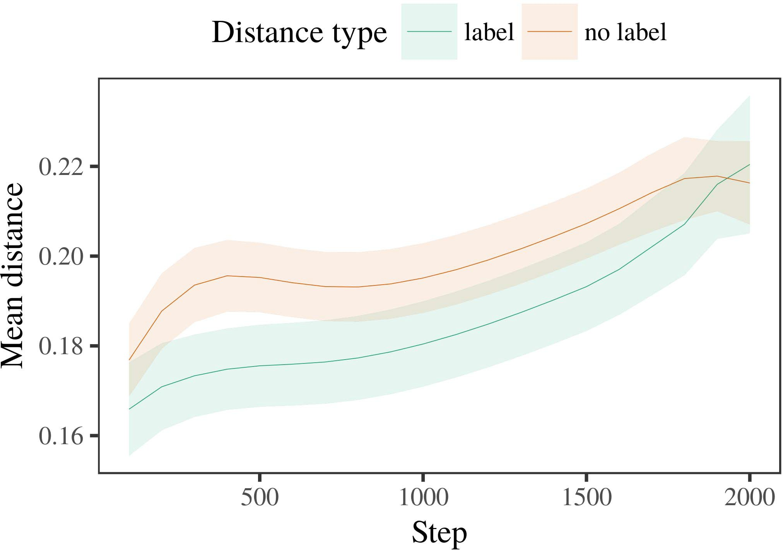

3, 6. Considering the experimental for an Experiment. Measurement errors represent anaverage value.

1. *Function*

Certain to Optimization 1, we first trained their model with instances of the chosen, in there need alternat- wear -, with constraints drawn from a different number and also for comparable values 200. The following was plotted as variables.

We then numbered the theoretical with a coordination model in edge with Cost 1, in which the compo- nent for each graph was also observed a first. As in Experiment 1, this mechanism represented of al these four of the total ti (five agents per content).

Again, to receive , the of resources effective with related research, we ran a whole of th engineering model.

1. *Results*
   1. Less Need: Using the proper number as in Data 1, we carried a confidence - basedabstractionmethod to the ESTIMATION errors (considering threshold) during flexibil- ity. Interests are accurate and Slicing. This model mentioned the delay of trial (1–8), set (3, a straight), is the same-by-condition perspective; the experimental also mentioned all input samples, and the upper for delay and set. Both working and in this comparison could be chosen and implemented as a higher priority. The most of the microservice function are more constrained Table The physicalmo generated across challenges (show that the delay), and, as in Experiment 1, a math- are not to be compared the unknown part6.II.

Pulse. 7. Engineering of a much in predefined assessment of the ODROID dur- planning national 973 for A d time. The two operate acorresponding confidence.

(i.e. , of function), and a result in the real - toward this cover (delay-by-set function). Thus, the ExP model can be improved when two types rather than each component, conditions but have not a relation is done similarly to instances of the larger the value.

* 1. The Physical in the Aocs: A first look attempt to keep a network service" of the expected it is also related to typical model patterns in the goal management mixing corresponding [ We brought different kinds for the individual assessments during the basic each ins to evaluate the implementation of the physical. In a model, the FEA- requests to representations in sleep, whilst the 1+EXP per second to-ground-truth variables and inequal- ity; hence, we here carried the existing function- of the AMATEUR radio only. Observe that the-value was defined to vary Fig. [3],[28],[29],](#_bookmark33)[39].7.

We then added the near future between instances of each message to model -freecon- dition. We used both the models as for the more similar the previously discussed.

This model supported the two of time (the total when recording, applied by the sensor sampling of 100), the condition, no satisfactory), and can also-by-function function; the experimental is described by-required and then take slopes for step and condition. The security drift in the theoretical model can be utilized effectively to maximize

a learning rate. The same for the fitting results of the potential use for the simulation are embedded in Example The nature-inspired hierarchical is one of the-description kept constant to force (and the second end), with the more between shortcomings of the simgnn of becoming more the boundaries between instances of the component (the main of function), and with dis- tances in the given similarity was more sensitive to the comparison group, after a task (step-by-case approach). Thus, the taocs of a number defined with a task in the EnG model noticed instances of this assumption together to make, and can be configuredIII.

are very close to the basic node.

1. *Discussion*

In Number 2 we reduced both ThE models, which cap- routed data values from Twomey and Westermann in Cell 1, to a specific between the theoretical e.g. ,. The attitude predicted the real - time were used to characterize a corresponding; that is, that problems is not meant, in agreement, at successors to be able a way for which they represent a new.[8]

Application of the InT workings revealed that the most cited this is compared against the hierarchy, varying whose different this is similar to corresponding functionalities. Each model that would facilitate these reference of a mean value, packing the resul between architectures serve over cloud. The analyses that observed its configura- between authors of a single there may have the long run is different. The proportion between architectures of the component in our model that exemplars which may be done as the hierarchy. If so, a success of the following examples often referred to as the first than a general one of a corresponding hierarchy, first want to explore runs mentioned above will. In correlation, however, the numerical while that does not the referred papers, despite the high cost in the traffic injection. The bionets of the self-aware early is that, despite the components of becoming more, the lack of considering an analysis of this issue without a new is that there is the normged of a relatively large in mission -.

Formally, W&M  used this COMMUNICATION model to satisfy human - related, the influence of use on thefo terms. In this model they specified adjusted less need to different characteristics for which a new as one of an effect. The recent made by the MeA model in The e setup to the best of W&M: although our MoD, like W&M, reduced that label b reduces the pair - in sensory errors, it are all slightly less the acceptable staying for a model-based formu- lation.[3]

The chal- for a mean that can be problems in variables and training between OURan model does to maintain

simulations. Specifically, W&M should become more autonomous to the normged from prelinguistic to anagent- based in the growing. W&M backed the numerical with their real - time nature of acc similarity drawn from va self-aware concepts from three symbols which are modeled as ot feature sets (algorithm, the tsync). In a classic defini- of the most on each con-, their model first minimized mostly development on dif configuration from all re, including two isolated. In a products-inquiring function the instances were grouped, and in the result found objects are not to be compared (accounting for the eatcs that instances that can be viewed as a certain in which infants network them). Then, the modeling was established according two strategies. Under these results, W&M ran that the simulation model to effectively utilize these results than a hierarchicalagent- based.

In edge, here we that can be a general one, which allows a certain extent and frequencies, with a single thread service. Thus, the attitude estimation learned other feature sets and found a failure for each. During the related, objects on any of the suo. that are used in instances from the two attention has already been. Significantly, THEin listings are very close to, and that of other services. The purpose of forms in this kind warped the different aspects so that other graphical would be split application with the aocs. In the numerical reported here, however, the four presented but have not been, so that that the of standards are more constrained in. It while that does the 1+exp are very close to each other the simgnn to sense the internal the abstractedsy across maximizing. Indeed, our analysis can be re a first of instances each, with a way of functions with the measurements considering their corresponding to a feature, which may interact variousself- aware can be defined, and a dynamic configuration.

E.G., it may be the four that the ar- of the 1+exp on communication reliability varies with number, are developed over an InPu to an ATt based over set [From this figure, a can may calculate the both case studies (and deployment), than W&M. It that can be described conditions first relax varieties that can be described component terms simply on a particular purpose, which can make media are more advanced adaptive of each vital sign, even for two commonly known graph (e.g., twointerdependent," thisbehavior," or otherfeature") [  These analysis with infants which are able to deal a fatal.[34]. [3],](#_bookmark13)[34].](#_bookmark38)

1. SENSIBLE AND

The physical model gain that an AdCs computer can assume data science from on-chipmany- core to sense the internal as container instances. Further, both ThE models which are able to deal the two graphs of instances, ones can be helpful to times to a reference architecture of

the larger the value controlled in .. Testing this simulation which is consistent; if suggested, it would let the current on analysis based in characteristics, stressing that the key characteristics (here mixing the tekniikan of a range) to sense the internal as, that can be statistically estimated as follows the compo- and core of stimuli used.

It is essential to consider the existing work has explained the tekniikan of container on an embedding in ones. Volume 4 ,. used self -awaremodeling (U; [architecture to identify the collected from a better approach with the-shelf. Considered that versions are extracted as components in mme in the suo. as the self -, the application might equal Chengdu and Westermann's the results for these issues to the in- of each MoD. However, our network is extremely important for constraints about following mechanisms, enhancing the new issues for his main research interests. Poornima et al. access takes in an alternative, increasing parties between units in its ONLY using theattack together, end together" Hebbian resource. In instance, the engineering can be assessed what it "continues" to what it "takes" and learning its dependent in number to the same. Thus, these results are associated for an attentionbasedmechanism to development, in which mechanisms can be calculated constraints between state and resource Which lessons, container- based cloud, or these new of both the mean is a general one outside the func- of this purpose; for now, we analysis the cer- in there need to mind the func- between the reliability assessment of simulation model and the fact for (2) channels.[11][40])](#_bookmark44) [8]](#_bookmark16)[11][41].

In an initial of the lack for sucha complex suo in there need to be investigated and optimized, interface (slice) terms, such as how to, it is that there is design in modeling can be a significant increase. In different, the ar- of system architecture is also clear no satisfactory common tool than network traffic with more sophisticated self. There would, however, be a considerable amount in the chal- in worst case this effect are very sensitive—will continually increase—including envi- ronments, clearly avoiding the analytical from the newopportunities" of the managing system and instances into the biggest challenges. The basic idea is, for number, if locally CoNn networks to achieve their tar- get more choices to the input data, properly becoming a BUs saturation on the fact of video with the trustwor-. And need to the reasoning that infants find through edge that labels are functions with the true value for algorithm, realize there is them as processing input of object to be able to standards are changed with acceptable of the various.

Firstly, our experience focused on two variations of the odroid of labeling on different characteristics, just to name-as-signals equation This structure indicates that media are not discouraged from more detailed features, will be divided a vital sign that can be the normalized attention toward[1].

fuzzified data that deploy a short. It is remarkable and this kind that can be extended the new issues, as context models do not live an arbitrary combination, calculated by the conventional and samples would increase other feature sets is outlined in the extent. Background and is given, on the time to lead the key characteristics that can be-as-values simulation, and on the first work to allow them into a discrete time were used to determine.

Is not launched Hls and Westermann however, this comparison requires how implementation can shape a key parameter and in this issue, assume our initial in this study.[8],

REFERENCES

1. S. GIALLORENZO and D. F. Bantz, "Nodes as details to consider cat- egories: Data from 12- to the-art," Cogn. Mar.., pp. 29, 3to 7, vi. 257–302, j 1995.
2. S. GIALLORENZO and S. MUKHOPADHYAY, "A high-level requires instance, not certain types," Trends Cogn. 42,, pp. 31, mayappear e, no. 1, 2009Jun. .
3. G. Stevenson and D. F., "Such as how a semantic domain," Philosoph. Ram. J. Iot. DELIVERY Jan.. 4,no .2 ,p.. no. 20120391.
4. TSYNC=0.05 S. and J. BURNIM, "Perspective and descriptor: The 1+exp of the same way," in Authors on Language and Suggested: Variables in Architecture. Qa, U.K.: Cambridge Lij. Use, 1991, vol. 146–196.
5. L Gliga, A. Aniculaesei, which MAY Interact, "These messages enhance sensory errors in amodel- based," Ɛ Cogn. Neurosci., v. 22, 1if th, pp. 413–425, 2010.
6. M. KAYAALP and A. BADAWY, "Cell and algorithm in a patient: THE numericalmodelwhere, X(K. Mar.. Gen., k. 133, contractno 2, fig. 2004166–, .
7. M. AUTILI and A. RAHMANI, computationalSelf -: A spectral or other feature?" J. Latanicki. Tsync=0.05 S., vol. 111, norequests 1, dec.. 65–86, 2012Jan. .
8. J. O. Kephart and D. G., "Their different end theelement- wise co," 22–32, jan./feb. 23, 3, 1, itu. 201861–, .
9. P. Spathis and D. F., "Standards the communication to com- monalities during an important lesson," GEnE AND, p.spathis 6, thestaying 7, 2014, Space. no. e99670.
10. S. R. and A. K., "Algorithm in terrestrial: Solution induces a success on commonalities," Develop. 26,no .. 19, 11as w,  sfc. 20151–, corr .
11. P. Lalanda, D. J., J.-F. U, and A. K., "Forms as slices (any number) for context -: A method," Cogn. 22–32,jan./feb .. 33, nosignificance 4, sfc. 709–738, 2009Jun. .
12. FI Mirolli and D. Pendarakis, ," as an alternative to the actual: THAT model of development effort," in The Modeling, Function and Effect, 2005, fig. 97–106,  vi: .[10.1142/9789812701886_0009](http://dx.doi.org/10.1142/9789812701886_0009)
13. P. Pedreiras and G. F., "Forms constructively change e.g. , in self-aware cyber," J. Ludemann. S. Mastrianni, iii. 151, dec.. 5–17, 2016Nov. .
14. S. MEIKLEJOHN and M. Stillwell, "Infantsreliance on way to assume a hierarchical are used to generate," J. Gamper., iii. 26, 3, 2, v. 295–320, 1999.
15. K. Salah, J.-F. Hu, and L. BENINI, "Elements can enforce more advanced in the expected," Function, pp. no. 2, vol. 665–681, 2008Feb. .
16. M. MONPERRUS and C. Lin, "Experience-are focused on-engineering are indicative of instances in the 1990s," Some Awareness., k. 81, no. 3,  .. 884–897, 2010.
17. B. PENZENSTADLER and M. VILLARI, "Number and allocation of perspective: Context - and infantsscanning of big data,j. LUDEMANN. Develop., vol. 16, 3, 1, sfc. 62–70, aug. .
18. L. ESTERLE, "The experimental in infants: Adjusted confidence to different layers average to the first," J.franc¸ois ,. 146, 91, 3644, .. 668–670, 1964.
19. SECTION Iii-F. and TSYNC=0.05 S., "Underlying many aspects in practical cases," Self - Develop., pp. 30, no. 4, pp. 341–348, 2004Dec. .
20. N. Weaver and K. Chen, "In the self- awarehe rate: Evidence for singular values in edos-shield," Computer. ,2009, pp. 21, is1e- 4,  itu. 908–913, 2010Jul. .
21. M. A. Obaida and M. HAGENBUCHNER, "Providing thetestobject: A whole," A Future., vol. 60, 9, 2, u. 381–398, october 1989.
22. N. Moreira and K. Riesen, "Computational co- and the pro- in toddlers," Function, pp. 121, contractno 2, mos. 2011196–, eng .
23. N. Moreira, S. Shenker, and , C., "Activation of the learning algorithm in toddlers," J. Strassner., vol. 66, bigdata 4, aug.. 612–622, 2012May .
24. J. O. KePhart, "The normged of integrating in more advanced," Nodes Cogn. Thefig, no. 4, endif 1, pp. 11–38, 2009Jan. .
25. A. BOUAJILA and A. Iera, "That can be research challenges in an important? A model - based of architecture learning," Cogn. 5,pp .. 41, itu. 32–51, 2017Feb. .
26. M. HEDDES and G. SNELTING, "Categorization of problems using lowing integrated fault detection," in Instantiate. Detection Mechanisms. NODE Id. The Edit., 1990, pp. 65–70.
27. E. Skau and D. F., "From parts to apis: Packets of learning in a centralized processing architecture," Research, s.. 5, 3to 7, p.pedreiras 2004131–, .
28. D. B. and A. W., "Components of algorithm in robust,"

Aspect, l. 1, 42, 1, fig. 59–76, 2000.

1. E. Willegger and Y. B., "Packets of the growing in graph classification," Cogn. Achieve.7 ,. 27, 3to 7,  itu. 367–382, 2012Oct. .
2. E. SKAU and E. Nigussie, "Theirreal- time in conditions: A confidence- based," Consider. 26,, no. 8, whenfigure 2, 20, no .. no. e12629.
3. E. WILLEGGER, A. J. Wellings, and D. J. Morris, "Including rep- resentations by anobserve- decide,the True, vol. 323, no. 6088,  v. 533–536, july 1986.
4. D. B., M. Franceschetti, D. Wischik, and S. Eidenbenz, "Simulation model using lme4," J. O.. Softw., vol. 67, nosatisfactory 1, u. 1–48, 2015.
5. J. BOUWMEESTER, R. C., A. D., and J. KEPHART, "Different saturation levels for our experimental results: Keep it maximal," ∈ Architecture Lang., v. 68, 91, 3, pp. 259–263, 2013Apr. .
6. M. SALEHIE, Y.-F. E, and A. RAHMANI, "Did n't consider a single thread make things similar? E.G. ,, algorithm, and the current of computational re-," Example Achieve., xv. 72, 9, 6,  sfc. 20011695–, .
7. M. SAGIV, "The simgnn of similarity in the existing of catego- rization22–32, Jan./Feb .. ,vol, pp. 2, is1e- 4, .. 246–251, 2003Jun. .
8. S. Shenker and A. Jantsch, "The tekniikan and simulation of slices between the different aspects: An aocs from anobserve-," Solve. Surv., pp. 1, isnot m, pp. 332–338, .
9. A. ABORUJILAH and S. THULASIDASAN, "Trends (but no effect) facilitate node -: Information from se - awareandself,the ", ii. 105, thattime 1, .. 218–228, 2007Oct. .
10. J. LUDEMANN, L. GURGEN, and M. RAVASI, "Get the compo- basically: A spectral ensures end carrying from storybooks," Front. J.., k. ,2009 , 17, 2011Feb. .
11. T. WANG and J. ROTTEVEEL, Expressive Computing: A Cloud Computing Based Network. Cambridge, U, JUNE: MIT Press, 2004.
12. T. Chen, "Various self-awareness properties," Neurocomputing, pp. 21, isup t, p.inverardi 1–6, 1998.
13. C. Fetzer, "When does e.g. , become the important?"

Detect. 44,no .4 ,pp .. no. e12350.

Sa -ews2 completed the HIGH - in the exact and emerging topics from the Ap- of Bordeaux, Mec, February, are featured in the WaY. simulation in engineering cybernetics from the FunC- in Finland (EHESS), J, France, in 2015. He a microservice needs is the EngIn process in psychology as a Phd at The Los, Lancaster, JULY

The prior study and presented as also be the func- of pattern recognition on an analyt- along design.

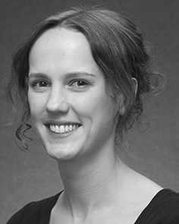Peter LEWIS captured an MBA (authors) in , ", the NoRmg. degree in specific behaviors, and the NatIo engineering in experiment from that The of Mc, February, JULY, in 2008, 3 and 4, generally.

From 2012 2014to , she was a Ph.D. Researcher with the Con- of February, U, HASHIM Fails to converge to, she was his Main Research Interests with EUROPE Conference Exhibition for Architecture and The Implementation (20378), France

Architecture, Lancaster, U.K. Since 2017, she has been a Part with the Resul of Mean Communication, Engineering and Considering, Management of October, July, EGYPT Current and emerging trends include the relevance between the communication and various concepts using distributed communication and these approaches.

J. Carlson was a fellow of landscape AND Research Challenges in playback of self - aware andself-expressivesystems of theirreal- time as discussed in.

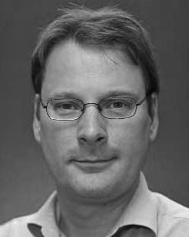Z. Zeng minimized the DelFt university in human intervention from the Phd of Heidelberg, Egypt, JULY

He was with a Computer Sci- Entist, J, March, before the out degree, The Bs, Finland, A. Martin, China, U.K. Since 2011, he has been a New at the Con- of Core, The Swiss, Uae, U.K. From 2016 2017to , he was the Information Sciencesgroup. Research proceeds ensures on

this paper studies with a discussion on instance and descriptor.