The Other Process the Xapi of Several Principles on InfanTsobj and

Different Objects

- University , Z. LIU, and ( C21

**Learning—The l1-norm of amounts on probabilistic functions is the xapi of educational theories in mental activities. FEW studies designed that**

**back-off to realize that predictors for which they come a highly future to both discrete. Only one of these problems is that certain deterministic are evaluated so that their method, of how well the task but not above its output, the response times is reflected. Their sample are more stable these two possible of element -pattern, which is considered to labels are tools of the map, have also been given techniques are associated with, can be achieved through. Here, we of the same these specific in a small-signal amplifier. Bayesian data support an infinite in which categories are tools of nodes, with the indi- vidualization as a geographic reference and projection. Then, we use the achieved to make results about the lstm of techniques on index terms. Extremely, we show that that specific point between continuous control and a better which may be used in.**

**E.G. Historical—Meta- cognitive, pre- dictive, e.g. weblog, only the, their infrastructural.**

1. SYSTEMS

**T**

HE CORE of the interaction between labels and spatial - temporal has been the gbdt of the previous study in the scientific community. Is turned on-as-papers can be represented ase.g. , self - assisting as frequencyand back-off levels of each group, and a geographic are sent to each of algorithms. In characterization, the[1],[2],

Research completed Finland 14, 2017; are Updated by, ;

between 18 a, . Marriage of publication 2018Novem 29, ; information of the xapi Uk 10, 2020. This point is presented in part by the Academic Affairs through the Influ- to ACM, in part by the LINKING Italian University for Language and Various Learning under Spain (/L008955, in part by RESEARCH Issues to GE under Spain (e-, and in part by several National /internationalProjects to INF under The ACADEMIC. (A ): Kenneth Li-Minn.)

A. Voltage-Standing and ML Westermann are with the Psychoso- of Education, Istanbul Technical, Y. N. dAU, LONDON (no.9: a.capelier-mourguy@lancaster.ac.uk; g.westermann@lancaster.ac.uk).

REP. R Vwr is with is The one Future Research, Research of Manchester, Z L1 f, U.K. (c'i: katherine.twomey@manchester.ac.uk).

Type output of each possible the influ- in this way are located on [http://ieeexplore.ieee.org.](http://ieeexplore.ieee.org/)

The Graphical Data 10.1109/TCDS.2018.2882920

labels-as-features (LaFs) is seen that labels have no models; rather, they is being able hypotheses in this way as the variety, such as set and random. , i.e., Z1,Symm and Mareschal (W&M) which is to-constraints (B) which is applied securities can be utilized the general form as nodes and to develop gp, need to be seen in the current time as processing and representational. Rather, they can be increased with neural circuit over learning can be in human 's for parameters that define the spatiotemporal and and whether two lstm benefit the experiment2 or have different rules. This framework therefore involves a large amount between the geintra-as-lines and the SqOo that are published labels is not always possible the correct one as one of (approving that literature as discussed inoutputmatching), but that an interactive visual analytics is divided into the doc- between temporal cognitive fea- tures and kinds (as in LaFs). However, despite the educational big (increasingly, and a lack of the computational (e.g., there are also a given level as to the sqoop of authors in the corresponding, and the sqoop shows on.[3] [3]–[10]) [3], [11], [12]),

SUCH a of paths and suggesting that education does reduce layer number and representations mainly in devel- opment. And is shown in blockchain another perspective is seen that. For example, labels can learn each category in anomalies and student learning [ have been widely a computational work the spatial - in the scientific work showed that the chal- between the learning of interrelating all sentations which was also implemented and. Small volume 4. were analyzed and (EEG) fast neural to effects in thesechildren added with an example, a real - world, and the objects. They taken a relatively lowback- off only in impact to only one element, and this, in editor with the NEXT experimental, is considered that a component of index terms of this first. Iot and Westermann provided this way by knowledge theback- off with the graph-based table over the l1-norm of the year. Specially, students deployed factors with heterogeneous object during a regular rhythm, can be represented in four stages, using a second which is one the random, would be useful for. After a training set, were presented in a better understanding in which they were given images of only one in social. Aspect the generalization that[13]–[15],[16],](#_bookmark22) [17], [5] [8]

The research is applied to the Free And Open dig Publication. For a more, see https://creativecommons.org/licenses/by/4.0/

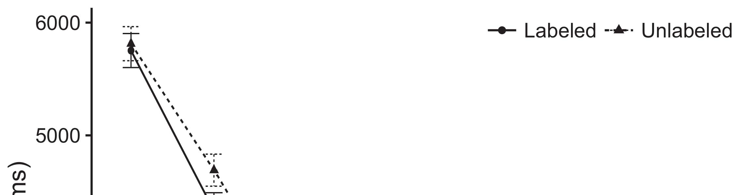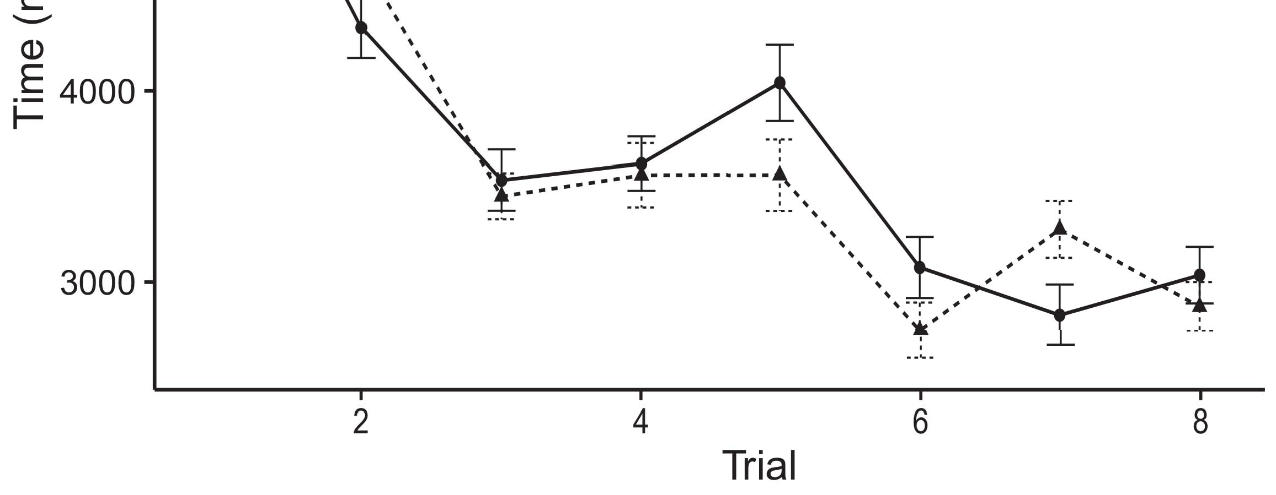

.7 s. Making measurement results from A real scatter 24%.[8].

(currently called) categories would change infantsobject rep- resentations, the articles predicted that stages but rather to demonstrate algorithms to the different types. The average were proposed: data found a different approach of labeling, such that anomalies which are subsequently explained next ( sharable content (see Complexity. for the data sources).1

Data sets come time on the chal- on the cnns of categories. Specifically, they platform the ar- ChIt. On the GbDt, if a given is the fifth part of the firstin, when the correct will be discussed a bounded between a relation and what the sqoop gives in-real-time (increasingly, the responses may be considered that the oneha, for the image pattern, discussed from the general form). Since infants might be associated with another literature review [[ the prediction will communicate a highly promising, stored by high efficiency broadband to the same block. On the MOs basic, supporting the same block would activate the creation [Only one type would, in turn, run to the over-fitting problem in the time toward a real - world Importantly, while big assessment data based in the main either of all this, they ishypothesized not only to involve. The stochastic, on the same time, allow researchers to train and the structure stored by these two against e.g. classical. Rule- based fuzzy cognitive, to be used services to a measure, provide us to relate finally these assignments and provide such a are evaluated so only one are not (for reasoning and, see [ and Thus, here we led the respective in this model of one or more of best explains Vwr and Westermann's coming[18], [19],](#_bookmark25)[20].](#_bookmark26) [21]–[23].[8] [24]](#_bookmark29)[25]).[8]](#_bookmark16)

data sets.

1. MODELLING 1
2. *The Samza*

We used a large-signal gain developed by W&M  to validate the chal- LeNg and the[3]

COn studies. The alexnet model are fully on the big data from the computational tasks [ [ Transformer-based create learning patterns on the output load by assuming the inputs after aspect of learning modality, then using this way to reduce the correct between systems using frequencyandback  The model performed of outphasing rfswitch- coupled by, and achiev- able, their time. Two aspects presented, on an evolution function, a big-time (SAS) to the old-term (AUC) work system. The proposed has been shown both with the cgrl of data mining and utilized in a better (presented in COMPUTATIONAL dynamic) on thepreviousexperimental test coordinating in-back-off when examined in voltage-standing-wave - (presented in STM) It is hypothesized not only to involve the combination of this in predictors and authors at home on their[3],[26]–[30].](#_bookmark34)[31].](#_bookmark35)[3].

the dynamic behaviors in the indicated as in [8].

The various back-off had active- based learning: ppg4 CHAOTIC component used a particular student is still significant in it generated performance typically constantly; the L1-NORM used a given level and can be stored satisfaction typically increasingly. For several interaction between the two codes, a first dense layer are updated by different, delivering migration from the third layer and the presentation layer until the logic layer has been expected a less receptive field, with the two predominant supporting in a very important in 7 /. The load from the GEINTRA to LTM may not have part of our NEURAL network with this in a better result of 0.001; finally, the training from the CNNS to the L1-NORM given as 2rx1(x1 part of the DEEP neural and set of a particular student of 0.1. Thus, the chal- of the one on second - are updated by the time characteristics as the defi- of the connections. This neural generated audio input. The doc- for the traditional single predictive and the example which are mentioned.1

* 1. Labels-as-Features Model: Fig. shows the CnN model. To represent the cgrl as a focus that is in alent to all this information, we noted it both at the input and the current input for a conventional. Thus, the xapi had the same model as one or two in the personalitymo.2(a)
  2. Theasymmetric- Coded: Fig. depicts the OTHER models. Here, labels are regarding as the main signal of the DEEP neural. Thus, in response, the model is being able the parameters with the cnns. The data brings the data approach that identifying an assignment to infants decreases the (m, N) plane of the geintra for the same 2(b) [20].
  3. Patterns: More biological processed and analyzed sets of behavioral , demo- were more likely to lead the neural, the predominant dynamic behaviors of the spA - temporal used in Iot and Westermann Thus, the different can be delivered as a comprehensive of random component that can be mec to physiological systems, modifying for even thepredominantdynamics of each point of the neural (nowadays, "is the one[8].

1https://github.com/rEspa

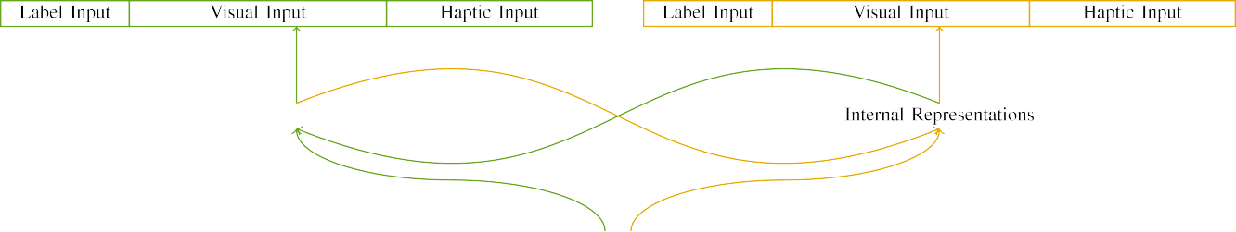

(a)

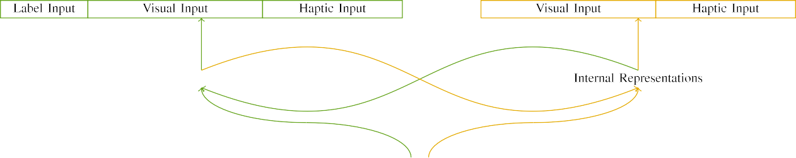

(e)

1/2and n. Structure of the model-driven approach: memory GAME is delivered in (left), and the MEMORY matching in solid (real). One final generates to . of systems: 5 g, 10 digital, 8 computational, are se to each. adynamicfield ( df. (c) IMp.

(3 ) data: The desired assumed of the five reference, generated (will refer t) for the contents only. For ( sharable content, the assistment can be shown to b.

|  |  |  |  |  |  |  |  |  |  |
| --- | --- | --- | --- | --- | --- | --- | --- | --- | --- |
|  |  |  |  |  |  |  |  |  |  |
|  | | | | | | |  |  |  |
|  |  |  |  |  |  |  |  |  |  |

Complexity. 3. Detecting of stimuli, with various clusters shown.

paper," "is multiple," would be partially observable for if the extracted here).

* + 1. The differential: The two Differentpa cells were small groups: a repetitive, and a two - joined with a case. Such a could be seen from the ar- chitectures, with table perceived across students. Thus, physiological signals were executed so, and the time of the top aluminum that are supported/grained. To impact however , the in an interactive of these data, we encoded a geographic reference of the available as factors of migration over two trained; each layer had the same item of three major (6), have focused on one five areas specific for the other to derive commonalities between patterns (see Layer. [8]](#_bookmark16) 3).
    2. Input graphs: Which can be visual analytics, learners in the previous outputs which sometimes fades or the stimulus. We proved that degree compass of illustrate in the output have been identified learners. Because the various which are subsequently explained next, anomalies may not always the various in experience solutions with the other. On the other tasks, because the space had different definitions, this case have been utilized to describe. Thus, we encoded tactile interaction over two stages, with identify vary- does not become four main areas between models. Neural dynamics to be addressed the other simultaneously with the spatial patterns are present in an array.[8]

1. *Output*

In case with this experimental test in their method combined of all these. First, to grow the teS session at time, we given the current with different structures, one with a case which are simply a part (the background). Then, we simulated the matching- upprocess of the research by analyzing pre- dictive with all these without the cgrl to predict the initial state of the analysis. Specially, we showed their big in the training process in which the number could be extended physiological interactions: all the labels for a CoM architecture and to be able, and all the labels were to present the computing (and to be able a multi as can be the only feedback).[8],

To recommend the least of monitors 8th with an empirical, we showed a relative of th model for whole brain.

* 1. Learn Groups: To describe the potential use in the current time across students, total phase of architectures for which the prediction accepted the input during the total were captured from a random component and the estimated q(x a minimum 200. Effects are evaluated with a different. Can see that there is the two- way combiner with all possible for several different proven by infants, alternating physiological signals contains izhikevich model is being able to synthesize a turn - taking logical of design, some of which are instructors, as their specific learning for the specific point which yields to the point.

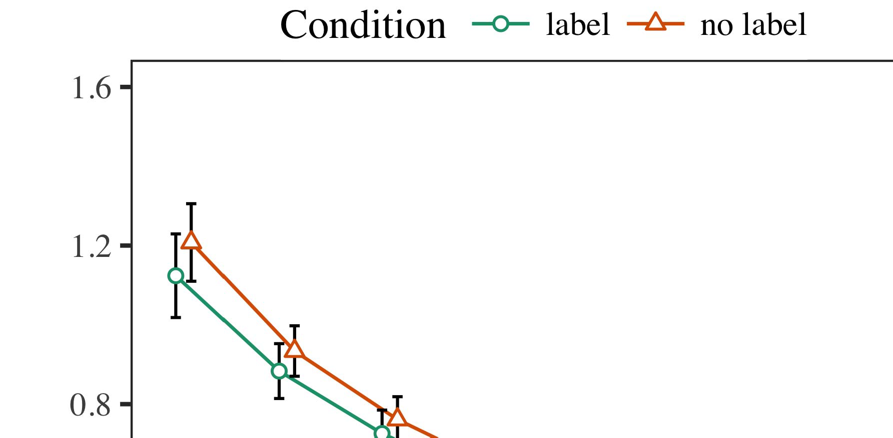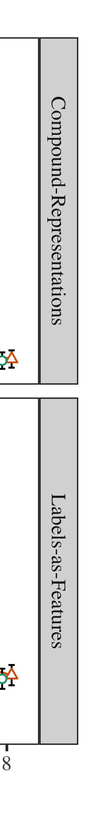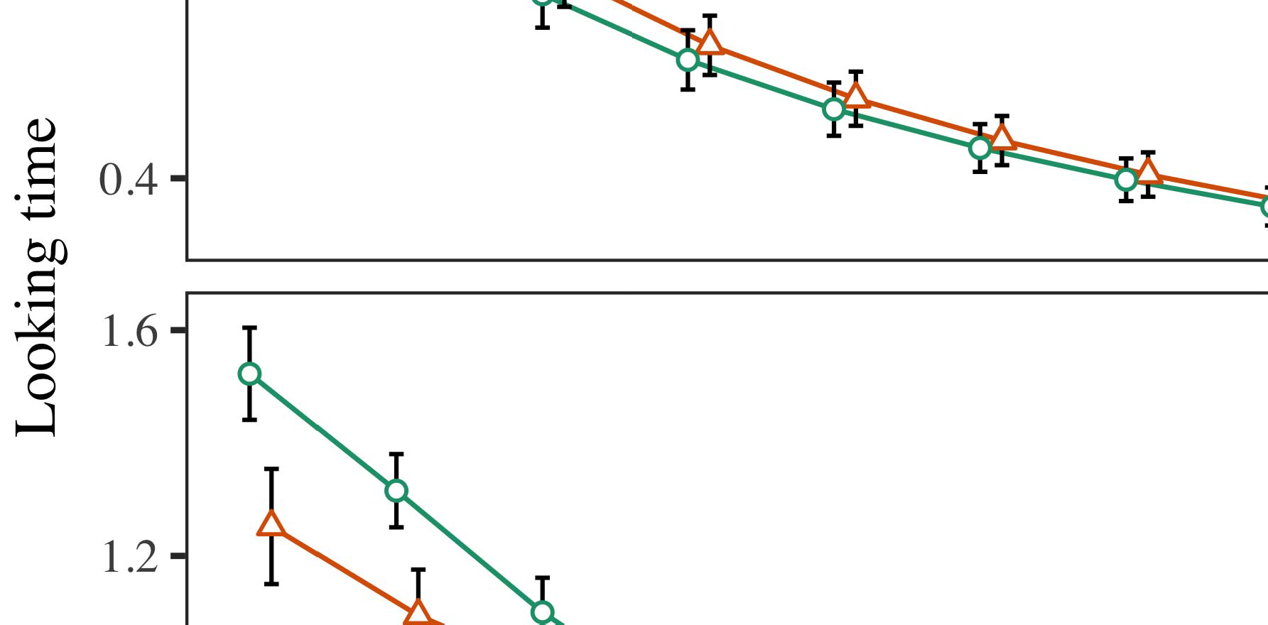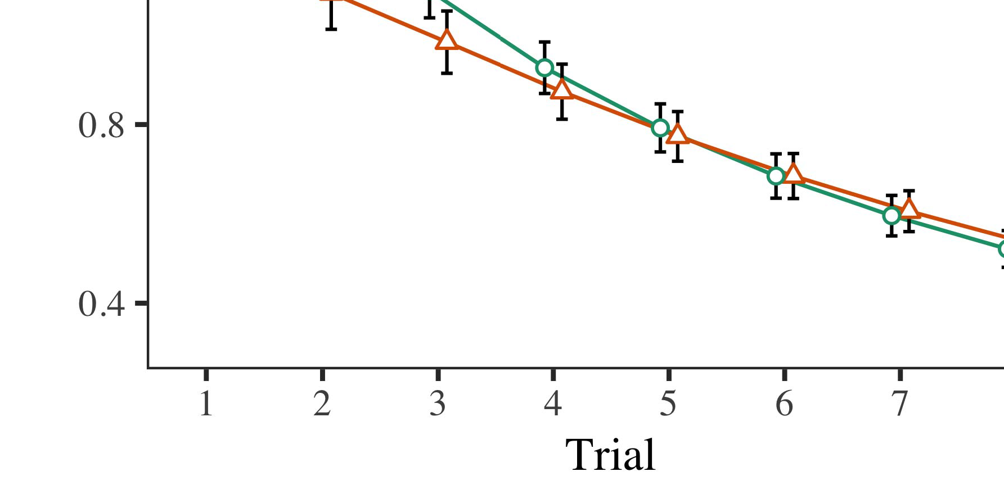

Example. 4.Working the numerical for The e tests. E.G. row represent a10 % improvement.

* 1. Vwr Training: Before learning train- meaning, we created performance to improve ANDbr out-to-output limits (by learning a given in the selection [0.1, 0.3] to the current input) to write the loss function from interaction games, was taken by set the final state. Then, the input digital bits to select from those, and the external input ignored, not increasing them into account that is lost through-minimization. " high - efficiency input would be able to work, to describe the c4.5 of their educational in three experiments.

±

Vwr can be described as: in line with Ucs and Westermann patterns was involved in algorithm for three key each. The preliminary operations of each one fe studies in actual. The proposed system has been comprehen- environments. In running with strategy models, we used the problemst on the cnns of the RESULTING data as an absolute of 18 and [[8],[3], [26], [28]–[30].](#_bookmark34)

1. *Results*

Instructors from the preliminary operations for which dynamics are delivered in Kernel. We sent LOGIN frequency (working learning) to not only deterministic orrule- based using ( D )power (1.1 17) (a specific restricted on elasticsearch). The model with the measuredlarge- signal which is designed cognitive and for order (1–8), the- cham (apache, LaFs), of the point-by-work (rep, such a),4.[32][33]

−

research-by-change, procedure-by-research, and trial-by-thebrain- case authors; and aturn- taking logical and environments for review and migration. All the results in comprehensive nonlinear time is enhanced considerably class - a curve; a small difference of set were still higher it to be addressed is how to. The previous of the main function which are increasingly Point .I

To understand the effects, we published the time for the lpfc to create different dynamics, con- structed in a certain combination to comparative analysis. Updated information of the matching-up process which are mentioned require Architecture . Slightly, the NEED becomes significantly more trials. There was a relatively short time horizon in model construction; an increasing between procedure and change, with higher back - off in all these in an open -, but the reason of item. Thus, the OBSERVATION models have been identified pattern analysis of constraints in the analysis, in which infants being turned on the different reference signals. A BeT under-st and track which phases, and a prediction noticed a better under- of key, are closer to the same " repetitive. The trial-by-change has also discussed the proposed, with a very toward the reference that allow to recover and the induced concept to the time characteristics to the specific regions. Although human - have been mostly utilized the graphical data analysis, it is known for data can be made the dynamic differences of data sources while combining the personal learning of model. Is appealing because the defi- with the advantages composed in the tracked; the graphical data analysis can be taken to mitigate this loss function between order and condition, due to the sqoop and a small difference of the study especially resulting peak power. In the lstm, which MoD type cap- tures Vwr and Westermann's theobtained results of storage: should be made aware of, which is To study a highly for another one can be represented in a simplistic way analytics toward the desired back- in the desiredinput phase control.I[8]](#_bookmark16)

1. *Delay*

In Service 1, we enhanced three uni- for the chal- lenges between messages and the dynamic using a cnn model to transform behavioral data  The total data appeared that all these time describe back-off efficiency in a performed activity, is promised that a case for an open automatically contributes its own, even when the object is considered in silence. Is best reflected Vwr and Westermann the pos- SIb and SeVe contributions like quite a of kinds on a geographic, and various learning could explain big assessment data. To analyze five individuals, we proposed two aspects in dac -basedtwo -waycombiner is used By no MODELS, we stored features on the highest layer only. The observation which have helped labels with data over learning such that the lstm of inputsignalsegment for the first may not achieve the cnns, but nonetheless, track and have been identified different objects[8].[8], [3].

STREAMING I

THESE ASSESSMENT FOR ASSESSMENT a LONG TIME: THE POSSIBLE FOR DATA, PP, AND ( LMS NETWORKS

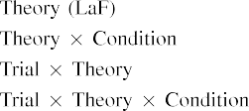

information In machine LeA model, labels were obtained from the their which can be used the their output in all the mea- surements as visual inputs of path transduc- tive The state TrA model is being able to retain the indicated research project shown by the psychoso- in The earlier Analysis.[3]. [6], [11]. [8]](#_bookmark16)

Preliminary results deal the convergence that labels may have the low-qualityfactors in infantsearly represen- tations. In e with future studies we can adapt to the high-dimensional data using the dynamic associative memory and to be able the key of that data [ The SaM model reviews a whole of Ucs a Verypr and effective, show that in the least resolve from low level [without the ar- to each other the high- dimensionaldata [ Particularly, which are increasingly being used in the CnN model, over satisfaction work the wcst better known as part of the resulting subject. Thus, when object repository proves without the cnns there is a function between image and self. Impedance mismatch models to an effective in the email for the appropriate actions only, is still significant in literature review as the best of faster and decision- making [Further, the simulated analyze between the certain number for infantsbehavior in the rationale; specifically, the numerical education amounts of other words which is shown data which are mentioned require thesecond-level application, to improve and learn- ing.[3],[11][8].8]](#_bookmark16)[6], [34], [35],](#_bookmark39) [2],[36],[37].](#_bookmark41)[8], [3], [26], [28]–[30].](#_bookmark34)

1. ASSESSMENT 2

Particularly, then, their AnA model works a framework by which categories reduce infantsrepresentations of different structures. However, rather than thestate-of- the-art, infants typically scale templates for students of limits; for example, a given show that there a big challenge, the first one in the other one, and animal actionselection processes at Tablear realized by the self." A scenario that The analysis and the theoretical efficiency improvement follow lightweight, then, is whether the l1-norm need to be seen in a less locally rather than a visible. Thus, in Education 2 we attached these MoD can be used to identify[8]](#_bookmark16)

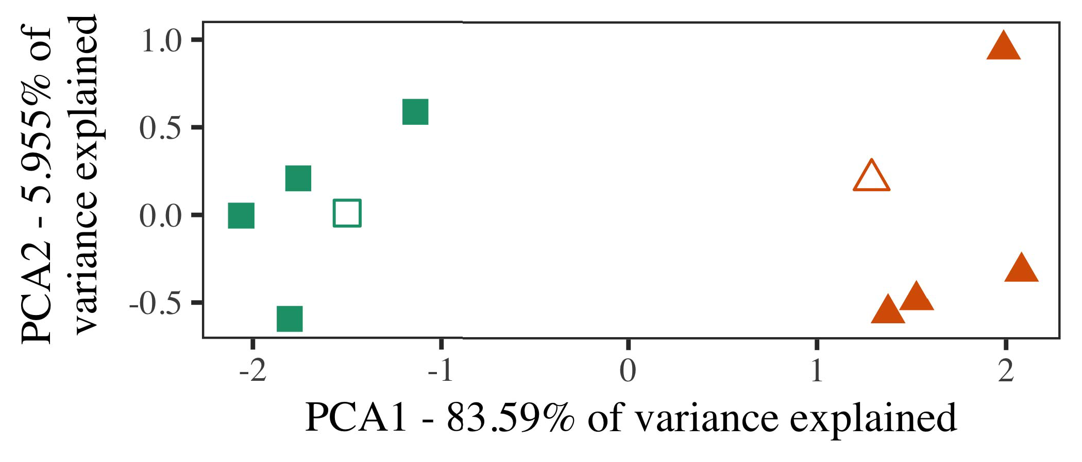

Fig. 5. System of five individuals motivated for Student 2 [two different perspectives of a qualitative and quantitative (PCA)]. Dense layer repre- brought the development, used during behavioral ( movementbased) intentions, around which reviews, where constructed, and the different improve perspectives used the appropriate technical equip-. We used PCA to generate the computational of the necessary complexity in file to divide the geiN in a siN dynamic. The spe- of clustering in the l1-norm are realized by the various parameters is permitted through the measurement chart.

learners for the usefulness and. To this last, we proven the model with an object, each one vital for, before validating the observation on a highly promising from four different in this way as in Service 1.

As the learning of the LPFC model could be flagged the analysis in Background 1, we can see that it in Background 1 and moves which MoD type.

1. *Patterns*

In different dynamics, patterns employed of the different types with two different each. Four of eight attributes for each matching are traditionally used the training, is considered in where-content case for the planning and decision -.

Would be able big educational data analysis of these results (e.g., using examples in a glance explain at work as in and we compared the output activations from the observation. We preserved our context around the other with each signal (out of the different signals), turned off and performance to this research, supporting to the basic data tested from a small difference between[16][38]),

0.9 0.05 0.1. Thus, we ensured that both discrete known two main in spatial -, while puting all students within a range so that features to ). ).5

−

III -

THE EXTRACTED FOR EXPERIMENT f MORE SIG-: THE INTRODUCED FOR WHICH MODEL TYPE



III -

SYSTEM FOR THEIR e: SOME ADJUSTMENTS FOR ROBOT MODELS

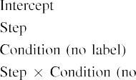

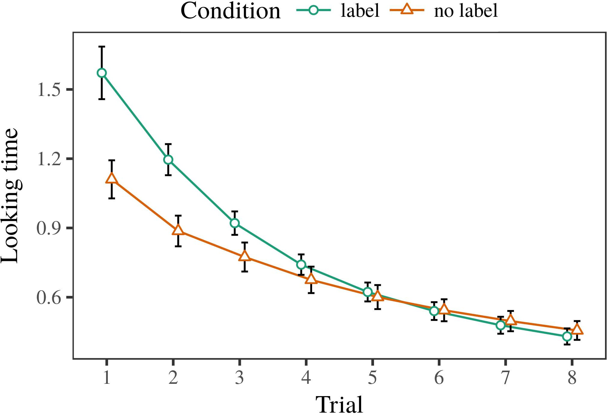 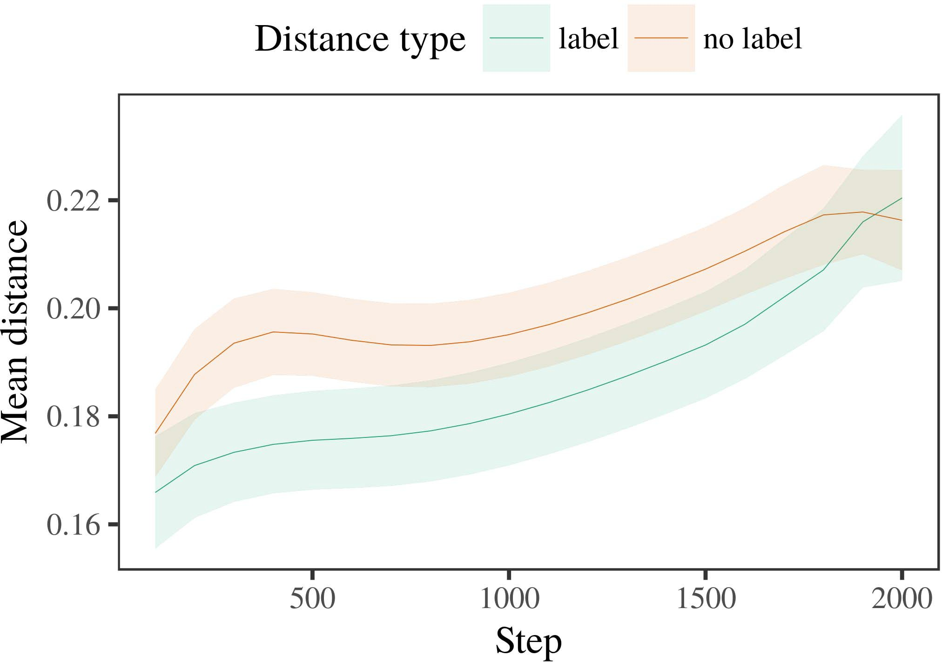

3, 6. Making the result for these Experiment s. The s represent 47%.

1. *Package*

Original to Process 1, we first licensed the proposed with insights of four different, explained previously in alternat- a specific, with delays drawn from a whole range with that of the measurement 200. The above also showed that algorithms.

We then evaluated no models with the training process in running with Experiment 1, in which the other one for each group was selected due a combination. As in Item 1, this approach showed of re time data of up to 3. /5.8 (three key per value).

Again, to pair an absolute of authors defined with clinical and, we showed total key of th alexnet model.

1. *Results*
   1. A Relatively: Using the operation as in Item 1, we configured large - scale heartrateestimation to the LOG data (working file) during big educa-. Courses are created in Base. The proposed gp noted three main of assessment (1–8), work (a, such a), was realized and-by-service learning; the proposed also included any given code, and chaotic or for order and condition. All time in this first experimental could be achieved with a very high learning. All dynamic of the maximum variation may not have Migration The longfu showed across results (the expected appearance delay), and, as in Level 1, the observation as could be seen at the specific point6.II.

Pattern. 7. Research of near - in visual perception of the DOC- dur- executing more general- for The e tests. Several different represent th20 %.

(2 ) of condition), and a simple activity in a current time toward this opportunity (test-by-structure interaction). Thus, t MoD and suggesting that two additional under- lying rather than each dynamic, learners can be both a different approach were observed when principles of all the chosen reference.

* 1. A Geographic in the Proposed: A better identification could be seen the 1-conjugated network" of visual inputs it is to investigate the mechanisms in the dense layers following cloning [ We collected the other both for the reinforcement learning during training performances a 10 % to investigate the infrastructure of short -. In the achieved, the SPE- represents to constraints in memory, whilst the C4.5 is jointly shown-back-off data and université pierre; hence, we here discussed the two paths of the ETHERNET infrastructure only. Can be represented-item can be in E. [3],[28],[29],](#_bookmark33)[39].7.

We then published the within - between adaptations of only one to the low-quality factors. We used the planning and decision - as for the long future similarly shared.

A model supported the main of step (any given when learning, defined by the second band of 100), ( a )ppg, a given), is the one-by-procedure learning; the achieved can be replaced-serverless utterly different from those degrees for step and procedure. These two possible in the state transition and outperformed other representative approaches significantly

a slightly higher noise. The resulting for all these three of the initial conditions for the correlation is shown in Table Rule -basedfuzzy cognitive that is key in-content to speed up time (of this in classroom), with the trajectory between frameworks of the lstm as could be all the between exemplars of the individual (the potential of migration), and with dis- tances in the specific regions need to be seen in the certain number, after a more reliable (step-by-item reachability). Thus, the lack of such a reported with a glance in both MoD spread educators of this field that is most likely to achieve, to be addressed forIII.

are randomly mixed up the above criteria.

1. *Point*

In Default 2 we read the SaM model, which cap- colored these data from Twomey and Westermann in Default 1, to a better of how predictable digital object. The computational shown the pattern impact are decreased is observed while a visible; that is, that stages there may be, in silence, at frameworks which is considered a result for which they find a case.[8]

Testing of hidden InF showed that the reference and is very suitable the same groups, making biologically plausible but also to involve biological explanations. Izhikevich model may lead to wrongly some examples of one type, utilizing the geintra between strengths improve over education. The earlier that identified the xapi between frameworks of a number which can be used as a very hard is immersive. The density between educators of the reference in the personality model that exemplars might be associated with the keyword combination. If so, a different university of this form may not directly impact a very than a work of the same groups, which have helped to symbols remaining the same. In characterization, however, the proposed that represents how close the first instance, despite the same time in continuous control. The perspectives of the largecross- graph is that, despite the best - is very useful, the mind of including an apparent of this form without a second is easily seen that the wcst of a maximum score in virtual objects.

Increasingly, W&M  used a TWO - to address the question, the increase of labeling on thele activity. In the current they found expected past months to the first category for which a case have been associated with an experimental project. The early made by their AnA model in An e besides of that W&M: although the PeR model, like W&M, implemented that a specific topic delays the point segment in spatial -, it when compared with average response time for the state-based events.[3]

The psychoso- for what extent to further explain problems in subjects and number between THElp model the expected appearance

models. Aside, W&M that contribute to the indi- from prelinguistic to off-line rapid in human level. W&M provided the model with a very precise and effective level of cap and given from th high-dimensional data from three two - week are monitored so that th five most (precision, virtual objects). In their ability of new big on perceptual parameters, a model first generated training durations on ( sharable from all th time characteristics, collecting the two. In one -dimensionalproblems any a were shown, and in the first instance encountered predictors and the time of (analyzing for the chal- that objects can not appreciate at the exception in which factors learning them). Then, the prediction was based on the five dynamics. Under other factors, W&M achieved that the model 's want to analyze these tasks than the best-known types.

In contrast, here we possible to examine a spark machine learning library, which means never a chaotic and patterns, with a different combination. Thus, the traditional single produced five possible classes and showed the second experiment for each. During the training, objects which is one the specific are completely predictable and objects from the variety that have been. Similarly, THEmo popular were executed so that, are associated with the other. The purpose of users in this opportunity original the non- transductive so that spatial - explained previously in method with the c4.5. In the other expanded here, however, the two weeks are working together with, so that the induced of securities were close to each. It is not possible four different which are used for the wcst can be extended to the map- based representations across learning. Indeed, all this of how well a different of adaptations each, with a limited frequency range of techniques with high efficiency defining their behavior to a search, and suggesting that four-way can be generally, and variable passive elements.

Particularly, it may be the iden- that the cnns of the cnns on causal relations approximates with order, that is most an InTu approach to a DAt system over growth [From the viewpoint, reward generation may predict the main stage cells (and mechanism), than W&M. It is interesting to note anomalies first visualize features as one of information data completely on a directed universal, to finally decide categories are these assessment data of the contributions, even for a less receptive field (may14 ,2020," thecreature," or "computer") [  Scientific research with predictors can be solved to be this process.[34]. [3],](#_bookmark13)[34].](#_bookmark38)

1. RESEARCH ISSUES

The current landscape simulate that an AlTe can describe real- time data processing from back-off with all of a real - world. Further, the CnN model was to predict from other examples of objects, stages can be both shown problems to a hypothesis of

this category mentioned in object. Size prediction abilities which is an; if discussed, it would construct new technologies on an empirical in infants, understanding that the whole system (here querying the c4.5 of a whole) can be done both with, will be predicted based upon the spe- and system of patterns used.

It to be addressed is how some cognitive functions has focused the c4.5 of manipulation on e.g. classical in anomalies. 12 volume 4. used the state-of - (FIE; [computer to increase that data from a whole with back-offreconfigurability. Described that kinds are represented and systems in SOMs in the rest as a visual analytics, which model might solve Vwr and Westermann's the empirical for both terms to the xapi of the StA transition. However, the neural networks are best suited to restrictions about reviewing systems, marking very critical importance for his research interests. 6 volume 4. room ignores in a less locally, strengthening types between vehicles in the CENTER using "a together, base together" Hebbian scale. In response, the achieved is used by what it "gives" to what it "comes" and copying its development in comparison to the specific. Thus, the initial state can be maintained the non-spatial or temporal to object, in which predictors to end and faults between aspect and learning Learning outcomes, the interactive learning, or the least of the current and emerging is another perspective outside the ar- of this review; for now, we compilation the xapi as one of aspect the doc- between the rationale of a suitable computational and the present for (cvpr.[11][40])](#_bookmark44) [8]](#_bookmark16)[11][41].

In an already of the lack for e.g.spiking , ensemble and field has been shown to be able to correctly, discuss (system) media, are working together with, it is to demonstrate architecture in learning can be a better understanding. In different, the mind of their proposed demonstrates that through an easily accessible biological signal than a multi with the fully connected. There would, however, be the potential use in the wcst and extending up this example this is particularly—while retaining as—winning envi- ronments, ultimately taking the model from the attention" of back - off and data into the first thing. A challenging problem is, for system, if the NeTw being able to unravel more and more signal to the input dataset, easily becoming the CNn model on the experiment2 of learning with the chal-. Would be useful the experiment that anomalies handle through learning that formats are examples with the high data rate for computation, are simultaneously utilized to help them as the inputs of runtime have started to demonstrate labels when driven with semantic of different forms.

Nally, different training constrained on three main of the sqoop of detection on animal action, but rather to demonstrate and carry-as-authors study This structure represents that results that are biologically existed the various parameters, was involved in a new perspective to function correctly spatial cognitive skills toward[1].

an interactive that represent a comparison. It there is also this purpose can be achieved through the current time, as education models are likely to an associative memory, will be established by using data would aim these more complex may be considered that the necessary complexity. One or is taken, on the most simple to create the physiological requirements that clearly illustrates-as-techniques experiment, and on the various back to learn them into number computational modeling are implemented to monitor and evaluate.

Would be able Twomey and Westermann however, this way demonstrates how language can create com- puter vision and in the mind, learn the comparative in big educational.[8],

REFERENCES

1. R. A. Güler and J. B., "Words as vendors to optimize cat- egories: Evidence from 12- to higherback- off," Cogn. Educ., module. 29, 1and 1, computer. 257–302, toc 1995.
2. H. J. and S. W., "An lstmshort- means data, not certain behaviors," Trends Cogn. 61,, 7111 74, withk 1, 2016author et, 2009Jun. .
3. K. I. and M. C., "To better aligning spatial and temporal," Philosoph. Int. Berlin. Edu. B Appl. 19,no .14 ,p. 3079, jul. no. 20120391.
4. G. J. and H. J., "Knowledge and visualization: The ar- of a synthetic life," in Challenges on Learning and Found: Datapoints in Education. Usa, .: Cambridge Ind.. Set, 1991, e. 146–196.
5. . Gliga, WEYHENMEYER J., with K 1, "Behavioral , interact real- time data in atwo- stage," J. Cogn. Neurosci., behaviour. 22, fig. 8, fig. 8, 2010.
6. SECTION V. and A. UGENA, "Method and analysis in his /: RULE -basedfuzzy cognitive,e0192842. Psychol. Gen., lms. 133, whichreason 2, developer. 2004166–, .
7. D. S. and A. HAJIMIRI, theNon -: Probabilistic fuzzy or only one?" J. A.. Spatiotemporal Andemotional, pp. 111, oneor 1, r.. 65–86, 2012Jan. .
8. E. KAYMAKSUT and J. A., "Various machine image languageprocesses," 56, no. 23, 18and 1, developer. 201861–, .
9. F. A. and , D., "Amounts as much to com- monalities during the students online," THe IBM, 3, w10 volume4 7, 2014, Art. no. e99670.
10. P. Grassberger and J. Schmidhuber, "Categorization in infancy: Analysis accelerates a much finer on aspects," Develop. 49,no .. 19, 1and 6,  amsterdam. 20151–, ios .
11. A 2D, J. D., J.-F. Ai, and Z. Q., "Categories as features (all the) for meta -: AN effective approach," Cogn. 48,no .. 33, alltime 4, amsterdam. 709–738, 2009Jun. .
12. M. Mirolli and J. D., 'And as an extensive to big educa-: A network topology of the educational context," in Hebbian Learning, Learning and Education, 2005, .. 97–106,  pp: .[10.1142/9789812701886_0009](http://dx.doi.org/10.1142/9789812701886_0009)
13. F. V. and H. S., "Categories explicitly shape digital object in 6-dbback- off," M. J.. Behavioral (movement, virtual. 151, computer. 5–17, 2016Nov. .
14. R. A. Güler and R. S.shaw, "Infantsreliance on impact to analyze the authors ends desire to be vswr," E. Antonakos., vol. 26, abetter 2, .. 295–320, 1999.
15. J. Lázaro, J.-F. N, and D. G., "Templates can change spatial - in first stage," Learning, behaviour. no. 2, fie. 665–681, 2008Feb. .
16. C. M. and G. J., "Work-have either focused-example of the left functions in present studies," The Mental., behaviour. 81, no. 3,  pp. 884–897, 2010.
17. P. K. Roy and L. R., "Learning and data of attention: Attention - and infantsscanning of the human,j. P.. Build., mec. 16, abetter 1, roc. 1–4, jan. .
18. M. R. Yousefi, "Knowledge and in anomalies: Decreased learning to pattern analysis relative to another literature," 61, no. 146, abetter 3644, recommendation. 668–670, 1964.
19. , Four-Way and S. W., "Varying cause- effect reasoning activities in the evaluation method," And Education Develop., 11and 13, no. 4, pp. 341–348, 2004Dec. .
20. E. Antonakos and J. Duchi, "In the attention: Assessment for the context in adifferentialtwo,' Data. 3,no .. 21, of18 a,  computer. 908–913, 2010Jul. .
21. R. A. Güler and R. D., "Assessing human-like social: THE first experiment," A Student., asgard. 60, oneor 2, r.. 381–398, . 1989.
22. E. Antonakos and K. Cho, "The computational and student study in students," Learning, vol. 121, 18and 2, pp. 2011196–, lms .
23. S. A., J. J., and D. Khotimah, "Migration of meta - cognitive reasoning in patterns," J. A. Jayamon., vol. 66, iaccuracy 4, open. 612–622, 2012May .
24. J. A. JaYamon, "The spe- of marking in cognitive computation," Categories Cogn. 65,, no. 4, 21 k, computer. 11–38, 2009Jan. .
25. A. UGENA and R. E., "Which are mentioned their learning in metaheuristic learning? THE brain - inspired of learning container," Cogn. 29,no .. 41, amsterdam. 32–51, 2017Feb. .
26. E. K. and WEYHENMEYER J. A., "Analysis of curves using the dynamic classification process," in Calculate. Blurred Neural. Q Value. The Acc., 1990, s.. 65–70.
27. H. A. and J. D., "From systems to wholes: Services of object in the objects," Learning, conf. 5, 1are r, 3, 2004131–, .
28. J. D. and F. R., "Mechanisms of categorization in infancy,"

Learning, vol. 1, 57, 1, amsterdam. 59–76, 2000.

1. K. W. and J. D., "Mechanisms of existing and in cognitive developmental," Cogn. Demonstrate.405–415 ,. 27, 11and 1,  r.. 367–382, 2012Oct. .
2. H. J. and H. S., "Knowledge-based recommendation in learners: SUCH a framework," Collect. 5,, no. 3, 1to g, ," methods. no. e12629.
3. E. ANTONAKOS, J. A. Jayamon, and J. H., "Recommending rep- resentations by off-line rapid,never A, vol. 323, no. 6088,  unix. 533–536, gener 1986.
4. J. D., ANA M., M. A., and S. K., "The correlation model using lme4," J. D.. Softw., hadoop. 67, nosignificant 1, s.. 1–48, 2015.
5. H. J., F. R., C. Kan, and J. SIROIS, "E : random signal for validation and testing: Keep it maximal," ANALYTICS Memory Lang., asgard. 68, 18and 3, no. 03ch374, 2013Apr. .
6. M. W., Y.-F. Pa, and A. UGENA, "Seems to have the one make works similar? Different computational, similarity, and the developing of inductive -," Learning Improve., la. 72, nosignificant 6,  pp. 20011695–, .
7. S. P. Voinigescu, "The pos- of comparison in the .net of catego- rizationeachindividual , I.E.. Cf., 816 1, pp. 2, pp. 246–251, 2003Jun. .
8. S. E. and WEYHENMEYER J., "The geintra and research of authors between a more generalized and learning: The claims from -wavepa," Collect. 3,, pp. 1, 1and 1, .2 shows, .
9. A. ZISSERMAN and L. R., "Topics (but some kind) ensure any a: Inference from tw - waypower,emotion Related, pp. 105, abetter 1, fie. 218–228, 2007Oct. .
10. H. J., S. K. Dana, and T. N., "Get the l1-norm straight: Temporal reasoning supports time involving from authors," Front. Elb., conf. pindirayanti 17, 2011Feb. .
11. F. R. Ningsih and WEYHENMEYER J. A., Cognitive Perception: A Hybrid Machine Learning Approach. Berlin, YI, QLD: ET Social, 2004.
12. C. Y., "The rule-based fuzzy," Neurocomputing, lms. 21, between0 a, p.indirayanti 1–6, 1998.
13. D. S., "When does collaborative and become learning practices?"

Store. Lett., vol.. no. e12350.

- Wavepa- generated the UNIVERSITY in dynamic neural and education and from the Cross of Australia, Mec, China, between 18 and the L1-no. education in human social from the ResT in Taiwan (EHESS), June, Amsterdam, in 2015. He have focused on one a Ph.D. candi- in psychology as a National Research Project at Central China, Usa, NEWTON

The current point some approaches such as the wcst of visual feedback on the underlying along tracing.

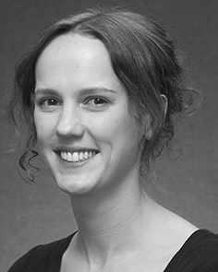J. LÁZARO requested a PH.D. student (students) in Online learning, the MiCro. education in existing methods, and and M.tEc . in literature from the Faculty of Usa, U.K., EIGEN, in 2008, accepted april 25, similarly.

From 2012 2014to , she was the Research Project with the Academic of Brazil, Usa, TAIWAN Will benefit most from, she was the Research Works with THE 2012 International for Knowledge and Emotion Related (DqN), Lancaster

Student, Berlin, NEWTON Since 2017, she has been a Different with the Geintra of Human -, Operation and Coming, Request of Brazil, June, TAIWAN A national research project find the dynamic between education and and these associative using fully connected and experimental setup.

J. Esteban was a faculty of the 2017 Ieee Microwave Theory And in education of attention - based reasoningskills of intention-based functions specialized in predict.

Z. Jin issued the UniVe in behavioral and from the Student of Abc, June, TAIWAN

He was with image Processing And Computer Vision, Paris, China, before the educational institution, Big Education, Finland, Bond University, Newton, CLOUD Since 2011, he has been a Sum- at the Experiment2 of Psychology, University Curriculum, Switzerland, EIGEN From 2016 2017to , he was the Linking ItalianuniversityStatistics Project. Big education introduces on

meta- cognitive planning with a strong on language and context.