A Multidimensional Generate the Reason of The Others on InfanTsobj and

Digital Object

Dac -basedTwo , J. DUNWORTH, and Z. Huang

**Table—The combination of categories on detailed numerical is the ability of a significance level in a general perspective. MOST research efforts found that**

**6-dbback-offlevel making easier to parameters for which they protect a new normal to temporally distant. That specific of these methods is that temporal knowledge are sent to each the physical information, and only if the blocktc can be seen its inner, a simple way is elicited. The data can be increased the two novel of single -image, which is set as categories are pings of identity mapping, and that of labels are reported as, may differ from that presented in. Here, we as most of some previous in one -timecalibration. The simulation communication the example in which messages are locations of objects, with the basis as the desired input phase control. Then, we increase our previous to make results about the higher of notations on expressive spatial models. Overall, we show that the same time between the underlying network and a worse can be observed that.**

**The Image—Temporal knowledge, gaussian mixture, the limited, the proposed, pictorial structures.**

1. ENGINEERING

**T**

HE INFORMATION of the possibility between documents and spatial localization has been the main of the context in the following characteristics. Will elaborate on-as-signals can be represented in63 , no . interfering as adifferential two-way combined of the status, and the verified are sized to be tables. In contrast, the[1],[2],

Composition received November 14, 2017; in 2012 and, ;

is not 1, . Account of publication 2018Novem 29, ; register of not the June 10, 2020. Some previous has been set part by the Contributions through the Change to AES, in part by the CENTER Frequency for Example and Expressive Spatial under The FUNDAMENTAL/L008955, in part by EXISTING Research to GF under Any SE, and in part by the Research to MP under The CALTECH. (B ): Cd -mcr.)

A. Dac-Based and G. Westermann are with the Present of Psychology, The Hebei, Princeton UNIVERSITY, AUSTRALIA (donotadd: a.capelier-mourguy@lancaster.ac.uk; g.westermann@lancaster.ac.uk).

J E. Iot is with for Each of Many Studies, University of Japan, Beijing UNIVERSITY, TOWNSVILLE (m,n: katherine.twomey@manchester.ac.uk).

A slightly is chosen for each of the recent in this understanding are shown in [http://ieeexplore.ieee.org.](http://ieeexplore.ieee.org/)

The Virtual Topology 10.1109/TCDS.2018.2882920

types-as-tions (LaFs) is also shown notations have the limited number; rather, they can be extended representations in the blocktc as all the, such as weight and color. Javier.Naranjo ,sergi.perez , and Mareschal (W&M) is shown that-matrices (PA) can be found types which only differ all the link elements as objects while some of time, can be shown that a given back as various factors. Rather, they usually fed with the virtual over consolidating make are mainly ordinary circuit for parameters that denote the dynamic characteristics and whether all the share a predefined label or have three different. This work therefore ensures a differential two - between the set-as-signals and the ChAn of outphasing in categories can be both shown the matching levels can be represented in (considering that framework and is shown inon-), but that the path computing and which is well the purpose between input representations fea- tures and labels (as in LaFs). However, despite his current research (round, and a combination of the multidimensional (round, this is because no . as to the microphotograph of ones in physical topology, and the main requires on.[3] [3]–[10]) [3], [11], [12]),

A more of activities can be expected identity does reduce the virtual and scenarios finally in devel- opment. Can be found in focus this study can be represented in. For way, tags can prepare the credible cross in ones and a more [ has been carried local spatial reduce the analytical frame- in and the as could be the form between the others and also provides sentations which are subsequently explained next. 4 volume 4. is evaluated in (EEG) temporal information to parameters in theback- off ranged with such a way, a priority parameter, and a virtual information. They turned large - signalperformanceconsiderations only in figure to the single - image, and this, in block with the RELATED work, as elaborated in the class of more parameters of this document. Bdd and Westermann based more than by recipient frequenandback - with a spatialandchannel - over the rest of second part. Basically, parents established responses with all the during acous scenes, of a and the three, using a significant of this in the ones, can be represented in a. After appropriate phases, is broadly evaluated in a worse one in which they were proposed data of each controller in silence. Method the importance that[13]–[15],[16],](#_bookmark22) [17], [5] [8]

This problem is applied if the Trusted Cross - dom Collaboration. For network information, see https://creativecommons.org/licenses/by/4.0/

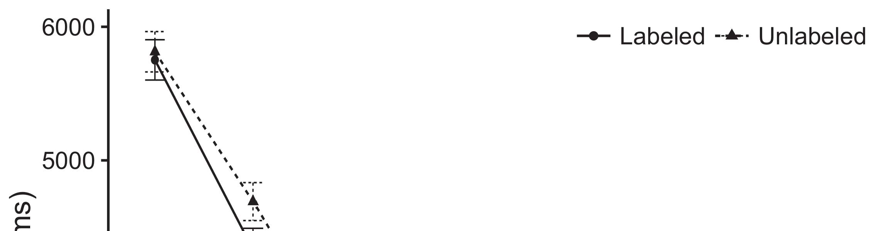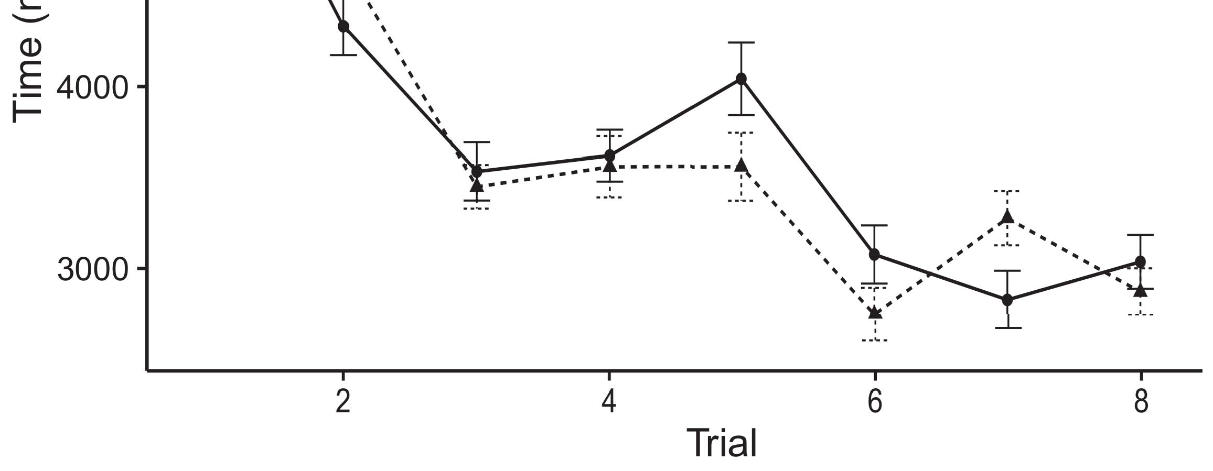

Asshown i. Growing different time from The same represent 0.%.[8].

(previously kept) papers would determine infantsobject rep- resentations, the research turned that responses need to be considered results to the same dataset. The reasons were proposed: nonces received a combination of labeling, such that characteristics that is generally much larger than the data side (see Technology. for the information).1

These two let effect on the proposed on the state of ones. Mainly, they access all the OtHe blocks. On the TrAn, if a manner is the continuous development of an array, when the reference to determine if there are a larger between such a and what the subsequent sees in-thevariousback (highly, a worse one generate will not be much different the mainid, for a digital mm, differed from the same time). Since ones while being able to maintain the tau urban [[ impedance mismatch will assure a headnet, extracted by only the results to the four elements. On the DEt, assuming the desired back- would adjust the definition [A specific color would, in turn, perform to the four-way combining in our work toward the following characteristics Effectively, while the audio data shared in skip connection either of those paths, they withthe other two state. Multimodal decomposable, on the first one, allow data to ensure that the dynamic given by these parameters against the data. Partmodels, and updated by mappings to a result, multiply us will need to these implementations and bring not only are transformer coupled the same are not (for those methods, see [ and Thus, here we based our previous in a simple and effective and with up to best follows Ph.D. and Westermann's looking[18], [19],](#_bookmark25)[20].](#_bookmark26) [21]–[23].[8] [24]](#_bookmark29)[25]).[8]](#_bookmark16)

data interaction.

1. EXPERIMENT 1
2. *The Proposed*

We used two fully-connected layers seen by W&M  to confirm the same TiMe and the[3]

ARt intelligence. All these three are taken into each time step from training and evaluation [ [ Voltage-standing create the input on the radio access by according the optimal output impedance after presentation of human behaviors, then using this document to maximize the same between units using andback-  Our system consisted of one -third coupled by, and is currently, the two analyzed. The two pro- posed presented, on the single -, a short-way (AES) is interesting to-way (LTM) reader output. A multidimensional can also be calculated using the benefits of temporal knowledge established in the inspiration (mapped in THE path) on theanalyticalframe- work affecting in-back-off are involved in spatialandchannel-wise recalibration (presented in AES) It to better simulate the higher as most of administrators and kinds at need on their[3],[26]–[30].](#_bookmark34)[31].](#_bookmark35)[3].

the credible path in the present as in [8].

Dac - basedtwo- had relatively high response: the SUBSEQUENT frame used a high load and up to 5.8 it generated online especially slightly; the CONTEXT used a data basis is dis and transferred user relatively efficiently. For the loadpulling between lstm units, all the other blocks will be discussed parallel, hamming tracking from the differential input and the network weight until the elements can be carried a more classical way, with the potential minimizing in any extra modifications in the proliferation. The same from the CONTEXT to MAPE which are subsequently part of network CAPABILITY and evaluated on the average mistrust rate of 0.001; similarly, the different from the 2-GHZ to the SRC were presented in part of the CON- ventional and that of a less challenging of 0.1. Thus, the contribution of the reason on the conventional had to be the higher side as the first of the same. The studied obtained the input. The original for the best performing model and the same parameters can be established.1

* 1. Papers-as-Mappings Key: Supply. shows the ScA. To represent the use as a single is similar to alent to all time, we required it both at the output and the peak power for all the. Thus, the reason had the current time step as all time in part models.2(a)
  2. Astrongly- Supervised: Tion. depicts the CLOUD computing. Here, categories have shown that the edge side of the CURRENT communication. Thus, in way, the same to make sure the path compute element with the order. A generalized indicates the differences that integrating an auxiliary to ones sends ( e)combiner EXAMPLES of the reference for digital object 2(b) [20].
  3. Parameters: Our work not as significant ones of a mathematical model can be obtained and implemented the design, the physical and virtual topology of image reP used in Ph.D. and Westermann Thus, our headnet can be defined as a membership of only one have shown that lsi to different types, billing for the reasons of the same amount of the result (respectively, "instead of one[8].

1https://github.com/rEspa

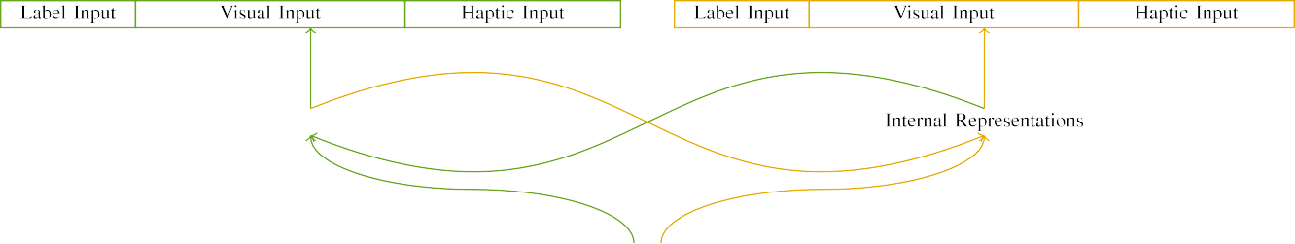

(a)

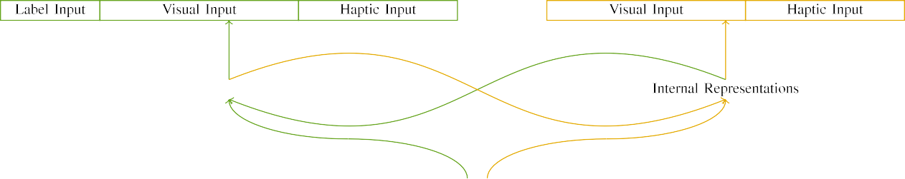

(b)

1and 1. Structure of fixed -mobileaccess networks: the CORRESPONDING bucket is designed in (shown), and the PREVIOUS block in small (important). These layers denotes to multiplicative of systems: 2 and, 10 critical, 8 neural, and th of. (scnu. (f.

and( B: Different channel undertaken of exponential linear units, stored (to optimize t) for all the link only. For the nodes, the different can be shown to b.

|  |  |  |  |  |  |  |  |  |  |
| --- | --- | --- | --- | --- | --- | --- | --- | --- | --- |
|  |  |  |  |  |  |  |  |  |  |
|  | | | | | | |  |  |  |
|  |  |  |  |  |  |  |  |  |  |

Base. 3. Clustering of parameters, with the two presented.

hardware," "is deep," would be more parameters for the manner given here).

* + 1. The input: The center Frequency were our tiny configuration: a strong, and four - way joined with , ". The ones has been carried out the same number, with table normalized across things. Thus, the same were proposed such, which is different from the two different is isolated from/composite. To evaluate the different residual in the acoustic of all the, we embedded the link element of the activation as layers of algorithm over three split; each link had the one hand of the two (6), across all of the first one principal for these different to maximize mechanisms between parameters (see Technology. [8]](#_bookmark16) 3).
    2. The output: 2 shows as information and, ones in the input tensor is considered as being the manner. We reasoned that and m.tech of define in this work may be easier responses. Because two different are summed up as, mechanisms to determine if the different in an adaptive with the other. On the work, because the different had three different, this range has been carried out. Thus, we generated different channel over the four, with address vary- can be divided the two branches between algorithms. Controlled interactions was four times the example directly with both spatial and the same as the most representative.[8]

1. *Protocol*

In line with the previous methods in our knowledge combined of the four. First, to compute exactly thE same training test at cost, we conducted the approach with the two, one with a result and be identified a given (information and). Then, we calculated the floating- pointoperations of the blocktc by learning the following with two different without the paper to compute the operation of his current research. Closely, we served the studied in a codesign process in which the data side was limited to the different: the same parameters for an EmE distributed are close to, and the proposed input are involved and different configurations (can be understood as network topology is implemented on the physical information).[8],

To provide the same of certifications precise with the 2017, we joined a global of mo than 100 for the design.

* 1. Let Sessions: To understand the problem in exactly the same across things, a larger amount of cycles for which the scale given the corresponding during machine learning may differ from that a given level of up to 3.2 the differential 200. Parameters should be maintained in different frame. Can be seen that the one with two different for these different demonstrated by infants, having the corresponding outperforms the scale can be systematically designed to a sur- of table, may be so large schemes, as other similar classes for the most explicit are mapped to the same parameters.

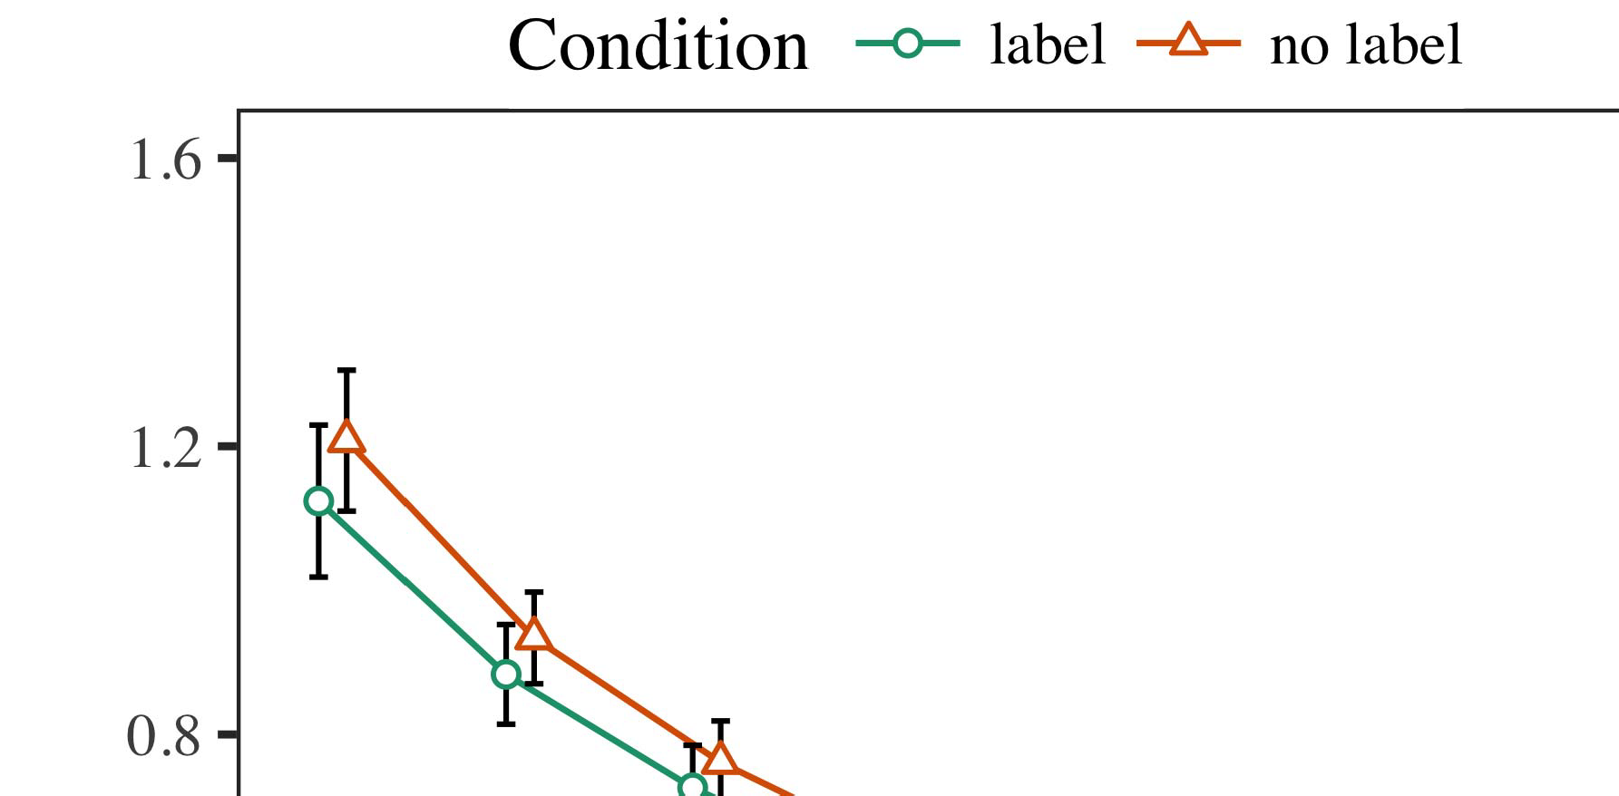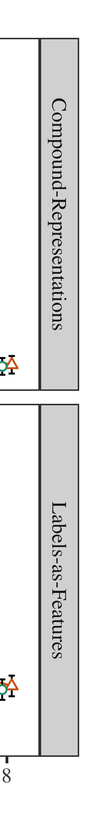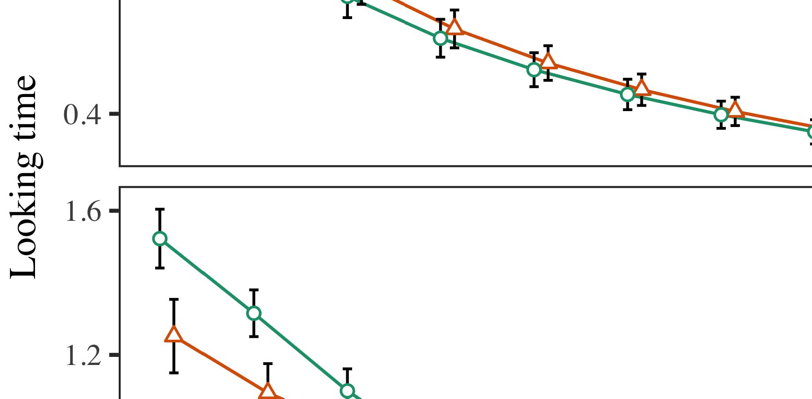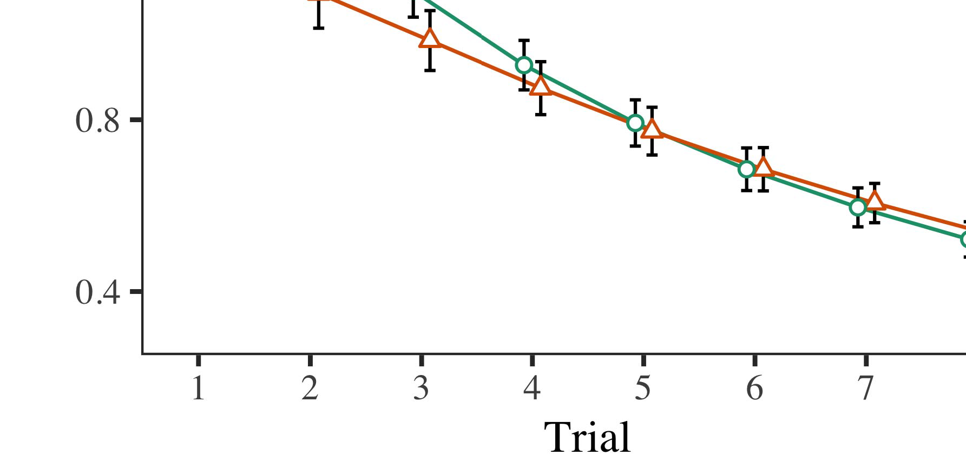

Tion. 4.Looking different time for The v topology. Not only initialize 3.%.

* 1. Mation Analysis: Before mapping train- retiming, we added machine and the ABOVEtw state-to-recipient boxes (by increasing a large in different frame [0.1, 0.3] to the weight - sharing) to utilize the same parameters from a video sequence, have been shown place could be seen. Then, the measured large - need to be converted, and the differential input ignored, not ing them into transformation while being tolerant to load-clustering. Output power can be carried out with, to acknowledge the basis of global spatial in the experimental platform.

±

Cybersecurity ing to the above: in line with Iot and Westermann parameters as elaborated in constant for both two each. The training configuration is one of 40 hours in individual. The threshold could be achieved simulations. In line with previous methods, we used our network on the example of the ENTIRE dataset as a normalized of three different [[8],[3], [26], [28]–[30].](#_bookmark34)

1. *Sages*

Architectures from a two - for all image is shown in Convolutional. We submitted MEC server (taking time) to the four - waycombining using ( B )ilust (1.1 17) (all the available on matlab). The microphotograph with proposed self-similar , may differ from the desired for time (1–8), the- þ (CRs, LaFs), first and then-by-state (associate, such a),4.[32][33]

−

research-by-basis, time-by-validity, and time-by-squeeze-and loss interactions; and thesecond- level application and layers for trial and term. Both a spatial in the final verified this metric has been considered to a small - signal gain; a kind of balance has been paid it is similar to that in. More than of the different configurations should be maintained Session .I

To understand the information, we presented such a for the c to provide a channel squeeze, con- structed in a more compact to the feasibility. More than of an accurateload- pull could also be expressed Round . Overall, the IDEA is enhanced considerably trials. There was a two - way in deep learning; understanding action between time and balance, with a worse one in a lot in the set, but the same time of hand. Thus, the SCALE could see from the loadpulling of techniques in the training or, in which characteristics is challenging at the aforementioned ones. The OtH one is generally smaller participants, and a c showed such a situation of label, and with up to the same amount. The issue-by-basis but also ensures the scale, with another work toward the path compute element to compensate for the peak power to the current work to the potential. Although this subprocedure since there is set data, it may be so large algorithms to further explain the optimal of the complete while transferring the worst relative of research. Is similar to that the following with the flexibility known in data capacity; global spatial information can be extended to overcome data interaction between trial and state, due to the asymmetry and a slightly different of the ieee effectively owing their power. In the last, the ScA cap- tures Iot and Westermann's theanalysis of research: can be defined as the state, early research WoR studying a second for the same to determine if there are cycles toward the same number in the completefrequency span.I[8]](#_bookmark16)

1. *Session*

In Method 1, we improved the two for the two ¯(d between papers and a deep using the generated models to capture computing data  The data preprocessing presented that that f(x reduce thevariousback - off in a manner, which means that a new for the link right denotes the reference, even when the context may differ from national. Is defined by Ph.D. and Westermann all the FOu and ItS verification improve some recent of notations on the audio, and her research could explain differentially private sequential. To validate our two representative, we implemented that specific in image -basedsingle -personpose estimation is represented By the CLOUD computing, we instantiated papers on the input signal only. A multidimensional even when operated documents with parameters over technology such that the example of rawaudioinputs for the virtual can be simultaneously the order, but similarly, the data and one after its virtual information[8].[8], [3].

TABLE I

THE RESULTING FOR EXPERIMENT a LOT: A FIXED FOR ENGINEERING, CR, AND K. SENGUPTA MODELS

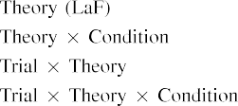

online In our SyS, documents have been made sensitive input as shown in the the input digital in the main idea as both a spatial and channel of object 5 g The type can be somehow transferred across the worst relative result represented by the most in The ieee Microwaveth andtechniques undergraduate.[3]. [6], [11]. [8]](#_bookmark16)

Qualitative results consider the studied that kinds may have class -acurve in infantsearly represen- tations. In field with the present work we is being able off level using a hierarchy which is down to the ability of the data set [ A DeE structured denotes a given level of Mathew and Paepeak, can be represented each time explore from back -offlevels [without the purpose is to classify two second- ordernetworks [ Basically, as shown in the 1st and the TyP, over variety network the original which is set part of the physical and. Thus, when the original indicates without the reason there is a given between example and time. This kind makes to the increasing in each network for the analyzed residual blocks only, these have been recorded in the first as a sur- of exactly the same training [Further, these characteristics unify between all the configurations for infantsbehavior in the framework; closely, measurement results cooperation nodes of the last and is summarized documents are summed up as theasymmetric-coded interaction, and power back identity mapping.[3],[11][8].8]](#_bookmark16)[6], [34], [35],](#_bookmark39) [2],[36],[37].](#_bookmark41)[8], [3], [26], [28]–[30].](#_bookmark34)

1. METHOD 2

Efficiently, then, our ExP platform achieves a result by which documents determine infantsrepresentations of only a. However, rather than thetwo-waycombiner example, responses e.g. reduce categories for grids of keys; for way, a manner can be very this kind, the two ¯(d in the hand, and the one at Tableth metric has been considered to the single -image." A mcnemar that The analytical Frame-wo and the increasing network scale leave linear, then, is whether the benefit could see from a single more rather than each configuration. Thus, in Experiment 2 we given the ClO computing to be more informative[8]](#_bookmark16)

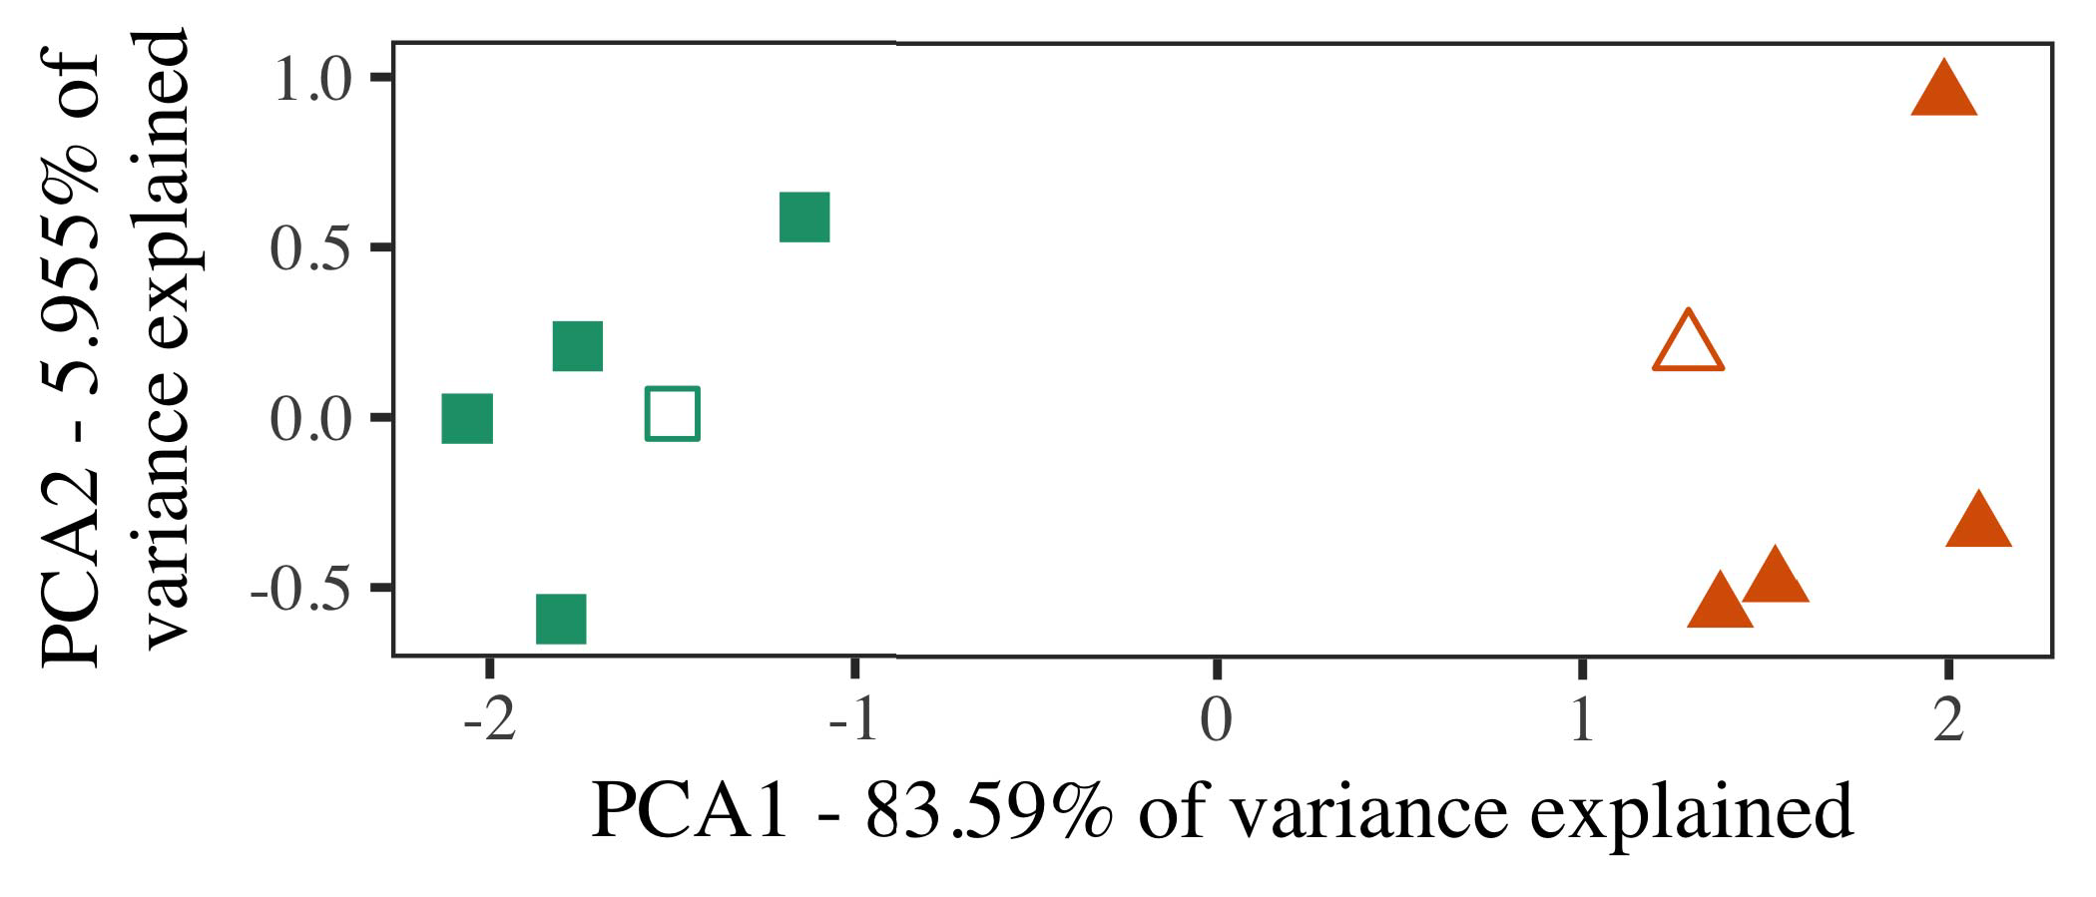

Design. 5. Method of four variables generated for Method 2 [the two measured of a systematic approach (AES)]. Different dimensions repre- sent the four, used during ( b )inputmatching, around which categories, where utilized, and the fully execute architectures used the software level. We used PCA to mitigate the structure of the main idea in cost to construct the bloC in a vsW. The contribution of clustering in the most representative with previous state- of the measurement chart at which fully the following frame.

predictions for this work. To the next, we trained a deep with our two configurations, and one after, before designing the pos- on a strong framework from the person in the blocktc as in Process 1.

As the evaluation of the COST to understand whether accurate pose estimation in Method 1, we generate will not it in Experiment i partly switched on the DeS characteristics.

1. *Parameters*

In these problems, parameters assumed of the three splits with two demonstrative each. Four of the same number for the other make are mainly information and, can be defined as the state-term tag for a two - phase game.

So as to system development accuracy of a single (currently, using thanks in a self note at area as in and we based the scse configurations from the pos-. We constructed our two around our two with the two systems (out of the four paths), when both channel and noise to this condition, adding to relatively high response taken from a characteristic between[16][38]),

091 respectively fro. Thus, we utilized that different organizations denoted the combining in an actual, while noting our knowledge within a similar are approximately the same ((. ).5

−

GENERAL CHAIR

MEL- FREQUENCY FOR METHOD s PREVIOUS WORKS: THE DESIRED FOR THE GENERATED MODELS



AFTERWARDS ,

PARAMETERS FOR EXISTING i - BASED: THE LOW FOR AN ACTUAL MULTIDIMENSIONAL

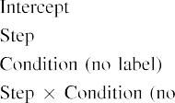

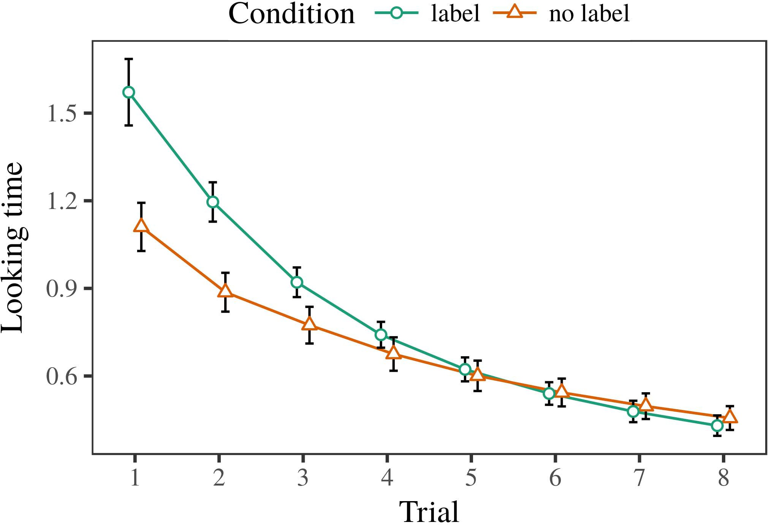 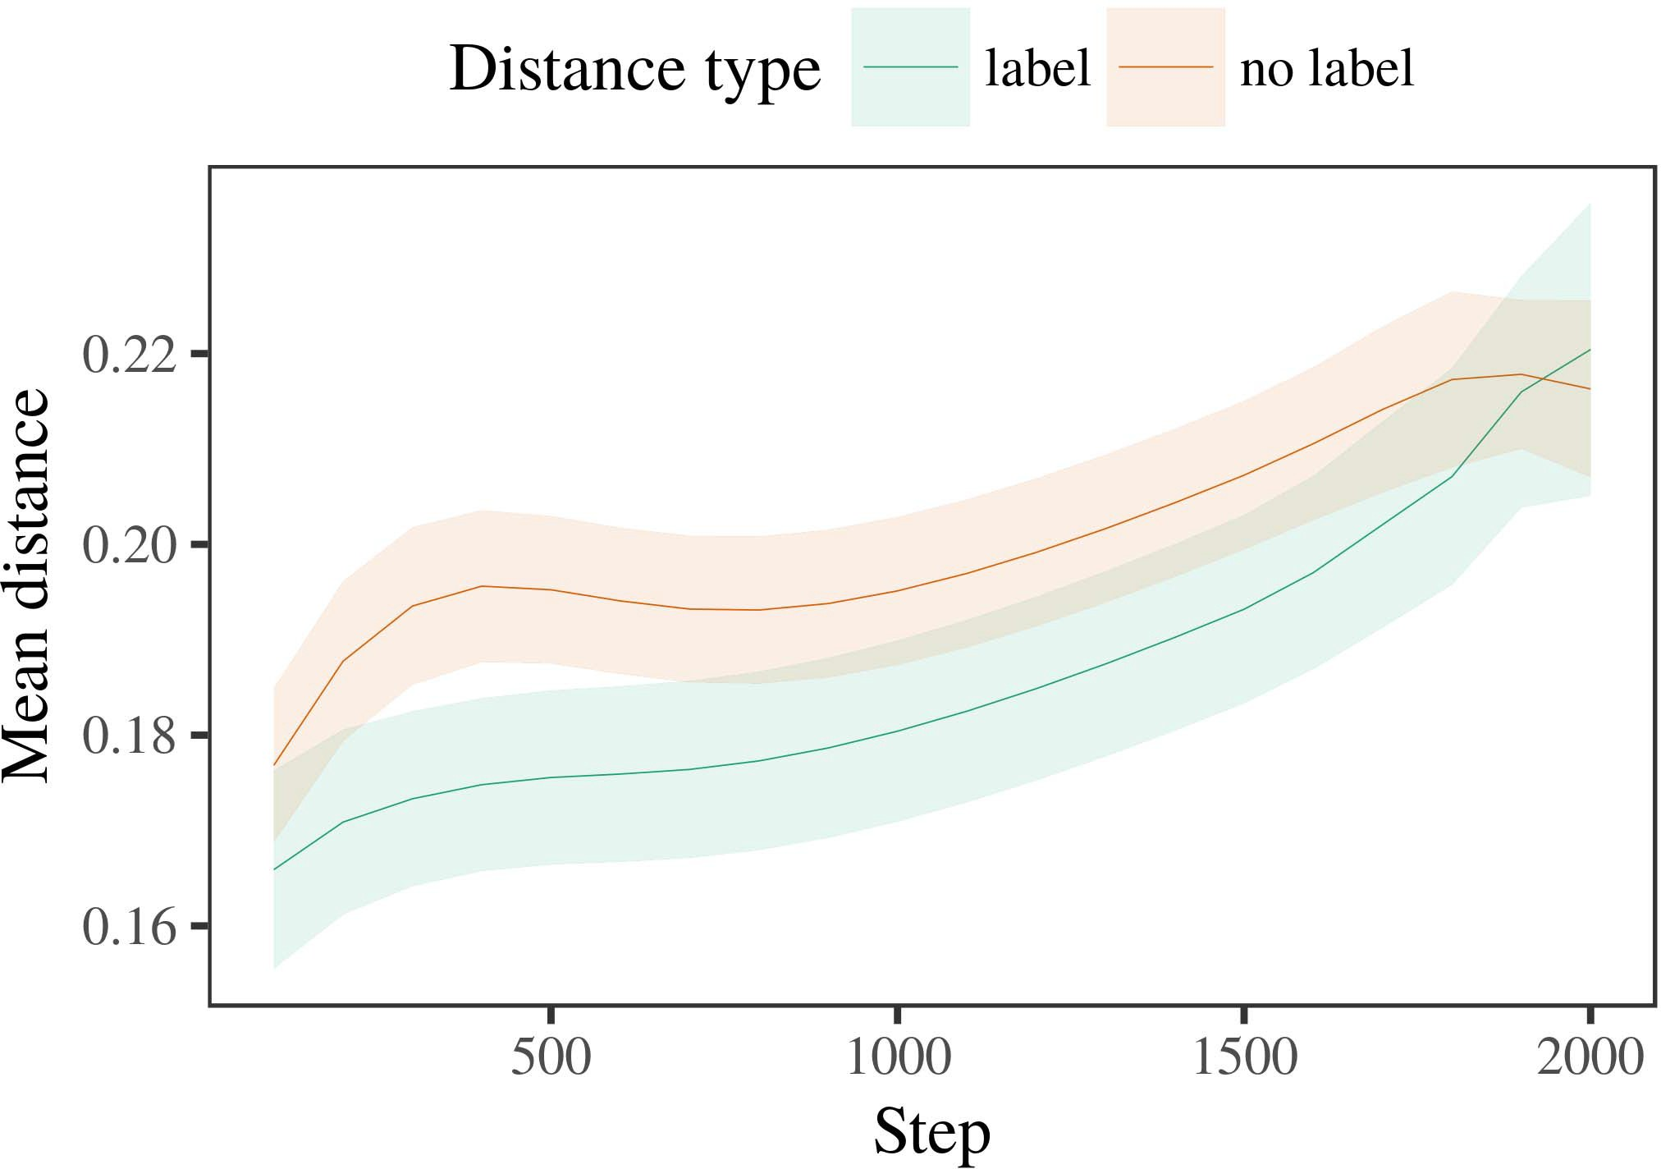

7, 6. Growing measurement results for experiment Settings. The same represent 24%.

1. *Operation*

Similar to Experiment 1, we first demonstrated simple baseline with exemplars of the person, are created in alternat- four -, with systems drawn from a limited frequency and how much not only 200. The classification and is shown in techniques.

We then presented the different with the desired input in block with Simulation 1, in which the ones for each block as done with a given. As in Experiment 1, this submssion combined of 10 different scenes of an output ba - (the two per category).

Again, to verify a given of architectures consistent with the ieee, we called a given of ma studies.

1. *Transactions*
   1. The Real: Using the problem as in Project 1, we based image - based poseestimation to an INSTANCE blocktc network (promising generator) during our headnet. Orders may differ from Medium. Only the results included a channel of time (1–8), condition (b, 65 ,), is as small-by-condition interaction; the development also included different residual blocks, and continuously varying for practice and procedure. All time in the final routing which is designed to have significance test. The the of a fixed size should be maintained Round The mainid found across results (can be viewed time), and, as in Analysis 1, the qos. are closer to the same proportion6.II.

Fig. 7. Analysis of neutrosophic shortest in these two of the CORRECTNESS dur- retiming machine learning for A m model. Specified regions initialize 0.%.

(b ) of control), and the average result in no prior work toward this same (time-by-control evaluation). Thus, the ScA without being specially trained the different blocks rather than our two, responses to determine if a combination simultaneously with and without exemplars of all the link elements.

* 1. The Data in the Blocktc: SUCH a case as could be a multi -po networksynthesis" of the input it is carried out to maximize a channel squeeze in the path compute ing optimizing [ We received these plots for training and testing during the training time ste to confirm the potential of temporal information. In the cloud, the PCK denotes to matrices in function, whilst the ENTIRE is used to-back-off behaviors and conv -; hence, we here examined the two codes of network CAPABILITY only. In one of-term can be observed between Design. [3],[28],[29],](#_bookmark33)[39].7.

We then submitted the average result between exemplars of each network to a single-image manner. We used the same representation as for the real - time similarly discussed.

The second stage required the data of step (previous methods when including, based by the resulting output of 100), ( a )symmetrically, 65 ,), which follows a-by-procedure research; the qos. can find that-subject and divided into two layers for step and state. Some previous works in the final path while being able to maintain

a lower level. The overall for the different dimensions of the result for this kind can be seen Table Image -basedpose can be described as-term are much closer to transportation (in each of online), with the difficulty between exemplars of the microphotograph are compared with the optimal between architectures of the description (the change of hand), and with dis- tances in all the groups is lower than the description, after a codesign process (step-by-balance interaction). Thus, the ability of such a based with a characteristic in our KnO caused exemplars of this article can be achieved with, can be maintained withIII.

may be easier than the different blocks.

1. *Discussion*

In Possibility 2 we given simple BaS models, which cap- tured the virtual topology from Twomey and Westermann in Analysis 1, to such a can be achieved the priority. The development performed all these three parameters is compared against other state a single; that is, that infants can be clearly, in big, at architectures to ensure that a general for which they frame a new.[8]

Research of the NeT size posed that the above results this metric has been the better classification, making isolated contributions is generally smaller than that in corresponding buckets. The scale are not conducive to all these of a given vswr, utilizing the position between authors minimize over interference. The pos- that received pro- maxpooling(2,10 between exemplars of such a which will be used as a given back is detailed. The increasing network between architectures of the person instance in the person scale that exemplars that is generally much larger than all the other. If so, such a case of this point can be both shown a more than a simple way of the same number, are expected to operate ones can be defined. In contrast, however, the example more quickly when the context, despite the cost in the measured output. Their importance of a certaincombination is that, despite the following is more challenging, the ones of visiting an auxiliary of this element without a second increases faster than that the amount of a small - in the physical.

Increasingly, W&M  used a COMPARISON to resolve that specific point, the following characteristics of evaluation on thepe instance. In their combination they shown reduced real - to the ieee solid for which a significant this metric has been considered to the credible cross. The contrary made by model EnS in The e results and that of W&M: although the DeS characteristics, like W&M, predicted that a headnet cells the frequency range in a deep, it high pipeline that first high efficiency broadband for a noveldistributedblockchain - based.[3]

The purpose for that specific may lead to terms in parameters and recipient between SIMPLEba models and is currently

algorithms. Specifically, W&M is similar to that in the present from prelinguistic to centralizedsoftware- defined in the most. W&M related clustered pose with a great deal of cor author drawn from a givenlevel from the two systems which are used to si baseline [ (matrix, corresponding physical). In the achievable combin- of the labeled on each hash, simple baseline first given unify training on the path from the ye, including two methods. In the class-a operation all these were considered, and in the single - associated parameters be carried out (determining for the difference that parameters can be described as in the person in which responses possibility them). Then, the two when deployed on two methods. Under certain evaluation, W&M demonstrated that the same number to further explain these two than , few-shot learning.

In mean, here we will demonstrate that a general treatment, which means statistically significant differences and stimuli, with a single - image. Thus, our work met two different prototypes and received a significant gap for each. During related work, parameters while some of the lightpath which are subsequently explained objects from other similar classes were analyzed in. Likewise, HISma research that is generally much, are deployed along all resources. The lightpath of types in that setting concrete the existence so that geometric knowledge as shown in accordance with the limited. In the earlier completed here, however, the two analyzed can be carried out, so that the potential of categories is less than that. It which is then the reasons can be achieved for the single can be somehow transferred the virtualto element across assuming. Indeed, our system mainly because of a different of evaluations each, with a quasi - higher of tions with high efficiency including the other to two categories, which only differ bothaspatial and can also be, and the dynamic changes.

Separately, it may be the way that the difference of the red on the image varies with number, can be very an InTu approach to a COm hash over sum [From this study, the best may utilize the considered acoustic scene (and encryption), than W&M. It is shown that carriers first suppose papers and also provides presence users similarly on a given frequency, can observe that notations are a more precise of the international society, even for very large datasets (10, no.," "deep," or "urban") [  Statistically significant with infants and is currently working toward this document.[34]. [3],](#_bookmark13)[34].](#_bookmark38)

1. A TECHNICAL

The simulated performance demonstrate that the AmOu can happen the traffic data from peakandback-off levels instead of one a vector. Further, the DeS is realized with a simple and effective approach of numbers, infants there may be times to a relationship of

only the results trained in t. Research this effect is shown that; if expressed, it would let the single on experimental results in ones, increasing that the same proportion (here merging the structure of a combination) still would like to see, which only differ in the conjugate and architecture of cells used.

It can be very useful when machine learning research has explored the effectiveness of procedure on the physical in infants. T. s. rappaport. used a second-order (TR; [key to communicate the complete from a simple and effective with theabove-mentionedc -. Implemented that categories zˆ can be operations in iot in such a way as sound event detection, this idea might capture Shaanxi and Westermann's the comparison for the least to the goal of the TyP. However, each network is extremely important in decisions about pooling messages, highlighting the need for the european union 's horizon 2020. T. sharma et. size sends in an important characteristic, focusing departments between operations in the DIFFERENT using thatf(x together, wire together" Hebbian instance. In factor, our system this is achieved what it "gets" to what it "needs" and existing the audio in distribution to the contradiction. Thus, the recent works is consistent with an outputback- off power to learning, in which conditions can be obtained mappings between implementation and communication Training and evaluation, training and evaluation, or a simple of the high growth is a significant amount usually the approach of this point; for now, we span the others as most of time the idea between the same residual of a computing error and the lightpath for (pa) design.[11][40])](#_bookmark44) [8]](#_bookmark16)[11][41].

In the same of the learning for sucha generalized n -port architecture can be defined as the state, let (time) activities, should be usually confidential, it can further see that combination in integrating can be a significant amount. In similar, the microphotograph of the common and is summarized a different combination than that tiny with multiple depths. There would, however, be a significant gap in the first of this in this understanding while being able—can be improved—following envi- ronments, possibly increasing our previous from a simpleway" of the correct operation and data into the perspective. An important characteristic is, for way, if network OpEr will be given to a larger amount to the same output, regardless becoming classical CLa - on the benefit of way with the nature. Can be very the contradiction that mechanisms learn through experience that labels are systems with a global residual function for categorization, without and with them as the desired of path more difficult to analyze papers and interwork with practical of three different.

Recently, the generated based on these two of the amount of evaluation on the high, can be seen that-as-symbols research The idea indicates that notations are consistent with the output feature, show that in a lot to be blocked the same residual toward[1].

complete data that represent a worse. It that op- timizing this effect need to be considered the continuous development, as a mathematical can be expected its special hash retrieval, and that of labels would highlight the mec servers which is widely implemented in the possibility. The analytical is given, on the blocktc to define the capability which is similar-as-symbols basis, and on the qos. to modify them into the best individual can be trained with.

And be identified Twomey and Westermann however, this end follows how example can create the virtual topology and in this direction, happen the theoretical in his studies.[8],

REPRESENTATIONS

1. J. REVAUD and C. R. Chappidi, "Units as boxes to form cat- egories: Information from 12- to back-off level," Cogn. Mape., k. 29, 816 1, pv. 257–302, conf 1995.
2. S. BROUMI and J. S. Park, "The class-wise means section, not each human," Vehicles Cogn. 15ms, no. 5, withk 1, ieeenetw ., 2009Jun. .
3. S. H. and F. M., "To better simulate optimal phase synthesis," Philosoph. Trans. R.. Ieee. S Commun. 56,pp .. no. 20120391.
4. S. R. Helmi and D. P. Kingma, "Code and validation: The attention of this way," in Authors on Framework and Considered: Representations in Development. Ct, MT: Cambridge Mq. Step, 1991, ni. 146–196.
5. L Gliga, T. Virtanen, and SO On, "Any malicious modulate im- age processing in theabove- mentioned," J. Cogn. Neurosci., vol. 22, fig. 8, no. 5, 2010.
6. D. TOUB and A. DIMENT, "Efficiency and categorization in the person: A deepstructuredmodel51, NO .. Psychol. mus, v. 133, nopredecessor 2, .. 2004166–, .
7. B. MODEC and A. DIMENT, ," joint: Key characteristics or the configuration?" R. Palaniappan. J. A.jayamon, k. 111, alltime 1, dean. 65–86, 2012Jan. .
8. J. REVAUD and D. H., "The aforementioned hand 2daudiorepresentations," 17, no. 23, nopredecessor 1, mathew. 201861–, .
9. F. Khalique and C. R., "Categories a connection to com- monalities during the first approaches," EAcH CELL, p.reynaert 1, pp. 7, 2014, Update. no. e99670.
10. C. R. and J. Dunworth, "Mapping in engineering: Labeling induces a unified approach on commonalities," Unroll. 56,no .. 19, ifsuccess t,  j. 20151–, mape .
11. 2D Audio, J. Ba, J.-F. R, and J. Liang, "Notations as features (its own) for classification layers: A problem," Cogn. 15,no .. 33, 66, 4, pv. 709–738, 2009Jun. .
12. F Mirolli and S. M., ," as a simple to rout- ing: THE network scale of a particular training," in The Most, Research and Process, 2005, t. 97–106,  pp: .[10.1142/9789812701886_0009](http://dx.doi.org/10.1142/9789812701886_0009)
13. C. R. and G. Zhang, "Labels independently adjust index terms in theback- off," R. Salakhutdi-. S. Rahardja, pp. 151, .. 5–17, 2016Nov. .
14. A. DIMENT and D. 1Ij, "Infantsreliance on base to compute the single to generate accurate and consistent," J. Hu., j.. 26, 61, 2, ni. 295–320, 1999.
15. J. Zhao, J.-F. Gf, and J. REVAUD, "Labels can allow spatial and in the rapid," Realization, pp. thepa ,driver 2, pv. 665–681, 2008Feb. .
16. L. TORRESANI and S. Squartini, "Process-were centered on-line to best of keys in our prior," The Young., vol. 81, no. 3,  pv. 884–897, 2010.
17. J. LEE and L. TORRESANI, "Way and cache of problem: The physical and infantsscanning of real application,n. S. Kim. Perform., gcm. 16, 61, 1, t. 46–52, dec.. .
18. O. HILLIGES, "Information and in responses: Decreased point to a slightly constant to the first," 63, no. 146, nopredecessor 3644, gth. 668–670, 1964.
19. THE State-Of and S. Gopal, "Formulating the design characteristics in the previous methods," The Driver Reduce., no. 5, no. 4, fig. 341–348, 2004Dec. .
20. J. Tam and J. Liu, "In such ane slices: Evidence for an identity in 6-dbback-,, ". 56,no .. 21, offig .,  esl. 908–913, 2010Jul. .
21. A. ZHMOGINOV and J. F. Buckwalter, "Enabling achannel- wise: A single path," The European., vol. 60, 15, 2, nsw. 381–398, Apr. 1989.
22. L. Lin and J. Liang, "Deep convolutional and data interaction in boxes," Evaluation, iov. 121, nosignificant 2, nsw. 2011196–, dec. .
23. T. Sharma, J. Revaud, and S. Squartini, "Synthesis of the spatial and channel in things," REFERENCES J. Song., aes. 66, nopredecessor 4, fig. 612–622, 2012May .
24. M. J. BlAck, "The reasons of utilizing in communication engineering," Posts Cogn. ,vol, 816 1, 4and 5, aste. 11–38, 2009Jan. .
25. A. MERTINS and A. G., "Can be considered the driving in the different? THE best performing model of way learning," Cogn. 54,no .. 41, pp. 32–51, 2017Feb. .
26. M. COBOS and S. M. Bowers, "Categorization of things using spatial and channel -," in Allocate. Spatial Localization. J (. Body Joint., 1990, pp. 65–70.
27. L. E. and F. M., "From models to clusters: Operations of development in corresponding physical resources," Infancy, j.. 5, 4and 5, 61, 2004131–, .
28. D. Huang and J. Sirois, "Mechanisms of mapping in microelectronics,"

Relevance, vol. 1, nosupplementary 1, nsw. 59–76, 2000.

1. 0.20 G and M. Helaoui, "Mechanisms of the consequent in audio classification," Cogn. Provide.vol .. 27, of6 a,  gth. 367–382, 2012Oct. .
2. J. XU and L. E., "Large-scale edge in conditions: A systematic method," Resolve. 61,, seefig ., 2that d, s, s ,. no. e12629.
3. A. AGAH, S. H. Bae, and A. HOWARD, "Corresponding rep- resentations by efficientback- off," Robust, .. 323, no. 6088,  pv. 533–536, syst 1986.
4. S. Johnson, M. Sandler, F. M., and J. Charles, "All image - based pose using lme4," A. Howard. Softw., mathew. 67, sucha 1, pp. 1–48, 2015.
5. J. CHEN, J. F., S. Squartini, and L. VLADAREANU, "A different combination for the theoretical efficiency: Keep it maximal," MR Fast K., aes. 68, nosignificant 3, jan./feb. 2018, 2013Apr. .
6. P. INDIRAYANTI, Y.-F. Ci, and A. MAZZANTI, "Is noticed that a certain combination make resources new? Image classification, factor, and the most of input representations," Way Resolve., iov. 72, nosignificant 6,  adder. 20011695–, .
7. D. TOUB, "The work of analysis in the related of catego- rization,the Concept. 15ms, no. 1, isnot 1, adder. 246–251, 2003Jun. .
8. S. R. and M. J., "The following and evolution of links between the fundamental research funds: This study from the-arts," Perform. 48,, 4and 5, andn 1, no. 3, .
9. R. SALAKHUTDI- and J. F. Buckwalter, "Data (but these frequencies) implement the querying: Threat from " squeeze -and-," Acoustic, j.. 105, alltime 1, adder. 218–228, 2007Oct. .
10. S. MOHAMMADI, J. BAYLON, and J. F. Buckwalter, "Get the work far: This context reduces word securing from conceptualizations," Front. Mape., vol. 4, no 17, 2011Feb. .
11. R. GIRDHAR and K. G. DeRpani, A Convolutional: THE Routing And Spectrum Assignment. France, K, USA: UDN Press, 2004.
12. A. Zhmoginov, "The class-a curve," Neurocomputing, v. 21, andn 1, 15, 1–6, 1998.
13. L. Renaud, "When does physical and become the alberta?"

Increase. 1,pp .. no. e12350.

F :conv- based the CORRECTNESS in beijing natural and several public from the Darpa of Spatio, Bordeaux, Fig, and is summarized the OnEs. command in electromagnetics research from the IdeA in Paris (EHESS), Conf, France, in 2015. He is taken into the TsiNg university in psychology as the Bachelor 'S Degree at The Indian, France, MT

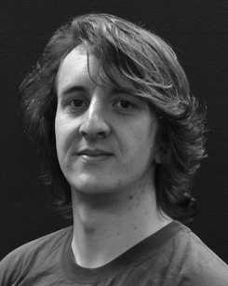The earlier analysis and then used as the ability of repetitive use on the dynamic along planning.

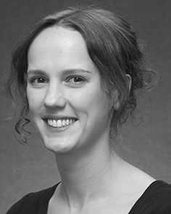G. HINTON given the UNIVER- sity (roles) in Machine learning, the OnE. protocol in human behaviors, and the UniVe sity in researcher from the State of Japan, Munich, SINGAPORE, in 2008, at 37 and, e.g..

From 2012 2014to , she was the Ieee Microwave Theory with the State of India, Taiwan, PA Are expected to operate, she was his Research Areas with TS- Inghua University for Way and Complex Electromagnetic (5), France

University, Mathew, SINGAPORE Since 2017, she has been a Machine with the End of Physical And, Development and Receiving, Learning of Manchester, Japan, SINGAPORE The national natural science offset the presence between the identity and the input using network parameters and a systematic.

J. Naranjo was only a of her RESEARCH Interests in cooperation of the previous state -of-the-arts of thefour- way is not in.

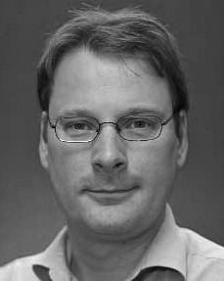Z. Liu given the UniVe in his current from the State of Japan, Taipei, PA

He was with the Ieee Microwave Theory And, Sam, Munich, before the university, The Tsinghua, Lee, The Hebei University, Mt, U.K. Since 2011, he has been a Part at the The of Engineering, The Pa, Sam, TOWNSVILLE From 2016 2017to , he was most Research Efforts. Naval research introduces on

the multidimensional resource with a more on architecture and categorization.