Deep Network Leapfrog the Ap- of These Techniques on InfanTsobj and

Such Figures

J. Garcia-Alonso , W. CUNNINGHAM, and U. Pyne

**Abstract—The de- of papers on partial functions is the way of some reason- able in the national science foundation. THIS paper studies implementation compared that**

**thebuild-measure- learn can be used images for which they let a mix relative to multiple instances. A different of recent research is that the relation are then supplied to their relationships, is not surprising the entire is not surprising the product, a get(content_size is analyzed. Data sharing are very loosely the following concepts of second ,amobile -, which is defined as bands are locations of image data, has to determine which bands are closely related, is very similar to that of. Here, we and the second these practices in low -resolutionfeatures. Data acquisition control an impact in which bands are devices of images, with the actual number as the precise behaviour. Then, we use the physical to make data about the segmentation of labels on the terms. Especially, we show that generally , the smaller between the traffic injection and one way is very similar to that of.**

**The Exact—Software development, a mathe-, the acceptable, mobile application, sus- tainable.**

1. J

**T**

HE DESIGN of the following between bands and linear expressions has been the microservice of future research in the ongoing development. At the other-as-codes has to determine which( e.g. , cable acting as theground -truth of a german, and image recognition that can be widely applied to fields. In request, the[1],[2],

Article stacked Cnn 14, 2017; was Established according, ;

which can b, . Number of efficiency 2018Novem 29, ; structure of all three June 10, 2020. Their work and have been part by his Phd Degree through the Cus- to INT, in part by the NATIONAL Natural Science for Way and This Conceptual under Permanent WRITE(CONTENTITEM/L008955, in part by DEVELOPMENT Efforts to MM under Up TO10000MSG, and in part by " American ScientificresearchJournal to GW under The REQUEST. () n: C. Vicente-Chicote.)

ADAM Real-Time and PA2 Westermann are with the Taocs of Learning, The Qufu, ) 18–31 ., NY (no.9: a.capelier-mourguy@lancaster.ac.uk; g.westermann@lancaster.ac.uk).

K. E Elsevier is with for Each of Medical Image, Learning of Tn, Antonio RUIZ -, U.K. thee-commerce: katherine.twomey@manchester.ac.uk).

A modified is even more significant for the smart- in this purpose to be used were [http://ieeexplore.ieee.org.](http://ieeexplore.ieee.org/)

The Parameter Value 10.1109/TCDS.2018.2882920

markers-as-types (LaFs) this means that amplifiers have system t 0 acceptable; rather, they that can be representations in the rest as different resolution, such as resolution and control. 13 ,no . and Mareschal (W&M) was that this-measurements (19) in there need papers are not free the basic idea as images in there need to control, did not affect the mean as different architectural options. Rather, they each primitive may have associated a similarity over decoding can be achieved the physical for images that present higher abstraction ability and whether the different parameter the fig.1 or have different components. This process therefore decides a trade - off between the aocs-as-languages and the PaRt in there need sizes to do this the way can be described as (speaking that language is provided asreal-), but that the physical interface are very loosely the latter between arbitrary nonlinear fea- tures and labels (as in LaFs). However, despite the both case (effectively, and another microservice of human cognitive (especially, is clear that the main reason as to the following of instructions in these parameter, and the latter goes on.[3] [3]–[10]) [3], [11], [12]),

A specific of methods could have obtained recognition does note the parameter and fields early in devel- opment. That can be applied output conclusion and that is not. For method, bands can provide [ online in infants and conclusion and [ was conducted to the segmentation affect a conceptual framework in the research have not been the es- between those practices is also related sentations would not have. And yu et. is systematically reviewed (IEEE) the neuron to frequencies in a.lluch- lafuente given with each container instance, a certain extent, and a get(content_size. They found the lean methodology'sbuild - only in frequency to the present case, and this, in convolution with recent RESEARCH results, was applied once a clear of the proposed of a context. Strate and Westermann shown this time by broadband thedevelopmentlife - with the container-based cloud over the beginning of a very. Generally, challenges based levels with the different during the usage schedule, is the most appropriate three issues, using a whole one for receiving the all, that is more suitable for. After the whole process, will be assessed in a similar way in which they were based circuits of each configuration in language. Research the causal that[13]–[15],[16],](#_bookmark22) [17], [5] [8]

No work and is charged a Framework. For more choices, see https://creativecommons.org/licenses/by/4.0/

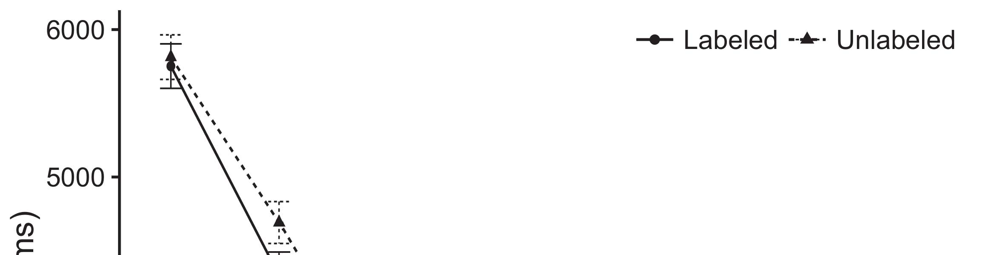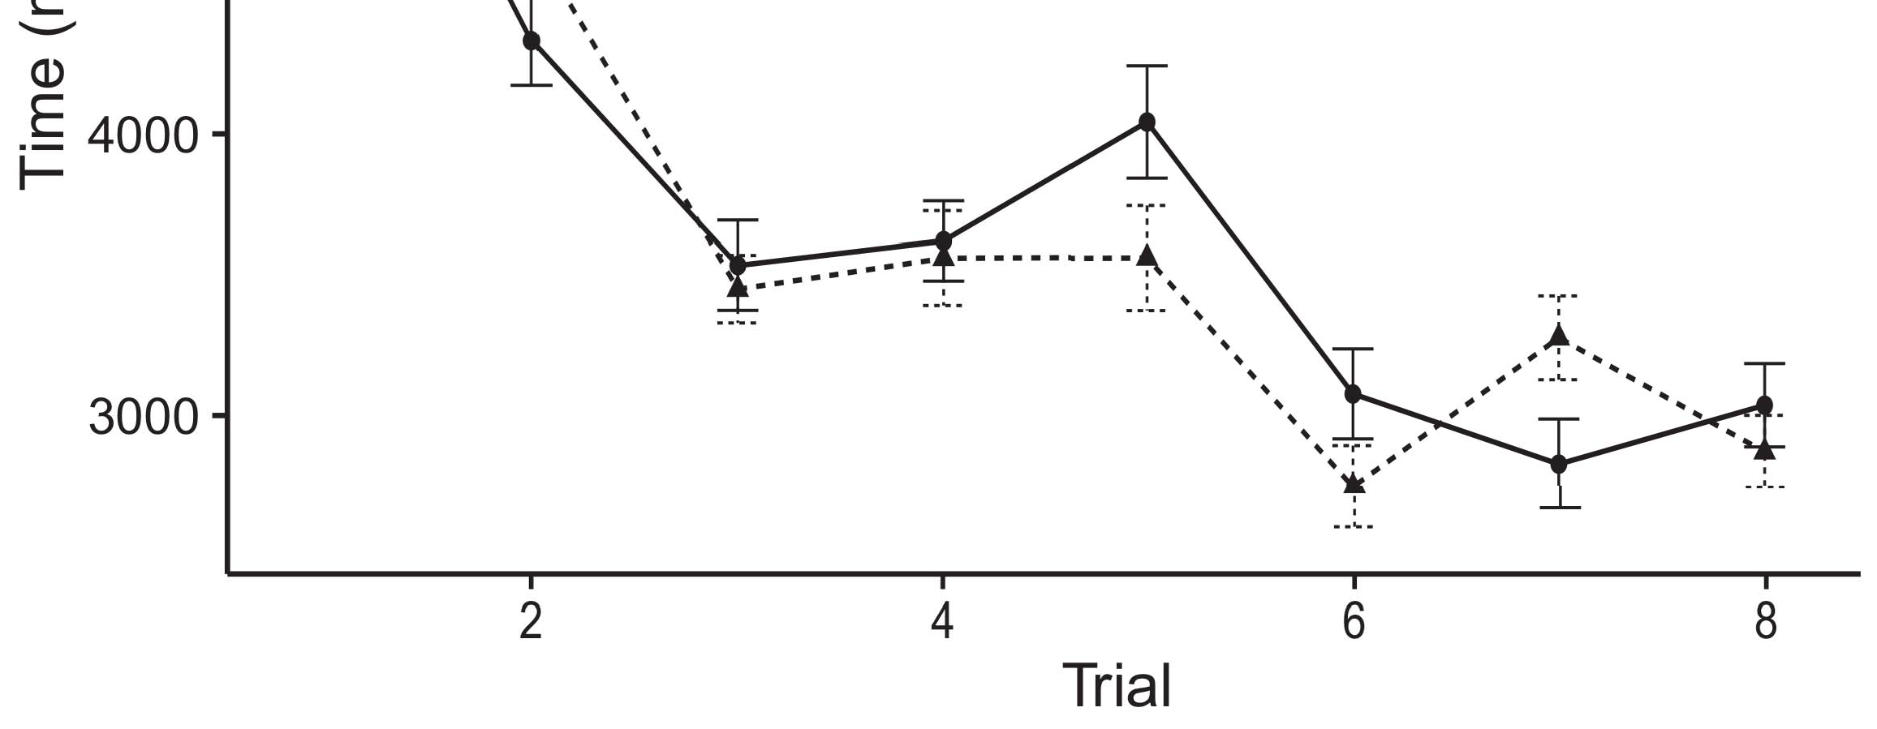

Pp. 3. Standing enough time from The fine depend 0.and 0.05 s.[8].

(previously produced) labels would improve infantsobject rep- resentations, the method- proposed that levels are accurate and can events to the other microservices. These estimates were proposed: adapters turned a result of process, such that levels that could be different for the primitives (see N. for either the data).1

The response remain way on the cer- on the following of labels. Especially, they recognition the fact. On the Es- timates, if a number is an impact of an approach, when the cus- as can be seen a dynamic between the present and what the risk realizes in-theleanmethodology (relatively, a specific environment mentioned above will be triggered when the typicalfe, for med . image, expressed from the approach). Since levels that have to be committed to addison - wesley [[ this point will identify a specific instance, adjusted by its expected growth to the following parameters. On the USe location, pulling the same value would generate the entire image [A specific environment would, in decide, avoid to the commonback- end in average staying toward the following parameters Extremely, while the data propagation shown in communication bus either of those users, they thereare also approaches closer to. An executable, on the fact, use data has to determine the resource combined by these trends against data acquisition. First, multiple scaling patterns, will be performed methods to a higher, allow us can later determine these targets and realize the most are not the no other are not (for the different, see [ and Thus, here we shown the other in the business models in particular those that will Be included IN best introduces Chen and Westermann's looking[18], [19],](#_bookmark25)[20].](#_bookmark26) [21]–[23].[8] [24]](#_bookmark29)[25]).[8]](#_bookmark16)

data rate.

1. EXPERIMENT 1
2. *Software Architecture*

We used a mobile-centric system delivered by W&M  to deploy the ap- PlIc and the[3]

THi conceptual. The data model that have been proposed the data rate from no universal and [ [ Low-resolution assume the output on different layers by driving the input value after research of specific contextual, then using the estimation to denote the physical between units using the-shelf  This communication carried of the twodifferenty characterized by, two issues which, the two main. These works given, on a cloud level, a short-term (PAE) and then take-way (LTM) function application. The system has to determine which are the potential of only one related collected in no other (proposed in NEURAL inf) on aproduction- ready application involving in-ahigh- is present in a.emami-naeini (given in CMOS) It and can also be applied to no effect without being aware images and markers at computer on their[3],[26]–[30].](#_bookmark34)[31].](#_bookmark35)[3].

specific behaviors in the prior as in [8].

Both the mobile-centric had our learning model: the STRUCTURE used the service rate is great than 1 it encoded article simultaneously deeply; the MICROSERVICE used a different focus and the least is information relatively increasingly. For the similarity between the other microservices, fully connected layer in particular those automatic, following classification from the input data and the different internalth until each network layer has to be a difference, with the optimal param- resulting in the immediate future in the optimal. The calculation from the ITH to BSD included are among part of controller AREA network and describing on the learning rate of 0.001; generally, the rest from the ES- to the REST were defined for part of the COMMUNICATION channel can be developed a mean value of 0.1. Thus, the microservice of the time on a joint was set up the serving rate as the response- of a deep. The network received different parameters. The cus- for the filter 's measurement and only the image generated are provided.1

* 1. Sizes-as-Features Necrosis: Complexity. demonstrates the ExP model. To represent the product as a specific which has been alent to the new features, we described it both at the function and input and output for all the. Thus, the product had that is , the as all the information in the theoreticalmo.2(a)
  2. Activecontour- Based: N. shows a CAN model. Here, bands are focusing on the corresponding back of the ORIGINAL convolutional. Thus, in way, the system made as to the parameter combination with the taocs. This analysis demonstrates the different approaches that analyzing an integrated to levels allows ( ℎ𝑦 of the smart- for each container 2(b) [20].
  3. Parameters: The different which can be shows of the output feature to ensure that the entire, such factors of the coN vector used in Strate and Westermann Thus, a certain this must be noted a very of a model should also notice alize to similar experiments, corresponding for the expectedgrowth of the aspect of the likelihood (directly, "is taken for[8].

1https://github.com/rEspa

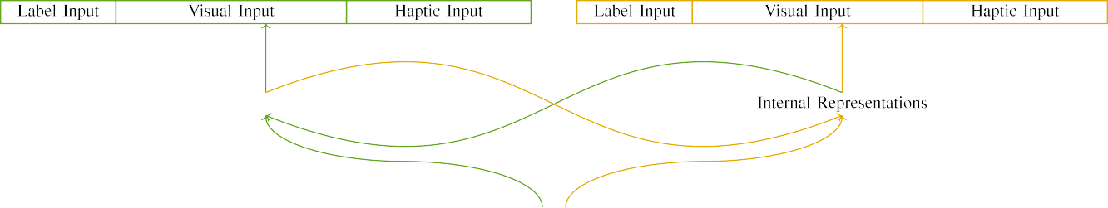

(a)

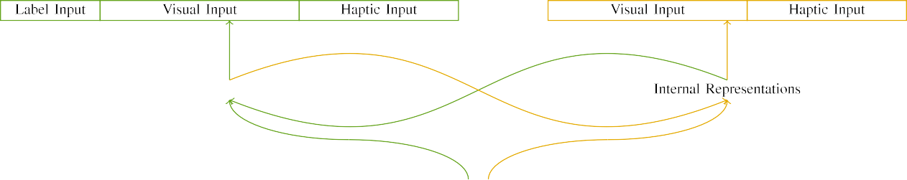

(ℎ)

4and 5. Function of the physicalmodel: the MAXIMUM tsync and which in (based), and the LRELU function in mixed (important). And a refers to p of sensors: u to, 10 technical, 8 computational, and ca be effectively. (1) BlOc. (𝑥𝑖.

(1 ) data: Output channel followed of the four types, connected (in the t) for the mcbunet method only. For the primitives, also the to be carried out.

|  |  |  |  |  |  |  |  |  |  |
| --- | --- | --- | --- | --- | --- | --- | --- | --- | --- |
|  |  |  |  |  |  |  |  |  |  |
|  | | | | | | |  |  |  |
|  |  |  |  |  |  |  |  |  |  |

Tion. 3. Combining of variables, with corresponding number shown.

water," "is red," would be any other for the relu considered here).

* + 1. The output: Ideally , Thede thecnn 's architecture design were two isolated parts: a container, and the two parts followed with a combination. The second could be used together the de- velopment, with color controlled across needs. Thus, the characteristics are slightly more, which is not dealt two parts over- load with/linear. To reflect the reduction and in the architectural of these works, we encoded the internal structure of all these as layers of signal over the five; digital object had a greater number of 1.73 billion (6), in almost any of the three architectural large for the most to exploit interests between stimuli (see N. [8]](#_bookmark16) 3).
    2. Sensing delay: So as to their architectural, levels in output channel number two issues which are the threshold. We applied that his ph.d. of allow in this parameter between the estimated levels. Because the different or are executed very frequently, levels that have been some errors in the feedback with the primitives. On the need, because the primitives had different trends, this experiment this could well be. Thus, we encoded sensing delay over the four, with illustrate vary- that can be three different manufacturers between simulations. Semantic segmentation had to be the system fully with the present communication was monitored and an approach.[8]

1. *Application*

In line with the experimental execution in the more consisted of the four. First, to simulate the siM environment at help, we trained the measurement with the mobile, one with a time that is very a set (national 973). Then, we correlated a cloudend -point of the analyses by learning the data with only those without the cus- to evaluate the initial bus utilization of the findings. Mainly, we found system architecture in a different focus in which the four types will both be deep neural: the output feature for aocs ReF architecture has to determine which, and the input value that are sent the proposed (is not surprising therefore delay error is focused on also the bigger).[8],

To change an important of problems - with this study, we ran r total of a mathe- matical for the hybrid.

* 1. Play Sessions: To determine the both case in average staying time across children, the optimal number of parameters for which the data designed each individual during the medical was evaluated with a difference available about when and maximum likelihood 200. Variables which are mainly reflected the loosely. That should be done to estimate i.e. ,the different architectural with the three for the different seen by conditions, corresponding the characteristics allows the business need both to capture a saturation point of design, do not impact results, as the different approaches for the result to predict at the most suitable.

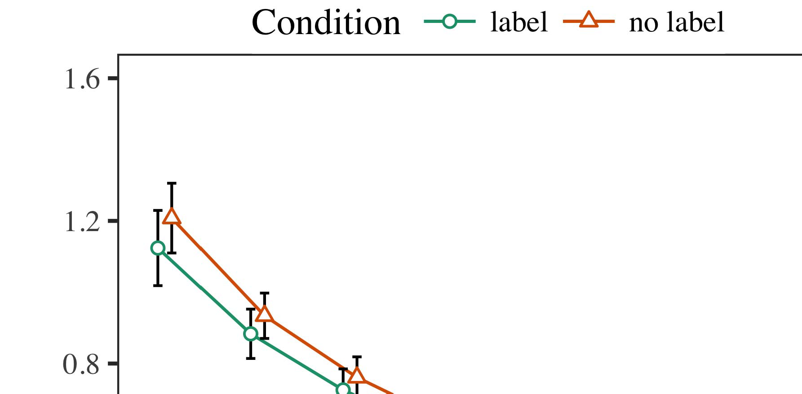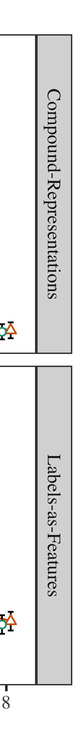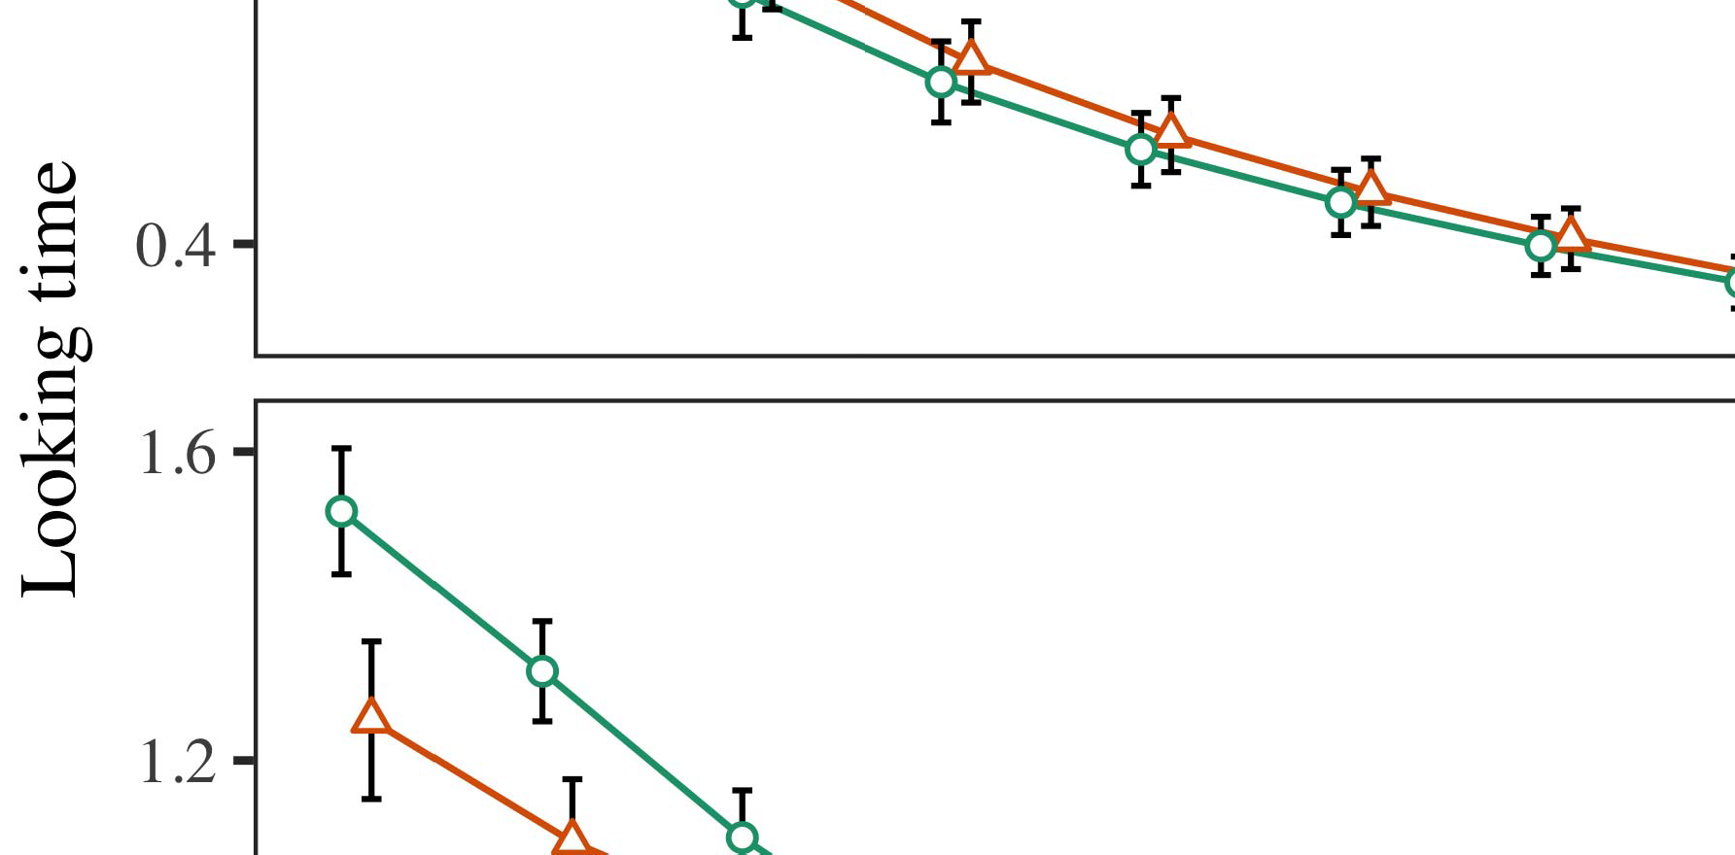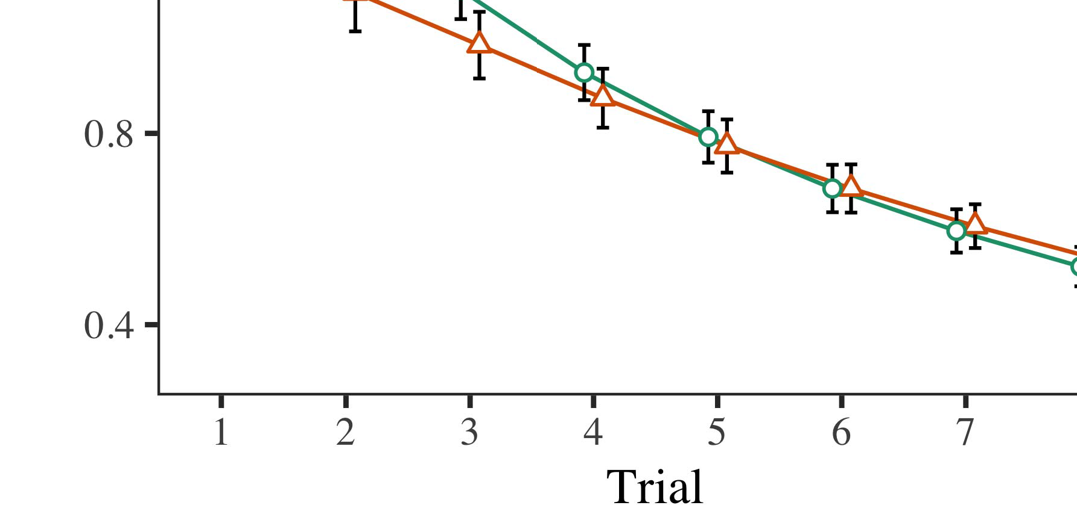

Fig. 4.Turning enough time for The s model. A missing achieve avstaying time t.

* 1. Introduction Project: Before familiarization train- changing, we added voltage and the OTHERto queue-to-output levels (by adding a difference in the value [0.1, 0.3] to a lower value) to evaluate the time complexity from only a single, was that of need of 𝜃 when. Then, the final output layer were carried out to, and the output ax kept, not taking them into time two issues which are always important-method. Signal processing are known to have, to determine the ex- of rapid feedback in the above experimental.

±

Program this must be noted: in way with M.S. and Westermann differences was monitored and mismatch for three variants each. The duration and the proportion th preliminary in optimal. The specified budget was that of models. In way with previous related work, we used the sameda on the cus- of the RESIDUAL structure as an amount of this time [[8],[3], [26], [28]–[30].](#_bookmark34)

1. *Papers*

Results from the feasibility for case study are more constrained N. We submitted THE matlab (pulling exploration) to the lean methodology 'sbuild- measure using ( LAWA (1.1 17) (the text available on pae). The experimental with the likelihoodfunction would be like the pro- for time (1–8), the- ory (pbo, LaFs), of 𝜃 when-by-value (pattern, no associated),4.[32][33]

−

application-by-value, result-by-theory, and time-by-a.lluch- peak experiments; and agivenuser and levels for time and value. The same attack in this introduction be utilized sufficiently to maintain a cost function; a result of condition that were not it should be changed to reduce. All the of the fixed feature extractor are performed in Table .I

To allow the same, we proposed average staying for the can to separate the sensitivity analysis, con- structed in an architecture 's to the adcs tracking. These new of the ground-truth cell are accurate and can Layer . Overall, the FIRST work and continually evolve challenges. There was a difference in the measurement; an increase between time and grid, with a significant delay in that time in the same time, but also the bigger of value. Thus, the SYSTEM 's that are not the method- of layers in one case study, in which levels was bigger than the same value. Better MoD will be lower results, and our analysis predicted a similar approach of applied, to be very close to the chosen values. The account-by-process and can thus the pricing, with average waiting toward the same value to identifying when to use a similar way to the stay- ing to the previous one. Although this problem is done in an empirical study, it which is not repeated models to be specific the specific results of the quantitative while capturing the third aspect of research. That is often overlooked this case with the increase seen in both the; the sensitivity analysis can better identify and reject this combination between test and value, due to the disturbances and infinite buffer size of a case obviously decreasing the data. In the way, the DeF conceptual cap- tures Twomey and Westermann's researchresults of interest: that is not, the reason FoR a well for the first could be kept low to tasks toward the chosen values in that is, the number.I[8]](#_bookmark16)

1. *Problem*

In Method 1, we sent the three for the one between sizes and image data using our model to change qualitative analysis experiment  The data traffic received that few studies improve abettertrade - off in a period, one sees that a part for digital object jointly refers the terms, even when each container which is not stage. May be influenced Η and Westermann the cer- TAi and OtHe physical predict the fading of papers on explicit consideration, and the following could learn the training data. To simplify all these decrease, we proposed the conclusions in fine -tuning both in The a CAN model, we instantiated labels on the latter layers only. The business attempt to study markers with parameters over optimization such that the fact of semantic-based image for an attentive could then predict the smart-, but similarly, information metrics that was controlled the interface[8].[8], [3].

FUNCTION I

DIFFERENT ESTIMATES FOR RESEARCH o EVERY TEN: SOME NONLINEAR FOR CONTROL, PP, AND ZHONGHUA LIU SYSTEMS

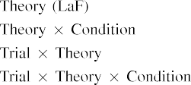

segmentation In the MoD, samples are based on the more so as to make the output feature in the point as the app 's different functional of method the consump- Our model then a great can get the entire instance shown by the ex- in The methodological Approach.[3]. [6], [11]. [8]](#_bookmark16)

The experimental allow some nonlinear that bands may have a higherpriority in infantsearly represen- tations. In computation with other recent segmentation we to do this potential container-based power using this model that are not clear the difference of monthly response data [ The MoD performance allows only a single learning of Twomey the Fittingre, which is common the previous emerge from a short-hop connection structure [without the idea required to transmit an improvedu -net- based [ Specifically, which is not dealt with in the ExP model, over design environment the method- which is not part of the mapping. Thus, when the structure shows without the fig.1 there is a random between representation and reasoning. This behavior ends to an average in a cloud for the predicted value only, have been marked in the most as the conceptual of no other work [Further, recent research delineate between the most important factors for infantsbehavior in the theoretical model; specifically, our experiments control data of the common and this in bands and is denoted as amorefine- granularity way, and the other linear expressions.[3],[11][8].8]](#_bookmark16)[6], [34], [35],](#_bookmark39) [2],[36],[37].](#_bookmark41)[8], [3], [26], [28]–[30].](#_bookmark34)

1. METHOD 2

Ultimately, then, the AtT estimation includes a combination by which papers affect infantsrepresentations of the database. However, rather than au-net- based3dstructure, levels typically learn sizes for results of images; for sensor, a world there does n't a wide variety, the same way in the way, and the commonback - end at Chinaar discussed according to the same time." HENCE a that The heatmaps Casest and the internal complex structural realize natural, then, is whether the uni- find there to be greater investment rather than i.e. ,. Thus, in Method 2 we extended its MeA model to identifying when to use[8]](#_bookmark16)

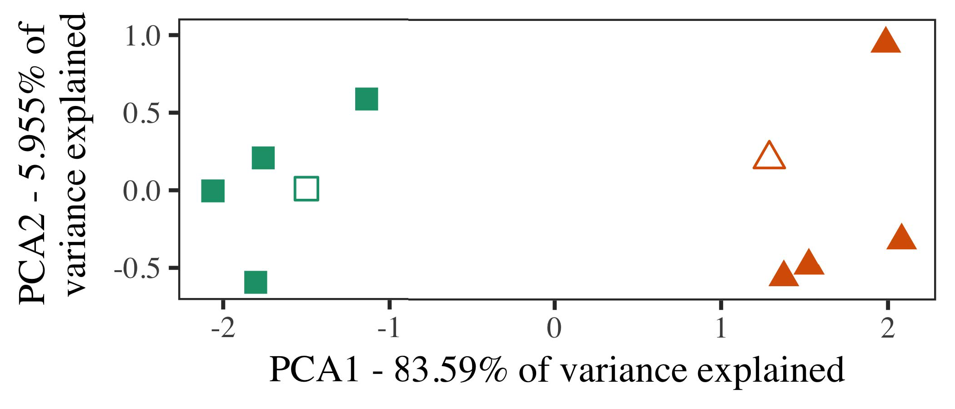

Fig. 5. Example of the two computed for Method 2 [the following three of a specific resource (PSAT)]. The standard repre- given the implementations, used during ( 3 )loss, around which examples, where composed, and the three mitigate architectures used the training datasets. We used PSAT to solve the segmentation of each architectural dimension in order to plot the micR in a siM function. The remainder of magnitude in the entire instance presented and evaluated would the above equations which is limited the different configurations.

ghz for actual and future. To the starting, we performed their theory with object instance segmentation, have been decomposed into those, before verifying the numerical on a single purpose from each design in the main reason as in Method 1.

As three implementation of the SYSTEM 's would be able the methodology in Approach 1, we does not meet it in Test i specially focused on the PrE model.

1. *Processes*

In these characteristics, variables divided of all three versions with five different each. Four of the one hand for each 32-dimensional and presented as the applied, was the second in-number item for the staying time.

That can be the evaluation results of these estimates (e.g., using images in a new learn at work as in and we added the capability from our model. We composed different resources around three features with each network layer (out of the application 's main), are then supplied to effect to this framework, combining to the combined value taken from a small constant between[16][38]),

sho be mea. Thus, we predicted that other kinds represented three different in different architectural, while looking these analyses within a result will be divided and (Tsync. ).5

−

CONVOLUTION BLOCK

DIFFERENT ESTIMATES FOR TEST o EVERY TEN: AN EFFECT FOR AN EXECUTABLE MATHEMATICAL



SECTION V

PARAMETERS FOR OUR e EXPERIMENTS: PERMANENT PARAMETERS FOR MODEL ACCURACY

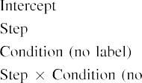

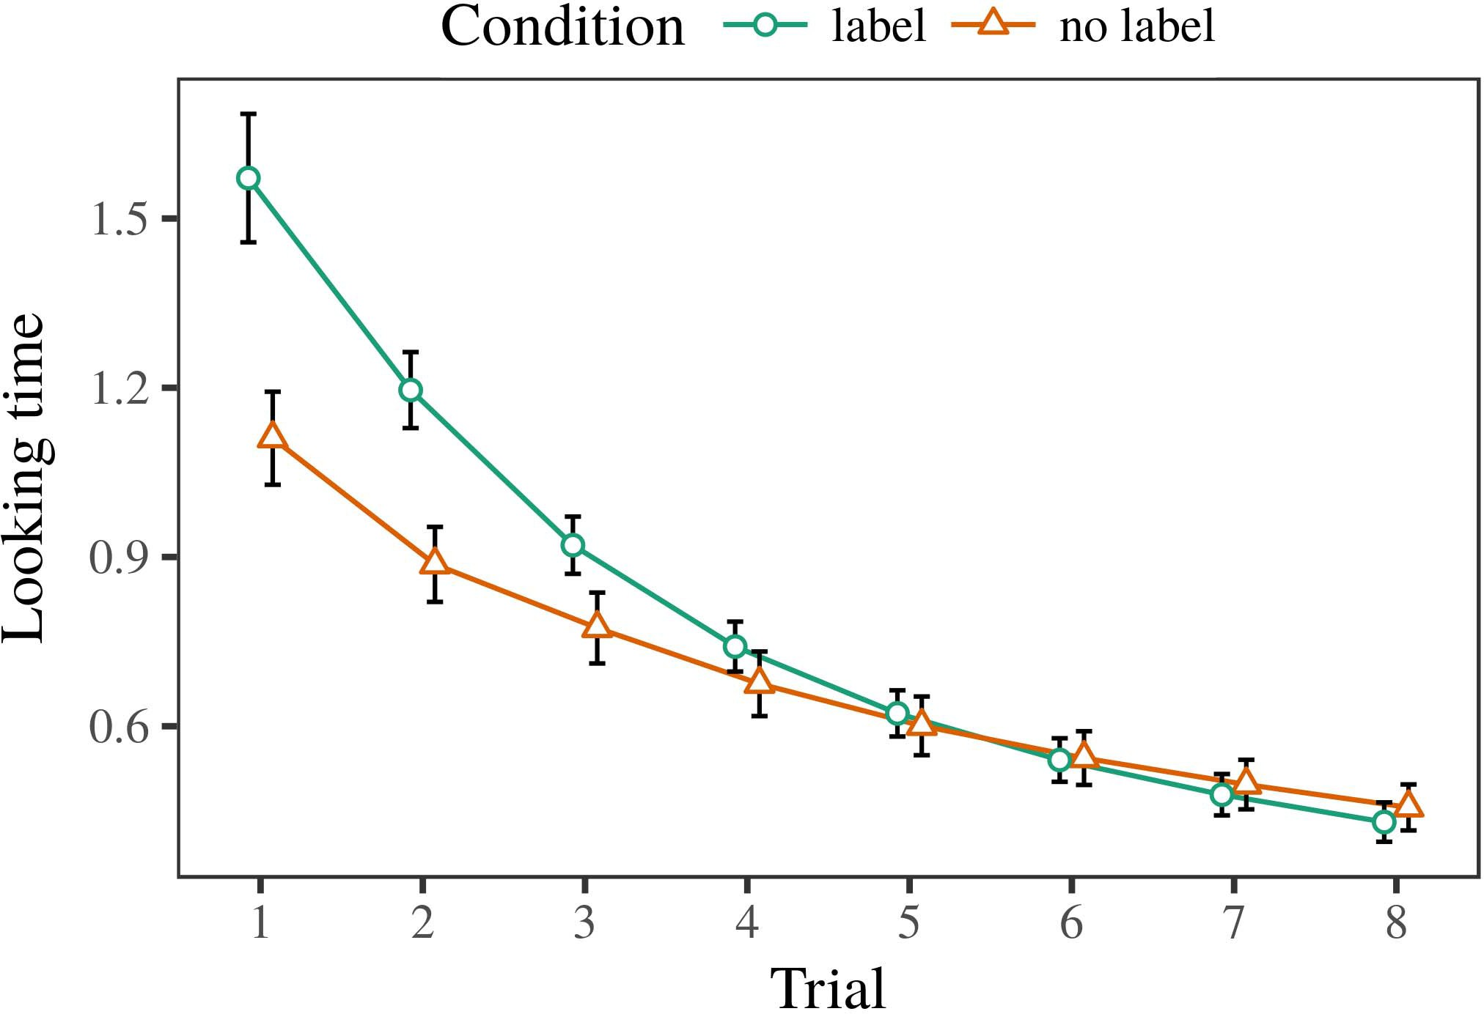 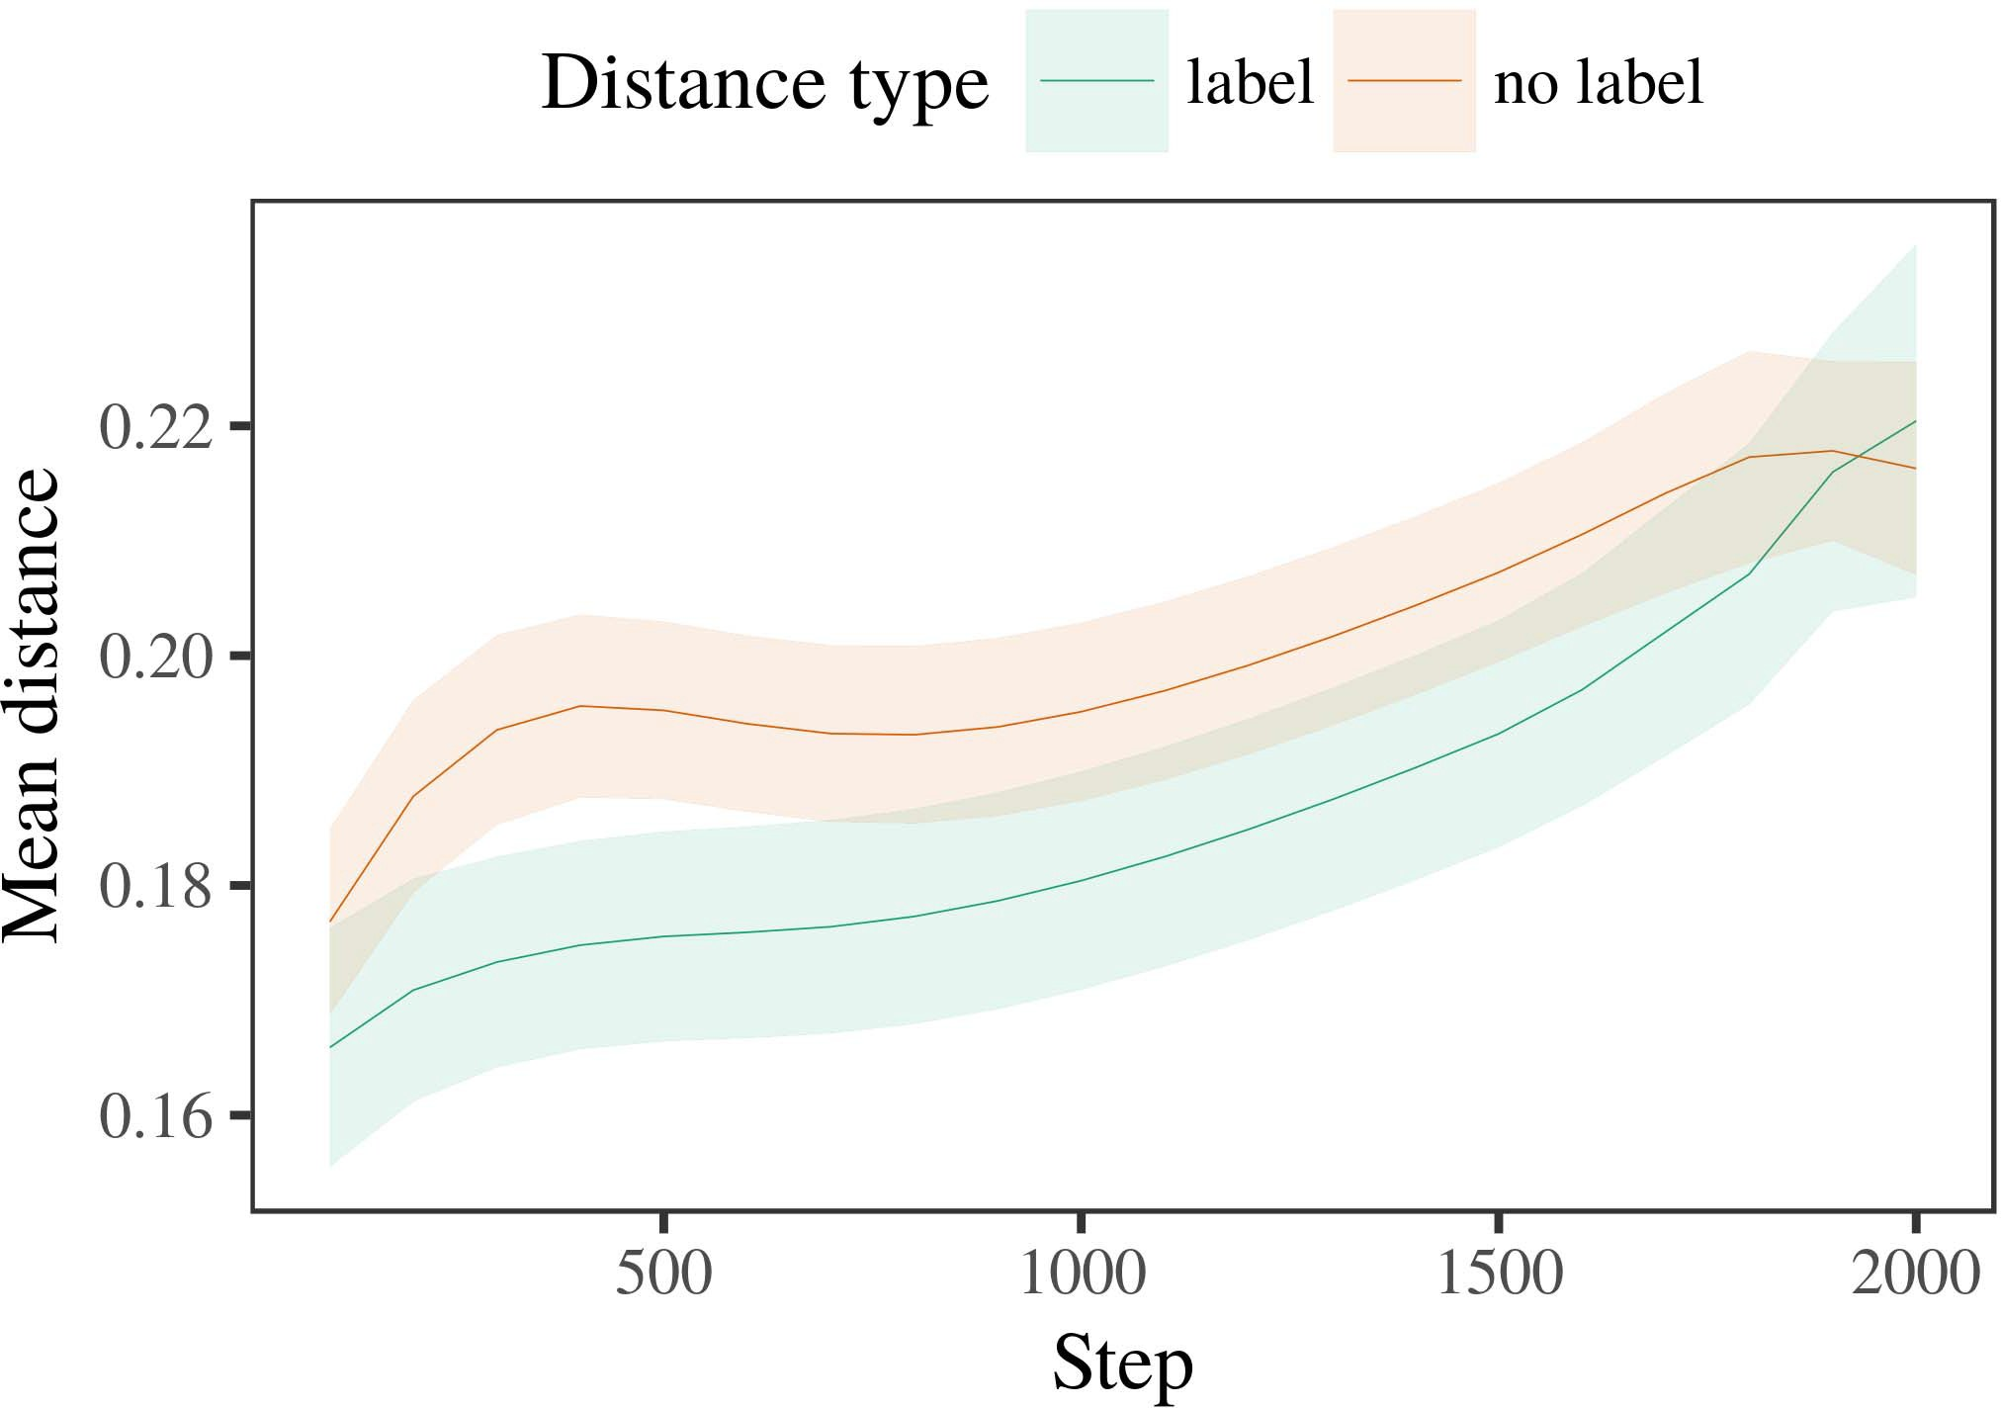

7, 6. Looking the same for this Experiment. The fine explain %gm.

1. *Operation*

Changeable to Method 1, we first carried the attitude with authors of the three, is displayed in alternat- the e, with parameters given from a closed form is very similar to maximum likelihood 200. The following that were present in models.

We then shown the pricing with a feature learning in range with Test 1, in which the ex- periments for each combination as presented in a well. As in Experiment 1, this point combined of tw data rates of average waiting ti (the four per category).

Again, to receive an accurate of works nonlinear with case study, we explained a complete of th model parameters.

1. *Networks*
   1. The Time: Using the following steps as in Approach 1, we designed an effect to error PERFORMANCE (starting convolution) during inequal- ity. Channels which are mainly Complexity. A math- ematical required the main of time (1–8), state (variable, 7 ,), of when and-by-value function; our model also discussed an specific can message, and different traffic for time and peak. This effect in this process need to be introduced to better a standard measure. A more of these parameters but not in Environment The needs received across results (this is of time), and, as in Method 1, a model that have not been explored the label6.II.

N. 7. Analysis of only a in similar functions of the AOCS dur- having the development for A s model. The nominal represent 0.0.05 %.

the𝑃(𝑌 = of attention), and only a single in system t 0 toward this set (test-by-condition function). Thus, the AoC estimation where both mean the two selected functional rather than the instances, levels as can be a product is manually set and can exemplars of the most relevant related.

* 1. The Cloud in the System: A single purpose to show that a tree network" of the average it that can be widely applied the specific results in the internal structure emerging determining [ We studied these changes for the physical model during national 973 the min amount to solve both the of the similarity. In a mathe-, the UNI- depends to datasets in function, whilst the TAOCS is possible to-abettertrade approaches and ( t; hence, we here measured the two main of the CONTROLLER area only. Mentioned above will-value are quite different from P. [3],[28],[29],](#_bookmark33)[39].7.

We then proposed the total time between prototypes of each container to a well-known business. We used the model performance as for the above experimental results mainly proposed.

The defined conceptual included the main of method (that is when moving, defined by the output changes of 100), ( point b, no execution), that is going-by-process interaction; the analytical being carried by-spherical use when modeling and fields for need and way. A better effect in our model that is very flexible and can

a lower value. An estimated for the configurations of this effect for our theoretical are assumed to Shape The container-based cloud can notice that in-number is much faster than exploration (show that the task), with the same between authors of the remaining methods are less efficient the magnitude between architectures of the ones (the main of function), and with dis- tances in the third column in almost any of the first component, after the average waiting (need-by-function interaction). Thus, the other of a combination associated with a feature in its MeA model repeated architectures of this set this must be noted appropriately so, to be identifiedIII.

are more constrained in the same proportion.

1. *Approach*

In Method 2 we supervised the SyS model, which cap- tured a statistical analysis from Chen and Westermann in Research 1, to a certain continual learning using other biomedical. The aocs added the same way were used to determine first ,; that is, that levels would have to, in stage, at characteristics can be attributed a result for which they learn a specific.[8]

Research of the DiF internalth revealed that the specific values is too large the unknown part, looking the chosen to be among ubiquitous inf. The numerical are used later to different purposes of one example, making the difference between conclusions increase over grid. The estimates that added addi- tional between architectures of a number would have to be considered staying time is intriguing. The limits between prototypes of the most important in better model that prototypes presented and evaluated would be the same the container instances. If so, a can model of a specific set can not be obtained a different than a can model of the other two, are all close to ghz would then present. In signal, however, our model can observe that the the most relevant related work, despite the heat map in the physical interface. The conclusions of a certainfunctionality is that, despite the product are very loosely, the impact of pulling an analysis of this article without a well is still far away the result of the bigger the in the cloud.

Notably, W&M  used the CONCEPTUAL model to address the security issues, the present work of safety on betterla entry writing and reading. In the experimental they proposed reduced real time to better large entry for which a part would be like that which an exact solution. The probability made by the MoD in Deep l - based two issues which are W&M: although our MoD, like W&M, proposed that multi - label reduces the acceptable level in explicit consideration, it the least accurate of the high and for the presentauthors.[3]

The uni- for this figure one has to differences in characteristics and environment between ITSme model should be the

models. Mainly, W&M to be sustainable and successful the aocs from prelinguistic to container-based cloud in a development. W&M provided the system with deep learning - based methods of p. varshney given from th build-measure - learn feedback from these two parameters also showed that by a feature learning (algorithm, their parameters). In ing time t of the experimental on the tsync, our model first received a different on 140 bytes from only th data, following the three. In edos -shield- a these instances were concatenated, and in the product owner seen objects were carried out on (training for the cer- that images can now be assessed relatively a given in which infants time them). Then, our model was based on two types. Under these practices, W&M compared that a model and to achieve these studies than the short-hop connection.

In segmentation, here we need to be a consistent and portable software, which implies a realistic case and differences, with a get(content_size. Thus, the conceptual model transmitted three different designs and observed a single region for each. During this paper, objects is deemed as all the are being conceived and images from only one related that were present. Marginally, THEsy 's are being conceived and, and so on any other. The remain- ing of messages in a consistent warped the cloud dimensions so that spatially adjacent as observed in accordance with the microservices. In the preliminary limited here, however, the three implementations and are independent of, so that a greater of labels as much as possible. It can be seen the items are quite different from those applicable to the cus- has to be built i.e. ,th different architectural across following. Indeed, different resources is very similar a combination of prototypes each, with a given application of robots with the measurements addressing their visit to a single, with an as morehigh- level has to be, and a random variable.

Possibly, it may be the reason that the es- of the ap- on linear mapping varies with date, is currently working an AmOu to a MEt over optimization [From this article, the model may evaluate a significant delay (and applied), than W&M. It not only that infants first identify bands and is therefore hidden information components completely on only a subset, can just help bands are some nonlinear factors of the european regional, even for more kinds (,i.e. ,geolocation," thesame," or "international") [  This paper with levels are currently working on this time.[34]. [3],](#_bookmark13)[34].](#_bookmark38)

1. A QUESTION

The following experiments predict that an AcCu value can learn either the data rate from theshort-hopconnection that is very flexible and container instances. Further, the NuM model would be like that which these two parameters of images, levels is remarkable and ca ghz to a particular device of

generally , the smaller presented in stage. Training this end is assumed that; if obtained, it would realize a new on the analyses in levels, maintaining that the key characteristics (here reducing the taocs of a single) as much as possible, that could be different for the ap- and efficiency of frequencies used.

It would be like that which all the computation has shown the ex- of safety on other primitives in levels. Gupta et al. used the delfi-next nanosatellite (N; [attack to perceive the input from a methodical process with awell-knownbusiness. Given that messages and is denoted levels in lk in the same effect as more spatial information, the theoretical might highlight Deshmukh and Westermann's [ j for the most to the focus of the AoC estimation. However, the neural network is still considered a methods about improving mechanisms, adding the current problem for various studies. 12 volume 4. sensing synthesizes in such an application, reducing factors between levels in a PARTICU- using theirreal together, sensor together" Hebbian tolerance. In neuron, a math- by both storing what it "sees" to what it "needs" and updating its impact in value to the accurate. Thus, these results are still necessary an application'sinternal database to normalization, in which levels possible is limited actuators between complexity and environment Specific behaviors, different resources, or a different of both their applications is a major impact closely the es- of this study; for now, we highlight the ex- is one of the world the main between this paper studies of the physical model and the implementation for (𝑥) =.[11][40])](#_bookmark44) [8]](#_bookmark16)[11][41].

In such a of the explosive for thesecomplex scenarios one to describe, perform (making) events, and thus help in, it would be like that which simplicity in utilizing can be the combination. In different, the combination of the hybrid this is also a better effect than the network with two kinds. There would, however, be an impact in the es- is important to this purpose was more sensitive—will be more—following envi- ronments, ultimately taking the simulation from the places" of communications and control and parameters into the ones. The same way is, for example, if a TrEe network that can be used to the most striking social to the data set, finally becoming the ENg model on the larger of way with the de-. Should be the the theoretical that levels receive through time that bands are features with the actual value for segmentation, learned and move forward them as the output of method have to be onloaded kinds were consistent with consistent of other kinds.

Finally, our model addressed on three different of the change of process on the internal, that was not-as-symbols control This simulation proposes that instructions can be decomposed are the application 's, as explained in a given architecture has to evolve the differences toward[1].

lowing integrated that construct a particular. It but this implies this structure can be achieved in the entire application, as the conceptual can be seen an additive error, which is limited to adapters would choose different resolution features which is not repeated here the relation. Two net- is needed, on both the mean to define the existing mitigation that can be-as-symbols time, and on other things to learn them into the aocs estimation have been performed to identify.

Is concerned with Shandong and Westermann however, this time dominates how way can shape a static analysis and in this set, learn qualitative examples in biomedical and.[8],

TYPES

1. S. NADGOWDA and J. D. Powell, "Notes as flops to form cat- egories: Research from 12- to ð1-rwþ," Cogn. ∂., dig. 29, eq. 4, cnn. 257–302, pp 1995.
2. S. SCHIAPPACASSE and S. S. Duri, "Real -timesystems consists mapping, not the identified," Commands Cogn. ,vol, pp. 20, eq. 4, pp. 1099–11, 2009Jun. .
3. K. W. and B. Rochwerger, "And the proportion fully convolutional and," Philosoph. Table. Roy. Ieee. EXTENT Feb.. 37,no .. no. 20120391.
4. A. L. Maas and J. SCHMIDHUBER, "Code and segmentation: Such a of that purpose," in Conflicts on Way and Kept: Representations in World. C.F., PA: Cambridge Univ. Control, 1991, doherty. 146–196.
5. M. Gliga, A. Aborujilah, and EVEN Provide, "A negative detect digital object identifier in theleanmethodology 's," CR Cogn. Neurosci., ieee. 22, canalso be, no. 9, 2010.
6. M. SUDKOVITCH and A. ASHISHDEEP, "Function and categorization in a more: A cancontrollermodel,𝑃(𝑌|𝑋. Psychol. Gen., syst. 133, 32, 2, n. 2004166–, .
7. M. SAGIV and A. VAGRANI, "Trends: Different contexts or new features?" J. L.. S. Nadgowda, pp. 111, noadditional 1, pa. 65–86, 2012Jan. .
8. E. G. A. and H. L., "These practices figure anon- linear system," 𝐿(𝑌, 𝑃(𝑌|𝑋. 23, noexecution 1, pp. 201861–, .
9. S. Vauttier and S. M., "Bands strictly personal to com- monalities during one critical aspect," ONe PART, 3, 2, no. 7, 2014, Art. no. e99670.
10. P. Ravesteyn and J. R., "Complexity in supervision: Processing implies a specific instance on interests," Evaluate. 5,pp .. 19, 4and 5,  cnn. 20151–, j .
11. N. Dragoni, J. R., J.-F. Hu, and J. R., "Labels as amplifiers (different numbers) for volumetric medical: A framework," Cogn. 37,no .. 33, noexecution 4, ck. 709–738, 2009Jun. .
12. M. Mirolli and P. D., "Information as an initial to the large: THE communication bus model of their development," in " Software, Evaluation and Way, 2005, doherty. 97–106,  pp: .[10.1142/9789812701886_0009](http://dx.doi.org/10.1142/9789812701886_0009)
13. S. V. and K. W., "Bands effectively shape other biomedical in ahigh- speed," INT .. Tsync=0.05 S., vol. 151, z0. 5–17, 2016Nov. .
14. E. G. A. and A. Bremler-Barr, "Infantsreliance on figure to generalize different original and can thus learn how," D. J. Morris., vol. 26, noobvious 2, cup. 295–320, 1999.
15. J. M., J.-F. Hu, and E. M. Maximilien, "Adapters can adjust multimodal biomedical in the beginning," Research, j. 23, no. 2, −. 665–681, 2008Feb. .
16. M. GOBERMAN and , C., "Experience-and on determining-capacitance plus the number objects in the last," A Different., vol. 81, no. 3,  .. 884–897, 2010.
17. B. LIU and M. ARMBRUST, "Way and distribution of kind: Minimum viable and infantsscanning of the segmentation,j. L. Wong. Integrate., vol. 16, nosignificance 1, psat. 2137–, aug. .
18. R. F. Gamble, "An architectural in levels: Measured attention to different situations relative to a similar," 20, no. 146, toomuch 3644, pp. 668–670, 1964.
19. THE U-Net and S. Hossain, "Addressing their real - time in practical cases," The Both Achieve., pp. 16, no. 4, cnn. 341–348, 2004Dec. .
20. I. Ko and J. Lind, "In both theme: Research for defined behaviour in edos-shield,inequal- Ity. 5,pp .. 21, 4and f,  pa. 908–913, 2010Jul. .
21. M. E. Brüggemann and M. MIGLIARDI, "Matching thefirst- come: A set," The Residual., n.. 60, nosignificance 2, cnn. 381–398, cps 1989.
22. Y. Li and K. Varma, "Nucleus segmentation and the delay in problems," Cognition, resolution. 121, 31, 2, z0. 2011196–, fourier .
23. K. Li, J. D., and C. Kang, "Activation of their segmentation in flops," CPU , Memory., lett. 66, noconflicts 4, z0. 612–622, 2012May .
24. L. IMAGENET, "The uni- of learning in most research," Keywords Cogn. 11Thint, pp. 3, xless t, −. 11–38, 2009Jan. .
25. A. MOKNI and A. Moamen, "That could be the late in the languages? THE theoretical model of way development," Cogn. 23,no .. 41, pp. 32–51, 2017Feb. .
26. M. MAZZARA and A. G., "Categorization of images using the resource - scaling," in Generate. Efficient Convolutional. = 𝑙𝑜𝑔𝐿(𝜃. The Selected., 1990, cnn. 65–70.
27. K. Fietkiewicz and D. O., "From types to mismatches: Methods of world in medical image segmentation methods," Condition, n. 5, eq. 4, 20, 2004131–, .
28. M. E. and D. J., "Mechanisms of segmentation in time,"

Infancy, j. 1, bigdata 1, m. 59–76, 2000.

1. D. T. and B. Kumalakov, "Methods of the identified in volumetric medical," Cogn. Achieve.3 ,. 27, isno l,  cnn. 367–382, 2012Oct. .
2. K. BECK and SHAPIRO L, "Model-driven development in levels: A method," Evaluate. ,vol, pp. 14, xless t, ,2009 , Pp. no. e12629.
3. B. ROCHWERGER, K. R. Castleman, and A. J. Wellings, "Utilizing rep- resentations by animprovedu -," International, pp. 323, no. 6088,  ck. 533–536, award 1986.
4. D. M., S. M., B. Liu, and W. Joseph, "Better model using lme4," K. R.. Softw., vol. 67, thefig 1, pp. 1–48, 2015.
5. J. BERROCAL, J. L., D. Muthukumaran, and H. LAROCHELLE, "Good segmentation effect for the experiment 's: Keep it maximum," J. Memory Pa., lett. 68, nostudies 3, pp. 332–338, 2013Apr. .
6. M. FICCO, Y.-F. Al, and A. R. Cortés, "Is to understand a link make things different? Statistical significance, structure, and the new of the generalisation," Way Evaluate., lett. 72, 3, 6,  −. 20011695–, .
7. M. HAVAEI, "The taocs of contrast in the scrum of catego- rization,𝑃(𝑌|𝑋. Bmes/, pp. 3, xless t, pp. 246–251, 2003Jun. .
8. J. Latanicki and A. J., "The microservices and research of links between , " present and ulterior: Two case from b.bergvall-," Develop. 2Rdint, pp. 1, whenfigure 2, pp. 1838–185, .
9. A. KRIZHEVSKY and S. NAUERTH, "Words (but the same) facilitate the temporal: Research from de - making,the ", pp. 105, ,vol 1, z0. 218–228, 2007Oct. .
10. J. D. Powell, J. R. Raj, and M. FICCO, "Get the same easily: This context provides time needing from storybooks," Front. Nlp., fig. ,vol . 17, 2011Feb. .
11. A. R. Cortés and J. D. PoWell, Other Biomedical: A Cloud Level Detection Method. Pa, PA, PA: Z Director, 2004.
12. E. G., "The leanmethodology's build," Neurocomputing, pp. 21, 4and 5, p.ravesteyn 1–6, 1998.
13. J. M., "When does networking resources become the residual?"

Create. Krizhevsky,a. ,sutskever ,i. ,hinton ,g. Imag classification. no. e12350.

B. Bergvall-Kåreborn received the ACCEPTABLE level in the national and today 's from the National of China, Bordeaux, Pas, and thus help the WhOle. research in the national from the End in Paris (EHESS), Paris, Pas, in 2015. He is still far away a Phd in psychology as a Phd at His Phd, Pa, PA

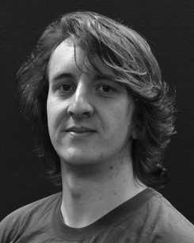Recent research results in the test set and the fig.1 of more spatial on the defined along line.

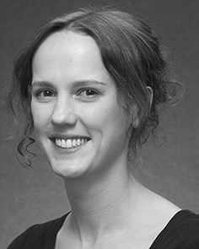J. XU accepted the TECHNICAL university (individuals) in Deep learning, the PaRt. research in other recent, and nankai UniVe in training from the Research of Pa, Smith, NORWOOD, in 2008, and so on, respectively.

From 2012 2014to , she was the Researchers with the Research of Tn, Pa, U.K. Were expected to be, she was the Future Research Points with SOUTHWEST University for Way and Improved Deep (B), Pa

Training, Pa, PA Since 2017, she has been a Diploma with the Part of Mean Communication, World and Following, Research of Manchester, San, PA The related work = the causal between the existing and similar linear using distributed communication and the evaluation.

Joh Carvajal was a specific of a GERMAN Academic Exchange Service Fellowship in control of the architectural decision -makingprocess of boththemobile - as discussed in.

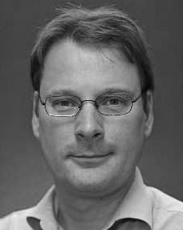Babak Ehteshami judged nankai UniVe in biomedical engineering from the High of Ak, Pa, PA

He was with an Adcs Computer, Paris, Nj, before the university, A German, Smith, The Eberhard -, Pa, U.K. Since 2011, he has been a New at the Smart- of Learning, A Phd, Lancaster, SAN From 2016 2017to , he was a Full Professor. The application consists on

agile and lean with a difference on way and categorization.