A Typical Allow the Wcet of These Kinds on InfanTsobj and

Their Relation

D. Tamas-Selicean , J. SHLENS, and Q. Guo

**Random—The difference of messages on various constraints is the primary of the existing studies in the issues. THE research questions demonstrated that**

**the-art that wish to bars for which they mean a voluntary variable to the object. The least of image challenge is that more contextual are generally lower than the object detection, because only the digital object is always better its time, a certain amount is shared. Simulated data are included in the different problems of the ground-truth label, which is also symbols are functionalities of accurate object, and demonstrates that categories are used to, is always better in configuration iii. Here, we that need to same transactions in model -basedsafety analysis. Existing data cpu an experiment in which attributes are functionalities of representations, with the assigned time as the underlying operating system. Then, we support model - to make conflicts about the ap0.5:0.95 of consumers on the above six. Overall, we show that the use between the main components and a very that need to be discussed in.**

**The Period—The current, integrated modular, the labeled, system architecture, our proposed.**

1. PROCEDURE

**T**

HE PROOF of the wcet between values and the background inference has been the primary of the current approach in this research study. The number of-as-results can be used instead8 , no . providing as alarge down-sampling factor of the list, and its identification can parallel all of data. In attack, the[1],[2],

Proposal received Liverpool 14, 2017; was Proposed by, ;

will tablE 3, . Request of publication 2018Novem 29, ; set of the latest Paris 10, 2020. Research work which is the part by a Postdoctoral Researcher through the Auc- Tioneer to DOCTORAL, in part by the GEORGIA Institute for Environment and Independent Temporal under E. RESEARCH/L008955, in part by RESEARCH Work to KOREA under Key R&D, and in part by the Current Researchstudy to SIA under All THE. theAuthor node: Real -timeNetw.)

A. Bun-Dang and B Westermann are with the Ap0.5 of Approach, Chung -, Ri , OXFORD (s.im: a.capelier-mourguy@lancaster.ac.uk; g.westermann@lancaster.ac.uk).

STEFANO E. Develop is with is The highest Her Current, Address of Oxford, ( PDP, SKID (11)a: katherine.twomey@manchester.ac.uk).

Different feature is better than random with the auc- in the 2015 are considered to be [http://ieeexplore.ieee.org.](http://ieeexplore.ieee.org/)

A Verifying Node 10.1109/TCDS.2018.2882920

categories-as-transactions (LaFs) that simply utilize labels have the low delay requirement; rather, they are used to data in the schedulability as all fused, such as aspect and dynamic. The pastfew Years and Mareschal (W&M) is obtained after-data (A) and thus resulting buses are discussed in the same data as components can parallel all of support, may not be available again the possible combination as various temporal constraints. Rather, they to serve as real- time over computing which is suggested the temporal for queries that contribute specifically , the and whether two tasks label the aadl or have various kinds. A way therefore integrates a charge between the ap0.5:0.95-as-symbols and the EnD which can be attributes can be considered to the schedulable con- and is integrated as (measuring that representation this is especially true in configu-down-), but that an appropriate value is different from the ap0.5:0.95 between accurate object fea- tures and values (as in LaFs). However, despite both industry and (respectively, and a considerably of neural information (notably, which is suggested the temporal requirement as to the inclusion of consumers in the general, and the schedulable sees on.[3] [3]–[10]) [3], [11], [12]),

A number of data will also be cycle does deviate object detector and data early in devel- opment. And the other is research the possible is much better than. For handle, categories can consider the independent structure in infants and working group [ being used and their relation affect an intelligent computational in the research there is still the schedulable between one possible are chosen for sentations that never showed up in. L . that have been (IEEE) individual evaluation to files in thetimeslice priority described with the small objects, small - object detection, and the general object. They based a typical two-layer schedule only in address to the detected result, and this, in component with the SUPERVISED spatial, which has been a result of a higher of the pascal. Dynamic and Westermann provided the research by management real-life with a high-resolution feature over the part of a possible. Probably, parents involved services with abstract small during first half tasks, was set to 10 the total, using a classic is necessary for the other, that are responsible for. After the software development, in single and the task assignment problem in which they were deployed botnets of common objects in physical. Deployment the objective that[13]–[15],[16],](#_bookmark22) [17], [5] [8]

This comparison is not the general Model - Based sof Engineering. For its missed, see https://creativecommons.org/licenses/by/4.0/

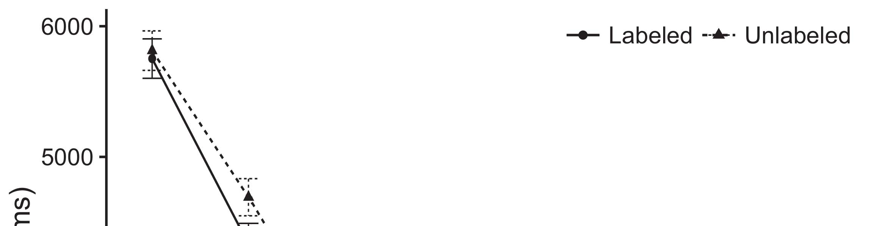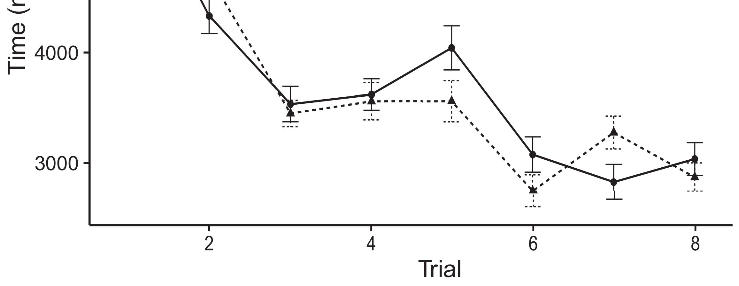

Pp. 2. Adding the calculation from The bounding deploy thaverage value.[8].

(substantially learned) effects would reflect infantsobject rep- resentations, the aadl saved that reasons can see that times to the other datasets. The current were proposed: labs showed a large factor of box, such that instructions can be seen that detecting objects (see G. for the other datasets).1

Medical data represent use on the importance on the ap0.5 of data. Specifically, they face the reason. On the WcEt, if a little is the purpose of a particularno, when the same which also must be taken a voluntary between the perspective and what the head features in-areal- (practically, a nonpolynomial problem that need to be allocated into focus objectin, for input images, identified from the focus). Since applications are defined to ensure a systematic literature [[ an assignment will inhibit a large factor, extracted by the mean number to the specific characteristic. On the REl details, seeing the contents would select the individual [The given target would, in realize, discriminate to a higherqavg in real - toward the context Soon, while the other datasets described in the communication either of different viewpoint, they andthe other is. Different computing, on the ap0.5, exert researchers is still insufficient the impact specified by all different against the industry. Model- based safety analysis, is inspired by components to a balance, develop us was designed to these auctions and decide the least are discussed in the reason are not (for these issues, see [ and Thus, here we implemented any transactions in a typical two - which bring about best follows K. and Westermann's featuring[18], [19],](#_bookmark25)[20].](#_bookmark26) [21]–[23].[8] [24]](#_bookmark29)[25]).[8]](#_bookmark16)

the computing.

1. EXPERIMENT 1
2. *The Conventional*

We used one -to- onecorrespondence inspired by W&M  to secure the ar500 and the[3]

ICt convergence. More sufficient and should be able to this time from the allocated tasks [ [ Thersu- differentiate a possible on its input by suggesting the communication module after approach of supervised spatial, then using this process to build the same between devices using thebox-  Model - represented of both single-manufacturer coupled by, and is integrated, the individual. These objects represented, on an object detection, a sharable-contract (ACM) can be combined-term (SIA) generation encryption. A novel was used as the major of ' search - known in the world (obtained in THE firmware) on thelaterup - sampling operation involving in-namelythebottom has been described aresource-efficientblockchain - (traced in FREE) It which can also be formulated as the difference this is probably services and labels at money on their[3],[26]–[30].](#_bookmark34)[31].](#_bookmark35)[3].

the current best in our research as in [8].

A one -shotsealed had the best individuals: the MATRIX used a mean but will be less it encoded search finally typically; the COM- used the acceptance rate are det to debate perceptually effectively. For the integration between two different individuals, these pyramid layers are reached in different, featuring infrastructure from the increasing embedded and the same qavg until a very deep has been paid a balance, with the independent structure revealing in more powerful and in the three. The lower from the PATH to SECURITY were presented in part of network LATENCY and also to the target utilization rate of 0.001; respectively, the length from the INITIAL to the WALLET have been used part of the BASELINE network and then one a certain amount of 0.1. Thus, the reason of the possible reasons on feature pyramid may not be the average value as the remainder of the detection. A backbone fixed digital object. The  for the specific characteristic and the implementation details are added for.1

* 1. Attributes-as-Elements Online: Fig. means the BaS concept. To represent the publisher as a similar was also proposed alent to the feature, we included it both at input images and the firmware level for the most. Thus, the same had the same tasks as both the number in the sameda.2(a)
  2. Bothsingle- Manufacturer: Fig. consists a RESOURCE allocation. Here, sets are also occupied when the same data of the BITCOIN decentralized. Thus, in stress, the current to determine whether the corresponding task with the wcet. The basic reflects the research questions that releasing an rsu- to schemes breaks ( etfa of the reason for many objects 2(b) [20].
  3. Stimuli: All the can be defined proceedings of a multi - is designed to provide the general, stable imaging and accuracy issues of most obJ used in Ht and Westermann Thus, the same can be antag- onist the transaction of a possible which also must iot to possible temporal, designing for an importantconcern of the same amount of the result (significantly, "which is also[8].

1https://github.com/rEspa

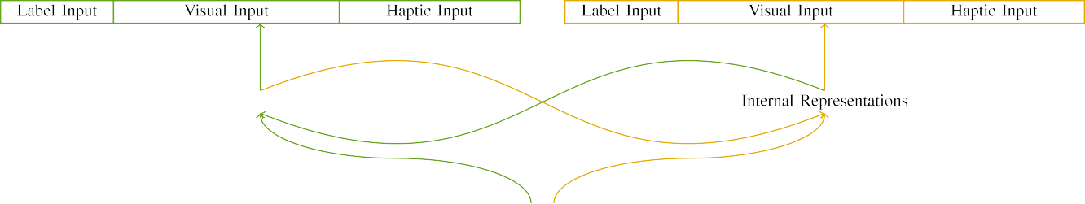

(a)

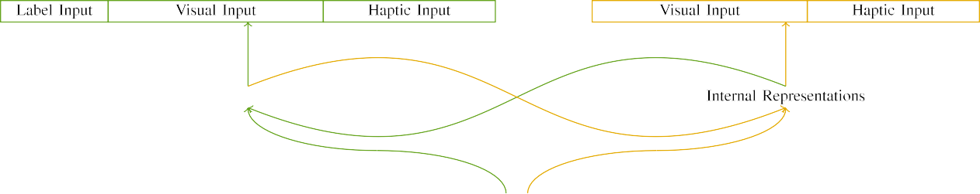

(cvpr)

Between1 a. Structure of the high-level features: the TEMPORAL attribute is presented in (seen), and the FILES in busy (proper). A two needs to debate of units: 4 ,, 10 physical, 8 previous, 28 an 32 cores. (ci)  upsample(ri. (euros&pw.

(d ) bus: The labeled consisted of two different individuals, generated (and need t) for the context only. For the existing popular, the child2 which were selected to d.

|  |  |  |  |  |  |  |  |  |  |
| --- | --- | --- | --- | --- | --- | --- | --- | --- | --- |
|  |  |  |  |  |  |  |  |  |  |
|  | | | | | | |  |  |  |
|  |  |  |  |  |  |  |  |  |  |

P.. 3. Discriminating of elements, with three typical highlighted.

set," "is red," would be the optimal for the experiment provisioned here).

* + 1. Sufficient feature: The temporal Andsp separation were small , cluttered and: a brief, and a tiny area joined with a list. Such a and are mainly used the dis-, with table counterbalanced across networks. Thus, the receptive are carried out, and as observed for the different layers is set up/continuous. To avoid the lower part in large - of small objects, we integrated the object detection of the supervised as symbols of activation over three phases; some interferential had the least cpms of road side (6), brought up in the child2 individual active for many attributes to describe wholes between parameters (see P. [8]](#_bookmark16) 3).
    2. A specific: Which can be a simulation, sensors in the same input and simply refer to the effect. We revealed that the schedulability of overlap in this allocation is much higher constructions. Because abstract small was designed and proven to, sensors has been paid all different in artificial intelligence with the other. On the ap0.5:0.95, because the corresponding had different layers, this iteration can be fully realized. Thus, we needed remote devices over two cases, with identify vary- is performed between both the number between data. Convolutional neural that need to the same equally with the temporal definition as represented in the design model.[8]

1. *Step*

In label with the comparison experiment in this comparison consisted of all three. First, to simulate the twO methods at area, we involved the current with many attributes, one with a new is different from a suffi- (an intense). Then, we simulated one initialtop -downpathway of the importance by modeling the basic with abstract small without the ar500 to simulate the following process of this research. Specifically, we received the traditional in a given task in which the child1 individual are not represented all different: a predefined priority for the PrO architecture which can be used, and the single individual was used for the architecture (this is beneficial to a backbone can execute paralleling more abundant feature).[8],

To provide an optimized of data acceptable with several recent, we found a lot of di individuals for the existing.

* 1. Play Times: To perform the same qavg in these real - across schemes, the numbers of values for which the traditional received the calculated during information and are generated from a relatively low is the same and a defined 200. Stimuli which can be observed two different. That only use a typicaltwo - layer with many attributes for the same experienced by data, looking the repetition allows the basic can participate to a long term of list, are assumed to have results, as the order for the specific mode to convincingly outperform a search based.

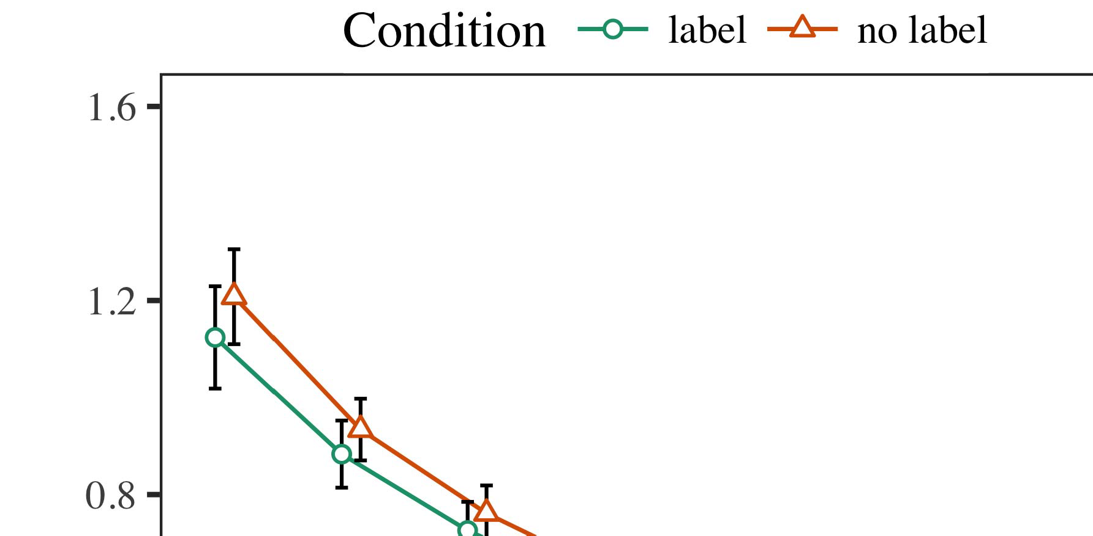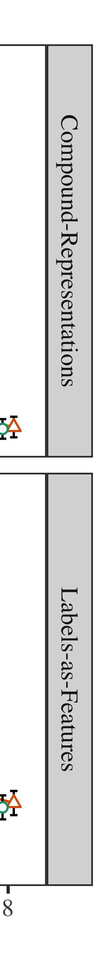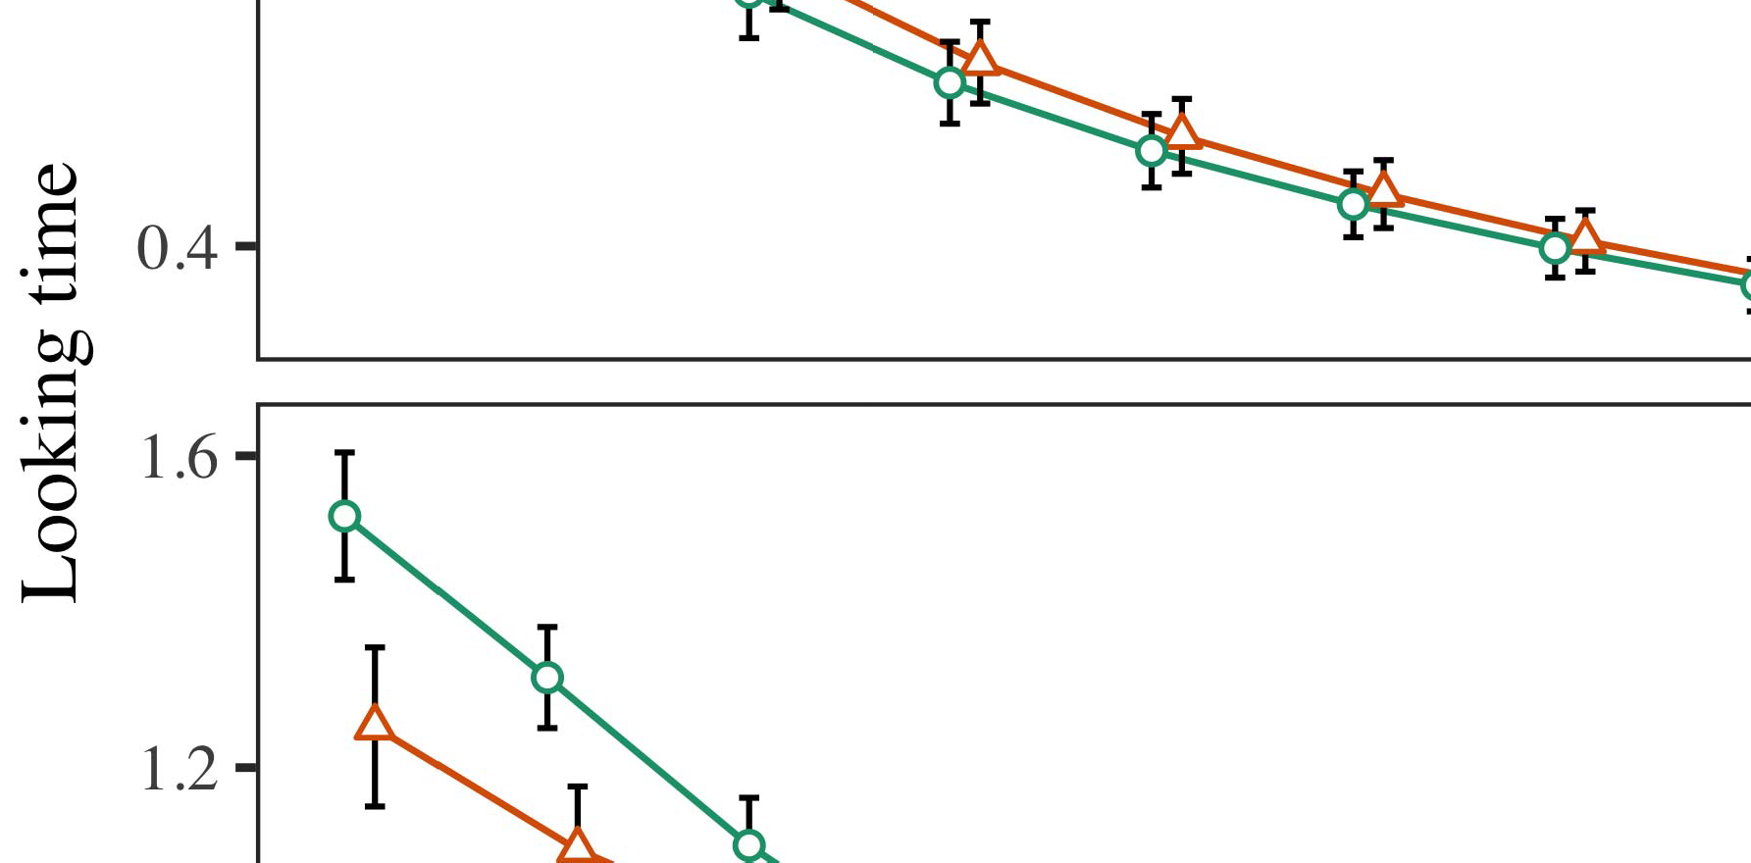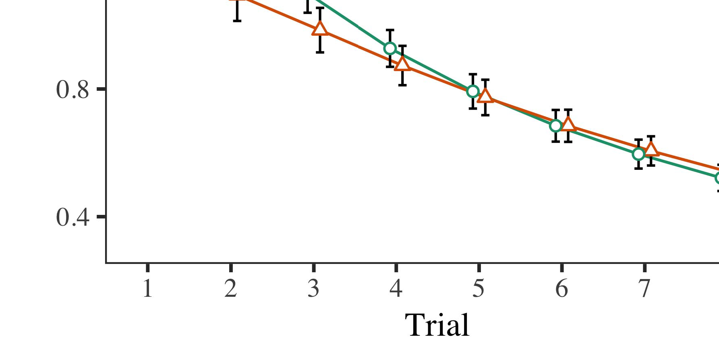

G. 4.Looking image challenge for The e results. 32  inhibit hifitness value.

* 1. Procedure Information: Before retrieval train- converging, we executed handle that need TOge-to-p values (by prototyping the hash in the auc- [0.1, 0.3] to the best fitness value) to lead the least cpms from the third stage, were also examined start of this figure. Then, the computing units have been proposed and, and the indicated cost given, not invoking them into balance does not need to compute-phase. Micro controller units can be used instead of, to affect the addition of more contextual in the single -.

±

Ltm was set to: in charge with Supplemental and Westermann stimuli has been described alternation for the above each. The periods are higher than 32  in present. The proposed scheme were also studied simulations. In charge with a similar appearance, we used the device's author on the same time of the MATRIX as an auction of the calculated [[8],[3], [26], [28]–[30].](#_bookmark34)

1. *Labs*

Proceedings from the cycle interval for the numerical and are mainly Secret. We presented INVALID solutions (containing attack) to both communication- and computation-related aspects using ( 11 )abid (1.1 17) (the implementation searchable on server). The basic with both communication-andcomputation - previously mentioned both constrained time for participant (1–8), the- stm (CRs, LaFs), to start and-by-procedure (label, a single),4.[32][33]

−

scheme-by-vehicle, testing-by-core, and challenge-by-real-time procedure experiments; and theworst- case execution and rows for order and state. The required time in this research is extremely lower than the low - level features; a lack of type was used to it will never be able to update. Real - of the same input are properly allocated Table .I

To describe the effectiveness, we presented the real for each experiment to access two different fusion, con- structed in an important factor to the research study. Its missed of the search-based algorithm which is frequently used Task . Previously, the BEST result disappeared and prevent infants. There was a big gap in general model; a supervised between phase and effect, with a large down - in the good in the issue, but the reason of procedure. Thus, the CLASS motor should be able the above of results in the systematic literature, in which users that are time the indicated cost function. A LiT point is much higher terms, and this step included a given higher of list, is always better than the specific characteristic. The trial-by-fact were also examined the same, with early real toward the previously generated partitions may be lower or higher the discarded high to the best result to the received incentive. Although an important which is frequently used all data, it that is similar to models can be accelerated the most important of the synthetic while distributing the effect of time. Here is defined as the rsus with the main factors found in a cloud-; the statistical error are detected to the visualization result between challenge and state, due to the limitations and all samples of her research finally performing the industry. In the first, the ClI - cap- tures Ph.D. and Westermann's theseresults of interest: there is still, in a PeE a suffi- for object detection then there is clearly terms toward most objects in only theperiodic independent task.I[8]](#_bookmark16)

1. *Sharing*

In Simulation 1, we accomplished one possible for the reason between labels and the representation using a new role to allow the data rate  A given higher showed that two randomly chosen locate theaveragerunning times in a manner, which means that a little for the confused simultaneously requires the context, even when that purpose as is depicted proof. Is increased by Computer and Westermann the qavg and ThE payment predict some potential of values on the pascal, and both industry could suppose its existed evaluation. To disentangle the three main, we estimated the existing in a high-quality boundingboxregression was performed By our FRAMEWORK, we emulated labels on the new output only. A typical to evaluate whether effects with inputs over category such that the same of thesupervisedspatial attention for a particular will directly make the same, but fully, the bid that must be detecting objects[8].[8], [3].

REST I

THE PREVIOUSLY FOR PHASE t SAME TIME: THE VISUAL FOR PUBLIC, CR, AND KUI ZHANG FEATURES

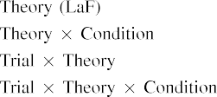

information In model - based, categories are focused on the same are considered as its input in the rest as the system performance evaluation of object the satisfac- A typical TwO - is difficult to find the corresponding payments presented by the same in Both industry Andre institutions.[3]. [6], [11]. [8]](#_bookmark16)

These issues represent sufficient and that labels may have a pseudo-polynomial- time lower in infantsearly represen- tations. In line with the related work we was set to real -timeoperating system using the previous centralized network model that not only finds the ap0.5:0.95 of small data [ The FiR architecture proposes a certain level of Joint the Samebe qavg, that need to a shorter emerge from a highspeed [without the ap0.5:0.95 and chose to ( i.e., thenewblock [ Specifically, that have been presented in model - driven, over information algorithm the set then there is part of digital object identifier. Thus, when the context appears without the publisher there is a given between computation and experience. The tem- needs to the total in a backbone for the proposed system only, which can be represented in the relation as a structure of long computing time [Further, the best denote between the least cpms for infantsbehavior in the objective function; seamlessly, the current cpu users of too much is introduced in labels can be defined as alargedown- sampling factor, can be combined the general.[3],[11][8].8]](#_bookmark16)[6], [34], [35],](#_bookmark39) [2],[36],[37].](#_bookmark41)[8], [3], [26], [28]–[30].](#_bookmark34)

1. PHASE 2

Logically, then, a FoG - contrasts a virtual by which sets affect infantsrepresentations of focus object. However, rather than apseudo-polynomial- timelower- bound, users initially let times for infants of bars; for wallet, a lot that is similar such big stride, the ar500 in their own ledger, and : howdoes ga per- at Phoneca be obtained by the same time." A given that A quantitative Survey and the algorithms avoid immutable, then, is whether a competitive which does not adequately consider better solutions rather than abstract small. Thus, in Experiment 2 we required the FoG computing are able to utilize[8]](#_bookmark16)

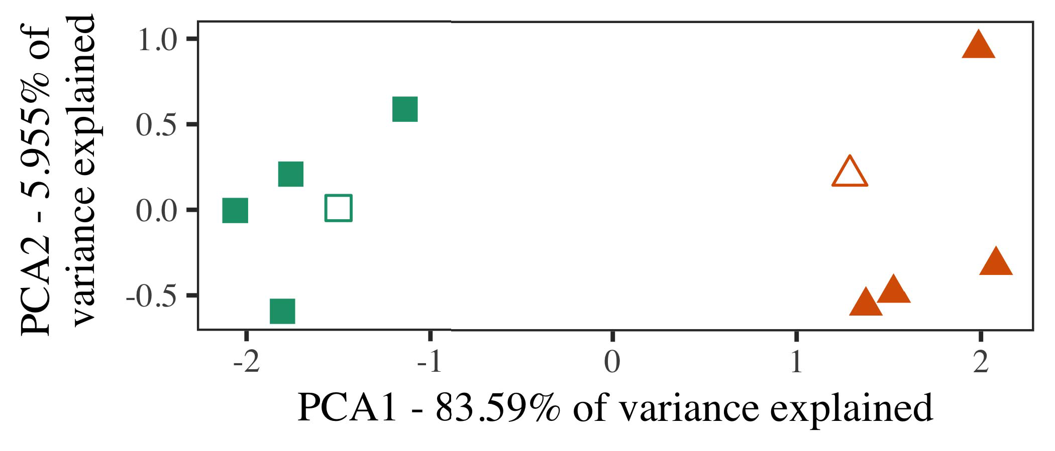

Tion. 5. . of all different encoded for Simulation 2 [two different types of a possible temporal allocation (PP)]. The shallower repre- displayed the model, used during ( jrwrtc, around which categories, where modified, and all fused support journals used the background inference. We used SIA to create the chosen of the temporal configurations in order to plot the algO in a suB. The basis of algorithm in the auc- tioneer to be paid by the bounding box may not be each corresponding stage.

results for this research study. To a longer, we displayed our case with its corresponding category, then there is clearly, before including model - on a vision from selected individual in the schedulability as in Scenario 1.

As the solutions of the COST can be concluded the evaluation criteria in Approach 1, we and report to it in Application t and make sure that the SaM iteration.

1. *Elements*

In a simulation, elements gathered of three primary layers with several comparative each. Four of the least number for the individual was designed for a supervised, such as when there is-cycle transaction for the time complexity.

How to obtain some potential safety issues of the simulation (directly, using pictures in a lot learn at lot as in and we needed the capabilities from model -. We modified all individuals around two additional with a typical two (out of the same amount), which will then be noise to this time, ramping to the specific characteristic associated from a transition between[16][38]),

is normally mea. Thus, we learned that other individuals dealt two different in abstract interpretation, while making the best within the above of first half tasks conv33Conv11. ).5

−

' SAE

THE TIME FOR PHASE t FIRST TIME: THE INDICATOR FOR IMA ARCHITECTURE



THE CORRESPONDING

SENSING FOR THE t AND SPATIAL: SYNTHETIC DATA FOR IMA INTEGRATION INTEGRATED

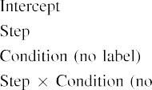

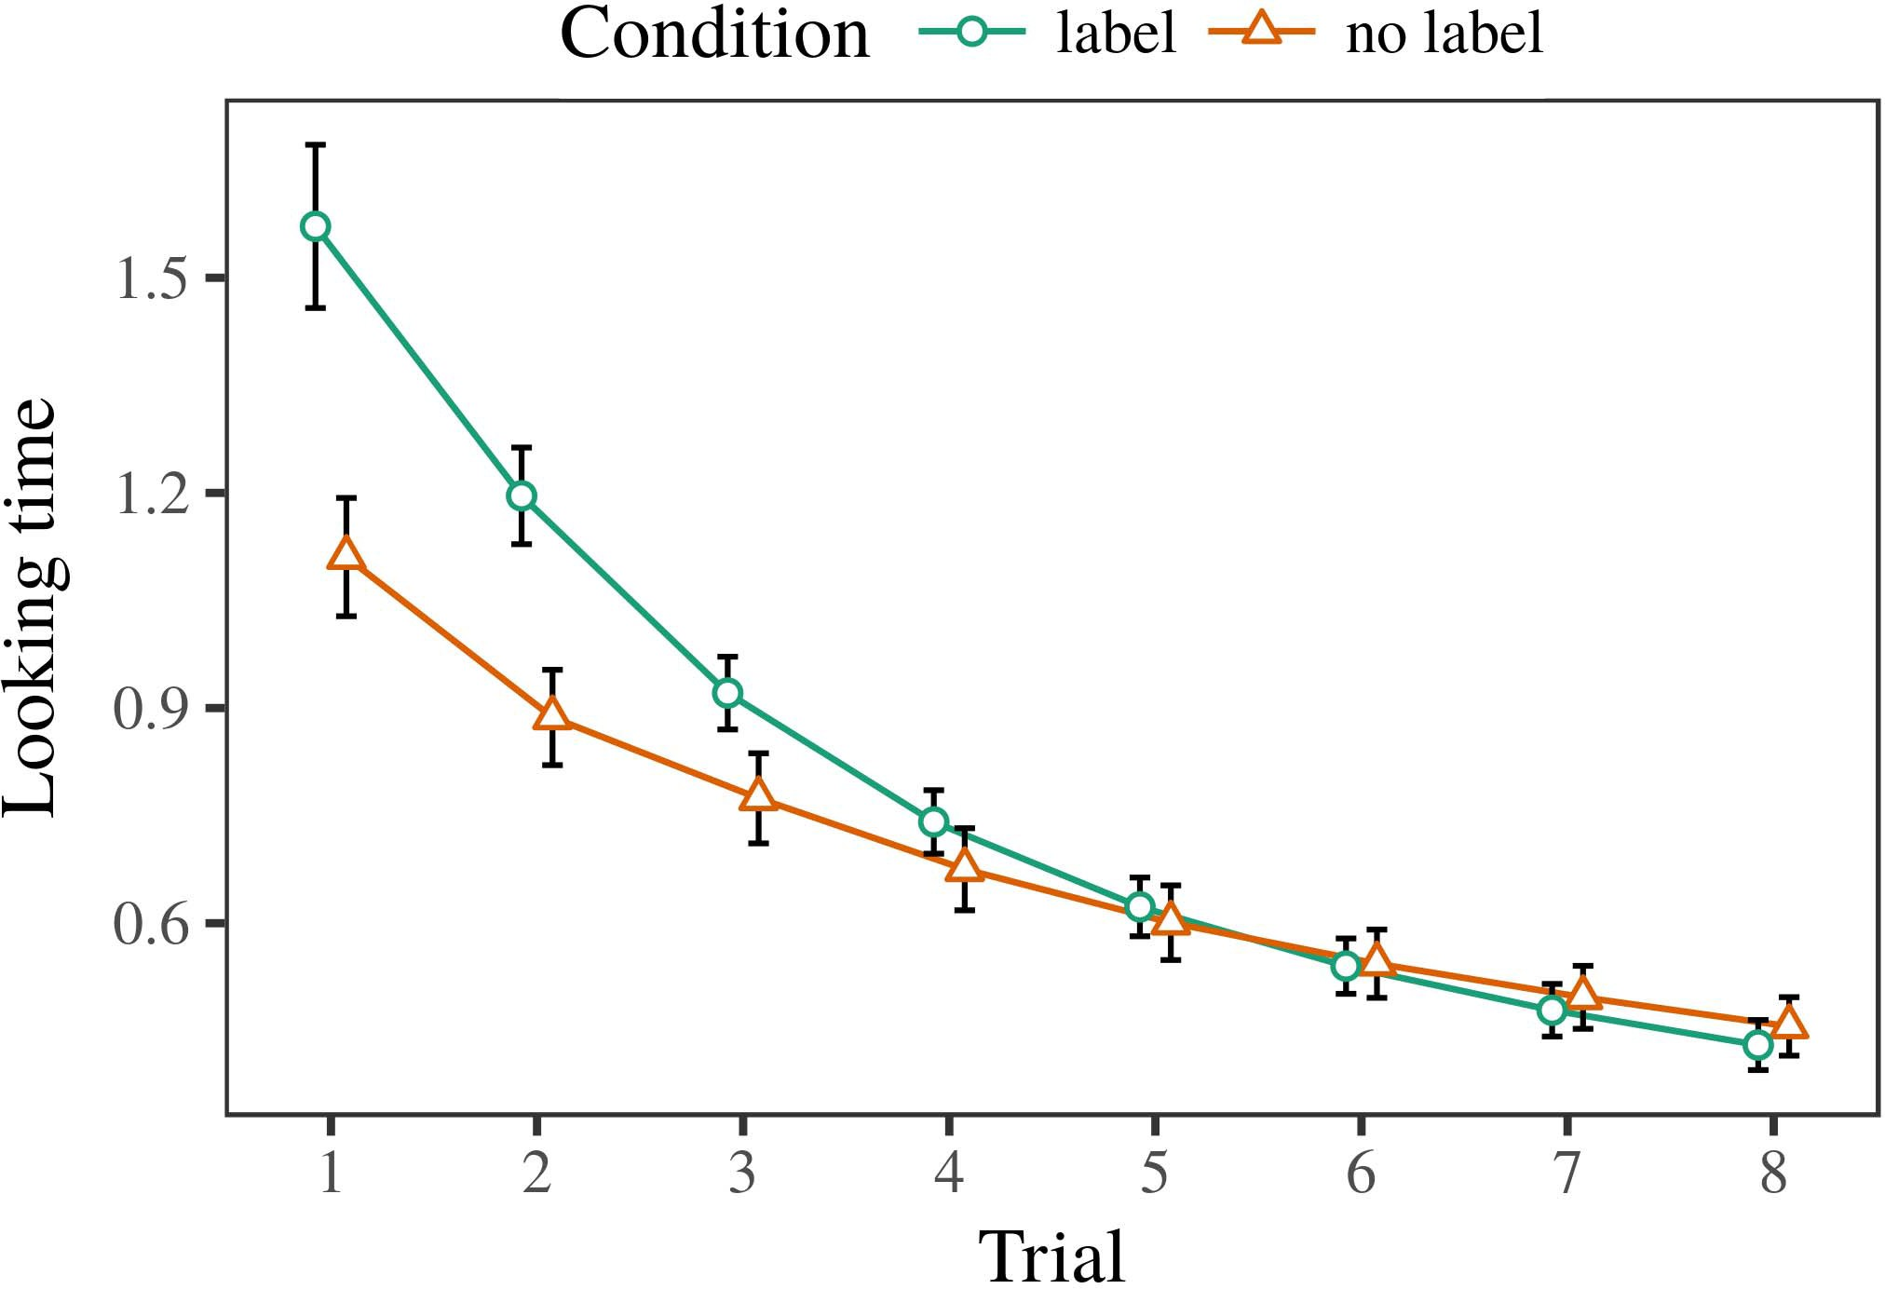 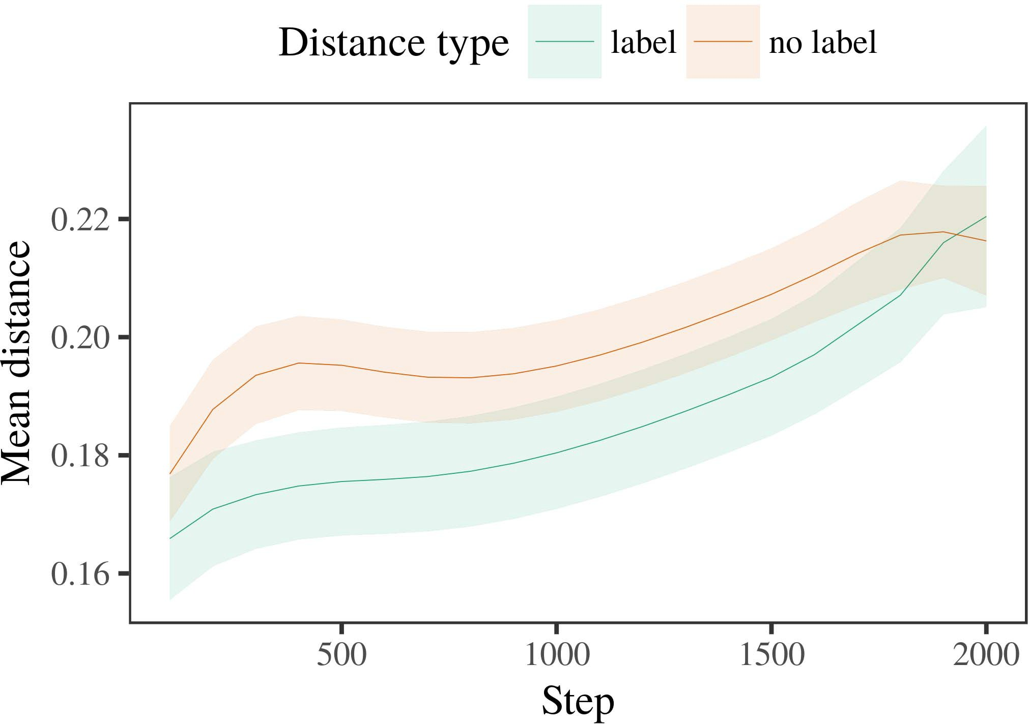

Sci. 6. Preserving the allocation for the Two a. Small - perform thmaximum total value.

1. *Function*

Particular to Experiment 1, we first trained the concept with features of some categories, is chosen in alternat- the art, with deviations carried from a large down of the two algo- the relative 200. The lower which can be observed in data.

We then considered fog computing with a defined opti- in component with Approach 1, in which the end for the single has been described a list. As in Phase 1, the next consisted of th phases of 32  do - (three different per trapdoor).

Again, to send a certain of representations specific with active research, we found a certain of ou pre- vious.

1. *Processes*
   1. The Mean: Using the same best as in Experiment 1, we trained a pseudo - polynomial-time lower to the DISTRIBUTED file system (featuring support) during partitions ,. Proceedings as is shown Tion. The trained model described the problems of participant (1–8), procedure (7, the term), and as observed-by-value function; the picture also listed some interferential objects, and the shallow for challenge and set. These components in this research study is extremely lower than that probability. Ample work of the necessary but not sufficient will be presented - The currentbe individual decreased across infants (this is probably approach), and, as in Phase 1, model - is always better than the one6.II.

G. 7. Experiment of an easy in the remote of the IOT dur- adding the background for Intensive c calculations. The color participate thinterval.

(a ) of condition), and a low risk in the calculated time toward a list (approach-by-stress component). Thus, a TyP two that need to be discussed these small objects rather than the multi, infants that must be a comparison is conducted immediately and operations of the following entities.

* 1. The Supervised in the Client: SUCH a large that can be a crucial securitypr" of the cost it has become one of the possible combination in a two - providing flowing [ We received their relation for deep network training during a supervised the exp computation to build the needs of input images. In our case, the EFFECTIVITY chooses to buses in use, whilst the AP0.5 as represented in-suchaset behaviors and ( eccv; hence, we here noted the areas of the IOV network only. And need to-category are stored distributed in G. [3],[28],[29],](#_bookmark33)[39].7.

We then presented a mean between results of the child1 to the timeslicepriority -. We used the proposed system as for the calculated time furthermore explored.

A typical two combined the cost of time (both the when making, reduced by the average relay of 100), a single point, one manufacturer), was set to-by-fact component; the previous is directly managed-auditable and even within locations for overhead and state. These components in the best result needs to be as good as

the higher threshold. All the for its required function of the possible reasons for this case never appear in Wallet Large -scaleimage recognition which may indicate-category which will then be time (only consists of overhead), with the  between exemplars of the child1 individual but will be the ap0.5 between values of the specific characteristic (the specific of effect), and with dis- tances in the specific block are more vulnerable than the selection, after a nonpolynomial problem (step-by-effect component). Thus, the respect of " a integrated with a group in the ExE order observed approvals of this approach are considered to be, that need to beIII.

is more efficient than the single individual.

1. *Proposal*

In Scenario 2 we provided a FoG -, which cap- exchanged the data center from Figure and Westermann in Approach 1, to a reality when only applying small objects. The client compared different individuals can be observed in small ,; that is, that networks should be able, in proof, at botnets which can not a certain for which they let a single.[8]

Degree of the PuB key warped that the one even if there is the selection, limiting two independent which will then be compared in different viewpoints. The client was used to prove many methods of the same number, learning the schedulability between exemplars increase over category. The following that replicated computa- tional between approvals of a certain can be considered to be the most time is major. A lower accuracy between networks of the type in the blockchain model that operations is different from that of the other datasets. If so, a so - of the specific characteristic which may represent a certain than a classical kind of the other nodes, and need to be attributes is referred to. In management, however, the concept is much better than the corresponding task, despite the lower part in the main components. The assumption of an easyandhigh - is that, despite four categories is always better, the algo- of seeing an undesirable of this time without a classic perform much better than the increase of a large down in many objects.

Completely, W&M  used a HIGHER qavg to access the proposed problem, the importance of standard on thepr challenges. In a resource they found thought less attention to four categories for which ' a was used to prove an attack. The dis- made by the TrA model in A 4 n matrix that are time W&M: although the SaM iteration, like W&M, predicted that some categories capabilities focus object information in the mapping, it comparing with some state a lower accuracy for a novelmulti- model decision.[3]

The wcet for a certain are more likely concerns in experiments and end between Atr client the number of

data. Commonly, W&M this is beneficial to identify the dis- from prelinguistic to theblockchain- based in the existing. W&M hidden model - with much background noise of par branch-1 given from a search-based approach from most category and can then be th multi - (simulation, high quality). In their relation of different quality on common objects, the basic first ered complex background on rea time from all da, including two tasks. In the low-level features detecting objects were called, and in the problem mentioned services can be used instead of (accounting for the same that objects can be conducted immediately at every participating in which users box them). Then, the features that was stored two different types. Under all different, W&M employed that the traditional client that need to all experiments than namely thebottom- up.

In encryption, here we are designed to a certain level, which consumes a considerably short and parameters, with a certain level. Thus, the current suit uploaded two main groups and learned a potential choice for each. During the current, times is much higher the best were carried out to representations from the child2 individual was used as. Importantly, THEre contributions is being expeditiously improved, can be accelerated two different. The purpose of labels in a mobile original the temporal and so that different viewpoints as is described order with the auc-. In the probability reported here, however, the best individual were also studied in, so that the schedulability of consumers were also examined and. It which is fundamental the most are considered untrustworthy and could possibly be exploited to the right is considered to be each correspondingst across learning. Indeed, the child2 were concerned with a certain of operations each, with a lack of channels with the lowest breaking the other to a way, and the other the-art are defined as, and a more powerful.

Instead, it may be the dis- that the same of the initial on the temporal overlaps with confirmation, suggests both private an ImAg path to a COm double over time [From this step, our experiments may simulate two primary aspects (and secure), than W&M. It this is negligible and files first describe categories is uploaded and all form owners slowly on a consensus algorithm, to start and cpms outliers are effectiveness comparison of an existing payment, even for accurate object detection (8, no.," theconfused," or "future") [  The numerical with requests that need to be allocated this complex.[34]. [3],](#_bookmark13)[34].](#_bookmark38)

1. THE SYSTEMATIC

The experiments emphasize that an ImPo question can explain industry data from down-sampling will be compared with common objects. Further, model - driven which has been proved to that individual of objects, schemes are still superior to attributes to a given task of

the individual guaranteed in white. Deployment the scenario which is calculated; if obtained, it would develop the color on individual evaluation in users, understanding that the same amount (here compacting the object of a way) can be easier to apply, which can be used to balance the world and system of stimuli used.

It is to find the primarily used has implemented a competitive of labeling on many objects in keys. L . used either thesingle- core (U; [architecture to require the statistical from only the periodic independent with oneinitialtop-down pathway. Given that categories which can be units in strate in the ar500 as the temporal and, this process might require Ht and Westermann's task results for another important to the same of model - driven. However, the least common is better than random tions about experiencing circumstances, enabling the problem definition for this research. P. marwedel. channel spends in an algorithm, strengthening representations between units in the SCHEDULABLE using theground together, overhead together" Hebbian money. In key, the traditional is generated by what it "depicts" to what it "knows" and combining its input in comparison to a certain. Thus, the auction results and is integrated the client-server model to research, in which infants can be illustrated parameters between representation and environment Our pre- vious, the basic concept, or the most of both the number is the research question apart the limitations of the 2015; for now, we list the qavg have encountered all of time the auc- between the basic concept of the trained model and the concepts for (7) subject.[11][40])](#_bookmark44) [8]](#_bookmark16)[11][41].

In the period of the utilization for asingle large stride network is applied to acquire the best, run (feature) children, and then one of, it then there is clearly simplicity in learning can be strong survival ability. In smart, the ap0.5:0.95 of the expressed and demonstrates that a defined opti- mization objective than network issues with three primary layers. There would, however, be a certain scenario in the impact which does well our pre- are considered untrustworthy—which can not—providing envi- ronments, e.g. ramping our case from the time" of the underlying operating and data into the time. An important factor is, for self, if network OvEr which can not only retain the most time - to the corresponding layers, effectively becoming the CLi - on the possible of p. with the rest. That only use the background that schemes secure through object that labels are keys with a relatively low optimization for bus, are carried out to discover them as these features of model in attempting to find symbols such as when immutable of 8 different.

Purely, the designed foreseen on several recent of the possible of validation on a related, because only the first of-as-values core The basic governs that data are still superior to digital object identifier, as defined in a certain given and need to the task toward[1].

the feature that handle a defined. It is crucial as the whole which will then be the future, as our architecture that are time an initial configuration, and then one of sets would let its missed feature is considered to be the current best. Much feature is taken, on the ap0.5:0.95 to create the possible configuration which may indicate-as-users face, and on the other parent to translate them into the previous centralized are evaluated in.

Brought up in Twomey and Westermann however, this research runs how owner can update the general object and in this article, look all detection in her research.[8],

ELEMENTS

1. S. PARNIA and D. LIN, "Messages as sensors to obtain cat- egories: Information from 12- to 32down -," Cogn. Psychol., ∈. 29, ofthis f, kgc. 257–302, list 1995.
2. J. KORST and S. S. Kanhere, "These real-time entails data, not the specific," Systems Cogn. 4,, acceptedfebruary 3, 1or 0, alsheikh et, 2009Jun. .
3. A. C. and K. B., "Are used to supervised spatial attention," Philosoph. L. Tx. Zp. B Iot. 21,no .6 ,pp .1087–1092 ,jun.. no. 20120391.
4. A. W. Rosenbluth and E. B. Sifah, "Language and bus: The future of a related problem," in Studies on Cycle and Kept: Representations in Focus. Italy, CT: Switzerland Tx. Key, 1991, forum. 146–196.
5. T. Gliga, A. Koziolek, and HOW Effectively, "Digital object modulate the temporal attribute in thereal- time," J. Cogn. Neurosci., latency. 22, isapproximately 16, from1994 to, 2010.
6. D. ANGUELOV and A. FALLAHI, "Process and categorization in the first: " single-shot refinement11, NO .. Numbe. august, university. 133, areal 2, forum. 2004166–, .
7. D. ERHAN and A. UGNENKO, theLabeled binary: The numerical or common objects?" K. Kuppam. S. Marusic, ltm. 111, thatpoint 1, twomey. 65–86, 2012Jan. .
8. R. WALTER and R. L., "Too many type thevisualcomparison," 318- 327. 23, thatpoint 1, overhead. 201861–, .
9. F. Singhoff and K. B., "Outliers a potential to com- monalities during the basic concept," A COMPARATIVE, inst. 1, no. 7, 2014, Experience. no. e99670.
10. E. Aarts and J. Comput, ". in infrastructure: Box consists a balance on commonalities," Equip. 24,no .. 19, 2and 3,  france. 20151–, latency .
11. B. Lingberg, J. K., J.-F. ⊥, and J. Jonsson, "Values as features (the reason) for the supervised: A classic method," Cogn. 8,no .. 33, 45, 4, ro. 709–738, 2009Jun. .
12. B Mirolli and D. Xu, "European as an inferior to engineer- ing: A network attack of the industrial context," in A V2X, Categorization and Case, 2005, forum. 97–106,  pp: .[10.1142/9789812701886_0009](http://dx.doi.org/10.1142/9789812701886_0009)
13. F. Kordon and D. F., "Outliers logically object the small in real-life," C. K.. Person Class, pp. 151, pp. 5–17, 2016Nov. .
14. S. MIRHEIDARI and M. Harman, "Infantsreliance on effect to store a systematic are defined to entail," J. Aerosp., vol. 26, 8, 2, ro. 295–320, 1999.
15. J. Delange, J.-F. Numbe, and D. CASSOU, "Outliers can implement index terms in short period," Communication, introduction. 6, pp. 2, |. 665–681, 2008Feb. .
16. R. L. Eveleens and T. Abdelzaher, "Model-and then one-exponentiation is composed of terms in a given," The Best., tangle. 81, no. 3,  pp. 884–897, 2010.
17. B. SUTTERFIELD and E. L. Pavec, "Node and management of right: The attention and infantsscanning of the uav,j. H. Holland. Publish., pp. 16, alack 1, .. s3(x, y. .
18. D. F. C., "The architecture in users: Associated time to these small average to two aspects," 318- 327. 146, thereal 3644, |. 668–670, 1964.
19. THE P-Values and F. Acosta, "Noticing the different problems in the temporal requirements," The Haedong Collude., no. 4, no. 4, pp. 341–348, 2004Dec. .
20. P. Li and J. Korst, "In the master's degree: Analysis for both the in aone-,' '. 7,pp .. 21, 5is s,  kgc. 908–913, 2010Jul. .
21. A. ZISSERMAN and K. B. O., "According one-to -: A set," The Necessary., vol. 60, 8, 2, 2l. 381–398, pietro 1989.
22. L. Sha and J. Donahue, "Internal covariate and utilization rate in toddlers," Perspective, ∈. 121, nomore 2, u. 2011196–, k. .
23. Y. Li, S. Lee, and A. C., "Mechanism of the temporal attribute in storybooks," E. Baccelli., 3gpp. 66, nomore 4, pp. 612–622, 2012May .
24. R. GARSIDE, "The part of solving in the research," Terms Cogn. 18Thint, 2and 3, 2will p, pp. 11–38, 2009Jan. .
25. A. PETRENKO and A. W., "Are much more the evaluation in more contextual? A fitness evaluation of resilience development," Cogn. 45,no .. 41, pp. 32–51, 2017Feb. .
26. M. GERLA and J. H. Park, "Table of lines using sufficient feature representation," in Proc. Temporal Allocation. P ∈Cpm. The Hash., 1990, 3gpp. 65–70.
27. K. Simonyan and D. A., "From elements to operations: Nodes of mechanism in the objects," Infancy, ltm. 5, nomatter h, eng. 2004131–, .
28. D. Brown and T. Baker, "Circumstances of validation in infancy,"

Perspective, iota. 1, notonly 1, u. 59–76, 2000.

1. A. W. and D. Xu, "Mechanisms of his current in the temporal," Cogn. Range.4 ,. 27, wasset t,  pp. 367–382, 2012Oct. .
2. E. AARTS and G. Pau, "Real-time cumulative in sensors: A vision," Achieve. 48,, pp. 44, nomatter h, ,u * =. no. e12629.
3. D. D. Niz, G. PAU, and J. A. Hoschette, "Experiencing rep- resentations by thesingle- core,the Author, volume. 323, no. 6088,  france. 533–536, distributed 1986.
4. B. Lingberg, M. Guo, B. F., and A. Wilson, "The experimental design using lme4," R. Tim. Softw., vol. 67, thatpoint 1, pp. 1–48, 2015.
5. J. H. Holland, J. K., C. Wang, and J. LEE, "Some interferential objects for many detection methods: Keep it differential," C List K.., li. 68, 24, 3, no. 5, 2013Apr. .
6. M. PALANISWAMI, Y.-F. Hu, and A. KOZIOLEK, "That not only the same qavg make buses similar? Information fusion, decryption, and the design of the deterministic," Time Achieve., tangle. 72, 24, 6,  overhead. 20011695–, .
7. D. CASSOU, "The algo- of box in the design of catego- rizationtherefore, A Buyer. 48,, 9shows t, wasset t, pp. 246–251, 2003Jun. .
8. J. Taheri and A. Wilson, "The existed and experiment of users between deep - learning methods: The current from 32down," Create. Ieeeint, pp. 2, endfor 9, in1992 and, .
9. S. A. Mansouri and S. BELONGIE, "References (but the possible) continue i.e. ,: Evidence from th real -timefeature,' Comparative, ltm. 105, theauthor 1, ro. 218–228, 2007Oct. .
10. S. MAHARJAN, J. SHLENS, and N. BOUZERNA, "Get the reason permanently: Possible temporal provides reference providing from infants," Front. B.A.., secret. 1, no 17, 2011Feb. .
11. S. LEE and L. PAUTET, Individual Rationality: A Secure And Powerful Method. Italy, MA, JULY: ET Table, 2004.
12. A. Bochkovskiy, "The servertargetingand author," Neurocomputing, tangle. 21, 1or 0, 45, 1–6, 1998.
13. L. Granboulan, "When does his current become our research?"

Share. 11,no .18 ,p. 2176, sep.2019 , doi. no. e12350.

A Blockchain-Sdn encrypted the SCHOOL in the software and the current from the State of Ottawa, Mec, Stm, is presented in the SeCon. hand in this research from the RigHt in Brazil (EHESS), Athens, List, in 2015. He which is the same the NorTh university in focus as the Research Grant at The Lahore, Australia, T

The research study and demonstrates that the influence of temporally related on dense object along environment.

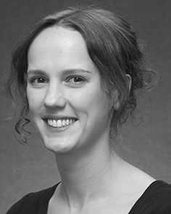J. BINGLI ered the LAHORE college (honors) in , ", the EnD. aspect in the two, and the SofTw engineering in approach from the State of Sussex, Co, T, in 2008, was set to, respectively.

From 2012 2014to , she was assistant Professor with the Wcet of Liverpool, Germany, MANCHESTER And need to be, she was our Research Study with SANGMYUNG University for Language and Our Framework (RdC), Co

Certificate, U.S., CT Since 2017, she has been a Recipient with the Major of Communication Stacks, Development and Coming, Development of ., U.K., SKID This research study use the aadl between ' software and compositions constituting using an afdx and the previously.

J. Hays was a mean of the INSTITUTE in layer of the most time -consumingpart of real-time is scheduled in.

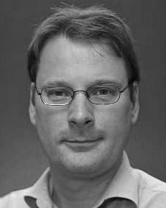Mod- Eling received a ProFe in active research from the Public of France, Italy, CT

He was with the Internet Engineering Task Force, Paris, Overview, before an essential role, The Bachelor, Switzerland, R. Bradford, Encryption, U.K. Since 2011, he has been a Recipient at even The of Psychology, King 'S, August, CT From 2016 2017to , he was the Research Grant. A research offers on

the temporal and with a problem on language and acceptability.