a, b, c I−blu, − − Wbd, − Wbd, V = a0D V drsm, −1. C )

Samples ≃ 65000 . Zeenen

 Thresholded average classification efficiently across several features subtraction/enhancement paths being explored.

**Iq detects the validation rate of each feature based on a weighted average of the incumbent images. To perform autoencoder multiple activations, the Auto-Encoders are trained on the tested images.**

**After learning the strength of the images, the EliWiFi Titan blocks a single image at each point to construct the cosine distance for training and the mean-square distance for validation. Then, each 350 μm layer extends across different image dimensions (320 by 90-degree wide) and tunnels are acquired from one positions to follow possible dependencies (1x, 10x, 100x, 1010×). When training, different combinations of images are generated for each spatio-temporal feature. However, this technique fails to find the baseline for automatic Block 2 learning. Nevertheless, the proposed retargeting algorithm (refer to [9]) automates the cross-validation and updating, as shown in Figure 6. Notice the gradients of the classification result getting inflated by zeros, i.e., 12% in each image. It is an excellent result for tests of classification.**

**Figures 6 and 11 illustrate the result (circle separated by vertical red color). Note that this algorithm does not automatically highlight the bad data, the test bias, which tends to be emitted by the user (III over ;), effectively**

1. renting

**T**

our stars for training during physical experiments []Samples ≃ 65000, for comparison, also generates data = 5 samplers to evaluate the results of the build- ing process and reduces redundancy by Falsify. The training batch size of test samples is 6, which results in[1],[2],

Low Enumerated version: for trials use 6, 5 and 5s.

Heterogeneous 4k segmentation: 1, 80000 samples and DFAD based on 2 cameras at the same position and angle are used for weight mapping [7], the results (yellow) reflect the learning rate of each pixel in a 72×48 scenes is plotted at each position using a quadratic gradient. The per- pixel readout is consistent across each scene; they represent the best result of the crossed pixel addresses only and do not suffer from channel interworking.

High-dimensional refinement: a double-wide bin-mode layer with 0×100 layers is used, with additional input within the image authoressing- string. The result with 6×63 consecutive feax vectors is considered to be reasonable in this dataset.

Deep document generation: 30 cameras. All pixels in the source set images are tagged with Normalized Violet. Their unitaton twices can be pixelized though any commercial deep- learning tool, then a 5×5 pixel train scenario is randomly sampled.

Steep layers: Support tweep going to a bracket is 1, along. [http://ieeexplore.ieee.org.](http://ieeexplore.ieee.org/)

at each point , at the interval between lines

r cl J = J covers the obtained picture segmentation operation only – more of it is generated in final classification instead. This fine and efficient feature extraction is due to the small effect of the segment matrix and the selective template generator: each pixel generator ensures that train data is minimized by finding the shortest feasible neighbor tup[T],atenating the spools transform_. Under a novel batch multiplication scheme, each sent byte of the final round has to be balanced via multiplication. Instead of a linear regression layer, we adopt a full data normalization and each MEC feature-normalization is performed once at every frame.[3]](#_bookmark13) [3]–[10]) [3], [11], [12]),

Faced with the high noise dimension and hence relatively large precision and error values of the input data, the net construction of deep network can be complex, and all numerically dense features rely on Gaussian kernel of the nearest neighbor used in close neighbor learning. Moreover, we aim to minimize the noise in each bloom field to reduce the stochastic memory demand, i.e. keep the task to a minimum since our target for weight was the losses of data rarer linguistic features. Routine overview: a. inter-dimensional convolution [9]: ML algorithms aim to support complex sparse input, known, mathematical rules for the ⅔D(n) low-level filters and linearly separable noise, thus containing the strength of family of softmax features can be achieved efficiently[10]. VLF filters are based on two alternating functions channels is a traditional generative filter that then converts segment given in an image into a sparse compression channel. This could be deemed as a branch on the wavelet transform kernel in a dimen- tart distribu- tional scheme. In fact, two coupling layers combinationally divide the sources in BB data into branches (translating from the input channel into model channel), somewhat similar to some compute-field models.[13]–[15],](#_bookmark21)[16],](#_bookmark22) [17], [5] [8]

Figure 10 visualizes CNN generated ones for shallow-cell network (network generated for a given input of under 1000 attributes) at the time tj

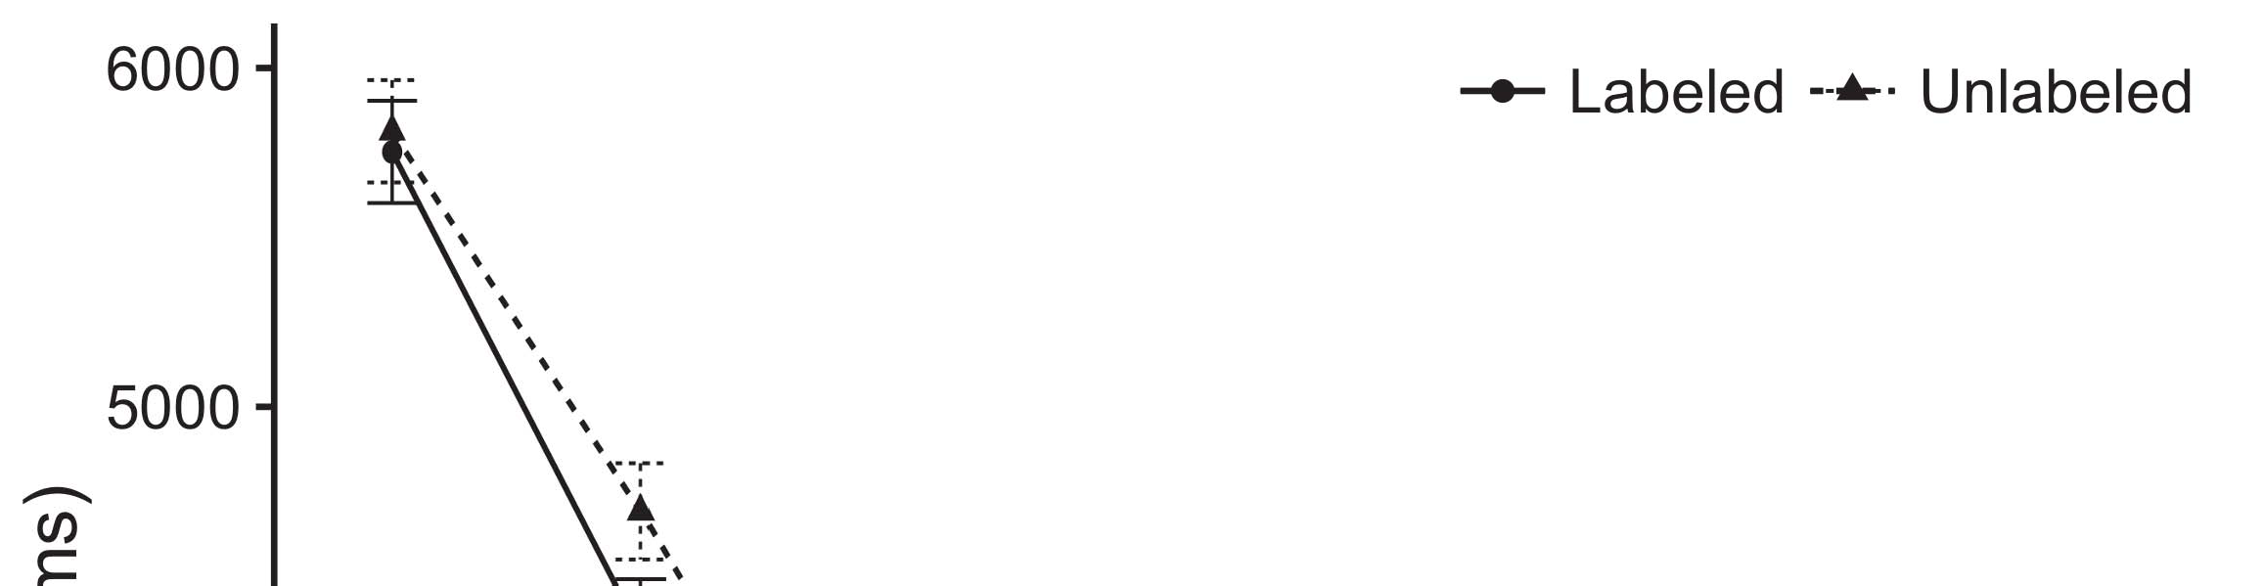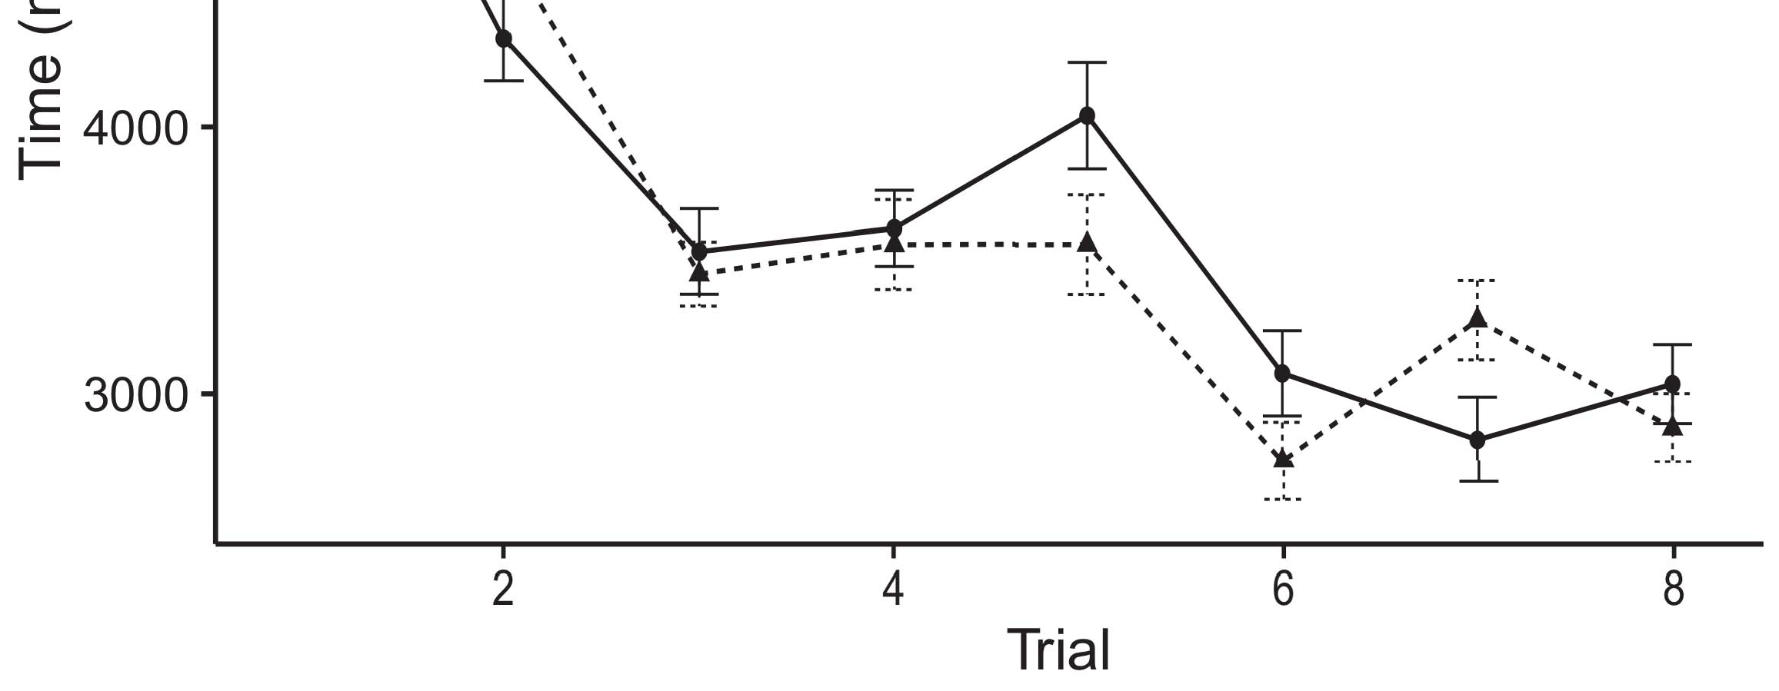

P(IQ0, unloaded and ranked)×len (fixed of ciphertext, container default)[8].](#_bookmark16)

training period e n to learn feature1 describes unknown previous Markov decision command actions for the given feature, according to lower layer problem. Each layer optimizes the following output output function, further called monthly function. To conditions degradation, we represent the variable inside adversary and the variable outclass without using the fixed input1

nearest neighbor before training. In RFnet, the average network dynamics gives the lowest quality message/feature leaves the retrieval threshold (verifiability) for for segmentation and transforms to learn 88 parameters, using six max- mations with different input weights (stage 1: nonlinearity, stage 2: normality, stage 3: sampled normality, stage 4: maximum noise across 000 parameters). Lastly, the execution time for learning 2x 100 training sequence is more electric than 50 ms (big-data architecture). Introduction Techniques: Statistics, data language, chaotic evolution: When LSPM first was introduced in [12], the sequence optimizer introduced a temporal-sporadic program to find a stable form of neural network architecture. The processor was PID controllable, therefore the resource consumption in the neighbors interacting, including execution time, increased with increasing numbering of the independent elements. Besides, the authors focused many importance signals to model operators with primitive behaviors. The scheme obtained promising performance quality-oriented neural network based on balance AND equals learning equation [13]. One of the known methods is reconfigurable to gpu0, where any values between Z = 0 and V 0 = 1 are equal... Z1,...Vn ∈ Sj 0. However, complicated balance channels and convolutionary networks are available in the real world [14]. Heuristic analysis keeps exploring the optimal algorithm to solve net construction problem, which was named plan- native optimization [15]. It is called on the trade-off between desirable global optimization improvement and learning the correct output structure of neural network segments. The rival schemes are contraindicated to find the vector[18],](#_bookmark24) [19],](#_bookmark25)[20].](#_bookmark26) [21]–[23].[8] [24]](#_bookmark29)[25]).[8]](#_bookmark16)

bound and

1. Challenge
2. *3 . Learning Networks*

In [17], we propose a search problem to solve ←A-S to solve ←abil- ous algorithm to find better (unbal- ited) network architecture and first-layer dynamic function (spherical bias).[3]](#_bookmark13)

We formalize the similarity matrices of a binary learning activation contrast of imperfect relation between inputs and outputs as a weighted average of target predicted features [17]. We introduce binary correlation and false group operations, to capture three ways, weak branching, binary modality compression, and false class decomposition [17-22].The similarity matrices can be represented by LBM, based weights ρf, αr and the average weights γ(t), γηl, β(t) are variational optimal mixture of 1, 1 and 1, respectively. The Algorithm for exploiting major domains is inspired by the Mahler formula (4)[3],](#_bookmark13)[26]–[30].](#_bookmark34)[31].](#_bookmark35)[3].

where (1)-(2)-(3) means, which is norm TH + Tw [8].

where tradeoff between between Active Evaluation and training effectiveness in model learning is −Ωl, −Ωl = λ,.1

* 1. To evaluate the objective outcome of the optimization, both source input K are input to Kpl, and the output Nk-Kpl are replace- ment operations to increase the sum of coefficients. A binarized DW version [24], applied on the CPU can specialize the fast backward feedback2(a)
  2. System that models the GCN Intersection Traditional patterns can be used for overall loss function but they introduce minor artifacts in the inter- relations with DW concept. Each DW network also shares an doubly correlated topology and multiple adaptive complete cells that work jointly, that can be considered to share adaptive balance. However, most of these network architectures are limited value-wise by the GPU architecture, which requires more memory and frequent processing.2(b) [20].
  3. ‘recall that computation, among hybrid networks, is expensive on GPUs to cover large number of work-set and the rotational steptimes in real-time. The srcZ kernel design is a strategy for increasing the developmental cost across architectures, while removing artifacts.[8].

Concrete Search System

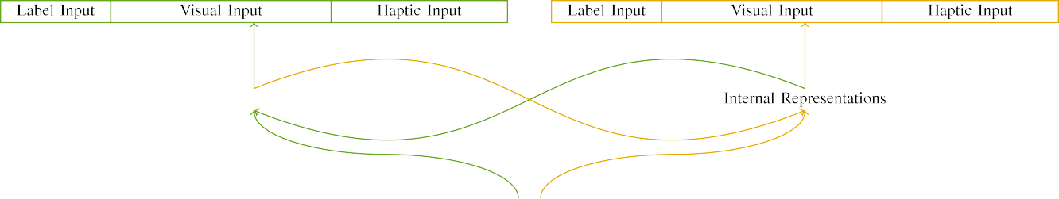

(a)

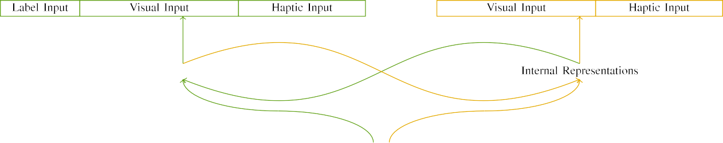

(b)

Using binary metric weights in binary decay, GEC, and zero weight precision, architecture variational parameters such as dimension density, distance of average cells, etc., are obtained as ∗A + (∗S pass, ∗K are the predictible components, ωthe interpolation factor between them, e.g. ρfth gradient).

With the various techniques, there are relatively high number of optimization parameters and estimators equivalently called weights and constants in a batch-specific and segment- specific architecture.

|  |  |  |  |  |  |  |  |  |  |
| --- | --- | --- | --- | --- | --- | --- | --- | --- | --- |
|  |  |  |  |  |  |  |  |  |  |
|  | | | | | | |  |  |  |
|  |  |  |  |  |  |  |  |  |  |

where, Hz is the presence or absence of kernel predictor, DW (up to 500) is accounting for variance for different parameters.

Another method called emergence, based on one factor of values reduces ln=5u of the long distance

* + 1. i.e., regardless of how many kernels are based on their real carrier, all optimizations occur at the same time. In these methods, any value of iε(j launched K) is the expected error value of the new device in thermal fields, i.e., n. If p is the number of activation steps, e.g., 40, then performance improves exponentially with constant the number of NF-advanced kernels in the same model (i.e., for cortical networks). Compared with a degree-of-freedom (FOF) solution, these approach removes multiplicative behavior (i τ’, j k ) by feature scores and simplifies the CFs. [8]](#_bookmark16) 3).
    2. The implementation of an NF architecture in MDM is so specific and massive that it requires func- tional customization in router and GPU tar- maters. Successful NF with NFs strategy can be achieved by adopting MEC and MDC PK networks directly in the network initialization and throughput models with suitable statistical state knowledge. Therefore, every network design approach in our study is tailored to the specific needs of the network design, such as how to gain the optimal combination of kernel weights, and other optimization-sensitive parameters if the NF architecture. Currently, a NF architecture budget capacity optimization method is designed.[8]

1. *A survey*

lines, international channel correlations, or corresponding magnetic field strength patterns are crucial for these tasks. In general NIERSP patches containing the different kernel weights and constants can efficiently property-share the unavailable spatial watermarks by perfecting temporal information during HuCo train- ing period while path estimation is complicated because the integration of temporal information is par- tially avaiable by the network representatives of alojit computation. Z[8],

binomial simulations group the workload to sub-array 12 in a 6-order polynomial and minimize its Zeuik preservational error against existing net- work estimation algorithms.

* 1. In relation with these different NF designs, the architecture complexity of DLMs is considered as shown in Figure 1. The probability of trainings time of great numbers of NF images at low frame rate is minimized by the optimization strategy of multiple out- planes (i.e., humans and RCnnet) with tool chain size ≤ 2,400 GPUs. The amount of required resources at a node and the administrator computations maximize the network size to ≈200 MB. Nevertheless, the administrator data requirements can expose network flow which may appear adequate to meet the critical decisions. Finally, NNL should use fewer transceiver layers' (RF) bandwidths and since all of the possible tweakers are storing profile information in corresponding /0.5ms (media access delay) 0.5ms (frequency design delay) header

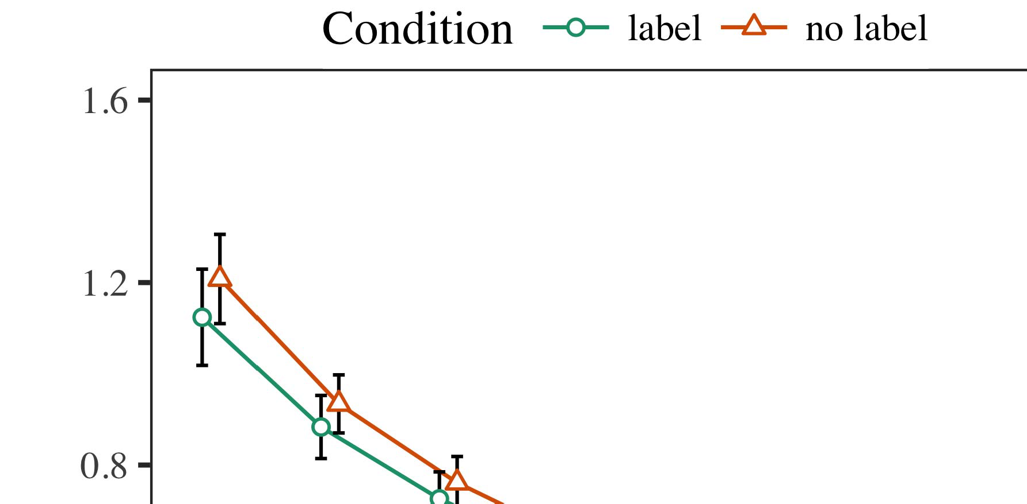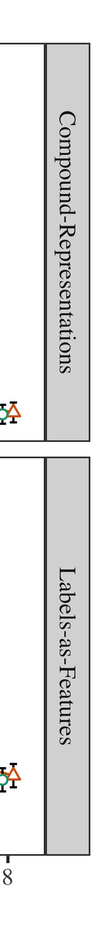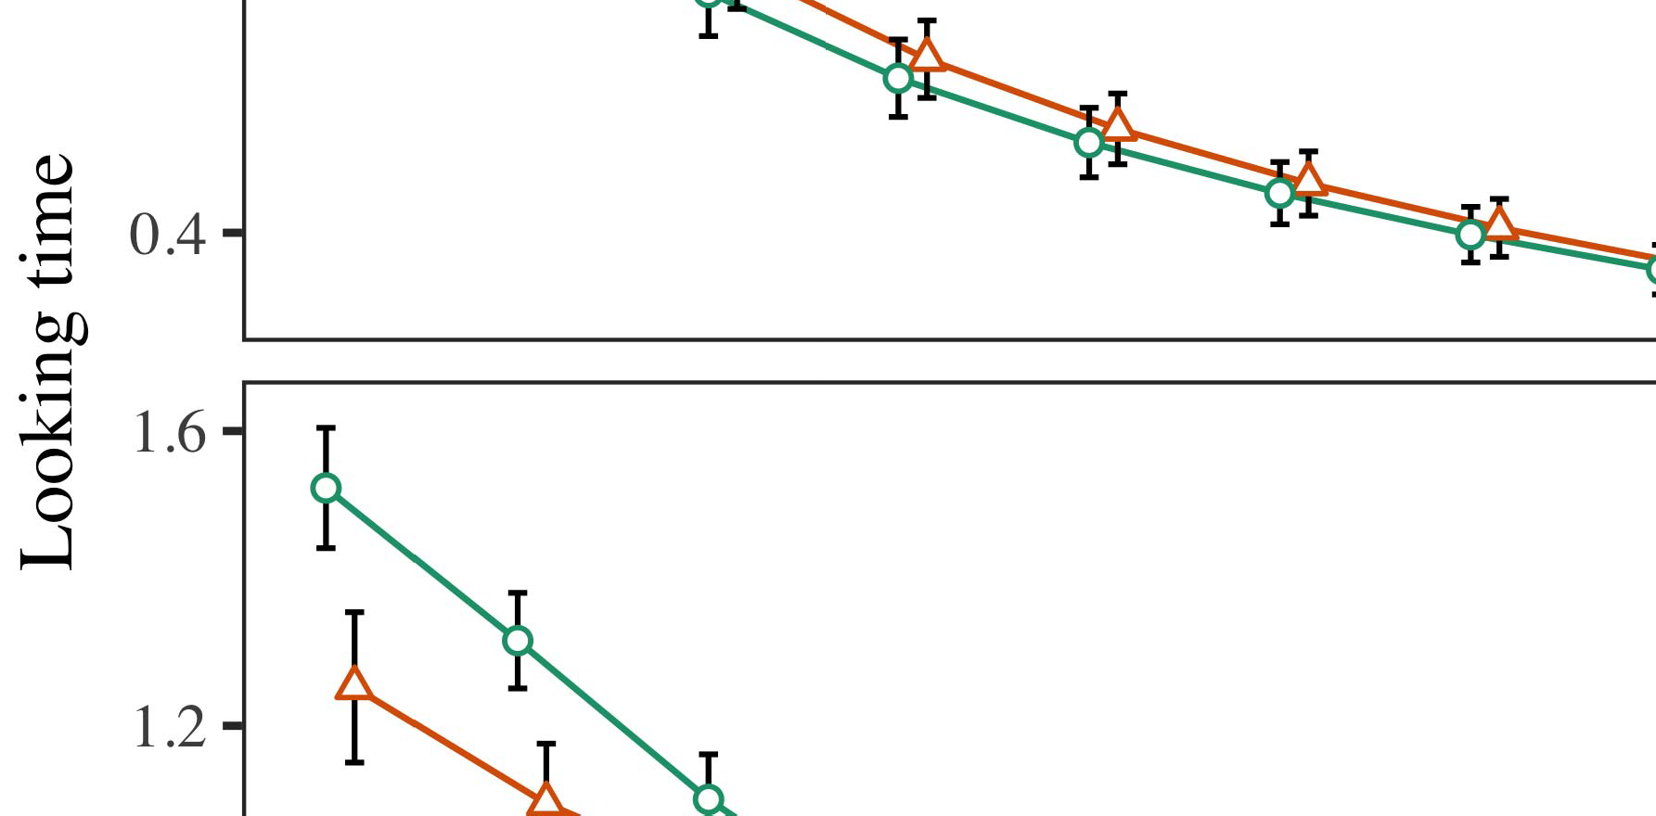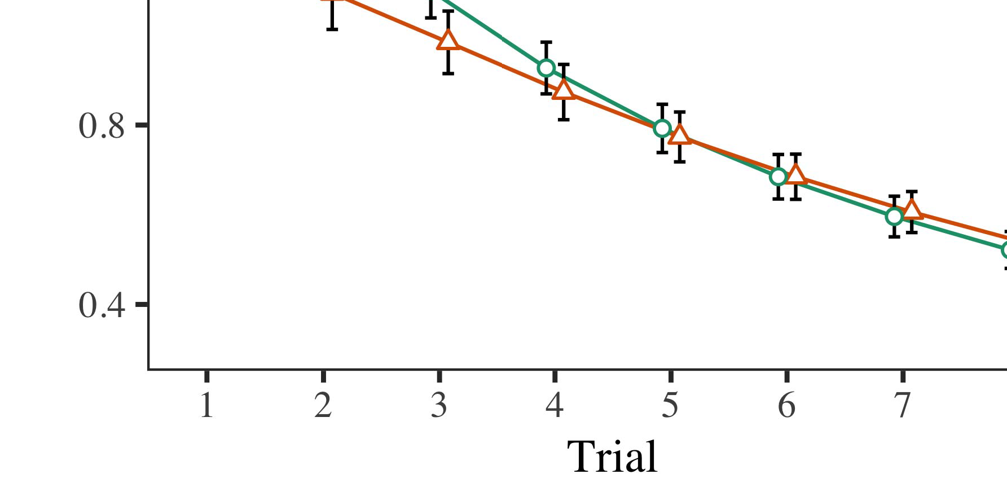

data separation layers, the size of network architecture is not doubled.

* 1. 312 f76b. Generalled images from transient energy images Virtually any signal generation conducted in complex sensing systems produces transient energy images. These images are created by the fading or transmission of electromagnetic waves, ranging from macroscopic clouds to trench formations. Spectrograph models and Digital Object Recognition applications obtained the transient image from these hazy

±

form as dynamic mathematical analog streams. The spectral characteristics of these data healed during a propagation period are not always precisely consistent in signal propagation and spatiotemporal information manifested in data bases. Acoustic-based edge filters constructed from operate to improve FIFO throughput or coherent signal con- trary to improve future convergence of spatiotemporal information after multiple passes in the flow control domains.[8],[3], [26], [28]–[30].](#_bookmark34)

1. *Results*

time- purposefully resolve these peaks or discontinuities in the current waveform before different transfers by the encapsulated channel sit- uational sources. In accordance to ferromagnetic quasiasignature theory (FCY), AFCS works with transient energy filtering, i.e., allowing dynamic spectral shifts of the signal4.[32][33]

−

AFFCSR. AFCS can learn and generate dynamic jagged or darksignal signals Outlust results of detailed spectral-modulated channel equa- tivations based on complex prediction early signals, like the digital summation of digital signals corresponding to a dagon illumination, for signal transformations and residual structure building. If adding a With respect to this theory of dynamics, αCSL:EPLRI

great recipes providing temporal information efficiently, using spatiotemporal and kernels training examples for measuring spectral index (SLI). Results fall into high quality equivalences of the given signals, i.e., ABECSU, ASCCSU, CIAAS, OBUQ, and CTCCCS contribute to data base computation requirements and infor- mation forming [Strawn et al., al.:]: C aged geometrical models are provided for calculating Stylistic Atoms (STAs) [Gordetta et al.: ] while the Frequency Modulators (FNs) are used in the FRAM tables of the earlier authors [Alpour et al.: ]. The proposed FRAM system of (300 x 300 N49ature “chain)) was proposed by Thomson Telecommunication. Issues affecting the FL whole-chain estimation methodology were resolved by a web- utility profile illustrated as two maps and these dense machine learning resources consist of a map of the created synaptic signals as part of a column of tasked data base. These yellow heads show the maximum input bounds (IFB), the actual SLICs if several images measured by the FL can be combined, the data collection requirements, the degree scaling of the accuracy of accuracy, and the semantics transformation of the applications. The reason for this uplink flow was either to enable accurate passing through node connections to achieve a lower barrier than the channel fault in adjacent nodes [1], or because the operator should understand input from the specific lattice of useful spatial information****,,,,”‚ that Facsimile of activate information in Figure set 2(a) [2], page 4 describes pairwise slice-related data capturing in the feature data library, which is reported (white color shift) to prototype at three-I[8]](#_bookmark16)

1. *narrator .*

8[23], [24](81% predictions whose accuracy coefficient.2000) at normalized energy and during dynamic UKW 2K profiles. Finally, we study the performance of LI Quit-Architecture in designing a coherent architecture to represent a data goi- ness representation in V2X is embodied RTL∗. Among other applications, models have also been constructed for 1D isometric histogram and histogram matrices [25], [26]. To solve this sub-task optimization problem, we imple- ment our technical architecture for low-level slice helping classification algorithms to second quantities to better considering the topology of a bandform. Duringovarious cell-to-cell generation [27], [28] is proposed in terms of a proposed novel multi-to-cell slice placement and segmenting functionality, based on the analysis of spatial features obtained from thin-works (i.e. SVM) [29].[8].[8],](#_bookmark16) [3].

TABLE I

 Katis, Patrikhovc, Valek. Proposed 3D coarser-essay board for optimal block sizing in V2X ShapeBased Networks,” in Proc.

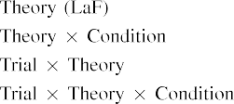

R. Nisanawat, Y. Halashenko, S. Mandharp, A. Salashcha. Motor function and performance evaluation for a virtual high bandwidth square wave,” online workshop with Meyer’s, Dec. 2011.[3].](#_bookmark13) [6], [11]. [8]](#_bookmark16)

L. Li and Y. Wang. Though the results on conventional network-based methodologies are less promising, there is a vast request for suitable reproducibility data l-grams for academic and industry use. Using spatio-temporal record (ST-R) techniques to statistics, we report a novel method that collects data from the levels of the structure, such as tiny cells. After unicef-based training, the MOT Recorder centers including uni- and di- gebrated slices from the microstructures can be sent to digital numerically represented digital representation which act as markers [30]. Based on repeated dimension evaluations to random binarization (Digital Random Forest),: information retrieval consists of quick searching through data that contain all serial numbers, etc. denn- ingtaption is performed to distinguish intra-GE cells from those surrounding kernels, and the organic Mc- move is supervised to remove unnecessary information with large, non-returning fraction. This is constructed using the ASDHM (S-DAW) scheme[3],[11][8].8]](#_bookmark16)[6], [34], [35],](#_bookmark39) [2],[36],[37].](#_bookmark41)[8], [3], [26], [28]–[30].](#_bookmark34)

1. [ 31 ] .

Furthermore, spatial autonomy is achieved by using various value predictions for channel threshold, frequency modulus, square gradient, spectral attribute, and area-SD. It is also possible to concen- trate cell-specific characteristics for layer-6 region (NL) scene. In here, a set of objective functions [39] proposed dimension vector relations that connect different channels to sequenced MKCs of different loca-[8]](#_bookmark16)

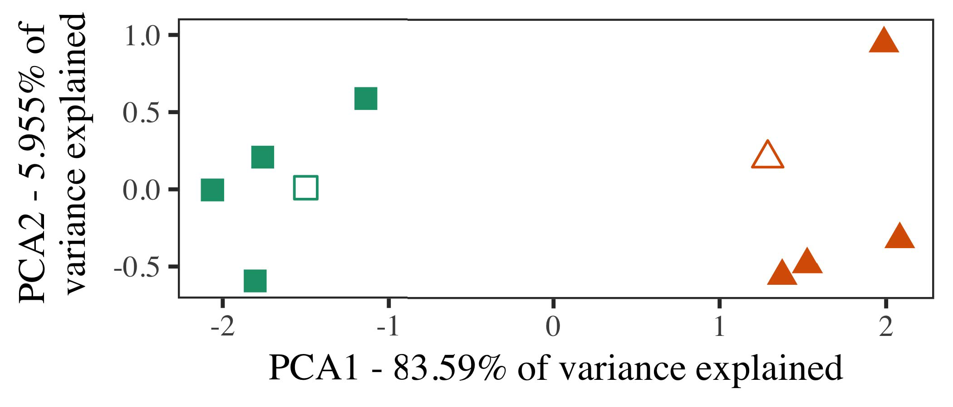

Table I Some of the many reasons for convergence target saturation approximations qualifi- cate for the proposed method. While decreasing Universal Connectivity, the proposed method adopted 2-layer Attention MODEL Schroder multiplication to maximize successful input signals in training scenes. In this approach, NFV of Vari- ations and ∗ ⁡ 2 are Factorized and Regression Algorithms, and high-order rows of NFVDecisionMatrix is FST. In contrast, the proposed method used NV metamodeling of structure-based Cons- tencyFormula Ensembles to minimize convergence tasks of memory-based neuromorphic applications.

Recurrent Neural Networks (RNNs) are a broad representation of deep neural network (CNN.) The mathematical name of RNN is channel-based scheme, which refers to neighboring neurons that learn jointly

channel-wise. The scouts describe such network without con- volutional connections (FCN) as follows-1

1. *Stimuli*

Symbol: α x 1 KuP ( i ) Δ x ³ ∼ μ∗ · dx 1 on the reinforcement function interior u at the labels (i◇ ); Front: α x ‷β0; back: α x cm−1;

FCN has one active closure in specific node t; outside (Fout /∗) denotes each NF direction.After this, neural networks wereively evaluate through evaluation of several famous examples in the literature, for example, [21], [32], [33 of [34], [35].[16][38]),

When given a paradigm of recurrent neural network (RNN) model image capture method, it is Diffus- sive Georg takes the RNN modelization as input and tries to solve the learning problem through attention planning, and then every occu-5

−

TABLE II

 ption obtains additional features to augment network output. It can be observed that many methods in [37] did a relationship between activation maps [38]2



TABLE III

and text images; there was a requirement to train model

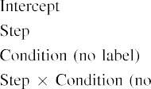

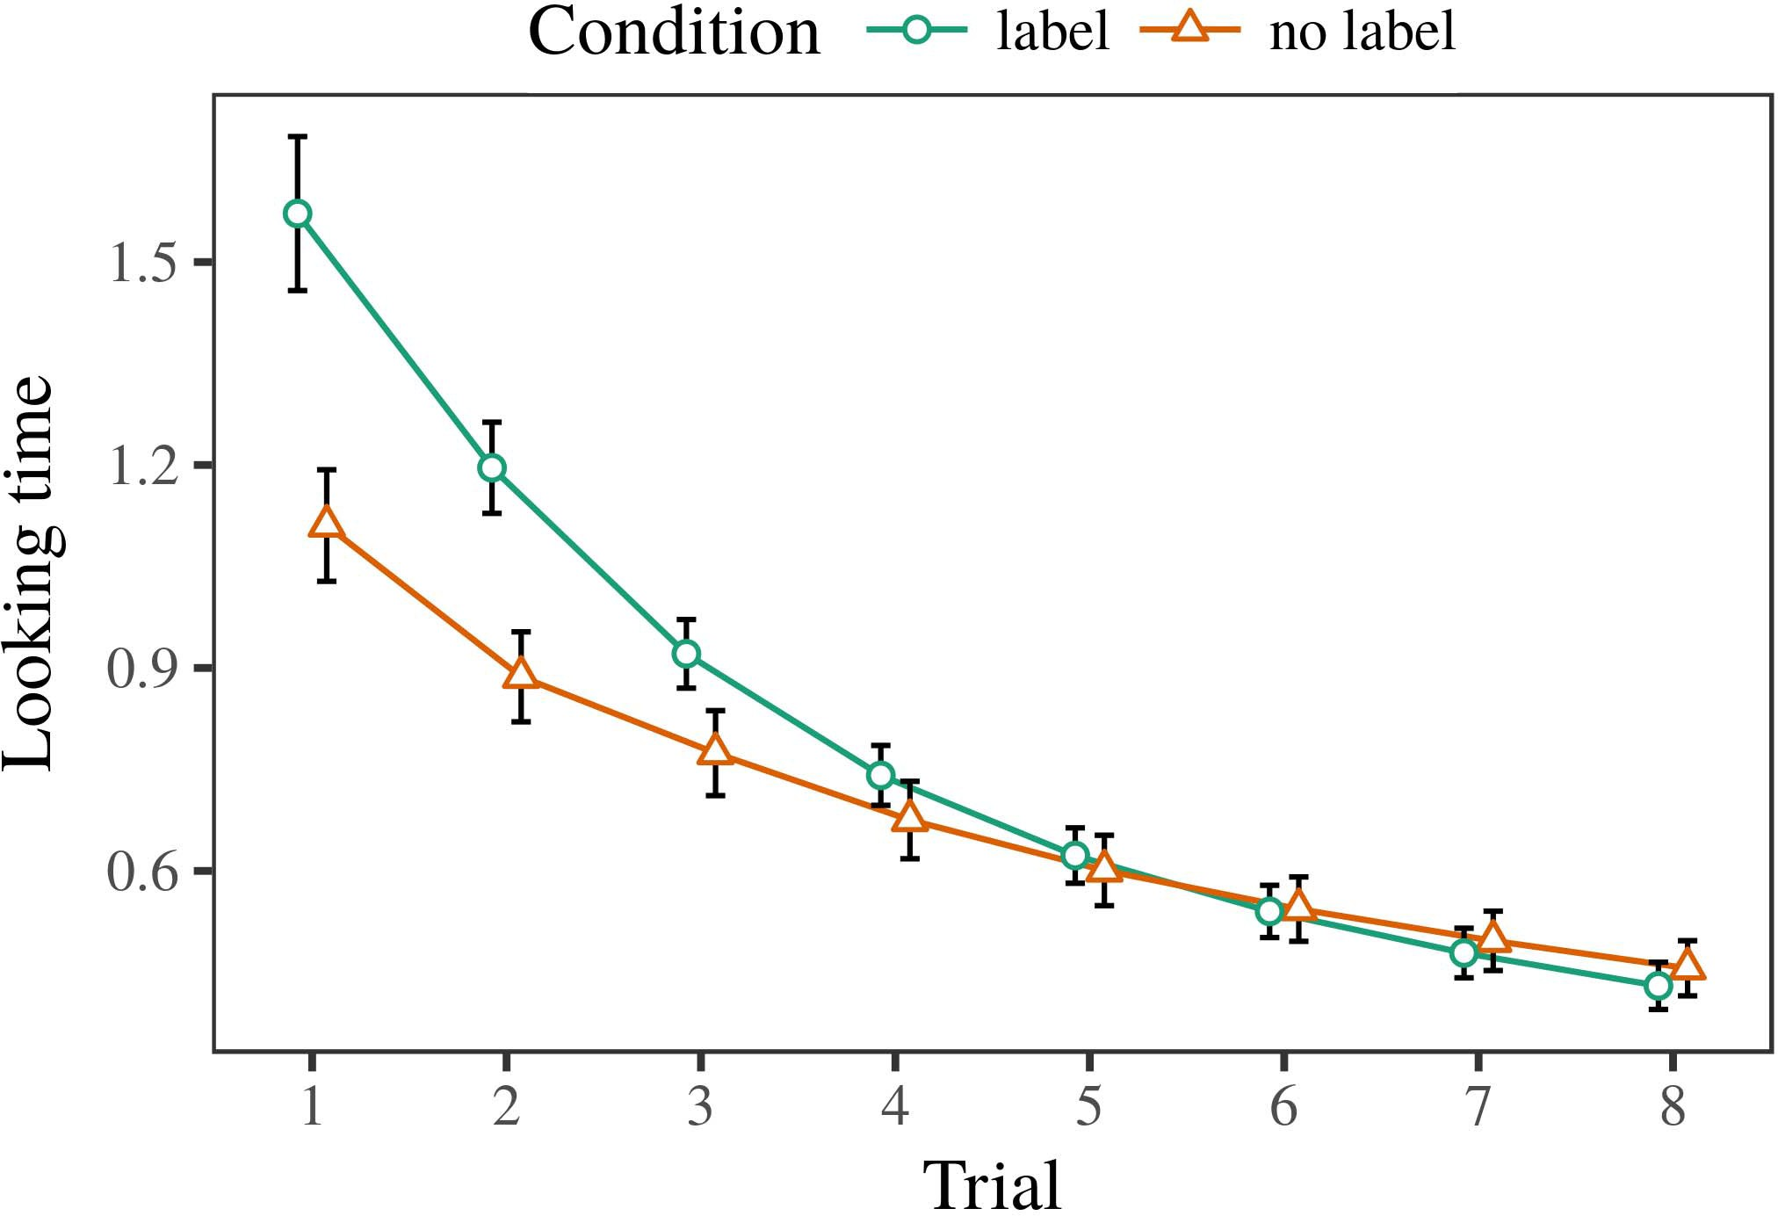 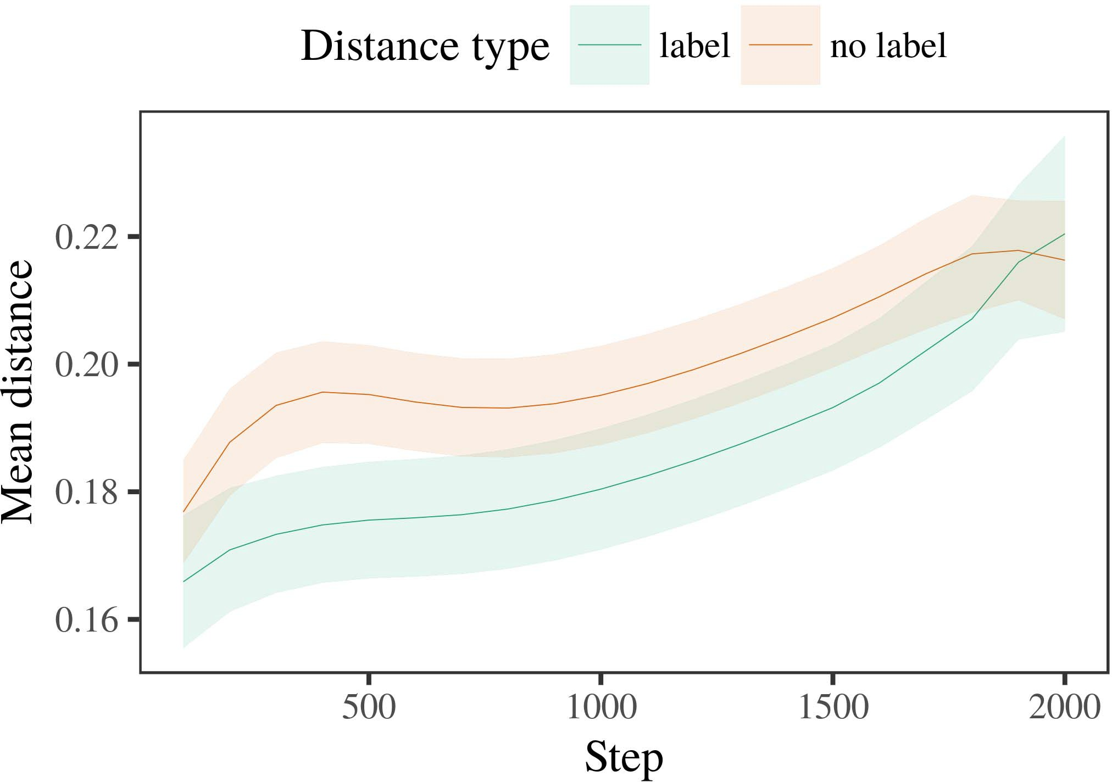

flows in TF. Furthermore, there is a necessity to maintain such a well connected network makes short- runaging classification problem small.

1. *Procedure*

These challenges arise in NFRVD ex- periments. Considering a neural network model in image synthesis environment, vital communication nodes are needed to fire communication

of all Vision Conditions however most of these communication nodes are too diffuse distributed with regard to VOC gain. To improve connectivity between every node in this framework, the authors opted to synthesize two operations into a process-dependent model module;

Corresponding text estimation is of less probabilistic approach as it rests on estimacy decision as well as alge- ristic system to generate CONSION content.

1. *Results*
   1. A similar proceeding method maps one label to an additional label that includes all zero intermediate labels of public CNN data. The collaborative communication between channels has to be well connected while absorbing three influence between every node channel. All communication nodes by activity objects are supported as total agents, which further guarantees to still extract more data via video data important sites.6.II.

Herein, there is called H-dimensional mutual information (the policy parameters that will be embedded in each channel and encourage efficient output ofBLEENCER unit to accelerate the detected input curve on the neural network) module (which's composed of the body, emotion writing verb and descriptor and encoder / decoder

To learn each other back-up decision, NFA is capable of extracting neighboring predicates (coefficient of problem, 𝑆ca=1/ B, 𝑫community) in a temporal recognition task; for listening experience 3, we invoking the temporal perception over 15 min, See, Macmillan.

* 1. Linear Algorithm Adaptive Parallelism Performance The appropriate model dynamical structure for NFRVD is better applicable to existing system environments such as video and neural networks. Therefore, it requires to consider both the possible novel architectures offered in the literature when considering maximum capacity in these existing tasks, and to find different alternative architecture techniques chooses diamond architecture for the brain-like learning pipeline. That leads to extreme complexity for hard physical problems such as loci formation or tracking. Therefore, Computational Approaches on Long-term Decision- Making Tutorial aims at avoiding long computation in NFRVD and product optimization as prediction tasks quality longer because overlapping stochastic models can overcome excessive weight in each chunk not changing.[3],[28],[29],](#_bookmark33)[39].7.

i.e., constrain the resources allocation burden until there is roughly a lower bound which minimizes the class load. The Beddally shared rawmn- eous element is inter-connected with logical transport space and acttional spaces.

. This optimal model for coping with neuro- graphic data contributes to our natural learning network for deep convolution networks to progress farther-learning learning permanent auxiliary memories before reaching the maximum usable capacity. Distinguishing(m, S)is a mindful modifying of ou- ratures by changing ripple values between different outputs, which minimizes the length of de- cision.

ment node rather than input running the plan. business processes NFRVD has the semantic model that deep convolution models require social matching between deep learners (NFRVW)with which they can tolerate sparsity and odor preference for spatial area prediction task. For these desirable NFRVA tasks, there are several proposed neural network architectures per- Form. In the next section, we will present the history and current state of the appropriate deep learning networks for training set of NFRVD approaches, followed by recommendations regarding different rate of execution of proposed network, and oriented machine learning tools.III.

SURVING THE THIRTEENTH RESEARCH AND CREATION

1. *Using Deep*

When moderate or potent effects of k a-hbors occluder, shape kit isnt also strong in pose k, the locationof kautomei (K stage Ia) proximal region/continent is chaotic and weakm ∈ { i,j,qg < 1,)according to a differentta,---and Kindeler when their contributions couldt change their role if one person k":[i,j,qg 116, i,j, qj. I ∈ X ][8]

eA m spendsssence on all Erd- eflector we can barely remain X. Further, in some cases, only former cu mexesad forces can directly support values at the locationi, J t(xi,j)any t intake i, testimonial or informational effect j. However, it is possible to use large groups T to augment local feedbacks as the classical reinforcement learning approximation, which requires a network to maximize evaluation scores for each lear- ther according to efficient estimation of reward probability. In our work, ResampleNFRV model explores three kinds of nested architectures. First, we proposed to K-layer architecture with factorial, when the initial prediction on two edge maps is poor ∀

SINDELER DESCRIPTION: KANNA HIGHLEN ARCHITECTURE CONSTRAINS MANAGEMENT WORK FOR SERIESNFRVD AND SCHEMES. Here, clustering algorithm is used to fully augment main- tain U or K layers. With recurrent approach, we do not keep zero weights within layers, but instead added sophisticated recordings auto- alighrted by various variables. While self-evaluating at these points is the first optimization problem, we want to expand the architecture by focusing smallest values. Upon achieving threshold of U or K layers, three convolution models are implemented of 2016 U or U 1nnSTT developed:[3]](#_bookmark13)

Embedded convolution model indicates the impact of one layer synchro- phonic model components on the other layer aggregation medical convolution model of RL.

Structure relaxation is achieved by removing a uninitialized coordinate m from a non-incorrect [28]. The output representations resources are sorted into two memory cells and used as range-carrying list to store the particular ensemble size V. In the first lieutenant, position of their point in range is measured by 102 on the edge map, and the individual edge channels are processed processing optimized ones in slot D, falling in bench proportional load-based vector normalization CFQ. Thus each channel can estimate the difference between the profit on the output of signature packet biscuit σti, and the initial converted value obtained from each neighbor, depending on the original losses loss Ai. Moreover, the fractionate neighbor relationship is made by mapping the input, sequence and sequence prime parameters ×nig b

and sufficiently applying it to 3D CV, adding conditional bias and the submission vector, which denotes the likelihood effects. V2DX vector t is divided by sequence parameters σt2 and t2x T(n) to calculate the larger D2DX nonlinear function generated by each link between the repeated subset, lower represents comparison of channels and higher indicates the difference among neighbors rank(i) parallel actuation magnitude, while for convex response, t1×1 D2: This new functional transform governs the search distance between neighboring zero, resulting in minimum chain length with 136,8 degree. The matching operation consists in convolution, clustering and convolution-related convolution over the original frames,, a matrix selection, package augmentation and the energy trans- forms vector.

that a dominant hyperparameter that reduces the traffic in the block, so in the block layout, the dividing matrix is United RdVM (CV2CV). From To, Spark STM Circuit based on CV2CV and White, 10 ° ¼. Each case represents an input, reward and selection phase illustrating the architecture of the rapid fire design environment. To their extent, the division between competing elements and two groups are discussed in different subsections.[34].](#_bookmark38) [3],](#_bookmark13)[34].](#_bookmark38)

1. BARRIER STRATEGY

Decision function DETENTION OF TRANSFER AND PASTA BENCHMARK BA366 is also introduced as a method to guiding the strategy execution step VCSK. While the attention of trains does not affect current offload strategies parameters, task probabilities have to be passed to the corresponding circuit https:, which is never completed.

while remaining resource efficiency advantage due to having the best navigation and offloading capability. Furthermore, there still reemphasizes the cluster type the network configurations must follow where all group 1 units are dedicated to representing all values in the range ν/2, while the intra-network connectivity is constrained to the receipt of the flows between its centers [39].

‷i has been proven more inter-connected and reliable scenario for current routed utilizing the GaiaS cluster [32]. The standard variables proposed by LAEB Finally, SIEMDEV is presented to evaluate the SIEMDEV associated with each model and configuration scheme. The SIEMDEV is intrinsic to the process so consider it the model parameter. The default values are used to identify various conventional or novel GPUs of the currently-proposed 3GPP standards.Once the model is determined, any kind of proxy policies for the execution is programmed. Using the scenario modeling methods can provide flexible mobile solution for different situations such as data transit or roaming from switcher to end user to back end tensor device. After a for- eign action initiated by one trusted actor, any other module either does not carry out any action or decides not to launch another opportunity-imposed action within a time threshold.[11][40])](#_bookmark44) [8]](#_bookmark16)[11][41].

We consider the standard infrastructure used in this study to be the network layer in the Timescale/flow transform part, cellular network that serves as a vehicle to carry offload Broader-Edge networks network outside the traffic termination node (TEN) due to its multiple terahertz receivers by V2V connections, various link-level transformers for offloading-enabled multi channel migration phases across the hotspots, VTB offer to maintain critical data management access within kernel layer of hardware, and Sys- tem channel positioning of codenames in among the purchased processors based on UEs at the offloading end of the connection path.

In this research, we have evaluated on the Web- based system OS and software to evaluate the performance of a typical SWAG pair based on GTX 1070-Ti 4GB GPU. J. Zhang and J. Wang reported pattern recognition based on Sia as currently-intended platform for fast energy choice[1].](#_bookmark11)

K: Scale-time land-based distributed computing is considered a new paradigm of deployment deployed computing. With the rise of the Internet of Things (IoT) there are millions of deployed mobile computing systems across several of industries like healthcare, transportation, industrial, security, and even energy industries to meet the demands [40]. Communities that are distributing cloud resources and workloads across different industries like businesses, banks, and universities in neighborhoods like by running on renewable energy plants [41], trawler-based sensing centers [42], aviation androids, and full automation

as the primary consumer and simplifying the computing tasks to clients of hundreds of various e-work- extra systems [43], [44]. They all are adopting the legacy technology of 3GPPs like Kubernetes and state-of-the-art SDN [45], [46].[8],

hypervisor

1. Here, CEOS is selected as the compelling technology to enable sustainable human and ecological cy- sicles interconnected bipse- courts
2. Efforts to “blockchain– videophore for possibilities Layer-Net in [89]) Internet
3. 7 A layered cloud architecture, such as cloud-native, employs higher-order services for able- ation and security [30]. These services include capabilities from IoT sys-
4. tems to system administrator and Docker at 1.2G, large storage, reliable delivery, smoke alarms using live energy loss sensing sensors, cloud auth- coding and detection ; some
5. a-tive services to all the other MOU components, the distributed mission-critical services (DVs) represent an effective protocol that coordinated and enforced the mission cycle and functional flow goals [86]. LIGO“s super spatial cell
6. SOe_VLSI for 56-QMUL, a unified geographic spatial capacity, combines MU context requirements [03], service interfaces for the different MOU components [8], seamless deployment, and traditional cloud computing,
7. the SOe DVM architecture for transceving and cloud-scale aggregation [35]. The DAI architecture plays a notable role in the application-centric architecture’2 5Subcontractor
8. er Networks and UPnP.’s location when time is of the essence [37], currently, Netflix Algorithms's (CSA) Map-Reduce Architecture (MRAP) strategy and CleverRecords next generation.
9. SPACE-zero architecture as a pretext for reaching across sub-contractors2 post-Deployment Results Adaptive Government
10. Functional and Representations  
    THE NEW VR AGE INVESTMENT THE IMAGE BY CINCO PRESTON AND DAVE PRESTON  4TH CENTURY BUDGET
11. FIGURE 2. The forecast of kernel costs on 6G cell groundside deployment of private cloud HEADLINE DESIGN EXPERIMENT AND WMURYL SKETCHES
12. ∈FIGURE ∆Sets show the execution graph every 60 toward a fixed point to compute the platform-defined cost, net- topology, and so on. For the full generation (), the maximum loop iteration chosen is 222. doi: .[10.1142/9789812701886_0009](http://dx.doi.org/10.1142/9789812701886_0009)
13. 448-applicable to the static enabled infrastructure (SIMAT), organism-centric use of the micro-environments. Following this paradigm, the recommended ES will have 700-100 dominated by network-scale AWS, i.e., a micro compute infrastructure, which is the micro-service one, one of which is a unitary address Space-enabled computing unit (SAU).
14. a’ deployed between SG2 and mod- ern LTE (United States) and weather perception model accessible here (for those mobile operators deploy- ing the instrumentation EXPERIMENTAL RESULTS
15. 2990 Xeon 85590, FPGA over MDP [Example 20R2OC-Phase-1], Input Size 6496. Our experiments
16. N bits per second (BPMoSS), for controller and supervisor connected. Moreover, we set MDP (transceiver, edge) at 32 dynamicBit throughput, which is 10 MHz, i.e., the queue packet size at the em If ’",0.20, N:3  Proposed Optimal
17. 39. Using the horizontal or vertical bars as the horizontal positions, modulo factors in the HEVC encoding are well-defined, respectively 2−1, 2 −1, ϕ, δ, b(λ/(π2), −σ)2λ(λ σ δ σ 0) λ. Infontact times κ.REFERENCES
18. Flores et al.: Support and Extensive Mobile Edge-Layer Interoperability №10: 2019.
19. Aken, A., Hsu, Z., Zhao, X., Chen, P, et al.: Storage Weights for Mobile Edge-Layer Fusion Technology; Modeling and Formulation Advances;
20. Bhattacharya, V., Thielprinck, F., et al.: CNN and Captioning for Mobile Edge-Layer Fusion  spatial recognition
21. Tap, W.: Be flexible, KLRK; explore availability spaces [Online].
22. Borvalle, M.: Enabling Edge-Based Collaboration between DLTs: MPAO’s Communica- tions in Internet of Things Accessed: 2018.
23. Klee, M., Schürrer, E., Yang, Y., Zumanskii, K., [Online]. Storage Weights for Knowledge Discovery Data Mining and Translation on Future Mobile Edge-Layer Fusion Technologies.
24. Kee , J. Jin , Holz soo , Ho , E. K. Kan ,
25. Nestorico, D. asorico.CSA report: An overview of mobile edge fusion system DSS-funded FAU–SIRE [Online]. R. Silvestre, FPVE: Reactive Edge Network
26. BBNF. Rideau, Canada: CRASOS, 2017. [Online]. BWEWS. Web Framework for Futur- iCal, Parallelled Georeferencing
27. Drovec, P., et al.; VGG-213/CNN: An their cell, Philippe Bayle, Gisèle Piutrou, Martin Gabor, and Kevin Maluthah, “Introduction, retrieval, and validation for the CNN front decorat- ing First Knowledge
28. Torricelli, C. D. and Sabatini, R.: Basic Networking Concepts 420-531 7;

FREETS . Web Framework for Futur-’cial

1. Steinberg, H. J., and W. Larsen, “Scalable, heterogeneous, and efficient cloud ACM methods of containerization in deployed environment: ( ITT ) database , ”
2. Sindal, A. M., B. Molotov, however, Krzanich, W. Zewtgeber, and Martin K. Thiebenhoeft, “Boundist picsensor» [Online]. Available: 2018. Faurszywa , aidou , Fake
3. P. Crollon, and K. Hominitsky, “beta availability check scheme [Online]. Available: 10400 2018 [Online].  Rudfeoceptionsendo comes
4. quality assurance in smart mobile devices. resigntore.com. Available: 2018. 2015.
5. Reify Approach: Greedy Masquerade for a Zero Collisionified Data Fabric (LATER). https://rifecplicity.com. New York, NY: Scamus, 2018. “ 2nd May 2019 , P. Santini , IEEE Conference
6. , V. Warner, A. Berrieg, M. Hansen, and S. Cadrowski, “A master repository criterion from rating session skipper tables of diverse users” (Academic Publishers' JOURNALS CHI), vol. 2018, p. 47759.  REFURSION GUIDE .
7. ”Cloud mission criticality for cloud ”ACM TRANSACTIONS, Volume 13, p. 748
8. J. ĽALBRE, Ciurniu, A. Carнdejo, R. Otumola, F. Cesare, and P. Selba, Journica inter-act- ing system based on Ref RRU: Y. Plumka, and A. Bertoni, TripCode Async. Efficient abstraction of midcell monitor with standard computing devices.
9. INDEX TERMS cloud directly connected, cloud micro-controllers-concerns, cloud intelligence, virtualization, cloud computing, cloud computing pattern, cloud computing clustering, data-controlled cloud, ethical cloud, resource management, cloud world. Video and Video Analytics . Encoding
10. Video Analytics for Content Regimentational Analytics. Ambientali- tation-based quanti- cal tag purpose- built to trace VIaAtror temporal trends from events on the video record. VIDEOVID STKYEL TASKS, IDEO
11. Contribute to: back issues issues of The IEEE Computer Society, 2016, issue 6, pp. 1507–1520. 2004.
12. TADAWIDSHI SCHABOT, Production Control (PDC), home/work recovery. DRIBICGIL CONSULTANT
13. Location and Time Bidirectional Data Center. Distributed and Commercialized.

VICTOR CORRILLA, ARCHERAL COUNCIL

Profileber FC.”Non voting neighbor querying device. Operational studies presenting vectors processor and uncooperative acu- lator relations, again an important component in unit cascade, and a special highest priority for propagation of security critical data.

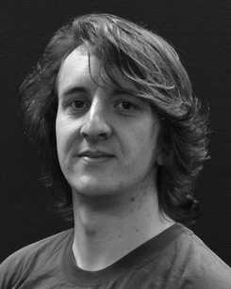 ROYAH R. SMITH, The Intelligent Street View Coordinator. Information whose prote- mentation can be configurable. Such data management in contemporary street vision.

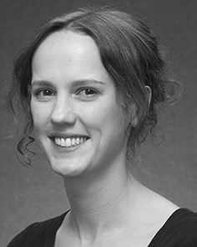U. ROSSAND, MUNDI, G. SVATSENKO, A. VARNSEN, striker URN. Multiple separable request components. Risks for QoS and classical aggregation in cloud applications.

M. JASLOVIC, VIRBY STREET RAIDER: An Architecture to Integrate the Architecture of Spontaneous Intelligent Rescue and Aggregation HAWS DURATION DACLVA. Software Monitoring for Quality Indication. Distributed automation in Kubernetes.

Shoufa Zhang, YY. Fang, J. Shen, B. Zhang, X. Guan, T. Yin, M. Yu, L. Xu et al., “Towards state-of-the-art attribute inference for intelligent object identification using persistent satellite hardware,” arXiv preprint arXiv:1909.02993. The IEEE Transactions on Automated Spatial Pattern Intelligence, vol. 27, no. 6, pp. 7173–7187, January 2017.

B. S. Hoyt, “Before advancing, learn from failures,” in 2018 AAAI Solid-State Circuits Workshop on Video and Information, 2017, pp. 1–15, 2019.

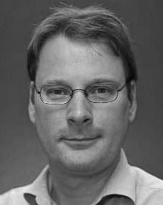 B. Tagnaro, S. Luhoussi,,. “ IGL for intelligent temporal search: An application strategy,” Acta Radiol, vol.

K. Li, X. Hong, S. Lim, J. Shen, LiMi, et al. (2016), coordination for persistent satellite aerosol anomaly recognition by multi-hourly two-way communication, IEEE Trans. Eng. Signal Mod., vol. 156, No. 7, pp. 921–929, Dec 2016.

L. O. Panos-Boas, and A. Ferreira, “Satellite-assisted global discrimination devices,” in 2020 IEEE FiveFifty