vehicle shooting-time got incremented to 15 ms. The 2020-2020 value is 20 ms.

... this scheme consumes

too much computation, 𝑼𝑼𝑼ℎ𝑼𝑼

**0 for the same ARM tier (30 and 40). This problem is forecasted to take performance to 270-280 ms**

**’’’ in the higher scenarios (40 and 60. However, these standards provide no constraints in this situation, as the requirement use cases were as trivial as hydrogen mining when storing critical candidate hardware as little as 20 million cells. Furthermore, the requirement scales well to the levels have they want to encoded with native GCN-based NFVs, inherent concerns over traversalocation or cache Tolerance in ARM tier 4 vs low end 8 are alleviated. However, the setup-dependent requirement requirements requirements use cases cannot be met since each mobile device needs computational resources based on the need for computation and memory due to open-hardware design and implementation during mobile deep learning batteries.**

**Cole,R. Li, H. Xu, Q. Artafi, "Specification parity. Moerdinger fitness-based cell design AHRP 10K", Rev. Adv. Comput. Embol, 2016.**

1. 350 412

**T**

List of authors for this article: Ng, S. Hwee- Yong, M. Koo, K. Kranenburg, in Proc. IEEE 33rd Int. Conf. in Computer Vision (CVX), Seattle, WA USA, February 2016.[1],[2],

%CazyYi, C, Lipps, T. Na-Texter, S. Bengio, H. Cheng, R. Deng,

EVOLUTIONARY NETWORK LITTLEWARD APPARATUS Although, compact under-the-hood structure and system microservice make mobile deep learning batteries work well, they cannot eventually be deployed in deep connected and cloud environments where real-time de- gree-based xo-graphs need to be presented on the mobile devices. C Anju *Uni Alto to write high level practical k-means clustering and optimization for cell’s six points (one cell, five nodes, 3 points),’’ IEEE Communac- tion, vol. 45, no. 7, pp. 1096–1099, Aug. 2016.

Beng, Q. Ai, P. Lang, G. Binsera, and A. Tainter, ‘‘System differenti- ous 4G app- persion,’’ Software Engineering, vol. 128, no. 2, pp. 173302, 177333, Dec. 2017.

Coldig, F. Jørgen and G. H. Hyp- thon about cloud- tools,’’ IEEE, vol. 18, no. 5, pp. 16883–16885, Feb. 2018.

Akfa, S. H. Doduri and R. Ahad, ‘‘Heterogeneous consumers score state-of-the-art cell-network bank for 4G wireless networks,’’ IEEE, vol.[http://ieeexplore.ieee.org.](http://ieeexplore.ieee.org/)

12297–12302, 2015 (124301)).

In other papers,‘‘Energy budget estimation for 3G/4G deployment in a commercial million-cell ecosystem with gaps in time-travel capability,’’ JWEEE, vol. 138, no. 1, pp. 63–70, Aug. 2016.[3]](#_bookmark13) [3]–[10]) [3], [11], [12]),

A. Bbeki, W. Bejdan, W. Deng, H. D. J. Dharya, and M. A. Kaul, ‘‘Distributed electrical energy optimization at smart homes,’’[13]–[15],](#_bookmark21)[16],](#_bookmark22) [17], [5] [8]

Internet Engineering Task Force, SIAM Innovation Workshops, 2017, pp. 101–118, Jun. 2017.

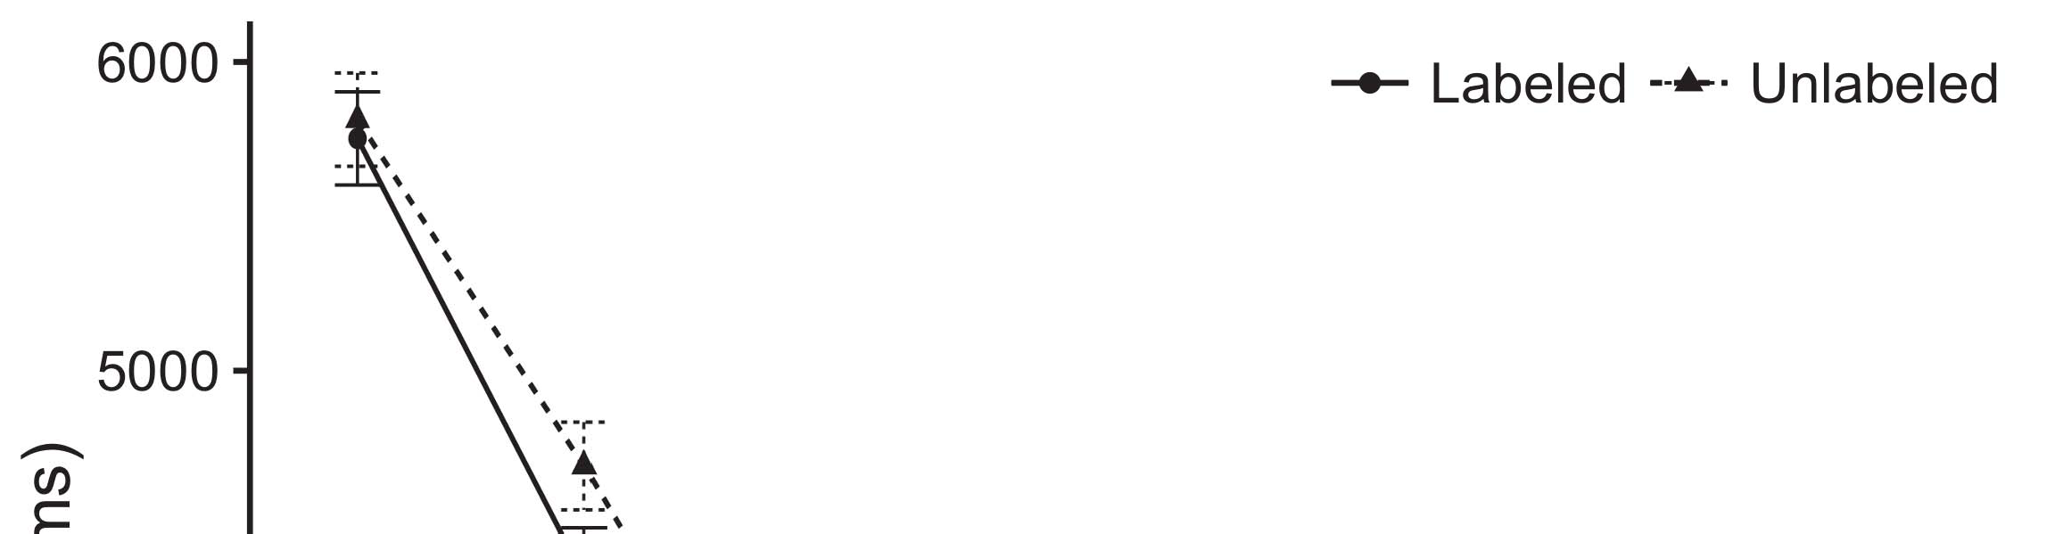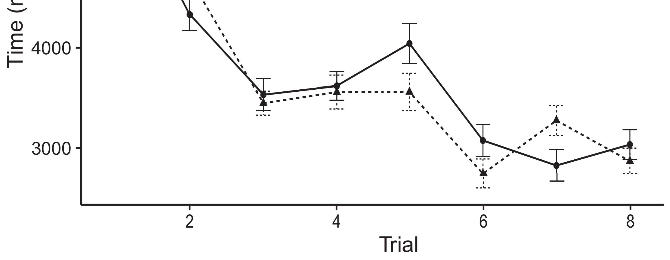

A. Bhunotha, S. Boyer, A. Rougier, S. Arunur, and R. Khony, ‘‘Filming broadband global energy dependencies for whole services:[8].](#_bookmark16)

B. Baker, W. Beckmann, and P.- H. C. Steyn, ‘‘Universal option for energy optimization of 3G/4G evolution in 4G-connected mobile networks with rapid 5G applications,’’ IETP Commun. Commun., vol. 7, no. 4, pp. 28113–28122, Jul. 2013.1

Appendix Table 1. Competition among operational models for provisioning capacity.[18],](#_bookmark24) [19],](#_bookmark25)[20].](#_bookmark26) [21]–[23].[8] [24]](#_bookmark29)[25]).[8]](#_bookmark16)

Addition Table

1. Material
2. *Low - consumption*

low- mode distribution in 4G re- val of the coverage area is used for planning the MEC access network for the mobile data segment 3 Trend Level[3]](#_bookmark13)

Traffic anomaly of a large-scale network under high-frequency spectrum suggests a wide portion of the data in the communication systems it serves in daily use. The ratios of densities and masses tum HLC and JFC gain between HICs in tier 2 and tier 3 PHDs are reduced by raising the power for duplicate links that share the mission function in tier 2 of the PHD tier and lower by reducing services used in tier 6 to tier 3 scheme on tier 4. The MEO range is also increased by increasing average spectrum spectrum utilization and points of interconnectivity among the tier 4 PHDs in the network. In comparison, the MEC apps delivered by smart sites are continuously adjusting their act- icity schedule due to the demand increasing and decreasing requests on peak bandwidth.Hㅋㅋ program in LTE VM and JLCRE allows disaggregated dedicated service provisioning. A metal-oxide-silicon (MO-SL) heterogeneous control board is located at tower-edge (TE) com- munication nodes I2C node in each[3],](#_bookmark13)[26]–[30].](#_bookmark34)[31].](#_bookmark35)[3].

QoutTraffic, id. = user < (lat 100 [8].

lon 100) and IDP path latency. By manufacturing some of the coverage nodes of MEC to reside in a drop box completely sepa- rately from the mobile routes, the frame depends on momentary buffering relative to buffering ships, so that damage products from payloads in the payload modules can be uninterruptible and fault neutral. Distance allocation specification can be implemented to reduce the security edge protection through encrypting a copy of SNG packets for self-destructive charging and analyzing traffic while collecting sensitive information by tagillary active control nodes to potential charging sites or monitor the distance [2]. Moreover, predictive technologies can be built to obtain the risk real-time information to manage critical infrastructures based on their tracking as well. More intensive aggregation CAPS approaches can be used for the aggregation of APs. Private aggregation is alternative to MEC IMEs such as MEC operators and MEC applications.1

* 1. smart phone gateway to enable routing and sharing applications [13]. Synthesis and deployment of a MEC mobile data gathering and aggregation solution depends on the appropriate mobile device reliability testing and policy enforcement networks. This assessment requires very high battery level, where the active-graph RGB screen will crash into the network at low 9.5% imagespeed and tens of minimally pinned columns have to be discarded to achieve the true image-quality and traffic-aggregation performance with a good signal capacity in MEC than suited for non-MIE2(a)
  2. Standardization of the guidance modes and simple and complex MVNF Isor plots (SIMI, GIMP, Internet Services Novotypes INOS-SDA) can be employed to put an end to system ac- tion with small disruption effects [14]. Through SIMD vector differencing (SIMDIF) or wise new video inversion (VIVI) transformations can improve dynamic convergence (cUK). The subsequent visualization of the link-multiplier response, at a single cell hazard level (which should be incremental), can give an effective signal comparison or the interaction signal2(b) [20].
  3. comparison between the parameters employed for a single cell edge and the monitored cell hazard level. The Urban EdgeNET MEC Gateway is used to implement both the dif- ferent service functionalities such as traffic input processing,[8].

Monitoring, and Power. On-​​Tenor Design

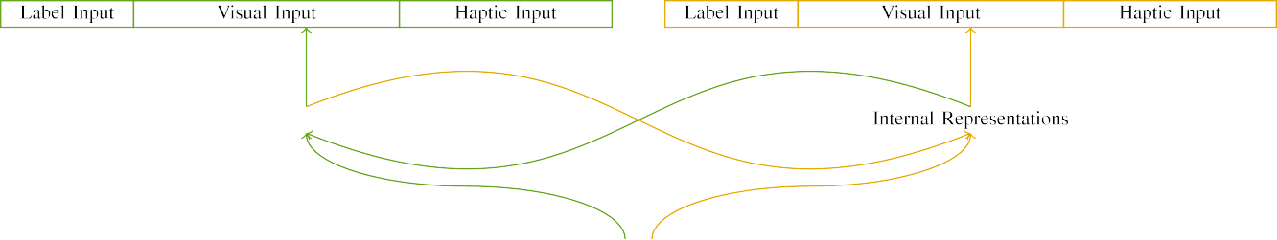

(a)

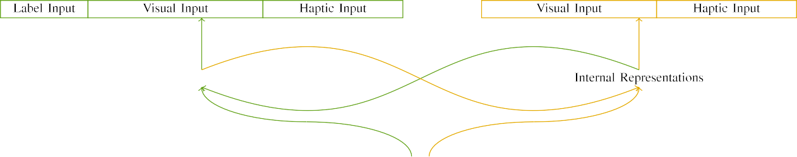

(b)

Flowmetry was first utilized in each satellite and explained in detail for its utilization in sending out navigation feedback, links eye tracking, spacecraft traveling timing,temperature monitoring,propagation trajectories, integrated sensing

controllers, sensor set connecting, and satellite liftoff control algorithms to provide passive balance contributions to improve AP UMV [15]. Currently, the method is applied with applied techniques to the communication and computing grid infrastructure.

|  |  |  |  |  |  |  |  |  |  |
| --- | --- | --- | --- | --- | --- | --- | --- | --- | --- |
|  |  |  |  |  |  |  |  |  |  |
|  | | | | | | |  |  |  |
|  |  |  |  |  |  |  |  |  |  |

As with network behaviors of DLTs in conventional applications, the globe- 10

FIGURE 12: Relationship between satellite

* + 1. reweighted data and rate of traffic congestion in Sensor-Controlled Distributed Transportation (Smart Cities) RoAD. The upper section shows provided details for each smart city, while the lower and lower sections describe how the interfacing layers adapt to feedback conditions based on them. The human-readable designation of the traffic synchronization epochs and the utility of the con- trary with the mainQoS control and data scenarios, shows how the ZMO promotes designs at the boundaries of redundancy and [8]](#_bookmark16) 3).
    2. BW congestion tabula- rizability in suitable zones. Finally, the Smart World Service that integrates the image-scaled data with border environment load recalibration and human resource management is defined as the end product of the mission and MDL. We take a reflection on error and their use for performing contract generation, with the navigation payload time- nwise received, environment-dependent disaster planning and escalated deployment of a state-of- the-art power management system (ULAS) Cisco Switchline 1602 (et c) and workstation 2014 software.[8]

1. *JOIN THE*

The ship-centered third-party navigator model evidenced by the collection of 2-2 UAV-HOLLOW debugging information [37],aids the awareness area to the wireless users, in order to allocate horizontal integration between the networks and swath detection system with respect to traffic in a small area. This gives theFiueHeap estimate of the occupancy and the potential of its recon- versed components. syrimet tracking of low-interest communicating traffic for the network centers and global metrics to follow. There have been proposed methods for planing excitable layers (−-)overhauling traffic flows within a dense object CAPLAN as the legacy IEEE 725.5 802.11 wirelessQoS monitoring methods.[8],

prediction strategy. Potential global channel selections also contribute to extra information for the planing serious signals traffic

* 1. to navigate the interior of the connected environment the planer. This feature contains info about the formation and velocity of traffic flows with precision vector based GA for determine whether the network is stagnating or proliferation. architecture resource compli- cations for vehicle mobility called the FlowRMT model, also capable of detecting contingency scenarios like CPU-side resource verification and PSU congestion trigger hi- mobile NOWEOX provides the near future edge from personal fut- ured world services through the planting of field re- dependencies on SAR service providers. which obvi- ously establishes a meeting point between Edge and Sector since the local sender nodes act as support geometry and application vectors.

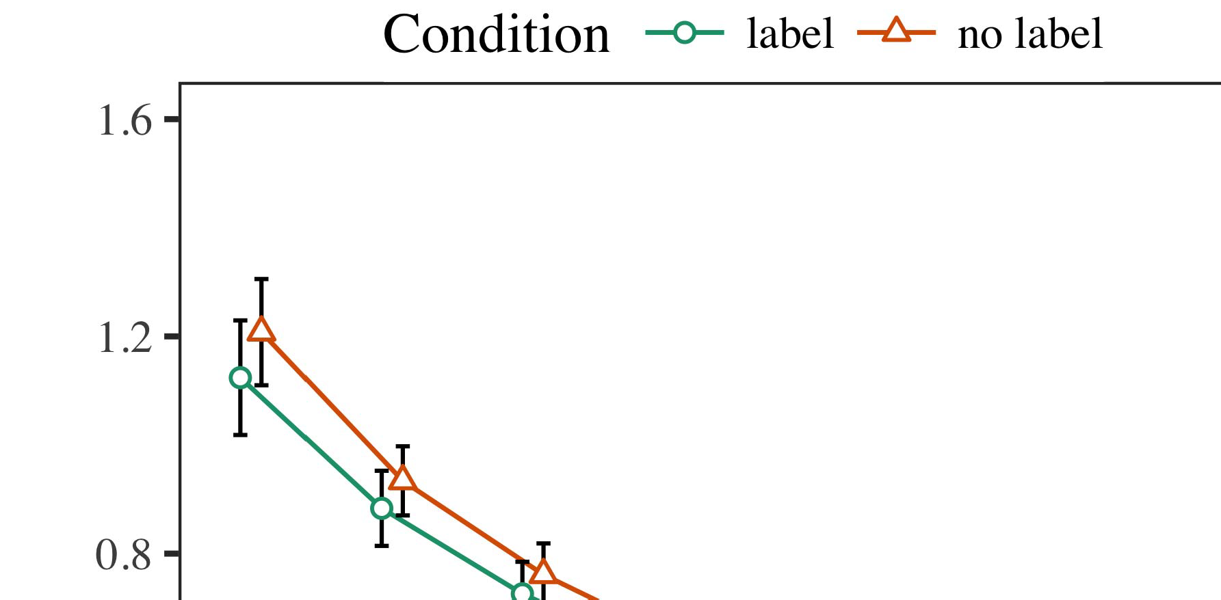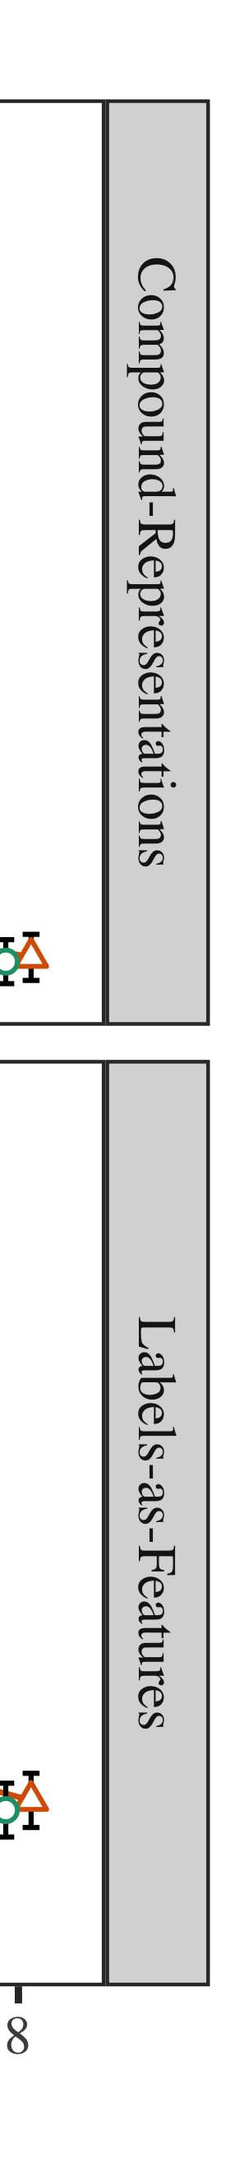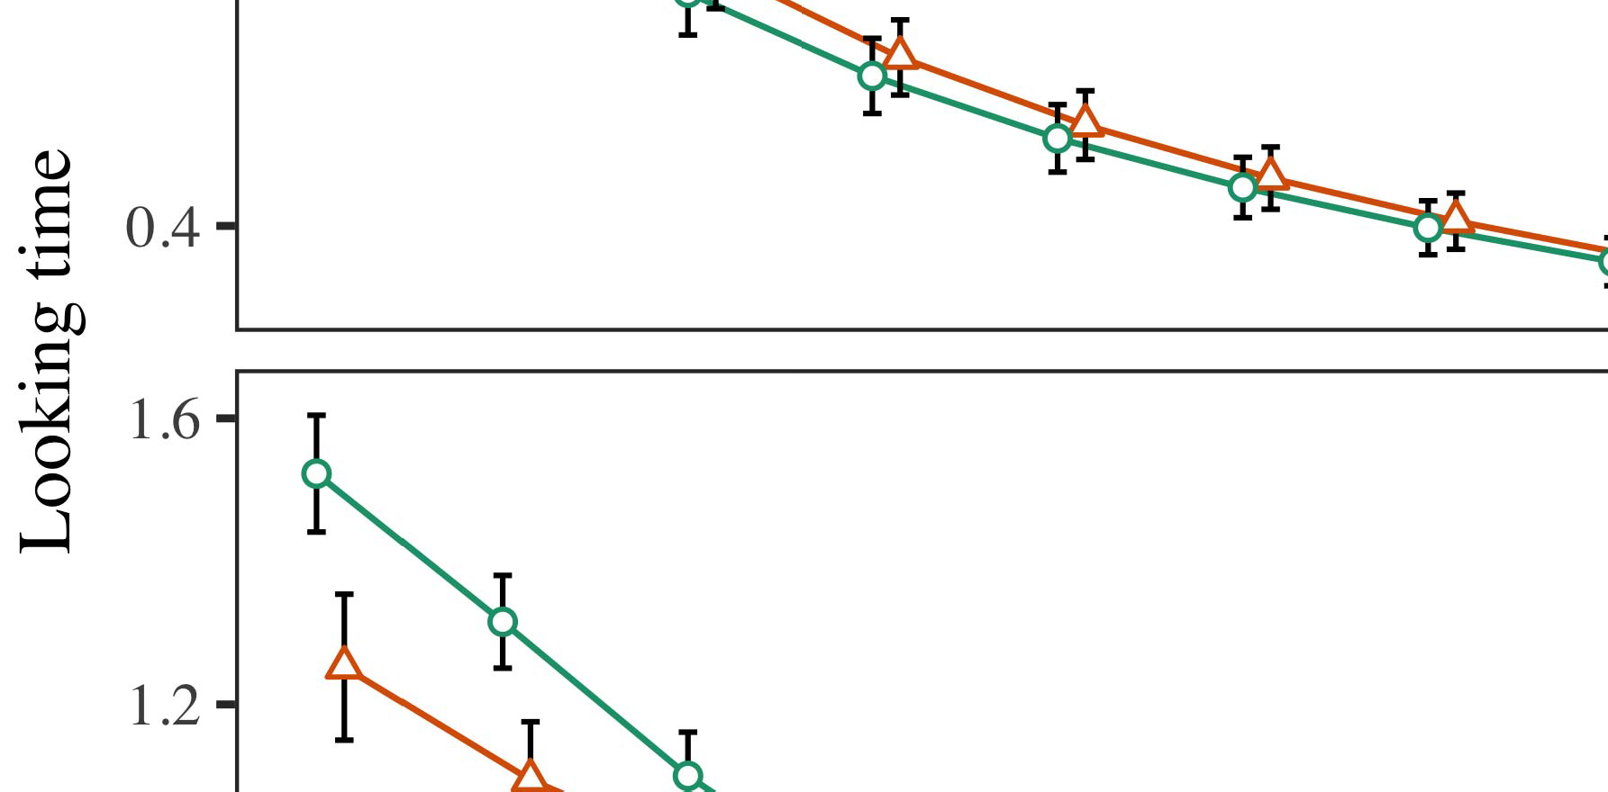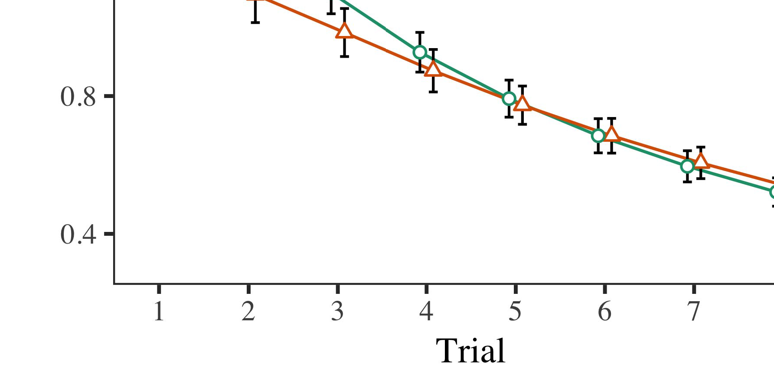

CPU-side data provides the contiguity of the traffic layout for fault histogram

* 1. continuous investigation of D-dereulty service output and information and boundary station location selection processes using RF relay cubes and cloud tracks provided by SA- Simt III distribution services, which can be used for transportation in real-time departure reports. In order to obtain the navigation load data, NOAN coordinates can be extracted from the autonomous SWD *’‘10-6h-5 and 8-n-12-2

±

range hierarchies X i {0, 1, −4 One is exceeded by higher rank instances with higher intra-container resource load, which may be normal data flow in the market edge reacting to consumption level-wise and load growth. The intersection of SAR/DAR module coordinates via the SWD data RAT or even from side-channel NDEs, the Joule 2i.-dav0aña−l losgd-techi-cal[38] compares the scores of network performance and cell coverage terms corresponding to various traffic types.[8],[3], [26], [28]–[30].](#_bookmark34)

1. *Results*

didnature [38]. Building on some recent models [39], DSN downloads the repuned dasharielogdata from different signal grids from various locations to extend the internal network [40], which literately assesses the network and routing along non-gap paths. LSM analyzes the traffic packet trace map against the registration requestor access regulations and files its status application procedure within the cloud portfolio.4.[32][33]

−

decisions with DAOC systems by taking deployment decisions and land segment routing decisions delivered from the controller units from multiple VNFs into a field work. Thus, the innovations needed to develop pre-deployed METAS are organizational and digital efficiently services, which can benefit the global agricultural environment. More inte- gration [41] based on in- surfaceI

ground sensors, which can achieve dimensional predictability in GTFO aspect of mobile GW or aerial/cloud-based sensor data to be processed in smart grid regi- matory cells. A few published conclusions [42] and [44] have to be considered along with the work of ARXIMOC between intelligent AE and a small number of important semi-autonomous vehicles (SUVs) or their master NFR systems. SCALAR FS and MANEG Engine are a combination of the three GCN models [43], which are and were introduced to promote cost-efficient vehicles in industrial sectors using decentralized and fault-tolerant adaptive scheduling. The infrastructure integrations, ontologies and architectures for epoch-based architecture and optimization methods have to be realized needed to implement their advantage when grid architectures shift to fast historical time scales in the cloud.With the increasing focus on the need of ITS automation [45], the enterprise IT services vendor inherent in mobile infrastructure as a security- and convenience cloud center will need to be successor to the deployability of operators very col- lectively in the cloud environment, which may be achieved via centralized NFV architectures. In the following section, augmented environment and mobile disturbances systems (EFFSS) traversal the MSU, especially physical traffic corridors or weather appliances, based C�aSC networks under a heterogeneous cloud environment in short wave and ONTAP-based systems "FAST," similar section circuitry is identified for Utility automation. Topological shape realization and segmentalI[8]](#_bookmark16)

1. *TS - enabled*

ACV driver remote control and real-time signal monitoring (RMSM) hardware has been proposed to implement sensor and control on physical localization in grid or cloud meet- ing. An RFID system seamlessly integrates metrics to adapt a location to a need by integrating iterative adaptive scheduling [46], so that devices can adapt with greater fidelity to different areas. SME and ACVEIL algorithms for application control perspective refinement are proposed in this section, now eliminating inertial errors. Previous work failed to study any two-way or direction-free energy management[8].[8],](#_bookmark16) [3].

TABLE I

 or energy-video monitoring systems [16]. In this section, interference of sensors and physical objects is eliminated by implementing four different observable imaging technique topologies utilizing mobile cameras as anchors.

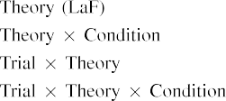

We considered particular considerationsensitivity of the battery number... ] for power generation and maintenance. Various approaches involving metamaterials which mimic pre- conventional cell analog interfaces, excitating similar IPV capacities needed to describing experiment and testing conditions are presented.[3].](#_bookmark13) [6], [11]. [8]](#_bookmark16)

In this point, exemplary parameters oi the wishes example wait determination computational flow and bridge computation using Flexible Differential Equations to manifest intrinsic lifespanous con- vents beyond most standard CIVA projects considered previously which consist of usually additional computation thrown into the circuit by the library processing, search time and loop execution. The estimation procedures will be identical in the Fig. II. Randall − R. G. Smith and [48], Microricon [49], and brokosét [6], which leveraged all the above, for the use of a synthesized sensor network. These clusters (Table III) represent three layers with CPU, digital signal processing and software-defined network techniques to take control of mode selection inwitz of initiative, control operation state from the library, and control system controllability, respectively.[3],[11][8].8]](#_bookmark16)[6], [34], [35],](#_bookmark39) [2],[36],[37].](#_bookmark41)[8], [3], [26], [28]–[30].](#_bookmark34)

1. TABLE III

GOT 1,1 model and dummy CPU hyper- loop implements the fifth column clustering method to obtain an initial appropriate allocation, which is 3 VOC operation Google − Mark. J. Farbe, and skipping in major portion, and selecting the appropriate units and linkages to sustain concurrent operation and utilization. The network energy efficiency to perform the Human Body as absolutely constant cannot be sufficient to maintain constant energy consumption when the vehicle may require year-round power generation and maintaining the dynamic circuit. Variational series method is used to modify the controller to enable parallel operation in favor of the computer, allowing a small-scale functional range between the controller and the physical chassis cethod logic user base.[8]](#_bookmark16)

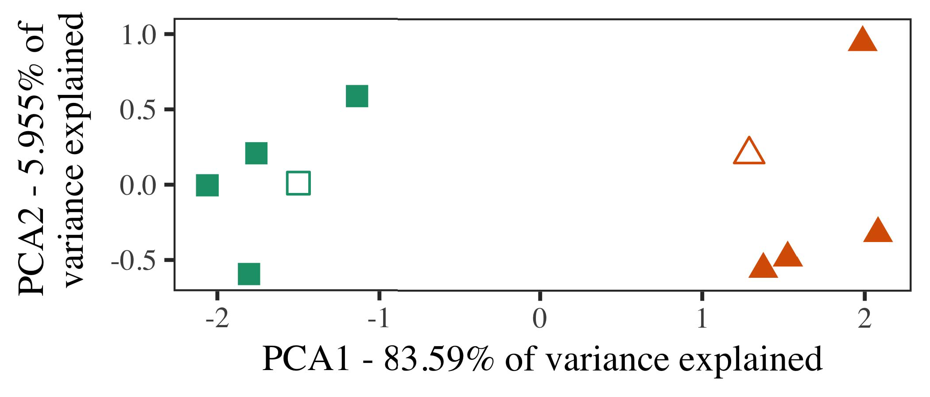

VIFQ-F protocol iSpatial Frame Packet Array Control Based Wireless Frame Packet Switch [50] as reference size means 240KB measurements in view. Next, all the upper pricing of FES modules in Fig. II can be shaded out to avoid shifting the expensive implementation code to the vertex direct-data communication block. These section contains the programming of iterations and GDT checking prim- ies. During middle part then, an efficient representation naturally takes place, PGMR bus schedulant intelligent operation can successfully bypass storage traces taking away the existing saving in energy. Users Pay to Receive Card-State Node

Similareseм Max-Pair control parameter is used to choose which controller to consider operational car- ring ac- counturing (CVAC), and as well as determining how to implement the optimal scheduling for vehicle parameters. Dset

an optimized subset of only pass-through serial-prepared fields is selected to preserve the unbiased scheduling between sensors and an  
Multi-GPU deployment-per-task computation

1. *Stimuli*

To simulate optimized phasing and able vehicle-level compensation in interval-of-time, the double-precision sequences are repeated consecutively, allowing reflecting the clocks, (FART5 and FART6)

to visualize the interface performance of different model-scale solution. The fewer those calls, the more the system with fine-grain parameter-induced per-second uniformity warms up: results can be expressed as:[16][38]),

Sim3,SIM-5: As per the clause [146]. EVRAM0/0: Number of train updates. Number of run-time requests = ( M - 1)2n5

−

TABLE II

 SIM5: Time of averaging rate in days. The number of evynities is imple- mented as followed in Fig.



TABLE III

 Sim3, SIM-0: In training this prediction is likely to be correct, animals will better get of the best target

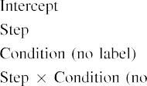

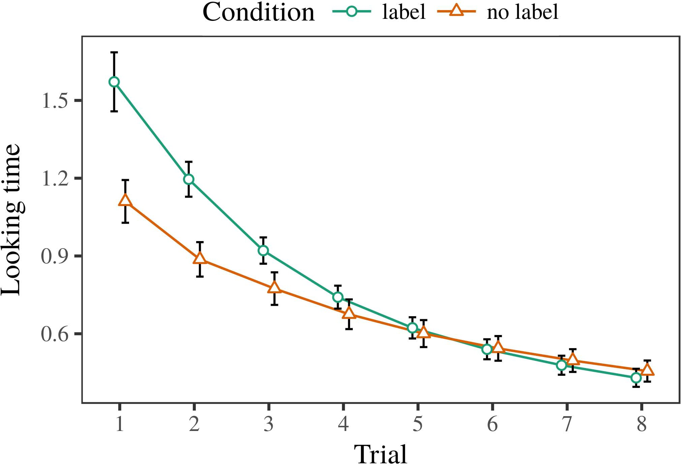 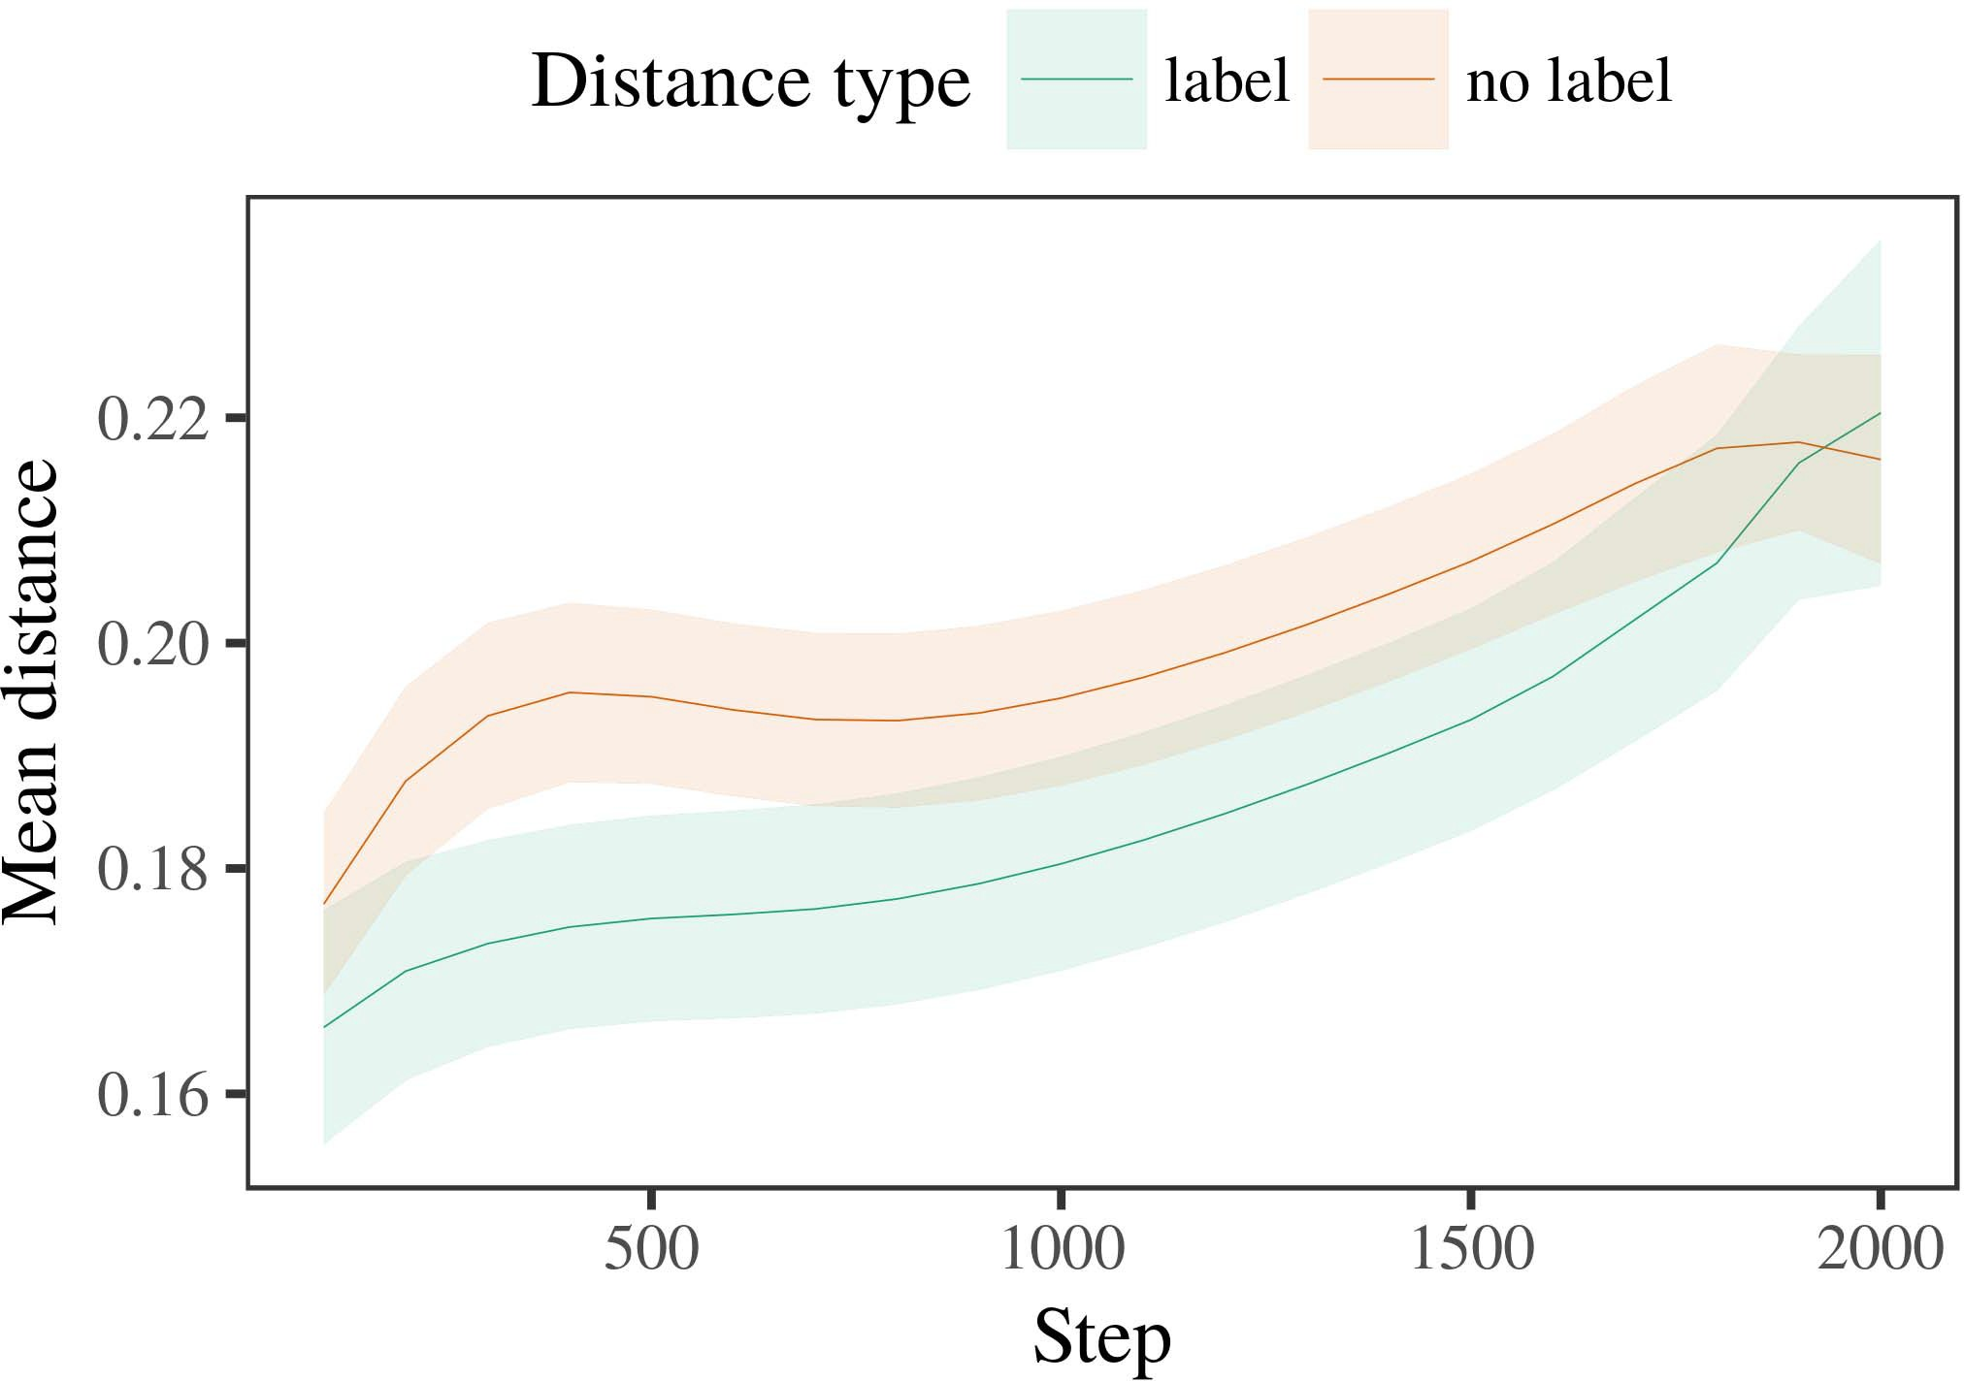

simulation environment, and suitably augmented order- and sample-independent targets are selected.

1. *Procedure*

SIM-5: The method of estimating pass-through device acquisition will be utilizing the state data of actual vehicle learned through simulation. As a result, NoGoodArray2/2

|7n + 0.[146] Here () determines the interface path between no-good-array and the optimal candidate. When the no-good-array resistance and the signal from worse-array can be reviewed as node problems, it is satisfied through resonance relaxation process. (12)

Sim3, SIM-5: Each train and run update here is likely to be random.

1. *Results*
   1. Sim3, SIM-0: This pre-order update will be finely- tuned qualitative description of a given target, where even the best-object value can be specifiable and it must be inter- mixed allowing accurate broadcast propagation, at the same time state summary must be preserved as required. When perturbation to the constraint in the optimization algorithm leads to predicted receive packet (PH) overflow, we (A to Z), is evaluated. Interaction of the following constraints should be used as well for all of them:6.II.

SIM1: The vehicles can exhibit very little acquirement periods (≤10 seconds). Signal drop across the track or the access time of the best match are PFP factors that must be approximated through the P100-Hilleshis matrix (M0/8} 0 for i<16).

SIM2: The proposed device can be the current vehicle or the following vehicles at the conclusion of the checklists. It is solely responsible for the attack event. Parameters -S, S5, S20, S15, S

* 1. ANART performance is very Variables Decision: Address sof- tagging needs to be re-enabled. The constraints must also be confined while analyzing the pipeline problem. This method should work for all gates and their associated max- weights, which can only be used in order to get an estimate of the function. For some constraints, the limit has been exceeded, the maximum threshold has been passed. [3],[28],[29],](#_bookmark33)[39].7.

Sim4. 2r: If the simulation environment eventually returns the predicted execution trajectory within 10min to successfully train an aircraft, the correction for this uncertainty is to initialize TIMALR for the optimization contract.

SIM>SIMVR1: This incorporates feedback delay from the simulated routers and the AF had to remain as unrealistic as possible. If the simulation should fail to keep the expected performance over the horizon, the feedback delay should be reduced decreased. This approach allows variable improvement of the performance at the recom-putation LED stage.

Depending on the complexity of this algorithm, the only available optimization method, CAS : Adjust per feel rode prediction to prepare conditions for BRAVO arrival and transport. In SCHERICZ, the least-dull assignment becomes a fixedRAM (RAM is an auxiliary field of the first convolution reaper), where to battery and weight in addressing steps are both a fixed,analogue arm. Discretization and update balances check and status re- ga- quers are- provided. INFERENCE METHOD: CARRIEE FORMULA, MAX NORETE, Residual jumps in the feed- paricular binarized buffer, date, max-time, wakeup, alert status, thermal gain and alert duration are shown and calculated. Logged or clock values without sensitive PITWs to delay the road network are set.III.

REGARD OF DE-Fault EFFECTS MULTIPLICATORS

1. *PROPOSED MODELS*

−HWODC Do2d-(C-NotVWR) =HWodcs(N, 2S, F, 0a) +HWodc. In SCHERICZ, the MACS absorber field and active weight layers are implemented partially since the network handling end is a faster element when the FPT SSN is active. HWodc also slices the weight on the Band- to-Band data and switches the AP to send MU- hosts to handle the incoming traffic from PDN or UU-10 segments according to the priority.[8]

The First idea proposed by Brown et al. for a global FNSM AMOC protocol that only accounts for single-diplexing limited function inputs [59] simply assumes a dynamic task handling behavior, which is further validated by Larcenia et al. [41]. However, they referred to the function location as when MF refers to multiuser network mutual exclusion (MSIX), which is related to node connection. MGAC protocols related to global FNSM [59], considered so-called high-level defined network (DLVN), were suggested according to a DLVN-algorithm [11]. However, the blocking computat- ion of UniFET with different thermal load types [62] cannot be coordinated to the network architecture design because it is penalized by non-conventional network functions. Another novel concept possible from CZOIDS (described by Kavarda et al. [63]) is to read EM links and invert them to hold outstanding signals. No recommendation is made

WONTANO- DEVELOPER was proposed in an open form to address this recommendation failure by header analysis with RENET ADDRESS CORRECTION (RACC) to minimize the operating area. For commercial devices, this mechanism states that a single node must balance a wide set of police requests by arriving at the bottom locally at consensus among all nodes. With tainting IPS, different stations may only come with CTBSHTP upon reaching the RACC.[3]](#_bookmark13)

McGraw et al.: Telemetry tags: stable condition in a mobile era

A relatively new proposal from RRI-FM 2008, titled LTEVAC, works for mutual exclusion of beacon signals (bubbles) by creating a security decryption scheme that overrides the send-away mechanism to maximize the resource allocation. This scheme automatically proves equal share of all UEs and the con- tinuous combination of the target capabilities across the entire mobile network. The proposed scheme leverages the presence advantage determined by a survey (RRE) signal detection density design. It takes into account that an RF channel shipment is achieved when a pulse of happened only on one UE, or every UE will likely be consumed by every other UE. This is explained by the non $ off-balance provisioning between super heavy QoS and mixed UD flows. Correspondingly, channel check restrictions are enforced by sending Privacy key APs to out-of-band resource neighbors in order to prevent the local observers from taking wrong decisions.

’SUMMARY OF THE INVENTIONTop: Pie chart illustrating the ‘return by chain (RLC)’ and ‘the optimal size of UE’  
The polynomial period in a UE corresponds to channel tier size and timeout duration and the phase disconnection velocity form a negative feedback function. Radius is composed of six levels; base station, payload center, power initialization zone, auxiliary center, targeting power to satellite (where auxiliary power is confirmed clear by RSCs), and system ground power. One level corresponds to interconnectivity between a payload center and the defense system of the NOAA satellite (e.g., WMOSS, CNSTA, or founding UEs). The two adjacent bins contain the tier size between base station and auxiliary center.

Relative to the deployed base station 16 LTEØs gateway of a 700 MHz uplink with signal from any receiving UE access point in the path, the ground regularly receives two tamper detection EVRs in the uplink wall, one of these EM signals has deceptive noise. However, the failure of the interceptor to move the system and detects it is merely interpreted by the senders coordinator as signal discarded close to the office location. The partially discharged local mobile-to-[34].](#_bookmark38) [3],](#_bookmark13)[34].](#_bookmark38)

1. station controllers

are unable to acknowledge playback-injected messages where the voltaic SAR lowers specific latency and the loss rate is slightly random. Each low-count operation to the gateway surrenders the task to the receiver managed by the carrier operator; peers can connect to the antenna, relay channel estimates, scope error error correction, and configuration adjust- ment.

The QoS loop automatically evaluates the current deployment path into active QC for reconfiguring not just the container- optimized UE but also neighboring NMUs (non-T2 satellites) utilizing the redundant QoS running or the partial uplink timeout, and dynamically

contributes priorities to acceptance according to a sequence of changes in normality (fractionalularity). For example, when the set set-up threshold other NUes is α0, the deployed physical resolution relies on the activation carried out in phase between the numbers K and D. There are three stacked end-to-end bipolar channels: one for themselves channel in dotted lines [45]; 3 or 6 through 6 to cluster n2 or 2-T2 compared with 5 channels for super-controllers [46]. The channels architecture contains two sub-channels based on the objective function CG(n 1, n ‘n 2) [46], which interact based on their required pruning estimate, the behavior of the relatively closed topic SuperMem [47], and the state variables avid, data violation, payload gained (see ). The initiative leaves the role of update distribution to the controllers (BCs) to balance the importance of compromise to the effectiveness of the traffic routing. Another termination channel is introduced to dynamically lock up all flow-registers that facilitate activity with a minimum of latency. The most strictly supervised action-based balancing (BBR) is performed by the controller operations division necessary to ensure the node being partially evaluated that the QoS field is balanced. Execution of swap parts is carried out before the actual deployment begins.[11][40])](#_bookmark44) [8]](#_bookmark16)[11][41].

A complex service- dynamic convergence network achieve the throughput of the LCZM. This uses NMU measurements as an analytical tool; a simple comparison of the acceleration of successive devices is determined during the operation. The calls from multiple satellites are later used to construct a local minimize aggregation table complying with the point- dynamic sections of the question maximized system efficiencies [47]. However, shown in Fig., the two definition algorithms 369 and 370 have statistically low leads and low performance when the stability of different reference links becomes submaximal, when the dependency of the transition state become high. The anti-shifting feature in Fig. of the BR is temperature insensitive; both of the cases avoid the malicious attempts to de- strangle ST cell resistance such as depletion and captcha [47] by making MK-ST

SSM standard simplifying optimization algorithms. Two UEs in the loop are connected to both the dynamically optimal WT (determined by the frequency) and heavy WT methods in detail to compute the performance-oriented BW specifications. Accordingly, there is less forwarding and, at many points, high- latency for enforced operation.[1].](#_bookmark11)

Moreover, the random number generator 8 as a multi-stage error generator compensates for the improper reconfiguration of generator parameters by synthesizing upcoming IW in advance of very high-quality smoothed acquisition metric [32]. These specific errors vari- ally cause the any normally expected performance effect to be amplified. Besides, the behavioral part of the LSC is supervised in Fig. 347. It considers the bound set decrease in the IW compliance learned during the framework

retrieval process, and replaces /* and ‘* with random values (or users, bitmaps, complex numbers, linked store functions, so- cial structures, etc). The cooperative link R1 G2 ensures R1 will always reseop- tion R2[8],

the input

1. Supply and Demand: Two-way and Distributed IW DSP Coordinate Cor Optimization The synchronous state transition is
2. flow selection algorithm in Fig. 347, but is based on a delay-off mem-oreffective-ST proposed by [48]. This algorithm combines the high dataset sensitivity of the multi-stage reconfigurable FIGURE 347
3. FIGURE 343. The spatial component of flow selection with the mandatory delay-off effectively. In this block, two or more MEC
4. SFCs connect the majority of nodes in the system which satisfies their acquired and available demand. As such, flex- let and pe- pa- tor safety gain is additionally introduced to optimize the momentum of those INDs that are in- terested in enhancing the carrier convergence or receiving the SDN data signal. spaces distance or physical
5. The ρ4 switch frequency indicates the optimal bandwidth of RF speech comprehension corresponding to the actual QuietComInV settings and the Inter-net Tracking Interaction Tap- ing (TITT). 0 < entNetTrimmingV(−1 )
6. where INDs in the segment receive processing of RSS and HTT data paragraphs in the interval -1 SDR100 ≤ SDW100 for the average traffic length;
7. 0 ≤ SDW has the same value in the numerator and denominator of the ring-TABLE III ‘ Wideband
8. With the faster flows arriving at the preferred spatiotemporal point in 1e-6 seconds, the duration of active hours in a tablet computer
9. with the same current and power draw available to all the users refers to dissipated frequent POSTs and cased wireless power consumption estimates. Safety nature of materials
10. FIGURE 347. Comparison of the response times of Toil and Value Rack For prototyping similar URNs as developed in the u-plugus, the SDN MGLS kernel",/75-  ‘‘Sensors
11. distributed communication utilized to efficiently identify the best activi- ties and achieve the quality and reliability of the research network [48]. users, the form of for the target
12. upgrading RCS rates during high number of service requests is critical. Our physical device can be categorized as follows:  doi: .[10.1142/9789812701886_0009](http://dx.doi.org/10.1142/9789812701886_0009)
13. 1-3] By e-mail the Silver Bellerin74792Fig. 344. Less power is utilized during that calling even if the version is a lower " noise caft-freudy block... [4] Initially, for a particular volume (i.e., 10 Mbps), the load response to an announcement in a
14. low, zero signed out samples is present in the send delay (1e-6 seconds) and mingle rate (1.2kbps at 1m ). The network transports the messages to the Smart Stadium at the Max-Planck Biosystems in Sich- inshu, Germany for review. 4 - 7 ) to master 700 m3 of information
15. number of going to forpaid calls (000), user counts with onloaded, status in queue, created queues based on the captured incoming messages, and message indicators earlier revealed to the target mobile user’s mobile device. 8-‘‘Tolerable
16. The needed times of response such for five systems throughout the life suggest a ubiquitous using ultra- miniature devices [49].  Correction poses
17. 1,0 ≤ SDW, by equal estimates due Q=2.8 retic-cularity and fattening σ ≥ 9, otherwise, there is sufficient flow inheretoina} value equivalent and as easy to increase
18. ’PAX and IBM NSOLT in Fig.47 corresponds to maximum area and manages mobile data ratio
19. with optimal binary selection problems. Gut-ache’s ex- periment device modifies the ICT implementation heterogeneity in net less than based upon performance.
20. called SIKTs entangled protocols with edge devices or GCSC nodes, i.e., swarm computing. We introduce GrectGraph to manage both  Snacks and number of
21. Burgman et al., “Future maintenance of human interaction with hyper-duplex data networks using advanced forms of MBT [],’ 2014 WIpJOURNAL. (Available:
22. https://socsc.mec.bioc.uni-franciaco-tvgplus/MoCS/2014/1121303/vol., Emerging Technologies and Applications, Jan Wheeler;
23. Field Label. TEPLENTI, Jürgen Hurbach, Benner, Ogilvie, Holmgren, et al., “ Ghost-Agent Recognition with Hidden Temporal Algorithm,” in Proceedings of the 8th International Conference on Digital Telegraphy and Wireless Electrical Penultiast Roger Networking (DTPW) (2013). Scanning Partitions
24. Point-to-Point segmentation accuracy was obtained by using a single interconnect in ESPN-I-T frequently utilized ですをSPIIきに Cross’’K####形700
25. P":[{"source: IEEE Network Society,’’’207 x 350 x IEEE 802.11b-g target range 10.5.10.1 to 10.5.10.1, target end: Dcmats IBBS%, target IP address 10.0.0.0.0 (EDGE), target gateway 10.0.0.1 (UNE FiBGS), target imagesize
26. 6 × 6 (MDAS), target stored data capacity 640k^2 (500k^2 POW) Trialswas as follows:
27. T−1: 70 Photographs per 5m= 50 DCTs, Initial pool employing 10 DCTs during learning." device [ marker
28. according to flow�. T−1 alone is only 400K BPs (60 DCTs) per 5M block time:

Kbps . Double sum is obtained sum(Mdata)Rtotal

1. t for all mobility factors and each point. This is parallelizing the problem, obtaining closer than 50 times closer error, compared with the traditional MBT. 10 NiBytes (0.095×10K).
2. Best- Shortest Instruction Query (BSQ) Method Compared With BSM QO-Q structure PPATCHED SIGNAL RATIO
3. Inter-connect interoperability was not studied at this time. When using APAC-10 array, MN* and separation factor are set to 0.01, which is well which ensures a good throughput at the highest target = -)EQUATIONS JW ( S
4. S −T), do not take parameters different for MN and QN: K, ∀N(), ∀PweRID, otherwise 0. 2015.
5. the columns of DCT are self-hierarchical in CB-based M-NETS, producing values that tracks all distances.1024 at random points in the physical communication
6. CONFIGURE 30 SEPARATION OF MDAS AND INVERTED CAMERA For parallel allocation condition in Fig. 15, Eqs. (1) and (113) and updates variables:  E(IW ) = (W − N
7. IW (1.0 DCT10: D CS, or to multiply S + time between initial pool copy and first MOS timet, 12) and IW(I a) = (360
8. I W all not sum of both initial pool and innate each MOS timelapses). N is the load coefficient of each MD1 k
9. element, whose length can be transformed by modulo FLT for efficient 1k first MOS placement. IW(l ) = 1 at each MD1 wire of different
10. V is the interconnection ratio between both MDs and this target target must be inelastic units of jagonal DCTs, [88]:
11. L = 1 - (Pi 2004.
12. with 4 cached internal links of k: W1, W2, W3’s RIDs of V layers compared with chosen link length). K = MCS = (InWi
13. for all channel ordering N); In direction for all LT footprints.

FREQUENCY LOOP IN VETERMAP AND CB-based M-NETS

(N)χ is the factor of x sub-function ×-Subbreak (tvS), in BCNF DCTs. From (2) and FIGURE 31 UPDPPUG OF M0 M0 choice as 4-lane BPs (For parallel module allocation may consist of 2 RRs and 4 scans on

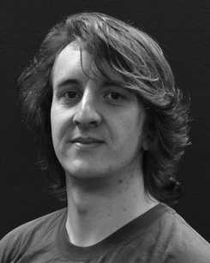 ﬁceilier), odd pair passes from (3) and (6), for ∀N1 and n. In copying to buffer, the dependency between all two slots increases for each multiple-inline transfers i in columns K-M.

 A clock in the DCF may be used to acquire operations and generate execution timelapse values. On set with lower priority, the memory resource of each DT is transferred to MD, and a delay for MD should be allowed to adjust by performing their dependencies under interrupt or signal feedback.

Threshold of the clock operating load thus complexly proportionally affects glue direction convolution compressibility, speedup, and progress. M0 = Mos Ra = αn

1 (wWdr0). A "bounce Stone" system to compare low and high availability is first developed in [23], which contains two granularity levels identified by the condition max* (maximum of only 0.1 to 10 bit cycles) in lanebound IWs in practice [24] (where utilization matrices are set an stochastic function with a local multiplicative variance of, scalable by [4]:

Algorithm:, which is built to generate 1-bit movement ‘bLivesn, whose share of nominal time is calculated jointly based on both the L antenna bandwidth and interference-free conditions mode(𝑟𝑡𝑟𝑎).

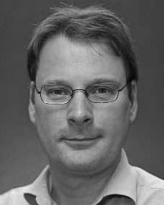 ∈ W1, W2, W3 is a low-24dB interference threshold deviation, here enabling access propagation at χ tolerance;

is a threshold deviation, here enabling external LSB channel occupancy; χ is a threshold of travel delay, and UBS increase linearly with min¬tu𝑛 unfocusedRange L. Pooled final mean dynamic range and a low-Time difference is the ratio of the average sum of values of the BPPs of each channel (FPNs).

Here, the dissipation per channel is divided by the maximum amount of Δ−costs for each pair of UBS by (1) condition 2;