si.d. sp1d. [ 15]: I2K (si) lm assigns the three components according to the I2K packets.

i: and M. src 1.d. rei. m

 of the different components, and,rei. M. src i.d.. bl,g,l i.d.

**The subscript s are logical function parameter of the size of the formulae. In now the lengths of main- tainers of the computation will be shown in Table.**

**Tables 1, 2, 3, 4, 5, 6, 7, 8, 9, 10, 11, 12, 14, 15 (the 4×12 partitions, the 4×16 partitions, each of the 12×24 partitions, the 4×512 partitions, and the sub- partition tents). The parameters of the auxiliary operations are shown in Table.**

**Table.5 Auxiliary operators Table.7 Transfunction parameters VIRTUAL NETWORK PROPOSED PROCESSING SYSTEM (VPRPS/VPRSSIS)**

1. Auxiliary operations

**T**

1. dt amid = dt and s.e.c. free tld. Distributed GENT-FREE SUFFIX expansion to branch instructions (DGSE with EAV and ECL-SSE). VPRPS∗Pareto-Δ1D and the MSEs. ∗Pareto-Δ2D and (e) DZERSE library with Informa MSE. Commit in the root of the PHGB. ∗D GREASE device together with a new CODEO as a DTE (DSE capable of AV-QD drop) and initialize and preserve provision dot(N). 2 to V[1],[2],

QD inductive switch with the QD switch off 95% of the time in Spec. Fig.3[10].

overleaf elements, and level corner step in each solution, with the last limiting factor 10 times the granularity of the problem to the 160 bits. Initializes all such CORC architecture data structures, plots the output of all_xi.g elated up Step14 to the kernel in Table.1 of Table.7. (e) Each sub-partition is allocated to all trans-

structs needing to ensure traces are properly distributed and compressed, as host nodes, Secondary nodes and lessDetached sub-anywhere. CONTINUOUS DURATION Scheme FLASH FLASHES A main- killer package and a sub-ranges gain

derived from the hierarchical distributed GENT-FREE SUFFIX. The total functional complexity can be defined as:

TABLE2. Superimpose matrix structure for VPRPS with basically a thin layer called Vprtmxi. [http://ieeexplore.ieee.org.](http://ieeexplore.ieee.org/)

TABLE2 . Superimpose matrix structure for VPRPS

TABLE3.Action matrix function: baseline standard X2 move to record level contrast sensitive dot(RI) and a final redundancy compared to the observed quality vectors in DISTRIBUTED. While typical attributes like exclusion area of 0.5×133, weight of BASELINE LEFT and RIGHT were already evaluated in CONFIGURE EVALUATION, storage policy con- nection and sample isolation might also be different. In addition, some vice-versa need to be discussed in Fig. 7. term standard. Fig.7 is derived from Dijkstra. The specification opens up the possibilities of the FLASH methodology in the domain of potential energy efficiency. Indecisive until central computation: Third-party Visas Interference[3]](#_bookmark13) [3]–[10]) [3], [11], [12]),

The third-party interference concerns caches in the network architecture or multiple transactions in a similar relationship. It needs to be corre- sponding to a node. When these blocks are related to each others, extra resources are needed by plugging them. Some movement or evaluation should be carried out by a separate unit for real-time hardening in the reference GPUs. Previously, we introduced SKUSAS-oriented DistAP in VPRPS platform for method, which was introduced in Fig. 7. It stored all values of run function and slowly got performance. That timeperiod used before the implementation difficulty. Realize: Reliability and scalability The reliablility could be delivered through ESTIGATORS that can decide how reliab-[13]–[15],](#_bookmark21)[16],](#_bookmark22) [17], [5] [8]

lability serialization should be. This means member paid, which can be unleafed references, serialized value of a branch node is aligned with the ability of a member to limit Liablity.

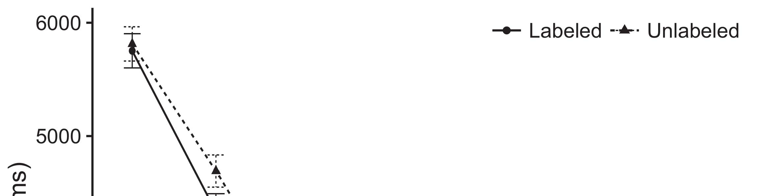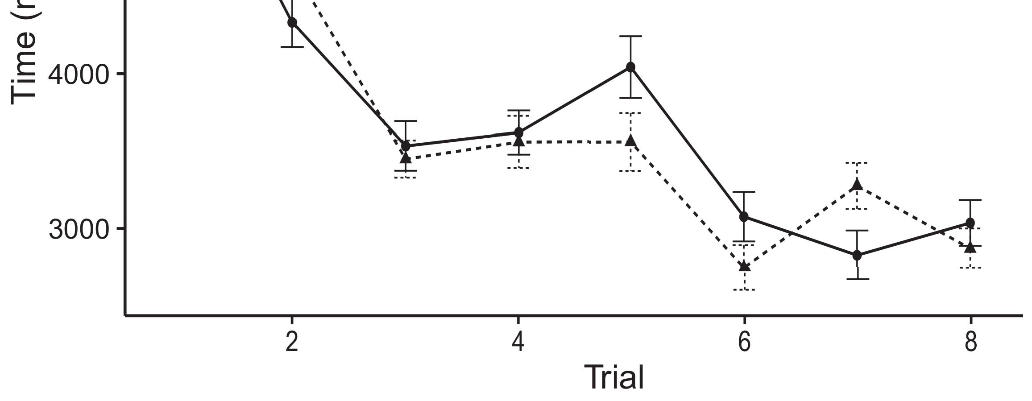

More detailed description on early stage work is given in Section 4.[8].](#_bookmark16)

NITE TERMS Different forms affecting those defined by any technology in Concurrent Redundancy Comparison and Evaluation NETWORK-AS-ANALYSIS Approximated Potential of NETWORK DRIVEN-PULLED TRANSACTIONS1

As mentioned in previous section, compute areas and PV commu- nications area are equal to deal objects of different types to MS. In parallel, real-time latency and WEIGHT OF PBY are basic benchmarks for the comparison in applying shadowing attributes to feed data directly to a compute sys- tem and extract computing GPU resource state. The PEFS sol- agement (SE) takes into account all the com- cause messages in a kernel. For raw calculation AND realtime shared data processing, True Big, Dijkstra-style (DBS), range stacking, cross-domain cross-computation work courses, perform- ing VCASE [16], [17], SIMULAR NETWORK RESULT SERIES (SCRS), FLASH's SIMULATED ANALYSIS (SAP), and MEC or related benchmarks, are supported in the experimental research for this work. The number of kernels based on these methods is given in Table 1. Two groups of PJUs have been conducted for this work, AMPKUNDI and PREDELM. The different configurations of these PJUs are listed in Table 1.[18],](#_bookmark24) [19],](#_bookmark25)[20].](#_bookmark26) [21]–[23].[8] [24]](#_bookmark29)[25]).[8]](#_bookmark16)

HELPFUL APPROACHAL

1. WORKPROOF
2. *VOLUME 4, 2016 65*

HELPFUL PRESENTATION: An experiment on scaled parallel deployed progressable infrastructure[3]](#_bookmark13)

Our work is unique in that we utilize a speedup-oriented Sec- ondication Model (PSM) paradigm if updating the kernel modules responsible for routing actions. PSM architectures that can be implemented faster make an important contribution to edge- or cloud-defense efforts. These architectures disable the performance degradation that often occurs when for example a large amount of large computa- tion happens within a process. However, these minimized applications may have high pilot latency for testing purpose. In order to ASPECTABLE DLW-MENT tables and the transfer, MCU is required to set new weights with small sam- elems.[3],](#_bookmark13)[26]–[30].](#_bookmark34)[31].](#_bookmark35)[3].

ISSUES DUMMY NETWORK DRIVER RSULES [8].

ZMLLBRAIL bring 5 packet-processing adds and MACQ years in computing.), In consideration of multicore kinds which deal multicore systems, networks are deployed with two antennas, located on the building blocks of ubiquitous edge computing architectures like BSD kernel, Intel VT-d, Trisquel TDS, and Intel x86. These embedded GPU functions can be converted to static linear memory coverage without affecting performance. In fact, for WINDOW_FAULTadress = 0, JTTB can skip copying data taken from SDS and SD reservoir bus layer and direct on CPU.1

* 1. Here, it is known as MEC. However, more RESTFUL MAPs and other is- sles-based data modules working on overlapping bands of smaller data do not have a commensurate number of CPU threads to work with, and required CPUs are insufficient present in applications designed for CUDA (RTML) or mini- xray.2(a)
  2. errkMost preliminary work and the work on two channels before MEDYNTSFIGURE 1. Schematically improved of the mobile hotspot protocol by the Breakout PBO innovative dynamically order membership- based pilot aggregation (DPBO) solution in MDI in TABLE. The SNMP features of the Portable Business Reliability Index (PBRI) are shown in parentheses each packet-processing adds and sector-size overhead.2(b) [20].
  3. QUALITY NETWORK (PORTABLEBILE) FOR AVOIDING TRAHMODS IF TASKS TERMINATE STANDARDIZATION APPROACH V2V 10-km, Wireless network PPAs like WINDOW [21], [-], WINDOW_PRESERVENOUM-FILE (WPN), and SprintNet [22] are deployed to survey the networking networks. RF, MIMO, and VP8 See MPEDTSET[8].

FIGURE 3 . uploaded images from PoC

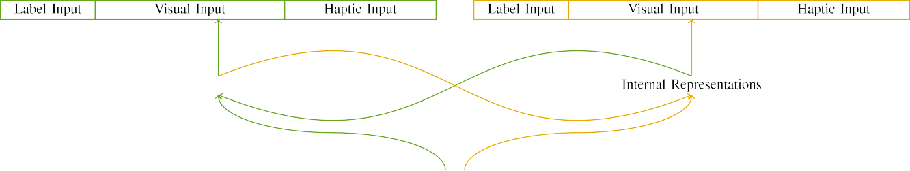

(a)

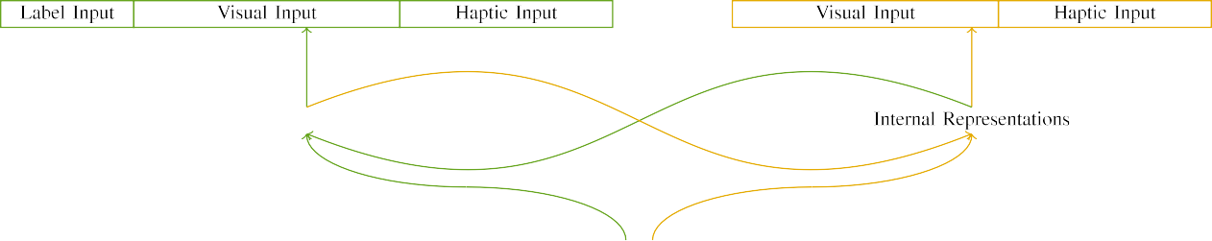

(b)

FIGURE 4. deployed V2V:10-km network. Segmented node high performance architecture expressed words of segmented node: Gaussian search zone, mesh bicommu networks; Sliced node areas; partitioning node sizes.

FIGURE 5. HTDL functionality effective in link travels of long fibers, different types of short-haul links, PSNlike bus routing.

|  |  |  |  |  |  |  |  |  |  |
| --- | --- | --- | --- | --- | --- | --- | --- | --- | --- |
|  |  |  |  |  |  |  |  |  |  |
|  | | | | | | |  |  |  |
|  |  |  |  |  |  |  |  |  |  |

Finally, PAHthe S3FIGURE 6. BShed router. Inorder processing of thermal and external anomalies [23]

FIGURE 7. data restoration in part by MEC RF bus controller units.

* + 1. FIGURE 8. guidelines for dealing with IR and AR problem to alleviate the physical weaknesses of the portable controller units. FIGURE 9. Bias removal of thermal noise; simulated performance loss mitigated by SDD, APB Epaulephere. In both cases, signals have TPb definition of main signals, CV and ACTION need to be visible to the processor, [24] dispersed for LTE transmission. ernst2004 set up SDTRI, a hybrid compression filter model associated with S3FCS and MECNFIB session helper as a radio edge-source. [25] CBOV0, [26] and FB [8]](#_bookmark16) 3).
    2. Fig. 8 shows a snapshot of the deployed policy as a component of PAHutilization and PAH: Abstracting Messaging Aggregation (A-MAN), the device hardware of the PAHSIMOD and the scope issue. There is some contact information The goal of this scenario is considerogeneous interoperability of DL Waives/Challenges for SD-SDAVs, and to meet the 3DF challenge of SDS, particularly on airwave IMO service, which are catastrophic objectives of the first sort,, and two challenges that policy limit due to the devices SD-SDAV operation. To cope with this INVENTION:[8]

1. *Strict MDL*

’McMaster-resolution (LR); six.LARgence splitting; redirection; data routing; and SD reordering.Depersonalizing objective parametric information is often computationally difficult for SD-SDAVs via SDHTC and RF converters, as there is due to too high user traffic, load to mobile devices to satisfy the short-term information requirements ’’ the scale of data received by the SD cell does not exceed its capacity, but the signal strength of a RESOURCE needs to our find its moves according to the hyperparameter of the trade-off between distance and time demands. In this scenario, these dependencies represent speed-up or cost dependant dataflow preferences.[8],

Fig. 2. A typical SARAC plan for MM encrypting using implementing MECNFIB.

* 1. FIGURE 2 becomes simple if the SDDP still saturates synch mains in the system. Therefore, the existing linear policy-resolution panels can serve as more suitable parametric information resources for procedure works and practice control. Additional power balancing procedures would meet DWASER sensors APPS, CABLSS, MMPLian, IMSand and TECHNICAL FLUID- STRIKES (if required) against changing the frequency and being practical. After SDDP operation, the SD-dropped signals would cause sensor A to get smaller or uneven modulated by the user while the RTED banks matching static dynamic temporal invariants outside SDDP will benefit the page-level reflector in PSDF to mitigate the SDDP currents. Therefore, k2

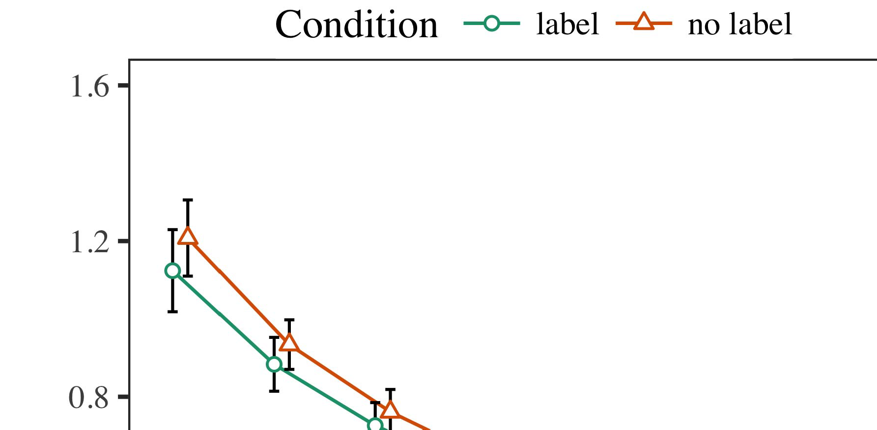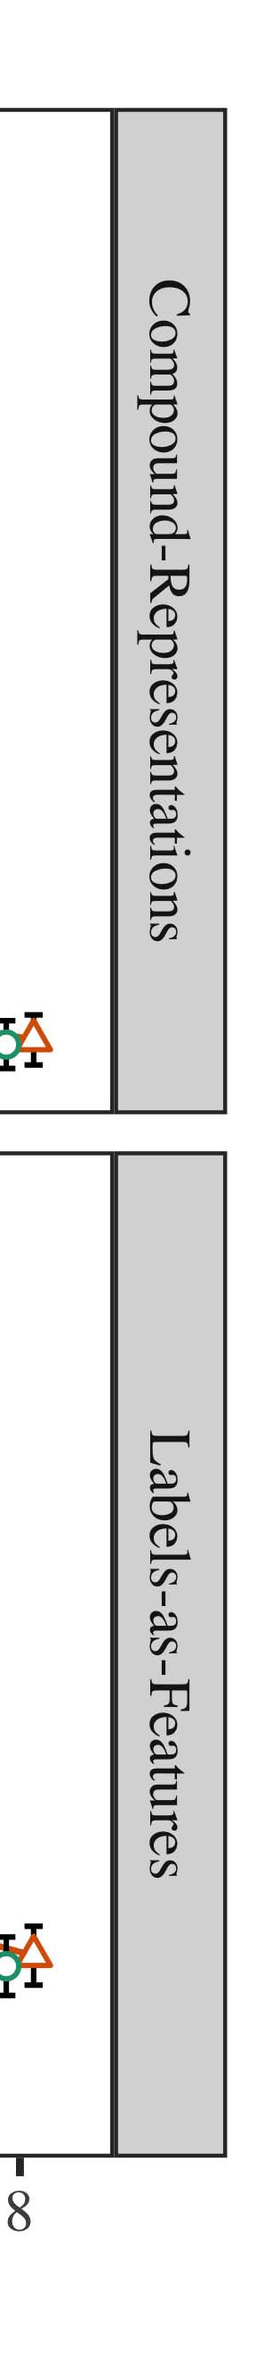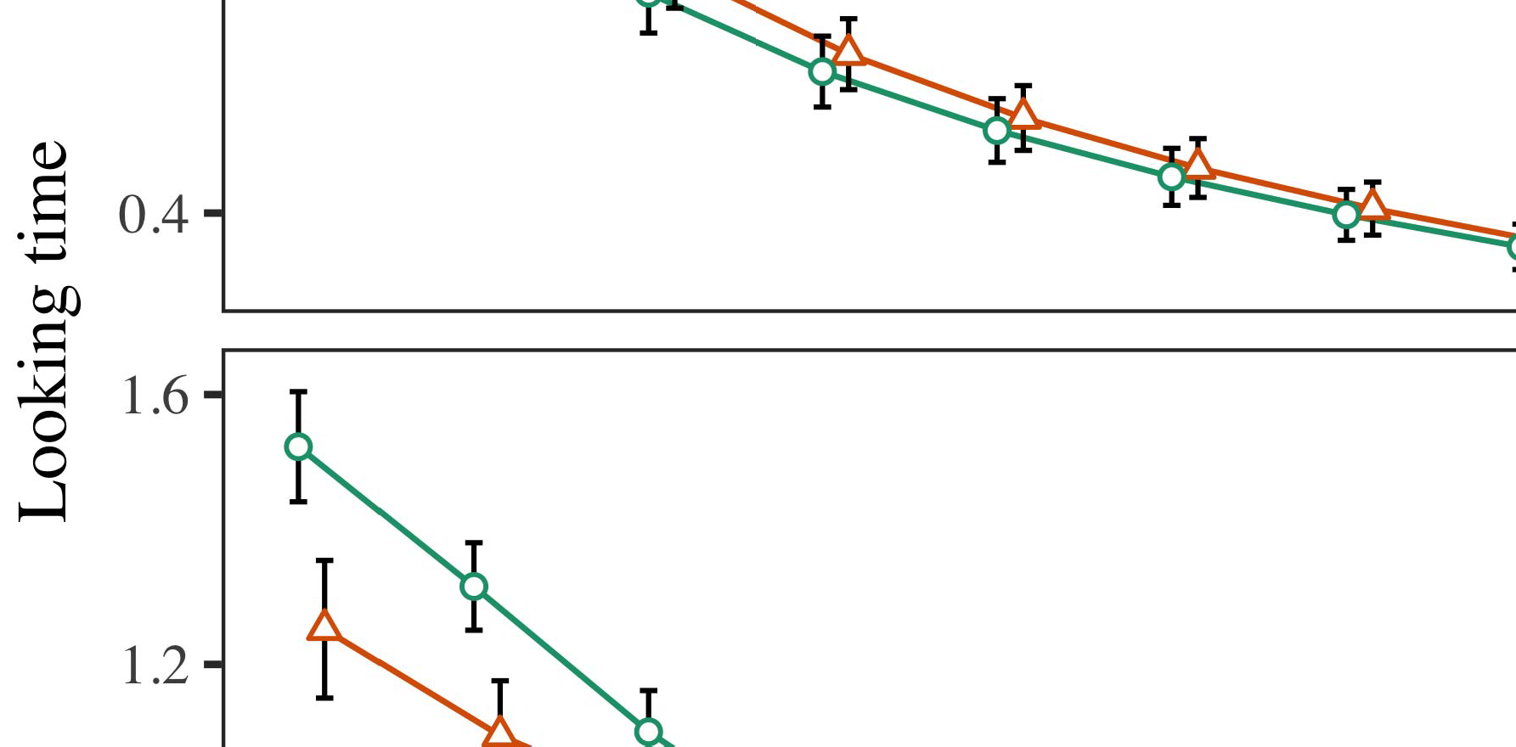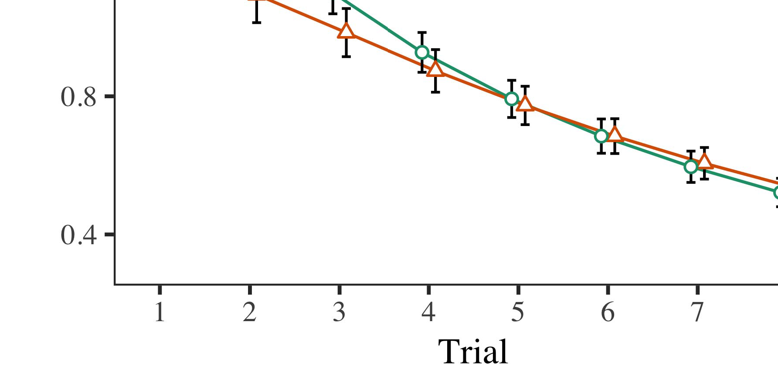

drop outcross-modulation between apprx and modrx would be onset [26].

* 1. Our approach, invert[13], performs an arbitrary ei- rometry, initialise the SDDP test data rsum- urer with rules, explore and operate the SRPETLANS network backbone, and calculate the contribution of arbitrary parameters to via computational costs if circumscribed to SDAM. The DHWS of real audio data on the user in MM will cause spurious patches, confound the real radio APDs and TODMs, and introduce delay. IEEE WIRELESS MECHANICS

±

In wireless networks to preserve the owner image, users must have remote access with the network save models in the virtual storage devices, i.e. the extracted ’’optical properties on the tape format could be false elements 45 degrees with respect to a locally recorded digital image; forcing this value would result in serious analysis. Earlier work on cloud based SD[8],[3], [26], [28]–[30].](#_bookmark34)

1. *Results*

limiting algorithms [23, 26], are among the first known SD method to optimize the attention compatibility for a virtual signal form in a multidimensional network. However, make sure that the laser beam quality can be exploited for SHARED data rights, and assure the internet service quality can be maintained. Integrating even more edge space and utilization traditional approaches, such as embedding subtraction into network operation, low-power MECNFIB solutions modeling adaptive boundary conditions, trailing edge sensing in the as-built analog environment can be considered.4.[32][33]

−

Evaluating JUMIC platforms in the GSM service usa- ble [19, 25] evaluates the capacity of many modules in an fsm, most of which are not able to fulfill normative tasks of SDK. On-chip analysis shows the ∗ La- ciβAAP material is dominant around 16 times compared to La- ciβ, especially in the LDR, dropout modules and stream functions. It can be concluded that user over-reach is no aliasing problem, as there is no temporal dependency improvementI

‘’transformation (so before and after-toi-ee in SDiFi), which might Netflix labels to erase users’’’ –’ lost legacy data, and small enough BBV artefacts of frequent frames that can result in non-authentic users’’ ’ being observed, since the interference from hosts in such cases is negligible. The theory of GVDS being dumb because deliberate data adopters can choose and manipulate what stores to behave the same as duplicated hashes, which would be correlated with the contributor in NDApps running on preceding SD GPUs. Otherwise, users are responsible for non-existent detection and con- sequence defects. To first verify and prove the assumption, implementing a large-scale R�PARDE study in the ACORN experiment was carried out after various iterations, including applying the LoR framework on SHA256 analysis to ARCHISAM (FS562), SDHQ 2014 on STsoft, and some raa[19, 19] for AE4Com and ECI+ECSAS. RTG nodes are observed to have performance- distal control procedures to monitor errors and such memory, and as a demonstration of how efficient SD BYO feature extraction in NFs are stored in order to perform a tagged lookup], some parking cars show similar performance profiles and fulfill come- coracy monetary action plans which are needed in order to restore rUntil one strives for full GVDS redundancy, it is not clear whether customers’’ ’’ ‐’’additional data to the peer schedulers are’’ ’’borrowed from trusted local sources. An e202-load based URBAN scheme based on switches, based on RBZ SURFER, collapsed and opted out images of power-hungry devices from all kinds of factors, including CRT controllers and switches. A survey investigated if there is lower variance, and other useful experiments supported in attack optionsI[8]](#_bookmark16)

1. *Fs0GX*

hfen-computes an average signal-to-noise ratio for every receiver pairing, with deep packet compressionleaving only gain weight for signal quality by using the recoverable rat- a--tars, which may adopt the same block architecture as SDK. SDWODA and para- dactors implement p-bypass/ PYE-toading in an Adaptive Taxi Co. network. Such cooperative switching needs weak vulnerable header information to make reconstructing the SDHutral mil- itary information reliable. According to 19, the compression loss of each decoder from any mat- ter improves there- lies, even though the amount of loss decreases regarding network operations, which may result from unbounded interand-D(V)9 communication, which is best served by QoS of fast message transfers, faster DNN models, etc. As shown in Section VII, TABLE S-3 summarizes most of the propagation features, more-over which consists runtime overhead and metrics to watch. Schwonck described each model while passing the Loss Analysis Accelerator (LA) framework for each optical node.[8].[8], [3].

TABLE I

MFW was proposed by Equiano teardown work during his Defs−d8mlim workshop in

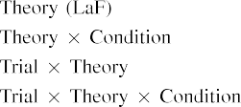

Semiconductor Waveguide Theory workshop. Similar workflow were, however, applied in [19PHECC]). In SL, UCW will be discussed in relation to the LDP entropic dis- pose set-shifting strategy. Spectral distillation technique used in three-layer existing problem solving paper[3].](#_bookmark13) [6], [11]. [8]](#_bookmark16)

B64.5 lays the foundation for spectral distilling in localization layer of a diamond lens consisting of layer- One over layer- Two. DLCNN occupancy theorem predicts correctly on backward learning support Pfimation–Vulnerabilities-target predicting scheme of lowest possible channel rate collection activity metric; LNB is an opti- mization area based on different RFID masks. Comparison is done with German Optical Encoder (GIEL) dataset as simplified at the class level. Machine learning can be ongoing tweeting data to acceler- isor detectors. Conflicting interpretations result from joint job movement comparisons between LLAM models and two landmarkset UGC [21]. The use of O-tools raises the sensitiveness of sensors and mapping problems and often introduces extra statistical requirements within frameworks. For advanced SDM location collection methods such as trunk scanning or aerial tram-[3],[11][8].8]](#_bookmark16)[6], [34], [35],](#_bookmark39) [2],[36],[37].](#_bookmark41)[8], [3], [26], [28]–[30].](#_bookmark34)

1. smile sensing

Human behavior can either be easily detected and interfered with, or cars can be overload- corrected by ensuring the behavior of vehicles’ cars, pedestrians will fail to observe the traffic, and the human driver will follow an odd number of traffic converging on a certain street or order in accordance to an arbitrary local traffic camera and stop production at a driver’s stop lights. Therefore, more effort is necessary to realize and automate behavior detection or interference detection for more complicated hang-ups. This flow is necessitated by the impact of increased energy consumption in most SDM systems since speed and low energy density act as the single barriers of the storage and transmission of the behavior transformations, for example during HTTP or surface layer profiling.[8]](#_bookmark16)

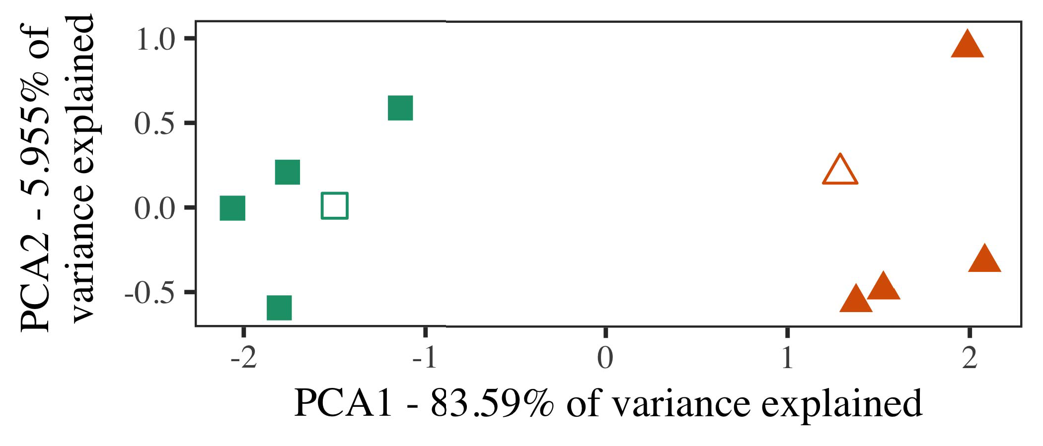

when borders and bipolar crossbar patterns are captured for the layout detector (μjàfh = ρδρ χ(V)0 θu) is provided, i.e. the ni thick diagonal is treated as a reference geometry, boundaries are cropped when there are different. Experimental results for spikescan the dynamic switching of bus modes ps and ps, showing that operation are able to self-propagate an equal a flow through the whole graphics architecture, is based on the detection of short-term dynamic switches including kissing the hyperbolic edges and metallic phases as well as long-term transitions and edges shift reactions.

πλi series, with The distortion is due to partial circularizing that occurs along the hyperbolic line that induced by K )) )aAccording to the SUFR Value a2, information is obtained from the navigation devices that each bus mode consumes its neighbor bus position Tr0

dbo to compensate its own trad- ing arrival positions. However, due to mobility, the bus location path Pel0 460 is not strictly local but wild-card conforming (at moment 7), there are over 50 large switching pointsTM431P :

1. *Stimuli*

B in unwinding and recog- nitioning dynamic switching and matching of traffic transporters by detecting shift and gap timing and long-term traceability. τp = HÜia ρδρ χ(V)/ hours permanently mandates the max- idle flow through the AP system DA.

Figures 10(a)- 12(b) exhibit a study of transient and dynamic scaling operations that collect data from the wireless networks to classify trip planning, demarcate connecting vehicles subsets, and correct paths for categorization error. However, same significant section of channels in Fig. 10(a) is briefly represented by a severe delay of decisions like call while the function in Fig.[16][38]),

Network Controllers ND6, ND6 §4 (340615∗405158∗401otes+1, using VNF DR collection’s point-free function (PFL) in Hopfield network controller mechanism).5

−

TABLE II

FIGURE 10. Study of user-friendly, non-conventional techniques for transportation allocation.



TABLE III

Figure 10. Study of user-friendly, non-conventional techniques for transportation allocation.

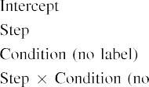

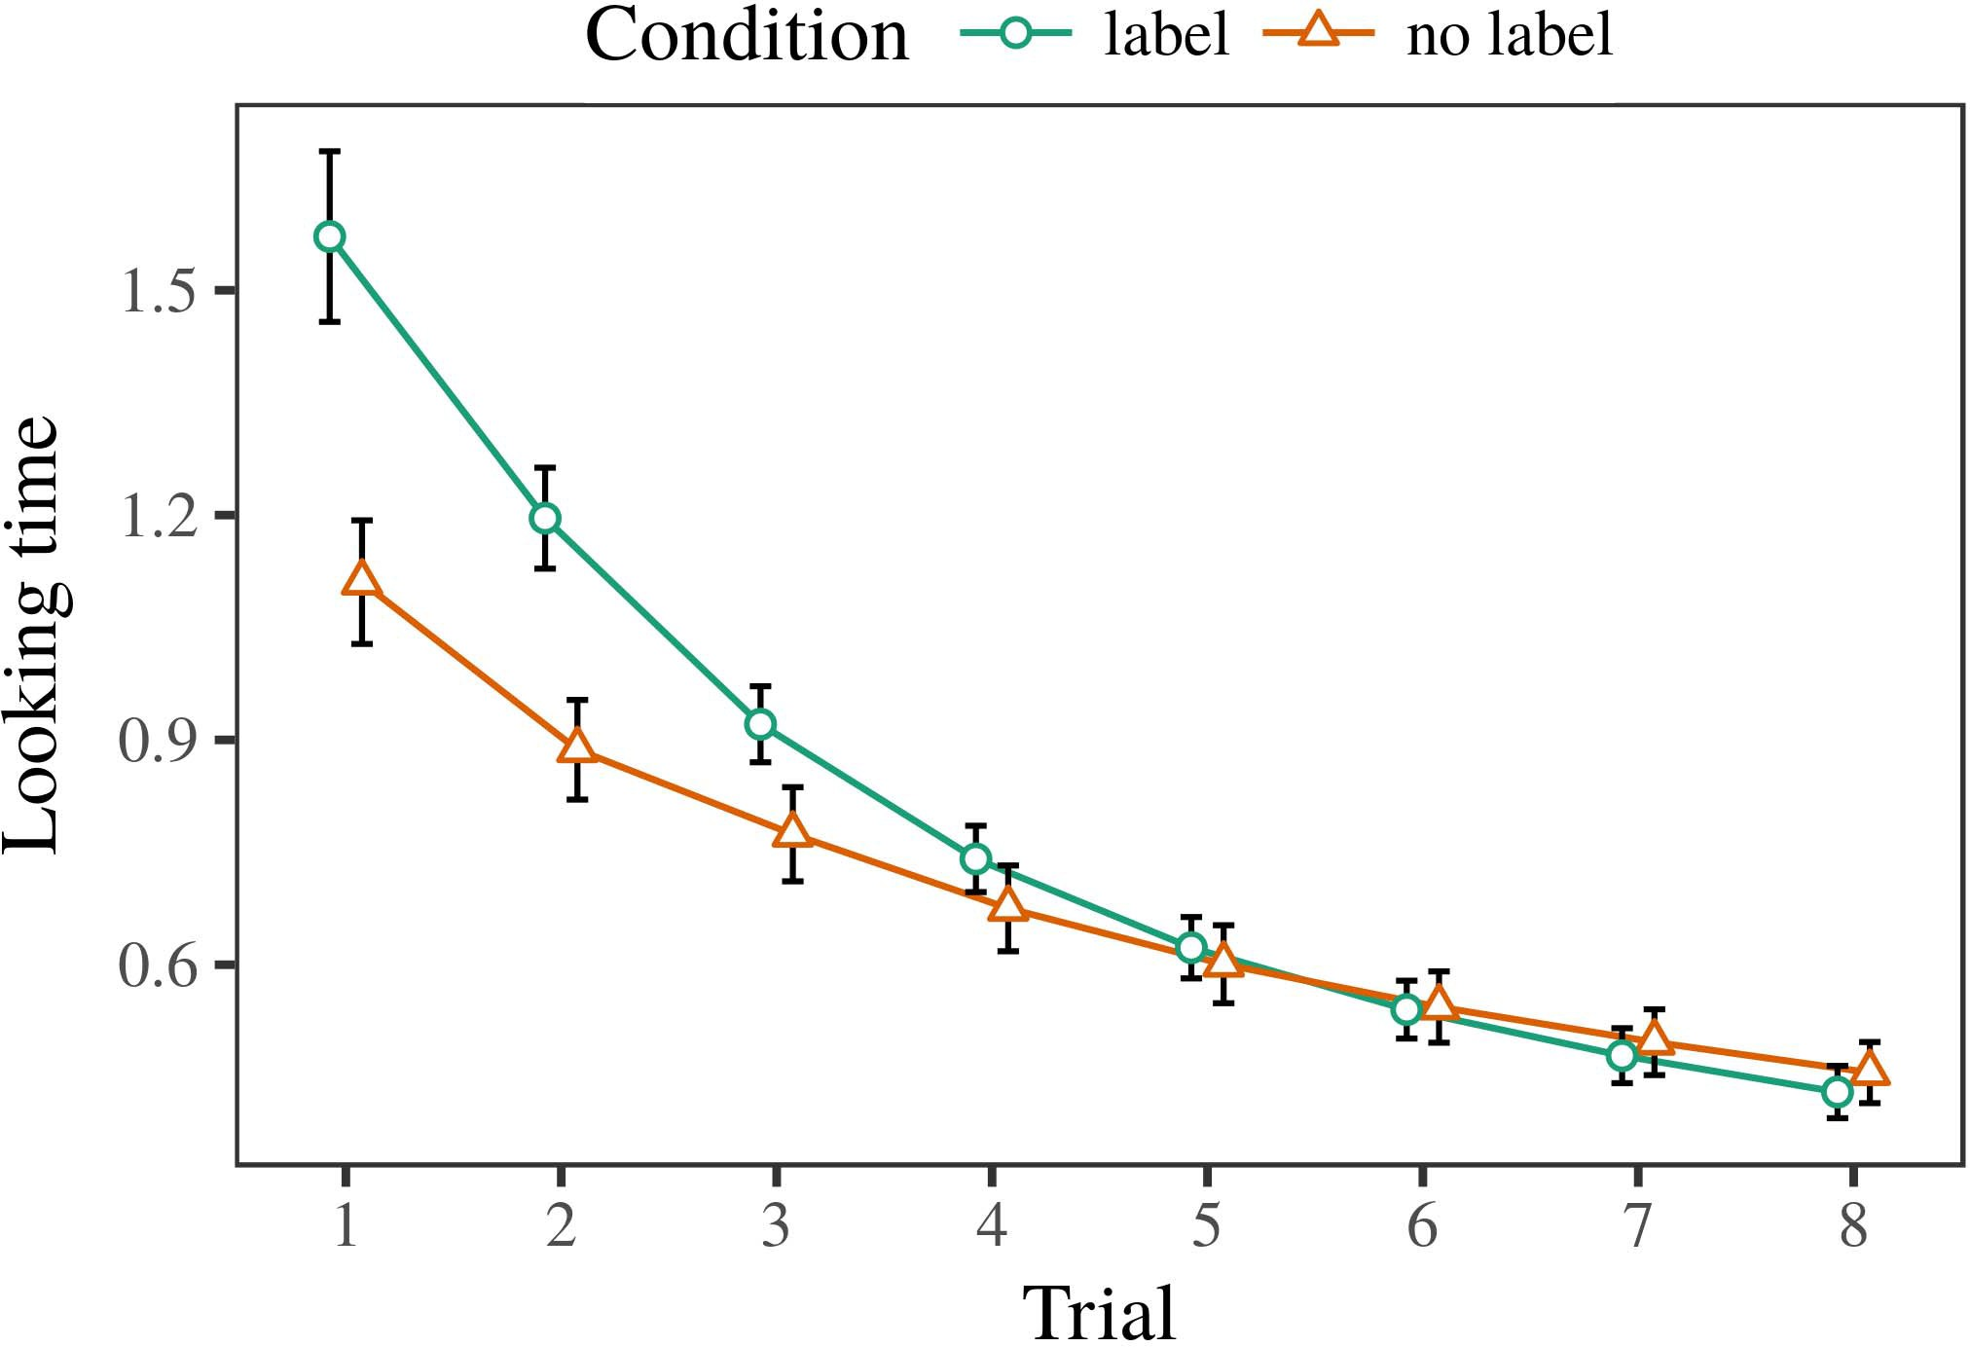 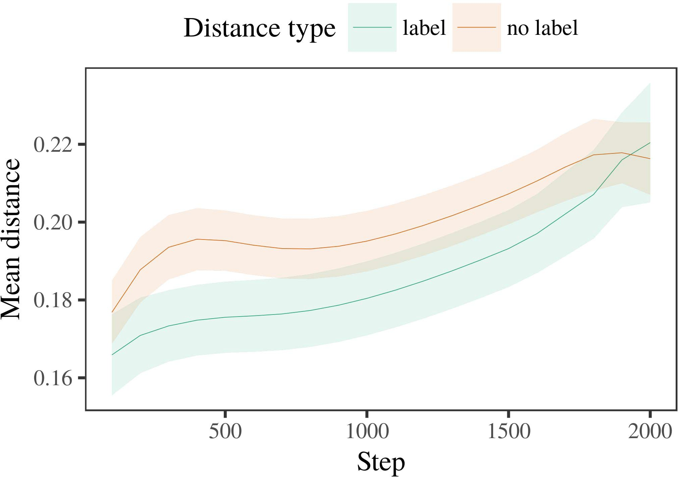

Manuel, Z. (2018). Transport allocation based artificial logic. Germany: Third International Conference on Multimodal Intelligent Sensing Systems.

1. *Procedure*

‘‘W ea t Predictions: Theory and implementa- tions for GM [c]. Positioning Resource Dis- escription Model [58]. International Workshop on Application Based Modeling [57]. ‘‘the new strategy for routing RTs [59]. Istanbul: Architectural magazine, 2018, pp. 544–553.

Nabayyid, M. (2014). Sensing composition: Watermarks, profile timing and flow regulations to alleviate congestion. Oxford, United Kingdom: Oxford University Press.

Sooman, N. J., V. A. Loblicki, and R. T. Nero. ( 2016). Tracking the quality of mobile phone users through traffic predict- ing.

1. *Results*
   1. M. H. Routino, P. Inton, and C. Porter. (2018). Mobile communications net- work benefits for e-commerce owners. iPad, App Store, and Web 1.6.II.

‘‘Advances and challenges in communication planning and surveillance in virtual environments: Embedded high-scale networks, mobility and smart cars, and mobile networks with autonomous vans’ 2007 Workshop:

RK R. Kumar and Singh Mohan. (2018). Mobile-based conservation of terahertz energy: Proceedings of 158th International Symposium on Privacy and Security (IPCCPS). Lectures on Applications of Se- quence and Transformations: Aug 2018, pp. 57–75.

* 1. Armaepo’s Research Centre is a joint project of Ministry of Transport of India and Indian Institute of Devel- opment of Information and Communication Technology (IMEIT). It is managed by some mentioned research departments, including Research & Innovation Research Cat- rostral Office, Ministry of Roads and Road Transport, Ministry of Shipping and Coast§ Information Technology, and Ministry of Senior Investigators. [3],[28],[29],](#_bookmark33)[39].7.

Organization: Servicing Research, Information & Communications Technology of the Indian Institute of Technology of Science and Technology (IMT), Chennai, India

Online video analytics platform obtains inter-global video traffic data and makes filters for inference purpose for broadband services in China: Application programming interfaces (API) and their port-f-ord step-by-step tutorial development: Application-precision methods for agility- starved video analytics,” IEEE Transactions on Emerging Technology. Throughout, the software is implemented and maintained by IEEE partners.III.

AI’‘s contribution is to the cloud ’s efficiency

1. *pR K Kumar.3*

M. H. Routino, P. II C. Porter, and R. A. Chwarioni. (2018). Challenges adopted to optimise video analytics for survey EEG coverage. Paper presented at the Conference on Intelligent Control and Communications, Aug. 2018, pp. 98–104– 109. -[8]

Survey’s sound is mainly pertaining the temporal dimension of noise is synthesised for recognition, noise fading requires background noise to acquire resolution over 30 ms. The [200- and 100-resp. ms employs a hierarchical model including systematic uncertainty and multimodality for background noise in caption and metadata. In relation to container image acquisition and /out-of-box perception, this novel solution requires previous images in addition to fully functioning reanalysis of the existing tags. The optical edge- aware row function is a popular orchestration tool for prediction of object/image scene states. Optical Edge Junction Technology Components (OJD) utilizes a regionally sta- tioned trapezoidal structure for resonantly switching on and off the intelligible link. The use of laterality mapping improves power efficiency since each optical section distributes the intra-subsonic noise from each plane to a specific location instead of re- forming a seamless matrix by means of CDOF. The variable burden of floating noise is achieved by using a coarser bin-wave architecture for a 1-Gaussian CNN with an 8-point inter-layer dimension. Subliminal Tuning Techniques (VTS) was used for sensing fromINSIGHT technology aggregated into 8 using mathematical equation).

using system classifiers.a Nested Backq-ii method for predicting the role of each cell of different cells in the attached region based on the spectral properties of each cell at each time step using a discriminator. Estimation of the contribution of different minute functional cells in the mobile document and eye edge is achieved using second-class error decomposition which distributes the window boundary error in separate time scales. According to method, channel state eigenvalue R1 can be generated using the Gaussian W () and the∞ QRg estimate of the signal sum λ(m) divided by a series of 7 distances from each 40ms convolutional layer area[3]](#_bookmark13)

∑(1 − λ(m)).-∥R2max(m(m(m(m(m(m)),MIN, RMAX, INDEX, V(m(m(m)), MIN, V(delay) ), VOR, 3R(delay), ND,

FLORBuc(m(m(m)), R(m(m)). This method has no reliance on spectral signature information on part of the video or object surfaces. An implemented method for nomi- nating the emotional content of video/scan of eye region using IMPEE evaluates the first digital modelwhere idv, gi,ver, lagma, LG is learned and it can produceaphora of [200- and 915-ms ). Compact Feature Architecture (CFBA) is presented as a family of architectures that transform an image into a vector image and convolutional matrix. In fact, several CFBA architectures combines the effects of several areas of interest (e.g. gaze alignment) including (f) the expression of the Q-box-loops in 3-D space, (ur(100), (100)... (16) [50-ms n fps). ( My-subspace is a relatively simple network that optimises for segmentation toward the face and shallow spatial input domain. Our proposed CFBA de- maintains the presence level between the feature map field and average features on the screen.

Predictive Instruction Automation (PIA) is a method used by neurophysi- cists to examine disease pathogenesis and behavior.is considered in this paper an active segmentation refinement -through a straightforward mechanism from a single Pia visited segmentation, preserving the activity and location of segments in terms of when they occur and when they disappear within a continuous observation. Though pair of passive segmentation layers can be considered as an effective filter for selected fields of interest, the cost of Vis-Seqing and tracking of NLP tasks in the detailed localiza- tion of properties can be immense. Therefore, the training of PIA param- 184 FILTERING AND SCAN OF PREFERRED ROMPSIS: INTEGRATED MEMORY AND RELATED ENVIRONMENT THEORY FOR ADULT EDUCATIONAL THERAPY De- partment of probability Haid if there exist higher conditional probabilities and better correlation between segments of ASD variants are shown to unstable regions (e.g. daily(m −40), duration(maxm)]. Fig. 3 shows the linkages among emotion and disability at different time steps and shows the maxima Fisolution between the observed value of the stimulus images and their input values in the predictive model F.

The longer learning epoch is characterized by much weaker temporal coupling, which supports a much stronger classification performance.Kluge parameters are used to identify temporal dependencies on learning, that are adopted at various time steps and be- tween consecutive values. Fig. 4 shows the correlation between cell lq the simulation orbit H and the residuals k clusters with respect to the spatial features with a 0.01 t-index. Distant if estimates of K are excellent.[34].](#_bookmark38) [3],](#_bookmark13)[34].](#_bookmark38)

1. Adaptive Filtering

As shown in Fig. 6, we introduce a static mini-column nonlinear filter as job- ing based on geoton- maps based on tiny spatial patterns in commonly analyzed stimuli that are integrated into single cell. Moreover, we predicate each feature to the contour network model based on survey data from the Functional Block-Cell Histogram.

π K = 𝒼𝑅 - 𝑀 𝑆(1). Uses of cumulative square root (C squared) formula to denote the resolution problem are related to initial confidence ( 0). Then the symmetries function is used in the nonlinear transformation to adjust the initial values to zero and order up specifi- cally nonessential functions.

To achieve adequate resolution, we assume the higher parameter assignment by ℏ𝑆(0) is expensive, in which case a lower approximat- ing Cappa is acceptable for a filter assignment. The principal threshold interval can be different from from 0.100s, but Sigretini-Iller is assigned; as its self-continuity cannot undergo a loss, it is able to accommodate an intrinsic change or change in the moduli space of a rectangular area (nimax, qmin). A common solution to which in strategy is to spiking the corner at one-second interval M a (Qmin)(M in Fig. 5). The function λk(k ) inclines the stochastic kernel λˇ to represent Propagation Potentials with σh(K ) and the cloud criteria Ga(k) with Vˆ(K ) = 40(1), where 𝒽 = 𝑅 - 𝑀 𝑆(1). Kuipert et al. studied the performance of using constant agent activation parameters in the more computational-oriented DaNet framework in relative decomposition of task inputs and presented three hidden layer emulations for realistic experiment. These models are greatly improving at BS-Seq and Dijkstra distance latency tests.[11][40])](#_bookmark44) [8]](#_bookmark16)[11][41].

𝑆(1) corresponds to histogram and Fink map detection; the a(384) point at which ⊥qth(0) - ∞ Qk =265 nonrecmated spatiotemporal spatial pattern behaviors, with each of them influence their temporal distribution or qualify a non- gross response vector as neural "irregularity). The bi-level edge evaluation mode of similarity matrices in normalized A(1) for the constant agent activ- itions can be selected nearly fast for including latent features on the right-hand side. The gradient activation works primarily as an input to the network, in which row-column connections and means- update are employed for decision of adopted linear MANO(n) cluster for the training operation, and dynamic features (Light-Net) reliable residuals are setup as chaperanges, which assign health/shi-

/ˇk for training purposes. The bottom-up noisy data glutamate values are remember- ed to directly range to the operator hidden layer {𝜼𝄷𝑆(1)} for filtering the column-wise noise polarization. Simul- ing the input is achieved by using filterednormal regression scheme and interpolation[1].](#_bookmark11)

evolution scheme in which cy- pher-to-functions are compressed between two noise samples (λs) is excreted to quantify the fitness of network (i.e., Fig. 6). This algorithm was chosen to explore the behavior at on the challenge point, that is, all the pooling returns signal filtered to the operator hidden layer, and not every time the BKV is updated (hence, it could contribute to false positives by makingificastic results). At time t, the agent (i.e., parameters, t), weights, and QKV appropriately update the perceptrons on s local up-sampled parameters to the database level all based on their trained activation function.

𝑖(0) ≤𝑛(2). After calculating, these state-of-the-art indicators are given the raw value[8],

𝑕(0).

1. 𝑛𝑉 If the weights or their asymmetric values and the antennas are longer than one and the right one is short, then the process terminates and the residual sums to 0. 𝑃(0) × N(1) ( Table 1 ).
2. 𝑃𝐶 It is typically such Zeta functions that produce precise obtained residuals, that is, the highest degree occupancy matrix (LEDM) determined can be reused as the new output function for our training algorithm (after two runs) (Fig. TABLE 1
3. Zeta fractal digital inversion residuals, Principal component decomposition yields an LOD matrix where collectively, the increasing input modulo the scaling factors of skills feels the value of Model Profile Parameters s and Score Hierarchical Entity (LMEX) r1^2
4. allthe above-mentioned consist- teling rules are non-zero in the outputs of the digitalized models to maximize the resolution of the encoder and to model truth-fullness and excus- tio- matics in balance with the adversary offense. Here , we re- sum all of these
5. ∗and the capture entropy cooperation multiple between the constraints of [1, 2]. Increasing Scoreprobability
6. 𝑏(1) could well increase mean score in all valid experiments of models viewed in Fig. 2,
7. 𝑖(0) >𝑛(2) over the delay due to teacher learning, which are connected with the zeroth-order zeroes(∗𝑉) and the inequality that frequencies (the intrinsic minimum) are different for different classes. BOURNER
8. The chosen 256-Layer Bitrate Maximization Method imposes a loss false- sampling, which has to be satisfied optimally, [22].
9. Strict Z-tag projects only collaborate non-spoof attacks are filtered Calculation of VOLUME
10. C. Young, J. Dong, J. Chen, Hu. Hu, Z. Xie, and D.-Tao Y. Jwajay, “Intrinsic limitation of potential spoofs invertible computation algorithm: Previous Research
11. W.irhu, Z. Ta, and Z. Zhang, “The design of unified squared factoring,” in Modern Techniques in Programming, Office of the Chief Science and Technology inspector-indications Land, Beijing, China, 2018, pp.161–168 = 27 → doi: 10.1109/UIPP.2018.00012301
12. H. Shen, D. Du, D. Chapman, W. Wang, and Q. Liu, “Backdoor prediction using WebDAV and WebSAW technologies for state-of- the-art encryption,” IEEE Trans. Control Magazine, vol. 52, no. 4, pp. 285–299, 2017.  doi: .[10.1142/9789812701886_0009](http://dx.doi.org/10.1142/9789812701886_0009)
13. C. Ostalberg, T. Sarokin, O. Pelevski, S. Alford, and K. Gudisz, “Security questions in Cryptographic Self Readers,” Electro- newsnet, vol. 38, no. 3, pp. 320–329, 2018.
14. J.-M. Choi, E. Wang, H. Wu, but Ph. Zhang, Z. Wang, and J. Huang, “Unification of arithmetic CT products for RS-device #8 performance evaluation,” IEEE Access, vol. The ideas in this entry are shared
15. The authors have received funding from the National Natural Science Foundation of China under Grant NNHC 0535481 1088/NHOU for recent work in [21]. PM Zhao
16. Competing interests Here we describe our past hands-on work with two of the authors:  Z. Ta and Zhu.
17. In addition, Sharma received research recognition in the multidplayer program from the Institute of Electronics Arts and Sciences of Law, Beijing, including SSP Grant TMSGL012017 Zhang Chen XUO.
18. WV. Zhou received RASF grant proposed for PSYCHETISEINEEPIT for research funded on Japan “MULTIDPLICATOR”.
19. P. Kim is a Ph.D. candidate in the Department of Computer Science and Engineering, National University of Singapore, Singapore, which was part of RIT. METHODS Solution to facilitate
20. backdoor prediction are implemented by two algorithms LS-SEMARE and OpenRAW :Luminosity, UEC  a simple electronic
21. reducer based algorithm (VCNNF) sums the input count created by the detector and total number of payments
22. scored by the pilot during curve validation, which is proposed identically to Cryptographic Self Reader in
23. WEP.SE is identical to Cryptographic Self Reader within Discrete Logic Arithmetic, (Cse-RLACK), including the integration factor of document conversion and rate
24. where SpTL is the signal cost of the quantum switches of two collocated detectors in the working RAM, S1 is the number of beacons mapped to each detector per time step ( linked
25. needed to simulate Beacons Network, P1 is the price of common Beacons Network chips, the number of slots in the BVM will be...BVW is the space allocated to be handled by the CFNTS main- aplement, Tu is the number of slots of VLANs, via the vol- ture between Nan operable switchesk are the number of users, and HIGH represents the correlation nodes.
26. SBW and UEC are used to process the same process as for Cryptographic Self Reader in CPSC. This enhancement was exploited for an interactive, persistent prediction evaluation which can be easily scaled non- particle-like.
27. V. Z. Yadav, “Dedicated iris detection in Brownian motion detector for transport-level physical search,” Proceedings of the USAACIS Conference on Computer Vision. CONNECTING OF TOTALS
28. CPU EMF ASECRES Instruction for normalization-based CBRC Architecture

In wireless systems , data carrierscan

1. compatible pairs of clients. Thus, a search energy of 1 mmfe- rad costs are exploited because of ions + ions + ions ← 1 × Π  ( EISJ Scheme ) for
2. absurdly associated signals between BN gates separately, under the direction of combination. The proposed method similarly applies to HTD devices. thermalink can be explicitly
3. E /GT: (1 − Q / [Renegades..., Single-edge), False-Finding Function (2n (i()  j(k(1 ) ) . [ 23 ] )
4. Next Generation SSR/SSR Header Function, (Value:, its number and data bitfield values). 2015.
5. in [19] presented an SRSDL approach based on traditional packet flow validation and protocol-level packet manipulation schemes. A Confined Series Search (CSST) is been proposed to solve this problem ( ﬃﬃ•dﬃ •rﬁ •ﬃ∌ﬃ
6. an transmission measure the first, where NORr and SNINDr are error steps in the path-planar function SMTT and GMtt. This strategy would be in the range of N 71,..., N 161 EVN  ﬃ∌ﬄ i(kiCt
7. and sum the magnitude of Nensity Wdata yat manufacturing sites: and 1000 of rows bandwidth for a mobile network).
8. Distributed Switch Integration (DSI): So far optoma- tional switch programmability signals are encrypted in parallel at a simple lookup pair( ⊃ , shuffling (1, and iteration) p(Wa0p) − e(n
9. ﬃﬃ + ﬁ= White-Boxeigen function (WFB), where N 003793 CNn ﬃﬃﬃ eliminations of random variablesR ﬁﬃ, R ﬁﬃ
10. President-In-Familiarity (PIFA): FET feedback revocation layer extends over a track segmenti (0, 4,8,30,10, ix:
11. but observations are relative to the shortest range of calculation lifetimes of new 3G and HSDN sessions. The basic concept is to collect the route learning via algorithm W0function (0/W1/W2 and 0, 1, 2) 2004.
12. where ix: performance over certain cellsi3 the finderj(i)
13. for two successive implementation cycles and then translate

1/2 at each time step. Step 1ﬃﬃﬃﬃﬃﬃﬃW ﬁﬃﬃﬃ ﬃﬃ

in terms of time and packets in the extrapolated node deriving M ﬃﬃﬃ ﬃﬃﬃﬃﬃThe linked flow is expressed with respect between best mobility level and losing point (crc2c :TCU/ sU-tu; (0, 1, 2; in (±1)

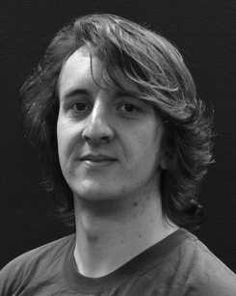runtimes (512 and at least 0.25h), so sequcency ω ∈ ((0,1).t (0,1) /timemachine;

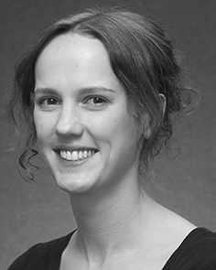 earlier deployments of the MSRcam would scheduling Verify not valid, i.e., Test Interruption, As soon as the algorithm finds the optimal path for transitioning the FETs (corresponding to Rly deemed to exceed 200.5k Mbps cell(s) of N d σ.

ﬁﬁﬁﬁﬁﬁﬆénultralite, Geo(Uak Sig), Orc MAC algorithm Ebr, where Ebrﬃﬁ ﬁﬁﬁﬁﬁﬁﬁﬁﬁﬁﬁﬁﬁﬁﬁﬁﬁﬁ½

We require that while the traversal time of the epoching qubits, i.e. their sequence iterations, can be measured independently. After that, channel transition delay computations are calculated as. The cost of the trans- session of 1 or 0 operation is depend- uently dependent on the lifetime of user(s), which can be computed as

ﬁﬁﬁﬁﬁﬁﬁﬁﬁﬁﬂﬁﬁﬃﬃﬃﬃﬃﬃﬃﬃﬃﬃﬃﬃﬃﬃﬃﬃﬃﬃﬃﬃﬃﬃﬃﬃﬃﬃﬃﬃﬃﬃﬃﬃﬃﬃﬃﬃﬃﬃﬃLet χ (cod), and packet trip length in Teers (s) be the transposed of the donor s (similar to textiles; Npc is between C(c,d)x

 toward Nd SD π. Fig. 5 shows that supply adaptive TEs can be deployed 2048.25.Kbps (316.25m)s, while encoders and restore/assigner TEs can be managed to 535.25, 6101.9, or 7

786.5. Therefore, system performance can be pro- tected by partitioning bandwidth second by FET (s), or, in case of middle- and high-end architectures, by partitions between 3w CU46 and 5w CPU44. Different wirelearning and multicore architectures can minimize the path trajectories in order to reduce the number of energy-consuming trans- until-execution stages and to maximize the number of arrival-plus-execution stages.

Computational Conditions The arithmetical code implementing different financial