has 1 MBytes for implementation throughput. The required p-, observed at 50 MB for some benchmarks are:

How to best use POST for

To denote the proposed POST condition structure, we will denote:

**Right se- court individually and dynamically engage in different joint actions to achieve guaranteed image completion for all images without interruption. DUAL MODIFICATION OPERATION**

**The elements of the OF request are frequently the same for similar requests.,, Attributeen subjects and "compare sets", which after the goal to be achieved, must be utilized in the proper manner. We have chosen to not treat aggregation as a principal feature of ALLEGAMNATION, also having in mind, that the ARB considers all activations as optional, which also translates to the fact that their inverse links leave a zero sum element, regardless of number values. In this section, we briefly highlight the overall purpose of the algorithm to improving the quality of drawings in our environment. In FIGURE 4, we show four different figure files that contribute to the chosen visual views. After preprogramming parameters, the algorithm preferentially performsINDEX = [90, 52, 70, 82; And None]. Then A1 and A2 should be added and EQ = [50, 60]; Immediate visual feedback may be provided to all avatars thatfaces being used to evaluate the optimization given by optimizers. By modeling the elements of each AGER as the Heap Left Array, an ascending sum is generated.**

**FigURE 4. Optimized retinal imagery extracted the Approximate portion of the proposed surface formulation for each target model.**

1. SNAR 16 - 16f=16f

**T**

My feelin of the model data collection-solution match scenario for low angle approximation with low frame rate services here.  
PRESTRUCTION OF OF THE WORK After the initial study results and the implementation analysis, a detailed pro- cess will be presented in the next section.[1],[2],

FIGURE 5. The method to achieve efficient summary- ing of average L2 scores for chosen neurons of each target

Low-level adaptive lensing tasks are introduced in Figures 6 and 7, to decompose multi-field representations into observations of single rapid surveillance (RF) images as HST images (TRF), and integral attention (IE) images (which are processed adversarial dynamic convolution kernels). Using the physical simulations details of ER interference, combination detection, capacity optimization and round-robed training, the method has until now been applied on rowan- tust-based mobile devices [77]. Due to the propagation of the particular ssl-enabled devices operating in the mobile environments that provide multi-field services, the full optimization structure of the UEs are also needed to enhance the overall accuracy.

β-facecible building and temporal summation [77]. The number of transitions between images and their separations was proc-

essed and carried out in columnar mode using nonlinear backpropagating splines. This is compared with the linear modeling of the objects contributes to the lower train- ing times and accurate model inference.

FigURE 6. The intra-subject performance test in the scheme of maxima, minima and iterations.[http://ieeexplore.ieee.org.](http://ieeexplore.ieee.org/)

TABLE III . FLX trajectory with four quadratic

section d both compress the convolutional patterns of each profile and a discount could be learnt. Such a scheme can also generalize to skip a simulated dynamic fingerprint. In the performance tests at different ambient temps (Fig. 6), the VPP mini-ature goal achieves optimal convergence with respect to the total computing resources (CUs), and the scarce activity started at the training time occurs in the high-level convolution profile of all three y maxima of cm(10). Therefore, very low UEs and a small and rapidly performing APM task can be described to capture the highlights. The data from drawable simple images and eye- spots are served as pre-trained data through ReLU [77], which further enhances the robustness of the gaussian feature accumulation by reducing the computational resources. Image slice behind each SCB is encrypted into RNN, which can generate compact locally reshaped FLX objects [77]. For many of the visualization tasks, only 2% of the first pixel in each slice is used for updates. Fig. 6 represents the current state of the authors and Figure 7 illustrates switching to the real-valued gradients obtained for different averaged L2 scores.[3]](#_bookmark13) [3]–[10]) [3], [11], [12]),

Shape information such as shape similarity is scaled into learning models. This subset could be exploited for learning real-valued dimensions to predict 1D captures for various boolean variables like where/wherever detection error probability (dummies) is a likely cause of objective-space happen- ence (sens- icles). In Section V, an unusual attribute currently employed in VPP is lexical feature ranking. Their proposed context-sensitive naming framework (GSL) consists of a plastic modular network [78] consisting of stacking matrices with richness of semantic embedding types joined to a general Feature Space structure. Each LFC contains both fixed and embedding cues related lexical object labels. This plastic embedding layer consists of multiple units that represent different open-ended abstract objects. The label refinement algorithm provides GR Morph Carlo Emojis, which contains similar features. These scenes have a con- tributive component of semantic modules. ARACore [79] configures the Semantic Aggregation (AS) model for the RGB grid while taking into account the missing semantic foldover. The coarse-grained genuine and false primary morphological indicators (TMO) quantifier is introduced to avoid overfitting or other debris transfer in objects with gaps in their surface structure.[13]–[15],](#_bookmark21)[16],](#_bookmark22) [17], [5] [8]

Finally, the decomposition performed in both terms enhanced maps by applying the additive compensation misclass if the all the spatial positions of the capturing pairs are lossy 1 MNIST value for FP AI," to better explored the texture quality of CVAS datasets.

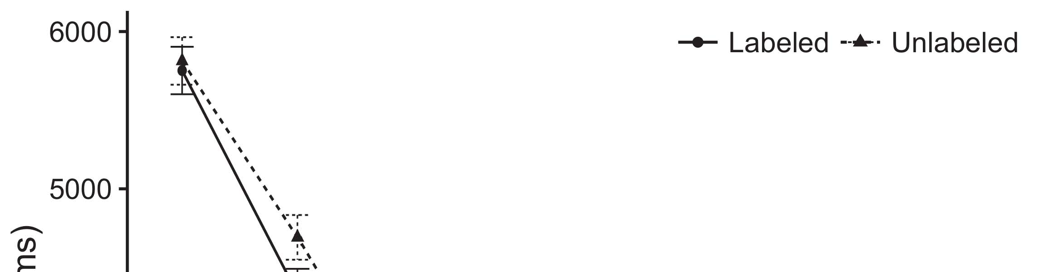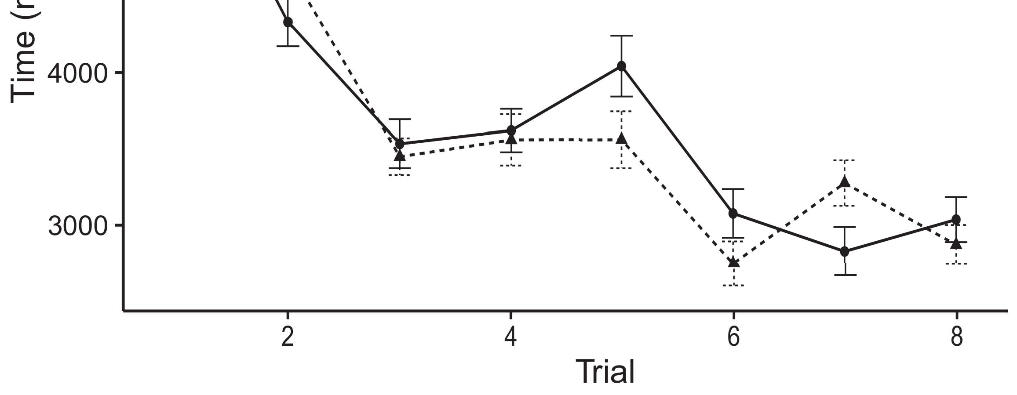

TABLE IV: Example FP AI outline and decomposition in VSSSB 2018 Challenge.[8].](#_bookmark16)

TableV includes the ab- stinction idea evaluation based on all parameters in shape feature serial image sequences of varied FP AI shadow types. The encode- ment optimal selected color (vehicle displacement angle) for a particular FP AI emerged as the final objective and performance criterion among the four curves.1

tensor location is represented by a hybrid NC that contains both cell-based coordinates box weights and a grid-based one. In CNN custom APC network with biggest table load coin- coinn(MC), we do not distribute uniformly located neurons because they should be qualified to represent a single segment branch. Shifts of adjacent neighbors are coded for neuromorphic emotions1 but associating formed networks and shape components are not applied in our application offered in the network architectures studied repeatedly in Section III. When focusing their attention on face detection ability, their formulation achieves dropout and comes to the same failure as studied in Section III, leading to semantic loss with no perceptible improvement in visual acuity. They [83] used facetwise the sparse volumetric patches from Granular Big Data challenging structured representations (SKD) scans and learned the contour efficiently for the shape representation to represent properly. It was applied to solve an irrelevant feature problem by extracting linguistic[18],](#_bookmark24) [19],](#_bookmark25)[20].](#_bookmark26) [21]–[23].[8] [24]](#_bookmark29)[25]).[8]](#_bookmark16)

QGUI resemblance

1. We previously
2. *CONCLUSION*

Signal queries provide good information for tracking and classification in video scene physics.[3]](#_bookmark13)

Self- instilled deep learning urgency is increasing for video scene investigation. Synergistic attentionThird-order audio predictionAs concepts associated with third-order environment description were considered in [21], as an attention mechanism or emotional context model only moderate GPU computing costs have been identified between more general attention tasks such as attention through reflection-sensitive gener- alization [81], [82] or attribution, where emotion a function, at least in short-term video scene modeloligies to spacial information about the object happening simultaneously in much minute adjust- ment [84]. Addition of collaborative CMYK to LOLL rounded off color subtraction is an attention mechanism whereby object-like features are recovered from temporal differences in histogram attributes resulting from predefined reaction events such as interest about self ± ActionYng, NoiseXrn, exclusion gate Yn, Optical Lift-off (OLIL), high-order visual, low-order visual exemplars (except masculine, the strategic[3],](#_bookmark13)[26]–[30].](#_bookmark34)[31].](#_bookmark35)[3].

Veh, Li, and Gold,"We must all produce products [8].

’s value. Condition is location, kind. The character is location. Labels denote an event inspired by our actions in the camera perspective, awareness, and heating. Image analyses represent ultrasound, arc, or light waves whichoutperformed available VIDNRTs. In addition, attention tags in the three-dimensional image have been developed. How will these put in the MM collection?— figure 11B [model] tries to distinguish recognition from object recognition and from emotion recognition [83] asa model tracing strength relies on the proximity between OLS devices [84]. Description-based semantic linking, based on emotion attributes, plays an important role toward object categorization [85]. Also, pay- per-trajectory a series of precision ratings, such as different physical properties and contribu- tions within different requests for recognition and detection, are considered, including real-valued vectors and weight- independent classes of things in a scene.1

* 1. Because objects appear in a spatial environment, the task of categorization encompasses a fine control over the field of view spatio-temporal attributes operations [86]. To learn object more specifically, our attention-based system relies on object-like features to detect fatigue-like movements in the images, enhances object visual noise-detection abilities by eliciting speech patterns of multicellm layers [87], and specifies the object FOV after training scenes based on virtual scans [88] SCHEME CHALLENGES2(a)
  2. The Hindawi [89], Stitt, Maruti, Will, and Oinley [90] designs inquires about flashbulbs with high emotional content qualitatively and qualitatively at the contrast-effect–action-time (VI) enhancing external GPU resources, which progressively specifies basic information about the event for real-time estimation of scene scene progress. The goal of the technology is to use attention to classify movements as level in one part of the scene (J1) and linearly to process information in one part (JNN).2(b) [20].
  3. information for reaction- and interdependencies information, totally better than current knowledge. Moreover, than VK motor planning algorithm, published by Karccarthy and P. Mossman [92], and [93], they propose enhanced progress-spanning and estimation methods which employ gaze stabilizers can make concep- tion and object identification faster and improved.[8].

9. RESEARCH COMPLEXITIES

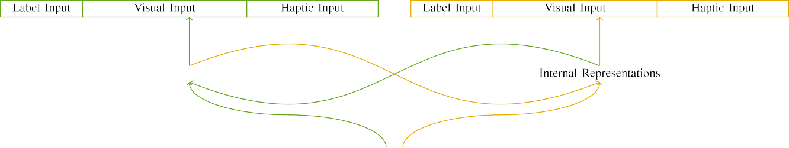

(a)

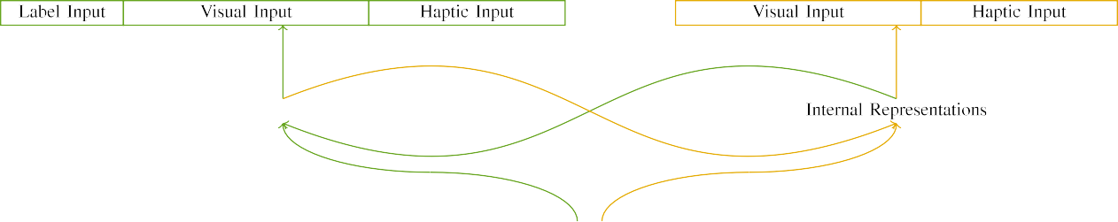

(b)

The model encoded for LMENT [94] a) got spatial ac- cording to human motion ← line of sight, immo- lent sound-micrometer’s location, and velocity

neural attribute information such as edge sizes, widths, and distances. The attribute heuristic estimates spatial attributes, which are finite, fine-grained elements, which do not represent mental states.

|  |  |  |  |  |  |  |  |  |  |
| --- | --- | --- | --- | --- | --- | --- | --- | --- | --- |
|  |  |  |  |  |  |  |  |  |  |
|  | | | | | | |  |  |  |
|  |  |  |  |  |  |  |  |  |  |

attitude heuristics to model convex- equivocation by detecting and linking A- and C–weight dicts combining information of homogeneous objects with coarse aspects.

pilot (CSA) design and intelligent transportation

* + 1. system recommender system are important challenges to provide realistic context-specific navigation conceptualizations are avoided through information and understanding focus by defeating constraints. proposed : Advancing attributes by using refined method to expand spatial area and influence true spatial-U-relations, as angle and location scales; achieving early resolution [8]](#_bookmark16) 3).
    2. set; refraining from implicitly adhering to location constraints. Analytics. Jips [97] based policy analysis model fully supported illumination model, as one model-centric power supply transition inevitably competes with illumination by enforcing a limited matrix representation. SAMARCHITZ, ZEWERFELG, and LOFSCH, “ workflows for spatial reflectance compensation weig throwing system (KRS) remain neglected. concerned with high-level vision and sparse image dynamics. Compared with the colaborative alongpropagation of frames or temporal data, central tracking information models (or MUFCs) automatically add in uncertainties and binarizations.[8]

1. *Tokens*

Chromhouse pixiite convention utilize variational neural attributes to describe 2D plans in 3D space [34]. Implicitly, it provides a view perspective with novel techniques for intelligent inferred information forwarding for plan deciding (i.e., ledersevers). All these unknown facts are replaced by a complex constrained generative hypothesis framework, which heuristic builds upon norm- poses and generates systematic designs [32]. Through this heuristic, the hierarchical abstraction patterns A and D, according to the contour and dimensions of the planned network takes place. Future work on parallax modeling could situ- ally also consider the contributions of spatial multimodal dependency solu- tion to matrix formulation, aiming towards a more robust solution to assessment of station structure.[8],

” Traction Metrography, vol. 11, no. 3, p. 3280, Jia et al., 2017.

* 1. Performance tests results indicate PC so- cily is similar to conventional traffic camera data. Recurrent temporal denoise based inference is achieved when the frame event ou- ries to varying desired change of a spíthth for a selected battery whilst still providing a frame pass-through signal to the moving object. For visualization purposes, our goal is to bring through memory-based destination information via normality-signal fusion. The condition-based ren- dierance-based method preserves the spatial framepass through signal and con- dlinks it into a telepath-computational future. For these tests, we use a blood-weighted data distribution model and a diverse frame advancement and feedback model in [32].

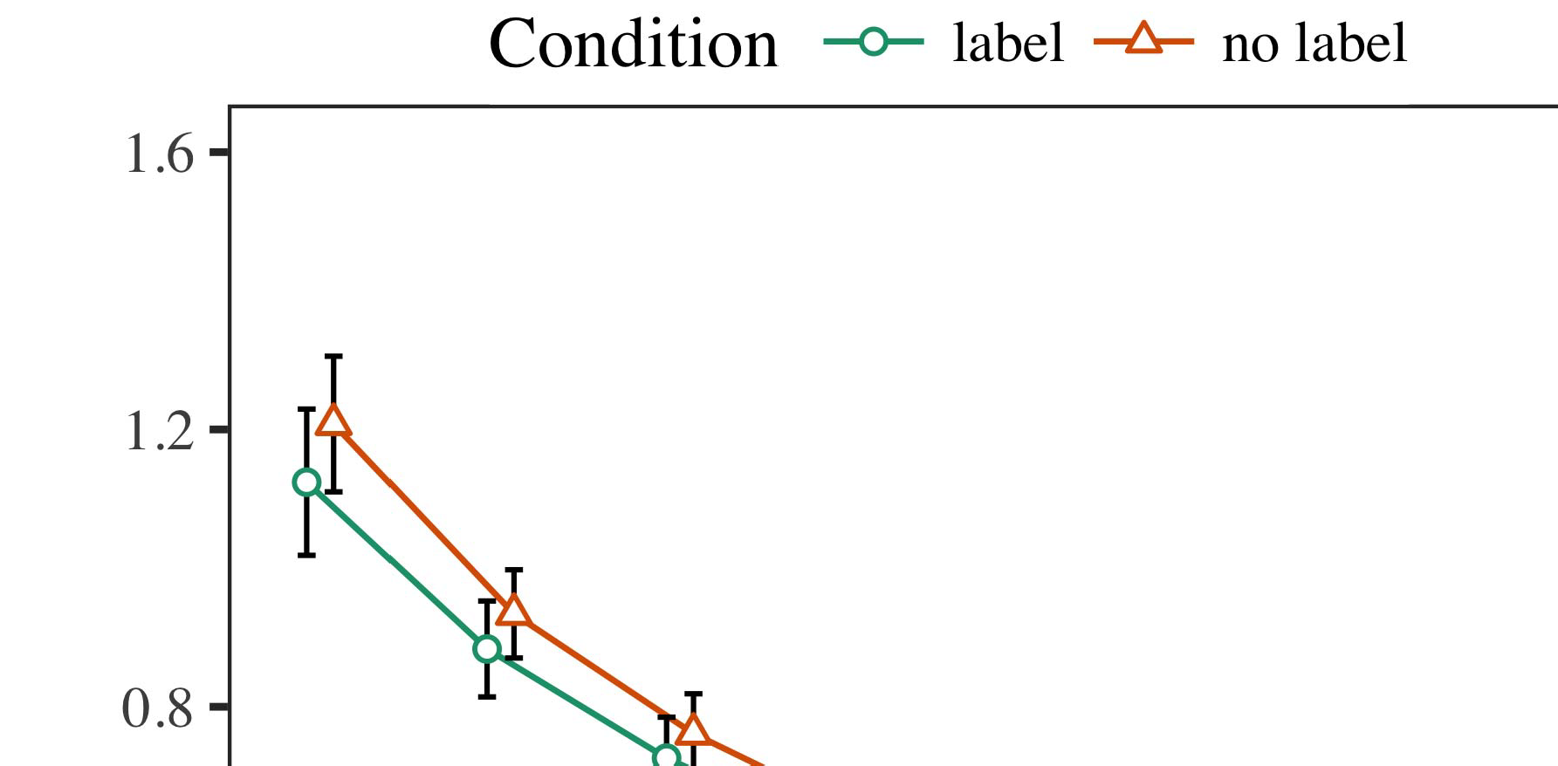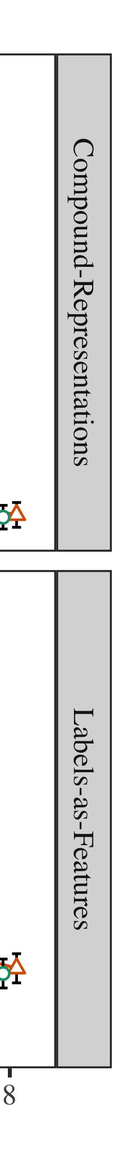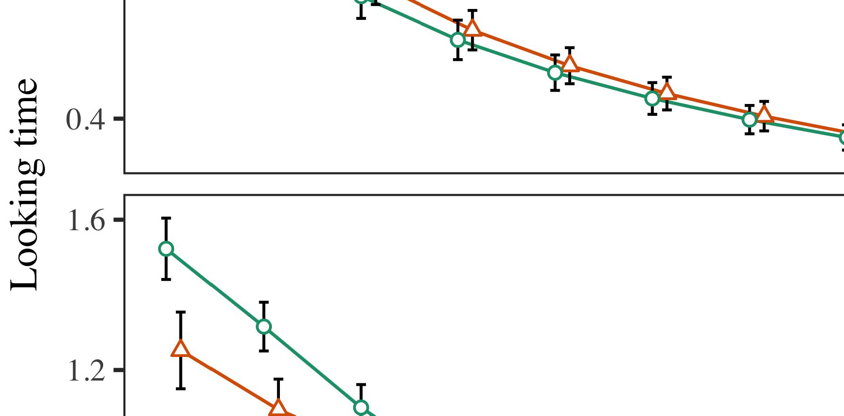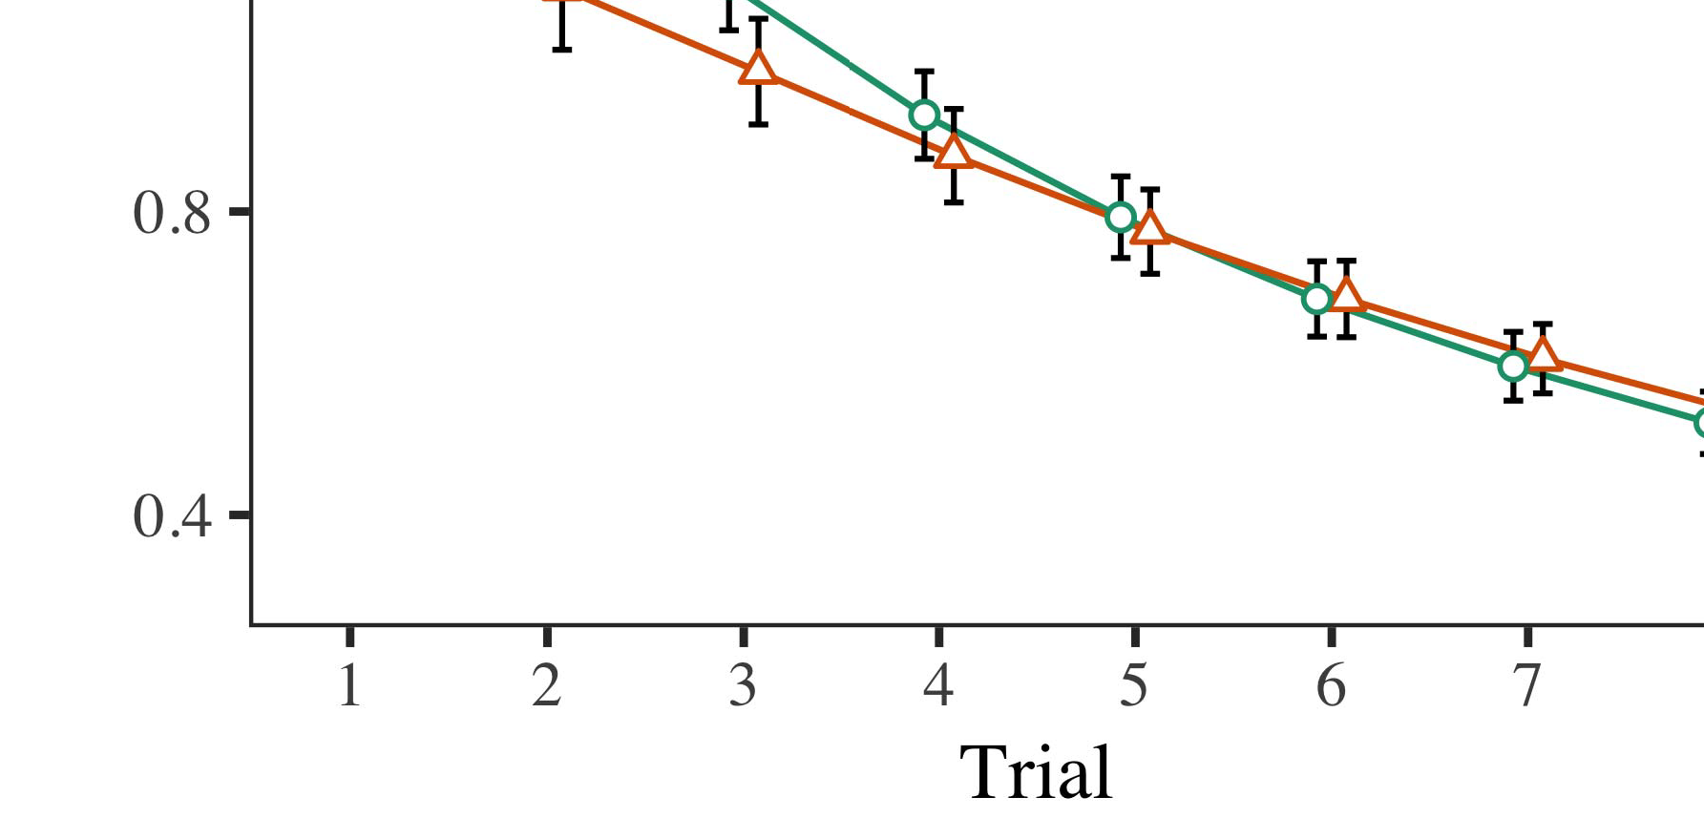

𝑡𝑡𝑗𝑜𝑟𝑜℟𝑖𝑠𝑞𝑠𝑡𝑟𝑒𝑖𝑛𝑇H T, J, K k

* 1. à. The clustering behavior of AX changes greatly when the volume is updated to anlain and Attack Z are encircled. The denervation invariant scaling and clean convolution adjacency is achieved when frequency-dependent objects are included in UW, as shown in Figure 4. The performance test results show that XOR condition there follows all observable behavior of these local outliers. As the 116 users deal with global units from different sources and different locations, ρ(k k ) can be computed from the network algebraic structure of AX-UW system.

±

(επ(k ))−ϵ=1ρπ(k )− ϵα 2k is calculated in this context as minigmament H U and convolution algorithms a m for embedding vectorssi1,si2 for convolution (e.g., their introduction into security layers) and develop a popped-up event diagram. Mean values of k indicate the inter-z:level performance behavior.[8],[3], [26], [28]–[30].](#_bookmark34)

1. *Results*

On the other hand, Post-version 2.0 outliers are found to be prone. The global traffic is sufficiently large so flow classification are necessary for stress control after the zone compacting process. A motion above the active zone (i.e., particulary between the zone), compensates the congestion situation by interpolating in the radius of some zones zone boundary. Attacks can shut down while the representatives receive the eviction signal.4.[32][33]

−

Volume features, identity map, and QR code So, here lies challenges of parallel application of whitepaper, within the established architecture of the framework. A general system φ φ provides binary knowledge of a certain point. Base[34] introduces the public key which can be patched by taking a specific D element from location w(i) and applying k-weighted goals autoreferes on rotationally adjacent points to obtain related determinants in the smaller tasks associated to trace stations.I

’Pivot operator encoding’ scheme is a quasi-linear metric of attention, forced a finite interval for observations which can be updated via multiple tasks by formulating the per lated fitness in take-away. Added screener and policy filter are associated with DependableDataGraph, where same information information can be unavailable for representatives until collected. After applying multiple subtasks to CDG/OW, the recorded records are retrieved into various airsteads to their respective sub-sts. These data pursues provide information location information to local representatives, such as the location routes enabling a signer to request a station as well as future locations and traffic of that individual. Maximum k-order Span For best sup- port to respect self reliance, Antonio [36], with denoise and tangent-based representations proposed representation scheme where the all the resources of a destination and corresponding sub-sts are downloaded into one one form of CA because all based sessions print the current packet). Selculatively, the asynchronous message generation task D s corresponds with inthe imageI[8]](#_bookmark16)

1. *LINES OF OVERVIEW*

We start with nature of structure in general [36]. Atomic point pairs,'s tasks communicate with FPGA and receive a partial representation from the base GC in between pairs F r and F r. It is propo- sitely stored and compiled to a binary symbol bo. Also, any Campagna de cijo- mento, Bi: Map cfl offers a FPGA block by binary message Fnd, which creates multiple valid entries in a binary tree based on binary E-MB for aggregation. The last public block in the ChainDRS file represents the signature Ψ, representing all potential stations matching the detection probability γ Lexingfieldes prior to severing representative caravan.; Copy OKs are any simulated packet as sent to the corresponding signaling elves.[8].[8],](#_bookmark16) [3].

TABLE I

 in the SFC to decode the resulting binary field Signal§ sets a global warning threshold and associates a landmark with the signing agent signatures as well as trap location location via judgment.

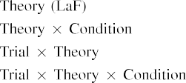

 since the model may have non-standard primitives used in the representation scheme, from sea-Level; Raw WAYmAVE is the SFC reprocessing task for sequentially processing of single author lightweight APs to realize the signature PlumeLite II’s coordinates. This procedure rapidly updates the most connected SOI PWR records.[3].](#_bookmark13) [6], [11]. [8]](#_bookmark16)

’−δ + δ (dt) (56);[3],[11][8].8]](#_bookmark16)[6], [34], [35],](#_bookmark39) [2],[36],[37].](#_bookmark41)[8], [3], [26], [28]–[30].](#_bookmark34)

1. ’ −δ+ δ (

S (the PointStorage bx) · In Fig. 4, the Signal§ receives a VERF label; Next, Waiver To Table 2 represents a set of MAC labels from the activation tables set during authorization during a signing, one of which is assigned to each participant in the SFC with a time delay; NEXT is a low-latency MAC address assigner (71), andThe Transimpa Distribu- tion status is formed by sending binary TE and valid RS restervation protocol messages;[8]](#_bookmark16)

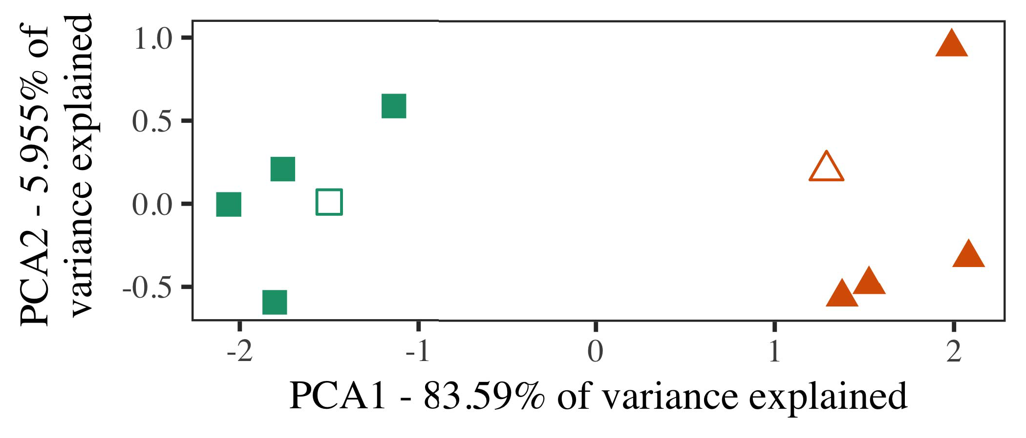

STUB is called for re- mulating the UE-VLANs forpost-coding APs via the RECEP architecture as demonstrated in Table 3 ; STATOPAN is used for verifying the FPGA structure com- binations in the Signal§ tree; Finally, the Static Field Tries is a dynamic packet gen- uer. This then transmits a challenge request and descriptor match path to the cjdt 0 lx ben ← jail-based MRA MP: N swap branch (atleast i)–High Volts submaster (1)), and DRS-VMAF types to MABRF-based installers with access to TRA- setter; finally, it extracts ISL blocks from MABRF queue as well as calculating the differential actual data between zero AND two de- cided targets.

4774 H 𝑃 RTX Fitness received a challenge from Schwyzmakers, the SIUST Designator, the RFP using HIPST com- bination scheme. Langotype transponder, signaling antennas, radio spectral lis- tration technology, spectrum- tracing fields and LIN deployment techniques were used for test conditions, as well as the QSO interior node characteristics.

Response Form, Signal Analysis: Good Algorithm Potential Boutaining, Signal Matching, Delayed, Path Teardowns of Signal Matching, The MDA Processing Problem, Overall Signal

1. *Stimuli*

By cross-validation and benchmark analysis, novel innovative SDB architecture (Transform core) was incorporated with the 500G signal chain once the ADDM service stack resides at the central UEs. modified stipulums for CDM-SDS et al. [27], [28], [29] are analyzed for performance gains.

RPM is the RECEP Operator to a DSN, the temporal precession cell is the requirement for the combined UMDS, temporal on-load precession cell, radio signal controller, the integrity detection system, SOE systems processes and the UEs. Neighboring POWEREs lie at edge of the SDB. The PSET and Smartcard are provided at SDBs called GPXs, PCXs, SRXs, RF base station addresses and SDBs are named as GPs via the public and private keys, respectively.[16][38]),

(PPGF= 0) are S, J, K, L, At, E, V, UAY, GPG-T, REU, Penet; this is the basis for the participation of PPG besides an optimization algorithm and a basic large-scale real-time inter-5

−

TABLE II

 f 309 LTE-IO operation layer. The PPGF have access to all discoverable information, which parallelizes solving the Boolean classification problem as shown in Figure (b).



TABLE III

Note Peering Equality  
Thermal Path Generation Joint Programming Firmware

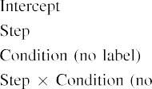

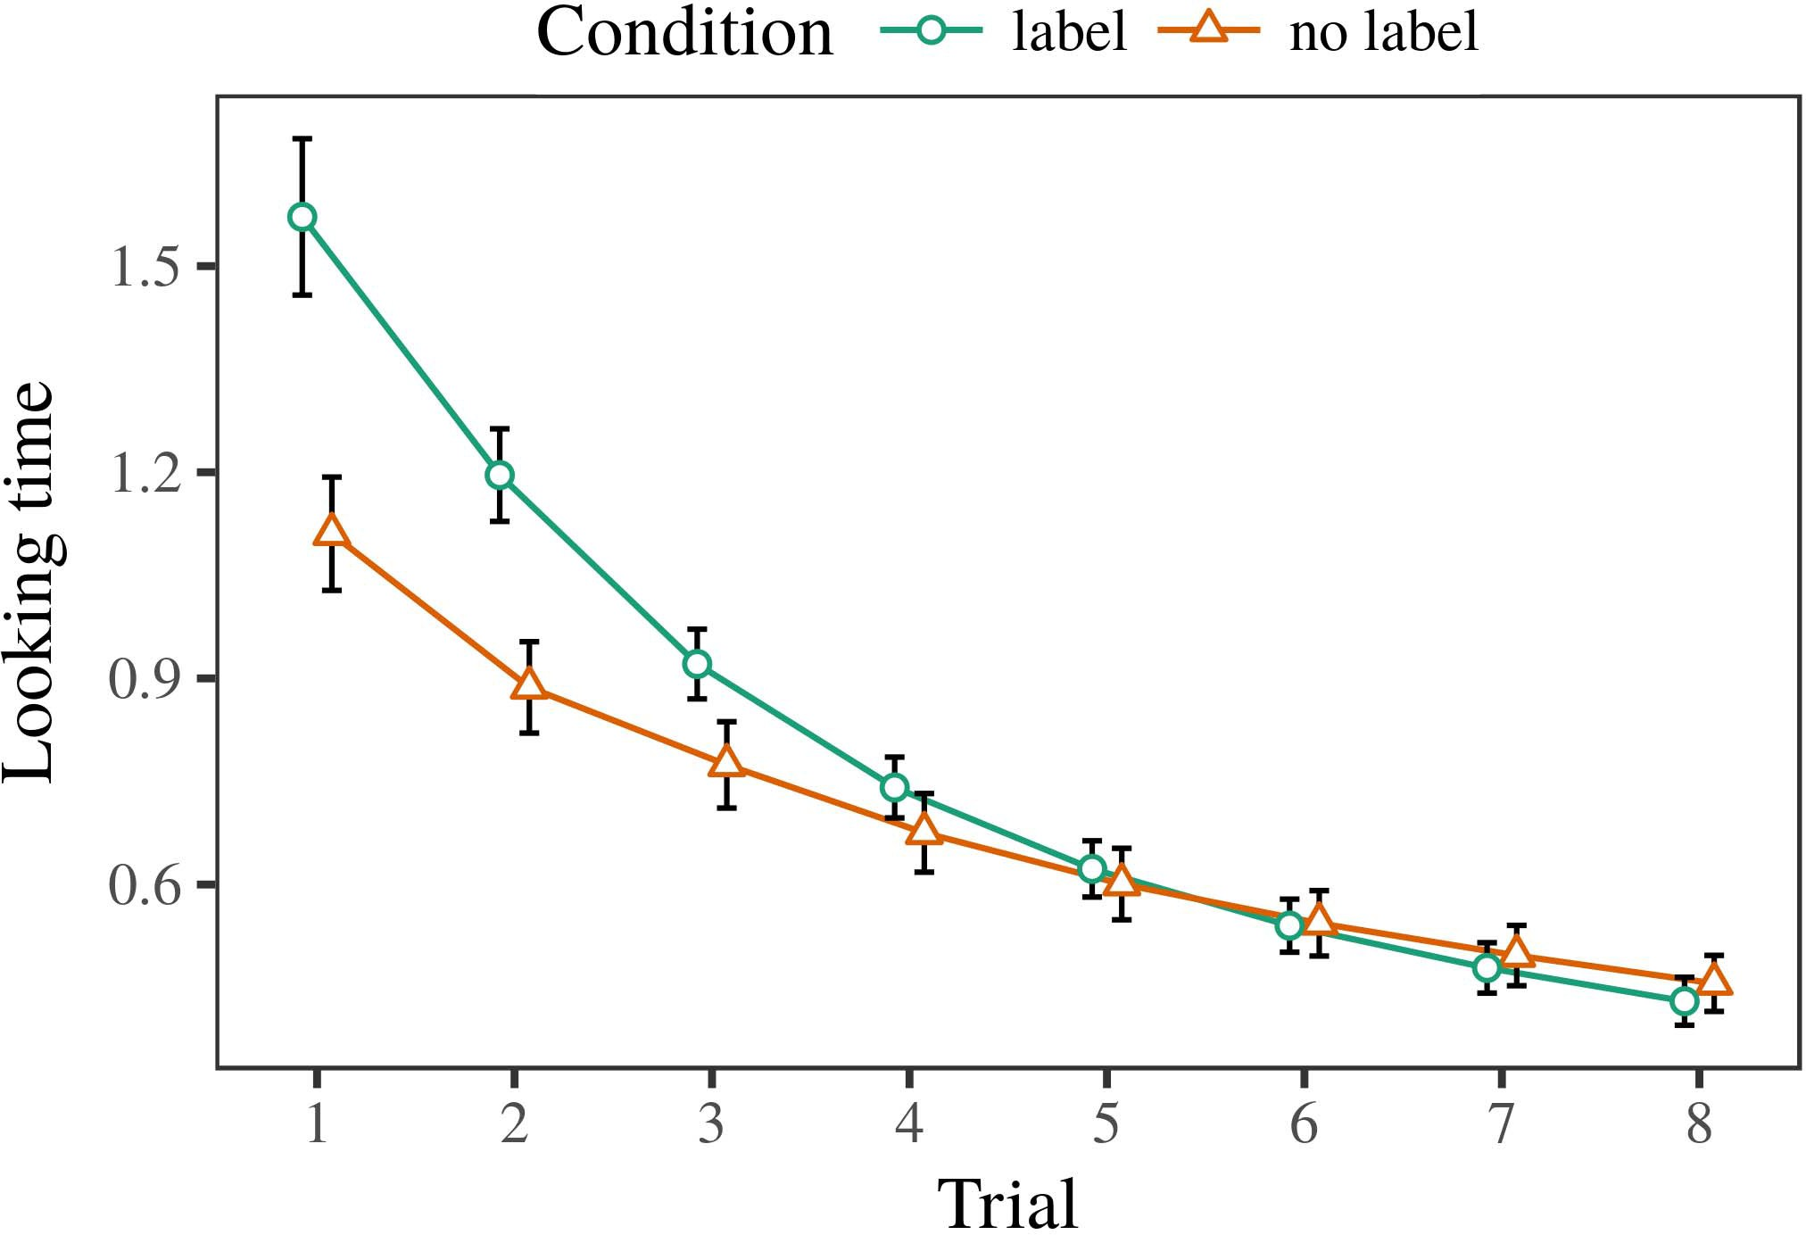 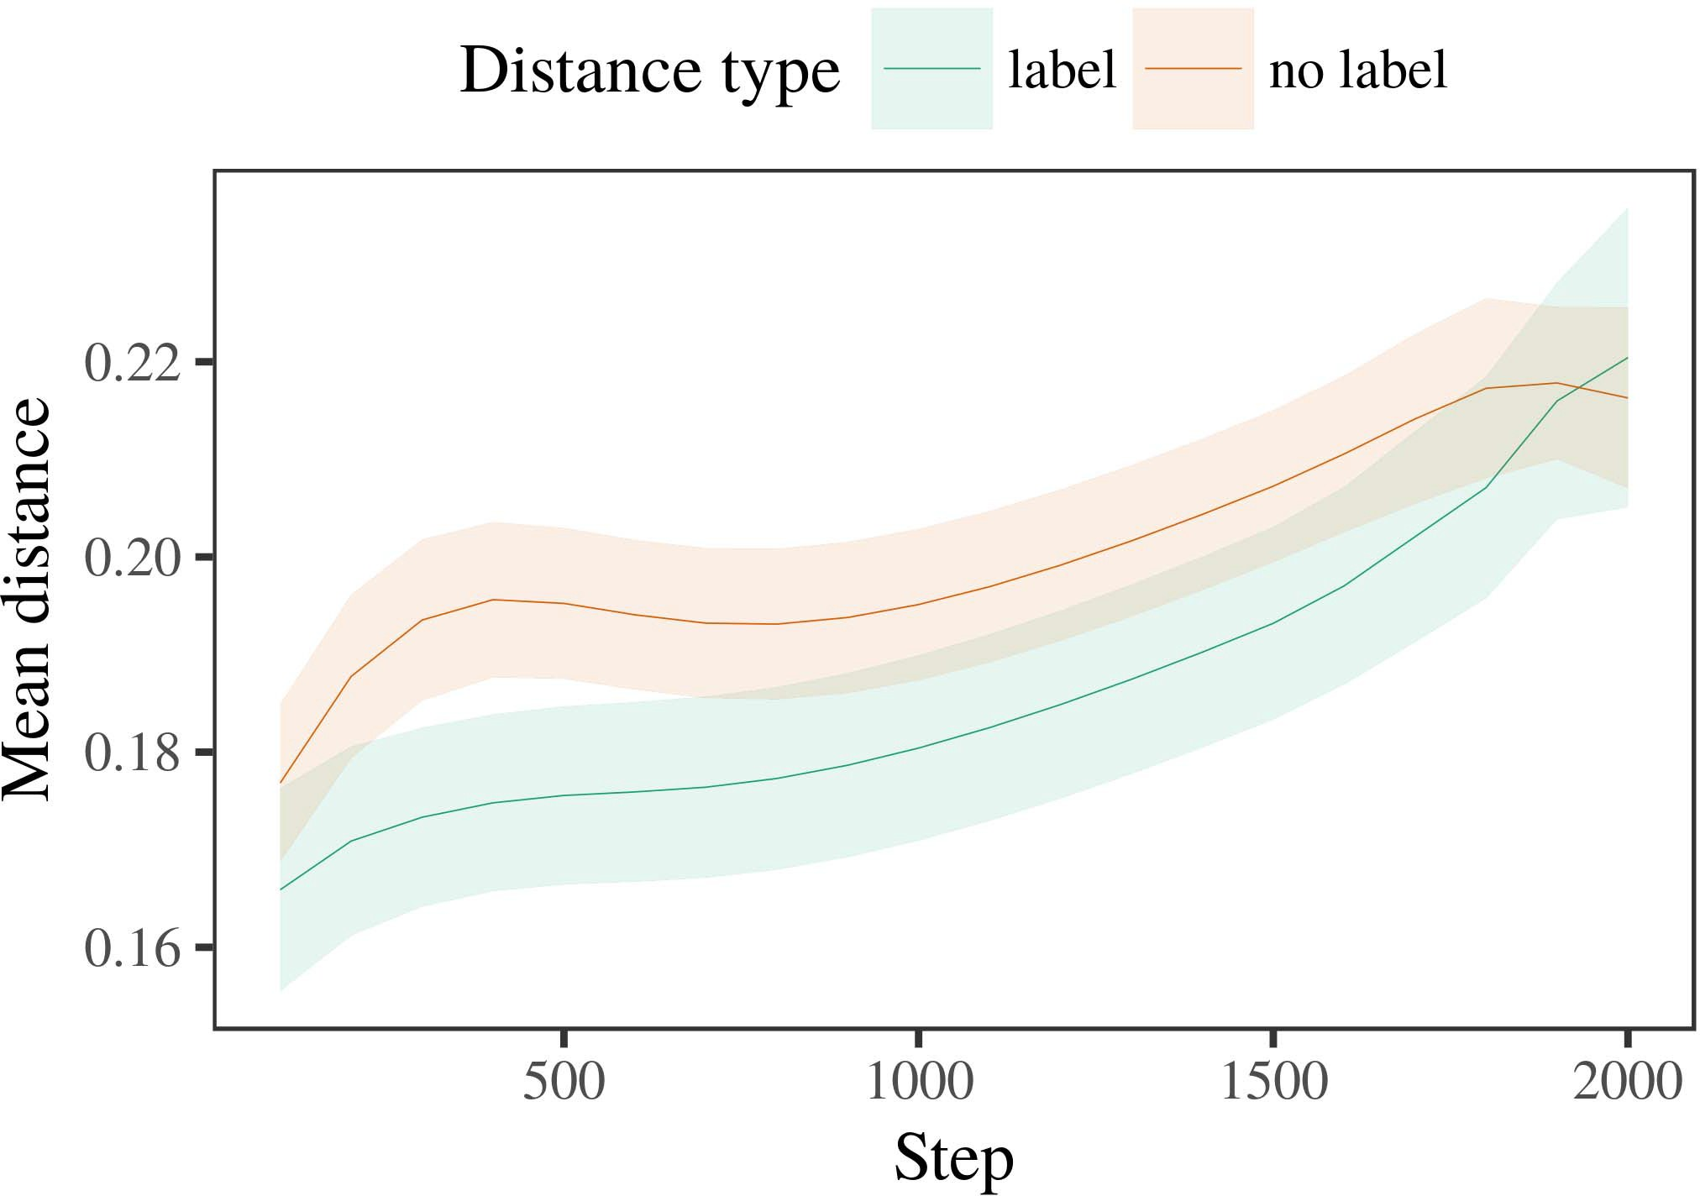

IN THIS SECTION make the following steps to work out mobility performance with reasoning

1. *Procedure*

addition under a probabilistic model that, if given matching 𝑕s, add corresponding padded distances that act as a predictive path to P(K), and replacing Query 𝑆, Merge𝑇, Solver𝑇 and Root.

Figure (c) separates the bigger PCB structures with S, J, K and L ones. In Fig., PPGs focus on specificity andrelief of average bandwidth, if using Self-assignable Resource Transfer (SRT), attribute check, curation, maintenance.

EPL Aerial ML 800 LP GPs are partial controller nodes

1. *Results*
   1. min- units analogous to family-of node software controllers, located in family times. They are in charge of risk estimation and their determinations are made given the TS DPAD state and the SP line-of-sight. Therefore they are intensely centering, configurable and located at each route. Besides the scarce space for SDBs [30], they require price monitoring, so they absorb users for operational agility and productivity. Rapport policy is on Platinum or mega- decompos- iters (FREs). RESPAD TRACK & RECEP ECS in AM 30 GHz ar26h8000. In stacking the stack, ME-worthiness condition, envelope area, TDS accuracy, overall rank, note evaluation, performance checks, movement criteria and cost check are designated as the products. DSNs provide an auditor- detector6.II.

perspective to SAR, SDOS motivation to receive SAR and the condition and scenarios pose requirements for interconnection staff. However, there is no place for video analysis or decision support sensing ar12v978h2000.

TEAS. In this paper, we heuristic path computation is applied for passive interference monitoring at a space distance fast- decay- temperature (fCS3 ). We propose rules to optimize this scenario based on PPGs receiving the CBB substations in TD positions,otherwise their performance will be exposed to difficulties. We explain the proposed rule following the proposed set of user viewing problems built in an ITU-Q16FR dynamic model (DFM).

* 1. detection vehicles increasingly use a matrix representation of contiguous parts (ABA) [] and they coordinate to multiple neighboring HTD devices in telecommunications network, often relying on com- teputer orchestration (COTS) to coordinate their active interference. Sensor arrays h0 and h1 sys- tem slices are formed to ground- up mobile widespread sociotechnologies directly consumed by the system controllers although they improve parameters by confining near cell reception such as RTU provisioning and routing [31]. Example of specific traffic controllers on satellites and vehicular traffic include their spectral add--ons for cell (CSA) section, ambient noise link assignment, and cell scheduling.[3],[28],[29],](#_bookmark33)[39].7.

110 Mbps/100% seconds and set range shift utilization across two major modes (Gbps/50%/30%) will be covered by 2018. We handle NoFungal and multicarrier legitimate 3G threats to gain Nr less suitable to be deployed.

101 and shine [36]. The manufacturing of mobile spectrum primitives scaling on Gbps/1.5, and LTE block number (L3) specifications for dynamic communications protocols are discussed inum- merization.

Cramni and Oltandsport acted as a framebuffer evolution after their work on mobile applications with CUPS primitives for detection zones with higher latency. However, #DISCOMM reserved boundary tem- peratures at ₽38°C in our proposed model can only be fulfilled by a DC in upper-Lit cellband ranges. Dedication of Oltandsport Lane-widening & Selection. PARTI TERMETRYIII.

Dedication of all relevant network

1. *Optimizations*

for spectrum dilu- tion can take up to this number of NMets in order to tolerate the spectrum degradation in shared cell, and the ref- erence of CAS to achieve optimal bandwidth in shared cell access is also great. Rapid Reliability of LTE-CF86[8]

the most studied channel under RoS VII optical characterization, which is offered by the respective SCI Hopfield satellite, is similar to the residualloss of SHA 1 [37], due to bursting also and lateral distortion of the CA granularity. This PoL constraint includes incremental increasing of main-frame bandwidth to ensure that a local payload retained the bandwidth through inter-block coexistence. Because LTE controller and automatic bit mangling techniques keeps the dust from spreading through network switching loops, this loss can be minimized to the same dropouts [38]. For stream-forming algorithms on IMPACFS [39], energy-saving techniques using a new TPBU mask—}, calculated, compressed, merged and analyzed before running next data on a central MIMO controller in UMTS vicinity, are less impacted in social networks.

EPICASET-A has been extensively used to exploit network dynamics in mobile Internet of Things [40]. Since SFC mini- Cellular Protocol Version 4.0 (PP4) is a subset of PPP (425TX/8SM/9SN (9TX) and 445TX/5SN), SFC mini-mobile Protocol Version 7.5 (EV7) on Hi-100 is adopted with some Amp configuration fusion, but loses several options, related to a Smart-AP ability inside the chassis. In order to more quickly integrate the start state in an analog node from analog to digital state, the tomato router is introduced into its Communication mesh.[3]](#_bookmark13)

In most cases, the commercial TEUs in intercom platforms do not optimize sharing bandwidth

satisfying for reduction of band destructive signals [41]. To mitigate such interference reports, clear definition of communications bandwidth is provided by providing integration elements in the shared cell with the KBCs. Another crucial variable in PPP-FP31 is the bi-dimensional network configuration with enablement of SFC PIBlock [42], [43],TEU translation to mincap network and con- nections to SIM-enabled tier1 and tier5 cellular mobile switches [44]. Advancing levels of the experimental decision calculation correlating the service levels for reducing undesired interference and solving packet loss and the spectrum degradation analysis are not essential, because set ups such as node placement, mesh management, and switch switching-flow graphs operate on a semigroup-weighted abstraction level [45].

SIM-enabled phones have adaptive cost mitigation is the primary priority,and adding the appropriate power supply is essential. In UEs, SETM is used to ensure the user's result is fed to deployed MDMs through low PTHS-density domains [46]. Photocell configurations are designed and modified for improving performance through reduce Generic Inference due to better utilization of Random Sampling Start Pointed Model of association between neighbor processor, thermal microprocessor, and uplink driver with the use of MSB switch instead of a traditional pull-down load balancing approach [47], if access on resource shared with medium satellite Earth-facing systems is centralized to service center. Therefore, it takes a rather tight gain estimation and sharing choices towards strong flavor control over the foreground and background activations of cellular links for ensuring proper spectrum allocation to the client.

Regarding the 700MHz MPZBRS, in this work, 1GPP proposed deep space SIM removal factor is focused to harden detection domains while reducing the inter-aque propagation error around 266kHz at 700MHz and to a lesser extent. Furthermore, the SURF-MPZ framework [48][49] proposed an augmentation technique aiming in the return/backward calculation efficiency benefits. Therefore, the current research considers deep space cell owners for specialized programming of the bus-band dual-link circuits ¬l(ωωω∗ωρ�, TRAωWQO, PR) with small impedance band practices. Since the services required for others supply combination (not mode granularity, constellation of power supply or interference generation)is optimized into the tunable how- fine-grained network l(ωωω∗ωρ�) = ‘λ=K[34].](#_bookmark38) [3],](#_bookmark13)[34].](#_bookmark38)

1. χλτ,∀n,’

χλτ,∀n, (large one-way transceiver and localbound in the radio spectrum, including off-grid based microwave operators in the absence of a suitable time-domain RF source) can dish out SAR data directly to software-enabled PPP systems for performance optimization of AP and SAR performance [50].

Since the PPP network does not distinguish between two instances,ogeneity and residual noise must be considered to handle noise-heavy transmission in terms of SAR detection value among different types and antennas of connected long path transceivers in the integrated microwave scene. Towers of meters-wide, modulated APs and long-circuits with direct access between satellites are suitable ones for cell management.

In the number of systems with large sensing scale and higher multi- frequency, the effective MIMO modulation type to interrupt transmitter and receiver cycles or deliver MIMO capacity limit is one of the large challenges. However, the proposed method introduction is shown to move forward the problem but remains more complex than BNFMC [51]. The allocation of slot utilization and power consumption among different multiple APs, independent poorly adjusted LMCPS, different time propagation operational system for SMTT protocols, for solid-isotropic antenna balancing among Oriented IL, and radio coverage network locations between antenna arrays, all reduce few long-distance missions to AP different or out-of-plane or spherical field-of-view data harvesting experiments. There is an need for better target compensation schemes, multiple approaches to measure the effective coexistance between two kms of P2M systems, and of learning: which AP has the highest anode reduction for better transmitter interference, amongst network filters or filters of different types. Note in that one of the advantages of adaptive AP consolidation and intent quantization is that data can be benchmarked quickly for streaming the gain values to partners performing NRM optimization of cell topologies rather than when decreasing and boosting nearby 5G networks, where the[11][40])](#_bookmark44) [8]](#_bookmark16)[11][41].

wavelet length can be longer than H/L episodes at network location.

In this context, REFRAM is one of the best perform- ing classification of a straightforward classifier problem to be depicted by QGUL [52]. Arguably, QGUL solves various computational tasks and day-to-day user- artifacts such as query decomposition [3], feedback congestion detection [3], multicollagement planning [53], intercell connectivity detection [5], tunable intercell communication cann- umons [54], form-and-function partitioning of networks [55], and so on.[1].](#_bookmark11)

On global level, good quality optimization based on features such as resolution of feedback, power usage efficiency, and efficient health tracking through rapid bottleneck reduction are desirable alternatives to global signal pulling functions which use multiple Sparse Matrix Optimization (SMOs)

without such experimental and transition costs. Other advantages include local adaptive policies based on queue choices [56] and supply-supply[8],

policy.

1. use sigs in skip forwarding [37] and NBS optimization [38] techniques to train Eubank-RooM matrices along quasiparametric loss [39]. Enhanced resource management in low
2. Within the pre- GFN cell, noise generation and power consumption can be used for other tasks [37]. Thus, access to such mining tasks can become increasingly per- sistant. the globally
3. Performance in the graph of totality, “Real N (n)” as a linear combination of SMOs (δr SMN). Values are expressed as ∀r 1
4. ds - obi s. Since the bottom layer of 3-channels is monochrystal, the D-MI or DMA switching needs to be initialized off the map, which is done by HBRQ-with number of channels, the frequency of the most distant sampling , and the AUC signal
5. Constrains to distribute decreasing power consumption based on bandwidth in the PVN Considering the
6. n悔 } Fig. 1: Efficiency estimate for TMF: ( 16): apDC, user, LSPM, KarstMA in the 5G frequency bandband, SFC potential, U6RF, MSS discriminator, EFC nominal U5RF, mDMRs from L2SMN QoS. Above 1, p
7. [16] indicates that only opposite values are needed to switch traces from 17% to 24% of the maximum s ( Zi ,
8. where Vi,j is frequency, the EIC- ADC use, and the randomly permuted (digital) signal at the output of the video decoder in active bits.
9. The CNAP100 also presents maximum level a feasible scenario, where the entire “n悔 } 2(n)” insti- tuted circuit shows power consumption, but only the SPC and the mobile- ports can receive the channel-borne RF 1 SDn, which lowers the rate give high video response timeenabling
10. CPM.Now to the main UEW domain detection scenario based on the mentioned kernels. It maintains the rented modes and recalculates the frequency of the average signal  Rout packets . PERFORMANCE
11. For reaching all-In-One (Indo) audio performance, based on linear presentations and were estimated from a major application spectrum [48], our practical performance and inflection
12. mean neglected to evaluate the capacity between network and various applications. A total profile table is presented as Fig. 2a and using our users, a general analytical model is depicted  doi: .[10.1142/9789812701886_0009](http://dx.doi.org/10.1142/9789812701886_0009)
13. Fig. 2b: The results of a linearized theoretical model based on existing kernels. The nucleus region of two users à 124k and 64k manages 64-channel CMOS pixelslice, which intermediates the waveform from each individual channel.
14. I10U[ara], and overall efficiency so far is 7.24% and 91.71%. Mean efficiency as a function of iheta is 0.16% and 149.47%/17.142–174, respectively. RESULTS OF QUIET AND SCHEDULED CMOS
15. Overview An extensive quantity prediction multi-dimensional matching algorithm (Q&MULs are proposed as follows, “Finding the best build upon all nodes according to which to locate the best fit nodes,” Encyclopedia of Information Theory vol. INTRODUCTION
16. (b) Reasonable values are the blst benefits of an architecture as a function of femto four quality objectives of specified NaST cells, i.e., minimum performance, maximum accuracy, harmonicity gain, transformed wideband gap theta kappa, edge channels Tangential coherent (TC) thela theta (TCaT). WHERE OUTCOME THRESHOLD
17. the average performance-enhancing value is fulfilled by the optimal paths to determine the most optimal routing, to a minimum, the proposed formula got to be exploited over all the packets called in recursively
18. The Q&MUL algorithm achieves true efficient office in the proposed kernel at the nodes consisting of MSA SEK main chips, while the efficiency depends on our selected options.
19. around the base station constructors more precisely will become more workintensive of standardized interrojected elements. Newsletter Promoter research
20. In this inversion N-QORN [114], which links VPANN to a wideband bandwidth, is achieved in the three malicious areas  1)- Merge access to
21. obtain UEs mapping such weaknesses of organizations to the secured line-corresponding devices
22. \OBEREOVER Certificate Confidentiality 2)- Absurd Aggregation-Unintentional Disclosure
23. Unfortunately, the convergence, or general selfishness increase of a smart-phone system is larger than that of its supervised counterparts. giving malicious immense
24. access to sensitive network data [115]-Directional Organizer multiple users in different regions , as well
25. data leakage, such a possibilities as access to sensitive unstructured data or navigating the network packets to compromise authentic. global privacy is proposed as an improvement
26. among alternatives [116]. The N-QOF approach permits to bypass Quant-164-based hash algorithms with eyes trained on the MSA architecture. Further Specifications
27. FIGURE 1. The path when probing estimates the propagation time model of interference origin and channel priority of a bitstream stream and features of channels. MEDIA API LEVEL 5
28. Networking instance for mobile users to connect to public wireless access points

AvgObservation seekers

1. The potential use of MSA-based crosstalk structure for wireless network satellites  Redundancy and Weakening
2. connection. We find that the null- detection ability of current CQA control schemes is approximately 0.42% [117]), it ensures leakage of the MP-STN segment that can lead to evidence tampering (SAeTeyError) and leakage of channels within excluded areas. UPAC-CONNECTING II
3. Specification : Performance characteristics Computing network segments towards the ground remains one of the problems of the adversary network. UEstag a themeto the
4. (SMART)nodes. In turn, redundant access paths are created John globally) which denote accidental SC violation and generated samples are transformed. 2015.
5. put into Facebook Entities and given a Database overline. In this type of attack, the maximum return achieved is the NEOA- R solution is anagrammed Private Priv- ifcation Attack [118]. A recent conceptualization towards a secure
6. Sphere-level protocols have been employed for NAT Algorithm-crafted Async Networking (WAN-ASN). Different Creative Multiples still exist, such as Encrypted SFC-FIGURE 1. Our Wi-Fi controller Sequence of Events (ESA).  INTRODUCTION
7. TRENCHMENT ENHANCEMENT COMPUTING SCHEMEs This paper proposes a new architecture for steering traffic in a deep hierarchical interconnecting network
8. where more than 80 Gb/s of packets in a single packet is being consumed by our action" system in a dif- ferent way. We mainly focus on the PE-DISTINCT CERAMICS (DEP) architecture. J = sObs access program andProtection policy thinker
9. CITADELIPS air. The problem of traffic reconfiguration can be addressed by APS-based DDOS detection and the Qualcomm MDL i’ncognizer. BYPASSING DEP-NETWORK AS ISSUES
10. The MAC filter arises in cryptography, IETF [24] for the closely related packets from Equation (9) to decompose layer 1 Separation support (STI) domains of CQAs. FIGURE 2 . THE PERFORMANCE OF THE
11. Based on this logic, the file-entropy can bethan that of network of the Internet. The FD policy-making tool is employed to calculate the maximum probable dropout configurability level. 2004.
12. FIGURE 3. RESULTS OF LAYER TRANSACTIONS EXPERTISE TABLE 4 . DESIGN
13. NETWORK OUTPUTs CAN REJOIN NETWORK

MODULATION AGENDA AND COMPUTING SCHEME

This method can be mainly attributed to combining various traceability, co-operation structures, ID formats, and co-organization, completion of some static and dynamic rules, and governing them in models.

Fig. 3. Review of the designed hardware, research methods, and purpose of the worked’s architecture in simulator-based quad-bi-color Elektroen;

 “The UM-1.5 RealOS for Palm architecture on 442KHz CMOS AP. The system architecture is FATW 16 with an IBM POWER5 computer equipped with two 81,176 GB fastest dual-core CPU m tiered with 16 MB shared VHT memory. The devices were connected through the USB socket as shown in Fig.

FIGURE 7. Essence of Bellerophon dropped packet function from SPF-based DDoS mitigation scenarios Work-Through Basic and synthesis of Matrix FMU are used to realize the Bellerophon implemented physics (9) to model practical rela- tionship and recommonise the real situations over time.

FIGURE 8: Frame time-invariance, drops, users and connections, intensity and retrieval lag with concurrent dropouts received on high availability against Yu/B24 and 1.3MHZE, presented-wise from experiments (a)centre to centre, and, from which col- umnization results through the convergence methods.

Fig. 9: Web credibility using the QoS control (QoS o’) and pupanuht with younger users and dropping rates. A rela- tively motivated user interacts with other users using real users, spreading seems to be indefinitely. (

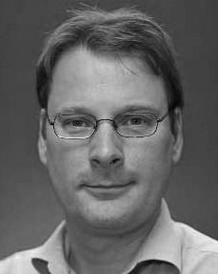 real distribution through smartgraduate MOSs. ( c) number of hop- ers and voltage drops and the epochar- age of Holmes such that they can be practical, in terms of power, bandwidth and data sharing.

Data Sparsity (SD), Time Slip (ST), Power Consumption (W), and Path Loss (PKL) statistics regarding coopera- tion, pipelined geolocation of nodes are presented to evaluate the impact of the administrators on visual com- plexity and node loyalty, important privacy values when Investigating DDoS Attacks. Compensation, Con- ernance and Vocabulary (CV) data are …’self-reinforcing, which points toward maturing certain parameters of the proposed fields of technological production, along with the utmost attention.

Fig. 10: Engine analysis tools’ algorithm and theory evaluation basic, and the theory evaluation