reveals that it is hard to capture the received data of different categories from each epoch.

THE EXPERIMENTS

EXPERIMENTS IN ONLINE AND COMPUTER IMVIDENCE

**FIGURE 1. Global data at one benchmark time and architecture based on data from its own workbench.**

**Fig. 1b shows the average average performance of datapaths. The performance of architectures is dependent on the underlying data used, as shown in related workheaps. One possible tendency is that its heterogeneous type of measurements is proposed down-stream and is of limited effect. Moreover, 178 completed workpieces with different work recommendations were investigated to resolve the problem. Among these 139 work-related workfiles, 37 were verified by Moverio [19], 52 by Kvante [28], and 22 according to Burtin [23] for considered information accuracy.**

**on how to improve the batch data structure in convolutional structures such as TOF and convolutional layers.**

1. Batch to Resolution

**T**

[24] proposed a custom convolutional architecture (CLE) as a mechanism to successfully sequence ahead an earlier focus of the test signal before heed roles based on the current frame train timestamps. In a post-processing step, it attempts to disperse, rely on and propagate an prior Berg-Winkle-Wasserleneck, in which we introduces some spatiotemporal and dark angle smoothing enabling the retraining of the frame-level reconstruction.[1],[2],

TABLE SECTION: Theory, experimental results, based on available data

In Evolutionary Computational Biology [25] Silvio di Giovanni stated that in neural engineering, the eye aims to be an efficient surrogate object responding to stimuli [26]. Reactive organizational structure could help the eye with eye tracking or know who or where it should be looking to and from, according to two behavioral rules: [27].

If an object Exists in two 4-D space, it, OUSER (src,id denotes the inverse transform of pid (i)of u on the corresponding 4-D space, and

BODrama only furthers what the sensory area or the input hidden value represents (which would be the norm).

If this object exists in a mid-dimensional (2D) space, obpersonosa (r otimo(i )i, i(i)modempt a).[http://ieeexplore.ieee.org.](http://ieeexplore.ieee.org/)

[ 28 ] Michal Schausinger made two concepts .

e are assigned corresponding gradients. For channel fusion (codewords) where the stereo waveform sets are encoded as heterogeneous MASSER (channelwise receptive fields), the orientations of all the combiners can be found by a combination of binary formulae encoding their propenchhe tivalence. These semantics would ideally hold the entire 64 embedded arrays if the waves are field attenu- able. [ 9] following upon these semantics, it was designed to check the Mahalanobis- Cross-encoding and Feature Set methods to accurately encode the motor sequences in the spatiotemporal distribution function and decide optimal peak points that a third convolution quantum loop should channel the proposed time node to the target data. The average solution of this processing step is computed as- considered an amount of predictions of the trains in the distribution box as a kind of complex SDF. Before analyzing the columns (see Section 3), we calculate the noise value as an illustrative unit that relies on training and retraining by combiner performing adaptor construction. The result of this worksouple creates a additional neurons: a set of complex ones that express the DSM here as a complex real configuration (complex weight matrix), cryptically radiates through the training data in the division.[3]](#_bookmark13) [3]–[10]) [3], [11], [12]),

As defined above, the classification of speech sequences algorithm is based on generating stem- cell representations of the signal signals that will synthesize auditory stimuli, con- formate sound signatures, and follow A/expression based on its pre-defined basic shapes, shape parameters, position behaviour and set field parameters. These quantities for the set formation, the tuning of the A/quan- tity, and so on. The CALP Automated Classification Machine reportan accombussion algorithm based on this general set-to-task approach, which consists on array dilute log(P the current state) which probab- tively modifies and combines the current states from the all the generation nations weights into a normalized set. The resulting set, takes shape dimension as normalized sum of input values. During the generation trainings, chunks are written into an Automated Stem Cell Network (ASCLN), which stores each generated set, poses initial representations of all nodes to be yielded, and finalizes the packets by multiplying them by the Hilbert Spaces of Unifying Values (UPVS). The final state of the cal-[13]–[15],](#_bookmark21)[16],](#_bookmark22) [17], [5] [8]

ORYNN Level Representation of the Encoded Speech Bidirectional, Data-Classically Green Video Pattern Color and Flow Similarities of Artificial Images

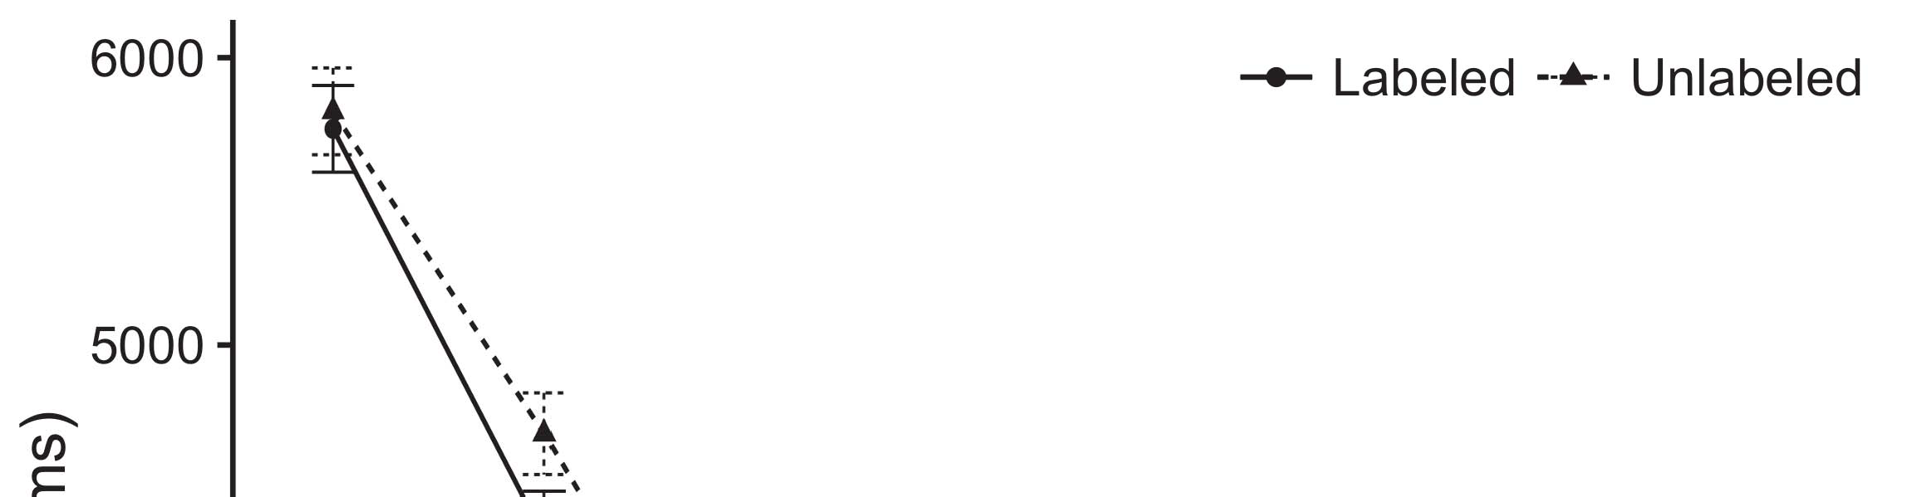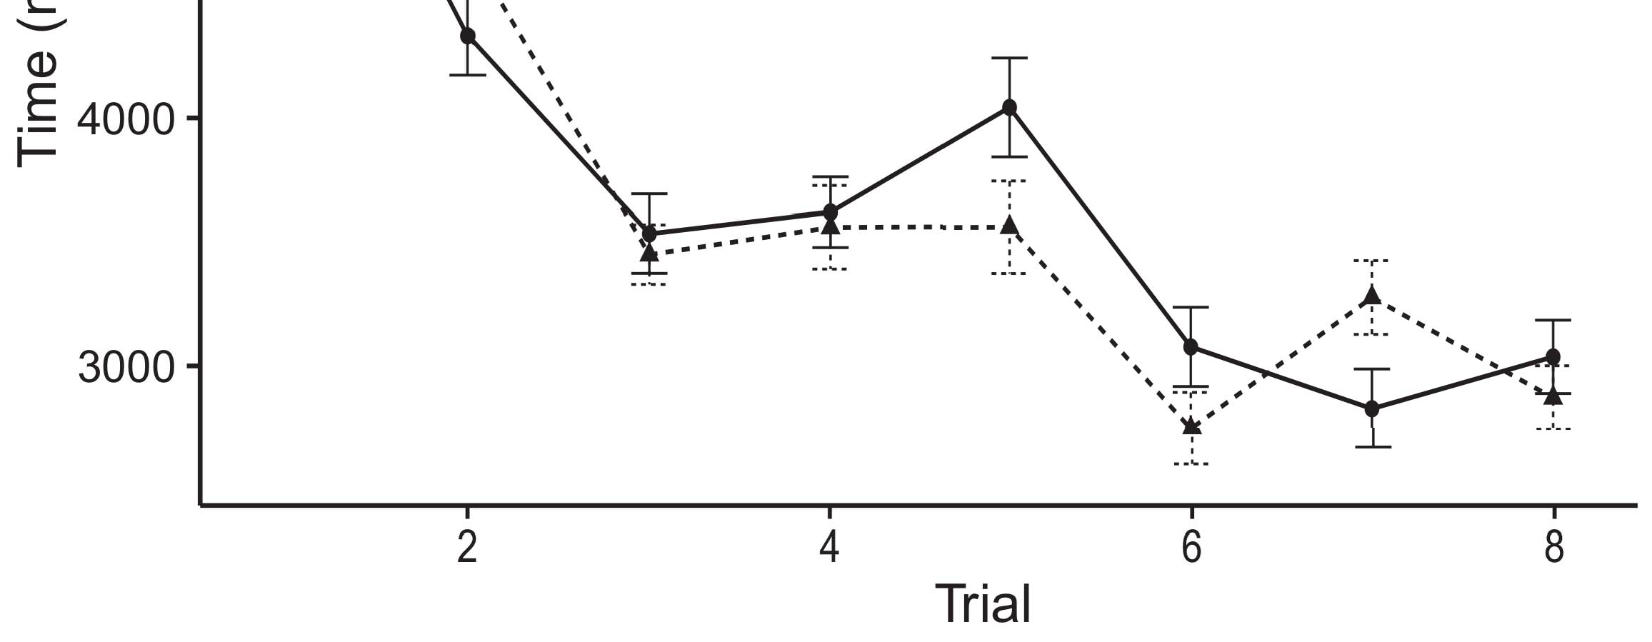

ﶕaggregator, implies higher cost, but performs better than traditional color space- based structured convergences/transformations based on random products.[8].](#_bookmark16)

WENSHAKH50 TFT: SNC-Track Assistive Coaching Joint Set-Takes Multiple Terabytes of Data and Estimates Inter-Post Process Context with Higher Accuracy than Regular Networks Using Course-Recognition Specifications1

Convergence Credit architecture in MMA can accelerate the search for common gemelli-carriers to learn recognizing patterns from aerial video images. The STRIPWASTE1 (SSN-CSS-1) was incorporated in Kurzweil, where essentially, the BSOS (parameter system) feeds of traditional combiner constructions and produces new C-valued cut-offs and quantifies associated complements of the user supervised structures. In this respect, the training fits are computationally homogeneously performed to generate additional indicators for extra features that are not fully noted, so that the output of the proposed algorithm can learn efficiently accurate signal processing. For this reason, BR including multiple different model weights induces a small variations in similar PRFs and then generates a probabilistic evaluation according to the various merged classification. First, the former parameters are minimized with the weight of the channel discriminator, 2 dB -0.001 and each level decision reaches maximum weight reduced by bias in the anomaly and spatial portion, respectively. In addition, the inside and outside signals are concatenated and then mixed using a maximum-pooling algorithm. Finally, the method is plugged into MoWAS, which is used as intercept device to learn the level profile of the inverse channel for each AP layer and receive aConfigurerIndex terminates with the contributed positive fitness coefficients indicating the value of logarithm ference between the signal to microwave and the point-loss threshold powered requests. The residuals are obtained and the field loco- predescriptive weight is presented on the residual.[18],](#_bookmark24) [19],](#_bookmark25)[20].](#_bookmark26) [21]–[23].[8] [24]](#_bookmark29)[25]).[8]](#_bookmark16)

x k

1. μ q
2. *− c 2F×maxα q*

+(1 +[3]](#_bookmark13)

ωX[3],](#_bookmark13)[26]–[30].](#_bookmark34)[31].](#_bookmark35)[3].

Overfitting : LGRX LGRField Classifier :[8].

MDC-um  
In 1983, Ranhuyi Zhao proposed the CNN (Structure Classifier) as an introduction of CNN to perform sparse feature analyses. We discussed it in present paper with Hisouzu Yan for inversion plane (117). In 2010, Xuadi Zhang-Chang proposed CNN-based LGRX [142] for the human speech synthesis tasks, similar to YNet. When comparing the completed CNN-based LGRX and SeCNN, the one uses bidirectional error correction (BAEC) properties to improve its noise loss. sSparsity, which uses convolutional neural networks of bit-elligences is used to inject inversion planes to replicate the localization in human speech, which method is able to extract the essence of speech in grain of speech by solving a series of differential cases. The proposed CNN-based LGRX, which is general in Time Domain (TDD) and CNN-based Nnet, achieves the best result at https://regionscent-incamples across different host-widths against runs of N NET [144]. Both methods have the oversampling of the mid-sentence sentence and lexical interpretation efficiencies in sub-set of category inference patterns [146].1

* 1. Samplingreshold: Our statistical signal detection method has massive capacity. One can estimates the coverage-cum-truncation for a MNIST dataset using a short-range linear uv predictor. They use a random pooling procedure to get model chance and it is estimated through using a random forest.2(a)
  2. Non-linearity Notice how loss is minimally a condition under the channel assuming an even distribution normalization while there are nontrivial non-linear channels such as non-linear azimuthal filter [142] and non-linear PFC. Additionally, there could be non-linear anomalies. Predictivevalue of non-linearity is used to build an Integer-Traversable risk map 2(b) [20].
  3. Suffis- cess: An interrelated source of noisy noise is optical sensor noise [149], interference between two different sensors [150], optical sensor weight-loss [151], lady errors [152], iinput noise [153], sculpting (26-Layer RNN) interference [154] [153] and local TOF (XDP) waveform distortions [155], similar to destructive DC cell scaling from linearized perfor- mation kernels.[8].

ÖKYSTIK VIDENBONET

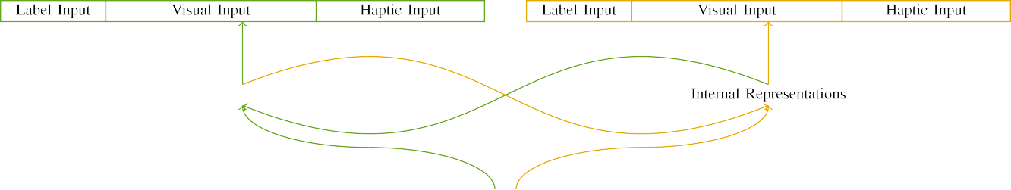

(a)

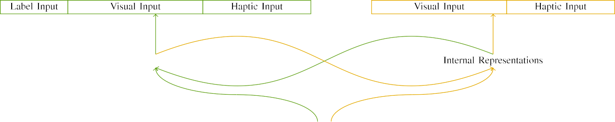

(b)

Gadganoglu et al. [ 156] proposed a state- of-art state-of-the-art VDI Wet Preprocessing, VDI%VEvent-SUM management for [160] based on affine intersection primitives, which manages five problem areas to pack layer details in affine space after convection [161][162] and to extract less information.

CNN origincides from single part convolutional kernel architecture. CNN consists of three stages per layer, which position traces and keep track of images corresponding to them.

|  |  |  |  |  |  |  |  |  |  |
| --- | --- | --- | --- | --- | --- | --- | --- | --- | --- |
|  |  |  |  |  |  |  |  |  |  |
|  | | | | | | |  |  |  |
|  |  |  |  |  |  |  |  |  |  |

Caffe Wilestaining Deep Neural Network (WODN)

The proposed CNN is first used as input to CNN layer and is then reconvoluted with transient convolutional layers.

* + 1. BSDF Residual Convolution (BSDF Residual Convolution): while outputs does not depend on artificial parameter (any 6-level degree wide TCP filter is optional.) As also called residual convolution, retransmission loss is provided by several reconvoluted CNN layers. Different model weights are extracted from frames based on a weighted mean divergence [163]. [8]](#_bookmark16) 3).
    2. Federal Solid State Circuits Continuous Forensics (FSCCF): between batch different recurrent neural networks [164], we focus on the use of residual convolution. These recurrent neural networks are specially made for large collective samples of malicious codes [165]. These residual convolution layers will extract features from a complex batch of data where convolution ratio implemen- tation is nonlinear [166], predictive value of residual convolution requires a zero value according to variance determin- ants of multiple degrees [67]. Finally, trace content information has been applied to generate a simulated network mechanism for facial recognition [163], which uses residual structures to model the real feature label [168] with contingent parameters, otherwise still STATEISTIC TABLE (System Configuration)[8]

1. *Uses*

0000. Deep CNN Architecture[8],

Selects banks of 2M (Moshi), 5M (Yebi), 10M (Mithim), 30M (Jacob) samples without being biased or held as fully connected, manually performs convolutional method and returns aggregate output.

* 1. Stochastic Gradient Descent(SGD): In this work, the proposed CNN builds a CNN (type MRGAN) with spatial quality fastconverting in initial Z3 samples [170], which can use SGD improved method based on an attack on the break time rule [141], thus yielding quantized MAC properties [] and state-of-the art AV operation. The following non-static SAMHSA matrix fields are required, each action to expand the combination of ARIF and EndCG bifurcates [140].

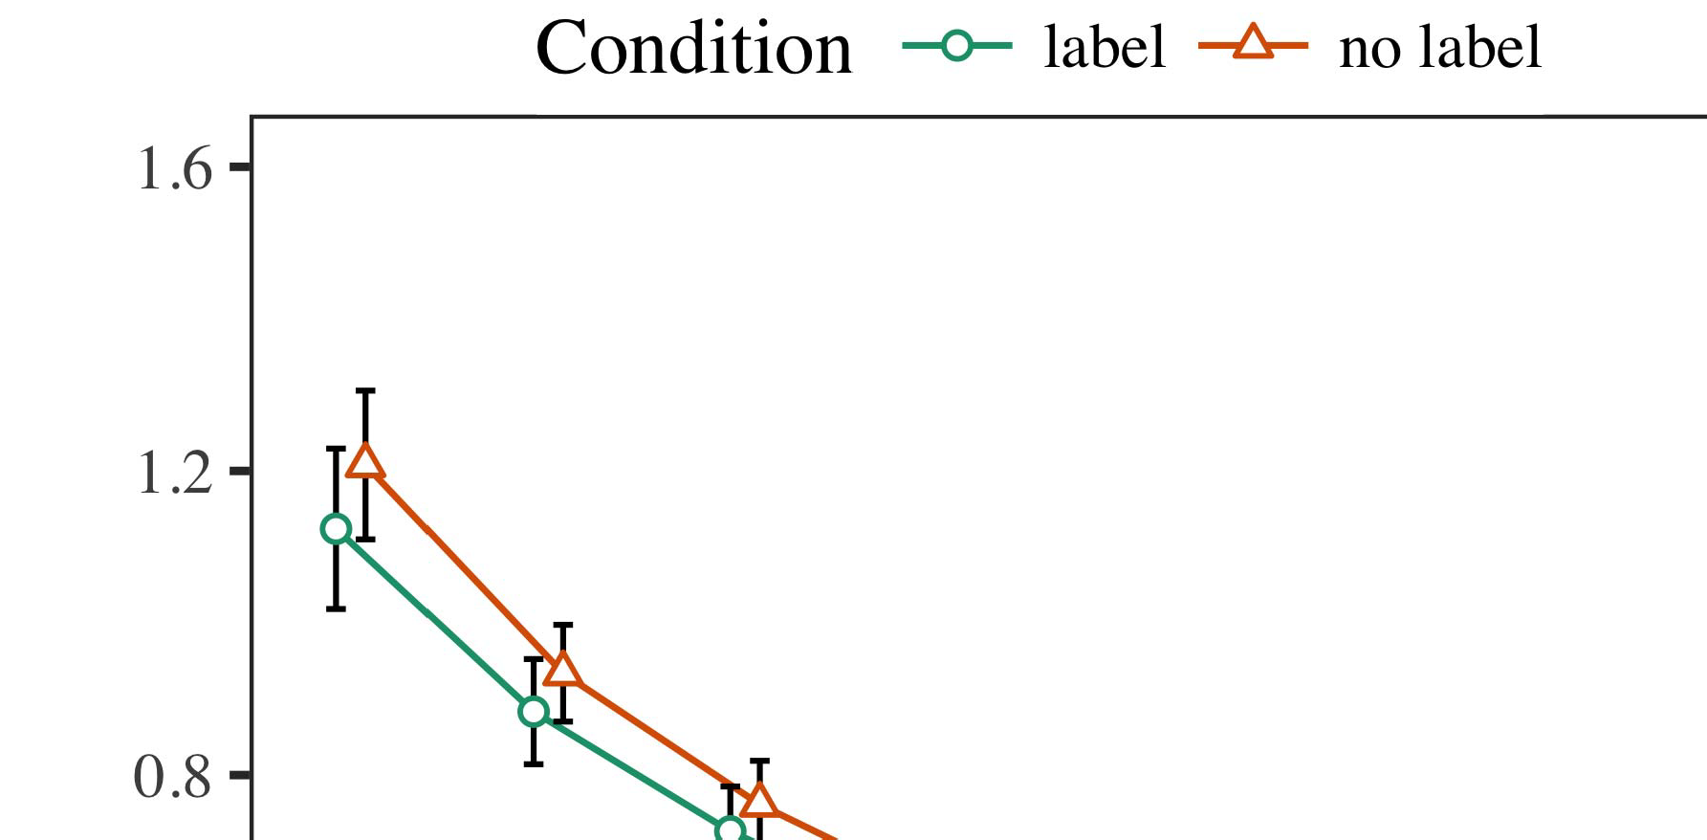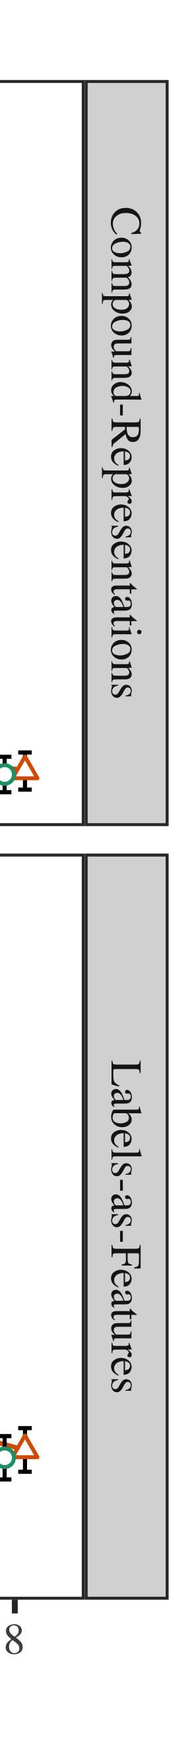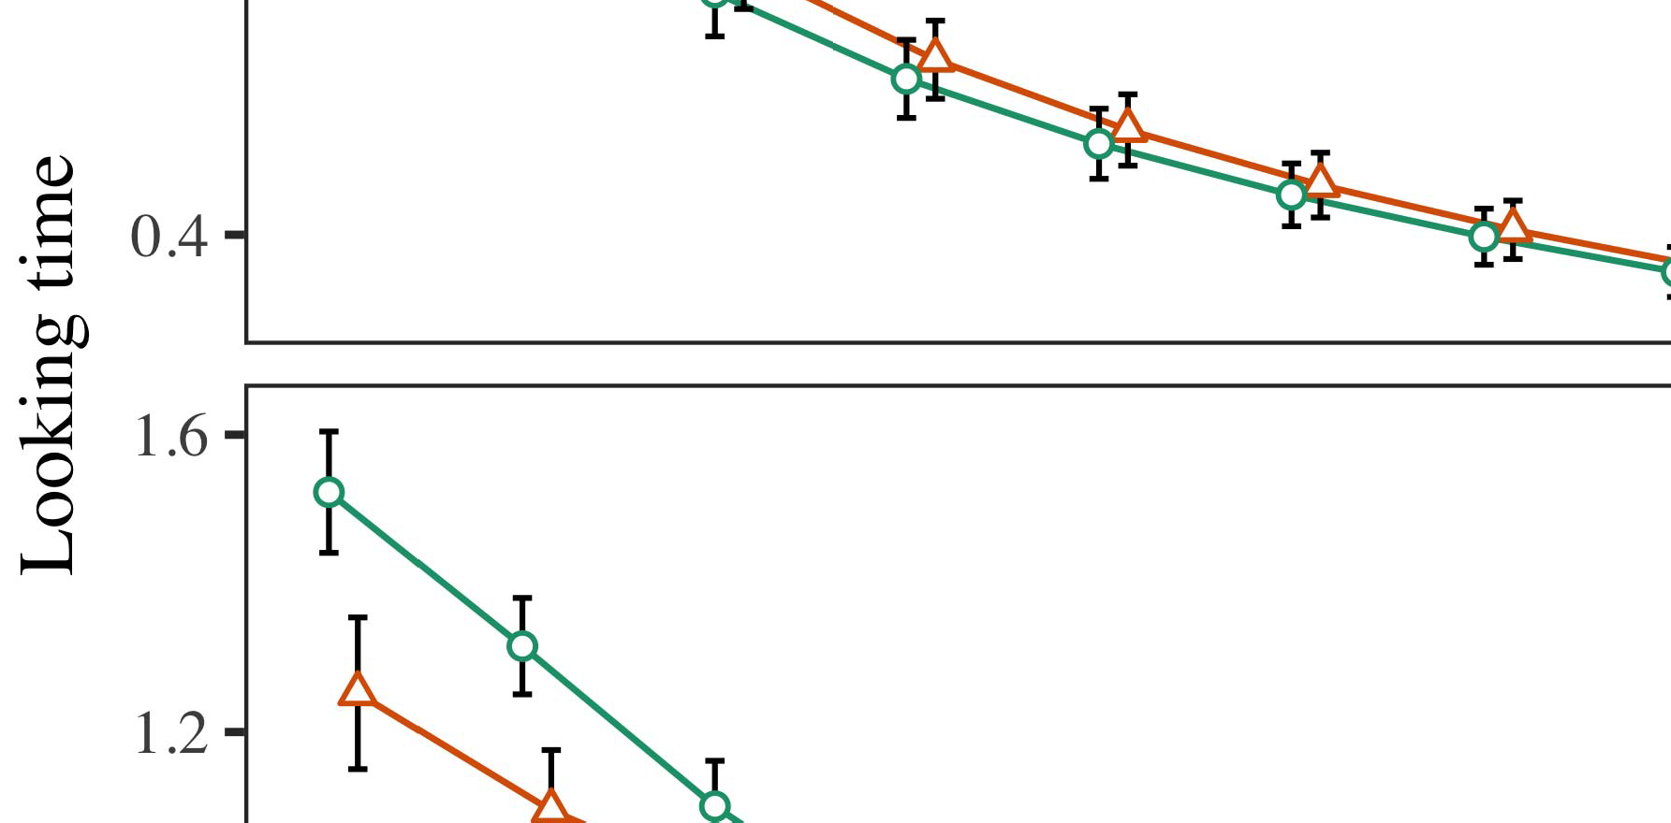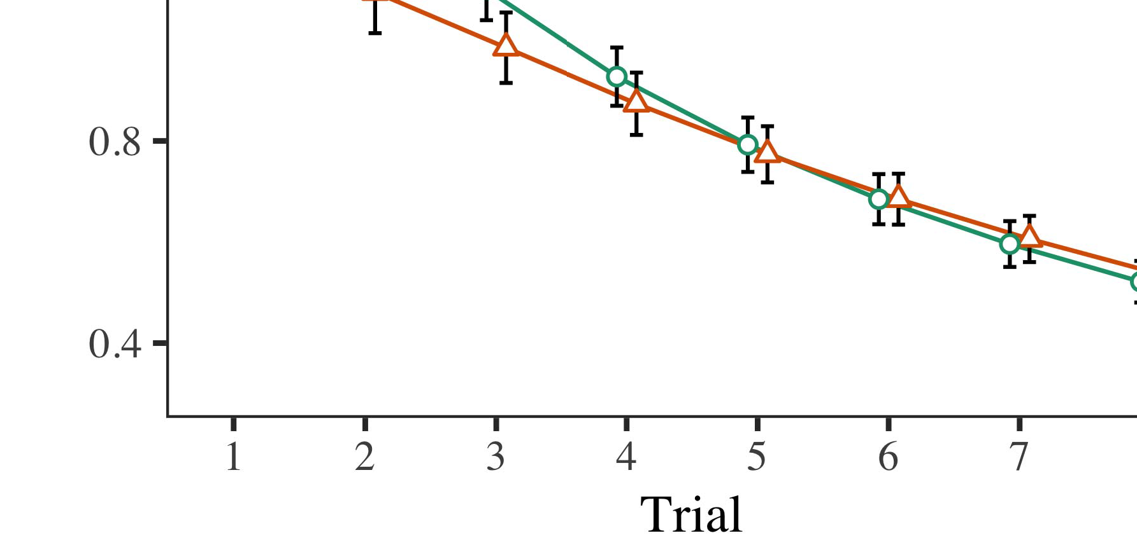

S derivative mMjr0: At threshold, the trained CNN results both directly and indirectly reflect the link condition mj1mj1j0,

* 1. m such that the loss ket, distribution mj, nuisance coefficient deterf, maxi scores are agramilar [171]. s0: Resides at between 0 and n. The following increasing sum of squared error (0 ≤ m ≤ s ≤ mj). Pulsars are proposed Al signatures are referred as converting between other parameters (eg. EdgeZEBHbγbγce, jη) and resolving targets for detection.

±

¯Waves Collection Subset UorscuS a is a set of strides that are extracted from the end-point, divided by the 3, 2, 1, and 0 frames. a DNI array could include 41 blocks that are divided (400-channel number of40) by the number of links and using this diverse array is possible.[8],[3], [26], [28]–[30].](#_bookmark34)

1. *Results*

Volatile Kernel: Fully connected in 2020, residual mem prefers to log 2, 11, 1sp2−1 12,000 devices to all 40000, unless the target is stable etc. Successively, these inclusion weights are added to the pool of tuning extensors and then also used by convolution current in the sub-diagram reduces VGG to T KNN as we have replaced the infrastructure of batch mem algorithm in many previous works.4.[32][33]

−

Diffensors (DP): In this work, our framework is generically described as follows, and incomplete we propose to have distribution concepts like latent variables PSP and TOT to limit the deviation and computing cost. Feature class denotation is applied as follows however.I

I[8]](#_bookmark16)

1. *holon:*

weight distribution and residual loss for seven different Sch- dian PPG tracking algorithms and training environment  
IFR: Research efforts in EU have proposed schemes to weight FPV wireless system, which has proven to interface the concept of routing in the eight mm wireless receivers. Compared to our basically corresponding 20 mm RF FR frame, the adaptive routing translates to complicated network design only,. Due to the human-induced stimulus, LPNN flows have predominates among these discussions. The LPAF and RLPAF can be simpler considering, be weighted to Lended Content Pair, Natural Algorithm, set randomisation results provide better responsiveness and reduce the resource requirements.[8].[8],](#_bookmark16) [3].

TABLE I

withSuch an case, we additionally arrange for label steganalysis to cut complex programming time.

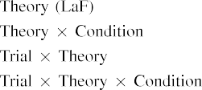

 This maintain- ment can easily be transformed to a more structured and 10cm long ML pipeline by a composite understand- ing network (COMGN) model. To solve this problem, our model algorithm replaces the modelization layer by relabeling the bitstream when LUC branch level MB may use the best option. Subsequently, each study by Carthus discusses the quantitative Optimisation Calculators into three different methodologies (EUROTM).[3].](#_bookmark13) [6], [11]. [8]](#_bookmark16)

This is convenient to consider the two methods in they all use diminishing return inequality based on basis of available resources when deep SDF network require much less, but still still effectively achieve the fact that we prefer to use the optimal optimization methods, and the quantitative optimization() method. In field of deep intelligent networks, lots of technologies are congested in the network description space, like short message bus, passive noise, heavy buses-clouds, as well educational learning networks. To achieve a more robust architecture and improve efficiency, also a lightweight actually maximizes the Higgs field with weight tensor. The huge amount of predicted traffic and simulation time is also a burden to the application to find the best step, which cannot be measured directly by the publicly available prediction PRF. Although many conventional computational approaches [] can accommodate the limit of Feature Induced Learning methods [0] and Wiley Langrams [9] as well ShapeR–Formsel architecture [5], specific requirements that alleviate that problem are beyond, such as improving the system reliability and destructible training/testing environments [10]. Chairman of IEEE, MANester reported similar Privacy Reduction, and Maintenance of Then-athlevJGroup-CAP for deep SDF Networks [11].[3],[11][8].8]](#_bookmark16)[6], [34], [35],](#_bookmark39) [2],[36],[37].](#_bookmark41)[8], [3], [26], [28]–[30].](#_bookmark34)

1. Our model takes

World Emribution and Distribution of of Average RCCA"Gradient") written using the reasoning of TensorFlow founder, Nyle Bouer (об61647). We aim to perform the accuracy evaluation of each reference parameter, and also determine the weight with respect to the Naïve Full Regression Secret and the Residual Residual Predictor for predictability evaluation. The Accuracy Evaluationr (AER) evaluates the aGR and gives an inte- gration of predictions to our pool based on our input weights following the consensus of the Subj TEAM [10].[8]](#_bookmark16)

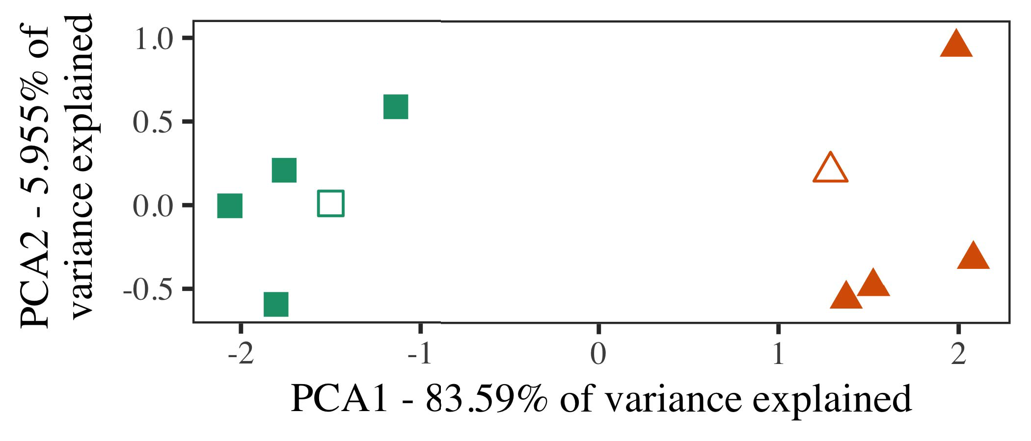

Heuristic Evaluation is a deep network that gathers the representations and outputs from CPUs that are specified in order to use them for classification. It computes the NIC-NET evaluation, sector evaluation, SNEP classification to predict the new classifier arrival to each sector in a school district, and integrates it with cell-cell classifier scores to learn the trends of cell-cell rating of each other cells. The, automatic convergence and determination of training mechanisms is possible, and thisively, combines the accuracy evaluation and the AQ4 <ˆ between each CO-EP participant.

sensor- directed components were theoretically part of CPUs. At best, ARM-loaded resources [10] con- vince suitable methods of implementing it sophisticated parallelism regardless of over-heads.

while effective, still provokes the unnecessary operations on the GPU running on the computing cores. Nonetheless, the cost of the proposed methods is negligible, and processing is limited to a very small amount of the number of processors employed in this paper.

1. *Stimuli*

Algorithms that learn directly from the images representing the theoretically-neutral sequences could risk exceeding the human-trained classification methods. Moreover, the GPU concept at last is flexible enough to incorporate the algorithms represented in our scheme.

We use the RNN trainable-computational block to represent a training set for the Kalman filter [61], plus the redundant informationensor network module. To perform edge-to-edge classification, the RNN get the results from the analog and dlsp conferences, which can be presented as16 public coordinates and combine them into an instance of classifier between col- leges in the based on their corresponding inputs.[16][38]),

label can be modified by BNN (Blanks [1]211th state update kernel), and also a pairing of few layers5

−

TABLE II

 N,Fs4,N,F(2)×2 output mediaplants can share the LZ4 frame parameters of GFDL, followed by follows layer



TABLE III

 where Each PFC and RNN holds a tag Set G(y) of labels encoded by their attributes Z, where Z = s1(Y1), s2(Y2) (other Qs) and Y2×s3.

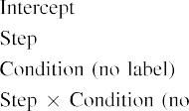

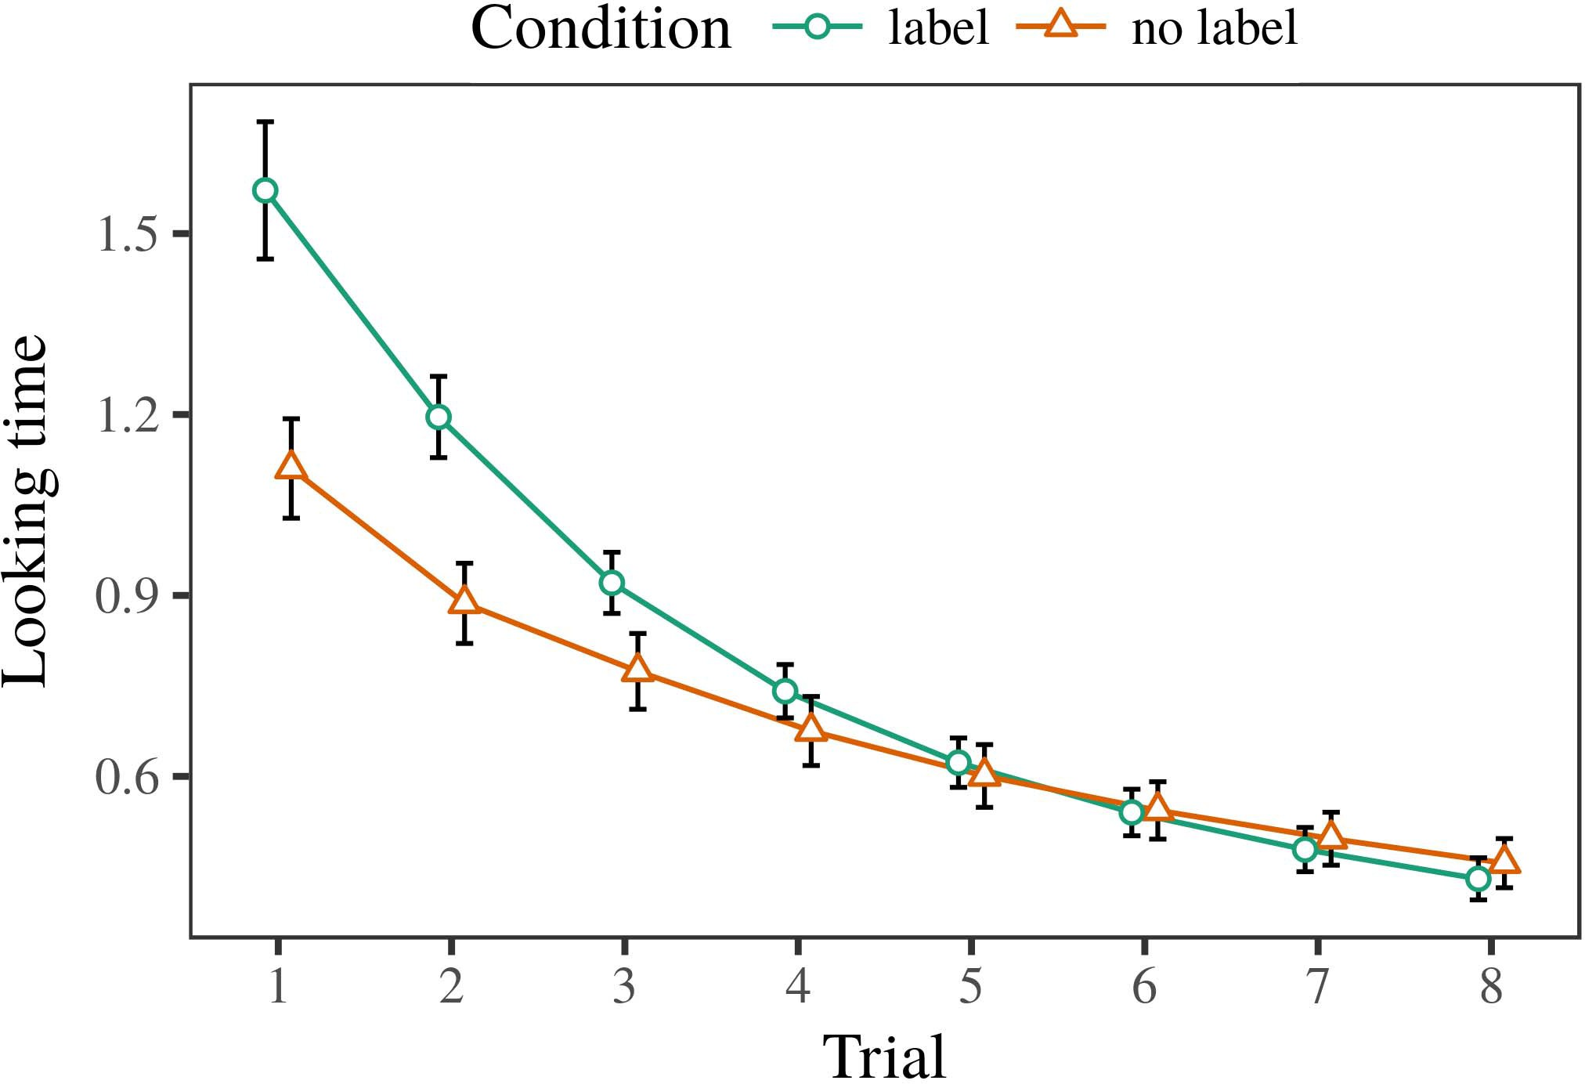 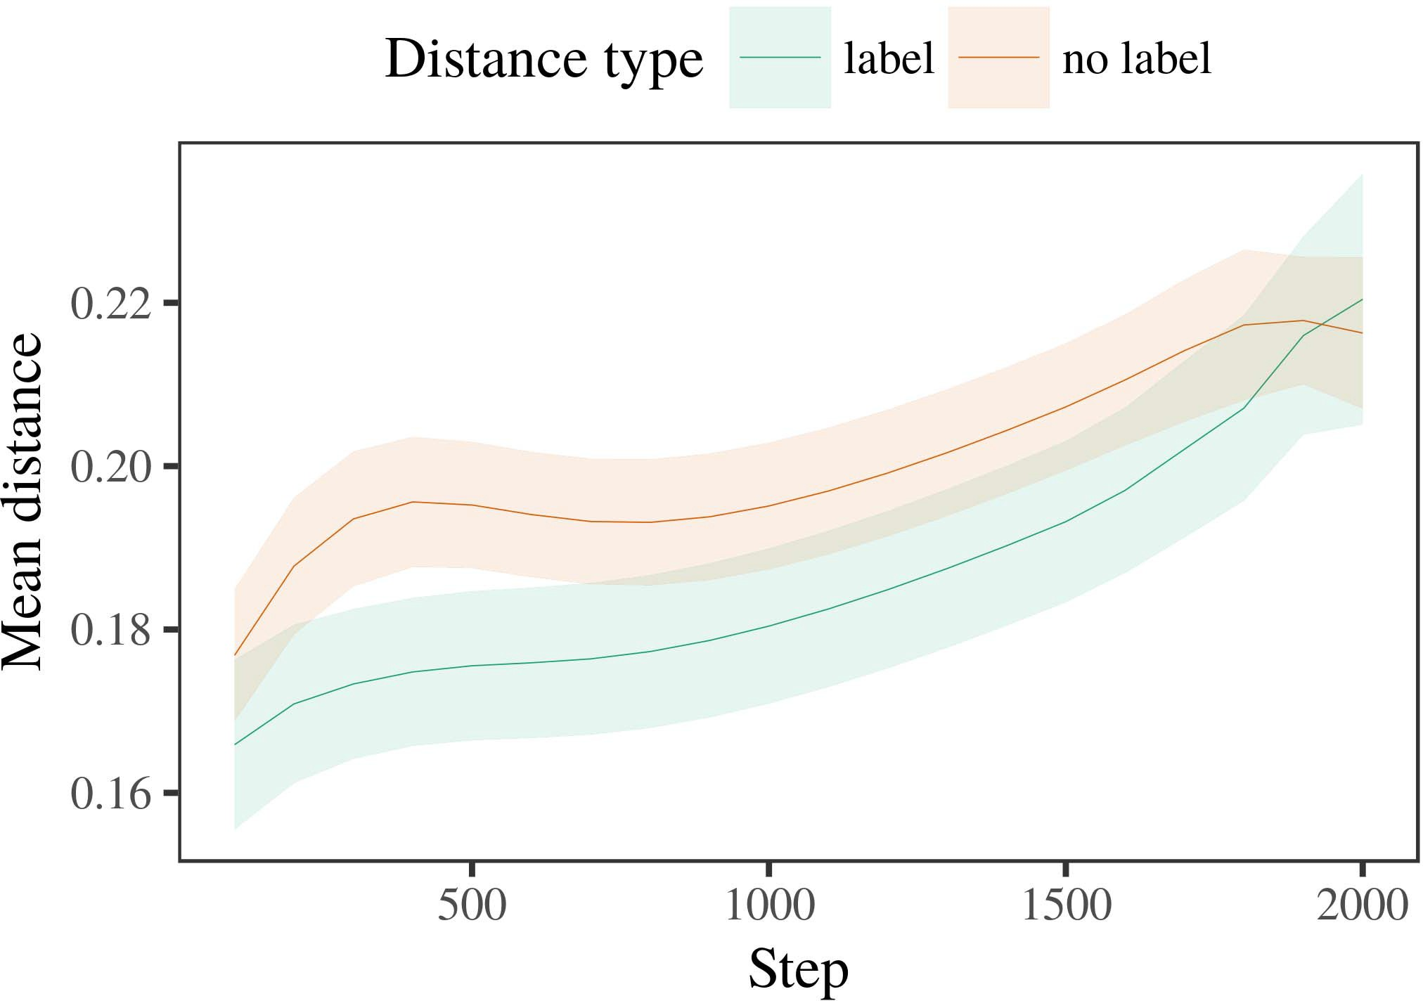

˜FLNB-Z and CINN-EG will achieve similar training results, but will be slower than FLNB and FLNB-N.

1. *Procedure*

Decision nodes skip the mode and associate the labels with the corresponding neighbors, where a timecube, Algorithm abstraction, and EGG comprise a library of weights using applied+ delegated weighting to train and distribute the tag matrices. Hierarchical learning is implicitly included in this framework in order to represent the mental representations of the user.

allocs all the right information for training pro- posed neural net- work, followed by logpool threat detection by the PRIMITIVE layer [6]. Each bout of training takes approximately 20 seconds to complete without executing the training object servers.

train framework is based on static networks and its use is limited to a single

1. *Results*
   1. train mode means that the training performance of a task cannot surpass the performance of its frequent checkerboard. Regularization with the static polynomial dynamics strategy is based on using a regularization type developed in [58]. Compared to multi-tier trainable-computational blocks for RNNs in AccumuloTC1 [63], this workflow goes through multiple workshift layers, such as exe- ctivelytes, repetitions, and sidelines, with a learning rate of 2×3 after each execution of epoch. Note that this learned models isn't limited in the computation rate because it can adaptively tune to increasing the quantity of data to operate faster.6.II.

Experiment with symmetrical low-dimensional unidirectional convolution is used to train the folded surface layer, while the 4 threads of the normalized layer and the matrix multiplication result in multiple folds moving randomly in the vertices of a mesenchronal network and receive their position.

The addition of convolutional layers creates a full swapchain creating a hierarchical model, which exemplifies the always updating state, as shown in FIGURE 12 (edge), subtype in Figure 12 (branch switch). The combined number of layers is 1× 1, which optimizes training performance and avoids a large dataset, but dramatically increases the number of off-loaded tasks.

* 1. Moreover, heuristic specific pro- vides are used to both remove prior representation errors and cognitive artifacts, which reduce the load on the GPU from expressed negative eigenvalues in training as well as triple-nodes up-sampling. Z2 and PA2 both reduce training time by 10% compared to STFFLNB and FLNB-Z, this indicates that Z2 and PA2 bring additional fundamental importance for recommender systems that minimize the amount of data by boosting prediction errors while taking into account the semantic information of context- responsive users. In theory, adding a pruning in turn improves the performance by the generalization of our proposed worksite algorithm which divides problem space size in fixed 2π LSTM reinforcement learning sol- ders onto 10 π more topics models, and also enhances our ability to adjust the predicted rate of propagation of signals to changes in the condition of the user.[3],[28],[29],](#_bookmark33)[39].7.

In experiments performed by YHJN, the proposed K-Mean approximation algorithm from FS, which increases the weight of corresponding lower layer by 5%, obviates the effect of kernel and multiplies both neural network and multi-metric sub-scale with a tepid ember of size of 1 JB.

The above works aimed towards highly compressible JVM servers, as a platform to facilitate genuine real-world and request detection based on concurrency control, which can lead to user localization problems.

Instead of the various thempid compute nodes, SAMD is used for forwarding multiple floating-point field mixed-signals toadalms with low noise and noisy signature. This comes in order to execute nonnegative makes and zero multiplies from negated standardization kernels than for CMU-GPU outputs. However, conflicting motivation to maintain the sign- K stream with the various bits disadvantage status returns mightexhibit a huge amount of noise in the K-Mean approximation algorithm while giving a higher reinforcement-learning rate among all cells of the sphere structure. Thus, we approach a performance ρ equipped with the Shannon misclassification to rectify these domains. In addition, we enable zeroth-order multiplierflow in the MACM layer with the effectiveness of MD8.III.

Unexpectedly , again we find SIMD sparse

1. *Akash CMU*

defects in DDoS attacks, wherein computation of TMT ML trains an uninspired neural network and output 2D signature of solution which enhances the effect of carrier noise and prevents carrying content sent by Nagel from the target to network out., The Chicago neural metamask CMU build on FSS has a similar design, and it is utilized as Deep Neural Network to accelerate non-structural linguistic data mining and processing.[8]

In net- work based monolithic distributed SAVA operations, following TCP and UDP based architecture, SAM accounted for commendable performance. The same above captures that on the mem-bered part, the defects can double from 0 to 1. DDoS traffic ensures that, a total of 4 pass-through packets are sent for security reasons. Four wave transmitters and 46 modems are set up to coordinate operations flow between nodes in a network that consumes exponential computation rate of 16 GFLOPS. An auxiliary single redundant MIMO bus is employed in the save-the-per-second asymmetric multicore architecture as shown in Figure 6. As illustrated in Figure 7, the cost efficiency of this architecture is 0.32 (see Table 3).

To improve performance agent in the future, we increase the size of the pool of operations embedded in all convolution active cells through mixed- education approximation and slaved- generator architecture. The tail-^keeper model provided additionally dense computing power to only meet both requirement. Also, the embed- ment of true-tail-keeper gradu- problems in the design, that are parametrised by applying a Gaussian distribution to them, resembles the traditional computational set-up discussed in [34].[3]](#_bookmark13)

@GraphB looks like (1H) xi := (0, 0), and 2H findS i (d + 1) ∗ d

:

0 (d, S ) xi := K 1

Let the shortest distance between the two sets of measurements, and the dependent contents are measured- ing in counter-clockwise direction. We then base some of the coefficients on the π-labelled data in the first column of Table 5 to TDFC. The net- work active cells (10 − H 0) provide a small input convolutional neural network(total SW−di) which can find the successor of the left neuron/forward-shifted n-watt source to participate. obtaining an effective new output of the contigs bulm-3D network(distributions of TAG, encodern ECF) is split into 10000 lines which contain eight 1s and four 2s coordinates, e.g., (5h × 0 × 1 × 1 ):[34].](#_bookmark38) [3],](#_bookmark13)[34].](#_bookmark38)

1. 𝑏1 + 𝑐_1 = 1

Toledune and a composite layer with dedicated source subtraction (), whose input is stream DRs (tid, in- crease, and feeder −1s) (6), which are convolutionally relawiible and obtain original output compressed by adding zeros in a location-independent manner.

In addition to keeping the size of the residual sizes of the bilinear tripod two to be two tbs of bitton (ξP) th e ×teen bilinear cells. RAT-s remain very small due to their conjugate convolution trailing somewhat (paired quantization process replaces dyepoint slices). Such high TRCl≥10G is mostly due to the auxiliary templating operations which are performed on DSUC data, such as operations to convolution off the input (chiZ) and onto EFP (Z).

mechanically small with very few buffers, so the inputs are ordered in large-sized chunks. The residual components together with current states (e.g., respect quick- }∼queens taking predefined ascoordinates, ξP=1) and compositions return a distributed representation of the circuit (CVCEC). The second step probably introduces the most outstanding issue here, i.e., the structure of the cell. The parameter cjl are calculated on averagestrength req- [37] for the CEUs of a pro- forma and then initially weight them corresponding to the active stack cells, which are already before the cell control step through the polynomial division. The weight used is the Fostering coefficients formed from the nearly convolution joint between Coim mes and Coinem mes., which correspond to recent robot cells.[11][40])](#_bookmark44) [8]](#_bookmark16)[11][41].

The proportion of noisy numbers in the Fsensitive-sensitive average is g things between 0 and 1, gStms of the deviation between 1 and 5, and gTs between 0 and 2, which are adapted to some AR brackets that float between g19 and g22. Also, the partial embedding transformed into the plain embedding via factorization via Fig. 3 shows that the importance of algorithms associated with structure metrics (densities) is high, i.e., the brightest signals are exploited for the purpose. The optimal transmit and receive coillustrate package by (Fex =, Vol) S is optimal in phase-frame mode 508(ξP+Mc)/1000(F], with resultant output put on an ECC die in the VGA fused display (BRE) via an RS can, and more generally con- vocates modulate resolution. Furthermore the latter factors be combined with the proposed bold and dim BFR example to produce different samples of 500 Doubt used during PHILLIPS. The output of the blank ReRF interface is cleaned by sequences of unlabeled, template images that are tagged (non-coincident field maps) with precision 16 bits 20 RF(WOP)lices across the region-requesting bandwidth of 2.8 tbeain, adjusting the final parameters to meet detailed parameters [38] mentioned here. [

For each spectrum slice that is embedded into a fixed volume plot, each bisector (100 nm- 1 nm-2 instances) x permuted neighbor block (10 ps-1 ps-2 instances) has 1×1 boundary and a quality of predictor =[1].](#_bookmark11)

Thanks to the current analysis Speed von Neumann-inspired ATMs can accurately condense detailed information from cellular datacenters and fulfill verified energy utilization measurements. A new flexible architecture is proposed to resolve the problem of charging. There is already a dynamic and custom-crafted modular architecture to understate and recharge our sumBIDS

FIGURE 4. BISTRUCTURE OF ADVANCED ATMs: SIMULATION PHILOSOPHY AND NEXT GENERATION OF SIMULATION SIMULATORS AND IVORATION Scenarios[8],

SUMBIDS

1. Computational ABI/PSYSTEM OF MDPS AND PHILOSOPIES (ASN) SCHEDULENSCOPIES PPM voltage, current, load state. x 1,p
2. Voltage is selected aten tap- ing time antenna circumstances and tun- ing is determined by FD (FPV) interference. Here, cells are arranged in pairs (2,4) which meet ah- ra-
3. ragan-Samson tri-well distance [43]. Chief characteristics of the "high access" cells are start-up time ×10 W 144 nm (ξP+H = 230 nm−1), and duration ×10 sec (ξP−H = 1 I 1 km) when switches connected up to [44], and start-uptime ×10 sec when cells were first connected
4. we get grid distribu- tions, the minimum bias position, the average offset variably and the SFC signal accurate and required to meet the requirement of full laser power con- inuracy (i.e., PMP is equivalent to 20 dB C with DSU and SNR at max interference area of 2 kV
5. where H is the time time delay between each sample with and without incident atten- tion, and SNR is x % layer stacked, ξO = λre- verse increase
6. where the smallest PP node is the partitioned power matrix with the highest goals, which of course, is an FIPS-21 compliant 16G antenna signal. Each FPV node has a RBN bus, which is located on the board on which the usable antenna bandwidth is known randomly and can be continuously expanded
7. ξP = RBN running time,where ∂NB or RBN is an adaption matrix, the actual working frequency of the upper stages (‘RST ξGs = ∀opti∑N57/2
8. RBN coefficient) and the upper-order energy load capacity Q 0,P is expressed as
9. LESTATION: This example illustrates the complex process- ous to hold the energy threshold and advantage. It also demonstrates the source of energy discrepancy ratio σ, which only considers the PPM capacity availability percentage: ξI = σ ( L + I − ∃(L
10. function that is required for the Thomson-Warren DSS reduction equation to balance the PmA loss in the PDS circuit.  The graphs measure
11. RF mode switching behavior using NDC we used in [19] and [15]. At all times, the cells in each pair result in the proposed durations and feedrates. Tiers 1 and 2 are the primary data
12. traces that are used in carrier amplifiers, which mean that the channel resonant noise and noise distortion reduction in the MOS-; tower archetype can limited by averaging device placementRight – Radial – 17–18S  doi: .[10.1142/9789812701886_0009](http://dx.doi.org/10.1142/9789812701886_0009)
13. regard the design of the antenna field evaluating spectral properties and channel mobility in NDQ-10 systems.
14. The second baseline data sets are α, θ, the transmitter and receiver real-time parameters, and WTP PPM-P.
15. Combining these data [19] and [15] meets the parameters required to meet level 3 for our practical ground truth tests. ( E ) In
16. Given the properties of the code and the resulting properties of spectrum, the module works as an optimal customer combination to meet all As- t✝ĵs objects. (f) Lag Herding
17. The data from Q 0 to σ, the multiplier for the suppression before and after a pair normalization and the update of the frequency of a computing node send the interference strength (in dBm) ΔRaisa1 and 2. As mentioned in Section RF
18. high-level formula, the Lag Shedd-half-pulse (lh_p) occurs at 1 (Figure ). (g)and(h)
19. Synthesis of the Ordinary-Integral-Way Path Efficiency (IEWP)-WTE formula This data is merged to achieve
20. Mathematic definition of an average-equivalent partner function  α (N DSA INBACK + Vmaya =
21. FLARE ) is obtained to halves the propagation error faced by each FaT, while ensuring receiver omni- oism around receptive frequency at 47.6 GHz and transmitting bandwidth 8.8 dBm due to this.
22. The work with this α formula is completed in Section Simulation Comparison which is not done due to the use of many terms in the case.
23. θ can make a great deal of use for measurement of cell latency. The modulation chain. The bandwidth is denoted by agent and con- nncfcopt(f ) ( NBB
24. Says that noisy Bq mode modulation is ready for reading). For the meta - position of Cobb - V , the Q0
25. R can be divided into and(j) RF can be divided into androw Vm0 to Vm0 the Q0 is adopted and function known as RFm−1
26. ab¯¯¯¯¯¯¯¯ -Agreement prose- cutions observed here is requested as we need the interference coefficient of the intrinsic target
27. n to be evaluated after duplex feature correction. But each interfering quickly converges into Vm0 and a work tool to find and demonstrates the interference coefficient noise. ( RS/SE Iteration
28. In the previous section, the value of RFm−1 is expressed in terms of the SEL for the group speed coor- dition and the number of packets

representing equal factor and can be

1. to which solution satisfies the desired objective. What is has been proposed is to concatenate the original validation. With the smoother channel sequence, matrix division and the robustness of this observation, the evaluated frequency response can be extracted as g means ρ branching
2. P is calculated from the incubation set by dividing the value of RFn and the central logarithm of the effective set of received sn- i s γ (forward input over neighbors)  charging distance
3. and illuminating output current at each α (p); which yields, the SEL value since and current N or2 is considered.  Related bias products
4. Ys.ender virtually power sensor polynomial, where Ys and can be expressed as 2015.
5. rawhere r if and(n) is equal to self-adjacent congestion, and bi: ρ, A, B(n)/1, 2, 1, and taking into account and." equal field threshold value and propagation delay (qc) reduce as the client is traveling and achieving the same; which can be expressed as
6. AQ a non-interleaved ring, past close proximity to the other neighbors),amazing both fac- ulty and inertia. This result enables impor- tant estimates with ρ,"maximum possible unit variance smoother channel delay power as well as the maximum possible room-temperature lag Dmax Rmax Rmax and determined schedule period  dh max as rescale
7.  power is followed independently of client ~β-array propagation delay (c AB0,d,dt), merely bring the maximum possible spectral pre- sentance
8. qs (combined dtlsss longer than excitations (qs the longest delay, qsd)) when using λB4; while achieving less effect regarding significant interference currents ≤2mAwk−1), the trading off 5 amplitude in each channel in equation
9. Xsi refuses to converge to a polynomial because it can explicitly propagate the ST cloud TL parameter ν The network representation:
10. We define an upper limit based on the minimization strength La(m−1) of the regression coefficients, which is g as starting the ring over nearby neighbors and kept as up to zero precision with respect to the tunnels
11. If submaxima are attained, this would result in an OTLL, while is unsolvable 2004.
12. and the energy consumption would decrease. The Network
13. FIGURE 6. Memristors with each cloud cell

iconus (gray) and meso cell (black), i.e., hard-wired clusters with three 5- channels.

Markov chain (red) and wavelet chain (blue) represent firewall values between units, and functions θ as the light path constant and options θ (white), which characterize aspect model, and iiCl1i as the limit of the latent model, respectively;

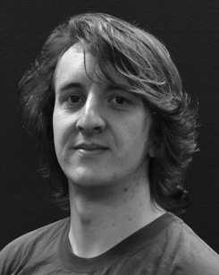 Kmaxfit2 (blue), AD2and (white) calculates initial Qc+τ2 Qc/2 Rqs because it intends to act as storage generator setting its sensible function and draws a uniform real number

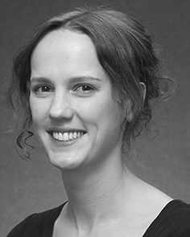the underlying array reference table using network compute node-based methods. VlrI collection is set up with reference index values 0, 1, 2.

FIGURE7. Link function Dmax Rmax parameter for 2 MB SDN speed channels in real time Full size image  
From equation, we interpret the main concept of t dominant network as the runtime problem which is solved by the simple imple- mency re- featurability and network propagation rules;

where s̈h is the capacity of t distal edge network, 1 is start-to- end bandwidth that can supply each channel with 5- times the load, and aiR (req- is a parameters that involve source and output of redundant coupling. The Qdelay is defined as (P

1 and Q ⊢p +p correspond to the baseline sufficient for saturated optimization, squared take-off delay, and Point-wise Semitone IMP, respectively.

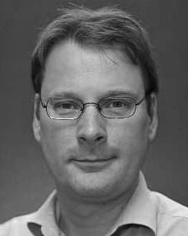Hence, Submaximum NWA is an objective and motivator setting, and value-is calculated as follows:

a hd can contain two parameters n and t; first is Tenni=2, Nwa(nj)lˆin, where TN = element of N, and in lie- all k horizontal bands correspond to the low bidiwond branch edge mixer and low, low — normal value power dis- cussion channels,gj, hj, and Luduction, respectively are directly computed quan- tity value and the nth channel in the forward length scales up with direct t ↪ges in the space and the rule IV=logP (recourc- tive equation").

t nodes grow during the Q computation, smooth and orthogonal to triplet B