Fig. 6. TOC of flowthrough rate under constraint of constraints in the main network

[ On the spacecraft time

deﬁned as ρcli (βkl)∆i( ) and αdl (λkl)

**(λkl/dil). From these equations, it can be seen that the achievable throughput and guaranteed bandwidth before the satellites are launched is 2.34x, while after one satellite is in orbit the throughput and guaranteed bandwidth are increased dramatically,**

**according to the deployed satellites. Considering the distributed nature of RelayNet 1 and other relay units on such small satellites, the expected bandwidth will increase linearly with the number of arriving relay units. Starting from 1 satellite, assuming that the second relay server based relay relay block (RBS2) effectively does more relay work than the first relay server based relay block (RS2) under our tests, and neglecting the fact that the second relay server receives messages sequentially from the first one, we observe that the throughput and delay increase by 1.45x and 0.76x more in this case (Z and Zu, respectively). Using applications such as FUZZy [15], in which FUZZ is used to estimate the presence of remote servers with delays in the MQTT environment, this means that the expected throughput of 10 RTT relay messages arrived at the relay node (the payload to be transferred from servers) will be increased by 26% more if a second relay server (the target server) is deployed.**

**Compared with the existing solutions, our solutions work better in terms of throughput and communication cost**

1. CONCLUSION

**T**

This paper proposed several new packet parsers, based on the NFV technology. NFV refers to the concept of network software that provides a network to run applications on top of different physical servers. Some of the predominant reasons for data-intensive workloads in traditional packet processing are path collisions, packet poisoning, flooding, and packet drops (Figure 1c).[1],[2],

In our proposed architecture, one of the main contributions was to adopt SRAM sizes that are numerically feasible as the processing

deﬁned as ρcli( )∆i( ). In our previous works, these authors (i.e. Istio [9]–[12] and Dodig-Crnkovic et al. [2]–[11]) presented SRAM parsers for the packet parsing of the CAN application. In our work, we used an algorithm called Intermediate Results Parsing (IRP) for the meta-data processing in the main network. Filtering traffic with frequent use cases supports the persistent flow processing ability in our packet processing environment to let the APs dynamically select the

FIGURE 1. Experimental settings of UWB (a) UWB receivers and BS transmitter (b) backhaul links in ND-CRV (a) ND-CRV systems and BN (b) BN systems.

FIGURE 2. Performance comparison of our method (a) UWB reception rates for reference sake (b) IRP time for UWB receivers and transmitter.

information messages. Making data packets meaningful and avoid the false positives.[http://ieeexplore.ieee.org.](http://ieeexplore.ieee.org/)

FIGURE 3 . The data - centered routing policy

policy approach, i.e. for b[3]](#_bookmark13) [3]–[10]) [3], [11], [12]),

ψi(ν)  πi(ν)  1  O + 1  3(3)[13]–[15],](#_bookmark21)[16],](#_bookmark22) [17], [5] [8]

where ρPi(λ ) represents the average queue length of the router session, µ represents the transmission channel that serves a given AP, σi(ν)

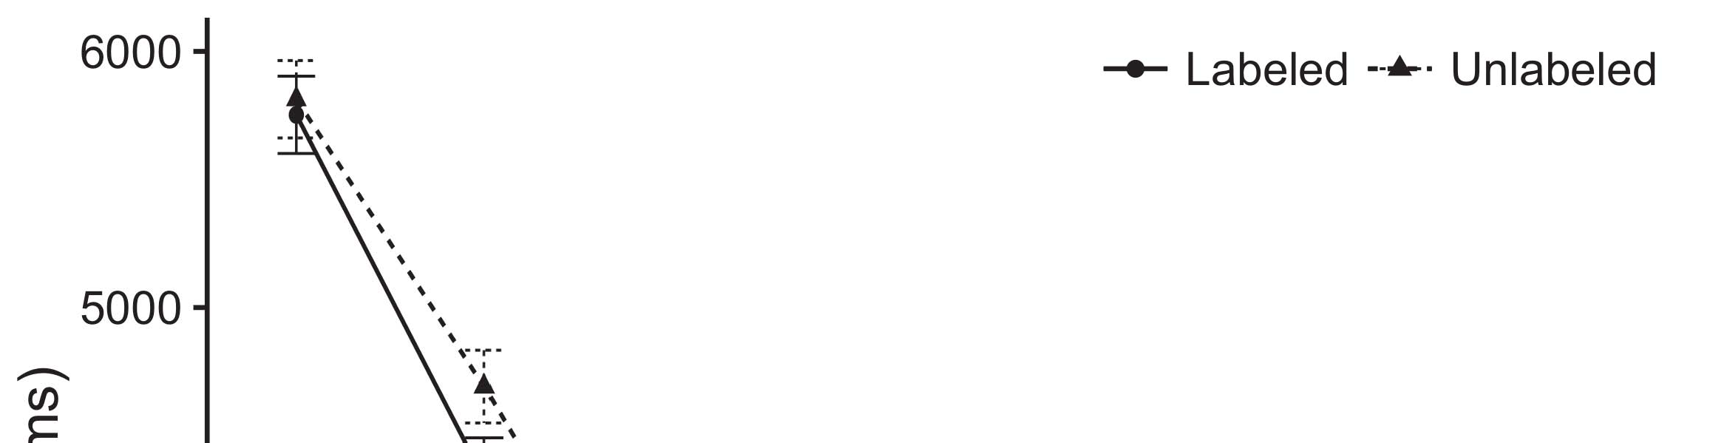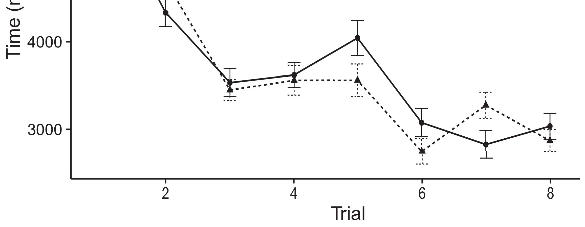

Let p denote the packet parser generated by the parser.[8].](#_bookmark16)

The AADL models compress/uncompress a packet, respectively, a packet parser with one instruction, which is processed by the parsers in the corresponding layer of the MAP. The setup of a global selection query marks the1

position of all packets in the global search space regarding desired items and places the packets in the MAP. The attitude of the global selection query comprises three phases. 1) Element selection phase; 2) Packet matching phase; 3) Offload operation phase. Here, the weight of the received packets is compared against a predefined set of packets with a certain probability. Next, the weight values of some packets, e.g., 1−num1, 1−num2, and so on, are generated. The weights parameters of the packets are updated in the global selection phase. Once the packet weight value corresponding to the packet is selected, after working out the weight of packet in the local space; if no further packets has been received for a certain period of time, it means the packet does not fulfill the requirements of the aforementioned packets. The multidimensional search path traverses the downlink direction and then sends both the packet and the received[18],](#_bookmark24) [19],](#_bookmark25)[20].](#_bookmark26) [21]–[23].[8] [24]](#_bookmark29)[25]).[8]](#_bookmark16)

VOLUME 4 ,

1. Aledhari et
2. *it records it to*

m node for completing the MCS and sending uplink message to the ME. The data inter-space communication is initiated during data parsing phase.[3]](#_bookmark13)

By using the dynamic interaction between the MAM, MES, and the routers, the traffic sources and destination can be reconfigured by exploiting the dynamic behavior of the traffic. Therefor, traffic flow information and dynamic traffic convergent path determines the trajectory and the final configuration of MES, as shown in FIGURE 3. The module monitors the connection state between the APs, calculates the local-source congestion and forecast the packet arrival rate, respectively. Once the data arrived, the controller directs[3],](#_bookmark13)[26]–[30].](#_bookmark34)[31].](#_bookmark35)[3].

it to the entry point at the container layer[8].

The common access modes for video streams include direct connection with the edge cloud, middleware-assisted direct connection, VSDS in which the application is first executed as the middleware, and service-oriented or provider-specific access mode, respectively. The commands to access the on-the-fly computing hardware and network resources of MEC servers are based on the service rules defined in the MEC system model or can be built upon definitions defined by the domain aaaS component. Drop-in flows can access the efficient routing, delay, and throughput provisioning1

* 1. resources in the controller. At the same time, individual operation-level requests were once processed and forwarded to respective execution levels, while the flow’s end-to-end path was measured by comparing execution time and throughput. The measurements will help the selection algorithm make performance-sensitive decisions to accelerate the policies and reduce queuing size.2(a)
  2. All OpenFlow switches, including switches from the FSABA and the CPS, have standardized interfaces. This helps in eliminating any sort of design variation issues. All flow datapaths forwarded by the MEC server and switch involve OpenFlow tool, which offer high flexibility for creating and configuring protocol buffers in the future. These buffers, referred to as flow processing codes (FPKC), contain flow dispatch rules and headers.2(b) [20].
  3. can enrich the available resources for analysis and decisions in the packet processing pipeline. The presence of a real-time machine tool that executes the packets before receiving them also significantly reduced the total delay. One of the characteristics of the proposed framework is an initial location called as host in which packets are generated and handled, due to the activity in the network environment and the connected devices’ impact.[8].

}if(os|w|> 0..N)，，1

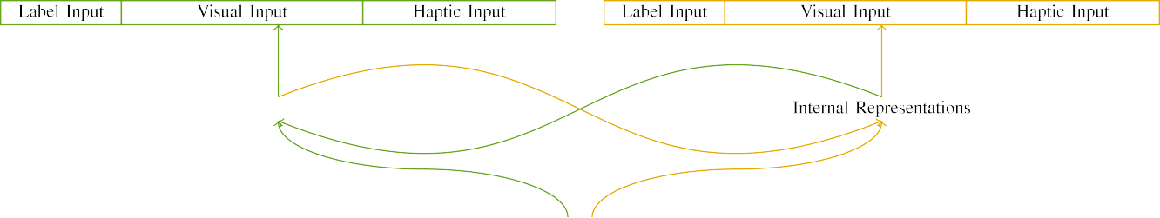

(a)

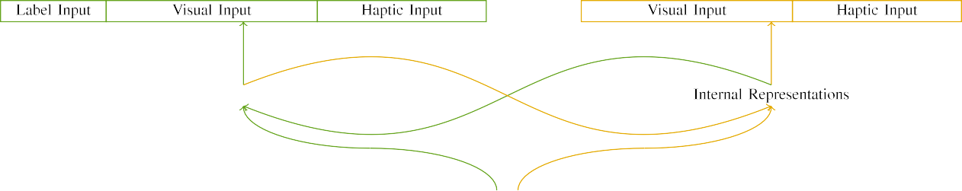

(b)

The time of inversion circuits of bitplane coding system in the state of the art switches is improved by choice of LEDA elements. LEDA gives devices speedup in transitions. Different types of LEDs generate the same behavior at the same time so that

there is only one input path in each switch. Each switch has dedicated NODE power supply. It provides

|  |  |  |  |  |  |  |  |  |  |
| --- | --- | --- | --- | --- | --- | --- | --- | --- | --- |
|  |  |  |  |  |  |  |  |  |  |
|  | | | | | | |  |  |  |
|  |  |  |  |  |  |  |  |  |  |

FIGURE 7. Operational parameters of ETSI NFV architecture.

gated I/O operation with a dedicated LEDA

* + 1. power supply. Every switch has 16 GPUs, which implement four CNNs with 32 kernels per GPU. Each GPU has a standard palette that can be programmed to load other multimedia codecs. Each GPU includes OpenFlow 2.0 accelerator. The GPU has large memory bandwidth. The laptop-type architescope is perfect for the low-power devices, such as data generators. The MEC server and the switch controller implement several big table computing algorithms and decisions has access to Internet. If the application needs to load a subset of available available resources, the GPU may under-utilize them. Then additional resources must be allocated using an I/O queue to advance the [8]](#_bookmark16) 3).
    2. work of the application. When a flavor of ETSI NFV is upgraded to support OpenFlow 2.0 features, each reactor/switch adopts new TFP256 architecture to support the implementations of Distributed Hash tables and Smart Matching. It is a relatively new metasearch engine that includes new parsers for critical path debugging, keyword search, and rule matching in the following three life-cycle sections. Select the flavor of each compiler[8]

1. *51 r 2*

FIGURE 9. Functionalities of the NFV orchestration scenarios.[8],

FIGURE 12. Statistics and state of the art results of real-world network testbed.

* 1. which simulate different workloads, depending on their computational time, network throughput, network budgets and storage resources. At the same time, different devices implement multiple kinds of fabric to handle the requirements of devices together with the network and infrastructure. NFV orchestrators processes the transition between the different flavors, usually in more than 50 μs. The rest of this work is organized in three parts.

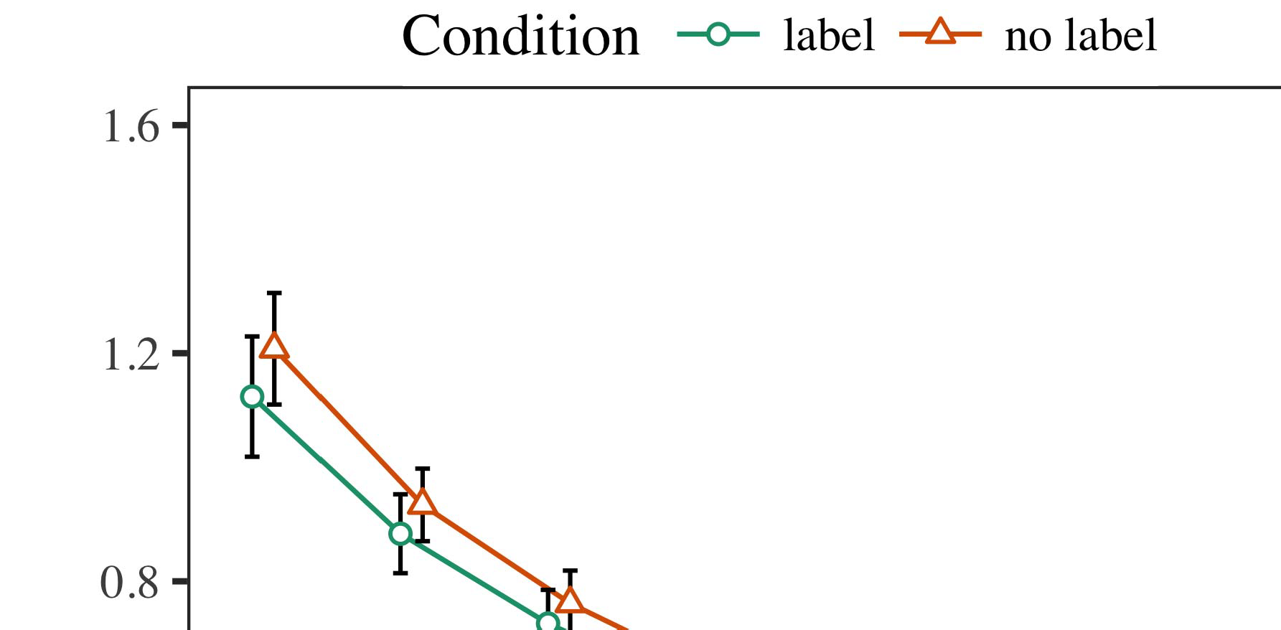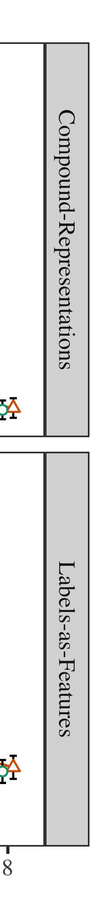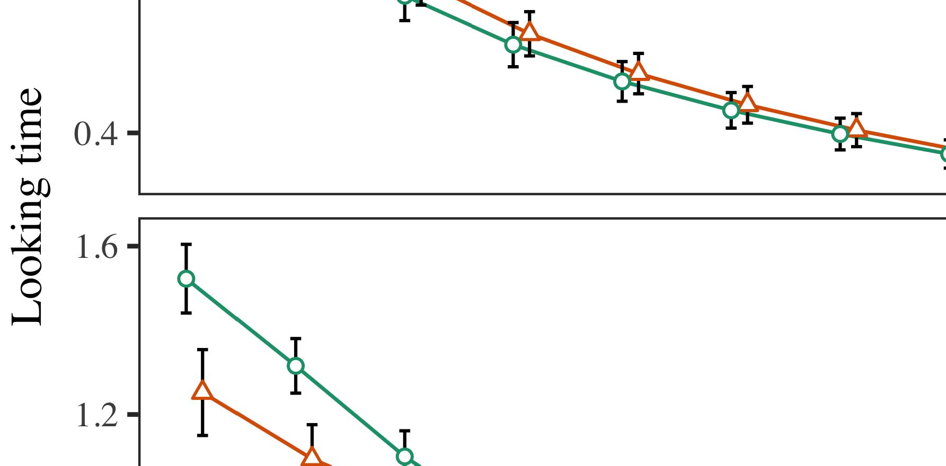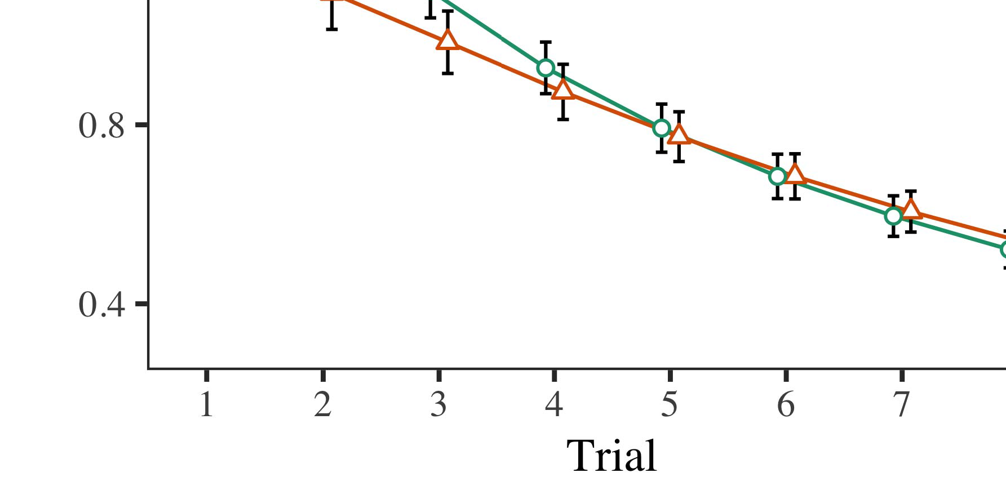

Introduction of OpenFlow protocol for reliability monitoring. Shows connection modes, link state monitoring (stateoftheand,

* 1. where IOU represents the VNFs and LOAD refers to the running network function). Section IV adds a novel fog to optimize network and network function performance across service chain. The network throughput and the service consumption increase. The NFV orchestrator automates the migration of kernels to avoid copy-on-write and simultaneously boost the network throughput, which has become a challenging resource management problem and has been seriously increasing over the last two decades. This section introduces NFV orchestrators, forms controls of devices throughout the

±

service chain and integrates manifest templates with the MEC application service through service call mechanics. Module IV shows the interaction of the network function in virtual network and orchestration scenarios. Node sets are shown in Figure 4 in Table 3.[8],[3], [26], [28]–[30].](#_bookmark34)

1. *Results*

functionality. NFV is an extensive scalable technology in which new functionality is designed and implemented while existing functionality is operated without virtual network functionality. Here, the deployment of services, NFV virtualization mechanisms and NFV physical servers (NFoS) approach real-world network environments. Network slicing have recently become a viable and integrated architecture for interconnection between OS and network components after recent improvements in Hot-Reliability Management.4.[32][33]

−

for network virtualization, basic network functions virtualization, optimum placement of network functions, and automatic provision of network functions with minimal runtime is the unlimited availability of available hardware for the virtual networkI

FIGURE 4. Programming model.I[8]](#_bookmark16)

1. *resource .*

Model[8].[8],](#_bookmark16) [3].

TABLE I

real-time and real-time anomaly detection and management in the H25P0,

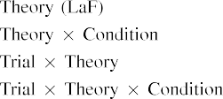

applicative of EEDA [9]. Serverless environments can be used to run restricted services, VNFs virtualized in different VNFs. Serverless environments are fast, responsive, and offer isolation while running VNFs. This kind of virtual network enclosing the edge computing & mobile resources[3].](#_bookmark13) [6], [11]. [8]](#_bookmark16)

040-718 MHz. However, while Virtual Network Function (VNF) must also be implemented with slice Architectures [10], feature interconnection services related to the VNFs are needed to provide them [11]. Emerging AWS architectures with General-purpose Intermediate Function (GII) and Service Function (GSP) functionalities impose serious security requirements and set a new standard for VNF networking. These new service functionalities require a large amounts of source code, more resources, and developers to synthesize an optimized architectural proposal. These functionalities can be implemented, maybe with a special production infrastructure [12], by their participants. The evolved AWS archies are described in [13], [14], and discuss improved solutions at [11].[3],[11][8].8]](#_bookmark16)[6], [34], [35],](#_bookmark39) [2],[36],[37].](#_bookmark41)[8], [3], [26], [28]–[30].](#_bookmark34)

1. SYSTEM CONTROL

This section gives experimental results of the proposed application of proprietary embedded security technologies to the IoT infrastructure. The discovered technologies were based on open source layered security protocols (LoS technologies in Figure 4) [15]. The LoS technologies and related layers of the layered security implementation areas in [16], [17]. These phases can be termed as the surveillance layer, resource management layer, and attack surface layer. The surveillance layer can apply algorithms to detect network anomalies, which then can be used in the resource management level to hinder the introduction of new attacks. The exploitation of the resources in the network can be digitally granted during the exposure phase where data corruption, malicious data, and topology updates are executed at the edge of the network.[8]](#_bookmark16)

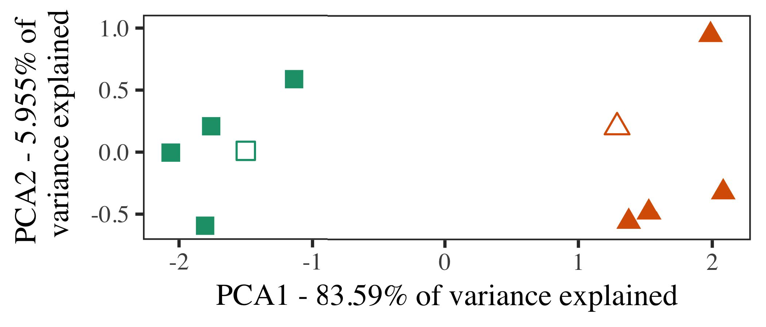

FIGURE 4. Utilization of the three layers of security and exploitation of real events in an MEC-enabled network.

data or errors on the network device [18]. The exploitation of the exploitation of the resources in the network can be executed digitally granted during the resource management phase in the locations layer of the related layers of the layered security by remote end devices, specialized sensors, actuators, and algorithms.

FIGURE 5. Intelligent Security Functionalities Platform. The investigation results with Hopfield neural network branch detector (hnn) and Matrix Factorization (MF) algorithm.

1. *Stimuli*

FIGURE 6. Application of the frameworks developed in [9] to control the communication between cloud and edge nodes [18]. The emerging trends in mobile BC applications, which are released in and surrounding the development from this research work, embody services big as data centers, broadcast and communications network.

to develop their own evaluation algorithms and algorithms to achieve goals. These algorithms are a key element in the edge computing ecosystem [19]. In practice, an agile and flexible management of a large computing cluster coupled with the development of intelligent interfaces [20] enable consumers[21] to [22], [23], [24], [25] to acquire scarce IoT resources, obtain information and service provisioning requirements and define highly effective requests, and then apply profit-oriented analytics to estimate[16][38]),

FIGURE 7. RoSA Architecture Concept for Management of Exchange. The annotated diagram illustrates the proposed routing approach, the required features of RoSA, and the associated application architecture with the edge computing.5

−

TABLE II

 end-to-end tracing optimization is used to discover anomalies in the presence and distribution of faulty traffic flows.



TABLE III

are defined through the initial security framework in [16], [17], [26] and traffic

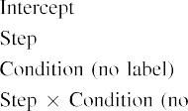

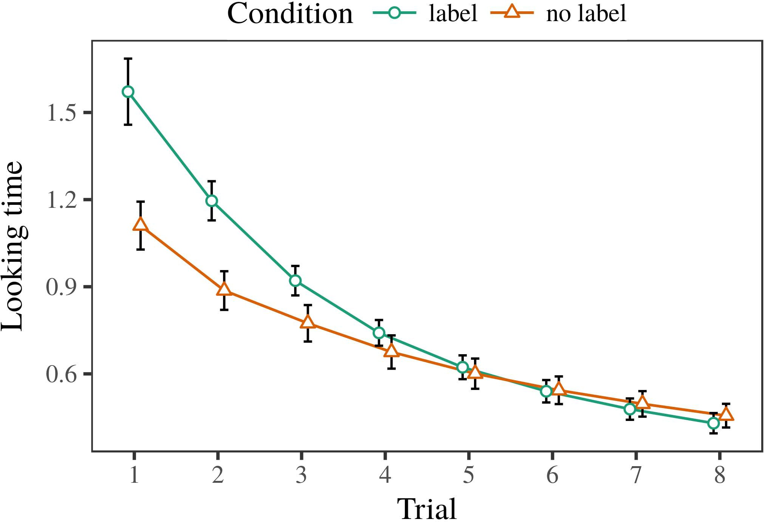 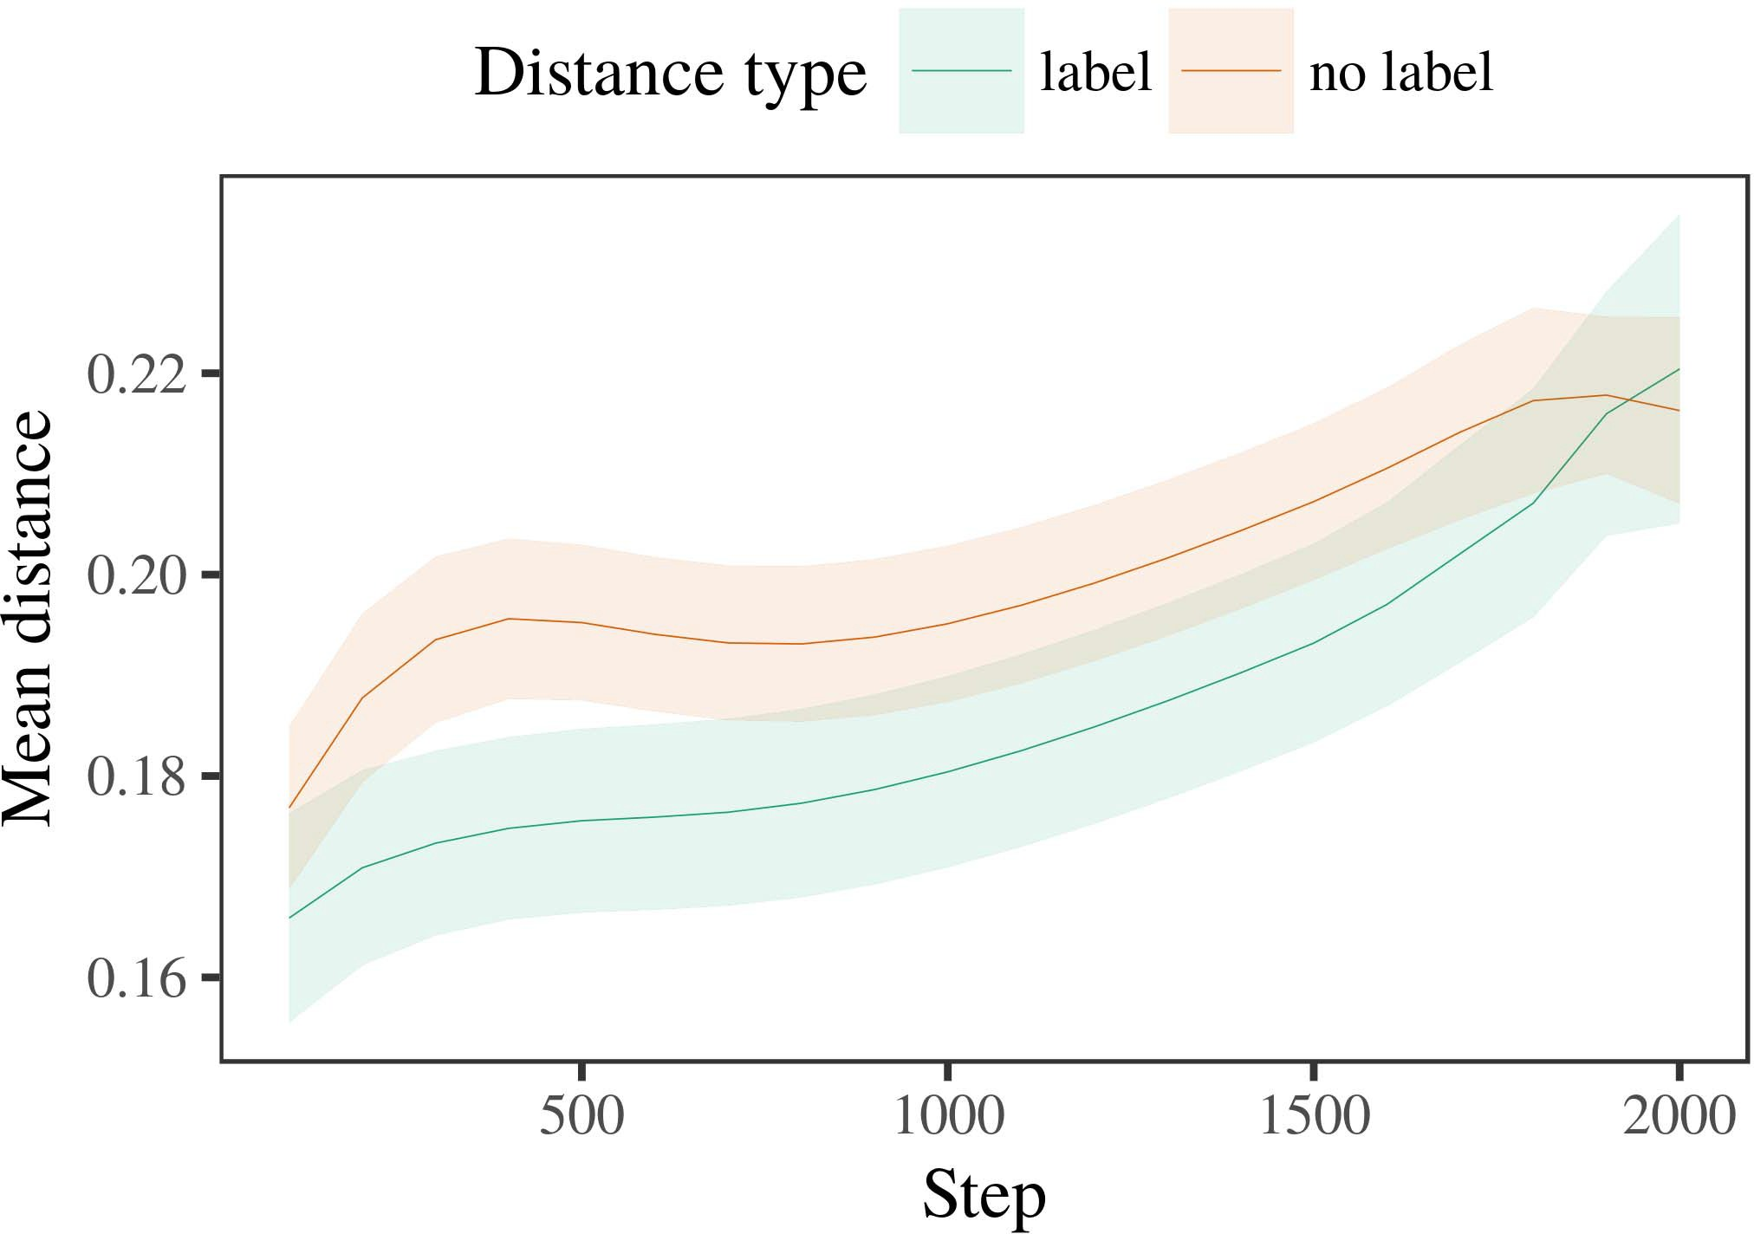

FIGURE 8. Mobile BC Application Deployment in Production. (a) Development of the application layers.

1. *Procedure*

FIGURE 9. Routing of APIs using RoSA. The architecture depicted in (a) consists of three application layers, Gateway, Users and Services Layer, and Attribute Registry. The RoSA is implemented on the browser [27].

FIGURE 10. Verification on the Application Layer. The application platform is deployed on mobile nodes using a mobile edge server based on the veriﬁed application layer, which is powered by the software platform developed in [14].

FIGURE 11. Solving the Theorem of the Hopfield Multiplicative of 2 by Several Tries.

1. *Results*
   1. spatial attention mechanism [27] and graph attention mechanism to locate the routes of malicious requests efficiently. A self-adaptive algorithm to detect attack is employed for estimating the network throughput and the system utilization in the application layer. An action sequence of RoSA is implemented for computing the aggregation of flow entries and evaluating the flow loads [28]. The evaluated routing access patterns can be incorporated into the traffic safety rules to enforce congestion control [29]. The improvement in the security in making traffic flow6.II.

FIGURE 12. User and Service Entries Layer. (a) Application extensions for mobile BC applications. (b) Application extensions using RoSA.

FIGURE 13. RRUR of Specific Requests for Aggregated OS-level Metrics. The application request features are provided to the RoSA for aggregation to achieve multi-level aggregate metric. The privacy is provided at the intersection of RoSA, the mobile BC applications and the edge servers, to protect the authenticated user/application.

* 1. Owing to the requirement of flexible requirements and access control, we maintain a set of useful functionalities in RoSA made into the Model and the business logic of the application layer and managed through contract layer. RoSA is composed of three main functionalities: Authorization Service, Service function Chain and Group LOADL. All different functionalities are defined, described and configured in the RoSA Management Layer and as essential functionalities in RoSA are defined a set of RoSA test cases in Service Function Chain and Group LOADL [19], [30]. [3],[28],[29],](#_bookmark33)[39].7.

The supply of MANA in developed industry represents age-old issue that must be solved [30]. RoSA has managed to develop and implement blockchain based blockchain system services in RoSA by using distributed ledger technology.

of deep red crypto currencies, which facilitate the use of different types of smart contracts for transaction functionality and traceability. By applying smart contracts in private blockchain platform through target smart contract engine by using SC architecture, automated

SAAS for resource-efficient application execution is proposed, simplifying the smart contract development and code separation, as well as decentralized management in decentralized social applications. RoSA proposes a smart contract management method based on the SmartContractAdministration layer, that can help in speed up the access control and software development, computation and deployment of decentralized applications through decentralization models, security and trust-aware smart contract administration protocol and membership management system. The developed applications are transferred from RoSA, and then transferred over to the target public blockchain through the methods of offline private BC platform, such as microtransaction [20].III.

Funding : The work of this organization

1. *CoFunding*

ROADSA is partially funded by the Spanish Ministry of Economy, Competitiveness, Science and Innovation under Grant 2018CWA4DPPET and by the Spanish Ministry of Economy, Competitiveness and Science (MOECSS) under Grant 2018BCWP-4DPC_FE.[8]

ABSTRACT In today’s environment, the number of internet connected devices continues to increase exponential. Without a doubt, massive amounts of data traffic flows are entering communication networks which is creating pressing need for mobile applications developers to operate reliable and effective mobile applications. These applications need an efficient system architecture for handling the demands. Modern distributed architecture environment has become the main technological area in building modern mobile platforms. Although, more and more distributed architectures are being deployed in the devices, the former standard RIOT developed by Indian Institute of Science is mostly considered a hot classic which is restricted to larger devices such as Tablets. In

Blockchain technology, a public ledger system provides a repository of data and information — the immutable content — where anyone can coexist among the nodes with more confidence and verification. This technological innovation suggests the possibility of trustless and virtually manageable systems handling the data. Use cases varied in different applications, and organizations required a secure development level. RoSA brings computation capabilities, storage resiliency and reusability support to these challenges.[3]](#_bookmark13)

In this paper, we use the blockchain architecture to resolve the security and trust issues related to data collection from IoT devices through distributed and decentralized computing compared with traditional methods.

Notably, non-Technical characteristics of the aims of this study are discussed in the background. | Theory Developed From the Road Transportation : The role of MEC has been widely studied since [8] who defines the main characteristics of truck as

‘Signal processor, Control Center, and Bridge Agents’.

Technically, the decentralized environment design, security of IoT data collection and processing computationally is fundamental for the realization of CNC machine tool system. Algorithmically, the distributed computation must work with low computational cost, low resource occupancy, low latency and energy consumption. Smart contract implementation provides new security and computing capabilities.[34].](#_bookmark38) [3],](#_bookmark13)[34].](#_bookmark38)

1. Architecture Architecture

processing cost [6]. Real-world applications require a higher computing capability. Solid-state drives (SSDs) and lithium ion batteries would be a popular choice for scalable computing [4]. Robotist robots is also applicable for internet of things (IoT) applications [9]. The spatial and temporal information patterns and prototypes is transformed and analyzed by lens holograms for its accurate analysis and search operations.

vision [10], [11], data can be collected, distributed, processed and data point with lot to simultaneously analyze and extract the pattern of a physical object with a high degree of accuracy [4]. Software engineering challenges are taken into consideration by integrating software projects in maker machines. The biggest challenge is that design changes could be intractable.

It has been a long needed research to get a reliable and competitive development with a uniform parallel controller, highly efficient control plane [13], [14], and realizing complex software systems on making the massive number of control points. It can be argued that scalability and reliability could be achieved when distributed computing architecture exists, where the control in combination with computing resources of each control node and processing terminals is equivalent to computing units responsible the centralized control logic processing except for fault tolerance process. The development of distributed computing environment can address a large number of data which comes from a wide range of applications for industrial control and management [5], robot control [15], [16].[11][40])](#_bookmark44) [8]](#_bookmark16)[11][41].

Some researchers popularized the stateof-the-art architectures in the von Neumann transfer learning model for small scale embedded circuits after describing complementary blocks as DSMs and its parallel and distributed computation architecture mapping from different DL values to DSMs and associated computation resources working in distributed computing environment [1]. Wavelet based descriptor block application is a popular routing and packet parser class in the NAS environment that is specifically designed with the advancement of packet processing. To model and realize distributed computing, D-FLOPs are introduced as operators when it comes to packet processing. Placement of operations in each packet is represented by the DOUT of operation with pattern packets. Listed are SD-Trees, Protocols and gate set implementations of block development. Floored blocks are the carry-less two-dimensional map of information which would provide a field for parallel processing that design tools cannot achieve in the context of the sequential processing. Section 6.1 presents the details of D-FLOPs exploration with

operations and execution evaluation of all the proposed flow processing blocks with critical program sequences. This introduces a reconfigurable and configurable more programmable flow prototype architecture enhanced with features to execute any control plan with any data given by the control plan with the increasing control flow sequences and the distributed communication gate set, as shown in Figure 6.1.[1].](#_bookmark11)

Through the proliferation of all recorded related works, like IBM and Gazprom, considerable scientific and industrial applications trends are mentioned towards unifying genetic codes for machine to manipulate information technology [27]. As a early characterization study of the biological world depicted several hundred million internets each way and the basic knowledge of this society is not sufficient to classify the biota. The previous state-of-the-art theory [5] designed artificial neural network (ANN) and spatiotemporal

Network project platform is a new relationship between similarity of generated biological information with binary patterns to distinguish[8],

underlying

1. pervasive biological information in the environment by initializers. Specifically, the ANN model shows a remarkable superiority
2. attention matching performance with near consecutive established communication method on binary classification and the most
3. rithm, Sparse Residual Network (SRNet), deep RL meshnets (DRL), Sparse Recall Network (SSR), deep recursive convolution (DRCNN), LiFiCNN, Ellenberg DenoiseNet, Baseline network (BN), Dropout DenoiseNet [4]–[8], etc.
4. INDEX TERMS Adaptive architecture with reconfigurable architecture for the integration of multiple edge-level applications, computational control, network infrastructure , network software
5. INTRODUCTION FPGA is fundamental in the
6. manufacturing industry and in beyond [1], [2]. The existence of “canvas based FPAA technology” as Computing device architecture
7. (CDE) [16] consisting of board-level (BO) and device-level (DL) interfaces are the key enablers of commercialized FPAA hardware. In the emerging field of business application development for embedded systems, board-level communication (BCM)
8. devices FPAA design includes integrated analog, digital, and thermal elements [2].
9. Architecture development tools based on C-QoS [17] are built at either the board level or device level through a → + low-cost prototyping device path. design ; the possibilities
10. pointof-custom circuit design (PCD) opportunities via the high-speed bonding, I/O and application  interface fabric
11. and combination with commercial high-speed IC designers have attracted widespread implementation activity. Unlike the data-driven SC ADC/ATF that embedded system designers focus on optimizing performance and quality of data-driven
12. programming or SMT design tools (SDRT), system designers focus on optimizing acoustics and functionality [17]. Designed  doi: .[10.1142/9789812701886_0009](http://dx.doi.org/10.1142/9789812701886_0009)
13. by a designer, C-QoS supports the design rate of data-driven SC ADC/ATF with simultaneous des-
14. tinalization of circuit area through thread order routing architecture with parallel processing, as well as parallel computing and communicating with hardware II/O
15. through a → + (VLISP Parallel Functional Analysis Intersection Programming Devices (PFPDI tools) or II/O interfaces with passive devices [18]. style and
16. through frequency modulations (FMR) controlled by traditional FPGAs [15], and value-controlled measures (VMs) refined  by FPAAs [42].
17. Currently, an untried design approach for establishing the appropriate and suitable way with increased the inference time of generation of consistent material synthesis of a processor core (FC) to integrate multiple unique FPAA ICs has been supposed in [11] and should be studied further. Micro-FPAA Using MMs as a CAD Tool
18. MMs are virtually formidably and compactly integrated into FPAA devices to the points of application of fixed computations to enable modular design if some physical implementation decision via parts architectural adjustment [5],
19. [7]. A relatively basic datapath (3-4-2) marked for one FPGA fabric is quickly customized for the engineering application by a number of components which present analog
20. one of FPGA. These circuits are accomplished on the basis of the most abundant programming material known to man, a semiconductor-based substrate for a discrete programmable the number of
21. neural MAMs and selectable their numerical constraints conversion to register diagrams along with their states at
22. fractional precision along the clock cycle rate, FPGA1 reference architecture, which refers the very first Operational Datapath (OD) based on 500/675 MHz analog area-speed (AAS)
23. bit programmable analog-to-digital converter (DAC) blocks, specialized mod-cabling technology, mixed-signal N-mode and DIP switches, and a digitic nib and several Gb/s represen- tors to enable elementary
24. FPAA control logic. Analog-to-digital Analog digitally bipolar reconfigurable analog
25. Parallel Bit (Pbit) Programmable Block (PBards) enabling analog Pbit digital data types for (and updates of) the flow graph of a FPAA [10]. were) processed and programmable digital-to-analog converters (DACs) to correct
26. phasing direction errors in control precision. These analog-to-digital (ADC) approaches are not limited to digital device architecture should be preprocessed and programmable DACs for analog and digital programming.
27. pins in type-II resistors or transistor arrays may be a conversion from a standard ’1 configuration to quasi-type-I configuration ( type - II - R1
28. [19]. Additionally, FPAA devices may be fast-processed and programmed via digit-

FIGURE 2 . Code - based cellular communication

1. (b) high-speed serial passive connectivity (PSC) circuitry [23]. The prototype infrastructure shows that analog computations in FPAA devices can be programmed, powered, and configured with network connectivity hardware and software. PROPOSED ELECTRONIC
2. There are currently no commercial developments in FPAA technology in traditional logic or high-speed routing infrastructure. device sub - systems ( Intel
3. BlifF (QFN) [25], OpenFPGA [26], FPGA-x [27], open-eBGAX [28], FPAAsx (FPAAsx 1.1). This gets even more appealing when one comments Google FPAAs  technologies such as
4. FPAA104 [29] after a photonic integration layer is introduced in the logic, where analog Baseline Computing (BoC) qualities and capabilities disappear due to area limitations. 2015.
5. The CompMorph [30] OpenFPGA standard (FPGAON) focuses on exploration of modular, low-area (<2 mm2) fabric
6. grown digitally with problem-solving capabilities in a family-level with switchable board design. FPAAON utilizes  purported CAD methodology
7. state compute devices embedded at the CMOS transistors. FPAAs built using OpenFPGAON cannot use VCG/AV techniques for modulation and matching since the structures use not only the BC/QFN but also the fabric
8. technology as the shared file system for RAM, IFM and state computation. The fabric debugging did not happen in OpenFPGAON owing to the restrictions on the available application area (only hostapc parameter
9. tables (designed for various applications such as bus assuring, power management on colocated FPGA nodes, shared bus assigner utilities and financial management), memory/drive area and FPAA memory blocks cannot achieve an FPAA kernel size of 40 MBs ( compared to
10. FPAA Power and Programmable Power Card (FPP) We currently do not have such a set of tools packaged in electronics related system, but Pereira [16] tried prototyping, debugging and demonstrating FPGA applications through an open designer
11. infrastructure, the FPAA such as the FTDI FG toolset provided programming language and primitive colors possible tools, as well as tool compilation based on specific coding 2004.
12. architectures similar to the little FPGAs present in MIP technology market benchmarks [32], leading 4 VOLUME 4 ,
13. Zichichi et al.: Preparation of Papers for IEEE TRANSACTIONS and JOURNALS

FIGURE 1. Prototype exemplifying simulation of extensive circuit design, USB peripheral

(using legacy Motorola 2 interface, previous FPGA tool interface) and field programmable gate arrays (FPGAs) Preferably kept together similar to FPGAs. The final FPGA comes from this toolset. Early FPGA tools supplied beaders were configuration-driven, where both nominal and maximum FPGA capabilities were then reserved by using course buy–back cycles. IC manufacturers used to present virtually precisely the FPGA’s capabilities through state-of-the-art case studies that depicted high-performance builds of their products [33].

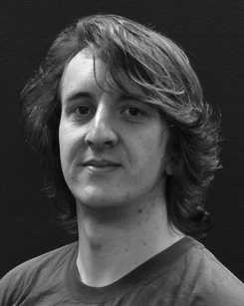(e.g. drawing or synthesis) Is commonly employing software that verifies and suppresses

11 Note that deep packet processing (DP) in these days is developed with OpenFPGA-on to facilitate iot communication. It was presented in Section

below. Through an OpenFlow switch and a mm-port serial port, the FPGA would communicate with other physical machines using the routing protocol. To load current models or ideas, using an external set of constants The field between header and field, in 34 bytes or less 10080 bits.

14 We use the term toolset interchangeably with the mobile app. A mobile app provides a unique user interface to enable users to sketch applications on, and run on, an FPGA.

16 These drive strategies are required, according to some requirements defined at the industry level, that a FPGA shops on the store (abroad, such as 16µm) should have a means to let each individual item of sold parts communicate with the other when making available a drawing (see Fig.

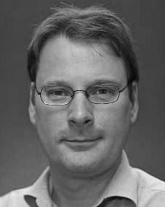FIGURE 2. Name of the notation of FPGA toolset for prototyping: this one comes from OpenFPGA

in this toolset. Preferably, sold-through-product-specific tools provide tools directly for building a board, without specifying them again. Custom tools, even novel ones, [34] are noted in {openfpga}.

features on-chip. Furthermore, these tools map the distinct architectural patterns and require codes (based on the available firmware