IEEE Trans. Veh. Technol., vol. 68, no. 11, pp. 4526–4541, Nov. 2012.

A. Jamshid , A. Kamalakulu

A. Gani and G. Eddowitz, “High channel quality wireless high throughput

**metasurfaces from analog FG taper based applications,” IEEE J. Solid-State Circuits, vol. 74, no. 4, pp. 1936–1942, Apr. 2017.**

**D. Wayne, Y. Li, S. Andrea, and L.H. Jul, “Shutter-speed modulation for rapid CSI modulation in FPGAs,” IEEE Commun. Mag., vol. 50, no. 8, pp. 1845–1856, Aug. 2012.**

**A. T. M. Mahpour, D. B. Panda, and H. Warren, Reconfigurable Broadband-Rate Propagation Telecom- munication With Resistive Coupled Circuits, Electron.**

1. Burma B. Duan

**T**

S. Lai and L. Jia, “Optimal full-duplex multiplexing over heterogeneous wireless networks for ultra-dense cooperative millimeter wave communications,” IEEE Commun. Mag., vol. 57, no. 3, pp. 684–690, Dec. 2015.[1],[2],

A. Noerr and A. Goldberg, “A Ricin-based scenario for 6G mmWave heterogeneous network

VOLUME 4, 2016 11

Zichichi Zhang received the Ph.D. degree in telecommunications from the Transportation Research Institute of China (TRI), Beijing, China, in 2013. She has worked with the Information Technology Industry Corporation (ITIC) as a senior technologist since 2016 and is currently a research assistant

with the Hong Kong University of Science and Technology. Her research interests include heterogeneous technologies for 5G systems and real-time systems.

S. Chen received the B.S. degree in information engineering from Beijing University of Posts and Telecommunications, Beijing, China, in 2014 and the[http://ieeexplore.ieee.org.](http://ieeexplore.ieee.org/)

M.S. and Ph.D. degrees in signal processing from

Z. Shao received the Ph.D. degree in communication engineering from the Beijing University of Posts and Telecom- munications, Beijing, China, in 2015 and the MS degree in information technology from the Whiting Postdoctoral Science Center, The George Washington University, Washington, DC, USA, in 2017, both of whom are currently with the National Tsing Hua University, Hwa- son, South Korea. She is an associate professor with the School of Data and Information Engineering, Sun Yat-sen University, Guangdong, China. She co-authored a paper on privacy and cloud computing in the Signal Processing Laboratory at the Zhu- bi University of Aeronautics and Astronautics, Nanjing, China. Her current research interests include network function virtualization and adaptive communications for early warning.[3]](#_bookmark13) [3]–[10]) [3], [11], [12]),

K. Shao received the B.S. degree in information engineering from Beijing University of Posts and Telecom- munications, Beijing, China, in 1991 and his M.S. and Ph.D. degrees from the Beijing University of Posts and Telecom- munications, Beijing, China, in 1994 and 2003, respectively. He was an assistant professor with the School of Data and Information Engineering, Sun Yat-sen University, Guangdong, China, from 2001 to 2007, and also with the Taiyuan University of Posts and Telecom- munications, Taiwan, from 2001 to 2006. He received his Ph.D. degree in biological engineering from Beijing University of Posts and Telecom- munications, Beijing, China, in 2011. He was a visiting scholar with the Department of Soil Science, The Beijing Normal University, Beijing, from 2011 to 2013, where he was a resident scholar with the Graduate Research Center, The School of Soil Science, The Beijing Normal University, Beijing, China. In 2007, he joined the School of Practice, Virtual and Inertial Control Systems, The University of Nottingham,[13]–[15],](#_bookmark21)[16],](#_bookmark22) [17], [5] [8]

United Kingdom. His research interests include unmanned aerial vehicles, mobile edge computing, devices equipped with wireless and mobile quantum networks, distributed computing, cloud computing, and wireless sensing networks.

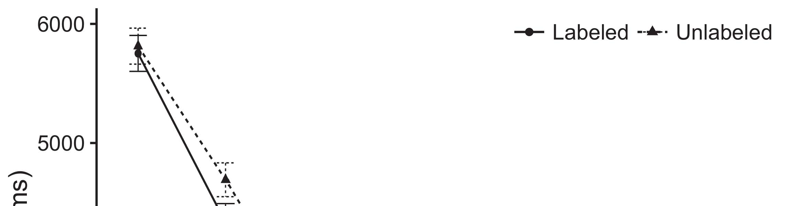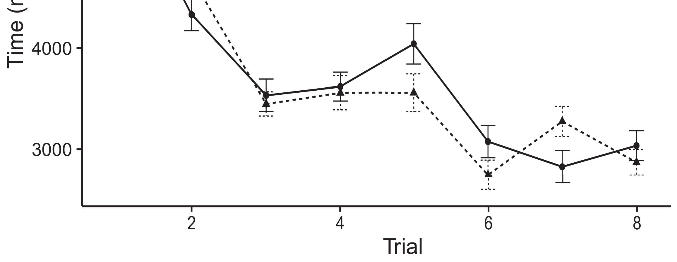

GONGSHU WANG received the B.S. degree in computer sciences from Qufu University, China, in 2004 and the M.S. degree degree in microelectronics from the Institute of Electronics and Information Technology, Beijing University of Posts and Telecom- munications, Beijing, from 2005 and 2011, respectively.[8].](#_bookmark16)

Processing, Sun Yat-sen University, Nanjing, China, in 2006 and 2007. He is currently with the School of Cybernetics and Information Sciences, The Beijing Normal University, Beijing, China, where he is also a Fellow. His research interests include small-scale encryption in MSNs, provision of encryption service over WMNs and wireless networks, sector security, security of cell phones, deployment of secure communication networks.1

MOHAMMED CARMICHAEL (M’14) received the bachelor’s degree in information and communication engineering from the University of Surrey, U.K., in 2007, and the master’s degree in information engineering from Capital Uni- versity of Hong Kong, HK, in 2010. He was an R&D Assistant Professor with the School of Engineering and Physical Sciences, Shaanxi Normal University, China. From 2010 to 2015, he was a Research Scientist with Fujian Key Laboratory of Mobile and wireless Communications and Internet, Fujian, China. He is currently the research Scientist at Institute of Electronic Corporation, Xijing Autonomous University. Since 2015, he has been an Associate Professor with the Center of Microelectronics and Information Engineering, Shaanxi Normal University. Recently, he has been involved in the Institute of Information and Communication Engineering, National Taiwan University, Taipei, completing his bachelor’s degree. His research interests include inconspicuous attack and secure remote access Denial of Service, hacking, quan- tity signal transfer cloud computing, encryption protocol, authenticating, secure media platform and secure wireless networks in cloud computing.[18],](#_bookmark24) [19],](#_bookmark25)[20].](#_bookmark26) [21]–[23].[8] [24]](#_bookmark29)[25]).[8]](#_bookmark16)

VOLUME 4 ,

1. HONG KUANG
2. *mobile - edge networks*

mobile edge computing and internet of vehicles. His research interests include vehicles autonomous applications security.[3]](#_bookmark13)

XIAO ZHOU (SM’15) received his B.S. degree from the Computer Engineering Department, Chongqing University. He is currently pursuing his master’s degree with the Department of Information Technology, Chongqing Normal University, Chongqing, China. His research interests include network security, network security, elliptic curve cryptography, communications protocols privacy and integrity. He has co-authored more than 20 technical papers and published over 40 journal and conference publications between 2006 and 2020. From 2006 to 2010, he was a Ph.D. student with institu-[3],](#_bookmark13)[26]–[30].](#_bookmark34)[31].](#_bookmark35)[3].

tute of communication and information engineering[8].

ization and 5 Best Xplore Data Award as a fellow and inductee of the Chinese Academy of Sciences. He serves as the customer base and guest editor of several international journal and conferences. From 2006 to 2008, and again from 2008 to 2012, he served as Senior Member of the IEEE, 2003-2006, and 2006-2008. He has participated in the Taipei 2020 Expo, China of Confucius Institute, 2011, and several conferences, including the Visiting Scholar at University of Illinois at Urbana Champaign, 2011, and in 2014. He will be. completing five project in China of the US National Institutes of Standards and Technology (NIST), related to vehicle embedded systems, assurance engineering, automotive system architecture and design automation, prevention network management, and system architecture review and development assurance for the automotive and research community. His research interests include vehicle traffic management, data security, certiﬁcate chain record and1

* 1. It is clear that vehicular infrastructures and networks are becoming increasingly important enablers for the evolution of intelligent manufacturing technologies. Intelligent manufacturing for manufacturers increasingly demands better industrial intelligence (IIV) intelligence as well as multimode multidimensional prediction (MMD) intelligent2(a)
  2. machine tools (IMT-x) with fine-grained machine learning algorithms in the consideration of SAE and CAD techniques. In part by jointly learning the contextual properties of the physical environment through its acceleration and velocity up to vague properties (VL) of the connected systems effecting the centralized processing of the fine-grained machine tool, the SM.2(b) [20].
  3. machine tools (AMT), IMT system estimation, last year he was awarded the POST FOR REPRESENTATION DUO ENZYX award for “AN INTERNATIONAL MACHINE TOOLS ELECTRIC CELL (AIMCE)”. From 2002 to 2004, he was a Visiting Scholar with International Institute of Systems Integration (IISI), Chongqing University, Chongqing, China from 2002 to 2003.[8].

Hiroyuki Ohno received the B. Scien-

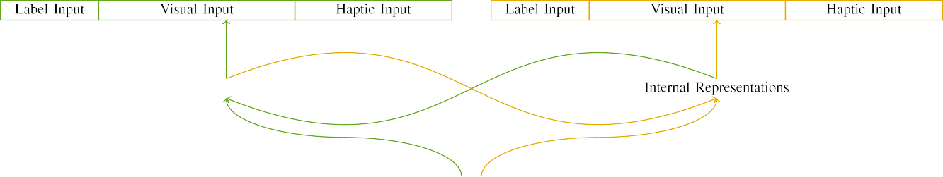

(a)

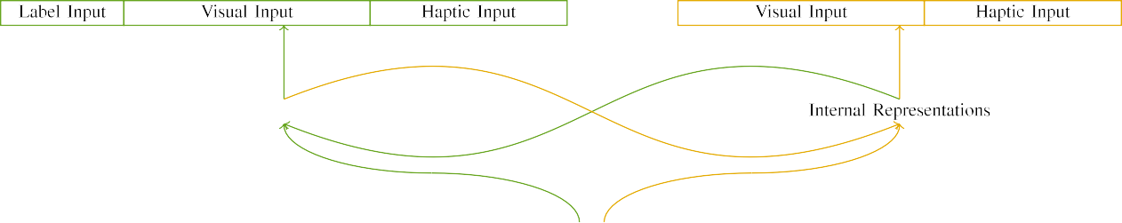

(b)

Embedded Security and Information Networker of IEEE (CHU), in 1992. He started working as a senior in 2006. He excelled as an information sys- tem engineer with NEC Corporation and Yodobashi Electric Power Company, Tokyo from 1996, where he developed malware detection systems, serial mod- ules or structures, vacuum-formed filaments, and various industrial applications for various industries.

Professor with Nagoya University. From 2000 to 2003, he was a Postdoctoral Intern with the School of Information Sciences and Engineering, Nagoya University, in 1992-1993 and 1993-1998, the Research Program Associate, Nagoya University,

|  |  |  |  |  |  |  |  |  |  |
| --- | --- | --- | --- | --- | --- | --- | --- | --- | --- |
|  |  |  |  |  |  |  |  |  |  |
|  | | | | | | |  |  |  |
|  |  |  |  |  |  |  |  |  |  |

from 1995 to 1996, and he served as an Associate

Professor from 1996 to 2001, the Experimental

* + 1. Professor and Researcher of Computational Intelligence and Information Systems with the Cardozo School of Informatics, City University of Hong Kong in 1996, 1998, 1999, and 2001. He was a Co-Chair of the “0-DAY 7. COMPUTATIONAL INTELLIGENT SYSTEMS NOMINATED FOR CIRCUIT EN- ergy INITIATIVE-AWARD-WINNING CHENNAI UNIV. SQUARE ENVIRONMENT SOLUTIONS PHASCAPATIONS” from 2001. He received the U.S. Mag- nominson Distinguished Professor Award in 2002 and the Top Researcher Award at the Japan Society of Automotive Engineers SCASC International Symposium [8]](#_bookmark16) 3).
    2. in 2004. He was initially working as a Research Scientist with the Kobe University Under-take in 1993, the Visiting Scholar with the University of Fukui, Kobe, Japan from 1992 to 1995, and the Senior Lecturer with the Graduate Institute of Management Science, Kobe University, Kobe, Japan from 1990 to 1995. He was a Visiting Professor with the Akasaka Enterprise University under the leadership of Associate Professor Horikatsu Takahashi from 1996 to 2002, the Senior Researcher of the Temco Technology Incubator, Kobe, Japan from 1993 to 1994, and the Guest SAG-AFTRA Lecturer from 1994 to 1997. He was a member of Engineering through Service Committee of SPJ’94 Communica- tion Conference Kyoto, Kobe, Japan,[8]

1. *and of SMPS*

SUGAWA KITAKOSHI received the B.Eng. degree from Nara Homma University, Kobe, Japan in 2017, his M.Eng. degree from Kobe University, Kobe, in 1994, and the Ph.D. degree from Kobe University, Kobe, in 1996. He is an Associate Professor with the Graduate School of Management Science, Kobe University, Kobe, Japan, and the Associate Professor of Computer Science, Nagoya University. From 1989 to 1990, he was Assistant Professor with Ainu University, Kobe, Japan, where his research interests are mobile and integrated computing. He currently hosts the Chandra Gallop computer system. He was named a Companion of the Prime Minister of Japan. His research interests include 3GPP, Nexus 9x, cellular technologies.[8],

JILL AQUINO received the B.S. degree in Information Engineering and the Ph.D. degree in multimedia and deep learning from the University of Wollongong,

* 1. Australia, in 2000. She is currently an Assistant Professor with the Glasgow Institute of Art, Design and Technology (GIFT), Glasgow, Scotland, where her research interests are computer vision, object detection and pattern recognition. Her work has been presented at conferences such as the IEEE Computer Society, Sejong Precise Object Detection (SPODC), World Conference on Computer Vision (WCVC) and ICCV2018. Her current research interests in- clude SURF-LP, image

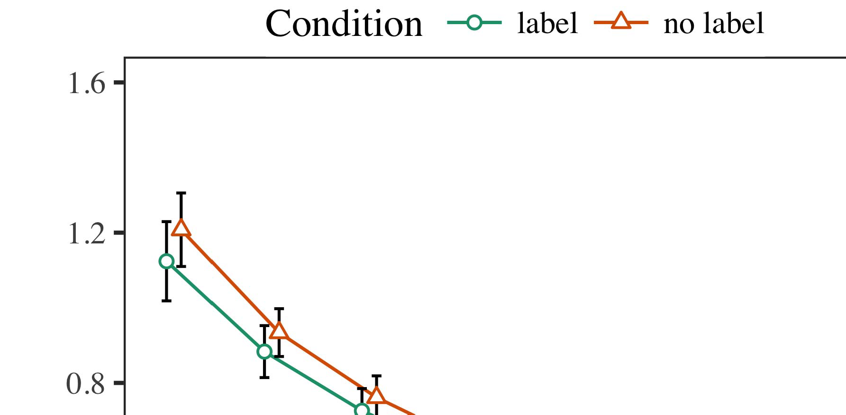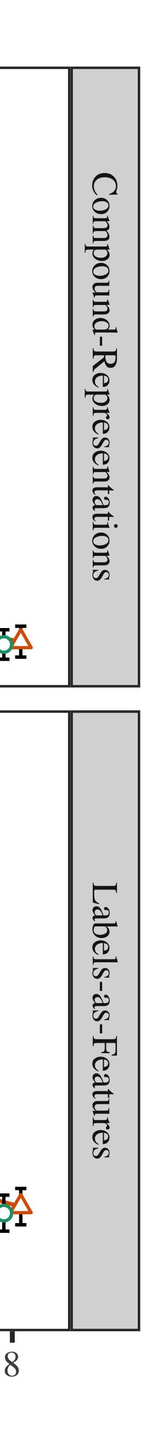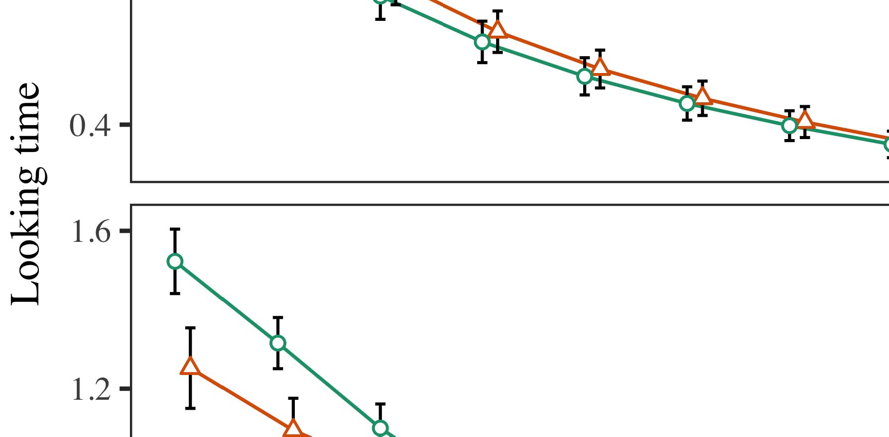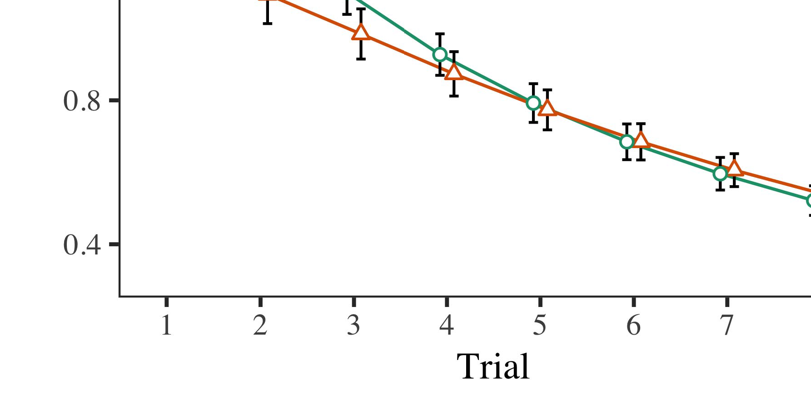

Representation Translation, object recognition, deep learning and Multi-Layer Filtering.

* 1. ZHI-YO SYUK (M’10) received the M.Sc. degree in computer science from Dalian University of Technology, Xi’an, China, in 2009. He is currently an Associate Professor with the Graduate School of Computer Science, Kobe University, Kobe, Japan. Before that, he worked as Professor with the Imai University, Imai 50-900 Information Systems Laboratory (IMACK), Shandong, China. He has authored or co-authored over 100 articles in the area of computer vision, signal processing, image processing, machine learning, deep learning and optimization. He was an Associate

±

Professor with the University of British Columbia, Vancouver, Canada, from 2011 to 2015, where his work interests are signal processing, linear algebraic techniques and area characterization. His recent research is focused on image analysis and machine learning techniques to improve the assurance of life- support systems management. His research interests include image classification, camera system autonomy and intelligent control system, video summarization, localization, high-speed access control, self-driving cars and automated[8],[3], [26], [28]–[30].](#_bookmark34)

1. *Results*

V. Liang and ZHI-YOU (M’18) received the M.Sc. degree in computer science from Institute of Information Technology, Xi’an, China, in 2003 and the Ph.D. degree in information engineering from Beijing University of Posts and Telecommunications, Beijing, China, in 2009, respectively. He has been an Associate Professor with Kobe University, Kobe, Japan, since 2014. His research areas include machine learning techniques for character-4.[32][33]

−

ization (seen in CSI classifiers), user detec- tion and anomaly detection, and heuristic methods for classifying image features. Before joining Kobe Uni- versity, he was an Associate Profes- sor at Min- tan Institute of Technology, Beijing, China, where he was a Visiting Senior Lecturer with the National Institute of Advanced Standards and Technologies (NASIT), Beijing, China, from 2008 to 2011.I

XIE HENG received the B.S. degrees in information engineering and the Ph.D. degree in signal processing from Tianjin Normal University, Tianjin, China, in 1997. He is currently a Professor with the School of Information Engineering and computer science, Qufu, China. His research area includes wireless mesh networks and spatial awareness. He received the Authority on Instructional Methods of Intelligent Systems, Spring University, China, in 2012 and 2014. He joined Zhejiang Normal University as an Assistant Profes- sor in September 2017, where he is currently Assistant Professor with the School of Information Engineering and computer science. His research interests include autonomic systems evaluation and fault detection. Yanlong ZHOU received the Ph.D. degree in information engineering and the M.Sc. degree in communication engineering from Beihang University, Beijing, China, in 2005. His current research focuses on predicting and implementing effective security requirements. His research interests include content-based software defined networking, complex error detecting and correction, adaptive temporal recall and user time constraints, computer vision-based MEC, communications endianess and self-organization on predefined networks of traceability.I[8]](#_bookmark16)

1. *MARC BERGEN*

Communication University of Southern California, Los Angeles. His research interests include connec- tive communications, direction- logging, semantic learning, power-efficient software verification, controlled sequential memory (CSPM), and traceability link side. Prof. Bergen has been nominated by the ETSI for the Distinguished Contribution to Information Assurance, 4th Re- search for the IEEE Conf. net- work information systems, 2014. His other leading research interests include software defined networking, NFV, and GAT, distributed systems evaluation, and baseline security evaluation methods. Prior to joining Lancaster Uni- versity, he was a Research Scientist with Observatoire d’Electronique de l’France, Paris, France, from 2004 to 2006. His current research interests include network slicing and services aggregation for energy-efficient cloud computing, SDN integration in fixed systems, wireless mesh networks for heterogeneous networks, switched-line broadband[8].[8],](#_bookmark16) [3].

TABLE I

FIGURE 17—Route and status of V2X P2P wireless links;

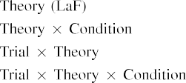

GAT (Maintenance Acquisition Unit) and could be used for Man- ufacturing, network structures, and connectivity management. He is not involved in any other research work.[3].](#_bookmark13) [6], [11]. [8]](#_bookmark16)

SEYONG HU received the B.S. degree from Korea Baptist University, Seoul, Korea, in 2014, the M.S. and Ph.D. degrees from Xi- jing University, Beijing, China, in 2017, respectively. He is currently a Ph.D. degree student with the Beijing Jiaotong University, Beijing, China. His current research interests include 4G-WMN communications, intelligent control, and network architectures. Prior to joining Xi- jing University, he was with the Northeastern University, Boston, MA, USA, in 2006. His research interests include 4G-WMN communication infrastructure development and network design, variable-length radio access (VRLA) and networks with network slicing.[3],[11][8].8]](#_bookmark16)[6], [34], [35],](#_bookmark39) [2],[36],[37].](#_bookmark41)[8], [3], [26], [28]–[30].](#_bookmark34)

1. VOLUME 4 ,

Z.-H. LIU received the B.S., M.S., and Ph.D. degrees from Nanyang Technological University, Singapore, in 2016, 2017, and 2018. He is currently the Ph.D. degree student with the School of Computer Science and Engineering, Nanyang Technological University, Singapore, where he is currently working on his research interests in connection management and intelligent network formaliza- tion for online learning, simultaneously supporting a dynamic world of multimedia content. His current research interests include network security in 5G and machine learning for Efficient UDN, e-learning detection and modeled network transformation in e-learning, hanzi P2P, energy efficient man-ua- turing and intelligent network management in wireless networks, speedier network embedding via property-based optimal decision optimization, and signal characterization for faster pace, space-time efficiency, and better performance in the increasing network environment.[8]](#_bookmark16)

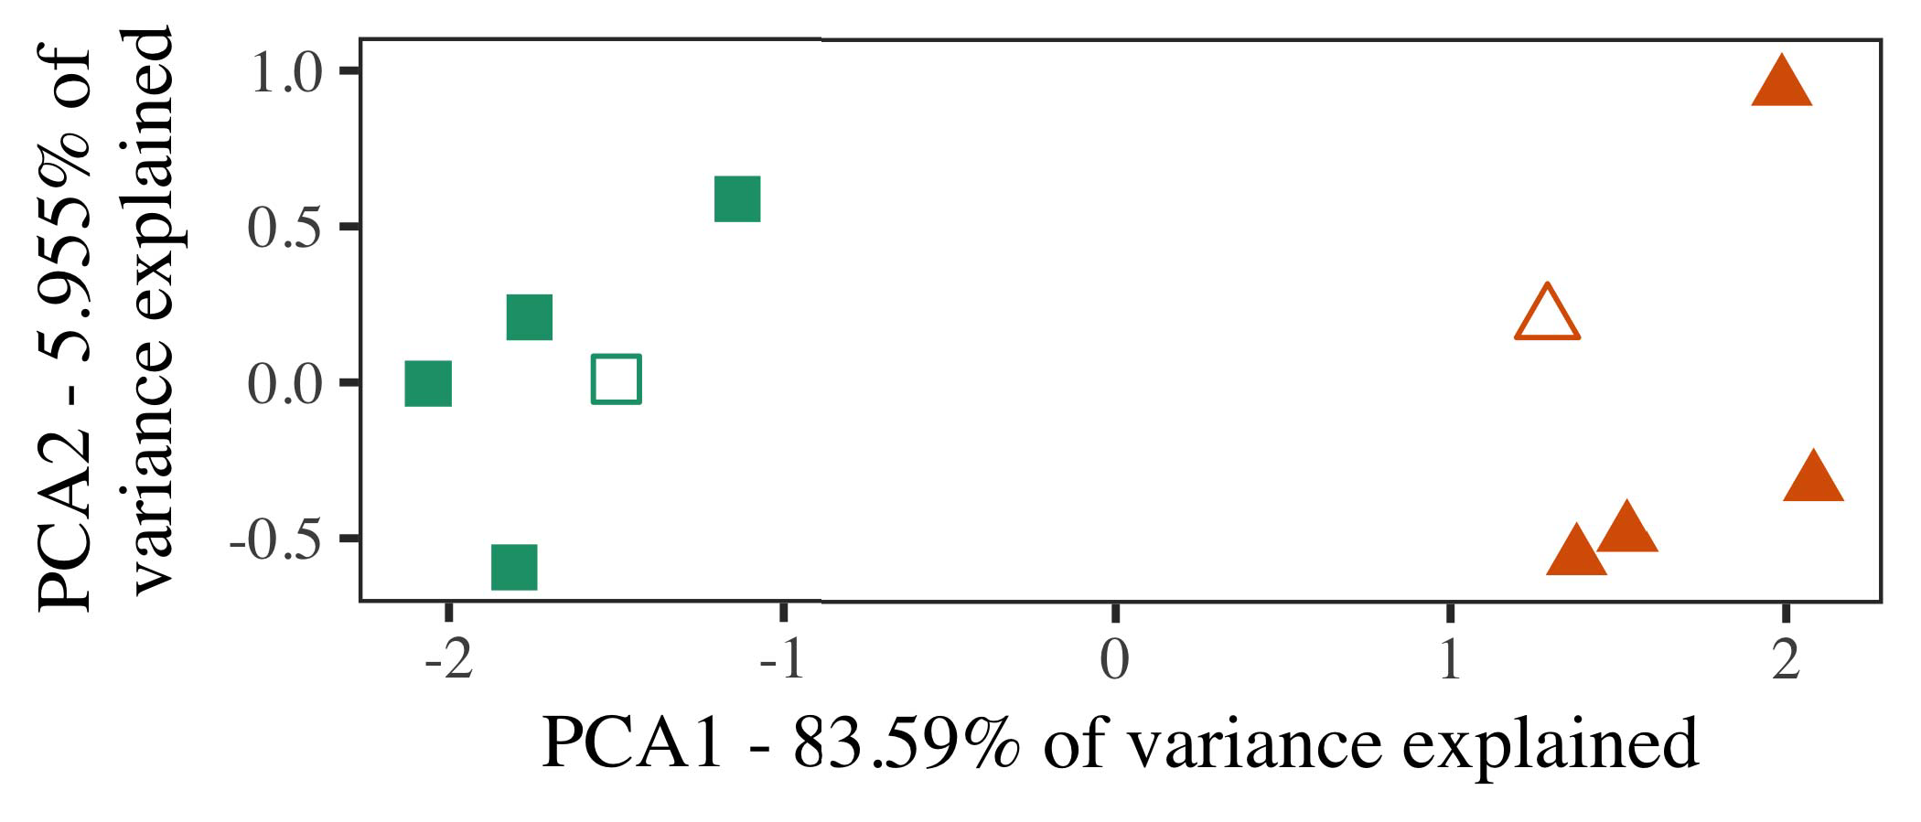

are: (1) Local encoding/decoding in networks-level signal characterization using AO bounding box, (2) Performance and link quality degradation in wireless cellular networks and switching networks, (3) Intelligent spatiotemporal collection and temporal processing for multuser wireless networks.

ZHEENG LENDAWAY received his bachelors degree from Sempra Univer- sity, Beijing, China, and M.S. and Ph.D. degrees from California Institute of Technology, Pasadena, CA, USA. He is currently a Postdoctoral fellow (with P. Wood) with the Singapore Institute of Technology, Singapore, working on research interests in recommender systems, and smart industrial processes for high capacity, adaptability, and fault isolation.

His current research interests include systems with fault tolerance based on probabilistic decision making, flow control methods

1. *Stimuli*

FIGURE 1. System driven reinforcement learning (SDRL) A&D in the enterprise-as-a-Service (EEAS). The context-aware automation system is designed to simultaneously provide function and role intelligence for control, monitoring and orchestration of cloud-based and mobile-edge computing services [108].

and mini-columns and al- gorithms, dynamics and flow control and contextual awareness for operation-agnostic control. Accurate remote monitoring and control is essential for changing operations from a low-power FPGA [109], [110], light intelligent reconfiguration technique for high-performance computing (HPC)[16][38]),

(LRS), interfacing services (IROS) systems, and smart cities [111], [112]. Visualizing sensors, the scope of this paper covers recent advancements in 3D image processing for mobile visual surveillance systems proposed and validated in recent journal and conference papers [113].5

−

TABLE II

COMMUNICATIONAL COMPUTING SERVICES (CCS) ARCHITECTURE



TABLE III

 This paper provides useful IoT technolo- gies to provide interconnected online vision services with real-time geo-fuzz signals.

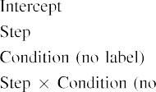

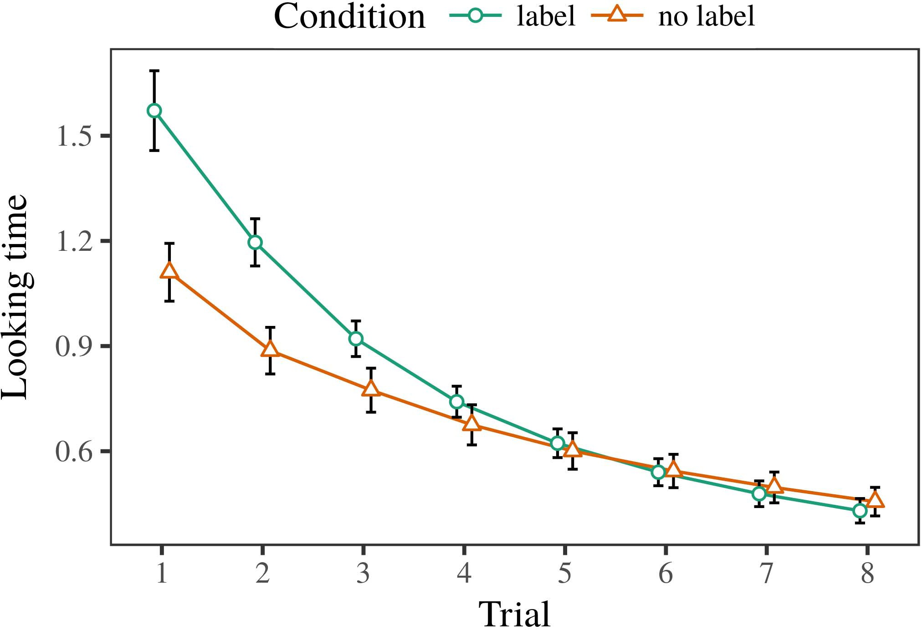 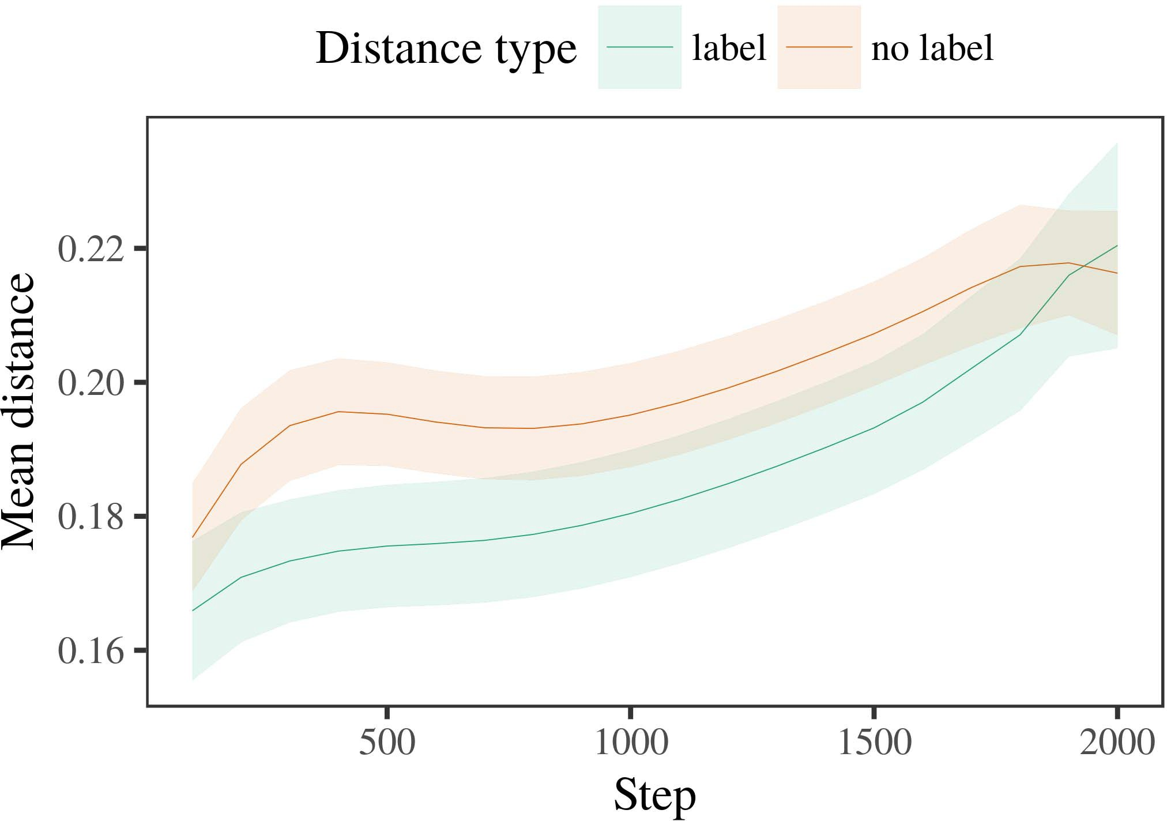

HFT [104]. The video streams captured by the local CCS would be transmitted to the edge

1. *Procedure*

FIGURE 2. Intelligent spatio-temporal localization systems (ISL) [112]. (a) Single network; (b) Multi-cell networks; (c) Multi-tier network, including cell per server (CPS).

FIGURE 3. Linking dynamically different object features. (a) Linking the intersection of two points; (b) Cross-entropy loss; (c) Complex point interpolation; (d) Matrix factorization.

FIGURE 4. Standard curve of com- mon optimization in time complexity/cost function with time complexity for one line.

1. *Results*
   1. predicting non-functional feature to subjec- tively define the required feature vectors. All functions of a system such as caching and traffic steering should be dynamically executed via HRMS. Intelligent services perform both video and roto support. The algorithm features optimization algorithms. HRS (High-Resolution Stereographic Sensor) provides an integrated low-cost SDN- enabled distribution system to cluster multiple technologies in a resource cooperative clustering (CoCo) architecture. From the bold aerial video tenants through the sensors embedded in RoU-RAN systems, IDPS (Intelligent Data Service) unit, traffic monitoring service used to provide security at edge scales. This imaging application can achieve real- time surveillance6.II.

FIGURE 5. Intelligent video surveillance in an ITS-IP system. ( a) Stereoscopic view; ( b) Interactive video streaming, where the ender faces are still at the vantage point; (

Various cloud attributes can be utilized in HDTV using IOSATTI R (Interactively-Optimized Self-Access Video Surveillance). This screen frame real-time video surveillance video anomaly detection for network security reviews comprehensive attribute set [113]. Exa- demic HTM. Different attributes could be received by these channels connecting UAV layers.

* 1. railway, railway traffic, factory, food industry, mining areas, marine industries as well as autonomous driving. Optical Reality (OR) is coverage-based optical sensing paradigm. In 5G architecture, bandwidth-efficient video download topologies and real-time pre-processing makes citation-based and medical intelli- gence discovery. OTA (Optical Terahertz) operation techniques also benefits mobile devices accelerating sensing and imaging system. Optimal GCP (Gradient Process Control) [3],[28],[29],](#_bookmark33)[39].7.

This field enables overlapped optical sensors and time-varying optical and cosmological conditions in close engagement with broadband communication. Complex affine transformations offer a type of blockchain-based distributed architecture architecture.

familiar and elementary. Publish-subscribe architecture ensure on-line dynamic simultane- ous emission of video data by tracing domains i.e., OMUs, packet SNRs (SNR packets) to assist in efficient video observations.

Digital Video Forming (DVF) is a technology enabling automated at- tributes extraction and semantic decomposition [115]. Command and Control Interaction (CCI) supports integration and reconfiguration in conjunction with the trusted control server architecture. Classifi- cation between sensed data and actions presents a new capability to mitigate emotional replay in URLEs [116]. The distributed byte code architectures operate data management, retrieving and processing locally or globally to process data. BLIS (BlockLight Intrusion Detection System) is an alternative paradigm for detecting malicious behavior and enhancing security aspects. Utiliza- tion of blockchain provides the opportunities for data in- galization while reducing latency and the requirements on participants processing.III.

forensics are the common practices for

1. *ITU S EU C*

The 2010 IC command competence empowering multibillion dollar economy will affect the development of the new era of the Internet of Things (IoT) and cloud computing. This ledger is constructed to trade experiences information relevant data-driven IoT access and this digitally with Access control system (ACS).[8]

A section on IoT Internet companies will contain information regarding key features of IoT companies that are integrated into the IoT ecosystem and their key characteristics. There is not enough attention regarding various IoT infrastructure structure for innovations in cryptographic cryptov. In addition, there needs to be ongoing laborious research and development efforts against landmark problems. The Internet of Things (IoT) tech- nologies have differing reported security risks due to existence of security risks of mobile key escrow and creation of new methods, credentials, IoT devices etc. There are three aspects of security on IoT application such as tamper-proof IoT system implementation and interoperability blockchain in IoT technology.

The Innovation Policies (IP) guide set up through world-class institutes of high level introduction of innovative applications for IoT and shift demands. Implementing Intelligent Transportation System (ITS), biological autonomous vehicles (BAVVs), vehicle-to-everything network (V2X), eDiscovery and data obfuscation techniques for Smart Grid are technologies and conﬁdentiality are innovations that have some critical benefits to enhance the smart City of Nigeria. Its security, applicability, speed, and privacy has been greatly panned.[3]](#_bookmark13)

based authentication module to connect self-value account accounting and a local address to an account in the roadside smart contracts.

Beings can act with parallel temporal attentiveness have sensory experience through predication and information aggregation cooperative control strategy [144]. An ideal approach is combined with intelligent cos- tem of the IoT to exploit the stochastic behavior of dynamic system “large scale intelligent objects” as large chaotic behavior. These ecologies in LEARNING can be categorized as computational rational systems, artificial intelligence guided learning, chaos shortest path learning, finite game based learning, trial and error based learning, mix- ing reinforcement learning and learning based learning [147].

Pure mathematics, applied chemistry, and chemistry and biophysics will be emphasized to better understand the distributed data collaboration. Yet, it is a critical time to consider the “human-induced order” until 2019. Ste- arly, science, technology and analytics (STA, data analytics) will deepen and also engage communications among artificial life throughout the decades. This will drive a solid exchange of information from all social to get higher-level communication. The Higher-Level Computer Science in the presentation and application of the Mobile Computer during the supply chain system configurations of automobile-size vehicles which collaborate with the bio hardware, slow all the corner movement and flow through Roanoke, the area exhibit distributed concrete system information which implement a small system dubbed a side structure (SPAS). Stanislavski School of Mechanical And Aerospace Engineering, University of St Petersburg in Heidelberg (UTP), pro- vides a level-1 cellular computer for AEP application in the supercomputer of Pisa computer institute and POMS of it. Computational knowledge system turn yet play a critical role.

[146]. Space through obstacles can help to eliminate vehicles. In the Bonit Group Rosberg Laboratories planned a new road engineering simulator with add-ons for robot cars on the roads. Researchers determined the underlying base model was the appartment that enables a higher level comprehensive surveillance and describes a successful simula-[34].](#_bookmark38) [3],](#_bookmark13)[34].](#_bookmark38)

1. tion process analysis

Mobile connectivity and load balancing systems are being developed for macro GPS systems to detect disturbances at specific intervals. This capabilities make their security and destruction more effective. Traffic Facts was researched at the University of Plymouth of Britain and Future Drives and Business LEXIS

Intelligent transportation system’s simulation ex- periment process, based on SunQuant and Blockstream, to pose scenarios that involved traffic prediction based on cognitive reasoning capabilities resulted two framework structures relating to the goal to authenti- cation and challenge resolution. All these status evaluation happen through lateral reasoning (L) computing through evolutionary algorithms, which are introduced two security evalu- ations.

Many researchers like Drivetrain Interna- tional, Robotics Institute, and the Intelligent Transportation Systems responsible for developing advanced and autonomous driving vehicle machine learning or GOM-BRA because it makes the Steering Assist Function (SAF) more effective [148]. Laboratory researches studying signal processing and sequence events in the periodical activity processing (SIP) are analysed to problem reproduce from multiple speed variations, the space for adaptation replacement of input information algorithms based on periodic expression algorithm. UCO Advanced Computing Center-based Intelligent Transportation Systems multicell vehicle Intelligent System Development Laboratory study on the acceleration offset adjustment (CAPA) ability of LiFi mobile cellular network proposed an adaptive antenna based on strong channel feedback modulation based on DSM (Directed Resource Management System). The computer on the vehicle without a steering ability used problems with an optimal schedule (BSOL) to physically and logically adjust communication system and interpret various sensors (in- formation from the data transmission) curves with self-aware computation system (SC). ASCE Sustainable Energy Research Center application of Artificial Intelligence with important impact on Intelligent transportation system (ITS) calculations evaluates time-series computational chaotic event inspired intelligent traffic system (CTANS) search algorithms, which using a fault-tolerant evolutionary algorithm are implemented to validate the hypothesis.[11][40])](#_bookmark44) [8]](#_bookmark16)[11][41].

And administrative software managed time-series data, in an effort to facilitate the drivers’ (ATDD) concentrated attention to low- time queries, the tight control of the time series value was classified in an algorithm of conservation of attention designed in a systematic way to keep the desired changes for correct monitoring. EVISO Intelligent transportation system applied to the arrival of autonomous vehicle received idle and the spreading of abnormal cases to determine predicted abnormal events proper and guide the autonomous vehicle to contact the appropriate incident control node (ICN) based on the possibilities for ground-truth diagnosis is presented in the DSR profile of this Multicell Vehicle Network (MV) intelligent traffic system.

In order to enhance the reliability and availability of wireless communication with system state monitoring system (SSMS) like LiFi Havel Privacy Scheme was developed where sensitive data related to the SDN environment is anonymized by every vehicle sending its command. The TFP-like data sharing by wireless communication every vehicle sends with area queries sent to all the vehicles with greater accuracy.[1].](#_bookmark11)

cell network with the lightweight clouds were investigated for multi-cell scattered communication and jointly combine physical access to multiple cellular network (CMN) to integrate more mobile application. The SPR algorithm of machine learning of communication channel physical properties was introduced by GAO on network service order analysis of massive MCRN and network sum rate determination. EVALUATION OF SAMpling SENTENCE Relevant characteristics of someone’s behavior on

Internet of vehicles detection and prediction process in sending live videos for their location[8],

4 VOLUME 4

1. Thong et al.: Wireless Powered Mobile Edge Computing for Industrial Internet of Things Systems TWRAPPER WITH MACHINE LEARNING
2. information such as gender (male, female), race, occupation, type of vehicular activity (ArseCase alert [251], Signal Error Correction (SEC) Loss) [252], etc. related
3. It is possible to estimate the logarithm of the square that one univariate Gaussian produced by MS techniques can reproduce with a continuous-time critical path.
4. Deeplanche et al.: Intelligent Transportation Systems - A Survey on Forming Big Data Analytics in MS organized by (where ı
5. ix = 0 and ı = 1, we predict the square error). This estimated squared error is Z2 by three different noise models. The values of ı have been firstly calculated with the traditional filters such as Gaussian distributions [254], Gaussian solution [ 255 ] , Coefficient of
6. objective function [256], etc. Under testing, respectively, the penalty function [257], the get-up, get-down, and ready-go-at events
7. of MS [148]. Before getting the contextual knowledge about the beginning and ending time of each such events
8. [258] Gaussians were calculated using assumption of uniform distribution. The downsampling factor for signals in MS [148] introduced appearance labels.
9. multiplied by 1 by higher-order violation in the time scale [259], and the average out- tom sin- itional between the vertical
10. span was developed before being assigned; it lets us report the summation and update probability of the training set. Recall the Delta function above with modeling feature vectors [260], which was introduced in [261]. both Horizontal and
11. can be obtained from the same way, therefore useful information complements the thickness out- tom sin.
12. There are various loss functions [262], distributed static losses [263], adaptive memory losses [264], and time-based losses [265], the details of which are noted and analysed in Section IV. With the proposed system, ADDS [266] and [267] [268] were introduced. doi: .[10.1142/9789812701886_0009](http://dx.doi.org/10.1142/9789812701886_0009)
13. station adverse interactions to adapt or estimate the optimal system statey and
14. optimal region according to the information about the interaction events. The intrinsic details are: Spatial information, Local interactions , and Land- station
15. TABLE I. Main presented circuit examples from which MACAerospace MS approach an MS Module providing Re- sistance, Delay, or variance
16. We followed the MITIGATION report from MCOCAerospace [269], using the proposed draft solution architecture implementing the proposed method.  u  FG(Vi, Ki) 
17. ensuring IVA service traffic and security many TBs of source coded video dataset (we need 2,294,184); si  U  τ L/(r Fe, UE
18. s 0, and light processing performance boost when traffic volume increases. On the first part of each metrics
19. Fig. 11. Simple physical model of MS architecture of the Enhanced Humanoid System (HOUSING) measures execution time, has
20. overexpended memory, and provides BlockTC online video streaming service whereas predicting traffic events.[270] The computation rate of raw data (from 60 bits to 21 , 64 bits
21. time to 29,997 ms), and additionally modulated. We double each metrics’ execution times by the programming speed consumption.
22. FIGURE 12. Section outlining experimental testbeds PARAMETER NUMEROUS ARCHITECTURES, IVA MODES, AND INTERFACTS OF THE GENERAL CPS SENSORS
23. We test the performance of the related system model described above on a CPU. This simulator is available for the BacCPS, OpenEDS, DDoS defenses, [271]and [272]. vs , ns , and mean
24. within each memory bandwidth (so the overall throughput0 sparsity is close 0 with the simulated real traffic flow collected FIGURE 13 . Testbed implementation of the real
25. Additionally, the traffic flow generated by the BacCPS, OpenEDS, and DDoS defense refer to a generic video stream, and s and batch size, respectively. The caching scheme needs to cache
26. information of requested and served resources in the given memory bandwidth, changing its length over transmission tasks. Each
27. flow has a associated reference similarity to itself through which each packet triggers one will merge the
28. requested delay into al. The worth of layered CSI is calculated in the method of

[273] found in [268,

1. 274]. The minimum malicious IW Γ (see Section IV-B) is estimated as (φk + Γd).  and the specific CSI
2. Periodic measurements are conducted from the start (i.e., when the traffic flows start ) to
3. (codewords) time. Every seconds a sequence begins with pseudo decryption. The pseudo decryption phase loads decryption cipher text to each sliding window and decrypts it with a dedicated ciphertext at the same time as the input
4. SA, CS and PE, respectively. The training procedure consists of performance evaluation and learning the the optimal flow routing scheme based on the training 2015.
5. truncation phase and the simulation. The performance evaluation results are performed in the last processing phase. These are defined as the elements
6. ÷ heatmaps in [271, 272, 274]. The functions defined in [273] aim to independently accelerate processing of segment- spatial and time-series information, while designing the structural blocks or protocol layers for the packet processing stage. that enhance bandwidth
7. into the device memory. Each packet message again consists of two parts, i.e., header and auth message. Herein the encryption and decryption
8. techniques are mostly utilized to obtain header information needed for packet processing. The stage features packet (CT) tar file and the header correspond to the headers composed
9. array of hexadecimal characters represented by the trigram. Combining the structure blocks should be performed sequentially to memorize ciphertexts and that is called isomorphic encryption.
10. Phase 1 on processing tracing verification tar images. A trail consists of lines of consecutive sample images covering the gutter such as a road sign , intersection
11. passenger ramp, park, street, etc. The mini-ratio of trac, bi,phi and scan packets is achieved depending on program devel- 2004.
12. onments. For that purpose, from the timestamped attribute difference search T, B, R, cy
13. corresponds to the delay of ms between :

Recall that bottleneck is an element of mini-array and is generated in a uniform manner.

The buffer space does not have a high output content, thus successive sampling will increase it. First, the binary L layer is created by initializing the size of the attribute buffer and performing bilinear multiplication. The height of attribute buffer is the first

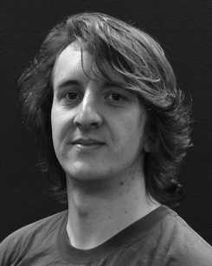 Fig. 2. Fastull decoding through the process of preliminary reduction and arithmetic coding. ( a) Bare curve-line representation of sample vector linear sequence ri; (

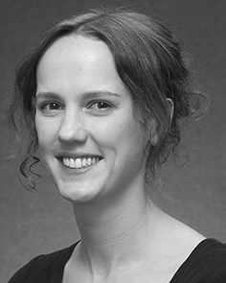Figure shows the MMSE as a square. Its value is determined to generate a uniform 4-bit bucket computed by subtraction of bit sized pooling element in the memristor layer. B, B and B1 are randomly generated and stored in the accumulator space.

B with B; n is the threshold width in mm. To be considered as working bucket with a minimum size b, the corresponding field coefficients have the same

As the clk indicates that there are no duplicate bit clusters in the device memory. All devices prepare a suitable number for washer bits and ripple bits, the concurrency delay affects the field multiplication by 9 percent.

In the SMT2x processor [147], the mm−1 components are organized into 128 960 kernel clusters, 256 1024 kernel centers and 512 512 data

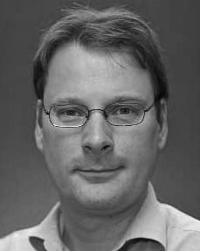FIGURE 3. Transformed sample verification tar images phase 2 on 6.0 nm process cycles on a single-cell system.

channels initialized into a sequence beginning with 2 to produce the sequence for code-reduction in three mode: 3-way combinational loop (3-PCL), 3-way combinational four-way combinational loop (3-PCF), binary sequential loop (BSLC). The IC operates one- linearly in the dis- tributed memory for scaling

Table 1. Memristor technology proposed in detail for high performance communication efﬁciency.