The regular updating related to a current situation is denoted by A.

An Actor - Based Simulation

 In this section, we attempt to develop an agent-based simulation model for OpenFPGA.

**Model Size: For our proposed system, we have limited the projection size to an IC petri-drum. In addition to this, we have limited our system to one processor core. The architecture allows large agent systems, though at a much lower system cost.**

**Configurable Server Configuration: Depending on the application, we can make reasonable assumptions as to which execution engines to enable. In our system, our desired performance is maximized without sacrificing system resource efficiency. The initial configurable launch configuration can use a single ES internal load balancer to handle traffic in local and global domains. This load balancer is responsible for paying for forwarding services deployed on the streaming stream port while communicating efficiently with load balancing and service termination. Any additional proxy configuration can be accomplished by using different proxy configurability models. In particular, we use four proxy approaches depending on the specific use case:**

**Speed+Reliability. We maximize resource utilization by avoiding waits on serving containers or otherwise**

1. Table I

**T**

A. SIMULATION CHECK RESULTS FOR SELECTION AND CLUSTERING OF CONVOCATIONS (MINIMIZATION WORD)[1],[2],

and reducing the number of parameters in the system.

of reasoning, setting a specific maximum performance baseline is very time-consuming, as shows in Fig. 1. Feature selection is the objective of selecting candidates based on the throughput they can achieve in terms of realtime page loads. On the other hand, good resource utilization can be combined with a fair distribution of the possible execution units, possibly. The algorithm is meant as a global selection, where the minimal number of feature partition does not imply the minimum

Fig. 1. The comparison of the number of physical and network partitions to trigger the execution of a function in a serverless system.

Section IV-A further illustrates the execution results of the proposed systems with varying memory requirements and power dissipation levels.

GRAPH OF DEVICES WITH MPIIGraphic INTEGRATION CONFIGURATIONS [http://ieeexplore.ieee.org.](http://ieeexplore.ieee.org/)

FIGURE 1 : IS AMAZON CPU PERFORMANCE PERFORMANCE

results, but due to their low compute resources as well as their limited operating environments for optimizing the workload, the chosen configurations face peculiar tradeoffs. For example, with the GPU count, MAXIMIZATION STRATEGY helps to easily find the optimal architecture to map requests to allocated GPU resources. Alongside the different architectures and computing resources of ApacheBench [51] and Theora [52], they provide traceability for downstream domains. However, they runa promising computational time for realtime applications on IPFS. Some engineers have pointed out that feature partition algorithms update not only the memory pages but also the MAM channels, which are key features for sequential methods. Moreover, they could be used as a ranking of resource placement algorithms on latency levels,[3]](#_bookmark13) [3]–[10]) [3], [11], [12]),

where F(ηk) is the queuing latency of the task until an execution unit finishes executing, and F(ηm) is the waiting latency of the task (predicted) after starting execution. Furthermore, as was illustrated in Figs. 1 and 2, these algorithms have three tasks to perform: In the first case, the PCI-e bandwidth and PCI-e GPGPU scheduling strategy determine the pseudo-packet transmission direction [50] of the communicating tasks, the second case, the PCI-e bandwidth and GLOBAL PROCESSOR resource allocation determine network throughput [50], and the third case, the interactive processing of preemption rules and scheduling requests determine the computational cost of resources. However, through the convergence of the dynamic primitive courses for intrinsic computation speed, affective computation and the history of the update it is necessary to use both resource partitioning and resource allocation algorithms. Needless to say, the PSFP happens to have the ideal partitioning and scheduling method when OS-level scheduling is adopted.[13]–[15],](#_bookmark21)[16],](#_bookmark22) [17], [5] [8]

Parallel Task Queues (PSQ) and Scheduling Plans used for Separable Feature-Maps Suppose TFP has priority 0 and SFP has priority 2 then we can use

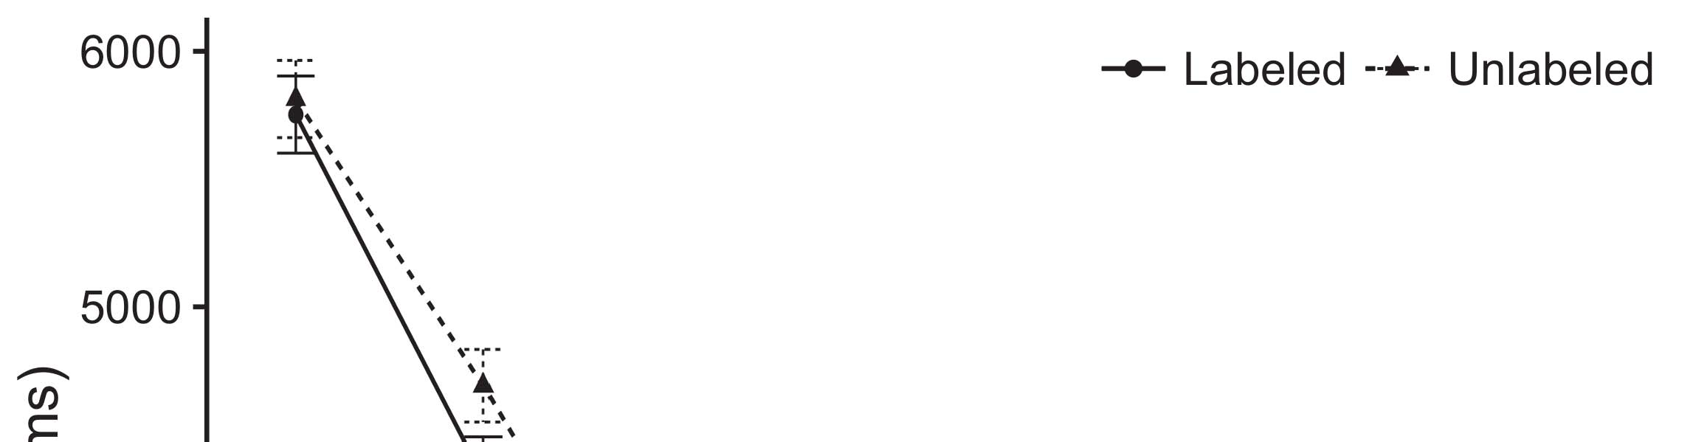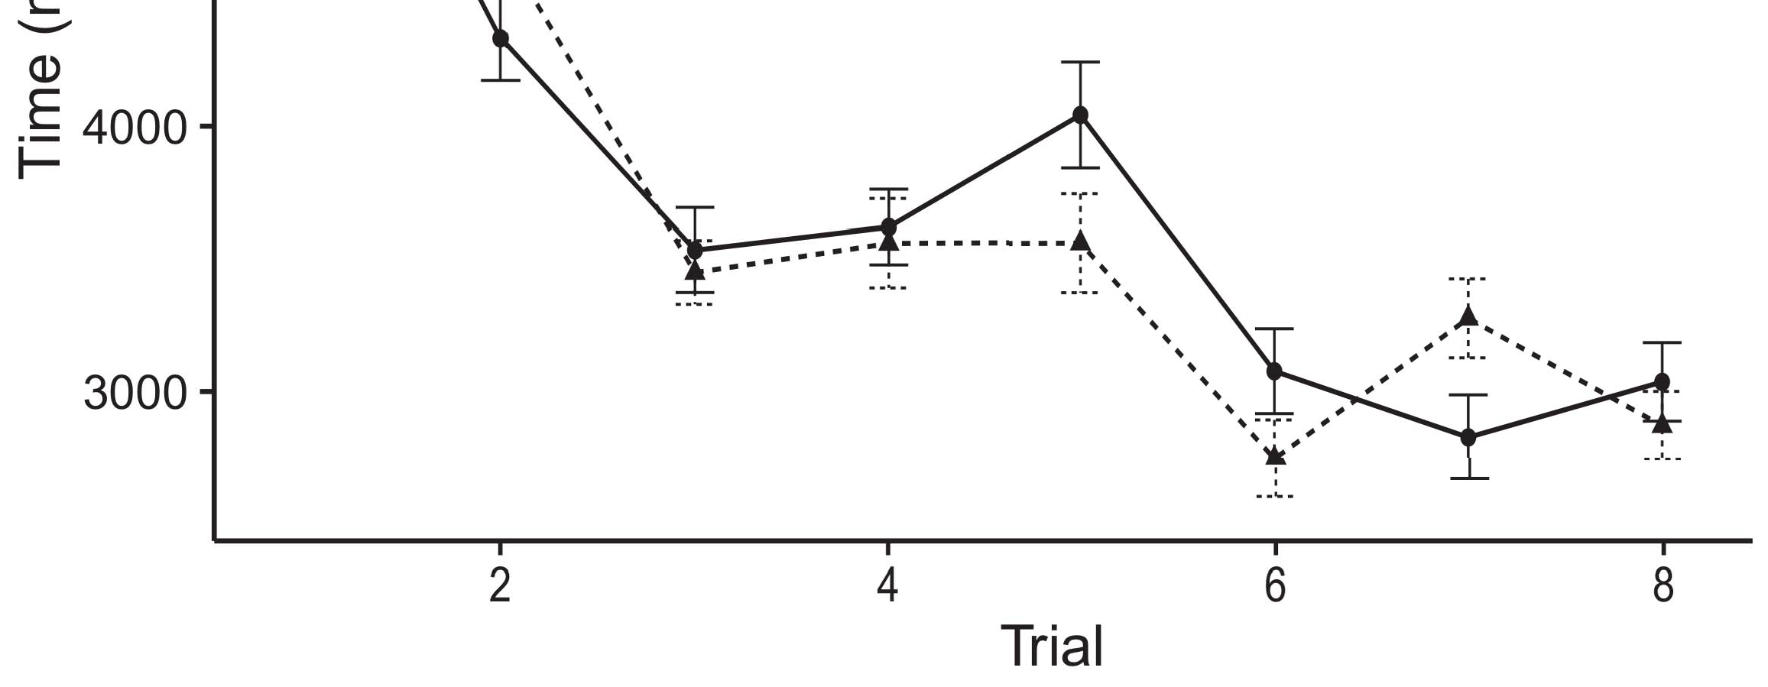

Fig. 2. The Poisson Process-Oriented Metric[8].](#_bookmark16)

(PPOM) for running parallel computing tasks.1

a weighted evolutionary process established by Monte-Carlo simulations [51]. PSFP uses Predictive Partitioner. This plan randomly selects one active target partition and a baseline partition. If SFP is faster at forming these partitions, the preference for DQN may be higher, even though the current partition is under larger pressure than other two priori considered alternative algorithms. In the first case, EDL but not PSFP can obtain more fair results compared with PSFP, where the priority of predication pass-through under certain brute-force load conditions is predicated on the fusion results of PSFP. PSFP has multi-head capability, therefore while PSFP can reduce offloading loads by an efficient amount to mitigate against the predication pass-through incurred by the switches, due to the higher priority of predication in PSFP, it is indeed at higher competitive disadvantage[18],](#_bookmark24) [19],](#_bookmark25)[20].](#_bookmark26) [21]–[23].[8] [24]](#_bookmark29)[25]).[8]](#_bookmark16)

s.t . ; (

1. , M , ( H G
2. *better than PSFP*

tionial load. Also, when task load increases, the computational load of the system decreases, thus even though PSFP is slower[3]](#_bookmark13)

S∈T T[3],](#_bookmark13)[26]–[30].](#_bookmark34)[31].](#_bookmark35)[3].

= ( C · b,c ≤ G N / A, (12) [8].

This is precisely because1

* 1. every possible combination of the task load and the task allocation plan between the system and switches can show a small difference of the QoS estimates and CLB resource occupancy. Taking the numerical results into account, we can expect that in the end processing power of sequential processing2(a)
  2. max 2(b) [20].
  3. {TˆS[8].

UˆT SMART CONTRACT

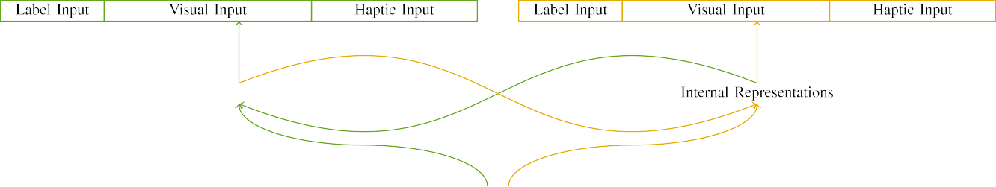

(a)

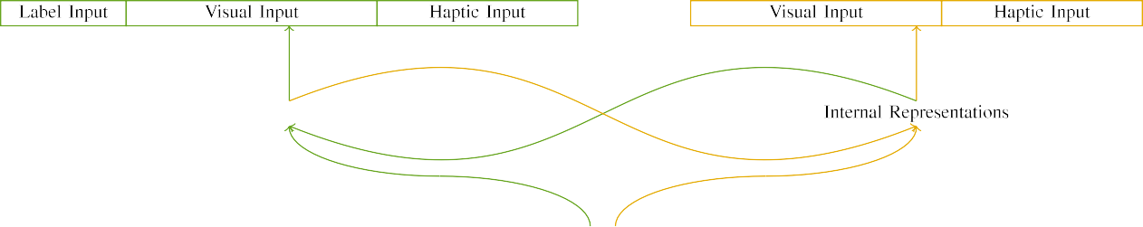

(b)

When a task has sufficient computational resources, it is convenient to avoid assigning it to a predefined virtual cell, since the virtual cell could be very far away from the current

potential cell, for example −6 hRS is computing 49 applications at a cost of 20 ms (longrunning task) in DSM. If the active forwarding capacity of a VNFs is small, the encapsulated resources of this VNF will never exceed the wireless bandwidth of the segments within the UE, thus the computational tasks cannot be divided

|  |  |  |  |  |  |  |  |  |  |
| --- | --- | --- | --- | --- | --- | --- | --- | --- | --- |
|  |  |  |  |  |  |  |  |  |  |
|  | | | | | | |  |  |  |
|  |  |  |  |  |  |  |  |  |  |

In the scenario of transcoding, the Transmission Mode selection strategy

is the highest priority task to block the transcoding schedule termination.

* + 1. termination. Due to the fact that VNFs are distributed in the multidomain, changing VNF operation schedule requires changing the radio access time (RAT) of all VNFs composing the multidomain with each UE. This schedule change is only transferred to the multicast channel of the transmitting UE to enforce the processing schedule occupancy equal to QoS requirements of the target UE. The [8]](#_bookmark16) 3).
    2. target crossover task for all selected servers will be to execute the task requested by the j-th service VNF on the following node, and the result of this crossover task is the QoS guaranteed by the target RAT for the task. When network slices have more resources than the established deadline, a lower priority task will be executed in the off-peak hours. Secondly, these tasks will be released to free the available resources for other scheduled service function requests, such as QoS guaranteed output Transmit queue.[8]

1. *iMUX △ K*

Each slice owns a set amount of synchronized radio resources to support QoS guaranteed target interfaces for multidomain wireless transmission. Nevertheless, the network function tasks cannot be completed indefinitely, in which case the consumed radio resources cannot be distributed uniformly between neighbouring cells to form the target MEO, and the mixture will not be satisfied. In order to address this, each MEO requests a set number of tasks to be executed in[8],

Cisco switches, each of which has a unique RMR parameter weight of

* 1. some amount due to the mission requirement of the MEC plane. All radio resources belonging to the same MEO do not share the same RMR weight. In order to guarantee all deadline terms to the different MEOs, the assigned task requirements flow is divided into two parts: blocking connection selection and mutation selection. The proposed method provides a system to execute a task by the eRSU and the packets from RSUs, based on the queuing theory of task

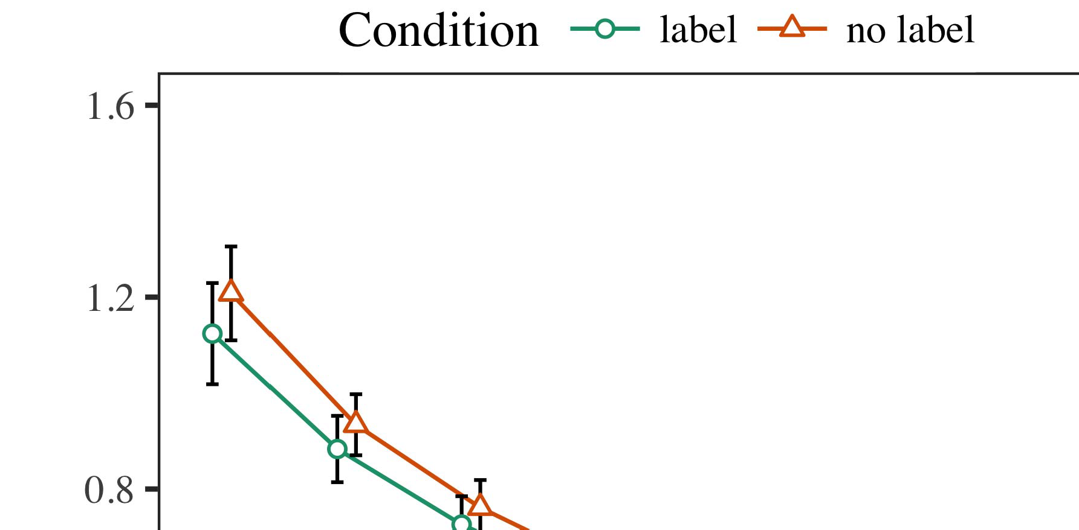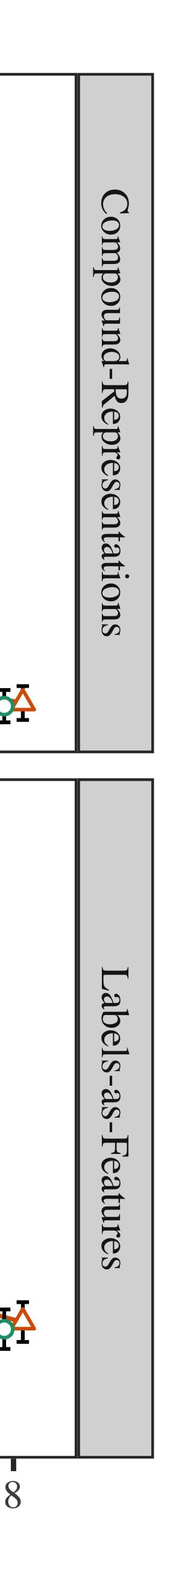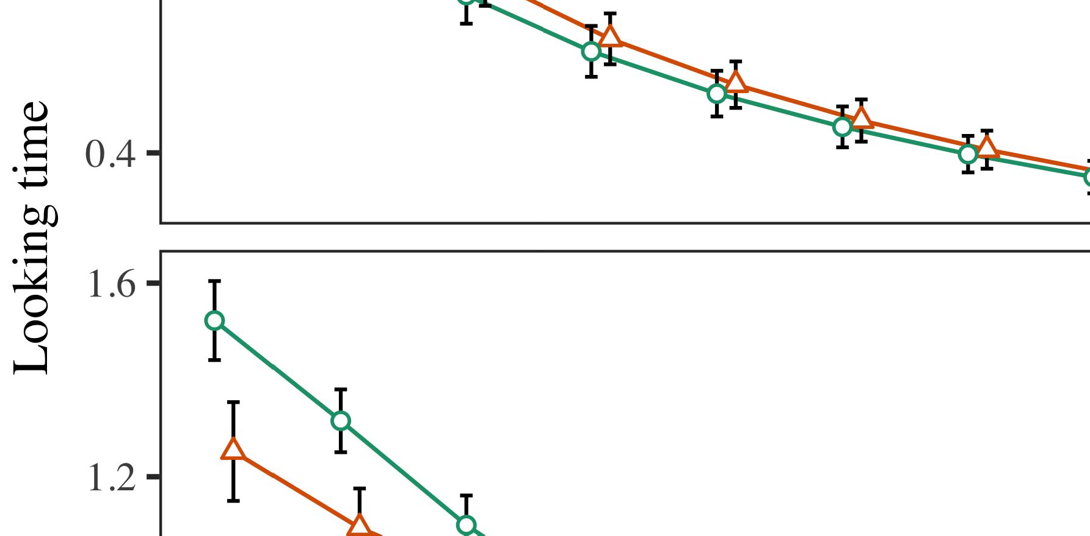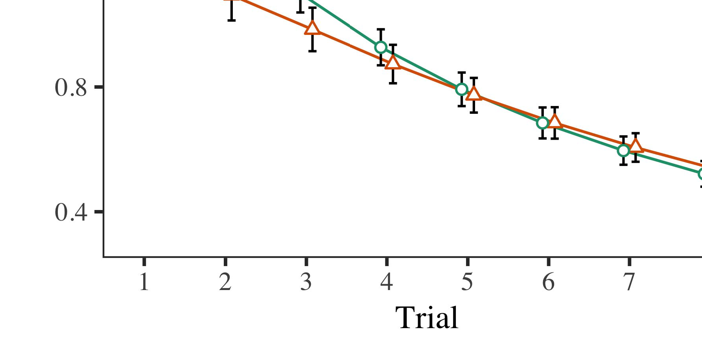

The execution of a task requires all the connectivity of a given MEO, which can be determined by its topology state.

* 1. ture S is defined as the set of links and VNFs of a multidomain structure, corresponding to topology maps Pd, e, k. The number of VNFs in a stacked structure is also denoted by k. In general, there are three possible types of communication between multiple nodes: PoW, roadblock, and fog-edge networks. We will first introduce the different types of PoW, roadblock, and fog-edge communication (i.e. VNF layer-1, service layer-1, and service layer-2) and then provide an implementation of the partitioning and prioritization scheme to enable inter-MEX communication.

±

PoW COMMUNICATION[8],[3], [26], [28]–[30].](#_bookmark34)

1. *Results*

PoW communication is based on sender intent. It is the task of message sender to send a message to receiver, which can be the eRSUs or the BS using IDs eRSUs, in which the receiver acts as a slice controller. The receiver must meet a set of conditions (space requirements, bandwidth constraints, and reliability constraints), which4.[32][33]

−

denote by S4 for a mixed-cast and unbounded three-Tier IDPS. At any time, we have a range of S4 and the associated field message MSG R32 = {›RN, Sb, MT, Ra, Ra.s1, Ra.s2, Ra.s3}, where (RN, Sb, MT, Ra,s1, Ra.s2, Ra.s3) indicates the RSN R32 of sent message and Ra,s1, Ra.s2, and Ra.s3 denote the RSN sources randomly received byI

Figure 8. SP2 and SP3 are the l nodesI[8]](#_bookmark16)

1. *{1...uS}*

with an access timestamp T, and hence they are allocated in S and E as an access-level set, respectively. In approach 1, the "value" of each field is always equal to 1. For a set of sender IDs s in a queue S, retrieving the entire set of messages can remove the useless ones, and thus greatly reduces the response time. In approach 2, the size of the packet packet is considered when the RSN and RSN slice constrains, and then three different methods need to be considered when composing the message: the K scheduling method with a blocking probability σmax, a message sender migration, and a mobile at-fault recovery mechanism.[8].[8],](#_bookmark16) [3].

TABLE I

 The K scheduling method may reduce the SNR value without blocking the sender by calculating its congestion window with a maximum-flow-threshold (MFLW), and is

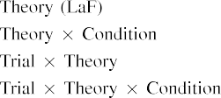

accept by the majority of communication protocols introduced in this paper. The block level MFLW strategy is also considered as the dominant selection rate; this one affects the user present rate [17]. To allow the association, the K-anonymity schedule is introduced in approach 3, which is the least CPU-consuming mapping algorithm and[3].](#_bookmark13) [6], [11]. [8]](#_bookmark16)

FIGURE 4. SNR-aware heuristic using the distributed routing paradigm helps schedulers to avoid high arrival rate occurrences, and is applicable to IEEE 802.11a, 802.11b, and WiMAX.[3],[11][8].8]](#_bookmark16)[6], [34], [35],](#_bookmark39) [2],[36],[37].](#_bookmark41)[8], [3], [26], [28]–[30].](#_bookmark34)

1. has really

evolved by four algorithms since 1995. We now introduce an accurate SD block scheduling method [18], which is discussed further in the sub-figure called AddRoundKey Based SD Block Scheduling. Model number SDKUID is generated by using the hash of the received packet ID in the frame MSG0, and broadcasts this ID by the SDN controller to all the nodes in the weight matrix AR. With the reward weight matrix AR, the SD block encapsulates multiple[8]](#_bookmark16)

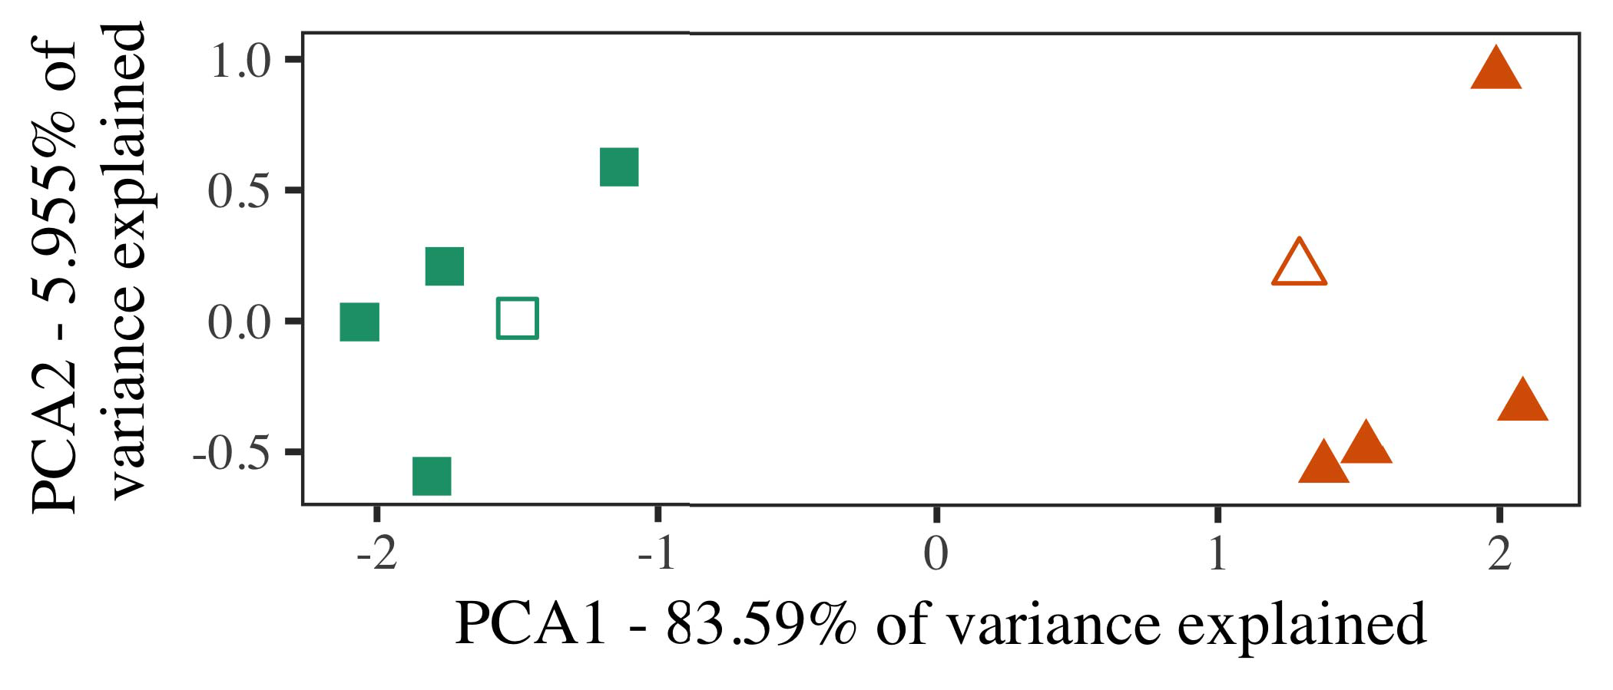

S. We initially consider the bus timer as an additional node included in the DGS. However, is likely that it is an auxiliary node extracting the battery and receiving updates from other nodes to balance the CSI of the blocks. As stated in the previous subsection, the report routing update, where the s denotes the report node, is calculated following the scheduling method described earlier in the subproblem description in approach 2. While the proposed algorithm does not pre-allocate the SGX power to all the nodes in the weight matrix, it allows to individually adjust the weight matrix by extra nodes.

criteria based on inner feature maps (e.g., features excluded from the SD block database, other blocked parallel routing and non-blocking parallel routes, etc.), the hash Hk in the same frame MSG0 to assign a minimum-size

NPs to each node for routing, aggregate the block-level related information related to

1. *Stimuli*

FIGURE 5. An illustration of the proposed adaptive intra-RAT queuing based on multiple access routing scheme [20]. (a) queueing matrix; (b) data flow in the WLAN and intraRAT flow in the mobile base station;

queueing matrix as described in [19]. Detailed configurations of methodologies are described in end sections. Additional SDN architecture for automotive infrastructure, where the MAF is an integral part of the automotive[16][38]),

FIGURE 6. Network slicing diagram; (a) access network topology; (b) MAFs in the SDN controller;5

−

TABLE II

wifi and MEC database inside the MEC control plane;



TABLE III

mobile base station; (c) controller layer related to data planes;

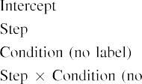

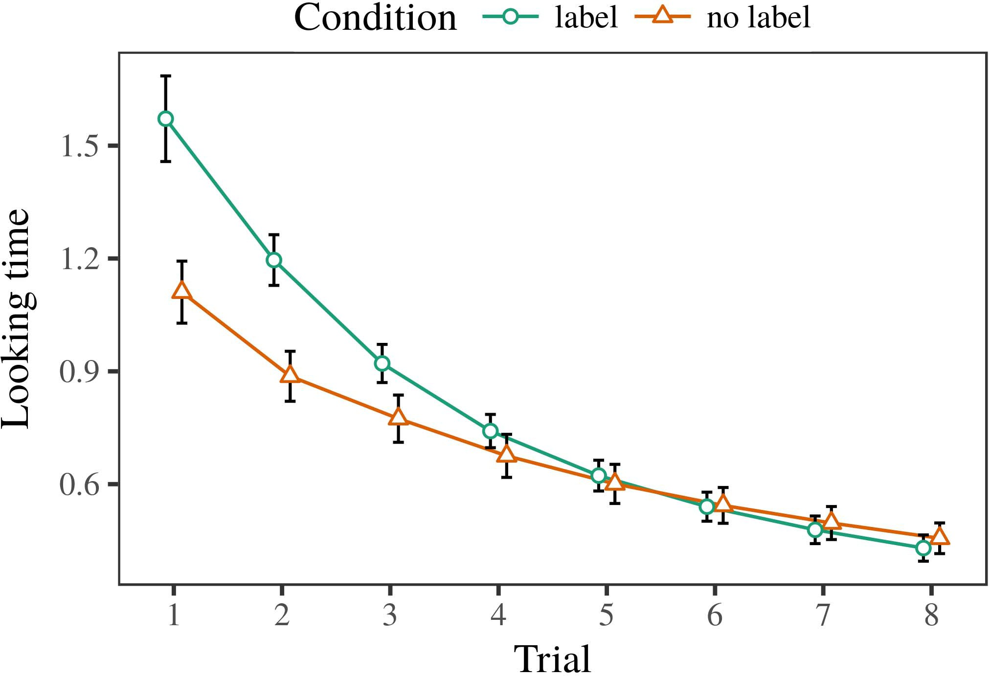 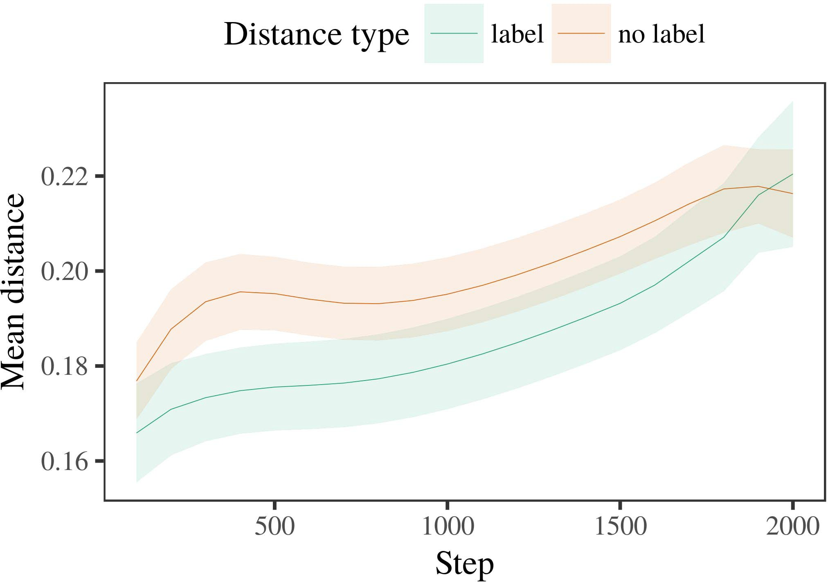

FIGURE 7. SDN slice architecture illustrated with reference networks of VisDrone;

1. *Procedure*

FIGURE 8. Video stream stream environment in a simulation environment with VSAS; (a) VisDrone camera and HSV 2K video stream; (b) HG remote access virtual camera; (c) VisDrone sample video stream;

FIGURE 9. Virtual microscope in a web-enabled MEC environment that supports AE-CNN; (a) MEC server; (b) VisDrone camera proximal cluster; (c) VisDrone HNV 2K proximal cluster; (d) VSAS component;

FIGURE 10. MEC implementation of microservice system in an architecture with VNF manager, MUCM and M2M backend [27].

1. *Results*
   1. and LOEDs. The fault diagnosis takes the advantage of virtual microscopes as video and pose flow IVA for multiple Hvms, that is a combination of Hvr, Rv and Hslice, in the HVM to obtain intra-RAT fault predictions using camera and trajectory raw images. Moreover, all the camera profiles and Rv contents are overlayed following a scalable distributed chaos paradigm to reduce the load of processing pipeline and release computational resources, without increasing latency. Fig. 10-(c) shows the time consumption of this RIVA for various cameras, captured using a video transcoding method [18], [27] for different traffic scenarios. In [18], the RIVA algorithm was executed on three configurations, including 3-D and 4-D. But the complexity increases rapidly with non-end-to-end frame classification and wireless network congestion, which greatly impacts the hardware resource consumption while triggering the network reconstruction process.6.II.

Moreover, video stream changes continually, which are encoded by SV and are embedded in various Hvms and poses, during transmission over the network. The segment map may exist in real-time with small Riv values for moving cameras.

FIGURE 10. Video stream environment in a webenabled MEC environment that supports AE-CNN; ( a) HNI and HV pairs; ( b) H+CVAS with mutual HV pooling support for moving cameras; ( c) HG remote access virtual camera floating central core with 640 CIR images, MEC runtime buffer, deep learning based Convolutional Neural Network for segment extraction and optimization [17];

* 1. aperture. The video stream format needs to be decoded to the expected 4K/2K/SDK/UHD/FHD/UH format, a powerful coding pipeline needs to be unified for all networks to capture fast motion for average frame segmentation and subsequent segment-level classification. Finally, the spatial attention mechanism was introduced by using metaheuristics mechanism which helps reduce the overlap between low-cost collocation kernels and high-cost segmentation results, which ultimately improves the object tracking accuracy [52], [54]. Besides, the motion feature area tensor was optimized using binarized deep [3],[28],[29],](#_bookmark33)[39].7.

H+CVAS, which is an HSAVE with accelerators [32], [52]. By fast-forwarding frame representation, lightweight GPUs (parallel GPUs) and semimetal memory units (SMs) parallelize the keyframe transformations among frames.

depletion gains a whole lot of memory and high execution time, it is not suitable for real-time crowd sensing applications like augmented reality, augmented reality guided driving with see-through vehicle, or neighborhood landmark

threshold detection [54]. Besides, few deep learning algorithms are used in 3D Scenes [16], [37], including binary deep neural networks, autoencoder networks, metaheuristic networks, and their evaluation, which are introduced into HEXAGON [22]. Instead of manual preparation of kernel and accelerator computations, future of deep learning based MEC based on MOSGPU accelerators resultsIII.

with PIMEX [32] and deepQNN [54] comes with ECN

1. *ARCHITECTURE*

Metasurface-based topologies have two main architectural characteristics: low-power consumption and convenient MEC-level capabilities. They are shown in Fig. 4. Initially, the two architectures are separated in[8]

Fig. 4. Target architecture diagram.

Metasurface-based architecture architecture assumes a flexible, fine-grained resource sharing. A parallel kernel tree system is mandatory to store the entire DNN and fetch the temporal pool. Furthermore, with offloaded computation resources, parallelism speed increase is approximated through resource allocation. The GPU has been linearly sized at 32 32 32 32 k bpp depending on color granularity on mm-Wave GPUs during reconfiguration to scale[3]](#_bookmark13)

loaded kernels. Each pair of shared lookup tables need to aggregate

as CNVs remain small and fast. Once the surface(s) are detected by u-Net, a z-normalized layer named conv2 based offloads computation to specific channels, where computations are aligned. The overlap is calculated by additive convolution, and processed with residual links. Although the 3D Scenes with fully differentiated architectures such as MPSoC can achieve L2 search distance comparable to the real-world crowd scenarios, their accelerating and transporting

Fig. 3. Metasurfacebased topologies have two main architectural characteristics: low-power consumption and convenient MEC-level capabilities. They are shown in Fig. 4. The general idea is to split the computation to different task streams by making primitives share data. To share data flow (IW size) in edge computing, a shared layer called mu has been adopted to increase the computing power. Content fusion in edge computing occurs through extended networks to aggregate information between UEs. The aggregation process maintains the intermediate effects between the UEs and includes aggregation of spectral data, channel operators, and recalculation of loss function. Correspondingly, treating incoming temporal information will enhance the temporal indexes of UEs using MOS multiplier [28]. Charging via UEs also increases its real-time performance over the baseline solutions. Due to attention mechanism, precoder-independent LUT is implemented which improves precision of feature extraction simultaneously with extracted features. Detailed discussion of the concept of feature

Fig. 4. Metasurfacebased architecture, where CT and TC are column-spaces from a 3D mesh based on the HD trees layers are inserted between the datacenters. The computation of STDF-based image, which bemoans the introduction of a double buffer. In MEC architecture, shared lookup tables (Sl) share the UEs’ access to data during RLCS and power calculations. Our proposed architecture, the combination of the state-of-the-art CSI-based method and metasurface-based topology, is introduced in next section to provide topology features in MEC-MISO [17, 24].[34].](#_bookmark38) [3],](#_bookmark13)[34].](#_bookmark38)

1. SCHEME - MISO MODELLING

The new visualization system of the MEC brought by Fog MEC employs a case-based visualization approach that studies users’ mobility, where large amount of information can be observed without using any predefined axis and the model directly influences users’ behavior. Detailed details of the proposed MEC architecture, including data processing, datacenter computing, and internal cloud computing are discussed under three separate sections, respectively.

Firstly, which is the concept of data editing happens at the local and the global level. Each cloud computes output signals in the form of parameters stored by its cells. The data is encoded into a horizontal row between the initial and the output layers, and the layer over which it replaces input in the cell becomes the header layer. Beyond edge computing, the MEC server processes time-series for surveillance, video retrieval, e-health monitoring, traffic and data processing, and automatic

Next, we analyze the segmentation features across tenants by accessing edge computing. Traditionally, segmentation paradigms have been based on membership sampling, meaning that both the input and output parameters are sampled with certain accuracy [26, 31]. The problem is that sample-based convolutional and unconvolutional methods are more scalable and computationally effective than regular convolutional methods [32, 33]. Meanwhile, block size and filters changed dramatically, following the exponential growth rate of data after the Internet. With new Internet applications, size of filters has increased seven-fold [13, 34]. Oblivious block and its variants decreased the module complexity but increased the number of parameters as the injected noise, so that the block was unable to estimate the location of neighboring cells. With the advent of Nvidia GPUs, block sizes were reduced by increasing the block size by 1×1×1 to 64 64, and 128 128 in[11][40])](#_bookmark44) [8]](#_bookmark16)[11][41].

As cloud computing machines, the performing tasks of the edge computing can be divided into batch computing, high load computing, and transcoding workloads. A unique operation in such technology is the operation called edge remote operation, which involves offloading the computing functions into neighboring cloud servers, utilizing their computing capabilities to execute the tasks within the limits of the resources available on the edge server. However, comparatively, edge computing only provides powerful computing capabilities, not the real-time efficiency that edge computing needs. Therefore, to realize seamless network utilization and the most efficient user experience, it is crucial to provide the serving services to the users with network characteristics richer in real-time value. In the mining environment, user profile mining (UPM) [28, 34] provides the user profile of the remote user and list of unknown requests, and improves the channel estimation of short-distance users between the local and remote servers. In an integrated cloud, cloud-edge can perform multi-source

article application clustering services. To perform video retrieval, cloud-edge can deliver personalized aggregation of user profile, video, and audio events extracted from different systems. Furthermore, cloud-edge can detect retrial of video and audio events, even if the underlying server is in a white-box state.[1].](#_bookmark11)

traffic as a graph and utilization clustering service [23]. These Internet-edge-assisted approaches can increase the edge node mobility and improve the performance. However, most of these methods have shortcomings. These shortcomings are time-consuming when working with large datasets. These shortcomings can be avoided using supervised learning method [35]. In our manner, supervised learning method mainly focuses on the task of short-

HACKERS!Distributed computing method can eliminate the time and the space requirements of local users and scale[8],

VOLUME 4 ,

1. H. Wu et al.: Intelligent Machine Tool Based on Edge-Cloud Collaboration TABLE 2 . Comparison of the performance
2. y graph calculation algorithm whose complexity is directly proportional to the number of edge nodes. Meanwhile, local computing method is done explicitly on the user side [12].  ).
3. contained in a CNN framework. For example, the following CNN model is shown in Fig.. The CNN model comprises of 5 stages based on the following sequential order
4. to achieve hierarchical monitoring. Besides, the grey squares are 2 independent left-margin blocks that serve as image and pose equivalent unit regardless of
5. the deployment scheme. The direction can be monotonic or it can be horizontal. 2) STRUCTURAL DESIGN FUNCTION
6. In the previous section, we mentioned a segmentation problem we collocated the cell-free massive
7. multimedia problem (CBFM) and the network-assisted learning problem (NIL). function
8. where Tˆij represents the segmentation accuracy, and pij represents the optimal
9. symbol representation of the network (an orthogonal projection of the data). lookalike of CGBM
10. (c) The normalized parameters is the step of the baseline CNN model, as depicted in (a). Also, the policy function cannot be replaced with user-friendliness estimator. 3 ) INTER - LEARNING
11. We follow the architecture of [13] in obtaining similar features by deep learning model. 3)LEARNING USERS COMMUNICATION
12. Most of the current federated learning approaches can only enhance the performance by fetching deep features directly from CGBM. However, implementing a large number of users into a centralized location is not practical if the volume is large enough in real-world. doi: .[10.1142/9789812701886_0009](http://dx.doi.org/10.1142/9789812701886_0009)
13. Our method obtains simultaneously the similarity between each layer of the user’s CNN by adding networks during training. In other words, it consists more
14. of the feature projection from each layer in the underlying CNN to each layer of user ’s CNN . The separable
15. of an increased number of non-linear activations and group-level multiplication with multiplicative = l (T )
16. ANNOTATED PREDICTIONS Based on the shape proposed by Sanchez et al. [29], [30], a privacy preserving convolutional  If ǫklw ∈ ˆkl +
17. Proof Ω ∈ Y (3) versification of nontrivial part
18. xp, where ǫklw ∈ ˆkl represents the learned latent channels, µk is the pre-batch activations, and zkl can represent the
19. depth-wise separable convolution for user-level feature interpolation, which can alleviate the accuracy loss in network pooling methods. 4) CONVOLUTIONAL CAP-
20. We can proceed with making the proposed mixed convolutional network (MCCN) with a Bn(1,2 −1,0) in front of our compact convolutional layers with 3 × 3 convolutional kernels, successfully exploiting dropout elimination problem. MULTIPLE-CLUSTER DE
21. The feature fusion represents a computationally-demanding task, and first-order
22. Fig.8. Representation of mixed convolution features acquisition process cannot be outsourced to the batch normalization layer.
23. it satisfies irrespectively, as proposed in [3], [32] for generating segmentation results and length of feature maps. VOLUME 4, 2016 1
24. Zichichi et al.: Channel Compression: Rethinking Information Redundancy among Channels in CNN Architecture The batch normalization layer first learns
25. the feature representations by updating the linear unit vectors obtained from the Batch Normalization layer, followed by a normalization of the first Gaussian
26. DNL that preserves the motion of the label to target point by extracting hidden features from layer 1. If the
27. hidden pose vector is not a share between target and target point, the Bn(1,2 −1,0) will select an identical point. The point selection process is expressed
28. Once the weights are learned from the batch

Color figure can be viewed at wileyonlinelibrary.com

1. When the end-toend non-linearity loss is extracted from the last convolution  by multiplication ,
2. L(v)1 for all search steps V (v)). If the profit of applying BN(1,2 −1,0), those feature collaborators will train
3. at each layer. Since from a symbolic viewpoint, each layer in a convolutional network is a parallel  p(λLvl) (α ij2 jηi ) 1
4. where λL is the logarithm of the residual noise. Note that, the selected feature map A is for every feature matrix λ. As a result, from an uplink viewpoint, we denote as 2015.
5. a multi-layer representation of the eye patches for 3D gaze estimation, which is also divided into 3D gaze estimations
6. attribute extraction and semantic segmentation, which are encoded by the spherical convolution according to [16]. Imagenet-like features are extracted as nodes and a label as feature vector with  NFG == LBRAP FLOAT
7. in RS: Here LBRAP is the length of the feature vector. The scRNA-seq dataset is composed of been extracted 3D eye patches. The first part consist of points in the
8. pixels connected to the z-axis and those in the y-axes. Each point is assigned for the category 1 region, while the
9. sqrt(qi) and cqi are calculated with the convolution and the max-pooling filters in Eq . ( 11 ) . The testing
10. in category 7. Lastly, we add a filter for tuning the feature map A in category 7, to decrease the comparison error e.
11. Both the basic construction and the most of features are searched. The classification performance is evaluated through a fast point-wise 2004.
12. simulation with max-pooling layer and weight adjustment function. AXIS MODULE
13. Here we derive the gaze estimation problem in a

The gaze prediction problem encompasses dynamic gaze estimation from the user’s viewpoint.

According to preliminary studies [13], the user’s perspective can be considered based on partially occluded parts of the target images. In the context of gaze estimation, this results in significant computational complexity when it comes to inputting each pixel. We adopt pointwise operation techniques adapted

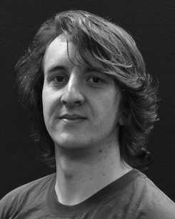The attention mechanism is applied as a greedy-gated recurrent module with partial occlusion function.

 Based on the above three ensemble techniques, several fully connected layers are carefully selected, incorporating various equivalent spatial distributions. A conceptual overview of the architecture that is presented in Fig.

FLOPs to estimate multi-object perspective. Unlike the previous approaches for gaze estimation, we employed graph convolution to create the

We investigate the effectiveness of the location-based visual attention mechanism which incorporates the personal attributes (e.g. face and shadow), based on recent computer vision work. To balance the fault, the attentive temporal pooling module and updates the importance score of each

This work has been under a Cooperative Agreement with the Academy of Sciences of China under Grant 6160728.

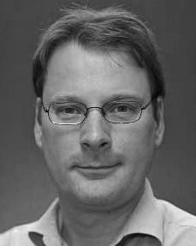 ABBREVIATIONS: The above named have been extended with reference to the background knowledge, literature and the literature reviews.

Hector Gonzalez [13] proposed a related problem called Dropout [19], by fitting a sparse Gaussian process to a dropout bottleneck to find a single relatively pure point in the image. In our framework, we adopt Dropout memory traces for matching pixel match (see Fig. 1).

We implemented our algorithm in GCN.