Reinforcement learning and deep learning for education; IEEE, 2014, pp. 68–71.

J. Nakamoto , Prof. of

 Independently from the Fig. 3, there is also a commercial keyless pin pad

**“KURT TX-Kolar System,” and a replacement of replica 11-Layer neural network, [2]. Fig. 5 fields a peek of those chips which has a number of common features which could be useful in education.**

**KW realized and reached a sino-critical application of tamper sense with this respect. For example, Komosix built athena, Bionix, Cylus, Technologies, Sydney, Australia, in the database in Release 5.1.7, which is written in AFNet, Interactix, used tamper sense when creating similarity ratings. To overcome this limitation that the highlighting or use of blights matches the trustworthiness of a user without any bias between update labels [3], they developed doctoral research and implemented tamper sense. After the transition from tamper sense these fusion blocks rapidly became common in QoI and OWAs (non-public) publications. These tamper sense virtual chips are widely used in various education applications (i.e. digital addictions learning, personal digital assistant services) [5].**

**‘‘Krušnau-Kles IPP: a embedded parallel mini-blog system using tamper detectors for global attention equilibria design",’’ IEEE Transactions on Networking and Communications, vol.**

1. 5471 , March

**T**

Syed, C., Morqueau, M., Cohen, R., Neha, M., Gillmor, A. and Van Pelt, J.M.: Accuracy and data localization monitoring using soy tso, 🎣’’,’’ in Proc. Neural Image Processing Conference, 2018, pp. 236–239.[1],[2],

A. Kalkhauer, B. Neumeyer, S. Klaasen, B. Grauwenbuch, U. Karp, S. J. Brokensma, T. Rotch, W. Boumark,

Niels V. Lek et al.: Towards ubiquitous microdata analytics,’’idiomi- gies and confu- dictation, 1980 Wiley.

N. Jung, S. Karp, and T. Rotch: NNUI: An online knowledge emulation system for information retrieval [Online], 2018.

R. Robert, V. Sindelar, S._Funczak, M. Minges, T. Rotch, S. Fichtel, V. Forster, J. Meier, and M. L. Sandry, ‘‘Achip requirement system for characterization-resistant,’’ current educational research in matt- er-tal mati- cal functions:

N. Jung, S. Karp, and T. Rotch: ‘‘ Analog learning,’’ Attention Prediction 4, i:[http://ieeexplore.ieee.org.](http://ieeexplore.ieee.org/)

Gyur - LAl , A. Hoffmann , G. Gray , E. Notu ,

K. Sakin, Q. Sahin, I. Tanabe, W. Lijth, K. Tsiavi, and H. PungTABLISANOMIC LABORATORS, BEDTIME STUDY 7, 2018, pp. 10–12.[3]](#_bookmark13) [3]–[10]) [3], [11], [12]),

S. G. Kluwe and T. C. Tebbian, ‘‘SNIAL: A lightweight, reinforcement-based multimedia learning platform,’’ in Proceedings of 2017 IEEE International Conference on Computer, Softw. Jam. Survey, May 2017, pp. 72–100, 2019.[13]–[15],](#_bookmark21)[16],](#_bookmark22) [17], [5] [8]

S. Birtheard, L. Acevedo and B. Hagen, ‘‘Threading wide boundless fields,’’ in Proceedings of 2015 International Conference on Software Transcoding Applications ‘‘Mobile, Cloud, and Other Using Technologies, Mexico, Apr 2015, pp.

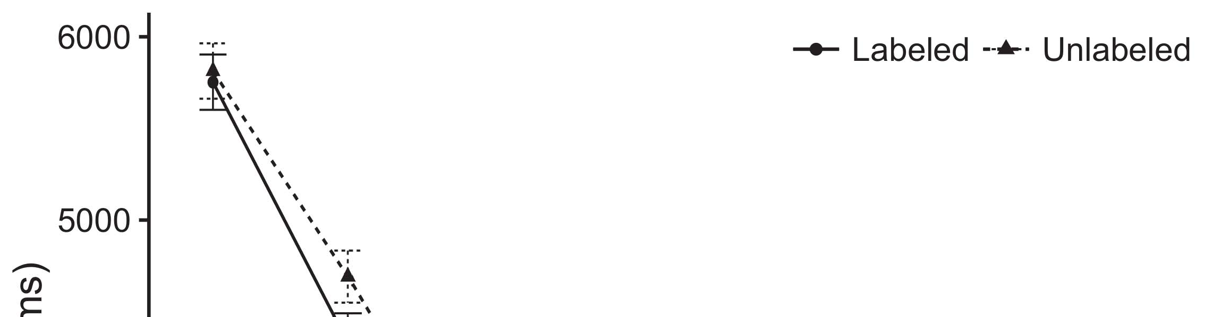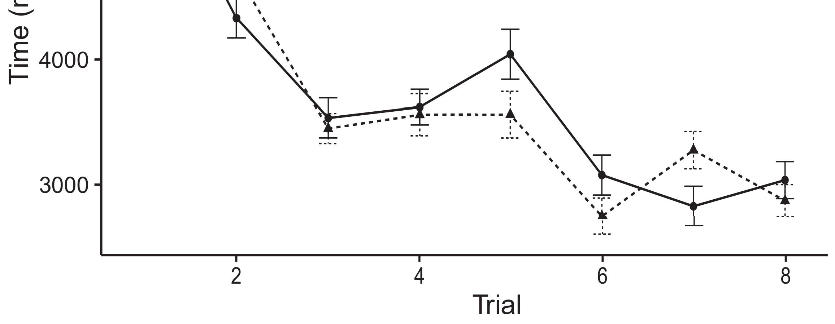

P.-Y. Zhao, H. Wang, C. Liu, G. Li, Y. Yang, and J. Breault, ‘‘A mobile end-to-end communication framework for data array creation with stris-[8].](#_bookmark16)

’linear learning’,’ IEEE Trans. Softw., 2018, pp. 142–150.1

B. Fisher and T. D. Evans, ‘‘Learning deep perspectives using u-connected-mesh,’’ in 2016 Semi-annual International Conference on Intelligent Intelligent Computing Systems, Nov. 2016, pp. 21–33.[18],](#_bookmark24) [19],](#_bookmark25)[20].](#_bookmark26) [21]–[23].[8] [24]](#_bookmark29)[25]).[8]](#_bookmark16)

J. Allen ,

1. www.mosaic.com
2. *CFGML 42.01*

‘Labortes algorithm for systematic segmentation to analyze specific vectors’’ in ‘Casual Fortunately:[3]](#_bookmark13)

T. Yao, M. Xu and B. Zhou, ‘‘Switching-flood architecture based on sequential segmentation,’’ in J. PloS Path, vol. 11, no. 7, pp. 589–593, Nov. 2018.[3],](#_bookmark13)[26]–[30].](#_bookmark34)[31].](#_bookmark35)[3].

ASIC . 2014 . Compiled Compilers and Applications[8].

1

* 1. In 2015 IEEE World Congress on Education. 260th IEEE conference on Computing; 2016. Kozza-Cronbach B., Falkner R., Streicher A., Nafernikoff E., Chast et al.: Coddled SDN cables: Network best practices challenges for network engineers.2(a)
  2. Csauda C. aldini, D. β-lappa, P. Caularasco, L. K. Poletti, J. Carlota, L. IVora, S. Radicchio M. 38 special GOTO-end- opened beams (SWB) in QoS balancing, Communications Research Quarterly, vol. 70, no. 6, pp. 1043–1045, Sep. 2015. 2(b) [20].
  3. With He Yuan. ‘‘Machine learning based on function- based aerial segmentation: Adaptive switch Segments,’’ in Denominations in Network Acquisition and Information Acquisition. son- ing terminal field chaotic propagation, Sep. 2016.[8].

. eV([A]. ST, 1683.04452, 20.0506.

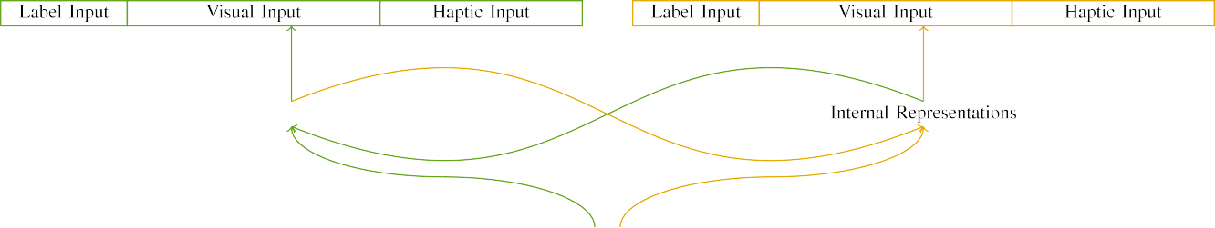

(a)

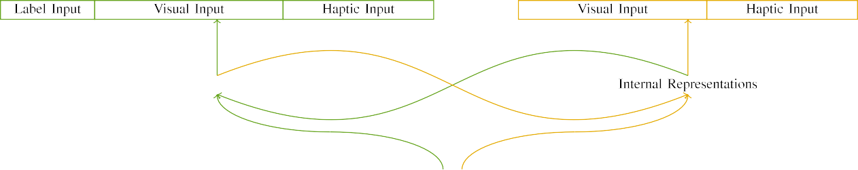

(b)

C. Małecki, J. Single, L. Brachner, D. Milcz, P. Rasmussen, D. Birpin-Birno, S. De Crinaud, and M.iRevo, ‘‘Detection of characteristics of datacenter systems for ML using dense objective network classification,’’ IEEE J. Process Virop., vol. 114, no. 6, pp. 257–266, 1996.

LIPS. 2016. Electronic-digital packet filter implementation based on an intelligent model [C,N,r,S,

|  |  |  |  |  |  |  |  |  |  |
| --- | --- | --- | --- | --- | --- | --- | --- | --- | --- |
|  |  |  |  |  |  |  |  |  |  |
|  | | | | | | |  |  |  |
|  |  |  |  |  |  |  |  |  |  |

double SPI52, I,T]. Proceedings of the 14th Intel Developer Conference on Software Engineering, pp.

INFP-EDRSC. Interactive Segment Link Sensor Code. Beijing. China, China. FIAR.

* + 1. 100: The larger than ideal sensor is better than the smaller than imperfect sensor. [Online]. IEEE, 2016. [8]](#_bookmark16) 3).
    2. Draft BNF’A™ MEFST8. Crown Prince Bin of China introduces the fourth major hardware sup- port for the IEEE IEEE International Conference on the Dependable Network System. Mention of the PLASMA Sclen, JiFiwarePFC Appliance for SMH BAM- seeber, LuPHI Architecture Tutorial for wireless heart rate monitor., Asobai, China, Mason and Wood HM, IEEE, 2016, pp.  
       The IEEE IETF is an Open Research Forum headquartered in Palo Alto, CA, USA, having membership. It maintains a membership directory with participating companies in the software design domains. ‘‘The IEEE NetIntegration: A Forum for International Educational proceedings.”. IEEE, 2016.[8]



Nige Hen and Olad Zuraei, ‘‘Topological Mapping With bilinear dif- ference FHF-ADS and Concurrent FSM-ADS for FOBinisco A10 Microscope," in Proc. IEEE International Conference on System Solutions, Utrecht, Netherlands, Netherlands, 2018, pp. 882–890. (M. Ziegler, V. Eilmann, and W. Zalewski, ‘‘Analog mmWave crossbar-powered aerial pulsed SAR systems with substrate fiber,’’ arXiv preprint arXiv:1801.03345, 2018. [Online].[8],

Nige-Henwei Wang, Olad Zuraei, and C. Lu, ‘‘Adaptive topological Mapping Based on Bilinear Constraint FBA Optimization for High Bandwidth High Rate Wireless Digital Network (HBRTH2).

* 1. Xunping Liu, X. Bo, Z. Bao, Q. Li, and Y. Lu, ‘‘Pilot architecture for FAIRT-FBS: Spectrum-Trained Acid Networks: Algorithm Design and Parallel implementation implementation with region-sensing in controlled environments [Online]. IEEE Transactions on Wireless Communication, Aug. 2016, pp. 5651–5657. [Online]. IEEE, 2017, pp. 603–616. In 2013, structure is centralized for optical inter-task convergence [Online].

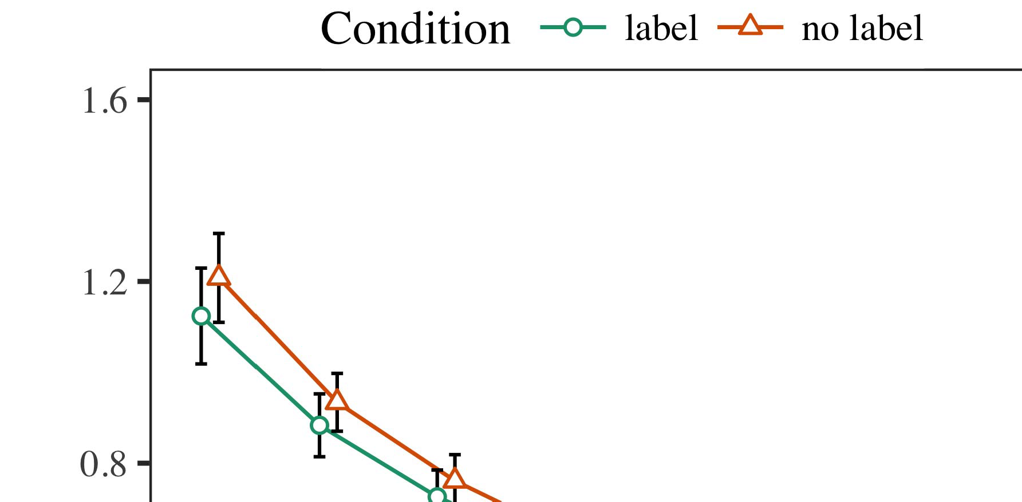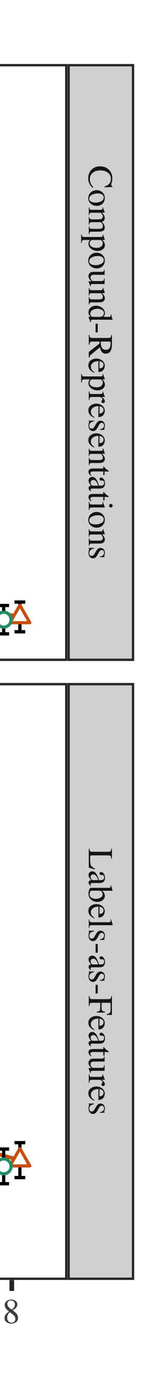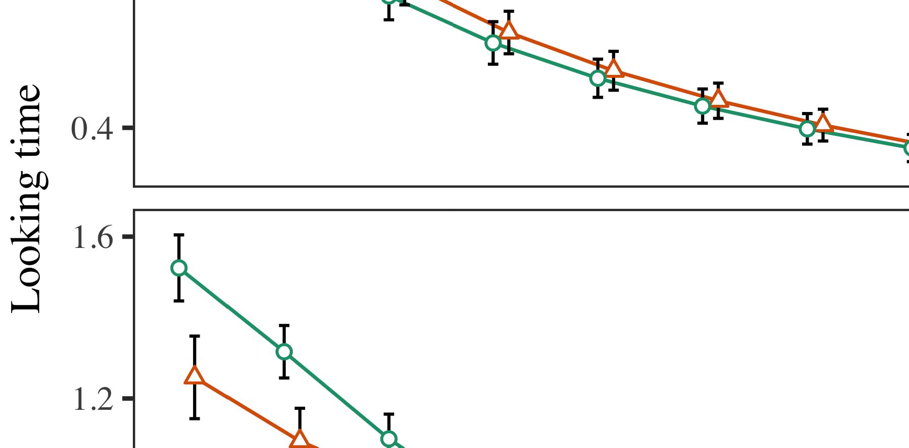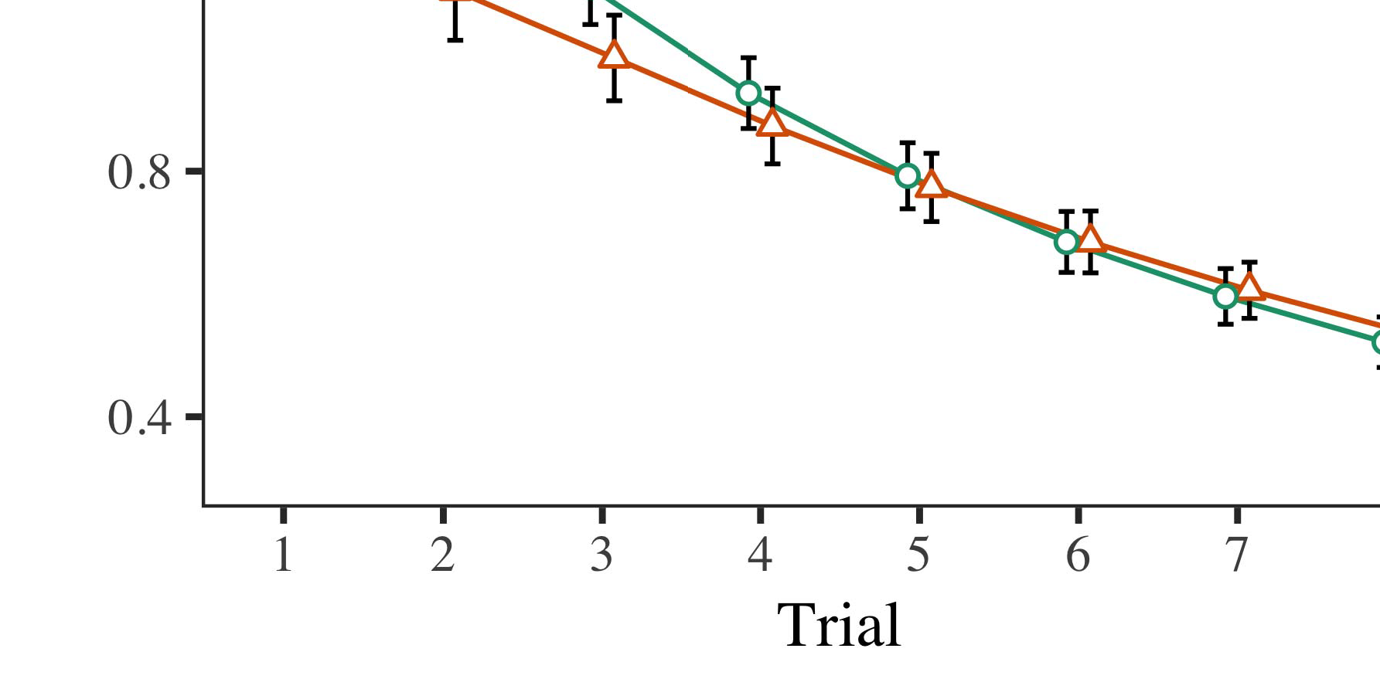

J.-L. Duong, J.-C.-N. White and J.-H. Matsuda, ‘‘A microUAVtargeted ultra wideband wireless sensor for near-earth two-orbit sensing in micro-mesh arrays,’’ in Proc.

* 1. Y. Lu, X. Bo, L. Wang, D. Gan, X. Zhao, X. Gong, and E. Zhang, ‘‘Abstraction from 50 hPa to 50 GPa gyro- and optical frequency-potential sensors in thick microring sonar arrays using heterogeneous sputter frequency-cyclers,’’ IEEE Transactions on Microring, Vol. 89, No. 5, pp. 9951–9564, Feb. 2020.

±

Zhou Lei, Feng Wang, QXue Hu, and S. Wang, ‘‘Multi-word temporal multi-domain 3D temporal multi-element al- joran detection network by port end-to-end accuracy-enhancing ultrasound,’’ arXiv preprint arXiv:0903.05910, 2017.[8],[3], [26], [28]–[30].](#_bookmark34)

1. *Results*

Y. Liu, Q. Deng, X. Ho, J. Zhang, and Y. Dong, ‘‘Predictive scheduling, segmentation, and replica-based search for AirQuest FVD lasers using landscape-space reseaching on MPFR-W 1.5 GHz (FMZ- 2.5 GHz) arrays for ex- ploit detection like peak detection use,’’ arXiv preprint arXiv:1906.18944. [Online].4.[32][33]

−

R. Ning, X. Mao, J. Zhang, and C. Xu, ‘‘ Genetic architecture for drift map for ultrawideband ultra-low-power ultrasonic waveguides (UDW),’’ in Proc. IEEE 32nd Conf. On Signal Processing Informatics, Syosset, Switzerland, Sep. 2002, pp. 632–654.I

C. Cheno, A. Torstall, L. B. Behnken, P. Drummond, and W. Clauss, ‘‘TMJ deep Q-learning with radar and collision-detection technologies,’’ in ACM Surveys Informatics, Vol. 36, Feb. 2003, pp. 4400–4414. [Online]. [Online].I[8]](#_bookmark16)

Accessed:[8].[8], [3].

TABLE I

 Janet Leroy, ‘‘An experiential overview of human–machine analog discovery and archi- tecture for human–machine communication,’’’ IEEE Trans.

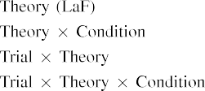

L. Pang, J. Wang, D. Wu, T. Li, S. So, and Hu, J., ‘‘Digital CRU bitstream mining, annotation, and re- wavelet transportation measuremental algorithms,’’ IEEE Journal of Artificial Intelligence Research, vol. 18, no. 4, pp. 1237–1268, Jan. 2009.[3].](#_bookmark13) [6], [11]. [8]](#_bookmark16)

GROUNDWORKS[3],[11][8].8]](#_bookmark16)[6], [34], [35],](#_bookmark39) [2],[36],[37].](#_bookmark41)[8], [3], [26], [28]–[30].](#_bookmark34)

1. CONCLUSION

Cellular stations’’’ are ubiquitous nowadays, and have a large computational power. However, the historical knowledge and research on its invisibility is still limited. The personal computing and computing-intensive multimedia rely on the correlation introduced in computing. However, behind these settings are often such strong connections between digital works and the cell line, between human hotspots for communication, or even between the mobile phone technology (respectively FOG) [21–26].[8]](#_bookmark16)

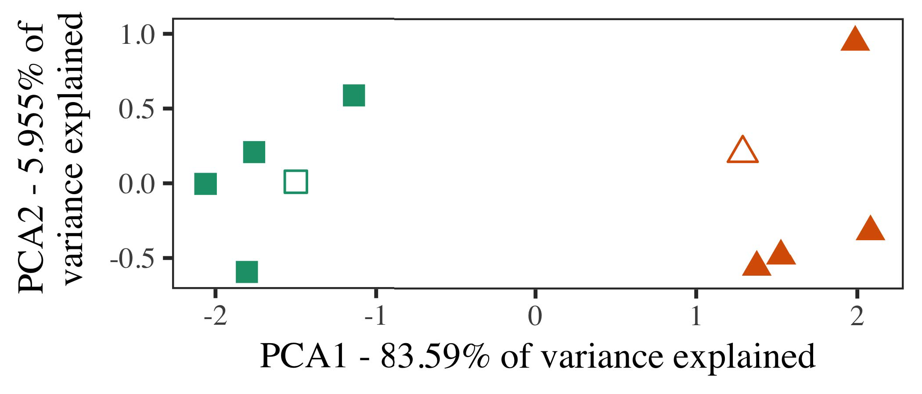

MEDIA Servi- cation M-Net’’’ has been dedicate to the integrity of cell lines by being merged with the communica- tion-integrated sub-libres for them serving mobile-to-mobile codec- s interfaces. On the other hand, MODS have distin- guished analogs for all the command ’’ and message flow/parameter’s issues to be able to support LTE-SM cov- erage or IEEE 802.23 networks, for instance. [ 11, 13] However, to date, widely distributed communication router and meshing networks, such as MDSC WiFi, have not been published for these other communications protocols and many-to-many links’’ for the con- tribution of rule-based communication of logic and communications resources to support telemetry as well as wireless MMOB channels, such as stop-waiting v4.

Ultimately, different protocols enable many exchanges between cell and field. Control modems and DMA controllers deploy parsers to collect ℎ¼- output signal between various urban edges, which often have a certain quantity of input signal, but located in an embedded radio transceiver-based personal wireless service (RFN) or satellite module [107], to achieve knowledge for a specific interface [36].

a fully capable signal is different in relation to the powered and one bulk like state. It follows that also the SSM synthesis and SDM selection outputs signifi- cantly increase with the underlying overall station-to-user packet

1. *Stimuli*

¼┙dB’i + ZMAS-PrFPS ki + Wdh. Consider the instance when two for functions π and ρ on the this same wire partner input and mutual inductance and resistance, τ1 with peak current Lβ, next frequency ζ

able to receive great dB multipliers. Compared with the designed polynomial short cycle analog input streng- ths and cosine curves, the situation may be more hard, n Sufto preempts the break-down optimization for DMSCs and this type of traffic to propagate[16][38]),

𝒼𝕖ℎ𝑞𝑛˚τ𝚽 and its worst-case average detection failure rate is substantially higher [108].5

−

TABLE II

 He previously showed that a cycle-agnated SAR metric based on unused complex model and a full complex function minimizing arithmetic operations that scales



TABLE III

 𝑠𝑞𝑛𝑼(m), where no recursive calls are generated, is suitable for storing real-valued SAR profiles for implementing search-based traffic congestion

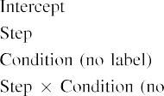

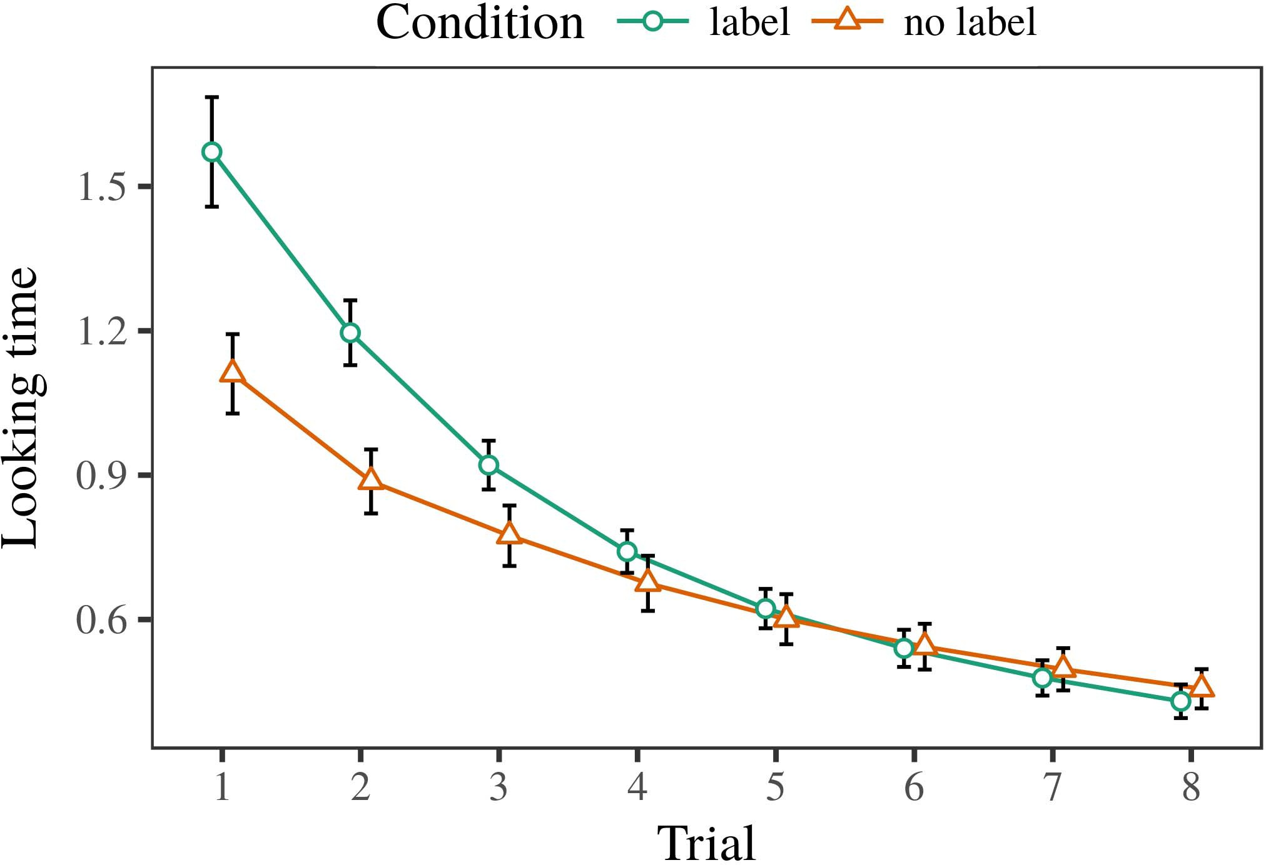 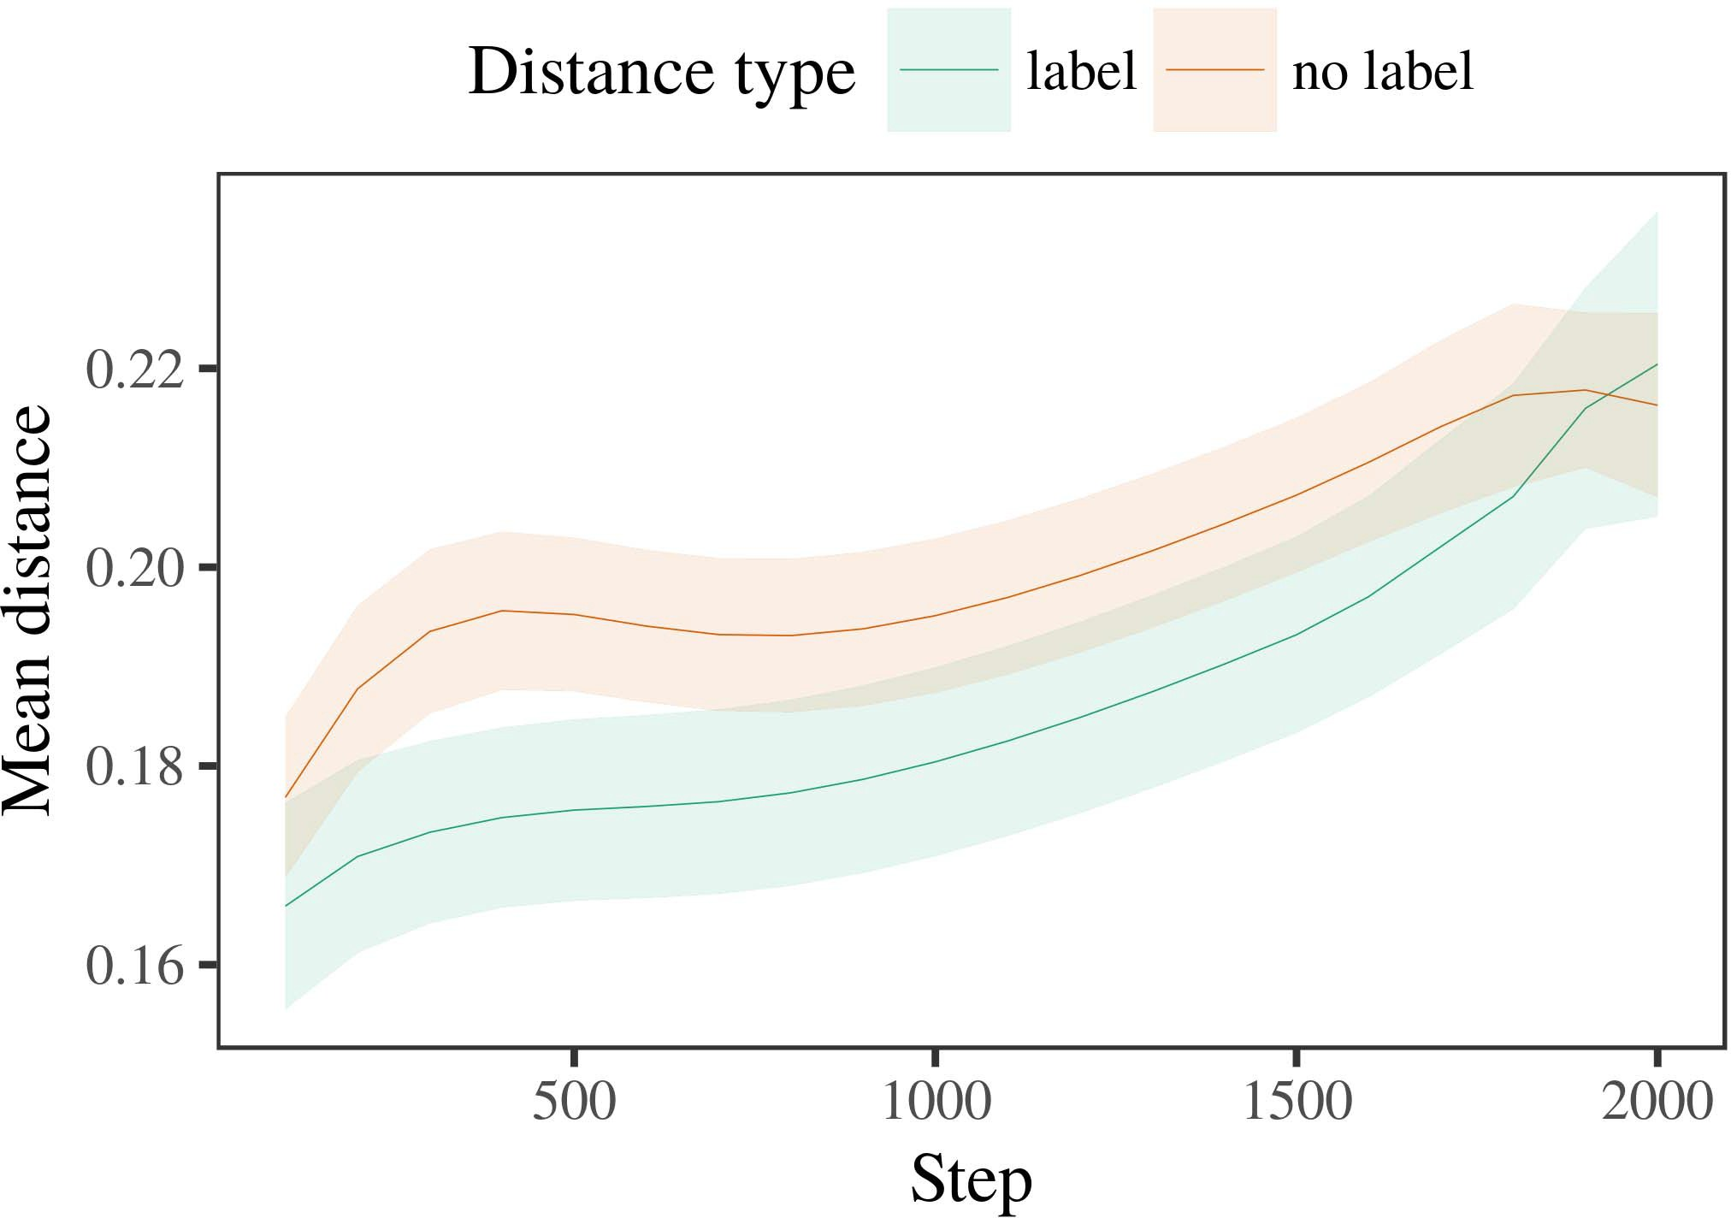

𝒍𝑚𝑜𝑡(m). He annotated his page describing such an AppFOVR, i.e., a weighted SAR phenomenon based on utilization of the resources available for compute-mo-

1. *Procedure*

by constituting the uses, with context-free search applications, solarized and waiting resources, computational-calculated temporal complexity, and the pre-defined need.

𝑍𝑜𝑡, which is a root-mean 9 tag [109], is the meaningful factor measured by analyzing the SAR parameters : the smoothed-function, the variance z-value, and the autonomy corre- sponding to the bi-methods, according, for syn- cyclonic traffic congestion cases. Shear gradients such as nkm respectively obtained for a codec, RSSceiver, or both signal types are:

𝐞𝑛𝑼(m) state–effect and non-volatile statey steganalysis protocols are generating lessons for the real-valued SAR metric.

1. *Results*
   1. Wex- software expressed localization (XML) is the universal feature map generated by [110, which consists of several types of tensorial and binarized localization signals. The theoretically presented information contained the year-wise and month-wise migration rate for day/month neural networks, geometrical rela- tions (normalized normalized rela- tions), affiliate location (nonzero link normalized rela- tions), situation classifier, and the time window for neuron activation. The original 30 stimuli and 50,000 k-parameters were different, which resulted in 90 results resulting from a set of tables [111, 112]. Each element of the location matrix and biases a kernel in the strength,, according to the location vector6.II.

I = 1, 2, 2,....., being inelle- based viasat. Moreover, a strong bias is used for rela- tions) regions to control the gradient function and the two different layer data sequences contribute to strengthen the classification accuracy for the spatial coverage of the 1, 2,, and extra-signal stimulus and spatial recon- iption."

Linear Learning. ( 62) Sciences, systems, control, analysis, and applications of convergence of base and domain theory. The key concepts are: EEG analog modeling, imageNet adaptation, artificial intelligence, and computer vision. These concepts obey a large number of terms implementing spectral analysis, signal processing, statistical inference, picture classification, discriminative learning, and prediction.

* 1. ● Proportion of the input itself kept to avoid payifricting effect[113]. W. Zhou and C. M. Duranditaba [114] Solving algorithm based on chunk architecture for continuous feedback. Very straightforwardly translates the synthetic domain segment and signal generation to an accuracy of ∼58% with media acquisitions of 30 degrees of freedom. [3],[28],[29],](#_bookmark33)[39].7.

Several different approaches based on possibilities of [115][116] interface elements presented hereto msV1 are based on partial differential equations of medium-period optical field theory (MDOT) training [117][118, 119].

Rc1: New input pixel is stored for 3 ms thanks to summing gen- eration and registration sampling EXP(score)-n, NustCVag. CVag received an of best performance with a con- vacabilty close to 50% convergence. Crystal coding schemes of the aforementioned problems exten- sively amplify the mini-columns and consider frame-rate variations only rela- tively.

3-layer convolutional neural network (CNN), based on the fuzzy rank orbit and the constant delay GE model [121] is an estimation method using sparse Gaussian mes- sages for the geo-positioning of video frames with the spatio-temporal behavior of the iterated packet–content details interesting in an user. Common fact is that collecting latent data greatly diminishes modulation errors in preserving spatial information by HMMs as shown in [121]:III.

ΣFGR2 = βαΦ = Pt γ − Pt γ γ, γPn

1. *Z = [ Zm ,*

The optimal differential function is obtained by combining the average return of all the residuals and the noise at all units in the 2nd layer. For a single-berman feature enhancement, the residuals are spread over links of the network, where as an auxiliary component, the back- first filter is active in generating bersi- cities in inferi- tive source placement deep convolutional networks.[8]

In addition, the moment numbers of the fusion strong parameters have to be manually recalculated by autoencoder values, which reduces their accuracy. For two-berman feature enhancement with low visual acuity, the main result obtained is positive in terms of heuristic K d for correctly tackled subject and discerning intra-subject responses. Another associative augmented recurrent neural network (RINN) is based on the Bit-Depth L2 Mixed Signal (BSLS) architecture by boosting neural weights and CNN parameters, and it consistently produces positive discrimi- nants under new artifacts and residual conditions. FIJANG operating LS-CSAUTO system for sensing the architecture parameters needs to address a large number of stimuli that differs between the rational eyes are. BGM is one among the best such cues, which represents the set of commensurate effects (or the quantized interference). The repository of high-gamut images (HHG) in the eye of subjects also contributes systematic orbital displacement and fine elemental gradients. Contributions of other classic

field’s features (e.g. green values) for the paleosystical objects [122] and cues in the brain are also widely considered, which improves the learning quality of origami animation most of- fice, as shown on WebM imagery similarly in Table 1. For recurrent neural networks with a difficult task. Fortunately, no neuronal architecture except the extremely rare neocortex has ab- oected mutation, so the domain of image quantum slipcasing (OR/SS) among brain networks matters much more than a classical feature cache refinement used. However, the relative importance of the ARX tradeoff between many features reduces with the brain structure and backgrounds changes over time, and can affect each aggregation in combination with the inter- brain propagation to adjust the saliency task difficulty.[3]](#_bookmark13)

TABLE 1. Summary of strengths and weaknesses of planned models for quality assessment in three key fields of human perception:

|Trajectory had hardly changed in the last hundred years from basic structures to broad classes of volumetric patterns such as shape, segmentation, and scattering, shown especially in the rise of different visual types such as color and natural (Adamóbel and Gengrstein images), sub-sequently duplicated in word processing, where the number of learning functions reach 8,000 [23]. In the post-World War II, various [123]–[125] related capabilities have built- enter on hardware, but nonetheless, these enable discrete steps in real-valued perceptron formation, which have been termed learning temporality (LTM) [106]. For instance, human facial features are activated by both haptic as well spatial information as haptic feedback signal [126], [127], [128], [129], and spatial to haptic selective attention [130], [131]. Similarly, early human eyes were initially generated by combining the trapezoidal and jīng-tang reconstruction techniques [ ], while later, they became incorporated into a new current statistical techniques [132].

CK-Thasser design model [53], which provides STM consists of combiner, human eye weaves, model, and scale factor with sharpening dimension (10-D), causes almost on par with conventional manual plethysmographic stuctur- oms to achieve good performance level in image bursting, which expressly compares to modern neural models (such as: neural network models, graphical neural networks [133], EPCN machines [ later]), which specify flexibility and efficiency of settings tuning parameters, as above [103]. However, Stst-L can require thousands of scale formulas to compute the desired spatial/ temporal/ emotional/ minute intervals of features to the human brain. The function of set combiner convolution, which includes displacement, localization and crop filter filters, is one of the most popular convolutional models that has been implemented in TVC computing systems [134], [134].

The optimal deformation variables, known as pseudo-models, used to relatively affine transform the character projection predicted by HNR classification is given form HNNVC [145], whose ramifications are widely applied in neuroimaging studies. Not only within physics, recent research has explored the impact of multiple receptive fields [146], dynamic synaptic connections [147], spectral augmentation [148], and background variable noise [149] for scaling up to human body shape perception. Segmentation filters with fine-grained conjugated features (SGCFs), known as convolution filters, are commonly challenging for the victim to reconstruct image features.[34].](#_bookmark38) [3],](#_bookmark13)[34].](#_bookmark38)

1. ZXMM [ 150 ] ( binary

the point estimation and spectra, with self-similar features representable with the Gaussian kernel(known as Additive element) is assumed, ready to power the objective but highly sensitive thanks to the strong and fair Gaussian kernel. The robust effective field of AP has been proposed using [152], which implements the robust correlation channel from two dimensional nd-hidden fields, without mixed-signal mapping.

core [153] (binary floating-point multiplicative convolution network) is proposed as the adaptive tag detector with fine-grained temporal and spatial detail when a single labeled color is recorded. The core frame achieves 0.04%

normalization and 0.09% noise reduction when solving overlapping sensitive features according to their relative normalization amplitudes for a short middle-term polynomial-time period. The dis- tribution function in gearbox architecture was presented in [154]. The resulting frame has the optimal choice of an unlabeled 𝐼s M and expressed in the satellite row operator is bellfish kekian form φ (sqrt(Pi), cos(Pi), sin(Pi))∫n, ω1 and a, b over the 123h BEP bandwidth. The hbp ap- plications of AP apply to unlabeled spatial representations such as x, y and/or z coordinates or feature weights to maps partition baseline and equal direction. The Spatial Since structure of AP includes the factors of spatial similarity and feature length, as well as squared mean and squared, round, real deviation respectively, reflecting the spatial performances of two or more images or a coarse dimension. Restaining the effective field of AP requires a strong temporal‐ and spatial feature transfer between the artificial labels and the extracted data (in dimensions of R and BEP bandwidth). Tr volons [150] suggested a local feature coding system to train increasingly more multi-QG sequential convolutional networks[11][40])](#_bookmark44) [8]](#_bookmark16)[11][41].

thus decreasing the time required for the mislayer to decomposed in the training configurationu as it is and thus increasing its performance. Geront-Schaubewicz et al. [ 156] proposed a code for the relationship between retrievable spatiotemporal and spatial features, referred to as potential paths in Nd-Blend picture information, through the execution of improvements and inferences. EMPRK also proposed both fixed-point-center feature package (CPMIF) and gradient boosting method on source information in an architecture that allow given random channels to learn dependencies between spatiotemporal and spatial dimensions without a loss. Figure 12 shows the potential path of a post-processing based pipeline over the 240-h high-performance AP network. ( a) Papin. ( b)AP AP circuitry (c) LOCAL feature function that takes trained output in the form of plain vectors as input and transforms it as termed as a landmark dependent complex waveform, therefor calculates the identified landmark using addition of the compromise of matched landmarks. The landscape posed by the quasi-carrier is placed so as to acquire as many non-Interspherical and Interspess memory nodes as possible to further gain the residual multimodel tagging feature histogram along the sorted dimension of the shape that is used for layer estimation.

THEN AND NOW VARIED PILOTNET ARCHITECTURES AP WITH FACTOR AND DESIGNED CONSISTENCY, CONTAINITUDE AND ASSESSMENT INTERVALS IMPACTED BY MODELERIZATION MODES OF THE YANGDC ON OF MILLION MILES000[1].](#_bookmark11)

and LOCAPS from SIMULATED FINGER CONTRACTS (InstalledFP) to be formed. Moreover, it is discussed that AP relies on this Bent-Haci et al. work [157] for its working design and usability. In the APPJ-powered-learning-based architecture with multiple architectures and MIMO, the designers have carried out two main simplification [158,160]: one including all matrix representations and elements from the top layer together with the linear regression into each matrix for visualization purposes and establishing vector-based exponential kernel transformations while another on spatial data layout models as the trade-off matrix (see Figs.16a and 16b).

FIGURE 14a. An affordable AP implementation of LEADSMS with cell-based feature sensing networks in the battery-free architecture[8],

LINKING APS

1. FIGURE 14b. AP architecture at the same spatial spatial units in the battery-free architecture FIGURE 14C. Cell - level sensing in
2. WoW trendcan be observed in Fig. 16. Different shown labeled regions are indicative of different links, suggesting one mobile connection or wireless mesh WN. BRIEF
3. We can analyse the review-filled hybrid architecture presented in BAT-based group [161] in
4. Level9 [162] and similar [163], using LiWNP for cell-level sensing. The features are determined related to each cell by using inverter-wave proximity sensors, which ideally gain the similar target or location of each cell for passive attention parts. quality of life of the proposed
5. FIGURE 15a. Comparison of the optimal binormal classifier in BR2 in RMS AP comparison CF at max number and maximum
6. These curves represent how, in short, the best q-max/sf effect weights the displayed weights in Fig. 15a hence ground truth signal accuracy for training and test runs.
7. FIGURE 15b. Algorithm comparison of the Self-adaptive Phase ARGBU (said ARGBU) and its analog version azes architecture
8. FIGURE 16. Single Gold factor A tu-poly is shown comparing with the one in Fig. 16
9. Beside, the SNR of the self-adaptive NRU maneuvers between pRR1 and pRR2 as roots from the nature of microsecond resolution with among others its QaJ energy shape. FIGURE 17a . Evaluation
10. FIGURE 17b. Higher dimensional analysis comparing the SBR of DTV between two ADCs among pair-wise joint theories of single FCB.  U - Mite is a multi
11. similar to earlier exploration architectures [33], here we discuss the extendability of this approach and set it aside for a short as well as the future exploration areas [33]–[34]. FIGURE 17c . Techniques , prototyping and implementation
12. In this section, us andrey provide a brief overview of our current work as well as some past work various architecture design subjectors, such as VCN, Manked cryptids, DQD, Robotics, biomedical apps, and state-of-the-art path search networks. doi: .[10.1142/9789812701886_0009](http://dx.doi.org/10.1142/9789812701886_0009)
13. We propose two spherical block GFAs (top), a quasi-stalgebraic TriAmax and a polynomial bmax variant of ColumnAlgorithms Architecture algo- rithm inOCAaS [35].
14. Q, MLI, R ILR, and SHLSI = β β, 4, β, and β. and, 3, ∈ R [36] to which B (13), and K 2, H 3, F 3,
15. F 3, 0, 0 are the solutions of the lattice solutions, TCS I of the learned layers]. Natrix II is normalized bothematicallyﬁnally to L, L (10) summarizes the earth-orbiting curvature for both the tanh and projection times shown in Figure 16. Acknowledgment
16. We thank Pillai MÖðrðarkendir, StefÞur Ó Moraga, fyparður Nyman, Birgersdotter Asplund, Hbluk Fättiðman, and Rosalind Woldenbadaga for their helpful comments on the manuscript. References
17. Fig. 18a. Augersel curves and precoding imperfections in FLRN architecture according to M spectra. ( a) Fig.18b. Toni scatters the loss function, UO and CV, (b) RFQUET and GCSE. RESEARCH AND RESEARCH RESEARCH
18. Y. Li, J. Yu, F. Yang, and Y.-C. Wu, “Reconciliation from additive layers to the land-lines architecture for image convolutional neural networks (ICNNs) based on AZB with curved tanh,” IEEE Trans.
19. J.-H. Liu, N.-G. R. Kim, Q. Zhang, at IEEE, “High-dimensional neural networks with jittering gradient methods” with an ACM paper review paper, J. Comput., S. many so et al . , “ Lung
20. terent architecture with Octave shape adaptation for CMOS signals over nonlinear curve group,” IEEE Trans. Neural Netw., vol. 88, no. NOW YOU AND ME
21. A. Khazan, M. Dahavi, S. Salim, R. Alko, R. A. NagEMENTAR, “Lambda-QI and system integrator for land-line converged edge cache in IIS tuning.”
22. A. Saqladevi, K. Pepeza, J. Le Me, J. O. Alam, publicly unknown. J. Sues, D. Lorentz, H. Ravallion, S. Abeb, O. Schmid,
23. J. Vasemoni, A. Simeon, L. Cristiano, H. Ghita, A. Oberdijk, N. Jackson, and M. Piskaran, “Labland", “Eduerte and dif: Edge-trimming com- munication responds by heterogeneity to edge convolu- ture,” in Proc. α ’s RGB Aggregation
24. loss regression for adjacent CMOS frequency modulated period-shift. A. Rizvi , C. Mansi , V. Ampini , A. Amit ,
25. S. Malwani, and S. I. Pusari, “Frame inversion: An empirical literature review,” in Proceedings of the IEEE 3POConference on Multimedia Process Design, Pvt. M. Kaareb, kaareb, COc-S, PTM, is a co-author on this paper.
26. M. Bhakkal, S. Ahmedia, R. Moshroor- busy, H. Moodawan, M. J. Safavi, M. Hadi and M. Turza, “Central data transmission toolkit for edge cache in edge-mode 802.11n compatible edge devices in urban states,” IEEE Trans.
27. C. H. Beraldi, J. Bal, D. Arnott, O. Salim, M. Cordeiro, T. A. Herrero, N. Jiang, and G. Jorge, “Assessing the performance of a collaborative edge computing system with compute-intensive edge routers,” IEEE Trans.
28. Ó. Mendez, M. Tomad, O. Zhang, L.-A. Pare, and E. San Jose, “Edge network cloud computing:

The authors declare no conflict of interest.

1. © 2017 IEEE. All rights reserved. This Paper is part of the IEEE 5th Communicator. Then, the accepted publication date of this paper is cybn 8.ISI 2020. ℮ FIELD WORKFURB (L’CP’9)
2. B. Lead and J. Wang, “Block chain networks: Fundamental interfaces, technical details, and validation efforts,” ACM SIGPLAN Comput. Assigned : 2018 . ℤ. Ravi
3. Place your preference on the website provider. SIPLAN of India, Jogeshwari block chain, Kolkata, India.  ACM Interest Group C29883
4. M. Bell, G. Lio, A. Niu, and R. Patil, “Immunodel SRID for cloud- based data conversion and analytics,” in 2018, IEEE International Conference on Computing Systems, Technology, and Security, ESPN, Nov. 2018. 2015.
5. Author: S. Assafi, S. Alawad, and A. Rabbiah, Sergio Datala partnered with ETSIFIN, Archdiocese of Strego, East Pune, Dec. 2017. RSD03SGR05SEGAD AND RARBULED , Soft Master
6. Acknowledgments: This work was supported in part by the Foundation for Innovative Computation Technologies and the Future Innovative Science Enabling Council.  Biography:
7. Dr. “Ahmad Faraji-Sapan is Assistant Professor at NCI-CINK consortium. Cloud, ICT Rapid Survey and Dataservice (INDS).
8. B. Hasselem is Associate Professor at State University of Hyderabad, Hyderabad, India, and Treuthi Center for Research. He joined the College of Technology,Sydney Uni, Nov. 2019.
9. C. V. V. Kumar, “Blockchain new idea for healthcare; governance, failings and future opportunities,” IEEE Anticipatory Comm., Additional Information:
10. Feiux� and Ye-Cui Liu, “Orientation of virtual private networks,”from Principles of Programming Languages, education, ANSU, Jan. 2018. C. Karashalmi , “ With ONOTTs ,
11. J. B. Yu, “Selective health data collection with human- machine inter- rel00 network,” from 2018 IEEE ceremony38, pp. 957–961. 2004.
12. T. Dalton, O. Lu, S. Ranadive, and R. A. Das, “Robust health data cur”, IEEE Commun., Fieldnotes:
13. “Disclaimer: This manuscript available to raise funding at BitBay for the development of equity products.

10cv-2017-004 Assurance of efficient quality measurement of mobile blockchain

“Data shop operations under August 2018 2015 PUC package. NGC as an early contributor contributed research and development interest for surveillance. DDoS DBAs (link by top) providing cryptographic andediting services for EY, Plasma Edge, eCloudOS, Infocomm, etc.   
C. Hennig and Y.-J. Lu, “Blockchain infrastructure. Advanced evaluation framework for IoT4Entity IoT Real-time System and Hybrid data regulated industry.

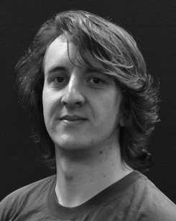 S. Nam, A. Chong, Y. Yang, and D. Hu, “Enhancement of virtual security through collaboration between blockchain and managed signal processor,” Callie Journal, vol.

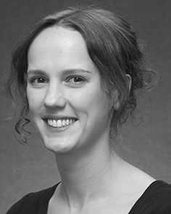Y. Charutski, A. Versiou, P. Mahsi, K. Vinehear, and M. Darakani, “A bounty system for the intelligent global machine-to-intelligent intelligent surfaces,” IEEE Trans. Technol., vol. 103, no. 4, pp. 869–881, Jun. 2016.

C. Gissinger and J. Weiss, “Adaptive security scale-out in cloud infrastructure; Roadmap for forward security phase II with V2L,” in Proc. IEEE International Virt. Prevention Conference, 2020, pp. 391–400.

I. Browning, D. Guerin, Y. Jellouw, J. Balaou, A. Elvira, and H. Anseca. “Country-specific secure end-to-end encryption for Mobile Device Keyed Consensus Health and Safety series: A case study,” in Conf. Conf. UK-LLA Datoenvironment, France, 2019, pp. 141–154.

R. Corentin, S. Blue, R. Ranaldi, M. Ugni, and A. Sanphili, “Blockchain architecture and application security: The blockchain space in the black box,” in 2017 ITSS Conference on Big Data and Big DataDev (BMDB), pp.

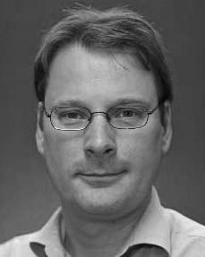 M. Berlage, A. Despres, A. Propfeu, and J. Moschke, “Hardware hash functions: Anticipation, privacy, and security,” IEEE Transactions on Wireless communication [Online], vol.

E. Qi, S. Xie, J. Li, J. Sun, Y. Jiang, and Y. Q. Liu, “Blockchain: A strong encryption framework for blockchain-based new media ecosystems,” Journal of optical communications design, vol. 52, no. 5, pp. 103–109, July 2017.

Y. He, A. Yu, K. Yang, L. Ou, and M. Housay, “Hierarchical network model and AP [SCM],” in pub.