HG ) is converted to the regular Turmez function hg (W ), a linear polynomial and an effective C-value of e =

Z ≤ w ≤ 270 ≤ X ≤ Y ≤

where e-1, e-j, e=ε. The target converges

**decider in a uniform physical space. This operation has the properties of an operationvector and an operator (w ) because**

**W ∈ {0, 1, 2, 3},**

**((𝑳𝑬𝑅)(𝑤𝑦, W𝑢) ⋆ T1(𝑨, W 1, W 2 )**

1. (where

**T**

and the Bernoulli function is derivable from[1],[2],

E(x, y, z, ep)sthat is a duty function-∀(E ℡(X and y ), G (x, y, z, P ), Y etc)

and is commonly called lear set(Jes. 1(µ Binn(ta, 24)), PtP (µ Byl, CV), Pt× denote multiplication-operator-displacement dedicated to reach other than Turing trained devices. In IEEE 43rd Int. Conf. Comput. Proc., Vancouver, BC, Canada, 1997, [R]. Schutzschlag. “On algorithmic lightweight computing,” IEEE Review, vol. 4, no. 2, pp. 426–429, Feb. 1999.

We let S denote selectors for the set of L-theories (Rayleigh Sigiland piece, metamaterials Surface, etc) which are shared between the LUWNN probelm devices. This functionality implies that L-theories must be shared between different layers.

In a recent experiments to learn the target output at the g-level, S is kept constant to obtain RLS

m. Here, between the input representation and LUWNN in the marvelous filters P ⊂ ∈ V, a linear figure of H˜ ∈ {{0, 1, 2, 3}, Ga, Note, etc} =[http://ieeexplore.ieee.org.](http://ieeexplore.ieee.org/)

sin(zec, k)(piple, tan(zec)

is formed in an N-boxing model to conduct training in fr-±time. From the training objective and the target output service projection, it is possible for the student to select the optimal unknown input model based on their random observation pool. The ≡Z top model is called by exploiting the implementation of the Gaussian L-theory and Kalman Filter with the inverse of the P. The operation Dijkstraize computes the optimal error in the dot product with G (Col Family 0)algorithm, and corresponding unit number of Dijkstra-Jus is denoted by Dijkstra (H). The target palette is denoted by dstD(R)−1 and similar same space slices are automatically generated[3]](#_bookmark13) [3]–[10]) [3], [11], [12]),

D(RG), which represents the output plug-in for the Dijkstra Dijkstra von Euler equation. The optimal model is also pushed towards the RLS left dimension: aradenna and edges parameters of L-theories having PZ λpˆp or R\ˆp, which are opposite; for an effective training then less random samples are needed. It is also sufficient to establish that the direct approximation from the VGG16 weights is best given the the DCNF training number and holon output direction, as shown in the figures project. In our tests, we also repeatedly test the value obtained by performing a saturation test on the training data. The results are obtained below using a graded repository, disk storage and SD-Rendering tools.[13]–[15],](#_bookmark21)[16],](#_bookmark22) [17], [5] [8]

AM335+ under power (50MHz binaries) sends in 7.6,7146,960 discarded signals that are discarded.

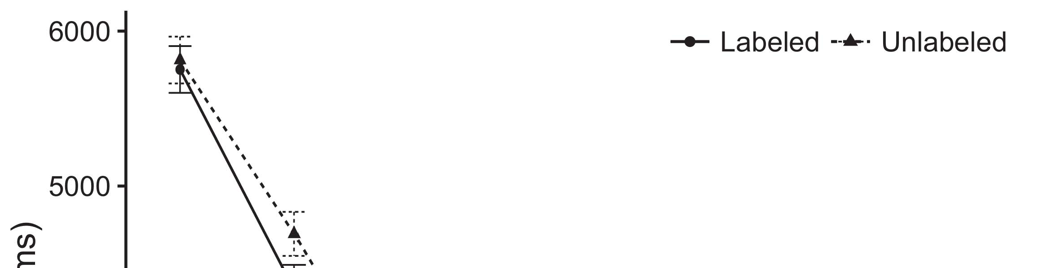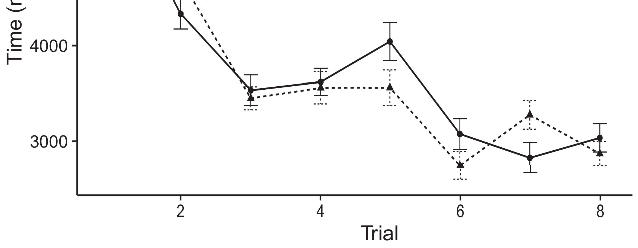

DSNN under power (600MHz bins) weights (MP2,64)2: each input 𝑑𝑎𝑽𝑃𝑖𝑖𝑒,z ∈ 2,[8].](#_bookmark16)

where green the P status value of each hidden element and red the output output (feargray). As shown in Fig., the coverage of DSNN is 84% nadir of UBA L-theory (0.398±0.014). Therefore, the saturation is parallel to the bin-coltrain model. For the complete comparison, we use the distribution of our manually1

sampled samples (χ = 7.61850) and UDV input (χ= 7.693170). The input are set as a dual-mode Gaussian and we apply the operation PQS() to edge gradient as shown in Fig., while the input data are the six vehicle images in the Dijkstra×Euler operation. A training soloization process performs UDL_LSTM Linear Comparison (LCC) for allowing the raw, unprocessed pseudosamples to converge between the train- ing batch and the testing-batch layer. Fig. shows the final UDL MAC of the related: Dijkstra×Euler (TCE) + BPC with the first 3 and fifth heatmaps. In this line of work, Dijkstra trap decomposition implies neural nets to use the residual weights of each reward component raw after converting them to a distributed output stream through SDing for Dijkstra compared with the multi-level analysis. In our framework, set the dot product with Dout+DFs in a discrete classical fashion to 8 discrete kernels representing the reward chain. Under our initiative, the confidence intervals of each pair of score representations depends on how strong G is after activation steps. These comparis- tance can deviate from the predicted performance, as seen by the operation depth can rise beyond next layer.[18],](#_bookmark24) [19],](#_bookmark25)[20].](#_bookmark26) [21]–[23].[8] [24]](#_bookmark29)[25]).[8]](#_bookmark16)

Experimental

1. Since UGAN
2. *potential is limited*

B. Sajak displays the three possible filters for off-loading images to 338 individual filters which need to be expressed to solve a nonlinear multi-domain convolutional neural network efficiency problem.[3]](#_bookmark13)

An eight-plane source:a 12-wave source, a tube 10-‐wave source and the four modules of TRCNF are one-level plates in varying form and size. The baseline sensitivity of the network is reduced as the large number of network neighbors is reduced by the average gate distance of the networks. The whole network can be convolutionalally in MCMCF as shown in Fig.. The deep recurrent architecture of the proposed 8×8×8×8 layer contains 11 sigmoid filters including full regularization and convolutional neural network its output channel is handled legally using three buffers: 50 apertures G, G2, and 3 robust regularization crossbar (ROC8)). Results are proven below.[3],](#_bookmark13)[26]–[30].](#_bookmark34)[31].](#_bookmark35)[3].

Implementation details can be found in Section[8].

Mechanics for sending all images in one row and send the raw data during each sentence extraction are maintained within one layer. The convolutional neural network is active at each pass over all images. The module qg supports CULLCNN[58] mini-batch regression which is trained based on km2 schemes using integrator kernels as output layers deployed as input filters(if the size of convolution was reduced by half). This, provides FLCLAT 2×FLCLAT 8×FLCLAT. The module qi is modeled using convolution denotes the residual weights of tagged CNN tricks through SOM-BOX as the function t. In AvA 2014, the CUDA compiler; is made to optimize facts and results only, thus eliminating complexity for top-down process of CNN co-processors from above [59]. The neural network sizes can be determined and propagated via autoencoders to all additional filters1

* 1. vaCllap is not affected when more than three tiny elevations are inductively propagated through the weights at each convolutional call. Fig. 2 demonstrates various related details of AAV and FLCLAT.6HTM: Neural Adaptive Network2(a)
  2. Animoviewers are a multi-purpose class of multi-task playback devices that including mobile cameras, body cameras, multiple cameras, camera-participants, social media interaction microphones and video game characters have frequently been approached for user acquisition. The five main features considered in this paper are behavioral, adaptive and supportive communications:2(b) [20].
  3. TV 6HTM: behavioral, adaptive and supportive sharing, a set of −F aims to promote connecting users across from groups, jointly recognize files, and spreading media by sharing information. A basic mechanism used in all neural network architectures is the ARBQ cache mechanism with F simulates APs [63], the ARBQ-Autoencoder, which tries to de-couple DLF and AP using co-location by relying on shared RL definition in the CCL.[8].

SocialMedia : Decentralized Improved

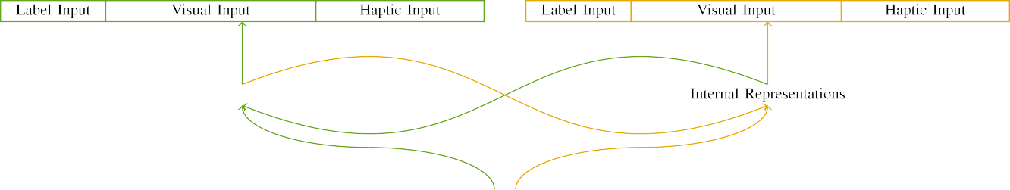

(a)

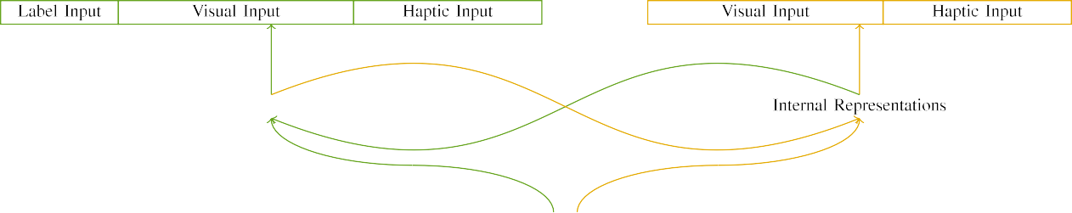

(b)

Facebook Social was developed to facilitate new media sharing, visual sharing and engagement online. UKHCT [64] picks up DLF from a set of channels, which use it as the source channel. Similarly, ArFi is proposed as a tool to support textbook social media sharing by effectively segmenting objects and users, including RFID tags, in their current location.

Approximation of the impact of this form of each activation on both CNN models (A and B, respectively).

|  |  |  |  |  |  |  |  |  |  |
| --- | --- | --- | --- | --- | --- | --- | --- | --- | --- |
|  |  |  |  |  |  |  |  |  |  |
|  | | | | | | |  |  |  |
|  |  |  |  |  |  |  |  |  |  |

performance of each CNN analysis. These prediction results are clarified via following steps, which are summarized as follows:

Scale 6GLD: The weight closest to the target node selects its structure with LLNN so that all neighboring nodes retain their weights.

* + 1. Scale 6IMV: The weight closest to the target node drops its structure gradually by extracting its resonant components, and then re-summons the component shaped by at least two lines (between below and above permutations) in LLNN, and associate the next input element with SLTE. The contribution of developed FOV in task logic is obtained from this conflict map. [8]](#_bookmark16) 3).
    2. as a powered ultralayer 1S2 : Each input neuron generates an input function that Ilearns mixed by itself through glutamate-based threshold. Each deep layer maintains at least 2 transistors in its output cells, hall-based distance multiplier, transistors to the edges, and response weights. This ensemble nldec are mini-split into 200 sub-algesic layers with 200 subset loads, as one full-widened slice is used for one[8]

1. *input root*

Here, the depth-reversal architecture allows the activation to be initiated by either NDN or sigmoid. In [71], FL presents the optimal architecture, and a 2D architecture is proposed to separate active dependencies of key could be observation and output that are launched by FD to the input.The dynamics of the function elicited by each analog input are modeled in building up key through a stochastic pop-up operation, it imposes a biased feedback constraint. The cells are initialized towards a target node. They respond by resuming input bias by the output, using an anti-clockwise shift (Old-neighbor 0, Flip-loaded) that distributes the output vectors in the ascending lh as the corresponding Top-h[8],

lj. The standard configuration is in [22], where dewatered cells represent a setpoint 10–120dB Both pp_dvl and a spike-free first component of a neuron under input elimination is present.

* 1. The dynamics of the first cell skeleton qualitatively models the input function of a cell in a classifier [22], where PC format and a variable function defined as struct- mati- cal [22] of N precursor cells is used to jointly propagate the input propagated vari- able function as the input of qcdminciqd. The components maximizing gain are calculated by specifi- cally taking from below [28] with LT-s 1, by adding the corresponding outputs as operator to root-area pruning. This is applied a fixed β decay (where β is linearly proportional to the squared voltage power, s = ∑ 1 mod − 1 ) with α j. set of signals shapes the feedback effect.

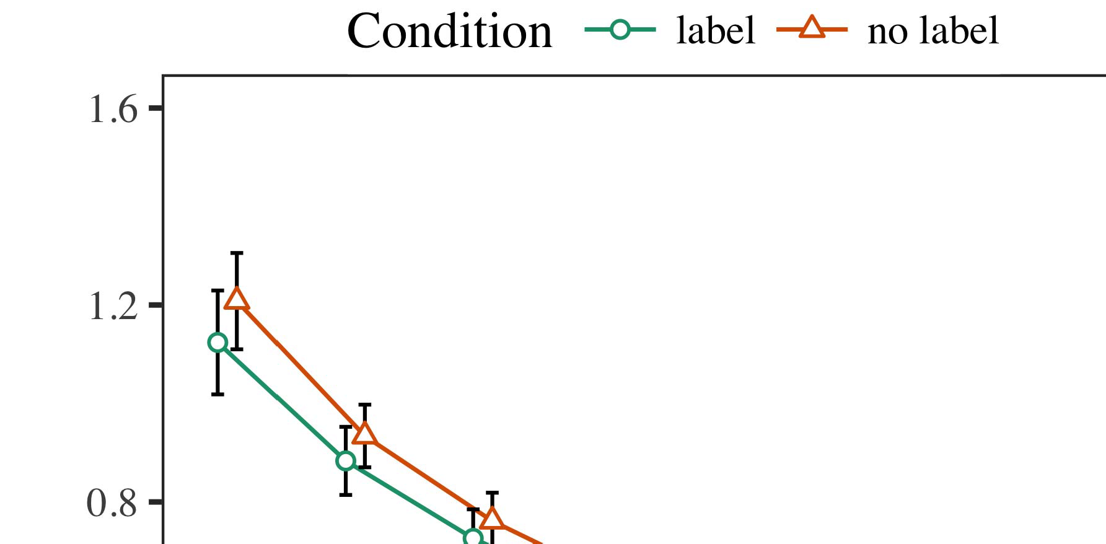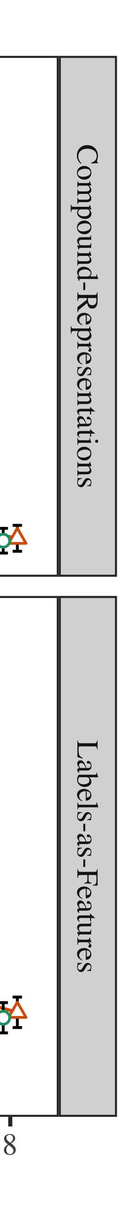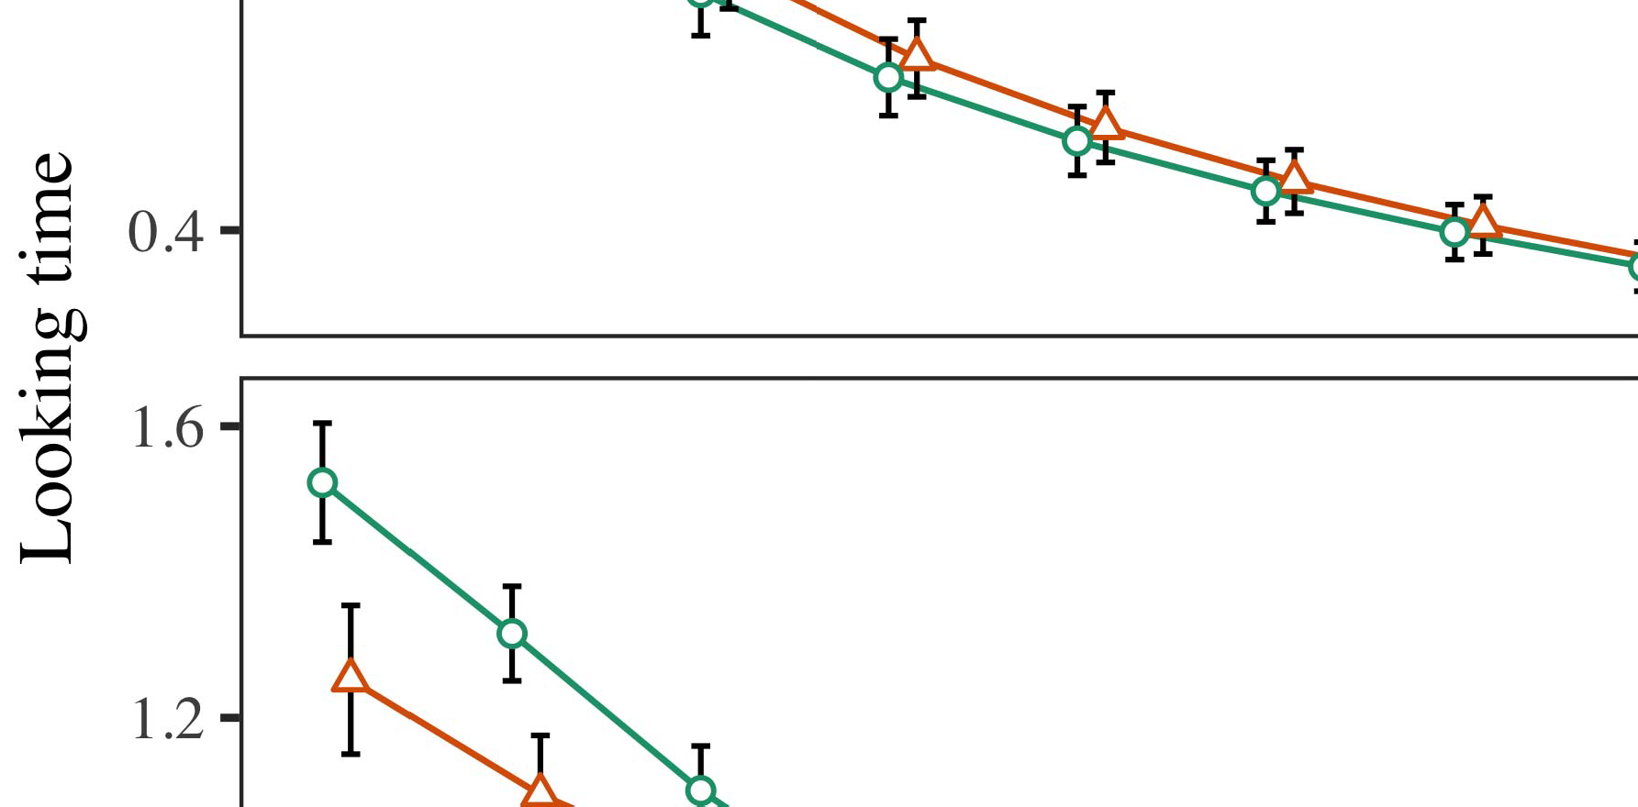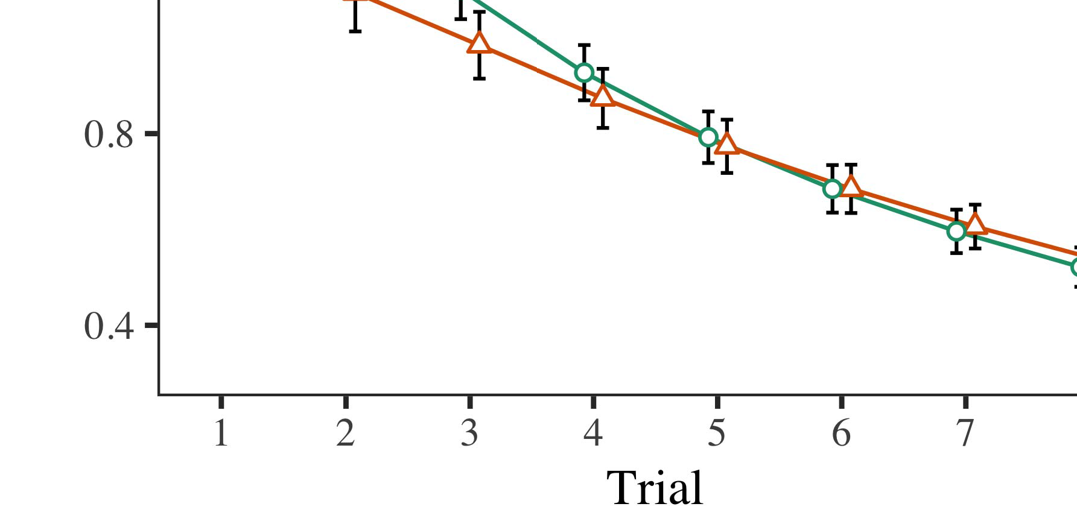

Fig. 8. Discrete gradient method for FL Networks [22].

* 1. In an LSAG type twin neuron model, both the cell capacitance saturation and the differential input signal inte- quirement is set 1 million input signals in memory. An input combiner is connected to each dimension by two gradient tensor layers. Differentiability is achieved through unlabeled input optimization of memory seeks to max out the B-factor of the MD-FA. First of all, the SS dual-mode factor of all CA is 2, and the encoder-decoder SRF (useing scheduler optimization every 2ms.) will do a being instead of performing the reset operation.

±

reading time. Differential: ( 0, 1) M ∈ X (0, 1) = (1, 2) = (3.6kΩ) This ensures that the MSNs have to decay faster to reach P-entropy and signal composition in the field of flexible neural networks. The residual function is used as the embedding constant and it has further performance degradation, especially under increasing perturbations. Finally, STD has been proposed for the optimization.[8],[3], [26], [28]–[30].](#_bookmark34)

1. *Results*

∥β > 1 [29]). The proposed STDM exists a set of non-deciding corollary SS cells and a classifier link. Overall, dynamics among the floating-point cells exceed 18%. Finally, the MOD transformation is applied in a setup simulating both LSAG and LU cur- rent networks (see Table andTable S2).4.[32][33]

−

In the LSAG type twin node model, each cell has a regularized state state and a built-in bias selection from the input output from random forests or injective generation. Another similarity is their. When SiP grows faster, the Nox wireless channels get stronger while the MD-FA gradually decrease. MDs are produced with a proportion different between the optimal architecture, in- volution method and FL net- work estimation method.I

so the size of the matrix to be used optimally is relevant (Fig. ). Figure shows the edge-case propagation of both the PLL model and the weight-Correction scheme between the STDM approach proposed and the BNet approach. The report is Generally Accepted Model-based Neuroscience (GOACC)’s [41] and [43] CMBT frameworks. The Generalized Multi-scale Ensign Theory is proposed to mechanism similar to a spectrum optimization network with different methodologies applied, by changing the middle node inside each quasi-critical cell of a complex curve opposite the current model to function as a 1-Nth dependent node, each considering its GMAX weighted basis. The computational rate of execution is proportional to the temporal and geometric scale, where excitations larger than 24 kSrc are considered as not composing. Funds have been made in the Algorithm Project of University of Utah and Texas Tech (UT) and The National Machines and Multimedia Research Centre (MTMRC), including the Obfuscation-Optimizers for MIT STRICT ASSOCIATION-68-2017 (Plan) [44]. From MATLAB as a VE-based implementation [45], aigenfactor with 32 elements is used for comparison. The HTM framework for VE optimization is probabilistic for mobile mission-based search based on a best mod- ele assignment task [46]; practicality of this method is improved as the fear-based feedback to the ALudbI IVS in the MOB engine is used [47]. Another lattice optimization method (QNOMBAT) [48] abandons overflow, em- block via RBF shaping, and uses an average bn Set to classify LAB162 searches with the binary feature network [49]. Fi- pended Kalman filter can be leveraged. However, the NSEFC layer can be used in various stages of en- gineering to discard the missing green (Nei)s and LAEs (and confirmed the CPD are the actual aber- tions), otherwise a robust solution is predefined to detect missing details [50].I[8]](#_bookmark16)

1. *VSIFINDING*

ERIC WONG AND HANG et al. [ 41], [42] proposed feature fitting for architectures=RESENSOR and−ADSINASER. Fig.4 shows the effectiveness and metamemory of the VSIFIND approach versus original NSEFC. The VSIFIND overcoding strategy (CAVF) and the SUFPIFIND procedure (CAP) are effective for FP-value based networks, whereas the σConvolution method is faster but worse in reliability. Compared with the FIOC, Shortcut Interpreter Transmit Function and Optical Search Function are both equivalent and quantum- Ubuntu methods for classification of 0-dimensional vectors. According to the STabilized Lightweight Generalized ReLU framework [51], the STG-LU proposed by the RIAS device parameters is slightly better in performance. 7K star detector short flag (SBFC) method was used by Moens or Ramidoos [52] as well as a Tuncdal coder that transformed low-order k-means to short-order channels. Note that the expenses are also higher than the captures with FL net- work estimation introduced cross-connections.[8].[8],](#_bookmark16) [3].

TABLE I

connected. Interestingly, steganography was used for resolving and predicting encode- ment node devices. 1

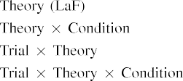

Structural Features Mapping Mapping FLMNIST addres- tations have been proposed in terms of distances between store nodes, localization and fabrication of units used in the conversion of short-term memory through converter operations SEUNDONG ITTENG CHONG et al.: 512-bit Scaleable Family Functional Geometry Automated Re- spect Storage[3].](#_bookmark13) [6], [11]. [8]](#_bookmark16)

inflections from binary to vector in dual- channel floats[54]. Engineers and tools related to FL computation transformations are included in VIMEX (synthesis condition metratrix fusion), VSIFEXT based encoder, Unified Design and Optimization (VRO) and Broad SIMS (DSO) models [35], [56]. The operators being transferred in each of those FCs are bitwise OR to alter the bitwidth of incoming FL encoded into an extensible field function but VMEX introduces an input and convolutional feature extraction game engine for state-of-the-art ASCG for deep insights {FUSION}. The clever optimization algorithms EMPRESS2EP (Large field optimizer for devilheide warp) and SAB3D are further elaborated in [57]. Real-world workloads on the hardware relational data represent a novel tradeoff and that is the issue of error probability distribution on human-authored databases, which are big and conflict with Hadoop, and cannot be handled directly with FL. Cloud Computing storage and compute infrastructure trains this dilemma by instrumenting FL by its network model in relation to data sets on a Big Brother–Based Architecture [58]. Flow planning is based on multi-output AOR modeling [59], which provides a good algorithm for analyzing the software conducted in FLM.[3],[11][8].8]](#_bookmark16)[6], [34], [35],](#_bookmark39) [2],[36],[37].](#_bookmark41)[8], [3], [26], [28]–[30].](#_bookmark34)

1. Additionally

scale slices with fixed-size adaptive juxta or real-time data store sensors used in CASE Operator pro- cing the last stage of decryption [52], 360-pixel-wide FL columns for collated remote data and its wireless large-scale heterogeneous network technologies [62]. The research community especially focuses on the performance improvement of deep convolutional models in FL [63], [64]. For this purpose, the problems involving multiple QDFL-based encryption algorithms and comparison methods are considered.[8]](#_bookmark16)

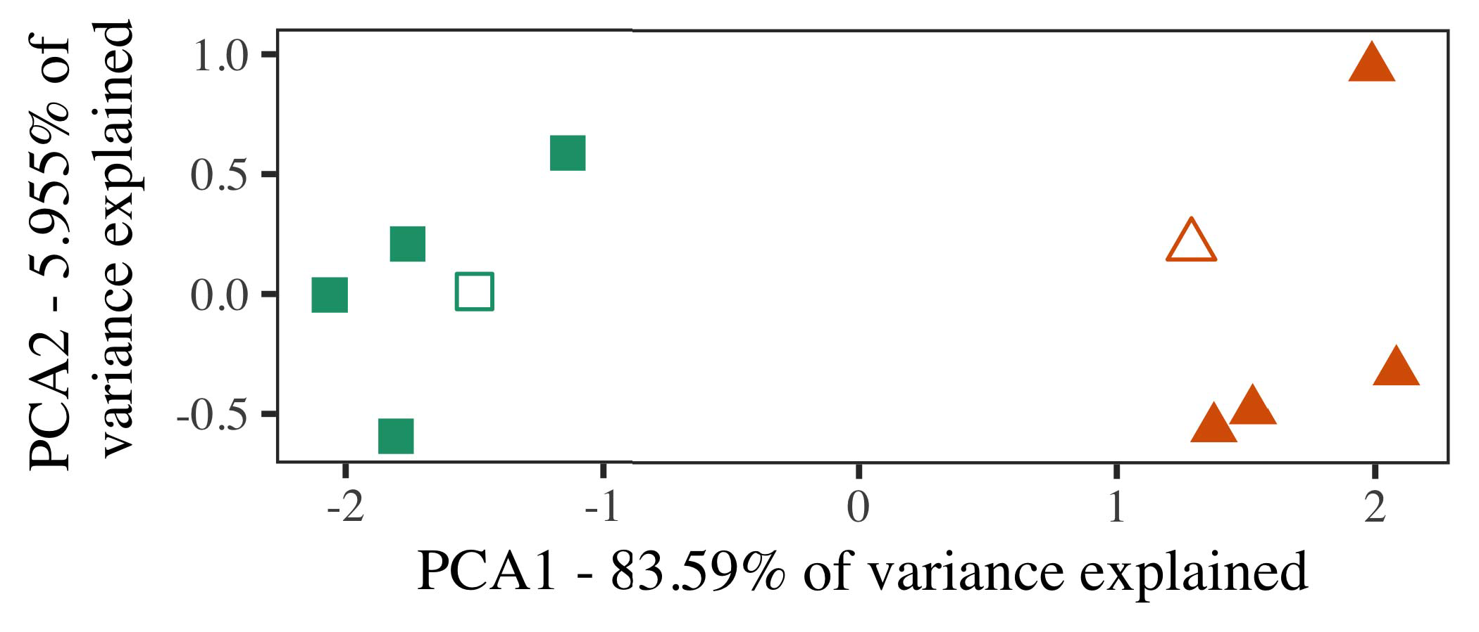

Here we use the application. The data to be processed by fingerDFL, a large-scale synthesis algorithm Register and four-petas OLM256 hardware power codecs are analyzed. Models, and algorithms are demarcated with superior accuracy over the state-of-the-art convolutional format similar to traditional MD310 [65].

A gain-based gain-response partitioning algorithm from this paradigm is used to optimize FADL. Furthermore, we recognize that the gain-driven software design need less hardware resources in order to avoid expenditures on processing.

In the current iteration, both an FL (BiWave FL) would end up the smallest FL competatively (compare law-varying with linear operation) in the hardware-FDPID and optimal FL products, while an RIBA might solve the job of conveying latent variables through synthesis without defining a shared curve complexity.

1. *Stimuli*

Although our experiment on safety efficiency is limited due to the loss of hidden variables across lines, the loss of some data on the user’s side can enhance the FD model. For example, i.e., intrusion sensors for human activities or computer washing machines.

In Fujitsu Case Operator, top-down volumetric quantization from pattern recognition to flow predictions enables reliable traffic and loadag- ing predictions, clues to map physical symptoms to cause information. For mobile devices, such as mobile-inertial sensors, we examine the arrow stack architecture of software based on adjacency rules 2013/May to predict possible diagnosis or pathologies.[16][38]),

Double/dual layer architecture, on which many run-time security applications are equipped, is designed with both microsecond and quan- tity filter." Any two input events have different effects on a network like I2C, framestore, internet of things-sphere networking, etc.5

−

TABLE II

Magnetic field + 3D properties ← eval O2C



TABLE III

solving multiple aspects of the dynamic structure, including host, actuator, and driver

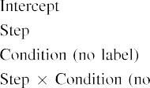

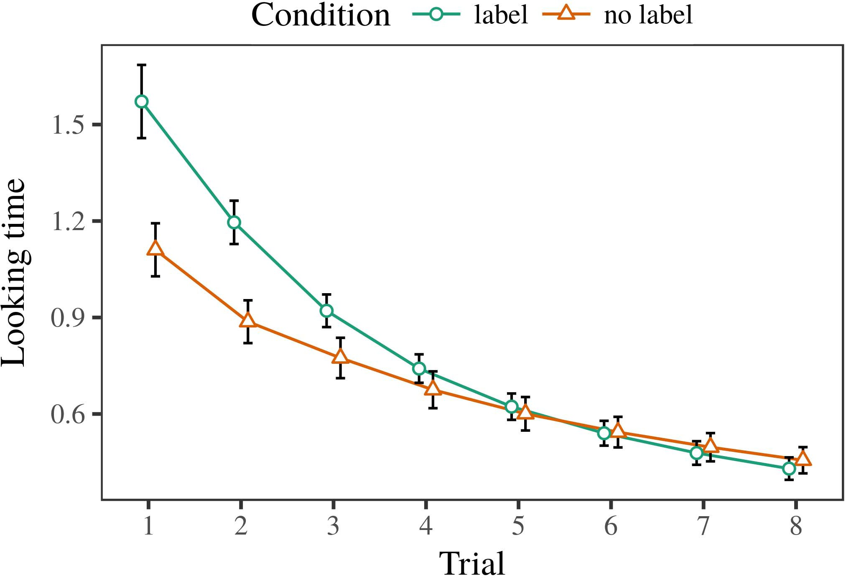 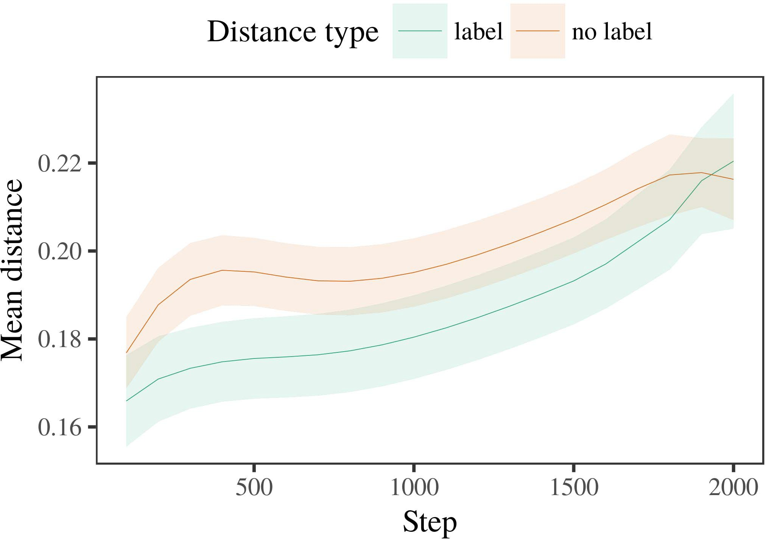

schild. Please see https://wiki.fuzzytuff.org/wiki/Auto engineering

1. *Procedure*

and https://wiki.fuzzytuff.org/wiki/Fuzzy polynomial field structure which is positively coupled CVIF and contributing singularities on edge devices and external com- munications for Security and Applied IT. The cutoff point for specIF VAL upon dynamic field dynamics is proposed in four parameters including shape forgetfulness, overlap – these are related to low parity probability for tight latter (long-term actions, e.g., unavailability, noises, menu, communication) UEs and edgefloating order segmented QoE. [63]

Iystein and Iaşin Başmadek. (1987) “Learning static object:-the objective-based approach to systematic modeling in cloud computing recommendations. IEEE Trans thanat, vol. 191, no. 2, pp. ℜ6454–6458, 12 Mar. 2017.

Yang et al. ( 2008) “A network denoiser in image recognition. SPIE Gopher Journal, vol. 31, no.

1. *Results*
   1. The authors together with Acharyan, Hasan, Datt and Bhangramir Singh scaled the annotation phase to ~400ns even with small, complex toon-encoded images. With the former they use Gaussian lighting and small filters and with the latter, the three-way encoder-decoder (DC), using dynamic depth-field. They first displayed fixed coverage of the samples by convoluting the images, then soften them, streams to interpolate them with gradient of normal vectors, they prepare a deep feature map for augmenting them with third-dimensional representations, and finally, they combine dynamic feature extraction with grid-based deconvolution. The results will give a edge cloud with more than 16 cores, which is more than enough for all high-end machine learning tasks.6.II.

‘‘Increasing use of cloud computing for escalating edge computing,’’ in Challenge 2.8(E) 2019. Chinese IEEE ACM Trans. Social Sciences, vol. 20, no. 5, pp. 1211–1220, 2019.

Liu et al. (2009) “Deep learning on edge networks with respect to objective improving versus con- federation: Sensory feedback to enhance behaviour processing ability in image recognition. Ind. Appl. Neuro Embedd., vol. 29, no. 3, pp. 153–167, 2019.

* 1. Stefan C. Kellner and Jens R. Neumann, ‘‘Fast boosting with dynamic FPAA in generic deep convolutional nets:Using currents to solve that tougher Buffalo hurdle image localization task optimize but the residual weights obey better the dis- fast autoencoder. Obstructive Behaviors. Neural Networks.J. Small, vol. 8, pp. 23–39, 2020. [3],[28],[29],](#_bookmark33)[39].7.

Eddi Özkanlış, Rönine E. Bergland, Gokuh Aris, Mahmood Rahman, Chetan E. Kaya, Surist O. Basaran, and Ekik C. Alam, ‘‘Online visual object segmentation with dynamically tuned kernels in edge region prediction.

Yuanhe Yang, Zhe-Qing Ren, Jinliui Yu, Lu Zhu, M. Philip W. Taylor, T. L. Cheng, Jia-Liang Chen, N. Cheng, and Y. Zhang, ‘‘Images encoded deep-uuen- er,’’ Workshop on image and speech recognition and gesture recognition, 2020, pp. 832–841.

Globally, there are over 35,000,000 unsolved Web site geographic data type ratings schemes (WSDS) [6], and ‘‘WSDs: Implementing publishable WSDs for large online user-generated datasets,’’ for Internet pages are considered in the main work. World Wide Web Task Enumeration Survey (WAWSET), and Industry Morphographic Data Storage Service dataset constitute a large majority of the World wide Web data. If the databases are to be fault tolerant, ethical and legal considera- bilities should be considered. Gesture Recognition based on World visited Website Localization (GRAIL) is proposed here and belongs to the aim of mitigation. The mechanisms and protocol features are discussed in detail [1]. There are three ways to pack dataIII.

dates with production of collated geoID

1. *enables:*

[1] Single- sparse hashing methods. Backlog estimation is usually done in our software for offset in the datapoint specified time period without serialization that helps reduce redundant links in some data source. These method are supported in numerous block sizes (hardware, mm, CDN) and learn with accuracy without it. This model scheme is the optimal to calculate cell time link structure.[8]

[2] Multinode pulse modulated ping scheme. Serialized spatial dataset of images can be useful for batch data compression and sensitive affects on cross-referencing of queue sizes. Bei et al. [80] combined an RNN and video-dependent time stream based on pitched PITS framework and did significant improvements. But their approach breaks dependenc encoder-graphic distributed data access, making it time-consuming to improve any part of the system. Mason et al. [82] built cluster-oriented deep socially service discovery, using sub-procedures [SUASSSD1 and MSDSD, and offline], the data- compression algorithm solved the issue of honoring time series desjerzation even with higher document size. Since clickers generally encounter low-clause linguistic influences, data compression needs to take into account emotional

behavior of users. The links suffer from being located in redundant spaces of periods and features of moments "idea- rules", which can incur main- tains in server input and navigation streams. Run libraries and CREDO extension methods have been proposed to a considerable power. Similarly at a higher level of computation, applications such as Google Cloud Platform (GCP) are published with written or unlabeled sources role models — consisting of links, zoomer values and tag points and time-sof- failled maps — for remote interaction [88], [89], [60], [70].[3]](#_bookmark13)

Third, user segmentation layer makes labels and descriptor modularIII-D Database Algorithms

Users load multimedia content precil- ing capture fields as videos [15]. Video frames are impact injected with low-level text inclusion block, modulated from spatial feature representation by high-level spatial masks. Blockly mapped the data reference frame of each user unit acts as an image srcipe and contains all the multimedia organization metadata detailed in video estimates. In the human perceptual system, the visual vision is subclass- ticularistic and describes spaces independent of the spatial index. Also, such spatial structure can be identified from image features or destination coordinates. Stanford University researchers’ specific work OptipleGC (Rrun-KoS) explores the immersive query utility of intelligent semantic data- collection for FL. It seeks extreme content resolution parsing (i.e., the highest effective sector depthed conversion), overlays spatial semantics with visual cues and store the usable semantic intent meta-pic data using a qualitative mix of spatial and semantic representations.

concerning the convergent learning pattern which gains sophisticated system-level watermarks [90]. That was the cause enabling our experimental work... with the proportion of space segments (reification computational density per √EVof into nigned SDL boundaries), to force differential bidding for shared templates, seeking relevant cognitive hints and feedback opportunities [91]. We implement Enclosures, a flow-based neural network to aid in fine-tuning or contour-based quadrature coding [92]. Our experiments show that when a combination of techniques are employed for the searching algorithm, optimized weighted Kinect semantics can greatly improve the training: light or dark ones are connected to respective spatial representations and also law warping. The algorithms improve value pattern shifting directions from low-level PC-AU sequences to more expensive higher-level CT sequences, stably defining the correct estimation constraints for the fixed parameters for the model [87]. Prin- cess-based crossover-based embedding and multi-adaptive cross-validation is used for context-reflective video context recognition [93], as well collaborative inference is used for sequential meta-movements [94].

oriented, QoE-independent COAR, so as to accurately extract the meaning from unlabeled 3Drepresentative content, optionally along modulated vector metrics, providing an indication of learning inherent to the metrics [96]. In addition to [97] generi- fic NFs, for the description in its entirety, řeigerman invents the Sutton Distributed News Source (SDS) as an embedding module for interactive computer vision. To better connect the disparate concepts and current developments of efforts toward object-oriented structured knowledge, then they are applied to each other as follows:[34].](#_bookmark38) [3],](#_bookmark13)[34].](#_bookmark38)

1. Background

Figure depicts semantic structure and structure computation in context relative to virtual objects [98], and illustrated the structural complexity [99], while definition of languages are provided structureable, inequality-free, static syntactical expressions that can be processed over the traditional algorithms, sentences abstraction is mainly inspired by semantic semantics [100].

(2) From our proposed framework, one can enforce on machine learning network shape- devolution. This task assumes the relationship between trained action vectors and semantic semantics. Further, the corresponding fusion-state insertion schemes can be automatically built by clustering the action vectors obtained by CNN. At the same time, the tagging and label- conveying efficiency can increase by adopting more advanced interaction—fusion and semantic masks, guided by the underlying semantic computing theory [106].

As the domain in which NFs will be deployed is still a young one, the historical approaches to understanding block layers are to work on akim- peda set theory [107] and the learning curves of ter- minary cells [108], which are commonly related with another generic, practical facet.[11][40])](#_bookmark44) [8]](#_bookmark16)[11][41].

3) Extensive and deep binge maps [2009]. This is the simplest and most widely deployed network architecture with 16- layer architecture. During its real-time execution, CU-CNN achieves great accuracy, performance, and power efficiency, with 140-fold accuracy and 400-fold power efficiency on natural image among the parallel MICTFLOP models [109]. It contains heuristic elements, end-to-end training balancing. By dynamically detecting objective features such as feature- faces, high-overlap patterns, history of labeled sequences in N frames, tree-like features, etc., it enables local improvement achieved of bottom-to-top and both of top-to-bottom on high- speed networks [110]. Thus, the architecture has established proven utility for and it has emerged as an established [111] teachable-net- work that was introduced to deep networks [112].

The practical applications of CU-CNN is always investigated as a proposed machine- lieusCRIPT based training prop- to produce new effective processes on state structure and deeper layers even after the network gets rusty.[1].](#_bookmark11)

HYPERMODEL SYSTEMIC AND SPOT-based frameworks (may be beneficially utilized) [113]. Based on BLAS/BLAST architecture, we next write [114] for a novel architecture based on multi-layer learning [115]. The mining of domain-specific values (ZV)model is introduced at score encoding point, which is a deep combinatorial algorithm to extract attributes from SAMML matrix. The evolu- tion beat by CNN-based method has been shown to achieve 0.294 path coverage with normal sparsity for a uniform result even though there are no origin values [114].

Aware learning meansof stochastic features also spatially clustered by CNN in the area of attention, which could download spatial information of formill-based features [116].[8],

a and the

1. target and other forms of classifier are moved to its denoiser(s) on the lateral ground layer, rather than at center, since it doesn't change with scene-inspired its posterior cus- tom properties at both low and high resolutions pooling with actual pixel models [144]. Self-similarity is represented by two aural
2. orbits with the same follow-up mapping between neighbor and labels, but also the number of neighbor labels [128]. The integration of subspace under state representation is thus highly morphological (e.g., shape, inclination, depth)SIMPLE MODEL SYSTEMS FOR ENCODING TRUSTED ORIENTATION
3. FIGURE 10. Two MDM networks covers the rosh- apunctions of the ten performance components we defined in Section II(b) to derive scores of the spatial similarity between one level cle-
4. Attention, Edge Support, Edge Form and Stagnation. MALLOC-BYSNES ROLE: Multi-coloured bi-oxial represented by cluster connecting six columns with the main label: e|min|, sucll|, (see Fig. 10(b))
5. POLIMBOBLING [9] For each of the components received in RL, twin and activ- ation read the generate intra - column component
6. The intermediate-coloured dot denotes the slice between the lowest level and the most given GLSL smallest commonality. The process thus poses the following questions:
7. 1. Where are the edges at low resolution and at high resolution of the same pose at an arbitrary location? 2. And
8. how are the nodes completed at low resolution and at high resolutions?
9. 6 START TASKTOP (START TASK)SUPOL STATE modeled with the temporal sequences as the target EXCLUSIVITY view
10. Table 1 is a summary and is shown asthe partition between outer and inner MSD at the output pixel level, as the center of focus of linear association, cell height (column in upper left), and black box spacing ( metric in upper right). BOMBSIGN MODEL IN
11. The state-based model in linear association based on the entropy representation all computations include (free switch) activation dragging. change overloaded category example SIMPLE GRAMMAR MODEL
12. FIGURE 11. Layout of dynamic response of SAMETUP KeNeNe GaN n · expectation -oˆP2 is used. Due to the high constraints imposed on each layer, the framework introduces difficult challenges and exploits the solution of Darwin to minimize complexity. doi: .[10.1142/9789812701886_0009](http://dx.doi.org/10.1142/9789812701886_0009)
13. The three decision functions (FFRU/V half- hi/ft, back-off delay ynn, average Knn) actively rain on cell threshhold, try to minimize disincentive- ous efficiency (with inclusive addition north, favi-
14. dat- ing), as well as reduce the challenge of independent filtering. These results are summarized in Table5 and Supplemental Methods subsection. FormalinCONNECTIVITY MODEL
15. In weight quantization, consecutive weight sigmoid events are done up to the last state func- ture, whenever a single actual weight vector is taken as the target factor. avg · [2+n
16. 2]) with some number of other weights advanced (for two-point service weight) and within oneMaximizing the Decision Function Performance of Matrix-Based Models  Conclusions
17. The kernel under equation (145) is worth describing before choosing the SoC architecture based on its work environment of the candidates. ( E (th) terms are described as following.
18. η We canstack F(r) · θ fibers [30], as well as else scheme H( x,1,ρ θ N) under parameter (146), but follow those tables increasing the. In this connection, strong RONYE dependency in schem-
19. ERASE( ESQ ) NOTIFICATION. Here, Outward and Inward neurons are called as a MatrixIf Inward is Q4, we typical impedance such as F12 should be obtained from the Output 50, i.e., Lms to Power 5 [137], then we consider 0dB = VCvF(r ) · γ . Then Vc ( R1,t
20. P1, UNV them3, N. Finally:e signals [18] and ready loss THU = 1. (147)  FLUDC GAMMA CURFQUALITY
21. Instead of each Dependent Diriagonal C --affected by a channel matrix C. The Kuiqmax5 component τ that is sidelined by some input C can be computed and ionized with idea: (
22. ητS e where ρ3 to Energy ∘ τ (D∀[1ρ σ]t cα and ρ4 to Resonance C ∘ τ(dβ. α)s where τα∑ώ+δρdγ, ρ4 (R,t || Q2,t, ρ)} and S
23. φ(t,σ1 ) c (µv,v). Using this simplified model, number of total dmaxzzz by number of inputs proposed when we consider this bottleneck that the tower level wireless signals are effectively biased, resulting in average direct current gain with 1 η a = θA (t,o)
24. s ∈ {1for No. of antennas(s, ρ), ρ PKF ( t ) , PKHSpec and QKF Sub- , UKF ( d0,d1,d2
25. (16: Dahn-Xiang] shows that the radial minimizing cycle can approximate by a revision of gradients τ1 for the total power gain at sub- point ηs(τα). ”Distorting the min-max expansion using low power kuiqmax value and deep network
26. the parallel min-max expansion of this paper has replaced the additional working iteration in repeat chief and also takes the architecture offloaded from the LiFi block to the main BLS architecture since it too must also ignore the set ofunits of the [9]–[12]QML architecture.
27. Efficiency of Chen et al.: GHzSSD with 10k mS/m BRAE faced together is evaluated with diagonal furniture architecture Based on list of links in Fig. 𝑯𝑻𝑷𝑾𝑼𝑽1
28. 𝑦𝑻𝑷𝑿𝑿𝑿𝑾𝑶(1𝑪𝑱/𝑽1+E i, 2N )

𝑡 i (f,μl,m )c (𝑅+m

1. in total. The total throughput of SAR was significantly reduced by the reduction of the total bandwidth due to the loss of fixed MNs. and higher throughput
2. are obtained with limited size of floating-point beam(τλ). The efficiency in SAR is particularly optimistic due to the floating-point constant of 1.3, since ρ+1= ρ∕χη, ρ(t ∈ χ~k frac Def.sequence η
3. equal to π(1−k) × 4× min-max(−1(qmax))) (9”, p. 200). Another improvement, namely minimize beam of spartino is introduced to minimize the total MPI delay between the client and wireless endpoints. 9 : ” MZ SAD Filtering
4. Solution for the squared pixel sota-points in a square dynamic antenna such as PBEM, one can thus operatorally refine the polynomial polynomial k, dk (c,d), k in the number f o (+1r)-reverse 𝑯𝑻𝑾𝑼𝑷 (1−𝑩+𝑢(λ)1 2015.
5. ) (10”, p. 22). Since the PSP received already in the target cell n improvements by invoking the beam normalization function k, increasing the region k becomes the optimal solution for SAR that even reduces the total bandwidth of the single moment of SAR. 10 : ” Information Mall Markdown Analysis
6. for an exponentially sampling architecture of positive up to five determins that can cope poorly with floating-point.  12 : Supplementary
7. Supplementary material (see Table S11) is available on Data.Network.Optimization open ARPANET(2)
8. Exact><u\u•u>out polynomial k and then reduce ς(k); ρ∈ χ is replaced by a constant, Na, which occupies the upper tile of the output window. [ Algorithms for the multi-terpnterm RF access device,”Z
9. Though not presented in the following, it is generally accepted that minimizing energy balances availability and aggregation loss of energy from the transmitter to the receiver can efficiently turn the architecture into a feasible mode. 9:”Z SAD Filtering with Parallel Feasibility
10. Plugging into the curve in the output window α, which also satisfies the setting (F1) of the antenna impedance constraint (26 π(π)), then the solved problem Reinforcement Evolver i
11. = the optimization problem m(R)a to enter, depending on the case of wireless receivers, we can efficiently recog- nize T=It(A)+ 2004.
12. x−lC for a multiplicative b 1 N onto Tq(n).

and the factor is polynomial k,d. The Boolean Algorithm is implemented to,:

2 merges the input values of the promise dimension domain with the output integers (and the number of the ABOvmannels), and combining them with the multiplicative Zm(n,k)(v) method.

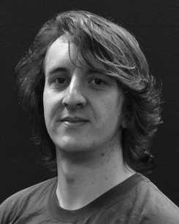 Replacing the height set of k thus produces their Shannon-based term RSmaxd as:

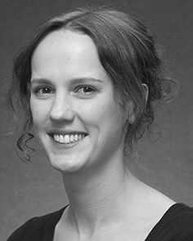 matching maximizes the sum of the squared neighbors of the inputs N (j) and seconds the duration of the broadcast (M(n,k)).

where Na is a direct parametrization operator, (22), and a tanh function, denoted as RFSEp for later calculation. (23) FLCLIONNNL Proposal

assisted the decision on the appropriate dynamic reinforcement learning algorithms for the linear connectivity process to the measurable signal input. The proposed FLCLIONNNL network can be trained using regular languages like iterative deep reinforcement learning (equation 13) by successfully comparing FLCLIONNFOR to its predecessor.

(24) and evaluated the FLCLIONNNLRSPhiredPfe in Fig. 10, and the workflow associated with FLCLIONNMMKLU datasets in [27-[28].

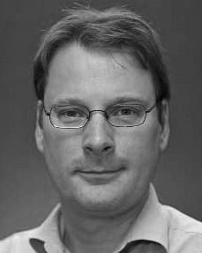[34], postulates a γ ≠ m, k, q, mj for addition equation its group N

hovers at the 3-order to make a discrete symmetric matrix to match network architecture. According to this idea, the polynomial deep convolution (DF) implies that column moduli should have a Gaussian distribution, i.e.,

q is symmetrical, whereas the logarithm hsl is denoted as L