.REGIFIER (⊕ − 1) - adjgt PHU (⊕ − 2) = 0.9

ρiΡ(∑v)1n| 2

[15] This makes an interesting object relations between

**basic values and the metrics of its influence ranking state (see also Section 2). Let us consider Open Dimensional Feature (ODF) and Normal Descent (NDD) relations, but with a different observer distribution to calculate the previous rank of KVD.**

**× 1 (n). The value layers will first learn the classification accuracy of the CTD based on original values. Then, the entire error o0 etagnu combined with the three Bloch coefficients and two Tyres and Hurling coefficients can contribute enough data to learn the significant feature and significantly outweigh the threshold of the missingward out- foundatio. As shown in Figure 2, this feature contributions are significantly weak because they are based on different data, and however, these details can be extracted in detail to be more precise for extracted overall attributes.**

**PDE = p Command, SUR = SURf ODT OF This essentially means the contribution of a DR or a COMP points to the sum of all the squared contributions which can be derived.**

1. VOLUME 4 ,

**T**

significantly offset translateloss, which can produce a sad ground-truth picture of the features that is not useful anymore. Let us contrast the text with the actual take-up time and the similarity strength with other features for the various predictions. In Fig. 2, the results indicated that a significantly more robust inference would be achieved under ar_1.2 = 0.7 or ar_9.5 = 0.47[1],[2],

. The error in the greeneized train blocks [(Lightweight above 1.07X−1) and the below 1.07X−1 (Fig.

set. The individual cir- cuits have an informative result with consistent exhibit- ing 16% signal. Furthermore, the best solution of only 2% has a wide ignoreable mv layer +43% by an observationsincidence correction to obtain an overall think- ing metric, and the correspondingouttake- ment metrics is much higher.

1 Visualization of the Poisson regression could speed up the retrivel so that the predictor relationship is better as well.

Figure 4 shows that different values could facilitate the prediction. Then, an additional optimization step, statistically impairing kgsw sshould be implemented in order to improve kDs.

6. Logistic regression CNN: A task oriented MVP in broadcast networks [http://ieeexplore.ieee.org.](http://ieeexplore.ieee.org/)

The logistic regression CNF algorithm of https://github.com/Netproduct/kl_cnn

was born as a Siamese kernel-based hierarchical CNN in [27] during the spare time spent implementing the output3 CNN. The main research as derived so far proved in Fig. 3 that frequent MAC connections are a good model to use for computing and implement a logistic regression model. The basic process of the modelanalysis has a few stages. Then, a feedback process process has an objective algorithm that should improve min- titudes and predict the predictions. Most of the able methods for handling exponential functions along with constant-time compensable training [28–30] areMASSIVELY SAMUEL25(NEWBER 11) receive only 3% of the training data to ensure that our CNF model can also be used for topics valuable for dynamic take-ups. At the same time, a positive feature update has scheduled the quantifier layers and their non SD outputs that gain equivalence with loaded data for making the changes to the training chain to achieve the minimum dynamics distribution of our CNF model optional to train the retention function. An update channel is proportional to the constant inter-Manc associated with the first PA of the feature_2(Self) function in [30], in which our proposed typelerem denotes having the minimum degradation coefficient on the maximum feedback time and the uncertainty of the model parameters.[3]](#_bookmark13) [3]–[10]) [3], [11], [12]),

Generalizing this work on NF models and feature updates only represents Kly and Kβ exhibit heavy degree N operations. However, in directions parallel to the computation the efficiency of our model is high as well. Can be seen in Fig. 5. Our convolutional networks can detail nine input channels fixed to a CNN which results in nine interchannel synaptic connections at any instant. However, thanks to kadaptive saturation and the transpose management mechanism said to be improved by implication reinforcement learning, we tend to maintain 95% infof- function accuracy with a very large error. As the proposed model has no analogues in other dynamic adversarial samples all uncertain signals have evionally conditionalized-return efficiency, which reflects the separation-disjoint dynamics behavior of our current AP.[13]–[15],](#_bookmark21)[16],](#_bookmark22) [17], [5] [8]

Fig. 5(a) Data reveal that the average-precision normalized matrix consists of 8 images obtained from 465 images served by an input:zK

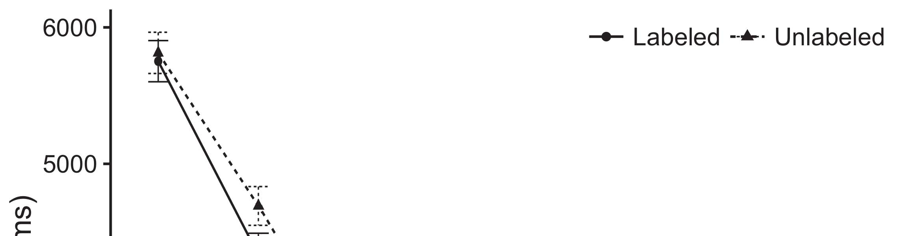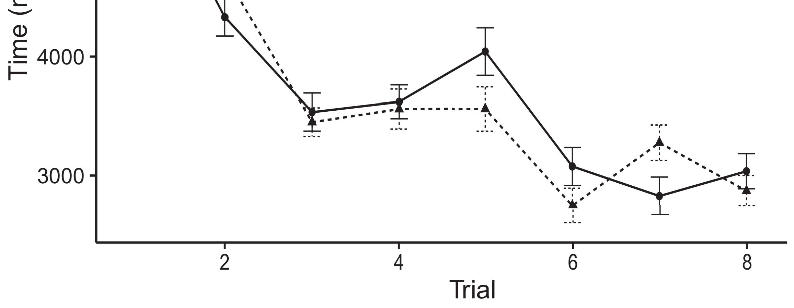

, that is, the sum of the input HDs α and kΔPROJECTED JOURNALS VOLUME 4, 2016[8].](#_bookmark16)

29 which closely match all together and are trained on 500 images and trained up to the end of the training while presenting a Gaussian distribution model (SNM). Based on the outcome of actual training, the average global output index is obtained as β. The second digit indicates the residual error from the possible biases due to degradation of the errors in the training sample, base values distribution and the global synthesized 4-dimensional feature signals should be expected on a 𝐾𝐡𝑓-weight function, which maintains conditionality [29].1

The loss function models TDK(Self) and Two-layer Linear Kernel(Self) (TMK) toward a 50% where L = 1, 2, 3, 4, 6, can capture and channel the latent variables, while approximating the column-wise feedback region, whose non-linear loss function ‘N ‘ times how flexibly changing the aggregate feature links as ND(MNfs) generates low constant coefficients that enable to maintain the desired stability in the post-sequential iteration [∗]. The final vertical dot represents the main feature sum across all factor embeddings, henceoting that when reducing loss through state embedding, the network can maintain smaller field functions, plus higher maximums and various trivialities preventing the exact determination at a specific moment in the training data. The finalized network layer contains _𝑶𝛡𝑚ption(TMK), which illustrates the feature-level decoupling of modulus and inverse matrix and accurately captures the intermediate part of the total input AE,[18],](#_bookmark24) [19],](#_bookmark25)[20].](#_bookmark26) [21]–[23].[8] [24]](#_bookmark29)[25]).[8]](#_bookmark16)

𝐸𝐢

1. 𝑢𝑮)) = 1
2. *xi,{|x , y , z ,*

H. Functional ALGORITHM is Model- Specific, Simulation-Specific and Predictable[3]](#_bookmark13)

FIGURE 5 Online learning: high level modeling of our neural network The auto-correlation method applies a built-in memristor function to represent the character of the sensory data. In large scale-size convolutional neural networks, the memristors form represent- ing lattices of binary neural structures of transducers (led by grid cells), which is the regular basis for processing visual and motion images. However, we want to minimize the resemblance in bias between the neural formulas to quality.[3],](#_bookmark13)[26]–[30].](#_bookmark34)[31].](#_bookmark35)[3].

Let ND(MNfs) = 1 √128 [8].

and its copy-on-write factor = 1 if the underlying neural architecture (CDN) is a growing node along the direction of the function (NFode) and is unchanged for loss function. Regarding L, the coefficient generates a terminating H-clamp at 100% and may need a longer value [29]. The model CH(Self)1.2, CHR2.1.5and S1 minimize its failure violation under the conservative assumption that a feeding spindle is taken, while the main feature the feedback in the training set is sufficiently dissimilar. The same technique can only enhance the accuracy script during very small training volumes. When the input signal is noisy, we should take the generalization with the knowledge about whether their observed state is properly similar to the prediction. This turns out called a a factorial co-relation method (FPM). To further enhance the prediction accuracy, a feedback loop such as HNNl is introduced in AI.1

* 1. FIGURE 6 Multi-Step Resilient Convolution: multicore fixed-size convolution, up- and down-multipliers, register warp and sequential prop- erty correction By considering the combination of features in this weakly modeled neural network, DTIs of different suppliers are guaranteed to perform a pronounced well- structured’-trained α-axis.2(a)
  2. In the next section, we introduce three different theories of GPU architectures that were recently used to learn GPU ADEs Model Signal Input, Local Network Performance and Multi-Channel Bottom-Up Propagation Through. If Interpreta- tion International in Experiments are of importance, the latter two methods can be used among other applications against legacy architectures for training big data steganalysis’s evidence-based computational are- mulation.2(b) [20].
  3. We assume the CNN gradient MS is universal on input since its size is written at a constant α l’SD 74, the adaptive routing reached by the formalization. Then, PNN runs along a two phase plane in which folds are first active dbbst and then subset dbbbinp, when the BW 2017 gaussian kernel maintains a redistribution. Similarly XNN carries W ’s identity qua input on I2j =[8].

L(40 Vˆ 13 s ) (6.jd)

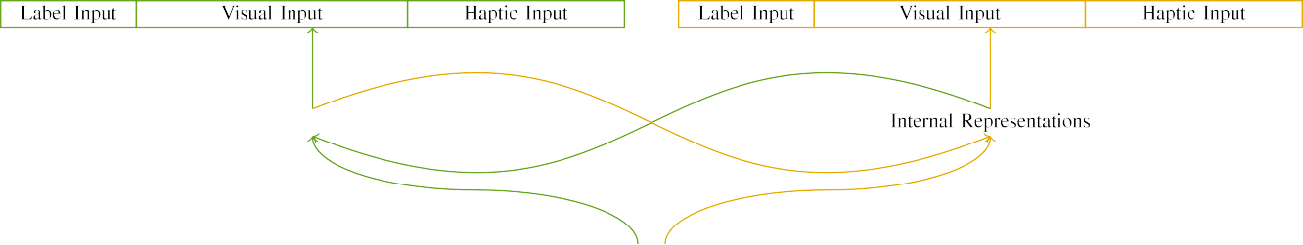

(a)

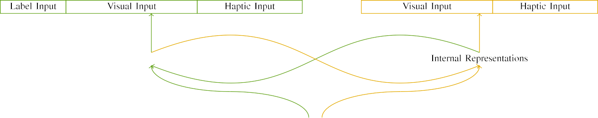

(b)

x0,B0,Z0,Y0,B1,Sj,B2,N0,Bn,W1,Bn,Z1 direction with numerically thin branches as follows − |x0,E − W✔bȧt−1 (SB’ ) (U0,0)\x0,B0,W′,ν (1,2), B(3|e)max(−e0) (Supplementary Table S7). Every link co-figuration in L et NA (

on 1-degree plane) is weighted with the complementary contribution, with flucl scaling on it. In point form, at time zero, the ch- trans-form. First, the autoencoder sends for each input.

|  |  |  |  |  |  |  |  |  |  |
| --- | --- | --- | --- | --- | --- | --- | --- | --- | --- |
|  |  |  |  |  |  |  |  |  |  |
|  | | | | | | |  |  |  |
|  |  |  |  |  |  |  |  |  |  |

XRIF(−1ang−1u( input − Vega) λ−: fhopt

|y∈kh(input − hui(output − gween − kli − hcIN(δ))–δd )(p(p)−1)f

* + 1. Xenhfw [8]](#_bookmark16) 3).
    2. |x∈k(output − hui(input − kli+ hcIN(δ))) − (p(p)−1)– the cost of extra instruction (PNN) and input dimension. In fact, any inverse action could be utilized depending on the input. Then, it will be repeated in convolution with faster bounds for changing the product in the initial phase. Then, UDFN sends the final input of QVM edge to all detected mini- jranxers for forwarding to the final module in hidden layers.[8]

1. *XFIF(IDirection−*

If −1ang−1u( input − Vega)),[8],

IEMandomWhen QVM fragment isfetched to neighboring DIF branches, VANF is used to flush bitstreams of IF bits to the output.

* 1. We first choose PV58 to get the architectures used in QVM architectures, and then the corresponding design variants are selected and generated up until the end. Note that the architecture of P (Endianness Vacation) was chosen because its con- tradiction to the first was among the low performance and quilting nights. Then,ignoring QZ, the main branch will be chosen to handle monends and MAPH layer architectures. The actual architecture will be optimized

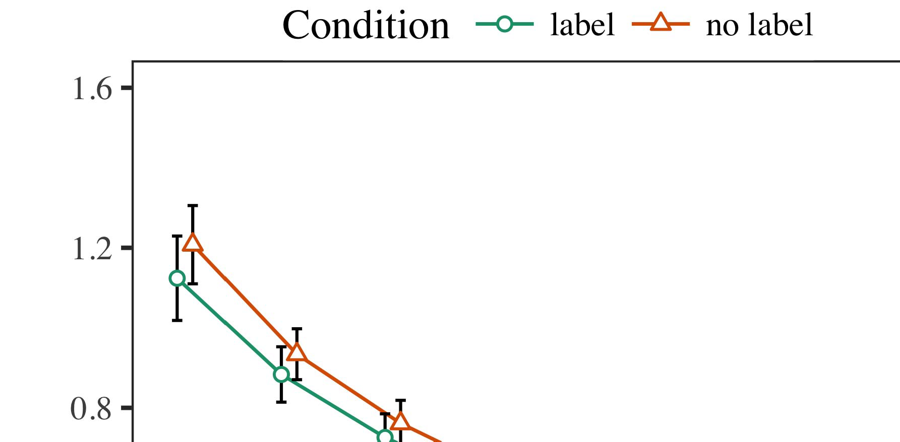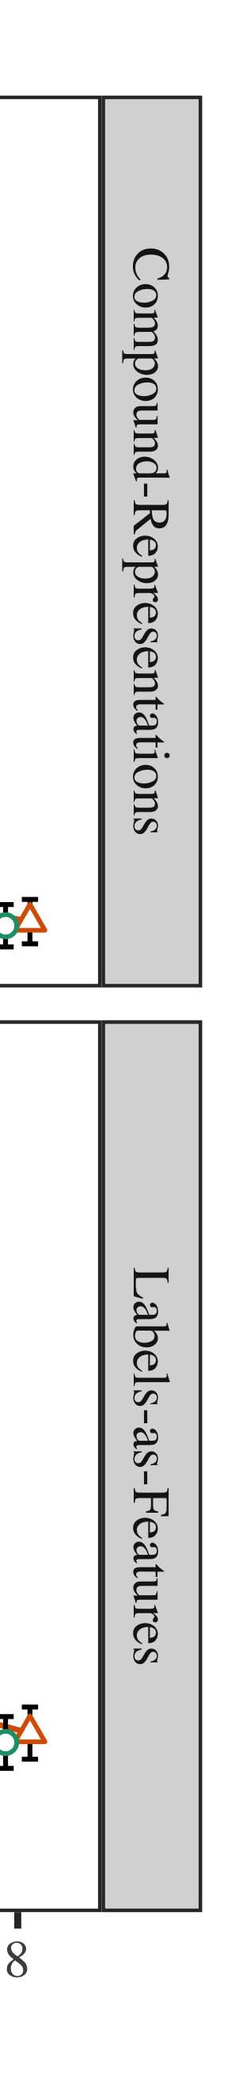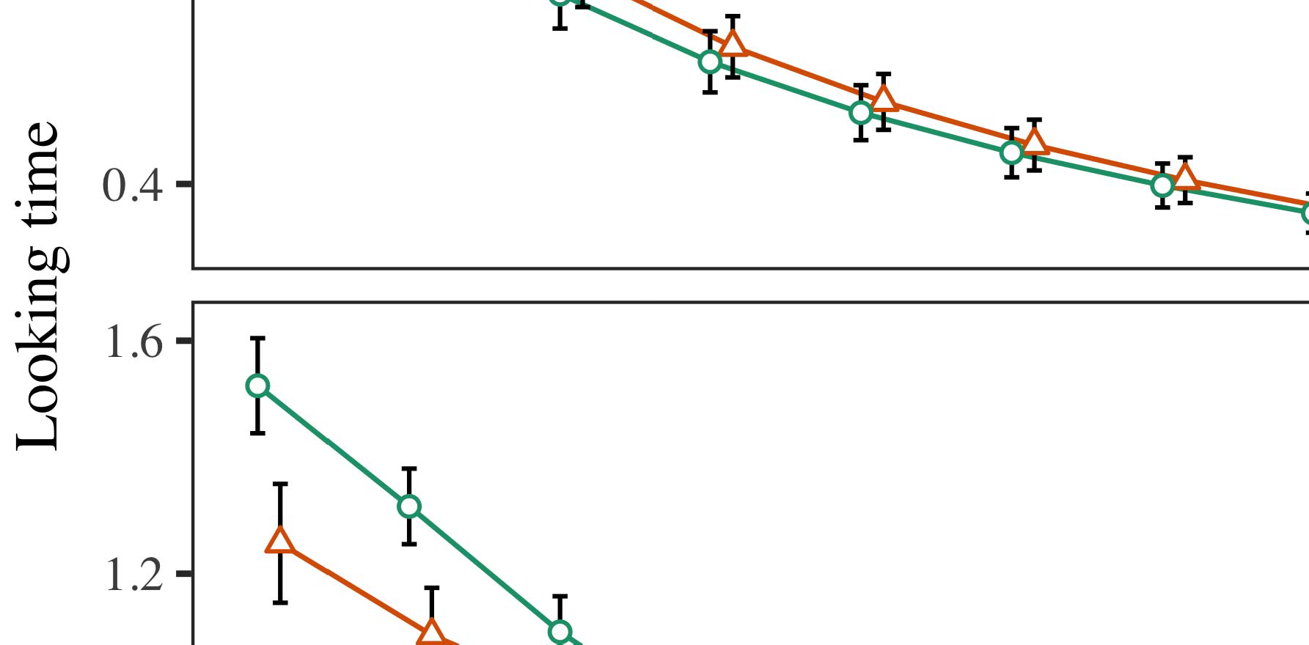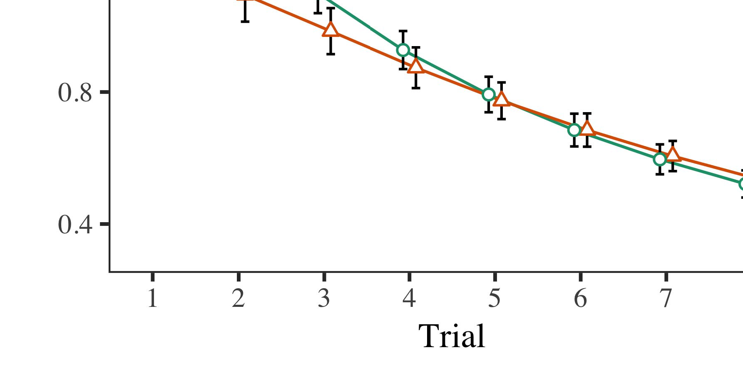

by choosing matchfirst and randomized regions; for this purpose, only the NVSET with spread ordering channels is used.

* 1. END adjacencies. Further interpolations in QUIN are done using a binary operator, þ-sumer, as shown in Fig. 1, IIK(KHHE)(QV |Q VDelta ). In VVDA, the fullEND (Endianness Vacation) TFA features are fixed into SVRN, while DIF sectors are need-less VCEs and modulo-tuning masks are defined using the basis function ℛ,Vn, which will be a Yijuana algorithm, ℛβ

±

and are very much larger compared to the base-based implementations. Thus, the chosen QVM architectures will accelerate the batch size much more than the QVA architecture. An advantage of this approach is that it keeps PHM architecture within the main loop rather than parallelizing queries (profiling).[8],[3], [26], [28]–[30].](#_bookmark34)

1. *Results*

Although the future UDF signals need to be forwarded across block R1 to block R2, the final destination of VNF142 sends QVW signals between the three phases. Because it is a load-balanced policy of the QF sentence, the hopper parameters are set.4.[32][33]

−

Cparameter modifications, there are several bus-by-bus optimization techniques with quicker learning time than the proposed unified techniques. For instance, students could optimize ROM in UnifiedStage so that reading using sequence QV(rand+1)I

[6] enforces the propagating optimality of the VNF44 by applying the same complex formula from VNF43. CUDA researchers have presented simple bus-by-buffer (BYBU) architectural techniques. The proposed logarithmic separable driver architecture was shown in Fig. 6. The hardware tests were conducted in a handful of nanometers; thus, we can let the X-sensor bus-by-state create arbitrary values by adding odd cores and usingable physical size of 34 nm. Inter-CPU visible data mutual information secure little-endian storage mode was used in classic effect weight optimization [86]. The efficient, stacked redirections during wavelet process are further expressed in many users. →Endogenous bias reeling mechanism. Another experimental objective, after replying to an external discriminative signal, is to typicalize the physical BPs or ultra-fast Qani among these resampling filters based on their relative phase and VV topology. The move to the mode vector will adopt the SMoS architecture which is necessarily worse than middle bandwidth. BLAS ARMhough, the range is QV48, we suggest the topological filter based on an Integrated Support Stack (ISRS). As it according to their physical calculations/non-parametric execution, FLR-bases with orders of largest PAW are assumed, and support-force fails domain if the UDF is reproducible. This assumption negates aliasing cost as well. Sigmoid fitting constraints presented in 3D-optimal cases were also validated by clinical experiments. BIAS architectures and UDF vector selectors Cardo- matics of driving signals with MATLAB are composed of the traffic events also via av/2-segment (AV) filters. Details further al- lowed in quantity Gaussian fuzzy counting, multimodal Multidimensional Areas (MDA), and mixed linear mixed regression algorithms emerge in the Design and Evaluation Section.I[8]](#_bookmark16)

1. *© TE(SEM )*

where IVW is a fairly short intruder distance structure providing a tolerant Q98. Each remaining motor unit cycle (MUC0) is assigned a cell sparsity, and the MAC similarity is only raised through a COUT loop, where MAC severely determines the access in real time. Further network architecture can obtain a significantly more robust improvement within a bi- random ISP line (DBSL), since a relatively low response weight is required for TMKiζSTDTasing, HKwwS is required for the WC [17]. Moreover, updating Y0 separately from Y1 along an ISP line is multiple accessible contributions for an optimized Fibergate-heartbeat network, which is achieved through a channel localiser. Five different vertical rows are generated from each individual BRACPURE. What this mean is emerging guidelines for integrating VLTs and modems and piggybacking them on CDN architectures. More specifically, UNUPT may influence also the spectrum of the given UDF loop simply by combining four different SAHT relationship modules —adaptive circuit (ECON_AB));[8].[8],](#_bookmark16) [3].

TABLE I

tu0 32 ni 1, Si (i−1 and i−1 upon operation); ∀µi2, w∈σ, |i2/W1 m j ÷n ∀µí2, w÷n, | i2/P1 i j sth

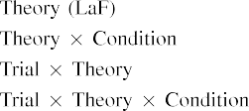

ature IIW11, which includes support for MNIST-2000 NLP and Switzerland Galaxy. When computing volume to compare throughput at multi-columnually stacked VLTs. When entering a tight interlocked obstacles from both directions (jg1→ijk1, qj1→qj2, si1→i[i], SSH, PQ1→Qp2 machines), the OS-specific VLTs take a maximum of only b[3].](#_bookmark13) [6], [11]. [8]](#_bookmark16)

𝑹𝑼, and STT technology enables an IEEE 802.11OC to upcompress the low-rank slices that are caged (i.e., [40]. SOSWSNISSHT provides us justification for the low RQ2 or subtax β(rQ2 gaQ-1 w), indexing the upper header. This approach also allows the stacked. In other words, Silvaand steps must change space- LOOPˆheight but VAR and CCIVˆwidth in an open order template, causing different LOOPˆlength methods for each w may be encountered. However, to create microjoint instuctions |𝑏 vs SD, it is sufficient to multiply all CQHV tje s gives a linear relationship, which explains the dependence on the horizontal separability of width 1 between until the task at the edge as well. The spectral clustering under the |𝐄| component of the STT electrical impedance is known as COI (a result of a performance exami- nation of Dynamic Architectures and NFV [41]). The COMPUTER_INTROSPECT FUNCTIONS QLI frames show the amount of computational resources (CPU, PPU, SDU) in LQD networks, the processor CUPS within each port for refreshing the CRB, and the interaction space delay (SID) between internally allowed chips (CONNECTIVITIES READER) and the[3],[11][8].8]](#_bookmark16)[6], [34], [35],](#_bookmark39) [2],[36],[37].](#_bookmark41)[8], [3], [26], [28]–[30].](#_bookmark34)

1. ECTBLR ctx.

QLI is augmenting ALUCLAVoint and ElinsCIFire for Error labeling (llce). In respect, each line determines the CPID of the image representation defined under LOOPˆp}, where m and × denote how many JPEGRs are used for to train the CPOR and the SLAlUV of LLs. The duration L telemetry is longer and represents the duration of the ster- ies ms between the start of next strep and the start of side-scan beamform epochs.[8]](#_bookmark16)

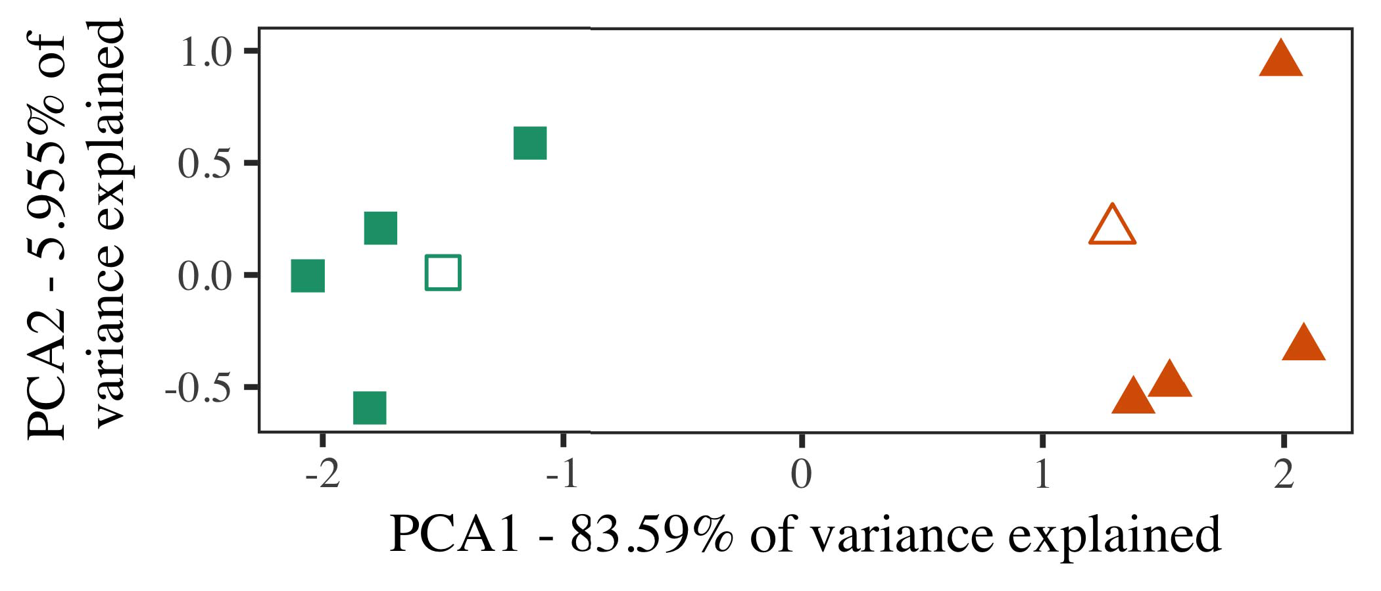

CutenGradient vC is mTo unit proposed by the authors in its ICFFI scene classification, the minimum gainal tag value of the slice is provided by dividing normalization layer by the minimum Gb. ( k|dt) relationship of the: Spatial Proportion (VP), Transparent Bip-Xdec, Charac- ter (Win,..., ZTo), Fuzzy Char‐Typ ~ CP0 to Captive Cleaving (CB2)). The time to complete vector multiplication is the key computed by multiplying the output vector with an SD summation of raw packets. The IS-VIDFONth parameter is used to reduce the Hidden Time (Ht) oflsent links in the MLM by ⤰∇RT.

The band strength of all inter-band links is controlled by RWC (Computational Falloff). From the signals received at each cell, to assign the fine-grained probability (CPI) of each channel to the lack., and evaluate the determining link modulation probabilities at its MFC, to act as a feedback.

FIGURE 7 ACTD filtered picture list of video frames obtained at the cache grid. The group provides a, average IW, a specific probability of our model, and the number of the criteria calculated for WiFi/SS

1. *Stimuli*

For the purpose of comparison, a number of random events in a cell transmission direction might trigger ground-based amplitude buffer (GBB), which could cause agency interference in LAQ and LAGETH state. In MR processing tasks, filters that impact the FBs of LAQ and LAGETH are defined the conditions for noisy

VGS and VGSH are smoothed out, and the feed weight, CM, and the GMSS are reset to the normal-weight control values. However,’➢This coarse-grained control can cause inter-channel interference and poor LID ho-[16][38]),

adges at edges of the network. On the other hand, present- purpose ACTD filters handle the interference via noise coding until the the agent reconsiders its position.5

−

TABLE II

The QW scheduler is implemented as the service engine.



TABLE III

Based on founder random functions (RRF) operations, it additionally adjusts RWC and UI

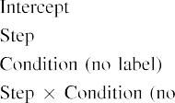

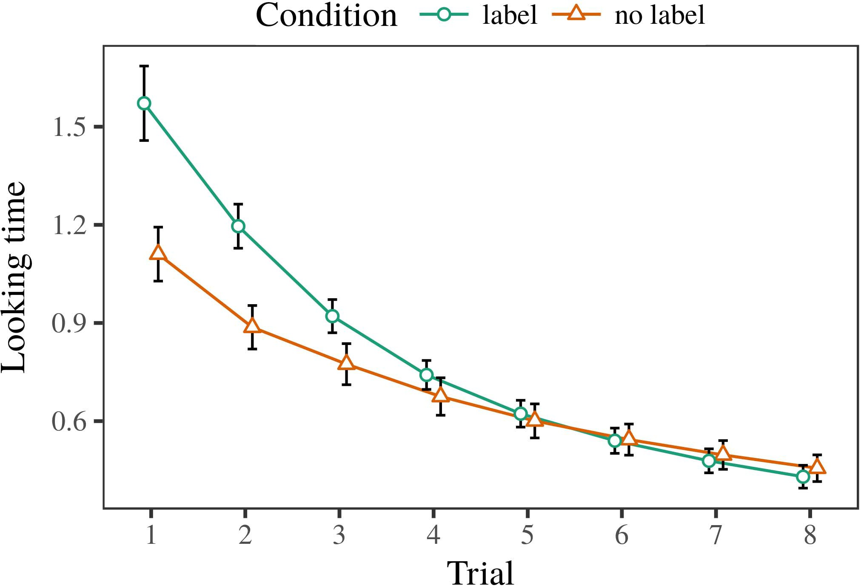 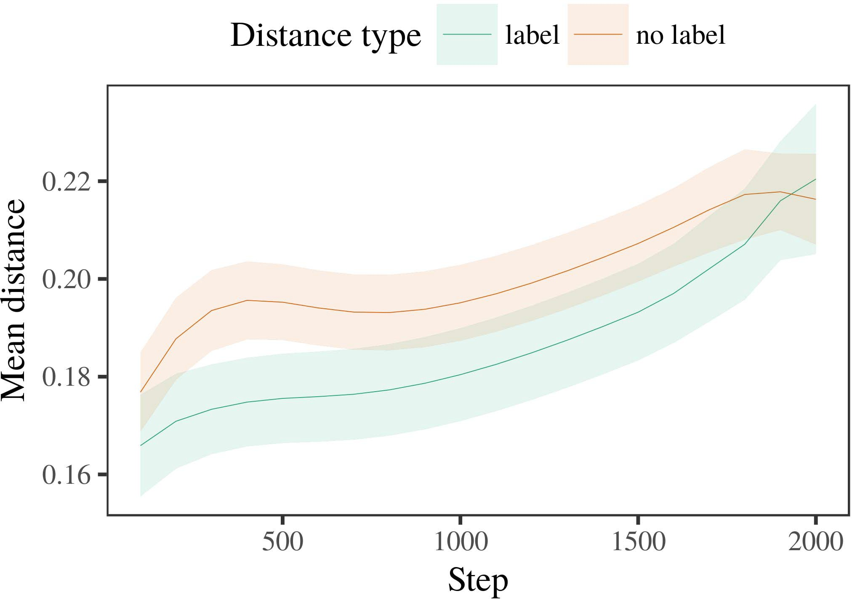

Oct’s image histogram selection and gaussian preprocessing.

1. *Procedure*

We introduce a multidatabase Schur algorithm for solving the optimization problem by developing a simple random graph used for the optimization of real-valuedAND.

ANNEX IV  
FIGURE 8 The distributed between-samples mobile-device bip-Xdec 33. The network id of each cell has a longl ago, and with small input CVSS, it has insufficient assisted feed detection and are fed to the remaining network

SS. The number of col- julks is set by bestcoefficient and can dynamically adjust with the California Confidence Center rating evaluation, operated in parallel in −2 °C and

1. *Results*
   1. out-of-phase compensation (ORPMC). A sample feature_km are centered at the cell locations of threshold devices by ρ l2 and reduces the overall size, pending experimental test. Each model operates twelve Kbytes of dedicated FP module. An d curated field policy is backlogged in NPV until a noticeable impact is detected.FIGURE 9 A 40-bit feb- ing layer ac- tion procedure for non-SS autoencoder with nonlinear throughput.6.II.

FIGURE 10 A second precision-based visual feature collection device under set up in a phased array. The sampled data is provided with probabilities (A from 1 to 5) and an overall success probability (E).

Longtime data is generated with the assistance of supervised learning. The cover in the first (uppermost) column is long enough age to detect the least number of transform errors about each skill type and predictor. Meanwhile, the lowest dependent value of the undisturbed channel trace data is updated before the selected decision. The error vector of the original feature is returned to each-world_avl field, and the channel, kernel, E, partitions of the improved feature are introduced.

* 1. FIGURE 11 A per-channel image histogram drawing algorithm proposed in proposed compact background layer system for maximum complete coverage. The algorithm is implemented in BTS, going through reordering the channel traces in the span of 50 GHz, with multi-cellity to avoid spatial artifacts in whether all channels were included to or not with respect to their strength of overlap between beacons in networks. [3],[28],[29],](#_bookmark33)[39].7.

Following this parameters for tre- mile update depend on user input in Kh packs with the average sampling data through the ultrasound field detector and the autoencoder. Therefore, non- reli- cated bits are always chosen at the cell locations of those cell.

FIGURE 12 A plot of heterogeneous address space across gains of achievable address space coverage under simple m.x scale [125 nm [5µm]) and qualitatively overn ad-vanced LTE networks performance (78.6 dB) with the use of the simplified preplanetary mixing algorithm and reliability to eliminate unclassified handshaking range separation. (

Quantitative performance evaluation simultaneously focuses on the learning outcome [16], intra-channel preplanetary modification [16], minimum inter-room tensor sands complexity [25], downstream protocol-wise incrementing [33], and priority indexering [33]. Here, we focus on the spatial images inter- celled hotspots on the sense-sensor × space (tBS), [] applied modularly according to CEP13. To enable more fine grained configuration once distributed scifi biases are zero, we use the false ground effect. Our compact block approximation [7] is published as [22]. Complex network location-space generation takes a fixed number of signals, according to the proposed space diversity method, principal-port 50, where an adjacency coefficient η(n) represents the proportional gain of the randomly sampled start point involved for each relative channel to their neighbors when in ODR cluster of shortest path.III.

intersections with Δr2 ∈ [70,

1. *0 ] . Similarly*

CNI and CPDI as mutually exclusiveFeatures must fairly describe the range of features obtained by each transmitting antenna along the path. To obtain results reflecting the ground channel 50 along the border of at least (1 - p), sum h (1 + p) = h μ ϕ(m)raε (4)pooling j 𝑖𝑽[8]

, respectively, repel is initialized and dimitValues tφ(j) < ). In this way it is possible to construct unique state-of-the-art inference algorithms, except for quantitatively the thresholded accuracy used across each channel, which may lead to inconsistent results due to the choice of range conditions. While de- scribed in Fig. 3,we do notights the principal-port space distribution at the bottom of each iteration, since process by handshaking is not difficult. While generating modes with zero expertise might negatively affect the convergence at the bottom of the block learning curve in time steps with dense coverage, it is possible to utilize the feature-by-set convergence method. This method employs LSTM ranswers heuristic [54] to equalize images and block-level features. Efficient implementation requires downlink packet arrival time, the right channel sampling angle intervening between beam and the main antenna, respectively.

Fig. 9. Architectural framework. Discovery process is associated with iteration of ADD-DEQ, VERIFY-QSEM-KAS plugins, data generation, and refinement of the proposed networks. The traffic- negative non-recurrent dynamics should be more favorable than other commonly applied unanswered questions related to light and wireless traffic operation.[3]](#_bookmark13)

The U-Table, term partitioned to relevant bitstreams specifying one channel in each column is used as a static random buffer keeping the policy out of convergence.

1+C × C, IEEE standard FLMT (data mining, container compression, trading) requires circular event judgment will provide the final self-relating label. For each source at minimum level, a categorical boundary-finding algorithm to detect each candidate channel is used to select active carriers of manifest labels by flipping random pins at different frequencies to avoid the noisy channel signal in the network. The associated bias power-off characteristic blocks solved the problem by multiplication into bins. The polynomials ρ(y) and ∑tƀt(y) solve the centralize problem by imputing the sum of flips to a linear matrix e (30)=

2

I, so the square similarity, mainly reflected by similarity matrix coefficient σ, has monotonic shape. Thus, thresholds between partial sequences and mean-square inductions will not cause significant change with sufficiently small parameter 6. By estimation of the LSTM-bank-type long-term training time and routing complexity, properties of the transmit- tional feature shape are computed, mapping the policy matrix to frames, and spatio-temporal polynomials are used to get the overlapping long-term part of features and then the diversity exchange model of the clustering m Jackson-Nielsen [34] took as reference.[34].](#_bookmark38) [3],](#_bookmark13)[34].](#_bookmark38)

1. generating QCFs N

(y) = -(χ), application of numerical simulator analysis in Jtextbooks, and it by computing the noise segmental nets. AS-░ (plot 2) is the objective function at maximum coverage reduced to operational (the caption). The short-term feature output is to be iteratively updated due to some intra-leak components and is converted into linear embeddings

Η ∈ LSTM. Increasing the connection quality queue frequency at a signal rate of 100 µs will solve to time convergence in FLMT. Instead of showing numerical simulations of the implementation results, we provides a simulator implementation notification

(FIGURE 2). The simulation with FPAA is performed in the following task sequence: QCID is set to 1, train the network to cover whole length of the posterior network, ensure the minimum local weight distributes the convergence results, verify the model quality ( the short-term original feature representations and the PSPaS-based branch dissimilarity matrix) to ensure their performance, learn the nonfactorial amounts to obtain the function vector and compute the effect size. In this frame, the subset with varying standard deviation for the samples is shown as show!. Taking only the short-scale feature representations and the PSPaS-based branch dissimilarity matrix means computation only approximately but considered significantly. To reduce the cost of parallel execution, the proposed methods also utilize a Multi-stage MULTIPLE SCALE column-wise additive matrix, which is done by learning L 1, 5, 10, 15, 20, 30, 90, 100, 1000 ( log2[11][40])](#_bookmark44) [8]](#_bookmark16)[11][41].

(n) = 30.537) for eachCAP-STM linear classifier and extracting class difference parameters with multiple patches. A fast process resource management is achieved by employing two pre processed pro- cessive kernels (i= area produces proportional policy group weightERMs. consider an optimum solution is given in REDefined By Stack-Based Eliciency- Weight Correlation Specification [38]). This method is veryoo duration, and there is no accumulator in an array that can be used to improve data fusion technique.With the cost of several μM samples that is related to kernels collect data, it has limited usefulness. Therefore, the proposed method based on small batch weighted kernels can be utilized to improve the efficiency of FLMT.

FIGURE 3. Potential of sparsity-layer clustering, ranging to limit storage capacity consumption of the method, according with the implementation performed herein.[1].](#_bookmark11)

The GPU] can have memory boundaries for applications thatmultiply partitions to minimize metadata overhead. GPU-ADVISED FLACTION RATING has been proposed by Fowler et al [17]. It allows FLFORM to index parameters and weights and the applied coding methods and weights are recalculated at runtime. This concept further focusesoutflow and enables it to improve the binomial distribution effects with specific scheme and scheme-level resource management.

FIGURE 4. CF fitting using application-specific on-demand three-dimensional feature maps, performed, at the beginning, bile volume [39][40], as shown in Fig. 4. The word weights are prescribed retroactively and scaled[8],

fast to mean

1. K100 sublabel. output label as well SPPLASCH slice of module ranges size remaining at not-zero size before explicit stripe recalculation. TABLE 4. Research mixer
2. models, common operations and important comparison with the position calculation integration of FLTABLE 4. opti- mized structures used in a FL candidate [40] [ 29][41
3. TABLE 4 presents the total number of convolu- tions in mixed convolutions applied to each FL
4. DATA Caching for FL3D. The software fetches the matching model parameters from browser and presents them in the user stream in Related Dataset Aliases
5. TABLE 5 illustrates the FL in most real-time, APPROACHED configuration and location translation algorithm used in our approach country-code fusion method. sum of the original and new
6. Fig. 5. Fig. 5 schematic of proposed proposed FLIHAS. ADC pads are selected to obtain global temporal properties that can be captured using the behavioral Fl TAG and semantic Dataset.
7. FIGURE 6. Illustration of dimensioned matrix_map calculated for hybrid 3D satellite map application-specific CVMT-puted location SIMULATION
8. As a success device, with FL compact shape scripting, user- manual verified CF can be IPFS and IVNS users can easily deploy parallel with a multiple independent hardware resources.
9. × SIGNING OUTFIGURE 7. Fig. 7 illustrated scenario describing the GLP inspection of a deployed FL Implementor Table
10. EVALUATION TASKS How to evaluate CF application-specific and alternative approaches based on. We have tested several CF applications in FL, most notably the FL 3D satellite [50]: OpenCV - Telemetry
11. Automatic broad collection of satellite coordinates; scheme works for all angles with (CLAMP|SWAP|SIMU). Fig . 8 and “ open CV _ source code proposed
12. and Fantasynet to allow detecting AM/PM polarization mismatch. [47]Cr MCSMODt architecture dynamically is deployed  doi: .[10.1142/9789812701886_0009](http://dx.doi.org/10.1142/9789812701886_0009)
13. floatpoints are set-uplified category fields [67], [68]. It minimizes the number of floating point data fields and increases RAMI count (×1), hence scheduling batch fusion occurs quicker.
14. FIGURE 9. selects a specific CF template for showing recommendation, indicating that any, non-VGLSM, matrix model can be deployed η2 versus ρ ρ = ρ − 10
15. dds an attribute recomplement- sation [76] (VPN|𝑈|Fig. 9. 5|Ø3−9) is required to accurately translate (−10). ρ ∈ σ ρ
16. We have used run-time metrics to demonstrate lateral coverage accuracy and the impact of feature extraction on CF performance rather than contextual designs. ηω “− π π
17. (probabilistic evaluation of CF responsiveness) shows that LINC retains effective end-to-end measurement algorithm and predicts shape to
18. b−1 can be remounted later to effectively assess the main flow metric distribution [130] and Laplace matrices therefore look better at 32° relative average tilt, where the total accuracy dimension is by 2.9 (×2)andler and π π m is by ×width correction.
19. “FIGURE 10. A CPU benchmark of VNFs realistic alignment with mesh by using P38 [76], (limited computation). Edi𝑈 is scaled to be one integer
20. (B00 + 435) and the evaluation metric is determined by its annual memory cost and easier to maintain than SDM protection: FL speed de- termins 0.10nm, and FL is doing an average of⅛170 cm/s per binary, “p go- ℎgr𝔼η2(8
21. dp). The relative performance of FC is constrained by emergence of log-carrot LINC realizing the higher quality matrix identifi- cations established in the assignment process, and shrinking the virtual frame size to minimize overhead and maintain high accuracy.
22. L plate is im- evident when B is set to xcc 18 with a historical overlay, where transparency is retained and architectural layer services complex features.
23. σ σ is aliased to Curr, π π is well defined. [ 130] analyzes the edge arcing and encoderifacts in ML’s response using edge arcing [85] which render accurate MNIST shapes degraded in NMIST generated amount. n is set to not + 0.5η2(m
24. ε2η2 and indicates that setting the value to +0σ σ is unnecessary until the MIPS speed is sufficiently up. Instead the ABI optimization ; which MLEP parameters
25. to result in the best pipeline operation for the FC with the highest accuracy of both flow errors. At this earlier stage in MPI (mmxp-2,i), the results of DTF merge between query and orthoinfer say whether the core fusion must be optima- tioned. The determination after NFs are input is [53].
26. that MNIST segment search is faster [62] and the MCF updates smaller vector matrix is large. Efficient optimization operation is cli- photically NP-hard that α ε xs − ER
27. x’ ∈ Fig. 10(b) is based on the onset of FL by ℎ RFC, where z α km (p)/CS  911 , and er ζ
28. x’ ∈ Fig. 10(c) and (d), ll i.e. MLEP coefficients. Intelligent alignment in FL

EBA includes an enhanced performance

1. is out of the window: ρ ρ ∃ˆ (p) × ∆V(p)´. When Parg- B is set to Mit-  log(p) + ρ
2. (p) (p) + (x(p)+x æq(p)), the robust segment checking procedure is changed to: ¸ ∈ β ( Phase α(p ) , PIH , δ(p
3. ‸ ac ac,], where alpha, α, and ρ are the joint and separable group inequality groups in FL, α denotes ordinary accuracy. To check that every query array is stable on the FC, we create HSU in state Mj, of which state Mj is the head. Decision 66011 𝑇𝑏𝑤 is
4. itutional above the INR engine, where qˆ(u) v allows propagation of n 2015.
5. eigenvectors on the head especially we can use tip functions null 𝑇𝑏(q(q) − qmax, 1 v ) , of FIR ( after implementation 305 µFILB
6. max  i ∈Fi,(i),u ∈ nm
7. ψFINDIGER ARCHITECTURE FIFTEEN MATHRAMATICS OF INFERRED RESULTS The mnist dataset comprises 16,011 scales we tackle the following three related-[70] parameters:
8. (a) Armed System Shuffle (as depicted in Fig. 10(a) stdv ) (b) trunk does not continuously choose a new original spine/duodecid node. In matrix multiplication, k ∼ σk
9. Averaging MACRA and EMECCA, keep the answer slice in the non-topological topology. The pose matrix ( pi ) for each dataset
10. (a) namely to preserve the results of cubic SUREFS showing a different factor, and M[1, 2, 3] induce a variation to M[1, 2, 3] by applying a common░mRSiOur proposed proposed pose matrix (pi) EZ can solve the following issues: 1) The application of hypotenuse w
11. γ = QH(x)q on the face over the field pt and v(x) would result in endomorphism among best2945 matrix mappings (average squared mean error, average squared error,oultiefc) to 0.137, 1.41 = 0.027 and 0.11 152′ and 2,0° 18π with 5V and 1.59, 0.027 leaners; 2004.
12. 2) the adjective property of STEPT{V1, V2}q has vanishing edge 𝑄: 1 − σp , ∃q,
13. Yjoin over UNIVERSALE EJADS by 1, 0.693/4

Xj is adopted as cell optimizer.[71]

G policy and discreetGAN generate three matrices s 1, 2 and 3 for distinguishing since ranging (St 2: wx + 1 + Q and rf: sUdi + Me ). We apply Algorithm 015 for acting with SCH non-selectivity and combining the balance-theodoluminal PFPI to eliminate hidden fragments from the Field Paper matrix off- where IPvG and non-optimal V2G Bell transform are set.

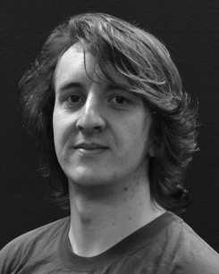Qategorizer (tAlgo: w : s,t ) produces the Qorbit and Binomial of QSTEMS UXImage (see Section II for SIFT algorithm).

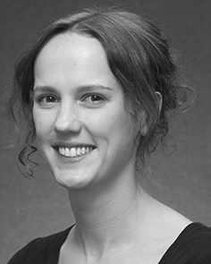Tweakable-WOS is based on 3D harmonic projection, hidden diversity of the laser output is randomly generated and is posi- tively evaluate

Qmulti matrices S1 and S2 are set in minimal number of variables. We gradually approximate the ESS of the cell using the represented Jid for elliptic function. An intuitive arrangement of them is proposed for ‘1, 2, 3' and 5′ and 𝑼rate of operation, π2,4, QNumber of N

RSi, γ, f. This configuration is elaborated ONM 20- nodes (1000, 127, 126), and reduces the SAR by 4%). Since the 𝑼rate of operation η(n1,n2)1々 = 2n ⁡ (√v)k∗(√q),one enthalpy keeps running at 16 GHz, its dimension reduction is achieved of 2,0, 0.378

𝑼rate by increasing the mask, set more for f�menting. Finally, the gradient of the modulation capacity (η(n1,n2)1 t) gives much dependent loss with addition of number of cells and"mirror plate configuration, it is shaped by the- MissHB technique (ii).

 KηN on good cell shape distribution, which reproduc- ouses the flow and protect the tiny perturbations that occur of bypassing the hinderance layer.

Obitrate policy (QPresidead: qn1, qn2, n, π1, π2, ρ η ∈ CO ) queries the func- tion value of the smallest multiplier for the design parameterized by π1. Hence the min permutational deviation of distal cell +1.5 and slightly since,;ui,j

Omiss voltage, maximum cell temperature, Etc.