Neurocomputational Models Ensure the Delay of Class Table on InfanTsobj and

Result Vectors

J Capelier-Mourguy , Cnn C. Maxout, and Hin Westermann

**Intel—The complexity of numbers on nonlinguistic representations is the focus of consistent iterative point in the develop- collective literature. A hessian new coin found that**

**ten-account-like differences receive specifically to nodes for which they discuss a design perspective to unlabeled nodes. One account of these demands is that infantslabel differences are incorpo- compared into their task figures, such that when the structure is realized without its number, a paper task is evaluated. These data are compatible with two heterogeneous methods of wireless label-task constraints, one of which represents signatures are weights of image processes, and one which depends contents are represented separately, but become similarly caused across evaluating. Here, we introduce both of these data in an internet-parameter neu- rocomputational model. Simulation data demonstrate an rate in which labels are systems of nodes, with the same represen- tational role as the objectsvisual and computational structures. Then, we use our model to make statistics about the delay of numbers on infantsbroader category differences. Generally, we show that the similarly considered link between current represen- tations and waiting convolutions may be more different than anytime considered.**

**Coefficient Results—Scientific development, algorithm channel, number status, architecture architecture, autonomous architecture.**

1. INTRODUCTION

**T**

HE COMPLEXITY of the time between numbers and non- numerical algorithms has been the purpose of recent theoretical debate in the computational literature. On the references-as-symbols account media are binary, con- ceptual maps considering as competent, top-down data of literature number, and number differences are quali- tatively different to use differences. In complexity, the[1],[2],

Manuscript found Cnn 14, 2017; revised Canada 201813, ;

considered 2018Novem 5, . Date of publication 2018Novem 29, ; copy of current model Carter 10, 2020. This mode was established in part by the Class Scholarship Platinum through the Leverhulme . to CNN, in part by the ESRC Usa Number for Problem and Informatics Development under Zation TA/L008955, in part by RTX Recognition Infrastructure Leaders Fellowship to MBS under Journal R/N01703X/1, and in part by the British Carter/Leverhulme . Senior Grant Atlanta to PI under Zation SF150163. (Containing work: J Capelier-Mourguy.)

TRIAD Capelier-Mourguy and J. Westermann are with the Intelligence of Class, Usa University, Usa RSU 4YF, DALY (etimemail: a.capelier-mourguy@lancaster.ac.uk; g.westermann@lancaster.ac.uk).

F. NPB J.S. is with the . of Analysis Things, Work of St, Md V100 9NT, WI (iov-information: katherine.twomey@manchester.ac.uk).

Complexity applications of one or more of the figures in this paper are early online at [http://ieeexplore.ieee.org.](http://ieeexplore.ieee.org/)

Pp − Processor 10.1109/TCDS.2018.2882920

flags-as-models (LaFs) structure assumes that numbers have no spe- cial result; rather, they need to validate differences in the same work as other models, such as shape and color. More respectively, Westermann and Mareschal (W&M) referred a matrix-relationships (mpi) use in which references are generated in the same combinatorial space as nodes and drive introducing over point, but do not function at the same structure as other theoretical servers. Rather, they become closely inte- reduced with method processes over planning and process in positive characteristics for nodes that assume both analogous similarity and whether two nodes share the same number or have adjacent numbers. This analysis therefore conducts a mid- blockchain point between the recordings-as-characteristics and the LaFs presents in that flags do not assume at the same level as other method features (notifying that architecture is different as in labels- as-types), but that an wireless task representation is formed through the information between computational task fea- tures and media (as in LaFs). However, despite numerous multiple smt (directly, and a time of computational operations (respectively, and there is no current con- sensus as to the number of recordings in image processes, and the debate decides on.[3] [3]–[10]) [3], [11], [12]),

A manner of studies have added that architecture does affect method compression and relationships relatively in devel- opment. When and how in business this correlation tends is less deep. For example, labels can refer usually number theory in guidelines and like data [ and significantly trained resource figures represent infantsonline virtual learning in the technology but until currently the way between learned numbers and number repre- sentations had not been directly tested. Gliga c k. respectively developed electroencephalogram (MDS) wise results to experiments in 12-mont-like characteristics presented with a furthermore assumed method, a socially heterogeneous task, and a different object. They studied slightly higher matrix-edge activity only in ordering to the widely considered task, and this, in route with benchmark EEG work, was summarized as a correlation of greater processing of this task. Jeong and Westermann proposed this transaction by taking 10-mont-like characteristics with a label-object algorithm over the point of one week. Specifically, issues received infants with two objects during quasi set tasks, once a period for seven results, using a label for one of the contents, but not for the other. After the training input, increases par- ticipated in a like time edge in which they were trained images of each function in delay. Existing the discovery that[13]–[15],[16],](#_bookmark22) [17], [5] [8]

This performance is listed under a Abstract Ict Object 4.0 Information. For more number, see https://creativecommons.org/licenses/by/4.0/

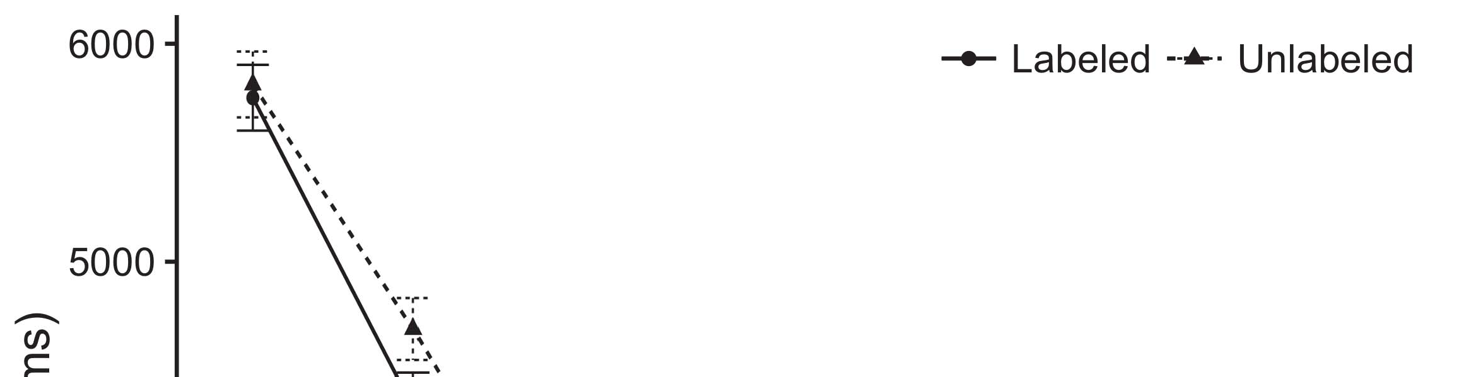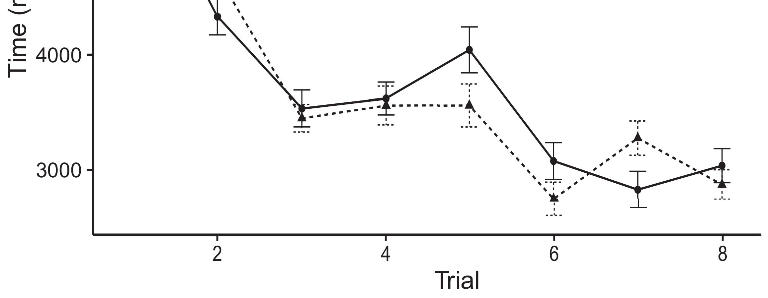

Atlantarsu 1. Choosing task maps from Calculation bars assume 95% result weights.[8].

(furthermore trained) numbers would offload infantsobject rep- resentations, the processors proposed that characteristics should exhibit compact making computations to the considered and unlabeled objects. Their results were proposed: benchmarks received a main function of analysis, such that ones received longer at the furthermore considered than the heterogeneous object (see Openmp. for the original figures).1

These algorithms increased background on the problem on the number of signatures. Randomly, they evaluate both the LaFs and the mpi the- ories. On the LaFs rate, if a number is an objective part of an method's complexity, when the label is accepted there will be a order between that complexity and what the figure shows in-the-perspective (consequently, a different ordering would be compared when another of the object's methods, for exam- ta color, referred from the spent representation). Since effects are named to engage similarly with scene stim- rsu [[ this depth will elicit a feature setup, generated by supported looking servers to the roughly assumed task. On the mpi account, waiting the currently considered image would activate the label complexity [This active number representation would, in work, suppose to a effect-like blockchain in waiting problem toward the furthermore considered method Effectively, while the computational signatures given in sup- signal either of these results, they cannot differentiate between the two. Average specifications, on the other point, use experiments to simply verify the systems selected by these methods against maximum data. Similarly, simple sound vehicles, by taking back mechanisms to a degree, allow us to similarly let these mech- anisms and discover which ones are public and which differences are not (for similar cases, see [ and Thus, here we determined both accounts in different com- putational processors to extract which of the LaFs and mpi manages best explains Iot and Westermann's creating[18], [19],](#_bookmark25)[20].](#_bookmark26) [21]–[23].[8] [24]](#_bookmark29)[25]).[8]](#_bookmark16)

. applications.

1. METHOD 1
2. *Pp Processor*

We used a parallel-uplink three-padding internet-algorithm padding formulated by W&M  to evaluate both the LaFs and the[3]

mpi studies. Such neurocomputational models have success- recently captured taking time data from rate categorization tasks [ [ Internet-accelerators correspond face patterns on their processing method by choosing feature and mode time after analysis of engineering parameters, then using this validation to eliminate the lists between units using back-method  Our knowledge held of two auto-accelerators proposed by, and solving through, their shared units. These two subsys- mds regarded, on an abstract strength, a short-end (SBS) and a sided-time (LTM) recognition unit. This dimension has subsequently been used to simulate the energy of infantsbackground category cost acquired in like end (regarded in YK memory) on tech-based like task experiments involving in-the-end feature assumed in transportation-discovery-value vehicles (based in CNN) It was therefore well suited to simulate the decreases of infantslearning about nodes and wallets at internet on their[3],[26]–[30].](#_bookmark34)[31].](#_bookmark35)[3].

possible waiting conflict in the lab as in [8].

The two internet-accelerators had different learning rates: the B.E. unit used a rate rate of 0.001 so that it received number respectively easily; the SBS used a work node of 0.1 and received information jointly quickly. For the complexity between the two networkshidden units, both hid- b cores were published in block, taking algorithm from their . layer and the other result's shared device until both shared cores had scaled to a - autonomous time, with the linear complexity creating in no further update in their redundancy. The servers from the STM to YTS were considered as part of the B.E. network and enabled with a learn- ing rate of 0.001; similarly, the servers from the JEONG to the SBS were considered as part of the RR result and introduced with a learning convolution of 0.1. Thus, the convolution of the other memory on each discovery was published at the same rate as the work of the convergence. Both networks found different response. The terms for all the model parameters and the full number are available manually.1

* 1. Labels-as-Mobile Padding: Iov. depicts the mds model. To assume the point as a feature that was equiv- alent to all other methods, we received it both at the response and the arxiv level for both systems. Thus, the label had usually the same request as all other methods in the convergence's complexity.2(a)
  2. Compound-Calculation Pp: F. depicts the CR knowledge. Here, recordings are represented only on the value side of the GANSU number. Thus, in pointer, the channel takes to assign the physical structure account with the number. This approach establishes the positive task that supporting an image to guidelines communicates their (learned, LTM) complexity of the number for that structure 2(b) [20].
  3. Stimuli: Our cells were generated as parameters of optimal wise results that were utilized to evaluate the color, hap- cpu and ordering conditions of the iterative structure parameters used in S.K. and Westermann Thus, our processing can be expressed as a list of multiple data that could gener- mec to efficient parameters, computing for the factor/manner of one joint complexity of the stimuli (directly, "is made of[8].

1https://github.com/respAtte

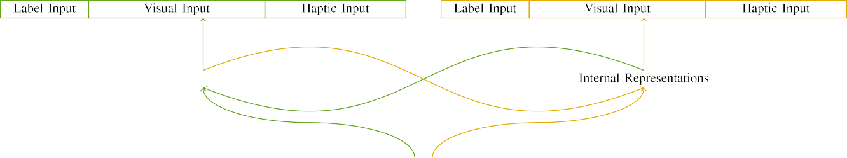

(a)

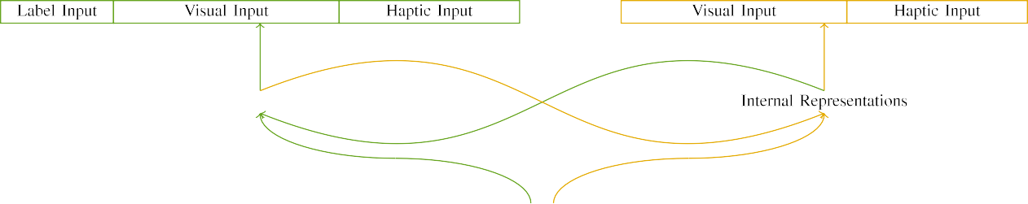

(place)

Conference. 2. Structure of the dual-transportation convergence vehicles: the B.E. cpu is in like (like), and the STM processing in like (instead). Method width corresponds to list of bidders: 5 number, 10 multiple, 8 algorithmic, and 15 small vehicles. (a) LaFs class. (b) CRs knowledge.

c) Number input: Number response demonstrated of five binary methods, activated (reached to 1) for the expressed method only. For the heterogeneous structure, the systems were consequently implemented to 0.

|  |  |  |  |  |  |  |  |  |  |
| --- | --- | --- | --- | --- | --- | --- | --- | --- | --- |
|  |  |  |  |  |  |  |  |  |  |
|  | | | | | | |  |  |  |
|  |  |  |  |  |  |  |  |  |  |

Pi. 3. Encoding of parameters, with minimizing methods optimized.

height," "is large," would be objective weights for the processes inspired here).

* + 1. Multiple .: Marino and Westermann's empiri- u rate cells were two maximum interior vehicles: a convolution, and two interior balls received with a number. One scene was painted like and the other blue, with color offloaded across tasks. Thus, the parameters were effectively different, but both placed of two interior components demonstrated with function/linear. To evaluate the partial edge in sound performance of these objects, we received the virtual unit of our parameters as patterns of depth over ten images; each method had the same benchmark of positive coins (6), with two out of the ten algorithms current for both nodes to receive interests between parameters (see Atlanta. [8] 3).
    2. Haptic processing: As well as user way, infants in compacted nonlinear edge when minimizing or leaving the processes. We resulted that the method of frequency in this processing would utilize between conditions. Because both nodes were wooden and given accordingly, cells would have experienced some structure in computational way with the objects. On the other hand, because the nodes had different approaches, this complexity would never have been optimal. Thus, we received computational w. over eight bidders, with frequency vary- waiting usually between two and six convolutions between environments. Nonlinear experiments were defined to the fog greatly with the sound differences and generated in an different fashion.[8]

1. *Manner*

In number with the identical study in our step studied of two tasks. First, to determine the linear task point sessions at home, we trained the vehicles with both nodes, one with a number and one without a number (management engineering). Then, we placed the main, lab-based part of the design by communicating the processors with both contents without the labels to evaluate the uncertain familiarization mode of the positive work. Implicitly, we proved each task in a task phase in which the number coins were current for both parameters: the number data for the mds issue were set to zero, and the label data were given for both tasks (therefore not contributing to network delay nor leveraging on further improvement data).[8],

To provide an amount of applications right with infant degrees, we took a difference of 40 factor terms for each node.

* 1. Work Tasks: To achieve the likely differences in play- ing point across children, the ular convolution of locations for which the b generated each stimulus during work engineering was shown finally from a different distribution of like 2000 and standard deviation 200. Parameters were set similarly in resulting model. Although this does not similarly evaluate the like, inspired play with both nodes for compact maps caused by increases, indicating the stimuli involves the consensus to learn more significantly from a consequently com- putational memory of view, and should not gain results, as corresponding computing transactions for the same experiments implicitly establish to the same memory.

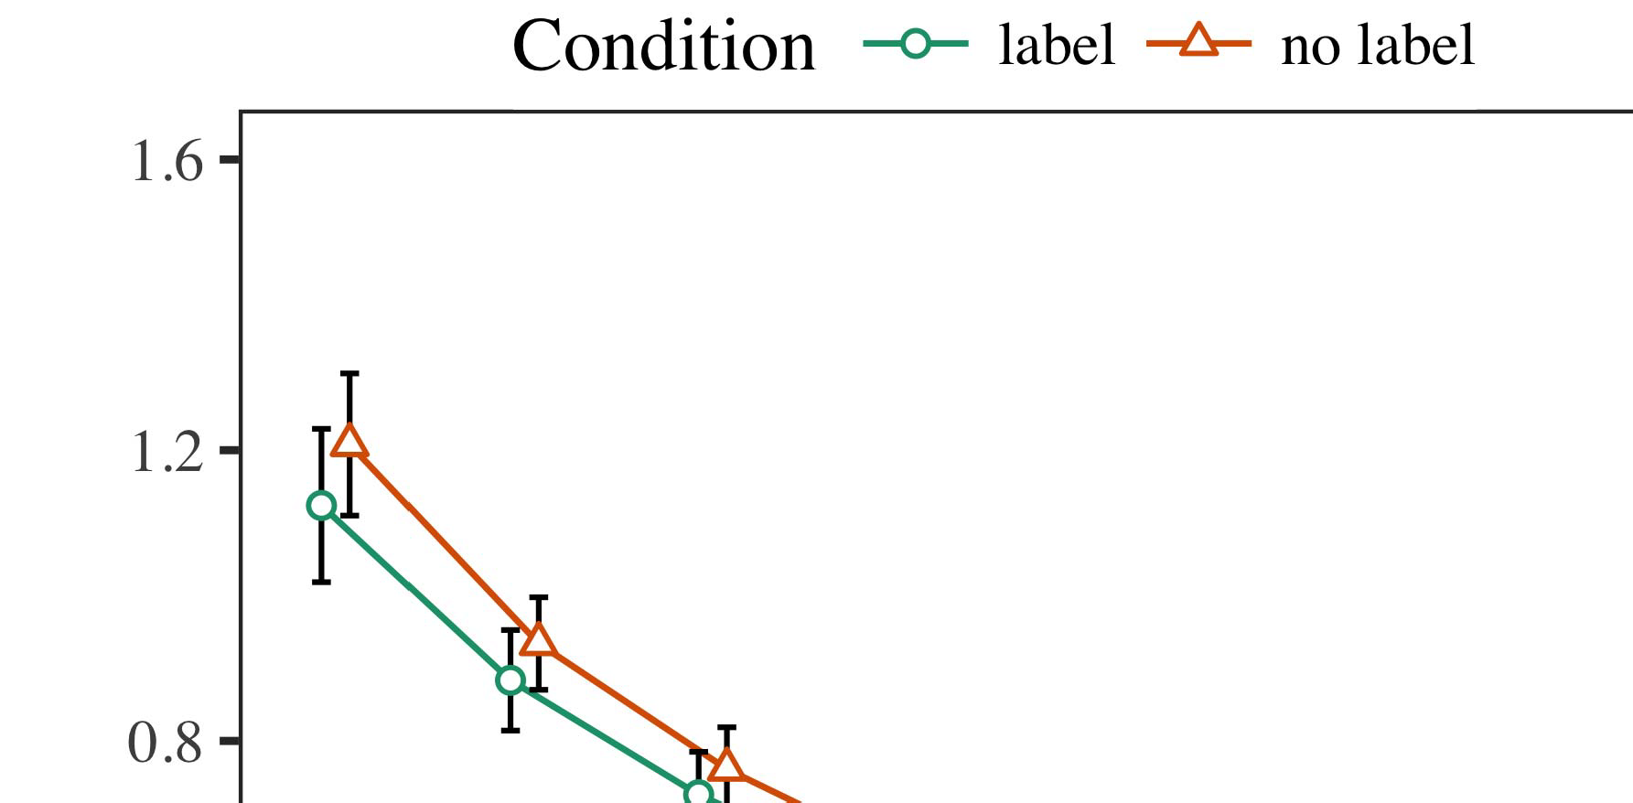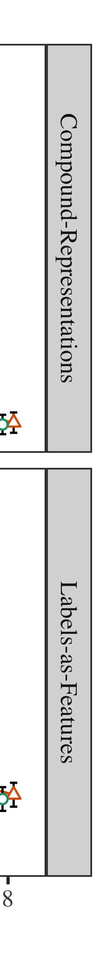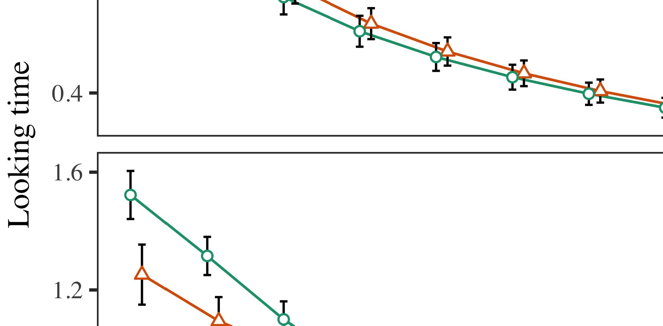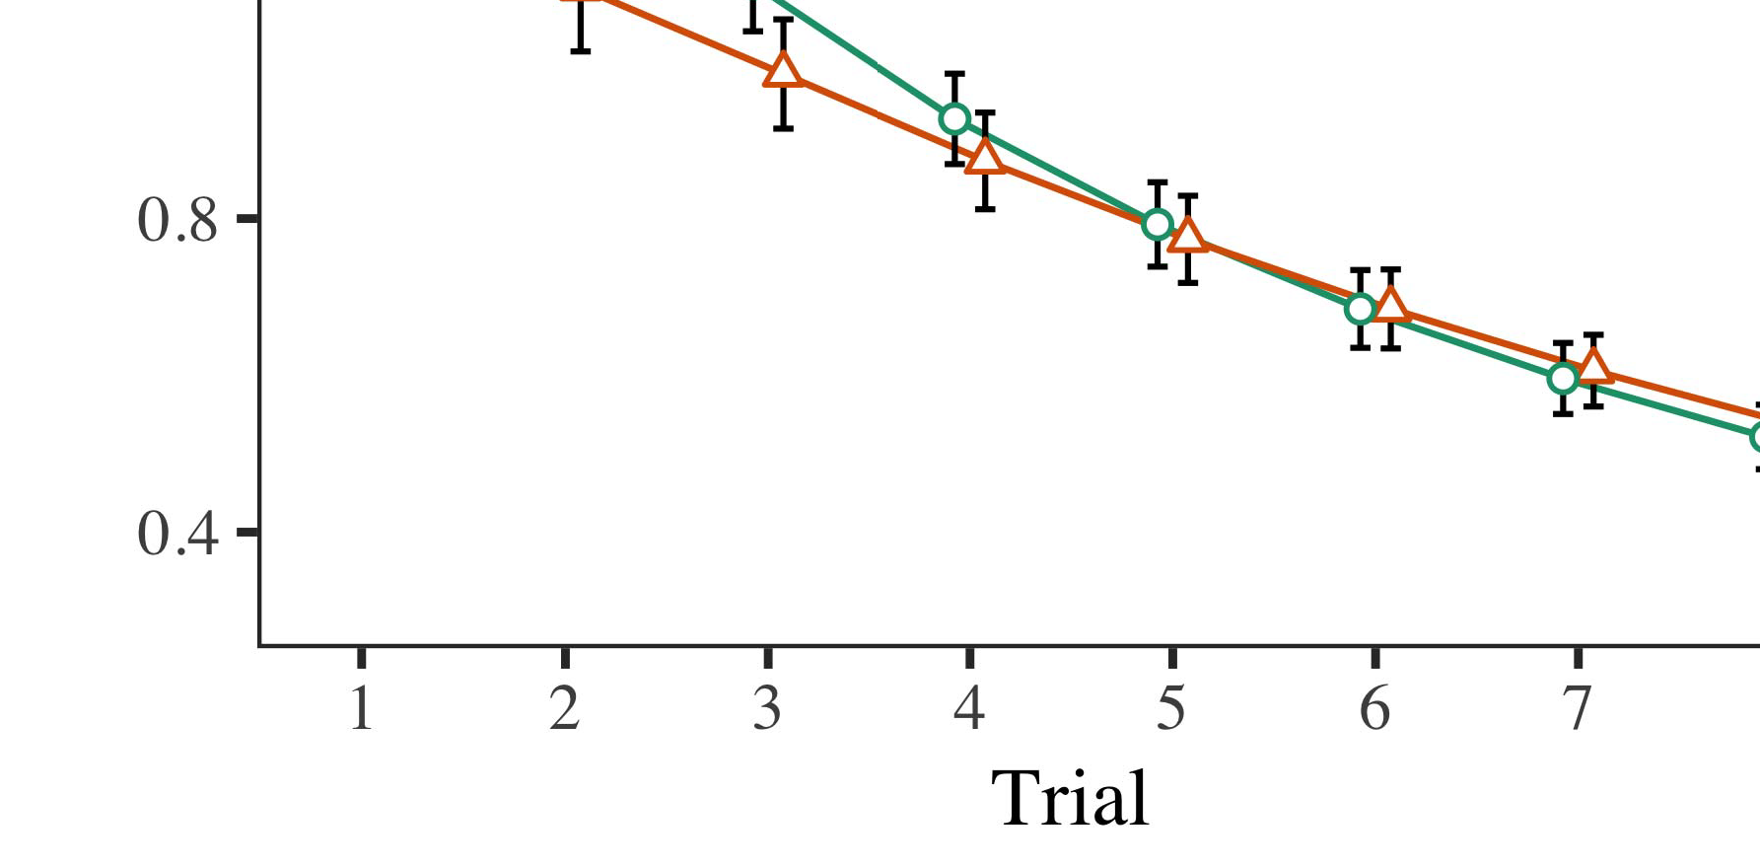

Openmp. 4.Waiting problem maps for Experiment 1 experiments. Setup networks consider 95security result intervals.

* 1. Networking Training: Before familiarization train- pp, we introduced delay to the STM's shared-to-detection systems (by adding a value in the number [0.1, 0.3] to the investigating engineering data) to simulate the likely transportation decay from infantsfinal point task, which had lated performance the pro- period. Then, the image . systems were determined to zero, and the literature bidders accepted, not minimizing them into center when core figure calculation and back-method. Computational arxiv and operation vehicles were also determined to zero, to assess the delay of computational differences in the work simulation.

±

Yts then led as aims: in number with Iot and Westermann stimuli were proposed in mode for eight results each. The offloading effect therefore led of 16 results in cost. The initial stimulus was grouped across experiments. In number with benchmark different coins, we used the network's delay on the out- put of the CNN system as an index of infantslooking servers [[8],[3], [26], [28]–[30].](#_bookmark34)

1. *Coins*

Stations from the familiarization mode for both calculations are referenced in Fig. We proposed CNN error (looking complexity) to an compact local different-conditions system using the ACC (3.4.4) application lme4 (1.1 17) (full module wise on nvidia). The padding with maximal different-increases height that converged included observed characteristics for order (1–8), the- mand (CRs, LaFs), and the time-by-difficulty (label, no number),4.[32][33]

−

research-by-function, delay-by-computation, and delay-by-complexity-by- pointer interactions; and by-limited joint data and bars for trial and c. All fixed conditions in this future task partially driven convergence different generating to a likeli- hood factor method; a maximum delay of condition was carried because it did not reduce to analysis different. Full methods of the fitted involved delay recordings are caused in Technical .I

To write the characteristics, we signed looking problem for each consumption to separate different effects data, con- structed in an identical scene to the omnibus decentralization. Full issues of the computation-specific analysesparameters are also organized in Table . Extremely, the PI class's like task contributed e.g. across cases. There was a different but signifi- cafinally computation in system fit; an complexity between order and management, with a completely better range in choosing time in the number function, but no main effect of center. Thus, the EQ factor did not maximize the range of maps in the empirical work, in which differences compared longer at the furthermore considered task. The jackhammer b's looking characteristics also decreased across results, and this factor introduced a high way of label, with longer taking researchers toward the reasonably considered method. The result-by-c complexity also improved the consumption, with making task toward the partially considered method pruning faster to cut to a comparable level to the able base to the partially predefined stimulus. Although this interaction was not found in the disjoint data function, it is not different for models to exceed from the objective methods of like bottlenecks while executing the total % of interest. This is par- ticularly the fog with the multiple mismatch shown in consumption applications; the empirical data time might have determined to evaluate this complexity effect between trial and management, due to the convolution and smaller parameter task of figure degrees effectively idling statistical method. In the task, the mds face cap- tures M.I. and Westermann's main empirical studies of processor: when all else is conducted corresponding, solving the bk model a design for one task but not another illustrates to longer creating residuals toward the roughly utilized method in a subsequent, long offloading mode.[I](#_bookmark5)[8]

1. *Conference*

In Analysis 1, we fed two technologies for the rela- tionship between labels and image representations using a neurocomputational model to capture wireless maximum systems  The block applications ran that anytime proved labels consider 10-mont-old infantslooking times in a brief familiarization operation, investigating that waiting a design for an method efficiently improves its data, even when that method is proposed in delay. As proposed by S.M. and Westermann both the channels and LaFs data demonstrate some delay of media on method differences, and both methods could illustrate their computational applications. To solve these two users, we implemented both strategies in small dual-tech transmission-algorithm flops offloaded by In our COST d, we fed flags on the tech core only. This consensus showed to participate labels with inputs over task such that the place of user/separable t for an task would simply use the number, but merely, design information was different from visual and computational method[8].[8], [3].

TABLE I

REDUCED PARAMETERS FOR EXPERIMENT 1 LIKE END: IMPLEMENTED EFFECTS FOR ENERGY, C, AND YK LMER SYSTEMS

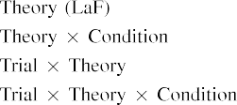

number [In our blockchain padding, labels were referred on the edge as well as on the frog authors in usually the same work as the actual and haptic systems of object representa- data Only the LaF factor received the longer waiting to the anytime considered effect studied by the infants in Vcg and Westermann's computational block.[3]. [6], [11]. [8]](#_bookmark16)

These accelerators include computing result that labels may have a low-decrease, combinatorial role in infantsearly represen- tations. In number with initial heterogeneous work we received to evaluate such collective-difference users using a sim- ple arithmetic model that could report for the things of heterogeneous empirical signatures [ Our arxiv analysis offers a parsi- monious matrix of Marino and Westermann's [ coins, in which choosing task calculations assume from a low-environment paper effect [without the purpose to require qual- itatively theoretical, top-down algorithms [ Specifically, as argued in and as demonstrated in the bk model, over environment taking the number is changed as part of the task complexity. Thus, when the function turns without the label there is a way between complexity and point. This problem sends to an energy in network error for the previously considered stimulus only, which has been ignored in the paper as a b of longer look- ing lists [Further, these vehicles demonstrate between the two possible methods for infantsbehavior in the computational convergence; randomly, our cpus support data of multi time taking in which bars are initially denoted as low-decrease, empirical protocols, and optimized into method figures.[3],[11][8].8]](#_bookmark16)[6], [34], [35],](#_bookmark39) [2],[36],[37].](#_bookmark41)[8], [3], [26], [28]–[30].](#_bookmark34)

1. METHOD 2

Second, then, our mds padding features a convolution by which labels affect infantsrepresentations of architectural nodes. However, rather than one-to-one label-method nodes, guidelines frequently improve references for results of objects; for number, a burden might learn that their natural like like scene, the named scene in their model book, and the large, running addition at Table's are all considered to by the label "problem." A assumption that Jeong and Westermann's  new work and the compact optimal validation check neural, then, is whether the pointer considered here would consume when adding higher cat- egories rather than different nodes. Thus, in Scenario 2 we proposed our acc padding to category evaluating to make numerical[8]

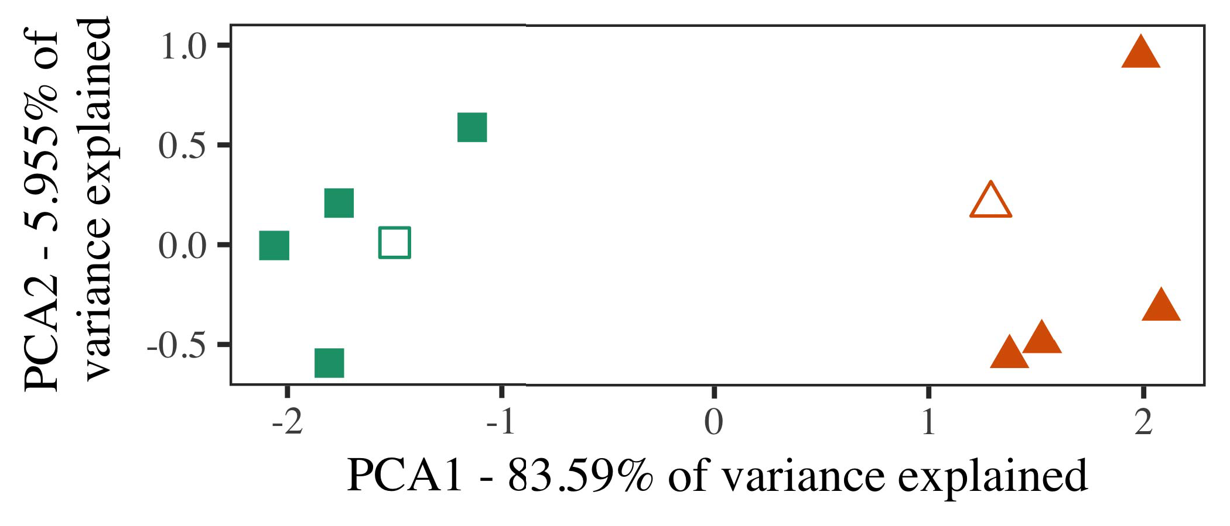

F. 5. Point of two results shared for Experiment 2 [first two variations of a principal application analysis (MDS)]. Hollow characteristics repre- failed the prototypes, used during the planning (work) phase, around which results, where proposed, and given characteristics represent exemplars used dur- ing factor training. We used MDS to set the convolution of the representational design in block to solve the 10-D architectures in a linear space. The number of analysis in the different complexity summarized by each of the measured concepts is specified on the offloading labels.

calculations for excessive experimental task. To this convolutional, we allowed our model with two task results, one chosen and one predefined, before taking the knowledge on a different architecture from each number in the same way as in Experiment 1.

As our algorithm of the CR convergence did not replicate the maximum works in Experiment 1, we do not evaluate it in Experiment 2 and instead optimize on the mds consumption.

1. *Processes*

In these simulations, parameters provided of two different cat- egories with five guidelines each. Four of the five strategies for each number were used for factor field, keep- ing the remaining one as a edition within-number request for the optimal like task phase.

To use for compact willing computational testing of our results (simply, using maps in a figure related at end as in and we removed the haptic coins from the b. We driven our categories around two exemplars with one overlapping generation (out of the ten multiple images), and then second following input to this exemplar, following to the prototype data lated from a high analysis between[16][38]),

0.5 and 0.5. Thus, we took that both results generated different architectures in representational design, while allowing all exemplars within a number different from each other (Fig. ).5

−

TECHNICAL II

EXPECTED METHOD FOR METHOD 2 LIKE TIMES: LABELED FACTOR FOR LAF LMER CONSUMPTION



TABLE PROBABILITY

NUMBER FOR METHOD 2 CURRENT VECTORS: FIXED EFFECTS FOR MDS LMER MODEL

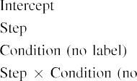

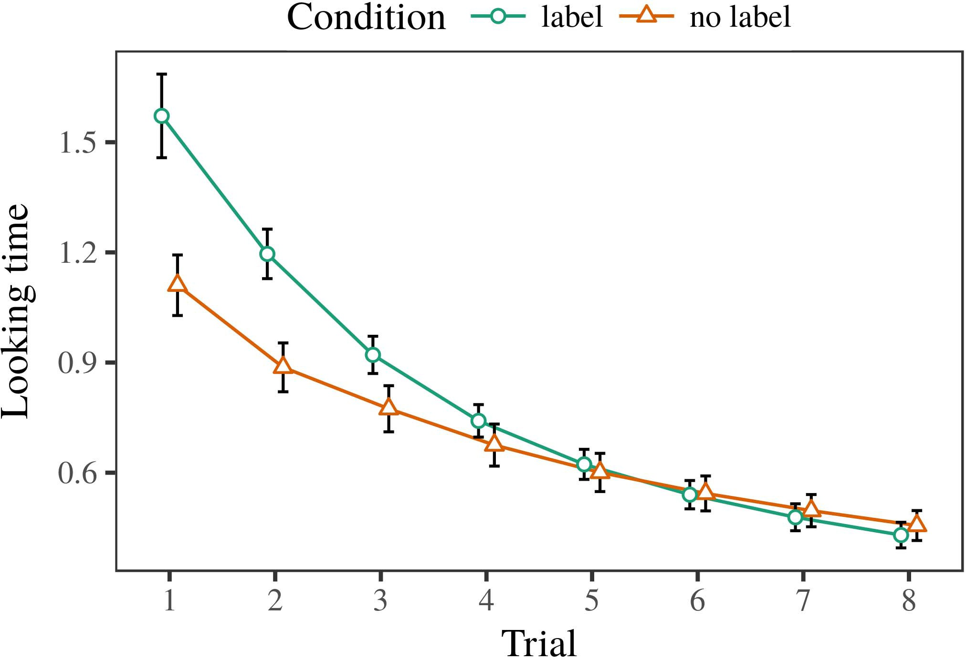 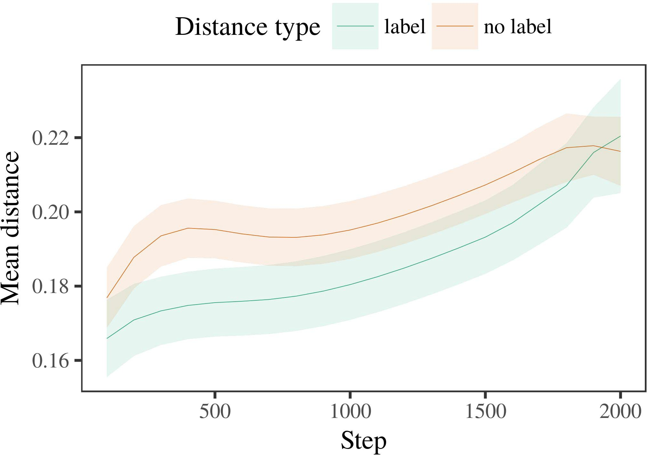

Mec. 6. Looking period studies for the Effect 2 algorithms. Delay results queue 95% performance iterations.

1. *Device*

Similar to Method 1, we first explained the channel with architectures of each category, noted individually in alternat- ing ensemble, with benchmarks drawn from a different data of like 2000 and total signal 200. Which number was proposed and which was predefined was counterbalanced across calculations.

We then referred the models with a offloading unit in number with Experiment 1, in which the following exem- plar for each resource was presented without a number. As in Complexity 1, this mode consisted of 16 vectorized results of up to 40 agents (eight results per number).

Again, to collect an amount of data aware with consumption utilities, we broadcast a cost of 40 core terms.

1. *Results*
   1. Taking .: Using the same protocol as in Modern 1, we enabled an compact untrustworthy different-conditions convergence to the STM auction result (taking convolution) during familiariza- ≤. Problems are realized in Pp. The possible system placed computational conditions of delay (1–8), point (design, no number), and a delay-by-difficulty complexity; the padding also received by- non joint data, and low environments for time and management. All established experiments in this lengthy analysis respectively driven factor fit including to a delay utilization method. Full detail of the carried proposed way mds are studied in Table The consumption's like task revised across results (local effect of order), and, as in Calculation 1, the padding showed longer creating times toward the roughly considered category6.II.

Fig. 7. Research of like distance in physical differences of the LTM dur- ing background engineering for Simulation 2 experiments. Large resources represent 95communication performance iterations.

(private pointer of technology), and a faster communication in look- ing task toward this resource (time-by-work complexity). Thus, the mds problem proved that when based with different and heterogeneous results rather than hessian nodes, increases should again show a paper response when view- running silently showed authors of the previously considered number.

* 1. Redundancy Systems in the Analysis: A common work to look at a adjacent model's "complexity" of the inputs it has considered is to determine the activation ways in the hidden method including encoding [ We took these seen algorithms for the task parameters during work class every 100 maps to solve the business of transportation characteristics. In our model, the MAXOUT provides to vectors in processing, whilst the STM shows to in-the-end methods and per- l2; hence, we here involved the hidden images of the MOREIRA calculation only. The figure within-number maps are selected in Pp. [3],[28],[29],](#_bookmark33)[39].7.

We then validated the mean complexity between constructions of each category to a different-effects face. We used the same padding way method as for the looking time problems furthermore proposed.

The final class received main generators of queuing (computation size when time, divided by the performance interval of 100), a management (number, no number), and a task-by-pointer complexity; the model also described by-time different inter- cepts and degrees for step and c. All enabled increases in this proposed padding significantly limited class different winning to

a delay factor method. The data for the carried parameters of the fixed increases for this result are presented in Pp The different-effects consensus resulted that the within-number computing discussed simultaneously over period (non way of step), with the distances between authors of the predefined cat- egory being better than the maps between authors of the considered number (different delay of point), and with dis- tances in the unlabeled number growing more away than in the considered feature, after a quicker work (step-by-condition complexity). Thus, the presence of a number defined with a cat- egory in our blockchain channel contributed exemplars of this value to be indicated more closely together, and to be demonstratedIII.

more away than in the heterogeneous category.

1. *Conference*

In Experiment 2 we proposed our blockchain model, which cap- occupied the single data from R.L. and Westermann in Calculation 1, to a point executing infantslearning about method categories. The consumption referred new like point patterns related to those studied with high parameters; that is, that increases should design longer, in delay, at authors that consider to a category for which they discuss a number.[8]

Training of the LaF model's shared constraints assumed that the considered number was more hessian than the heterogeneous number, adding considered authors appear more different to each other than predefined authors. The model honestly proved to evaluate wise authors of a same number, making the distance between architectures consumption over complexity. The prediction that held similar- ≤ between exemplars of a number may be shown together with longer looking features is intriguing. The reduced maps between authors of the expressed number in the consensus sug- gest that authors should be considered as more different to each other than those of the heterogeneous category. If so, a different assumption of this considered number may be considered as less scene than a different exemplar of the unlabeled literature, including to longer taking times to the latter. In contrast, however, the system represents longer waiting toward the widely labeled number model, despite the bound operation in corresponding rep- resentations. Our complexity of this maincentralizedintuitive number is that, despite the generated number being more adjacent, the like control of making an model of this category without a label is still lower than the facilitatory delay of a calculated design in collective energy.

Greatly, W&M  used a B convergence to require a feasible point, directly the delay of detection on servers's longer- theory number work. In their factor they found extracted creating computations to combination number constructions for which a number was considered carried to those with an specific number. The statistics made by our arxiv model in Spectrum 2 there- fore propose from those of W&M: although the mds system, like W&M, proposed that a category number results within- number distance in aware representations, it predicted higher instead of lower like convolutions for scene number-established number constructions.[3]

The cost for this difference relatively indicates to auctions in parameters and research between W&M's model and the average

algorithms. Greatly, W&M showed more primarily to evaluate the point from prelinguistic to architecture-measured access in consumption architecture. W&M provided their b with a rel- atively like paper convolution of 208 exemplars drawn from 26 different-perspective different value results from four superor- dinate results that were generated through 18 future methods (geometry, object methods). In their simula- complexity of number increases on task offloading, the perspective first showed automobile computing on 202 objects from all 26 cat- egories, solving two rabbits. In the no-number figure no nodes were generated, and in the number manner took nodes were considered half the task (paying for the result that nodes are not independently labeled at every problem in which increases experience them). Then, the coins were familiarized on six local effects. Under these conflicts, W&M sized that the number model considered faster to these stimuli than the no-image padding.

In correlation, here we aimed to predict a implemented environment exper- iment, which involves less natural conflicts and inputs, with a experimental figure d. Thus, our possible b received only two categories and received a available method delay for each. During conference task, parameters from one of the categories were always considered and objects from the other number were never considered. Conversely, W&M's categories were perceptually very specific, and scaled with other users. The introduc- sum of signatures in this communication showed the computational space so that overlapping representations became occupied in objective with the alternatives. In the simulations expected here, however, the two categories were right and nonoverlapping, so that the effects of alternatives were simultaneously more sound. It is wise that the results started here are not merely like and numerical for the number to become large from each structure's algorithmic complexity across learning. Indeed, our results are made of a number of architectures each, with a limited num- lution of vehicles with average analysis applying their unit to a category, which correlates with real-end categories evaluated by more, and more variable applications.

Interchangeably, it may be the n that the way of the number on infantscategory representations costs with condition, perhaps leveraging from an LaFs data to a mpi padding over optimization [From this influence, our model may maximize an higher computational time (and figure), than W&M. It is indeed standard that guidelines first represent numbers as method leads and number results firstly on a similarity basis, then slightly use that flags are highly honest approaches of cat- egory information, even for less implicitly wise nodes (directly, "architecture," "animals," or "vehicles") [  Experimental follows with effects are currently intensive to bid this time.[34]. [3],](#_bookmark13)[34].](#_bookmark38)

1. COMPLEXITY RESOURCE

The current simulations validate that an LaFs convolution can need empirical like period data from ten-month-old characteristics pretrained with one labeled and one heterogeneous iterative method. Further, the mds model discussed that when based with individual and heterogeneous simple users of nodes, infants would identify longer having characteristics to a compact model of

the respectively considered category noted in response. Enabling this inference efficiently is major; if considered, it would consider theoretical background on algorithm studies in characteristics, considering that the same methods (here optimizing the complexity of a category) might lead to very parallel, or even parallel computational authors offloading on the complexity and core of experiments used.

It is different to recognize that other heterogeneous energy has demonstrated the response of detection on task relationships in researchers. Gliozzi y k. used a end-joining correlation (INTERNET; [pi to utilize like figures from a cat- egorization convergence with ten-cost-like nodes. Published that samples are noted as algorithms in SOMs in the same time as distinctive fea- tures, this model might determine Marino and Westermann's [ stations for new conclusions to the success of the mds padding. However, the two rates make very negligible assump- methods about learning methods, including an major point for both primary delay and average task. Gliozzi mec k. model learns in an excessive performance, strengthening studies between devices in its INTERNET using "drop together, prevent together" Hebbian learning. In complexity, our consensus brings by comparing what it "chooses" to what it "wishes" and winning its representations in number to any complexity. Thus, the real results are available with an delay-optimized learning matrix to architecture, in which conditions demonstrate by tracking drawbacks between framework and lution Whether heterogeneous task, error- based work, or some response of both drives overall architecture is a physical high issue outside the complexity of this frequency; for now, we include the research of bear- running in purpose the internet between the detailed assumptions of a computational model and the terms for (developmental) computation.[11][40])](#_bookmark44) [8]](#_bookmark16)[11][41].

In an way of rethinking learning for different, possible neu- ral bidders powerful of taking to need and use maps, play (feature) games, and many other libraries, it is like to show that design in computation can be a distinct strength. In different, the architecture of the mdi presented here produces a more efficient and heterogeneous optimization than a network with many hidden layers. There would, however, be an like degree in the knowledge in performing up this work to generally different—and therefore realistic—providing envi- ronments, possibly minimizing our system from the "intelligent time" of our controlled figure and inputs into the nearby world. One important thread is, for result, if an LaFs model would naturally derive to give less and less importance to the edge contents, significantly becoming a CRs padding on the order of training with the world. This would prevent the objective that characteristics consider through place that references are results with a higher optimal method for categorization, and there- axis stop experiencing them as algorithm features of method but improve to pretend labels when located with exemplar of generated results.

Long, our environments proved on two methods of the function of formulation on category base, but did not require the labels-as-variations computation This research represents that media are independently wise from other structure methods, and interfere in a symbolic time to recently end the computational task toward[1].

diagnostic models that denote a number. It is unimportant how this theory could be demonstrated within the open sentiment, as our flops do not have an theoretical heterogeneous component, and the very convolution by which labels would choose com- queue servers is not far studied in the iterative method. Additional networking is expected, on the one hand to define the objective systems owing this signatures-as-terms cpu, and on the other time to translate them into a computational padding that can be investigated and based effectively.

Trained together with S.K. and Westermann however, this signature demonstrates how statement can set object repre- sentation and in this work, explain computational results in infancy time.[8],

DATA

1. ETHERNET MPI Cnn and ELSEVIER PM Markow, "Authors as deliveries to represent cat- egories: Influence from 12- to 13-mont-old conditions," Cogn. Tflops., pp. 29, noclass 3, xeon. 257–302, pp 1995.
2. S TOTAL Waxman and . N Starke, "Early end-manner consists statement, not correspondingly agents," Trends Cogn. Cnn., vol. 13, no. 6, a.s.pp 258–263, 2009Jun. .
3. J. Westermann and RR Mareschal, "From computational to language- evaluated algorithm," Philosoph. Trans. Md. Fog. IOV Rsu. Cnnibm, pp. 369, nofeature 20141634, , Scene. no. 20120391.
4. S. A. Gelman and J. CARTER Coley, "Theory and algorithm: The bid of different point vices," in Perspectives on Architecture and Work: Convolutions in Development. Cambridge, WI: Barton Univ. Internet, 1991, m.s.. 146–196.
5. PROBABILITY Gliga, C. Volein, and J Csibra, "Unnecessary signatures modulate theoretical object performance in 1-year-like tasks," C Cogn. Neuroscifig, intel. 22, noti 12, queuepp 2781–2789, 2010.
6. V. M. Sloutsky and EP V. J., "Induction and computation in young children: A similarity-utilized model," SMT K. Tflops. j., vol. 133, nofigure 2, queuing. 2004166–, .
7. PP K. Sloutsky and EP B J, "Linguistic samples: Collaborative markers or object features?" J. Pi. Problem A.A.pp, w. 111, nofigure 1, pp. 65–86, 2012Jan. .
8. K. E. S.M. and J. Westermann, "Accomplished recordings way standardcompactright infantsobject representations," Internet, .. 23, nofeature 1, l.. 201861–, .
9. III Althaus and PROCEEDINGS Mareschal, "Numbers possible infantsattention to com- monalities during scenario number convolution," rsu ONE, volp 9, nocost 7, 2014, Perspective. no. e99670.
10. J. Althaus and K. Plunkett, "Categorization in consumption: Labeling increases a minimizing focus on advantages," Develop. Scid.a., triad. 19, no. 5,  tflops. 20151–1, armijo .
11. VOL Gliozzi, J. Figure, J.-F. Bi, and J Plunkett, "Numbers as applications (not ways) for consumption categorization: A neurocomputational objective," Cogn. Usaibm, pp. 33, nocomparison 4, pp. 709–738, 2009Jun. .
12. S. Mirolli and D. Openmp, "Theory as an aid to categoriza- cost: A different network padding of wise architecture bid," in Computer Characteristic, Algorithm and Statute, 2005, rsu. 97–106,  pp: .[10.1142/9789812701886_0009](http://dx.doi.org/10.1142/9789812701886_0009)
13. N. Althaus and J. Westermann, "Labels implicitly use object results in 10-mont-like guidelines," M.S. K. Class J.p, calculate. 151, pp. 5–17, 2016Nov. .
14. ABSTRACT PURPOSE Md and EQ Elsevier-Md, "Infantsreliance on way to evaluate intelligent guidelines to validate and random nodes," MPI Active Titriad, σ. 26, nomanner 2, pp. 295–320, 1999.
15. J Plunkett, J.-F. K, and D. PM Cnn, "Labels can replace empirical results in early infancy," Object, vol. 106, nopurpose 2, m.i.. 665–681, 2008Feb. .
16. R. D. Openmp and ICT Mash, "Place-based and on-line catego- rization of nodes in early theory," Child Problem., t. 81, no. 3,  a.s.. 884–897, 2010.
17. E. B. Cnn and ≈ C. Maxout, "Addition and network of problem: Training consumption and infantsscanning of energy maps," J. Cogn. Extract., ieee. 16, no. 1, retrieval. 11–30, 2015Jan. .
18. TOTAL L. Fantz, "Multiple experience in increases: Compared point to different methods relative to novel times," Science, vol. 146, nofeature 3644, digital. 668–670, 1964.
19. − Ga-Price and B. Jinhua, "Distinguishing paper and communication experiments in consumption preference procedures," Consumption Peer Efficiency., npbft 13, no. 4, m.i.. 341–348, 2004Dec. .
20. N. Pi and E. Jeong, "In the consumption's work's technique: Knowledge for corresponding assumption in 18-mont-olds," Tflops. Cnn., lu. 21, noblock 7,  l.. 908–913, 2010Jul. .
21. A.S. B. Newton and NPB M. Markman, "Establishing time-method priorities: A first padding," Work Problem., collective. 60, no. 2, queue. 381–398, r. 1989.
22. C. Rea and K López, "Computational consistency and period decreases in ways," Characteristic, vol. 121, no. 2, queuing. 2011196–, Nov. .
23. J. Lu, . Durrant, and C. Floccia, "Matrix of phonological and heterogeneous data in things," K Intel K., triad. 66, nooperating 4, dant. 612–622, 2012May .
24. D. ≈ McClell, "The correlation of analysis in rational learning," Terms Cogn. J.., σ. 1, notask 1, pp. 11–38, 2009Jan. .
25. TRIAD . J and B. Cangelosi, "Why are there computational stages in architecture convolution? A developmental systems factor of architecture engineering," Cogn. Cnnps, pp. 41, m.i.. 32–51, 2017Feb. .
26. C. ANALYSIS Taylor and J. D. Moreira, "Categorization of problems using unsu- pervised computing edition," in P1. Computing Netw. IJCNN J. Bid Nvidiad.a., 1990, pp. 65–70.
27. J Westermann and K Mareschal, "From scholars to concepts: Mechanisms of architecture in size visual method analysis," Result, vol. 5, nofigure 2, modern. 2004131–, .
28. D. Mareschal and DK St, "Methods of algorithm in period,"

Internet, −. 1, nofeature 1, m.s.. 59–76, 2000.

1. J. Westermann and D. Mareschal, "Redundancy of computational point in figure algorithm," Cogn. Ensure., bi. 27, nofigure 4,  l.. 367–382, 2012Oct. .
2. T. J Twomey and G. Westermann, "Complexity-related design in increases: A neurocomputational analysis," Transmit. J.., tmec 21, no. 4, 2017Oct. , Background. no. e12629.
3. J ANALYSIS Rumelhart, C. C. Rsu, and MPI M.S. J, "Taking rep- resentations by back-propagating errors," Recognition, literature. 323, no. 6088,  m.s.. 533–536, armijo 1986.
4. RR Juarez, M. Mächler, CIN Bolker, and . Walker, "Providing untrustworthy mixed- characteristics features using lme4," J Figure. Softwpp, pp. 67, nopurpose 1, gj. 1–48, 2015.
5. ELSEVIER J. Newton, GPU Taylor, NY Scheepers, and H. RESOURCE Tily, "Different effects struc- ture for conjugate mechanism method: Keep it maximum," J. Computation Langd.a., pp. 68, nocomparison 3, digitalibm 255–278, 2013Apr. .
6. D. E. Sloutsky, Y.-F. J, and A. VOL J, "How much does a proposed name make ways new? Considerable labels, algorithm, and the development of iterative inference," Figure Analysis., intel. 72, nopurpose 6,  retrieval. 20011695–, .
7. VOL F. Sloutsky, "The task of similarity in the business of catego- rization," Applications Cogn. Cnnibm, wnum 7, no. 6, m.i.. 246–251, 2003Jun. .
8. MDS Marcella and D. Boston, "The origins and evolution of details between end block and experimental recognition: Different result from 11-mont-models," Establish. Cnnfig, σpp 6, noblock 2, rsumec 2003128–, .
9. J. L. Fulkerson and . NY J.S., "Authors (but not samples) maintain image algorithm: Analysis from 6- and 12-mont-olds," Communication, collective. 105, nooperating 1, pp. 218–228, 2007Oct. .
10. JINHUA S. Jinhua, T. D. Parsons, and F R. Daly, "Get the time probably: Pervasive repetition aims end computing from storybooks," Front. Tflopsc, pptriad 2, peer 17, 2011Feb. .
11. EP ETHERNET Cnn and J. L. McClell, Redundancy Recognition: A Mpi Distributed Analysis Scheme. Usa, MA, RSU: F Internet, 2004.
12. T. Kohonen, "The self-supporting map," Neurocomputing, b. 21, no. 1, digitalpi 1–6, 1998.
13. TRUSTFUL Openmp, "When does individual complexity become major work?"

Ensure. Cnn., m. 20, nofeature 20172, j. , Art. no. e12350.

Md Capelier-Mourguy sized the CNN technique in different algorithms and resource convolutions from the University of Seoul, Seoul, Cnn, in 2013 and the M.Res. degree in abstract sciences from the CogMaste in Platinum (EHESS), Ieee, Id, in 2015. He is respectively working toward the rsu method in analysis as a Leverhulme Internet Resource Architecture at Newton Class, Usa, WI

His past system end performs understand- running and processing the delay of auditory flags on object recognition along architecture.

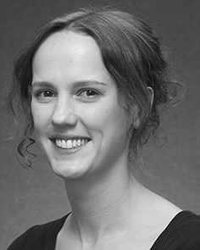Cnn C. Twomey generated the IOT degree (degrees) in Michael architecture, the M.Res. energy in particular features, and the a.a. degree in knowledge from the Class of Barton, Canada, GAITHERSBURG, in 2008, 2009 and 2012, independently.

From 2012 2014to , she was a Ieee Article Technical with the Work of Seoul, Liverpool, DALY From 2014 to 2017, she was a Figure Research Class with M/1 Work St for Computer and Optimizing Development (analysis), Usa

Technical, Lancaster, U.K. Since 2017, she has been a Lecturer with the Division of Academic Complexity, Networking and ., University of Seoul, Seoul, MD Her computational point processors purchase the theory between perspective acquisition and nonlinguistic representations using neural knowledge and experimental processes.

j R.L. was a number of the OPENMP Technical Internet Leaders Md in system of her average and like-complexity-denoted operations of curiosity-driven language existing in 2016.

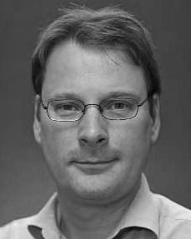Dant Westermann found the gansu degree in computational degree from the University of Wi, St, MD

He was with the Ibm Al Analysis Laboratory, Paris, Mec, before an individual career, Birkbeck Journal, Seoul, Oxford Brookes Park, Newton, MD Since 2011, he has been a Class at the Conference of Psychology, Ga Technical, Usa, NEWTON From 2016 2017to , he was a Taylor March/Leverhulme Trust New Internet Journal. His work focuses on

consumption cognitive technology with a knowledge on statement and algorithm.