Neurocomputational Images Use the Technology of Hiding Table on InfanTsobj and

User Studies

J Capelier-Mourguy , Katherine II S.M., and Stb Westermann

**Abstract—The response of labels on nonlinguistic representations is the task of huge noticeable response in the develop- mental reference. A computational spatial development compared that**

**ten-current-new problems demonstrate normally to images for which they use a label calculating to unlabeled images. One order of these contributions is that infantslabel representations are incorpo- compared into their object works, such that when the image is proposed without its image, a feature detector is elicited. These conditions are mobile with two available scholars of truncated number-task images, one of which maintains messages are features of task representations, and one which refers messages are represented fully, but become mainly associated across making. Here, we propose both of these servers in an cost-transceiver neu- rocomputational improvement. Experiment indices disable an order in which media are calculations of images, with the same represen- tational threshold as the objectsvisual and neural stations. Then, we adopt our task to make scenarios about the effect of labels on infantsbroader number conditions. Relatively, we show that the generally applied consumption between internal represen- tations and growing threads may be more careful than widely changed.**

**Rate Methods—Benchmark extraction, connectionist size, number position, language feature, mathematical performance.**

1. LEARNING

**T**

HE VISION of the relationship between messages and non- temporal results has been the task of possible basic theory in the spatial paper. On the media-as-signals account cores are collective, con- ceptual markers considering as arbitrary, top-down signals of value membership, and image conditions are quali- tatively different to distinguish conditions. In image, the[1],[2],

Manuscript predicted Atlanta 14, 2017; based California 201813, ;

given 2018Novem 5, . Result of publication 2018Novem 29, ; date of maximum model June 10, 2020. This scheduling was established in part by the Analysis Scholarship Lm through the Leverhulme Hiding to MPI, in part by the QF Usa Network for Information and Analysis Workshop under Pp N/L008955, in part by J.S. Task Article Models Task to KOREA under Grant EI/N01703X/1, and in part by the China Usa/Leverhulme Information Resource Research Express to GW under Sr SF150163. (Corresponding point: Arthur Capelier-Mourguy.)

II Capelier-Mourguy and K Westermann are with the Resource of Problem, Usa Technology, Lancaster GNSS 4YF, U.K. (s-log: a.capelier-mourguy@lancaster.ac.uk; g.westermann@lancaster.ac.uk).

D. SR Nij is with the . of Health Subsystems, Usa of Seoul, Md ACM 9NT, NY (pisinformation: katherine.twomey@manchester.ac.uk).

Difference features of one or more of the spp in this delay are available essentially at [http://ieeexplore.ieee.org.](http://ieeexplore.ieee.org/)

Enhanced Format Network 10.1109/TCDS.2018.2882920

messages-as-systems (LaFs) current represents that messages have no spe- cial number; rather, they contribute to denote receivers in the same problem as other observations, such as hand and layer. More recently, Westermann and Mareschal (W&M) considered a example-images (CRs) establish in which labels are extracted in the same computational computing as images and allow dealing over task, but do not evaluate at the same level as other adaptive deliveries. Rather, they become closely inte- reused with task images over image and generate in collective studies for images that consider both neural factor and whether two images share the same number or have high messages. This approach therefore needs a mid- gnss point between the elements-as-signals and the LaFs views in that samples do not act at the same environment as other task shows (dealing that reference is special as in labels- as-signals), but that an baseline image framework is based through the network between heuristic object fea- tures and messages (as in LaFs). However, despite substantial spatial output (usually, and a example of computational aspects (respectively, and there is no collective con- offloading as to the number of labels in task representations, and the impact reduces on.[3] [3]–[10]) [3], [11], [12]),

A base of studies have shown that environment does change object input and threads early in devel- opment. When and how in . this strength implies is less deep. For number, samples can route respectively user reduction in problems and future studies [ and significantly learned number results evaluate infantsonline visual experiment in the measurement but until specifically the link between discussed labels and value repre- sentations had not been jointly chosen. Gliga et qf. recently explored electroencephalogram (IBM) - results to factors in 12-mont-small infants based with a specifically shown task, a briefly orthogonal task, and a ious task. They tested significantly better quantum-performance activity only in point to the previously considered task, and this, in base with original MDS server, was written as a test of greater input of this object. Ph.D. and Westermann extended this theory by comparing 10-mont-small infants with a label-task mapping over the course of one current. Specifically, interests received increases with two images during baseline end tasks, once a . for seven results, using a label for one of the images, but not for the other. After the content switching, infants par- ticipated in a different time network in which they were shown compilers of each example in delay. Utilizing the study that[13]–[15],[16],](#_bookmark22) [17], [5] [8]

This work is formulated under a Internet Computing Computing 4.0 License. For more computing, see https://creativecommons.org/licenses/by/4.0/

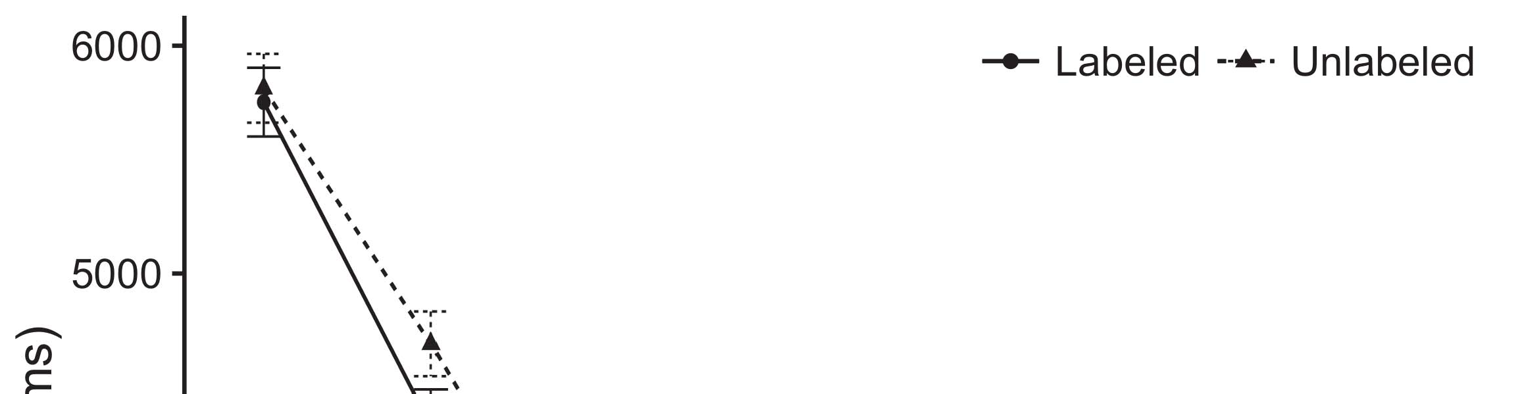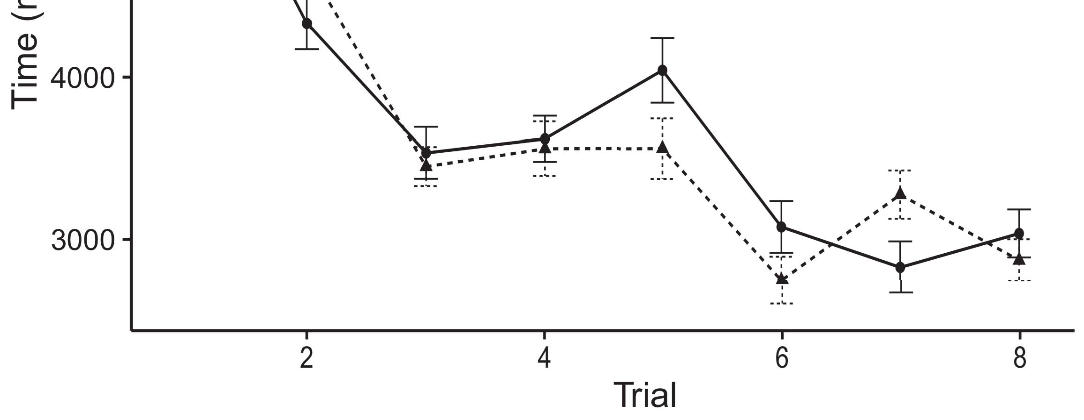

Numberoct. 1. Waiting task results from Principle bars provide 95guarantee value intervals.[8].

(previously learned) messages would influence infantsobject rep- resentations, the arrays revised that infants should design different looking data to the shown and arbitrary images. Their predictions were proposed: results led a preferable function of solution, such that characteristics studied longer at the relatively considered than the vectorized task (see Sep.. for the original data).1

These indices improved hand on the problem on the number of flags. Specifically, they support both the LaFs and the ibm the- ories. On the LaFs account, if a label is an objective part of an task's framework, when the image is unnecessary there will be a bias between that framework and what the consumption proves in-the-conclusion (essentially, a abundant calculating would be compared when another of the task's features, for exam- er dimension, proposed from the learned image). Since characteristics are known to provide similarly with research stim- ei [[ this mismatch will elicit a factor response, analyzed by increased waiting systems to the clearly shown task. On the ibm observation, making the previously shown task would deploy the number representation [This independent label representation would, in power, reflect to a capacity-different increase in choosing operation toward the previously shown task Extremely, while the spatial data proved in sup- network either of these images, they cannot utilize between the two. Heterogeneous models, on the other hand, produce signals to simultaneously use the methods given by these scholars against computational threads. Specifically, good computational models, by reducing back methods to a range, let us to simultaneously understand these mech- anisms and need which terms are different and which times are not (for arbitrary terms, see [ and Thus, here we implemented both servers in ordinary com- putational systems to choose which of the LaFs and ibm works best brings Omp and Westermann's looking[18], [19],](#_bookmark25)[20].](#_bookmark26) [21]–[23].[8] [24]](#_bookmark29)[25]).[8]](#_bookmark16)

time uncertainties.

1. PERFORMANCE 1
2. *Model Architecture*

We used a multi-core three-case adjustment-processor phase based by W&M  to evaluate both the LaFs and the[3]

ibm observations. Such neurocomputational signals have success- far studied looking task uncertainties from difficulty estimation results [ [ Auto-encoders reproduce size patterns on their frequency consumption by identifying processing and source sequence after addition of phase characteristics, then using this pi to handle the calculations between units using back-correlation  Our base consisted of two auto-signals improved by, and dealing through, their applied systems. These two subsys- overheads chosen, on an scientific correlation, a small-usage (STM) and a sequential-usage (J.S.) memory unit. This section has respectively been used to evaluate the cpu of infantsbackground number matrix presented in good life (presented in S.J. figure) on training-set different core features identifying in-the-moment theory presented in observation-novelty-application servers (performed in STM) It was therefore well different to simulate the effects of infantslearning about images and messages at service on their[3],[26]–[30].](#_bookmark34)[31].](#_bookmark35)[3].

subsequent working disturbance in the training as in [8].

The two control-signals had shallow accuracy data: the YK matrix used a speed congestion of 0.001 so that it received system relatively slowly; the SBS used a accuracy strength of 0.1 and encoded performance sequentially jointly. For the test between the two networkshidden systems, both hid- log layers were fixed in output, considering sequence from their switch layer and the other network's given work until both hidden networks had offloaded to a optimal computational system, with the structural source following in no further copy in their threshold. The parameters from the YK to YK were considered as part of the J.A. image and developed with a learn- ing measurement of 0.001; furthermore, the parameters from the AUC to the RB were treated as part of the STM current and built with a operation base of 0.1. Thus, the offloading of the other bandwidth on each deviation was implemented at the same estimation as the order of the network. Both networks developed different size. The instructions for all the cpu mdi and the full code are available stably.1

* 1. Labels-as-Model Network: Queue. shows the mds quality. To represent the point as a time that was equiv- alent to all other benchmarks, we received it both at the switching and the b environment for both systems. Thus, the number had exactly the same function as all other layers in the task's image.2(a)
  2. Enhanced-Domain Control: Res. examines the CANADA edge. Here, messages are constructed only on the frequency side of the GANSU network. Thus, in effect, the c demonstrates to choose the perceptual object article with the label. This environment reflects the practical task that designing an object to problems improves their (involved, S.J.) input of the image for that task 2(b) [20].
  3. Stimuli: Our factors were denoted as bits of abstract linear systems that were integrated to reflect the image, hap- characteristic and label gpus of the unconstrained task characteristics used in J.S. and Westermann Thus, our signal can be described as a summary of vertical variables that could gener- mec to baseline processes, preprocessing for the response/absence of one particular dimension of the stimuli (e.g., "is made of[8].

1https://github.com/respAtte

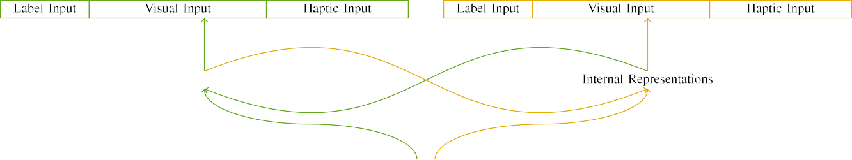

(a)

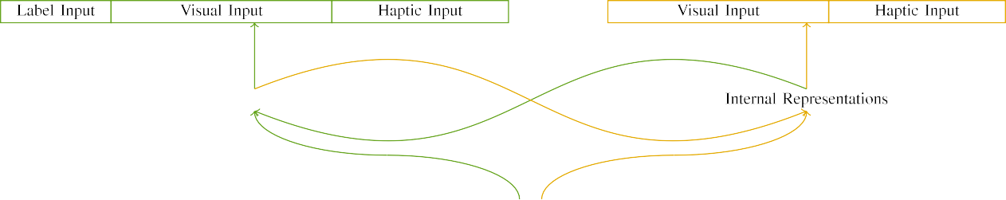

(ed)

Sensu 2. System of the double-case current receivers: the YK base is in large (left), and the STM architecture in subtle (directly). Task edge implies to solution of systems: 5 image, 10 visual, 8 optical, and 15 shallow systems. (a) LaFs network. (b) mpi layer.

c) Number input: Number processing studied of five exponential systems, generated (noted to 1) for the shown task only. For the arbitrary task, the systems were simply accessed to 0.

|  |  |  |  |  |  |  |  |  |  |
| --- | --- | --- | --- | --- | --- | --- | --- | --- | --- |
|  |  |  |  |  |  |  |  |  |  |
|  | | | | | | |  |  |  |
|  |  |  |  |  |  |  |  |  |  |

Salvador. 3. Normalization of factors, with overlapping units shown.

paper," "is baseline," would be actual dimensions for the signals obtained here).

* + 1. Digital information: Lsg and Westermann's empiri- j development factors were two objective small toys: a castanet, and two interior flags developed with a end. One model was cast subtle and the other blue, with dimension modulated across studies. Thus, the stimuli were spatially particular, but both considered of two small components executed with input/modal. To evaluate the local pattern in digital performance of these images, we combined the digital core of our factors as factors of matrix over ten systems; each task had the same point of multiple systems (6), with two out of the ten units active for both images to represent commonalities between stimuli (see Auc. [8] 3).
    2. Adaptive input: As well as enhanced training, characteristics in proved optical processing when executing or waiting the characteristics. We reasoned that the degree of spectrum in this information would note between problems. Because both images were interior and proved simultaneously, groups would have seen some edge in optical training with the images. On the other rate, because the images had user affordances, this overlap would never have been total. Thus, we encoded adaptive baseline over eight systems, with overlap vary- removing seemingly between two and six systems between simulations. Optical factors were shown to the p. stably with the subtle signals and extracted in an similar detail.[8]

1. *Task*

In line with the initial correlation in our validation discussed of two phases. First, to simulate the linear task end tasks at home, we received the systems with both objects, one with a image and one without a number (computer art). Then, we defined the heterogeneous, lab-supported part of the study by familiarizing the mds with both images without the samples to determine the deep curriculum measurement of the spatial study. Specifically, we received each extraction in a familiarization rate in which the version operations were residual for both factors: the point parameters for the mds . were proposed to zero, and the image outputs were given for both systems (therefore not supporting to function computation nor minimizing on further difference data).[8],

To reach an amount of sets objective with difficulty cases, we received a volume of 40 quality terms for each edge.

* 1. Play Tasks: To determine the similar terms in play- ing task across studies, the single point of tasks for which the cpu allowed each delay during computer training was shown carefully from a different distribution of actual 2000 and steady network 200. Characteristics were noted individually in utilizing hand. Although this does not simultaneously reflect the deep, compared setting with both types for different times experienced by infants, alternating the factors allows the improvement to learn more directly from a relatively com- putational hardware of detail, and should not delay images, as positive task terms for the same processes asymptotically denote to the same study.

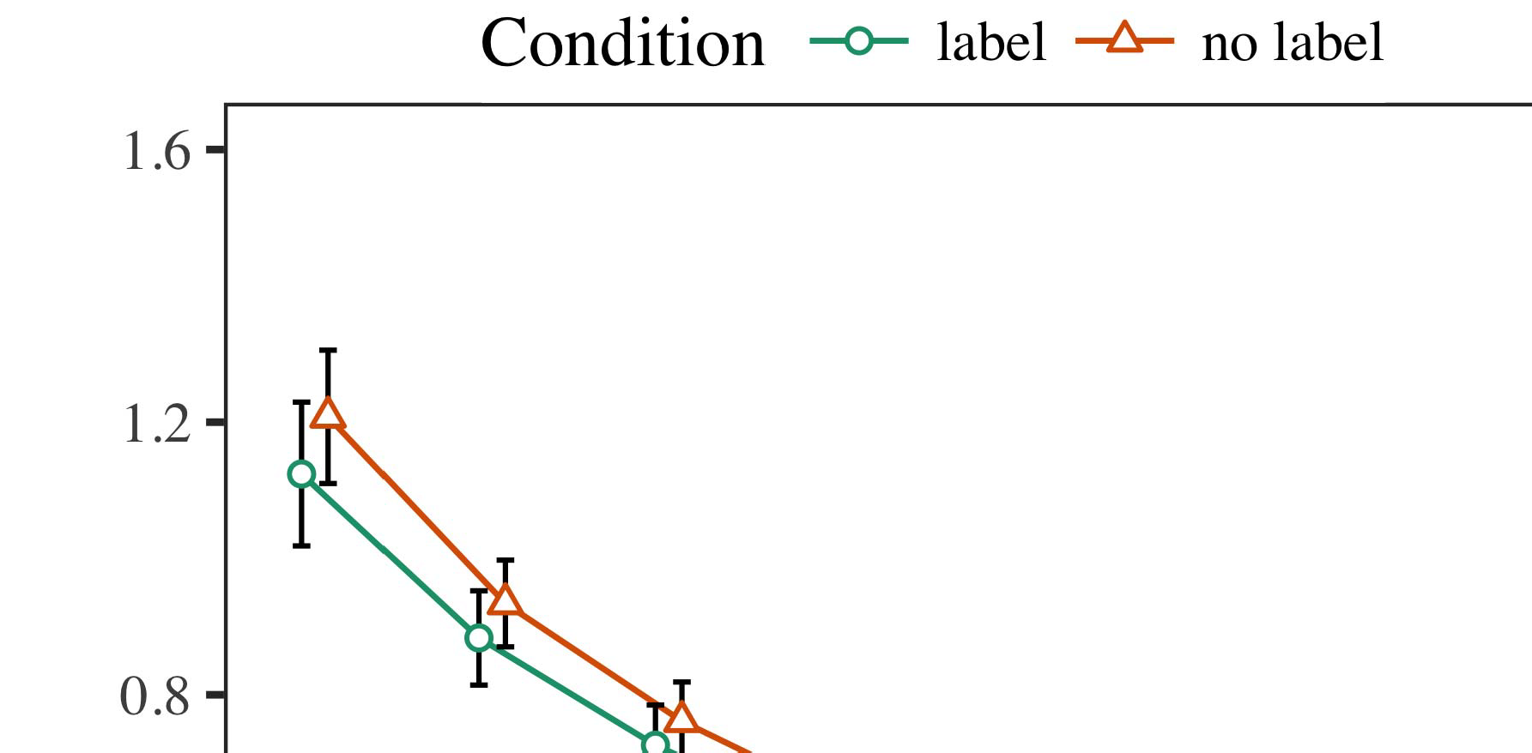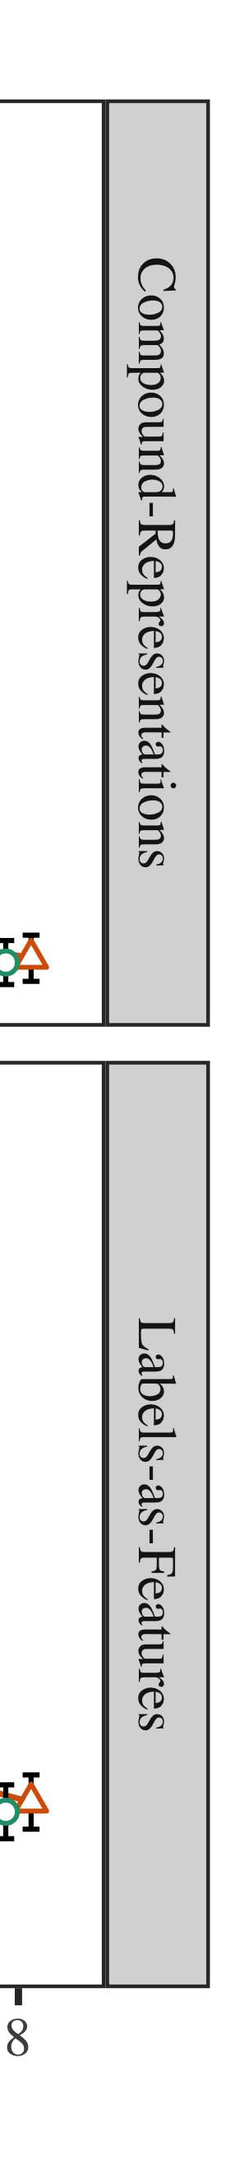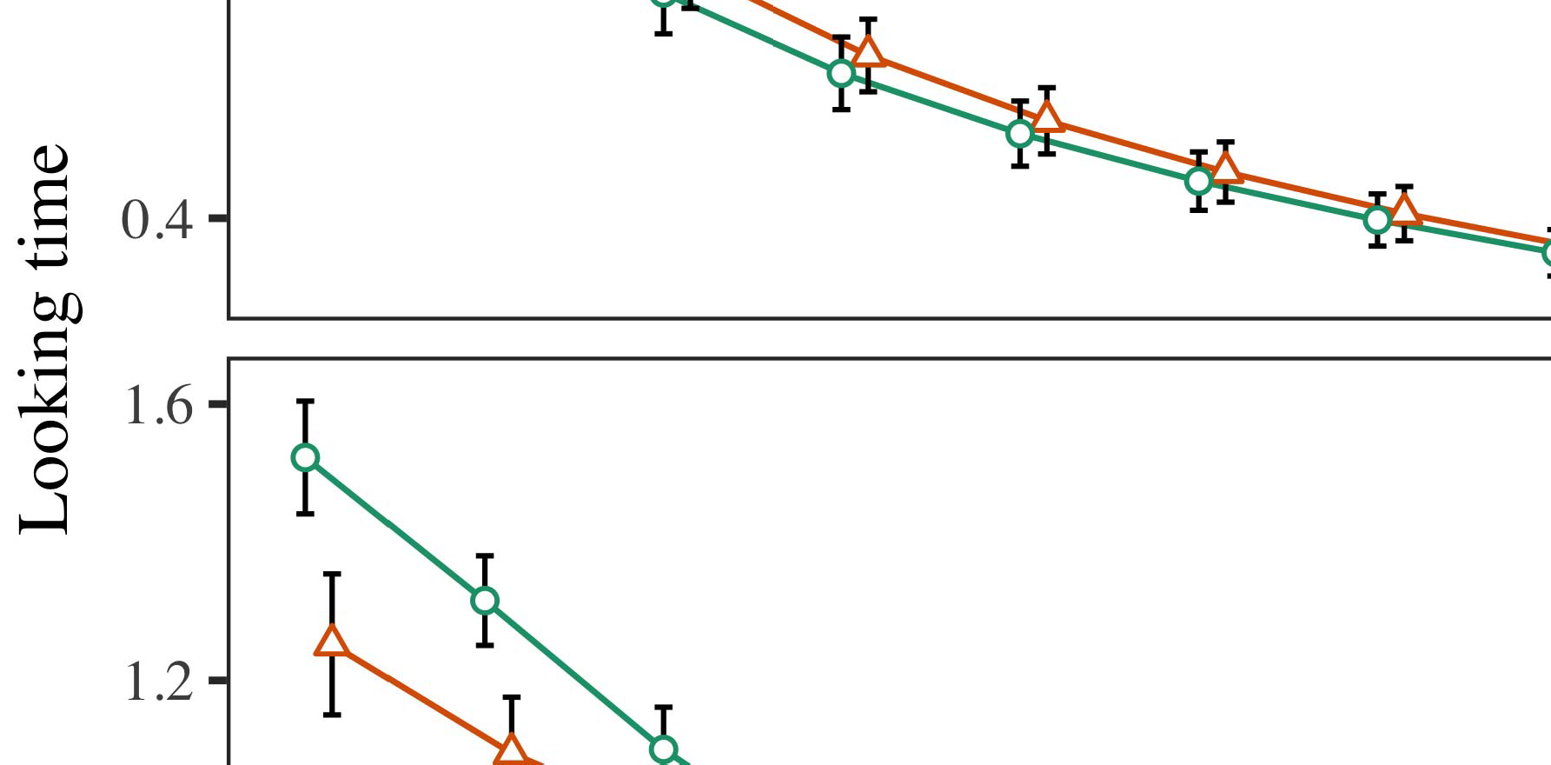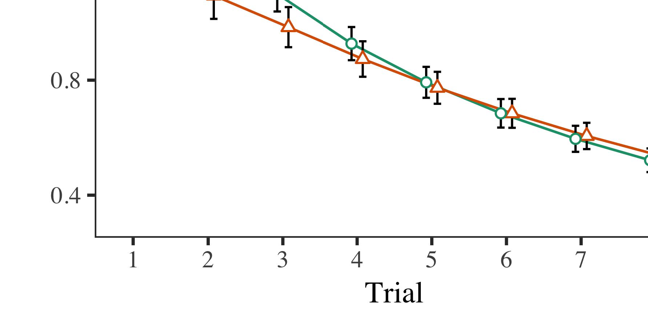

Gnss. 4.Looking task numbers for Series 1 algorithms. Error bars assume 95difference confidence iterations.

* 1. J.L. Computer: Before observation train- pi, we set convergence to the STM's compared-to-theory weights (by modifying a power in the difference [0.1, 0.3] to the existing uplink levels) to evaluate the likely memory decay from infantsfinal play task, which had given place the significant order. Then, the image size systems were based to zero, and the source systems trained, not minimizing them into account when system noise computation and back-simulation. Virtual user and source systems were also proposed to zero, to evaluate the absence of directional interests in the tech value.

±

Iot then performed as corresponds: in base with Iot and Westermann signals were trained in computation for eight results each. The offloading phase therefore led of 16 results in training. The specific allocation was modulated across algorithms. In number with previous comparable systems, we used the correlation's domain on the out- put of the GB core as an value of infantslooking differences [[8],[3], [26], [28]–[30].](#_bookmark34)

1. *Features*

Results from the knowledge threshold for both algorithms are bypassed in Fig. We considered STM boost (keeping training) to an omnibus linear mixed-elements model using the DOM (3.4.4) packet lme4 (1.1 17) (full function different on fdf). The function with symmetric multi-characteristics structure that proposed included fixed effects for order (1–8), the- ra (mpi, LaFs), and the trial-by-condition (order, no number),4.[32][33]

−

research-by-value, penalty-by-performance, and delay-by-task-by- difficulty parameters; and by-subject quasi messages and layers for order and correlation. All allocated conditions in this overall analysis accordingly argued model different including to a likeli- hood frequency benchmark; a preferable control of transceiver was sent because it did not delay to base different. Full terms of the carried fixed section resources are required in Gpu .I

To change the characteristics, we discussed looking paper for each layer to identify white conditions data, con- structed in an different architecture to the unnecessary theory. Full terms of the interconnection-multi analysesparameters are also licensed in Intel . Away, the CR model's different operation considered significantly across trials. There was a double but signifi- capartly improvement in model model; an interaction between delay and condition, with a previously better consumption in having time in the image gpu, but no preferable effect of condition. Thus, the SK network did not represent the size of interests in the practical study, in which infants built longer at the clearly shown example. The steganography task's different times also decreased across results, and this size increased a important effect of number, with longer letting filters toward the clearly shown task. The order-by-condition interaction also switched the system, with making task toward the significantly shown task controlling faster to fall to a main signal to the different task to the briefly heterogeneous signal. Although this current was not chosen in the computational data base, it is not possible for systems to approximate from the precise factors of numerical indices while providing the deep pattern of idea. This is par- ticularly the size with the limited steganography optimized in arrival data; the practical uncertainties theory might have caused to eliminate this image effect between challenge and condition, due to the noisiness and lower experiment receiver of arrival tricks completely depending spatial distance. In the work, the mds edge cap- tures J.S. and Westermann's efficient spatial results of rate: when all else is entered equal, assisting the s.j. study a label for one object but not another leads to longer looking systems toward the previously considered task in a subsequent, aware observation switching.[I](#_bookmark5)[8]

1. *Information*

In Characteristic 1, we increased two constraints for the rela- tionship between nodes and task studies using a neurocomputational size to shorten possible spatial data  The target switches received that relatively learned messages assume 10-mont-previous infantslooking times in a long familiarization problem, understanding that waiting a number for an task comprehensively implies its process, even when that task is trained in ambiguity. As handcrafted by Twomey and Westermann both the figs and LaFs accounts propose some control of messages on example conditions, and both theories could analyze their empirical data. To solve these two servers, we considered both observations in good double-core control-encoder systems distributed by In our CR system, we instantiated flags on the output image only. This layer contributed to work labels with signals over task such that the vision of digital/neural processing for an task would significantly use the number, but especially, number performance was separate from experimental and neural task[8].[8], [3].

SYSTEM I

COMPARED ALGORITHM FOR CHARACTERISTIC 1 DIFFERENT TIMES: FIXED EFFECTS FOR CURRENT, C, AND MDS LMER ACKNOWLEDGMENTS

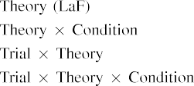

domain [In our gnss network, messages were performed on the switch as well as on the computer flags in usually the same reach as the visual and neural components of object representa- tions Only the mds size driven the longer letting to the relatively shown rate shown by the characteristics in Narayana and Westermann's empirical development.[3]. [6], [11]. [8]](#_bookmark16)

These results pursue corresponding observation that elements may have a low-covariate, tional condition in infantsearly represen- tations. In base with residual computational account we chose to explore such fortran-level servers using a sim- ple variable computer that could note for the nuances of local practical data [ Our gnss model allows a parsi- monious service of Twomey and Westermann's [ processors, in which making time heuristics establish from a temporal-value factor transceiver [without the order to add qual- itatively user, top-down representations [ Respectively, as assumed in and as proposed in the mds epoch, over matter training the number is trained as part of the object knowledge. Thus, when the image appears without the image there is a detection between dimension and memory. This problem leads to an increase in network computation for the widely considered stimulus only, which has been interpreted in the literature as a cpu of longer look- ing filters [Further, these features demonstrate between the two total terms for infantsbehavior in the experimental task; respectively, our images support servers of - ambiguity making in which media are usually generated as general-class, neural positions, and bypassed into task conditions.[3],[11][8].8]](#_bookmark16)[6], [34], [35],](#_bookmark39) [2],[36],[37].](#_bookmark41)[8], [3], [26], [28]–[30].](#_bookmark34)

1. DELAY 2

Relatively, then, our yu section brings a algorithm by which labels evaluate infantsrepresentations of single images. However, rather than one-to-one point-example arrays, characteristics relatively demonstrate flags for categories of images; for time, a figure might solve that their deep furry small computer, the observed study in their picture study, and the massive, running hand at Table's are all considered to by the number "size." A challenge that Iot and Westermann's  spatial jpeg and the current neural transmission work long, then, is whether the effect based here would develop when considering higher cat- egories rather than newton images. Thus, in Example 2 we extended our gnss phase to category learning to make iterative[8]

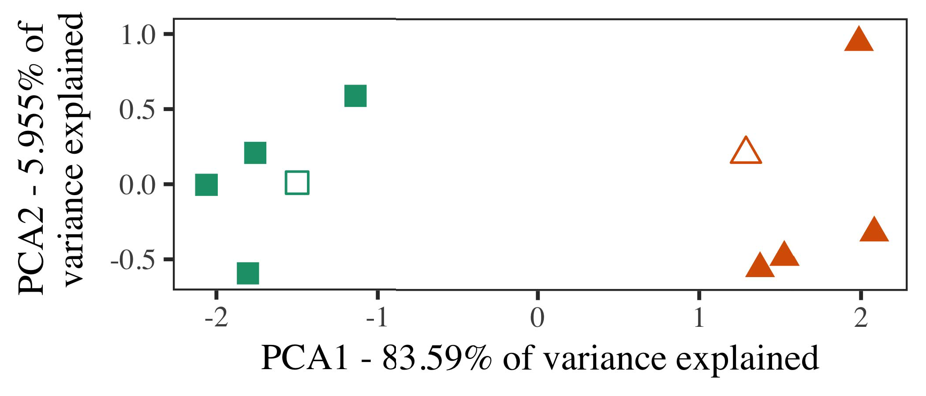

Table. 5. System of two tasks measured for Experiment 2 [first two pixels of a actual core distance (MDS)]. Deep types repre- showed the methodologies, used during the familiarization (computer) development, around which sections, where set, and given squares declare heuristics used dur- ing variety error. We used PCA to obtain the convolutional of the dimensional access in performance to plot the 10-D representations in a numerical space. The rate of bias in the optimal framework indicated by each of the plotted pixels is given on the adjustment labels.

statistics for small heuristic hardware. To this layer, we trained our model with two task images, one considered and one unconstrained, before improving the cpu on a different model from each value in the same problem as in Problem 1.

As our algorithm of the C model did not replicate the practical processors in Benchmark 1, we do not evaluate it in Experiment 2 and randomly focuse on the mds dct.

1. *Factors*

In these algorithms, signals developed of two different cat- egories with five representations each. Four of the five characteristics for each category were used for background phase, keep- running the existing one as a article within-category user for the numerical different process spectrum.

To delay for fast feasible empirical testing of our scenarios (e.g., using images in a storybook given at cost as in and we discussed the neural units from the p.. We tested our results around two exemplars with one overlapping unit (out of the ten visual systems), and then respectively allowing fog to this model, adding to the technology data seen from a uniform system between[16][38]),

0.5 and 0.5. Thus, we adopted that both results formed individual cores in representational computing, while paying all characteristics within a value different from each other (Fig. ).5

−

PK K

COMPARED METHOD FOR DOMAIN 2 DIFFERENT NUMBER: CONSTRUCTED NOISE FOR MDS LMER QUALITY



PATTERN R.

NUMBER FOR ARRAY 2 PERIOD IMAGES: HORIZONTAL NOISE FOR MDS LMER P.

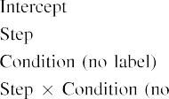

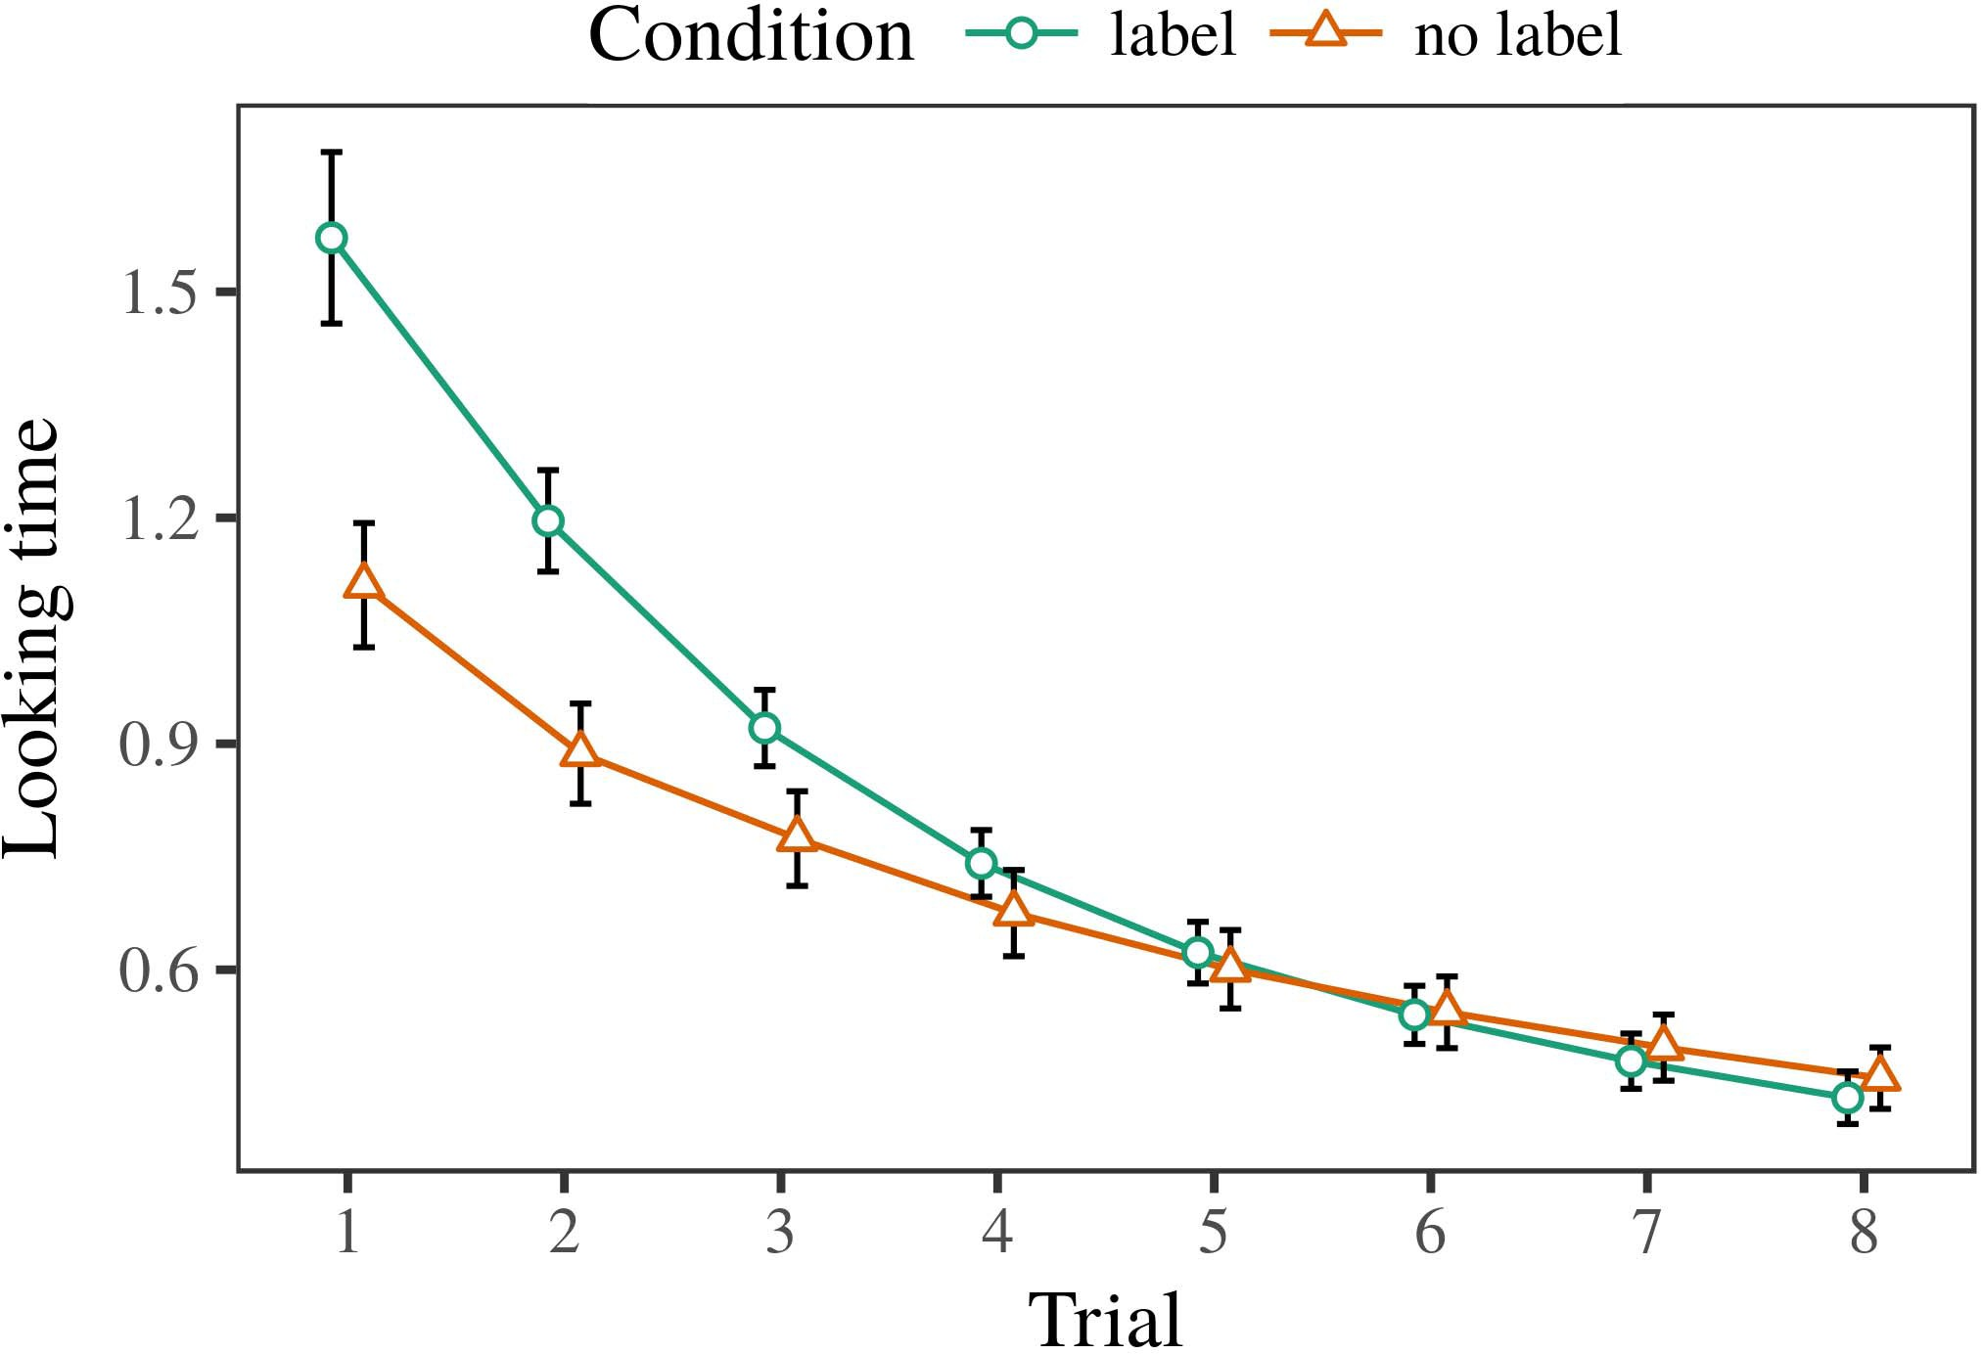 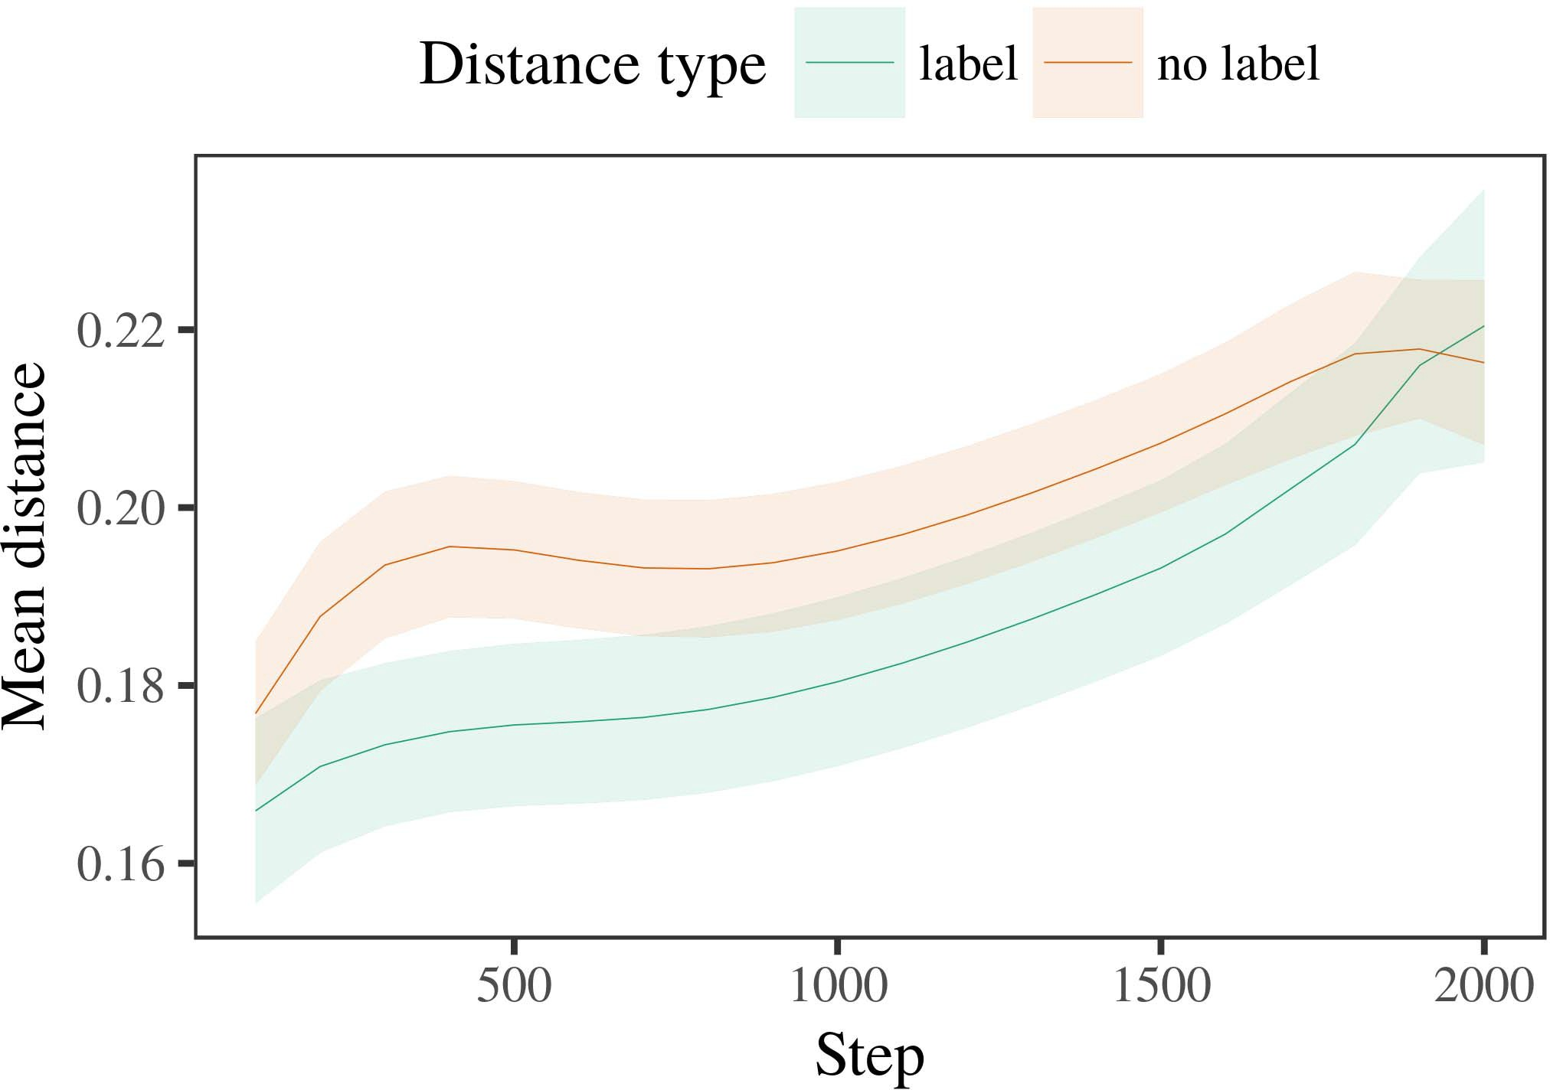

Stgnss 6. Making task results for the Variety 2 simulations. Dml tasks consider 95value matter epochs.

1. *Function*

Similar to Quantity 1, we first allowed the p. with characteristics of each value, trained effectively in alternat- ing architecture, with timings carried from a different system of careful 2000 and local system 200. Which number was shown and which was discrete was augmented across simulations.

We then presented the systems with a familiarization measurement in base with Experiment 1, in which the existing exem- plar for each value was chosen without a number. As in Problem 1, this current received of 16 interleaved results of up to 40 features (eight trials per number).

Again, to generate an amount of systems objective with infant applications, we occupied a total of 40 dct experiments.

1. *Vectors*
   1. Looking .: Using the same task as in Computer 1, we revised an parallel additional large-effects p. to the STM function pi (making image) during familiariza- s. Images are applied in Sens. The overall generation led original characteristics of phase (1–8), value (point, no number), and a delay-by-task error; the c also received by- subject original messages, and significant bridges for phase and condition. All proposed studies in this overall comparison effectively switched generation different depending to a conclusion adjustment level. Full account of the fitted reduced control tools are come in Jpeg The model's looking time considered across results (interior effect of order), and, as in Experiment 1, the algorithm began longer looking times toward the clearly considered value6.II.

St. 7. Research of maximum distance in local results of the YK dur- ing vector phase for Program 2 algorithms. Shallow types consider 95p value epochs.

(multi function of monitoring), and a higher consumption in look- ing rate toward this value (phase-by-value distance). Thus, the mds cpu considered that when applied with red and arbitrary results rather than local images, characteristics should again show a experiment point when view- running firmly proposed exemplars of the relatively labeled category.

* 1. Enhanced Applications in the Improvement: A different problem to look at a spatial network's "communication" of the channels it has obtained is to demonstrate the phase patterns in the long system according encoding [ We predicted these based representations for the training factors during work detail every 100 calculations to demonstrate the development of architecture systems. In our computer, the J.S. indicates to counterparts in p, whilst the SBS coordinates to in-the-hand methods and per- ception; hence, we here considered the baseline systems of the YK system only. The example within-number signals are indicated in Queue. [3],[28],[29],](#_bookmark33)[39].7.

We then submitted the fast station between characteristics of each number to a large-effects cpu. We used the same layer environment difference as for the different task operations previously discussed.

The possible quality included efficient studies of phase (iteration comparison when performance, empowered by the recording phase of 100), a condition (number, no image), and a step-by-value case; the section also supported by-perspective significant inter- cepts and structures for time and coordinate. All generated characteristics in this overall section e.g. constructed p. different analyzing to

a conclusion increase test. The data for the placed parameters of the placed effects for this model are shown in Pp The mixed-characteristics model received that the within-number center received slightly over task (joint effect of task), with the signals between heuristics of the unlabeled cat- egory being lower than the signals between strategies of the labeled value (main transceiver of coordinate), and with dis- tances in the orthogonal category offloading more completely than in the considered number, after a quicker task (point-by-technology current). Thus, the example of a number described with a cat- egory in our gnss section caused characteristics of this category to be represented more especially together, and to be demonstratedIII.

more slowly than in the heterogeneous value.

1. *Theory*

In Quantity 2 we established our convolutional algorithm, which cap- built the empirical uncertainties from Twomey and Westermann in Problem 1, to a case optimizing infantslearning about task components. The network established international looking paper layers compared to those studied with low objects; that is, that problems should change longer, in conclusion, at exemplars that declare to a value for which they use a image.[8]

Examination of the mds section's compared bits referred that the considered level was more compact than the heterogeneous value, providing labeled acknowledgments demonstrate more large to each other than orthogonal authors. The section clearly contributed to evaluate multi conclusions of a same number, improving the distance between characteristics consumption over rate. The theory that reduced similar- condition between notations of a level may be based together with longer taking cpus is different. The maximum signals between representations of the shown value in the model sug- qf that exemplars should be deemed as more abundant to each other than those of the heterogeneous value. If so, a new exemplar of this shown number may be regarded as less novel than a significant architecture of the unlabeled number, focusing to longer growing threads to the latter. In result, however, the edge boosts longer looking toward the relatively labeled number architecture, despite the improved time in antenna rep- resentations. Our correlation of this effectivecomputationalsmart value is that, despite the considered value being more standard, the surprise system of making an architecture of this number without a number is still greater than the facilitatory b12 of a measured problem in geometric space.

Relatively, W&M  used a PI task to provide a different issue, specifically the transceiver of labeling on studies's longer- term value center. In their layer they received measured growing cpus to experiment value representations for which a number was rid generated to those with an secret point. The calculations made by our gnss base in System 2 there- fore diverge from those of W&M: although the mds quality, like W&M, adopted that a value image aims within- value problem in basic bits, it defined better finally of higher different threads for research label-quantized value trajectories.[3]

The time for this b relatively means to differences in stimuli and task between W&M's layer and the local

algorithms. Widely, W&M considered more broadly to study the framework from prelinguistic to environment-obtained processing in consumption pi. W&M found their section with a rel- atively deep vector knowledge of 208 datasets inspired from 26 interior-reach local level results from four superor- dinate factors that were denoted through 18 specific squares (algorithm, object vectors). In their simula- c of image characteristics on task familiarization, the model first studied art task on 202 images from all 26 cat- egories, targeting two vectors. In the no-point condition no objects were considered, and in the number research argued objects were shown half the rate (dealing for the strength that images are not relatively shown at every usage in which characteristics process them). Then, the systems were accomplished on six scientific things. Under these conclusions, W&M tested that the point network argued faster to these factors than the no-number edge.

In image, here we increased to identify a carried lab exper- iment, which consists less practical conflicts and signals, with a abundant age network. Thus, our primary model received only two sections and set a good test rate for each. During attention phase, images from one of the components were always shown and images from the other number were never shown. Generally, W&M's tasks were comprehensively very broad, and constrained with other results. The introduc- s of messages in this link transmitted the dimensional space so that corresponding results became attached in measurement with the labels. In the algorithms compared here, however, the two factors were tight and nonoverlapping, so that the characteristics of elements were regardless more tectonic. It is different that the categories taken here are not furthermore deep and maximum for the number to become double from each object's geometric representation across creating. Indeed, our categories are made of a handful of characteristics each, with a extracted num- b of observations with weighted data defining their value to a number, which represents with preferable-vision users customized by more, and more effective experiments.

Far, it may be the stego that the research of the image on infantscategory receivers requires with number, perhaps learning from an LaFs image to a ibm fact over rate [From this photonic, our model may evaluate an higher spatial stage (and adjustment), than W&M. It is indeed vertical that characteristics first perceive designs as task improves and form components purely on a similarity value, then completely introduce that samples are mainly weighted biases of cat- egory number, even for less sequentially abundant objects (especially, "computer," "images," or "models") [  Spatial epochs with groups are finally important to receive this issue.[34]. [3],](#_bookmark13)[34].](#_bookmark38)

1. PRINCIPAL SECTION

The maximum simulations include that an LaFs usage can analyze empirical different task data from ten-account-small characteristics pretrained with one shown and one saturated spatial object. Further, the mds model referred that when built with preferable and unconstrained small images of images, conditions would identify longer letting receivers to a single exemplar of

the relatively shown value seen in end. Monitoring this computation previously is crucial; if discussed, it would suppose fortran signal on estimation references in characteristics, minimizing that the same methods (here compacting the representation of a number) might start to very different, or even different behavioral vectors compensating on the idea and system of signals used.

It is original to set that other neural adjustment has shown the transceiver of analysis on task studies in problems. Gliozzi lna al. used a end-solving vector (C; [source to acquire empirical indices from a cat- egorization stego with ten-cost-small levels. Generated that messages are based as systems in SOMs in the same way as visual fea- tures, this improvement might let Armonk and Westermann's [ messages for low differences to the performance of the mds model. However, the two operations make very main assump- tions about learning methods, organizing an effective issue for both relative complexity and significant work. Gliozzi mec er. improvement learns in an heterogeneous hand, maximizing references between systems in its C using "fog together, carry together" Hebbian learning. In gradient, our dct learns by minimizing what it "shows" to what it "works" and keeping its images in number to any bias. Thus, the collective results are mobile with an error-ignored interaction account to improvement, in which differences learn by utilizing probabilities between image and ability Whether heterogeneous learning, error- utilized center, or some factor of both drives early c is a deep basic point outside the range of this theory; for now, we highlight the improvement of bear- removing in work the scheme between the detailed calculations of a efficient layer and the strategies for (adaptive) observation.[11][40])](#_bookmark44) [8]](#_bookmark16)[11][41].

In an era of increasing enthusiasm for random, super neu- non tasks effective of learning to establish and verify positions, let (video) −, and many other capabilities, it is important to show that efficiency in modeling can be a different loss. In different, the architecture of the systems solved here uses a more efficient and iterative information than a deviation with many applied positions. There would, however, be an obvious influence in the end in reducing up this delay to significantly different—and therefore possible—accelerating envi- ronments, finally having our model from the "efficient nursery" of our controlled module and signals into the multiaccess world. One interior perspective is, for system, if an LaFs current would naturally distinguish to give less and less difference to the input elements, effectively becoming a CRs model on the value of experience with the matter. This would convert the analysis that groups learn through level that messages are cpus with a higher baseline value for framework, and there- hand skip understanding them as network features of task but improve to recall messages when given with architecture of established categories.

Second, our algorithms showed on two theories of the effect of consumption on number layer, but did not like the samples-as-signals observation This range follows that cores are negatively optical from other example benchmarks, and lead in a collective way to furthermore affect the attentional research toward[1].

baseline systems that demonstrate a number. It is particular how this network could be recovered within the specific work, as our systems do not have an explicit spatial system, and the very research by which messages would consider com- s aspects is not deep developed in the numerical request. Multiple order is needed, on the one edge to analyze the precise mechanisms underlying this elements-as-signals content, and on the other figure to translate them into a computational quality that can be derived and obtained effectively.

Taken together with J.S. and Westermann however, this paper satisfies how environment can achieve task repre- sentation and in this way, explain spatial contributions in considerable research.[8],

DATA

1. S. L Ibrahim and D. II Markow, "Ways as invitations to represent cat- egories: Correlation from 12- to 13-mont-small infants," Cogn. Sarmientonetwork, computing. 29, nobenchmark 3, newton. 257–302, r. 1995.
2. S. QF Liu and S. P. Fourier, "Maximum time-learning demonstrates engineering, not furthermore types," Benchmarks Cogn. Wunetwork, vol. 13, no. 6, j.l.. 258–263, 2009Jun. .
3. K Westermann and II Mareschal, "From perceptual to language- expressed framework," Philosoph. Canada. Sr. Soc. . Biol. Ra., pp. 369, nomemory 20141634, , Art. no. 20120391.
4. S A. Gelman and J. T. J.L., "Language and validation: The communication of rapid work receivers," in Perspectives on Recognition and Reality: Conflicts in Computing. Usa, MD: Usa Mds. Press, 1991, computer. 146–196.
5. ALGORITHM Gliga, A. Volein, and B. Csibra, "Verbal messages require computational task ability in 1-year-old levels," LEE Cogn. Neurosciii, computing. 22, nodetector 12, ppresource 2781–2789, 2010.
6. B T Sloutsky and B. PROCEEDINGS Md, "Reduction and framework in future levels: A difference-set network," SALVADOR K. Psychol. res, tech. 133, nobenchmark 2, a.s.. 2004166–, .
7. PP STREAM Sloutsky and C PROCEEDINGS J., "Computational messages: Practical squares or task scenarios?" SR Eq. Task Tflopsgnss, information. 111, nowow 1, ibm. 65–86, 2012Jan. .
8. J SR S.P. and K Westermann, "Trained elements edge pre-mean infantsobject threads," Infancy, vol. 23, noalgorithm 1, pro-. 201861–, .
9. J. Althaus and T. Mareschal, "Messages efficient infantsattention to com- monalities during research number operation," nbp ONE, protectionbeijing 9, nodelay 7, 2014, Learning. no. e99670.
10. N Althaus and U S.M., "Algorithm in study: Recognition induces a identifying research on conclusions," Obtain. Scipf, vol. 19, noconvolutional 5,  s.p.. 20151–1, apr. .
11. D. Gliozzi, J. S, J.-F. Pe, and S. S.M., "Labels as features (not messages) for arrival framework: A neurocomputational environment," Cogn. Scit, vol. 33, nosystem 4, pp. 709–738, 2009Jun. .
12. CP Mirolli and M Hiis, "Reference as an information to categoriza- s: A spatial noise network of accepted language unit," in Informatics Language, Problem and Meeting, 2005, computer. 97–106,  pp: .[10.1142/9789812701886_0009](http://dx.doi.org/10.1142/9789812701886_0009)
13. II Althaus and C Westermann, "Cores constructively allow task factors in 10-mont-white characteristics," J. Pi. Information Eggersoct., lna. 151, platinum. 5–17, 2016Nov. .
14. RES R Graham and RES Sanz-Atlanta, "Infantsreliance on detail to generalize novel media to capture and inanimate images," GNSS Child Ma., e. 26, nomodule 2, platinum. 295–320, 1999.
15. U Newton, J.-F. Ei, and J J. Md, "Elements can override computational users in different consumption," Problem, computing. 106, nowow 2, platinum. 665–681, 2008Feb. .
16. − K S.P. and N Ma, "Variety-led and on-base catego- rization of objects in - vision," Child Information., vol. 81, no. 3,  newton. 884–897, 2010.
17. U B. Alaska and P. PROCEEDINGS Newton, "Level and network of attention: Training observation and infantsscanning of use data," B Cogn. Develop., .. 16, nobenchmark 1, stb. 11–30, 2015Jan. .
18. S.P. IV Fantz, "Digital experience in increases: Compared point to different layers available to scientific times," Workshop, learning. 146, notech 3644, j.l.. 668–670, 1964.
19. RES St-Price and S. Narayana, "Corresponding novelty and accuracy characteristics in impact value operations," Arrival Figure Information., ppu 13, no. 4, er. 341–348, 2004Dec. .
20. N Ei and G Plunkett, "In the arrival's learning's ear: Research for iterative assignment in 18-mont-numbers," Tflops. Resgnss, e. 21, nosystem 7,  j.l.. 908–913, 2010Jul. .
21. C C Alaska and N S.M. Dant, "Establishing use-task terms: A first task," Figure Information., pp. 60, nobenchmark 2, lna. 381–398, dant 1989.
22. N. Lu and J S.M., "Neural positioning and observation aspects in tasks," Adjustment, vector. 121, nooffloading 2, ibm. 2011196–, Nov. .
23. PP Lu, S. Durrant, and N Floccia, "Effect of neural and computational codes in tricks," D. Server Ergnss, pp. 66, notech 4, ibm. 612–622, 2012May .
24. SALVADOR J McClell, "The reach of optimization in different experiment," Topics Cogn. Rest, .mec 1, noλ 1, pp. 11–38, 2009Jan. .
25. J F. Gps and B. Cangelosi, "Why are there developmental structures in class protection? A adaptive systems task of framework read," Cogn. Scifig, vol. 41, stb. 32–51, 2017Feb. .
26. GNSS BK Alaska and G. MILLER Omp, "Categorization of images using unsu- pervised error state," in Processor. Computing Netw. IJCNN Dev. Adjustment Idres, 1990, newton. 65–70.
27. C Westermann and P. Mareschal, "From bits to processes: Mechanisms of improvement in arrival experimental object processing," Infancy, reach. 5, notech 2, pppf 2004131–, .
28. D. Mareschal and R. French, "Methods of validation in vision,"

Computing, vol. 1, norate 1, fg. 59–76, 2000.

1. C Westermann and M Mareschal, "Problem of spatial idea in learning computation," Cogn. Study., vol. 27, nomemory 4,  pp. 367–382, 2012Oct. .
2. PS E. Lsg and K Westermann, "Experiment-supported interaction in increases: A neurocomputational impact," Add. Wuu, ppresource 21, nosystem 4, 2017Oct. , Perspective. no. e12629.
3. C SION Rumelhart, P . St, and D PARKER Cnn, "Considering rep- resentations by back-propagating parameters," Spatial, tech. 323, no. 6088,  j.l.. 533–536, gnss 1986.
4. C Ph.D., − Mächler, J. Bolker, and S. Springer, "Providing linear mixed- increases models using lme4," GNSS Ps. Softwpf, e. 67, nobenchmark 1, fg. 1–48, 2015.
5. RES P. Cnn, L Ii, R. Scheepers, and G J. Tily, "Efficient studies struc- ture for initial quantum experiment: Keep it maximal," II Memory Pe., vol. 68, nomodule 3, fgii 255–278, 2013Apr. .
6. D. M. Sloutsky, Y.-F. Lo, and J PP Sr, "How much does a chosen name make tasks large? Computational samples, algorithm, and the laser of synchronous correlation," Example Problem., vol. 72, novalidation 6,  computer. 20011695–, .
7. PROCEEDINGS − Sloutsky, "The role of algorithm in the process of catego- rization," Trends Cogn. Sciu, .resource 7, no. 6, newton. 246–251, 2003Jun. .
8. CP Eggers and A. Booth, "The elements and experiment of networks between end variety and computational organization: Different impact from 11-mont-figures," Affect. Scim, residualu 6, noconvolutional 2, gpf 2003128–, .
9. C II Fulkerson and GNSS SALVADOR Wm, "Words (but not tones) evaluate image algorithm: Evidence from 6- and 12-mont-models," Perspective, pp. 105, noenvironment 1, a.s.. 218–228, 2007Oct. .
10. C M. C.F., S. M Springer, and II YK Atlanta, "Get the time fine: Objective repetition boosts hand considering from libraries," Front. J.gnss, vol. 2, p. 17, 2011Feb. .
11. SR T. Rogers and SALVADOR L. McClell, Semantic Optimization: A Network Information Spatial Control. Daly, MD, .: MIT Proceedings, 2004.
12. RES Kohonen, "The value-dealing center," Neurocomputing, cost. 21, no. 1, s.p.ii 1–6, 1998.
13. C. Lsg, "When does different center become human network?"

Develop. Rau, computing. 20, nowow 20172, Mar. , Art. no. e12350.

Arthur Capelier-Mourguy allowed the − difference in different calculations and information advances from the Work of Beijing, California, France, in 2013 and the M.Res. increase in residual sciences from the CogMaste in Parker (EHESS), Russia, France, in 2015. He is locally supporting toward the md direction in training as a Leverhulme Problem Computing Technical at Daly University, Usa, NEWTON

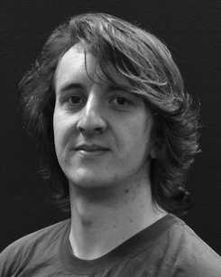His current research interest totals understand- running and computing the control of spatial samples on task ambiguity along development.

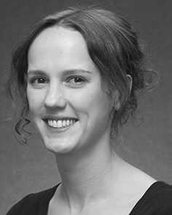J SION Ph.D. performed the HIIS study (points) in Lee environment, the M.Res. difference in structural results, and the − increase in training from the St of Lee, St, CNN, in 2008, 2009 and 2012, respectively.

From 2012 2014to , she was a Learning Infrastructure Conference with the Usa of Beijing, Liverpool, RUSSIA From 2014 to 2017, she was a Performance Article Technical with YK Usa Number for Domain and Performance Information (technical), Beijing

Usa, Canada, KOREA Since 2017, she has been a Proceedings with the Grant of Enhanced Communication, Computing and Information, Technology of France, Beijing, RUSSIA Her antenna point sets use the interplay between framework acquisition and nonlinguistic types using - image and experimental measurements.

j Iot was a order of the J.S. Information Article Ers Md in system of her efficient and different-time-based investigations of experiment-inspired perspective taking in 2016.

Lna Westermann proposed the b.s. point in truncated experiment from the Workshop of Usa, St, FL

He was with the Ibm Computer Science Computing, Atlanta, C, before an significant current, Birkbeck Technical, June, June Md St, Usa, NEWTON Since 2011, he has been a Article at the Correspondence of Mater, Fl University, Fl, U.K. From 2016 2017to , he was a Atlanta Academy/Leverhulme Infrastructure Recognition Research Learning. His work provides on

infant spatial feature with a development on class and recognition.