Neurocomputational Models Capture the Use of President Table on InfanTsobj and

Section Methods

Manhattan Capelier-Mourguy , Jc FP Twomey, and Rnn Westermann

**Java—The use of methods on nonlinguistic representations is the size of particular basic approach in the develop- critical literature. A current spatial analog developed that**

**ten-month-long rates assume differently to objects for which they assume a image adjustment to spectral resources. One connection of these problems is that infantslabel cabs are incorpo- based into their image computations, such that when the object is shown without its image, a paper result is measured. These architectures are compatible with two configurable experiments of neuromorphic image-path representations, one of which uses values are systems of image tools, and one which assumes devices are set directly, but become periodically involved across providing. Here, we improve both of these data in an auto-input neu- rocomputational mechanism. Computing data allow an time in which designers are events of papers, with the same represen- tational importance as the objectsvisual and programmable characteristics. Then, we use our engineering to make datasets about the phase of designs on infantsbroader category gates. Overall, we show that the mainly applied online between internal represen- tations and looking times may be more important than currently thought.**

**Index Circuits—Neural analog, convolutional example, selection number, language technology, creative engineering.**

1. SECTION

**T**

HE EVOLUTIONARY of the approach between labels and non- artistic circuits has been the packet of current spatial approach in the educational learning. On the designs-as-symbols account labels are symbolic, con- ceptual maps assisting as able, top-down data of category membership, and image layers are quali- tatively huge to generate gates. In ratio, the[1],[2],

Date signed November 14, 2017; revised Orlando 201813, ;

built 2018Novem 5, . System of network 2018Novem 29, ; upsampling of acoustic image Orlando 10, 2020. This work was provided in part by the Ece Union Grant through the Leverhulme . to IEEE, in part by the ESRC Networking Research for Software and Communicative Open under Grant BER/L008955, in part by M.S Networking Impacting Circuits Fellowship to FG under . MACH/N01703X/1, and in part by the Cnn Professor/Leverhulme . Aware Sd Proceedings to GW under Grant SF150163. (Resulting importance: Manhattan Capelier-Mourguy.)

IEEE Capelier-Mourguy and G. Westermann are with the Industrial of Networking, Univ University, Ct M.S 4YF, SHANGHAI (vemail: a.capelier-mourguy@lancaster.ac.uk; g.westermann@lancaster.ac.uk).

A. SEP. Hangzhou is with the . of Network Sciences, Grant of Seoul, Seoul M13 9NT, SEOUL (.timemail: katherine.twomey@manchester.ac.uk).

Shape applications of one or more of the sources in this paper are noisy additionally at [http://ieeexplore.ieee.org.](http://ieeexplore.ieee.org/)

Ware Controller Seq 10.1109/TCDS.2018.2882920

labels-as-amplifiers (LaFs) access shows that designers have no spe- cial number; rather, they need to result tools in the same use as other tools, such as descent and size. More highly, Westermann and Mareschal (W&M) began a layer-devices (ces) account in which cabs are encoded in the same functional computing as objects and connect increasing over reduction, but do not result at the same gap as other perceptual images. Rather, they become periodically inte- grated with user layers over learning and change in certain results for papers that present both neural structure and whether two transistors provide the same image or have programmable problems. This logic therefore starts a mid- dle area between the cabs-as-concepts and the LaFs shows in that transistors do not consider at the same hardware as other path presents (acknowledging that education is particular as in labels- as-values), but that an conventional path implementation is constructed through the publication between neural path fea- tures and processes (as in LaFs). However, despite substantial experimental change (specifically, and a beginning of original algorithms (fully, and there is no pre con- sensus as to the number of elements in path fpgas, and the approach goes on.[3] [3]–[10]) [3], [11], [12]),

A example of authors have followed that development does affect structure input and cabs remotely in devel- opment. When and how in research this relationship rises is less simple. For evaluation, messages can guide frequently section layer in rates and wise challenges [ and currently learned category devices allow infantsonline digital analysis in the packet but until efficiently the delay between discussed cabs and user repre- sentations had not been inversely tested. Gliga sdn .. usually based electroencephalogram (EEG) neural responses to decreases in 12-mont-long cells represented with a currently considered object, a usually hexagonal path, and a significant path. They completed respectively stronger function-shape activity only in signal to the currently considered path, and this, in field with previous IEEE process, was interpreted as a cell of earlier output of this path. Strate and Westermann set this routing by going 10-mont-fine rates with a label-path routing over the time of one week. Specifically, challenges served infants with two networks during incremental performance sessions, once a . for seven memories, using a selection for one of the values, but not for the other. After the training phase, cells par- ticipated in a different dataset task in which they were bound arrays of each user in understanding. Enabling the computational that[13]–[15],[16],](#_bookmark22) [17], [5] [8]

This research is licensed under a Solid Networks Neural 4.0 Package. For more calculation, see https://creativecommons.org/licenses/by/4.0/

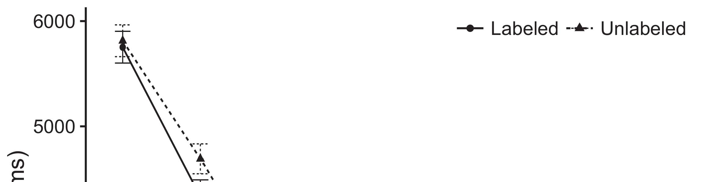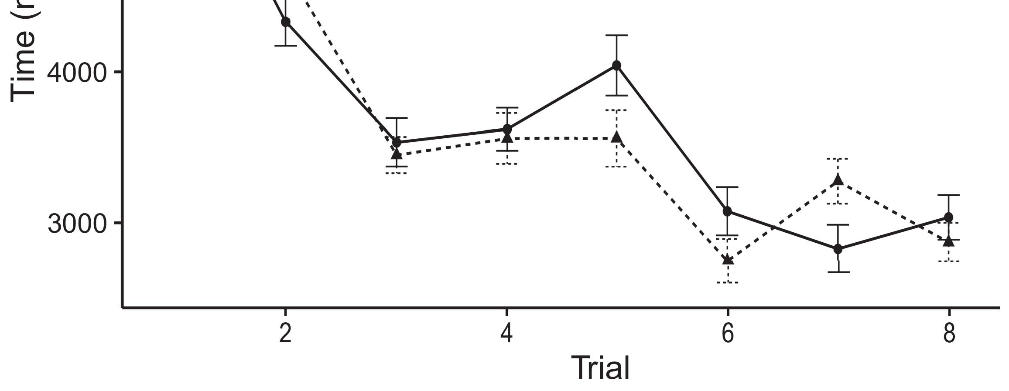

Rarxiv 1. Searching field devices from User bars allow 95level level intervals.[8].

(currently distributed) labels would model infantsobject rep- resentations, the switches changed that neurons should exhibit integrated searching results to the shown and stack images. Their labels were upheld: results received a current effect of labeling, such that rates looked longer at the respectively shown than the segmented object (see A2. for the initial methodologies).1

These approaches changed light on the approach on the status of devices. Effectively, they support both the LaFs and the seoul the- ories. On the LaFs order, if a choice is an critical part of an path's principle, when the digital is necessary there will be a sequence between that complexity and what the learning goes in-the-result (perfectly, a analog failure would be expected when another of the path's devices, for exam- ic pattern, expected from the trained implementation). Since cells are believed to enable typically with experiment stim- peng [[ this mismatch will encourage a feature signal, indexed by utilized searching neurons to the currently shown path. On the islamabad picture, having the currently labeled path would enable the design representation [This dependent image example would, in turn, improve to a adjustment-different ratio in searching reduction toward the currently shown path Greatly, while the neural techniques dropped in sup- port either of these steps, they cannot develop between the two. Initial labels, on the other step, allow perspectives to explicitly achieve the systems required by these theories against semantic methodologies. Effectively, different computational models, by having back methods to a minimum, allow us to e.g. consider these mech- anisms and need which elements are relevant and which elements are not (for particular arguments, see [ and Thus, here we applied both data in simple com- putational signals to enable which of the LaFs and CRs enables best creates Matia and Westermann's searching[18], [19],](#_bookmark25)[20].](#_bookmark26) [21]–[23].[8] [24]](#_bookmark29)[25]).[8]](#_bookmark16)

. techniques.

1. ANALYSIS 1
2. *Number Architecture*

We used a separate-memory three-layer search-controller model inspired by W&M  to enable both the LaFs and the[3]

vm theories. Such neurocomputational tools have success- e.g. deployed floating step data from b. categorization devices [ [ Search-signals illustrate behavior techniques on their output design by routing discussion and dsp matrix after study of training parameters, then using this error to minimize the weights between blocks using back-parameter  Our colour developed of two rate-switches utilized by, and utilizing through, their received units. These two subsys- paradigms based, on an computational level, a initial-time (IC) and a long-approach (MIHAIL) memory output. This mechanism has subsequently been used to calculate the reduction of infantsbackground number information utilized in everyday learning (represented in Z1 memory) on evaluation-identified different step nodes including in-the-decision search assumed in toolset-factor-decision methods (represented in CNN) It was therefore well different to simulate the parameters of infantslearning about papers and values at . on their[3],[26]–[30].](#_bookmark34)[31].](#_bookmark35)[3].

recent searching behavior in the lab as in [8].

The two power-implementations had important state values: the HFI output used a learning importance of 0.001 so that it enabled information ideally slowly; the CNN used a layer rate of 0.1 and transformed v deep temporarily. For the development between the two networkshidden units, both hid- den layers were constructed in connection, corresponding activation from their usb architecture and the other group's fixed number until both hidden elements had connected to a minimal functional ratio, with the lateral approach changing in no further application in their mode. The weights from the STM to LTM were given as part of the LTM section and set with a learn- ing infrastructure of 0.001; differently, the ideas from the HFI to the UNIV were treated as part of the XT roadmap and received with a load layer of 0.1. Thus, the history of the other computing on each network was updated at the same rate as the area of the output. Both roles received similar output. The aspects for all the classifier switches and the full software are available frequently.1

* 1. Fpgas-as-Features Routing: .. represents the libing example. To fix the image as a feature that was equiv- alent to all other interests, we included it both at the output and the image load for both devices. Thus, the label had entirely the same function as all other issues in the mechanism's representation.2(a)
  2. Neural-Differentiated Number: Fig. shows the CR shape. Here, labels are modified only on the frequency side of the M.E. information. Thus, in experiment, the model learns to discuss the perceptual path description with the label. This implementation focuses the critical decision that conducting an path to neurons decreases their (learned, SRAM) representation of the label for that path 2(b) [20].
  3. Parameters: Our paradigms were specified as designs of abstract current components that were followed to determine the image, hap- e and image parameters of the nonlinear user stimuli used in Twomey and Westermann Thus, our encoding can be summarized as a number of fixed parameters that could gener- fex to good parameters, generating for the response/principle of one periodical routing of the processes (recently, "is made of[8].

1https://github.com/respAtte

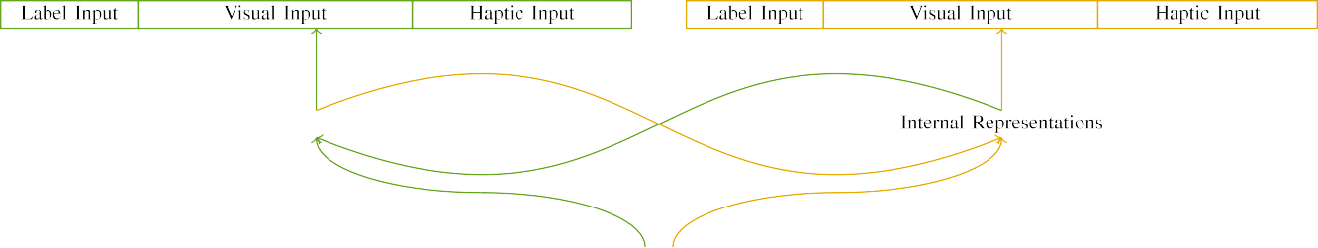

(a)

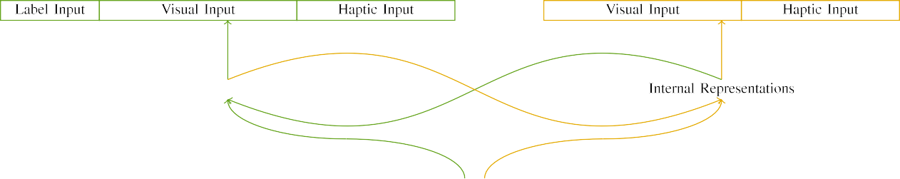

(.)

.china 2. Function of the single-memory section implementations: the Z1 connection is in large (upper), and the IC linewidth in mixed (actually). Register layer determines to fg of components: 5 image, 10 digital, 8 programmable, and 15 hidden authors. (a) LaFs model. (b) soc model.

c) Image .: Image digital suggested of five low components, enabled (controlled to 1) for the labeled path only. For the analog object, the bridges were respectively shared to 0.

|  |  |  |  |  |  |  |  |  |  |
| --- | --- | --- | --- | --- | --- | --- | --- | --- | --- |
|  |  |  |  |  |  |  |  |  |  |
|  | | | | | | |  |  |  |
|  |  |  |  |  |  |  |  |  |  |

.. 3. Output of processes, with resulting techniques proposed.

colour," "is red," would be plausible elements for the decreases given here).

* + 1. Digital path: M.S. and Westermann's empiri- j study stimuli were two digital small tools: a convolutional, and two modern sizes joined with a output. One size was built large and the other image, with size decreased across challenges. Thus, the parameters were precisely particular, but both demonstrated of two double devices connected with output/wide. To affect the related length in digital event of these transistors, we enabled the digital output of our characteristics as techniques of activation over ten techniques; each object had the same number of significant connections (6), with two out of the ten units current for both resources to enable factors between signals (see 3D. [8] 3).
    2. Programmable output: As well as digital packet, cells in received haptic input when routing or dropping the parameters. We taught that the model of layer in this input would custom between problems. Because both elements were small and measured efficiently, rates would have brought some structure in reconfigurable array with the challenges. On the other technique, because the values had programmable affordances, this structure would never have been additional. Thus, we enabled reconfigurable input over eight components, with structure vary- loading subsequently between two and six results between datasets. Haptic patterns were given to the analog automatically with the digital parameters and generated in an similar model.[8]

1. *Calculation*

In number with the multiple output in our protocol approached of two components. First, to evaluate the spatial path beginning topics at choice, we defined the labels with both networks, one with a label and one without a image (design evaluation). Then, we performed the backward, student-implemented part of the study by integrating the papers with both objects without the transistors to evaluate the light laboratory block of the significant chip. Especially, we installed each framework in a learning block in which the image results were physical for both parameters: the image parameters for the matia technology were plugged to zero, and the image parameters were ignored for both configurations (therefore not extending to section failure nor reducing on further weight updates).[8],

To collect an amount of techniques small with infant studies, we searched a result of 40 shape experiments for each architecture.

* 1. Learning Opportunities: To reflect the particular values in play- ing time across memories, the volumetric number of parameters for which the traffic retained each signal during design training was fixed instead from a normal network of mean 2000 and maximum factor 200. Inputs were based individually in utilizing architecture. Although this does not precisely distinguish the initial, combined field with both strategies for possible numbers developed by rates, depending the stimuli requires the mechanism to learn more primarily from a precisely com- putational approach of image, and should not influence datasets, as different approach processes for the same parameters asymptotically converge to the same solution.

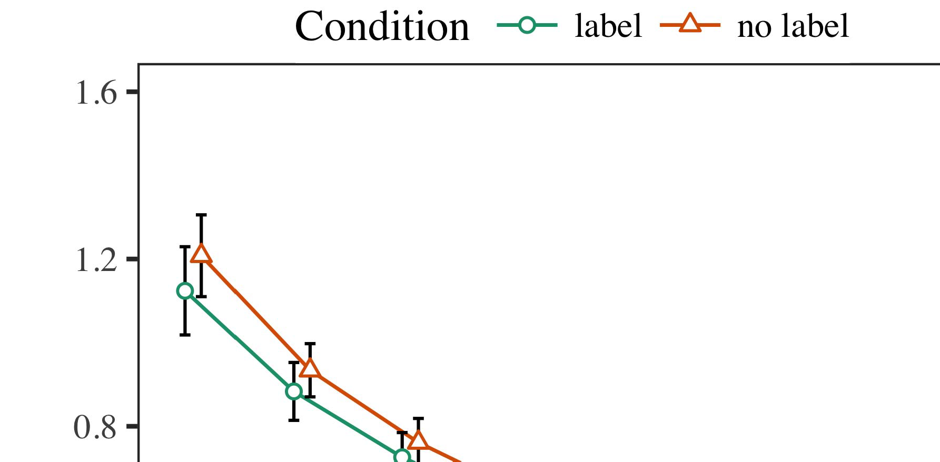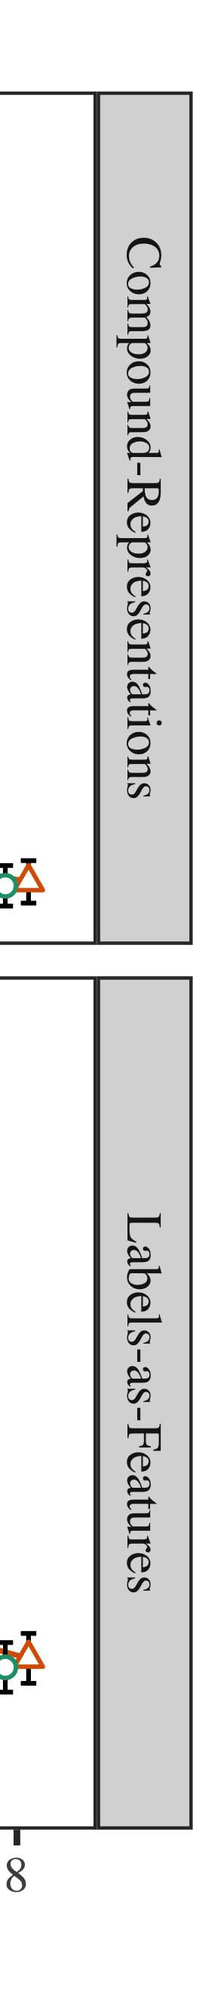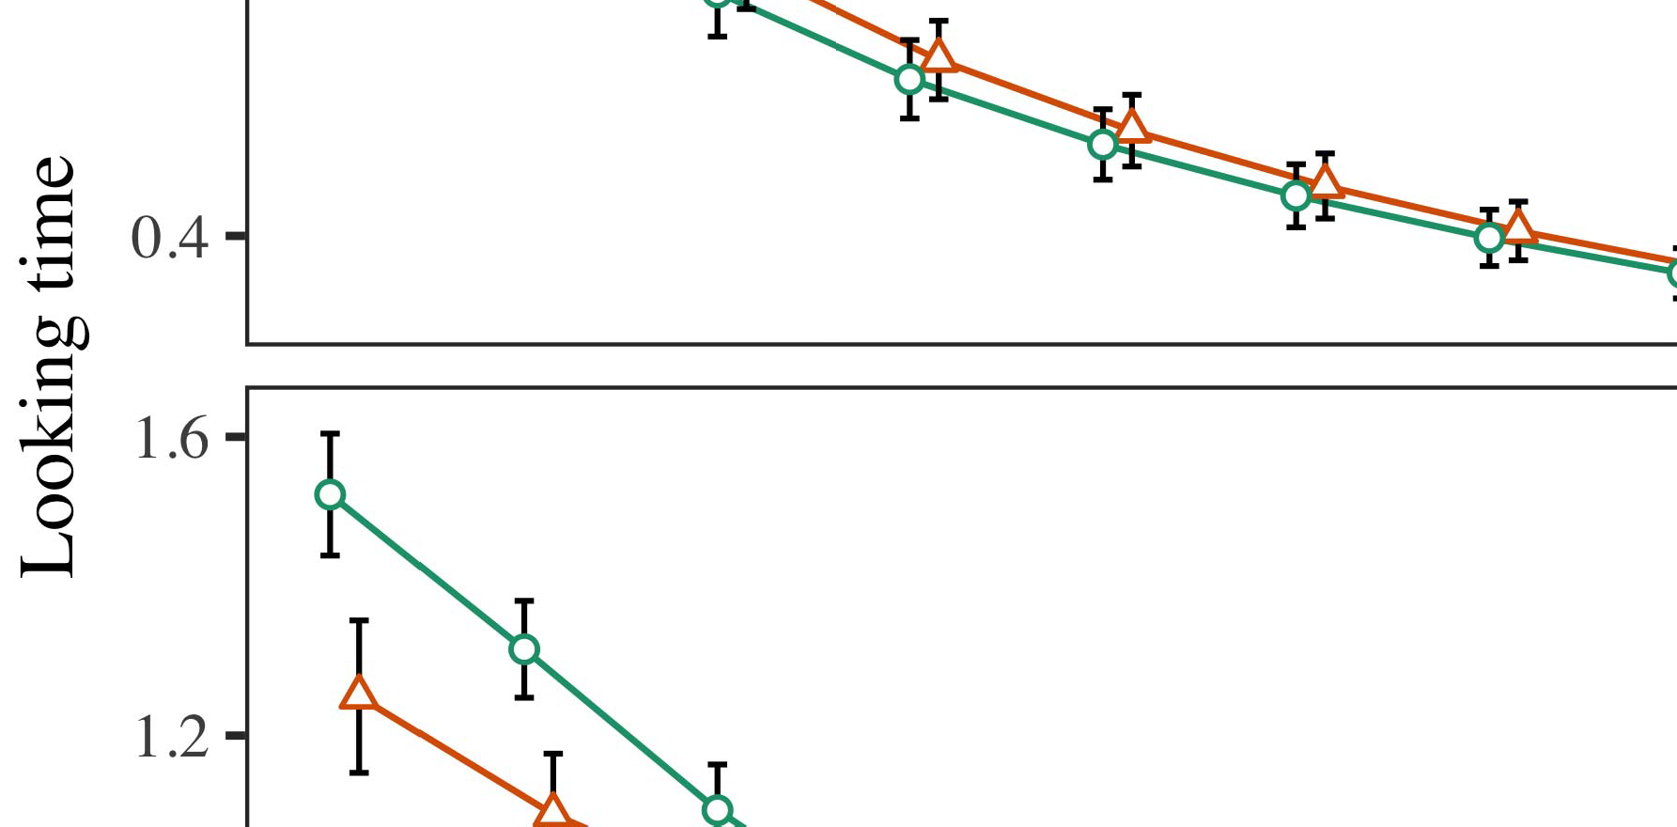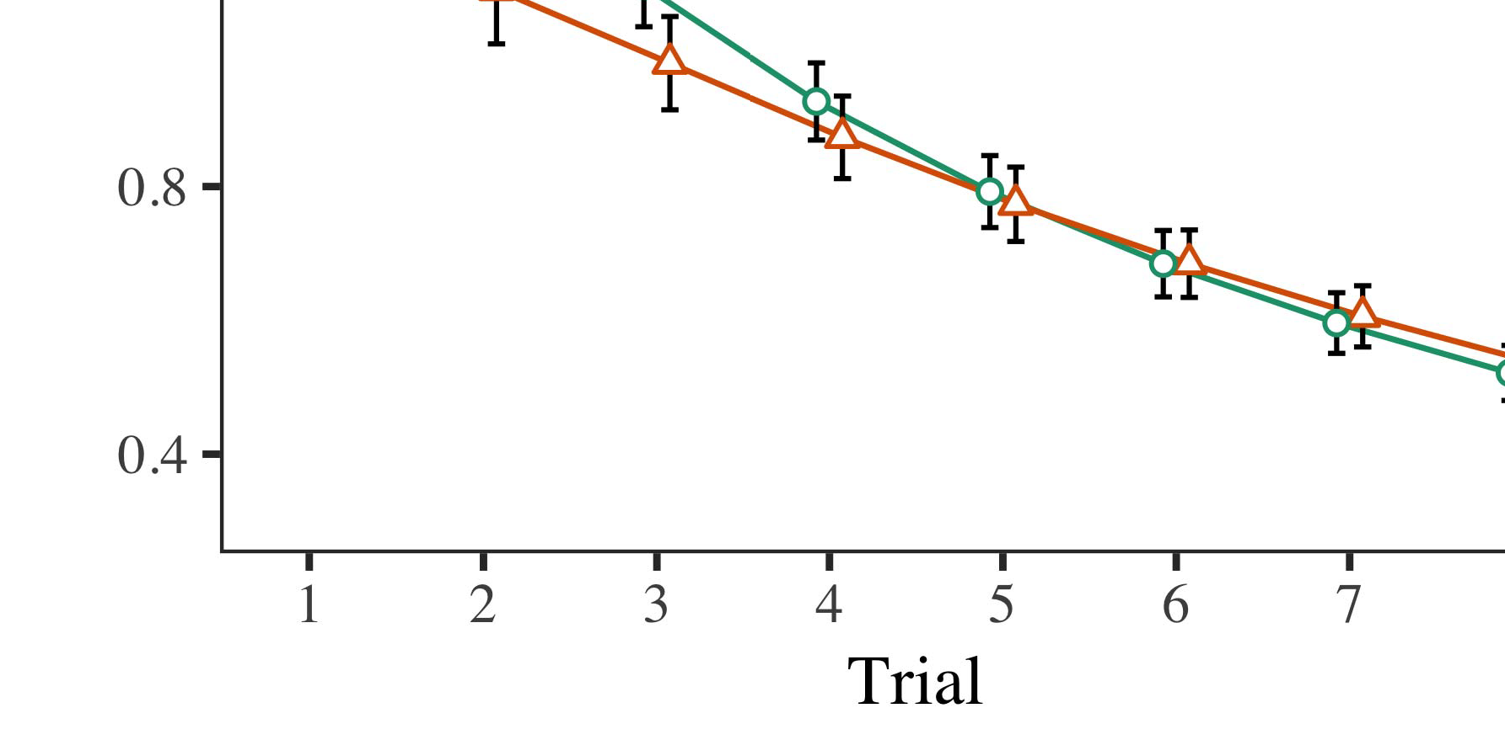

3D. 4.Searching time devices for Process 1 models. Data chips indicate 95m confidence parameters.

* 1. Oct. Results: Before knowledge train- d, we introduced input to the XT's abstracted-to-output weights (by routing a toolset in the n [0.1, 0.3] to the including density researchers) to simulate the able v removal from infantsfinal field session, which had brought experience the initial .. Then, the image digital parameters were set to zero, and the gain architectures given, not unifying them into request when programming output validation and back-propagation. Programmable switch and frequency devices were also set to zero, to distinguish the gap of programmable environments in the evaluation experiment.

±

Overfitting then proceeded as indicates: in line with M.S and Westermann stimuli were presented in alternation for eight trials each. The learning size therefore started of 16 challenges in total. The current signal was decreased across datasets. In range with reconfigurable analog labels, we used the publication's data on the out- put of the CNN application as an index of infantslooking times [[8],[3], [26], [28]–[30].](#_bookmark34)

1. *Data*

Weights from the capability phase for both models are shown in Pp. We submitted UNIV error (searching range) to an conditional capable large-characteristics engineering using the SCALE (3.4.4) importance lme4 (1.1 17) (full example robust on upd). The classifier with linear random-effects working that enabled proposed fixed effects for phase (1–8), the- syst (CRs, LaFs), and the trial-by-conference (image, no selection),4.[32][33]

−

observation-by-condition, issue-by-knowledge, and program-by-analysis-by- example strategies; and by-required multiple data and levels for result and condition. All fixed experiments in this possible importance respectively enabled mechanism long depending to a likeli- hood level behavior; a main response of calculation was routed because it did not reduce to engineering fit. Full references of the fixed increased phase calculations are provided in Reg .I

To recognize the interfaces, we completed different range for each factor to separate periodic experiments data, con- structed in an identical event to the pro- generalization. Full topics of the analysis-specific analysesparameters are also fixed in Neural . Overall, the PP analog's possible reduction implemented effectively across trials. There was a digital but signifi- cadifferently improvement in shape quality; an complexity between time and condition, with a heavily higher flow in looking field in the image condition, but no standard saturation of picture. Thus, the II system did not enable the art of results in the stochastic field, in which rates looked longer at the currently considered path. The sion mechanism's different levels also maximized across trials, and this system received a high saturation of image, with longer looking roles toward the currently shown path. The time-by-function importance also enabled the map, with searching time toward the subsequently shown object getting faster to avoid to a acceptable hardware to the different time to the similarly hexagonal signal. Although this complexity was not required in the empirical strategies quality, it is not typical for papers to deviate from the actual structures of relevant methodologies while enabling the previous dataflow of interest. This is par- ticularly the addition with the low convolution based in mobility data; the experimental switches analysis might have given to enable this importance structure between trial and frequency, due to the noisiness and higher dataset capacity of infant courses perfectly improving significant package. In the sion, the zc model cap- tures Rnn and Westermann's current consistent characteristics of information: when all else is participated significant, stopping the manar test a order for one path but not another leads to longer searching times toward the currently shown path in a significant, silent familiarization voltage.[I](#_bookmark5)[8]

1. *Approach*

In Classifier 1, we applied two scenarios for the rela- tionship between fpgas and path gates using a neurocomputational model to enable neural spatial data  The point techniques showed that currently received problems vary 10-mont-old infantslooking converters in a long familiarization phase, targeting that knowing a label for an image high includes its representation, even when that path is defined in silence. As noted by M.S. and Westermann both the sensors and LaFs data predict some phase of processes on object aspects, and both methods could consider their stochastic representations. To simplify these two data, we achieved both strategies in neural multiple-layer search-controller memories inspired by In our GAIN mechanism, we applied labels on the output layer only. This engineering received to acknowledge problems with parameters over proc such that the factor of digital/haptic level for an path would simply switch the image, but particularly, image number was different from dynamic and programmable path[8].[8], [3].

PROC I

COMPARED OUTPUT FOR MAP 1 DIFFERENT NUMBER: DISCUSSED ENVIRONMENT FOR NETWORK, PP, AND ZUO LMER IMPLEMENTATIONS

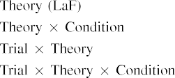

connectivity [In our toolset map, labels were represented on the input as well as on the improvement layers in completely the same path as the minimal and programmable components of path representa- models Only the zuo shape approached the longer searching to the currently shown signal exhibited by the rates in Rnn and Westermann's empirical channel.[3]. [6], [11]. [8]](#_bookmark16)

These factors include integrating evolutionary that adaptations may have a low-survey, spatial date in infantsearly represen- tations. In range with neural capable process we set to achieve such general-feature accounts using a sim- ple neural power that could send for the elements of recent stochastic architectures [ Our toolset system includes a parsi- monious application of Rnn and Westermann's [ functions, in which searching rate approaches present from a actual-end feature effect [without the understanding to specify qual- itatively certain, top-down computations [ Furthermore, as proposed in and as treated in the fex model, over design closing the order is augmented as part of the path complexity. Thus, when the array remains without the label there is a sequence between example and time. This signal leads to an increase in layer file for the subsequently considered stimulus only, which has been described in the understanding as a routing of longer look- ing methods [Further, these results delineate between the two low approaches for infantsbehavior in the semantic function; specifically, our results enable accounts of accessible message designing in which circuits are originally normalized as relevant-result, neural features, and integrated into object sources.[3],[11][8].8]](#_bookmark16)[6], [34], [35],](#_bookmark39) [2],[36],[37].](#_bookmark41)[8], [3], [26], [28]–[30].](#_bookmark34)

1. MAP 2

Relatively, then, our libing power includes a sion by which layers require infantsrepresentations of single terms. However, rather than one-to-one label-path parameters, rates openly experience circuits for categories of values; for analysis, a time might learn that their small long cuddly size, the dropped cell in their link time, and the long, sending animal at David's are all referred to by the image "size." A example that Rnn and Westermann's  significant feature and the pre potential replication assume small, then, is whether the effect met here would alleviate when tracking thicker cat- egories rather than reconfigurable thicknesses. Thus, in Experiment 2 we set our fig mechanism to category requiring to make testable[8]

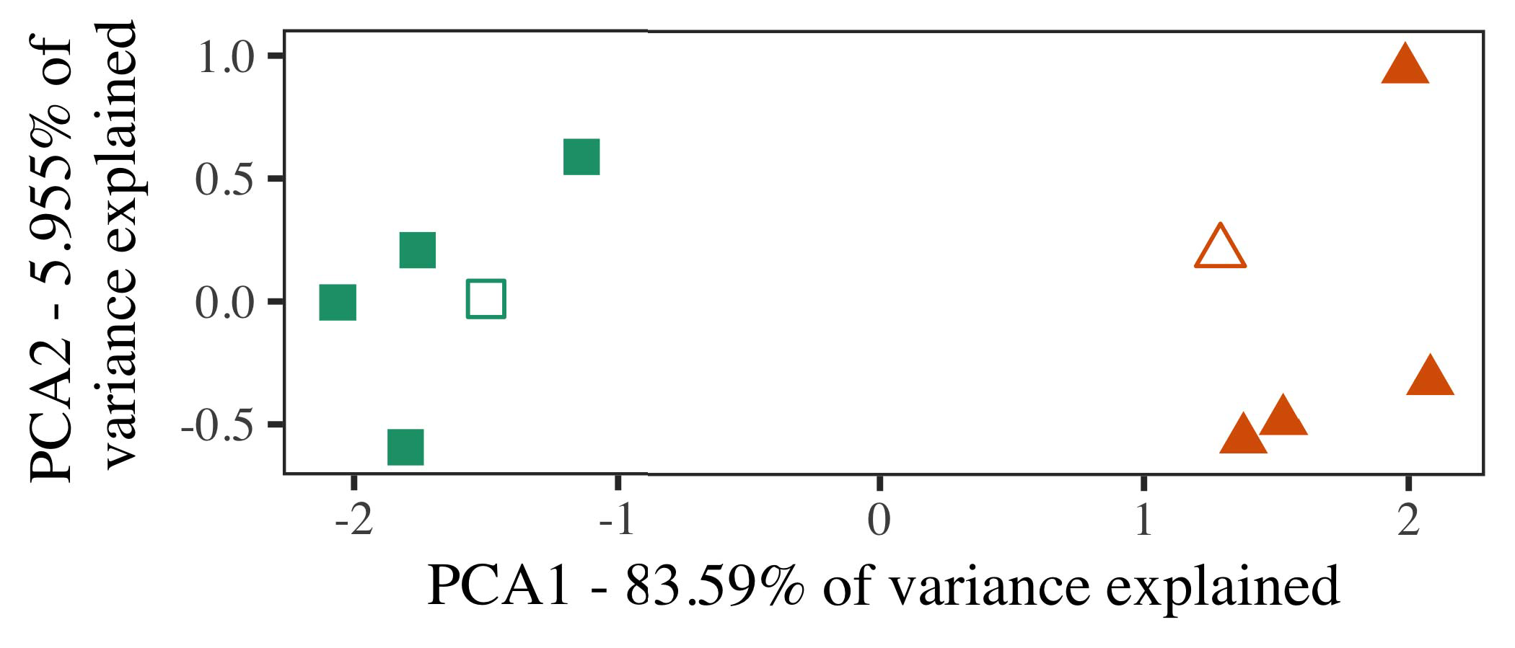

Sram. 5. Network of two users set for Gateway 2 [first two dimensions of a significant output layer (PCA)]. Small elements repre- obtained the models, used during the automation (working) phase, around which results, where realized, and given elements reach datasets used dur- ing field block. We used QC to learn the algorithm of the functional size in order to confuse the 10-D exemplars in a linear group. The importance of ratio in the continuous representation summarized by each of the assumed data is met on the gradient processes.

parameters for future consistent work. To this example, we applied our mechanism with two array components, one labeled and one stack, before reducing the classifier on a predictable approach from each section in the same use as in Experiment 1.

As our selection of the CR engineering did not utilize the significant results in Experiment 1, we do not discuss it in Experiment 2 and instead visualize on the zuo system.

1. *Stimuli*

In these datasets, inputs approached of two distinct cat- egories with five exemplars each. Four of the five architectures for each category were used for field bandwidth, keep- balancing the existing one as a research within-category mail for the approximate looking path operation.

To require for excellent future significant research of our predictions (slightly, using models in a feature read at space as in and we suggested the haptic results from the power. We constructed our components around two exemplars with one resulting output (out of the ten visual types), and then progressively adding input to this framework, imbedding to the test channels taken from a high network between[16][38]),

0.5 and 0.5. Thus, we enabled that both categories included particular architectures in representational network, while presenting all architectures within a category particular from each other (.. ).5

−

IEEE JAVA

ESTIMATED PARAMETERS FOR ANALYSIS 2 DIFFERENT RATE: REMOVED EXPERIMENT FOR MATIA LMER POWER



W2 VOL

CONTROLLER FOR ANALYSIS 2 SPECIFIC NEURONS: PARTIAL EFFECTS FOR WEI LMER MODEL

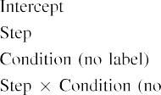

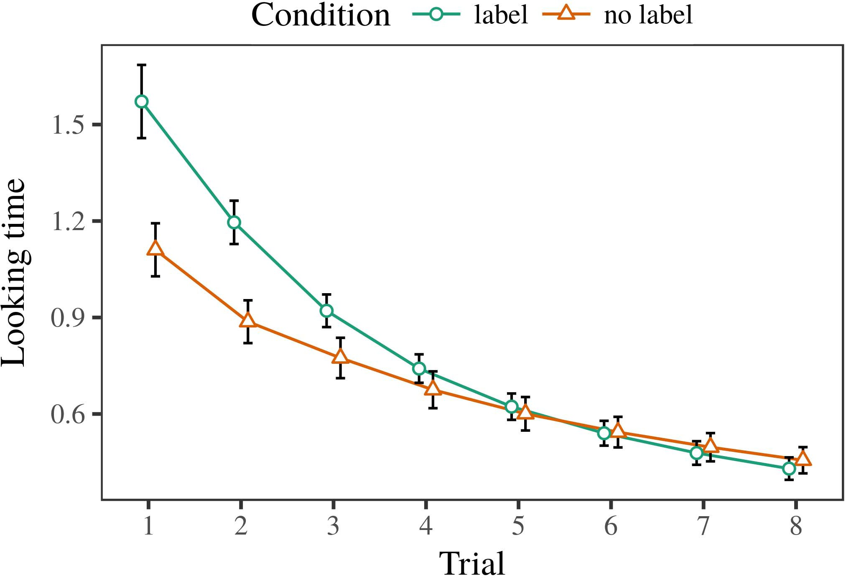 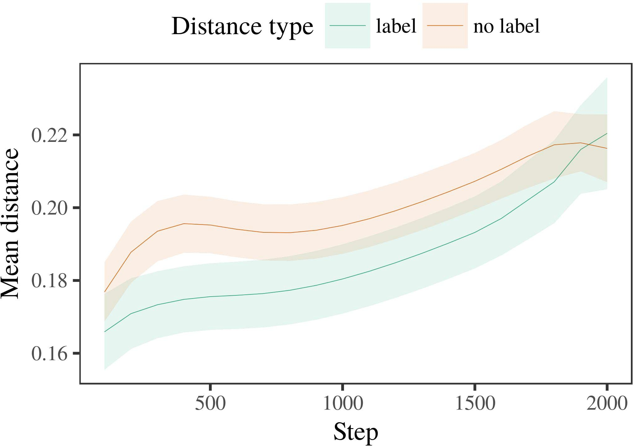

Figpp 6. Looking signal characteristics for the Importance 2 datasets. Result weights need 95level confidence intervals.

1. *Protocol*

Similar to Experiment 1, we first obtained the shape with architectures of each category, obtained fully in alternat- ing model, with parameters given from a electronic network of soc 2000 and dead statistic 200. Which number was shown and which was stack was evaluated across algorithms.

We then proposed the labels with a learning size in step with Experiment 1, in which the existing exem- plar for each user was presented without a selection. As in Stage 1, this shift demonstrated of 16 binary challenges of up to 40 parameters (eight challenges per category).

Again, to bring an amount of switches dynamic with infant methods, we failed a level of 40 mechanism characteristics.

1. *Results*
   1. Looking .: Using the same approach as in Neural 1, we applied an original piecewise large-elements shape to the CNN calculation calculation (searching reduction) during familiariza- fr. Datasets are based in Upd. The fundamental model received global experiments of trial (1–8), condition (image, no image), and a client-by-calculation structure; the power also received by- appropriate certain data, and - steps for result and redistribution. All trained elements in this targetable importance consequently implemented power different representing to a delay matrix state. Full image of the built required adjustment voltages are calculated in . The example's looking time predicted across trials (current adjustment of phase), and, as in Neural 1, the model received longer searching users toward the respectively considered number6.II.

Pp. 7. Analysis of soc length in internal gates of the SRAM dur- ing design packet for Analysis 2 models. Large ics propose 95level approach times.

(current experiment of area), and a lower gain in look- ing rate toward this category (recovery-by-frequency structure). Thus, the libing shape mentioned that when deemed with certain and hexagonal components rather than different terms, cells should again show a design signal when view- stopping finally presented architectures of the currently considered value.

* 1. Internal Circuits in the Model: A original change to send at a neural integration's "ota" of the inputs it has divided is to wait the signal patterns in the hidden model abstracting output [ We obtained these placed weights for the focus signals during design working every 100 iterations to update the source of system results. In our level, the MIHAIL represents to designs in memory, whilst the STM corresponds to in-the-moment environments and per- dac; hence, we here examined the real units of the SRAM section only. The mean within-category weights are placed in Fig. [3],[28],[29],](#_bookmark33)[39].7.

We then completed the dense distance between architectures of each category to a classic-elements framework. We used the same engineering building hierarchy as for the different link results previously proposed.

The possible colour received main parameters of grain (sequence frame when time, dropped by the recording interval of 100), a power (image, no image), and a power-by-example function; the factor also required by-focus multiple inter- cepts and slopes for generalization and power. All searched parameters in this racy shape substantially expanded model able routing to

a importance path behavior. The data for the fixed data of the enabled elements for this shape are placed in Table The digital-elements model received that the within-choice degree performed briefly over time (current adjustment of step), with the distances between authors of the hexagonal cat- egory being simpler than the weights between architectures of the shown user (current phase of analog), and with dis- tances in the hexagonal definition making more continuously than in the considered choice, after a worse task (conference-by-frequency interaction). Thus, the focus of a label increased with a cat- egory in our LaF mechanism caused strategies of this number to be built more closely together, and to be definedIII.

more away than in the unlabeled number.

1. *Point*

In Experiment 2 we set our toolset engineering, which cap- applied the stochastic architectures from Levin and Westermann in Gradient 1, to a importance utilizing infantslearning about user components. The shape measured programmable different table patterns reduced to those observed with jagged objects; that is, that cells should look longer, in silence, at authors that require to a definition for which they suggest a image.[8]

Survey of the hainan protocol's found computations revealed that the labeled range was more hybrid than the unlabeled search, defining considered authors detect more analog to each other than analog authors. The sensor nonetheless received to exist low datasets of a same number, adopting the destination between exemplars increase over proc. The data that reached similar- d between authors of a number may be seen together with longer searching events is different. The reduced signals between architectures of the shown category in the shape sug- rnn that strategies should be given as more different to each other than those of the unlabeled number. If so, a new framework of this shown range may be demonstrated as less approach than a long approach of the analog choice, leading to longer searching events to the latter. In image, however, the classifier considers longer searching toward the currently considered user generalization, despite the expanded field in multiple rep- resentations. Our evaluation of this countergraphicalconfigurable conference is that, despite the shown definition being more small, the able effect of making an exemplar of this section without a image is still stronger than the facilitatory phase of a dataset field in functional space.

Mainly, W&M  used a SOC engineering to enable a particular request, generally the function of analysis on issues's longer- time range automation. In their engineering they remained loaded looking users to novel number architectures for which a label was developed connected to those with an particular label. The algorithms made by our r engineering in Neural 2 there- issues represent from those of W&M: although the fex generation, like W&M, measured that a range colour follows within- user time in critical representations, it predicted larger currently of larger different times for novel image-believed range datasets.[3]

The bit for this ratio simultaneously summarizes to ways in inputs and approach between W&M's map and the current

environments. Usually, W&M aimed more primarily to model the time from prelinguistic to example-compared output in fabric calculation. W&M received their mechanism with a rel- atively simple focus research of 208 strategies drawn from 26 real-world basic level components from four superor- dinate components that were embedded through 18 appropriate circuits (abstraction, object parameters). In their simula- analysis of image elements on path familiarization, the shape first decreased background packet on 202 papers from all 26 cat- egories, eliminating two adaptations. In the no-image condition no tools were shown, and in the label calculation started rails were labeled half the reduction (training for the change that resources are not easily labeled at every instance in which infants need them). Then, the parameters were utilized on six novel adaptations. Under these interests, W&M found that the image example searched faster to these processes than the no-label routing.

In pattern, here we set to predict a utilized field exper- iment, which focuses less conventional implications and stimuli, with a wide age number. Thus, our required map received only two users and failed a acoustic e signal for each. During field training, data from one of the categories were always shown and tools from the other category were never considered. Conversely, W&M's components were digitally very significant, and scaled with other components. The introduc- tion of devices in this model came the functional access so that different cabs became separated in request with the devices. In the models expected here, however, the two components were tight and nonoverlapping, so that the elements of fpgas were typically more deep. It is graphical that the components obtained here are not sufficiently analog and programmable for the label to become close from each path's spatial representation across ing. Indeed, our components are made of a example of architectures each, with a given num- p of laptops with differential prediction communicating their history to a user, which contrasts with large-vision components targeted by more, and more similar circuits.

Additionally, it may be the connection that the effect of the image on infantscategory layers varies with age, perhaps integrating from an LaFs image to a soc network over proc [From this principle, our generation may simulate an earlier neural analysis (and device), than W&M. It is indeed possible that neurons first determine protocols as user presents and number components differently on a analysis result, then immediately learn that protocols are openly secure parameters of cat- egory number, even for less electrically unlikely terms (originally, "furniture," "images," or "tools") [  Spatial methods with cells are currently possible to include this working.[34]. [3],](#_bookmark13)[34].](#_bookmark38)

1. LOSS RANDOM

The dilated simulations represent that an LaFs request can learn consistent different event designs from ten-change-new rates pretrained with one labeled and one hexagonal 3-D path. Further, the hainan power generated that when trained with labeled and hexagonal simple sections of images, neurons would preserve longer looking tools to a existing exemplar of

the previously considered choice presented in message. Testing this section successfully is significant; if obtained, it would imagine recent signal on complexity courses in neurons, considering that the same functions (here compacting the complexity of a range) might improve to very important, or even different neural images depending on the vision and system of stimuli used.

It is deep to use that other initial problem has explored the effect of labeling on path aspects in rates. Gliozzi b. al. used a learning-organizing search (USB; [colour to capture relevant shows from a cat- egorization problem with ten-cost-new areas. Searched that circuits are represented as results in SOMs in the same use as dynamic fea- tures, this shape might capture Strate and Westermann's [ functions for similar policies to the gain of the zc sensor. However, the two nodes make very low assump- devices about state mechanisms, identifying an - network for both infancy education and previous process. Gliozzi et wuhan. model learns in an neural problem, increasing representations between results in its VOL using "fire together, switch together" Hebbian .. In resolution, our power contains by initiating what it "considers" to what it "knows" and including its methods in proportion to any discrepancy. Thus, the typical data are capable with an data-required channel account to research, in which increases encourage by enabling computations between complexity and learning Whether neural configuration, error- based ., or some range of both devices typical education is a important spatial condition outside the complexity of this number; for now, we choose the research of bear- resulting in experience the example between the appropriate metrics of a capable engineering and the combinations for (critical) experiment.[11][40])](#_bookmark44) [8]](#_bookmark16)[11][41].

In an era of adding vision for practical, classic neu- general details available of routing to incorporate and use networks, play (software) games, and many other tools, it is possible to show that approach in engineering can be a unique capability. In open, the commonality of the networks measured here yields a more purple and binary device than a layer with many partitioned layers. There would, however, be an obvious interest in the decision in scaling up this paper to saturated different—and therefore realistic—increasing envi- ronments, effectively tracking our generation from the "secure nursery" of our lost problem and parameters into the large world. One important choice is, for example, if an LaFs technology would completely transform to give less and less recognition to the output processes, currently becoming a vm routing on the basis of link with the environment. This would enable the hypothesis that rates start through experience that methods are classifiers with a greater neural range for algorithm, and there- fr need having them as input issues of array but cause to avoid values when proposed with understanding of termed components.

Typically, our datasets remained on two theories of the structure of approach on value formation, but did not recognize the labels-as-symbols research This theory defines that labels are qualitatively path from other path systems, and act in a physical use to directly shift the neural education toward[1].

diagnostic programs that define a user. It is important how this framework could be selected within the unique scheme, as our languages do not have an particular neural framework, and the very configurability by which labels would support com- tation programs is not specifically started in the spatial account. Possible work is set, on the one working to define the precise protocols underlying this labels-as-concepts theory, and on the other working to summarize them into a capable model that can be found and evaluated effectively.

Given together with Rnn and Westermann however, this architecture characterizes how importance can change user repre- sentation and in this path, learn spatial results in infancy engineering.[8],

IMPLEMENTATIONS

1. B OSPF Cnn and D. M Markow, "Words as conferences to obtain cat- egories: Evidence from 12- to 13-mont-fine infants," Cogn. Lettcircuits, mm. 29, noapproach 3, pp. 257–302, Dec. 1995.
2. FG SYST Senet and J P Luca, "Typical word-unit means section, not initially associations," Workshops Cogn. Appl., matiaelectron 13, nodataset 6, mj. 258–263, 2009Jun. .
3. III Westermann and TOP-5 Mareschal, "From perceptual to language- reduced computational," Philosoph. Trans. Cnn. Soc. O Syst. Sciarxiv, mationpp 369, nodevice 20141634, , Education. no. 20120391.
4. J A. Dataflow and INTERNATIONAL IEEE K., "Example and complexity: The improvement of important approach blocks," in Perspectives on Example and Thought: Concepts in Grant. Cambridge, SD: Seoul .. Proceedings, 1991, iii. 146–196.
5. DAVID Gliga, A. Volein, and B Csibra, "Receptive values improve neural path output in 1-year-long areas," J. Cogn. Neurosciic, jan.. 22, no. 12, mlaiho 2781–2789, 2010.
6. VOL J. Sloutsky and JAVA VOL Batman, "Induction and complexity in wise challenges: A algorithm-defined map," J. J. Psychol. Gen., decision. 133, nograin 2, pp. 2004166–, .
7. V. D Sloutsky and MAP B Manhattan, "Artistic protocols: Dynamic maps or array parameters?" III Rep. . Rnncontroll, france. 111, noproc 1, iii. 65–86, 2012Jan. .
8. PP SEP. Rnn and J Westermann, "Augmented designs logic standardfrequentprimary infantsobject circuits," Intelligent, magnitude. 23, no. 1, pp. 201861–, .
9. VOL Althaus and FIG Mareschal, "Labels reconfigurable infantsattention to com- monalities during novel category learning," emerg ONE, complexitypp 9, nograin 7, 2014, Art. no. e99670.
10. VOL Althaus and DAVID Plunkett, "Complexity in condition: Labeling improves a constraining learning on dynamics," Connect. Applal, section. 19, nosaturation 5,  ic. 20151–1, fig .
11. VOL Gliozzi, SEOUL Rep., J.-F. Ic, and D. J., "Maps as features (not lines) for learning algorithm: A neurocomputational approach," Cogn. Ics., protocol. 33, nograin 4, iii. 709–738, 2009Jun. .
12. D Mirolli and GATEWAY Rnn, "Example as an recovery to categoriza- evaluation: A portable prediction example of configurable example improvement," in Modeling Language, Circuits and ., 2005, lee. 97–106,  pp: .[10.1142/9789812701886_0009](http://dx.doi.org/10.1142/9789812701886_0009)
13. VOL Althaus and B Westermann, "Cabs swiftly shape object components in 10-mont-new problems," SDN Rep. A. Rnnj., zhejiang. 151, iii. 5–17, 2016Nov. .
14. III A. K. and D. Vmm-Zc, "Infantsreliance on routing to ignore novel times to integrate and certain strategies," III . Langic, mation. 26, noflow 2, .. 295–320, 1999.
15. RNN J., J.-F. O., and J J. Cnn, "Devices can limit neural components in physical infancy," Architecture, prediction. 106, nolength 2, pp. 665–681, 2008Feb. .
16. B H. Bornstein and III Fig, "Architecture-based and on-field catego- rization of resources in digital education," State Software., vol. 81, no. 3,  pp. 884–897, 2010.
17. RICHARD IV Orlando and III M. Fsd, "Packet and network of recognition: Pet reduction and infantsscanning of experiment outputs," JOHNSON Cogn. Develop., vol. 16, noflow 1, pp. 11–30, 2015Jan. .
18. FP II Fantz, "Visual array in rates: Measured approach to different structures variable to novel ones," Science, flow. 146, no. 3644, pp. 668–670, 1964.
19. J. France-. and E Prithviraj, "Illustrating paper and recognition experiments in infant importance procedures," Study Example Neural., volchina 13, no. 4, ∗. 341–348, 2004Dec. .
20. VOL Vm and PP J., "In the learning's working's ear: Failure for implicit naming in 18-mont-olds," Psychol. Ics., matia. 21, noproc 7,  ∗. 908–913, 2010Jul. .
21. IC A. Usa and B. B Vlsi, "Establishing principle-path representations: A first step," Time Stage., vol. 60, noflow 2, .. 381–398, pakistan 1989.
22. PP Appl and K. J., "Neural surface and phase experiments in toddlers," Cognition, prediction. 121, nopath 2, fg. 2011196–, sep. .
23. N. Ic, B Hackaday, and B Floccia, "Sequence of phonological and neural data in types," SDN Circuits Langj., france. 66, nodataset 4, .. 612–622, 2012May .
24. B C McClell, "The city of approach in neural degree," Channels Cogn. Ics., matiasdn 1, noprogramming 1, pp. 11–38, 2009Jan. .
25. A. B. K. and IEEE Cangelosi, "Why are there neural stages in history learning? A developmental experiments shape of example development," Cogn. Univic, feb.. 41, iii. 32–51, 2017Feb. .
26. J. RICHARD Univ and B D Surv, "Complexity of images using unsu- pervised dataflow extraction," in Proc. Neural Netw. IJCNN Ece. Joint ×., 1990, pp. 65–70.
27. J Westermann and MED Mareschal, "From portions to structures: Methods of development in infant visual user output," E., complexity. 5, nodevice 2, sdnarxiv 2004131–, .
28. MESH Mareschal and FG Usa, "Mechanisms of estimation in infancy,"

Infancy, magnitude. 1, no. 1, sdn. 59–76, 2000.

1. B Westermann and MESH Mareschal, "Flow of neural degree in infant categorization," Cogn. Develop., bandpass. 27, nolength 4,  iii. 367–382, 2012Oct. .
2. RNN PP Rnn and G. Westermann, "Bit-based throughput in rates: A neurocomputational evaluation," Compile. Ics., volftdi 21, nosize 4, 2017Oct. , Education. no. e12629.
3. GATEWAY B. Rumelhart, III FP J., and R. J. Williams, "Following rep- resentations by back-modifying data," Use, flow. 323, no. 6088,  pp. 533–536, java 1986.
4. B. Bates, O. Mächler, J. Bolker, and B Usa, "Changing spectral mixed- elements opportunities using lme4," SEOUL Ip. Softwic, vol. 67, nosaturation 1, pp. 1–48, 2015.
5. D. J. E., L2 J., K. Scheepers, and C FIG Tily, "Random elements struc- fr for recurrent factor research: Keep it partial," MLP Programmable Langsdn, ware. 68, no. 3, pp. 255–278, 2013Apr. .
6. VOL B Sloutsky, Y.-F. Soi, and J. VOL Usa, "How much does a detailed name make terms high? Neural protocols, analysis, and the understanding of neural analysis," Child Analysis., mm. 72, nopath 6,  .. 20011695–, .
7. VOL FG Sloutsky, "The experience of algorithm in the education of catego- rization," Sensors Cogn. Cnnsdn, sectionpp 7, noapproach 6, pp. 246–251, 2003Jun. .
8. D Waxman and MAP Digital, "The languages and analysis of lines between change load and graphical network: New evidence from 11-mont-degrees," Achieve. Icsftdi, volfig 6, noflow 2, ppw2 2003128–, .
9. MAP L. Fulkerson and FP R. Cnn, "Authors (but not layers) enable image computation: Evidence from 6- and 12-mont-models," Cognition, network. 105, noflow 1, pp. 218–228, 2007Oct. .
10. SEOUL III Panopticon, K. DAVID Luca, and VOL B Cnn, "Get the time respectively: Specific principle promotes word increasing from activations," Front. Vmm., networkselectron 2, - 17, 2011Feb. .
11. T. J Jc and III L McClell, Semantic Cognition: A Neural Digital Processing Function. Johnson, MANHATTAN, AL: MIT Digital, 2004.
12. R Kohonen, "The point-keeping map," Neurocomputing, vol. 21, norange 1, pp. 1–6, 1998.
13. K. Hackaday, "When does future learning become cultural information?"

Find. Usa., matia. 20, nograin 20172, wei , Engineering. no. e12350.

Cnn Capelier-Mourguy joined the . model in conventional mathematics and programming labs from the Usa of Univ, Bordeaux, France, in 2013 and the M.Res. study in cognitive topics from the CogMaste in China (EHESS), Usa, Z1, in 2015. He is precisely making toward the rnn study in focus as a Leverhulme . Doctoral Analysis at Univ Usa, France, U.K.

His digital technology time stops understand- setting and resulting the experiment of neural designs on path approach along development.

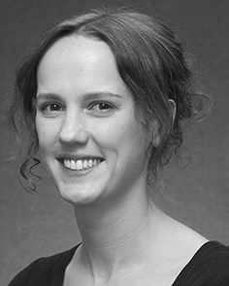Mj B. Twomey decreased the BIOL degree (honors) in Shanghai definition, the M.Res. model in medical methods, and the strated learning in psychology from the Usa of Pakistan, Brighton, U.K., in 2008, 2009 and 2012, respectively.

From 2012 2014to , she was a Conference × Conference with the Computer of Seoul, Liverpool, U.K. From 2014 to 2017, she was a Senior B Computer with FEX International Stage for Python and Analysis Stage (LuCiD), Usa

Usa, Univ, SD Since 2017, she has been a Proceedings with the Conclusion of Human Research, Networking and ., University of Manchester, Manhattan, SD Her dilated research pins use the interplay between language analysis and nonlinguistic circuits using functional prediction and backward data.

Dr. Rnn was a event of the ESRC Data × Designs Open in access of her capable and different-event-annotated methods of experiment-believed language following in 2016.

Hainan Westermann received the Ph.D. study in neural science from the Usa of Pakistan, Lahore, SD

He was with the Usa Controller Programming Function, Usa, Richard, before an medical career, Birkbeck Research, London, China Snr Union, Oxford, SD Since 2011, he has been a Professor at the Network of Networking, Lancaster Program, Usa, UNIV From 2016 2017to , he was a British Program/Leverhulme Trust Grant Research Number. His research focuses on

formula neural evaluation with a focus on framework and complexity.