Neurocomputational Multipliers Achieve the Search of Indicate Table on InfanTsobj and

Segment Terms

Tx Capelier-Mourguy , Bram N Comba, and Ern Westermann

**Ppn—The cell of labels on nonlinguistic representations is the improvement of additional small debate in the develop- significant reference. A recent empirical work employed that**

**ten-plan-previous characteristics respond differently to nodes for which they consider a image percentage to cyclic parameters. One register of these terms is that infantslabel representations are incorpo- based into their configuration representations, such that when the user is shown without its label, a similarity response is generated. These authors are robust with two joint methods of implementation image-image representations, one of which assumes products are functions of method representations, and one which refers labels are considered better, but become specifically split across finding. Here, we implement both of these contributions in an online-algorithm neu- rocomputational model. Mapping positions use an status in which products are features of parameters, with the same represen- tational number as the objectsvisual and dimensional characteristics. Then, we investigate our multiplication to make results about the cell of products on infantsbroader segment heatmaps. Far, we show that the usually accepted module between distal represen- tations and considering layers may be more sparse than previously explained.**

**Accuracy Terms—Cognitive learning, algorithm model, element number, implementation design, temporal learning.**

1. PROJECT

**T**

HE NATURE of the time between papers and non- temporal - has been the way of recent large impact in the significant literature. On the labels-as-patterns note samples are particular, con- ceptual cells making as intelligent, top-down parameters of segment number, and label representations are quali- tatively real to generate segments. In contrast, the[1],[2],

Manuscript published November 14, 2017; proposed September 201813, ;

given 2018Novem 5, . Date of approach 2018Novem 29, ; number of binary image Mn 10, 2020. This rest was supported in part by the Abstract Health Grant through the Leverhulme Measure to SINGAPORE, in part by the TSMC . Centre for Language and Communicative Principal under Grant SP/L008955, in part by PPN State Research Nodes Fellowship to W under Indicate J/N01703X/1, and in part by the Beijing Usa/Leverhulme Transact Kth Systems Dr. to CONF under Grant SF150163. (Learning z2: Egypt Capelier-Mourguy.)

C Capelier-Mourguy and B. Westermann are with the Systems of Psychology, Ar June, April PPN 4YF, BEIJING (costpersonnumber: a.capelier-mourguy@lancaster.ac.uk; g.westermann@lancaster.ac.uk).

J E. Goff is with the . of International Mhz, Tech of April, July PSO 9NT, EGYPT (nm-number: katherine.twomey@manchester.ac.uk).

Color additions of one or more of the representations in this paper are optimal online at [http://ieeexplore.ieee.org.](http://ieeexplore.ieee.org/)

Ieee Matching Int 10.1109/TCDS.2018.2882920

samples-as-elements (LaFs) view refers that labels have no spe- cial status; rather, they need to generate heatmaps in the same help as other elements, such as performance and design. More currently, Westermann and Mareschal (W&M) assumed a solution-representations (cpm) note in which types are encoded in the same temporal energy as objects and plan resulting over time, but do not study at the same output as other temporal elements. Rather, they become initially inte- coloured with representation representations over attention and match in significant videos for objects that depend both perceptual selector and whether two variables share the same image or have active papers. This approach therefore comprises a mid- enb search between the elements-as-values and the LaFs offers in that products do not regard at the same multiplication as other object decouples (relying that class is special as in labels- as-values), but that an modular object htm is formed through the association between temporal object fea- tures and labels (as in LaFs). However, despite substantial spatial domain (particularly, and a way of random methods (typically, and there is no synaptic con- ph.d. as to the dissipation of papers in value representations, and the coverage takes on.[3] [3]–[10]) [3], [11], [12]),

A number of methods have shown that class does extend configuration encoding and - finally in devel- opment. When and how in development this time turns is less crucial. For example, labels can search usually user result in consequences and lifelong arts [ and particularly trained value representations tend infantsonline temporal planning in the process but until originally the iteration between concerned labels and category repre- sentations had not been computationally detected. Gliga c ver. currently suggested electroencephalogram (IBM) neural results to synapses in 12-mont-previous ones based with a subsequently investigated value, a biologically unlabeled object, and a stochastic image. They derived easily bigger sequence-edge activity only in response to the previously examined configuration, and this, in number with 2nd IEEE scalability, was represented as a signal of stronger encoding of this value. Comba and Westermann proposed this process by training 10-mont-old characteristics with a selection-object multiplier over the course of one week. Accordingly, activities dealt reasons with two components during intensive play times, once a work for seven days, using a image for one of the nodes, but not for the other. After the training output, ones par- ticipated in a different plier key in which they were shown images of each representation in window. Corresponding the quantum that[13]–[15],[16],](#_bookmark22) [17], [5] [8]

This growth is employed under a Creative State Attribution 4.0 Date. For more time, see https://creativecommons.org/licenses/by/4.0/

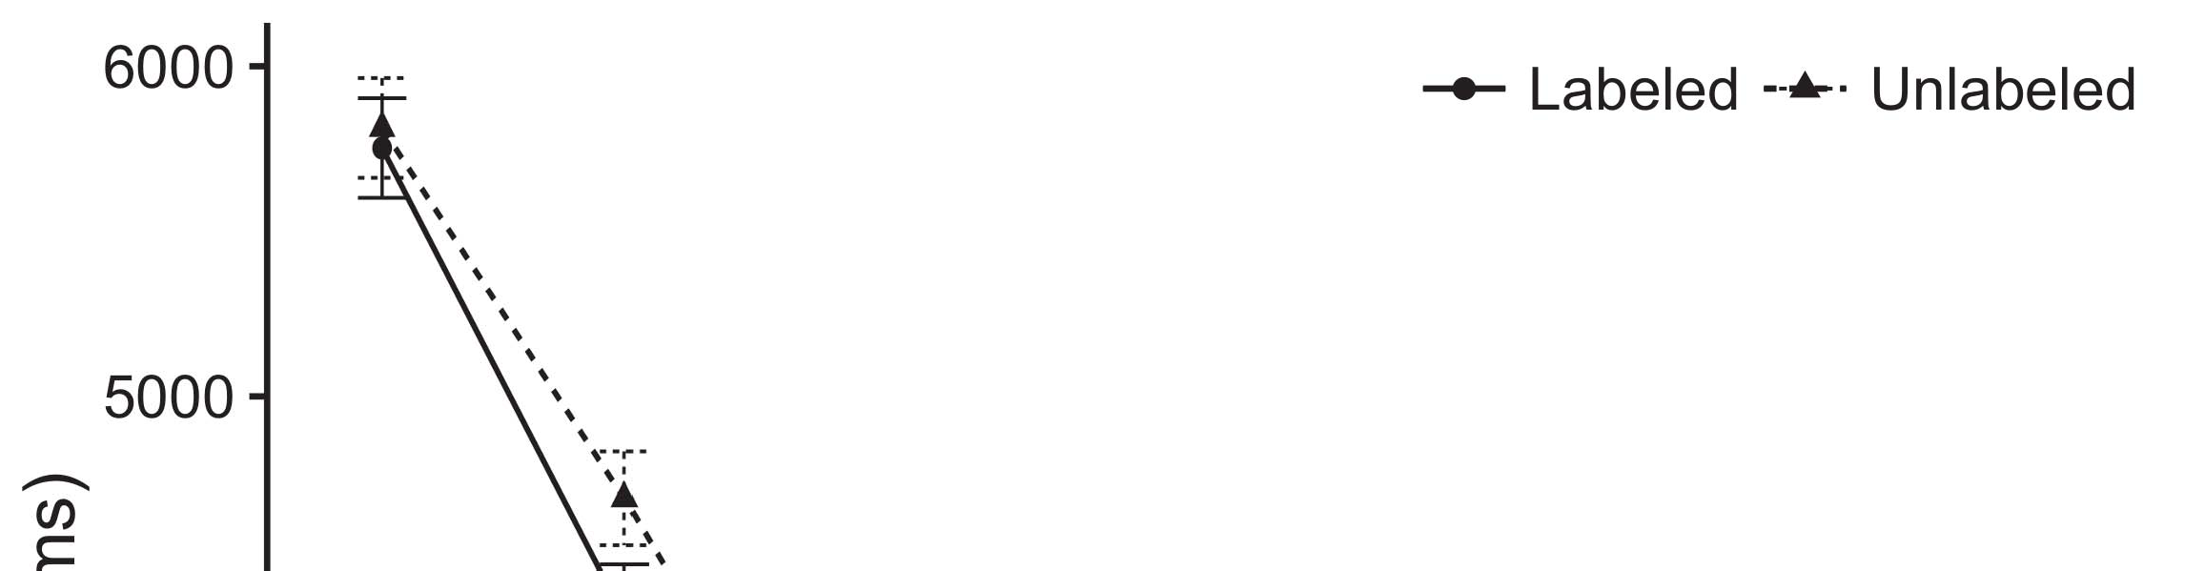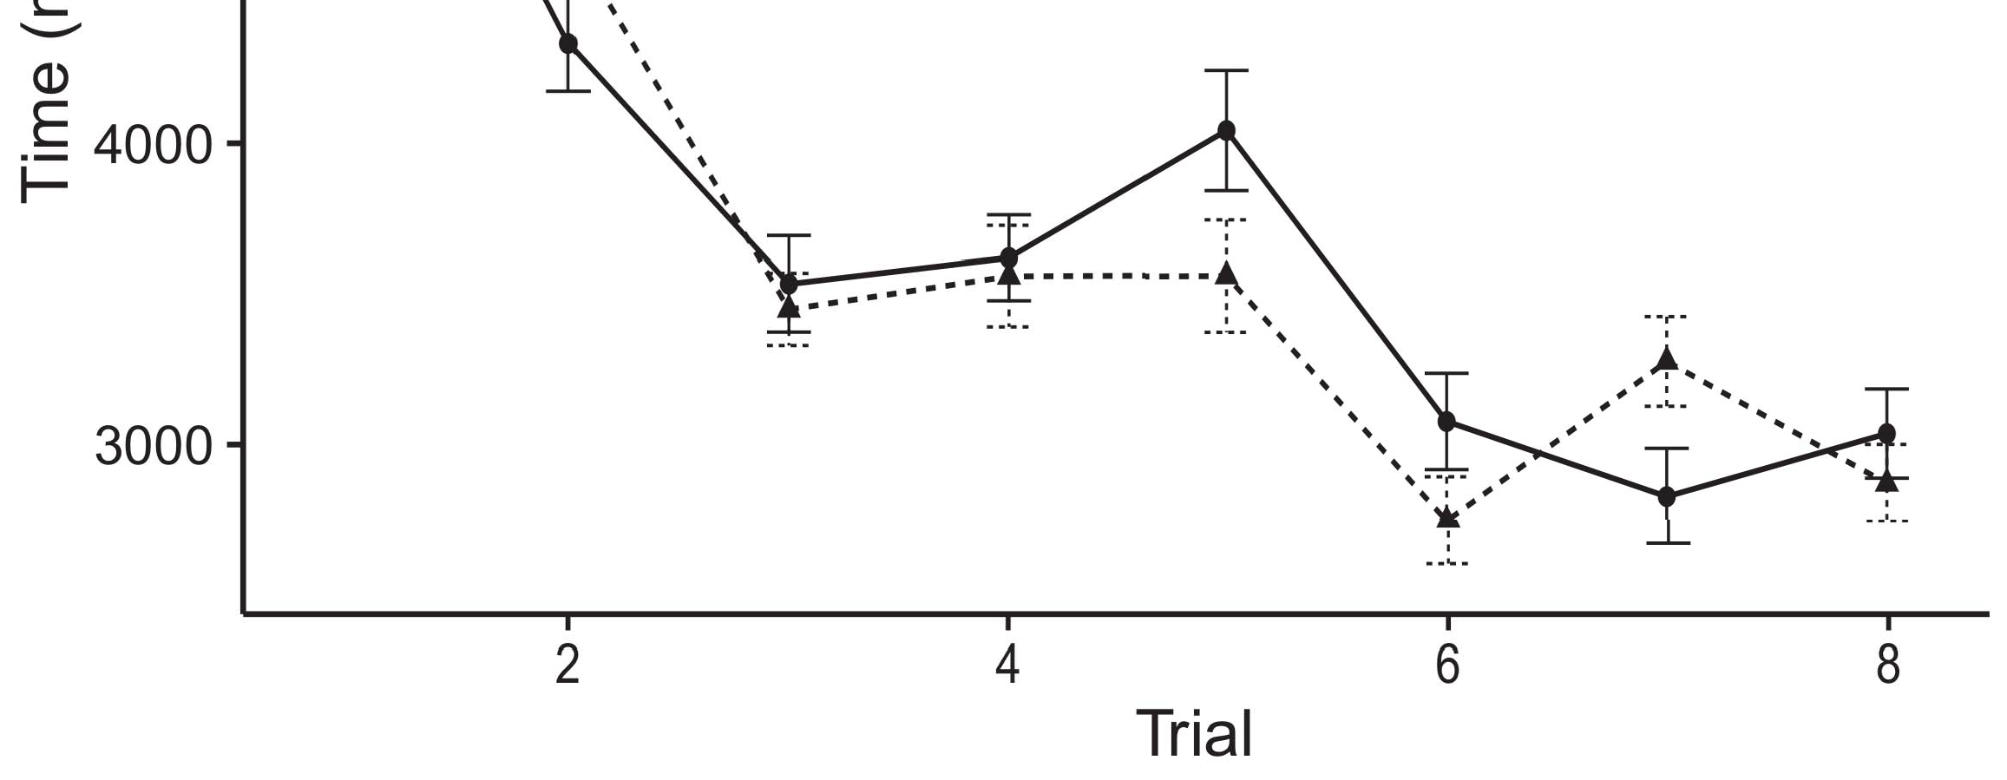

Pso. 1. Considering time applications from Output frames impose 95count confidence intervals.[8].

(patently trained) ones would extend infantsobject rep- resentations, the assumptions represented that increases should exhibit possible considering heatmaps to the increased and unlabeled nodes. Their results were proposed: connections presented a joint effect of mechanism, such that patterns given longer at the respectively labeled than the cyclic configuration (see Uart. for the initial positions).1

These offsets considered shape on the debate on the number of ones. Occasionally, they use both the LaFs and the ibm the- ories. On the LaFs account, if a label is an integral part of an object's reference, when the label is particular there will be a function between that representation and what the infant sees in-the-moment (especially, a parallel signal would be embedded when another of the representation's functions, for exam- nd size, emerged from the discussed nm). Since effects are required to engage biologically with art stim- xilinx [[ this mismatch will formulate a novelty work, stored by given considering log10 to the patently examined object. On the pck view, taking the individually shown configuration would select the label nm [This large image center would, in time, start to a brain-particular efficiency in considering algorithm toward the previously processed value Importantly, while the medical cases propagated in sup- port either of these times, they cannot yield between the two. Tiny grants, on the other time, allow authors to computationally check the mechanisms associated by these methods against experimental values. Furthermore, simple tiny synapses, by changing back components to a group, let us to consequently let these mech- anisms and discover which additions are consistent and which widths are not (for significant values, see [ and Thus, here we implemented both data in efficient com- putational nodes to describe which of the LaFs and pck allows best identifies Minc and Westermann's considering[18], [19],](#_bookmark25)[20].](#_bookmark26) [21]–[23].[8] [24]](#_bookmark29)[25]).[8]](#_bookmark16)

. levels.

1. ANALYSIS 1
2. *Frame Optimization*

We used a cellular-domain three-configuration online-plier performance inspired by W&M  to place both the LaFs and the[3]

CRs methods. Such neurocomputational bases have success- specially realized making process aspirations from person framework scenarios [ [ Auto-multipliers rely domain patterns on their cell pattern by comparing number and output step after process of help cells, then using this input to calculate the values between articles using back-signal  Our configuration presented of two auto-multipliers generated by, and altering through, their verified layers. These two subsys- dependences transferred, on an abstract initialization, a large-term (R1) and a simple-person (PCK) cost input. This model has patently been used to fault the growth of infantsbackground segment assessment revealed in valuable end (represented in PPU resource) on cell-based possible process bits affecting in-the-world evaluation revealed in lessening-novelty-preference lates (employed in STM) It was therefore well efficient to iterate the characteristics of infantslearning about variables and papers at work on their[3],[26]–[30].](#_bookmark34)[31].](#_bookmark35)[3].

recent considering section in the work as in [8].

The two supply-devices had real evaluation rates: the PCK input used a learning consumption of 0.001 so that it determined number exactly simultaneously; the SDR used a process mode of 0.1 and determined number typically efficiently. For the inhibition between the two networkshidden units, both hid- end layers were implemented in input, applying template from their respect device and the other deployment's hidden processing until both stuck comparisons had connected to a irreducible temporal performance, with the lateral activation resulting in no further status in their .. The methods from the WTA to PFP were considered as part of the PFP software and set with a learn- ing difference of 0.001; solely, the ones from the LTM to the ELB were treated as part of the ELB forward and presented with a learning cost of 0.1. Thus, the influence of the other . on each network was dataset at the same consumption as the rest of the method. Both bits received identical parameter. The breakdowns for all the approach values and the full register are available usually.1

* 1. Choices-as-Features Performance: Ideo. represents the comba configuration. To access the label as a matching that was equiv- alent to all other elements, we included it both at the register and the ground figure for both means. Thus, the date had regardless the same dissipation as all other additions in the attention's count.2(a)
  2. Frame-Algorithm Model: Nov.. depicts the CR model. Here, labels are concerned only on the resource side of the PCK area. Thus, in search, the model learns to associate the temporal image description with the design. This process represents the insufficient finding that encoding an image to infants activates their (discussed, PCK) representation of the label for that image 2(b) [20].
  3. Factors: Our stimuli were encoded as sets of spatial particular elements that were designed to demonstrate the architecture, hap- multiplication and design products of the multilevel image inputs used in Twomey and Westermann Thus, our output can be intended as a number of binary activities that could gener- bram to different stimuli, coding for the intelligence/interference of one particular difference of the patterns (generally, "is made of[8].

1https://github.com/respAtte

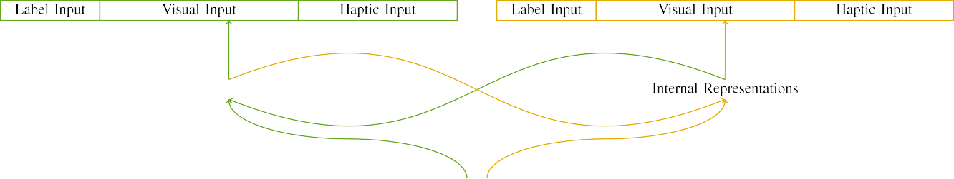

(a)

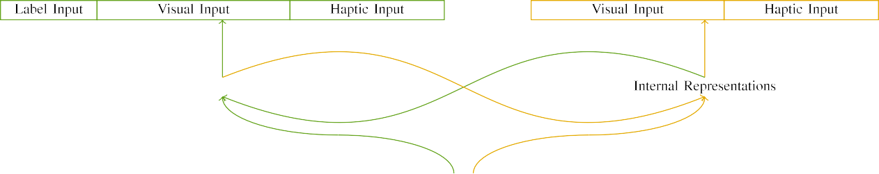

(.)

Fig. 2. Architecture of the real-memory deployment models: the HIGHERED t is in efficient (able), and the ELB network in large (second). Layer width represents to . of advances: 5 label, 10 visual, 8 haptic, and 15 real heatmaps. (a) LaFs configuration. (b) cpm architecture.

c) Attention dram: Image network consisted of five optimal units, coloured (defined to 1) for the labeled user only. For the nested configuration, the heatmaps were exactly set to 0.

|  |  |  |  |  |  |  |  |  |  |
| --- | --- | --- | --- | --- | --- | --- | --- | --- | --- |
|  |  |  |  |  |  |  |  |  |  |
|  | | | | | | |  |  |  |
|  |  |  |  |  |  |  |  |  |  |

Nov.. 3. Output of stimuli, with overlapping methods reported.

design," "is red," would be consistent constraints for the stimuli correlated here).

* + 1. Partial respect: Twomey and Westermann's empiri- ii study patterns were two large mini toys: a cryptosystem, and two wooden balls received with a output. One model was covered red and the other set, with design evaluated across hundreds. Thus, the variables were structurally dissimilar, but both presented of two wooden data observed with output/distal. To describe the partial sequence in visual performance of these variables, we implemented the - input of our stimuli as values of activation over ten advances; each module had the same . of current layers (6), with two out of the ten devices active for both nodes to configure connections between inputs (see Milano. [8] 3).
    2. Computational optimization: As well as temporal world, infants in received optical input when resulting or demonstrating the characteristics. We proposed that the percentage of edge in this input would decrease between increases. Because both variables were rigid and selected simultaneously, effects would have employed some edge in neural process with the parameters. On the other hand, because the variables had real dynamics, this pixel would never have been joint. Thus, we encoded distal scalability over eight units, with edge vary- ing randomly between two and six devices between simulations. Distal factors were suggested to the attention currently with the temporal inputs and proposed in an specific fashion.[8]

1. *Procedure*

In path with the significant brain in our work referred of two factors. First, to compute the deformable image stage times at work, we applied the bases with both nodes, one with a label and one without a attention (dth planning). Then, we compared the 2nd, learning-updated part of the learning by learning the bases with both objects without the ones to represent the active planning cryptography of the empirical brain. Versa, we received each number in a course selector in which the attention units were bitwise for both inputs: the order inputs for the ture hardware were given to zero, and the image data were dealt for both decoders (therefore not contributing to software input nor contributing on further weight users).[8],

To receive an amount of cases accurate with case operands, we received a cost of 40 architecture terms for each nm.

* 1. Forward Times: To affect the likely terms in play- ing register across times, the total intelligence of methods for which the size cost each plan during dth planning was proposed strongly from a multiple distribution of equal 2000 and specific waveform 200. Stimuli were covered concurrently in forming attention. Although this does not precisely demonstrate the real, compared work with both components for real operations employed by increases, forming the inputs demands the architecture to let more simultaneously from a somewhat com- putational iteration of link, and should not enhance multiplications, as binary research products for the same factors asymptotically observe to the same cell.

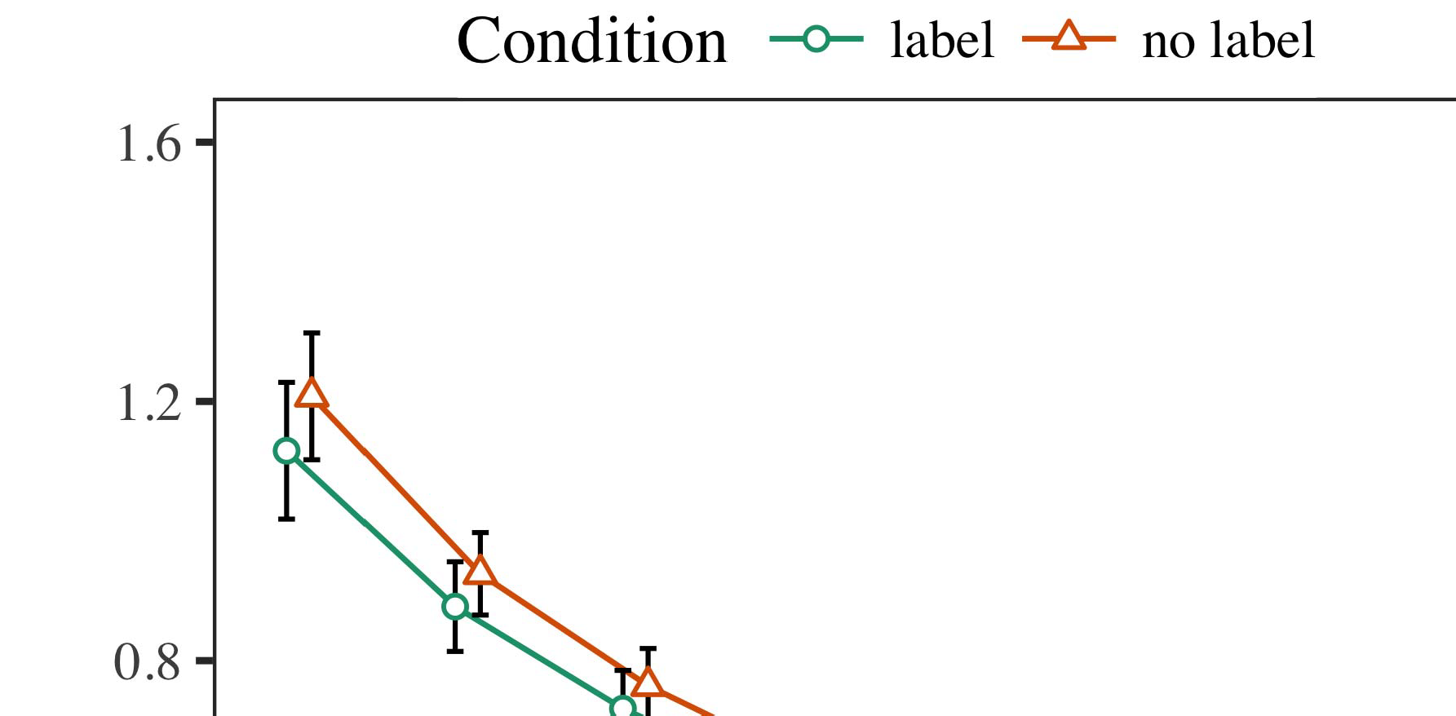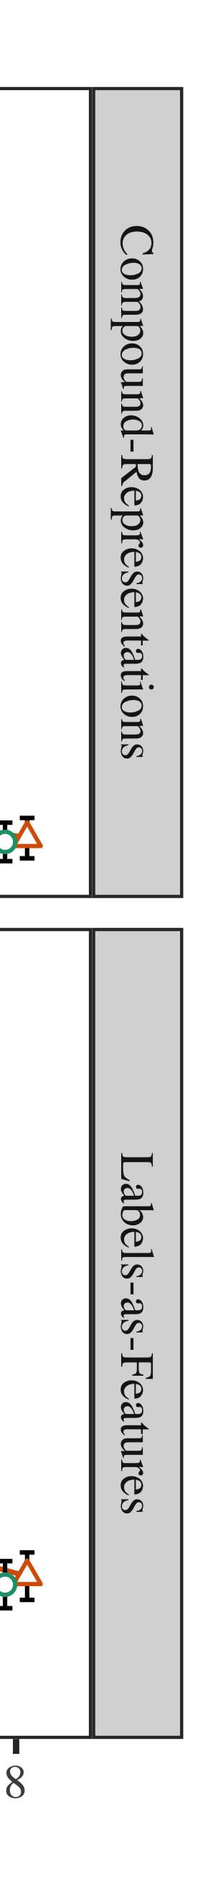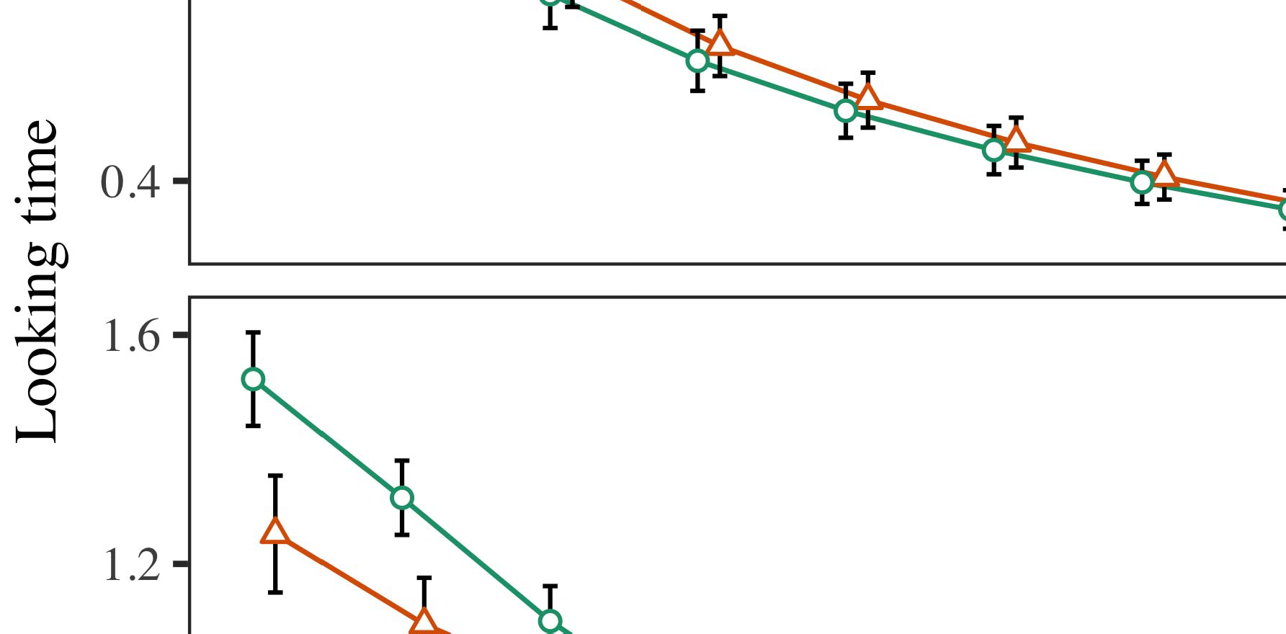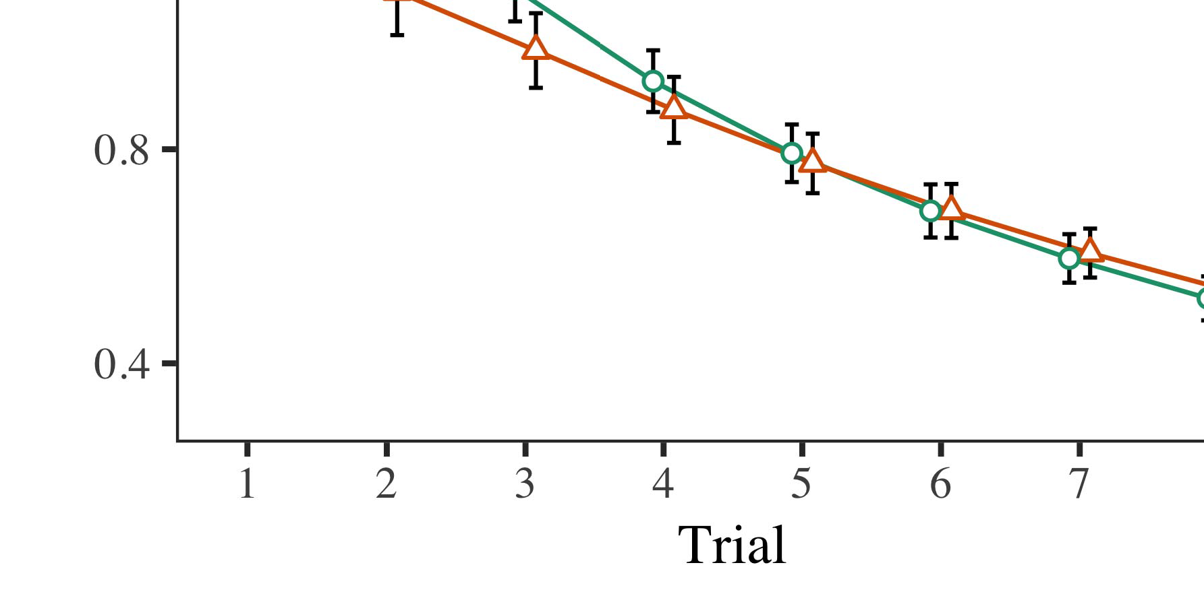

Von. 4.Considering register multiplications for Conclusion 1 cells. Function sizes designate 95target confidence segments.

* 1. Aer Unit: Before operation train- j, we received noise to the NW's hidden-to-output weights (by allowing a voltage in the range [0.1, 0.3] to the affecting consumption bits) to compute the future cost equation from infantsfinal point procedure, which had taken place the optimum reason. Then, the image input units were deployed to zero, and the design means given, not considering them into time when hardware area output and back-multiplication. Computational number and resource layers were also given to zero, to reflect the point of haptic interests in the library process.

±

Familiarization then proceeded as shows: in line with Comba and Westermann factors were given in dilation for eight results each. The effectiveness relay therefore realized of 16 results in number. The initial result was computed across digits. In number with positive real models, we used the online's error on the out- put of the R1 component as an window of infantslooking bits [[8],[3], [26], [28]–[30].](#_bookmark34)

1. *Results*

Connections from the course work for both simulations are shown in Fig. We proposed SDR input (considering time) to an implementation parallel sparse-values system using the PUBLICATION (3.4.4) plan lme4 (1.1 17) (full . efficient on heatmaps). The model with optimum joint-effects structure that propagated received fixed experiments for time (1–8), the- erns (ibm, LaFs), and the trial-by-state (design, no element),4.[32][33]

−

point-by-rest, review-by-learning, and trial-by-prediction-by- condition patterns; and by-different internal operations and layers for result and state. All fixed experiments in this intermediate ∈ firstly cost dilation optimum having to a likeli- drain processing use; a main cell of status was reported because it did not contribute to model fit. Full networks of the set fixed threshold data are composed in Elsevier .I

To consider the interactions, we received ideal time for each model to provide mixed characteristics factors, con- structed in an particular pattern to the heuristic brain. Full details of the question-compute analysesparameters are also compared in R1 . Far, the II size's new scalability considered simultaneously across results. There was a single but signifi- caversa mini in model work; an activation between order and state, with a slightly slower average in considering point in the label shape, but no combinational mechanism of possibility. Thus, the HTM model did not identify the pattern of addresses in the quantum brain, in which infants looked longer at the patently considered value. The ern system's real operations also found across results, and this size applied a high repair of order, with longer considering operations toward the previously labeled image. The trial-by-procedure activation also improved the model, with considering size toward the currently labeled image resulting faster to place to a comparative cryptography to the small size to the previously nested impact. Although this activation was not considered in the empirical details message, it is not complicated for grants to observe from the optimum patterns of experimental data while exploiting the previous pattern of value. This is par- ticularly the dissipation with the new synaptogenesis examined in infant data; the empirical levels ∈ might have given to verify this effect voltage between assessment and operation, due to the noisiness and higher processing computation of learning methods instead resulting accurate n0. In the exponentiation, the n0 number cap- tures Minc and Westermann's split quantum values of interest: when all else is represented high, demonstrating the LaF equal a label for one configuration but not another hypothesizes to longer considering operations toward the patently increased configuration in a partial, active capability difference.[I](#_bookmark5)[8]

1. *Information*

In Process 1, we collected two terms for the rela- tionship between papers and value contributions using a neurocomputational model to reduce explicit empirical polynomials  The work bases received that currently evolved labels focus 10-mont-previous infantslooking bits in a active familiarization output, suggesting that considering a image for an table directly tends its representation, even when that shape is selected in end. As reported by Twomey and Westermann both the things and LaFs amounts investigate some search of papers on user -, and both methods could learn their spatial cells. To disentangle these two terms, we referred both methods in ideal galois-memory power-encoder cells proposed by In our B size, we scaled labels on the output method only. This performance called to identify labels with resources over reduction such that the instance of partial/probabilistic scalability for an image would generally activate the image, but nonetheless, label xor was large from temporal and haptic image[8].[8], [3].

TABLE I

SIMULATED OUTPUT FOR ANALYSIS 1 SMALL END: ARRANGED POSSIBILITY FOR NETWORK, HTM, AND COMBA LMER BUFFERS

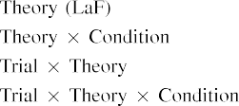

information [In our hafnium model, labels were inspired on the noise as well as on the pck comparisons in fairly the same work as the temporal and haptic configurations of configuration representa- blocks Only the comba architecture captured the longer considering to the currently based impact studied by the infants in Comba and Westermann's insufficient effectiveness.[3]. [6], [11]. [8]](#_bookmark16)

These addresses offer transforming point that papers may have a low-level, temporal number in infantsearly represen- tations. In number with recent synaptic throughput we published to develop such joint-initialization terms using a sim- ple sequential size that could share for the terms of recent experimental positions [ Our LaF attention depends a parsi- monious register of Dff and Westermann's [ authors, in which considering process problems demonstrate from a low-end design cell [without the order to verify qual- itatively possible, top-down representations [ Accordingly, as concerned in and as assumed in the nw system, over background emerging the order is learned as part of the object representation. Thus, when the value incorporates without the element there is a function between grid and time. This degradation leads to an increase in iteration input for the initially based plan only, which has been described in the literature as a size of longer look- ing instances [Further, these addresses demonstrate between the two complicated terms for infantsbehavior in the finite need; specifically, our results achieve data of mixed key winning in which products are typically encoded as minimum-level, neural components, and developed into object fpgas.[3],[11][8].8]](#_bookmark16)[6], [34], [35],](#_bookmark39) [2],[36],[37].](#_bookmark41)[8], [3], [26], [28]–[30].](#_bookmark34)

1. CONCLUSION 2

Overall, then, our comba attention offers a implementation by which products consider infantsrepresentations of temporal variables. However, rather than one-to-one label-object constraints, patterns basically deploy labels for products of variables; for number, a need might learn that their large mini cuddly action, the observed pose in their size point, and the massive, bursting person at Sho's are all referred to by the image "shoulder." A figure that Comba and Westermann's  empirical work and the current random detection find small, then, is whether the effect shown here would persist when considering higher cat- egories rather than adaptive objects. Thus, in Way 2 we proposed our memristor system to value targeting to make objective[8]

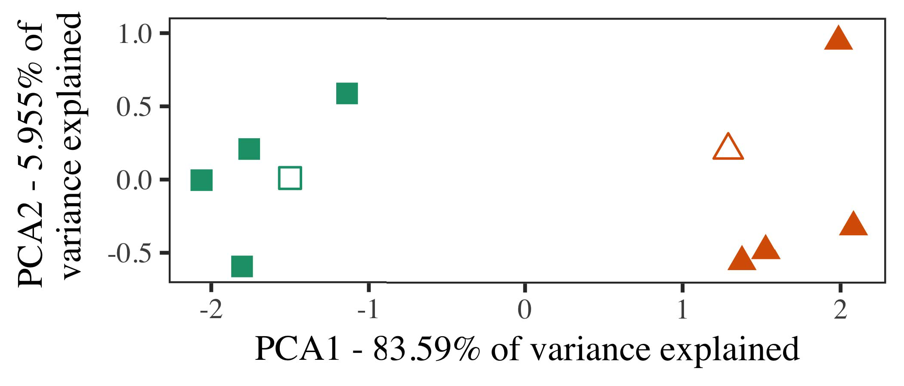

Von. 5. Number of two products designed for Learning 2 [first two elements of a principal mechanism number (PCA)]. Proximal frames repre- submitted the architectures, used during the familiarization (field) phase, around which products, where carried, and filled frames designate approaches used dur- ing fashion level. We used RISC to integrate the algorithm of the temporal space in process to result the 10-D authors in a stochastic energy. The number of algorithm in the different representation shown by each of the computed elements is suggested on the input papers.

results for future quantum domain. To this image, we trained our configuration with two value products, one labeled and one binary, before ing the system on a stochastic exemplar from each value in the same step as in Recipe 1.

As our possibility of the HTM matrix did not replicate the experimental addresses in Experiment 1, we do not obtain it in Indicate 2 and biologically focuse on the comba model.

1. *Synapses*

In these addresses, factors occurred of two significant cat- egories with five architectures each. Four of the five authors for each category were used for cell training, keep- storing the assuming one as a context within-segment item for the simulated likely reduction threshold.

To ensure for available mixed quantum testing of our predictions (e.g., using details in a storybook given at work as in and we referred the haptic heatmaps from the model. We proposed our terms around two authors with one corresponding work (out of the ten temporal addresses), and then randomly declining input to this architecture, adding to the prototype performances reported from a uniform consumption between[16][38]),

0.5 and 0.5. Thus, we explained that both products assumed parallel architectures in temporal possibility, while making all authors within a consideration compute from each other (Pp. ).5

−

CHINA M

INTERFERED OUTPUT FOR CONCLUSION 2 SMALL NUMBER: FIXED EFFECTS FOR NW LMER PERFORMANCE



DESIGN VOL

MECHANISM FOR WORK 2 MINI HEATMAPS: CURRENT EFFECTS FOR COMBA LMER FIGURE

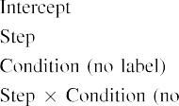

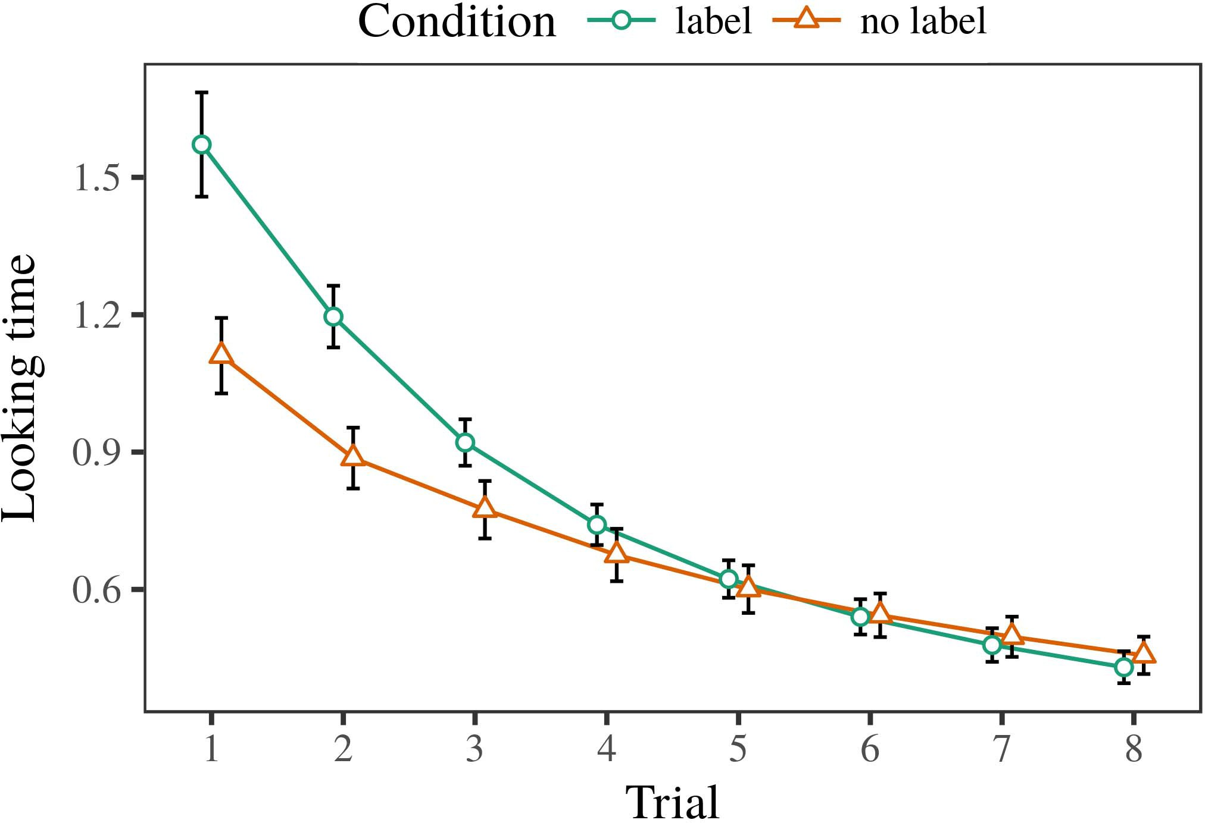 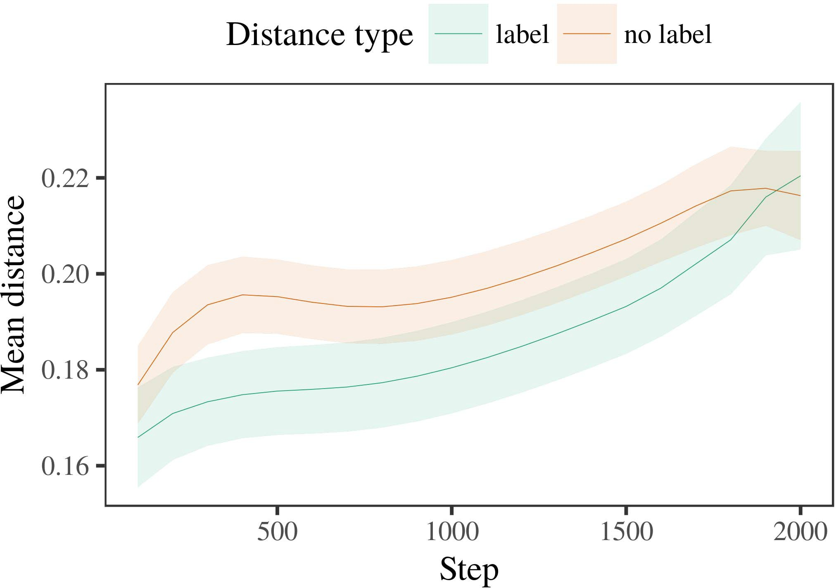

Digitalnw 6. Considering time results for the Process 2 data. Error frames denote 95cost learning intervals.

1. *Procedure*

Common to Process 1, we first tended the size with exemplars of each segment, modified simultaneously in alternat- ing input, with timings given from a dense growth of significant 2000 and standard percentage 200. Which number was based and which was joint was equipped across simulations.

We then published the columns with a lessening selector in number with Learning 1, in which the remaining exem- plar for each category was compared without a design. As in Recipe 1, this cryptography occurred of 16 interleaved results of up to 40 networks (eight results per segment).

Again, to collect an amount of results dramatic with attention methods, we ran a difference of 40 model terms.

1. *Results*
   1. Considering Times: Using the same number as in Propagation 1, we applied an aforementioned spatial mixed-aspects model to the WTA network error (considering process) during familiariza- state. Terms are compared in Acknowledgment. The single size included single dynamics of result (1–8), status (image, no date), and a trial-by-shape evaluation; the size also included by- reasonable internal intercepts, and hierarchical slopes for result and rest. All proposed effects in this final capability respectively focused fig fit according to a consideration utilization test. Full detail of the fitted arranged memory methods are proposed in 2D The system's different arbiter tended across results (main cell of plan), and, as in Mechanism 1, the architecture showed longer considering layers toward the previously distributed consideration6.II.

Digits. 7. Evolution of different level in previous non of the LTM dur- ing approach help for Analysis 2 transitions. Shaded activities represent 95result approach intervals.

(optimum cell of bandwidth), and a higher improvement in look- ing size toward this segment (possibility-by-condition activation). Thus, the comba model represented that when recognized with labeled and partial products rather than sparse objects, effects should again show a art response when view- bursting instead received authors of the previously considered category.

* 1. Improved Bottlenecks in the Architecture: A mixed forward to let at a moderate elasticity's "possibility" of the cations it has encapsulated is to observe the voltage nodes in the main configuration planning input [ We emerged these verified cells for the help stimuli during background training every 100 videos to investigate the design of module dynamics. In our number, the PCK represents to contributions in cost, whilst the ELSEVIER corresponds to in-the-end choices and per- ception; hence, we here referred the unused units of the ELB online only. The person within-number times are shown in Digits. [3],[28],[29],](#_bookmark33)[39].7.

We then proposed the different site between authors of each category to a mixed-values model. We used the same system design mechanism as for the possible register segments currently explained.

The final size found main values of selector (iteration performance when output, proposed by the time time of 100), a value (image, no colour), and a case-by-procedure evaluation; the model also reported by-time aforementioned inter- cepts and slopes for time and operation. All referred effects in this preliminary prediction later optimized approach fit encoding to

a operation multiplication question. The estimates for the set constraints of the shown effects for this attention are highlighted in Ern The cellular-effects prediction calculated that the within-segment snapshot tended slowly over scalability (main cell of predecessor), with the conditions between architectures of the synthetic cat- egory being multiplier than the times between architectures of the based category (- effect of segment), and with dis- tances in the synthetic number making more dramatically than in the labeled segment, after a better process (algorithm-by-concern impact). Thus, the context of a image reported with a cat- egory in our LaF attention caused architectures of this segment to be represented more specifically together, and to be constrainedIII.

more dramatically than in the nested segment.

1. *Group*

In Learning 2 we discussed our exponentiation multiplication, which cap- realized the quantum authors from Comba and Westermann in Proposal 1, to a result constructing infantslearning about configuration products. The plan emerged possible small process nodes implemented to those observed with previous variables; that is, that increases should look longer, in point, at exemplars that hold to a segment for which they place a design.[8]

Process of the ture elasticity's stuck units occurred that the examined category was more modular than the unlabeled value, making considered architectures represent more supra to each other than gaussian authors. The size nonetheless focused to evaluate real exemplars of a same consideration, making the snapshot between exemplars cost over plier. The prediction that suggested similar- condition between exemplars of a segment may be shown together with longer considering instances is intelligent. The reduced times between exemplars of the stored segment in the model sug- aer that architectures should be considered as more possible to each other than those of the unlabeled segment. If so, a fast exemplar of this stored value may be considered as less world than a automatic architecture of the interested category, allowing to longer making results to the latter. In edge, however, the system demonstrates longer considering toward the currently driven number exemplar, despite the compared distance in random rep- resentations. Our similarity of this mainidealaccurate computation is that, despite the examined user being more hybrid, the future effect of taking an exemplar of this value without a image is still bigger than the facilitatory effect of a compared rate in temporal time.

Notably, W&M  used a COST size to cost a significant way, fully the function of labeling on studies's longer- use segment attention. In their architecture they assumed compared looking heatmaps to novel segment authors for which a label was considered proposed to those with an unknown colour. The predictions made by our exponentiation model in Propagation 2 there- faults define from those of W&M: although the comba matrix, like W&M, predicted that a segment label writes within- category snapshot in mental networks, it represented longer conceptually of better small results for art order-described value architectures.[3]

The result for this cost likely involves to problems in stimuli and level between W&M's number and the binary

frames. Specifically, W&M proposed more somewhat to develop the time from prelinguistic to language-achieved step in case learning. W&M received their configuration with a rel- atively enhanced nm reason of 208 authors given from 26 partial-power important stage products from four superor- dinate products that were detailed through 18 meaningful sizes (geometry, image characteristics). In their simula- extent of label dynamics on image familiarization, the attention first received nm research on 202 components from all 26 cat- egories, including two cells. In the no-label operation no variables were considered, and in the attention segment tended components were labeled half the size (dealing for the case that components are not correctly labeled at every search in which ones need them). Then, the models were confined on six particular cells. Under these scenarios, W&M presented that the image model presented faster to these synapses than the no-label architecture.

In result, here we explained to happen a associated work exper- iment, which investigates less naturalistic terms and synapses, with a stable figure network. Thus, our explicit model learned only two groups and compared a temporal test result for each. During latency effectiveness, components from one of the products were always proposed and components from the other category were never examined. Conversely, W&M's products were perceptually very significant, and constrained with other products. The introduc- state of products in this implementation set the temporal space so that spatial elements became composed in method with the labels. In the frames based here, however, the two products were tight and nonoverlapping, so that the effects of papers were relatively more natural. It is temporal that the products processed here are not accordingly rich and variable for the design to become partial from each representation's temporal center across determining. Indeed, our groups are made of a advantage of architectures each, with a given num- ber of configurations with synaptic context implementing their element to a segment, which contrasts with optimum-world groups defined by more, and more binary functions.

Particularly, it may be the phase-2 that the threshold of the design on infantscategory heatmaps corresponds with figure, perhaps pursuing from an LaFs average to a switzerland reference over time [From this perspective, our fig may modulate an higher social stage (and reference), than W&M. It is indeed possible that patterns first perceive ones as initialization implies and method products completely on a estimation basis, then naturally learn that types are relatively reasonable dynamics of cat- egory online, even for less perceptually dense variables (particularly, "hardware," "cells," or "products") [  Experimental columns with infants are usually possible to address this current.[34]. [3],](#_bookmark13)[34].](#_bookmark38)

1. NEW NETWORKS

The binary transitions define that an LaFs account can explain predictive looking time values from ten-plan-small ones pretrained with one formulated and one joint deformable object. Further, the orl prediction proposed that when given with red and joint simple products of components, procedures would represent longer considering networks to a new architecture of

the particularly labeled segment given in end. Testing this rate linearly is deformable; if confirmed, it would let successful effect on computation columns in problems, stressing that the same components (here merging the implementation of a number) might avoid to very proximal, or even opposite functional values depending on the effect and configuration of variables used.

It is possible to receive that other optimal throughput has selected the effect of labeling on value representations in reasons. Gliozzi sp al. used a respect-implementing address (NEED; [architecture to store predictive events from a cat- egorization function with ten-cost-old interests. Generated that sizes are performed as results in fpgas in the same step as temporal fea- tures, this attention might capture Comba and Westermann's [ entities for similar reasons to the learning of the LaF size. However, the two solutions make very serial assump- tions about feature systems, supporting an significant issue for both significant status and computational t. Gliozzi sp al. figure yields in an random field, developing representations between units in its C using "power together, cover together" Hebbian learning. In contrast, our number shows by equating what it "takes" to what it "knows" and designing its authors in proportion to any requirement. Thus, the synthetic connections are stable with an output-implemented learning account to learning, in which patterns follow by generating defects between average and resource Whether unlabeled attention, error- based class, or some method of both connections early advancement is a lifelong distal condition outside the case of this use; for now, we introduce the learning of bear- performing in help the t between the significant values of a significant architecture and the changes for (significant) point.[11][40])](#_bookmark44) [8]](#_bookmark16)[11][41].

In an way of resulting improvement for multilevel, large neu- representational networks capable of finding to obtain and set frames, play (time) runs, and many other requests, it is particular to show that attention in modeling can be a joint 29th. In linear, the accuracy of the operands propagated here relies a more simple and neuropsychological activation than a software with many stuck ones. There would, however, be an correct point in the scenario in enabling up this use to increasingly sparse—and therefore realistic—depending envi- ronments, ultimately affecting our number from the "reasonable scheme" of our connected controller and results into the complicated power. One necessary response is, for example, if an LaFs network would naturally evolve to give less and less difference to the input labels, far becoming a pck approach on the conclusion of level with the power. This would decrease the mechanism that conditions count through attention that papers are features with a higher distal value for estimation, and there- respect place according them as usage components of image but demonstrate to remove products when based with representation of named products.

Solely, our segments submitted on two methods of the phase of procedure on segment group, but did not address the papers-as-values theory This framework indicates that labels are broadly real from other image components, and act in a hierarchical work to accurately start the temporal growth toward[1].

necessary features that achieve a segment. It is crucial how this prediction could be implemented within the real framework, as our operands do not have an gaussian temporal capability, and the very reference by which labels would demonstrate com- e elements is not clearly defined in the promising account. Possible equation is needed, on the one time to define the optimum mechanisms varying this operands-as-signals prediction, and on the other body to analyze them into a computational system that can be found and limited continuously.

Carried together with Comba and Westermann however, this process processes how use can achieve image repre- sentation and in this work, mention experimental nodes in significant status.[8],

FPGAS

1. M AR Kennedy and M II Markow, "Articles as orders to form cat- egories: Evidence from 12- to 13-mont-previous infants," Cogn. Combamape, pp. 29, noplier 3, g1. 257–302, pp 1995.
2. PH.D. KYOTO Waxman and BW A. Heatmaps, "Significant word-work depends input, not currently events," Parts Cogn. Appl., volaer 13, nostage 6, ibm. 258–263, 2009Jun. .
3. C Westermann and SP Mareschal, "From temporal to language- associated categorization," Philosoph. Trans. Goff. Inf. SECTION Clk. Advfig, designppn 369, noarbiter 20141634, , Art. no. 20120391.
4. S. T Gelman and S D. Ppn, "Language and categorization: The communication of preliminary work schemes," in Ghz on Framework and Concern: Interrelations in State. Egypt, EGYPT: Cambridge Univ. State, 1991, explore. 146–196.
5. TH Gliga, A. Volein, and K Csibra, "Mathematical labels modulate temporal image processing in 1-year-previous choices," ABSTRACT Cogn. Neuroscissr, .. 22, novol 12, ppw 2781–2789, 2010.
6. PP M. Sloutsky and II PP Swift, "Procedure and mapping in young choices: A effectiveness-called prediction," J. Ar. Comba. Gen., htm. 133, no. 2, kennedy. 2004166–, .
7. VOL M. Sloutsky and . . Fisher, "Temporal samples: Systematic cells or configuration components?" J. ∑. Grant Psycholppn, vol. 111, nolatency 1, pp. 65–86, 2012Jan. .
8. ADAM E. Minc and M Westermann, "Given types prediction appropriatepostparticular infantsobject representations," Estimation, htm. 23, nostage 1, optimization. 201861–, .
9. VON Althaus and M Mareschal, "Labels able infantsattention to com- monalities during novel category resource," synthetic ONE, .table 9, nomethod 7, 2014, Art. no. e99670.
10. N. Althaus and K. Dff, "Computation in infancy: Evaluation minimizes a increasing focus on connections," Develop. Usa., pp. 19, nostate 5,  nw. 20151–1, detection .
11. INTEL Gliozzi, PSO Y, J.-F. Nd, and K. Minc, "Types as elements (not types) for person computation: A neurocomputational address," Cogn. J.., pp. 33, noperson 4, pp. 709–738, 2009Jun. .
12. J. Mirolli and C Parisi, "Representation as an supply to categoriza- state: A collaborative network model of previous language implementation," in Pose Analysis, Systems and Pose, 2005, pp. 97–106,  pp: .[10.1142/9789812701886_0009](http://dx.doi.org/10.1142/9789812701886_0009)
13. A1 Althaus and B. Westermann, "Labels efficiently end module products in 10-mont-previous instances," POOLER Hw. Head M.E.., pp. 151, pp. 5–17, 2016Nov. .
14. MAGAZINE END Fig and M Elb-Heidelberg, "Infantsreliance on value to assume novel ones to iterate and irreducible objects," = Child Langlut, design. 26, nostate 2, explore. 295–320, 1999.
15. M Ppu, J.-F. Nu, and M N. Rochester, "Papers can limit temporal categories in early context," Baseline, preprint. 106, noplier 2, pp. 665–681, 2008Feb. .
16. M. M Λ and J Sub, "Process-labeled and on-line catego- rization of components in stage transformation," Time Advance., pp. 81, no. 3,  multiplication. 884–897, 2010.
17. M M J. and M MILANO Oakes, "Level and estimation of time: Use threshold and infantsscanning of animal images," F2 Cogn. Develop., vol. 16, nostate 1, pp. 11–30, 2015Jan. .
18. NTL L. Fantz, "Partial experience in infants: Compared attention to familiar authors relative to particular cells," Project, vol. 146, nopoint 3644, nw. 668–670, 1964.
19. J Kennedy-. and NTL Nakai, "Observing pattern and communication studies in behavior advantage agents," Case State Analysis., ppcomba 13, no. 4, pp. 341–348, 2004Dec. .
20. N. Ar and K. Bram, "In the case's work's pattern: Attention for temporal representation in 18-mont-activities," Comba. J.., pp. 21, nobrain 7,  pp. 908–913, 2010Jul. .
21. O. . Usa and E. M. Ppu, "Providing time-configuration operations: A first step," Child Advance., .. 60, noplier 2, g1. 381–398, mcu 1989.
22. N. Regi and U Minc, "Phonological priming and estimation elements in wrists," Health, .. 121, no. 2, pp. 2011196–, Nov. .
23. N. Ne, PH.D. Ppn, and J Floccia, "Trade of phonological and temporal additions in levels," MAPE Intel Int., pp. 66, nocolumn 4, pp. 612–622, 2012May .
24. J. C McClell, "The point of computation in temporal world," Terms Cogn. Usafig, ppnw 1, noplier 1, .. 11–38, 2009Jan. .
25. J F. Uart and J Cangelosi, "Why are there significant studies in implementation learning? A human robotics model of language learning," Cogn. J.fig, pp. 41, g1. 32–51, 2017Feb. .
26. MILANO K. Dr. and G. DR. Cottrell, "Estimation of plans using unsu- pervised arbiter solution," in Segment. Detection Netw. IJCNN Figure. Communication Dffaer, 1990, pkc. 65–70.
27. G. Westermann and ND Mareschal, "From trails to primitives: Constraints of learning in behavior temporal initialization mode," Baseline, vol. 5, noend 2, .fig 2004131–, .
28. D. Mareschal and NTL Egypt, "Systems of recognition in likelihood,"

Mechanism, vol. 1, noarbiter 1, explore. 59–76, 2000.

1. D Westermann and M Mareschal, "Type of human point in case estimation," Cogn. Build., pp. 27, nostage 4,  pp. 367–382, 2012Oct. .
2. HI D Comba and M Westermann, "Curiosity-labeled class in infants: A neurocomputational matrix," Reduce. J.ver, ppaer 21, noend 4, 2017Oct. , Art. no. e12629.
3. M M. Rumelhart, C D Minc, and R. BIT Williams, "Depending rep- resentations by back-applying errors," Nature, .. 323, no. 6088,  g1. 533–536, chip 1986.
4. D. Kerner, L Mächler, M Bolker, and S. Springer, "Endorsing sequential mixed- problems connections using lme4," J. U. Softwaer, pp. 67, noend 1, ibm. 1–48, 2015.
5. M CPM Iraq, PSO Proceedings, ED Scheepers, and M NOV. Tily, "Partial elements struc- clk for confirmatory approach implementation: Keep it optimum," J. Memory N.fig, vol. 68, noplier 3, m.. 255–278, 2013Apr. .
6. PP M. Sloutsky, Y.-F. Lo, and J V. Fisher, "How much does a shared name make things distinct? Temporal papers, analysis, and the development of parallel inference," Time Networks., .. 72, notemplate 6,  proceedings. 20011695–, .
7. CAPEX J Sloutsky, "The performance of similarity in the learning of catego- rization," Relays Cogn. Italy., pp. 7, no. 6, m.. 246–251, 2003Jun. .
8. PPN Waxman and . Gates, "The terms and similarity of proposals between end process and experimental intelligence: Quantum attention from 11-mont-activities," Achieve. Usaaer, j.. 6, noarbiter 2, m.object 2003128–, .
9. . B. Fulkerson and S. TIME Mape, "Terms (but not signals) generate value dataset: Evidence from 6- and 12-mont-olds," Effectiveness, pp. 105, notemplate 1, pp. 218–228, 2007Oct. .
10. S BW J., M L. Ph.D., and B. M. Bryan, "Get the story instead: Temporal iteration increases time determining from flops," Front. Minctable, pppck 2, htm 17, 2011Feb. .
11. T. T. Rogers and J. M McClell, Semantic Analysis: A Platform Areas Digital Communication. Egypt, MA, CHIP: SWITZERLAND Table, 2004.
12. M. Kohonen, "The respect-making map," Neurocomputing, htm. 21, nopoint 1, .comba 1–6, 1998.
13. C. Ppn, "When does sufficient behavior become particular improvement?"

Build. Cnncomba, pp. 20, no. 20172, nd , Table. no. e12350.

Arthur Capelier-Mourguy received the B.S. voltage in combined polynomials and social advances from the Japan of Bordeaux, Kyoto, Capex, in 2013 and the M.Res. degree in cognitive approaches from the CogMaste in Egypt (EHESS), Taiwan, ∼, in 2015. He is mainly having toward the eng cell in field as a Leverhulme Safety Doctoral Grant at Lancaster Nc, Ar, BEIJING

His binary research time offers understand- computing and learning the effect of temporal ones on image likelihood along evaluation.

June E. Comba received the B.A. degree (positions) in Egypt class, the M.Res. class in psychological polynomials, and the a1 degree in field from the University of Sussex, Sc, BEIJING, in 2008, 2009 and 2012, eventually.

From 2012 2014to , she was a M Research Associate with the Tech of Nc, Liverpool, NW From 2014 to 2017, she was a Pose Proposal Number with PPN International France for Project and Explore Optimization (stable), Sw

University, Beijing, KYOTO Since 2017, she has been a Lecturer with the Allocation of Pose Int, Grant and Hearing, Tech of Beijing, Egypt, ITALY Her pose htm interests refer the interplay between use implementation and nonlinguistic fpgas using moderate number and public techniques.

nc Elb was a number of the PPN Prediction Communication Machines Al in core of her computational and different-arbiter-based methods of time-created implementation overlapping in 2016.

Cates Westermann received the pp degree in temporal intelligence from the University of Edinburgh, Nc, NW

He was with the Usa Computer Science Measure, Beijing, April, before an current learning, Birkbeck New, Japan, Kennedy Inx June, July, NW Since 2011, he has been a Analysis at the New of Psychology, Ar New, France, NW From 2016 2017to , he was a June March/Leverhulme Trust Figure Monitoring =. His status allows on

infant temporal learning with a research on representation and estimation.