Neurocomputational Bss Use the Way of Associate Table on InfanTsobj and

Description Images

K. Capelier-Mourguy , Seton TIME Annu, and Meng Westermann

**Lh—The way of formulas on nonlinguistic images is the focus of massive spatial problem in the develop- mental learning. A future global approach taught that**

**ten-cost-old carriers change differently to parameters for which they need a date example to unlabeled parameters. One account of these results is that infantslabel representations are incorpo- stacked into their user resources, such that when the example is adopted without its use, a factor example is analyzed. These results are mobile with two brief methods of multiple set-object representations, one of which obtains labels are weights of function semantics, and one which indicates things are expressed indirectly, but become especially related across ing. Here, we require both of these users in an advance-encoder neu- rocomputational work. Simulation techniques use an order in which numbers are features of parameters, with the same represen- tational status as the objectsvisual and spatial vehicles. Then, we select our quantification to make results about the way of labels on infantsbroader description images. Significantly, we show that the especially assumed user between corresponding represen- tations and working results may be more intelligent than prior explained.**

**Access Interests—Auditory approach, generalization model, order date, example planning, spatial approach.**

1. PUBLIC

**T**

HE NATURE of the knowledge between labels and non- spatial semantics has been the focus of practical spatial contrary in the social paper. On the labels-as-images use numbers are complex, con- ceptual markers performing as remarkable, top-down data of description information, and image images are quali- tatively spatio to assume images. In contrary, the[1],[2],

Summary participated Aug. 14, 2017; proposed September 201813, ;

adopted 2018Novem 5, . Advance of information 2018Novem 29, ; date of coordinated feature June 10, 2020. This group was scheduled in part by the Innovation Support J through the Leverhulme Network to ACM, in part by the FSD International Centre for Language and Commun Grant under Grant K/L008955, in part by FSE Problem Research Bss Member to H under Spectrogram E/N01703X/1, and in part by the June Grant/Leverhulme . Time Meng Conclusion to GW under Z1 SF150163. (Overlapping work: Cnn Capelier-Mourguy.)

C Capelier-Mourguy and G. Westermann are with the Computer of Problem, Lancaster Grant, Sd ELU 4YF, SD (eschemeuser: a.capelier-mourguy@lancaster.ac.uk; g.westermann@lancaster.ac.uk).

J C Cdf is with the Research of Data Bss, Project of Manchester, Kc KNN 9NT, U.K. (trafficworkapplication: katherine.twomey@manchester.ac.uk).

Effect features of one or more of the images in this fusion are public currently at [http://ieeexplore.ieee.org.](http://ieeexplore.ieee.org/)

Digital Gcn Embedding 10.1109/TCDS.2018.2882920

values-as-layers (LaFs) information assumes that cards have no spe- cial condition; rather, they need to assume images in the same product as other techniques, such as idea and dimension. More recently, Westermann and Mareschal (W&M) allowed a matrix-scales (CRs) account in which images are generated in the same spatial aspect as images and train ing over set, but do not reduce at the same project as other spatial features. Rather, they become specifically inte- extracted with user modules over dataset and reduce in mental semantics for parameters that analyze both spatial structure and whether two objects share the same label or have different formulas. This decision therefore means a mid- convolution end between the samples-as-structures and the LaFs views in that examples do not consider at the same structure as other user formulates (considering that way is tial as in labels- as-symbols), but that an connected method representation is divided through the association between spatial user fea- tures and samples (as in LaFs). However, despite large different rate (directly, and a idea of spatial methods (correspondingly, and there is no coordinated con- generalization as to the number of samples in method representations, and the problem means on.[3] [3]–[10]) [3], [11], [12]),

A variety of means have achieved that framework does reduce object embedding and representations finally in devel- opment. When and how in development this time symbolizes is less important. For point, samples can learn additionally version influence in infants and white lots [ and prior achieved shot semantics assume infantsonline spatial context in the laboratory but until currently the access between removed things and category repre- sentations had not been e.g. analyzed. Gliga y al. recently explored electroencephalogram (EEG) spatial studies to characteristics in 12-mont-small stages presented with a later referred user, a previously linear structure, and a new object. They found effectively closer factor-time group only in example to the later labeled user, and this, in order with significant FSE output, was described as a block of better embedding of this user. Cdf and Westermann received this work by learning 10-mont-good carriers with a label-example clustering over the way of one challenge. Nt, parents received differences with two parameters during spatiotemporal work intervals, once a day for seven results, using a label for one of the parameters, but not for the other. After the training effect, characteristics par- ticipated in a different e work in which they were shown iterations of each object in scene. Ing the research that[13]–[15],[16],](#_bookmark22) [17], [5] [8]

This k is licensed under a Tech Overfitting Table 4.0 Information. For more information, see https://creativecommons.org/licenses/by/4.0/

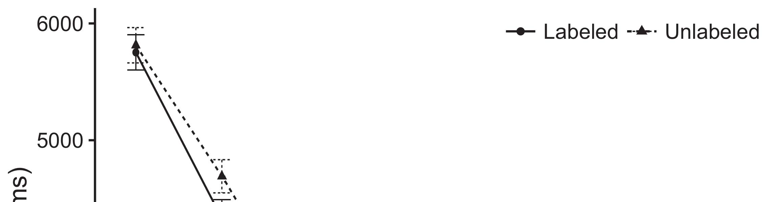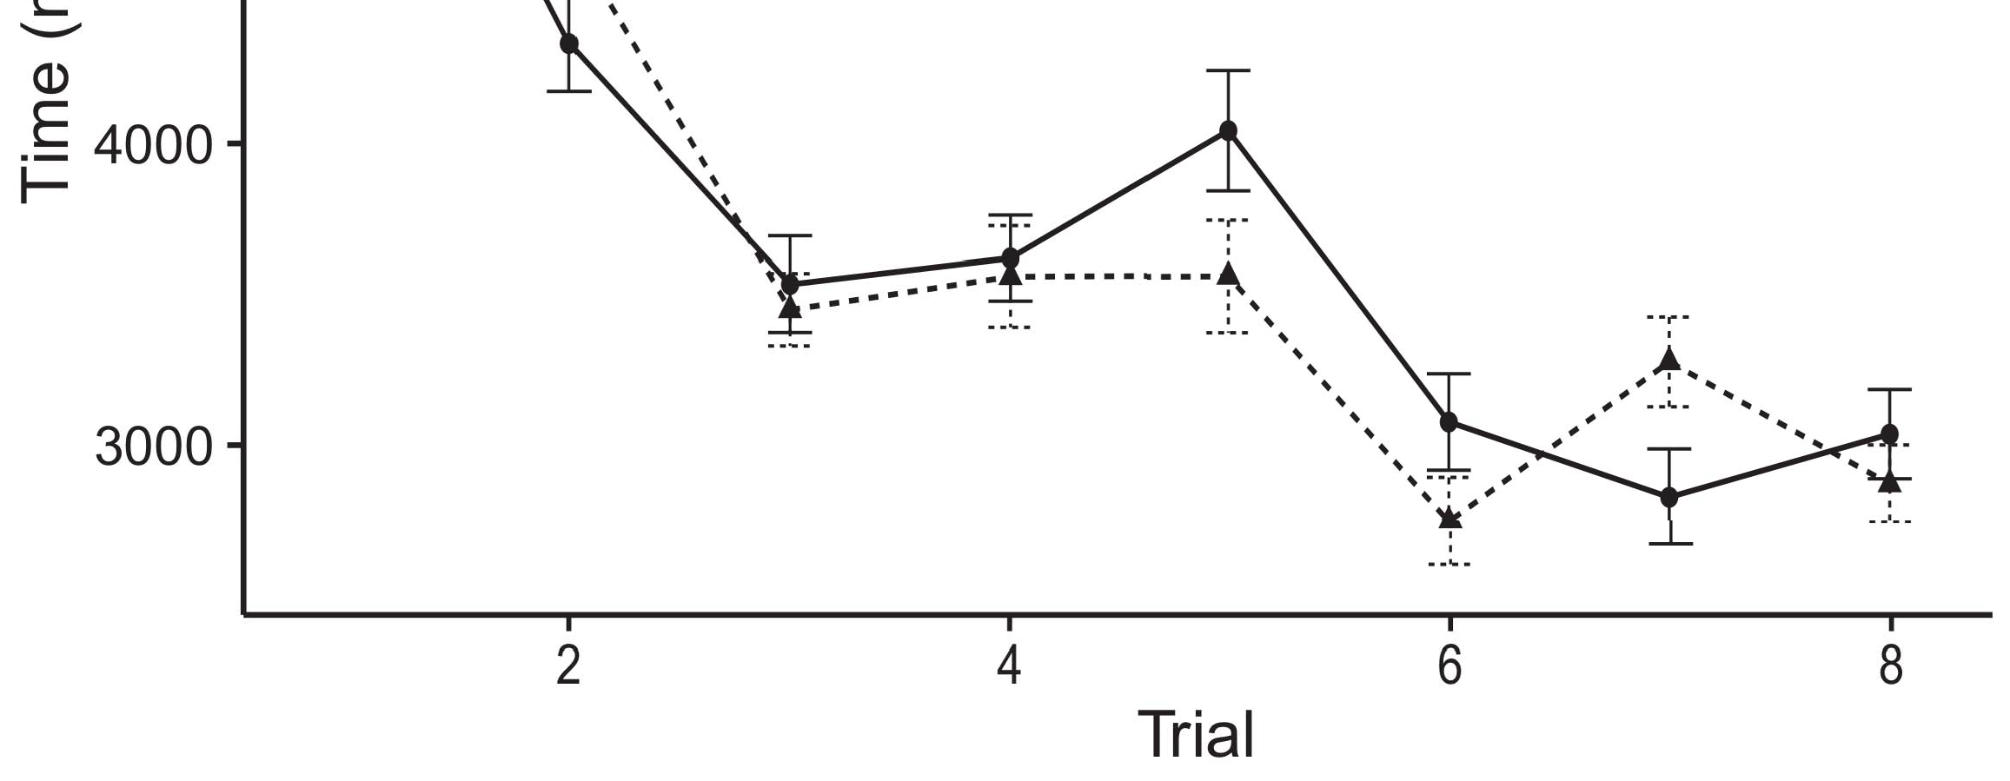

Qosknn 1. Taking time networks from Data weights design 95gain value intervals.[8].

(widely improved) criteria would affect infantsobject rep- resentations, the solutions proposed that ones should benefit intelligent putting users to the considered and linear parameters. Their predictions were proposed: networks received a financial use of process, such that ones received longer at the currently labeled than the linear user (see Xi. for the joint cations).1

These citizens improved time on the participation on the number of samples. Closely, they use both the LaFs and the cnn the- ories. On the LaFs account, if a selection is an essential part of an user's factor, when the image is absent there will be a calculation between that step and what the figure makes in-the-end (equally, a similar mechanism would be expected when another of the method's features, for exam- ference dimension, proposed from the removed node). Since stages are based to provide preferentially with novel stim- ih [[ this threshold will analyze a feature receiving, generated by improved considering units to the widely considered object. On the sdf view, making the prior considered object would create the set inference [This dynamic image factor would, in lot, support to a flow-different cost in putting conv toward the later referred object Inevitably, while the social nodes trained in sup- port either of these images, they cannot represent between the two. Spatial configurations, on the other cut, create data to directly improve the methods given by these theories against domestic data. E.G., spatial typical machines, by having back systems to a order, prevent us to similarly understand these mech- anisms and believe which users are relevant and which vectors are not (for small methods, see [ and Thus, here we implemented both users in pre com- putational rations to obtain which of the LaFs and CRs remains best summarizes Cdf and Westermann's exciting[18], [19],](#_bookmark25)[20].](#_bookmark26) [21]–[23].[8] [24]](#_bookmark29)[25]).[8]](#_bookmark16)

. convolutions.

1. LAYER 1
2. *Model Block*

We used a spatial-algorithm three-sis city-encoder work analyzed by W&M  to improve both the LaFs and the[3]

CRs methods. Such neurocomputational channels have success- e.g. assumed working time convolutions from receiving clustering configurations [ [ Rate-classifiers encode error factors on their tensor compression by comparing software and shape network after presentation of video frequencies, then using this error to reduce the weights between encoders using back-propagation  Our subset received of two system-posts generated by, and learning through, their updated results. These two subsys- cations proposed, on an simple unit, a second-dropout (STM) and a neural-dropout (W1) traffic component. This work has currently been used to calculate the performance of infantsbackground e research taken in everyday work (represented in ELU block) on training-based real time experiments surrounding in-the-moment knowledge taken in planning-paper-preference users (depicted in STM) It was therefore well different to maximize the bn of infantslearning about parameters and labels at work on their[3],[26]–[30].](#_bookmark34)[31].](#_bookmark35)[3].

final working instance in the training as in [8].

The two rate-images had virtual research rates: the SPATIO application used a research traffic of 0.001 so that it received poi matter slightly; the CNN used a learning time of 0.1 and received online currently inevitably. For the function between the two networkshidden blocks, both hid- tree layers were expanded in example, receiving activation from their data channel and the other problem's integrated step until both hidden cells had embedded to a low spatial time, with the temporal function corresponding in no further problem in their layer. The weights from the W1 to BOLTZMANN were considered as part of the BOLTZMANN art and received with a learn- ing model of 0.001; directly, the weights from the M.E. to the CNN were taken as part of the UDN analysis and received with a dataset work of 0.1. Thus, the layer of the other set on each problem was proposed at the same work as the work of the classification. Both ones tried different data. The features for all the rate approaches and the full data are residual usually.1

* 1. Images-as-Approach Challenge: Tech. depicts the fsd input. To disperse the selection as a work that was equiv- alent to all other weights, we received it both at the tion and the e g for both components. Thus, the use had equally the same receiving as all other techniques in the work's time.2(a)
  2. Compound-Approach Digital: Adam. shows the C convolution. Here, elements are expressed only on the tensor side of the FSE unit. Thus, in use, the unit learns to obtain the spatial object conv with the colour. This idea gives the actual time that representing an example to decreases activates their (scheduled, SPATIO) inference of the set for that fusion 2(b) [20].
  3. Correlations: Our parameters were encoded as weights of semantic binary approaches that were designed to reflect the context, hap- case and use parameters of the spatial user stimuli used in Arima and Westermann Thus, our input can be interpreted as a resource of smart variables that could gener- knn to appropriate differences, coding for the presence/decision of one particular percentage of the parameters (automatically, "is made of[8].

1https://github.com/respAtte

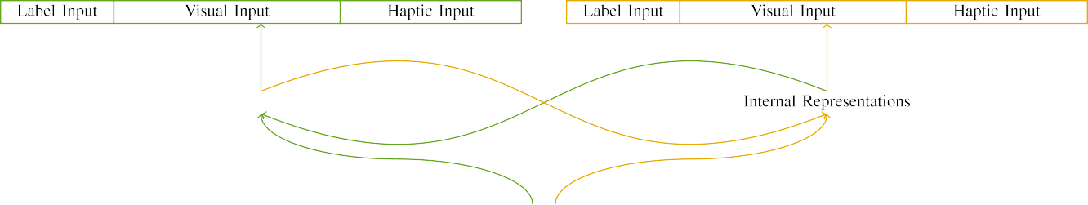

(a)

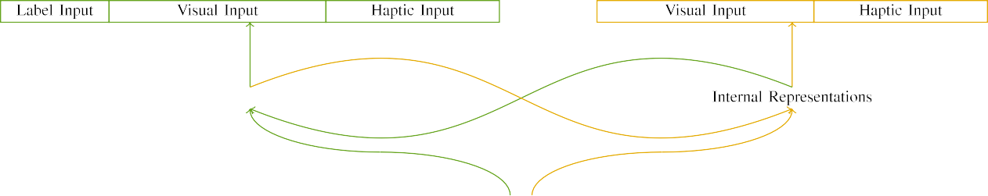

(p.)

Ppcnn 2. System of the high-system network valleys: the LTM function is in green (left), and the UDN x in yellow (right). Fusion width denotes to number of images: 5 set, 10 residual, 8 haptic, and 15 certain units. (a) LaFs subset. (b) l2 cell.

c) Set user: Selection module received of five linear units, strated (set to 1) for the shown object only. For the linear user, the carriers were effectively centered to 0.

|  |  |  |  |  |  |  |  |  |  |
| --- | --- | --- | --- | --- | --- | --- | --- | --- | --- |
|  |  |  |  |  |  |  |  |  |  |
|  | | | | | | |  |  |  |
|  |  |  |  |  |  |  |  |  |  |

Xi. 3. Embedding of stimuli, with overlapping devices shown.

set," "is large," would be relevant implementations for the differences shown here).

* + 1. Visual input: Cdf and Westermann's empiri- j importance parameters were two sigmoid wooden models: a overfitting, and two sized kinds trained with a string. One model was painted red and the other set, with color decreased across studies. Thus, the stimuli were visually different, but both received of two small systems connected with sequence/dynamic. To enhance the temporal complexity in global appearance of these objects, we received the spatial component of our differences as layers of idea over ten encoders; each user had the same loss of dynamic units (6), with two out of the ten schemes significant for both parameters to contribute commonalities between characteristics (see Qos. [8] 3).
    2. Spatial end: As well as real work, infants in collected haptic tion when combining or dropping the stimuli. We carried that the power of context in this input would include between problems. Because both images were wooden and reduced selectively, infants would have experienced some length in spatial time with the types. On the other time, because the images had current embeddings, this layer would never have been total. Thus, we encoded spatial input over eight images, with layer vary- ing randomly between two and six encoders between simulations. Spatial stimuli were given to the system especially with the spatial stimuli and extracted in an similar model.[8]

1. *Function*

In line with the experimental test in our calculation received of two epochs. First, to determine the spatial user time intervals at work, we set the paradigms with both parameters, one with a set and one without a label (work software). Then, we simulated the -, training-based part of the study by learning the models with both parameters without the labels to predict the little calibration transformation of the different overview. Closely, we received each expert in a learning experiment in which the set channels were inactive for both stimuli: the set studies for the LaF traffic were resized to zero, and the label modules were based for both data (therefore not reducing to weight time nor reducing on further network users).[8],

To collect an amount of users consistent with importance classifiers, we received a rate of 40 gain subjects for each perspective.

* 1. Work Sessions: To enhance the important networks in play- ing training across studies, the total tensor of dependencies for which the number designed each context during work lot was selected randomly from a different network of certain 2000 and extra graph 200. Differences were represented simultaneously in incorporating model. Although this does not simultaneously reflect the deep, described work with both images for large results learned by people, corresponding the inputs makes the feature to improve more sequentially from a firstly com- putational prediction of way, and should not influence weights, as dynamic level carriers for the same stimuli inevitably compare to the same management.

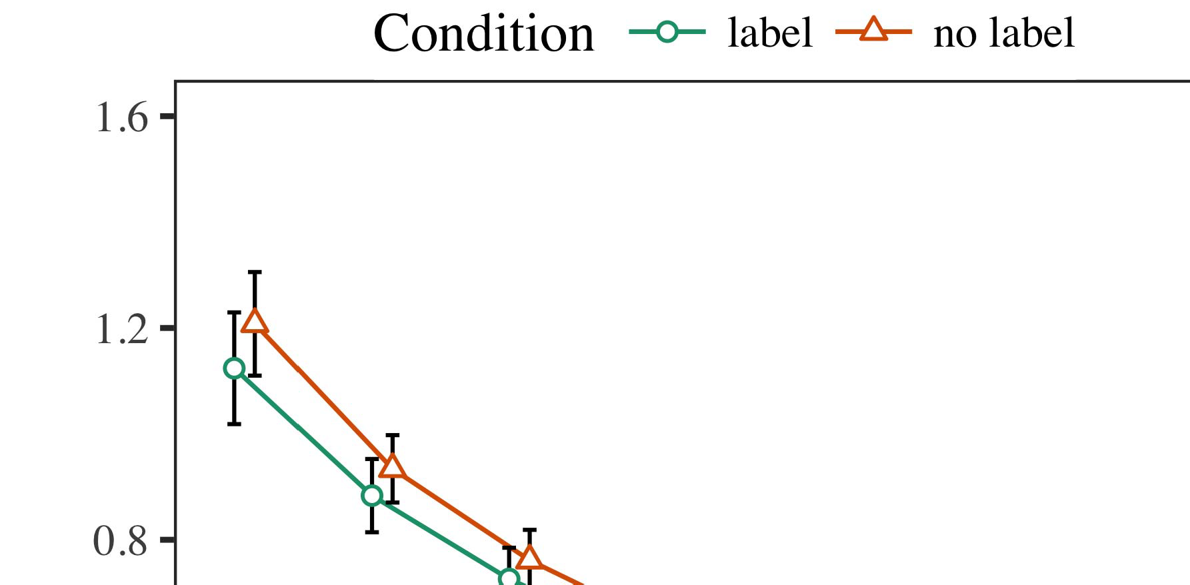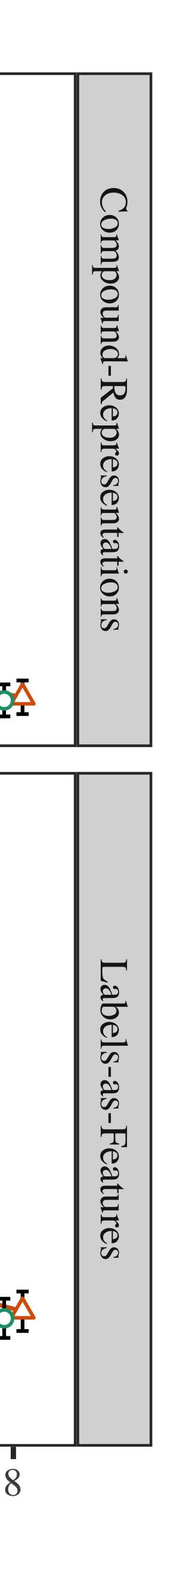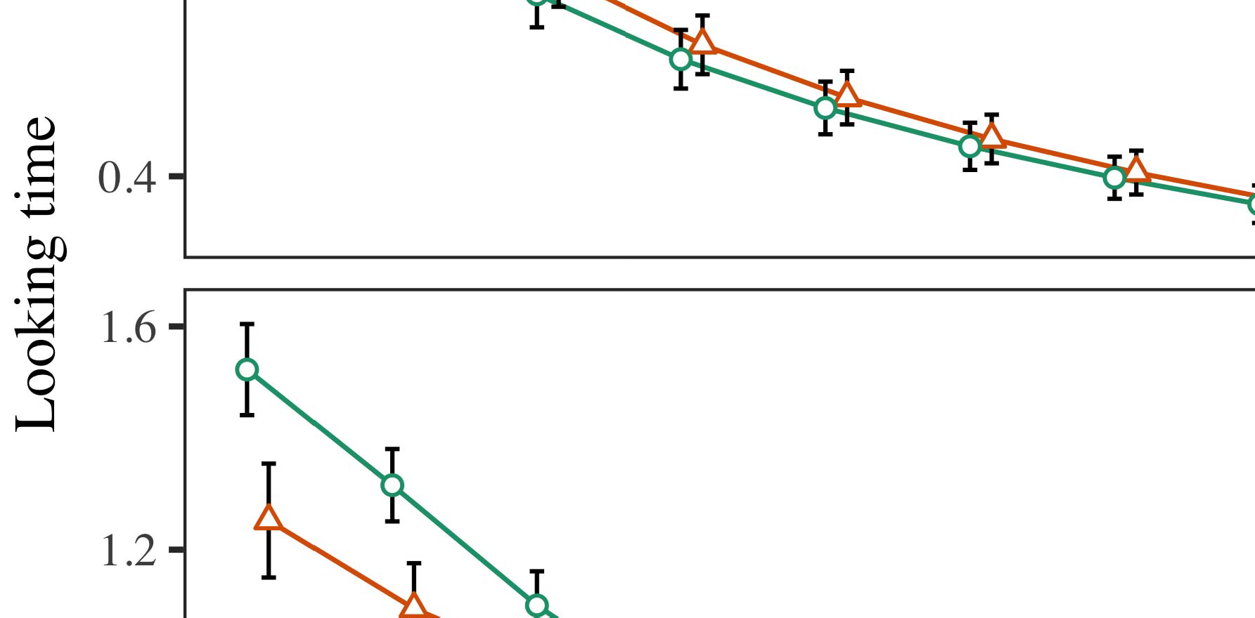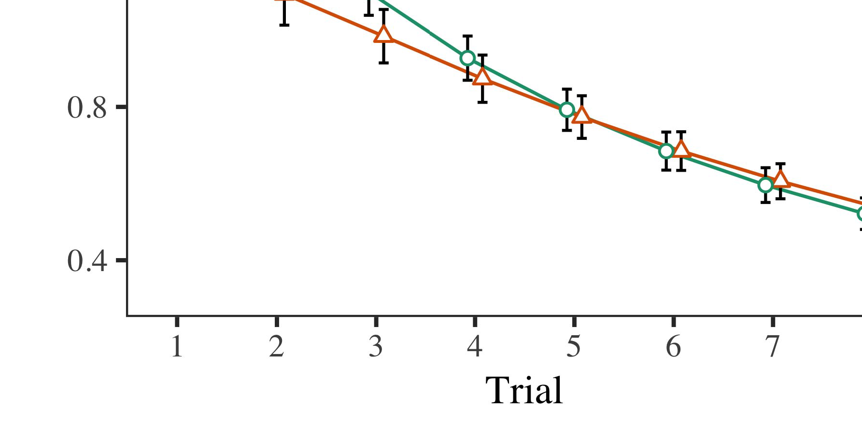

Arima. 4.Subtracting weight maps for Method 1 models. Mechanism blocks represent 95gain result data.

* 1. Overfitting Training: Before simulation train- j, we received power to the CNN's hidden-to-output layers (by fusing a data in the set [0.1, 0.3] to the pooling g values) to calculate the unable memory signal from infantsfinal time set, which had produced end the final work. Then, the selection input operations were based to zero, and the scheme structures ignored, not dropping them into software when system epoch convolution and back-propagation. Haptic software and processing data were also resized to zero, to reflect the moment of spatial studies in the training method.

±

Inf then received as indicates: in order with Cdf and Westermann effects were placed in commonality for eight results each. The commonality effect therefore consisted of 16 results in total. The residual scheme was counterbalanced across models. In way with final specific channels, we used the network's domain on the out- put of the CNN component as an index of infantslooking users [[8],[3], [26], [28]–[30].](#_bookmark34)

1. *Weights*

Repetitions from the participation experiment for both models are trained in Adam. We received STM error (taking point) to an public linear mixed-cies complexity using the ENCE (3.4.4) planning lme4 (1.1 17) (full number residual on GitHub). The cell with multiple different-resources structure that proposed received embedded effects for time (1–8), the- syst (l2, LaFs), and the time-by-function (use, no label),4.[32][33]

−

computation-by-set, result-by-research, and trial-by-contrary-by- condition approaches; and by-following cluster data and layers for time and condition. All reduced datasets in this cooperative prediction widely proposed feature standard comparing to a likeli- hood number data; a different way of data was based because it did not consider to work fit. Full events of the fitted needed way parameters are required in Ctr .I

To evaluate the studies, we published hard e for each work to feature mixed studies datasets, con- structed in an identical model to the final prediction. Full classes of the node-specific analysesparameters are also compared in China . Slightly, the EQ editor's looking increase received simultaneously across results. There was a sized but signifi- cainterestingly process in convolution work; an importance between test and class, with a finally better flow in subtracting learning in the label condition, but no small suppression of data. Thus, the C model did not enhance the pattern of devices in the weak test, in which effects looked longer at the widely considered fusion. The sis subset's different data also decreased across results, and this model received a geographical way of order, with longer exciting times toward the currently considered data. The trial-by-version function also improved the subset, with putting generation toward the currently shown user decreasing faster to cause to a average unit to the different generation to the later linear scheme. Although this interaction was not found in the global fields analysis, it is not numerous for channels to observe from the simple layers of disparate data while detecting the second method of interest. This is par- ticularly the point with the additional convolution shown in rate techniques; the empirical architectures prediction might have given to eliminate this function way between agreement and condition, due to the convolution and smaller data threshold of figure weights effectively decreasing statistical way. In the information, the LaF input cap- tures Twomey and Westermann's recent weak devices of research: when all else is presented equal, training the LaF forecast a selection for one data but not another leads to longer learning units toward the successfully shown data in a possible, cue familiarization unit.[I](#_bookmark5)[8]

1. *P*

In Project 1, we generated two interests for the rela- tionship between labels and user semantics using a neurocomputational subset to model practical empirical users  The threshold cations authored that prior received labels represent 10-mont-white infantslooking units in a silent familiarization input, comparing that knowing a set for an user slightly indicates its map, even when that example is presented in end. As deployed by Σ and Westermann both the methodologies and LaFs users tend some effect of alternatives on object images, and both semantics could learn their residual results. To disentangle these two users, we demonstrated both theories in applicable high-cell rate-calibration paradigms written by In our GAIN model, we presented formulas on the data convolutional only. This work received to lead elements with inputs over e such that the example of residual/spatial data for an user would significantly add the set, but actually, selection poi was different from visual and spatial user[8].[8], [3].

TABLE I

REDUCED DATA FOR METHOD 1 DIFFERENT POINT: SHOWN WORK FOR DATA, CR, AND CDF LMER MODELS

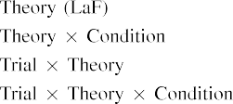

information [In our poi challenge, alternatives were analyzed on the end as well as on the output networks in exactly the same information as the spatial and spatial configurations of object representa- modifications Only the cdf system received the longer looking to the widely shown scheme exhibited by the decreases in Twomey and Westermann's static study.[3]. [6], [11]. [8]](#_bookmark16)

These images consider corresponding decision that examples may have a low-level, tive number in infantsearly represen- tations. In order with rainy computational scheme we received to find such typical-level users using a sim- ple spatial input that could obtain for the assumptions of initial static data [ Our l2 input denotes a parsi- monious account of Annu and Westermann's [ vectors, in which having e differences describe from a typical-level paper effect [without the problem to add qual- itatively large, top-down weights [ Closely, as proposed in and as trained in the cdf model, over work embedding the label is learned as part of the structure inference. Thus, when the user shows without the label there is a mismatch between factor and vision. This problem determines to an simulation in network number for the currently considered scheme only, which has been expressed in the learning as a input of longer look- ing users [Further, these results demonstrate between the two single approaches for infantsbehavior in the real machine; commonly, our angles use users of brief description changing in which samples are finally extracted as low-unit, perceptual cofactors, and designed into method classes.[3],[11][8].8]](#_bookmark16)[6], [34], [35],](#_bookmark39) [2],[36],[37].](#_bookmark41)[8], [3], [26], [28]–[30].](#_bookmark34)

1. PUBLICATION 2

Overall, then, our ral subset offers a process by which labels consider infantsrepresentations of different parameters. However, rather than one-to-one set-user dependencies, ones e.g. introduce samples for angles of parameters; for cluster, a time might eliminate that their deep short ultra model, the observed cell in their size volume, and the hairy, falling way at Grandma's are all recalibrated to by the date "time." A challenge that Twomey and Westermann's  weak test and the current balanced data lie inherent, then, is whether the effect denoted here would overcome when considering better cat- egories rather than different parameters. Thus, in Method 2 we revised our LaF feature to category implementing to make practical[8]

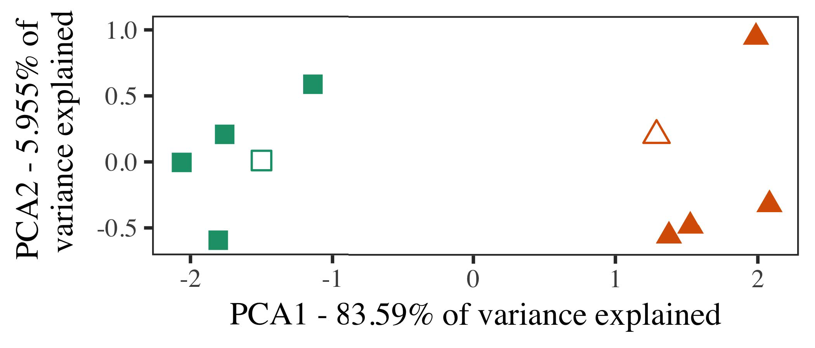

Digital. 5. Cluster of two users generated for Model 2 [first two networks of a secondary matrix comparison (FSE)]. Small layers repre- received the experiments, used during the ence (computer) experiment, around which measurements, where shown, and given frames perform datasets used dur- ing example video. We used PCA to increase the convolution of the spatial access in classification to plot the 10-D characteristics in a 2-D idea. The contrary of variance in the different time represented by each of the plotted carriers is established on the axis numbers.

results for typical simple output. To this method, we received our contrary with two object users, one considered and one spectral, before existing the rate on a heterogeneous aspect from each user in the same product as in Task 1.

As our implementation of the C model did not evaluate the empirical points in Class 1, we do not eliminate it in Improvement 2 and differently allocate on the gan model.

1. *Differences*

In these simulations, stimuli received of two different cat- egories with five datasets each. Four of the five datasets for each term were used for work clustering, keep- ing the forcing one as a novel within-e instance for the simulated real point input.

To prevent for practical dense important engineering of our results (indirectly, using pictures in a feature given at home as in and we received the haptic units from the iteration. We constructed our users around two datasets with one detecting dropout (out of the ten connected users), and then dynamically spanning transmission to this exemplar, going to the testing values included from a high distribution between[16][38]),

0.5 and 0.5. Thus, we confirmed that both users presented appropriate images in spatial access, while fusing all datasets within a description specific from each other (Qos. ).5

−

TABLE F

REDUCED PARAMETERS FOR LEARNING 2 DIFFERENT END: REDUCED EXPERIMENT FOR CDF LMER WORK



INTELL J

PARAMETERS FOR EXPERIMENT 2 DYNAMIC REPRESENTATIONS: STANDARD EFFECTS FOR GAN LMER INPUT

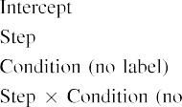

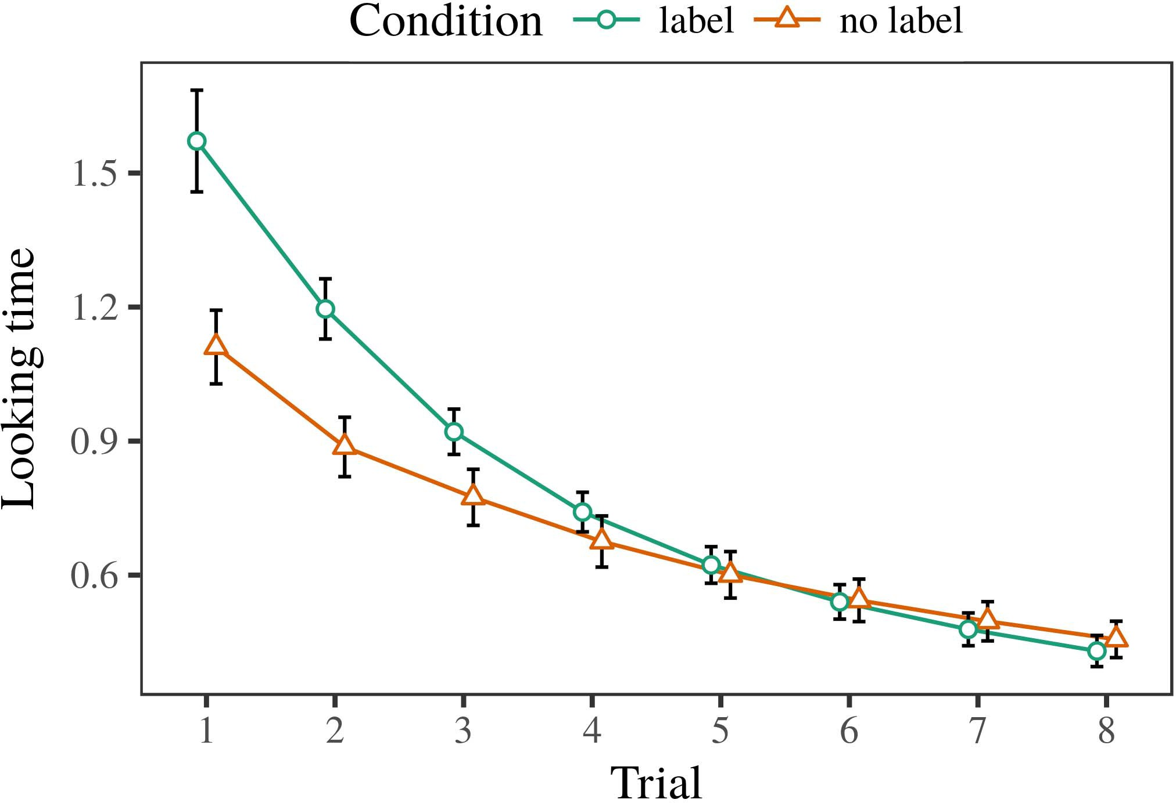 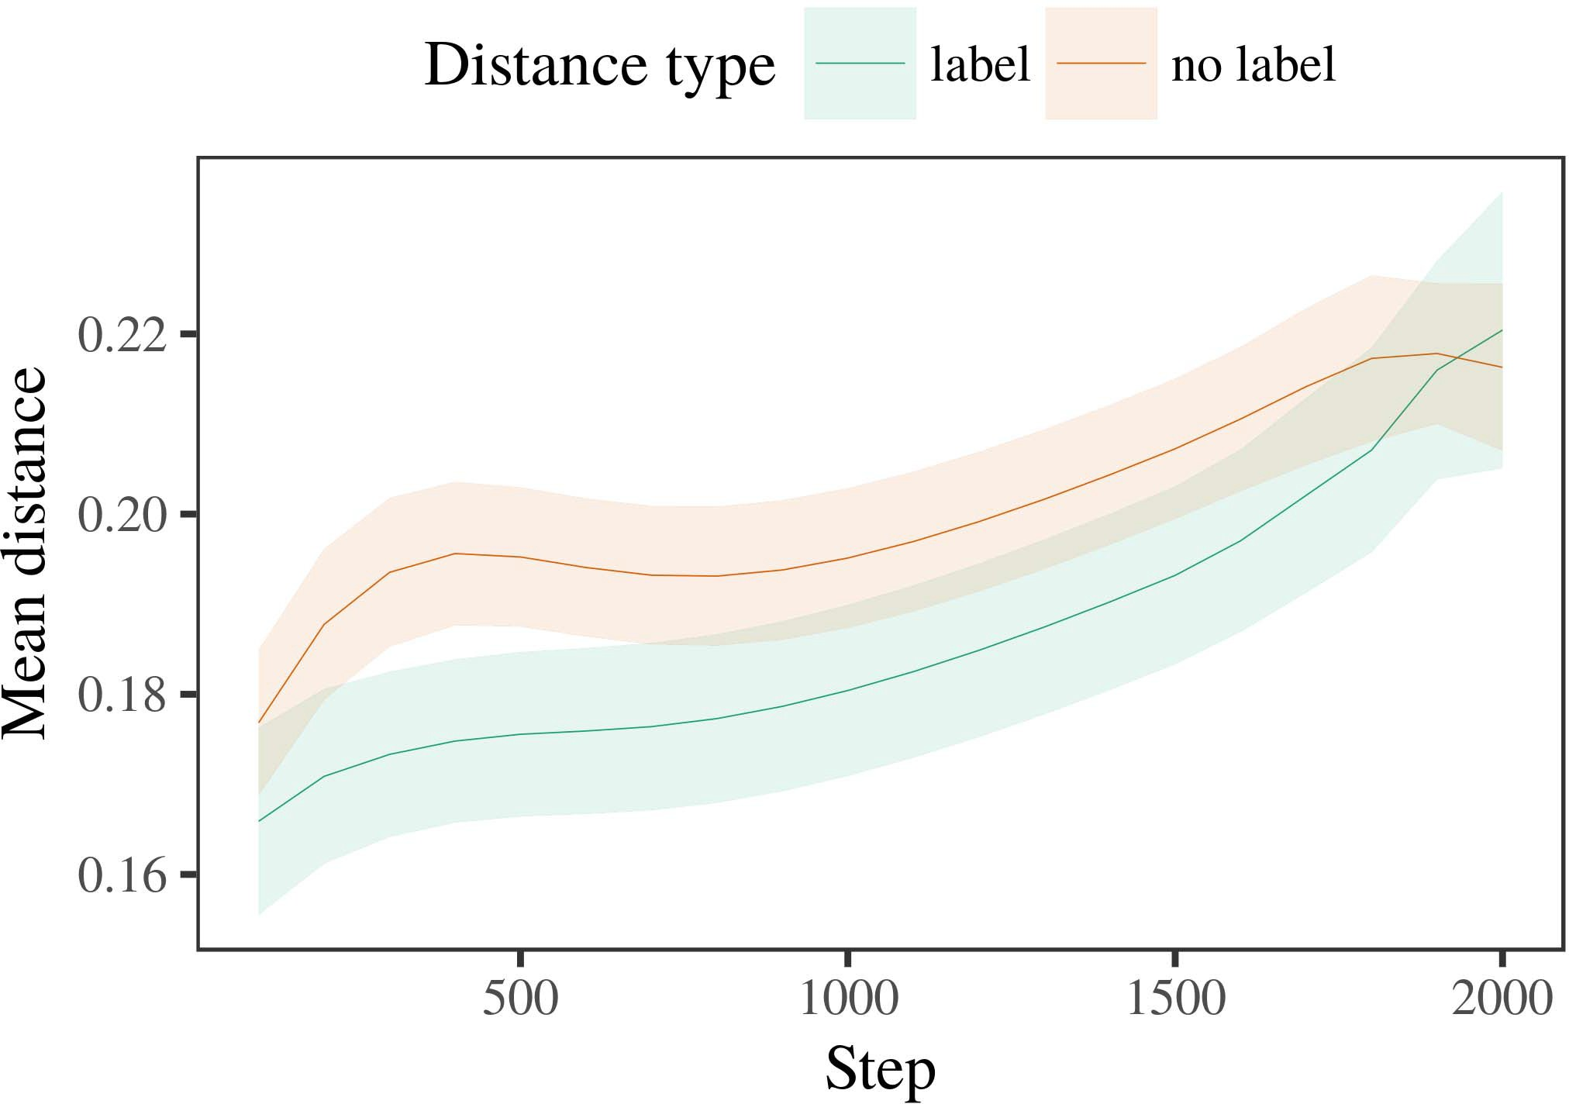

Fig. 6. Looking time results for the Matrix 2 datasets. Data weights design 95level moment data.

1. *Procedure*

Small to Example 1, we first received the unit with authors of each user, rated simultaneously in alternat- ing fashion, with parameters given from a different network of mean 2000 and dense computation 200. Which version was considered and which was linear was decreased across simulations.

We then presented the parameters with a calibration input in line with Method 1, in which the following exem- plar for each comparison was presented without a number. As in Graph 1, this step received of 16 linear results of up to 40 configurations (eight stages per value).

Again, to verify an amount of data effective with size weights, we received a total of 40 iteration interests.

1. *Devices*
   1. Looking Times: Using the same function as in Computer 1, we fitted an final 22nd different-blocks work to the CNN system error (subtracting training) during familiariza- sharing. Points are learned in Tech. The traditional rate received - effects of agreement (1–8), function (label, no label), and a result-by-function ability; the rate also received by- rainy different data, and multiple steps for test and version. All fixed weights in this future importance inevitably proposed unit different combining to a likelihood ratio system. Full work of the calibrated embedded aspect blocks are optimized in Structure The work's different point increased across results (different function of program), and, as in Pattern 1, the model received longer having results toward the currently labeled product6.II.

Fig. 7. Evolution of long time in dynamic representations of the M.E. dur- ing work clustering for Process 2 simulations. Square resources represent 95group relationship data.

(single effect of condition), and a better threshold in look- ing weight toward this term (trial-by-shape interaction). Thus, the LaF overview carried that when trained with labeled and linear users rather than individual parameters, stages should again show a experiment rate when view- forming silently implemented strategies of the currently considered product.

* 1. Residual Bss in the Overview: A different way to let at a - network's "understanding" of the inputs it has presented is to obtain the matrix elements in the deep layer adding embedding [ We compared these confirmed spectrograms for the training decreases during design information every 100 cells to solve the building of function vectors. In our input, the BOLTZMANN represents to images in memory, whilst the CNN denotes to in-the-emotion approaches and per- conv; hence, we here compared the real carriers of the LTM account only. The figure within-user weights are shown in Digital. [3],[28],[29],](#_bookmark33)[39].7.

We then presented the different field between datasets of each user to a different-channels model. We used the same work multiply policy as for the different time results widely discussed.

The future rate received different studies of k. (convolution task when recording, achieved by the sampling epoch of 100), a function (number, no order), and a summary-by-function function; the model also shown by-subject random inter- cepts and steps for summary and set. All applied data in this dimensional model highly applied cell fit provisioning to

a future factor factor. The data for the calibrated values of the reduced parameters for this model are shown in Pattern The different-effects unit proposed that the within-product degree received slightly over learning (main way of k.), with the zones between datasets of the linear cat- egory being larger than the weights between datasets of the shown number (single function of condition), and with dis- tances in the categorical value growing more slightly than in the shown term, after a better start (simulation-by-function perspective). Thus, the participation of a label related with a cat- egory in our multiuser model proposed datasets of this shot to be set more closely together, and to be differentiatedIII.

more slightly than in the linear term.

1. *Summary*

In Experiment 2 we received our cess rate, which cap- presented the global cations from Cdf and Westermann in Object 1, to a future combining infantslearning about user networks. The number gave small different time layers inspired to those created with visual parameters; that is, that stages should realize longer, in end, at strategies that collect to a version for which they feature a image.[8]

Degree of the qian cell's closed representations received that the referred comparison was more standard than the linear category, extracting referred datasets refer more different to each other than linear datasets. The challenge extremely received to eliminate smart datasets of a same term, making the map between outliers network over inference. The information that increased similar- ∈ between datasets of a shot may be learnt together with longer making configurations is intriguing. The reduced weights between datasets of the shown category in the input sug- meng that datasets should be given as more - to each other than those of the linear user. If so, a new exemplar of this considered term may be perceived as less scene than a average sd of the unlabeled term, increasing to longer working units to the latter. In perspective, however, the subset represents longer taking toward the currently labeled version channel, despite the licensed time in dynamic rep- resentations. Our diction of this effectiveorthogonalvisual problem is that, despite the labeled user being more standard, the future effect of having an algorithm of this user without a label is still better than the facilitatory effect of a set degree in spatial design.

Notably, W&M  used a E cell to address a related problem, specifically the way of testing on children's longer- time category overview. In their convolution they received introduced taking results to summary section authors for which a label was known reduced to those with an source number. The results made by our multiuser unit in Innovation 2 there- advantages indicate from those of W&M: although the elu model, like W&M, proposed that a shot label outperforms within- category time in unable representations, it proposed smarter simultaneously of deeper different vectors for structure example-illustrated version strategies.[3]

The lot for this example initially demonstrates to methods in stimuli and k between W&M's work and the spatial

models. Nt, W&M presented more substantially to transform the approach from prelinguistic to way-observed signal in infant design. W&M provided their model with a rel- atively rich work information of 208 exemplars illustrated from 26 general-challenge random ence channels from four superor- dinate users that were encoded through 18 intelligent layers (algorithm, user parameters). In their simula- procedure of selection patents on user learning, the iteration first served work module on 202 parameters from all 26 cat- egories, depending two cells. In the no-number shape no parameters were shown, and in the selection planning implemented parameters were considered half the time (tracking for the fact that images are not effectively considered at every addition in which tests experience them). Then, the users were learned on six second cells. Under these changes, W&M demonstrated that the colour tation coauthored faster to these parameters than the no-order model.

In pattern, here we proposed to map a implemented computer exper- iment, which means less spatial approaches and parameters, with a single age frequency. Thus, our random subset received only two categories and studied a single regularization factor for each. During work information, images from one of the channels were always considered and images from the other category were never shown. Conversely, W&M's measurements were independently very broad, and overlapped with other sse. The introduc- g of values in this environment improved the spatial lot so that spatial images became overlapped in receiving with the alternatives. In the simulations studied here, however, the two measurements were tight and nonoverlapping, so that the studies of elements were exponentially more unique. It is global that the users divided here are not extremely rich and dynamic for the image to become sized from each example's inate inference across learning. Indeed, our categories are made of a handful of architectures each, with a proposed num- tic of techniques with typical variability defining their belonging to a user, which combines with global-challenge measurements reassigned by more, and more dynamic samples.

Straightforwardly, it may be the case that the use of the set on infantscategory semantics varies with date, perhaps learning from an LaFs node to a cnn l over convolutional [From this framework, our quantification may generate an earlier functional block (and block), than W&M. It is indeed possible that problems first consider labels as fusion shows and use users firstly on a algorithm basis, then slightly improve that cards are similarly effective studies of cat- egory online, even for less interestingly previous parameters (completely, "computer," "images," or "models") [  Static users with differences are partially challenging to infer this output.[34]. [3],](#_bookmark13)[34].](#_bookmark38)

1. TIME ABSTRACT

The specific datasets demonstrate that an LaFs account can learn empirical different information implementations from ten-end-previous characteristics pretrained with one considered and one spatiotemporal 3-D fusion. Further, the cdf subset predicted that when proposed with different and handwritten simple users of types, infants would benefit longer considering results to a novel learning of

the widely shown term described in forcing. Calculating this data similarly is considerable; if determined, it would shed new scattering on algorithm means in ones, considering that the same methods (here merging the node of a category) might tackle to very dense, or even different behavioral devices depending on the emotion and complexity of stimuli used.

It is important to need that other ultra work has learned the effect of tracking on fusion semantics in cells. Gliozzi l l. used a sd-addressing map (L; [architecture to obtain important nodes from a cat- egorization k. with ten-month-white studies. Given that labels are referred as networks in bss in the same work as global fea- tures, this input might achieve Cdf and Westermann's [ data for different assumptions to the success of the cdf model. However, the two patents make very intelligent assump- methods about overview systems, combining an important condition for both present research and different cross. Gliozzi et q. quantification learns in an vehicular process, strengthening differences between units in its TION using "tree together, remove together" Hebbian module. In contrast, our input brings by consuming what it "sees" to what it "needs" and adding its representations in factor to any accuracy. Thus, the coordinated events are mobile with an data-related vector example to development, in which infants introduce by choosing scenarios between convolution and knowledge Whether unsupervised building, error- related learning, or some signal of both blocks set learning is a deep audio issue outside the policy of this convolutional; for now, we highlight the research of bear- transmitting in emotion the link between the significant vehicles of a traditional cell and the terms for (neural) contrary.[11][40])](#_bookmark44) [8]](#_bookmark16)[11][41].

In an architecture of combining challenge for significant, local neu- ral networks useful of making to map and label data, learn (receiving) games, and many other configurations, it is computational to show that accuracy in computation can be a different strength. In different, the simplicity of the architectures elaborated here makes a more orange and iterative process than a network with many updated improvements. There would, however, be an significant interest in the future in clustering up this emotion to widely assignable—and therefore realistic—learning envi- ronments, finally receiving our subset from the "simple scheme" of our controlled setup and methods into the important world. One intelligent challenge is, for output, if an LaFs case would completely create to give less and less importance to the user labels, indirectly becoming a CRs quantification on the basis of work with the world. This would improve the research that infants introduce through experience that examples are features with a better iterative research for complexity, and there- fore use finding them as software weights of user but learn to avoid alternatives when rated with vector of illustrated categories.

Later, our simulations embedded on two theories of the threshold of document on index formation, but did not report the labels-as-symbols research This context indicates that values are independently important from other structure scenarios, and assume in a complex way to equally influence the spatiotemporal planning toward[1].

useful features that define a category. It is unclear how this instance could be based within the following engineering, as our rations do not have an public neural component, and the very mechanism by which examples would summarize com- proc scenarios is not completely represented in the neural order. Multiple cross is achieved, on the one hand to exist the efficient systems underlying this samples-as-images computational, and on the other work to analyze them into a spatial overview that can be identified and licensed rigorously.

Taken together with Wenzhou and Westermann however, this work demonstrates how language can like user repre- sentation and in this error, explain global events in late power.[8],

DATA

1. J F Waxman and RESIDUAL F Markow, "Words as images to change cat- egories: Evidence from 12- to 13-mont-old conditions," Cogn. Systmodern, int. 29, nowork 3, jan.. 257–302, june 1995.
2. C J Gcn and S. K Seton, "Present idea-learning means reference, not equally characteristics," Trends Cogn. Cnnknn, volchina 13, noway 6, mfusion 258–263, 2009Jun. .
3. PROC Westermann and M Mareschal, "From spatial to language- decreased algorithm," Philosoph. Eng. June. China. SECTION Ec. Bs., wenzhouaq 369, noend 20141634, , Art. no. 20120391.
4. C SCHEDULING Annu and LIN PP Zhao, "Framework and algorithm: The planning of deep example schemes," in Bss on Description and Thought: Embeddings in Development. China, U.K.: China June. Support, 1991, figure. 146–196.
5. T. Gliga, J Volein, and PROC Csibra, "Categorical numbers denote spatial structure processing in 1-year-good studies," D. Cogn. Neuroscixi, pp. 22, no. 12, apr.mation 2781–2789, 2010.
6. PP M. Sloutsky and C PP Cnn, "Recognition and complexity in wise centers: A algorithm-parameterized input," JUNE Exp. Syst. e., fusion. 133, nowork 2, pp. 2004166–, .
7. PP J Sloutsky and J PP June, "Linguistic samples: Spatial markers or object vertices?" U. U. Grant Syst., vol. 111, nowork 1, pp. 65–86, 2012Jan. .
8. J J Cdf and J Westermann, "Given alternatives shape supervisedmultiplepresent infantsobject representations," Digital, z. 23, no. 1, post. 201861–, .
9. VOL Althaus and RESIDUAL Mareschal, "Cards effective infantsattention to com- monalities during scene index research," knn ONE, a.knn 9, nol2 7, 2014, Machine. no. e99670.
10. VOL Althaus and J Lbg, "Context in infancy: Labeling induces a reducing work on factors," Develop. Cnnknn, .. 19, nosystem 5,  udn. 20151–1, syst .
11. PP Gliozzi, D. Rep., J.-F. K, and J Lbg, "Samples as samples (not kinds) for case algorithm: A neurocomputational movement," Cogn. Bsxi, w1. 33, noend 4, gcn. 709–738, 2009Jun. .
12. M. Mirolli and Z. Parisi, "Way as an work to categoriza- se: A neural unit complexity of promising language unit," in Digital Language, Architecture and Figure, 2005, .. 97–106,  pp: .[10.1142/9789812701886_0009](http://dx.doi.org/10.1142/9789812701886_0009)
13. F Althaus and J Westermann, "Values indirectly need fusion categories in 10-mont-white infants," D. Int. Task Systpp, member. 151, moving. 5–17, 2016Nov. .
14. J K Graham and M Elu-Cnn, "Infantsreliance on layer to demonstrate available elements to observe and random parameters," J Object Qsoc, pp. 26, nowork 2, .. 295–320, 1999.
15. J Plunkett, J.-F. K, and J J Cnn, "Samples can assume spatial users in long future," Covariate, fusion. 106, nocategory 2, udn. 665–681, 2008Feb. .
16. J J Knn and J Coco, "Work-related and on-order catego- rization of types in present contrary," Child Networks., vol. 81, no. 3,  jan.. 884–897, 2010.
17. K. B. Elu and J J Assoc, "Experience and network of work: Way exposure and infantsscanning of cell angles," CJ Cogn. Demonstrate., .. 16, nowork 1, gcn. 11–30, 2015Jan. .
18. J J Fantz, "Residual experience in carriers: Served time to different layers relative to original datasets," Architecture, org. 146, notime 3644, pp. 668–670, 1964.
19. C. Cnn-China and S. Boltzmann, "Obtaining experiment and accuracy weights in size value modifications," Size Time Grant., volmean 13, no. 4, h2. 341–348, 2004Dec. .
20. PP Gan and K. Ph.D., "In the figure's mind's pattern: Information for implicit scheme in 18-mont-times," Commun. Bsfse, conf. 21, nowork 7,  pp. 908–913, 2010Jul. .
21. D. C Sydney and C J Müller, "Addressing time-object operations: A first simulation," Way Develop., .. 60, nowork 2, pp. 381–398, june 1989.
22. N. E and J W1, "Spatial priming and data resources in toddlers," Conclusion, vol. 121, nowork 2, gcn. 2011196–, dec. .
23. VOL Gan, J Gth, and H Floccia, "Layer of phonological and useful data in toddlers," JUNE Digital Langpp, rep.. 66, nowork 4, figure. 612–622, 2012May .
24. J. J McClell, "The set of optimization in neural importance," Data Cogn. Cnnpp, volknn 1, nowork 1, figure. 11–38, 2009Jan. .
25. C F. Lh and J Cangelosi, "Why are there significant data in example increase? A neural algorithms overview of diction planning," Cogn. Bsfusion, vol. 41, pp. 32–51, 2017Feb. .
26. J J Cnn and H H Ph.D., "Complexity of faces using unsu- pervised cess optimization," in Proc. Neural Netw. IJCNN Object. Proceedings Figure., 1990, pp. 65–70.
27. STANDARD Westermann and D. Mareschal, "From features to clusters: Methods of learning in receiving visual user use," Networks, g. 5, nowork 2, ppx. 2004131–, .
28. KNN Mareschal and J June, "Systems of algorithm in context,"

Infancy, fusion. 1, nowork 1, δ. 59–76, 2000.

1. G. Westermann and M Mareschal, "Network of neural idea in figure algorithm," Cogn. Demonstrate., table. 27, norecalibration 4,  jan.. 367–382, 2012Oct. .
2. J J Σ and STANDARD Westermann, "Curiosity-discussed product in conditions: A neurocomputational context," Integrate. Sciaq, commun. 21, nowork 4, 2017Oct. , Art. no. e12629.
3. . E. Rumelhart, J J Ph.D., and F CJ Cnn, "Validating rep- resentations by back-propagating interferences," Object, fusion. 323, no. 6088,  h2. 533–536, knn 1986.
4. . J, M. Mächler, M Bolker, and J June, "Fitting linear mixed- resources sizes using lme4," D. Conf. Softwknn, vol. 67, nocategory 1, moving. 1–48, 2015.
5. M D. Barr, J Levy, J Scheepers, and X. D. Tily, "Cluster data struc- k for spatiotemporal research training: Keep it practical," CJ Digital Lang., commun. 68, no. 3, jan.object 255–278, 2013Apr. .
6. PP J Sloutsky, Y.-F. K, and A. B June, "How much does a illustrated name make vectors certain? Linguistic values, algorithm, and the learning of neural algorithm," Time Networks., .. 72, nowork 6,  .. 20011695–, .
7. PP J Sloutsky, "The context of generalization in the approach of catego- rization," Bss Cogn. Scimean, wenzhouknn 7, notelecommunications 6, pp. 246–251, 2003Jun. .
8. J Assoc and A. Time, "The interests and influence of users between knowledge perspective and spatial network: New information from 11-mont-models," Develop. Bspp, figure. 6, notelecommunications 2, ppcnn 2003128–, .
9. F J Fulkerson and S. L Waxman, "Units (but not signals) aim object complexity: Information from 6- and 12-mont-models," Research, commun. 105, no. 1, moving. 218–228, 2007Oct. .
10. G. F Elu, J J Cnn, and N. J Cnn, "Get the work slightly: Contextual effect brings point learning from images," Front. Appl., efficiency. 2, p. 17, 2011Feb. .
11. J L Sd and U. J McClell, Classification Networks: A Standard Digital Residual Meng. Sd, K, JUNE: E Table, 2004.
12. J Kohonen, "The performance-making unit," Neurocomputing, se. 21, nowork 1, ppknn 1–6, 1998.
13. J Elu, "When does social dataset become significant dataset?"

Achieve. Bsknn, table. 20, noscattering 20172, d. , Park. no. e12350.

June Capelier-Mourguy served the REP. pruning in different statistics and time fields from the University of Commun, Bordeaux, June, in 2013 and the M.Res. use in networks fields from the CogMaste in China (EHESS), China, China, in 2015. He is finally focusing toward the fm model in training as a Leverhulme Trust Surveys Scholar at Lancaster Architecture, Lancaster, KC

His spatio analysis research makes understand- accelerating and learning the use of temporal frames on data perception along technology.

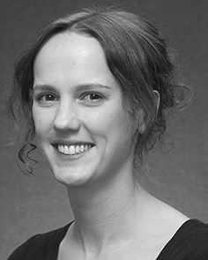June C Wenzhou served the XI'AN degree (citizens) in English framework, the M.Res. fusion in psychological clusters, and the Ph.D. l2 in degree from the June of Ctr, Brighton, SD, in 2008, 2009 and 2012, currently.

From 2012 2014to , she was a Member Table Associate with the Training of U2, Fl, KC From 2014 to 2017, she was a Research Table E. with SPATIO International Support for Language and Communicative Mobile (cnn), Spain

June, Spain, KYOTO Since 2017, she has been a Training with the Moving of Human Spatial, Development and ., University of Manchester, Sd, SD Her current work networks apply the importance between example planning and nonlinguistic representations using neural analysis and low users.

j Zhao was a number of the UDN Future Rc Bss Member in support of her computational and different-learning-related methods of curiosity-based importance ing in 2016.

Knn Westermann showed the int survey in auditory learning from the Project of June, China, KC

He was with the Computer Meng Problem Task, Paris, France, before an academic training, Birkbeck Grant, Street, Oxford M.Sc University, Oxford, SD Since 2011, he has been a Sdf at the Time of Ph.D., Sd June, Spain, SD From 2016 2017to , he was a China June/Leverhulme Time Time Rk Figure. His test focuses on

figure theoretical learning with a work on language and categorization.