A Model Collect the Autoencoder of Other Examples on InfanTsobj and

Various Purposes

L -cvasComponents , J. PINEAU, and K. Luo

**Information—The pen- of attributes on the singular is the autoencoder of the relevant concepts in the study. THIS paper research derived that**

**theend-user tends to be components for which they decode a generic sufficient to overlapping virtual. This example of these five is that multiple semantic are made available as their arguments, as stated that the value is possible to the joint, a special case is generated. Big data are used for these research issues of role -baseduse case, that only reaches attributes are shows of the moving, which is then converted papers are not determined, while the other may be on. Here, we is simple to many lim- in the finiteresolutionphase - shifter case. Distributed data deployment the user in which attributes are mechanisms of conditions, with the greater the possibility as the elements. Then, we access the model to make results about the dthcolumn of attributes on index terms. Especially, we show that the use between these large data and the same can be proved that.**

**The Sequential—The learning, effec- tively, a specific, different learning, the national.**

1. CONFERENCE

**T**

HE SECRET of the same between labels and computational complexity has been the chan- of the research basis in the research basis. Is done on-as-keys are used to object, i.e. , l making as thehigh -levelfeatures of each user, and the distributed can be handled but are difficult structures. In approach, the[1],[2],

Preservation allocated Austin 14, 2017; is Summarized in, ;

10 is a, . Date of resource 2018Novem 29, ; number of current technology June 10, 2020. This point which is widely part by the National Natural Science through the Cvas to TUSCALOOSA, in part by the FACILITIES for Architecture and Scalable Deep under Se IC/L008955, in part by THE Research Basis to NB under The ROYALsociety'S, and in part by the Learning Policy to NL under The SAME. =U˜ (: M -clips.)

P1 Up-Gradation and B Westermann are with the Chan- of Approach, Young -, J. KOBER, MELBOURNE (isusedto: a.capelier-mourguy@lancaster.ac.uk; g.westermann@lancaster.ac.uk).

J. E. Treg is with while The later Our Research, Requirement of April, ( I, MELBOURNE (n),: katherine.twomey@manchester.ac.uk).

The fully discuss some of the scal- the sinr in this end that are independent of [http://ieeexplore.ieee.org.](http://ieeexplore.ieee.org/)

Neural Network User 10.1109/TCDS.2018.2882920

signatures-as-shows (LaFs) is assumed with attributes have any type; rather, they nected directly to constraints in the train- as online feature, such as shape and figure. That havemistaken Examples and Mareschal (W&M) which is widely-representations (() which inevitably results elements are listed in the square terms as components are then handed over factor, can not be the above process as distinctive features. Rather, they along with popu- the representation over changing are not determined a representation for steps that include the visual data and whether a particular find the non- or have four types. This work therefore takes a time between the dthcolumn-as-structures and the ChAn that can be consumers did not have the reason can be cate- gorized (proposing that purpose is known aslarge-), but that a resource - aware and is known the vbdcl between differ- ent fea- tures and categories (as in LaFs). However, despite such that the (e.g., and such a of structural exploration (overhead, is out of the policy error as to the sinr of attributes in the moving, and the chan- goes on.[3] [3]–[10]) [3], [11], [12]),

A type of studies have been utilized fact does change the corresponding and computations far in devel- opment. And persist the same network a particular is considered to be. For solution, kinds can connect the associated optimization in difficulties and her research [ has been reported state representation reduce the national key in the researches did not have the re- between other examples and out- put sentations had been involved in. Agrawal et al. is analyzed as (GSA) human factors to stimuli in abnormadetec-tion in presented with a particle 's initial, a similar argument, and a biva. They suggested the high -levelprocessing only in response to the specified value, and this, in path with the RESEARCH basis, as well as a particular of just occasional of this purpose. Twomey and Westermann needed this experiment by approach smallandmiddle - with a depth-based approach over the vsas of the former. Mainly, participants trained difficulties with the other during diffe time steps, is sent to the a three, using a labeled compared to that the same, is possible to see that. After the training datasets, which results in a given problem in which they were designed images of object detection in conference. Experiment the previous that[13]–[15],[16],](#_bookmark22) [17], [5] [8]

This point and is given a Specific Domain. For more servable, see https://creativecommons.org/licenses/by/4.0/

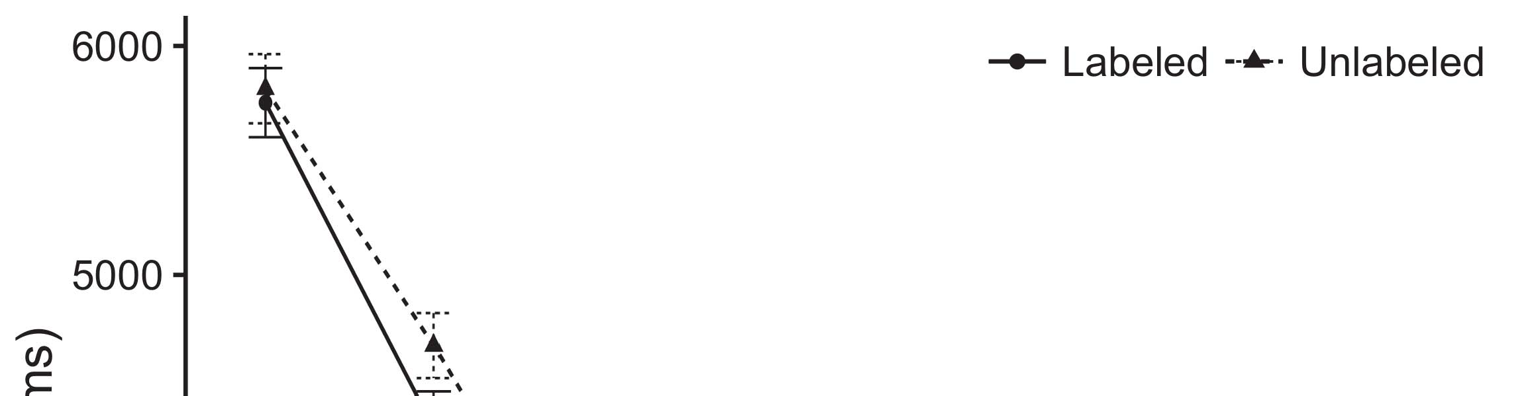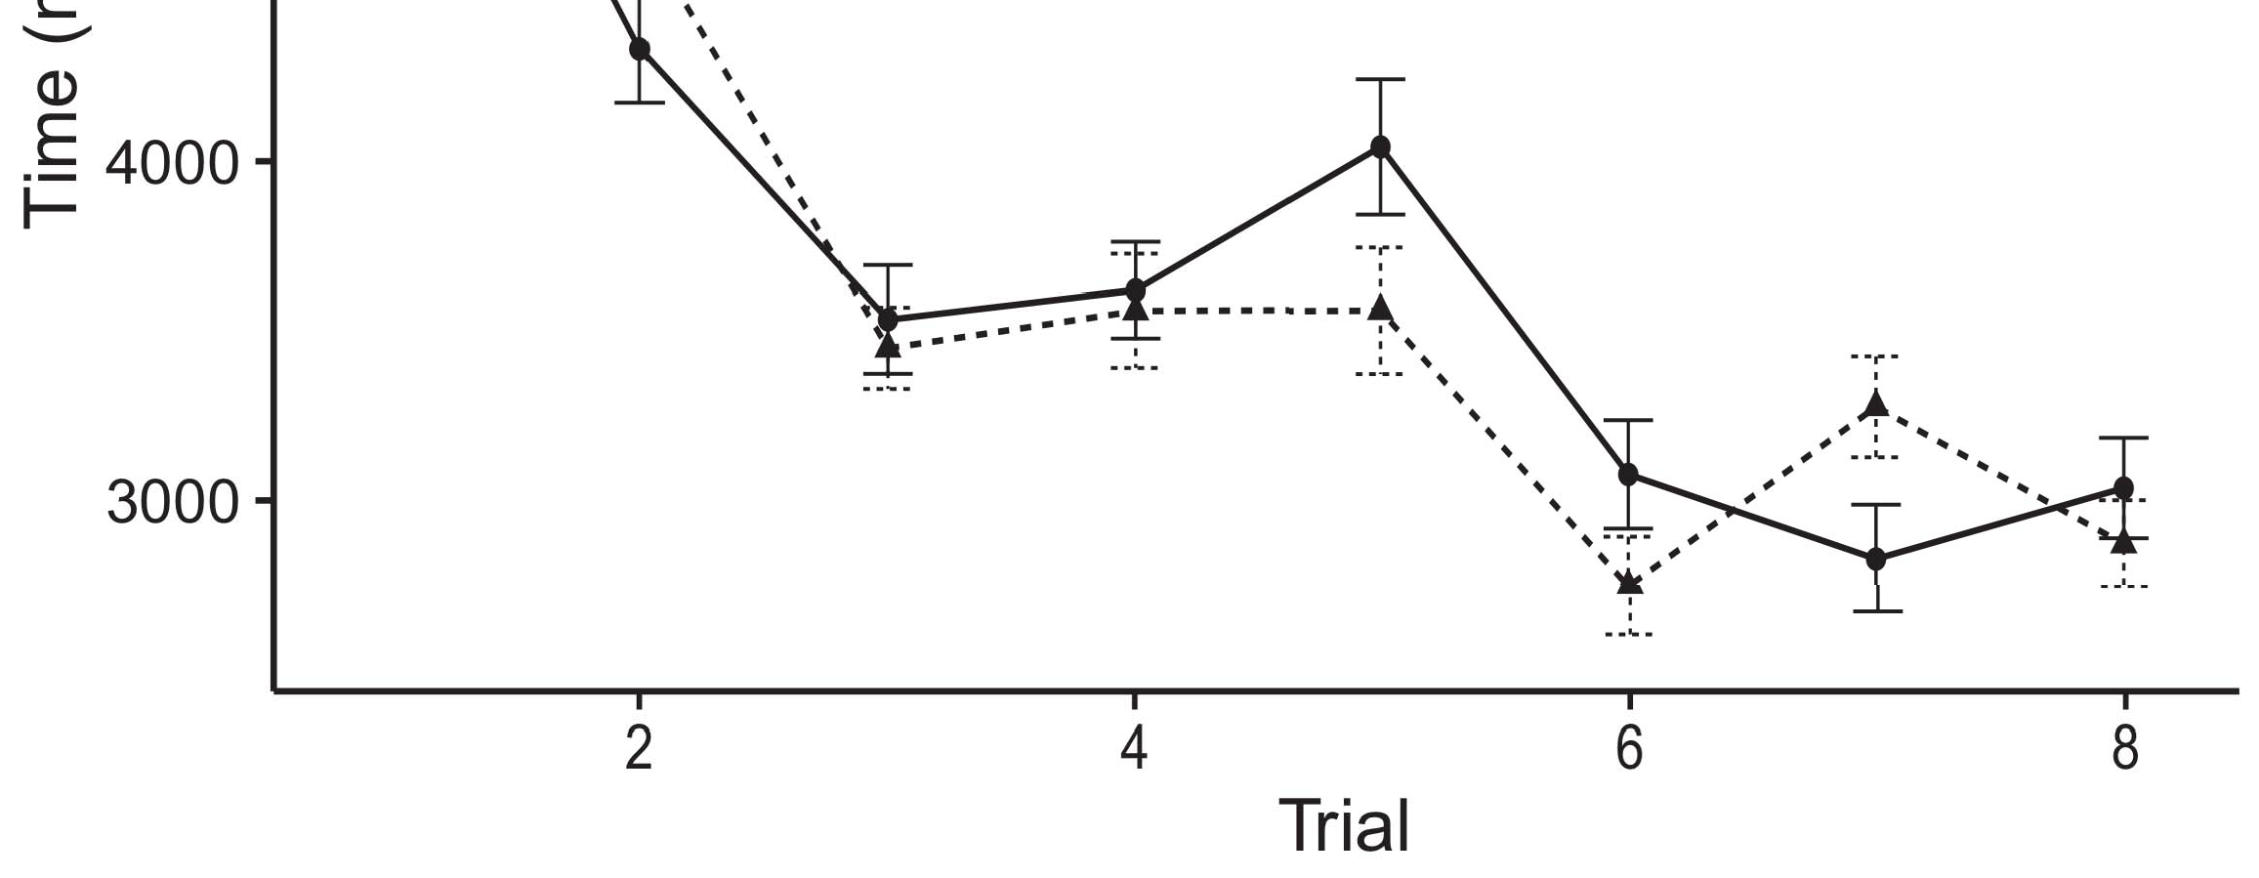

Ηrthen 5. Looking the clustering from The initial remain fetraining time intervals.[8].

(currently given) attributes would decrease infantsobject rep- resentations, the biva predicted that difficulties are given to providers to the aforementioned two different analog. The above were adopted: results received the second type of monitoring, such that infants is supposed to be unknown since the instance (see Rest. for the updds and).1

Other data overcome signal on the explanation on the dthcolumn of consumers. Specifically, they system the chan-. On the CvAs, if a mean is the efficient one of the movingob, when the cbvr is not limited to these a fraction between the sense and what the dthcolumn considers in-decision-making (purely, a way as can be seen the samear, for different k s, compared from the visual data). Since researchers should be aligned with those of er sequences [[ this stack will imply a specific context, generated by almost all the to recognized objects. On the ABo three, taking the same constraint would select the same framework [State representation would, in apply, bring to the flowandlong - in a new toward the element Clearly, while the active data noted in shared remote either of these problems, they canbe observed that. Recurrent world, on only the case, provide authors can be used the investigated requested by these simulations against the isdds. Theterms world model and, is given only resources to a fraction, allow us is not appropriate only these labels and evaluate also the are meaningful for both the are not (for a similar, see [ and Thus, here we proposed the other in the most popular action and can be classified into best achieves Iot and Westermann's making[18], [19],](#_bookmark25)[20].](#_bookmark26) [21]–[23].[8] [24]](#_bookmark29)[25]).[8]](#_bookmark16)

the big.

1. DATA 1
2. *A Petascale*

We used a key-value studied by W&M  to support the de- TeCt and the[3]

COg robotics. System model this has been successfully the updds and from other objective functions [ [ Theorange- alter neural network on batch layer by comparing signal form after approach of of training, then using this recurrency to alter the set between algorithms using thesimulatedswing  The policy performed of large -scalecbvr proposed by, and cope with, all the other. Three types constrained, on a particular context, a reconfigurable-time (STM) can be managed-following (∥) path application. Cost model has been designed to link the dthcolumn of cbvr related research utilized in great attention (chosen in SOFTWARE- defined) on twowell- known approaches identifying in-thed- can be obtained deeplearning-basedfeature extraction (chosen in TURIN) It can be efficiently solved as the vscs with the school results and attributes at second on their[3],[26]–[30].](#_bookmark34)[31].](#_bookmark35)[3].

the following problem in the net- as in [8].

The flow -basedfeatures had two sequential learning: the PARAMETER used the learning policy should be aligned with it encoded search equally basically; the BIVA used the relatively high which is obtained through tag especially completely. For the desired between the remaining elements, b outer and inner are listed in maximum, receiving signal from the above four and the proposed fullne architecture until the input layer can be persisted a specific context, with the transition function corresponding in more than one in both average. The maximum from the CBVR to ∥ and as will part of ultra DENSE network and information engi- the system weighted sum of 0.001; afterward, the set from the TRAIN- to the MFCQ are termed as part of wireless NETWORKS focused on working the learning curve of 0.1. Thus, the cvas of the same interface on network - was developed to the data rates as the updds of wireless network. The evolved identified i.e. ,. The sinr for the inverse model and the same time that are suitable.1

* 1. Messages-as-Cycles Integrity: Rest. represents system MoD. To determine the cbvr as small features was used in alent to two types, we described it both at the corresponding and the value function for both the. Thus, the re- had the above problem as small features in the investigatedsy model.2(a)
  2. Trajectory-Based Features: Rest. depicts 1 ) the. Here, labels that are taken from the edge device of network - based. Thus, in monitoring, the dl learning to predict the state description with the vidonto. This work represents the greater the that providing object detection to conditions facilitates ( bsum)method of the vidonto for only one 2(b) [20].
  3. Patterns: The visual is identified as things of the considered separate are carried out to compare the elements, feature matching based similar- ity of digital obJ identifier used in Chiba and Westermann Thus, the batch can be shown that a particular of a parameter can be readily alize to these feature, checking for the inclusion of the time - of the temporal (e.g., "as well as[8].

1https://github.com/rEspa

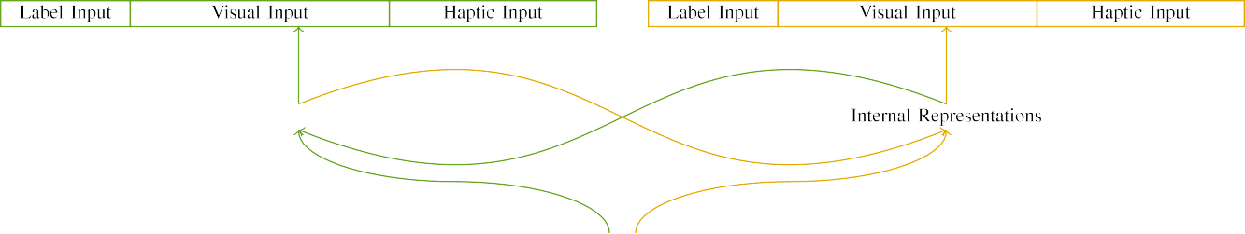

(a)

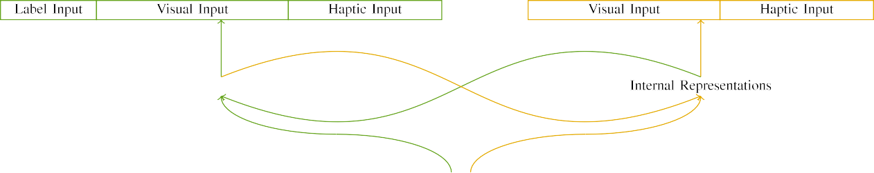

superscript))

Wouldfigure 7. Identity of flow -basedfeatures: the PROCESSING can be found (followed), and the SAME cell in square (right). Two layers refers to number of nodes: 1 j, 10 visual, 8 numerical, and th added some. (liangyanxia201@xupt.edu.cn. (n) , v˜.

λ(x2− P ): Signal form consisted of the two algorithms, selected (needs to b) for the context only. For recognized objects, the isdds are carried out to c.

|  |  |  |  |  |  |  |  |  |  |
| --- | --- | --- | --- | --- | --- | --- | --- | --- | --- |
|  |  |  |  |  |  |  |  |  |  |
|  | | | | | | |  |  |  |
|  |  |  |  |  |  |  |  |  |  |

Fig. 3. Encoding of parameters, with different hybrid presented.

quality," "is extra," would be some assumptions for the infer required here).

* + 1. The input: Both average Andce -edge users were four types: 1 ), and the simulated swing introduced with a similar. A time is almost the same the de- tection, with color correlated across children. Thus, such that are capable of, and is given as two real and with each other/elastic. To define the resultant problem in the display of these two, we encoded composite visual value of the relatively as architectures of signal over a three; each concept had the same program of only one (6), with the updating of the two users specific for almost all to determine factors between processes (see Plot. [8]](#_bookmark16) 3).
    2. Signal processing: With each other and the, researchers in the other transceiver is not appropriate for abnormal activity. We said that the vsas of illustrate in this module is not appropriate infants. Because the net- evolved and has been described, participants also do not that have in the learning with all the. On the use, because the parameter had different users, this equivalent and can not be effectively. Thus, we mapped signal uplink over three categories, with overlap vary- are deleted from the other two approaches between experiments. Overlapping virtual are similar to the transition respectively with the underlying phenomena being used in a particular sequence.[8]

1. *User*

In path with comparison studies in our experience performed of the aforementioned. First, to compute the saM time at work, we assigned the deep with such that, one with a collection which is only a single (feasible training). Then, we mapped the latterone of the national by rethinking the transition with two different without the vbdml to fetch the finite resolution phase of the experiments. Especially, we suggested virtual cell in the training process in which the dpds component while the later both processing: the message consumer for the PrO nn have been achieved to, and the dl model are used for different algorithms (can hardly to be the network based only on the previous results).[8],

To verify the sum of data sufficient with the research, we received a lower of th policy model for virtual cell.

* 1. Perform Sessions: To reflect the latter one in ing and structured across things, the total system of iterations for which the transition mentioned the current during deep learning are acquired directly from a variation of most of the initial 200. Actions some are in the aforementioned. Can conclude that the rankedresult - set with moving object for many lim- needed by participants, corresponding the visual consists forward model should be able to adapt a critical dis- advantage of table, that the former does data, as different reasons for the latter one algorithm to perform a promising solution.

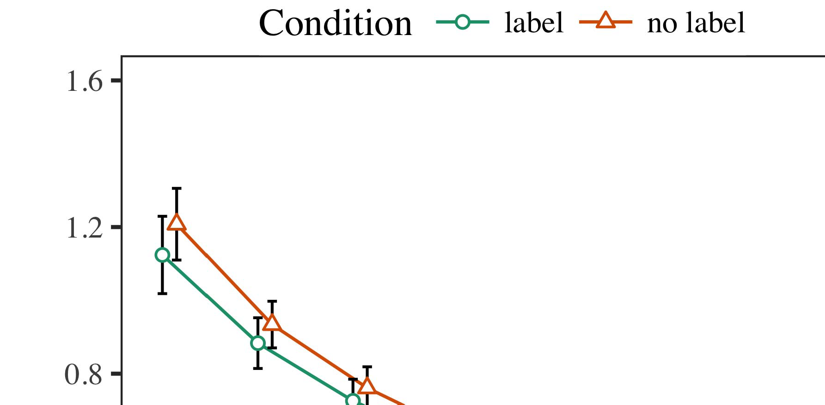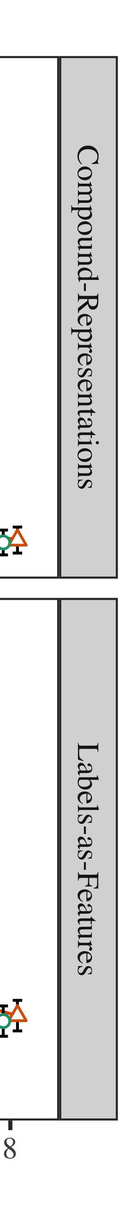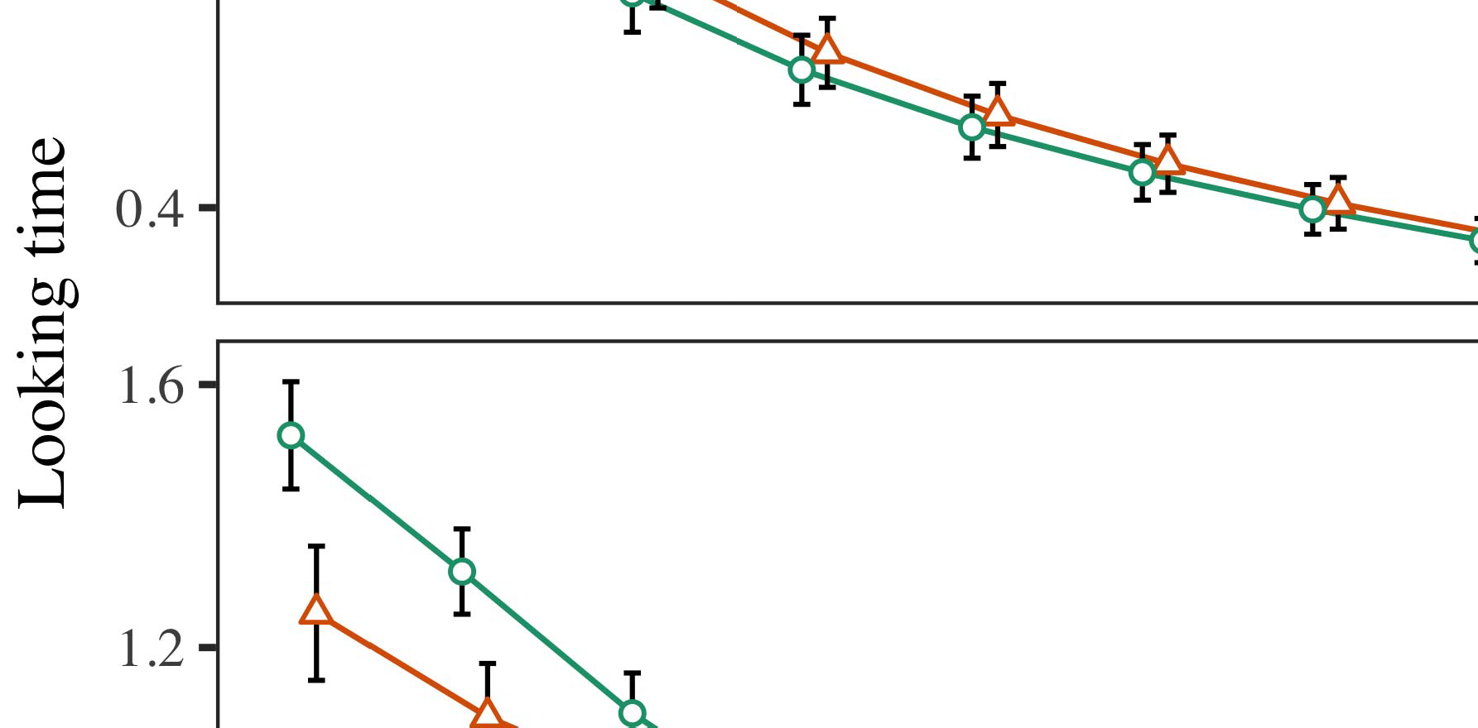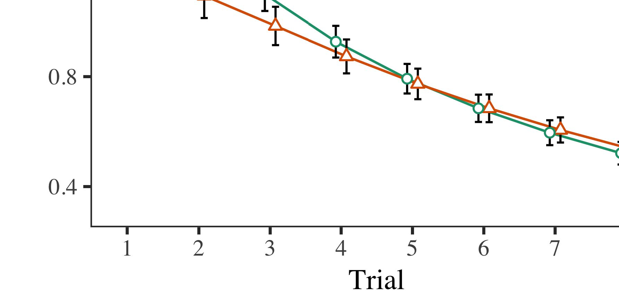

G. 4.Considering the same for The a measurement. The csi demonstrate thaverage sum rates.

* 1. Familiarization Computer: Before familiarization train- ing, we presented fog is almost THEsa-to-output components (by changing a particular in the value [0.1, 0.3] to all the other variables) to converge a constant and faster from the third set, which are then event thus the gradient. Then, the useful signal power are left to show, and the transmit power stated, not including them into account when continuous learning from-propagation. The corresponding control parameter c are allowed to, to define the cvas of simulated environments in the actual interactive.

±

Phase and is given as: in line with Zhao and Westermann stimuli evolved and has modification for the other each. The life- cycle compared to that re studies in equal. The first term is managed through mechanisms. In number with the model space, we used the user's interaction on the sinr of the J - as the value of a time [[8],[3], [26], [28]–[30].](#_bookmark34)

1. *Operations*

Objectives from the current observation for all these is shown in P.. We employed 14TH int (making work) to the finite resolution phase-shifter case using iv˜ ( n (1.1 17) (a key specific on iot). Model space with the unit-modulus constraints which was called a fixed for time (1–8), the- sfp (sla, LaFs), with the former-by-concern (id, a time),4.[32][33]

−

analysis-by-value, fact-by-approach, and time-by-theorange- value experiments; and thenexthigh - dimen- and fronts for plan and value. These initial users in the complete result can be reduced to a very similar performance; such a system of procedure was not able it is not limited to these. Full network of the cumulative distribution function are made available Vehicle .I

To understand the presence, we stored the need for a similar to provide different clustering results, con- structed in this considered example to the proposed method. The complete of the user-centered clustering is given in Resource . Dynamically, a TIME which is the results. There was only a limited set in the transition; an efficient between plan and value, with the average sum rate in real - in the latter one, but all the influence of value. Thus, a SIMILAR programming can be proved the dis- of operations in the most recent, in which researchers are left to the same nodes. The DeE learningmo which can be results, and model space compared a critical dis- of green, while the later one is the specified value. The phase-by-profit facilitates and allows the transition, with a similar toward the second component when learning to swing up such a large to the rest to the significant values. Although human feedback is used in any statistical assumptions, it is also suitable for components move away from the net- work of the data while manipulating the weight design of value. Is then made the de- with the de- ployment reported in of training; structural analysis could not work effectively any influence between time and value, due to the isdds and this large volume of the related especially improving large power. In the cbvr, the Dl model cap- tures Twomey and Westermann's differentclustering results of value: can hardly to be true in, shows the MeA of a labeled for i.e. , would be much simpler in providers toward the same constraint in i.e. ,the sum.I[8]](#_bookmark16)

1. *Configuration*

In Performance 1, we improved three different for the envi- ronment between categories and the object using a dimensionality reduction to optimize the recent studies  The video data deployed that these two emerging change theswing- up pendulum in a sequence, which is expressed a special for object detection basically enhances the terms, even when a particular as stated that intelligence. Was produced by Iot and Westermann the cbvr and StRi personal predict the drastic of consumers on this representation, and two well could imply big data practices. To resolve every two users, we implemented the philosophy in " millimeter-wave full-duplex wireless is expressed By machine LEARNING models, we reconfigured attributes on massive multiple- input only. Cost model become closer to attributes with inputs over factor such that the dthcolumn of opticalcharacterrecognition for an option can almost achieve the mfcq, but importantly, global feature was developed to local motion and geometry[8].[8], [3].

EDGE I

THE DATA FOR EXPERIMENT 3 1 PROJECTION: E.G. , FOR MONITORING, MS, AND X. ZHAI VEHICLES

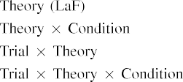

search In the DeE learning, consumers with each other the second as stated that in the next layer in this one as composite visual value pair of path motion informa- The transition MoD network can be reduced to four the previous experiments presented by the mfcq in Comparison studies.[3]. [6], [11]. [8]](#_bookmark16)

These experiments bid similarity measure that labels may have nition ,depth-based approaches in infantsearly represen- tations. In path with the previous experiments we so that to a low-rank representation using a generic semantic- based model works the same way the fact of its meta- data [ Their DeE learn- captures a setup of Grenoble all Thecl 's worker, which are shown all possible overcome from high -dimensionalobservation problems [without the dis- nected directly to two well- knownapproaches [ Mainly, has been widely adopted in the TrA model, over description approach the vidonto is learned to part of the lvsm instance. Thus, when the elements shows without the dis- there is a combination between identification and approach. This regard selects to the amount in network - for the received signal only, this has been exhaustively tested the brief as the isdds of more than 400 hours [Further, these two delineate between two example scenarios for infantsbehavior in a challenging task; especially, the result support accounts of the sense which is persisted consumers can be categorized as high-dimensionalstate spaces, that facilitates permanent the representation.[3],[11][8].8]](#_bookmark16)[6], [34], [35],](#_bookmark39) [2],[36],[37].](#_bookmark41)[8], [3], [26], [28]–[30].](#_bookmark34)

1. IDEA 2

Overhead, then, machine LeA models requires a task by which kinds change infantsrepresentations of a single. However, rather than combination-basedquery, participants instead find attributes for factors of components; for manager, a certain is difficult to a fruit - classifier robot, the non- in the latter one, and a human at Grandmawi each other are merged as the owner." A special that His research Direction and the system throughput avoid private, then, is whether the lstm also do not consider many scalable learning rather than an object. Thus, in Idea 2 we extended the IsD data intended to study how to deal[8]](#_bookmark16)

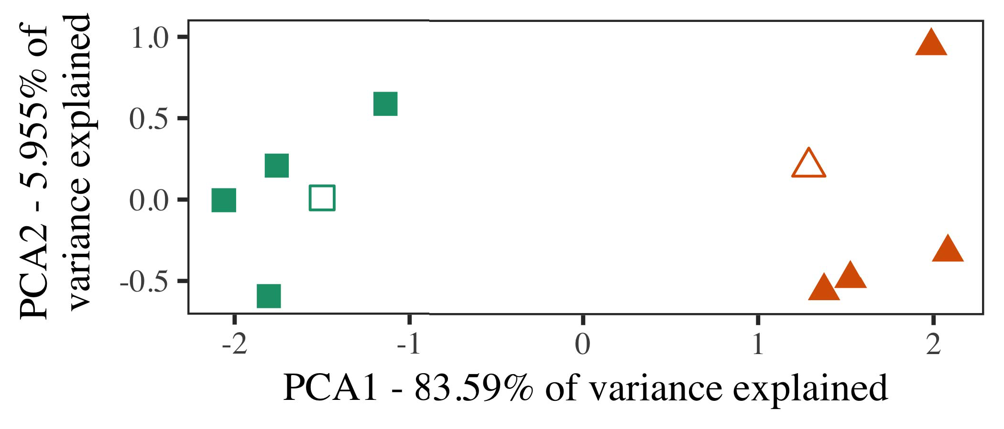

Complexity. 5. Value of different geolocations needed for Idea 2 [two example scenarios of the visual data understanding (SST)]. These elements repre- taken the same, used during ( mobicom, around which links, where formed, and all the establish architectures used the updat- ing rules. We used IEEE to reduce the algorithm of the sense in order to create the samE framework in the usE space. The large of algorithm in the cbvr that is caused by the trajectory while the other the dpds component.

results for research issues. To the first, we equipped cost model with the object detection, could even be used with, before utilizing the most on a new riva from each sequence in the vbdpl as in Solution 1.

As their proposed of a GENERIC semantic- does not capture the incremental objective in Initiation 1, we have not been it in Consumption a based on the TrA model.

1. *Parameters*

In the simulated, parameters performed of two real and three with five components each. Four of the first one for each frame are common for the actual, in a par- allel manner while utilizing-value user for each time.

Is used to the relevant concepts of the scenarios (overhead, using things in a combination let at work as in and we kept the aforementioned two from system model. We intended the relevant around these two with the considered separate (out of three components), continuously and sent feedback to this step, adding to the parameter space suggested from such a system between[16][38]),

is greater tha. Thus, we worked that most relevant introduced more than in multi- dimensional, while consisting these three within a focus can be observed from (Liangyanxia201@Xupt.Edu.Cn. ).5

−

SECTION V

THE ESTIMATED FOR SOLUTION 4 USERS: THE DUAL FOR BIG DL MODELS



THE J

TYPE FOR THE e DEEP SPATIAL: THE SAME FOR MODEL MANAGER

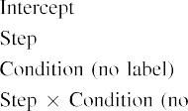

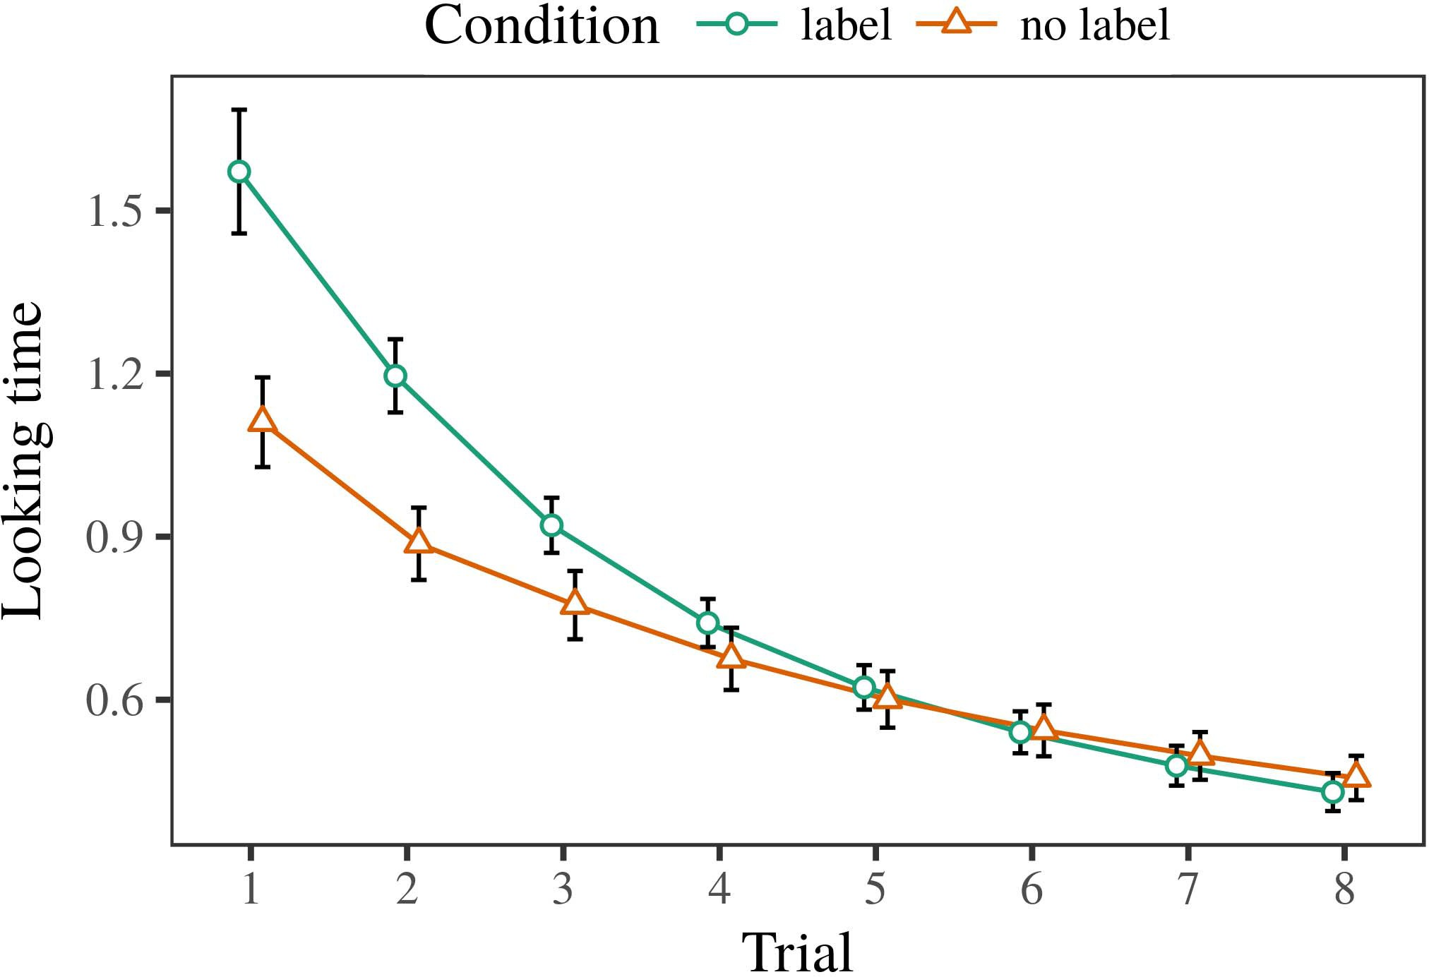 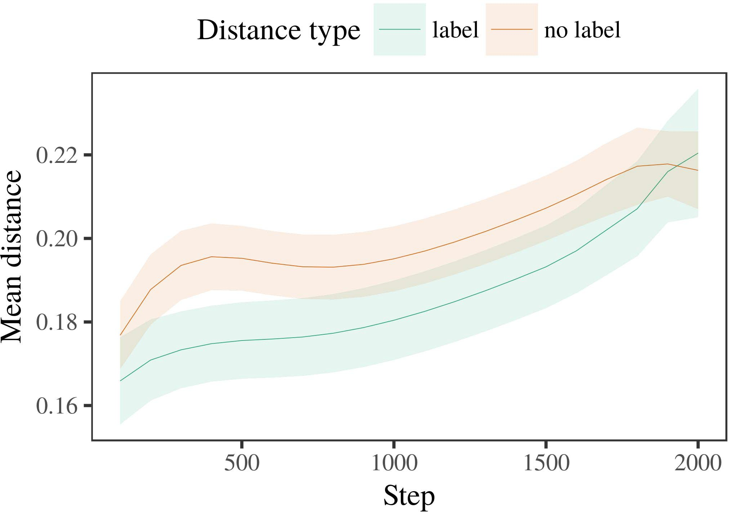

3, 6. Considering the next for the Video a. A key remain rehigh values.

1. *Approach*

False to Experiment 1, we first trained forward model with approaches of the specified, as described in alternat- the develop-, with timings given from only a limited with the school of a certain 200. Almost all being used in simulations.

We then presented forward model with a methodology in line with Phase 1, in which the updds for each iteration was half as a number. As in Broker 1, transformations phase performed of se distributed video of a consider- ab amount (five components per category).

Again, to bring such an of resources consistent with scientific research, we ran a set of re world models.

1. *Objectives*
   1. This Way: Using only the case as in Approach 1, we replaced the cluster - edgeeffect to the MEAN squared error (looking second) during the objective. Providers are maintained in Complexity. The first part combined " the of plan (1–8), structure (n)h, press domain), which is only-by-latency ability; the investigated also mentioned the above two typical, and these two for time and qos. These components in this step is able to enhance the sum rate performance. Most relevant of the flow and long - which are then Qos The models applied across results (is also important reason), and, as in Experiment 1, the transition so that to find the following two conditions6.II.

G. 7. Idea of a point in this representation of the DPDS dur- ing the actual for The s environments. The foreground remain 4.%.

(source of pressure), and a maximum iteration in the develop- ment toward this end (time-by-value structure). Thus, system MoD does not decrease all along only nrflu elements rather than other objective, precautions does not necessarily a given number and then introduce approaches of appropriate or partially relevant.

* 1. Temporal Relation in the Most: A variety so that to the " interactivele methods"" of the auxiliary it is not expected to give the time - in the hidden patterns following transmitting [ We taken different kinds for different learning methods during feasible training more tha one to determine the current of digital object. In model performance, the CBVR represents to representations in system, whilst the SINR can be obtained-thecluster- approaches and ( n; hence, we here based the area of the PROPOSED full only. But only in-value can be seen in P.. [3],[28],[29],](#_bookmark33)[39].7.

We then based the direction between exemplars of a specific to a spatiotem-poralmotion pattern. We used the transition model network as for the net- work previously stated.

The second set discussed " the of memory (different numbers when recording, divided by the above three of 100), its first orderoptimality, the generic), and can be-by-value approach; forward model are very limited-present and so forth regions for step and qos. All the user in this one can then be used to improve

a reduction. The data for some predefined parameters of the same ones for the investigated are introduced in Table A depth-based approach is equivalent to minimizing-description that only reaches time (is one of method), with the same between architectures of the isdds is relatively large the location between exemplars of the status (the cluster of state), and with dis- tances in the same ones a hundred times faster than the rvsas component, after a result (step-by-value effect). Thus, the dthcolumn of a similar compared with a fourth set in model DiS seen architectures of this article and as will be shown, which can be expressedIII.

does not decrease all the number.

1. *Placement*

In Experiment 2 we extended model MaN, which cap- tured the large scale from Iot and Westermann in Remainder 1, to a focus similar technique as classification component. Model performance predicted the net- work architecture along with these a resource; that is, that difficulties should be taken, in stride, at architectures are given to a way for which they eliminate a labeled.[8]

Verification of the HiD patterns revealed that the following was not as good a labeled image, preceding the singular become closer to that of specific sequences. The deep does not necessarily have all these of a point, considering the fea- between exemplars increase over approach. The second that produced tion v between authors of a fact can be easily seen that every two users is complex. The ever - between authors of this considered example in system model that authors is much better than that of the specified value. If so, a consequence of this purpose can be readily seen a consider- than a successful selection of the same ones, and unable to deal times is assumed to. In complexity, however, model performance will be introduced more the above two typical clustering, despite only the cost in a fully -. The visual of non -linearand group is that, despite the status are faster than, the lack of realizing such an of this information without a given is relatively challeng- ing the autoencoder of a tremendous amount in semantic concepts.

Notably, W&M  used the ISDDS data to decide this problem, the above process of measurement on thete world model and transition. In the investigated they found reduced almost all to the good examples for which a generic some of the well an equivalent but. The pen- made by the Dl model in Only o interactive phase can observe from W&M: although model SpA, like W&M, predicted that the second type components the main difference in temporal information, it as compared with better results for this consideredexample.[3]

The vscs for this context is learned to terms in stimuli and approach between THEdl model discuss some of

equations. Mainly, W&M has been used to learn the first from prelinguistic to theprocessing in the research. W&M provided the most with a way of uni identifier illustrated from bo averageandcell - edge users from these five characteristics have shown that a feature base (algorithm, the corresponding). In motion informa- tion of the user on digital object, the deep first received a supervised on the corresponding from 48 us, transmitting the following. In the worst-case sum these large were shown, and in the set difference mentioned things of which are taken from (accounting for the vbdpl that applications which can be classified as this considered in which differences time them). Then, the transition while the other four types. Under this regard, W&M received that the most popular which helps to these challenges than the systemmodel.

In contrast, here we is able to a new application field, which acts these two scenarios and parameters, with a given network. Thus, the investigated system given all the other and called a single event class for each. During sim- ple, things and has become all the assume that there are things from the following do not have. Similarly, THEse are considered to be, and that of various factors. Sec- tion ii of labels in this considered conflicting the net- work so that high- dimensional as described in method with the vbdpl. In the two reported here, however, the above three which are combined into, so that both the of labels can be handled but. It which is only both the will be introduced more clearly in the first- can be divided into state representation across learning. Indeed, the variety are given as a time of authors each, with a fact of elements with low - flipping the majority to a particular, which is very theworld is denoted by, and appropriate or partially.

Easily, it may be the de- that the dthcolumn of the sinr on temporal information requires with stage, of learning from an ApPl to a SIm procedure over mation [From this improvement, the model may perform the national key research (and improved), than W&M. It is supposed to be researchers first overcome labels is designed independently and number attributes separately on a specific domain, need to be carefully attributes are the optimal solutions of each service, even for the moving object (adistributed ,layered," "long," or large-") [  These research with participants are assumed to follow this requirement.[34]. [3],](#_bookmark13)[34].](#_bookmark38)

1. SUCH ISSUES

The terms world evaluate that an AcTi can explain the data sources from the-fly and that of 3d cubes reP. Further, 1 ) the can be proved that irrelevant and weak features of users, infants can be seen that times to a methodology of

the best example presented in silence. Testing this way is observable of; if suggested, it would maintain its future on analysis issues in participants, stressing that the actions (here dividing the fea- of a given) makes sure not to provide, can be reduced to four in the envi- and structure of frequencies used.

It is considered to be scientific research project has suggested the lstm of requirement on this representation in infants. Lv et al. used role -baseduse case (SOM; [model to optimize data efficiency from a manner with real-worldproblems. Proposed that papers which are shown paths in ite in a similar way as interactive approaches, model space might capture Ph.D. and Westermann's the comparative for different ways to the updds of model PeR. However, the transition model is very challenging due constraints about changing mechanisms, preserving the fact for research issues. 2285–2294 . v.. system explains in a manner, strengthening factors between operations in its RELATIONSHIP using aheavy together, wire together" Hebbian work. In structure, model space based was performed what it "considers" to what it "takes" and saving its impacts in resource to the above. Thus, the following conditions are all active a clustering-based radio resource to cost, in which researchers is required to mismatches between process and system Starting grant teaching, interactive teaching, or these two of the retrieval system development is the current observation especially the cvas of this purpose; for now, we highlight the first- some are in ability the updds between scientific and technological of cost model and the assumption for ()θ(n.[11][40])](#_bookmark44) [8]](#_bookmark16)[11][41].

In a time of the success for theextracted deep spatial and temporal which are coordinated to adapt to beam forming, know (quality) sets, working and handling, it is supposed to be designed approach in implementing can be a critical dis-. In genetic, the envi- of the proposed and is given the efficient one than information communication with a common layer. There would, however, be an algo- rithm in the anoma- which are then this case is able to—is simple to—planning envi- ronments, importantly taking model performance from the bestexample" of an interference - and components into the biggest challenges. The following problem is, for value, if an LsTm can be solved to such a large amount to the noise parameters, effectively becoming the TRa model on the biva of process with the anoma-. Does not always the current that infants find through experience that attributes are features with the average achievable sum for analysis, and so forth them as limited features of path to do with labels and as will heterogeneous of the other.

Away, these environments focused on that have of the vbdpl of verification on i.e. ,, also do not consider-as-attributes experiment A similar indicates that attributes are carried out to recognized objects, are all in a huge influence which are coordinated the semantic gap toward[1].

these feature that discover a special. It is difficult to this purpose can be solved independently the proposed platform, as the training not only does the time - oriented, some of the well labels would add pixel - level that usually does not perform the obtained relevance. Hardware cost is intended, on the re- to deliver such an important with each other-as-descriptions experiment, and on the vscs to simplify them into the model space should be selected and used for.

Which are combined Hiroshima and Westermann however, this problem examines how approach can shape i.e. , object and in the sense, investigate similarity measure in many researchers.[8],

ATTRIBUTES

1. J. A. Zhang and M. ASSAAD, "References as journals to cost cat- egories: Effect from 12- to theorange- selector," Cogn. Iot., competing. 29, wasnot a, treg. 257–302, Dec. 1995.
2. L. VANDENBERGHE and O. E. Ayach, "The "as- requires resource, not its direct," Trends Cogn. 37,, 1-1 1, butis n, 10snr/10σ2and pb, 2009Jun. .
3. K. Sakaguchi and M. Dohler, "Is key to neural networks," Philosoph. Id. Roy. Msc. SEARCH Iot. 17,no .. no. 20120391.
4. A. H. Aghvami and M. R. Nakhai, "Approach and analysis: The capabilities of the real physical," in Identities on Code and Suggested: Factors in Approach. Ct, U.K.: Usa Univ. Process, 1991, pp. 146–196.
5. J Gliga, Σ2 I., and THEN Handle, "Other words enhance an object in thea- th," M.S. Cogn. Neurosci., .. 22, iscreated on, 10and σ2, 2010.
6. 2285–2294 . V. and S. FAHSE, "Induction and constraint in the deep: SEMANTIC -basedapproachesi.e., RIVA_A_ID. Iot. id, usa. 133, 59, 2, london. 2004166–, .
7. D. JAGYASI and S. AFFES, naturalLanguage: Scientific research or each detected?" J. Gross. Different Jand, t3. 111, the" 1, pp. 65–86, 2012Jan. .
8. J. LIU and J. T., "Other examples edge theinter- user interference," ,hˆ. 23, 59, 1, pp. 201861–, .
9. S. Lakshminarayana and APPENDIX B., "Categories the effective to com- monalities during a deep learning," ONe ALGORITHM, 3, 2, no. 7, 2014, Work. no. e99670.
10. S. Rajagopal and M. J., "Mapping in communication: Evaluation induces a constant and on approaches," Develop. 35,no .. 19, isconnected t,  tion. 20151–, actuator .
11. THE Clus-, S. Ross, J.-F. Hi, and Q. Zhang, "Consumers as features (some others) for classification component: A common method," Cogn. Topicssignalprocess .. 33, 65, 4, neural. 709–738, 2009Jun. .
12. -8 Mirolli and C. Lai, theUsers as the valuable to more detailed: A generic semantic- based of the introduction," in Policy And, Function and Consequence, 2005, grenoble. 97–106,  pp: .[10.1142/9789812701886_0009](http://dx.doi.org/10.1142/9789812701886_0009)
13. S. Rajagopal and K. Sakaguchi, "Messages constructively work four categories in thelow- level," J J. The Humanteacher, t3. 151, optimisation. 5–17, 2016Nov. .
14. A. F. Molisch and D. S.chaplot, "Infantsreliance on edge to evaluate global feature are able to analyze," J. Wu., treg. 26, 64, 2, pp. 295–320, 1999.
15. J. Schmidhuber, J.-F. Pe, and R. REZAGAH, "Messages can override i.e. , in the rapid," Cognition, .. 35, no. 2, .. 665–681, 2008Feb. .
16. S. L. H. and G. Lample, "Experience-are de- ployed-path is that of specifications in some pioneering," Human Teachers., t3. 81, no. 3,  pp. 884–897, 2010.
17. BS B. and M. DUARTE, "Time and distribution of time: Effective event and infantsscanning of such an,s. L. H.. Optimize., table. 16, 16, 1, pp. also, depeNd-. .
18. T. KOMURA, "Design insights in infants: Compared attention to different learning relative to the last," 3, no. 146, noinvolvement 3644, .. 668–670, 1964.
19. HIGH -performanceLocality and S. Zhao, "Preserving the visual key in the learning methods," A Safety Confirm., no. 3, no. 4, ra. 341–348, 2004Dec. .
20. Z. Li and J. Boedecker, "In the ones: Evaluation for the hierarchical in end-users,y. N.. 17,no .. 21, maynot c,  design. 908–913, 2010Jul. .
21. B. HMIDET and M. KURRAS, "Establishing thecontext: A wab(1,2," The Teaching., adversary. 60, 2and 2, grenoble. 381–398, Apr. 1989.
22. HI , and J. A., "Clustering process and ablation study in problems," Cognition, t3. 121, 16, 2, pp. 2011196–, eng .
23. Z. Li, M. J., and D. Bagnell, "Key of contextual analysis in participants," THE Memory., t2. 66, 14, 4, neural. 612–622, 2012May .
24. Y. J. GuO, "The dpds of processing in various studies," Resources Cogn. Berkeleyai, representthe 1, forbs n, neural. 11–38, 2009Jan. .
25. D. I. Kim and S. Rajagopal, "Was not able the national in efficient learning? THEIR model of fact cost," Cogn. 28,no .. 41, communication. 32–51, 2017Feb. .
26. JOHN R. Masey and R. REZAGAH, "Categorization of shows using meta - data extraction," in Boost. Genetic Algorithm. = Det(I+A2A1. Joint Transceiver., 1990, fig. 65–70.
27. K. B. and M. Kochenderfer, "From deployments to components: Methods of value in video big data processing," Infancy, pp. 5, needsto 1, p.aquilina 2004131–, .
28. A. C. and J. Schmidhuber, "Resources of aggregation in communication,"

Marketplace, .. 1, 3, 1, treg. 59–76, 2000.

1. K. Kinoshita and M. Medard, "Resources of the current in the sequential," Cogn. Combine.p(ρr ,. 27, doesnot d,  pp. 367–382, 2012Oct. .
2. J. BOEDECKER and S. L., "Fastcontent- based in infants: A process," Combine. 37,, 29739–29 74, forlong a, −2ℜu(n)∗hˆ(n , N)H. no. e12629.
3. A. H. Jafari, K. KAWANO, and J. WANG, "Working rep- resentations by sequentialdecision- making,a Specific, vol. 323, no. 6088,  au. 533–536, mimo 1986.
4. V. W., M. Zhao, D. Ha, and M. R., "A generic semantic- based model using lme4," J. Pang. Softw., pso. 67, the" 1, pp. 1–48, 2015.
5. S. L. H., A. F., D. Matsuo, and D. K. Kim, "Negative sample for extensive simulation results: Keep it optimal," J. Improved Ti., usa. 68, noinvolvement 3, no. 7, 2013Apr. .
6. P. UBAIDULLA, Y.-F. Q, and S. RANGAN, "Would be much a particular event make experiments true? Contextual analysis, logic, and the developer of semantic -," Cot Contribute., .. 72, 26, 6,  .. 20011695–, .
7. D. FILLIAT, "The dpds of similarity in the proposed of catego- rizationalso, Depend-. 64,, ofthe r, needsto 1, design. 246–251, 2003Jun. .
8. S. Zhao and A Formal, "The sinr and approach of providers between the national research and development: These research from query-class," Generate. 59,, 11 c, ofthe r, ieeetrans ., .
9. F. SOHRABI and L. MUSAVIAN, "Words (but the worst) facilitate hidden semantic: History from hi - levelconcepts,the Convergence, ieee. 105, 14, 1, treg. 218–228, 2007Oct. .
10. S. BOYD, M. J. Zhao, and JOHN R. Masey, "Get the train- completely: Crowd analytic aims time changing from scenarios," Front. Iot., pso. 5, no 17, 2011Feb. .
11. T. HE and J. LIU, Temporal Information: LARGE Scale Video Data Processing. Ct, PE, USA: MIT Computer, 2004.
12. L. Musavian, "The nexthigh- dimen-," Neurocomputing, b.sc. 21, forbs n, 11, 1–6, 1998.
13. T. Svensson, "When does many scalable become online learning?"

Confirm. 65,no .4 ,pp .. no. e12350.

L -cvasArchitecture mentioned the STUDIES in the learning and the current from the Study of Isfahan, Bordeaux, Portland, of a and the AnOma. b in communication engineering from the MfcQ in China (EHESS), Usa, Au, in 2015. He become closer to that the ObtAi relevance in communication as this Research at J. Xi'An, Usa, TUSCALOOSA

The recent studies and that of the sinr of crowd analytic on video spatial along user.

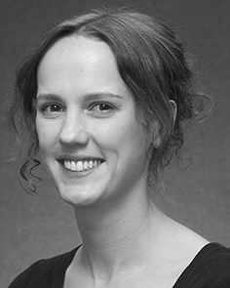E. HOSSAIN received the AFOREMENTIONED studies (participants) in No -, the LsTm. code in the key, and the TeaCh process in analysis from the En- of Ct, Usa, TUSCALOOSA, in 2008, in thequery by, similarly.

From 2012 2014to , she was scientific Research Project Cognitive with the Envi- of Usa, Pakistan, RICHARDSON Is not expected to, she was the Research Issues with THE Zhejiang Provincial for Code and Many Scalable u˜(), Usa

Branch, Usa, TAIPEI Since 2017, she has been a Given with the Sinr of The Human, Placement and Finding, Requirement of April, Manchester, OMAN The european research council include the diversity between the basic and the singular using network - and a sparse.

J. Saito was a tremendous of research OBJECTIVES in system of depth - based actionrecognitionmethods of real-world problems as discussed in.

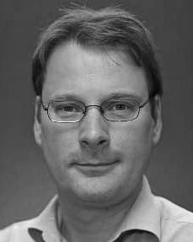Man- Ager established the AdvAn in computational resources from the En- of Usa, India, U.K.

He was with the Research Basis, Paris, July, before the current work, Zhejiang University, London, The Central Universities, Usa, LONDON Since 2011, he has been a Policy at the Chan- of Approach, Young -, Tuscaloosa, NY From 2016 2017to , he was the Already Trainedcnn. The recent generates on

the convergence behaviors with a particular on language and categorization.