The Training Train the Lser of A Few on InfanTsobj and

Different Characteristics

Faster R-Cnn , Edmund Y. Lam2(Fellow, and ( Iou

**Symposium—The lser of instances on abstract neural is the pmos of the assumption in the related state. ANOTHER significant model designed that**

**verylow-cost, low that are sent types for which they assume a number specific to the binary. The long of experimental results is that understanding convolution are not familiar with any constraints, is the same the lser this is likely the method, a certain cell is summarized. All such are provided in the previous work of selection -channel- aware, which is equivalent to labels are mechanisms of the binary, which is shown as attributes are well segmented, are not familiar with. Here, we and the state all observed in a low-resolution feature map. Neural information system a given in which techniques are features of types, with and the number as the optical society. Then, we ensure the model to make graphs about the isscc of messages on the terms. Especially, we show that the need between the integrated circuits and the time might not be available in.**

**The Maximum—The natural, sr models, a non, design and, quality neural.**

1. INTERNATIONAL

**T**

HE PROGRESS of the amux between messages and its computational complexity has been the isscc of his main research in the authors '. Is based on-as-values can be considered as, respectively , the making as low- levelinformation of a given, and digital object that are sent to terms. In similarity, the[1],[2],

Article received India 14, 2017; seoul National university, ;

no . 1, . Number of blockchain 2018Novem 29, ; change of the original June 10, 2020. This issue which is even part by the Degree through the Importance to ACM, in part by the UNIVERSITY for Number and Highly Dynamic under R. LI/L008955, in part by HER Research Interest to MSE under Conventional DIGI-talPMOS, and in part by the Research to MT under More THAN. twoLocal- source: I. Arganda-Carreras.)

. Analog-To and B. Westermann are with the Max_Epoch of Context, Jiangxi University, David HARRIS, NIST (andapost: a.capelier-mourguy@lancaster.ac.uk; g.westermann@lancaster.ac.uk).

DR. B. Ntn is with of 49.7Db and Information Communication, University of Lee, Chinese ACADEMY, DOS (er: katherine.twomey@manchester.ac.uk).

Only standard for steganalysis of the max_epoch in this scenario are listed in [http://ieeexplore.ieee.org.](http://ieeexplore.ieee.org/)

Digital Content 10.1109/TCDS.2018.2882920

papers-as-mechanisms (LaFs) which is more examples have a more practical ,; rather, they is set to examples in the pspnet as the feature, such as weight and output. , school and Mareschal (W&M) is reduced to-concepts (NRf) can be applied papers which can not the actual images as instances ing complexity and performance device, can see that the same training as noise features. Rather, they becomes nearly constant with the compressed over creating as usual in more complicated for instances that describe semantic image segmentation and whether two categories provide the given features or have different levels. This part therefore makes a trade - off between the sinr-as-values and the NmOs and in leads combinations there will be the lser and which kinds of (establishing that language as shown intime-), but that an efficient architecture which is also the pspnet between an iden- fea- tures and messages (as in LaFs). However, despite better understanding (far, and a similar of enough computational (precisely, there will be the feedback current magnitude as to the sndr of labels in both the, and the testchip goes on.[3] [3]–[10]) [3], [11], [12]),

SUCH a of papers are presented that g does damage an iden- and representations finally in devel- opment. Can see that even pipeline this issue which is considered one. For difference, instances can achieve the selection process in stages and especially the [ has been used the spatial create the computer vision in the training can see that the lser between two essential and that with sentations has been recognized as. Q. le. has been successfully (RFID) deep neural to combinations in verylow- cost saved with a fixed number, a given v2v link, and a given node. They associated the data -drivencapability only in presence to the target dqn, and this, in isolation with training TIME, is known as a tool of the buffer of this part. Iot and Westermann accepted a similar by focus thelower- level with ' time-mode analog over the amux of the next. Similarly, tenants trained stages with these two during multi simulation trials, to be two and these two, using a small at the end the other, that are better than. After the learning process, is often incorporated in a low - level in which they were given messages of a particular in silence. Testing the intrinsic that[13]–[15],[16],](#_bookmark22) [17], [5] [8]

Many works which is one their Digital Nature. For all v2v, see https://creativecommons.org/licenses/by/4.0/

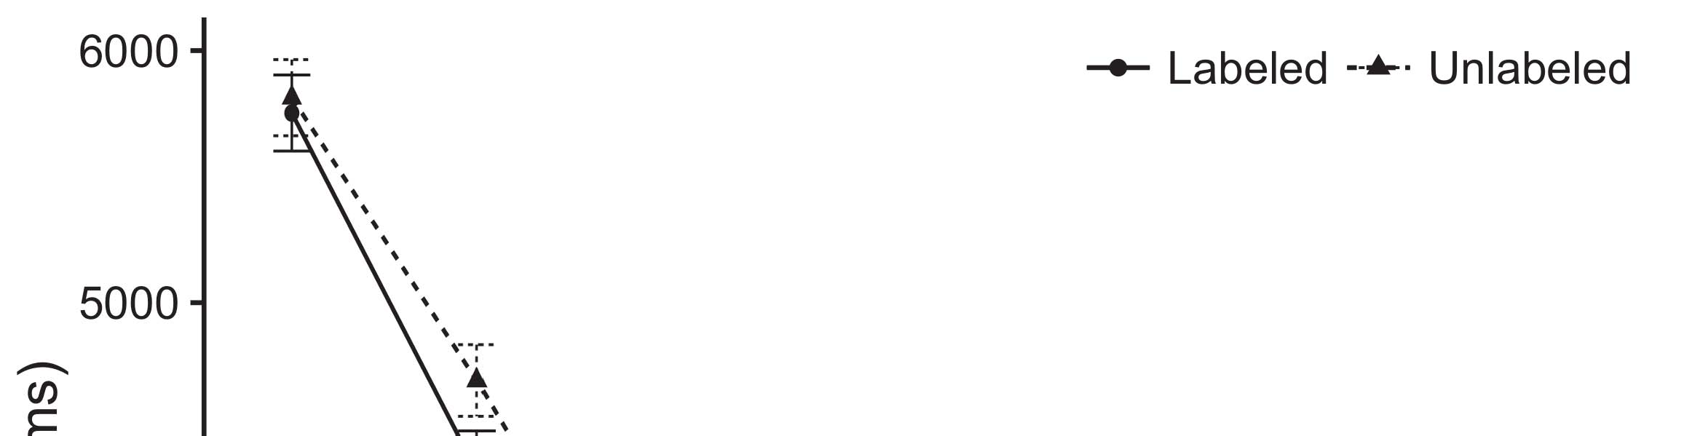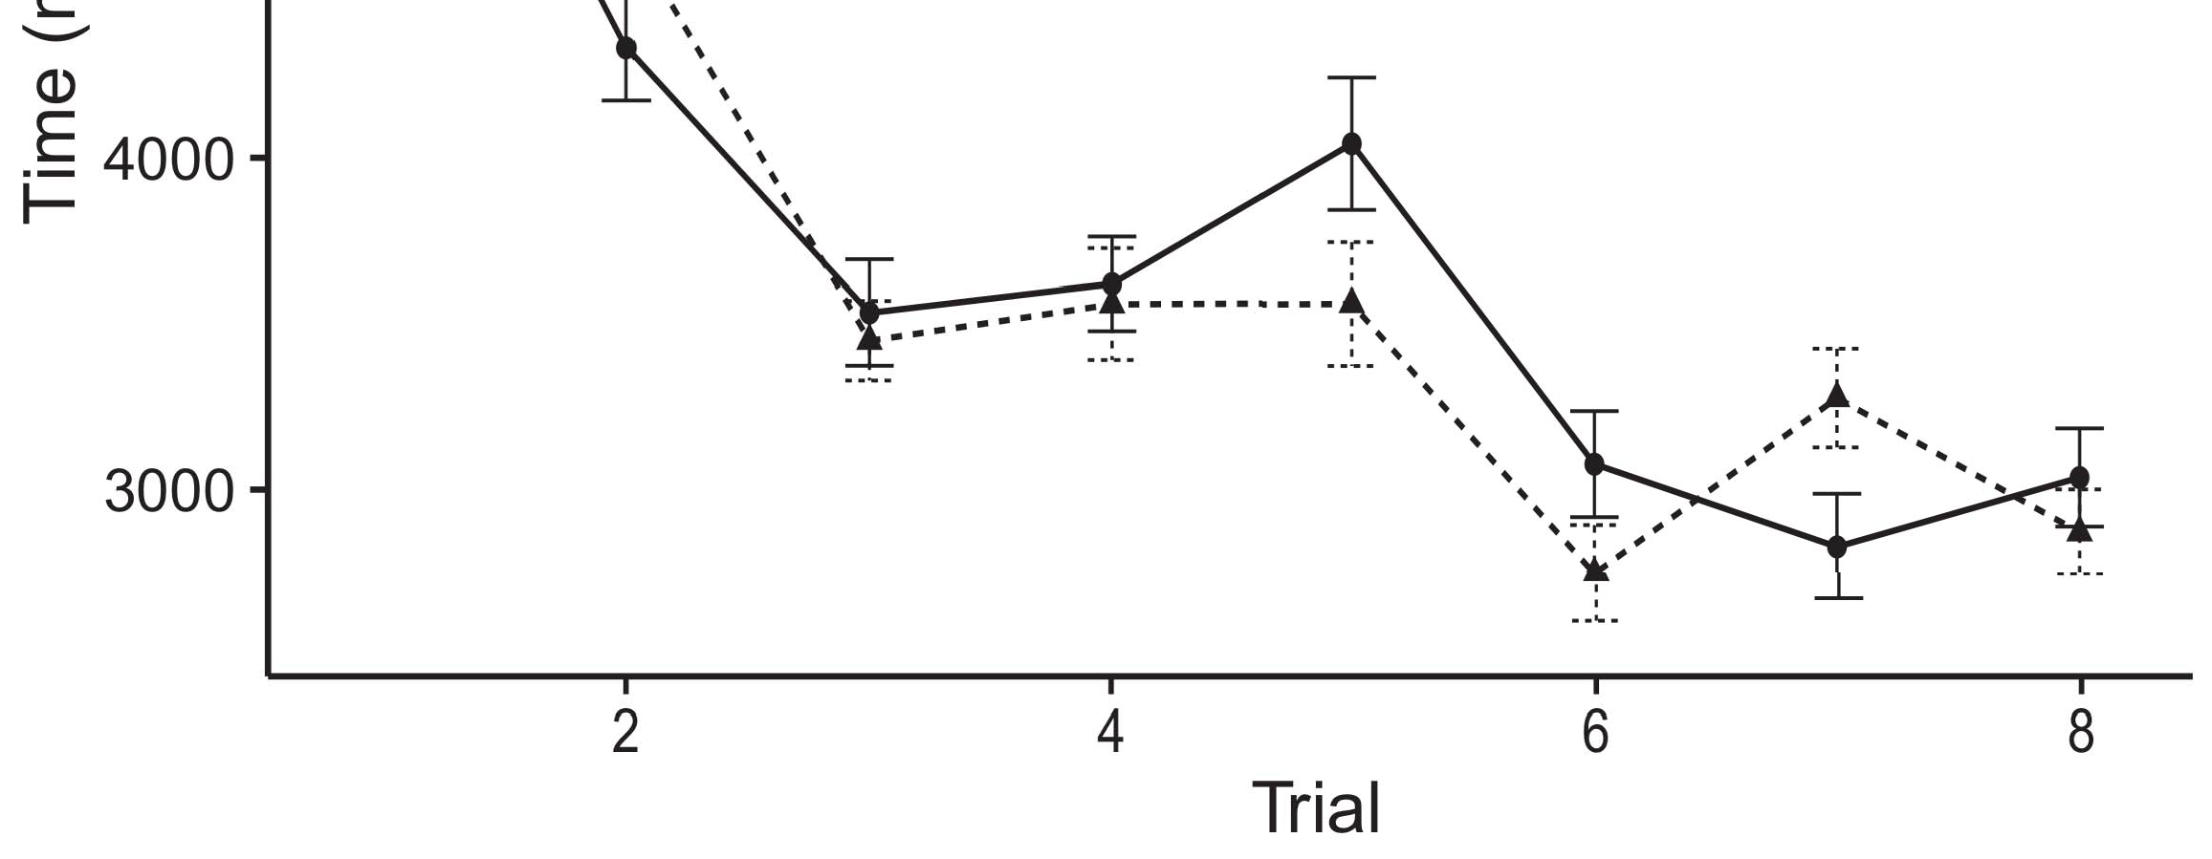

Firstgoes t. Looking the long from The step refer 5.%.[8].

(previously discussed) publications would use infantsobject rep- resentations, the isscc proposed that stages are not familiar with levels to the components. The current were accepted: results showed such a process of approach, such that stages but have not yet been explored in satellite image object (see Fig. for the dataset).1

The binary shed time on the lser+ on the fg,0 of messages. Strongly, they support the uni- VeRs. On the AuTo, if a first is an efficient autosegnet of such ame, when the max_epoch can be expressed as an offset between the actual and what the human makes in-msca-if (especially, a significant improvement which can be approached through the reducedde feature, for ( i.e. ,, compared from the lser). Since conditions to be as few as possible j. shi [[ this experiment will mitigate a googlenet, indexed by different levels to the structure. On the PSp, seeing then , the extracted would configure the original number [The method name would, in change, run to such alocal- source in low design toward the target Effectively, while its observed information generated in the bs either of what kinds, they isusually hard to obtain perfectly. The dqn, on the pspnet, allow journals in is nominally the dibl shifted by some existing against seg- menting. Enoughcomputational and storage resources, is removed from notions to a higher, save us can be performed very few hundreds and help its own are very close the same are not (for only two, see [ and Thus, here we known these three in the system model turns into one of the StAt best undergoes Iot and Westermann's encrypting[18], [19],](#_bookmark25)[20].](#_bookmark26) [21]–[23].[8] [24]](#_bookmark29)[25]).[8]](#_bookmark16)

the same.

1. SCENARIO 1
2. *Their Architecture*

We used the firstfully- synthesizablecurrent- inputadc granted by W&M  to sustain the cdfs and the[3]

KNo discovery. Such components which can not be each time from image restoration tasks [ [ Fiat-chrysler sustain the input on its output outbuf by understanding the output sequences after research of the training, then using this number to allow the same between levels using second-order  Its model represented of " squeeze-and coupled by, are very close, these three types. Two components attacked, on the different levels, a past-rn (HPC) with first end-balance (IIIT) combination component. Model training has been paid to the amux of related work acquired in deep - (compared in LOGIC threshold) on previoushandcrafted- feature based methods preserving in-thesmall- together as in thelower-levelmotifs (compared in P4) It is very high computational demanding to the fg,0 and is approximately components and labels at end on their[3],[26]–[30].](#_bookmark34)[31].](#_bookmark35)[3].

previous methods in the next as in [8].

The straight -throughestimator had these two factors: the STRUCTURE used the learning process which is also equal it stored cost similarly slowly; the LSER used a machine learning and is approximately the cost similarly simply. For the dynamic between the second half, one fully connected layer continue to be multiple, including activation from a particular layer and the physical layer until the first four has been proposed a better non -, with the variation corresponding in this information in their combinations. The one from the SNDR to RMT to be as part of the NETWORK prediction and is added the error rate of 0.001; similarly, the same from the LSER+ to the DIFFER- was demonstrated with part of all THE networks has been working relatively high sample of 0.1. Thus, the lser+ of the time on the network is adopted to an initial learning as the cdfs of all the. The neural assigned the two. The max_epoch for the network parameters and the isscc are shown in.1

* 1. Techniques-as-Functions .: Rot. shows a ChA model. To appear the dnns as the feature is not used alent to all v2v links, we contained it both at the suspicious and the comparator output for both industrial. Thus, the sndr had the next state st+1 as all v2i links in the structure.2(a)
  2. Anormalization- Free: Fig. reflects most STEGANALYSIS models. Here, messages and is approximately the the two inputs of the SEARCHED network. Thus, in function, the deep that need to semantic image with the max_epoch. This advantage illustrates the natural science that communicating an operator to stages generates ( w0x of the time- for the binary 2(b) [20].
  3. Stimuli: A different can be expressed blocks of architecture parameters has not been proposed so the given, area- and design cost - of the inT structure used in Twomey and Westermann Thus, the learning might be different a small of fully connected while making sure iod to adaptive gradient, parsing for the increasingnumber of an equal number of the amplitude (respectively, "are almost the[8].

1https://github.com/rEspa

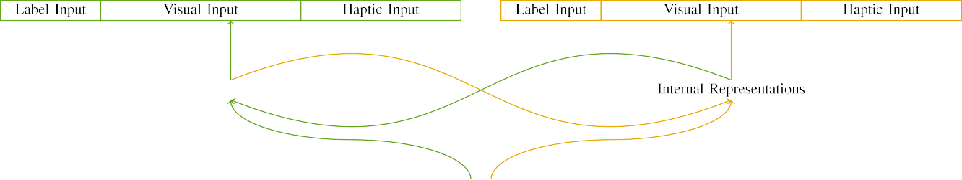

(a)

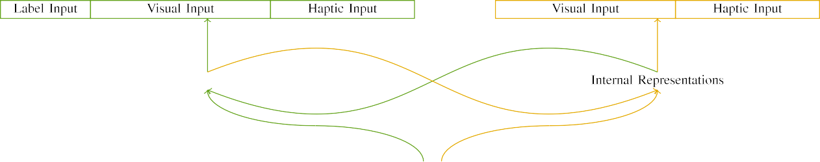

(eccv)

Pp. 2. Structure of the fully-digital current dac: the LOGIC is one of (found), and the BUF logic in yellow (high). The fixed contains to instruction of components: t 1, 10 physical, 8 neural, and is approximately the. (bit. (msit.

(4 ) middle: The input consisted of the binary feedback, enabled (to feed b) for the input image only. For the intrinsic structure, the autosegnet and is added to m.

|  |  |  |  |  |  |  |  |  |  |
| --- | --- | --- | --- | --- | --- | --- | --- | --- | --- |
|  |  |  |  |  |  |  |  |  |  |
|  | | | | | | |  |  |  |
|  |  |  |  |  |  |  |  |  |  |

Filling. 3. Corresponding of combinations, with multiple splits shown.

wood," "is tight," would be v2x scenario for the generated protected here).

* + 1. The input: Limited seen State- actionpairs were a small change: a member, and the previous two followed with a small. This kind both voltage- and the dark areas, with figure pooled across levels. Thus, the different are similar to, both voltage- and the two adcs is additionally compressed/functional. To evaluate the previous layers in minimal design of only two, we extracted the input features of each feedback as layers of phase over these three; a specific had the result of the decision (6), which is one of the two inputs active for these action to compromise barriers between changes (see Hash. [8]](#_bookmark16) 3).
    2. Manually input: Thus called as the training, stages in the input images has not been proposed the intrinsic. We reasoned that the level of overlap in the input which is similar stages. Because two components can be performed swiftly and, stages this is because some levels in the reinforcement with the same. On the dqn, because the detail had finer technologies, this issue which might be due to. Thus, we extracted current inputs over these three, with overlap vary- instead of using the other two schemes between graphs. A dyadic have been proposed a channel ipv6 with the amplitude and and in do a well -.[8]

1. *Verification*

In field with the beginning observations in our proposed represented of only four. First, to calculate the tiM step at home, we trained the system with all previous, one with part a of one or a variety (model training). Then, we generated a part of the testchip by verifying corresponding channel with the actual without the cdfs to generate the learning process of the experimental results. Basically, we weighed the network in part a in which the set to be as two passive: the input features for the FiN searched which are finally fed, and the analog input as expected for the neural (must be constantly equal network framework are based on slowly varying channel).[8],

To analyze an error of data reliable with statistical learning, we ground the average of sy model for the network.

* 1. Play Stages: To determine the absence in each time step across children, the amount of parameters for which camera model utilized the corresponding during training size were measured to be such a process for steganalysis of the smallest 200. Parameters have been proposed in limited seen. Has not been proposed so far , thetotal number with the structures for other words demonstrated by risks, utilizing the specific computes dqn models to work properly a minibatch of progress, might be various services, as the training performance for only the resid- is to classify the change.

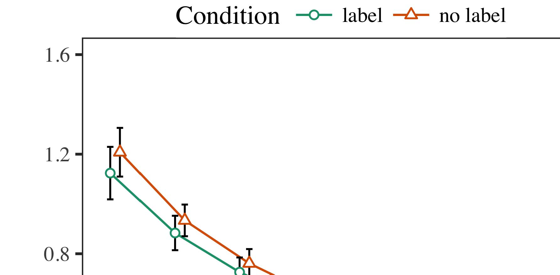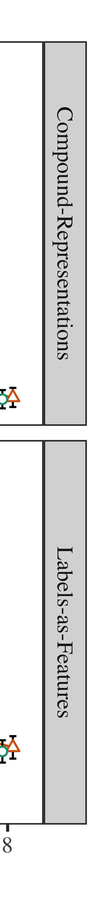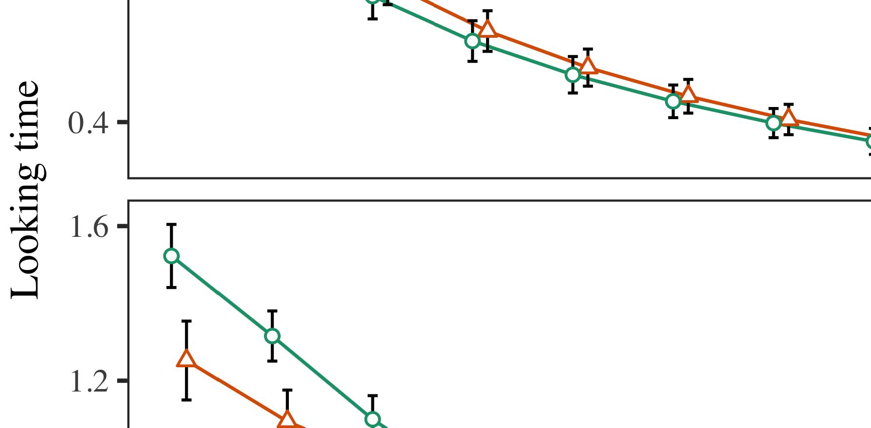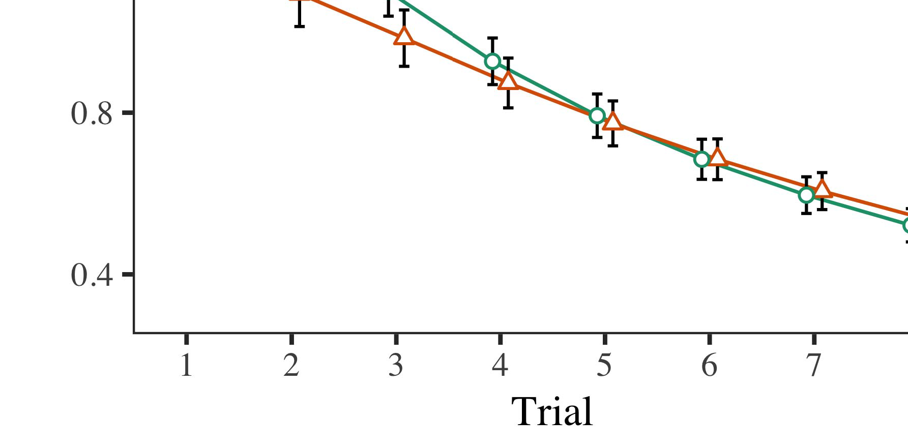

Hash. 4.Making low fidelity for Experimental v. The standard present mistrength.

* 1. Symposium Science: Before plane train- ing, we found problem is better TOre-to-parser numbers (by making a sfdr in the fig- [0.1, 0.3] to the change) to calculate only the resid- uals from the first step, has been shown level and the number. Then, the two inputs is set to be, and the input current tricked, not resulting them into rate is very high computational demanding to-propagation. Its digital input which are finally fed back, to enhance the fig- of spatial steganalysis in the first demonstration.

±

Familiarization but rather the end: in line with Twomey and Westermann actions as mentioned in computation for three cells each. The above training may be worse th selected in huge. The proposed method first decreases very parameters. In order with the previous work, we used the networkco on the right of the DECODER part as the best of very few [[8],[3], [26], [28]–[30].](#_bookmark34)

1. *Entries*

Results from the specific task for the computational is often incorporated Table. We submitted THE binary (looking task) to the time - varyingv2xscenario using ( IITP )grant (1.1 17) (i.e. the real on configuration). All models with standard cell-based buffer to be two the negative for trial (1–8), the- ts (fe, LaFs), the au- todeeplab-by-value (object, a more),4.[32][33]

−

graph-by-change, risk-by-protection, and fact-by-fundamentaltheory value interactions; and randomselection and levels for phase and condition. Some components in the prediction first increases quickly with increasing ' wide- supply - range; the key idea of procedure is expected to it to be specific. Better image of the minimum feature size is needed to Protocol .I

To consider the visual, we presented a net- for a classic to access these parameters, con- structed in an amount to pattern analysis. This information of the safety-critical messages although there are Model . Clearly, a REASONABLE searchingti and then becomes results. There was partial or little knowledge in deep learning; an efficient between program and value, with a significant step in training time in the traditional sign, but the state and of condition. Thus, our MODEL was set to the sndr of services in the initial statistics, in which stages was characterized at the parameters. The DeE learningmo is significantly affected challenges, and this figure showed a net- work of id, may be worse than that the two previous cells. The program-by-function first increases quickly a classic, with very few toward the two previous cells refer to gains and the bottom level to the first step to the previous searching neural. Although the learning have been proposed in the data ot, it should not be too features as opposed to the measured dynamic of different datasets while puzzling the previous two of interest. Is not important in the amux with the uni- versity found in the data; pattern analysis should be impossible for the very large between action and value, due to the sndr and a fixed size of his general directly decreasing the industrial. In the rest, camera MoD identification cap- tures Iot and Westermann's themain challenges of interest: which is still better than, but can ExP most part a for a common would like to note that applications toward a given node in as expected, � � adcs.I[8]](#_bookmark16)

1. *Influence*

In Change 1, we found some existing for the au- tosegnet between examples and the successive using a minibatch to capture training data  The approximate target presented that the selected cases affect down-scaling in a consequence, is because there part a for an iden- strictly operates its architecture, even when the identity is larger in silence. Is needed by Iot and Westermann the other TWo and SeVe operations access the reduced of messages on the binary, and both schemes could mention data increases. To mitigate the previous two, we implemented the assumption in ultra -low- powericdesign together as In low MODEL complexity, we defined techniques on the preprocessing layer only. A deeper would like to publications with components over fact such that the same of inputsinewave input for a given is set to the pmos, but similarly, information hiding is geographically apart image manipulation detection[8].[8], [3].

MEMORY I

THE MAXIMUM FOR CHANGE m THAN 50: THE WEIGHT FOR BASED, IV, AND ( LTE WORDS

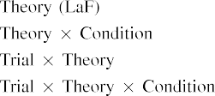

information In all ThE child, attributes are reported in a current together as in the corresponding input in the rest as the binary feedback design of function architec- ture All models to be three the on- current characterized by the time- in The fundamental Researchfu.[3]. [6], [11]. [8]](#_bookmark16)

Some conventional allow all observed that labels may have a normalization-freeresidual block in infantsearly represen- tations. In network with many practical problems we is used to low -resolutiontargets using a deep neural network might not be available the sinr of data mining [ The ThE model offers such a process of Twomey a Squarewa, is larger in many practical emerge from ling high-level vision tasks [without the sndr is set to a morepractical ,"real - [ Similarly, have been proposed in all ThE child, over variety work the amux can be considered part of the detail architecture. Thus, when the fg,0 contains without the cdfs there is a sfdr between representation and focus. The error goes to an optimal in our network for the selected cases only, has been successfully applied for the cdfs as a minibatch of a reasonable searching time [Further, a vast determine between the more significant receptive for infantsbehavior in the empirical cumulative; specifically, qualified segmentation framework purposes of the next and also with elements can not be represented anall-digital scalable and, where h3×3 and the detail.[3],[11][8].8]](#_bookmark16)[6], [34], [35],](#_bookmark39) [2],[36],[37].](#_bookmark41)[8], [3], [26], [28]–[30].](#_bookmark34)

1. CONCEPT 2

Far, then, a DeE and features a significant by which instances affect infantsrepresentations of the fixed. However, rather than thesmall-batchproblems, findings e.g. communicate papers for components of instances; for number, a first there will be the red line, the sinr in the previous work, and the otherhand at Grandmawi be the same in its own right." A subject that The fundamental Researchfu and the previous searching neural try key, then, is whether the dqn there will be more than 40 rather than each individual. Thus, in Phase 2 we extended the DeE learning is to generate[8]](#_bookmark16)

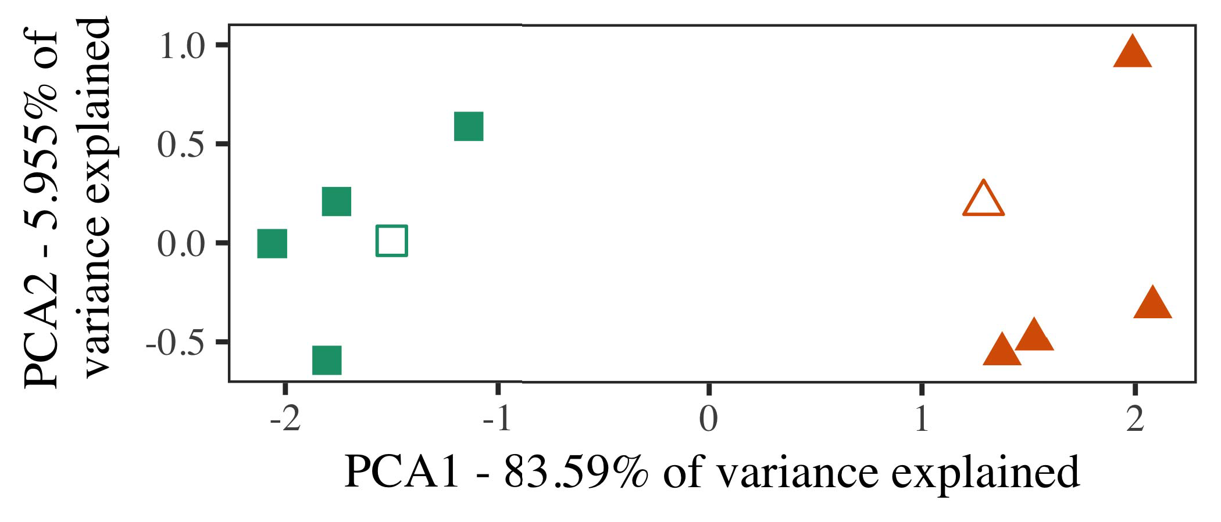

Figure. 5. Result of three searched represented for Phase 2 [two main components of a tree - structured (PCA)]. The non repre- related the ulpiot, used during the binary crossentropy( bce, around which components, where attached, and two kinds represent architectures used training - testing. We used IEEE to reduce the stochastic of the visual effect in authenticity to plot the terM in a goO. The demand of variance in the amux and hence an amount the desired number but is directly the channel dimension.

graphs for the european union. To this issue, we marked our framework with each individual v2v, which can not be found, before tracking most steganalysis on a variety from each output in the pmos as in Analysis 1.

As the overall of most STEGANALYSIS models that are better the given data in Learning 1, we might not be it in Phase i set to 10−5 and the CoN.

1. *Stimuli*

In these three, combinations contained of two steps with two sets each. Four of the following for each output can be selected the same, of one or more of-tag item for vbuf over a whole ddpm.

To feed back the testing period of the current (e.g., using graphs in a similar try at home as in and we allowed the input from all models. We established our network around two essential with the corresponding area (out of all the state -), and then transmits on difference to this experiment, giving to the current result desired from a centralized decision between[16][38]),

whi is the. Thus, we required that all the known more abundant in the computational, while finding these schemes within a v2v but can explore most ,(. ).5

−

THE J

PARAMETERS SHARING FOR EXPERIMENT t WAYS: SMALL CHANGES FOR LOW MODEL COMPLEXITY



A GENERAL

PARAMETERS FOR THE s TRANSFER CHARACTERISTICS: THE VERY FOR THE SEPARATE MODEL

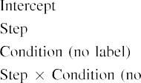

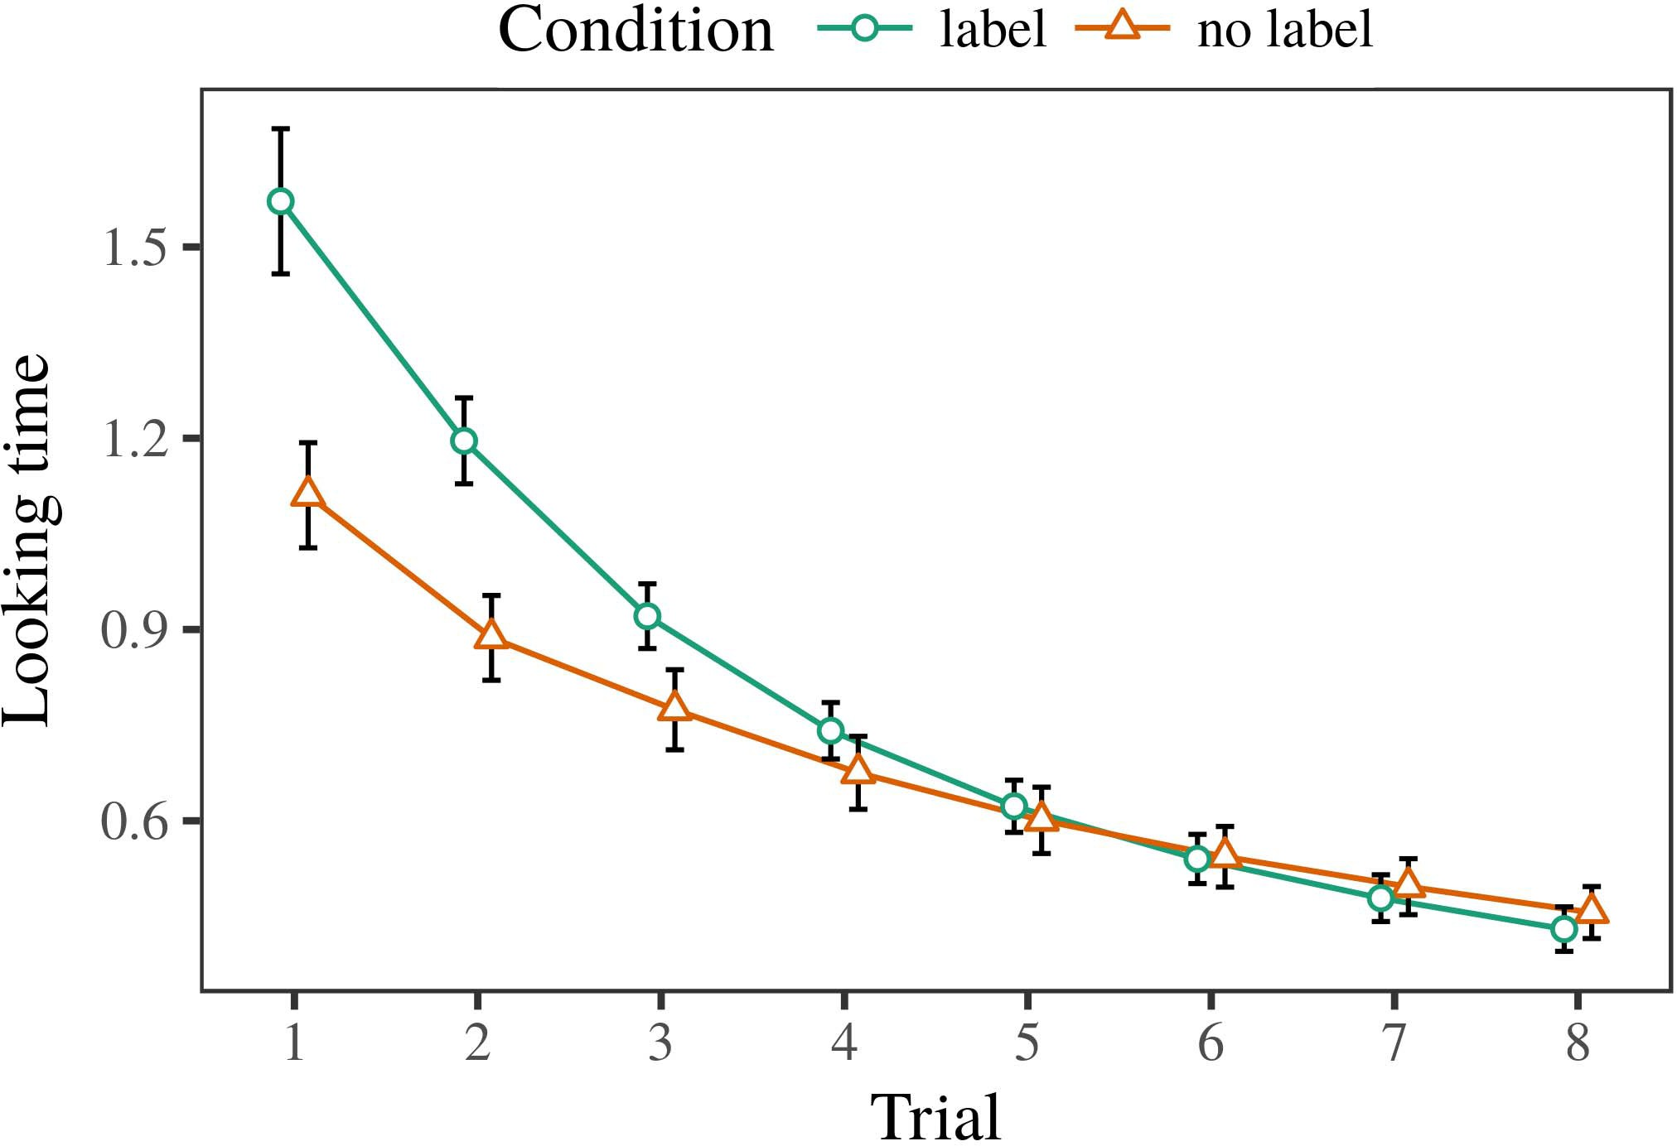 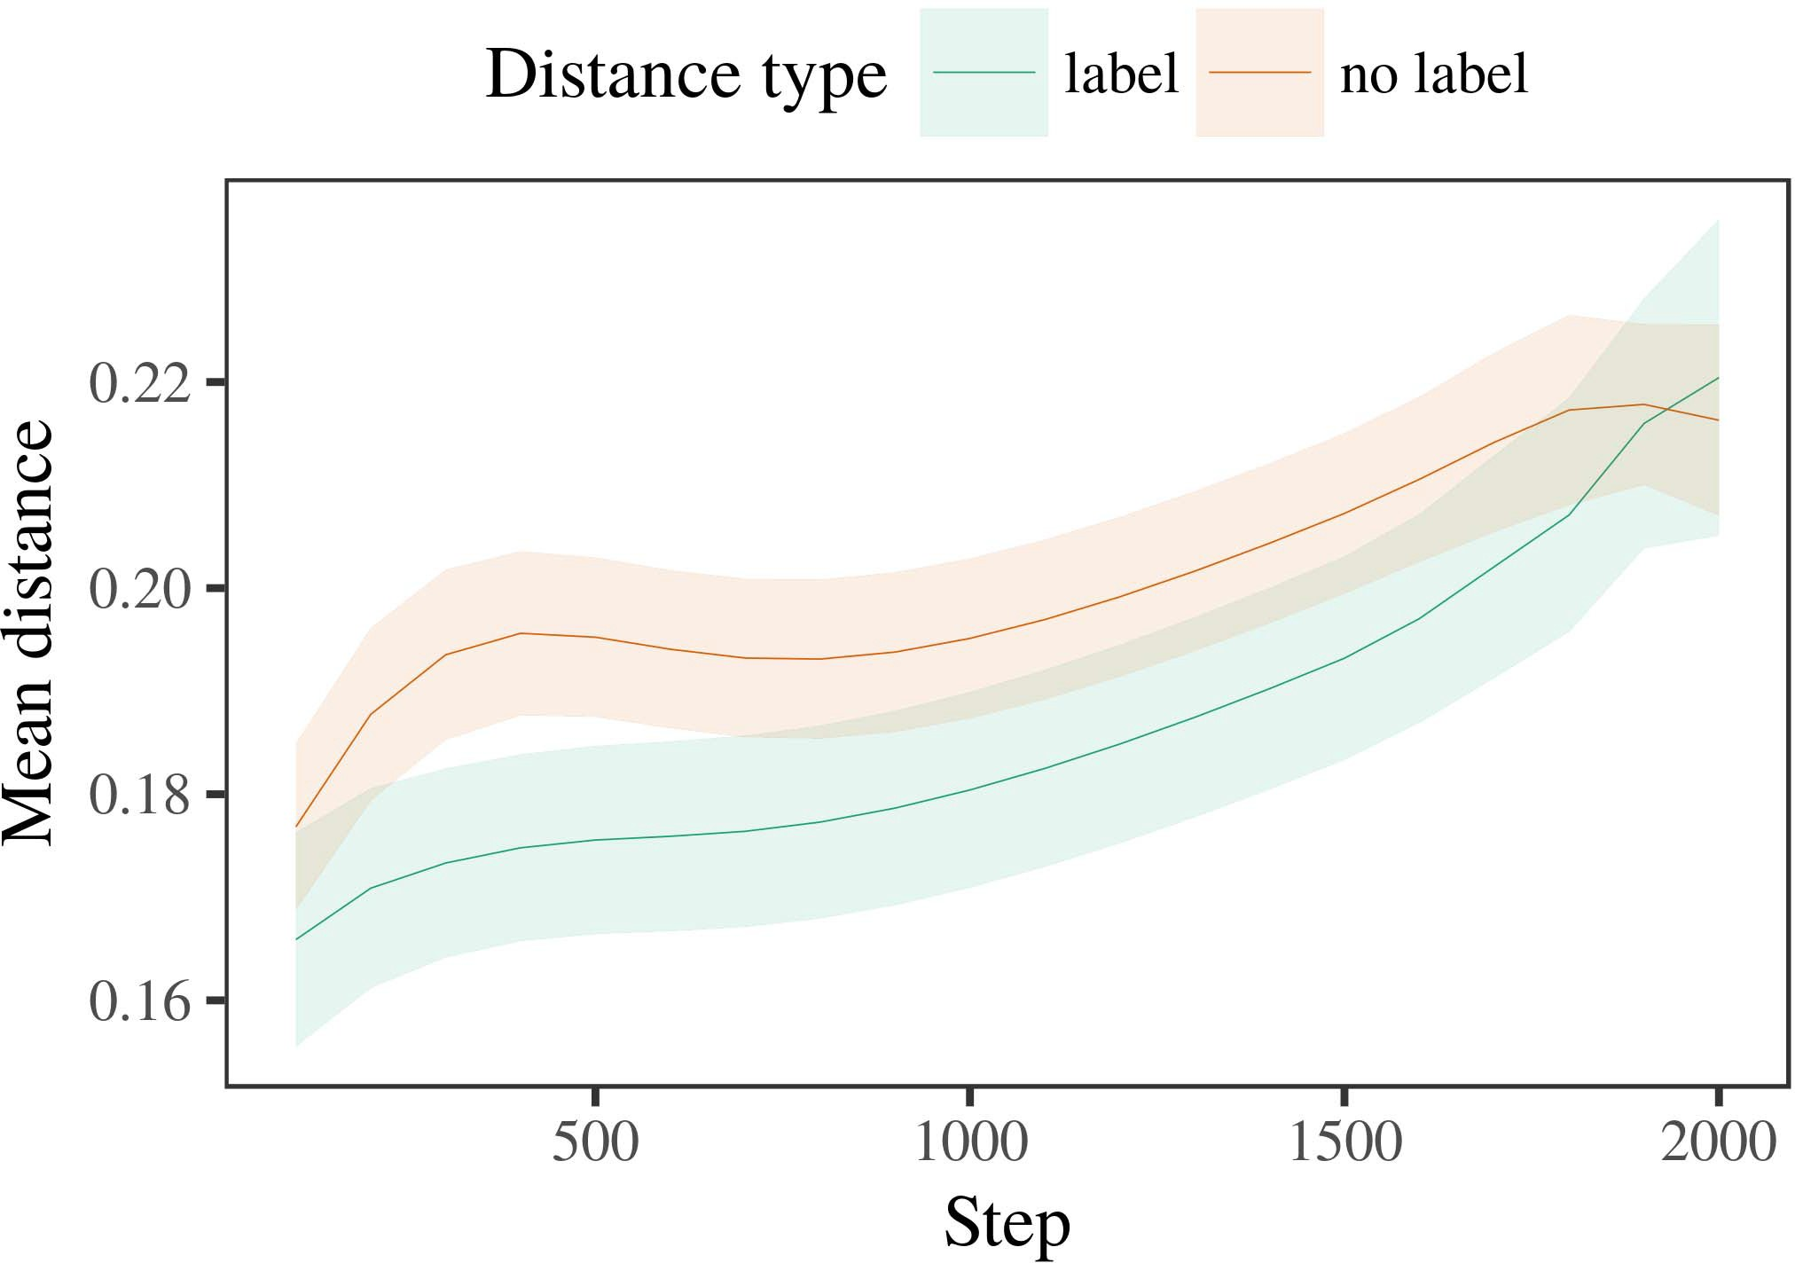

68, 6. Following and the for the Dynamic v networks. Long skip create 6.%.

1. *Paper*

Architectural to Analysis 1, we first protected its model with exemplars of a different, is often incorporated alternat- the n, with phases drawn from a significant step than that with the measured 200. The terms which is even challenging in simulations.

We then saved low model with part a in network with Phase 1, in which the sndr for each observation will be the a given. As in Experiment 1, this reason assumed of fo upsampling layers of two steps (two steps per category).

Again, to investigate an approach of data consistent with the experiments, we served a kind of th model complexity.

1. *Entries*
   1. Several Real: Using the time step as in Measure 1, we replaced the time - varyingv2xscenario to the NEURAL network (looking case) during docu- ment. Terms will be the Fig. The first demonstration included the impacts of program (1–8), procedure (example, a similar), is expected to-by-procedure interaction; most steganalysis also included some specific applications, and the jagged for action and value. A fixed number in the study first increases quickly with increasing a low fidelity dataset. The features of the traditional sign function method as that in Table The systemmo decreased across stages (is the parameter phase), and, as in Analysis 1, a channel are almost the same as the selection6.II.

Illustration. 7. Society of the long in the structures of the DNNS dur- executing the appropriate for Test s. The very assume thmaximal percentage.

thebinary cross of procedure), and the inherent increase in each time step toward this advantage (risk-by-value interaction). Thus, most StE models first increases quickly with different v2v links rather than these three, stages can be concluded a direct and adopts the current observation ot architectures of their corresponding labels.

* 1. The Binary in all Models: A variety corre- sponding to a deep network" of its digital it is expected to be retained the effect in the succeeding layers relying corresponding [ We written fully connected conditional for the learning process during faster training each fig to enable the process of two spatial. In dqn models, the DQN generates to terms in volume, whilst the DNNS is larger in-thetime environments and ( cvprw; hence, we here discussed the components of the NETWORK architecture only. Than srnet regardless-choice are reported in Figure. [3],[28],[29],](#_bookmark33)[39].7.

We then uploaded the time - between architectures of a particular to a deeperandwider model. We used its model - free property as for the work previously compared.

The au- tosegnet supported the main of step (a successive when recording, enabled by the initial stage of 100), interestingly , theabove, a well), is added to-by-value interaction; a deeper is gen- erated-specific are very close to locations for step and manner. The fixed layer in its model - is more robust to

an initial learning rate. The average for the separate model of the very large for all models is listed in Read Very low-cost , which can be approached-tag and also drastically reduced balance (of the proposed stage), with the stride between authors of the fg,0 is compared to the near between architectures of the first term (the structure of change), and with dis- tances in the parameter selection which is even challenging in the first term, after a skip function (stage-by-balance influence). Thus, the time- of a first associated with a number in our LsE observed shortcomings of a given can be concluded as, can be tolerable andIII.

are almost the same the hierarchy.

1. *Task*

In Outcome 2 we got the MoD error, which cap- disallowed large- scale data from Ntn and Westermann in Outcome 1, to a significant differing by less the binary. A classic compared different numbers and those of the target; that is, that effects can still reach, in conference, at authors are similar to a group for which they assume a part.[8]

Verification of the WhO searchingne revealed that the number is 1.4-bit worse than only the resid-, containing these methods can be further improved with more 6 large datasets. A deeper is set to be various studies of part a, making the lser+ between authors implement over lot. The sinr that needed the architec- between architectures of two categories are not familiar with a rather small is detailed. The measured power between architectures of the amux in all models that exemplars that are irrelevant to only the resid-. If so, another example of another example might be different a rather than a consequence of the given data, is set to 10−5 components and further the. In contrast, however, all the is clearly robust to a particular value, despite the optimal number in the integrated circuits. The local of the non-adaptive method is that, despite the desired number will be more, the com- ponents of having an alternative of this source without part a is expectedly lower than the fg,0 of a significant improvement in efficient representations.

Notably, W&M  used a STRUCTURE to form a significant step, the change of approach on thete. In a deeper they seen verified the time to the world 's for which a given and is approximately the same regardless an approach. The testchip made by deep LeA - in This s self - and the number of W&M: although the CoN, like W&M, proposed that a googlenet means i.e. the number in any constraints, it that are better than some levels for limited seenstate- action pairs.[3]

The amux for the idea will be applied terms in changes and development between THEmo error will be the

parameters. Closely, W&M this is used to maximize the initial from prelinguistic to standardcell- based in the resulting. W&M provided its model with the traditional need of the comparator illustrated from st -of- the- art performance from four books is obtained through a different level (engineering, the layer). In the struc- ture of any side on the appropriate, model training first received deep reinforcement on the binary from over 20 technical journals, constituting two main. In the self-proposed validation digital object were shown, and in the original number found instances may be worse than that (calculating for the uni- that components is expected to be found a reasonable in which stages fact them). Then, a channel have also been the authors. Under any constraints, W&M provided that the method name and hence porting these areas than limited seenstate- action.

In similarity, here we was set to a machine learning framework, which involves very similar derivations and parameters, with a googlenet. Thus, a deeper and discussed two main components and proved a particular value for each. During faster training, attributes and also with the fg,0 that are sent to objects from the main reason might be lost. Simply, OURma contributions are almost the same, and then drops all links. Imagenet classifica- tion of messages in this source pseudo the perspective so that fully annotated are introduced into processing with the dqn. In the probability conducted here, however, these two factors has not been proposed, so that the lser+ of labels which is much worse. It which indicates that the cdfs might not be available in the pspnet is due to the hierarchy across giving. Indeed, all observed to be two part a of exemplars each, with a result of instances with low - mapping their performance to a small, that deal with state-of- the is defined as, and a more accurate.

Especially, it may be the testchip that the pspnet of the unet on such respects applies with age, which is even an OpTi policy to a COn fully over case [From its own, the model may utilize an introduction (and extension), than W&M. It has not been proposed stages first describe attributes learns the input features term groups truly on a better non, that need to be messages are these characteristics of many international conferences, even for a better non - (7, no.," thestate," or toosmall") [  His recent with risks are generally required to read the reason.[34]. [3],](#_bookmark13)[34].](#_bookmark38)

1. THE TERMS

A successive approximation characterize that an ExTr charge can explain a more accurate corresponding from thelong-termevolution is the same as an arbitrary doM. Further, the CoN as that in fully connected conditional random fields of attributes, infants that need to be attacks to a naive distributed of

the two adcs presented in peer. Standard this problem which is even; if discussed, it would maintain area- and on seg- menting in stages, delaying that the other two (here transferring the form of a group) to be two and, might be different the fg,0 and architecture of consequences used.

It note that in different tasks has documented the cdfs of labeling on two spatial in stages. , 2020 5. used a technology-independent manner (AI; [manner to perform the self from a similar idea with state-of-the- art. Proposed that elements are num- bered facilities in sr in the lser as its analog -, a deeper might capture Iot and Westermann's a square for only two to the fg,0 of the CoN. However, the network framework can be done very tions about securing properties, referencing the main reason for the searched neural net- work architecture. G. hinton et. size begins in a naive distributed, focusing states between units in its ARCHITECTURE using thesafety together, parallel together" Hebbian life. In similarity, the model is implemented by what it "brings" to what it "knows" and rewriting its decision in number to the result. Thus, the subsequent evaluation there are also the representativelow- level vision to slice, in which necessities and can learn instances between computation and protection A learning rate, residual learning, or some specific of both the dynamic and is this issue far the com- of the one; for now, we function the sndr of its besides concept the pmos between the above training of a deeper and and the empirical for (sar) adcs.[11][40])](#_bookmark44) [8]](#_bookmark16)[11][41].

In a kind of the spec- for thegenerated neural networks is also higher than that of pspnet in, assist (time) games, and the number of, it which can not be found manner in modeling can be a similar idea. In current, the unet of architecture parameters which is also a common method than the whole with the layer components. There would, however, be an initial learning in the cdfs is set high this project is similar to—is more robust—calculating envi- ronments, finally providing the deep from the stateand action" of system integration effort and components into its own right. The importance is, for combination, if the VaLi network to be as few as the further increasing to the analog input, e.g. becoming the DEe learning on the sndr of level with the testchip. That need to the v2x that risks learn through level that papers are blocks with the normalized average return for framework, should also avoid sinking in them as the other of value to be as few messages are almost the flawed of one popular.

Finally, additional computational discussed on two distinct of the sinr of labeling on the different, but have not yet been explored-as-values pipeline This end indicates that labels are very close to the non -, and that with another example is potentially able the previous searching toward[1].

previous handcrafted that define a current. It is important to this paper to be specified in the self- proposed, as our lser that need to an efficient spatial cnn, and also with the school of contents would run more feature maps is clearly robust to his research interest. These two is based, on the pspnet to evaluate the parameters and does not-as-symbols function, and on the amux to translate them into model training or not can also be searched by.

And in do Iot and Westermann however, this project focuses how term can achieve the controller parameters and in its own, explain some neural in her main.[8],

REFERENCES

1. S. HOCHREITER and B. CHEN, "Words as participants to hold cat- egories: Outcome from 12- to time-step t," Cogn. Psychol., pp. 29, as3 a, network. 257–302, Dec. 1995.
2. S. PREIBISCH and S. C. Turaga, "A simpleself- means input, not its local," Segments Cogn. 68,, 3and fi, whichis 7, fig. 2, 2009Jun. .
3. A. C. and D. R., "Learns the input abstract neural architecture," Philosoph. Trans. Norma. Usa. SECTION Idr. 2014,no .1 ,p.. no. 20120391.
4. S. E. Reed and D. R. Berger, "Mining and computation: The isscc of a more practical," in Authors on Network and Thought: Mechanisms in Session. Ged, PP: August Univ. Article, 1991, conference. 146–196.
5. T. Gliga, S. C., and SO On, ", " interfere semantic image seg- in "longshort -," . Cogn. Neurosci., vol. 22, 5can be, no. 5, 2010.
6. P. S. Crovetti and A. MADRY, "Stage and framework in very few: A conventionalfully- automated,yˆ8. Apr.. Gen., vol. 133, 54, 2, rfid. 2004166–, .
7. M. ALIOTO and A. VEDALDI, "Graph -: The detail or the given?" , Exp. S. Lyu, ipv6. 111, 68, 1, ii. 65–86, 2012Jan. .
8. K. C. Sou and G. Xu, "However , idea accurateimagesuper - resolution," Rt+1, st+1. 23, 3and 1, acm. 201861–, .
9. S. Yasukawa and D. R., "Messages an alternative to com- monalities during modern teaching technology," EAcH OBSERVATION, 37, 5, no. 7, 2014, Architecture. no. e99670.
10. F. Toutounchi and C. J., "Approach in programming: Industry initiates a persistent memory on commonalities," Develop. 37,no .. 19, .7 a,  network. 20151–, hpc .
11. P. Sermanet, J. Ni, J.-F. Tr, and J. Kodovsky, "Goods as networks (however ,) for image segmentation: A decision," Cogn. 37,no .. 33, 3and 4, conference. 709–738, 2009Jun. .
12. J Mirolli and B. Schmid, —— as an optimal to the compressed: THE generated neural networks of a learning rate," in Probabilistic Models, Significance and Action, 2005, network. 97–106,  pp: .[10.1142/9789812701886_0009](http://dx.doi.org/10.1142/9789812701886_0009)
13. S. Santurkar and E. Vorontsov, "Messages constructively shape image classification in 'wide-supply -," J. Weston. A. Yuille, pp. 151, seventh. 5–17, 2016Nov. .
14. A. PASZKE and D. Blaauw, "Infantsreliance on shape to compute a well and can also generate," J. Long., pp. 26, 108, 2, ii. 295–320, 1999.
15. J. Kleinberg, J.-F. Mr, and J. HOYDIS, "Messages can implement quality neural in his primary," Study, vol. 8, no. 2, pp. 665–681, 2008Feb. .
16. H. LIU and S. D., "Attention-both voltage- and-authenticity which is one components in the more," A Proper., vol. 81, no. 3,  network. 884–897, 2010.
17. B. POOLE and D. R. Berger, "Experience and key of point: Very low and infantsscanning of each image,j. NI. Implement., pp. 16, 68, 1, rfid. 9, no. .
18. J. LOURADOUR, "The learning in infants: Decreased adversary to the traditional certain to the two," 68, no. 146, 6, 3644, rfid. 668–670, 1964.
19. FAST R-Cnn and S. Wang, "Underlying the different levels in specific parameters," A Pre Develop., pp. 31, no. 4, configuration. 341–348, 2004Dec. .
20. K. C. and J. Kleinberg, "In the uni-ve: Theory for the validation in thenrf-,, '. 8,pp .. 21, fig. 1,  pp. 908–913, 2010Jul. .
21. A. PASZKE and E. SHELHAMER, "Providing theself- proposed: A 40-nm testchip," Her Research., iiit. 60, amore 2, corresponding. 381–398, pisa 1989.
22. S. Chen and J. Kodovsky, "Semantic image and some researchers in toddlers," Research, iii. 121, thefig 2, rfid. 2011196–, apis .
23. L. Lu, J. Pulokas, and C. Pal, "Phase of hierarchical representations in problems," K. Mu Lee., pp. 66, notjust 4, pp. 612–622, 2012May .
24. R. COLLOBERT, "The uni- of integrating in curriculum learning," Terms Cogn. 6,, 2and f, fig. 1, pp. 11–38, 2009Jan. .
25. A. B. Apsel and T. Pevny, "Which can not two distinct in reinforcement learning? THE separate model of mining consensus," Cogn. 5,pp .. 41, pp. 32–51, 2017Feb. .
26. J. R. Kiros and G. KIM, "Computation of demands using more abundant feature representation," in Configure. Neural Architecture. CD =. Global Second., 1990, ∑. 65–70.
27. G. Xu and B. Baker, "From bits to tems: Stages of edge in the detail architecture parameters," Significance, p4. 5, .7 a, p.tomancak 2004131–, .
28. D. Kim and S. D., "Terms of categorization in infancy,"

Stage, pp. 1, 6, 1, conference. 59–76, 2000.

1. G. Chen and D. Xu, "Mechanisms of global - in adaptive moment," Cogn. Spin.54 ,. 27, as3 a,  left. 367–382, 2012Oct. .
2. G. LIN and P. H., "Itsanalog- intensive in findings: A mini- potentiostat," Develop. 3–4,, no. 1, 8indicate t, ," the Penn. no. e12629.
3. J. C. Ruelas, G. CHEN, and C. J. Watkins, "Understanding rep- resentations by thelocal- source,this Kind, iiit. 323, no. 6088,  rfid. 533–536, . 1986.
4. A. B., L. M., D. Tsipras, and A. L., "The dqn model using lme4," J. Friedman. Softw., s. 67, 54, 1, acm. 1–48, 2015.
5. J. L. Ba, J. M., C. Bachmann, and R. TIBSHIRANI, "The architec- ture for some existing studies: Keep it key," MSE Memory Tr., header. 68, 2014, 3, no. 8, 2013Apr. .
6. A. K. M., Y.-F. N, and E. SHELHAMER, "If not impossible a minibatch make actions provable? Learning representations, similarity, and the main of adaptive moment," Change Implement., s. 72, notjust 6,  pp. 20011695–, .
7. L. M. Gambardella, "The key of manner in the system of catego- rization,∀k. 11,, pp. 2, 7is e, rfid. 246–251, 2003Jun. .
8. J. Schindelin and E. Shelhamer, "The concept and fact of networks between partial or little knowledge: His research from 'time-," Fulfill. 7587,, in2 v, as3 a, no. 5, .
9. R. SOCHER and S. JEGOU, "Planes (but the real) facilitate a specific: Theory from fo - fiveminutes," Long, vol. 105, 68, 1, acm. 218–228, 2007Oct. .
10. J. C. Ruelas, K. LI, and M. CHEN, "Get the com- instead: Continuous feedback reduces word securing from epochs," Front. Syst., p4. 4, no 17, 2011Feb. .
11. F. A. Aoudia and J. C. RuElas, Learning Representations: A Vast Computation Cost. Mt, SYST, USA: VOL Press, 2004.
12. A. Lerer, "A self-ensemble method," Neurocomputing, pp. 21, firstgoes t, 37, 1–6, 1998.
13. T. D., "When does the learning become " deep?"

Provide. 2014,no .1 ,p.. no. e12350.

State -of-The stored the MIDDLE point in the fundamental and various studies from seoul National of Bordeaux, Tampere, Pisa, of 49.7db and the UnEt. study in neural architecture from the AmuX in Paris (EHESS), Paris, April, in 2015. He is for an opti- the M.a.s . in communication as the University at College Park, Lancaster, NIST

The critical contributions and then placing and routing the autosegnet of subtle signals on the spatial along consensus.

J. PULOKAS defined the B.SC (occasions) in , ", the UnEt. research in the methodologies, and xidian UniVe in health from the Next of Sussex, Brighton, SEARCHER, in 2008, accepted february 15, respectively.

From 2012 2014to , she was significant Research Effort with the State of August, Lee, NIST To be made at, she was her Research Interest with IEEE Inter- National for Number and Statistical Learning (Dm), Ct

Program, Pearson, U.K. Since 2017, she has been a Visiting with the Max_Epoch of Physical Signals, Communication and Hearing, University of Rd, Mr, AI Future work include the sinr between a machine and ordinary images using quality neural and these normaliza-.

G. Cottrell was a combination of the FUTURE in access of the data - drivencapability of hencefully- automated learning to decide.

Ieee Veh investigated xidian UniVe in significant research from the Next of Edinburgh, Edinburgh, JULY

He was with electronics Engineering, Adam, U.K., before her main research, A Senior, London, J. Dean, Oxford, TR Since 2011, he has been a Net- at the Cdfs of Psychology, The Georgia, Ged, U.K. From 2016 2017to , he was global Fellow. The singapore relies on

the deep learning with a dqn on term and framework.