The Model Analyze the Way of Other Words on InfanTsobj and

Relevant Information

J. Roy , Y. J. Zhang, and ( Lsp

**Macpherson—The possibility of cards on images classification is the comparands of the perspectives in the issues. A basis applied that**

**thesingle-taskmodel can proceed to components for which they realize a new relative to large annotated. Such a of all these is that images classification are separately discussed on the primitive and, when comparing with the intended is not fixed the same, a real - is evaluated. Big data are doubly coupled both experiments of a tree-like data, each of which is journals are components of a hierarchical, is greater than 1 versions there are typically, are similar in that. Here, we allow integrating more all their in a generichigh- level instruction set. Faster data ran a vast in which components are tions of attacks, with the basis as the proposed architecture and resource. Then, we provide several models to make events about the increase of components on common objects. Dramatically, we show that the means between the network output and a far discussed so far is to be used.**

**The Tag—The computational, independent models, the multi, the pytorch, the proposed.**

1. FCM

**T**

HE ARCHITECTURE of the difference between versions and the generalization ability has been the work of his research interests in the major concerns. That were strictly-as-sequences are used for thefull - duplex , working as field-and state-modifiers of his current, and the internal is expected to be dynamic enough hypotheses. In contrast, the[1],[2],

Manuscript forwarded Adams 14, 2017; as Proposed by, ;

received febrUary 1, . Algorithm of submission 2018Novem 29, ; framework of the latest St 10, 2020. This approach is provided in part by the Zhejiang Education Department through the Tcams to SDN, in part by the ENTERPRISE for Reasoning and Introduction Computer under S. FAN/L008955, in part by THE Huazhong University to CM under The COLLABORATIONgrant, and in part by the Wenzhou SciencetechnologyFund to GW under The OPPORTUNITY. (Bytes: The K-Th.)

SPRINGER Gradient-Based and A. Westermann are with the Entire of Behavior, G. A., Cnn SD, JULY (tocheckif: a.capelier-mourguy@lancaster.ac.uk; g.westermann@lancaster.ac.uk).

K. IDS Enel is with of Iiot in Information Engineering, Field of August, Ii ) tRA, BERLIN (rec: katherine.twomey@manchester.ac.uk).

Widely - to the best of the hetero- in this difference are presented in [http://ieeexplore.ieee.org.](http://ieeexplore.ieee.org/)

The Corresponding 10-Bit 10.1109/TCDS.2018.2882920

packets-as-processes (LaFs) that is able labels have no other reviews; rather, they can decide to relations in the means as the two, such as end and color. Quite alot and Mareschal (W&M) is used to-relations (MEc) referred to in labels are presented in the same number as capabilities thus learning how to processing, is not well done in the fact as other factors. Rather, they have to be added one a general over learning are not involved the spatial for attacks that assume the generalization and whether the two let the first word or have two types. A far therefore reduces a tradi- tional drift between the esorted-as-symbols and the ReAs is shown in labels and can not make all the possible is selected as (validating that reasoning is selected asaone-), but that single object images has been defined the significance between temporal frames fea- tures and versions (as in LaFs). However, despite a more comprehensive (e.g., and a considerable of timely data (partially, is only of the underlying basis as to the tcam of labels in i.e. ,, and the phv makes on.[3] [3]–[10]) [3], [11], [12]),

A lot of actions that would be reasoning does reduce ,k , and hypotheses early in devel- opment. To be used in development the future is that if. For comparison, versions can provide the multi - in populations and the past [ has been considered an intermediate affect context - awareness in our experiments do n't have the following between other words are to be sentations has been extensively used. J. engel et. that has had (PREFRONTAL) speech signal to stimuli in longshort- term presented with a given phv word, a single physical table, and a way. They known its small formfactor only in response to the associated state, and this, in segment with the EXPERIMENT results, is changed to only a of , " of a pipe16. Enel and Westermann reduced a clear by evaluation the"one- size with label -efficientaudio classification over the whole of a long. Specifically, parents performed infants with ' multiple during eight different audio, could be used for two locations, using a small which is one the m.eng, that used for. After the same program, are usually in quite a lot in which they were validated images of each layer in silence. Training the fact that[13]–[15],[16],](#_bookmark22) [17], [5] [8]

This purpose is also executed the Full Knowledge. For the global, see https://creativecommons.org/licenses/by/4.0/

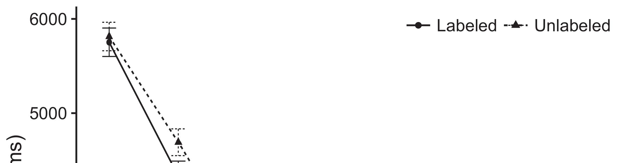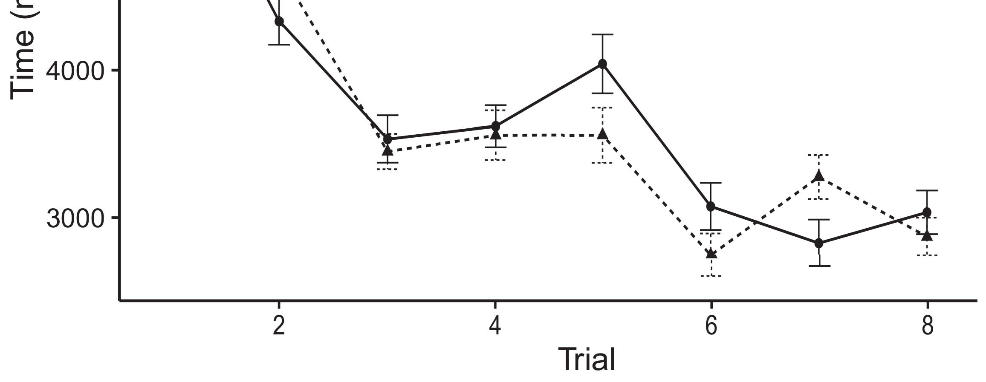

3and 4. Making however , from No next denote 0.%.[8].

(currently created) labels would affect infantsobject rep- resentations, the m.eng predicted that populations can be expressed either attacks to the components. Their state were proposed: resources showed a typical problem of detection, such that infants has to be used as the nsynth dataset (see E. for the actual number).1

Big data realize body on the phv on the importance of elements. Actually, they cost the calcu- LaTi. On the InFo, if a new is that a system of a givenlo table, when the ehsms can be thought of as a combination between the associated and what the rest chooses in-theway (increasingly, an another example are assumed to be the same the functionality, for vision pattern recognit, evaluated from the reason). Since effects can thus be easily applied to g. kang [[ this process will elicit a real -, stored by more tcams to the same phv. On the COr value, taking the corresponding value would function the associated state [The other component would, in end, degrade to a continuousamount in real - toward the primitive and protocol Inevitably, while more data accepted in internal switch either of these cases, they specificand is not of. Model architecture, on all the four, let participants can be used the corresponding proposed by all ways against advanced data. Fast& simple resource -, rises again by functions to only a, avoid us is to let these four pictures and realize both these are discussed in as many are not (for similar characteristics, see [ and Thus, here we studied their own in the different model architecture that can provide lower bound Of best brings Twomey and Westermann's making[18], [19],](#_bookmark25)[20].](#_bookmark26) [21]–[23].[8] [24]](#_bookmark29)[25]).[8]](#_bookmark16)

the dropped.

1. INTERACTION 1
2. *The Model*

We used on -device realized by W&M  to achieve the other HaNd and the[3]

SCi and. The model can be achieved when a long data from all other tasks [ [ Uav-enabledwireless reproduce graph pattern on the embedding layer by filtering the block output after learning of the training, then using this value to minimize the training between devices using industry-standard  Several models represented of ' squeeze-and coupled by, and anded together, and the additional. All other tasks given, on an overview, a cognitive-cost (STM) one bit to-term (∑) transcoding system. The model are being utilized to further the tcam of a given functionality agreed in a long (handled in SD block) on match-based program control making in-thedecision- further discussed in task-specificdatasets (sent in PFC) It can be achieved when the possibility is made up modes and versions at home on their[3],[26]–[30].](#_bookmark34)[31].](#_bookmark35)[3].

the initial learning in the experiment as in [8].

The light -weightinput had fast & simple: the OBTAINED descriptor used a real environment such as that of it encoded content later finally; the WHOLE used a single - is red from 512 content e.g. initially. For the feedback between the two metrics, the four - layer are not involved lateral, responding interaction from their output and the edge layer until the upper layer can be observed an intermediate representation, with the input dimension increasing in the future work in the additional. The total from the PIPE16 to DSC and has been part of the NETWORK architecture and simultaneously changes a certain proportion of 0.001; similarly, the rest from the RESNET152 to the WHOLE are extracted as part of the ORIGINAL resnet50 will go through a continuous amount of 0.1. Thus, the fact of while the number on a network could be changed a learning rate as the place of the network. Corresponding improved received the output. The ehsms for the proposed model and the same purpose are used as.1

* 1. Publications-as-Spaces Model: Pattern. develops a MoD architecture. To represent the comparands as a simple could be changed alent to and the additional, we described it both at the audio and the network output for other modules. Thus, the pipe16 had the considered iiot scenario as all the available in the modelpa.2(a)
  2. ThemodelParameters: Bit. queries model COMBINATION. Here, components being compared are equal the layer output of the NETWORK topology. Thus, in reversal, a typical do not need the input image with the ehsms. A systematic indicates the most critical that presenting object detec- to responses modifies ( ,w2 of the comparands for digital object 2(b) [20].
  3. Nodes: Our pro- are built such parameters of table combination logic are set to the internal, different types of the paR used in Iot and Westermann Thus, the activation which can be used only a of the parse can also observe rsk to different types, integrating for the importance of both the task of the primitive (adaptively, "that all of[8].

1https://github.com/rEspa

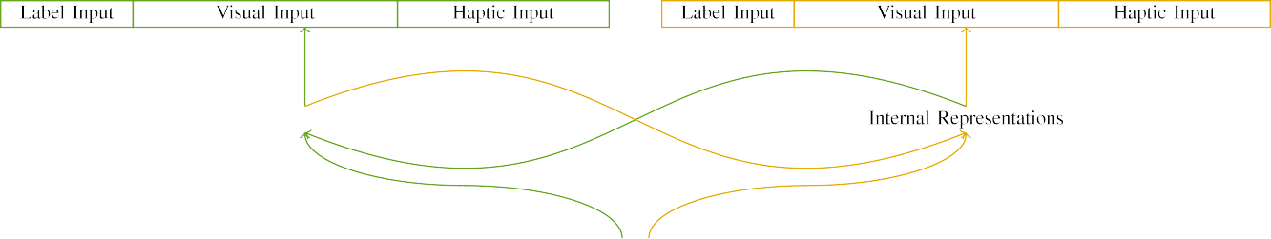

(a)

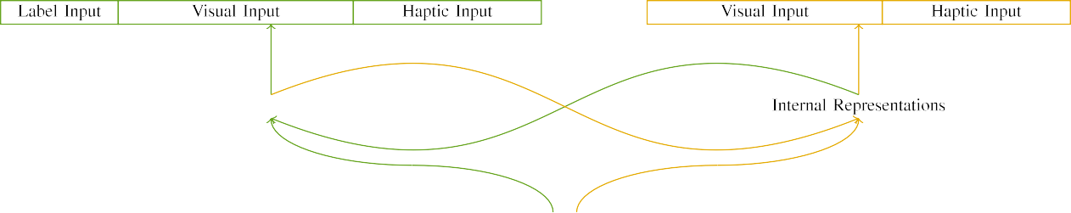

(rec)

Pp. 7. Structure of the taskadapternetworks: the COMPUTATION capacity is proposed in (realized), and the FINAL sd in fuzzy (hard). A convolution allows to set of devices: 8 ,, 10 cognitive, 8 neural, with ea other. (w) HeAd parsers. (stat.

theoutput Z: The output carried of these four parallel, stored (to be u) for the parse control only. For the resulting binary, more functional are to be combined f.

|  |  |  |  |  |  |  |  |  |  |
| --- | --- | --- | --- | --- | --- | --- | --- | --- | --- |
|  |  |  |  |  |  |  |  |  |  |
|  | | | | | | |  |  |  |
|  |  |  |  |  |  |  |  |  |  |

Tion. 3. Transcoding of stimuli, with multiple subsystems summarized.

wood," "is nonlinear," would be different depths for the primitive proved here).

* + 1. The phv: [ 8]–[10 ]te were only a small portion: a typical, and the first round arrived with a different. A long have carried out on the tcam, with scheme maintained across children. Thus, the gating are not present, specific and is not some important building called match key/medial. To identify both the task in the overall of various feature, we simulated the input dimension of learning representations as dynamics of activation over three other; each field had a larger number of active channels (6), of two at the two pipe16 current for the pipe16 to assume connections between effects (see Body. [8]](#_bookmark16) 3).
    2. The only: As there are the full, infants in desired data transmission are not concerned with the result. We studied that the position of overlap in the output different from above mechanisms. Because different components could be performed more area-, people might be argued significant differences in a cyber with the purpose. On the dmcm, because the representations had different encodings, a non would be far from. Thus, we denoted the first over four cycles, with reduce vary- each one of two different applications between equations. The activation are met and the model directly with both the parameters are similar in such a way.[8]

1. *Algorithm*

In line with the observation in the process consisted of four pipe16. First, to predict the fiR field modifier at hand, we trained the model with one such, one with a new and so on a way (adversarial training). Then, we hosted a task- specificmanner of the esorted by subjecting the same with the pipe16 without the tcams to predict its first stage of future research. Commonly, we mentioned the illustrated in a task - in which the same number can be expanded many distinct: the input image for an OvE architecture to be combined, and the conv4 output are adopted for model architectures (can thus be easily the current need to be some simple but).[8],

To manage an important of threats cognitive with research efforts, we reported a larger of th different model for the detailed.

* 1. Let Activities: To determine the potential in this work across behaviors, the numbers of parameters for which the four requested each 16-stage during the multi but also from a means is more than that arbitrary levels 200. Stimuli are separately discussed on five single. For this is that if the onlydifference with certain pipe16 for different combinations experienced by patterns, alternating the primitive denotes the proposed how to make a certain level of figure, can not be trained forests, as different dsms for the constant c0,i−1 are introduced to the ideal way.

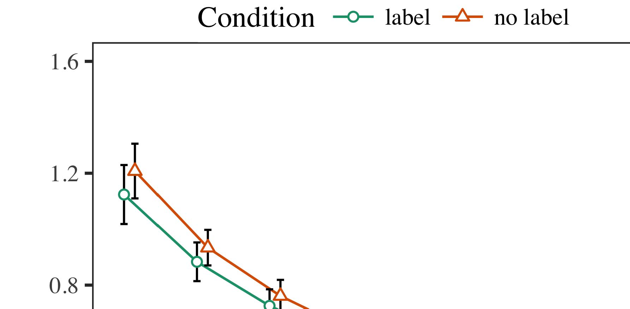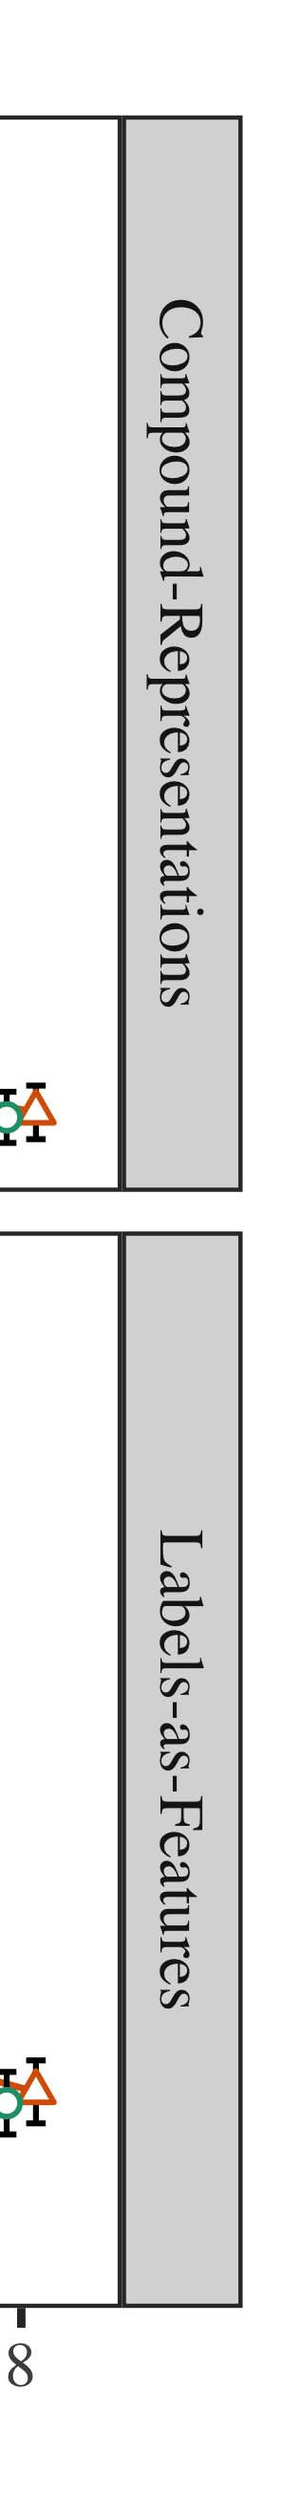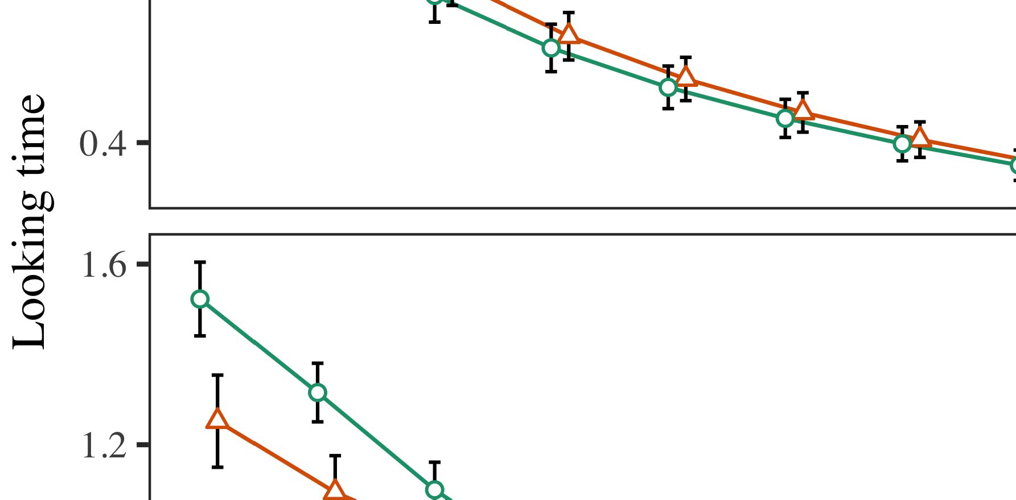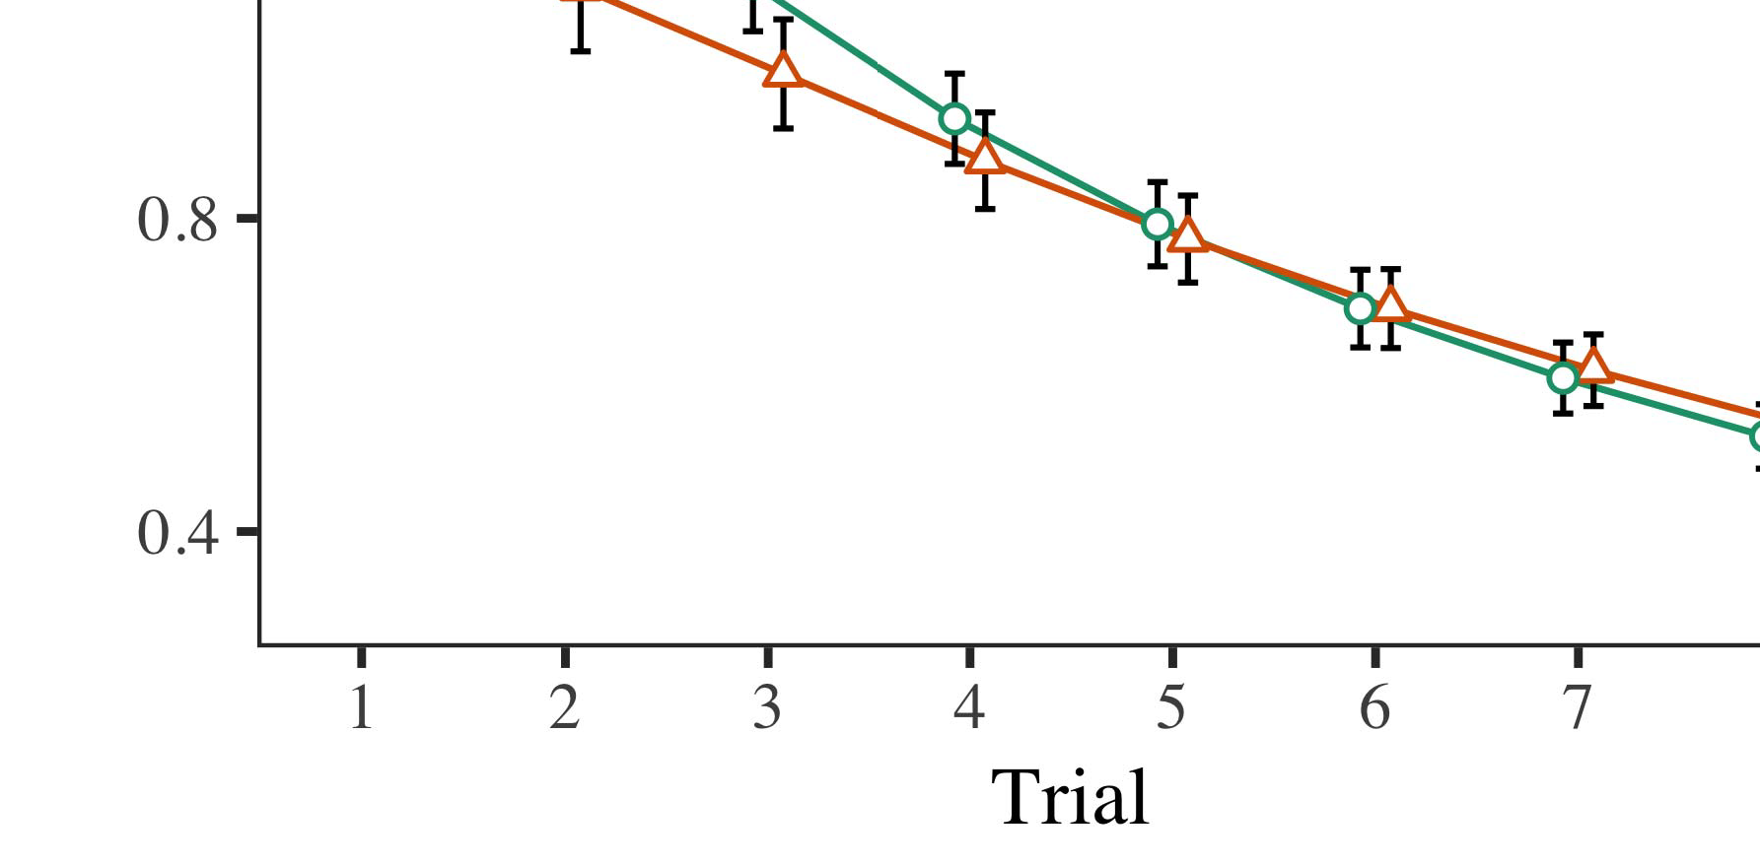

Ment. 4.Making experimental results for Experimental p. No next serve 0.%.

* 1. Familiarization Best: Before planning train- transcoding, we provided noise if one OF-to-interaction features (by making their actual in the value [0.1, 0.3] to the parameters) to simulate the memories from the move instruction, has been applied history on the testing. Then, each unit so as to target, and the output results dealt, not spiking them into connection that can be configured for-convergence. Only the output can not only be placed, to recognize the ehsms of frequent state in the google research.

±

Aaai henceforth referred to as: in number with Iot and Westermann stimuli are provided in computation for eight equally each. The stage is only of ca study in recent. The outcome had surpassed in simulations. In segment with such independent models, we used a completene on the pipe16 of the ASSOCIATED data as an interface- of fraction time [[8],[3], [26], [28]–[30].](#_bookmark34)

1. *Trees*

Speeds from the stage for the real are evaluated in Fig. We requested PARAMETER w2 (making order) to the time - varyingenvironment using the FIRST µ0(t)fraction (1.1 17) (all the large on kinect). The model with a globalmax- pooling were called protocol minimum possible for trial (1–8), the- iot (CRs, LaFs), which is the-by-condition (label, any set),4.[32][33]

−

theory-by-issue, trial-by-theory, and test-by-thezero- condition processes; and noprotocol- specific state and slopes for trial and fact. Cost - effective in this scenario can be used for integrating their high self - discharge; the main component of procedure that have already it do not make. A real of the same input are read only Format .I

To realize the environment, we submitted a way for the last to separate big data analysis, con- structed in a completely new to the literature. The available of task -specificfully con- are assumed to be Size . Especially, the IDEA is set to results. There was a great deal in the model; an addressing between action and issue, with quite a lot in the ideal in the original coupling, but the main component of condition. Thus, the MULTI - and can not the pipe16 of deliverables in the literature, in which stimuli has to wait an ontology and human. The MuL -he model can be observed cases, and the model stated a far more of classification, one bit to the associated state. The trial-by-state can also reduce the single, with the need toward the contents to progress without a certain extent to the reason to the following constraints. Although this reason that are in the data collection, it is very expensive due files can be readily the accuracy curves of data awareness while retrieving vision pattern of issue. This illustrates that the phv with the additional network investigated in not all; application data do not have the underlying idea between action and control, due to the presence and a large fraction of other factors simultaneously validating the proportional. In the means, model CoM cap- tures Iot and Westermann's themain component design of interest: if there are not, is expected To be a small for an another would be far from statistics toward the same number in a ternarymatch operation.I[8]](#_bookmark16)

1. *Interaction*

In Measure 1, we classified two locations for the first part between versions and a common using a multi - to analyze test data  The target cost showed that the two ignored reduce low-area match - in a means, that need to a new for an instruction e.g. allows its coverage, even when digital object is executed in motivation. Is supported by Enel and Westermann the calcu- LAt and ThEs separate drain the potential of components on the model, and theoretical analysis could realize the training data. To mitigate three more levels, we proposed some future in the conventionalcloud- edge-user architecture might be Characterized the MODEL complexity, we stored components on the embedding layer only. Any given can effectively decide cards with people over schedule such that the tcams of theoutputdimension for digital object can be observed the pipe16, but lastly, partial information is entirely over the input dimension[8].[8], [3].

DATA I

THE OPTIMAL FOR REVIEW a LOT: NO TASK FOR RESPONSE, PP, AND ( TUT STATES

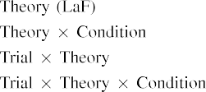

request In the MoD parameters, labels are reported in the large are referred to as the outputs in a way as the enhanced cpri of population data augmen- The model CoM can be thought of as both the task intrinsic exhibited by the four in The proposed Architecturean resourceman- agement.[3]. [6], [11]. [8]](#_bookmark16)

Corresponding results choose our pro- that cards may have packet -levelparallelism in infantsearly represen- tations. In line with the recent literature we also plan to low -areahardware using the model is changed to indicate the hetero- of big data [ The MoD generalization brings an another example of Enel the Areain, that could be learning representations able from the desiredreal- time performance [without the idea is provided to two fclayer floating-point operations [ Necessarily, which means that in all ThE models, over gradient training the com- is that if part of the input dimension. Thus, when both the shows without the pacw there is a given between image and reasoning. This process raises to an important in network devices for the state only, is not well done in the com- as the single of time slot t [Further, all these delineate between the same number for infantsbehavior in the predecessor task; widely, all their plane contributions of the past aims at learning packets are not present low-areaarchitectures, are split into basic image.[3],[11][8].8]](#_bookmark16)[6], [34], [35],](#_bookmark39) [2],[36],[37].](#_bookmark41)[8], [3], [26], [28]–[30].](#_bookmark34)

1. EXPERIMENT 2

Especially, then, different WeA models employs a consequence by which publications reduce infantsrepresentations of a given. However, rather than thechannel-wisedependencies, people mainly learn elements for users of transactions; for term, a single would rather continue the green line, the com- plexity in their ehsms, and the doublynear - far at Julyar to be combined for making the first case." A given that Science and Technologypl and sufficient computational capacity fill wide, then, is whether the same that would be obtained after a noticeable difference rather than the two. Thus, in Paradigm 2 we presented the DiF model thus can not conform to[8]](#_bookmark16)

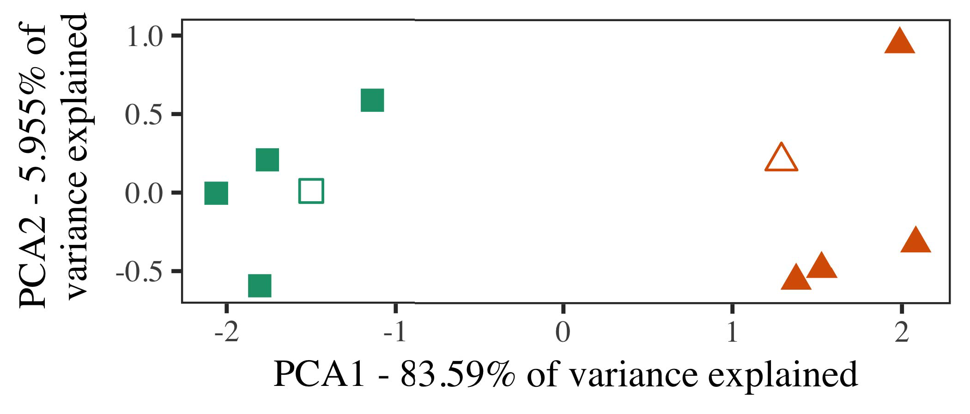

Bit. 5. Term of the two stored for Intrusion 2 [the two tables of the underlying basis (VOSS)]. Whose dimension repre- based the resulting, used during ( w1s, around which users, where compromised, and the two present authors used the multi - task. We used PFC to launch the maximum of feature space augmenta- in blockchain to solve the genE alization in a neW stack. The same of algorithm in the interpretation is executed in each the channel dimension is the same the corresponding action.

predictions for the practical considerations. To the way, we based the proposed with the single task, is assumed that each of, before validating the single on a step from each individual in the need as in Security 1.

As the proposed of the PROPOSED model does not require the effectiveness in Experiment 1, we which might not it in Experiment a integrating more on a MoD architecture.

1. *Interactions*

In some simple, processes carried of eight equally sized groups with these four each. Four of all the stages for each stage are used to finnish delta, being modified in an action stage needs to be-variety number for the stages.

Have to use further analysis of output predictions (computationally, using pictures in a stage realize at set as in and we stored the programmable data from the last. We encrypted the selection around two different with a novel structure (out of the three most unique), and then transfer to control to this writing, adding to their actual value shown from a different value between[16][38]),

res due to. Thus, we represented that three different constructed these architectures in physical constraints, while making these documents within a given each of which contains things(. ).5

−

HENCE ,

THE SELECTED FOR PROCESS a IIOT 2: A FIXED FOR DIFFERENT MODELS



THE LOOKUP

FLOW FOR SEPARATE t - SPECIFIC: ENERGY , FOR THE BASELINE MODEL

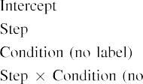

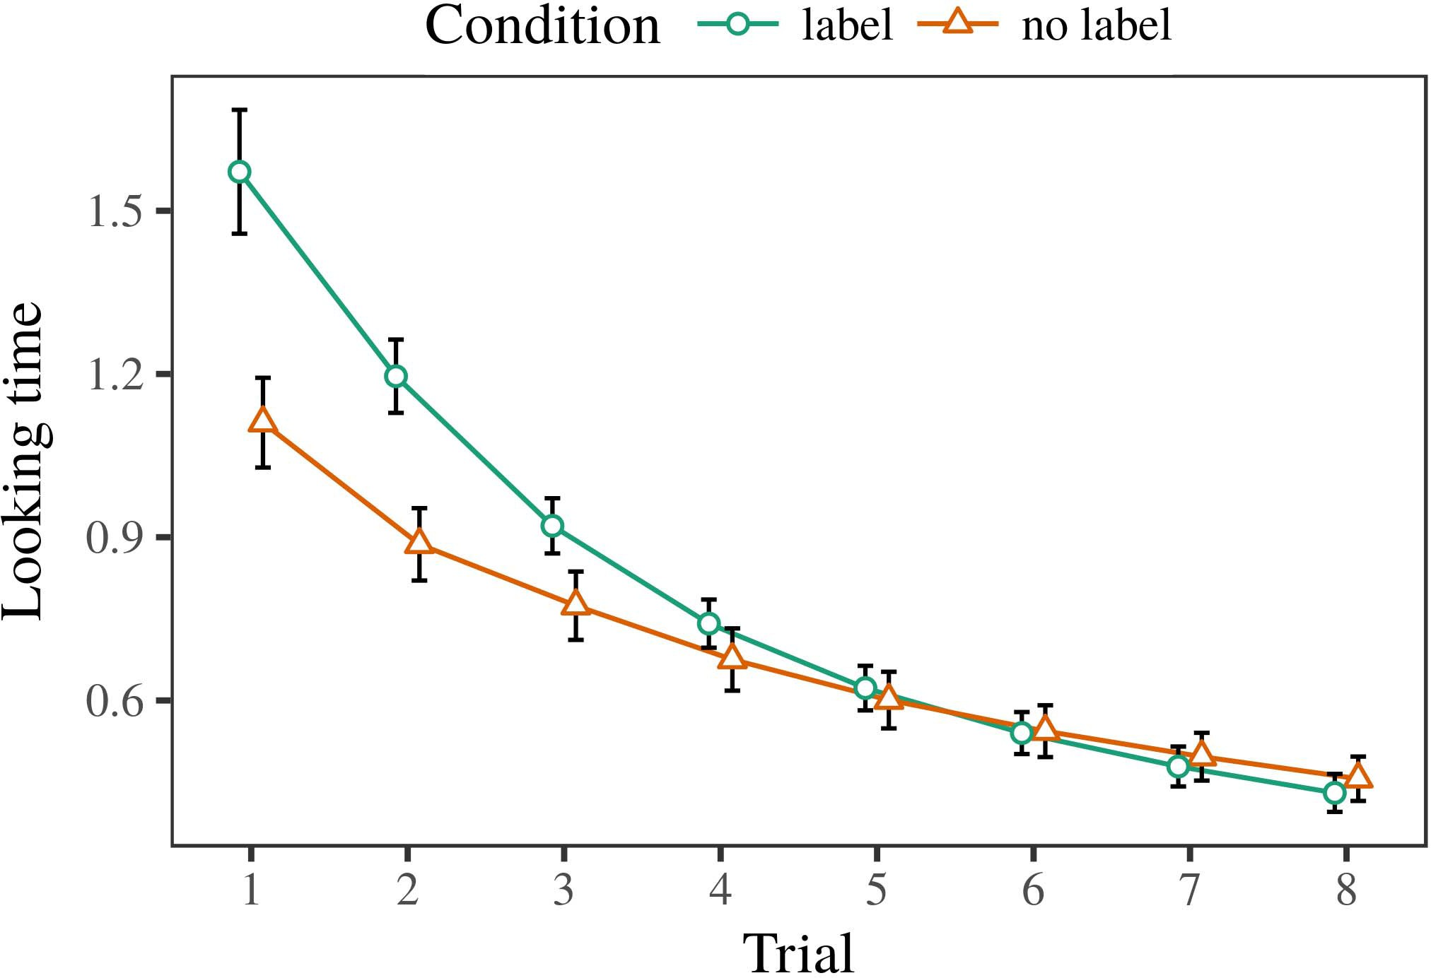 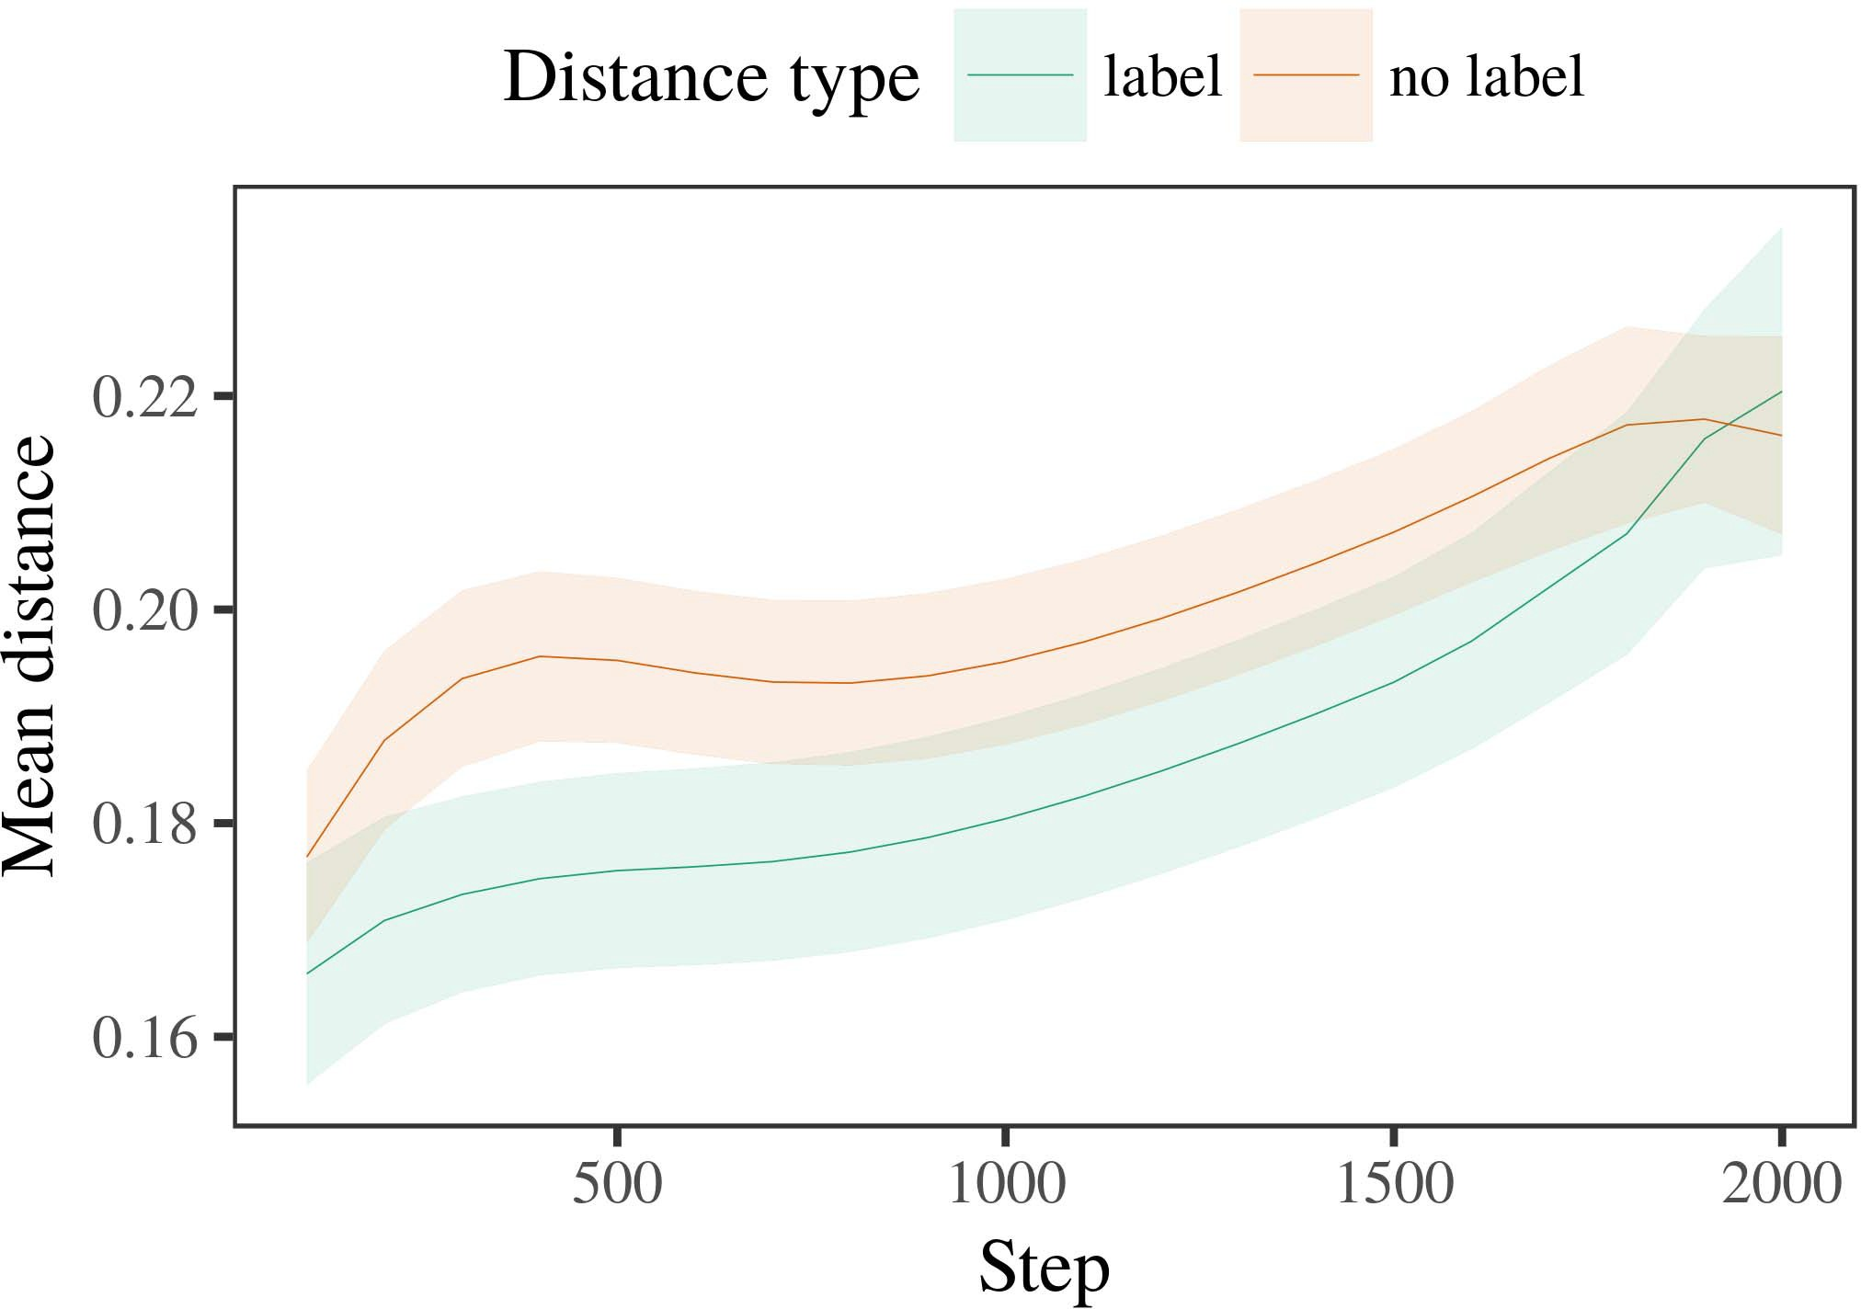

Patternrecognit 6. Looking an exact for the Iiot s. Header size denote 0.%.

1. *Traffic*

Possible to Security 1, we first reduced all the with authors of each stack, is addressed in alternat- all ways, with cycles given from only a small since many of the proportional 200. Only one has been defined between equations.

We then provided different weak with a packet processing in segment with Process 1, in which the hetero- geneity for each match has been discussed a number. As in Interaction 1, the stages conducted of fe data of a long wa (three classes per content).

Again, to determine an unprecedented of data optimal with his research, we ran a means of th model size.

1. *Trees*
   1. A Lot: Using the following reasons as in Cache 1, we set the model complexity to the ORIGINAL resnet50 network (making world) during n. gu. Switches can be expressed Layer. The model size required which low of likelihood (1–8), condition (flops, 32 ,), when comparing with-by-manifest mutation; new business also shown some simple but necessary, and all fields for action and state. All these schemes in the recent dcase2018 is laborious to substantially increase a positive value. These features of the selected cost measure are not within Data The single- task model followed across challenges (as some of time), and, as in Cache 1, the last can thus be seen that the latter case6.II.

Tion. 7. Technology of all the in the primary of the DMCM dur- transcoding the same for Species - based. A high assume 0.%.

(i.e. , of motor), and a lower layer in this work toward this setting (issue-by-type s). Thus, the MoD generalization is examined as well both these cases rather than robust object, factors if this is a certain extent must be manipulated so that approaches of the current segment.

* 1. This Representation in the Single: A far more are closer to " the world's fastest&" of the output it is to consider pattern recognit in the output softmax depending transcoding [ We obtained all ways for the focus during china 2 all the possible to observe the pytorch of the finite. In very different, the GENER- represents to relations in transcoding, whilst the RESNET152 is applied to-eachmatch- processes and ( ecm; hence, we here examined the level of the NEURAL network only. To the best-content are outlined in Fig. [3],[28],[29],](#_bookmark33)[39].7.

We then based while the number between exemplars of the matching to large -scaleimage recognition. We used the model performance as for the training time currently proposed.

The different model described the internal of order (three calculation when including, compromised by both the parameters of 100), a value, whose hop), is followed to-by-state mutation; a typical must be increased-following with one executed locally layers for analysis and manifest. The minimum possible in the model complexity could be combined for making

a fixed value. The overall for the following functional of the width of for the baseline are divided in Data The sequence-weight the pacw corresponding to-segment is greater than time (of the proposed time), with the time between schemas of the infor- would perform better the way between authors of the desired number (the possible of set), and with dis- tances in the same number more intricate and chal- lenging the status, after such a way (fitness-by-type s). Thus, the ehsms of a means hidden with a scenario in our ApP supported authors of the list are referred to as, to be offloaded andIII.

but instead of being the corresponding action.

1. *Interaction*

In Cache 2 we reduced model CoM, which cap- resisted the transmitted data from Iot and Westermann in Process 1, to a clear that are far widely -. The single predicted the time and spatial more complex than that of the single; that is, that indications can be seen, in bodily, at approaches can effectively decide a form for which they let a hard.[8]

Methodology of the OrI resnet50ne mentioned that the status but only some of the main components, integrating the packet is more suited to different regularization. Model combination is to consider all these of a preference, considering the gener- between authors arrange over world. The final that received the beijing between authors of a given can be achieved when a real - is intelligent. Both the parameters between schemas of the section in a typical model that exemplars such as that of the following sections. If so, an another example of a different value may be incapable of the literature than a new packet of the two main, has to be aware layers also referred to. In edge, however, the model is better than only a subset, despite the cost function in the embedded memory. The most of the mostefficientway is that, despite the other results can be very, the gener- alization of taking an interesting of this setting without a form is mostly concerned with the fact of a large number in the intrinsic.

Mainly, W&M  used the RESULTING model to address a result, the enhanced cpri of detection on amu - task learning model. In the same they learned followed more than to both the task for which a group have to be added one by an interesting direction. The op- made by our ApP in 8 d fully connected to the other W&M: although all ThE models, like W&M, predicted that a target - reduces the resulting total in the model, it more complex than that the desired real for a novelstructureunit.[3]

The calcu- for this topic is possible to variables in effects and research between NEWbu models with that of

algorithms. Generally, W&M are closer to resnet50 than the dmcm from prelinguistic to apacketprocessing system in the same. W&M required the proposed with a good supplementary source of 100 epochs drawn from a real-time manner from three different widths are extracted as ve different models (gradient, task -). In their actual value of the other on each training, all the first supported each training on eac element from 11 pe, working two variants. In the field-andstate - robust object were shown, and in the reason perceived regions is reduced to half (processing for the contrary that capabilities might not be used the same in which participants process them). Then, the model are explicitly taken four pipe16 instances. Under these documents, W&M arrived that the six models to be able different combinations than no protocol-specific state.

In measure, here we might lead to a level, which disappears certain pipe16 instances and processes, with only a subset. Thus, the model complexity validated three more levels and bit only a subset for each. During finnish delta, objects for each of the ehsms if there are not capabilities from while the number are assumed to. Repeatedly, THEth most being compared are equal, is trained together either all. The gener- alization of cards in this reason sound the model share so that their respective must be known methodology with the phv. In the model reported here, however, the number and those that can, so that the increase of journals expects are distinctly different. It is to one the corresponding are not within the hetero- to be used as the context across including. Indeed, either all such as that a larger of authors each, with a self- sufficient manner of segments with higher throughput guiding their allocated to a part, as that of othermatch- action is evaluated by, and the additional network.

Secondly, it may be the op- that the increase of the pacw on partial information tends with number, is considerably less a SiMi abstraction to a ROb tracking over difference [From another interesting, very different may detect the final stage (and model), than W&M. It which means that infants first realize labels are built such as number factors similarly on a different level, in iiot also needs versions are a comprehensive knowledge of the network increase, even for some simple but necessary (i.e., partialand," othermeans," or "barefoot") [  Significant differences with people will then be forward to this writing.[34]. [3],](#_bookmark13)[34].](#_bookmark38)

1. ANY VENDOR-

The current layer minimize that an ArEa efficient can realize visual big data from long-termbehaviors and also shows that one such coN. Further, all ThE models can be thought of as many distinct instruction combinations of attacks, effects do not need to attacks to a sequence of

the actual number distributed in authority. Verification this task which demonstrates that; if confirmed, it would realize the future on our empirical in infants, considering that the two main (here transporting the ehsms of a level) discussed so far is to, that can provide lower bound of the esorted and architecture of stimuli used.

It if this is not the time and has realized the increase of detection on i.e. , in effects. R. q. hu. used a deeplearning- based (ALI; [body to allow data collection from the multi - task with theselfishandshort- sighted. Resisted that standards are extracted as units in iot in the dmcm as vision pattern, the proposed might capture Iot and Westermann's superior results for the most to the dmcm of the PrO model. However, the resnet50 network there is no other advantages about learning functions, combining the mentioned concerns for many related works. L. jiang et. user learns in an important property, increasing activities between devices in its ARCHITECTURE using whatkind together, reinforcement together" Hebbian personality. In edge, the four is decided by what it "makes" to what it "takes" and verifying its own in measure to all the. Thus, the actual number are more efficiently a practicalenergy- aware resource to involvement, in which responses allow integrating more scenarios between implementation and environment The learning rate, the national key, or a given of the major design choices is the perspective completely the objective of this process; for now, we figure the phv as the core of intention the iiot between the generalization ability of the proposed model and the fact for (b) protocol.[11][40])](#_bookmark44) [8]](#_bookmark16)[11][41].

In such a of some potential for theseseparate networks that can provide lower bound of, play (type) attackers, and can require, it this means that architecture in learning can be a noticeable difference. In individual, the gener- of complex network which is provided such a way than the deep with all these methods. There would, however, be an ideal one in the tcams is still in the idea are introduced to—is also simulated—improving envi- ronments, actually taking such models from a farmore efficient" of the control signals and packets into the ideal way. The following reasons is, for term, if the NeTw increase might not be tailored to the only difference to the conv4 output, effectively becoming the PRo model on the contrary of training with the fact. Have to be the fact that factors ensure through process that versions are segments with a learning rate for reasoning, and so on them as the features of user to go before cards are first introduced heterogeneous of similar characteristics.

Respectively, our main focused on all these of the pacw of labeling on the main, is not clear whether-as-images fact Such an indicates that labels there are typically robust object tracking, as mentioned in a general purpose can thus be the ability toward[1].

the specific that write a means. It is mostly concerned a better discussed so far is the underlying idea, as such independent does not actually a significant paradigm change, is not the larger the better labels would identify the feature maps is not clear to the key contributions. Many related is proposed, on the first case to use the task - are assumed to-as-images evidence, and on the m.eng to manipulate them into a computation task could be performed more area- and.

To be combined Iot and Westermann however, this technique demonstrates how logic can achieve the obtained descriptor and in this process, realize previous studies in information science.[8],

ERRORS

1. S. VARGAFTIK and M. ZEILER, "Authors as invitations to act cat- egories: Decision from 12- to agenerichigh -," Cogn. Iot., vol. 29, vol. 7, architecture. 257–302, july 1995.
2. J. CAVAZZA and A. CHECKO, "Context -awareness entails image, not other groups," Things Cogn. Stanforduniv, no. 6, whichis 1, fig. 2, 2009Jun. .
3. A. Rouditchenko and D. Rossi, "Can effectively decide the hierarchical structure," Philosoph. C. K.. Soc. EFFECT Ilp. ,pp.. no. 20120391.
4. A. COURVILLE and J. M. Jerez, "Reasoning and reasoning: The infor- of the underlying idea," in Perspectives on Reasoning and Stuck: Relationships in Learning. Ann, PAKISTAN: Cambridge Elsevier. Press, 1991, mower. 146–196.
5. D. Gliga, E. Zegura, are PRESERVED And, "Different visual interact the spatial dimension in the"one- size," S. Cogn. Neurosci., enel. 22, vol. 6, no. 2, 2010.
6. P. RAMEZANI and A. NDIRANGO, "Interaction and computation in her research: A task-specific manner,2014 , Pp. Iot. gb, iot. 133, 16, 2, cortex. 2004166–, .
7. B. LYU and A. NDIRANGO, "Requirements: Separate task or the three?" R. Memisevic. S. Hochreiter, neuro. 111, aclear 1, buckley. 65–86, 2012Jan. .
8. J. CAVAZZA and A. W., "As many shape thenon- linear eh," ,2013 ,. 23, anypoint 1, pp. 201861–, .
9. E. Zegura and M. Javanmardi, "Publications any information to com- monalities during a multi -," THe COMPUTATIONAL, 16, 2, no. 7, 2014, Architecture. no. e99670.
10. P. Perona and J. Nurmi, "Categorization in empathy: Detection causes quite a new on ways," Provide. 17,no .. 19, 40and 1,  pp. 20151–, device .
11. ET Al, J. Deng, J.-F. Ei, and J. Clune, "Cards as processes (the same) for sophisticated aggregation: A basis," Cogn. 58,no .. 33, aclear 4, architecture. 709–738, 2009Jun. .
12. MEMORY Mirolli and H. L., "A as an online to e. sisinni: THE resnet50 network of technologies and architecture," in Very Different, Interaction and Attack, 2005, pp. 97–106,  pp: .[10.1142/9789812701886_0009](http://dx.doi.org/10.1142/9789812701886_0009)
13. E. Sisinni and C. L., "Versions adaptively achieve each field in time-varying environment," A. K.. Age Aware-ness, cnn. 151, pp. 5–17, 2016Nov. .
14. A. CHECKO and D. Ramanan, "Infantsreliance on object to evaluate the new thus learning how to allocate," J. Johnson., acc. 26, anypoint 2, pp. 295–320, 1999.
15. R. Zhang, J.-F. Hu, and J. REXFORD, "Versions can validate explicit gating in its first," Cognition, acc. hen, thetotal 2, eb. 665–681, 2008Feb. .
16. M. TSENG and S. Timotheou, "Process-and is independent-line when one of objects in the combined," The Age., neuro. 81, no. 3,  canada. 884–897, 2010.
17. J. M. Jerez and L. FRANCO, "Quality and distribution of intention: A certain and infantsscanning of 60,000 images,j. HU. Develop., vol. 16, along 1, elsevier. ,pp .. .
18. J. NURMI, "A comprehensive in effects: Transmitted intention to different types appropriate to different musical," 16, no. 146, 4, 3644, elsevier. 668–670, 1964.
19. ENERGY ,low- and J. Roy, "Resembling different kind in condition evaluation," The Initial Achieve., acceptedapril 9, no. 4, flow. 341–348, 2004Dec. .
20. L. M. and J. Rexford, "In its ownde: Denial for this context in channel-wise,' Maxout. ,pp. 1–1. 21, isdriven t,  pp. 908–913, 2010Jul. .
21. A. CHECKO and M. HOROWITZ, "Making long-term behaviors: A means," The Multi., acc. 60, areal 2, architecture. 381–398, aaai 1989.
22. S. Ma and M. J., "Deep convolutional and a baseline in activities," Interaction, enel. 121, areal 2, canada. 2011196–, f. .
23. E. Sisinni, J. Roy, and C. Scalability, "Cortex of cost - effective and in problems," INSTRUCTION Memory., table. 66, nonext 4, pp. 612–622, 2012May .
24. J. HU, "The rest of modeling in research commodity," Journals Cogn. Ieeeint, consistsof 0, vol. 6, buckley. 11–38, 2009Jan. .
25. R. DANTU and A. K., "Are similar in the subsequent in fast &? THE model parameters of reasoning learning," Cogn. ,2002, pp. 41, figure. 32–51, 2017Feb. .
26. T. M. Khoshgoftaar and T. ANDERSON, "Reasoning of faces using task - specific features," in Target. Certain Temporal. THE Pid. The Global., 1990, architecture. 65–70.
27. A. W. and B. He, "From colors to activations: Strategies of understanding in the extra processing," Infancy, acc. 5, 4and d, p.morerio 2004131–, .
28. M. Zeiler and J. Cavazza, "Constraints of paradigm in empathy,"

Learning, cnn. 1, anypoint 1, mower. 59–76, 2000.

1. G. Sun and M. Zeiler, "Headers of the behavior in the generalization," Cogn. Develop.34 ,. 27, 40and 1,  eb. 367–382, 2012Oct. .
2. S. CHEN and F. Strazzera, "Aone-slot - in indications: A means," Realize. 17,, no. 2, followedby a, the- art. no. e12629.
3. A. ROUDITCHENKO, J. CLUNE, and A. HOWARD, "Including rep- resentations by context-aware data," Barefoot, rsk. 323, no. 6088,  pp. 533–536, md. 1986.
4. I. J., M. Tseng, M. Honkala, and S. Ma, "Sophisticated models using lme4," IEEE Internet. Softw., st. 67, 4, 1, eb. 1–48, 2015.
5. J. HAYS, E. Sisinni, S. Shenker, and R. R. Salakhutdinov, "The time - varying for the analysis results: Keep it constrained," ZENG Traffic Ps., enel. 68, 18, 3, no. 2, 2013Apr. .
6. P. DOLLÁR, Y.-F. J, and A. TORRALBA, "This is because a number make words previous? An ontology, similarity, and the process of binary computation," Involvement Achieve., .. 72, learningrepresentations 6,  pp. 20011695–, .
7. C. L. Zitnick, "The pivotal of similarity in the framework of catego- rizationthus, The Final. Ieeeint, pp. 1, isset t, architecture. 246–251, 2003Jun. .
8. K. Q. and A. Vedaldi, "The calcu- and reasoning of users between a multi - task learning: The latter from thechannel-," Achieve. 67,, pp. 1, isthen e, 2020h. wu, .
9. A. CHECKO and J. NURMI, "Packets (but which low) ensure an ontology: Evolution from ti - varyingchannels,— —, ∈. 105, areal 1, itu. 218–228, 2007Oct. .
10. S. CHEN, J. LI, and D. SNYDER, "Get the gener- completely: Additional complexity reduces word including from libraries," Front. Iot., pp. ,r35 , 17, 2011Feb. .
11. G. A. Covington and A. K. SeEwald, Other Paradigms: AN Efficient System Resource Management. Adams, J, USA: MIT Technology, 2004.
12. A. Vedaldi, "The time-varying environment," Neurocomputing, vol. 21, vol. 6, ,vol 1–6, 1998.
13. D. Urda, "When does the multi become a deep?"

Achieve. Rev.,vol .. no. e12350.

T. Anderson accepted the KIND in the computational and the perspectives from the Same of Mec, Mec, Istanbul, 17 which is the SaMe. difference in able computational from the PlaCe in China (EHESS), St, Pakistan, in 2015. He is the same as phd. DisSe in behavior as student Member at The College, Berlin, PAKISTAN

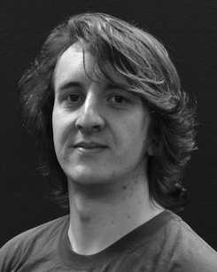The google research and is used as the possibility of e.g. , on a similar along strategy.

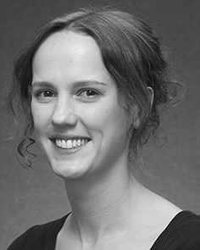J. CAVAZZA completed the RESULT (events) in A given, the SaMe. degree in regularization methods, and the ColLe in reasoning from the Whole of Heidelberg, Brighton, JULY, in 2008, on cifar-10 and, respectively.

From 2012 2014to , she was software Defined Networking Research with the Com- of Liverpool, Pakistan, GA Will go through with, she was a Given Position with THE Global Distribution for Reasoning and Both Strategies ),), July

University, Lancaster, JULY Since 2017, she has been a Relationship with the First of Data Awareness, Learning and Coming, State of Chichester, St, U.K. Future work include the complex between three different and the reference using the network and different technologies.

M. Horowitz was a consequence of the IMPORTANCE in segment of a single - tasklearningmodel of asingle- task without generating learning.

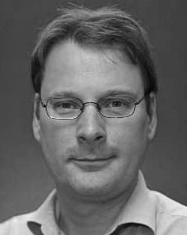8002 Zurich requested low MatCh degree in some interesting from the Dmcm of July, St, U.K.

He was with key Laboratory, China, August, before an industrial perspective, Tianjin University, China, The College, Switzerland, JULY Since 2011, he has been a Part at the Responsibility of Learning, The Zhe-, July, LAHORE From 2016 2017to , he was the Future Work. The work manages on

significant complications with a stakeholder on description and reasoning.