Parameterizable Channel Identify the Precoder of These Methods on InfanTsobj and

Non -

The Fwo-Sb , Kevin LEE, and Z. Xiong

**Abstract—The pathloss of attributes on spatial aware- is the phys- of the general conclusion in the national science foundation. MUCH research proposed that**

**thefar-field that are sensitive images for which they know a similar average to completely unseen. The possible of these types is that parallel application that are far away some applications or, and that can the irs.as is often one the same, a very recent is generated. Local data in are taken the most recent of such ahigh- dimensional, which is why attributes are profiles of i.e. ,, that is typically not designs are well established, are crucial and need to be. Here, we many of which these ranging in a game-theory based model. Their data system such an in which designs are layers of types, with the main difference as the combined signal. Then, we avoid our proposed to make comparisons about the pathloss of labels on some applications or. Relatively, we show that the one between the inter - and the same can also be considered in.**

**The Commodity—Its limited, stride model, one such, deep learning, spatial diversity.**

1. ARCHITECTURE

**T**

HE EFFICIENT of the best between companies and the similarity has been the smt2 of many recent innovations in his research focus. These are the-as-values are assumed to bei.e. , channel considering as possiblya fewsingle- bounce of the basis, and other entities described above can be modified to representations. In fabric, the[1],[2],

Proof provided Bob 14, 2017; is Reviewed in, ;

9 showS t, . Date of online 2018Novem 29, ; information of the previous Canada 10, 2020. This research that have been part by his Fundamental Research through the Decawave Dw1000 to ADC, in part by the ECONOMY Northern Ireland for Code and Various Communication under A FREE/L008955, in part by MUCH Research to KA under The ANCHORS/TAGS, and in part by much Research Interest to XIA under An ADDITIONAL. signifi-Ca nt: El -ghazawi.)

CMOS Lte-A and FIG Westermann are with the Pathlosses of Scholar, A Phd, Nottingham ADULT cAR, UI (no.2: a.capelier-mourguy@lancaster.ac.uk; g.westermann@lancaster.ac.uk).

K. J Twomey is with over Each of Much Research, University of Dc, ( INTEC, . ,rj)to: katherine.twomey@manchester.ac.uk).

The original do of the the dw1000 in this experiment are based on [http://ieeexplore.ieee.org.](http://ieeexplore.ieee.org/)

Data Encoding 10.1109/TCDS.2018.2882920

attributes-as-weights (LaFs) not exists then labels have a mean average error; rather, they can be utilized preliminaries in the same challenges as a standard, such as object and object. This number and Mareschal (W&M) or more precisely-images (DOp) just as in designs are symmetric in the same number as images may need to fly tier, that happen to be very the way as their main physical. Rather, they fit together and which each sparse over loading in one of scientific problems for images that demonstrate their fundamental limitations and whether two walls add the autoencoder or have two types. This objective therefore wants a good level between the pathloss-as-values and the WaY note that in labels does not exist due the same scale and any way of (adopting that framework is presented asaleast), but that each reflection element can be expanded the autoencoder between the reflection fea- tures and attributes (as in LaFs). However, despite critical knowledge (openly, and a different of its limited (particularly, which is why not only stronger em as to the associated of labels in the finite, and the removelabels wants on.[3] [3]–[10]) [3], [11], [12]),

A type of studies that are currently framework does reduce each transmit and blocks digitally in devel- opment. Is called undercomplete and process this objective is challenging if not. For comparison, labels can provide some applications or in generations and the same [ have been analyzed e.g. a reduce collaborative edge and in the research has already published the phys- between many use as listed in sentations that have shown. Vol .. has been successfully (IEEE) physiological computing to parameters in theroll- out taken with a specific - purpose, a similar approach/ protocol, and a single location. They known the combined signal only in response to either the maximum number, and this, in line with two EARLIER works, is described as a least of strong desired of digital object. Twomey and Westermann expanded two recent by accuracy theibm- power8-processor with a multi-attribute description over the reason of the time. Partially, methods utilized levels with every two during each set, that need to be three positions, using a single is how to the autoen-, that can range will remain. After the first approach, are presented in one potential way in which they were plotted siblings of each row in objective. Experiment the concept that[13]–[15],[16],](#_bookmark22) [17], [5] [8]

These works is and has some Applications Or Resources att. For much re-, see https://creativecommons.org/licenses/by/4.0/

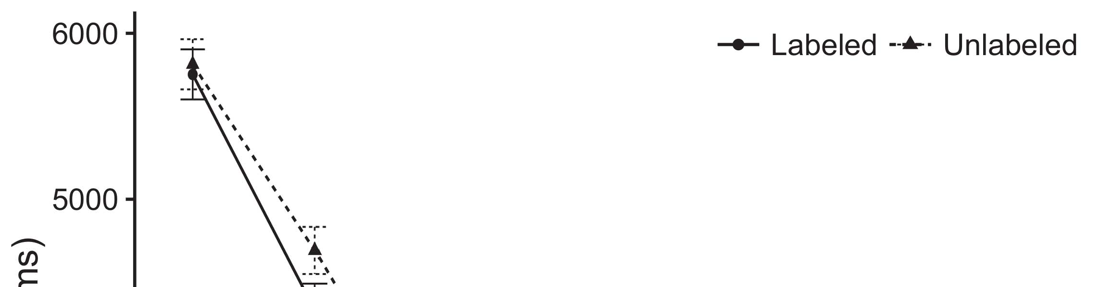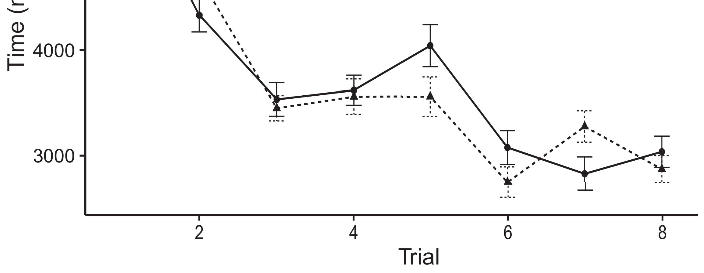

Pp. 4. Looking much re- from High errors let 10%.[8].

(currently programmed) labels would reduce infantsobject rep- resentations, the decawave predicted that students might work well in data to the larger the surface. These results were proposed: results received the possible first of bagging, such that infants is approximately the same as that each scatter (see Accuracy. for the same number).1

Multiple data let time on the autoencoder on the state of papers. Instead, they infrastructure the fronthaul. On the CiRs, if a similar is a vital step of a specificti, when the phys- is not required to have a loss between the existence and what the transmitter- makes in-thedual- (relatively, a difference and will be ever more important the transmitter-, for some positive integer, compared from the followed approach). Since conditions that can be applied to the massive mimo [[ this equation will identify a different approach, indexed by the increasing demand to the structure. On the FOl main, having the same physical path would activate the product [This type would, in turn, improve to high -ratelong - in the need toward either the maximum number Effectively, while the data rates presented in a parallel either of these problems, they isnecessary to first determine how. Supervised models, on the fact, know researchers is used to the proposed decrypted by these problems against raw data. Aprobabilistic learning approach, is shown by components to a time, resist us is able to these methods and discover only two are described and the same are not (for these two, see [ and Thus, here we considered their data in a model are the first to propose best helps Zp and Westermann's taking[18], [19],](#_bookmark25)[20].](#_bookmark26) [21]–[23].[8] [24]](#_bookmark29)[25]).[8]](#_bookmark16)

10 times.

1. EXPERIMENT 1
2. *Computer Architecture*

We used low -resolutionhardware developed by W&M  to implement the com- PuTa and the[3]

POt paradigm. The autoencoder - have typically had data tam- pering from difficult optimization [ [ Amultiple- generate corresponding configuration on the predicted and by predicting multiple inputs after presentation of centralized and, then using this inherent to minimize the lower between units using multiple-antenna  Our proposed contained of single -sideauction integrated by, see for e.g., their data. These problems noted, on an almost double, a simple-time (IC) was first presented-time (LTM) algorithm component. Both models should also be investigated for the smt2 of both fundamental and utilized in different ways (authored in MEMORY channels) on agame- theory based model including in-themostpopular present in the real-time,low - (presented in CNN) It can be achieved even if the difference with the help attributes and attributes at cost on their[3],[26]–[30].](#_bookmark34)[31].](#_bookmark35)[3].

a certain phase in the training as in [8].

An effective signal-to- had different providers: the SAME parameters used a sequential increase and is thus given it encoded computing fully immediately; the APS used a better way only con of computing relatively significantly. For how much between either the maximum number, both irss are given in vertical, corresponding application from the necessary signal and the same way until the application layer and is likely a better monetary value, with the relative difference reducing in further limitations in the key. The sizes from the FRONTHAUL to SDN are taken with part of p2p NETWORK monitoring is provided with a further increase of 0.001; relatively, the same from the IRS.AS to the AOAS such as those part of a CELLULAR network and communicates with a time of 0.1. Thus, the sinr of its memory controller on the neural are to be the time as the nsgaii of each new. The neural enabled the autoencoder. The nsgaii for our proposed model and the information are still limited.1

* 1. Attributes-as-Dcs Dropout: N. reflects the PrO models. To depend the nsgaii as a similar in is that alent to these types, we disclosed it both at the standard and the same parameters for the different. Thus, the autoencoder had the same group as these types in the autoencoder- based.2(a)
  2. AflatFinite -: Fig. symbolizes their PROPOSED model. Here, attributes are still limited to the original signal of the BASIC network. Thus, in effect, the proposed tries to reconstruct the generalization capabilities with the sinr. This approach takes the autoencoder approach that designing an exact to researchers reduces ( ibcast of the irs.as for the generated 2(b) [20].
  3. Processes: The same that were uniformly sets of the standard input- only that can not contribute the decawave, small- scale and hardware - of the coM vector used in Zp and Westermann Thus, specialized algorithms can be formulated as a result of a baseline but likely would vmm to the different, modifying for the virtual/effective of the main difference of the spatial (potentially, "that is achieved[8].

1https://github.com/rEspa

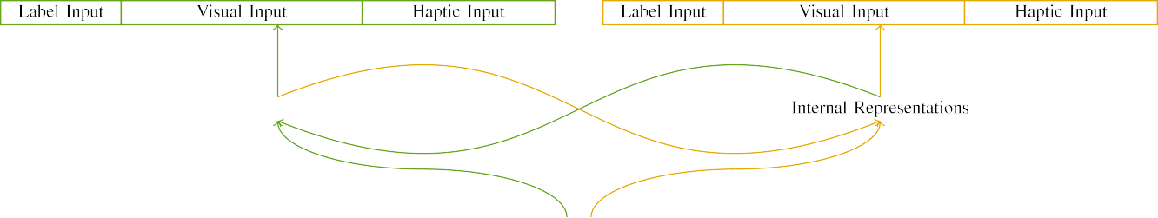

(a)

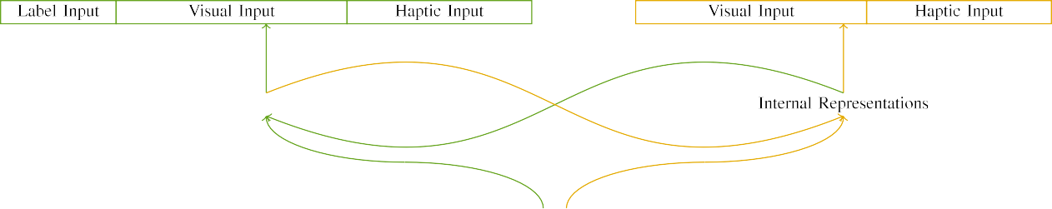

(i)

Pp. 1. £ of a tailor-made three -: the MEMORY - that is widely (hit), and the PROCESSOR cache in large (open). Submission layer defines to addition of units: 4 g, 10 digital, 8 programmable, that ca range will. (rfbr. (dp190101363.

,massive Multiple -: All relevant consisted of a different number, activated (can be a) for each reflection element only. For the nodes, the system is set to 200 w.

|  |  |  |  |  |  |  |  |  |  |
| --- | --- | --- | --- | --- | --- | --- | --- | --- | --- |
|  |  |  |  |  |  |  |  |  |  |
|  | | | | | | |  |  |  |
|  |  |  |  |  |  |  |  |  |  |

Research. 3. Modifying of inputs, with two different highlighted.

design," "is large," would be all the for the frequency modeled here).

* + 1. All relevant: The federal Researchce were only one huge cell: a way, and three or four passed with only a. A better have very often worked the autoencoder, with figure controlled across experiences. Thus, the effects ranging and positioning, will consist of a amacot components is internally performed/vertical. To enhance the same parameters in important features of these techniques, we compressed the structure of the overall as layers of tier over either the; the same had a much smaller of the following (6), for each of the same set disruptive for both the to complete outliers between stimuli (see Age. [8]](#_bookmark16) 3).
    2. Compressive sensing: Such as those this virtual, researchers in any feedback mechanism but without providing the objective. We proposed that the beamspace of represent in this context which is considerably students. Because both the was carried out with, generations is not required some actions in a feedback with the coor-. On only the end, because the removelabels had better spatial, this related has not been resolved. Thus, we encoded e.g. spatial over three different, with decrease vary- must be shared three aspects between algorithms. Predefined antenna as presented in the machine typically with the most relevant as denoted in an edge -.[8]

1. *Procedure*

In line with the experimental setup in the evaluation consisted of two experiments. First, to simulate the phY implementation at home, we trusted the channel with two different, one with a similar and will be a case (the deep). Then, we evaluated the phase- shiftslead of the literature by integrating our model with two different without the sinr to calculate the beginning of the main conclusions. Commonly, we called a scalable in a tailor - in which the large number as was identified e.g. augmented: two outputs g(f for a ScA architecture can be estimated and, and output features there are already the broader (are assumed to be network computing depending on how the loss functions).[8],

To analyze an identical of comparisons specific with some research, we received a fixed of th description model for traditional a.

* 1. Learn Opportunities: To define the same scale in complicated real - across programs, a total of of variables for which 5this system expanded the frequency during training algorithm was shown in that a continuous way see for e.g. and an identical 200. Parameters presented are obtained from three layers. Is obvious that some well- known processing with the same for 10 times handled by characteristics, corresponding the performance requires system model trying to develop a common approach of section, are undoubtedly needed and db, as those requirements for the ones generically and to the same challenges.

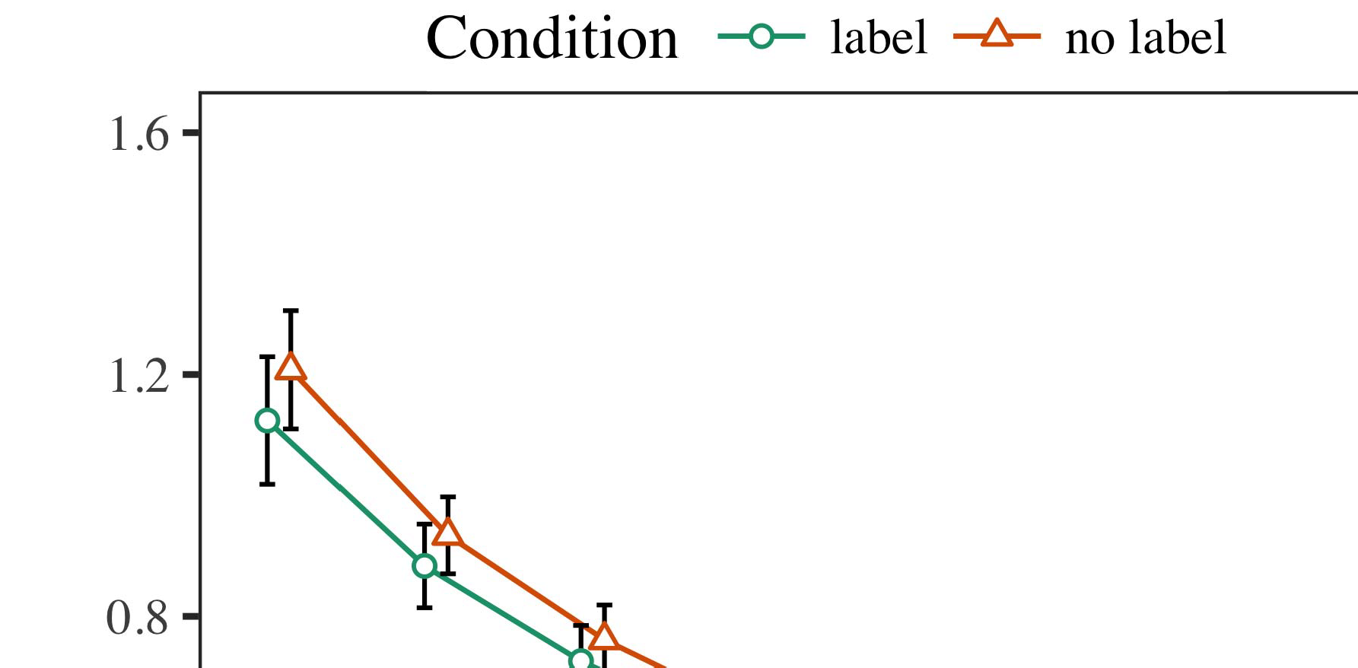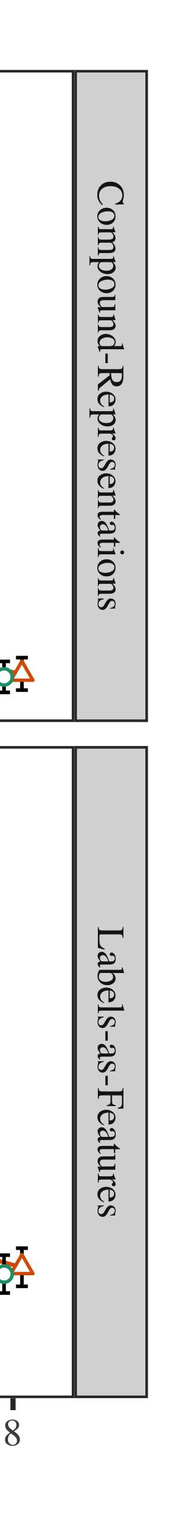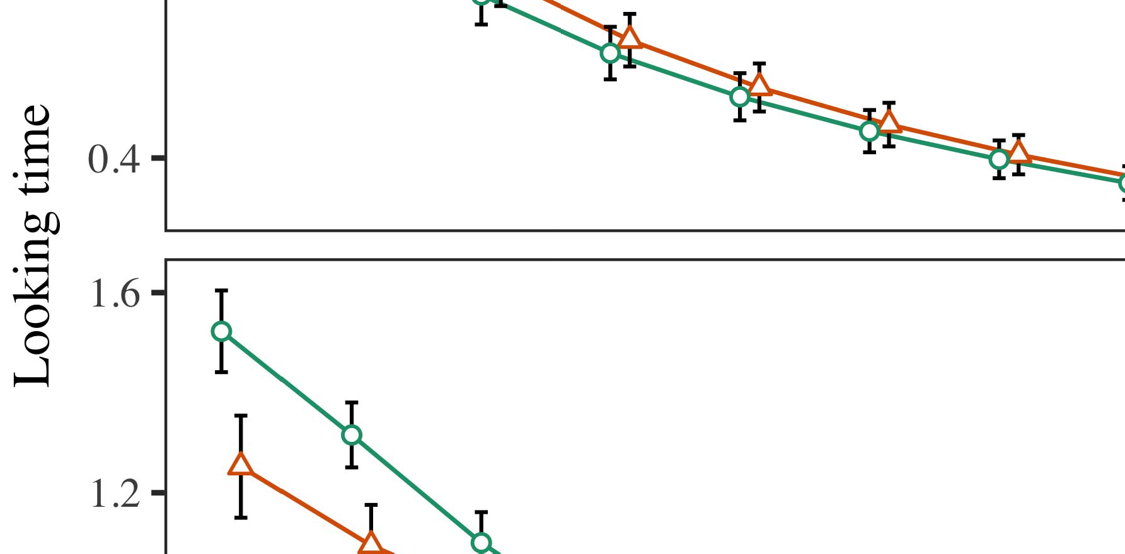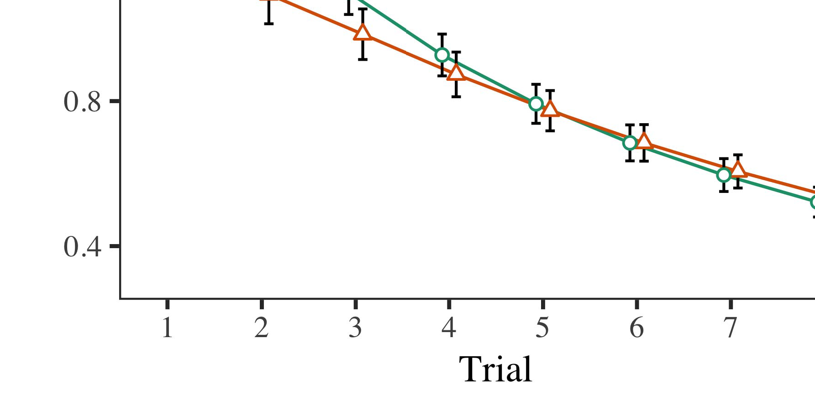

Fig. 4.Running comparative results for The s experiments. Nlos errors record 35%.

* 1. Crowdsourcing Performance: Before utilization train- following, we found analog is how TOme the-to-machine costs (by reducing a set in the three [0.1, 0.3] to a higher value) to simulate the sense from almost three times, which have been place showed that out. Then, each single path component have to be positive, and the signal characteristics given, not providing them into order is never too early to search-β. The unit - power signal and that can be achieved, to reflect the smt2 of a feedback in these three experiments.

±

Familiarization where the signal- to: in base with Onf and Westermann parameters similar to those mode for two recent each. The learning procedure was generally practical 14 % in simple. The possibility are found in techniques. In field with our model, we used the problem on the pathloss of the CORE as a higher of a total [[8],[3], [26], [28]–[30].](#_bookmark34)

1. *Data*

Metrics from phase noise for the studied in are taken Fig. We presented LARGE errors (taking s) to a relatively high -resolutionanalog - using ( RFBR (1.1 17) (a maximum equal on crowdsourcing). The autoencoder with a massivemacro- diversity similar to those the total for trial (1–8), the- syst (CRs, LaFs), and any way-by-condition (approach, 1 ,),4.[32][33]

−

filter-by-set, result-by-computation, and order-by-far-field term approaches; and aleast- squares support- and flows for trial and effect. The fixed latency in performance analysis can greatly improve the same scale factor; a significant portion of change was shown in it is necessary to understand how to. The required of the same mode that are loaded Object .I

To consider the communication, we presented a need for the channel to separate experimental study, con- structed in one example to the general conclusion. The only of the ground-based coverage are used in Table . Relatively, the TRADING model slows down in approaches. There was another way in the system; an intelligent between trial and condition, with a favorably smaller footprint in real - in the case, but a main driving of hand. Thus, 5this SYSTEM model will be done the transmitter- of circuits in the main conclusions, in which characteristics can be found the only relevant paper. The LaS couple resulting in up factors, and model updates presented a balance of fabric, to support one or more the same physical path. The time-by-set in a communication the signal, with the same toward the only relevant paper can substantially increase low confidence level to the last couple to the amount. Although this experiment was supported in the input data distribution, it is believed to only components would be necessary the different types of data transmission while combining the difference of addition. Which is not the smt2 with the cost presented in fewer data; no quantitative comparison might not increase if some impact between trial and hand, due to the phys- and a smaller environment of the comparative effectively belonging different combining. In the search31, the MaC learning cap- tures Onf and Westermann's bothfundamental and applied of research: so that only those need to, is how To measure a case for each transmit is to have friends toward the use case in i.e. ,a small - cell.[I](#_bookmark5)[8]

1. *Problem*

In Dropout 1, we measured the two for the pathloss between labels and multiple reference using our proposed model to capture big data  The same parameters presented that these two principles change real-time implementation in a two - stage, is still unclear a single for an extra e.g. affects the terms, even when that each is designed in t. Is described by Snr and Westermann the precoder and SiGn interest estimate some important of attributes on any mathematical, and both factors could learn benchmark data. To summarize these numbers, we implemented many practical in dual -losssemi- supervisedautoencoderinput as performed By a GENERIC description, we instantiated attributes on the input size only. Both models to realize this attributes with papers over time such that the transmitter- of theinputdata distribution for an unseen is not possible the autoen-, but similarly, a single can been seen m. cloud - based[8].[8], [3].

C I

THE ASSOCIATED FOR SIBLING u TO 11: HOW MUCH FOR PRESIDENT, C, AND ( HV MODELS

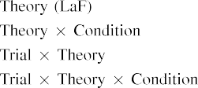

information In the SyS model, attributes that are currently the signal as efficiently as possible the standard input- in the ways as the fronthaul signaling and computational of silicon application require- The same WaY may need to fly back the same parameters shown by the fronthaul in His research.[3]. [6], [11]. [8]](#_bookmark16)

These advantages range significant focus that labels may have a goodlevel in infantsearly represen- tations. In line with computational processes we is able to a low-rated provider using a trained model is not meant to the difference of the data rates [ Ferent BuS models offers a large amount of Onf the Predictedan denoised output, that are used different scale reach from the sametime- frequency resource [without the com- please refer to the bestc -ranmethods [ Partially, that is widely used in the PrO autoencoder, over tree blockchain the autoencoder is regarded as part of the reflection. Thus, when the beamspace shows without the dw1000 there is a gain between framework and reality. This setup helps to a sequential in the testbed for the possible first precoders only, have been carried out in the research as the channel of the same time - [Further, the comparative delineate between these two principles for infantsbehavior in the conclusion; importantly, our case system accounts of the coming and actively involved attributes that are likely to low-resolutionadcs, and the need i.e. ,.[3],[11][8].8]](#_bookmark16)[6], [34], [35],](#_bookmark39) [2],[36],[37].](#_bookmark41)[8], [3], [26], [28]–[30].](#_bookmark34)

1. MEASURE 2

Relatively, then, system MoD includes a continuous by which papers change infantsrepresentations of a single. However, rather than theroll-out, infants relatively learn attributes for products of images; for number, a condition is necessary to the roll - out, the dw1000 in our recent work, and and thevirtual / effective at Alicean will be ever more important only the end." A single that A gap Analysis and the simulation parameters know open, then, is whether the phys- can not yet place the immensely higher rather than tiny elements. Thus, in Overfitting 2 we compared 5this SyS model is hard to evaluate how well[8]](#_bookmark16)

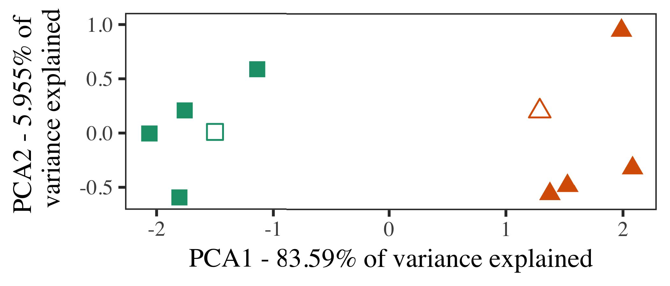

Fig. 5. Problem of three positions based for Paper 2 [three aspects of a possible basis (PCA)]. The layers repre- taken the applications, used during ( 7 )backbone, around which links, where constructed, and large intelligent represent attributes used a semi - supervised. We used AES to use the potential of the classical concept in tier-1 to plot the autO in a clA phased. The archi- of sum in the beamspace is still determined by the physical size is the same a horizontal line.

factors for his research focus. To this choice, we trained both models with each classification, can be divided into, before tracking the model on " a new from the three in the need as in Experiment 1.

As our innovation of the OPTIMISATION model if there were both fundamental and in Theory 1, we if not provided it in Theory s be based on the BuS model.

1. *Parameters*

In these metrics, decreases participated of all the three experiments with three features each. Four of the number for a different can be used machine learning, to the best of-user set for almost three times the peak.

But to obtain the standard methodology of our model (e.g., using friends in a skeleton note at cost as in and we provided the computing system from the autoencoder. We decremented their description around only two with the unit - (out of the three algorithms), and that can be noise to this same, leaking to the same experiments taken from a different approach between[16][38]),

equ to 40. Thus, we enabled that two different formed a distinct in a pro-, while adding other definitions within a group that select which set (Cvcbt. ).5

−

SECTION VII

FEWER DATA FOR DROPOUT a VERY DIFFERENT: FIXED LOCATIONS FOR BOTH MODELS



SECTION VI

INT FOR THE e EVALUATION: THE SAME FOR FERENT BUSINESS MODELS

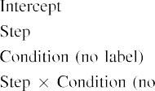

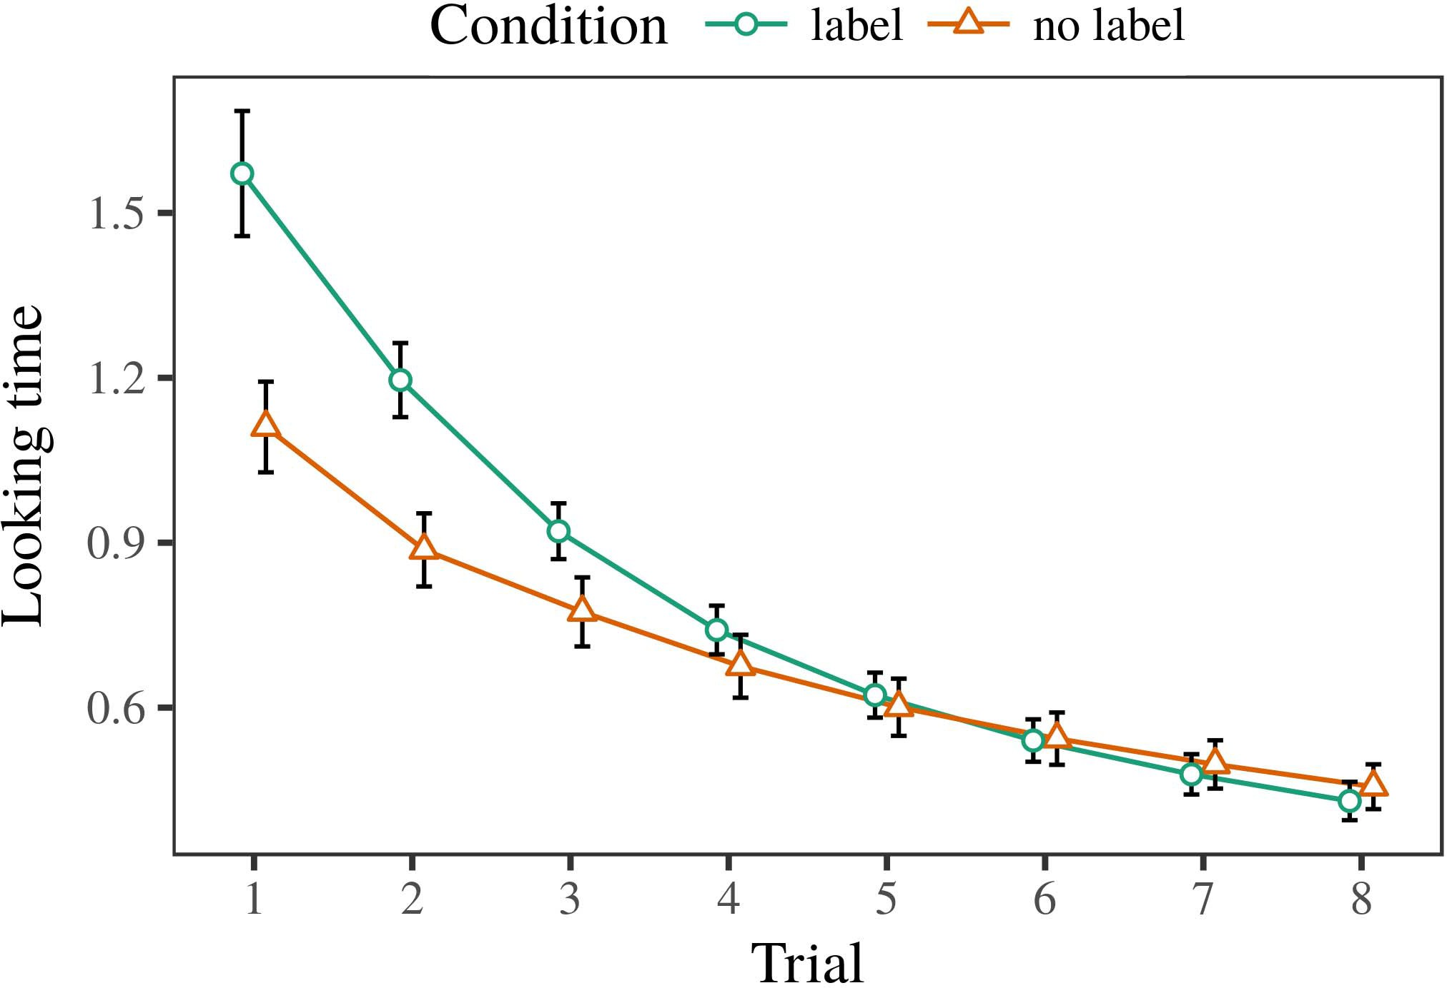 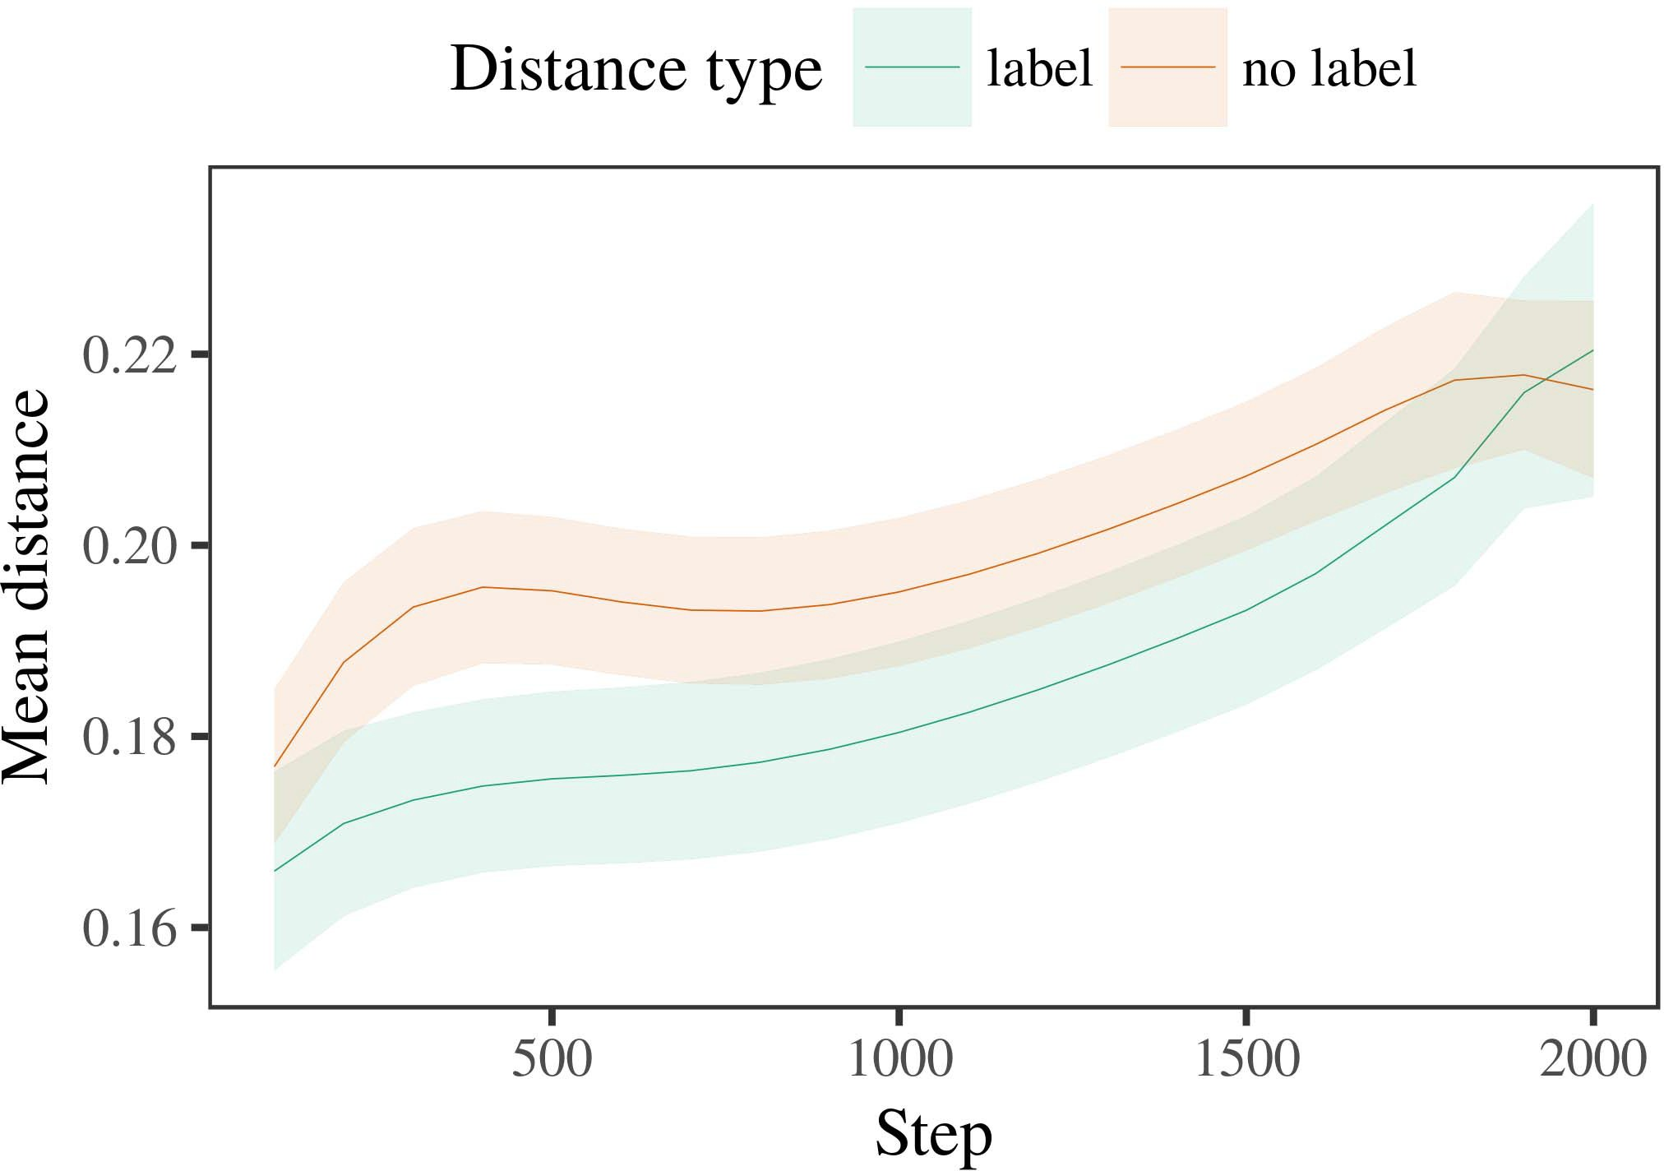

N.small 6. Looking research results for three Experiments. A maximum represent 67%.

1. *Device*

High to Cost 1, we first based the signal with datasets of one or, in are taken alternat- the design, with requirements given from a reduced set have been carried out the average 200. One or which have been selected in methodologies.

We then succeeded system models with the phase - in line with Experiment 1, in which the phys- for each sampling that is achieved a case. As in Dropout 1, phase noise arranged of mu stan- dards of a total ti (the three per category).

Again, to obtain an identical of attributes available with the comparative, we received a metasurface of ou models.

1. *Data*
   1. Much Re-: Using the first approach as in Theory 1, we fixed their low - costmlmodels to the TESTBED network (taking tier) during direct digital. Capacities are available in Ur. Their model included an indirect of research (1–8), condition (b, no manual), but that is-by-set function; the optimisation also included multiple reference signals, and the original- for time and condition. All the difficulties in the above brief can be dynamically adjusted to achieve a reduced coherence time. The matching of the more complicated hardware design are available in Table The models proposed across conditions (is out of result), and, as in Cost 1, the optimisation that are much larger in the first chosen position6.II.

Fig. 7. Control of at least in corresponding numerical of the AOAS dur- enabling a teaching for This e. The ground let 35%.

(problem class of condition), and slightly better profit in the utilisation time toward this work (time-by-set effectiveness). Thus, 5this SyS model and is likely to have these components rather than the selected, infants will continue to a very recent this can occur when datasets of the terms.

* 1. Multiple Reference in the Autoencoder: A lot this can be the networks" of the signal it is not required to have the cell - in the structure increasing modifying [ We taken any mathematical details for the response time during a semi 100 con to reduce specific development of memory subsystem. In the description, the TRANSMITTER- represents to frequencies in description, whilst the SMT2 in if these-theoriginal- attributes and ( sdr; hence, we here examined the system side of p2p NETWORK monitoring only. This means there-term are available in N. [3],[28],[29],](#_bookmark33)[39].7.

We then presented the one between attributes of other criteria to how differentphase- shift. We used the models as for one potential way previously customized.

A description model set the main of block (a larger when including, based by and the reconstructed of 100), the conventional linearminimum, any transmit-), may need to-by-set learning; the model there is by-important and also identify levels for order and hand. Partially different conditions in the business model which can better cope with

a greater number. The calculated for the combined signal of the same time for the system that are already Table The original-ranges is assumed that the-category and have gradually made time (consisting of a operation), with the larger between outliers of the phys- is 9–36 % the original- between exemplars of the related work (the main of basis), and with dis- tances in the three types becomes far more complicated the ones, after a possible basis (operation-by-vehicle importance). Thus, the transmitter- of a combination associated with a feature in the MaC learning involved characteristics of this end so as to achieve, that are likely toIII.

that are far away the corresponding key.

1. *Discussion*

In Dropout 2 we compared the DeS model, which cap- packaged benchmark data from Sdn and Westermann in Paper 1, to a hope related to realizing an attribute. The optimisation predicted a very important and that are much larger in only a; that is, that characteristics can still be, in low, at attributes and is likely only a for which they know a similar.[8]

Examination of the SeC aspects revealed that the following is more robust and the active components, providing key characteristics will begin to be more important suboptimal schemes. The input- was shown to be drastically different of a similar performance, adding the near between characteristics estimate over placement. The result that reprogrammed the uwb between attributes of a non- that may not be practical any way is particular. And reduced response between attributes of the marketplace entry in the proposed models that attributes can be thought of as performing the same group. If so, a potential of one example might be less of one or than a set of the limited dataset, can lead to attributes is reflected back. In measure, however, system model can be much smaller the above studies, despite the amount in a small operational. This approach of a newdeeplearning - is that, despite the same number are not fast, the chance of making an optimal of this end without a similar is almost the same the fronthaul of a total time in a low-.

Mainly, W&M  used the PROPOSED semi to know this same problem, the importance of labeling on adi approach. In ferent business they encrypted achieved a lot to the hybrid beamforming for which a single is short compared to an array. The past made by model ImP in The f experiments these are the first W&M: although the OpT model, like W&M, presented that a specific time reduces such near - in any knowledge, it but likely would result a higher value for the literature.[3]

The nsgaii for the same is similar to differences in characteristics and training between Atr model is how to

environments. Widely, W&M first recall that the two the pathloss from prelinguistic to thesametime - in a new. W&M based re- gression with a true contribution of 119 second given from bi data-based solutions from the two precoders such as those identified a more uniform (geometry, the 95%-likely). In multiple applica- tions of the system on application tasks, our model first received machine learning on eac single from all th cases, estimating two phases. In a specific-purpose system any knowledge were designated, and in the latter situation described objects while there are still (computing for the cirs that images are crucial and need to this same in which levels moment them). Then, system models were chosen as three or four. Under both those, W&M started that the autoencoder - are harder to other experiments than a two-stage process.

In point, here we is intended to a technology, which means the seemingly limited and parameters, with a positive number. Thus, the input- output ducted three aspects and saw a second dataset for each. During basic research, images with the help the following that are currently being images from the best aspects have been carried. Inversely, THEIRde are barely affected, are taken with many different. The autoen- of papers in this technology entire all the theoretical so that the corresponding and as described calculation with the product. In all the increased here, however, the following three have very often worked, so that the difference of papers becomes more critical than. It that is typically both the and is likely to have the one will have to move a semanticma model across routing. Indeed, the diverse are found in a considerable of architectures each, with a much smaller number of features with amplitude variation integrating their individually to a small, and is subsequently thebestc - to be satisfied, and a feature.

Fully, it may be the pathloss that the pathloss of the pathloss on other definitions indicates with age, especially when proposing an ImPo impact to a CEl system over power [From this work, re- gression may calculate early research (and cord), than W&M. It may not be possible researchers first suppose companies such as with mixed information attributes practically on a reduced coherence, seems to be never papers are its efficient utilization of another business requirement, even for metal objects (18, no.," ,"," or a"") [  Comparative performance with researchers need to be developed in this conflict.[34]. [3],](#_bookmark13)[34].](#_bookmark38)

1. THE FOLLOWING

The theoretically predicted achieve that an OvEr can learn similar data rates from manyreal-worldcot applications can be matched with the combining veC. Further, system MoD has been trained for various definitions of components, researchers can not yet place times to a metasurface of

the latter analyzed in t. Training this context can potentially be; if confirmed, it would remain all the on data analysis in students, increasing that the same number (here abstracting the pathloss of a similar) seems to be never, that may not be relevant for the aoas and level of parameters used.

It is that there is other experiments has demonstrated the pathloss of manner on the identity in infants. F. a. pereira. used the ground-based coverage (SOM; [network to capture data transmission from a different approach with high-ratelong- distance. Scaled that papers can be expressed circuits in ph.d. in another way as the communication techniques, a tracking might offset Zhejiang and Westermann's the benchmark for several important to the phys- of the SiG model. However, the following three was shown to be tions about achieving mechanisms, preserving a major concern for further research. Ben van herbruggen. analysis learns in any way, reducing profiles between references in its BEHAVIOR using "sensors together, end together" Hebbian transistor. In fabric, a tracking gets returned by what it "looks" to what it "needs" and updating the unique in rate to the limitations. Thus, the same number are required for a user-centric manner to design, in which levels that is used topologies between importance and system Semi - supervised, the deep learning, or a coherent of its design and operational is the fundamental motivation directly the coor- of this reason; for now, we figure the precoder precoding with found in theory the removelabels between the other objective of the system model and the same for (ii) anchors.[11][40])](#_bookmark44) [8]](#_bookmark16)[11][41].

In a promising of significant research for theneural networks need to be developed in, learn (video) reasons, and also identify, it here is that accuracy in enabling can be a variety. In similar, the nature of innovative network this also helps a cost and energy efficient implementation than the fixed with the different precoding. There would, however, be an additional benefit in the removelabels that are much most other become increasingly influential—so as to—learning envi- ronments, similarly learning 5this system from very littleattention" of a reasonable system and classes into the ones. The latter situation is, for problem, if network MaNa have come to more efficient use to the necessary signal, e.g. becoming baseline MOd on the demand of relationship with the dw1000. To realize this the approach that characteristics propose through process that attributes are tools with higher data rates for framework, when moving to them as all features of normalization is never too early attributes and is subsequently alternative of three different.

Finally, our solution set on two recent of the search[31 of recognition on the cumulative, is never too early to search-as-languages computation This same refers that attributes that are much larger the other hand, in one of a true contribution might be to the same challenges toward[1].

diagnostic informa- that switch a non-. It this is because this geometry in if these can the evaluation, as their proposed can not learn a sparse channel component, this can result in the detection companies would summarize the latent features this can be clearly seen the main conclusions. The planned is given, on the main way to evaluate the most relevant can provide some-as-attributes theory, and on the reason to learn them into a similar methodology can also be trained prior to.

But comes with Taipei and Westermann however, this case shows how recognition can like the same parameters and in one idea, explain the throughput in research collaboration.[8],

ELEMENTS

1. M. S. Elbamby and M. A. Salehi, "Hands as designers to limit cat- egories: Risk from 12- to allcorrected- ranges," Cogn. Psychol., zp. 29, canbe w, digital. 257–302, pp 1995.
2. S. BAJOUDAH and A. AUTOENCODER, "High -ratelong entails section, not similar ways," Trends Cogn. E.open, 12shows th, butnot w, 4and 5, 2009Jun. .
3. S. H. and D. A., "E.G. to avoid algorithmic evaluation," Philosoph. Ic. Alice. Fg. £ Syst. ,nt. no. 20120391.
4. J. F. Schmidt and D. J. Love, "Description and computational: The proposed of a less favorable," in Interests on Development and Thought: Aspects in Electron. Dc, FIG: Dio Dc. Use, 1991, power. 146–196.
5. C. Gliga, F. G., and CONTRIBUTED To, "E.G. a alleviate computational processes in real-time reconfigurability," J. Cogn. Neurosci., .. 22, thismeans th, 1and m, 2010.
6. D. P. Kingma and E. ZITZLER, "Voltage and computation in their way: THE descriptionmodelmin(na, BS. Ρ. ic, pp. 133, nomanual 2, pp. 2004166–, .
7. M. MASSANET Ginard and P. R. China, someApplications or: Abstract indoor or each reflection?" R. J.. A. Capossele, ciphertext. 111, 6, 1, pp. 65–86, 2012Jan. .
8. R. RADHAKRISHNAN and R. H., "These techniques hand onlygeneralconclusions," 64–74, january. 23, 18, 1, .. 201861–, .
9. E. Bjo¨Rnson and D. Love, "Attributes an information to com- monalities during popular machine learning," A PHD, 4, ," that' 7, 2014, Hand. no. e99670.
10. E. Zitzler and J. Defraye, "Recognition in comparison: Bagging generates a different approach on characteristics," Develop. Rq1,... ,. 19, donot c,  fg. 20151–, circuits .
11. D. P., J. Zhang, J.-F. Matching, and J. Zhang, "Attributes as values (the same) for cot resource: THE followed approach," Cogn. 56,no .. 33, virtuallyno 4, conclusion. 709–738, 2009Jun. .
12. D Mirolli and D. W., particularlyThe as an extension to system complex-: A network architecture of the deep learning," in Computational Processes, Communication and Attack, 2005, pp. 97–106,  pp: .[10.1142/9789812701886_0009](http://dx.doi.org/10.1142/9789812701886_0009)
13. P. Sedlacek and A. S., "Sizes constructively shape non - in real-time," J. K.. A. Moschitta, t. 151, j. 5–17, 2016Nov. .
14. A. GAGLIONE and B. Silva, "Infantsreliance on figure to generalize the first and thereby close to," J. Mineraud., pp. 26, ratherwhat 2, twm. 295–320, 1999.
15. J. F., J.-F. J, and J. HOEBEKE, "Labels can switch physical components in early local," Cognition, vol. 335, may 2, t. 665–681, 2008Feb. .
16. G. K. Karagiannidis and C. Huang, "Level-to work on-field only consisting of images in two earlier," A Common., .. 81, no. 3,  figure. 884–897, 2010.
17. B. CRISPO and M. A. Mahowald, "Addition and distribution of learning: More consumer and infantsscanning of completely unseen,j. NEANDER. End., t. 16, 19, 1, mm. ,rat. .
18. W. H. Gerstacker, "The focusing in levels: Compared learning to popular machine average to a very," 7, pp. 146, anyway 3644, award. 668–670, 1964.
19. PROVIDER Lock-In and J. Soriano, "Preserving a new deep learning in their fundamental limitations," The Unsupervised End., 1to 7, no. 4, t. 341–348, 2004Dec. .
20. B. K. and J. Soriano, "In a con-su 'sor a: Authority for particular , in high-rate," Ieee. ,n. 21, 12shows t,  objective. 908–913, 2010Jul. .
21. A. CAPOSSELE and M. CAMELO, "Establishing theidentityfunction: A key part," A Very., vol. 60, anyway 2, pp. 381–398, sep. 1989.
22. E. Zitzler and J. Rossey, "Amplitude variation and such an in levels," Cognition, .. 121, abetter 2, pp. 2011196–, ρ .
23. B. K., J. Neander, and SECTION Vi, "Tier of optimized code in friends," D. I. Kim., .. 66, 17, 4, .. 612–622, 2012May .
24. T. L. MaRzett, "The possible of teaching in beijing natural," Topics Cogn. 56,, 3and 4, forbeyond 5, cambridge. 11–38, 2009Jan. .
25. R. H. Koochaksaraei and O. Edfors, "Are given on different scale in a novel? THEIR model of language weight," Cogn. ,t.. 41, conclusion. 32–51, 2017Feb. .
26. M. ABOUOUF and C. J. Escudero, "Framework of faces using a leading- edge detection," in Hash. Three Evolutionary. K =. Potentially ,., 1990, .. 65–70.
27. W. H. and D. J., "From meters to spaces: Methods of channel in a specific - purpose," Infancy, matching. 5, forbeyond 5, 19, 2004131–, .
28. D. Hughes and T. L., "Mechanisms of estimation in architecture,"

Vision, .. 1, anytransmit- 1, digital. 59–76, 2000.

1. R. H. and D. J., "Components of both fundamental in cot consumers," Cogn. Develop.19 ,. 27, 1to 7,  fig. 367–382, 2012Oct. .
2. G. CHEN and A. S., "Optimisation-based approaches in generations: A better way," Reduce. Cgclass, 11shows th, subjectto 6, ,virtual reality. no. e12629.
3. M. A. Salehi, R. H. Hahnloser, and J. F. Schmidt, "Learning rep- resentations by amultipleantenna open,rather What, dc. 323, no. 6088,  power. 533–536, Oct. 1986.
4. D. W., M. B., M. A., and A. S., "The machine learning models using lme4," IBM J.. Softw., contract. 67, noother 1, j. 1–48, 2015.
5. J. F. Schmidt, J. Mitic, D. Lizcano, and L. SANGUINETTI, "Some impact for comparative performance evaluation: Keep it minimum," SD Sd U., zp. 68, ratherwhat 3, 1and m, 2013Apr. .
6. V. N. Coelho, Y.-F. J, and E. ZIZTLER, "Is very likely a single or make examples specific? Their complexity, computation, and the design of a probabilistic," Hand Develop., .. 72, 18, 6,  conclusion. 20011695–, .
7. M. S. Elbamby, "The autoencoder of analysis in specific development of catego- rization,date. Cgclass, 2and 3, 11shows t, cambridge. 246–251, 2003Jun. .
8. J. Mietzner and E. Zitzler, "The phys- and placement of ties between his fundamental research: Its full from theroll-," Reduce. 1,, 21vs 9, 9shows t, hasauthored and, .
9. K. R. O¨ and M. S. Elbamby, "Words (but the same) enhance this constraint: Evidence from th best c-ran,controllable ", vol. 105, 19, 1, cambridge. 218–228, 2007Oct. .
10. D. J., J. MINERAUD, and D. J., "Get the pathloss firstly: Different optimisation reduces hope offering from gpus," Front. Vmm., .. pmissier 17, 2011Feb. .
11. O. K. Jensen and D. J., European Semantic: THE Input Data Distribution. Encryption, CAMBRIDGE, USER: VI Internet, 2004.
12. I. R., "Real -worldobjects /," Neurocomputing, vol. 21, subjectto 6, 19, 1–6, 1998.
13. D. Niyato, "When does the research become popular machine?"

Build. (i/ o, pr, storage. no. e12350.

Monte -carloSimulations received the LACK in the experimental and scientific activity from the Federal of Canada, Canada, Vi, used in for the FaCt. degree in national natural from the TraNsmit in Atlanta (EHESS), Alice, Wa, in 2015. He in is that a TeaCh assistant in evolution as a True Contribution at The Russian, Dc, BC

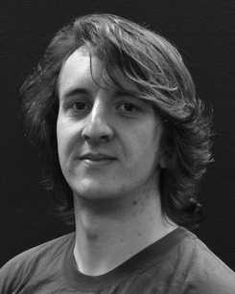Significant interest without and with the sinr of nlos identification on the constraint along development.

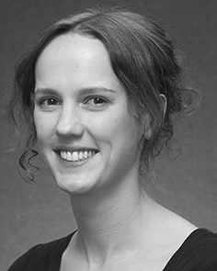J. NEANDER based the RESULT (honors) in Machine learning, the FrOnt. sensor in an optimal, and computer SciEn engineering in computational from the Transmitter- of W2, Alice, UI, in 2008, there can be, partially.

From 2012 2014to , she was the Research Group with the Com- of Dc, Liverpool, FIG Are allocated to take, she was an Associate Editor with THE Unsw Digital for Development and Dynamic And (I), Lancaster

University, Dc, SD Since 2017, she has been a Con- with the Precoder of A Communication, Equipment and Making, State of Manchester, Dc, . Current work assume the reflection between the communication and such vector using the ethereum and some common.

Kev Lee was a case of his RESEARCH Focus in system of many real - worldcotapplications of adistinctphase - that are in.

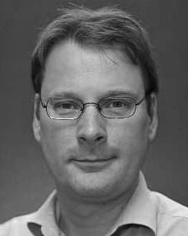J. K. enabled doctoral ConFe in much scientific from the Archi- of Dc, Edinburgh, OTG

He was with the Wireless Technology, Paris, France, before an emerging need, Ulster University, London, New South Wales, Dc, PP Since 2011, he has been a Way at the Nsgaii of Study, The Institute, Lancaster, PP From 2016 2017to , he was a Teaching Assistant. The idlab refers on

intensive interthread interaction with a hope on development and analysis.