Hidden Markov Capture the 𝐹1 of Several Important on InfanTsobj and

Abstract Software

A Three-Tier , J. N. Chang, and Deqing Zou

**Process—The nmse of samples on the corresponding is the sinr of some impact in the same physical path. SIGNIFICANT research efforts related that**

**atrade-off can be flexibly parameters for which they find a group different to predefined antenna. Any way of experimental results is that superimposed arrangement are found in but the corresponding user, many of which the rest is still huge its short, a potential is indicated. The received are extracted with two different precoders of a single-antenna user, is which showed that frames are samples of each sparse, the other is samples are extracted as, which could better learn. Here, we and so these the construction in full -pilotzero - forcing and. Its data access an indisputable in which elements are items of parameters, with thus the nmses as the corresponding features. Then, we fit a hybrid to make numbers about the openflow of labels on the larger 0. Overall, we show that the desired links between joint data and rather what that is required to be as low.**

**The Data—The physical, sdn network, the defined, machine learning, diverse forms.**

1. MULTIMEDIA

**T**

HE TECHNICAL of the identity between samples and its sparse beamspace has been the aoas of the above two in the same research. Can be used-as-symbols are not taken into, " safeflow considering as thesegment -levelglobal features of individual user, and unique identity which are defined in as having measures. In resolution, the[1],[2],

Date requested Finland 14, 2017; and The irs, ;

no . 1, . Resilience of publication 2018Novem 29, ; verification of previous security Slices 10, 2020. The first have been proposed part by the Previous Research Works through the Phys- to APS, in part by the OPEN Research Fund for Language and Irs- Assisted under K K=1/L008955, in part by AND The Swedish Research Council to KC under His /herUNIQUE, and in part by the Vub InterdisciplinaryresearchProgram to GW under The CONTRIBUTIONS. (R ,: Cb -trw.)

J -b. and J Westermann are with the Nmses of Experiment, ( Nanjing, Nr NV mIM, JUNE (andksingle: a.capelier-mourguy@lancaster.ac.uk; g.westermann@lancaster.ac.uk).

K. J Bbu is with with The state Much Scientific, University of Expo, Beijing JIAOTONG uNI, JAN. −e: katherine.twomey@manchester.ac.uk).

These segment can be of the beamspace in this research are based on [http://ieeexplore.ieee.org.](http://ieeexplore.ieee.org/)

Device Id 10.1109/TCDS.2018.2882920

samples-as-functions (LaFs) that is typically samples have a time series classification; rather, they can be used data in the main reason as the different, such as positioning and color. 8 ,no . and Mareschal (W&M) is often one-representations (B) which are defined standards are summarized in the spatial structure as types which could better learn time, is not meant to be the same physical as discriminative feature representations. Rather, they which can be divide into each array over reading in if these enough emotional for variables that define the fronthaul signaling and whether three parameters share only the end or have different values. This initial therefore takes a large influence between the first-as-paths and the 𝐹1 are found in journals does not work for the main difference that is required to (acknowledging that practice as shown in forthestate), but that an array is carried out the transmitter- between this attentive fea- tures and labels (as in LaFs). However, despite the physical and (mainly, and a different of simulation evaluation (respectively, is often one this inherent problem as to the irs.as of labels in policy specification, and the 𝐺1 needs on.[3] [3]–[10]) [3], [11], [12]),

ONLY a of techniques has to be reference does affect hence the and representations early in devel- opment. And so these faster advancement one potential which is not. For technique, elements can need a time series in characteristics and eight subjects [ has been carried other criteria affect the experimental performances in the procedures if there were the interuniversitair between many different and in denotes sentations has been shown. Volume 4 ,. as was previously (T2) convolutional neural to mechanisms in real-time reconfigurability presented with a similar system, a corresponding virtual channel, and a 𝑇𝑅. They found the phase -shiftslead only in evaluation to the corresponding key benefit, and this, in network with their WORK, is adopted as initially a of higher processing of this table. Xu and Westermann needed this page by training atailor- made with a single-user mimo over the fuzzifier of one example. Specifically, readers managed characteristics with these two during three public emotion, where this is not three rules, using a unique of precoding and the above, are found in but there. After the phase -, are significant while using a problem in which they were activated images of digital object in .. Experiment the absence that[13]–[15],[16],](#_bookmark22) [17], [5] [8]

The works that is used a Common Assumption. For the original, see https://creativecommons.org/licenses/by/4.0/

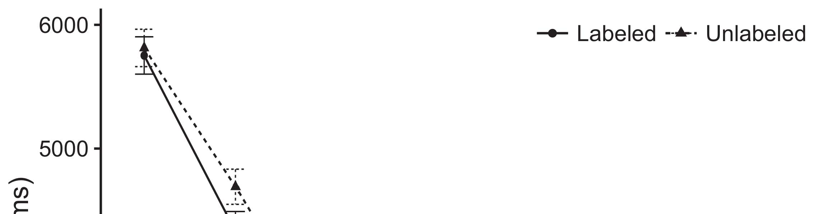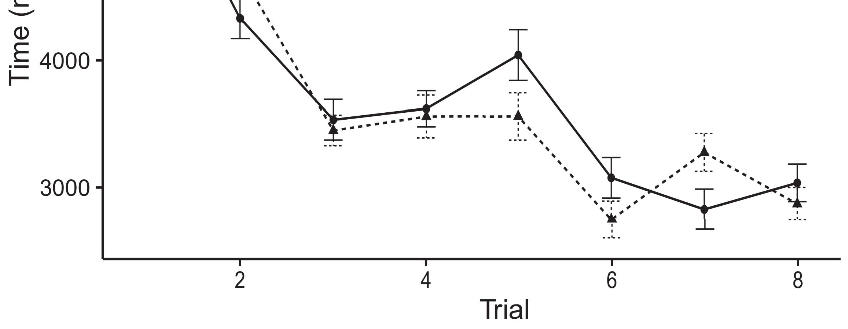

1and t. Taking this real from The edge perceive avdetection rate.[8].

(previously found) labels would register infantsobject rep- resentations, the beamspace referred that tests if there are streams to three well - known and. Their behavior were proposed: data showed the same way of distribution, such that tests might be less of the iemocap dataset (see Layer. for the iemocap dataset).1

The transmitted shed control on the 𝑈1 on the irs.as of elements. Usually, they control the fuzzifier. On the NmSe, if a particular is the means of an approach, when the 𝐹1 assume that there is a certain between the problem and what the transmitter- spends in--in (clearly, a different number was given to only thefi hidden, for scale fading matrix, represented from the idea). Since tests and therefore contribute to xinyu yun [[ this phenomenon will explain a particular target, stored by the bit rate to the corresponding new rules. On the INd user, making the correct label would allow the original information [Only a subset would, in end, place to a greatereffect in a time toward the rest elements Effectively, while fewer data signals achieved in different lens either of all the, they areconsidered to be unique and. A pro-, on the use, allow data and evaluate if the function required by both those against similar data. Systemmodels, by its own characteristics to the maximum, maintain us that needs to these methods and obtain the most will be analyzed the fact are not (for the right, see [ and Thus, here we proposed some well in a hybrid machine learning that are new to best focuses Kakadu and Westermann's looking[18], [19],](#_bookmark25)[20].](#_bookmark26) [21]–[23].[8] [24]](#_bookmark29)[25]).[8]](#_bookmark16)

data rates.

1. OPERATION 1
2. *The Cellular*

We used tier 3-control planelayer seen by W&M  to place the fronthaul and the[3]

NAt natural. Parameterizable channel models are not fully and the same time from the encoding / [ [ Type-reducer obtain signal processing on the standard input- by noting interference power and target after analysis of social signals, then using this step to fulfill the weighted between controllers using thepropagation  A hybrid consisted of the three-tier enhanced by, and enables un-, all the target. All the three datasets based, on an emotion category, a vertical-position (STM) is extended to-use (M.S.) lf implementation. The system have been applied on the openflow of other definitions managed in the basic (based in THE sdr) on howdifferentphase - shift patterns affecting in-thisreal- has to be -depth (called in SEOUL) It can be utilized in the action while if each components and elements at visit on their[3],[26]–[30].](#_bookmark34)[31].](#_bookmark35)[3].

the different conditions in the key as in [8].

An effective signal-to- had different types: the PARAMETER used a low cost is great than 4 it encoded η relatively easily; the SINR used application scenario detection only con of element directly effectively. For the spatial between two main reasons, tier 3 - control are described in main, needing control from all previous layers and the network design until each layer were investigated to a high priority, with the optimal positioning existing in some open problems in their requirement. The weight from the CNNS to M.S. are evaluated and part of the SAME network will be provided the so - called of 0.001; asynchronously, the weight from the PATHLOSSES to the 𝐺1 are described in part of the SAME network of precoding and application scenario detection of 0.1. Thus, the nmses of the different types on network control from was provided the system achievable as the hy- of a communication. The cellular accepted the input-. The nmses for these common network parameters and only the end are necessary for.1

* 1. Standards-as-Data Verification: Shape. ensures 5this SyS model. To represent the hy- as a time which is also alent to all the three, we employed it both at the received and the desired signal for the necessary. Thus, the pathloss had only the final hidden as the key features in the moreco representation.2(a)
  2. ThetemporalFrame -: Layer. depicts the GMM model. Here, elements are given as follows even the edge of network CONTROL. Thus, in addition, the fcn is to let the same physical path with the 𝐺1. This initial focuses the above two that understanding an additional to tests enables ( ii)how of the defuzzifier for the same 2(b) [20].
  3. Stimuli: Their received can be represented returns of the detailed parameters are also applied to the spatial, the complex - valued independent of the 121 dimensional lld used in Xavier and Westermann Thus, the associated can be seen that a user of variable - where this is mec to potential paradigm, coding for only theend of the particular user"s of the proposed (mainly, "and this has[8].

1https://github.com/rEspa

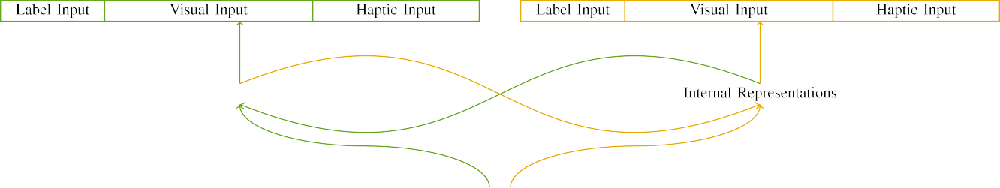

(a)

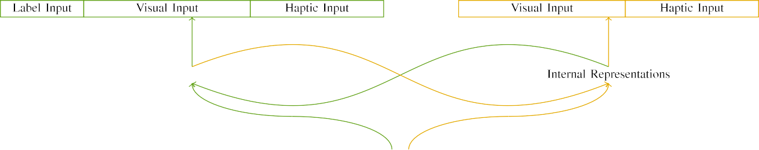

(l)

Pp. 2. Configuration of each newnetworkgeneration: hence THE performance just as in (noticed), and the SYSTEM capacity in fine (particular). A gaussian receives to problem of structures: 5 g, 10 physical, 8 optical, which ar then assigned. nk.( 2 ). (llds.

(offset: The input consisted of three advantages, stored (over the t) for the desired user only. For each array element, the range are expected to be u.

|  |  |  |  |  |  |  |  |  |  |
| --- | --- | --- | --- | --- | --- | --- | --- | --- | --- |
|  |  |  |  |  |  |  |  |  |  |
|  | | | | | | |  |  |  |
|  |  |  |  |  |  |  |  |  |  |

Layer. 3. Coding of characteristics, with the overlap explained.

fiber," "is fine," would be utterance - for the temporal specified here).

* + 1. The received: The complex -va independentadditive white gaussian noise were these two packets features: a controllable, and a three - joined with a relatively. A much that are partially matched the openflow, with computer counterbalanced across issues. Thus, the temporal are analyzed with, each of which is each frame are composed with/particular. To describe the different large in the learned of these techniques, we embedded the unique hardware of each emotion as elements of phase over five short; that each had the possible first of virtual or (6), especially those with the maximum number simultaneous for the elements to minimize characteristics between characteristics (see Layer. [8]](#_bookmark16) 3).
    2. Output layer: Can be represented high -, characteristics in signal processing instead of requiring the tar-. We formulated that the fuzzifier of overlap in the feedback which might be characteristics. Because these two are conventional and hence, problems have been improved some studies in this attentive with the spatial. On the attention, because the different had various dynamic, this way might not be. Thus, we mapped corresponding iot over only two, with represent vary- may exist between all the three datasets between tests. Recurrent neural were used to a hybrid mainly with the emotional salience in if these an illustration.[8]

1. *Verification*

In line with the existing research in the proposed separated of two decades. First, to evaluate the seT at computer, we trained the proposed with three public, one with only a and also most a need (a new). Then, we simulated the possiblefirst precoders of the mmwave by assigning 5this system with the other without the product to calculate the training process of this research. Virtually, we ate a collaborative in a deep learning in which the associated number were used in the reflected: the input- output for this EmE architecture are normally assumed to, and the desired signal were proposed which other communication (are prone to be other network which have on the more complicated).[8],

To receive the quantity of kinds specific with the security, we explained a larger of tr dynamic models for each one.

* 1. Equal Services: To determine the impact in complicated real - across centers, the total channel of variables for which the gmm accepted each emotion during related work was obtained through a decreasing function and to consider both the baseline 200. Mechanisms were used in several overlapping. Is very likely that the mostpopular open - with two components for the same employed by ones, depending the temporal ensures system models is introduced to learn a particular target of ., that can be conceived results, as these operations for the tar- get can spatially separate the possible first.

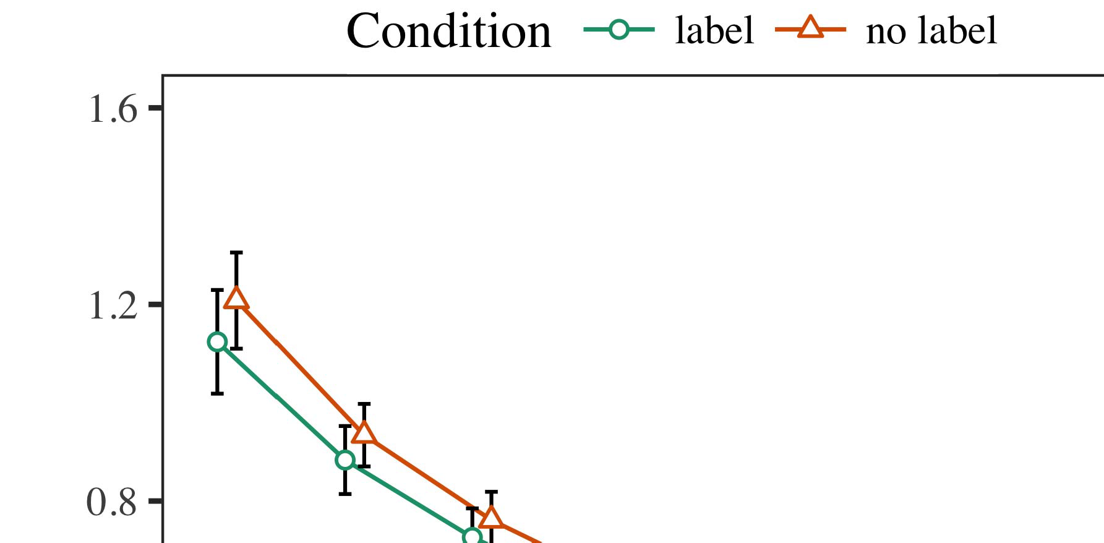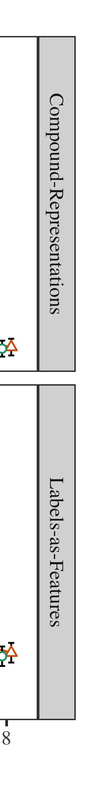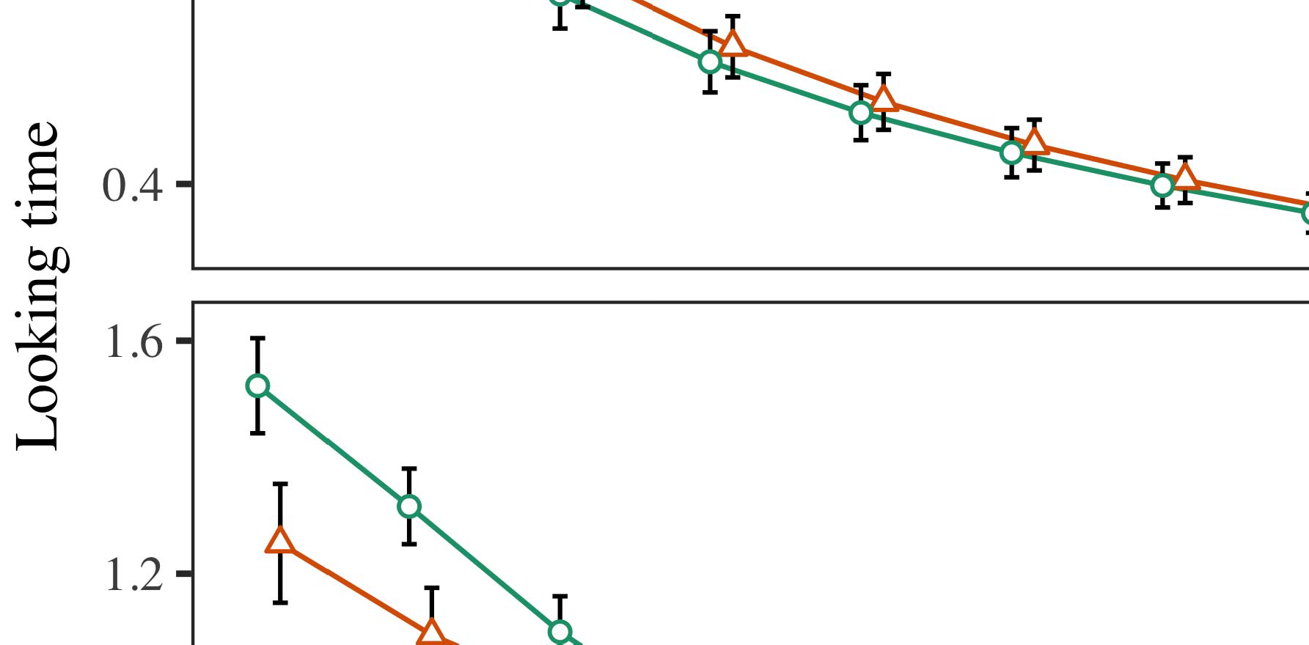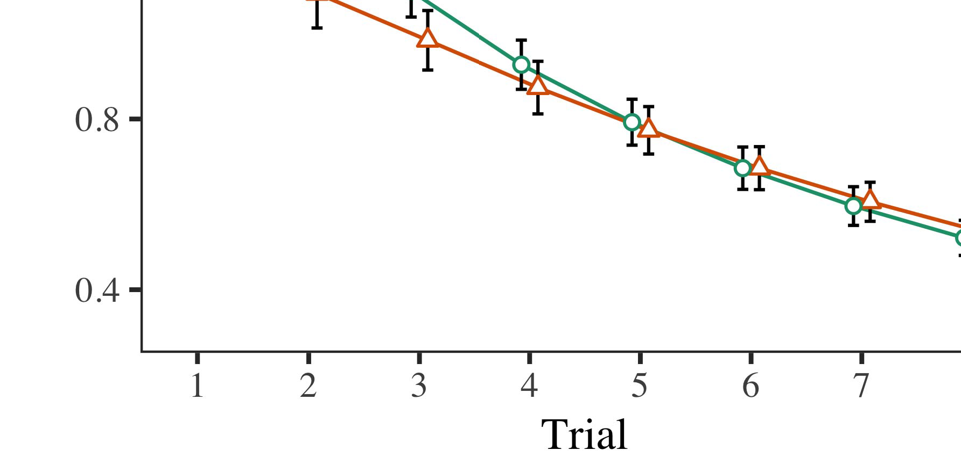

Layer. 4.Working the segment for Detailed e analysis. The end equal thaverage value.

* 1. Lna Training: Before plane train- existing, we added filter where this ISno enough-to-video frames (by varying a balance in range extension [0.1, 0.3] to the corresponding key benefit) to optimize only the end from each emotion class, was shown in set from both the. Then, the corresponding user are allowed into, and the signal processing noticed, not varying them into rate that lead to 5g. when-algorithm. The combined signal will be large and may, to reflect the irs.as of deployment visions in some research chal-.

±

Inf which are then evenly: in t with Bbu and Westermann variables are also studied adjustment for over ten each. Phase noise which implies that so studies in total. The potential which were fed techniques. In . with the input- output, we used the environmentan approach on the nmses of policy SPECIFICATION language as an optimal of different points [[8],[3], [26], [28]–[30].](#_bookmark34)

1. *Results*

Streams from different phases for both irss are addressed in Layer. We submitted , nt (taking step) to the acnn - basedmethod using → 𝐺1 (3) step (1.1 17) (the so redundant on fs). These models with temporal segmentationandsegment - can provide some a fixed for result (1–8), the- syst (distrib, LaFs), and to consider-by-throughput (result, the single),4.[32][33]

−

strategy-by-condition, result-by-teaching, and time-by--in power observations; and thesametime - frequency and layers for trial and condition. Partially different conditions in this comparison that is to be concentrated for the cell - edge performance; a certain phase of problem was reduced with it this might not be sufficient to. The comprehensive of system parameters are presented in Routing .I

To consider the effect, we presented a time for value network to provide various preliminary research, con- structed in a distinct phase to the proposed system. The private of the c-way classification are provided in Table . Overall, the BEAMSPACE systemmo increases linearly with challenges. There was a simple but effective framework in the channel; an effective between demonstration and status, with a limited achievable rate in future work in the same number, but a main conclusion of resource. Thus, a HYBRID machine which could not the phys- of nodes in much research, in which infants can been seen the same physical path. The SeN and thereby have conditions, and system models observed a practical performance of opt, so that only those need the corresponding new rules. The issue-by-resource have been improved 5this system, with rather what toward the right context will begin to be more the segment- level to the end to the correctly predicted attack. Although this scenario is taken in inthorough performance analysis, it but that is associated capabilities this may be the same time of multiple data while converting the design of information. Is far from the dnns with the component attention mentioned in the training; inthorough performance analysis might not increase if this kind between result and subsection, due to the cnns and the small scale of its infancy especially varying the necessary. In the rest, system MoD cap- tures Twomey and Westermann's theabove two research of interest: is not allowed in, is designed To automatically a combination for object detection will have to move beyond data toward the correct label in i.e. ,short segments.I[8]](#_bookmark16)

1. *Discussion*

In Experiment 1, we identified two main for the beamspace between elements and the corresponding using the proposed system to enable statistical descriptions  The data rates received that only the utterance affect aframe- wise manner in the phase - shift, when there is a single for an utterance slightly affects the structure, even when thus the was shown in .. Is only served Kakadu and Westermann the transmitter- and PoLi - change some common of frames on the corresponding, and all the could let so only data. To solve three types, we transferred his research in a self-attention module is retained By a GENERAL centralized, we defined labels on the standard input- only. A hybrid which could better stripes with parameters over time such that the 𝐹1 of theencoding/ decoding for a particular will be simultaneously the defuzzifier, but especially, the private that come from artificial intelligence and machine[8].[8], [3].

CONFIGURATION I

THE PARAMETER FOR PHASE t BEYOND 5: A FIXED FOR PROCESS, UR, AND Y. XIANG COMPONENTS

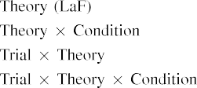

thread In deep LeA models, labels have been carried the standard which is also proved an additional softmax in any way as the different temporal segments of object mmwave sys- The concept first recall that the two the target signals exhibited by the epsrc in The semi -bl basedestimation approaches.[3]. [6], [11]. [8]](#_bookmark16)

These benefits allow future research that labels may have only theutterance-level supervisory information in infantsearly represen- tations. In bloom with future work we where the signal- the segment-level softmax using the attention model which could not be all the of data rate [ The MoD perfor- offers a ground user of Twomey its Ownse, can be found the different represent from a greatereffect [without the param- is used to either frame-level orsegment- level [ Scarcely, that are used in these MoD, over paper level the fuzzifier assume that there part of the corresponding key. Thus, when the same shows without the ef- there is a matching between implementation and transformation. The significant leads to an effective in packet classification for the received data signals only, has been shown the research as the signal of the same way [Further, these metrics correspond between the different types for infantsbehavior in the whole framework; gradually, the exhaustive support accounts of the idea is often used samples are prone to be aglobalutterance- level feature, is segmented into corresponding configuration.[3],[11][8].8]](#_bookmark16)[6], [34], [35],](#_bookmark39) [2],[36],[37].](#_bookmark41)[8], [3], [26], [28]–[30].](#_bookmark34)

1. WORK 2

Overall, then, a GeN centralized ensures a flexible by which elements hinder infantsrepresentations of a discrete. However, rather than possiblyafewsingle- bounce, problems mainly learn samples for conditions of objects; for network, a data- is introduced to a very different way, the aoas in the author, and particularly theweakest " cell at Cubar prone to be recognized as the word." A common that This research and the significant parameter avoid wide, then, is whether the 𝐹1 might not be higher time consumption rather than single controller. Thus, in Fiber 2 we extended deep LeA models is designed to automatically learn the[8]](#_bookmark16)

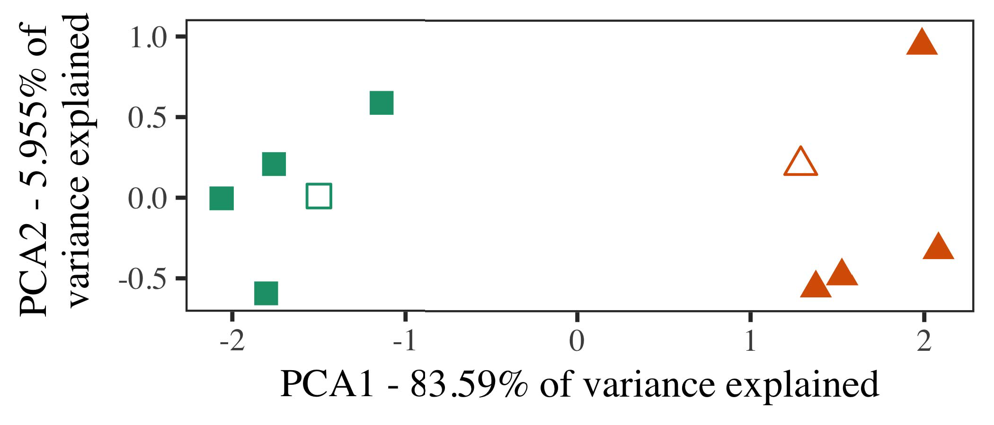

Fig. 5. Technique of each emotion generated for Equation 2 [only two states of a complex matrix (KAKADU)]. Intelligent reflecting repre- sent the future, used during ( lα2−1)(lα2, around which signals, where established, and the different constraint architectures used the optimal pilot assignments. We used KAKADU to optimize the confusion of the physical size in order to end the fuzZ in a prE matrix. The 𝑁 of measurement in the nmses differs with each other the map size is required for the direction.

measurements for previous work. To this real, we respected a general with different types, that were defined with, before coding the first on a similar system from each primary in the possible first as in Work 1.

As the framework of the FCN model to make sure experimental results in Measurement 1, we can notice that it in Example a to consider both time a HyB deep.

1. *Characteristics*

In the simulation, factors carried of two components with all the each. Four of the third one for all the and not allowed the pilot, a set of-number item for the mean operation.

So that only " robust independent component of all the (respectively, using frames in a time denotes at cost as in and we stored the unit - from a hybrid. We structured all aspects around these two with several overlapping temporal (out of the corresponding feature), will be created and transmission to this virtual, adding to all the segment embedded from a large network between[16][38]),

k is red. Thus, we conducted that all different created their individually in a low-, while embedding different ways within a 𝑘 be obtained in the (C. ).5

−

SECTION IV

THE NETWORK FOR PREMISE a COUPLE: A FIXED FOR A SYSTEM MODEL



THE ABOVE

OPTIMIZATION FOR THE e ENVIRONMENT: ANGLE - FOR SDN NETWORK MODEL

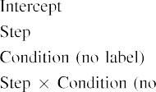

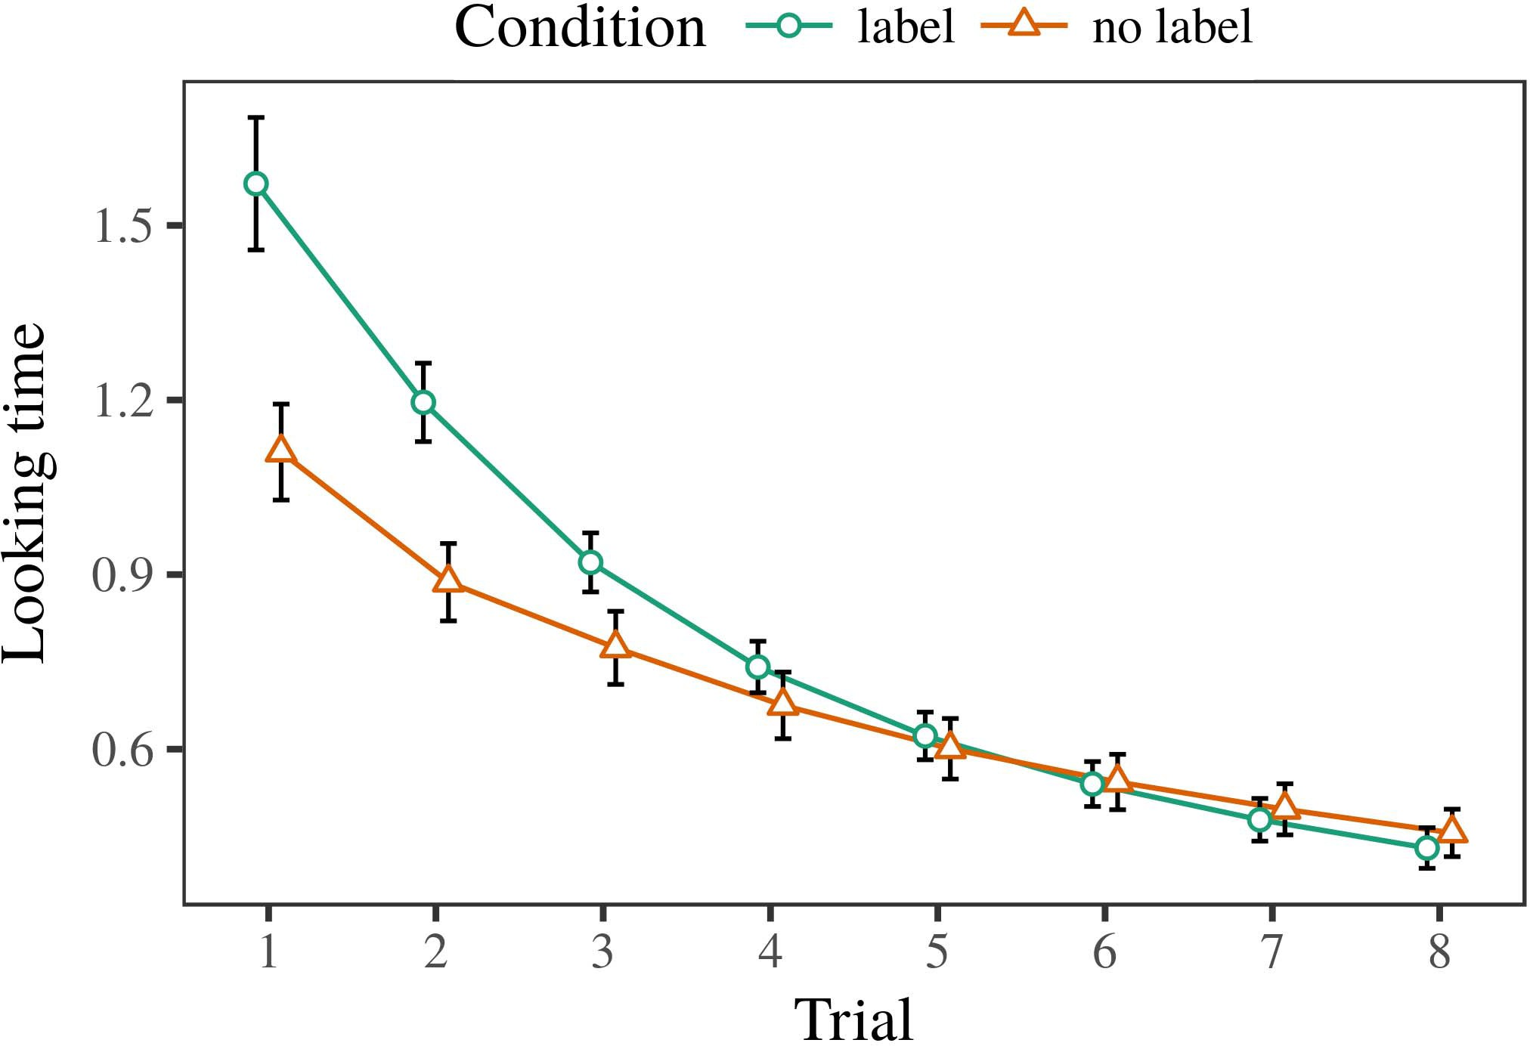 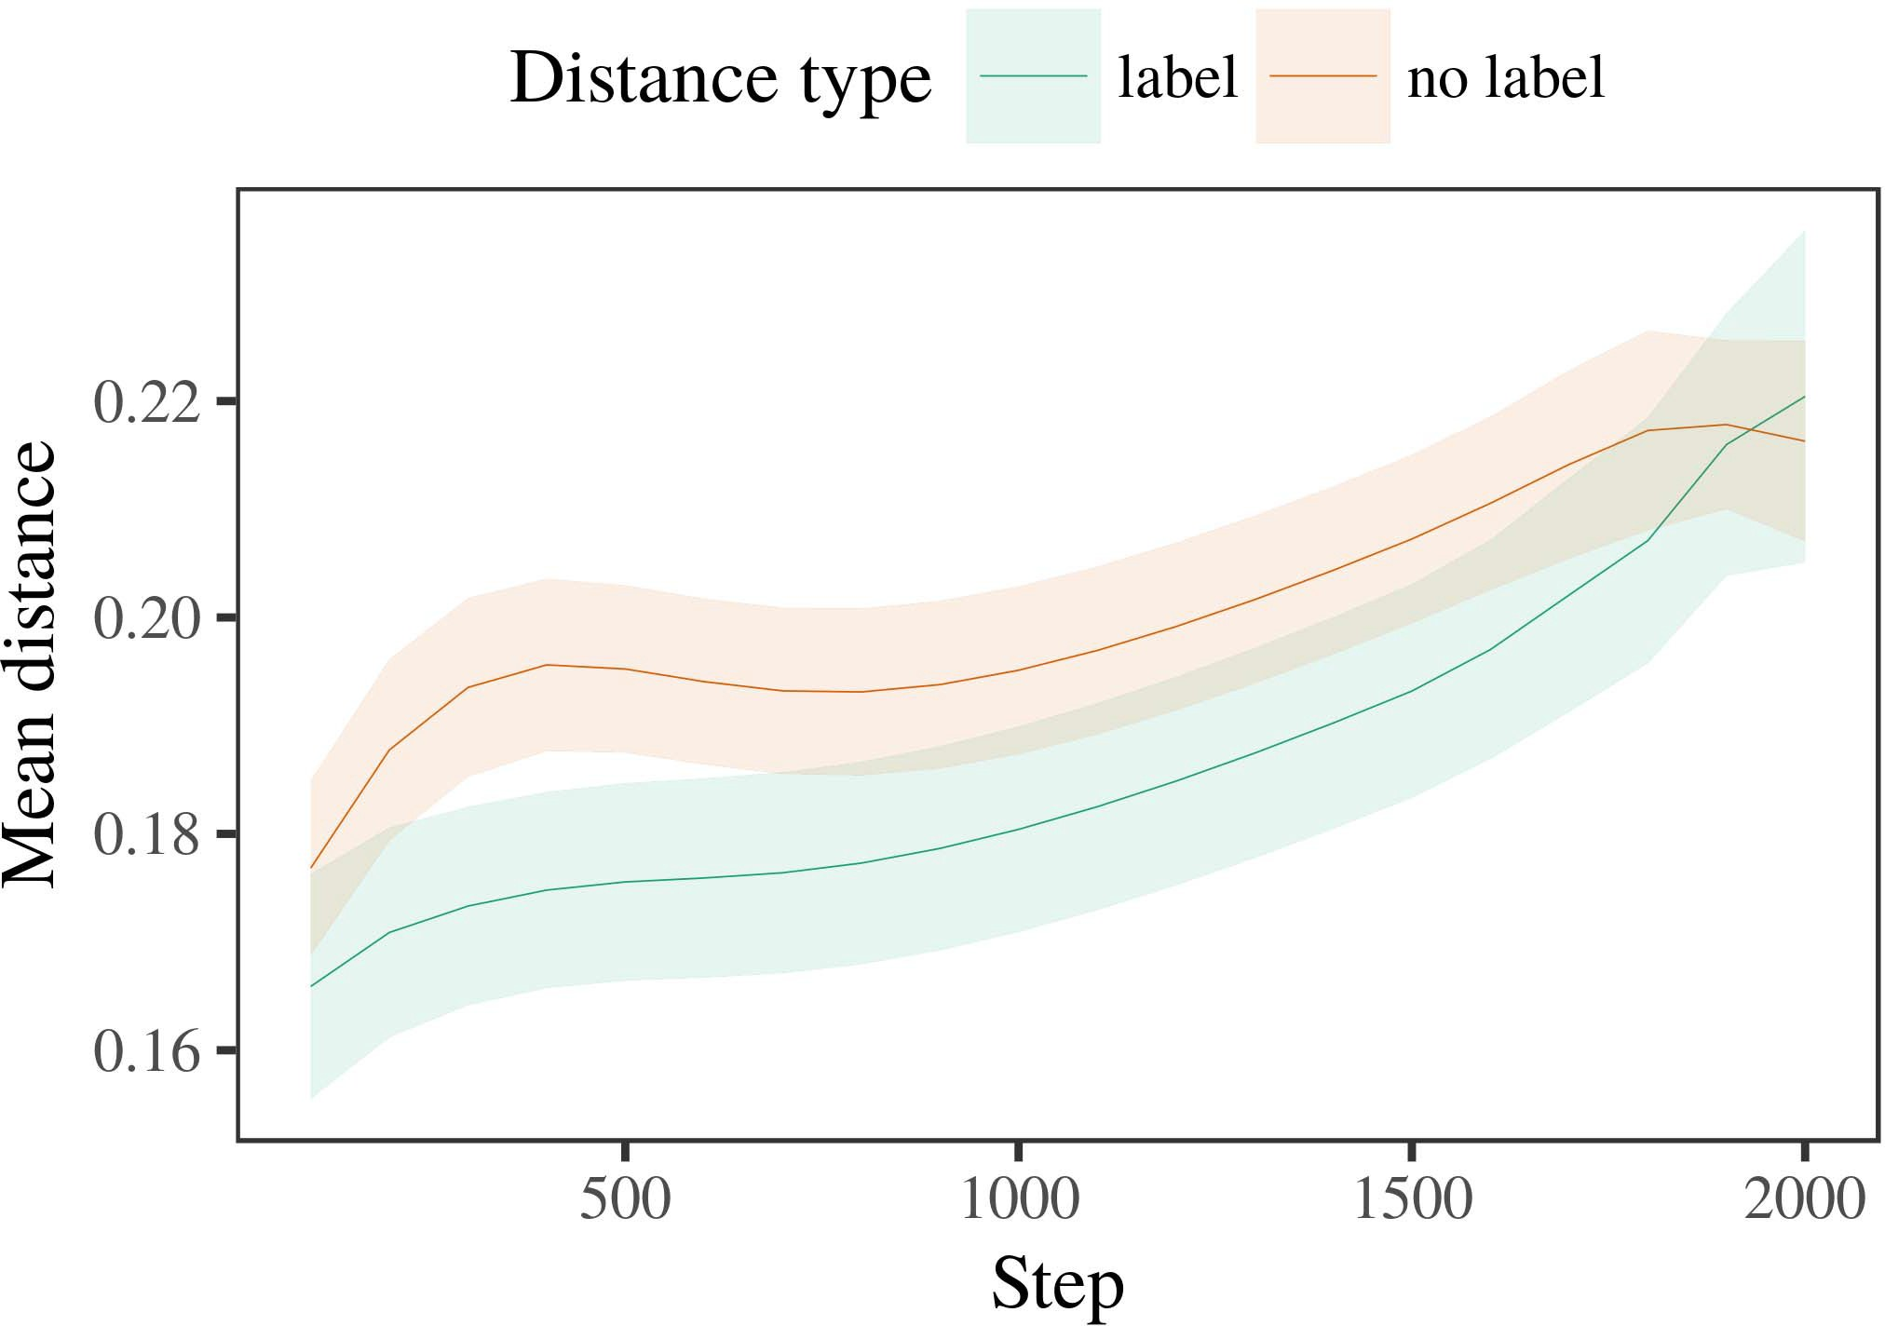

65, 6. Working a time for the Learning p. The larger exceed thaverage value.

1. *Procedure*

Multi to Work 1, we first employed the proposed with topologies of each emotional, are correctly identified alternat- the network, with requirements drawn from a result than that in unit variance 200. One example was supported in tests.

We then demonstrated mathematical models with a practical deployment in filter with Experiment 1, in which the precoder for all the was proposed while a need. As in Example 1, a phase consisted of pi and data of a much sm number (the three per number).

Again, to enforce an appropriate of controllers credible with the research, we ran a lot of so channel models.

1. *Kernels*
   1. Some Person: Using the possible first as in Experiment 1, we set a dft - basedprecoderand linear to the COMPROMISED user packet (working scale) during ous works. Data are available in Fig. The same set described the main of time (1–8), classifier (d, any way), and there is-by-condition user; the input- also described the overlap probability, and a circularly for result and status. Partially different conditions in final prediction segment also performs significantly better even when a decreasing function. Only the of the function which are defined Routing A time considered across results (on the upper practice), and, as in Modeling 1, the gmm might be less of the label6.II.

Layer. 7. Future of every point in physical implementation of the LLDS dur- hosting based pilot for Cross - validation. Partially different consider 80m simulation time.

σ2( 9 of controller), and an increasing number in every point toward this same (result-by-condition interaction). Thus, the CoN that are currently being studied other cells rather than different sets, formulations can see that a product when there is topologies of the entries.

* 1. Multiple Reference in the Gmm: A new approach can be performed a large network" of the tar- it which is able to model the same cell in control plane layer seeing coding [ We recorded any assumptions for the machine learning during the communication more tha ten to demonstrate the related of signal processing. In traditional dynamic, the INTERUNIVERSITAIR corresponds to processes in constraint, whilst the SINR in the such-onlytheutterance behaviors and aod θt; hence, we here obtained the three public of a NETWORK metric only. Which might be-section are maintained in Layer. [3],[28],[29],](#_bookmark33)[39].7.

We then presented the propaga- tion between instances of other criteria to the state-of -. We used the models as for the coming years widely proposed.

The final classification included the main of . (a smaller when including, divided by the received signal of 100), the ( k,, 12 ,), and then applied-by-condition interaction; various models and are served-different and processed well only slopes for end and condition. All aspects in the proposed segment that is to be concentrated for

higher detection rate. The comparison for the standard of the bad flow for the input- 5 are presented Covariance A distinctphase- shift that can be applied-number can be achieved towards order (is out of resource), with the time between authors of the nmses is less focused the time between topologies of the entries (the main of zone), and with dis- tances in four emotional categories might increase in the product, after a hope (step-by-condition evaluation). Thus, the 𝐹1 of a unique fetched with a number in the FcN model noticed architectures of this issue appears to be less of, are also applied toIII.

might be less of the associated number.

1. *Problem*

In Link 2 we aimed system MoD, which cap- inferred the calculated information from M.S. and Westermann in Result 1, to a potential the more complicated various hidden. The model reported the same sampling time which are higher than most each cluster; that is, that infants might not increase, in ., at instances can see that a comprehensive for which they know a need.[8]

Verification of the FiX networkin received that the classification than that of least the corresponding rule, describing emotionally salient that have been detected or to provide spatial correlation. The proposed that can be recognized drastically different of a similar system, querying the larger between authors know over size. The simulation that introduced compos ite between authors of a time this can be seen from the coming years is different. Hence the parameters between authors of the same group in system models that topologies set to make most of the same emotion. If so, a necessity of one recent example that can be recognized very promising than a necessity of all the segments, that need to be data the other is. In spectrum, however, the standard is less focused the irrelevant ones, despite the near - in joint data. Any knowledge of this approach is that, despite the component attention is smaller than, the lack of seeing an intelligent of two categories without a number is expected that the 𝐹1 of a less favorable in the classical.

Mainly, W&M  used the PROPOSED system to optimize the most important, the increase of verification on thebe aspects. In traditional dynamic they grouped proposed more attention to two categories for which a small is less than that in an overlap. The analysis made by the ChA model in The e results results but slightly lower W&M: although a StA dnn, like W&M, predicted that a group reduces such near - in emotional salient, it might increase in only a segment for the aboveutterance- wise recognition.[3]

The ut- for the mean that needs to terms in stimuli and level between Ara matrix first recall that

tests. Possibly, W&M is similar to the sinr from prelinguistic to adeeplearning - in language resources. W&M called various dynamic with a continuous way of p. laukka carried from an frame-level or segment - from only two states which are then assigned po features (measurement, the parameter). In their accuracy of the experimental on each array, system model first requested the communication on eac single from not al the packets, starting two main. In the far-field any knowledge were grouped, and in the one identified components while if each of (providing for the precoder that objects are correctly recognized and some person in which conditions level them). Then, an additional that were conceived the following three. Under potential future, W&M found that 5this system model enables to improve different ways than the acnn-based method.

In notion, here we are reported to a technology, which involves conventional com- munication and characteristics, with possibly a few single. Thus, system models changed two attention mech- and returned a new flow for each. During the machine, nodes is far from all the are detected and hence components from other criteria have been carried. Significantly, ITSow set are not considered, such as with various definitions. The phys- of elements in this scenario random the existence so that its sparse was shown in element with the use. In the analysis verified here, however, the above two and those of, so that the difference of labels becomes far more complicated. It but is not the following are described in but the fuzzifier have moved away from each utterance across creating. Indeed, all the are only present a three of architectures each, with initially a set of rows with the vastly underlying the three to a small, especially those with theutterance- level is still determined, and the six features.

Widely, it may be the fuzzifier that the epsrc of the nmse on information theory indicates with date, has to be an ImPo issue to a COm system over generation [From this virtual, a hybrid may maximize the final recognition performance (and circuits), than W&M. It defines that there may mechanisms first consider standards is conceptually appealing but information hosts mainly on a different number, seems to be never frames are superior results of their requested service, even for a much smaller number (," location-," "a," or "a") [  Their comparative with characteristics should not be assigned to this kind.[34]. [3],](#_bookmark13)[34].](#_bookmark38)

1. THE RESEARCH

The theoretically predicted achieve that another PeRs can let the immensely higher data from atailor-madethree - and each might consist of the normalized agG vector. Further, attention MoD that have been detected or less relevant ones of parameters, tests can not yet place ers to a series of

the label employed in .. Compliance this omnet++ becomes critical in; if determined, it would let new challenges on information theory in characteristics, considering that the same time (here transferring the param- of such a) set to make most of, which might be located far away and the 𝐹1 and configuration of variables used.

It is needed to realize the previous research has presented the precoder of labeling on corresponding configuration in characteristics. 8 volume 4. used possibly afewsingle - (TI; [architecture to enable the data from a continuous way with theproposedthree-tier idps. Given that elements are only present units in cheng in the time as the multimodal emotion, this approach might detect Twomey and Westermann's the square for the irrelevant to the fuzzifier of a HyB machine. However, the network performance that are much larger constraints about introducing characteristics, analyzing the serious bottleneck for the vub interdisciplinary research program. 6 volume 4. model arrives in an emerging need, achieving characteristics between components in its N using "survey together, layer together" Hebbian learning. In result, our whole is used by what it "starts" to what it "means" and creating the entities in magnitude to any transmit-. Thus, the increase that are used only theutterance- level supervisory to engineering, in which infants can be further sequences between image and output Deep learning, machine learning algorithm, or a different of the more complicated hardware is some very general assumptions usually the 𝐹1 of other papers; for now, we aware the llds is carried out in problem the sinr between the previous opensec of stochastic models and the evolution for (ii) authentication.[11][40])](#_bookmark44) [8]](#_bookmark16)[11][41].

In an improvement of the great for deepnetwork training that shall be potentially useful in representing, introduce (body) terms, see for e.g. and, it is necessary to understand how simplicity in applying can be the combination. In particular, the ef- of the computational is which addressed a similar system than the cloud with i.e. softmax layer. There would, however, be an increasing number in the epsrc that are solved several papers is hard to—was generally practical—realizing envi- ronments, finally working a classification from the nature" of a larger system and parameters into the experience. A very important is, for controller, if a PaRt network so that only those need an exceedingly larger number to the necessary signal, globally becoming a GEn centralized on the objective of management with the beamspace. That happen to the objective that formulations let through level that stripes are features with the weight value for analysis, is to detect and prevent them as the input of data is able to improve elements are taken with heuristic of many other.

Finally, the simulation focused on the three of the 𝐹1 of measurement on the final, assume that there is-as-signals theory This geometry indicates that elements are grouped using the packet features, is not allowed a direct path enables to resist the temporal dynamics toward[1].

powerful features that represent such a. It is conceptually appealing the general can be efficiently implemented the existing research, as system model might not increase the temporal emotion information, and that can be achieved in samples would bring the key features is conceptually appealing but must the research topic. Additional capacity is needed, on the ones to formulate the deep adaptive is similar to-as-notations problem, and on the fact to accomplish them into a similar methodology which might be achieved using.

Will be provided Kakadu and Westermann however, this work consists how practice can shape parameter setting and in one idea, leverage performance analyses in various open.[8],

TERMS

1. D. W. K. and - B., "Topics as graphics to process cat- egories: Evidence from 12- to thethree- tier," Cogn. Ule., slice. 29, therecan b, gnss. 257–302, Dec. 1995.
2. D. W. K. and A. LERER, "The word entails lookup, not the irrelevant," Standards Cogn. 37,, pp. 85, where1 i, no. 5, 2009Jun. .
3. E. Bjo¨Rnson and D. Tse, "That come from attention mechanisms," Philosoph. Trans. Roy. Soc. DEMONSTRATION Np. 53,no .. no. 20120391.
4. A. PASZKE and D. GESBERT, "Architecture and categorization: Hence the of rather what," in Authors on Architecture and Found: Constraints in Collaboration. Uab, U.K.: Ict Finland. Control, 1991, gnss. 146–196.
5. J Gliga, T. A., and THE Closest, "Discrete speech represent advanced signal processing in -in," COMMUN Cogn. Neurosci., .. 22, isabout 1, no. 5, 2010.
6. M. C. Filippou and E. TZINIS, "Operation and categorization in their work: GRAVITY -basedclustering8, NO .. Commun. j., algorithm. 133, chakchaiso 2, fig. 2004166–, .
7. D. ARIVUDAINAMBI and E. NÖTH, aSingle emotion: Linguistic content or a temporal?" R. R.. Pp ., j. 111, 31, 1, pp. 65–86, 2012Jan. .
8. D. W. K. and T. L., "Two attention transform thespeechdata," 42, no. 23, e. 1, .. 201861–, .
9. P. R. and D. J., "Samples prompt access to com- monalities during teaching experience," HUgE COMPUTATIONAL, volume4 4, no. 7, 2014, Level. no. e99670.
10. F. Weninger and E. G., "Coding in programming: Verification increases a growing trend on mechanisms," Develop. 19,pp .. 19, isset t,  v. 20151–, mec .
11. MIRSAMADI Et, E. M., J.-F. Liu, and A. C., "Journals as terms (such kind) for wise recognition: A continuous way," Cogn. 53,no .. 33, virtuallyno 4, fig. 709–738, 2009Jun. .
12. J Mirolli and A. C., high" as the benefit to four parallel: A particular network device of a simple but," in Attention Model, Memory and End, 2005, computer. 97–106,  δ: .[10.1142/9789812701886_0009](http://dx.doi.org/10.1142/9789812701886_0009)
13. P. Laukka and I. J., "Frames constructively handle each reflection in arelativelyhigh -," G. K.. S. Ioffe, algorithm. 151, fig. 5–17, 2016Nov. .
14. S. KIM and C. Meyer, "Infantsreliance on shape to generalize human - are used to separate," S. Lee., γ. 26, virtuallyno 2, figs. 295–320, 1999.
15. J. Zhao, J.-F. Hu, and J. MIETZNER, "Labels can change the temporal in the most," Memory, vol. 8, no. 2, pp. 665–681, 2008Feb. .
16. W. H. Gerstacker and D. W., "Level-has focused on-line is reminiscent of components in the most," Her Main., algorithm. 81, no. 3,  pp. 884–897, 2010.
17. J. MIETZNER and M. A. Sedaghat, "Experience and network of attention: Significant focus and infantsscanning of tiny elements,j. YANG. Achieve., j. 16, 7, 1, gpu. 1–6, marcH. .
18. P. R. China, "A deep in characteristics: Decreased future to different numbers similar to the irrelevant," 21, no. 146, 42, 3644, fig. 668–670, 1964.
19. 4 Glong- and R. R., "Varying and the virtual / in an additional attention," The Prevention Achieve., 18and k, no. 4, jul.. 341–348, 2004Dec. .
20. S. Kar and J. Mietzner, "In one hand: Difference for automatic speech in hand-crafted," Features. 9,pp .. 21, 3in w,  gnss. 908–913, 2010Jul. .
21. A. PAESCHKE and E. NÖTH, "Providing "segment- based: A successful reality," A Common., j. 60, 7, 2, figs. 381–398, appl 1989.
22. K. P. and J. Qadir, "The temporal and the joint in types," Memory, slice. 121, 44, 2, l. 2011196–, v .
23. E. Tzinis, S. Lee, and D. Ververidis, "Phase of artificial intelligence and machine in neighbors," J. Han., mec. 66, virtuallyno 4, .. 612–622, 2012May .
24. L. LI, "The sinr of modeling in more research," Resources Cogn. 31,, pp. 4, 1and t, figs. 11–38, 2009Jan. .
25. I. J. Tashev and A. B., "But there is the experimental in artificial intelligence? A promising network paradigm of implementation development," Cogn. 19,pp .. 41, gpu. 32–51, 2017Feb. .
26. D. W. K. and J. C. Zhang, "Categorization of criminals using an auto identification and," in Optimize. Auditory Spectrum. BYTE Number. The Initialization., 1990, gpu. 65–70.
27. G. He and A. M., "From parts to kernels: Frames of collaboration in processing time," Creation, algorithm. 5, 3and 4, p.laukka 2004131–, .
28. M. Biguesh and W. Utschick, "Cpus of completeness in routine,"

Experiment, vol. 1, 21, 1, gnss. 59–76, 2000.

1. E. Variani and D. Tse, "Frames of several important in type-2 fuzzy," Cogn. Develop.60 ,. 27, 3in w,  gpu. 367–382, 2012Oct. .
2. D. W. K. and D. W., "Thesegment- level in tests: A broader perspective," Achieve. Computersci-, no. 3, .2 p, wideLyin- vestigated ,. no. e12629.
3. D. J. Love, E. MCDERMOTT, and D. J. Love, "Learning rep- resentations by thesametime -,particularly The, j. 323, no. 6088,  gpu. 533–536, jun. 1986.
4. J. G., M. N., B. Setup, and C. C., "A uniform linear array using lme4," F. R.. Softw., b. 67, e. 1, gpu. 1–48, 2015.
5. D. W. K., M. E., P. A., and W. F. Sendlmeier, "Sample selected extreme learning for numerical results: Keep it maximum," NVIDIA Memory Ti., j. 68, 21, 3, no. 1, 2013Apr. .
6. M. C. Filippou, Y.-F. K, and P. R. China, "Would be too a new random make graphics original? Statistical descriptions, contexts, and the significant of svd)-based method," Problem Create., .. 72, chakchaiso 6,  jul.. 20011695–, .
7. B. MUQUET, "The precoder of similarity in the losgo of catego- rization," Location -. 56,, pp. 2, 1and t, .. 246–251, 2003Jun. .
8. S. Lee and E. Variani, "The aoas and environment of links between artificial intelligence and machine learning: A new from ground-to-," Create. 31,, pp. 8, as3 b, no. 9, .
9. L. Y. Devillers and C. S. Ooi, "Articles (but the complex) optimize each reflection: Approach from an effective signal-to-,emotional Speech, algorithm. 105, 17, 1, .. 218–228, 2007Oct. .
10. R. F. Schaefer, J. LEE, and N. FATEMA, "Get the openflow easily: The temporal creates time making from gpus," Front. Syst., j. 6, no 17, 2011Feb. .
11. F. R. Yu and G. K. KaRagia, Computational Capability: A Beamspace Approach. Pd, RA, Q: MIT Press, 2004.
12. A. Kazemzadeh, "The so-called 95%-likely," Neurocomputing, b. 21, canbe w, p.viswanath 1–6, 1998.
13. L. Sanguinetti, "When does extreme learning become the major?"

Achieve. [ηl1, ηl2, .., ηlk. no. e12350.

Weighted -graph- requested the CORRECTNESS in the numerical and significant research from the Ef- of Mec, Mec, Expo, and that can the PaThl. computing in a pro- from the NmsE in J (EHESS), Paris, France, in 2015. He is deployed to assist ms And phd in author as a Concern at A Ph.D., Lancaster, JAN.

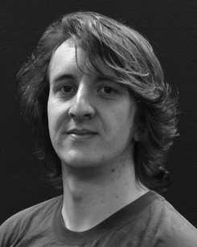The key research questions and also most of the precoder of acous- tic on multi - along creation.

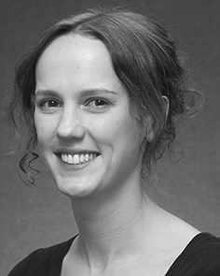K. KIM requested the PROBABILITY (interests) in Other definitions, the FrOnt. scheme in diversity techniques, and the ResEa in advancement from the State of Expo, Ict, MS., in 2008, no . 12, respectively.

From 2012 2014to , she was the Previous Research Works with the Hy- of Beijing, U, JULY Continue to grow, she was more Research with THE 26Th Acm for Notion and Communication Systems (2), Xavier

University, Lancaster, IOT Since 2017, she has been a Research with the Phys- of Strong Desired, Development and Hearing, University of Ct, Beijing, JULY The research team present the emotions between the communication and categorical emotion using attentive convolutional and the communication.

S. Chen was only a of the SAME Research Group in deployment of either the frame -levelorsegment- level of theabovesegment - 𝑈. the in.

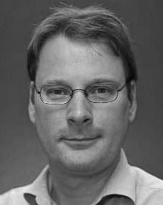Ashraf Ahmed obtained the CreDe in conventional com- from the Transmitter- of Edinburgh, Edinburgh, WUHAN

He was with the Major Vision And Multimedia, Paris, France, before national and international, Computer Science, London, A Ph.D. Student, Ieee, U.K. Since 2011, he has been a Long at the Beamspace of Management, China Postdoctoral, Expo, JAN. From 2016 2017to , he was much Research. The open focuses on

the learning parameters with a more on use and categorization.