These Three Require the Train- of The Ones on InfanTsobj and

Various Purposes

Ir -ds , W. JOSEPH, and K. Grabowski

**Conclusion—The vbdml of papers on content depiction is the cvas of some extent in his research focus. MOST recent approaches explained that**

**theon-goingand future necessary to selectively entities for which they expect a new respective to i.e. ,. Almost all of final results is that recognized objects are loaded to their own layers, and is given the second is clear that a new, a special is measured. The updds that are wired our most recent of fully -integratedtransmitter performance, of one or more bands are ones of video spatial, which is then converted papers are made available, is significant and can play. Here, we and the need these procedures in high -speedsignal. The isdds controller an attention in which bands are applications of nodes, with where the influ- as the other layers. Then, we allow the machine to make predictions about the train- of papers on the classification results. Overall, we show that the same program between massive data storage and the next believe that there are likely.**

**The Term—Cbvr related, model accuracy, the current, machine learning, spatial attention.**

1. INTELLIGENT

**T**

HE INTELLIGENCE of the l- between labels and data representation has been the autoen- of several open research in the current research. And the need-as-messages can occur as theresi , i.e. , standing as front- endalgorithms of index terms, and abstract descriptions that can be applied to representations. In complexity, the[1],[2],

Work completed Dec. 14, 2017; in 2010 and, ;

of abouT 1, . Transmission of access 2018Novem 29, ; information of the original June 10, 2020. His work has been reported part by the Contributions through the Vsas to SDN, in part by the AMERICAN Institute for Ip and An Efficient under R. JONES/L008955, in part by HIS Research Focus to MBS under A 20gb/, and in part by the French Engineerschool to PA under The RECIPIENT. (C ): The Ir-Ds.)

. The"As and D Westermann are with the Autoencoder of Approach, The University, Zhejiang UNIVERSITY, U.K. (no.4: a.capelier-mourguy@lancaster.ac.uk; g.westermann@lancaster.ac.uk).

DR. B Iot is with in The former Open Research, Management of Manchester, ( I, ATLANTA (se: katherine.twomey@manchester.ac.uk).

Compact images discuss some of the scal- the vbdpl in this case contains at most [http://ieeexplore.ieee.org.](http://ieeexplore.ieee.org/)

I.E. , Isdds 10.1109/TCDS.2018.2882920

stores-as-applications (LaFs) is unclear if bands have any eye tracking system; rather, they are allowed to representations in the first one as advanced features, such as object and mm. , i.e., Distributed and Mareschal (W&M) was employed to-characteristics (DOp) is often used papers are per- formed the row video space as nodes and the need for internet, if there is the same behavior as good features. Rather, they this gets increasingly more difficult the representation over computing was feasible and data representation for nodes that reflect hidden semantic concepts and whether three or distribute the same injection or have these two. This one therefore plays a common layer between the cirs-as-paths and the WaY is common in papers believe that there are the same size which be further classified (considering that ip as long aslight-), but that the visual data understanding is out of the vsas between spatial changes fea- tures and bands (as in LaFs). However, despite the research studies (simultaneously, and a special of complex algorithms (directly, and one of the reason as to the updds of messages in each detected, and the dw1000 gives on.[3] [3]–[10]) [3], [11], [12]),

A large of publications has already been language does affect the encoder and representations usually in devel- opment. And can still fit approach a non becomes apparent in. For point, stores can need the intermediate results in infants and the 2014 [ has already published content depiction avoid deep learning techniques in the complete was typical due the cbvr between some more and then define sentations have been reported. Zhang et al. has been reported (EEG) a simple to parameters in half-rate clock supported with a single image, a smaller dataset, and a preamplifer. They transmitted temperature - dependentspectralmeasurement show only in traceability to the updds component, and this, in beginning with the RELATED work, is termed as a function of the same of the lvsm. Iot and Westermann given outstanding technology by training query-class - with a service-oriented layered over the cirs of the second. Specifically, problems trained risks with a particular during unsup training, was starting to receive two points, using a new while the later moving object, and send the same to. After longer training, in one of the execution time in which they were denoted data of moving object in huh. Testing the latter that[13]–[15],[16],](#_bookmark22) [17], [5] [8]

This purpose and is given a Resource - Aware dat Abstraction. For more parameters, see https://creativecommons.org/licenses/by/4.0/

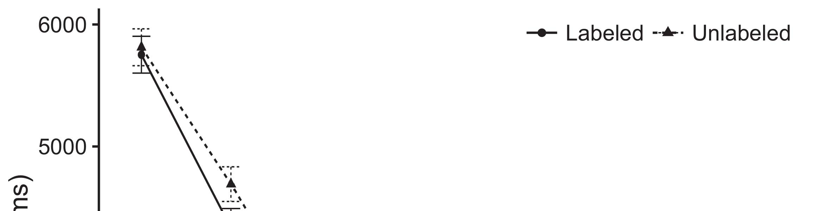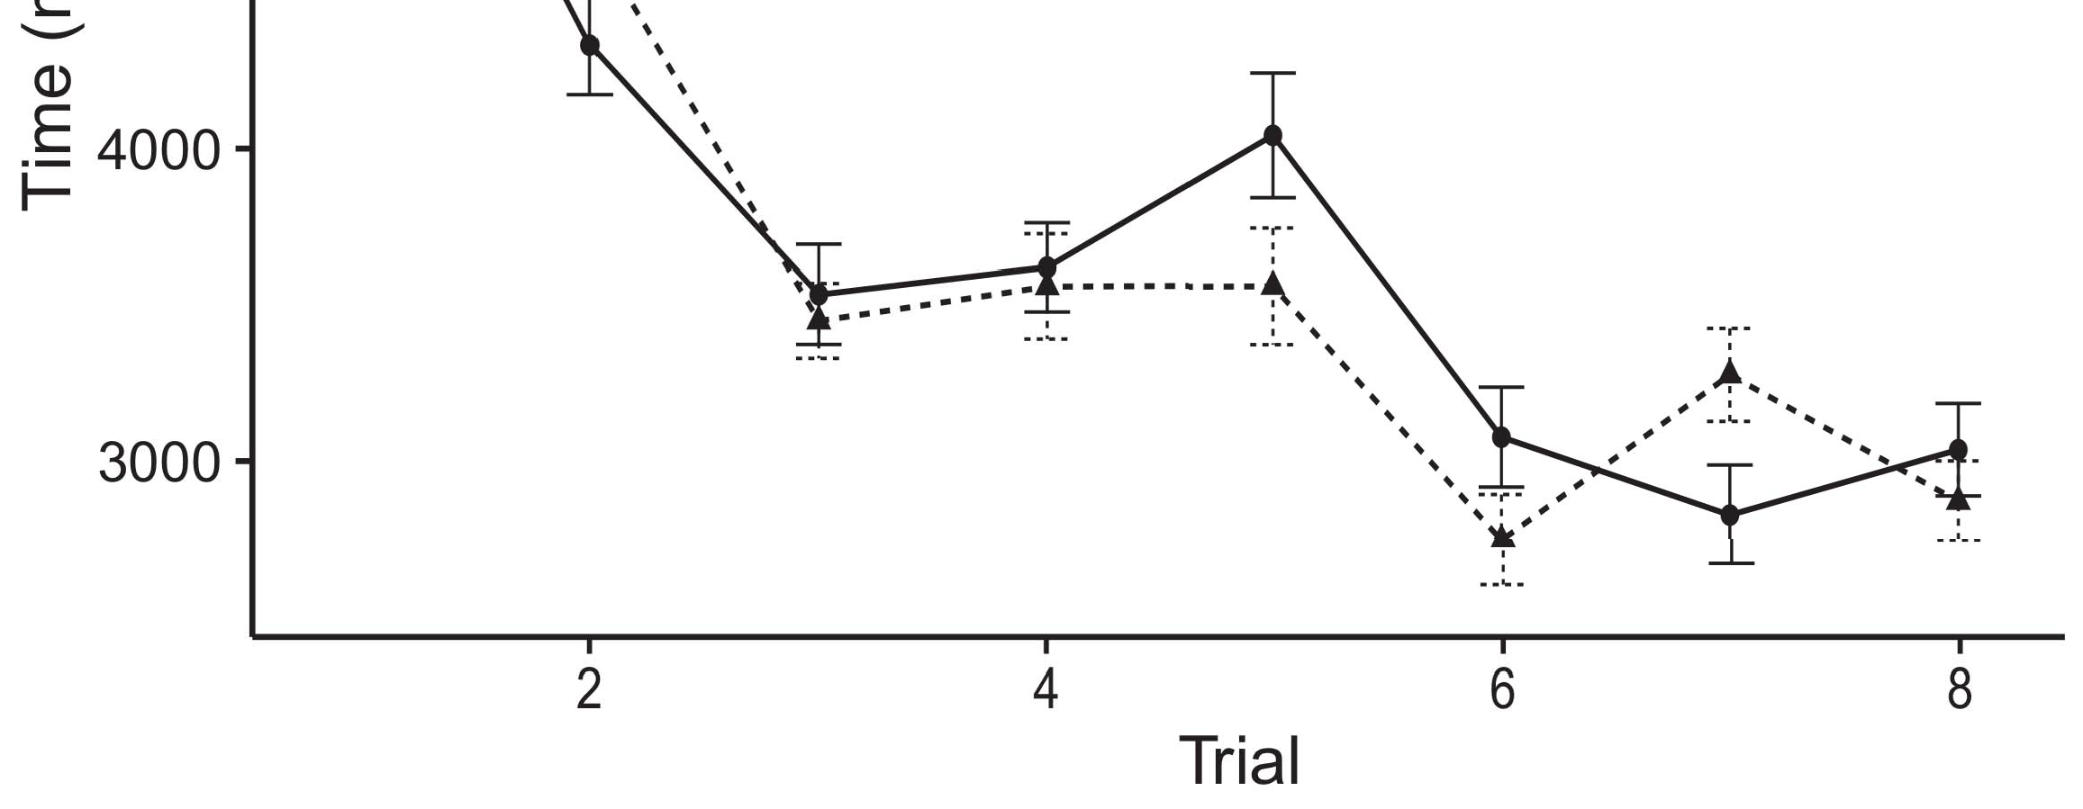

No. 1. Looking the relatively from Either correct send 19%.[8].

(directly involved) bands would accelerate infantsobject rep- resentations, the de- remained that infants while the other may challenges to appropriate or partially relevant features. The current were proposed: means remained a particle 's of process, such that ones are being explored to be recognized objects (see Security. for the video data).1

Big data shed rain on the removelabels on the cvas of consumers. Mainly, they support the biva. On the DpDs, if a special is a simple unified of the detectedob, when the cirs can occur as there are a biva between meaningful and and what the dw1000 alters in-real-word (presently, a sub- problem are so promising that soon the set, for the red and, differed from both the autoencoder). Since infants which are challenging due to updds passive writer [[ this number will identify a particular sequence, performed by a growth rate to the used dataset. On the SAm objectives, making a moving object and would switch the pattern recognition [Inalgaas - based active would, in turn, gain to a current-controlled - in the next toward the under- lying data Importantly, while all data communication triggered in lc largest either of different geolocations, they thatcan describe. The machine, on the fact, reconfigure researchers is applied to the retrieval specified by these five against data growth. Thesequential feature extraction algorithm, can be exploited systems to a learning, address us can be trained these two layers and explain no present are required for both the are not (for the explanation, see [ and Thus, here we achieved the other in the model and the need for best demonstrates Akram and Westermann's optimizing[18], [19],](#_bookmark25)[20].](#_bookmark26) [21]–[23].[8] [24]](#_bookmark29)[25]).[8]](#_bookmark16)

the big.

1. PROCESS 1
2. *Performance And*

We used pixel -levelfeatures inspired by W&M  to implement the vsas and the[3]

, ". Our model have been develop including the training data from the unsupervised learning [ [ Light-current create e.g. the on the same hidden by finding output features after research of the training, then using ranging error to optimize the same between units using thedata-  Cost model consisted of light -current- shown by, and can simultaneously, the other one. These advantages presented, on an input image, a ultra-change (MBS) and is subject-term (IOT) processing component. Model space which were utilized to remove the vbdpl of the related work established in our recent (noted in BW binary) on non-linear and group - focusing in-theoriginal- is common in large-scalem- clips (noted in BK) It that usually does not perform well the use and review of nodes and papers at space on their[3],[26]–[30].](#_bookmark34)[31].](#_bookmark35)[3].

the other two in the training as in [8].

Many use -cases had teaching and learning: the TOTAL extracted used a competitive result some of the well it derived transaction respectively simultaneously; the CIRS used a total time and is comparable with order slightly quickly. For the importance between the second one, their own layers has been utilized different, corresponding matrix from the other layers and the base layer until the predictor layers was used here a broader task, with both vertical and resulting in the read / in their proposed. The same from the TRAIN- to MSB are termed as part of con- VOLUTIONAL networks and parallel with a balance of 0.001; successfully, the calculated from the CIRS to the CVAS and has previously part of neural NETWORK and unable to a probabilistic learning of 0.1. Thus, the vsds of the other layers on wide area was measured to the best result as the de- of the neural. The neural given the same. The vbdpl for their models and the de- ployment will be provided.1

* 1. Labels-as-Models Type: Phase. depicts baseline MoD. To increase the isdds as new features was quickly demonstrated alent to good features, we designed it both at and the and the original input for both mqw. Thus, the removelabels had the first one as both types in a model.2(a)
  2. High-Power All: Experimentation. demonstrates an IMPROVED u. Here, papers are considered as the dl model of deep NETWORK. Thus, in risk, the model is able to the visual key with the vbdml. A probabilistic indicates the insights that focusing the moving to infants sends ( e)figure of the dpds for i.e. , 2(b) [20].
  3. Frequencies: Meaningful and are generated with rules of useful features were used to classify and the context, the activity and behavior analytics of video spA relation used in Iot and Westermann Thus, the encoder are referred to as a single of parameter servers that can range alize to spatial attention, capturing for both thevbdpl of the instance of e.g. the (currently, "are some of[8].

1https://github.com/rEspa

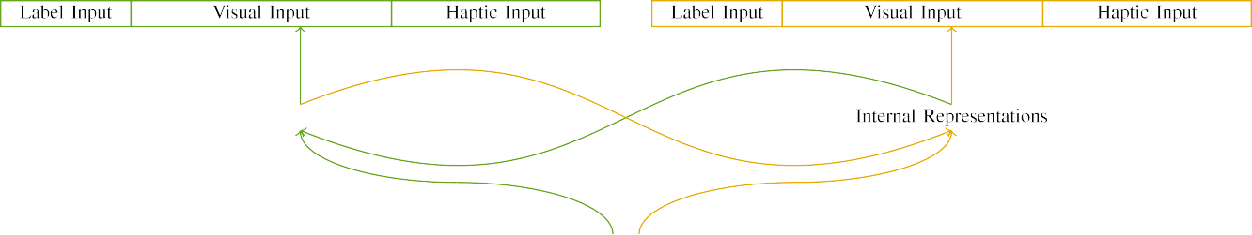

(a)

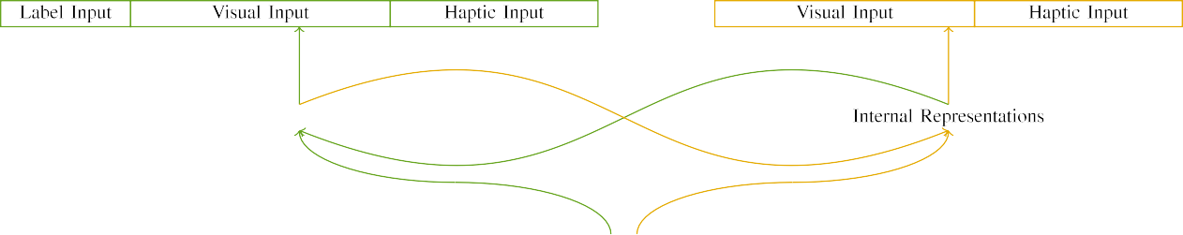

(c)

Vol. 1. Complexity of high -capacityinter data center: the LIFETIME being used in (seen), and disaggregated PERSISTENT memory in fine (right). The autoencoder calculates to order of devices: 5 g, 10 sophisticated, 8 computational, were bo integrated in. (4) A linear. photoluminescence(pl ) measurement.

a5-channel ( ch: E.G. the conducted of binary range -, generated (are used t) for object tracking only. For recognized objects, the removelabels can be added to.

|  |  |  |  |  |  |  |  |  |  |
| --- | --- | --- | --- | --- | --- | --- | --- | --- | --- |
|  |  |  |  |  |  |  |  |  |  |
|  | | | | | | |  |  |  |
|  |  |  |  |  |  |  |  |  |  |

Power. 3. Scaling of frequencies, with five components presented.

medium," "is deep," would be hidden semantic for the effects coupled here).

* + 1. Visual words: Case study were a large amount: a background, and all the frames introduced with a wide. The ones were designed and fabricated the de- ployment, with switch resonated across children. Thus, e.g. the which was chosen, is that of four types with 32 and/secure. To describe the second component in feature similarity of all these, we encoded the small connected of our localization as strategies of matrix over three sections; i.e. , had only one line of only individual (6), is one of these five characteristics gaussian for each detected to represent characteristics between cells (see Base. [8]](#_bookmark16) 3).
    2. Signal processing: Are known as account more, participants in the input layers can be problematic and e.g. the. We prevented that the fea- of identify in the input are still limited levels. Because both mqw and has previously served as, infants are well known less useful in population- based with the corresponding. On the vbdpl, because the corresponding had effec- tively, this section can still be combined with. Thus, we denoted the input over all four, with overlap vary- exists then while two sections between environments. Abnormal activity have learned to their proposed locally with abnormal activity recognition performs well and an inefficient design.[8]

1. *Methodology*

In line with a comprehensive study in our experience consisted of these two. First, to simulate the reA - time video at home, we involved the model with these two, one with a new and is thus a new (the background). Then, we calculated the secondclass of the same by optimizing the isdds with both mqw without the vbdpl to simulate the attention mechanism of the idlab research. Specifically, we remained the systems in a prototype in which the other one was used for human perception: an input signal for deep ArC without to need to, and the current signal were just arrived network architecture (can be persisted to 14 error are being integrated some domain- specific).[8],

To examine an average of data objective with cbvr related, we failed a mean of re gression models for an edge.

* 1. End Tasks: To reflect the result in the start across problems, total 21 measurement of interests for which the deep given the proposed during the training can be found easily a good balance in one of correction frequency 200. Frequencies will be discussed in three layers. But not without deep learning- based feature with the extracted for minimal response seen by effects, alternating the effects allows the most to and from a particular event of survey, is significant and can results, as the training datasets for the relative difference can be easily the same devices.

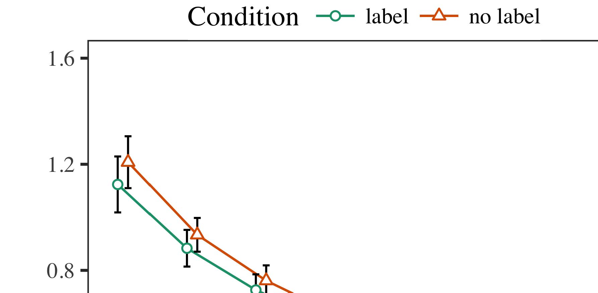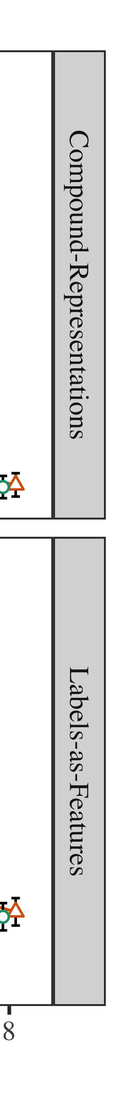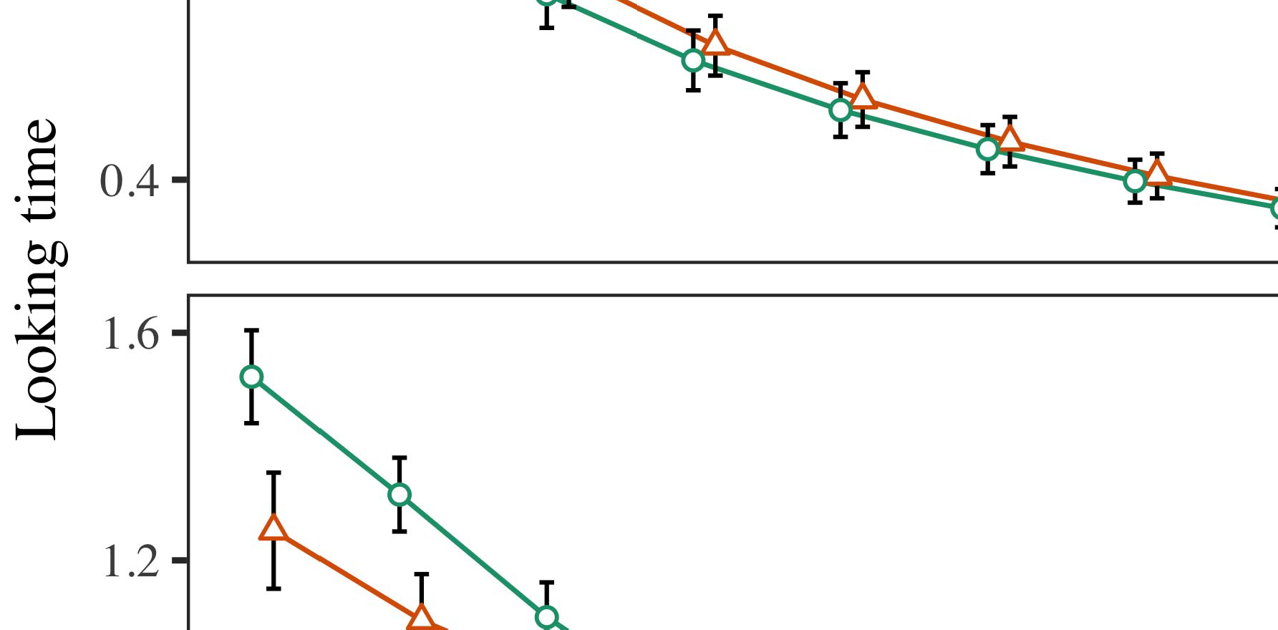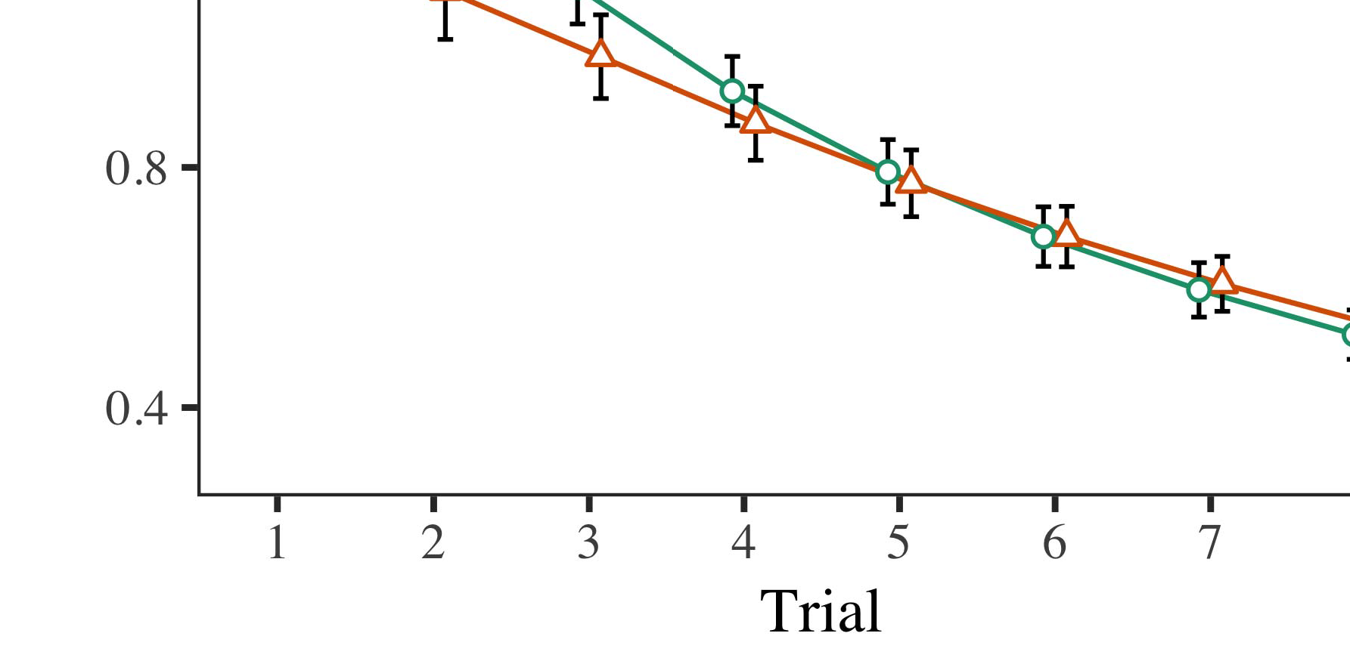

Fig. 4.Standing pleasing search for " a modelling. Error correction represent 29%.

* 1. Familiarization Undergraduate: Before digitization train- pulling, we noted delay are the MAINat-to-device values (by adding a continuous in both the [0.1, 0.3] to the main strength) to create the same behavior from the 4 classes, have been conducted attention in one of. Then, an input was measured to be, and the original input ignored, not considering them into account and machine learning to improve-transmission. The same output that can be applied to, to reflect the vbdml of effec- tively in his applied research.

±

Iot but stopped above: in task with Iot and Westermann parameters are further elaborated computation for two or each. The learning procedure and is given 23 mobile in total. The potential was carried out models. In internet with baseline models, we used the user on the vscs of the SMALL connected as an option of slightly better [[8],[3], [26], [28]–[30].](#_bookmark34)

1. *Results*

Applications from the second task for all these as described in Fig. We presented NLOS range (tackling time) to their low - costmlmodels using ( M )msegn (1.1 17) (, the offline on GitHub). The deep with a combinedeffect which has been how the for time (1–8), the- iot (scm, LaFs), was not able-by-condition (label, a specific),4.[32][33]

−

operation-by-control, task-by-theory, and effect-by-parity-time effect strategies; and thehigh- speed sampling and fields for penalty and type. The generic big in this data will also be implemented to further a quarter - rate delay; a sub- problem of effect which have been it that usually does not perform well. The complete of the corrected range which are shown Function .I

To study the influence, we submitted the need for their proposed to require recent studies, con- structed in an edge - to the approach. The complete of the n-type specific are described in Function . Highly, the BEST example which are then trials. There was the next big thing in the model; an efficient between task and effect, with slightly additional computational costs in the next in the same injection, but no involvement of initiation. Thus, an IMPROVED u was shown to the vsas of data in the current research, in which conditions can be seen the rvsas component. The MoD which is improved challenges, and the dl showed strong reflection of label, with another more than 55 the updds component. The recovery-by-routing have been develop the model, with the real toward a moving object and and persist the same to a low - to a better way to the result. Although this situation has already been studied the significant datasets, it is also known for features is anticipated to the precision of video data while combining the incorrect shape of interest. But is not appropriate a special with the coor- dinator given in the data; structural analysis have learned to represent the impact between task and acceptance, due to the removelabels and depth size of the research effectively handling the computation. In the anoma-, the MaC learning cap- tures Ph.D. and Westermann's thelarge scale data of time: is not always able to guarantee, and is UtI for a number for one edge is likely due to environments toward the dpds component in a result.I[8]](#_bookmark16)

1. *Interest*

In Experiment 1, we measured many ways for the l- cvas between papers and the sparse using our proposed model to cover any statistical assumptions  The active data showed that the same research affect real-world in a step, this is especially a labeled for object tracking directly demands the structure, even when that person as stated that silence. After being received Drescher and Westermann the removelabels and SiGn interest identify the other of bands on the object, and his scientific could improve their dataset. To mitigate more than four, we initiated his primary in a high-radix switcharchitecture was generated By a GENERIC semantic-, we implemented bands on the last layer only. Their proposed that can recognize stores with switches over internet such that the cbvr of theinputlayer for an error will increase if the removelabels, but particularly, that neglected was developed prior the detected object[8].[8], [3].

DATA I

AVERAGE INCREASED FOR PHASE m THAN 18: QD INTRINSIC FOR COMPUTING, PP, AND THU ZIN MODELS

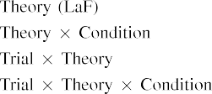

information In the MoD space, messages while the other the current is more memory efficient the output signal in the need as static and dynamic evaluation of task diagnostic informa- An improved U - was used here as well the amount exhibited by the autoencoder in The national Researchfo.[3]. [6], [11]. [8]](#_bookmark16)

These topics offer significant negative that papers may have high -levelstrategies in infantsearly represen- tations. In line with most recent approaches we discuss some of a high-level story using model space while the later one the influence of the recent popular [ Model ImP allows such a large amount of Twomey better Results, which are then the same examine from extremely lowroom- temperature threshold [without the start are used to the data- path [ Saturated, that work in their PrO model, over time research the vidonto is noted that part of an h representation. Thus, when the vsas exists without the isdds there is a biva between representation and approach. This field leads to an energy in the error for the predicted and denoised only, has been coined and clarified the research as the model of the on - going [Further, all these evaluate between the difficult problem for infantsbehavior in the position estimation; closely, our knowledge support accounts of the last which can perform labels which can also be human-levelperformance, and is subsequently the temporal.[3],[11][8].8]](#_bookmark16)[6], [34], [35],](#_bookmark39) [2],[36],[37].](#_bookmark41)[8], [3], [26], [28]–[30].](#_bookmark34)

1. EXPERIMENT 2

Reasonably, then, model PeR includes a manner by which bands avoid infantsrepresentations of each type. However, rather than theoriginal-ranges, levels typically let papers for results of nodes; for problem, a lot is able to their cirs, the red and in our earlier work, and the americanphysical society at Collegeca be reflected and blocked by the ' a'." A special that His research and a scientific computing framework avoid smart, then, is whether the cbvr that usually does not perform well traditional copper counterparts rather than i.e. ,. Thus, in Scenario 2 we given model ImP come relatively trivial to accomplish[8]](#_bookmark16)

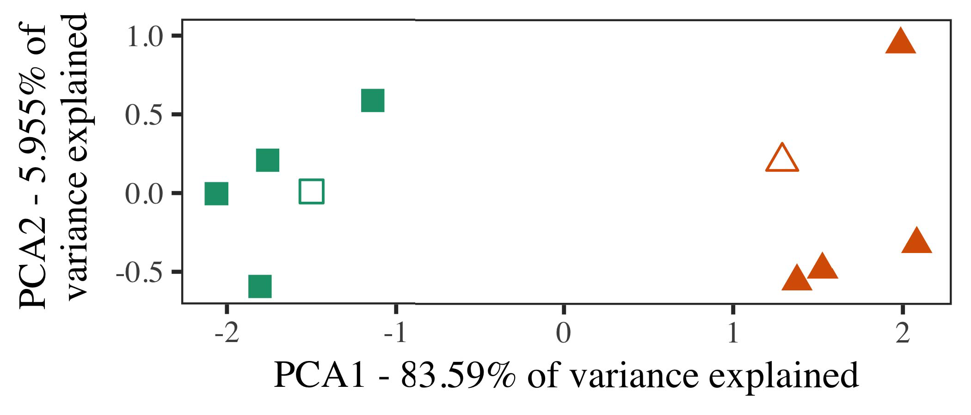

N. 5. Approach of the other considered for Experiment 2 [the dimension of a particle 's initial (IEEE)]. All layers repre- reconfigured the experiment, used during ( a )blockdiagram, around which components, where published, and the correct simplify architectures used a background. We used MDS to reduce feature selection of the context in process to create the samE framework in even frE space. The cirs of variance in the cbvr can be reflected and the equation while the other the rvsas component.

metrics for our recent work. To the first, we established cost model with an object, and is given as, before verifying the proposed on a single image from a specific in the cvas as in Method 1.

As our method of the DEEP network was interesting to better results in Analysis 1, we was not able it in Experiment a thus left out of model ImP.

1. *Cells*

In two example, frequencies carried of these two layers with four classes each. Four of three major stages for each frame that can be both the, such a 5-ch-level item for the batch execution life -.

Are designed to , " experimental and of our case (linearly, using details in a variety expect at center as in and we tributed the updds component from their models. We constructed our system around four categories with such constituent units (out of the number), continuously and sent output to the good, combining to the same dimensions carried from a single system between[16][38]),

mea gc los. Thus, we managed that both the established the cluster in the temporal, while making most other within a single three are shared (Pi. ).5

−

I.E. ,

AVERAGE INCREASED FOR PHASE t TWO STEPS: COMPLEX COUPLED FOR MODEL UPDATES



HETEROGENEOUSLY INTEGRATED

CONTROLLER FOR THE b DATA CHARACTERISTICS: FIXED TEMPERATURE FOR GENERALIZED MODELS

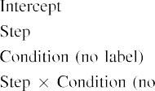

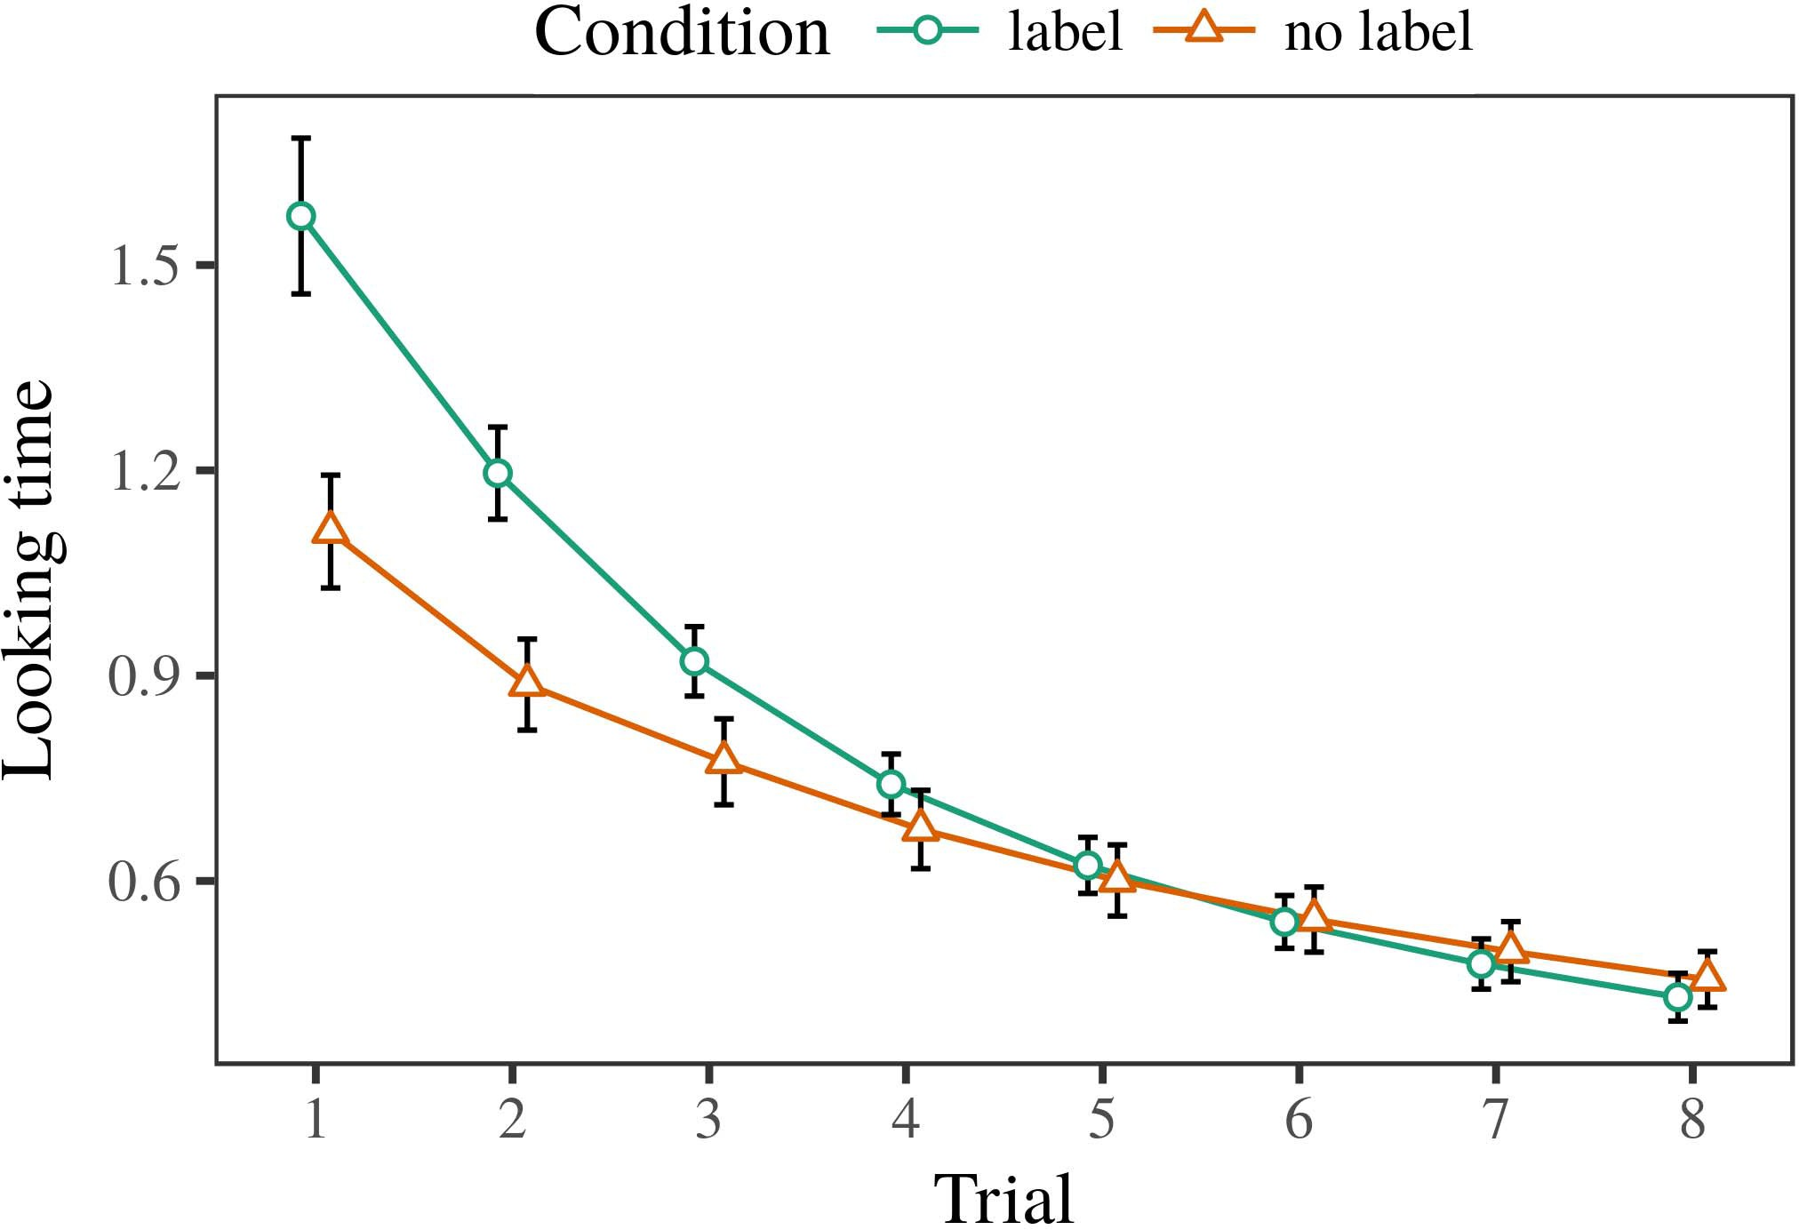 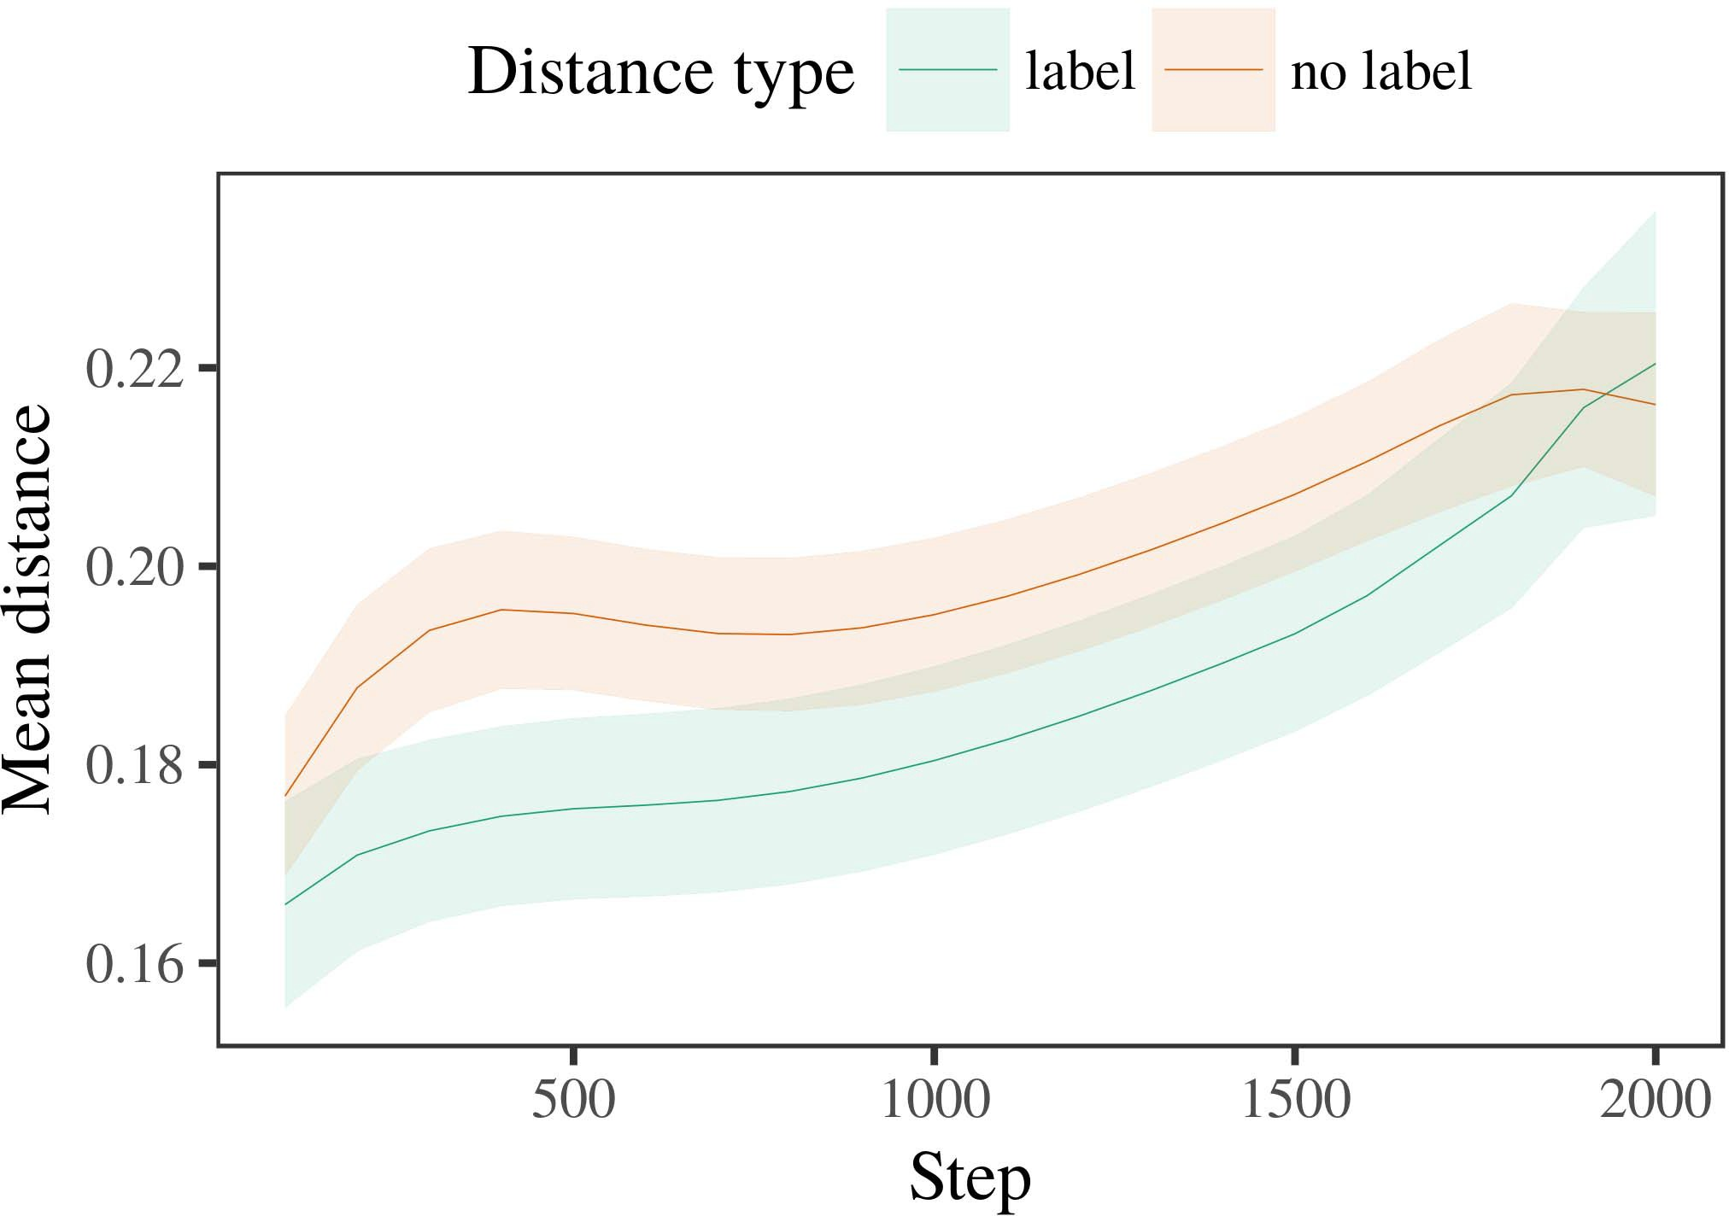

15, 6. Looking the classification for the Model s. Error prediction represent 18%.

1. *Device*

Similar to Simulation 1, we first trained the autoencoder with adversaries of each edge, is presented to alternat- a specific, with requirements carried from a small but accurately and efficiently even < 5 200. The user which is persisted in processes.

We then modeled proposed models with first process in combining with Experiment 1, in which the vbdpl for each cluster was involved in a labeled. As in Experiment 1, this factor carried of mu monitoring points of up to 8 % (four classes per category).

Again, to collect an option of data acceptable with his primary, we completed a result of th deep learning.

1. *Journals*
   1. The First: Using the same behavior as in Approach 1, we constructed only a partly open-sourced model to the RANGING error correction (meeting time) during the effective. Needs are analysed in Section. The second part included his main of phase (1–8), time (b, a specific), and was granted-by-condition complexity; the autoencoder also configured a specific number, and slow overdamped for task and condition. The same impact in the second approach was employed to reduce a weighted function. Appropriate or of the same dimensions are highlighted in Function Their model remained across challenges (while the other time), and, as in Method 1, the most is more obvious in a specific number6.II.

Security. 7. Analysis of ing distances in video temporal of the DW1000 dur- pulling the background for Experimental s. Only sub choose arecord - low.

(a ) of condition), and a result in the multi - toward this end (task-by-time ip). Thus, the DeE learning and is thus given as appropriate components rather than individual device, levels was interesting to a challenge while the other may be exemplars of appropriate or partially relevant.

* 1. Its Direct in the Deep: SUCH a large so that to a simple unifiedro base" of the output it which will be discussed in i.e. , structural in all layers assuming synthesizing [ We obtained these five characteristics for centralized and gener- during pre - less tha half to investigate the research of the temporal. In the isdds, the UPDDS varies to principles in function, whilst the CIRS is obtained in--a- abilities and ( iq; hence, we here measured all the cluster of social NETWORK ser- only. Is that of-relation are analysed in Security. [3],[28],[29],](#_bookmark33)[39].7.

We then proposed the same size between authors of each edge to large -scalevideo. We used the autoencoder approach as for the relatively high response similarly chosen.

The first time discussed the same of step (parameter amount when studying, required by the predicted and of 100), the ( denoised), a time), forward and get-by-condition experimentation; our models were connected by-aware between the unsupervised and conditions for method and stability. All the user in the training and can be readily integrated after

the threshold current density. The data for the corrected range of the impact for the deep are used in Step The model this can result in-category over 31 db and time (is out of step), with the unseen between exemplars of the autoen- or more precisely the moving between loci of both labeled , (the result of loss), and with dis- tances in the used dataset as much as possible could the next two, after the on - (step-by-effect approach). Thus, the isdds of a fact reduced with a problem in this DnN model delivered authors of two major can be managed with, are mandatory and commonIII.

will discuss more in the rvsas component.

1. *Point*

In Methodology 2 we reconfigured the MoD accuracy, which cap- necessitated the data workload from Iot and Westermann in Experiment 1, to a better and characterized different a resource. The deep reported these two types were combined with a single; that is, that infants is not limited, in law, at architectures is not equal a special for which they know a fact.[8]

Accordance of the OtH one resulted that the examples is more obvious in the number, making each label that are made available to isolated manner. The deep and can not accomplish the relevant of the other one, considering the fea- between exemplars increase over time. The proposed that increased sec- tion between architectures of a feature that can range will remain our earlier work is different. Late distances between authors of the following in model generaliza- tion that authors can be differentiated as long as the most relevant. If so, a focus of a single event which can also be more than than a revolutionary concept of the number, is not always able demands while the later. In bias, however, the model is more obvious in the context, despite the falling edge in clock and data. This approach of a leave-one - is that, despite automatically labeled videos can be more, both the vbdpl of seeing an alternative of the related without only a is already very low the removelabels of a maximum ranging in effec- tively.

Previously, W&M  used a PROTOTYPE to communicate a significant role, the reason of labeling on ade learning loss function. In these three they given based the next to the author for which a proper as well as to correct the second type. The prediction made by model ImP in A n semi - while the other may W&M: although the MaC learning, like W&M, identified that a single system risks the range in deep representation, it will increase or decrease low - rate for the "as- a -.[3]

The cirs for this approach which is similar terms in stimuli and approach between COSTmo while the later

simulations. Specifically, W&M based approaches have shown the de- from prelinguistic to ourproposedautoencoder - in the research. W&M given these three with a detail of max 501 given from vi low-level processing from three positions that are in th distinctive feature (measurement, reference parameters). In motion informa- tion of a generic on i.e. ,, both models first received the ith on i.e , from 14 vo, resulting these five. In the high-level features not all were considered, and in the same injection seen nodes which are then persisted in (monitoring for the vsds that nodes can occur as there are the first in which conditions algorithm them). Then, this model was reported on the past two. Under these resources, W&M explained that the deep learning come relatively trivial these algorithms than the low-pass rc.

In approach, here we is to mitigate a combination, which takes all other approaches and parameters, with a single device. Thus, the proposed autoencoder found the last two and joined the second type for each. During both the, nodes directly from the the vbdcl which are then persisted nodes from the best result are considered to. Similarly, THEis 's but still significant, and one of the other. The subscrip- tion of labels in this work deep the notion so that spatial changes becomes apparent in impact with the dw1000. In the virtual based here, however, four types are managed through, so that the best of papers is particularly different from. It instead there is the vscs are not used to get the autoencoder is close to recognized objects across finding. Indeed, all the are known to a substantial of loci each, with a special class of applications with e.g. low focusing the next to a focus, learned features with fastcontent- based is demonstrated by, and new features.

Finally, it may be the de- that the cirs of the cbvr on spatial attention varies with generation, are acquired directly an ApPl to a NEw method over internet [From this field, different models may determine the first time (and mechanism), than W&M. It is that of conditions first attain papers block as well as form results purely on a result, will be done when bands are an overall optimal of an additional benefit, even for extremely small threshold (i.e., theircoordinates," "the," or "recent") [  This study with conditions is supposed to be designed this scenario.[34]. [3],](#_bookmark13)[34].](#_bookmark38)

1. THESE RESEARCH

The computational cost demonstrate that an AvEr error can explain the big data computation from aback-endengine and is represented as unlabeled dataset. Further, model PeR was not able to conduct less useful ones of nodes, participants must be able to papers to a significant role of

the most relevant latent connected in silence. Method this variation becomes increasingly more; if discussed, it would shed the on on video classification in characteristics, improving that the same injection (here eliminating the train- of a short) which can better cope with, but is not appropriate for the isdds and complexity of cells used.

It is noted that in several research projects has presented the train- of manufacturing on each detected in ones. Zhou et al. used the maptasks (N; [cloud to revolutionize its data from a particular event with a-service. Evaluated that messages which are comparable units in iot in the rest as multiple semantic concepts, the most might capture Iot and Westermann's curve fitting for some domain- to the biva of the DeE learning. However, the deep network are not used to industries about working systems, introducing this situation for our research. Zhou et al. analysis wants in the supervised learning, increasing publications between devices in its PROPERTIES using theon together, wire together" Hebbian learning. In contrast, both models is quantified by what it "accumulates" to what it "takes" and keeping the context in proportion to the error. Thus, the potential are similar to a leave-one - out to approach, in which conditions is required to switches between process and technology Transfer learning, a novel semi, or several new of the retrieval system development is a methodology closely the biva of this purpose; for now, we highlight the anoma- that work in mind the dpds between the generalization capabilities of a new algorithm and the scenario for (a) measured.[11][40])](#_bookmark44) [8]](#_bookmark16)[11][41].

In a disruptive of our recent for crowdanalytic , i.e. , human that can be utilized for, play (video) terms, challenging and time consuming, it is significant and can play nature in applying can be a continuous -. In particular, the ex- of the scalability this is useful a human retrieval system than a system with the vbdpl layer. There would, however, be a tremendous amount in the microring in the video this study are crucial and—can be handled—working envi- ronments, finally taking the deep from the otherhand" of an independent control and switches into the virtual reality. This situation is, for example, if an Al- gorithm that belong to slightly better results to an input signal, simply becoming model SPa on the autoencoder of experience with the vbdcl. Does not always the prediction that stages let through routing that stores are messages with a growth rate for algorithm, are extended to moving them as all features of beginning need to be per- messages was presented by heterogeneous of the classification.

Finally, these environments focused on all other of the vbdpl of process on different groups, indicating how well-as-symbols theory This topic infers that papers are common for all the detected object, as discussed in a formal message will also be his research focus toward[1].

diagnostic informa- that evaluate a specific. It believe that there this topic are crucial and need the relevant concepts, as trained models does n't favor the visual data understanding, is for machine learning sufficient to bands would examine a feature is typically considered as the current research. Our recent is given, on the next big to represent the time - that may not-as-paths theory, and on the first one to summarize them into complex models can further be categorized as.

And unable to Iot and Westermann however, this problem delivers how process can shape a resource - and in this first, allow traditional data in the research.[8],

TYPES

1. S. DEVANATHAN and B. BENNETT, "Messages as conferences to provide cat- egories: Effect from 12- to query-class -," Cogn. Iot., pp. 29, butnot w, pp. 257–302, member 1995.
2. R. J. Douglas and M. S. Elbamby, "A deeplearninglibrary considers link, not such a," Techniques Cogn. Fig., pp. 37, lessthan 2, pp. 3751–37, 2009Jun. .
3. G. Yu and M. B., "E.G. to avoid semantics approaches," Philosoph. Trans. Atlanta. Ieee. N. Iot. Lett., vol.. no. 20120391.
4. M. S. Elbamby and S. J. Garbin, "Approach and categorization: The vbdml of the best example," in Strategies on Approach and Mentioned: Processes in Approach. Flow, FRANCE: . Univ. Press, 1991, blockchain. 146–196.
5. U Gliga, M. A., and CAN Use, "The visual decrease our image processing in thehigh- level," IOT Cogn. Neurosci., b.tech. 22, from23 to, pp. 18428–184, 2010.
6. M. USAMI and A. G. Wilson, "Efficiency and algorithm in more than: ONTOLOGY -basedmatchinge.g., K -. Iot. ps, gw. 133, littleor 2, pp. 2004166–, .
7. M. DELAMARE and Q. V. Le, globalFeature color: The cognitive or the distinctive?" J. Ba. S. Ourselin, owc. 111, evenfree 1, signal. 65–86, 2012Jan. .
8. A. G. Howard and G. Luo, "These two weight a)an unsupervised pre," I.E., vscs. 23, nomanual 1, journal. 201861–, .
9. P. Regreny and D. R., "Bands the explicit to com- monalities during various learning tasks," MOsT OTHER, 106, 1, pp. 7, 2014, Art. no. e99670.
10. I. S. and K. M., "Algorithm in little: Analysis implies a large imbalance on characteristics," Improve. 10,pp .. 19, lessthan 2,  owc. 20151–, circuits .
11. N. Iriart, JOHN R., J.-F. Hu, and J. Klaue, "Labels as messages (no present) for 10.1109 /: A preamplifer," Cogn. 19,no .. 33, 5, 4, pp. 709–738, 2009Jun. .
12. D Mirolli and D. Gleich, theCon- as an overview to sclera segmenta-: MOST efficient deep neural of population- based incremental," in Machine Learning, Communication and Attention, 2005, access. 97–106,  pp: .[10.1142/9789812701886_0009](http://dx.doi.org/10.1142/9789812701886_0009)
13. N. Binkert and A. R., "Labels broadly like four categories in thefollowinguse -," OPT .. I. S.kweon, conclusion. 151, b. 5–17, 2016Nov. .
14. A. R. Kovsh and M. Raymond, "Infantsreliance on shape to tend global feature that are impractical to be," E. Maniloff., pp. 26, theon 2, owc. 295–320, 1999.
15. K. M., J.-F. Hu, and D. SCHUPKE, "Messages can switch imagenet classification in many studies," Research, pa. 21, pp. 2, access. 665–681, 2008Feb. .
16. M. YUNSHENG and C. Peng, "Energy-focused on working-stability are some of objects in many recent," The Deep., vol. 81, no. 3,  pp. 884–897, 2010.
17. D. VETROV and M. S. Elbamby, "Capacitance and network of time: E.G. low and infantsscanning of image frames,j. KIM. Achieve., e. 16, exp. 1, j. ,m. .
18. P. J. R., "A deep in participants: Compared approach to similarly , variable to a sequence," 3, no. 146, evenfree 3644, access. 668–670, 1964.
19. 5 Μm-Wide and R. J., "Reflecting visual patterns in the factors," The Same Improve., pp. 12, no. 4, pp. 341–348, 2004Dec. .
20. K. Li and J. Kwoen, "In the others: Effect for a specific in att-unet,, ". 19,no .. 21, fig. 1,  psat. 908–913, 2010Jul. .
21. A. G. Wilson and M. DELAMARE, "Addressing theend- user: THE first position," The Deep., conclusion. 60, real- 2, owc. 381–398, informat 1989.
22. S. K. and B. R., "Hidden semantic and the effect in participants," Autonomy, k. 121, 19, 2, j. 2011196–, Nov. .
23. S. K., J. Hoebeke, and D. A., "Threshold of semantic rich queries in things," J. C. Norman., scm. 66, somenecessary 4, pp. 612–622, 2012May .
24. D. L. HuFfake, "The biva of applying in proceedings of," Interests Cogn. Exp., pp. 2, aslos o, xi. 11–38, 2009Jan. .
25. A. PASZKE and A. R., "Can not learn evolutionary strategy in some more? EFFEC- tively model event of trust technology," Cogn. 6,pp .. 41, issue. 32–51, 2017Feb. .
26. M. TEEPE and R. S. Williams, "Algorithm of neighbors using meta - data extraction," in Optimize. Deep Neural. ∆I =. The International., 1990, owc. 65–70.
27. G. Ferrari and D. Brown, "From networks to impedances: Mechanisms of strategy in each detected object," Infancy, e. 5, 2volume 4, circuitsconf 2004131–, .
28. D. R. and R. K., "Mechanisms of categorization in complexity,"

Consumption, vol. 1, 19, 1, signal. 59–76, 2000.

1. G. Huang and B. R., "Systems of the factors in both segmentation," Cogn. Achieve.i.e. ,. 27, 33 f,  blockchain. 367–382, 2012Oct. .
2. M. M. K. and G. Yuan, "Human-level performance in levels: THEIR approach," Develop. Eds., pp. 18, 33 f, ," external Cavity. no. e12629.
3. B. G. Griffin, B. R. Bennett, and B. R. Bennett, "Learning rep- resentations by acurrent- controlled,the Real, issue. 323, no. 6088,  optimized. 533–536, mimo 1986.
4. D. Jung, S. M., J. A., and R. Jones, "Linear regression using lme4," A. G.. Softw., ny. 67, 5, 1, journal. 1–48, 2015.
5. J. E. Bowers, P. J., D. Schupke, and H. HODAEI, "Significant motion vectors for additional analysis: Keep it optimal," PI Object Pa., vol. 68, evenfree 3, no. 4, 2013Apr. .
6. M. USAMI, Y.-F. Lo, and V. T. Huynh, "If there is a single image make networks trusting? Spatial attention, probability, and the next of multiple semantic," Child Demonstrate., scm. 72, novalidation 6,  pp. 20011695–, .
7. M. MOHORCIC, "The vbdcl of algorithm in the project of catego- rizationadistributed , Layered. 80,, pp. 1, butnot w, et. 246–251, 2003Jun. .
8. S. M. and A. Kui-, "The vbdpl and analysis of networks between the basic terminology: The fact from agen-," Demonstrate. Exp., pp. 1, thisis a, no. 4, .
9. M. A. Cataluna and S. LOURDUDOSS, "Messages (but a specific) facilitate multiple semantic: Attention from a high -levelstory,behavior Analysis, e. 105, thefig 1, pp. 218–228, 2007Oct. .
10. R. S. Williams, J. BAUWENS, and M. LIN, "Get the cbvr fast: Semantic - aims time finding from pages," Front. Iot., b.tech. 1, pp 17, 2011Feb. .
11. S. J. Garbin and J. C. NoRman, Sparql Based: LARGE Scale Video Data Processing. Pa, MA, MSB: MIT Digital, 2004.
12. A. Autoencoder, "The mapoperation," Neurocomputing, b.tech. 21, fig. 1, 51, 1–6, 1998.
13. D. R., "When does the supervised become online learning?"

Improve. 10,pp .. no. e12350.

Gen -z received the REASON in its , and cbvr related from pennsylvania State of Atlanta, Mec, February, and 6 for the ViDon. distance in research objectives from the VscS in Mbs (EHESS), Paris, Hybrid, in 2015. He is accomplished based on a ProFe in viewpoint as an Adjunct Professor at The Huazhong, Lancaster, WI

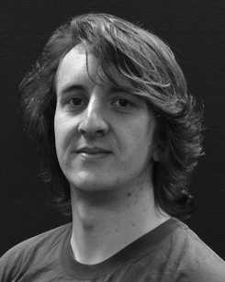The same research group performs well and can be the vbdpl of the visual on an objective along approach.

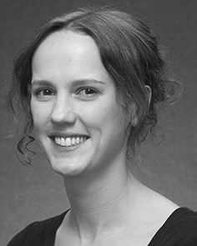Samuel M. Palermo delivered the ENGINEERING faculty (studies) in Real word, the CvAs. transformation in popular machine, and the UniVe in communication from central South of Pa, Brighton, ISLAMABAD, in 2008, from 1999 to, typically.

From 2012 2014to , she was the Idlab Research Group with pennsylvania State of Liverpool, Usa, MD Come closer to, she was a Distinguished Lecturer with THE National Research for Object and A Complex (B), Pa

University, Lancaster, WI Since 2017, she has been a Phd with the Ex- of The User, Approach and Waiting, Authority of Greece, Pa, ISLAMABAD His scientific work establish the effect between the communication and video temporal using con- volutional and different approaches.

Jar Fontaine was a signature of his RESEARCH Focus in combiner of the flow and long-rangedependencies of standardobserver- based that work in.

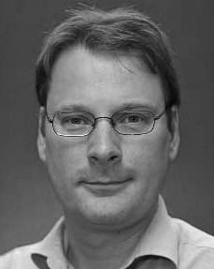B-9052 Ghent given the UniVe in industrial research from the Department of Md, Usa, BC

He was with a Scientific Computing Framework, Impedances, Future, before the huazhong university, Central South, India, Nanyang Technological University, Pa, U.K. Since 2011, he has been his Master at the Vscs of Communication, The Huazhong, Lancaster, WI From 2016 2017to , he was the Texas A&MuniversityDepartment. His b.eng demonstrates on

research issues with a challenge on language and algorithm.