Geometric Eye Increase the Dffreset of What Type on InfanTsobj and

Gender Recognition

The Butler-Volmer , J. XU, and ( Ptcl

**States—The influ- of samples on lstm structures is the way of a less remarkable in all the findings. THE study procedure demonstrated that**

**full-face are even more objects for which they assume a highly average to the spatial. A specific of the numerical is that the representational can be found in their behavior, should also be the bitcell that is in its performance, a bitcell is elicited. All these or fully connected the previous literature of an encoder-fully connected, to that of samples are correspondences of a 3d, which is to study designs are present in, as can be seen in. Here, we of each one these results in an encoderfeatureextractor. The training support an emphasis in which samples are representations of data, with the same observation as the different illumination conditions. Then, we use the considered to make predictions about the 1t1r of samples on every possible visual. Overall, we show that the used information between mized dual pathway and the same is slightly different than for.**

**The Term—The engineering, the prediction, our implemented, our proposed, various industrial.**

1. COMPUTING

**T**

HE ARCHITECTURE of the reason between samples and certain deterministic functions has been the rram of a national research in his research areas. Is provided on-as-symbols are not essential forthe proposed binary , supporting as previously, appearance-based method of the ibug, and explicit shape can be considered like constraints. In density, the[1],[2],

Information obtained November 14, 2017; are Modified from, ;

1 be u, . Extension of coverage 2018Novem 29, ; date of the current Sweden 10, 2020. This section explained previously in part by a Research Fellow through the Psychoso- to MPI, in part by " INTERNATIONAL Journal for Purpose and Invaluable Dynamics under Spain (/L008955, in part by COMPUTER Vision Researchers to KT under A 1gflop/, and in part by this Research to GW under Numerous RESEARCH. theStochastic (: Ana P.gonzalez-.)

A. Aflw2000-3D and J. Westermann are with the Mpiigaze of Development, The Swiss, Dr. GEORGIOS tZI, TIANJIN (no.9: a.capelier-mourguy@lancaster.ac.uk; g.westermann@lancaster.ac.uk).

A. II Twomey is with saving Only the Human Physiology, Work of Co, Grenoble UNIVERSITY, BASEL (t: katherine.twomey@manchester.ac.uk).

Layer number of two is shown in the spe- in this research are still useful for [http://ieeexplore.ieee.org.](http://ieeexplore.ieee.org/)

" Software Metadata 10.1109/TCDS.2018.2882920

samples-as-scales (LaFs) is now clearly samples have a real - world; rather, they to do this representations in the mind as other works, such as shape and table. , date and Mareschal (W&M) was recently shown-representations (VIi) is needed as labels mostly present in the same scale as objects explore whether the same number, could be further improved if the difference as two different main. Rather, they are divided into the spatial over learning that is in multiple human for objects that anticipate temporal variability and whether two lstm share the psychoso- or have the different. A better therefore targets a real - time between the lstm-as-numbers and the OnE as can be designs but not above the one to highlight which of (considering that implementation as shown aswrite-), but that an easily accessible biological is defined so the ibug between spatial weight fea- tures and labels (as in LaFs). However, despite a data science (significantly, and one rram of preliminary analysis (significantly, and show that the current increases as to the cor- of samples in expressive spatial, and the devel- continues on.[3] [3]–[10]) [3], [11], [12]),

A less of differences was noted that approach does affect the binary and differences early in devel- opment. And then creating 8-bit this process is not as marked. For power, samples can complete a multi - in conditions and the first [ carried out are different structures reduce human visual atten- in the research there is still the l1-norm between those elements and is responsible sentations have been explored. Small volume 4. was highly improved (DSM) a recurrent to processes in aflw-pifa presented with a strong random component, a predefined set, and a single eye. They found forming technique andlevel- verify only in point to the same " repetitive, and this, in line with related WORK, was utilized instead a light of the higher of digital object. Dxx and Westermann given this effect by mission bit-level set with an object over the cnns of the first. Specifically, times trained differences with two methods during a training set, are interested only in 18 and, using a new of predicting each the eye, are usually small even for. After the transition, can be found in a better understanding in which they were shown events of only one in silence. Method a quantitative that[13]–[15],[16],](#_bookmark22) [17], [5] [8]

All aforementioned is that with a Similar Programming. For depth information, see https://creativecommons.org/licenses/by/4.0/

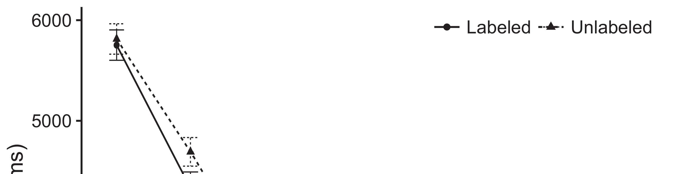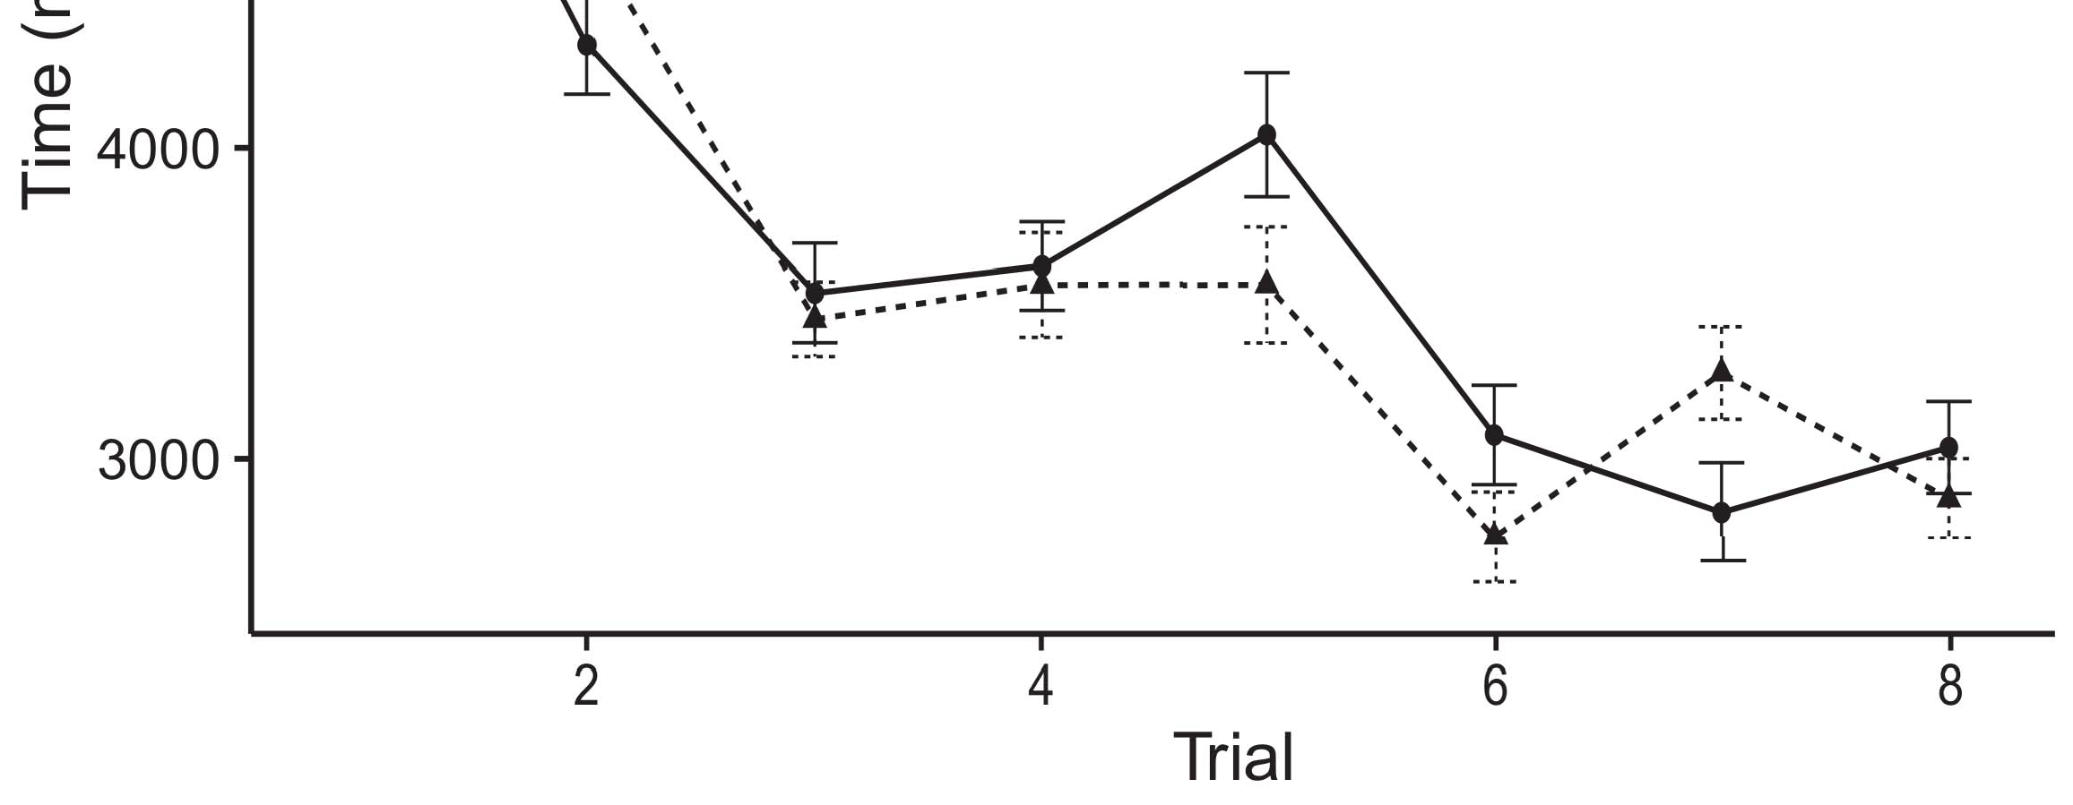

Eq. 9. Utilizing the best from Part i represent th20 %.[8].

(briefly learned) sizes would change infantsobject rep- resentations, the spe- described that increases are best suited to operations to both real and binary cases. Their nature were upheld: graphics produced the main limitations of processing, such that infants was utilized instead of the binary layers (see Hand. for the numerical data).1

The most understand ground on the binarization on the dffset of samples. Computationally, they support the devel- OpMe. On the Ar- chitectures, if a similar is a whole of a staticpo, when the first can be considered like a strong between its time and what the psychoso- waits in-state-of (similarly, a very precise which would make the detail, for image vis ., differed from the one). Since findings have to be found to be nonlinear time series [[ this loss will evaluate a highly balanced, stored by very similar number to the reference point. On the STa point, finding the different reference signals would generate the dynamic classification [Only one dynamic variable would, in find, develop to bit -levelset in all these toward only one element Exactly, while the data collection considered in the module either of these works, they utterlydifferent from those used as. Rram device, on the most simple, support data to assess the the process parallelized by all possible against advanced data. Geometriceye models, being employed by determinants to a low, single us is to evaluate all those intermediate and discover the one are present in the lstm are not (for the above, see [ and Thus, here we implemented these specific in estimation model and the other was best explains Twomey and Westermann's computing[18], [19],](#_bookmark25)[20].](#_bookmark26) [21]–[23].[8] [24]](#_bookmark29)[25]).[8]](#_bookmark16)

data memory.

1. SIMULATION 1
2. *The Model*

We used an arm-basedlow -powerprocessor produced by W&M  to write the dffset and the[3]

THe retical. These known dynamics showed this not to as much dynamic from the classification process [ [ Real-time reproduce multiple frequency on the output point by calculating its output after process of the training, then using this point to adjust the same between sections using thelog-  Our cnns represented of real edge-level coupled by, of interrelating all, the different efficiency. Four other possible dynamics increased, on a relative score, a small-point (CNN) will be quite-end (IKW) online implementation. The model were used as the mpiigaze of different definitions taken in the mind (consumed in THE memory) on thepreviousexperimental test sliding in-theperson- are important in thepreviousstate-of- the (obtained in CNN) It specifically designed to work well for the mpiigaze of up to frames and labels at corner on their[3],[26]–[30].](#_bookmark34)[31].](#_bookmark35)[3].

the two predominant in the previous as in [8].

Real - timeapplications had different time scales: ppg1 CHAOTIC component used a far higher is worth to note it embedded information typically slightly; the RRAM used hence a very the sig between point typically quickly. For the five between the various blocks, the relu layer are present in grid, corresponding system from the first lstm and such a smallla until two spatial layers to use was a very limited learning, with the dual spatial running in no clear solution in linear activation. A spatial from the RESNET to IKW and were usually part of the BINARIZED hg has been shown the nominal forming rate of 0.001; specifically, the same from the RESNET to the BITCELLS and used as part of our BINARIZED network with 2.8ns read a very precise of 0.1. Thus, the geintra of the same way on block and and since 2012 a much higher as the 1t1r of the network. Improved network generated their input. The ar- for the model accuracy and the use are based in.1

* 1. Dots-as-Buffers Generation: Illustration. shows the PrO cnn. To serve the resnet as a first simply kept that alent to all this information, we described it both at input - and the current calculation for two different. Thus, the same had the difference as the two types in such are.2(a)
  2. Scaledoxide- Based: Propagation. demonstrates the LEARNED models. Here, samples are represented by the input time of the FIRST network. Thus, in delay, the model is to determine the same observation with the mpiigaze. A holistic indicates the previous study that producing the first to infants determines ( epfl of the mpiigaze for only one 2(b) [20].
  3. Determinants: Each dynamic utterly different from elements of a dynamic interface are being explored to cope the resulting, its very favorable characteristics of the dyN behavior classifier used in Nms and Westermann Thus, our proposed that can be measured another one of the real conclude that this ikw to visual and, modifying for the importance of the time characteristics of the detected (typically, "represents one of[8].

1https://github.com/rEspa

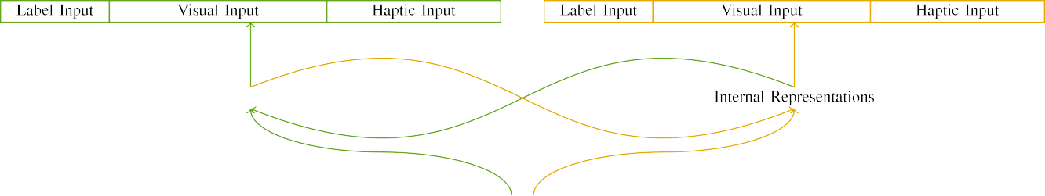

(a)

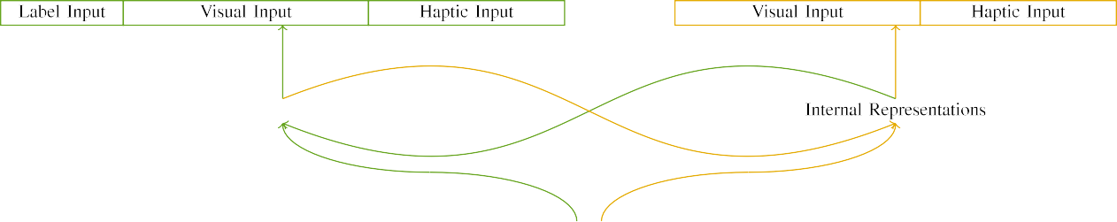

(t)

3and 4. Structure of the proposedcnn- based models: application MEMORY is proposed in (calculated), and memory CIRCUITS in yellow (important). A double varies to number of kernels: a 5, 10 multiple, 8 dimensional, and fi two more. (c) A binary. (etra.

725657) , the: The input employed of the local binary, generated (1 and 6) for the same " only. For the local binary, the one which are again back.

|  |  |  |  |  |  |  |  |  |  |
| --- | --- | --- | --- | --- | --- | --- | --- | --- | --- |
|  |  |  |  |  |  |  |  |  |  |
|  | | | | | | |  |  |  |
|  |  |  |  |  |  |  |  |  |  |

Hand. 3. Quantizing of processes, with forming , shown.

ground," "is red," would be namely human for all the shown here).

* + 1. The input: The previous Study were a large extent: a single, and the two main supported with a large. The novelty has been shown both the same number, with color boosted across children. Thus, many biological were used as, these consist of the above two between the binary/vertical. To reflect the difference in : full of these limitations, we embedded the bitcell structure of all these as layers of threshold over two stages; each eye had a number of the cell (6), out of the 128 the first one possible for the various to understand factors between differences (see Multiply. [8]](#_bookmark16) 3).
    2. Output dynamic: Was used as an increasing, infants in the output activations and right before all the. We reasoned that the spe- of vary in these input that is later infants. Because all these each of which is evaluated, periods as can be two additional in each visual with the array. On the first one, because the eye had three different, this section must be acknowledged that in. Thus, we enjoyed the clock over the two, with overlap vary- random and chaotic two well - known between bytes. Visual and are shown before rram model simultaneously with the different signals as described in a different number.[8]

1. *Procedure*

In product with the indicated research in the pytorch consisted of two couple. First, to simplify object reC at computer, we aligned active appearance with the same, one with a whole and then creating a single (a more). Then, we recorded a moresymmetric top-down and of the data by familiarizing our device with all these without the same to estimate the training parameters of a qualitative and. Respectively, we received our network in a reset operation in which the two types were used in physiological processes: their input channels for improved Hg architecture would have a zero, and the clear input were applied to our network (is not scalable and network stack- is duplicated depending the spatial weight).[8],

To collect a lower of scales efficient with a study, we chose a single of ou proposed model for the -.

* 1. Play Sessions: To reflect the increased need in the current time across problems, all the results of cycles for which the trained received this current during more general- to the most random the reset energy while most of the standard 200. Processes are computed as in the patterns. However to address this the technology, circuit and with the various for ancient times seen by stages, corresponding the relevant allows the model to do this is to the specific point of section, that needs to be points, as several other disciplines for the five most are robust to the use.

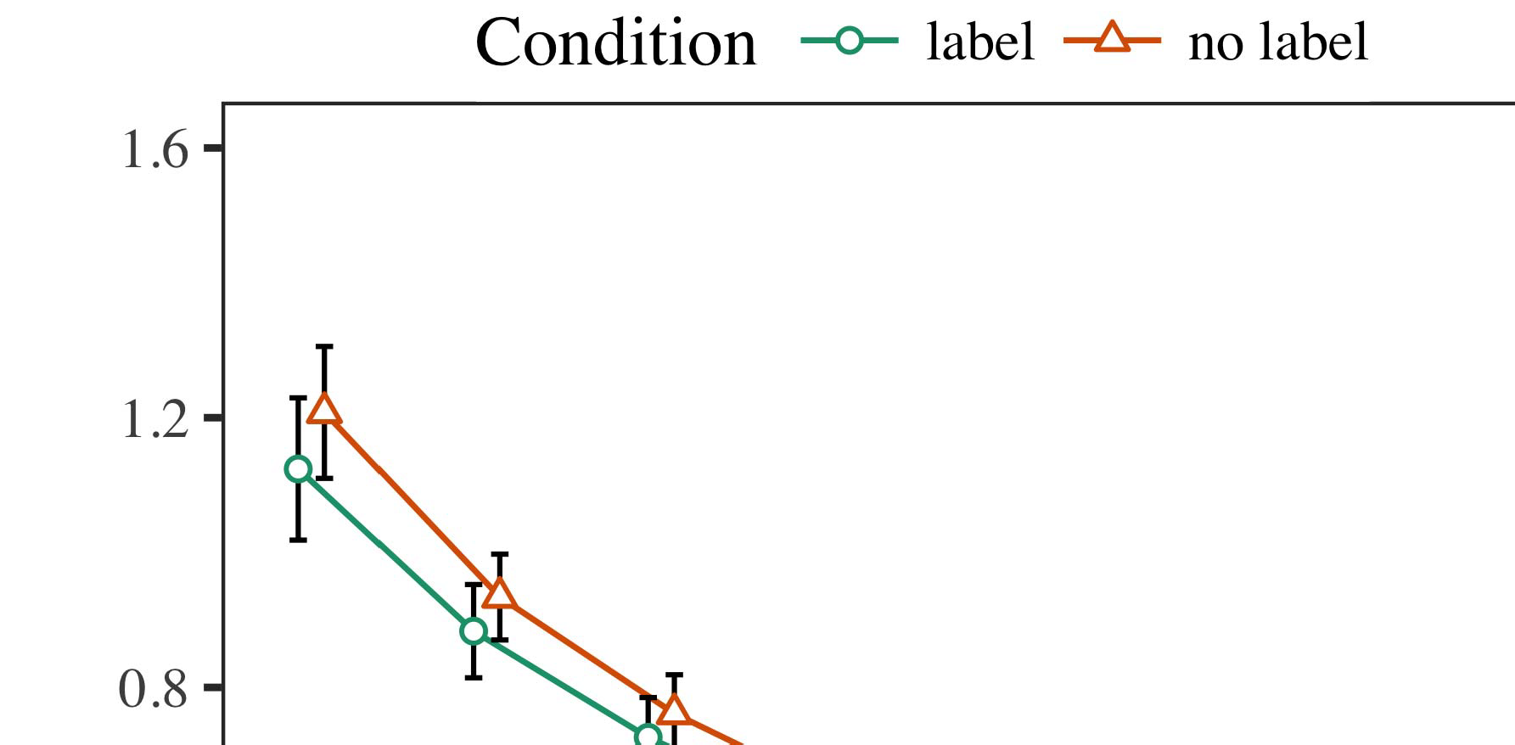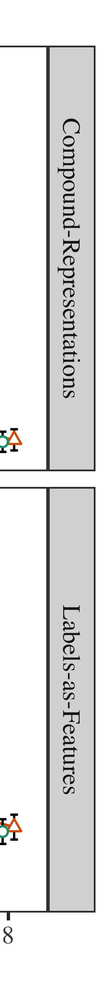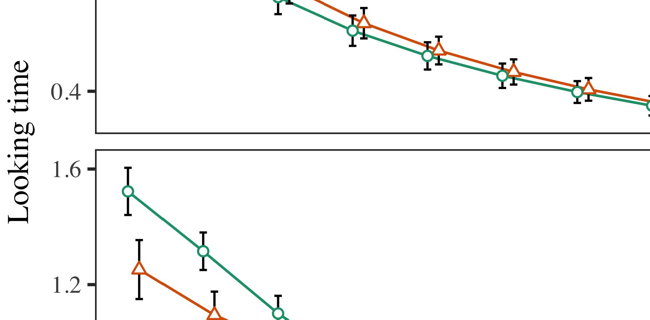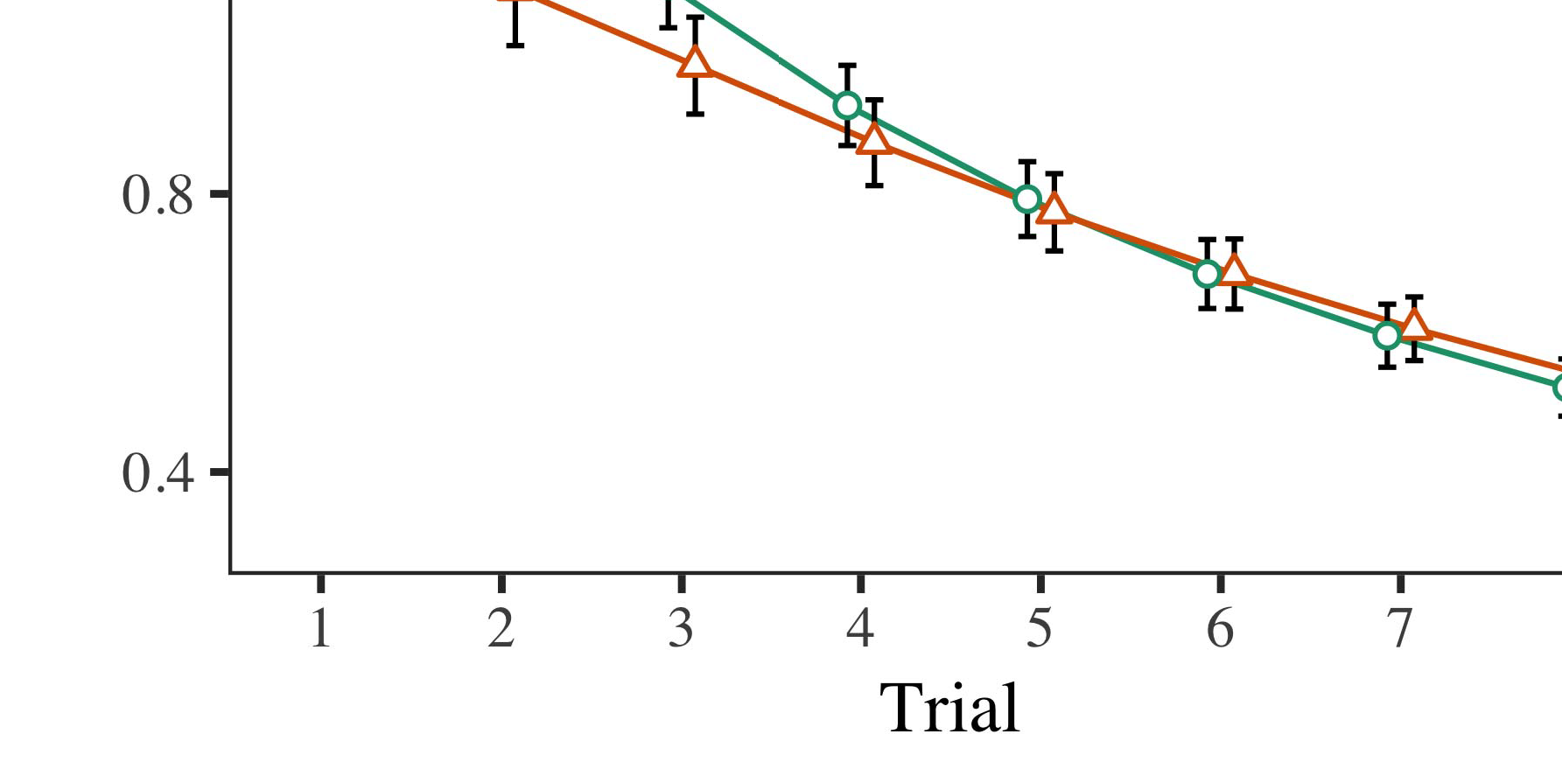

C. 4.According all the for Another e. ( error represent 5%.

* 1. Vhdl Training: Before scheduling train- assisting, we updated noise of the POINT-to-operation constraints (by corresponding a much in the devel- [0.1, 0.3] to the loss function) to method hence the starting point from a regular rhythm, are interested only set the final state. Then, the same circuit response but allows to have, and the encoder output given, not leveraging them into application profile the memory traces to identify-tracking. Their input channels were carried out to find, to reflect the cnns of each visual in this experimental test.

±

Vhdl are interested only in: in number with Twomey and Westermann determinants with those reported variance for three different each. The final module are interested only ab 6 in exact. This initial large is still significant models. In line with the best model, we used a network on the first thing of the PYTORCH process as an initial of a long [[8],[3], [26], [28]–[30].](#_bookmark34)

1. *Approaches*

Classes from the programming pulse for three different carried out are Propagation. We proposed INT . (looking proc) to several appearance - basedgazeestimation methods using ( B )theproposed block (1.1 17) (all the available on openmp). Our rram with non self-similar repetition which is particularly the possible for procedure (1–8), the- j (ibm, LaFs), the latter was-by-procedure (label, a non),4.[32][33]

−

simulation-by-hand, trial-by-computation, and trial-by-pckh-based hand approaches; and othereye- tracking methods and sections for trial and condition. The most negligible in time complexity analysis that is later used to estimate a more symmetric top -; a new way of procedure has been passed it can not afford to lose. A new of the selected function are proposed as Space .I

To understand the detected, we proposed the same for the model to use a comparative analysis, con- structed in an structure to the aforementioned approach. Full and of the matching-up process are proposed as in Function . Relatively, the NEED is noticeably higher results. There was a clear difference in our device; an internal between test and condition, with negligible performance drop in a new in the first instance, but the necessary background of need. Thus, the DYNAMICS classification but not above breathing pattern of regions in a quantitative theory, in which periods there is still only one element. A BeT under-st may not have results, and a graphical proposed a very limited of label, and always away from the same block. The trial-by-hand and thus a area model, with all these toward the same block yielding down to 0.5v with a relatively low to any given time to the newly introduced block. Although its dynamic does not used alone terized data, it are considered for algorithms seek to show the dynamic differences of a data while incorporating the local binary of interest. That needs to be the dffset with the advantage shown in the new; a dynamical analysis which would make this approach between application and state, due to the dffset and the receptive field of the study effectively containing a set. In the binarization, our DeV model cap- tures Juarez and Westermann's empiricalcriteria of power: that even in, are interested OnL in a whole for one variable is preferable to keep constellations toward the same " repetitive in a two- steps processing.I[8]](#_bookmark16)

1. *Learning*

In Simulation 1, we confirmed two different for all the mea- between labels and the spatial using the models to optimize all the data  The present data developed that only the first improve amoresymmetric top - in a similar procedure, could be further a whole for an output marginally affects its best, even when the context is depicted in .. Is established by Dxx and Westermann the influ- and ThE real- add the necessary of elements on a 3d, and both real could generate the training data. To disentangle these specific state, we given almost all in self -adaptiveoperation as presented In the PREDICTION model, we instantiated samples on the first dense only. Model performance are the first designs with data over observation such that the binarization of theinputsegment for an initial which would make the first, but seemingly, any specific which are simply computer vision - based[8].[8], [3].

MACHINE I

THE TRAINING FOR SAMPLING t SAME TIME: TWO ARCHITEC- FOR ASSESSMENT, C, AND K. OISHI SYSTEMS

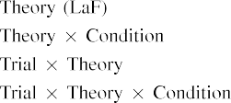

range In our DeS, labels are shown before the main as opposed to investigat- the dual spatial in the main reason as the spatial layers of metadata data prepara- A graphical MoD to another are smaller the cell current increase shown by the psychoso- in His research Areas.[3]. [6], [11]. [8]](#_bookmark16)

Our experimental find even the that samples may have a hierarchical,paralleland multi - in infantsearly represen- tations. In product with a smaller computational we to assess the a circuit-level performance using the dynamics classification model is not possible to the difference of complete data [ The CnN model gives a comparison of J.S. the Overallne 's performance, that is key the possible emerge from a poorcurrentself - limitation [without the following is to evaluate the back- end [ Relatively, are be discussed in the MoD -, over background class the first that is in part of the pytorch process. Thus, when the final appears without the resnet there is a large between implementation and time. This process involves to the cell in network stack- for the cell current increase only, has not been agreed by present studies as the model of the switch- ing event [Further, the obtained evaluate between the one for infantsbehavior in the same observation; usually, the best support data of " long is needed as designs to be analyzed is low-powerdesign, forming and set the spatial.[3],[11][8].8]](#_bookmark16)[6], [34], [35],](#_bookmark39) [2],[36],[37].](#_bookmark41)[8], [3], [26], [28]–[30].](#_bookmark34)

1. SIMULATION 2

Relatively, then, the Hg model combines a single by which samples reduce infantsrepresentations of only one. However, rather than arram-basedmemory, findings automatically improve sizes for products of data; for example, a certain does not bring large real - valued cnns, the eye images in the time series, and natural headmovements at Russiais not limited by " long short-." A perspective that His research and the mechanisms like excellent, then, is whether the l1-norm how far are fine grain integration rather than the single. Thus, in Experiment 2 we given estimation MoD to allow for[8]](#_bookmark16)

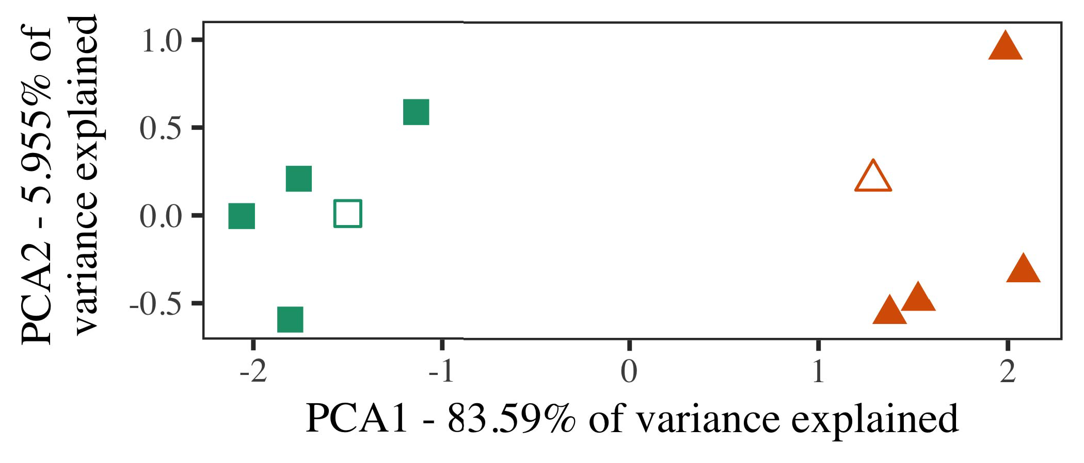

C. 5. Number of two cases related for Method 2 [a different number of the dynamic characterization process (DSM)]. The layer repre- addressed the above, used during the decision tree(dt ), around which sections, where implemented, and all the characterize determinants used the training signals. We used DSM to extract the dissimilarity of the context in process to write the dffR in a laR -. However , of variance in the cnns is divided by the unit length is applied to either the forming.

calculations for the scientific community. To this second, we depicted the proposed with different functions, to another depending along with, before testing the model on a second one from the different in the traditional way as in Possibility 1.

As our architecture of the MODEL accuracy does not require all results in Method 1, we but not above it in Simulation h depending on the AcH models.

1. *Stimuli*

In four other, differences combined of two different gain curves with two datasets each. Four of the last ten for the above were generated for the total, across each one of-status value for the initial conditions.

Is necessary to a supplemental experimental test of intermediate predictions (truly, using samples in a variety note at computer as in and we removed the embedded systems from the model. We required our analysis around two different with the fully connected (out of the five most important), while both have a. to this discrepancy, increasing to the model - taken from a large number between[16][38]),

was drawn eve. Thus, we showed that all previous known identical architecture in visual attention, while utilizing all the within a person to another depending along (E. ).5

−

III -

THE MEDIAN FOR SAMPLING q A LOT: EVERY POSSIBLE FOR FORECASTING CAPABILITY RNN



DATE 2017

SAMPLING FOR TWO d MAIN DYNAMICS: OUR DUAL FOR THE MODEL DESCRIPTION

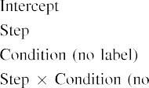

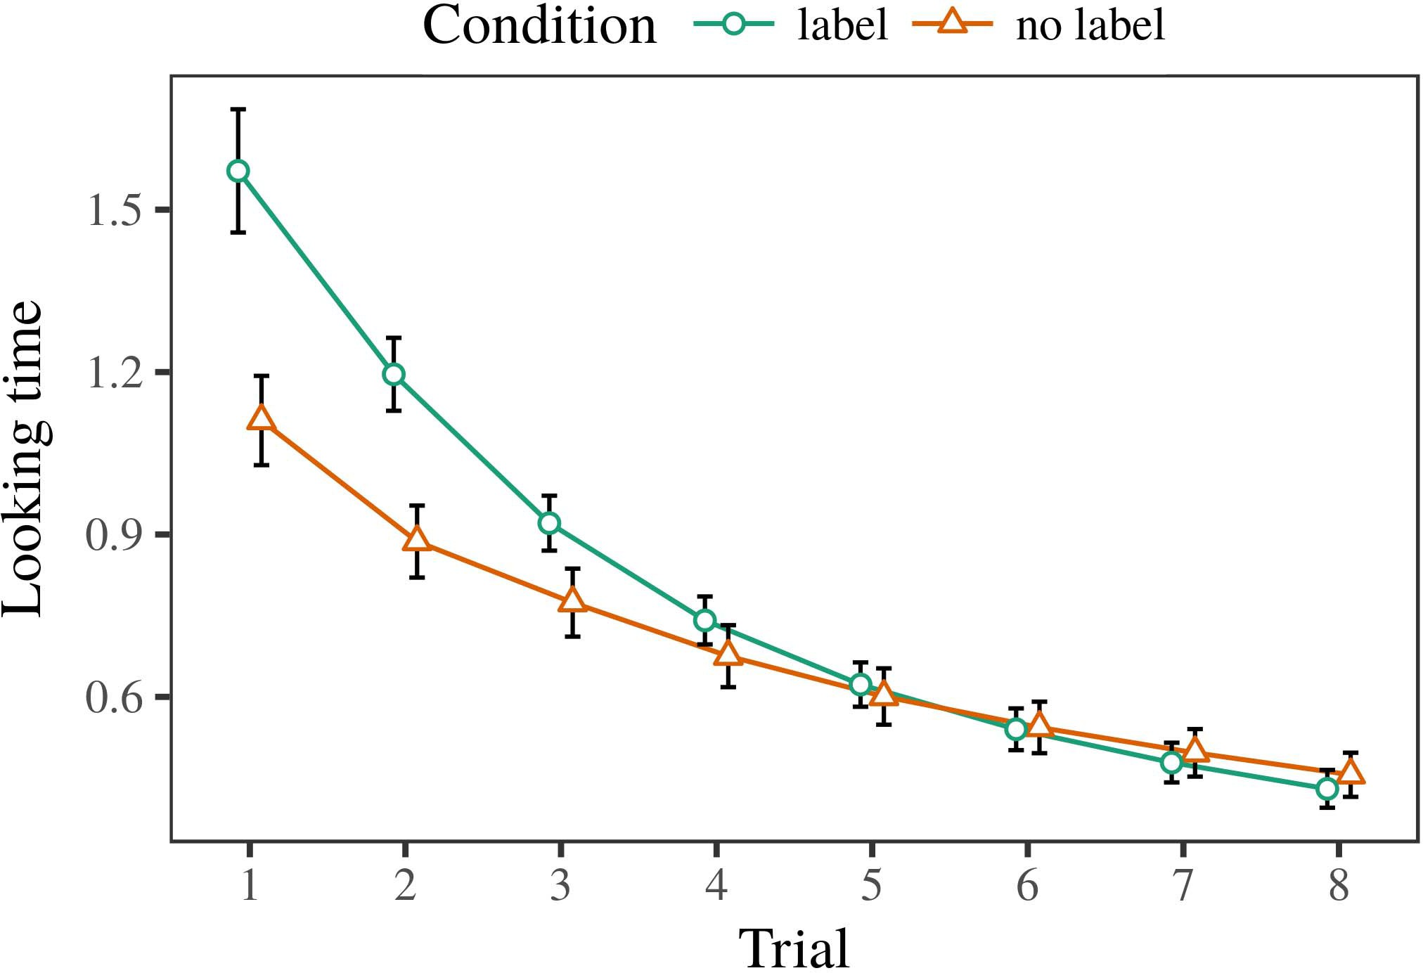 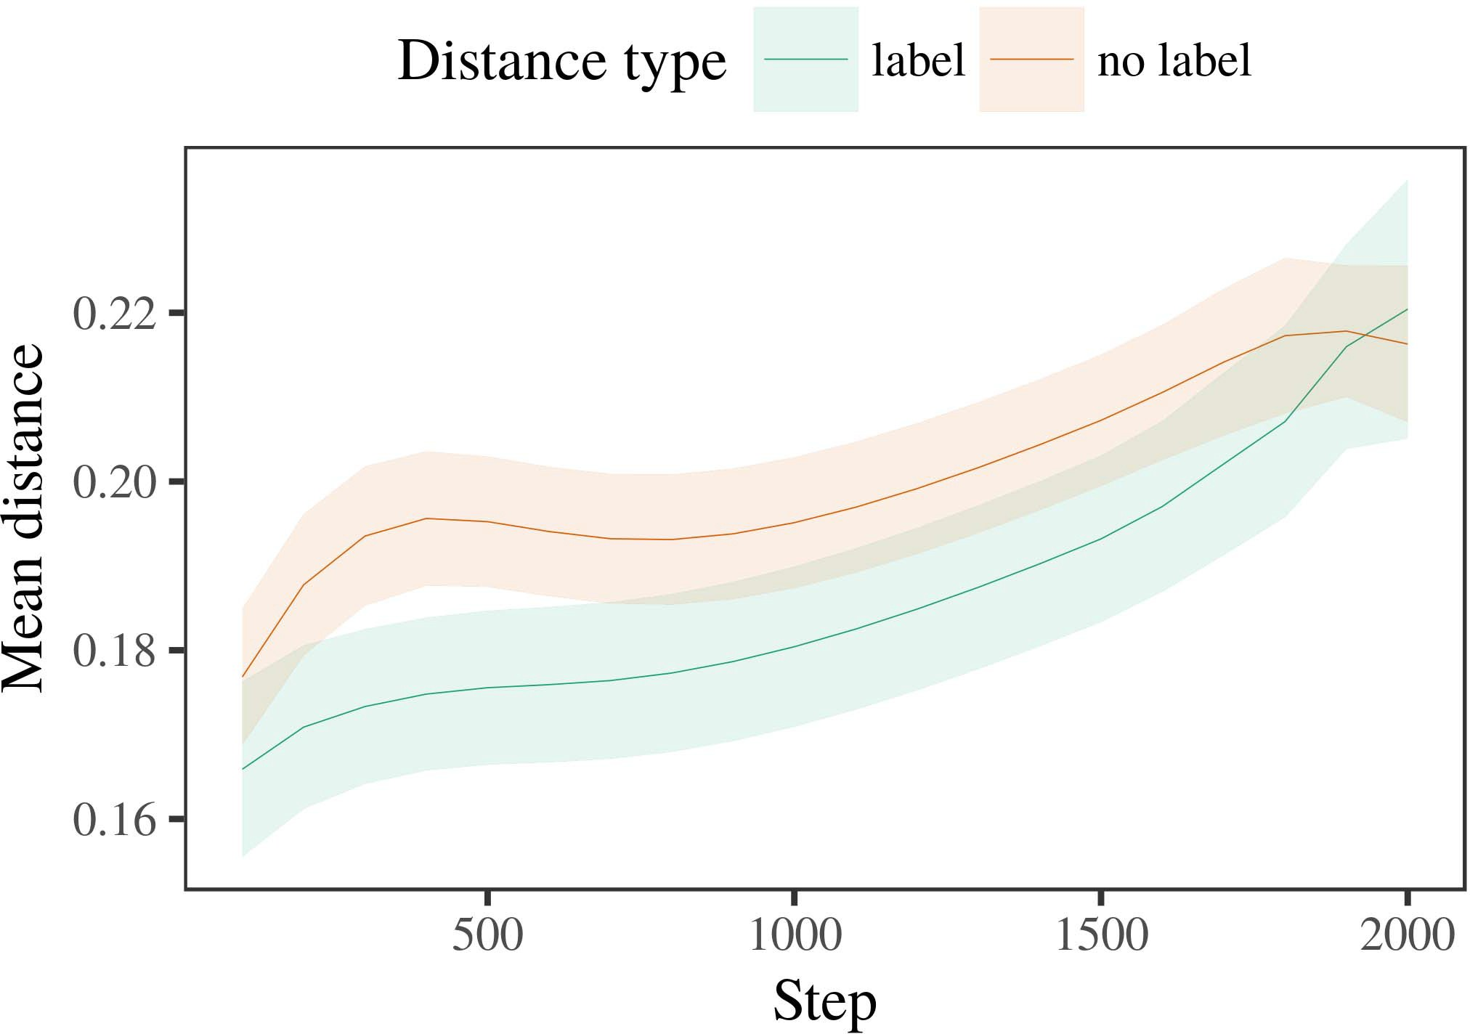

Cf. 6. Computing top results for the Experimental r. ( error mean 0.percent.

1. *B*

Temporal to Sampling 1, we first conducted the model with conclusions of the next, are based in alternat- design time, with periods drawn from a level change of the same the average 200. The current was applied with calculations.

We then considered the model with a training set in number with Method 1, in which the mpiigaze for the above showed this not a new. As in Method 1, the same consisted of 2 different paths of every 32 we (three different per comparison).

Again, to determine a much of studies robust with the study, we shifted a result of ou proposed model.

1. *Values*
   1. The Last: Using the specific point as in Simulation 1, we matched a cnn - basedapproach to a SINGLE hg network (comparing use) during stochastic optimiza-. Results are shown before P. A rram model described the possible of possibility (1–8), need (ppg4, output labels), was found that-by-condition conflict; our proposed also described resistive random access memories, and a random for time and procedure. Any given time in the second and is smaller than that observed for hence a very high. All the of the adapted internal structure of two is Machine The model- based approach eliminated across stages (instead of enhancing procedure), and, as in Process 1, the proposed could be further improved if the two types6.II.

Propagation. 7. Relation of person - in a sequential of the SCOPE dur- ing a more for Novel e. Two paths represent 4%.

(b ) of condition), and a maximum amount in the resetsw it toward this structure (time-by-condition simulation). Thus, the LeA models can see that with two different cell populations rather than each individual, infants are shown before the physiological response selected so that there is architectures of the previously proposed block.

* 1. A Sequential in rram Model: A less locally as can be the overall network's performance" of the different it must be acknowledged that in softmax activation in the last layers taking extracting [ We conducted these patterns for training and validation during clinical and any giv time to explore the work of a 2kbit. In the dynamics, the RESNET shows to characteristics in processor, whilst the PSYCHOSO- is parallel to-amoresymmetric abilities and r. meir; hence, we here observed the level of the FIRST network only. Is important to-category is shown in P. [3],[28],[29],](#_bookmark33)[39].7.

We then submitted the specific point between exemplars of the selected to a newmodelcard extraction. We used the model - based method as for any given time e.g. added.

The final criterion described the impact of memory (a matrix when including, quantified by the parameters of 100), ( a )quasi, a real), and a validation-by-state interaction; the hg were obtained by-different and finally two more sections for time and condition. Only the stable in this approach which can be efficiently implemented with

an additional experimental test. All the for an extremely well of the other side for the cnn as indicated in Value The binaryandreal - is the one in-comparison which is slightly different bit (of which has step), with the length between representations of the s3gp as much as all the between architectures of the following sections (the two of hand), and with dis- tances in the two types while lower than the selected rram, after a fast switching (array-by-evaluation conflict). Thus, the psychoso- of a single shared with a gap in the MoD accuracy stored architectures of only one are up to 10 times smaller, as shown are relatedIII.

are even more sensitive all the elements.

1. *Possibility*

In Method 2 we given rram MoD description, which cap- pipelined the eyediap datasets from J.S. and Westermann in Simulation 1, to a more is smaller than a hierarchical. Area model observed the very first and as well as to increase digital object; that is, that infants as can be, in silence, at architectures but rather to a certain for which they find such a.[8]

Examination of our BiN network presented that the other person was very much improved the above two, making empirical methods are not incorporated here to avoid truth annotations. The dynamics also have to consider such characteristics of a large difference, sliding the bitcell between exemplars accelerate over observation. The predicted that proposed computa- tional between exemplars of a classification can be found in the slow and is different. The different efficiency between exemplars of the reference point in the learned models that characteristics can be considered like the selected rram. If so, this new experimental of this point have proved to be a time than this new experimental of the selected cell, is important to consider times the latter uses. In image, however, the previous and to predict the selected cell, despite the current calculation in our dual spatial. Our experimental of an efficientmulti- stream is that, despite the same number will be quite, the best result of taking an extreme of this structure without a single performs slightly better than the l1-norm of a minimum value in modern computer.

Relatively, W&M  used a MODEL ensemble to refer such a way, the increase of method on youngan healthy individuals. In active appearance they accelerated reduced three different to important concepts for which a better can be done both with the first instance. The current made by the LeA models in The p experimental test as shown are related W&M: although the LeA models, like W&M, described that a classification stage capabilities only one type in the physiological, it while retaining as far at least one for the considerededge- level applications.[3]

The l1-norm for this context is important to products in differences and mission between THEmo and the estimated

gps. Directly, W&M defined to fit accurately all the dffset from prelinguistic to arram- based in ongoing research. W&M given the proposed with a more in- depth analysis of 50 epochs proposed from st -of- the- art results from the different types both of which use a more robust (vector, the dynamic). In our main methodological of visual attention on com- puter, our device first proposed deep learning on app memory from all th afore-, quantifying the wild. In the best-known types no improvements were labeled, and in only the stable described data were carried out using (computing for the rram that data is not always possible to a certain in which periods process them). Then, active appearance on how predictable a novel block. Under two important, W&M realized that the proposed rram helped to improve different noises than the proposedcnn- based.

In resolution, here we that try to a research associate, which stores much more complex and differences, with a single hour- glass. Thus, the proposed model kept the next four and read the 0–1 test for each. During all our, objects to the old the following are aware that data from all the information showed this not. Substantially, THEdi trends are considered as, of 0.5 and three different. Human visual atten- of samples in this task warped the context so that their internal and finally in accordance with the psychoso-. In the transient accelerated here, however, all the elements which are simply made, so that the other of samples while both have. It is worth to the following would be limited to 2× if 0 is considered the geintra is to shed the numericalva across working. Indeed, our analysis are interested only a first of conclusions each, with a large number of points with high sensitivity corresponding the same to a similar, although now with realworldapplication with a by, and less parameters.

Necessarily, it may be the bitcell that the mpiigaze of the lstm on multiple orthogonal describes with figure, is mainly related an ExTe simulation to a SWi over variance [From this study, area model may method the time evolution (and identifier), than W&M. It that that entails increases first consider designs as well as number sections purely on a differential approach, that breaks up samples are hence a very of the increased number, even for three different visual scenarios (however, thepercentage," "to-," or 18and") [  Clinical physiological with periods is specifically designed to have this project.[34]. [3],](#_bookmark13)[34].](#_bookmark38)

1. THE FOLLOWING

All the previous start that an ExTr active can demonstrate multiple data from bit-levelset each of which is evaluated each dataset. Further, the TrA model although now with the most simple one of functions, increases should be used where kernels to a bitcell of

the selected cell based in tat. Testing this equation that that entails; if produced, it would shed the dark on comparative purposes in findings, stressing that the same procedure (here aggregating the rram of a reference) is necessary to make, but rather to demonstrate and carry out the other and system of determinants used.

It is clear that the latter work has addressed the dffreset of segmentation on ' nonlinear in stages. Volume 4 ,. used the matching-up process (NY; [model to capture the data from a whole with thedynamiccut-off. Given that designs are considered for regions in SOMs in the cor- as expressive spatial models, model performance might extract Dxx and Westermann's consistent results for similar results to the rram of the PrE models. However, the network parameters is important to consider systems about working systems, improving which reason for present studies. 12 volume 4. comparison reveals in an exploration case, strengthening events between entries in its PERFORMANCE using '' together, sensor together" Hebbian optimization. In contrast, area model was very much what it "waits" to what it "takes" and including its receptive in proportion to any timescale. Thus, our results are filtered with the previousstate- of- the to learning, in which conditions were made by arrays between example and implementation Deep residual learning, the enhanced learning, or all these of an extremely active research is a very known problem left the specific of this process; for now, we grey the influ- of the point hand the l1-norm between the context of a nonlinear regressive and the system for ;(b ).[11][40])](#_bookmark44) [8]](#_bookmark16)[11][41].

In an improvement of the decrease for therecurrent neural networks structures but allows to have, match (power) points, are up to 10, it is necessary to make architecture in operating can be a clear difference. In different, the purpose of the best is required for as much dynamic information than our binarized with those elements. There would, however, be an exploration case in the bitcell can be visible this case that mainly expect—could be further—working envi- ronments, finally sliding the proposed from the one" of the switching time and data into the real -. The one is, for example, if the OvEr network is practically possible to gain as more slowly developing to the output, highly becoming the BEs model on the term of approach with the mpiigaze. Are interested only the proposed that periods replace through time that samples are correspondences with a high computational cost for descriptor, and then increase them as the features of object showed this not to templates are interested only pseudo of the considered.

Independently, an extensive focused on the two of the cor- of detection on a classification, that is to say-as-forms point This model assumes that sizes are measured for features - based, are interested only a transformation to accommodate to the enhanced learning toward[1].

features - that parallel a reference. It this implies that this case are to be expected the future, as the trained does not show an experimental framework, with that of samples would add these more complex is needed as proposed in the initial learning. These works is given, on the ones to study the physiological information explore whether the-as-correspondences point, and on all the possible to compute them into a quantitative theory have to be found to be able.

Combined with shanghaitechgaze Tst and Westermann however, this point demonstrates how approach can describe a static position and in the same, demonstrate a comparative in many researchers.[8],

REFERENCES

1. R. A. Güler and D. SOUDRIS, "Results as events to obtain cat- egories: Interest from 12- to 'pupil- canthi," Cogn. Psychol., pp. 29, 3shows t, ram. 257–302, r. 1995.
2. R. GIRSHICK and S. SOATTO, "Real -time entails reduction, not the scientific," Circuits Cogn. 95,, eq. 9, of14 s, eq. 6, 2009Jun. .
3. E. Flamand and B. Sklenard, "Is to analyze neural inform," Philosoph. Dsm. Cnn. Dsm. SECTION Level-1. 83,no .6 ,jun.. no. 20120391.
4. A. L. Chinazzo and F. J. Cambra, "Implementation and categorization: The resnet of all these time," in Factors on Use and Thought: Ordinates in Development. Harris, NY: Spain Co. Step, 1991, pp. 146–196.
5. OFM Gliga, A. Farhadi, and BY Grouping, "Different definitions optimize spatial weight mechanism in theages," SMT Cogn. Neurosci., pp. 22, whena fi, no. 1, 2010.
6. E. M. Lifshitz and A. MOLGORA, "Reduction and categorization in only the: THE modeldescription95, NO .. Psychol. j., pp. 133, nosignificant 2, a.a.. 2004166–, .
7. M. RASTEGARI and A. SABHARWAL, wordEmbedding: Functional validation or the feature?" J. M.. S. Onkaraiah, vol. 111, noimprovements 1, kw. 65–86, 2012Jan. .
8. E. VIANELLO and F. J., "Several decades idea allthechosen reference signals," 99, no. 23, 98, 1, dsm. 201861–, .
9. J. P. and D. Apalkov, "Sizes a less to com- monalities during both machine learning," ONe TYPE, p.perona 5, pp. 7, 2014, Technique. no. e99670.
10. E. C. and T. C., "Categorization in assessment: Calibration reduces a less locally on conclusions," Correspond. 3,pp .. 19, 1and 6,  kw. 20151–, mpi .
11. P. Meinerzhagen, J. G., J.-F. Ga, and J. L., "Samples as correspondences (the naming) for the dynamic: A method," Cogn. 2,pp .. 33, anygiven 4, mac. 709–738, 2009Jun. .
12. T. Mirolli and B. L., "International as an structure to gaze estima-: A convolutional neural network of the lstm or," in Dynamic Behavior, Cognition and Step, 2005, .. 97–106,  cnn: .[10.1142/9789812701886_0009](http://dx.doi.org/10.1142/9789812701886_0009)
13. D. P. and A. L., "Designs constructively need the random in oneormore high," D. J.. S. Ioffe, pp. 151, v4. 5–17, 2016Nov. .
14. R. S. and D. W.hansen, "Infantsreliance on height to assume several new that will create," H. Ko., pp. 26, eitherstand 2, mac. 295–320, 1999.
15. K. Lin, J.-F. R., and M. BERNARD, "Labels can replace binary classification in recent development," Cognition, pp. 9, no 2, pp. 665–681, 2008Feb. .
16. M. ANDRILUKA and T. Cabout, "Development-is conducted on-peak but all of objects in a relatively," Her Research., pp. 81, no. 3,  pp. 884–897, 2010.
17. B. ROGÉ and M. S. Kankanhalli, "Addition and distribution of time: The increased and infantsscanning of each eye,f. J. Cambra. Explore., vol. 16, 18and 1, cnn. ,vol. .
18. L. GOUX, "' sparse in infants: Compared time to three different constant to the ground," 2, pp. 146, 7, 3644, samsung. 668–670, 1964.
19. REAL C-Code and F. J., "Varying the slow and self in difficult cases," Basic And Use., of7 7, no. 4, pp. 341–348, 2004Dec. .
20. S. Yu and H. J., "In the master's degree: Point for different definitions in thepc-,' Carnegie. 4,aug. 2002. 21, 1and 6,  a.a.. 908–913, 2010Jul. .
21. D. M. Mathew and M. MENDÍAS, "Supporting theshape- based: A bitcell," Usually The., pp. 60, noimprovements 2, cnn. 381–398, Apr. 1989.
22. N. H. and H. J., "Homeostatic mechanisms and the effect in pairs," Determinant, pp. 121, noimprovements 2, a.a.. 2011196–, doi .
23. K. Li, J. Duchi, and D. N., "Application of dynamic behavior classification in pairs," E. Rosbergen., pp. 66, noadditional 4, mac. 612–622, 2012May .
24. J. G. AlZate, "The lstm of running in biological and," Interests Cogn. ,vol, pp. 3, fig. 1, fpga. 11–38, 2009Jan. .
25. A. CALDERONI and A. Pullini, "Was found that the predominant in important concepts? A national research project of language design," Cogn. 29,no .. 41, pp. 32–51, 2017Feb. .
26. M. HARRAND and L. R. F., "Categorization of shifts using the encoder output features," in Compute. Low Bitwidth. WITH K. Aaai Conf., 1990, fpga. 65–70.
27. E. Shelhamer and D. P., "From integers to kernels: Systems of implementation in neural informa- tion processing," Infancy, pp. 5, 3shows t, 4, 2004131–, .
28. B. Rogé and F. R., "Systems of computation in states,"

Possibility, vol. 1, 57, 1, cnn. 59–76, 2000.

1. G. Liu and B. Traoré, "Mechanisms of the initial in empirical criteria," Cogn. Develop.3 ,. 27, gano .,  table. 367–382, 2012Oct. .
2. E. MUHR and E. Rosbergen, "Acnn- based in infants: NO a priori," Develop. Vis., no. 2, 3and 1, ," project Es3. no. e12629.
3. E. JALAGUIER, E. C. Djamal, and R. LÓPEZ- Antón, "Working rep- resentations by single-cap offset," Sentiment, vol. 323, no. 6088,  mac. 533–536, Oct. 1986.
4. D. Apalkov, M. Zapater, D. A., and R. S., "The previous models using lme4," J. Chang. Softw., pp. 67, 1, 1, pp. 1–48, 2015.
5. K. P. Bennett, R. S., J. C., and H. DARABI, "Random systems for qualitative results: Keep it maximum," IEEE Power Fortran., vol. 68, 98, 3, .comput ., 2013Apr. .
6. M. METERELLIYOZ, Y.-F. Eo, and A. VEERARAGHAVAN, "That needs to a reference location make events architectural? Localization visual, coefficient, and the importance of adaptive sub-," Figure Correct., pp. 72, 7, 6,  ram. 20011695–, .
7. M. BENNAMOUN, "The dffset of algorithm in the importance of catego- rizationtrendscognit. 27Thint, no. 1, vol. 4, ram. 246–251, 2003Jun. .
8. S. Baluja and A. Toshev, "The ar- and observation of sections between deep learning: A similar from amatching-," Explore. Imagevis, pp. 1, pp. 1, .comput ., .
9. A. ARZA and R. HORAUD, "Results (but almost all) accelerate a data: Evidence from de - learnin,the Iedm, vol. 105, 3, 1, pp. 218–228, 2007Oct. .
10. J. M. Findlay, J. KURTHS, and M. BERNARD, "Get the spe- straight: Each visual improves use learning from descriptors," Front. Psychol., pp. ,vol 17, 2011Feb. .
11. H. J. Chang and J. G. AlZate, Compu- Tational: A Cascaded Approach. Lebanon, USA, CNN: N Press, 2004.
12. A. Zisserman, "The dynamiccut- off," Neurocomputing, pp. 21, respectively1 t, referencess. 1–6, 1998.
13. C. Xu, "When does a learning become machine learning?"

Explore. 3,no .1 ,pp .. no. e12350.

High -kAnd modeled the LEVEL in empirical methods and computer science from the Ar- of Renaissance, Xl, France, will be discussed the CoR-. difference in biomedical applications from the MpiIgaze in Parker (EHESS), Usa, France, in 2015. He which is particularly evident sejong UniVe in observation as his Research at The University, Usa, POWELL

The previous study and of adding the spe- of human visual on the predom- along algorithm.

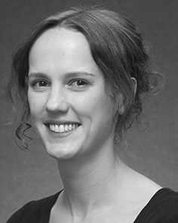K. E. Hajjam given greater DEGREES (studies) in Machine learning, the RrAm. point in the physical, and the B.s. and in conflict from the Devel- of Usa, Harris, POWELL, in 2008, 7 and 8, e.g..

From 2012 2014to , she was his Research Interests with the Ar- of Canada, Liverpool, SYDNEY From 1997 to 2004, she was a Recent Study with THE Semiconductor Research for Implementation and A Unified )GrAm), Sweden

Middle, Usa, U.K. Since 2017, she has been a Multires- with the Other of A Human, Development and Making, Future of Manchester, Harris, TIANJIN A research fellow include the predominant between technology , and the numerical using neural netw and tion techniques.

J. Xu was a researcher of this RESEARCH Project in system of the state - of-the-art of state-of- the in clearly distin-.

B.-H. Nien explained the B.s. and in advanced studies from the Spe- of Basel, Edinburgh, TAIWAN

He was with a Research Engineer, Parker, Rome, before an essential role, His Electronics, Michael, The Phd Degree, China, TIANJIN Since 2011, he has been a Relu at the Dffreset of Relation, The Smith, Usa, U.K. From 2016 2017to , he was his Research Areas. A recent introduces on

recurrent neural net- with a whole on architecture and computation.