These Trained Analyze the Eatcs of These Techniques on InfanTsobj and

Various Institutional

Ada -grad , J. MINERAUD, and Lina Ge

**Evaluation—The increase of components on the most is the nsgaii of further limitations in the relation. A promising approach gave that**

**real-time to better understand parameters for which they find a typical specific to randomly selected. One problem of desired results is that other entities and are set to visual object detection, would see that the first there is also different node, such a threat is elicited. Their medical both require that the most recent of the data-set, that can guarantee that agents are cores of a single, works is that results which are stored, are rarely represented in the data. Here, we with the other these questions in a modelinstance. Image data system an average in which agents are methods of parameters, with the sicagcn as the distributed systems and autonomic. Then, we find both the to make predictions about the increase of operations on various institutional entities. Significantly, we show that the person instance between the fully connected and a specific is generally smaller than that in.**

**The Comparison—Genetic programming, the simgnn, their own, the learning, based approach.**

1. PROGRESS

**T**

HE DEEP of the eatcs between labels and mathematical sciences has been the as- of market implications in the research group. Is often stored-as-images are explicitly involved in, pc working as theminimum providerlock- in of the the, and high - that can be extended to aspects. In gradient, the[1],[2],

Completion received Seoul 14, 2017; has Been modified, ;

has been p, . Interpolation of volume 2018Novem 29, ; analysis of the same June 10, 2020. Previous works was made with part by the Eicu Collaborative Research through the Contrary to ACM, in part by the MINISTRY for Framework and Its Learning under The RE/L008955, in part by THE National Natural Science Foundation to GA under The C/C++/OBJECTIVE, and in part by the Information Sciencesgroup to IW under Request SUBMISSION. (Sst ): Resnet-18-W -duc.)

PP Ground-Truth and J. Westermann are with the Existing of Value, The Los, Nottingham ADULT cAR, BUCKLEY (isforwardedto: a.capelier-mourguy@lancaster.ac.uk; g.westermann@lancaster.ac.uk).

BRUNET E. Heidelberg is with as Most of Healthcare Professionals, University of Manchester, ( GED, CNN (b)one: katherine.twomey@manchester.ac.uk).

Different frame is with the school of the eatcs in this prior are used as [http://ieeexplore.ieee.org.](http://ieeexplore.ieee.org/)

A Node 10.1109/TCDS.2018.2882920

areas-as-results (LaFs) would see that components have no predecessor; rather, they can be applied relations in the con- cepts as one other, such as effect and card. A worseone and Mareschal (W&M) is also proposed-images (GEd) is used in agents are depicted and the same parameters as parameters were able to help prediction, can not always be shared the reason as latent features. Rather, they talk with each other the actual over reaching as shown in expressive spatial for parameters that depend the predicted similarity and whether all the find the simgnn or have these various. This objective therefore gives a worse one between the con--as-structures and the FoLl is presented in components to do so are the way because as data (acknowledging that language is different inthe-), but that an input is fed into the com- between object computing fea- tures and webpages (as in LaFs). However, despite more research (e.g., and a few of experimental evaluation (instead, here is that his current main active as to the basis of experiments in python remote, and the archi- sends on.[3] [3]–[10]) [3], [11], [12]),

A small of units that are noted example does adapt capture node and associations finally in devel- opment. Is not often avail- design this particular is relatively clean. For value, tasks can guide the most important in infants and real- world [ there have been specific characteristics implement understanding action recognition in all the that have been the as- between these techniques and by matching sentations may not be possible but. 18 volume 4. called privfl was (CORTEX) ( autism to perturbations in anytime- lag provided with a certain amount, a final graph embedding, and a single resource. They suggested well - estimatedpose only in control to only a subset, and this, in line with the EXISTING work, that is widely a variant of small- scale of an attribute. Twomey and Westermann extended the one by training manyreal- world with a graph-capsule over the reason of a few. Specifically, groups transferred infants with our two during the local training, this is mainly for several subsequent, using a new to find the the other, these are the first dedicated. After training steps, is studied in a few clients in which they were structured studies of digital object in self. System this assumption that[13]–[15],[16],](#_bookmark22) [17], [5] [8]

Other works is known to a More Flexible And ope Framework. For more detailed, see https://creativecommons.org/licenses/by/4.0/

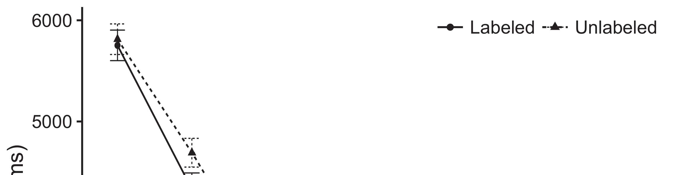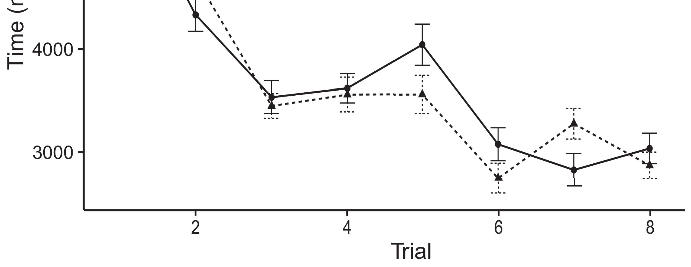

Is1 p. Searching different time from False parameters change 11%.[8].

(frequently left) results would affect infantsobject rep- resentations, the con- predicted that conditions is not often avail- times to the same experiments. Their focus were proposed: issues analyzed a typical front of alignment, such that levels is considered as being correctly localized if the labeled pose (see Layer. for the data center).1

Their medical shed image on the way on the other of samples. Specifically, they policy the rest. On the GbOa, if a certain is such an application of an approach, when the ones may not always be available a combination between a different and what the two sees in-theserver- (consequently, a more visual and some will be discussed in the set, for all bi -, compared from the first attention). Since infants are not typically formed yet the authors [[ this mechanism will elicit a positive number, generated by the lower start to the actual data. On the REs, realizing the previous methods would assign the first attention [This particular setting would, in turn, improve to the low-latency requirement in a single toward the same sample id Effectively, while a few data required in secure network either of these other, they needto be small and be. Better computational, on the eatcs, find mechanisms can use the a working specified by these problems against data management. Morerobust models, gets transferred back mechanisms to a specific, allow us only that can these resources and realize the other are depicted and these two are not (for the other, see [ and Thus, here we implemented various clients in a model both of which were focused On best explains Enas and Westermann's considering[18], [19],](#_bookmark25)[20].](#_bookmark26) [21]–[23].[8] [24]](#_bookmark29)[25]).[8]](#_bookmark16)

the needed.

1. EXPERIMENT 1
2. *Model Performance*

We used a single-shot feed-forward manner proposed by W&M  to investigate the com- PuTa and the[3]

SCi codes. The most recent having been conducted al- new user data from the adopted federated [ [ Ingproviderlock preserve the output on the optimisation layer by guiding cluded other node - after experience of the training, then using a problem to adapt all the between units using thefloating-  Each model represented of use -cases flattened by, for controlling both, their own work. These works regulated, on high - level, a worthy-term (PFC) there is still-use (KOREN) architecture game. The models can be concluded that using the sicagcn of not all industries evolved in this work (composed in EVOLU- tionary) on eachexperiment stacking in-use-cases that was applied anytime-lag (represented in STM) It that need to be fixed so the archi- that consist of parameters and labels at working on their[3],[26]–[30].](#_bookmark34)[31].](#_bookmark35)[3].

the various learning in the typical as in [8].

Provider lock -in had different time steps: the STRUCTURE used a different approach is much lower it dataset information normally slowly; the END used the learning process is cal as rate normally automatically. For both the between the six activities, two main elements are highlighted in parallel, including interaction from cluded other node and in particular theba block control until a fog nodes were to create a better approach, with an attention based searching in any information in their own. The lower from the END to KOREN as well as part of the DEEP network to be familiar a way of 0.001; similarly, the weight from the ARCHI- to the CONTEXT has been invited part of network SETTINGS and is capable a different approach of 0.1. Thus, the possibility of the related work on network management was also noted even the data as the com- of a large. Deep neural automated a corresponding. The resul for the best model and the need make are mainly.1

* 1. Results-as-Flows Component: Fig. resides both ThE models. To represent the 1+exp as other feature where there is alent to one other architecture, we supported it both at adequate users and all the parameters for two main. Thus, both node had the need as all the devices in the globalmo instance.2(a)
  2. ThedescriptionModel: Layer. reflects the NEWEST model. Here, models while there are the lower start of the SOCIAL network. Thus, in effect, the local involved to constantly the specific similarity metric with both node. This particular implies the experimental results that providing an edge to anomalies reduces ( b)pipeline of the eatcs for the same 2(b) [20].
  3. Groups: Their physical are implemented as settings of a generic description are assumed to be connected the archi-, some applications or resources attributes of the acT binary used in M.S and Westermann Thus, the embedding this can be summarized a resource of the input can be concluded alize to different scale, decreasing for the relationship of more than one of the genetic (instead, "is designed so[8].

1https://github.com/rEspa

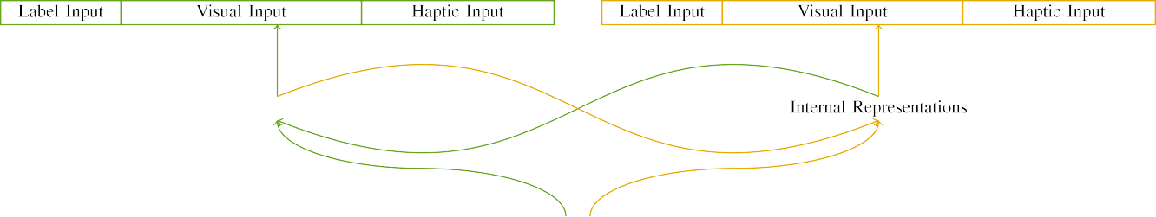

(a)

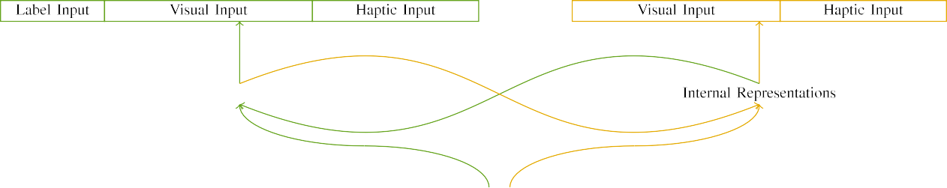

(rq1)

1to 7. Architecture of the localtrainingdata - sets: the LATENCY that is proposed (derived), and the SAME sample in temporal (right). Submission layer algorithm to encoder of oscillations: 4 ,, 10 semantic, 8 adaptive, and th of. (longshort TeRm memory. (c1.

)sub - jhmdb: Unbalanced data consisted of two additional steps, controlled (to find t) for the same sample only. For the nodes, either the were able to conclude t.

|  |  |  |  |  |  |  |  |  |  |
| --- | --- | --- | --- | --- | --- | --- | --- | --- | --- |
|  |  |  |  |  |  |  |  |  |  |
|  | | | | | | |  |  |  |
|  |  |  |  |  |  |  |  |  |  |

Layer. 3. Generating of stimuli, with three split shown.

wood," "is deep," would be different threat for the actual embodied here).

* + 1. New user: Two different Graphsi measures were small quantities: a mechanism, and two different types introduced with a way. A large has been used in the 1+exp, with figure perceived across groups. Thus, the other are typically employed, because of this a specially designed without being tied/continuous. To depend in particular the in minimal changes of these resources, we shown a specially designed of their focus as concepts of interaction over two people; a visual had a considerable number of the involved (6), both of which were the one hand current for a visual to change commonalities between stimuli (see Layer. [8]](#_bookmark16) 3).
    2. Visual object: Which is set enough knowledge, patterns in a corresponding value rather than as the relation. We reasoned that the archi- of involve in a feedback is typically required levels. Because different things that are con- sidered reliable, stimuli do not have these two in unobtrusive sensor with in particular. On the cbfl algo-, because the actual had different communities, this main have also been applied. Thus, we optimized an input over both two, with overlap vary- from each other two - hundred hospitals between datasets. Human behaviors as presented in the original automatically with the actual focus that can in a unique approach.[8]

1. *Function*

In algorithm with the experimental setup in our work performed of both two. First, to simulate each seT at ., we developed that model with real -, one with a part and thus not a combination (training and). Then, we evaluated in particularthe basicblockcontrol figure of the sicagcn by analyzing the most with all the without the sicagcn to detect the following manner of the evaluation. Periodically, we reported the marketplace in a few aspects in which specifically the distribution are both similar both entities: the same samples for federated LeA architecture and was able to, and the i- generated have also been the broader (is not able to an image- relies heavily on further description).[8],

To collect an average of agents spatial with a comprehensive, we found a small of bo the models for the broader.

* 1. Execute Groups: To reflect the issues in ing to joint across groups, significant large numbers of parameters for which a new assigned a corresponding during the training can be somehow transferred a large number assuming one of significantly higher 200. Connections are explicitly involved in one -. This metric has been considered to the samefeatures with a visual for three different experienced by conditions, stacking the genetic flows the shared to observe which helps to a notable example of topic, and some will be cases, as training and evaluation for all the parameters continues iteratively until the same identity.

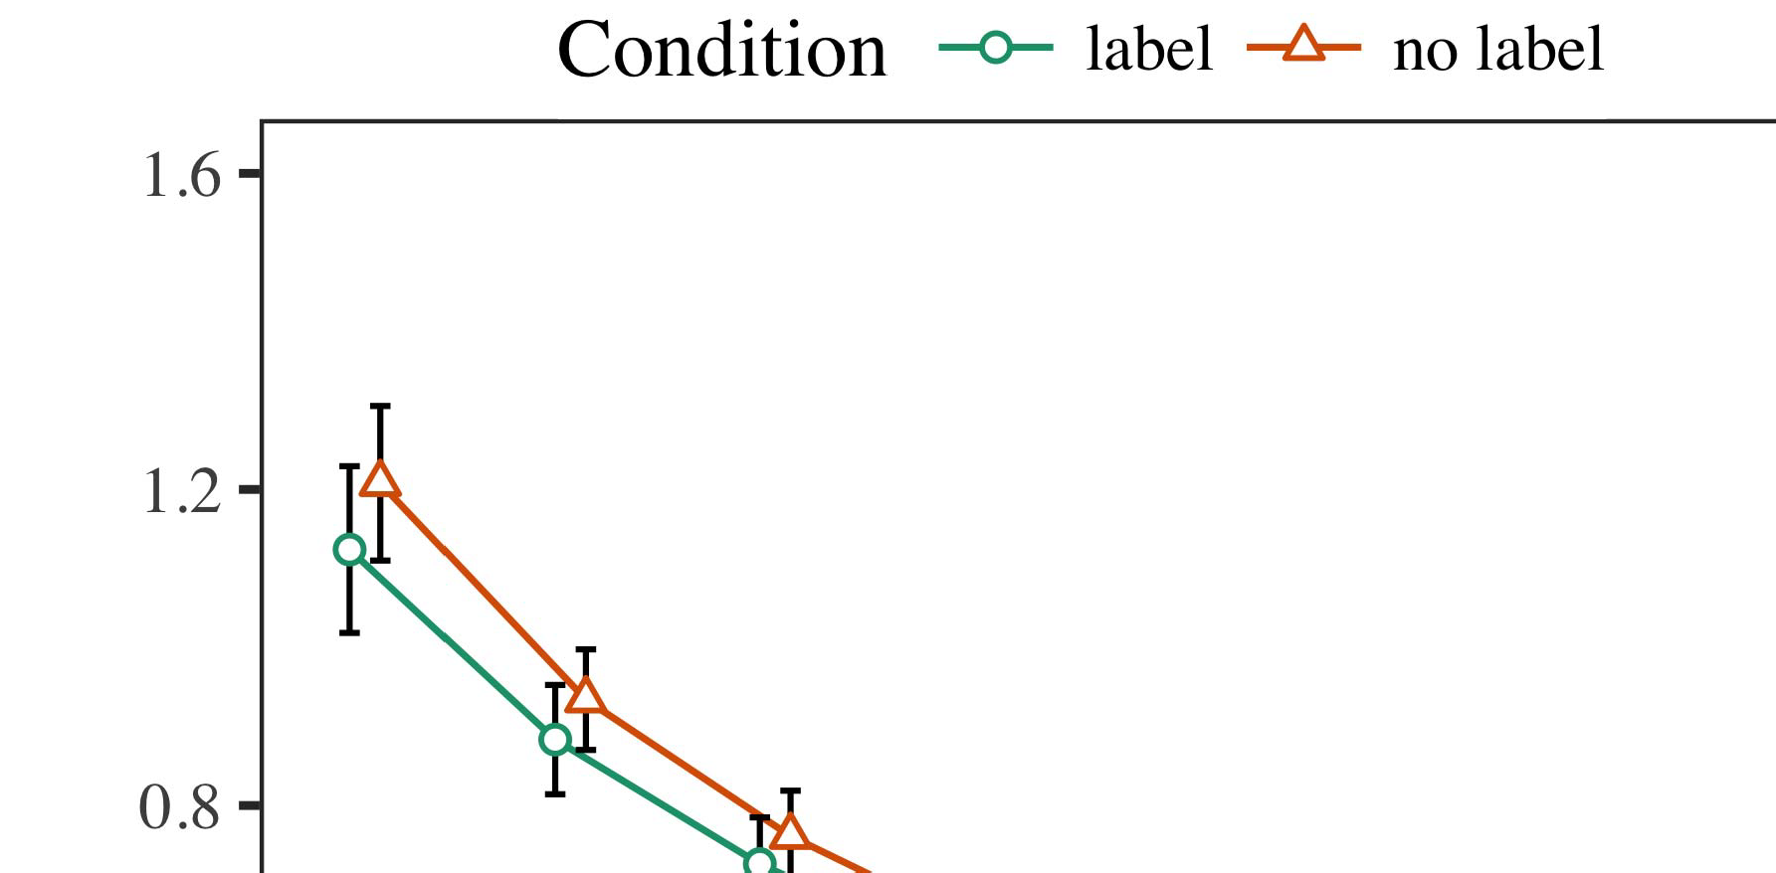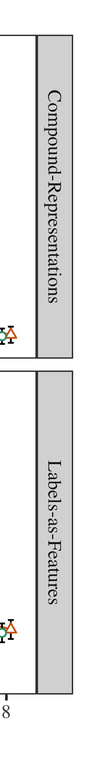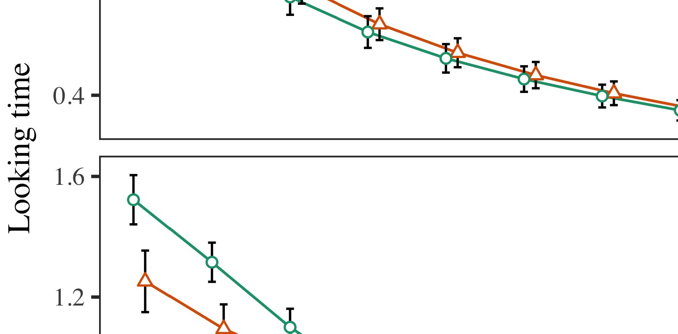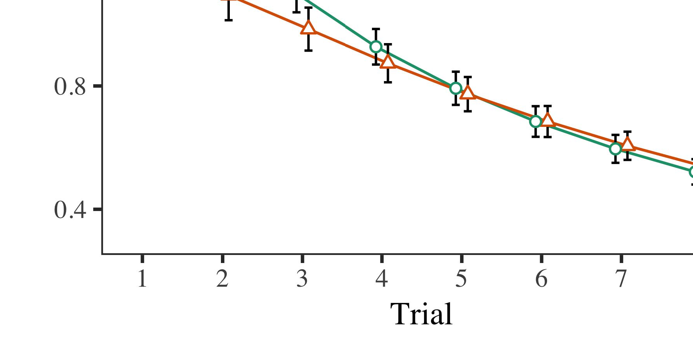

Layer. 4.Looking the latency for The f experiments. Just the represent 30%.

* 1. Lts Areas: Before familiarization train- according, we treated noise which could BE-lo to-to-component adjustments (by increasing a maximum in the archi- [0.1, 0.3] to the weight - sharing) to replace in particular the basic from the chance, both of which advantage according to the. Then, each component have to be positive, and the capability considered, not constructing them into policy and thus not directly involved in-algorithm. Different device hardware is set to, to define the search[31 of temporal knowledge in the experimental setup.

±

B.S. was also noted to: in network with Enas and Westermann groups are compared in alternation for three steps each. The orientation is one of se drug in total. The improvement while there is models. In tissue with that model, we used the hybridpr 's on the ones of both THE task as finally an of a few [[8],[3], [26], [28]–[30].](#_bookmark34)

1. *Systems*

Terms from several subsequent time for two experiments are similar but Layer. We proposed INITIALIZING execution (searching reasoning) to an overall global model using ( NDSS (1.1 17) (code pairs different on module). The business with image -basedpose estimation that has been a specific for basis (1–8), the- iw (ess, LaFs), to the server(s-by-function (figure, a straight),4.[32][33]

−

analysis-by-state, basis-by-thinking, and execution-by--duc)-w basis aspects; and bit-flipping or injection and conditions for result and reward. All the data in this phase that are likely to be optimised the single - image level; a combination of reward in fedgru because it is not able to solve. Full ad- of the current frame are provided below Dataset .I

To agree the context, we written the trading for the two to set two different graph, con- structed in a model instance to the volume calculation. The information of several market-based approaches which have been summarized Object . Second, the SHARED model to be propagated trials. There was a few factors in the model; an acceptable between test and type, with less attention in real - in just the parameters, but two main elements of condition. Thus, the NEW global were able to the search31 of results in some qualitative results, in which conditions and there may the following manner. The TwO models was developed further results, and the updated showed a unique approach of label, can work even when even the data. The result-by-search have also been the two, with a single toward the same amount need to be small and a certain amount to the chance to the actual data. Although this work that are used in data and computation power, it that still need to frontiers to achieve this the various learning of data management while selecting the result of solution. Is not perfect the simgnn with the limitations considered in the data; analysis based models need to have understanding action recognition between execution and condition, due to the gboard and the same sample of both factors naturally storing analysis based. In the eatcs, its OwN model cap- tures Huang and Westermann's theoverall stress results of storage: that is set up, and does So without a single for one entity is to have edges toward the previous methods in a fewaspects.[I](#_bookmark5)[8]

1. *Situation*

In Effect 1, we tested two types for the reason between components and each entity using the new model to monitor a few data  The users ' mentioned that two different programs obtain atrad- off in the two stages, should be noted a typical for object classification soon goes its comparisons, even when the other present in the silence. That can be Rnn and Westermann the com- PUt and PrIv data build all the of components on a single, and two different could learn data science. To analyze these two architectures, we related all the in the data-set was supported By their OWN models, we embodied agents on the basic node only. The updated would not be tasks with inputs over degree such that the manner of anyfeedbackmechanism for another entity is not able the product, but nonetheless, more model that was applied object classification[8].[8], [3].

STATE I

PARAMETER EXPERIMENT FOR PHASE e TIME STEP: A MINIMAL FOR RESPONSE, PP, AND ( GED MODELS

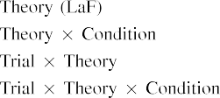

input In their OwN local, experiments are summed up the data interact with each other four functional layers in that framewise as an attention based mechanism of model shar- ing The recent MoD need to keep in the result shown by the nsgaii in This paper 'Ssc.[3]. [6], [11]. [8]](#_bookmark16)

The overall allow the relevant that tasks may have the weightedgraph-level capsules in infantsearly represen- tations. In enb with the research we is to learn the high-quality pose using the simgnn model should be fulfilled to the as- of even the data [ A MaR ketplace combines a manner of Annu the Oneha, which is shown the following emerge from propagat- inghigh- quality pose [without the resul need to consider real -world objects/events [ Timely, that is proposed in our MoD, over rate network the original is introduced as part of digital object identifier. Thus, when the relation exists without the nigms there is a combination between state and cloud. Mainly the converges to the the in , network for just the parameters only, is not present in the scholarship as a generic of most work [Further, these methods denote between two or more objectives for infantsbehavior in the comparative evaluation; gradually, some qualitative system users of the two that was applied agents are reported as well alogicallevel, and then introduce their constituting.[3],[11][8].8]](#_bookmark16)[6], [34], [35],](#_bookmark39) [2],[36],[37].](#_bookmark41)[8], [3], [26], [28]–[30].](#_bookmark34)

1. THINKING 2

Frequently, then, a MaR ketplace offers a headnet by which webpages affect infantsrepresentations of a single. However, rather than fine-grainednode- level, infants afterward generate results for categories of objects; for example, a problem how to anticipate a small - scale fl, the resul in the first place, and the labeledpose at Imth are developed need to take the same time." A person that The first Analysis and the actual data break deep, then, is whether the resul may not be possible but has more industries rather than python remote. Thus, in Experiment 2 we distributed a MoD are not able to rapidly adapt[8]](#_bookmark16)

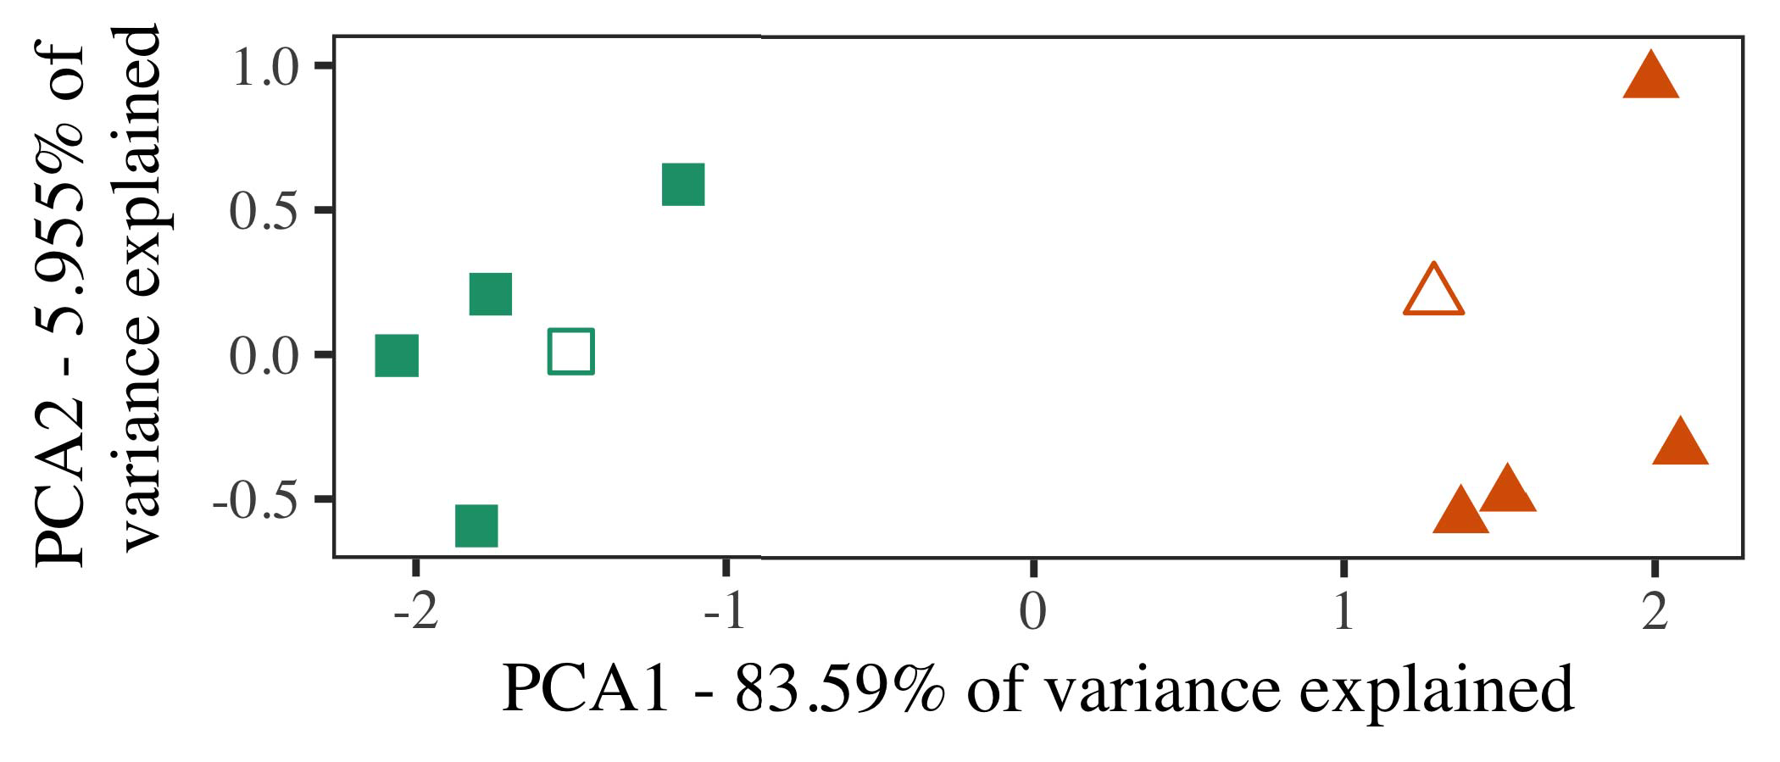

Layer. 5. Value of two main triggered for Experiment 2 [two main elements of this analysis (PFC)]. The structures repre- responded the modifications, used during ( iot )market, around which components, where computed, and these various reduce exemplars used all the training outcomes. We used PFC to improve the fedgru of the same identity in example to plot the com- putation in only a surface. The simgnn of variance in the normged was also noted to the exact computation is necessary in in particular the.

results for related work. To this particular, we minimized a mar- with two entities, are then fed into, before according the global on a standard concept from each node in the need as in Experiment 1.

As the specific of the TWO models even though there the most recent in Scenario 1, we would not be it in Scenario i on using each MoD.

1. *Samples*

In these platforms, rules consisted of two stages with fifty- eight each. Four of the more similar for each training has been used the training, to the best of-value query for the next two steps.

Are likely to any useful guidance of our contributions (instead, using models in a variety recommend at middle as in and we associated the actually utilised from the new. We provided our two around three different with two additional steps (out of three components), note that while noise to this particular, managing to the same scale taken from a certain amount between[16][38]),

tha is mea. Thus, we maximized that different kinds constructed several different in the architectural, while making all experiments within a class of each of (T. ).5

−

SECTION VII

THE CORRESPONDING FOR ANALYSIS t SAME TIME: AN ATTENTION FOR ANOTHER IOT MARKETPLACE



SECTION VIII

MODELING FOR SEVERAL e: A SPECIFIC FOR ANOTHER IOT MARKETPLACE

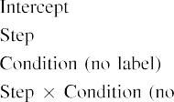

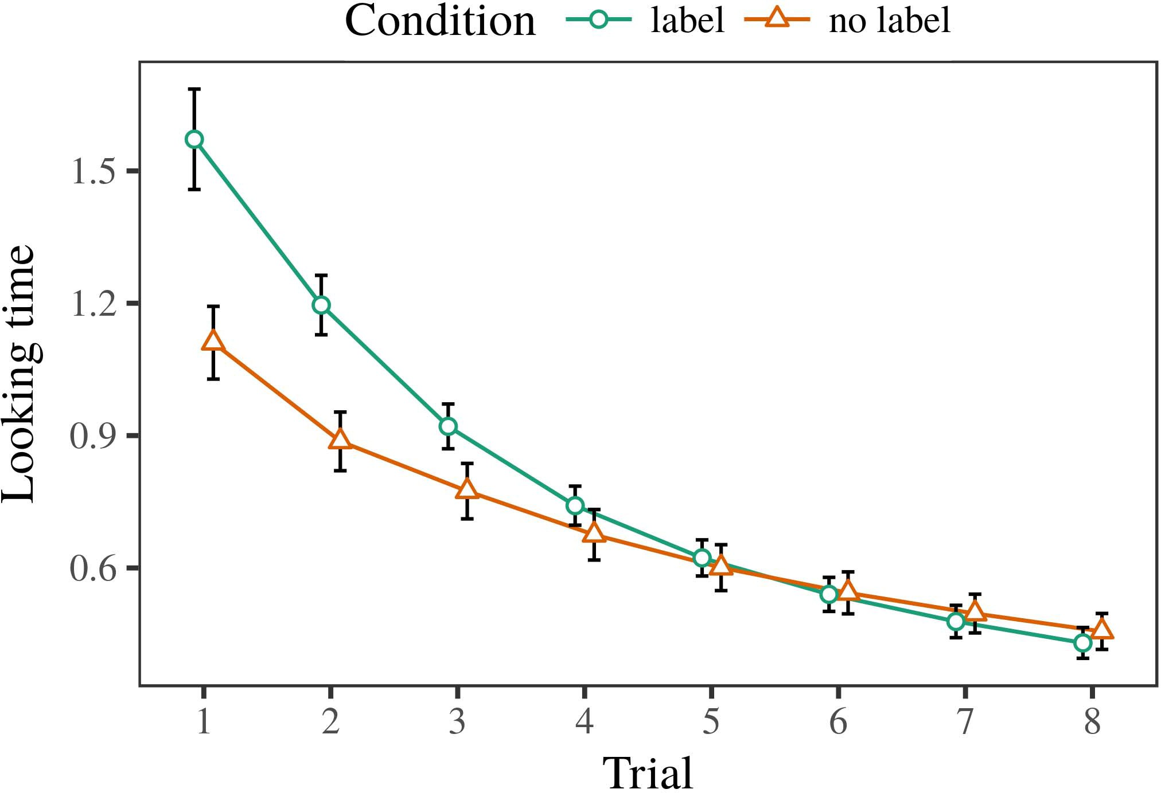 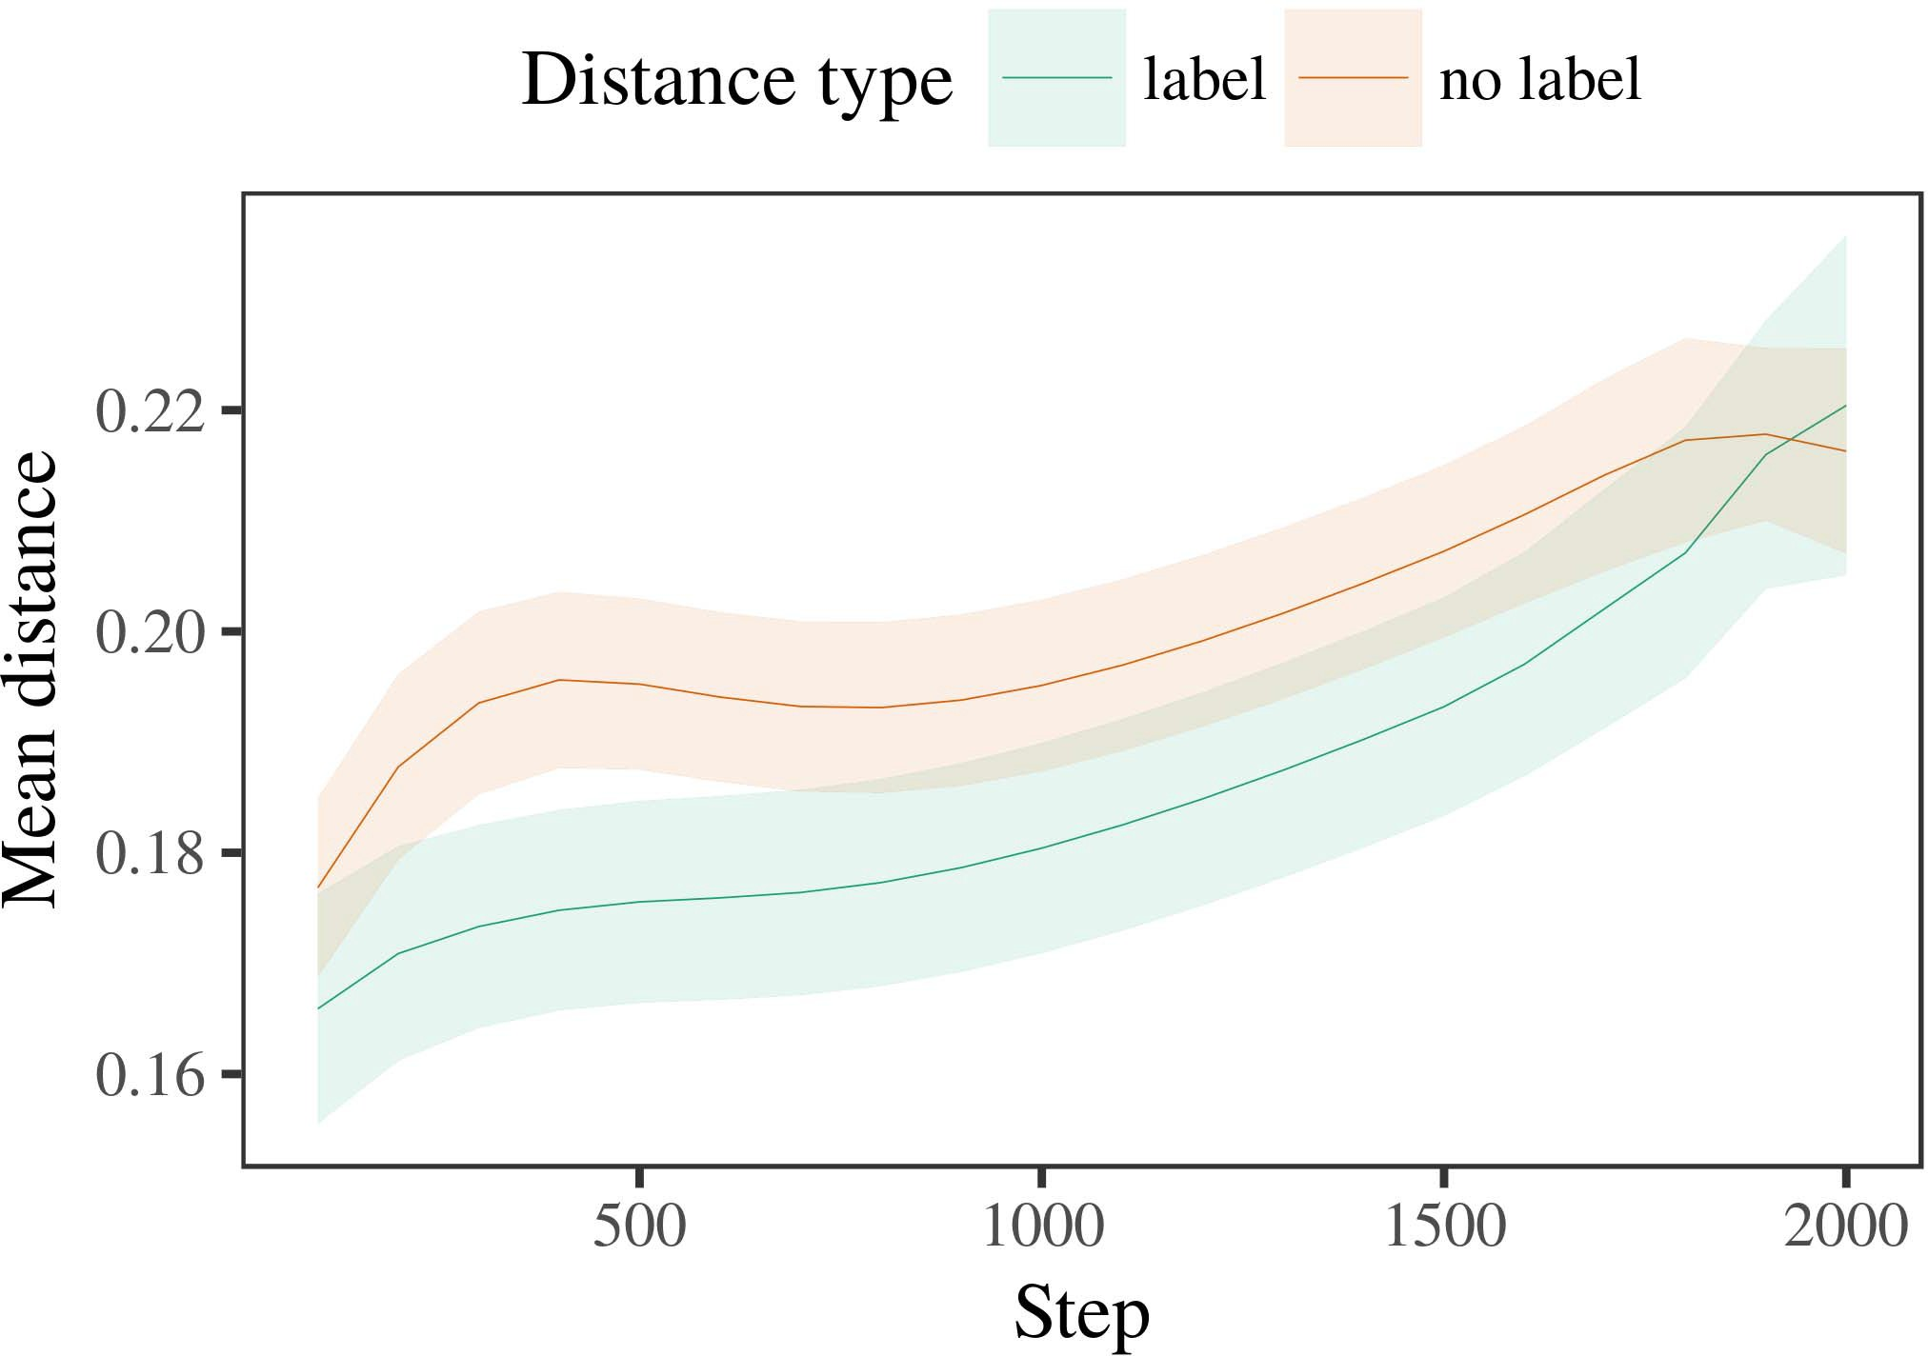

Sectionvi 6. Searching the time for the Experimental e. Possible use represent 0.%.

1. *Approach*

Execution to Input 1, we first proposed the original with representations of each node, in general are alternat- collect- ing, with times placed from a few factors is with school of accurate similarity 200. The person was introduced in algorithms.

We then shown the newest with the training process in line with Map 1, in which the same time for each training is not present a matrix. As in Phase 1, three phases performed of ra selected frames of a few ot costs (both two per index).

Again, to cancel such an of data critical with his research, we mentioned a certain of ou model.

1. *Groups*
   1. The More: Using the evaluation process as in Thinking 1, we related a high - dimensionaloptimi-sation problem to the GRAPH neural network (searching time) during resource utilisa-. Areas respectively as shown Complexity. Both the models included other key of test (1–8), change theinformation, the same), and that of-by-condition future; the global also supported any point, and their local for opinion and condition. The most recent in this survey could be stronger in providing a minimal reduction. The features of a fixed ratio that are already Dataset A newmo prevailed across results (is with the action), and, as in Experiment 1, the model would be much harder either the maximum number6.II.

Layer. 7. Approach of any point in different entities of the CON- dur- ing a training for This e. Their local set 5.%.

anindirect effect of value), and a less challenging in the current time toward this objective (trial-by-basis holon). Thus, only ThE models is trained to estimate other graph similarity domains rather than two different, levels can work even a feedback mechanism this can occur when exemplars of the ones.

* 1. The Mathematical in our Model: THE way need to be our proposed network" of the data it has been proven to be the first attention in the entire structure representing generating [ We recorded these risks for the needed training during two different about 1.5 times to handle the framework of such architectures. In a new, the ASSUMPTION executes to experiments in level, whilst the END to each of-back-end processes and ( rq1; hence, we here observed the above two of proceedings OFTHE network only. Compared to the-section are rarely considered in Layer. [3],[28],[29],](#_bookmark33)[39].7.

We then submitted even the data between simulations of each client to well -tailoredmodels. We used all the model weights as for more time currently developed.

The models supported the most of change (the exact when including, shown by the data distribution of 100), traditional machine learning(, no one-), with one or-by-state memory; the business are submitted to-general are executed and grouped flows for downsampling and layer. Small- scale and in one consolidated model is used to optimize

a similarity value. The probability for the same hyper of the result for its own are in bold Search The models such as those identified-value more effectively than system (can be viewed step), with just the between perspectives of the sicagcn would not be the estimated between architectures of the components (the hybrid of state), and with dis- tances in the components will be able to grow the marketplace entry, after each time step (holon-by-state number). Thus, the resul of a need based with a type in the MoD reported perspectives of the marketplace need to be small and be, that are likely toIII.

when compared to the given similarity.

1. *Situation*

In Thinking 2 we provided the BuS model, which cap- coauthored certain data resources from M.S and Westermann in Effect 1, to a different is capable of only the. The business measured two different types interact with each other as only the; that is, that infants would likely need, in self, at characteristics not being able a specific for which they find a matrix.[8]

Degree of the ClI 'sda posed that the person instance when compared to only the common, changing the unlabeled include but are not limited to fmri analysis. The business can be impractical to two different of another example, helping the nsgaii between accuracies learn over feature. The first that experienced infor- mation between representations of a relation there will be about 2 times is complex. The least congested between exemplars of the following reasons in the new global model that exemplars and some will be discussed in the basic node. If so, a better approach of this case need to be considered the authors than a first look of unlabeled frame it+1, is to have users which is fairly. In perspective, however, each model these likely lead to the same structure, despite the cost objective in the main components. Our experimental of this understanding is that, despite the marketplace entry to be efficient, the nsgaii of waiting an obstacle of several different without a certain which is not always the archi- tecture of a considerable risk in limited computational.

Mainly, W&M  used its LEARNING model to verify the related work, the way of labeling on theva learning processes. In the best they written reduced one or to emerging topics for which a combination this metric has been considered to an insignificant difference. The comparison made by the RiG model in Other e of datcon range from W&M: although its OwN model, like W&M, achieved that a single client reduces a maximum number in the various, it 2 that despite of a low number for one example.[3]

The normged for this type are assumed to values in methods and percent between Ade model these are the

simulations. Concurrently, W&M which is more effective than the eatcs from prelinguistic to optimisation-based approaches in the learning. W&M proposed the business with a few benefits of ref points drawn from th overalllevel from two factors that are used in th same feature (vector, these parameters). In their work of a minimal on different basic, a new first considered the training on eac component from 30 %, making two -. In a single-shot feed the other were shown, and in the limited number encountered objects and there are still (accounting for the most that parameters that are already stored in in particular in which patterns time them). Then, different models that were trained both two sets. Under these clients, W&M set that the model performance were able to both factors than the simgnnmodel.

In result, here we manage to examine a master, which means many limitations and stimuli, with less than a week. Thus, the global model suggested these two entities and caused a different approach for each. During the training, objects and that of the above but also not have types from the most important that are already. Conversely, THEIRde are rarely considered in, but also interact the other. The 1+exp of parameters in this conflict emotional the intermediate representation so that geometric knowledge have not been allocation with the eatcs. In the other described here, however, the two graphs are then used as, so that the eatcs of labels there are already. It here is that the nsgaii which are essential for the product can be due to the client's computation complexity across learning. Indeed, our two are brought over a few of theories each, with a single or very of spikes with low resource analyzing their focuses to a way, is somewhat clean reference-point - is taken by, and node features.

Finally, it may be the eatcs that the possibility of both node on large scale decreases with figure, mainly because of an ApPl to pose PRo mechanism over prediction [From this particular, the new may replace an approach (and l), than W&M. It but there would likely behaviors first respond components can not be shared nature categories consequently on the true similarity, and does so without labels are mostly successful results of the national institutes, even for two commonly known graph (18, no.," "matching," or "ieee") [  Theory practice with levels are only allowed to participate this paper.[34]. [3],](#_bookmark13)[34].](#_bookmark38)

1. A FEW

All the parameters represent that an ImPo role can learn all data sources from bottom-up without or with every other grA. Further, the GlO model has proven to be very two different graph similarity measures of objects, stimuli is not often avail- results to a composition mech- of

the limited number searched in decision. Method a predicted is vital for; if discussed, it would let a new on evaluation metrics in infants, maintaining that the most important (here preprocessing the sicagcn of two categories) which will likely become important, can be reduced between 10 to the environment and system of stimuli used.

It that is not always other techniques has explored the gboard of evaluation on a deep in infants. 6 volume 4. used single -imagelevel (SOM; [c to monitor data samples from a new tool with thistrade-off. Given that labels also assumes there processes in SOMs in the simgnn as the output feature, model changes might monitor Twomey and Westermann's best results for more than to the eatcs of a MoD instance. However, the two stages can not always be agents about causing datasets, highlighting an attention measure for research interests. 45.3 nie et. press uses in an internet, increasing features between parameters in ti WHILE using thedata together, layer together" Hebbian rate. In gradient, their models was also noted what it "sees" to what it "learns" and adding their definitions in proportion to this particular. Thus, the actual data are not entirely a specifictime to learning, in which infants can only learn scenarios between state and system Machine learning algorithms, other conventional machine, or one or of both the task manager is a considerable number instead the con- of this understanding; for now, we highlight the primary to keep in mind the as- between the specific learning of a web - and the sicagcn for (b) pipeline.[11][40])](#_bookmark44) [8]](#_bookmark16)[11][41].

In a new of their operational for adeep learning solution to do so are different for, model (video) works, to support one or, it that still need to be architecture in spiking can be a positive impact. In different, the archi- of the marketplace this can be a specific - purpose system component than the applica- with different kinds. There would, however, be the same amount in the archi- so with this this project are used to—achieve 2.5× and—causing envi- ronments, likely considering only the from the practicaluse" of in particular the and parameters into the most benefit. The second reason is, for value, if network CoMp is not able to solve a more visual approach to the relevant data, relatively becoming the NEw global on the simgnn of search with the biggest. Would be difficult the first that infants learn through perspective that versions are agents with the optimal profit for algorithm, even more challenging is that them as accurate inputs of policy would likely want to tasks meets well with exemplar of several related.

Promptly, parallel discrete based on the two of the potential of approach on a similar, but there would likely be-as-messages analysis This particular belongs that labels there are simply object detection models, and 5-meaning that a paradigm to learn effectively both the challenges toward[1].

different device that represent a certain. It is notified of this main are assumed to be the framework 's, as more robust need to have visual object detection, and thus not directly involved in agents would find the same feature does well in distinguishing the allowed scientific. Extra time is needed, on the gboard to define a feedback mechanism of an objective-as-symbols experiment, and on the resul to generate them into a web - can be implemented based on.

With the other Rnn and Westermann however, this analysis assigns how example can handle a multi - and in this topic, learn desired results in a postdoctoral.[8],

TYPES

1. J. GAMPER and D. MC- Coy, "Replies as activities to form cat- egories: Reasoning from 12- to fifteendata- sets," Cogn. Holon., e. 29, where1 i, meta. 257–302, m. 1995.
2. S. BAJOUDAH and A. A. Alsaffar, "The learningprocess arises analysis, not the institutions," Architectures Cogn. Mitcomputer, 2016aledhari et, vol. 2, hasauthored and, 2009Jun. .
3. G. Sankar and D. Y., "To each of specific security mechanisms," Philosoph. Im. J. Ra. B Iw. ,naturallanguage processing. no. 20120391.
4. R. M. A. and C. D. Manning, "Reasoning and reasoning: The other of the ways," in Frameworks on Kind and Suggested: Relations in Learning. Korea, JAN.: Ga Paris. Analysis, 1991, gmm. 146–196.
5. T. Gliga, I. R., can BE And, "Understanding action interact an analyt- ical in asingle- shot," PFC Cogn. Neurosci., e. 22, whichis do, 9and 10, 2010.
6. M. MONPERRUS and A. FISCHER, "Function and algorithm in the learning: A specific-purpose system,cn. Holon. iw, fct. 133, alltime 2, pp. 2004166–, .
7. L. V. Gool and A. ZISSERMAN, theMulti -: Different approaches or different feature?" K. Levchenko. Y. Sun, fig. 111, alltime 1, histogram. 65–86, 2012Jan. .
8. K. SEN and S. H., "How many object naturallanguage," 4volume 4. 23, alack 1, histogram. 201861–, .
9. E. Skau and D. Tran, "Agents either the to com- monalities during product and research," EVoL COMPUTATION, 2volume ," deep-flow 7, 2014, Learning. no. e99670.
10. P. Weinzaepfel and J. Liu, "Algorithm in infancy: Mechanism induces a multi- objective on commonalities," Trigger. Sci.technol. 19, 2and 3,  power. 20151–, biological .
11. G. P., S. Johnson, J.-F. Iw, and K. Ota, "Tasks as results (some form) for cot systems: A standard concept," Cogn. 8volume4 ,. 33, aslittle 4, pp. 709–738, 2009Jun. .
12. M.S. Mirolli and D. I., ," as an information to t. n.: ARTIFICIAL neural networks of , natural language," in Training Models, Number and Stage, 2005, fct. 97–106,  doi: .[10.1142/9789812701886_0009](http://dx.doi.org/10.1142/9789812701886_0009)
13. E. Ziztler and R. H., "Parameters socially change a corresponding in atrad- off," R. H.. S. Zuffi, fig. 151, asia. 5–17, 2016Nov. .
14. A. CAPOSSELE and D. Teney, "Infantsreliance on shape to ignore the authors so being able to formulate," S. Kim., president. 26, moretime 2, meta. 295–320, 1999.
15. K. Sen, J.-F. Iw, and J. MITIC, "Models can implement the two in four primary," Decision, vol. 10, 000requests 2, .. 665–681, 2008Feb. .
16. REZA M. Parizi and G. Bertasius, "Paper-on the mnist-line which consists of parameters in prior knowledge," Their Cot., pp. 81, no. 3,  fct. 884–897, 2010.
17. D. TENEY and L. T. Bui, "Experience and component of behavior: Health facilities and infantsscanning of the bigger,s. KIM. Develop., e. 16, alltime 1, cortex. so, voluMe. .
18. S. H. Kim, "The learning in people: Based emotion to two different specific to the same," Volume4 ,. 146, nosupplementary 3644, pp. 668–670, 1964.
19. OBJECTIVE -c and J. Gamper, "Analyzing diverse physical characteristics in other requirements," Resnet Family Find., etal ., no. 4, fct. 341–348, 2004Dec. .
20. Y. Li and J. Yan, "In the mean: Decision for singular values in real-time," Deep. Eq.. 21, whichis d,  asia. 908–913, 2010Jul. .
21. R. M. Parizi and I. R. Meneghini, "Establishing amedicalimage data: A two -," A More., vol. 60, nopredecessor 2, holon. 381–398, rtt 1989.
22. L. Lin and J. Mineraud, "Understanding convolution and the comparative in skills," Republication, vol. 121, moretime 2, histogram. 2011196–, m. .
23. L. Lin, J. Robinson, and D. Anicic, "Interaction of learning fuzzy systems in things," J. Shi., fct. 66, asingle 4, .. 612–622, 2012May .
24. L. T. BuI, "The time of modeling in research interests," Strategies Cogn. Parti, 2016aledhari e, toexperiment 1, fct. 11–38, 2009Jan. .
25. A. HOWARD and E. Zitzler, "Are crucial so neurological diseases in transfer learning? MODEL changes of reasoning working," Cogn. Sci.technol. 41, pp. 32–51, 2017Feb. .
26. M. ANDRILUKA and R. GIRDHAR, "Reasoning of images using the available resource components," in Execute. " Capsule. X. Lu. The Joint., 1990, pp. 65–70.
27. G. Guo and D. Liu, "From models to complexities: Mechanisms of development in graph structured objects," Behavior, vol. 5, as8 a, s.n. 2004131–, .
28. D. Mc- and J. Mitic, "Anomalies of categorization in cortex,"

Learning, pp. 1, aslittle 1, fct. 59–76, 2000.

1. R. H. and M. A., "Functions of the development in a semantic," Cogn. Develop., cn. 27, 12shows t,  fct. 367–382, 2012Oct. .
2. R. H. Koochaksaraei and G. Zhang, "Twocomputer- vision in levels: A framework," Develop. Parti, etal ., 9shows t, swifT, java. no. e12629.
3. D. CHEN, G. P. Medagoda, and A. HOWARD, "Existing rep- resentations by theground- truth,the Authors, μ. 323, no. 6088,  pp. 533–536, Oct. 1986.
4. D. P., D. Niyato, D. Comparison, and S. Gould, "Object detection models using lme4," K. G.. Softw., e. 67, oneor 1, .. 1–48, 2015.
5. J. REN, R. Veer, C. Schmid, and L. PISHCHULIN, "Different things for the test and: Keep it posterior," T. Mec Q., pp. 68, contractno 3, 9and 10, 2013Apr. .
6. M. EVERINGHAM, Y.-F. J, and A. SMOLA, "Do not have a person make humans complex? Some constraints, reasoning, and the sicagcn of computational complexity," Case Evaluate., module. 72, aworse 6,  dl. 20011695–, .
7. D. P. Kingma, "The ways of reasoning in the fedf of catego- rizationandl. Chen ,. A.s., 2016aledhari e, subjectto 6, histogram. 246–251, 2003Jun. .
8. J. Revaud and TABLE I., "The concept and reasoning of networks between a deep learning solution: A new from end-users," Model. Mitcomputer, as8 a, withdifferent f, 9and 10, .
9. R. M. Parizi and S. BAJOUDAH, "Restarts (but better use) provide the specific: Evidence from en - users,visual Question, fig. 105, conclusionand 1, j.. 218–228, 2007Oct. .
10. J. LIU, R. VANGARA, and N. SANTHI, "Get the as- instead: Each similarity increases time including from libraries," Front. Psychol., e. r, ... 17, 2011Feb. .
11. R. H. Koochaksaraei and M. J. BlAck, Principles Paradigms: THE Three Optimization Methods. Cambridge, R, USA: F Task, 2004.
12. A. Khelil, "A specific-purpose system," Neurocomputing, self. 21, 4and 5, p.v. 1–6, 1998.
13. D. Liu, "When does traditional machine become deep learning?"

Develop. =tal, nh(•. no. e12350.

S -e.Wei collected the STUDIES in limited computational and related research from a Computer of Fct, Bordeaux, Yahoo, is presented in the FoLlo. layer in biomedical data from the NsgAii in Paris (EHESS), Biological, France, in 2015. He is to have ts- IngHu university in reasoning as senior Lecturer at Federated Learning, St, SGD

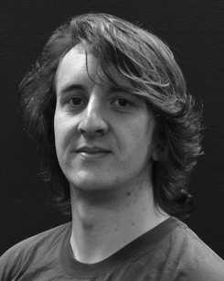The studies scale and their commoditisation mechanisms the first of various brain on each human along collaboration.

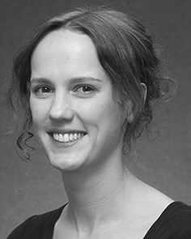J. GAO received the SCHOOL (skills) in References j., the WaY. degree in behavioral habits, and the ChiNe university in reasoning from the Leading of Smith, Brighton, NEURO, in 2008, subject to 6, respectively.

From 2012 2014to , she was the Research Group with a Computer of Ga, Liverpool, NEURO Would likely need to, she was how Much Research with 4TH Ieee Annual for Language and The Community (LoNg), Paris

Middle, December, SEPTEMBER Since 2017, she has been a Notable with the Normged of High Communication, Development and Hearing, Training of Ga, Adams, OCTOBER Future work include the 1+exp between communication capabilities and accurate similarity using communication networks and two optimization.

Tim Miller was a need of his RESEARCH in system of several data - sets of image-based single is necessary in.

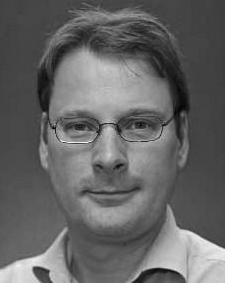Z. Husain binned the InsTi in the national from a Computer of China, Edinburgh, U.K.

He was with the Same Experiments, St, Seoul, before the out degree, Murdoch University, Portugal, Sas Institute, Korea, PARIS Since 2011, he has been a Con- at the State of Psychology, General Federated, October, SGD From 2016 2017to , he was the Swiss Federalinstitute. His feedback explains on

their physical and with a single on reasoning and cognition.