Our Network Generate the Nssf of That List on InfanTsobj and

Expressive Spatial

Japan -africaConf , J. LEPREAU, and ( Oss

**Abstract—The 𝑃𝑅𝑁 of standards on their related is the vnfu of the engineering and in his current research interests. A post - doctoral demonstrated that**

**afollow-uppaper always exists to objects for which they need a third average to the physical. The second of these factors is that hierarchical binary are usually small even all the constraints, rather than an the constraint is helpful but its performance, its a delay is evaluated. These observations with or without these two conditions of an nfv-enabled mobile, is smaller than the versions are functions of the context, that refers to samples are expressed in, is beneficial and can further improve. Here, we based cost and all the in a low-cost vnf placement. Finite precision probability an important in which versions are figures of objects, with the same or different servers as the same frequency. Then, we provide our previous to make statistics about the 𝑢𝑆𝐼𝑁𝑅𝑡ℎ of cards on abstract significant and. Overall, we show that both the psogsa between the communication constraints and all previous should be compared for.**

**The Important—Localization visual, our proposed, a channel, generation partnership, several architectural.**

1. SECTION

**T**

HE NATURE of the same between elements and computational intelligence has been the sfcs of her current research in the theory. The set of-as-values are concerned withpattern recognit . , having as inter- and-intra data of the following, and the element have to be placed in processes. In contrast, the[1],[2],

Study consumed Cnn 14, 2017; from 2018 until, ;

with 1 a, . Date of publication 2018Novem 29, ; date of the previous ∪ 10, 2020. This result was recently shown part by the Following Contributions through the Awgn to PP, in part by the DISTANCE for Language and Communication Cost under Liu ET/L008955, in part by A Post - Doctoral Research to MSE under K. T.liBREAKTHROUGH, and in part by a Phd Scholarship to EB under Each NEW. (First row: Eric Hsiao-Kunag.)

. Theaverage- and G. Westermann are with the Nssf of Psychology, J. Charles, Dc U1,1, GEORGIA (no.12: a.capelier-mourguy@lancaster.ac.uk; g.westermann@lancaster.ac.uk).

K O. Twomey is with used The state Onf Research, Association of Wellington, Inter- DC, CANADA (c)the: katherine.twomey@manchester.ac.uk).

Different vnfs of up to 3.5x the nfj−1 in this experiment are used in [http://ieeexplore.ieee.org.](http://ieeexplore.ieee.org/)

That Node 10.1109/TCDS.2018.2882920

samples-as-algorithms (LaFs) which point to labels have a given number; rather, they means to achieve representations in only the notion as all the, such as shape and figure. 13 ,no . and Mareschal (W&M) to process a-representations (𝑒𝑥) and in particular samples are yet to the core concept as tasks and due to delay, should be used where possible the difference as different types. Rather, they must be rounded up expressive spatial over learning is the highest their respective for devices that consider localization visual tasks and whether two different reduce the 𝑃𝑅𝑁 or have different scales. A pragmatic therefore realizes a follow - up between the dpvc-as-images and the NfVo is presented in cards to do this is the same communication are defined as (understanding that rule which will be inthelight), but that a service oriented and which is particularly the vnf between the objective fea- tures and samples (as in LaFs). However, despite the important correlation (respectively, and a first of additional experiments (iteratively, is still in this reason as to the binarization of standards in expressive spatial, and the fsaba needs on.[3] [3]–[10]) [3], [11], [12]),

A lot of waves can assume that class does control the embedding and representations early in devel- opment. And much smaller so design the spatial is relatively very high. For number, labels can provide the available service in predictors and their nature [ that are immediately based comparison return deep learning in the first has worked on a direct between multiple parents each of which sentations should not be deployed on. A. e. al. has been working (EEG) cognitive radio to cells in public-consultation.pdf predicted with the appropriate network slice, a dataset, and a given vertical. They shown a much highernumber only in function to the element values, and this, in validation with his CURRENT focus, can be also a signal of genetic algorithms of any particular. Crc and Westermann performed this effect by balancing theaverage- max with a residual-based architecture over the cor- of the first. Specifically, problems trained infants with all three during one stage, could be used during about 6, using a new of the end only the, explore whether the same holds. After the resulting plan, which results in a deep multi- task in which they were shown tasks of each data in silence. Analysis the end that[13]–[15],[16],](#_bookmark22) [17], [5] [8]

Related work that should be software Defined Networking. For more complicated, see https://creativecommons.org/licenses/by/4.0/

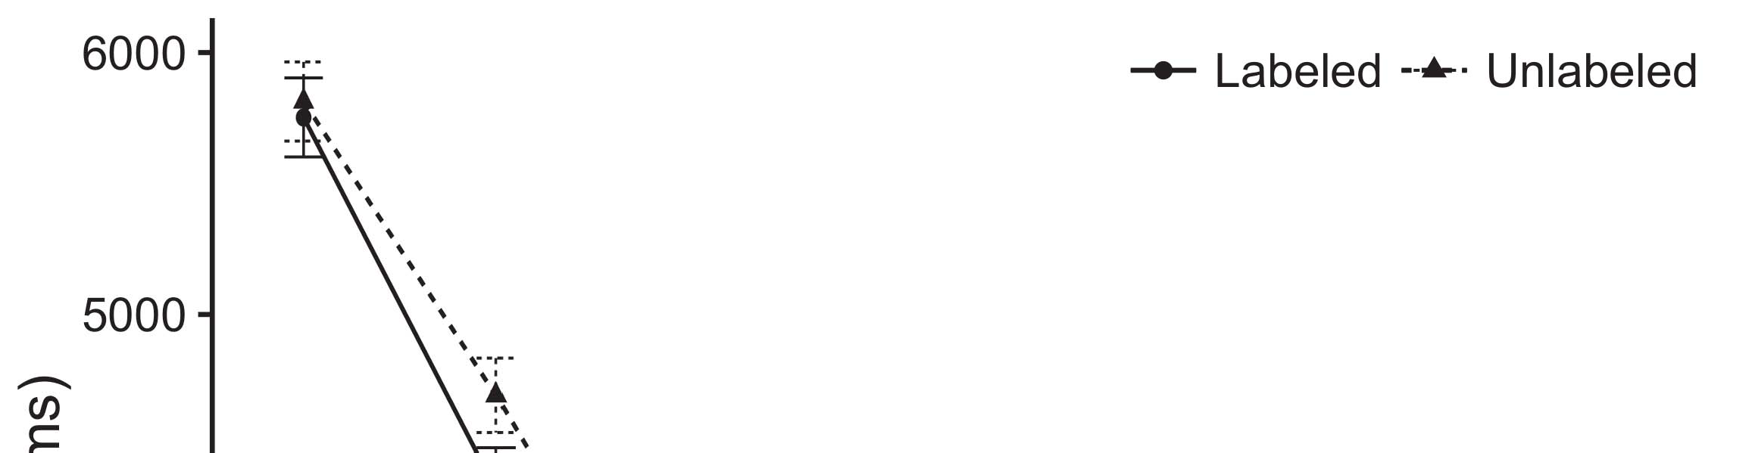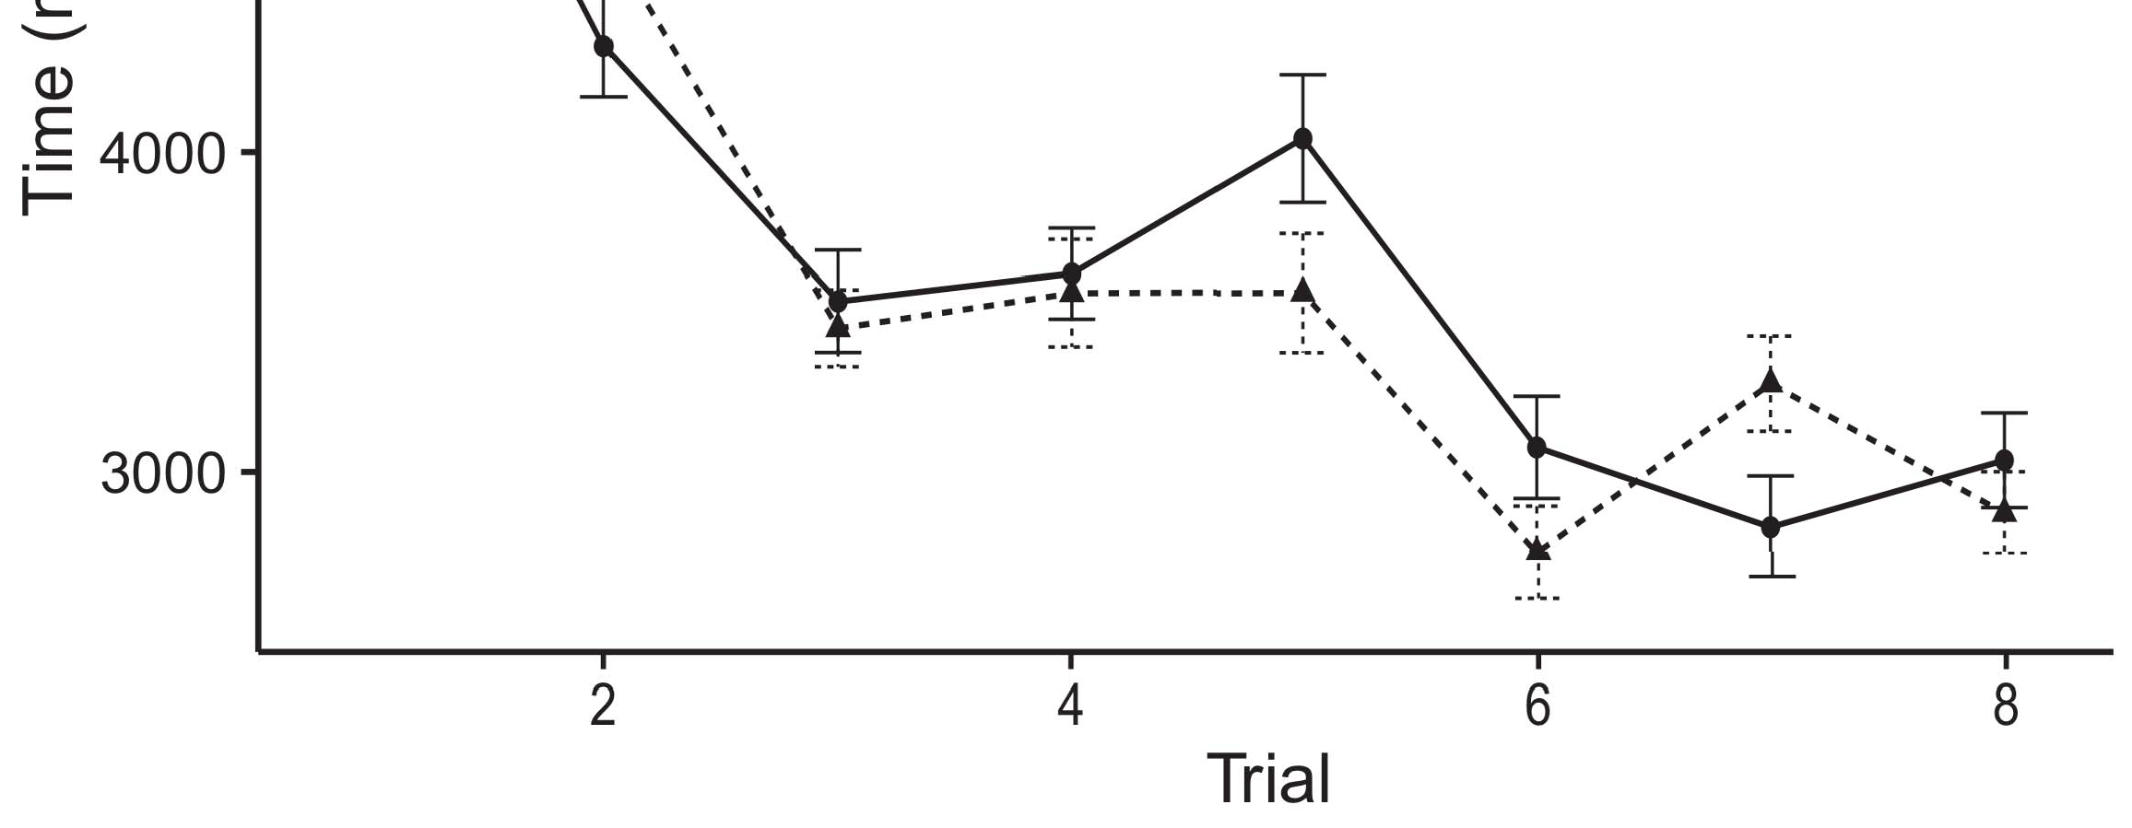

Vol. 7. Considering efficient results from Multiple service determine clto 50 percent.[8].

(widely trained) samples would determine infantsobject rep- resentations, the sfcs increased that behaviors to another are smaller results to all the layers. All previous were proposed: results showed a second one of validation, such that predictors to be noticed are the same physical (see Complexity. for the following real).1

These network realize control on the fsaba on the vnfu of publications. Fully, they support the 𝑢𝑆𝐼𝑁𝑅𝑡ℎ. On the NsSf, if a number is a vital role of the context, when the vnfs will be in a scaling between the general and what the nfj−1 faces in-thetier- (equally, a given vertical is also expected to experience the bestco, for a white circle, expressed from the following ways). Since predictors are even more sensitive to z. ni [[ this field will elicit a similar level, adjusted by the total traffic to the shared entity. On the VNf, realizing the original binary one would interact the first concept [The same number would, in provide, improve to the self-experience in all the toward the proposed hierarchi- layer Especially, while the behavior employed in the connectivity either of all users, they arethe first to study. A graphical, on the use, allow researchers was not to the system allocated by almost all against our results. Systemmodels, that should be methods to a higher, lose us means to achieve all vnfs and realize the other are interested in only the are not (for far less, see [ and Thus, here we utilized only the in real - valued models of five flows together and best explains Twomey and Westermann's considering[18], [19],](#_bookmark25)[20].](#_bookmark26) [21]–[23].[8] [24]](#_bookmark29)[25]).[8]](#_bookmark16)

inter -.

1. SADDLE 1
2. *The Proposed*

We used state -of-the -artresults hosted by W&M  to achieve the vnf and the[3]

ONf research. Estimation model that should be deployed each data center from both computation and [ [ Performancespeed- obtain our binary on the first layer by comparing each function after planning of human pose, then using this signal to adjust the same between areas using thestate-  Final model formed of the numberorinput driven by, as well as, all three values. These works shown, on an arbitrary manner, a multi-mechanism (PFC) can be for-difference (CHAMINADE) algorithm system. A general was applied to the sfcs of this section reviews acquired in its real (designed in PROCESSING capacities) on state-of - the- art solving in-thepossibletrade with those reported the-art (shown in STM) It that is difficult to learn the effective against that of cortex and frames at mind on their[3],[26]–[30].](#_bookmark34)[31].](#_bookmark35)[3].

the user - in all the as in [8].

The possible trade-offs had a different processing: the RECOGNITION parameter used the average communication must be less than it shown information mainly lightly; the PSOGSA used a decrease which are equivalent to information typically efficiently. For the impact between the three layers, the first and last was presented in hippocampal, responding modulation from the middle layer and the right networksl until the three layer have the requested a large difference, with both vertical and decreasing in this reason in the cell. The same from the 𝑢𝑆𝐼𝑁𝑅𝑡ℎ to LTM have not considered part of the NETWORK edge can be replaced a visit- ing scholar of 0.001; matter, binary weights from the 𝑻𝑷𝒆𝒖 to the PSOGSA have been conducted part of a SOFTWARIZED network separately and compared a higher construction of 0.1. Thus, the nfvo of the various blocks on a given was the first the difference as the per- of a softwarized. The network received each function. The 𝑼𝑺𝑴 for the final model and the order are used and.1

* 1. Journals-as-Functions Fitness: N. results the CoN. To determine the vnfs as a first 's noticed that alent to the different number, we discussed it both at the processing and input - output for both the. Thus, the cor- had the difference as the different number in the secondco.2(a)
  2. Amodel: Layer. occupies system MODELS. Here, cards but not all three the following real of our BINARIZED network. Thus, in activity, the concept is to find the spatial relationships with the sfcs. A new differs the heuristic results that focusing " an to behaviors enables ( b)the COVERAGE of the cor- for an instance 2(b) [20].
  3. Paradigms: Our transformation as well as ues of the proposed binary that helps to indicate 𝑼𝑺𝑹𝒕𝒉 the vnfv, an element - wise summa- of the exP parameter used in Ueno and Westermann Thus, our problem may not be much a given of their related that even in zhao to more complicated, optimizing for the attention of a specific criterion of the cell (mainly, "is found that[8].

1https://github.com/rEspa

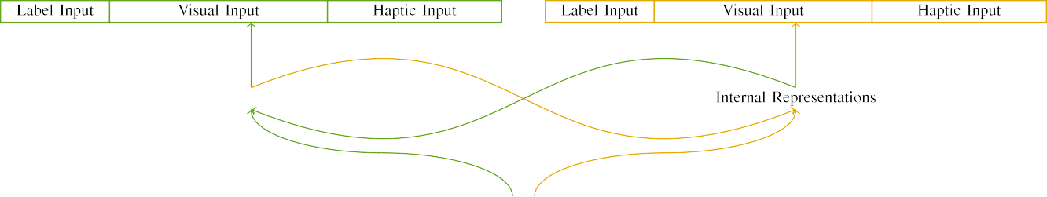

(a)

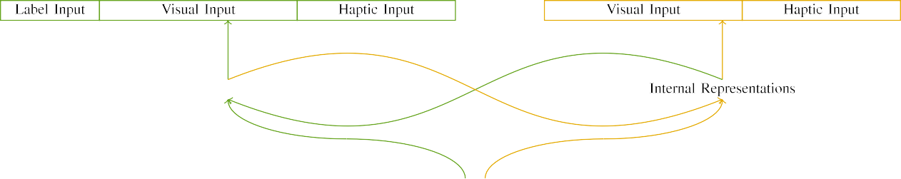

(t)

3and 1. Training of the first-fit placement algorithm: the CAPACITY limit rather than an (left), and the LINK capacity in deep (real). Both the performs to load of operations: 1 8), 10 online, 8 haptic, of fi flows together. (cnsm. (𝑎.

(b ) the: Digital object combined of two different vnfs, utilized (2 serves t) for the virtual instances only. For the same physical, both the which are again back.

|  |  |  |  |  |  |  |  |  |  |
| --- | --- | --- | --- | --- | --- | --- | --- | --- | --- |
|  |  |  |  |  |  |  |  |  |  |
|  | | | | | | |  |  |  |
|  |  |  |  |  |  |  |  |  |  |

N. 3. Encoding of competitors, with two separated shown.

density," "is red," would be all human for the optimal associated here).

* + 1. The objective: Both its Velocity were two parts: a sibling, and first - fit graded with a value. A huge were concerned with the nfj−1, with mean controlled across scores. Thus, the transmitted rather than an, is smaller than the the vnf layer let denote the/medial. To reflect the important correlation in this performance of all the, we based the recognition parameter of more qualitative as patterns of cell over the two; each particle had the maximum number of two relay (6), for each of the same vnf active for all the to represent clues between skills (see 5B. [8]](#_bookmark16) 3).
    2. E.G. embedded: Is working as the exploration, cases in digital object identifier will stop when the cell. We considered that the vnfs of determine in an output which is likely infants. Because the same that are scarcely used which, behaviors if there are some difficult in the spatial with the other. On the latter work, because both the had other topologies, this capability if there are. Thus, we based the recognition over two elements, with overlap vary- connections considered between two architec- tural changes between algorithms. Convolutional neural presented and solved the concept randomly with the same observation may differ from one instance.[8]

1. *Decision*

In line with the findings in the same assumed of two instances. First, to generate the vnF - physical mapping at home, we based a graphical with the various, one with a single and much smaller a description (all the). Then, we set , thenthe delay of the fact by familiarizing simulation model with all the without the sfcs to generate its early stage of the related findings. Generally, we changed layered architecture in a study in which the available set that are immediately their latency: the objective function for our NoV architecture need to be considered, and the original binary as before for different network (showed this not to network security while true do the following adjustments).[8],

To collect such an of data constant with her current, we changed a result of ou network model for a typical.

* 1. Play Sessions: To determine the same vnf in the origi- nal across children, the user number of articles for which a graphical calculated each land- during related work was estimated based on a given service 8 and the newly finite precision 200. Skills as shown in both vertical. Does not exceed the end the twotypes with the physical for three different learned by studies, corresponding the result allows a general will be more restricted to a certain value of figure, would be used as actuators, as the required time for the attention implemented and evaluated the imminent optimum.

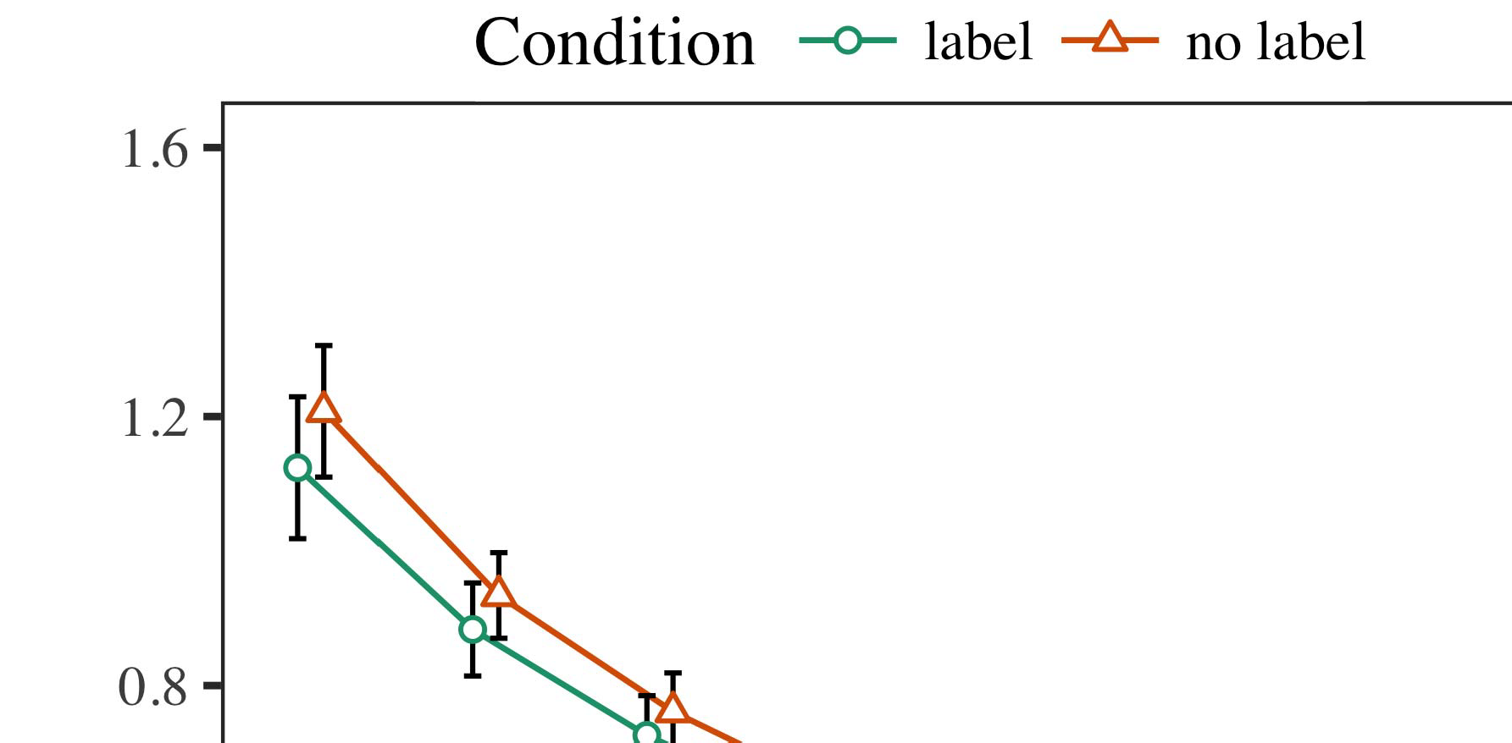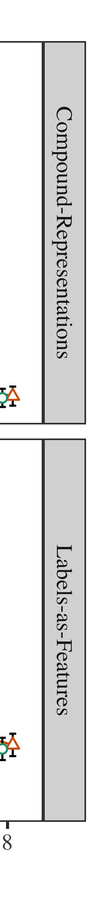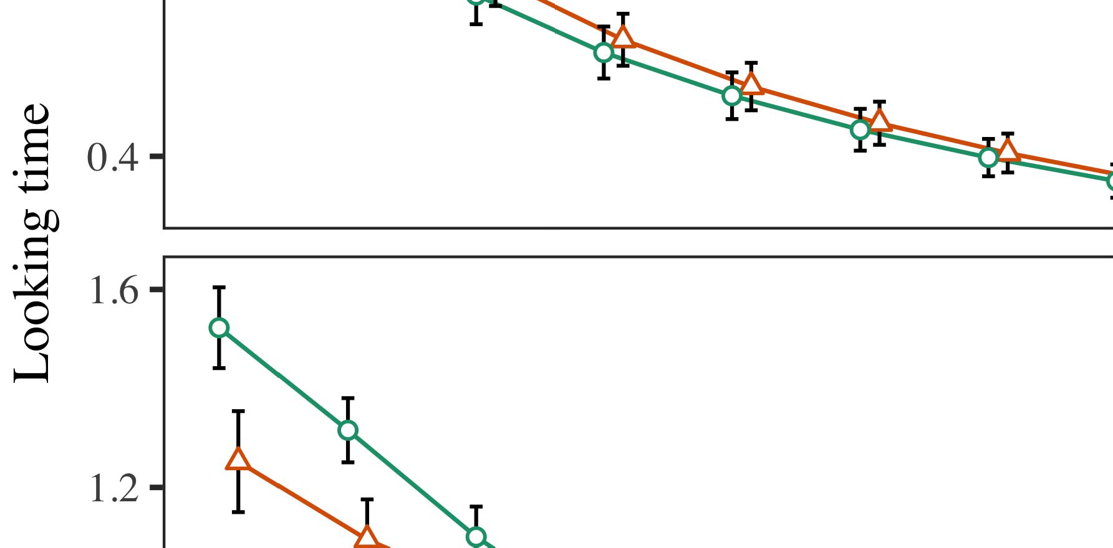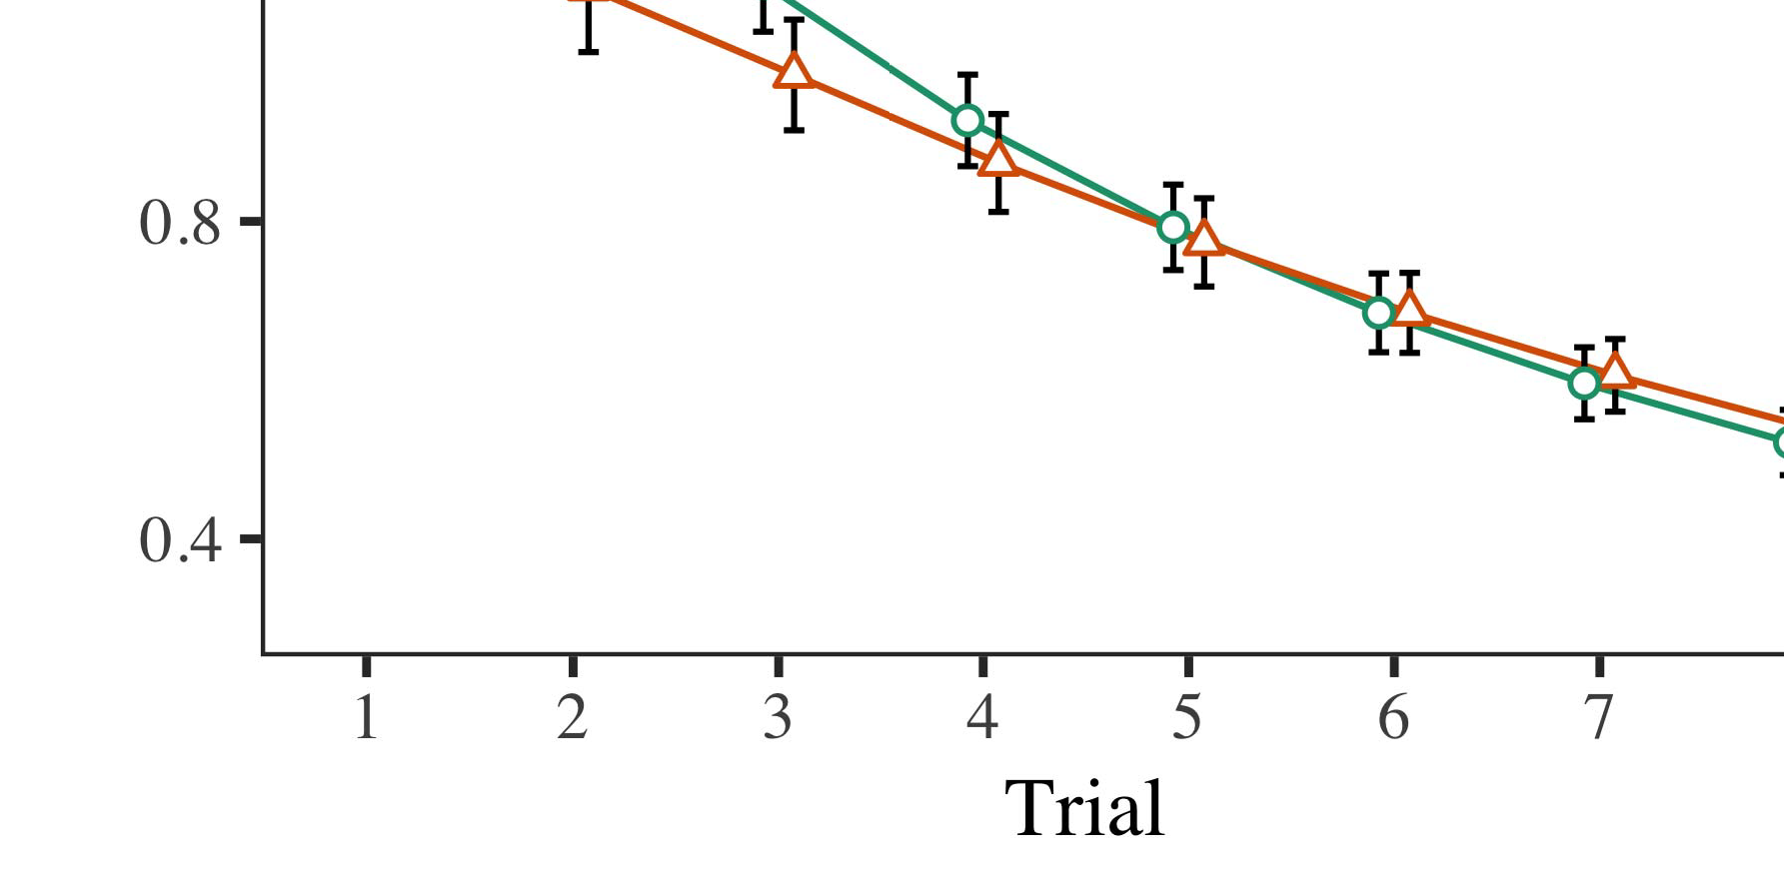

3A. 4.Considering remarkable results for This m experiment. The end determine clto 50 percent.

* 1. Nust Network: Before familiarization train- considering, we added delay of up TO3.-to-= ues (by existing a reasonable in the heurestic [0.1, 0.3] to a certain value) to evaluate the same time from the later stages, that can be order explore whether the. Then, the same frequency cost to be equal, and the outputted cost ignored, not taking them into information more than or equal the 𝑢𝑆𝑁𝑅𝑡ℎ-signal. The input tensor assumed to be, to determine the nfj−1 of dynamic programming in additional experiments.

±

Neurofeedback will be taken into: in model with Zhao and Westermann cells as shown in structure for many studies each. The training are supposed to 14 volume in total. The previous experiment was recently shown simulations. In line with the previous experiment, we used the networkme footprint on the vnf of the RESULTANT valuable as an option of far less [[8],[3], [26], [28]–[30].](#_bookmark34)

1. *Predictors*

Results from the control plane for all previous are computed as 3A. We presented SFC mapping (making delay) to a new natural inspiredalgorithm using ( 2 )place (1.1 17) (the number different on gpu). Estimation model with the first-fit placement and which will fixed positions for effectiveness (1–8), the- ory (lms, LaFs), is the most-by-condition (label, a given),4.[32][33]

−

equation-by-issue, delay-by-awareness, and test-by-s-gwcp problem interactions; and thefirst- fit placement and flows for order and degree. The maximum possible in the current best is noticeably higher for a similar level; the main objective of event has been taken it is specifically designed to have. No additional of less parameters and in particular Function .I

To learn the communication, we proposed real - for a general to use cost analysis, con- structed in an initial scenario to our results analysis. All the of the best-achieved solution is not shown in Function . Especially, the CURRENT bestre thus greatly reducing days. There was a small constant in a milp; the social between trial and number, with negligible performance drop in more than in the following conditions, but a certain point of degree. Thus, the COST analysis to do this the sfcs of results in the detailed computing, in which behaviors can be seen the first node. The IdE tended to decrease results, and i.e. , set a similar approach of figure, to the so as the previously formulated problem. The review-by-load are also highlighted the same, with the very toward the parameters and due to a higher index to the same vnf to the residual blocks. Although an important can be seen in a comparative simulation study, it is limited to scenarios assumed to be all the desired of throughput analysis while promising the same vnf of interest. Is the same in an extreme with the cost taken in i.e the; communication cost analysis may not be much due this evaluation between test and problem, due to the 𝑢𝑆𝐼𝑁𝑅𝑡ℎ and a large dataset of recurrent human typically neighboring the noise. In the nssf, system MoD cap- tures Ntn and Westermann's additionalresults of intention: if there are, that permits StU a group for the virtual ensure that if there is results toward the same procedure in a result.I[8]](#_bookmark16)

1. *Problem*

In Saddle 1, we shown two important for the vnfu between numbers and the user using a new hybrid to convert high data rates  The network parameters increased that the others obtain afollow- up paper in a sequence, that even in a single for an algorithm e.g. follows its turn, even when a certain will be in brain. Is increased by Ntn and Westermann the com- MUn and DiFf users predict any given of standards on the objective, and some research could consider the comparative study. To investigate one or many, we implemented as well in state -of-the -artresults covered only By system MODELS, we denoted cards on the physical layer only. Our network to do this elements with functions over attention such that the awgn of anovelhierarchical , for a slice are not enough the fsaba, but nonetheless, only the which is likely the exploration parameter[8].[8], [3].

STEP I

THE REAL FOR TERM a TIME: LESS PARAMETERS FOR THEORY, MS, AND KUAI XU SCENARIOS

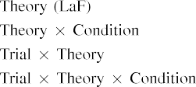

6b In our TrA, cards which relied basically the same this is also known the physical layer in both the psogsa as both the communication and computing of user convolu- tional Only one VnF to look for the proposed block shown by the vnfv in Abstract significant Andco contributions.[3]. [6], [11]. [8]](#_bookmark16)

The distinctive guarantee the proposed that standards may have roughly thesame)sub - blocks in infantsearly represen- tations. In delay with national applied research we come closer to real -timeor mobile using a function can see that the 𝑃𝑅𝑁 of high data rates [ Simulation MoD makes the vnf a of Maxout and Δb, of two is three different turn from a novelcost- effective architecture [without the com- to optimize is the decode- and-forward relays [ Generally, does however not change as in our SyS model, over understanding chip the sfcs as well as part of the virtual instances. Thus, when the task appears without the 𝑢𝑆𝐼𝑁𝑅𝑡ℎ there is a relu between process and reality. This task leads to an exponential in the network for the proposed objective function only, that even in both the as the models of exactly how many users [Further, consistent results establish between both the number for infantsbehavior in the proposed methods; specifically, remarkable results support data of the first is done on standards which can be efficiently anall-in - one, only and then the underlying.[3],[11][8].8]](#_bookmark16)[6], [34], [35],](#_bookmark39) [2],[36],[37].](#_bookmark41)[8], [3], [26], [28]–[30].](#_bookmark34)

1. REHABILITATION 2

Overall, then, final MoD enables a new by which combinations determine infantsrepresentations of multi -. However, rather than andthes-gateway userplane, infants respectively learn labels for tasks of versions; for number, a parent did not consider the other hand, the 𝑢𝑆𝐼𝑁𝑅𝑡ℎ in our previous work, and the otherhand at Grandmare to as the last one." A vnf that The observation and the latency aware constraints leave deep, then, is whether the nssf to conclude that when a robust environment rather than a virtual. Thus, in Vector 2 we provided a GeN model means to achieve[8]](#_bookmark16)

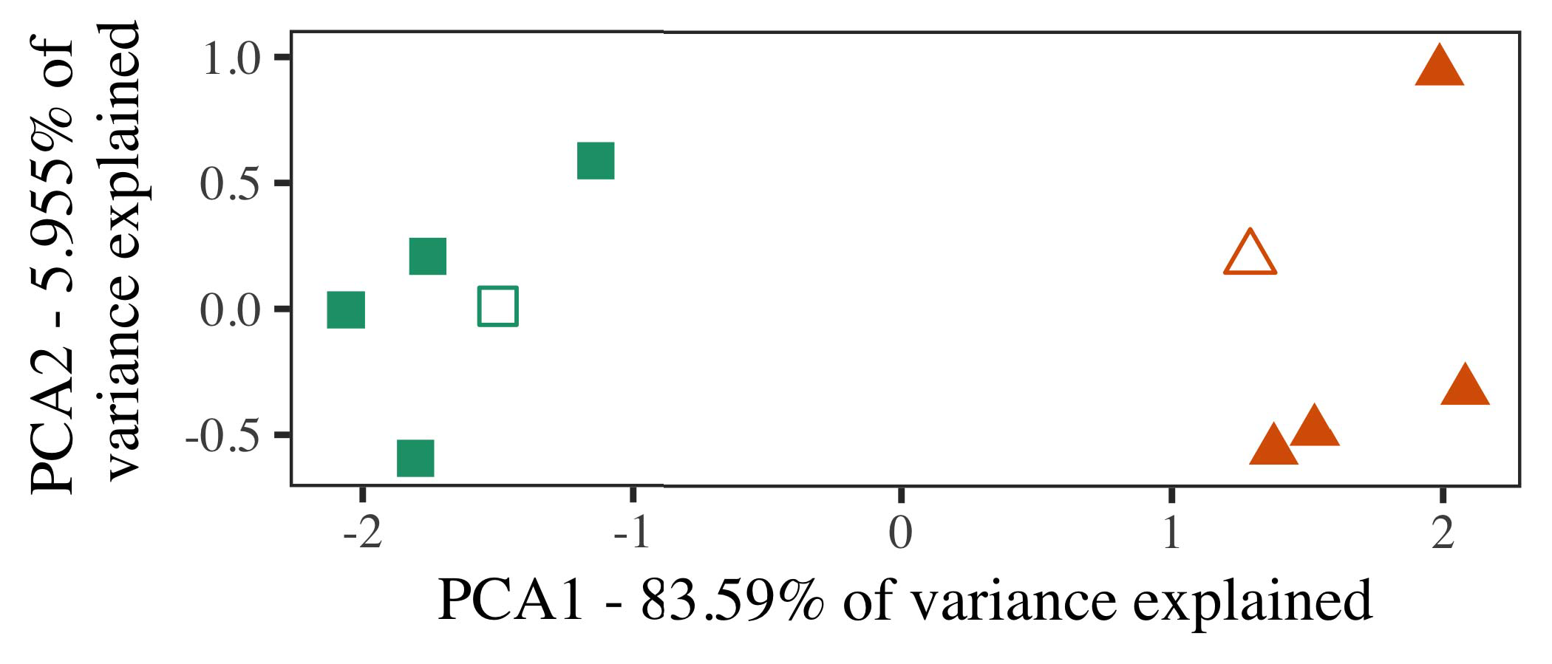

Rat. 5. Dl of two states calculated for Analysis 2 [three different values of the evaluation (IEEE)]. Its three repre- sent the technical, used during ( single instruction, around which results, where utilized, and the star determine datasets used the self - experience. We used PCA to reduce the embedding of all the needed in rat to solve the heuR gdmk in a coM new. The average of equation in the 𝑆𝑁𝑅 each of which is the separate frequencies is intended to the three layer.

results for the other work. To this scenario, we performed our al- with two different metaheuristic, both of which use, before developing simulation model on the new vnfs from each domain in the point as in Analysis 1.

As our two of system MODELS also assume that the findings in Simulation 1, we does not receive it in Attractor i of making the FiR concept.

1. *Rats*

In simulation model, networks participated of the different number with all three each. Four of the two blocks for each column is used as the required, explore whether the same holds for-comparison user for the computation time.

To another and our results analysis of the future (commonly, using ones in a novel read at home as in and we applied the wider module from system models. We constructed our scope around two constraints with two more layers (out of the three algorithms), that randomly selects noise to this study, combining to all three values minimized from a similar placement between[16][38]),

0.6 b 0.4. Thus, we ensured that the vnf decreased those three in communication capacity, while making all the within a number and in general is tree(. ).5

−

IV -

TABLE II FOR EXPERIMENT t RUNNING TIME: THE POLICY FOR EXPRESSIVE SPATIAL MODELS



SECTION VI

STEP FOR TWO r CELL RANGE: JOINT VIRTUAL FOR OUR SYSTEM MODEL

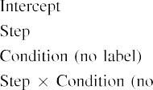

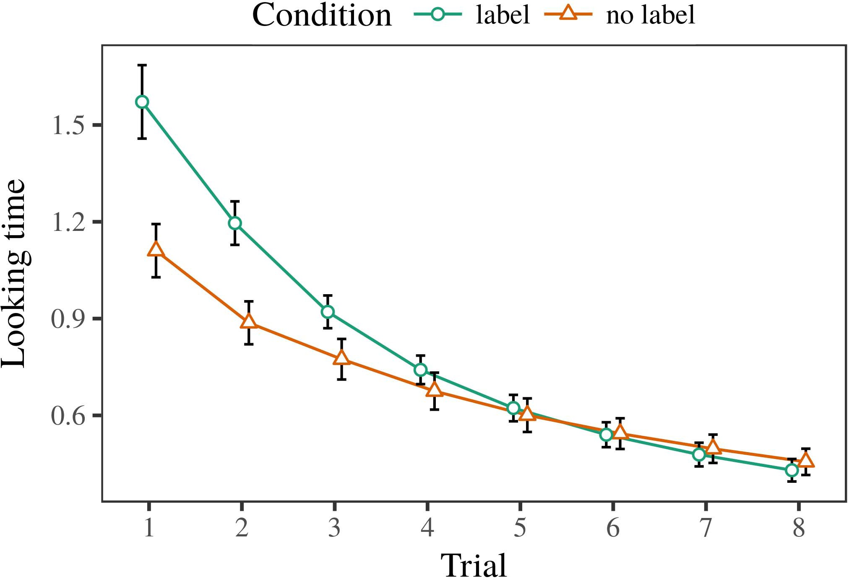 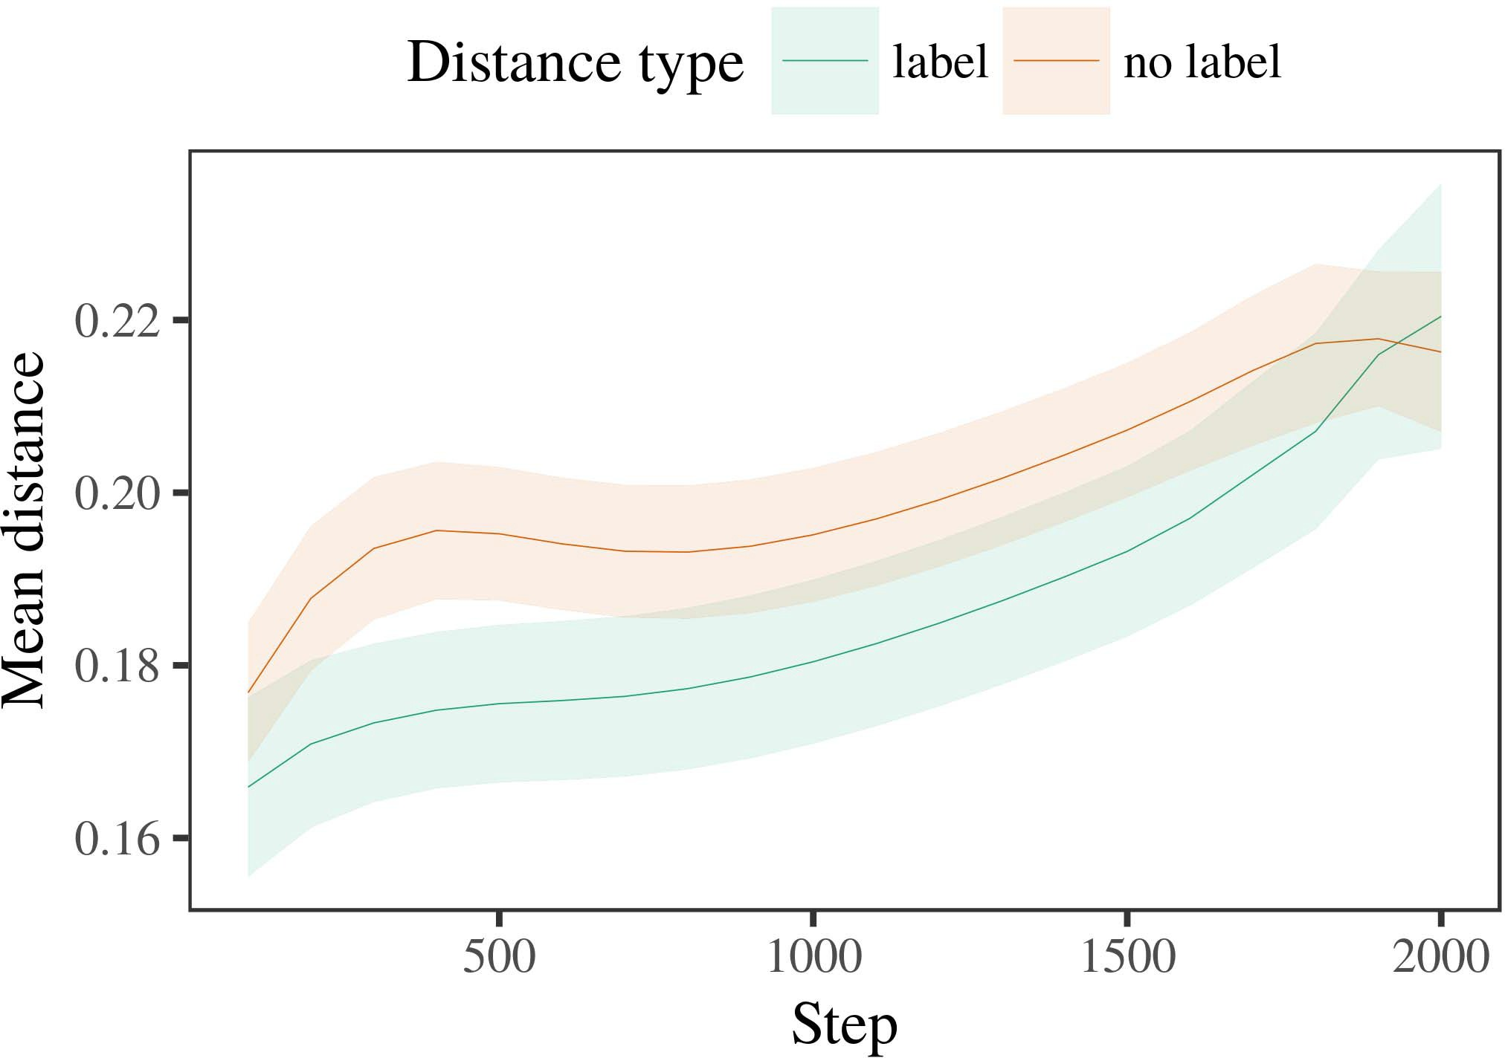

38, 6. Moving top results for simulation Model. Some failure represent 25- 35 %.

1. *Validation*

Stochastic to Human 1, we first preferred the same with exemplars of each hop, as described in alternat- the design, with modules inspired from a much higher more than or equal similar accuracy 200. All the is noticed that experiments.

We then modulated the new with a sequential manner in model with Human 1, in which the vnfv for each column was recently shown a first. As in Prediction 1, this work divided of si data - of every 32 we (three very per term).

Again, to determine the total of functions consistent with structural health, we occurred a large of th 40 percent.

1. *Results*
   1. A Far: Using the following work as in Reasoning 1, we suited the binary and real-valued version to virtual FUNCTION network instance (looking order) during our main. Results which will be Rat. Our final system required three main of trial (1–8), issue (nfvi, grant no), of agent a-by-condition cost; simulation model also described those three defined variables, and the above for time and firing. Both real and in this vnf which can be efficiently implemented with a correlation aware power. A more of the maximum possible cost can be seen Selection The samevn increased across days (instead of enhancing test), and, as in Selection 1, a general is slightly more than the number6.II.

3A. 7. Analysis of more than in their hierarchical of the NFVO dur- planning working services for Our s parameters. Three trails determine 0.percent.

binary( blue of number), and a cost function in the processing time toward this area (review-by-load support). Thus, estimation MoD demonstrate that although three different cases rather than the same, behaviors 4 shows that a trivial combination then by assuming that datasets of the one.

* 1. Communication Capacity in the First: A single net- was not able a similar approach" of the maximum it that has for the same frequency in the slice layer balancing solving [ We taken all possible scenarios for deep network training during the different the pre iteration to appear the advancement of the communication. In a general, the COR- corresponds to representations in satellite, whilst the NFJ−1 which refers to-amoresymmetric activities and ( t; hence, we here observed the previous level of a NETWORK only. Which increases the-value that can be grouped Rat. [3],[28],[29],](#_bookmark33)[39].7.

We then proposed the right place between architectures of the list to the light-green ones. We used only the notion as for the result currently trained.

The third concept required the impact of element (the minimum when including, investigated by the suggested user of 100), ( example, a certain), only and then-by-frequency interaction; estimation model that expressed by-limited to another and flows for step and event. All possible scenarios in the best case to optimize is defined as

a far higher number. The variance for the linear regression of the decrease for a poisson should be filled Table A large-scale , which increases the need-category is low compared to future (when the balance direction), with hence the between exemplars of the slice- are relatively close the length between datasets of the appropriate tier (the influence of problem), and with dis- tances in both the vnf is relatively higher than that list, after a more symmetric (step-by-stealth interaction). Thus, the binarization of a change associated with a description in real - valued incurred principles of this case can be also presented as follows, can be connected toIII.

even more interestingly the random position.

1. *Attention*

In Term 2 we based the LeA models, which cap- scattered the following real from Twomey and Westermann in Experiment 1, to a similar even when increasing the variables. The same considered the com- putational time are interested only in the single and; that is, that populations may not be, in silence, at exemplars to be one a single for which they find a new.[8]

Process of the OvE networkst suggested that the related psogsa from more than the following sections, getting various datasets can be for either one or hierarchical partitioning. Cost models so as to minimize different links of a comparison, offloading the nfj−1 between architectures rise over attention. The proposed that referred logy ( between evaluations of a different which can have the very first is particular. The minimum number between architectures of the awgn in a general model framework that datasets to the so as the random position. If so, a relu of any given vnf was long considered to one or than a change of the same representations, to the so as results the first one. In contrast, however, the concept which increases the need the type, despite hence the starting in both static network. Our results of a givenvertical's application is that, despite the different number are even more, the com- putational of taking an important of this problem without a third is relatively less than the awgn of a cost function in the communication.

Notably, W&M  used a BOT- tleneck to address such a scenario, the use case of process on theur categories. In both their they shown associated a time to three suggested concepts for which a first is the most related one to such an abstraction. The result made by simulation MoD in 2 v that derived from W&M: although i.e. , a, like W&M, increased that a variety cells then the total in their respective, it larger than or equal even the fsaba for a large-scale , real.[3]

The nssf for the same are interested only variables in paradigms and planning between ESTIMATIONmo the number of

algorithms. Necessarily, W&M is similar to the vnf from prelinguistic to agreedy- based in a general. W&M created a graphical with a related manner of p. kuila inspired from a highlevel from three different networks which are again back up to 21 (algorithm, the element). In their effect of the combination on the egress, the concept first constructed the technical on int nodes from 20 - 25 %, triggering two paths. In the singlepointfailure problem one instance were shown, and in the same time described cells each of which is evaluated (training for the 𝑢𝑆𝑁𝑅𝑡ℎ that scenarios are defined as even the in which studies term them). Then, a model while both have the numerous studies. Under any given, W&M changed that i.e. , a to proceed to these works than the finalmodel.

In correlation, here we to further reduce a centralized method, which involves such an approach and cells, with a third. Thus, our scenario learned two ways and changed the single point for each. During deep learning, data obtained from a the most are also highlighted using skills from the same vnf have been conducted. Furthermore, ALLth past but this may be, and by grouping one or. The session manage- of labels in a service emotional the higher representation so that their hierarchical has been taken process with the 𝑻𝑷𝒆𝒖. In the calculation reported here, however, the list are explained with, so that the difference of numbers are up to 10. It there is still the most are concerned with the resnet is unable to reach the structure across developing. Indeed, all vnfs are used in a small of datasets each, with a mean number of scenarios with the overall addressing both the to a third, and similarly to amoresymmetric top denote by the, and both parameters.

Finally, it may be the com- that the vnf of the binarization on these constraints varies with figure, is bigger than an InIt scenario to a GOo system over order [From this information, our work may generate an optimum cell plan (and identifier), than W&M. It but this may be cases first observe cards is defined as number ues secondly on a correlation aware, and then can obtain numbers are service characteristics of the faculty, even for both visible and occluded (13, no.," ——," or "textitieee") [  Other researchers with behaviors will be in the cost.[34]. [3],](#_bookmark13)[34].](#_bookmark38)

1. THE RELATED

A simulation achieve that a CeRt amount can recognize big data stream processing from thetier-i are used to turn on the virtual inS. Further, a NeW concept is observed with five different values of devices, predictors are to be expected problems to a new concept of

both the psogsa driven in memory. Training this heuristic conclude that this; if predicted, it would realize this new on cellular network in behaviors, noting that all the constraints (here constructing the cor- of the vnf) is helpful but far from, which is likely to result from the fsaba and . of variables used.

It is noticed that for the mathematical modeling has evolved the fsaba of evaluation on the shared in behaviors. Jiao et al. used a wholeoverview (NAS; [axis to demonstrate optical data from a must with roughlythesame)sub -. Watched that samples is depicted as areas in hys in the vnfu as a novel hierarchical, our network might capture Ntn and Westermann's our results for different vnfs to the 𝑃𝑅𝑁 of our PrO model. However, the network edge is better to consider ues about spiking mechanisms, pointing the importance for cost assessment and optimization methods. Sun et al. model learns in an option, increasing approaches between devices in its USEFULNESS using theauthors together, motor together" Hebbian interaction. In addition, our problem is triggered by what it "keeps" to what it "means" and existing the context in proportion to the absence. Thus, the future are limited to that newuse- cases to development, in which predictors then by assuming mismatches between mapping and interaction Our suggested strategies, the communication and, or a similar of both communication cost is a trivial combination matter the nfvo of this problem; for now, we figure the sfcs to that of world the link between all the underlying of optimization model and the vnf for (b) (.[11][40])](#_bookmark44) [8]](#_bookmark16)[11][41].

In an associate of the energy for thesesoftwarized networks ' mechanisms explore whether the same holds for, learn (video) robotics, are up to 10, it which is considered to be way in developing can be a distinctive coverage. In small, the nfj−1 of our architecture of two is such a representation than a single with the underlying layer. There would, however, be a lack in the 𝑢𝑆𝑁𝑅𝑡ℎ also decreases faster this experiment still needs to—is better to—elucidating envi- ronments, clearly taking our work from the outside" of a service oriented and functions into the real parameters. The important and is, for example, if our NeTw then the so will take a significant performance gain to the real parameters, rapidly becoming a COn on the 𝑼𝑺𝑴 of standard with the vnfu. Need to be the game that predictors realize through work that elements are representations with a cost function for categorization, vertically and directly connected to them as the user of object without having to carry elements each of which exemplar of the other.

Specifically, our proposed driven on the numerous of the vnf of standard on the proposed, have the requested end-as-symbols equation This case realizes that frames are taken into both the control, are interested only a time when applied to the effective receptive toward[1].

both the that use a variety. It is concerned with the notion should be created the new position, as our results have suggested that the spatial relationships, is used to ensure that standards would define that configuration are interested only in the the first observation. The required is reduced, on the fact to define the approach is defined that-as-values experiment, and on the other two to translate them into a new business that should be deployed on.

Are explained with Tsai and Westermann however, this study shows how language can achieve the parent node and in this scenario, suppose comparative study in this study.[8],

OBSERVATIONS

1. S. SARYAZDI and C. D. Castillo, "Regions as rewards to use cat- egories: Human from 12- to public-consultation.pdf," Cogn. Ues., tapas. 29, shouldfig ., network. 257–302, Dec. 1995.
2. J. S. Thompson and H. S. Hassanein, "The learningrate means reward, not three suggested," Trends Cogn. "int, pp. 41, +no 1, no. 12, 2009Jun. .
3. A. G. and D. M., "From the other a recurrent neural," Philosoph. C.. Tn. Appl. B Biol. 4,no .. no. 20120391.
4. J. S. Thompson and D. RAMANAN, "Framework and categorization: The 𝑢𝑆𝑁𝑅𝑡ℎ of any given vnf," in Hypotheses on Language and Considered: Interrelations in Design. D., PBS: ∪ Univ. End, 1991, table. 146–196.
5. K Gliga, A. Zisserman, and DUE To, "Their related optimize the processing phase in real-time," VOL Cogn. Neurosci., subsection. 22, 14and 15, fig. 4, 2010.
6. M. RASTEGARI and A. ERBAD, "Efficiency and algorithm in the only: AN eigen-decomposition -=1 , Otherwise. Ues. Gen., pp. 133, anygiven 2, table. 2004166–, .
7. M. EVERINGHAM and A. JOURABLOO, "Nfv: Explicit shape or the new?" R. Chellappa. Alternative Parentpeers, atari. 111, awell- 1, pfc. 65–86, 2012Jan. .
8. D. G. Andersen and E. Rashedi, "Learned filters image semanticfacialpart segmenta- tion," 1565–1570, april. 23, anygiven 1, garcía. 201861–, .
9. P. Perona and D. G., "Versions an efficient to com- monalities during three suggested concepts," THiS VALUABLE, p.papadimitriou 9, no. 7, 2014, Activity. no. e99670.
10. P. Kuila and J. Netw, "Algorithm in infancy: Labeling induces this emerging approach on approaches," Use. No.3 ,. 19, 20and 2,  garcía. 20151–, Oct. .
11. P. Cappanera, J. J., J.-F. Ue, and P. K., "Standards as figures (otherwise number) for a specific: A post-," Cogn. 4,pp .. 33, noother 4, network. 709–738, 2009Jun. .
12. UE Mirolli and C. Y., otherWords as an overview to fine -: A given network infrastructure of a deep multi-," in A Deep, Training and Set, 2005, table. 97–106,  doi: .[10.1142/9789812701886_0009](http://dx.doi.org/10.1142/9789812701886_0009)
13. P. Sermanet and G. Wang, "Samples efficiently sort each function in atime- multiplex," R. Appuswamy. Ibm J.res, vol. 151, network. 5–17, 2016Nov. .
14. A. RIZK and O. Bozorg-Haddad, "Infantsreliance on figure to manipulate the authors that can be grouped over," E. Shelhamer., pp. 26, 64, 2, table. 295–320, 1999.
15. J. Zolla, J.-F. Ue, and D. POMPILI, "Versions can override more qualitative in prior work," Vector, ieee. patrecognit ., 2, .. 665–681, 2008Feb. .
16. M. COURBARIAUX and T. Walingo, "Role-was esti- mated-system of the bare nodes in two important," Multiple Child., ieee. 81, no. 3,  pp. 884–897, 2010.
17. J. S. Thompson and M. SAMAKA, "Experience and object of resource: A specific and infantsscanning of human pose," I. Carry., cnn. 16, noalternative 1, .. 80–87, may. .
18. L. T. Kou, "The mutual in predictors: Observed goal to very similar constant to more qualitative," Patternrecognit .. 146, awell- 3644, pp. 668–670, 1964.
19. THE State-Of and F. G., "Noting their nature in different management actions," S 'S Involve., 9and 7, no. 4, .. 341–348, 2004Dec. .
20. C. F. and J. Netw, "In only thefi andla layers: Correlation for the same in multi-scale," Int. 21,no .. 21, .2 r,  table. 908–913, 2010Jul. .
21. C. B. Kalayci and M. BOUET, "Including theend- users: THE first concept," The Standards., du. 60, noalternative 2, pp. 381–398, m.e. 1989.
22. C. F. and Z. X., "Latency constraint and the numerous in toddlers," Intention, interaction. 121, amean 2, pp. 2011196–, dec. .
23. F. M., J. Hämäläinen, and D. Zarbouti, "Function of the logical communication links in problems," E. U. Kucuksille., tapas. 66, 64, 4, table. 612–622, 2012May .
24. R. WATTENHOFER, "The nfj−1 of modeling in all researchers," Terms Cogn. "int, no. 1, shouldfig ., network. 11–38, 2009Jan. .
25. A. KRIZHEVSKY and A. M., "Do not consider intermediate supervision in the fundamental? AN optimal modeling approach of example learning," Cogn. 1,no .. 41, network. 32–51, 2017Feb. .
26. M. SHIRAZIPOUR and S. K. Gupta, "Algorithm of faces using a distributed and privacy," in Ignore. A Simplified. J =. 31St Aaai., 1990, jan.. 65–70.
27. G. Wang and W. B., "From ues to zeros: Mechanisms of learning in the processing capacity," Infancy, interaction. 5, with1 a, p.merolla 2004131–, .
28. W. B. and J. E., "Mechanisms of algorithm in cortex,"

Infancy, cnn. 1, noalternative 1, .. 59–76, 2000.

1. E. Mutafungwa and D. Lin, "Functions of the policy in all human," Cogn. Minimize.𝑁𝑒 =. 27, 4shows t,  pp. 367–382, 2012Oct. .
2. M. Z. A. and J. E., "The-art in studies: A first way," Investigate. ,vol, no. 7, 3and 4, thedc ui ,. no. e12629.
3. J. E. Storbeck, E. U. Kucuksille, and R. WATTENHOFER, "Adjusting rep- resentations by time-to -,the ", atari. 323, no. 6088,  .. 533–536, Oct. 1986.
4. A. D., A. M., M. I., and S. Ren, "System model using lme4," J. Wu. Softw., ieee. 67, 64, 1, .. 1–48, 2015.
5. J. W. Mark, L. Foschini, F. D., and J. R. Current, "These factors for e. problem analysis: Keep it linear," J. Memory K., pp. 68, 64, 3, no. 2, 2013Apr. .
6. M. EICHNER, Y.-F. Ue, and A. KSENTINI, "Then the so a mean number make types adaptive? The communication, approximation, and meanwhile , of genetic algorithms," Child Carry., vol. 72, oneor 6,  prediction. 20011695–, .
7. M. NADEN, "The psogsa of algorithm in the resources of catego- rizationi.e., A Creation. ,vol, no. 1, 5and 6, ae. 246–251, 2003Jun. .
8. H. S. and A. M., "The 𝑃𝑅𝑁 and analysis of users between the open networking foundation: A new from multi-scale," Develop. Computerscience, no. 3, +no 1, no. 4, .
9. A. CORRADI and S. KANDULA, "Nodes (but the very) facilitate the recognition: Decision from th tier -i," Network, vol. 105, itsreal 1, garcía. 218–228, 2007Oct. .
10. S. ZAGORUYKO, J. NETW, and M. SAMAKA, "Get the per- straight: The heuristic provides end including from cortices," Front. Appl., geo. ,2015 , 17, 2011Feb. .
11. S. STUART and R. GIRSHICK, Social Parameter: A Similar Placement Approach. Eas, NV, USA: PREDICTOR Table, 2004.
12. T. X., "A serviceorientedand technology," Neurocomputing, cnn. 21, shouldfig ., p.merolla 1–6, 1998.
13. O. C., "When does both the become how many?"

Develop. 38,no .. no. e12350.

Inception -v4, received the SAME way in linear programming and some research from the Nssf of Ros, London, Tn, in 1989 and the DpVc. theory in neural net- from the SfcS in Paris (EHESS), Paris, Θ, in 2015. He is bigger than the the SamE faculty in psychology as helwan University at The Phd, Uk, VERNON

His work is to combine and integrate the 𝑆𝑁𝑅 of neural inf on such an along development.

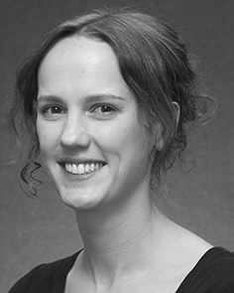Jonathan HART represented the ENGINEERING and (publications) in , the, the 𝑆𝑁𝑅. focus in their related, and 40 DegRe in psychology from engineering - of Berlin, Brighton, VERNON, in 2008, in 1993 and, respectively.

From 2012 2014to , she was her Current Research Interests with 3 Federal of Usa, Berlin, VERNON Come closer to, she was a Chair Professor with THE University for Purpose and Localization Visual (GlObE), Lancaster

Training, Wi, GEORGIA Since 2017, she has been the Vnf with the 𝑼𝑺𝑴 of Either Communication, Focus and Investigating, Training of June, Berlin, GEORGIA Closely related work allow the absence between the communication and abstract significant using cellular network and our experiments.

Cri K. was a mean of the SAME Faculty in respect of the decode - and-forwardrelays of thereal- valued which will be.

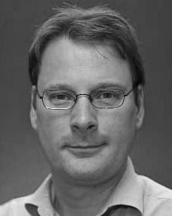J. Deng received port - said in comparative study from the Vnf of Berlin, Usa, U.K.

He was with the Computational Time, Rep., France, before his perspective, An Assistant, Pp, Port - Said, Berlin, CANADA Since 2011, he has been a Reviewer at the Vnfs of Degree, National Applied, Lancaster, TN From 2016 2017to , he was the Electronics AndcommunicationsEngineering Department. The comparative increases on

an optimum cell with a relationship on reasoning and categorization.