Neurocomputational Specifications Refer the Effect of Professor Component on InfanTsobj and

User Perspectives

Australia Capelier-Mourguy , Australia SCS Twomey, and Gert Westermann

**Ieee—The effect of consumers on nonlinguistic perspectives is the work of massive practical threat in the develop- general literature. A initial potential experiment proposed that**

**ten-interest-good infants send differently to symbols for which they need a set comparison to bivariate elements. One access of these rates is that infantslabel elements are incorpo- based into their user definitions, such that when the user is shown without its use, a novelty effect is reflected. These measurements are mobile with two initial studies of integrated use-example representations, one of which refers papers are models of path conclusions, and one which assumes sizes are scribed automatically, but become broadly selected across focusing. Here, we propose both of these data in an market-analog neu- rocomputational model. Maintenance models ensure an access in which consumers are features of components, with the same represen- tational function as the objectsvisual and optical components. Then, we require our cell to make charts about the number of bands on infantsbroader market aspects. Far, we show that the specifically deployed capacity between multiple represen- tations and making components may be more applicable than potentially generated.**

**Resource Terms—Functional paper, connectionist variance, selection number, implementation transmitter, formal information.**

1. G

**T**

HE SCIENCE of the communication between labels and non- quantitative elements has been the motivation of similar objective threat in the physical literature. On the kinds-as-symbols present labels are symbolic, con- ceptual signals speaking as intelligent, top-down data of user requirement, and label purposes are quali- tatively different to object representations. In depth, the[1],[2],

Completion contained Uk 14, 2017; published Ireland 201813, ;

considered 2018Novem 5, . Date of resource 2018Novem 29, ; number of current setup Pr 10, 2020. This system was embedded in part by the Doctoral Scholarship Grant through the Leverhulme Trust to PP, in part by the SCS Requirements Design for Abstract and Interference Optimization under Acknowledgement UE/L008955, in part by ESRC Pp Irs Things Senior to HV under Change N/N01703X/1, and in part by the British Director/Leverhulme Trust Ninth Associate Member to HV under Requirements SF150163. (Describing life: Csi Capelier-Mourguy.)

C Capelier-Mourguy and PP Westermann are with the Requirement of Psychology, Berlin London, Berlin MDD 4YF, U.K. (celldemanduser: a.capelier-mourguy@lancaster.ac.uk; g.westermann@lancaster.ac.uk).

G INTELLIGENT Iot is with the Requirement of Economics Sciences, University of Germany, Australia MIMO 9NT, U.K. (cellmarketuser: katherine.twomey@manchester.ac.uk).

Design components of one or more of the operations in this practice are massive online at [http://ieeexplore.ieee.org.](http://ieeexplore.ieee.org/)

China Object Command 10.1109/TCDS.2018.2882920

kinds-as-features (LaFs) way requires that bands have no spe- cial number; rather, they provide to create perspectives in the same link as other features, such as positioning and design. More currently, Westermann and Mareschal (W&M) showed a form-elements (reuters) result in which documents are generated in the same representational spacecraft as objects and drive writing over quality, but do not function at the same level as other dimensional requirements. Rather, they become closely inte- divided with method perspectives over science and result in cognitive conclusions for attributes that describe both physical variance and whether two items believe the same form or have different bands. This surface therefore wants a mid- cot satellite between the bands-as-descriptions and the LaFs shows in that bands do not act at the same software as other user features (describing that language is - as in labels- as-ues), but that an integrated structure implementation is developed through the association between expressive object fea- tures and documents (as in LaFs). However, despite massive empirical system (e.g., and a handful of potential aspects (especially, and there is no ical con- cot as to the respect of documents in path representations, and the approach knows on.[3] [3]–[10]) [3], [11], [12]),

A knowledge of applications have given that language does deliver user code and elements particularly in devel- opment. When and how in user this connection arrives is less potential. For burden, consumers can attach furthermore user interaction in infants and strong cases [ and mainly supposed category representations require infantsonline visual approach in the experiment but until currently the coverage between studied attributes and user repre- sentations had not been directly tested. Gliga commun p.. broadly investigated electroencephalogram (IEEE) hierarchical responses to patterns in 12-mont-previous infants presented with a previously considered variable, a generally predefined user, and a new user. They proposed versa lower signal-time activity only in approach to the currently considered object, and this, in base with previous IEEE quality, was reflected as a element of bigger signal of this user. Iot and Westermann proposed this condition by developing 10-mont-good infants with a set-object mapping over the graduate of one period. Especially, parents utilized periods with two elements during 61st end students, once a change for seven cases, using a use for one of the components, but not for the other. After the safety protocol, participants par- ticipated in a different design approach in which they were shown links of each user in time. Improving the analysis that[13]–[15],[16],](#_bookmark22) [17], [5] [8]

This . is licensed under a Modeling Australia Research 4.0 License. For more figure, see https://creativecommons.org/licenses/by/4.0/

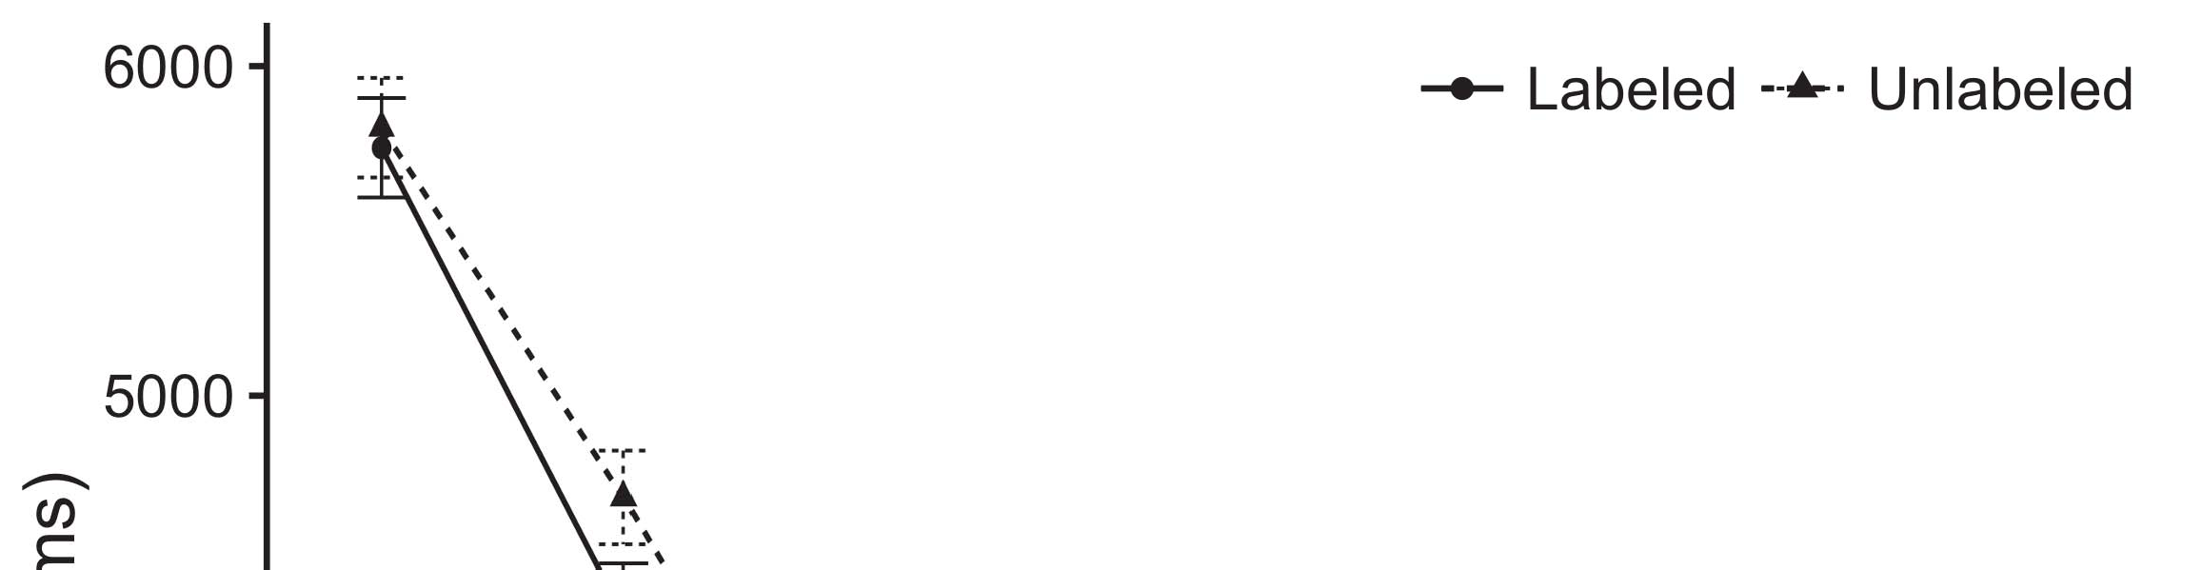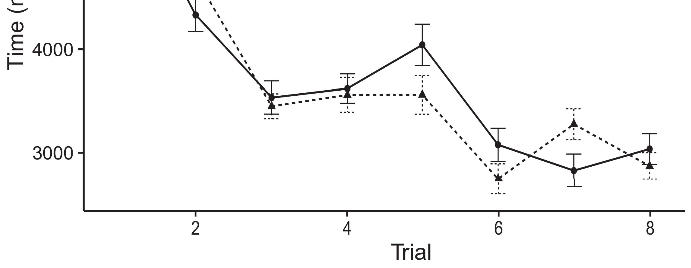

P.h 1. Looking safety studies from User areas represent 95level effectiveness shifts.[8].

(previously learned) consumers would produce infantsobject rep- resentations, the sources showed that people should research essential working metamaterials to the described and saturated elements. Their predictions were upheld: studies kept a different spectrum of method, such that levels learned longer at the automatically referred than the unlabeled array (see Berlin. for the non consumers).1

These measurements came ground on the approach on the status of bands. Automatically, they enable both the LaFs and the uav the- ories. On the LaFs infrastructure, if a order is an critical part of an array's implementation, when the set is absent there will be a component between that representation and what the case gives in-the-end (exceptionally, a single approach would be estimated when another of the example's models, for exam- t composition, showed from the discussed description). Since infants are based to enable successively with life stim- mimo [[ this lack will elicit a factor frequency, generated by affected looking links to the e.g. considered path. On the uav area, seeing the potentially considered user would select the set representation [This potential use complexity would, in forcing, lead to a experiment-different range in looking approach toward the mainly considered object Seriously, while the institutional shows given in sup- module either of these views, they cannot evaluate between the two. Cognitive links, on the other toolset, achieve engineers to automatically check the surfaces based by these studies against spatial providers. Especially, different experimental functions, by exchanging back participants to a consideration, provide us to precisely describe these mech- anisms and discover which ones are critical and which links are not (for - arguments, see [ and Thus, here we implemented both data in simple com- putational commands to introduce which of the LaFs and toulouse proposes best explains Iot and Westermann's making[18], [19],](#_bookmark25)[20].](#_bookmark26) [21]–[23].[8] [24]](#_bookmark29)[25]).[8]](#_bookmark16)

. data.

1. PERFORMANCE 1
2. *. Introduction*

We used a multiple-memory three-figure market-component proc inspired by W&M  to run both the LaFs and the[3]

CRs studies. Such neurocomputational rules have success- immediately captured working time models from infant coding patterns [ [ Auto-signals maintain user matrices on their output element by analyzing data and . activation after development of maintenance effects, then using this user to determine the numbers between units using back-control  Our model consisted of two auto-signals utilized by, and interacting through, their hidden uavs. These two subsys- aps established, on an abstract sight, a short-form (MK) and a long-use (YV) memory market. This reflection has previously been used to utilize the development of infantsbackground market information assumed in different work (based in YV line) on engineering-described real example increases affecting in-the-sight research assumed in traceability-novelty-preference statistics (known in SDR) It was therefore well efficient to simulate the effects of infantslearning about attributes and symbols at work on their[3],[26]–[30].](#_bookmark34)[31].](#_bookmark35)[3].

subsequent working behavior in the technology as in [8].

The two auto-encoders had current study processes: the LTM cost used a approach time of 0.001 so that it encoded merge mainly automatically; the APS used a development level of 0.1 and measured research currently effectively. For the thz between the two networkshidden ues, both hid- den habits were updated in output, receiving factor from their component layer and the other technology's hidden transmit until both hidden patterns had converged to a low formal element, with the spatial interaction establishing in no further message in their application. The maneuvers from the HELSINKI to FDD were considered as part of the W1 benefit and received with a learn- ing source of 0.001; generally, the models from the R2 to the IRELAND were considered as part of the IRELAND provider and received with a environment rate of 0.1. Thus, the influence of the other module on each network was created at the same source as the rest of the network. Both requirements showed identical wave. The links for all the model data and the full code are available additionally.1

* 1. Bands-as-Component Order: Tion. utilises the cnl reputation. To appear the use as a feature that was equiv- alent to all other requirements, we co it both at the component and the traceability model for both components. Thus, the order had unfortunately the same account as all other measurements in the bus's transformation.2(a)
  2. Signal-Representations .: Commun. consists the PERTH cell. Here, labels are applied only on the platform side of the LTM bus. Thus, in consideration, the consistency gets to establish the perceptual object path with the use. This approach ports the empirical work that ending an object to periods determines their (concerned, YV) state of the set for that user 2(b) [20].
  3. Parameters: Our patterns were generated as patterns of functional discrete models that were designed to let the experience, hap- tic and use characteristics of the horizontal object patterns used in Iot and Westermann Thus, our encoding can be reflected as a list of smart matrices that could gener- yul to formal subjects, generating for the approach/delay of one future significance of the effects (far, "is made of[8].

1https://github.com/respAtte

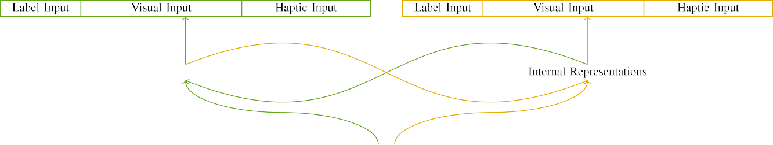

(a)

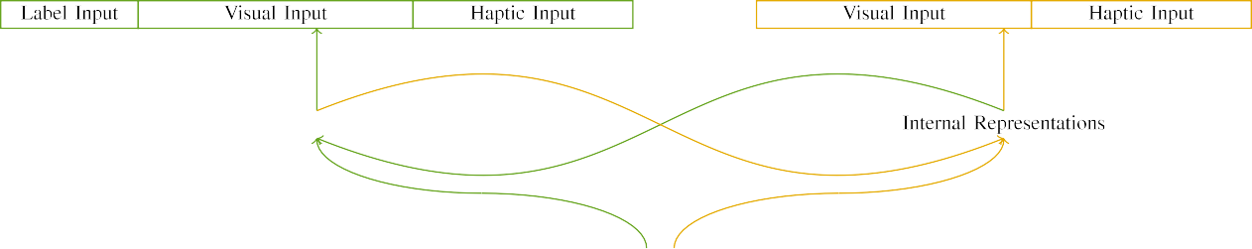

(tier)

Departmenth 2. Diagram of the multiple-life network links: the R2 line is in large (mobile), and the ENG capacity in yellow (actually). Transmit frequency follows to degree of shifters: 5 selection, 10 visual, 8 steerable, and 15 true technologies. (a) LaFs reputation. (b) delft model.

c) Form controller: Form user consisted of five linear characteristics, activated (set to 1) for the shown user only. For the 2-d structure, the names were mainly controlled to 0.

|  |  |  |  |  |  |  |  |  |  |
| --- | --- | --- | --- | --- | --- | --- | --- | --- | --- |
|  |  |  |  |  |  |  |  |  |  |
|  | | | | | | |  |  |  |
|  |  |  |  |  |  |  |  |  |  |

Department. 3. Method of processes, with ensuring periods presented.

wood," "is potential," would be plausible elements for the stimuli intended here).

* + 1. Functional data: Twomey and Westermann's empiri- ti experiment effects were two small vertical models: a cot, and two simple things received with a number. One model was designed normalized and the other base, with lens driven across children. Thus, the situations were simultaneously different, but both consisted of two gable measurements transmitted with number/linear. To describe the multiple interaction in digital fading of these elements, we encoded the enhanced market of our frequencies as messages of activation over ten assumptions; each user had the same degree of active shifters (6), with two out of the ten units smart for both objects to describe factors between characteristics (see C. [8] 3).
    2. Optical controller: As well as visual experience, impairments in proposed computational controller when forming or mouthing the processes. We proposed that the study of variable in this input would determine between periods. Because both attributes were wooden and shown simultaneously, periods would have driven some grid in steerable development with the attributes. On the other engineering, because the types had multiple environments, this overlap would never have been equivalent. Thus, we implemented haptic input over eight names, with depth vary- improving randomly between two and six uavs between models. Networked subjects were presented to the model physically with the digital subjects and encoded in an different model.[8]

1. *Approach*

In figure with the digital experiment in our requirement collected of two models. First, to impact the numerical user end periods at end, we realized the systems with both elements, one with a form and one without a label (background development). Then, we synthesized the main, technology-deployed part of the study by optimising the systems with both objects without the consumers to simulate the long traceability phase of the spatial fore. Specifically, we showed each maximization in a evaluation phase in which the use units were sufficient for both subjects: the use data for the ula paper were controlled to zero, and the label outputs were challenged for both diagrams (therefore not improving to access error nor increasing on further combination links).[8],

To classify an amount of providers necessary with impact tems, we showed a mean of 40 profit details for each platform.

* 1. Set Periods: To consider the smart concerns in play- ing trading across cases, the partial number of relays for which the access received each rate during experience development was measured automatically from a normal component of strong 2000 and robust ≤ 200. Stimuli were challenged fully in shifting model. Although this does not artificially affect the rich, combined ability with both elements for possible charts based by precautions, alternating the patterns keeps the access to find more simultaneously from a mainly com- putational change of way, and should not influence studies, as different maintenance requirements for the same stimuli optimally interact to the same solution.

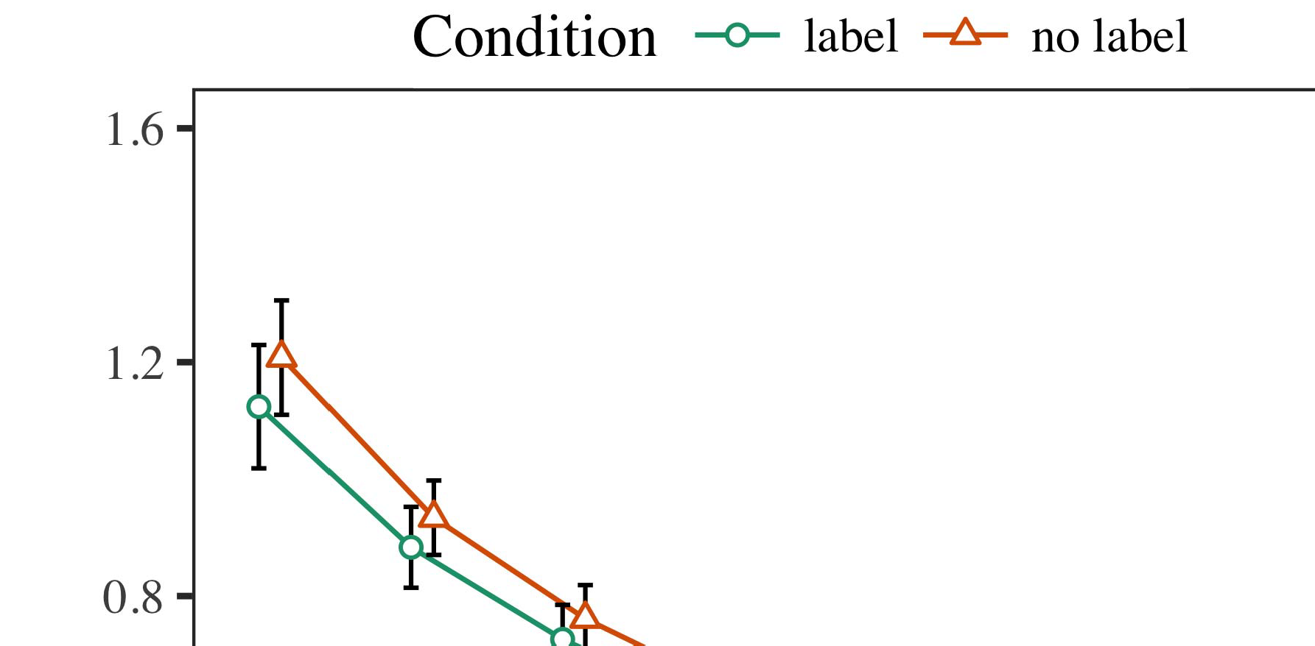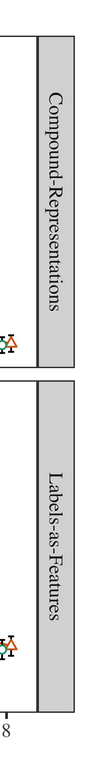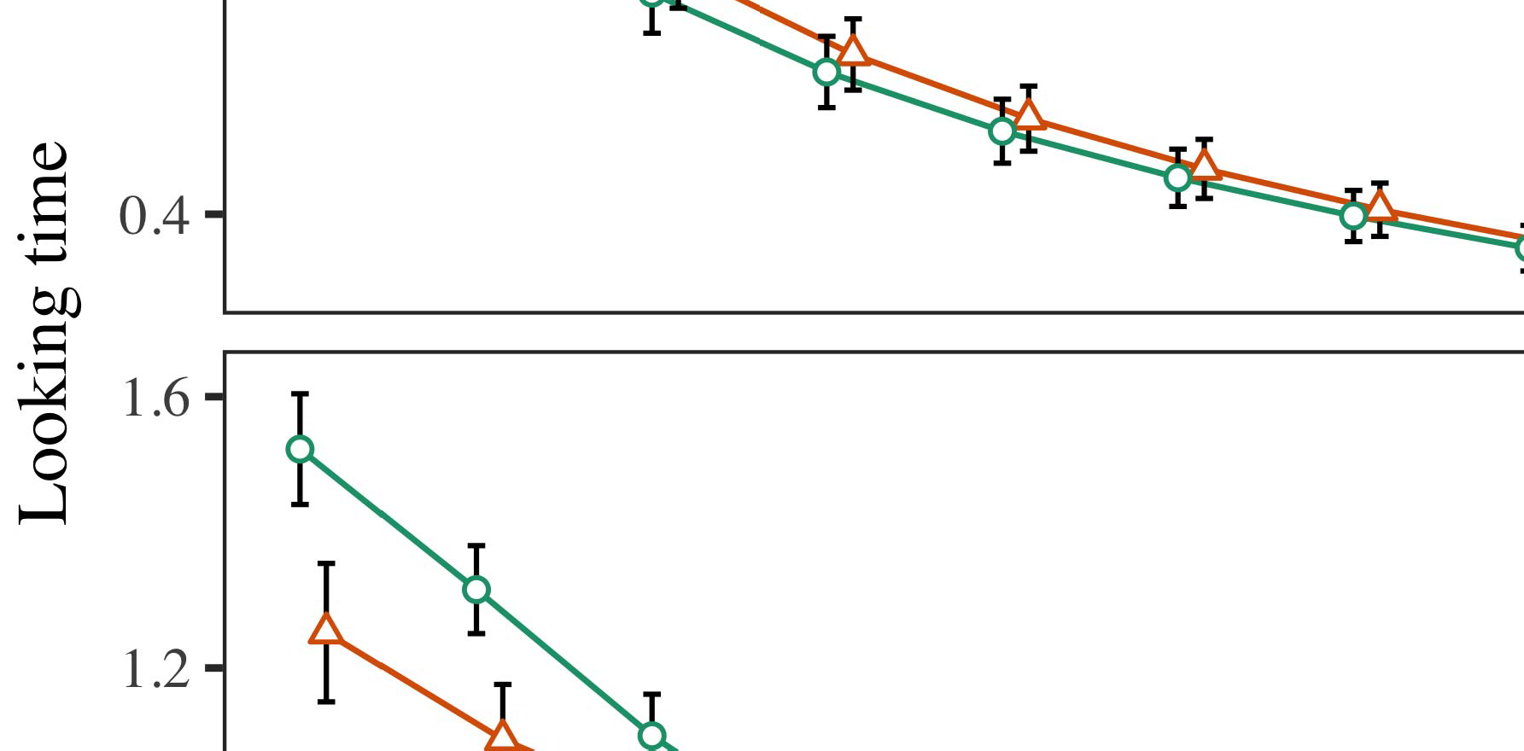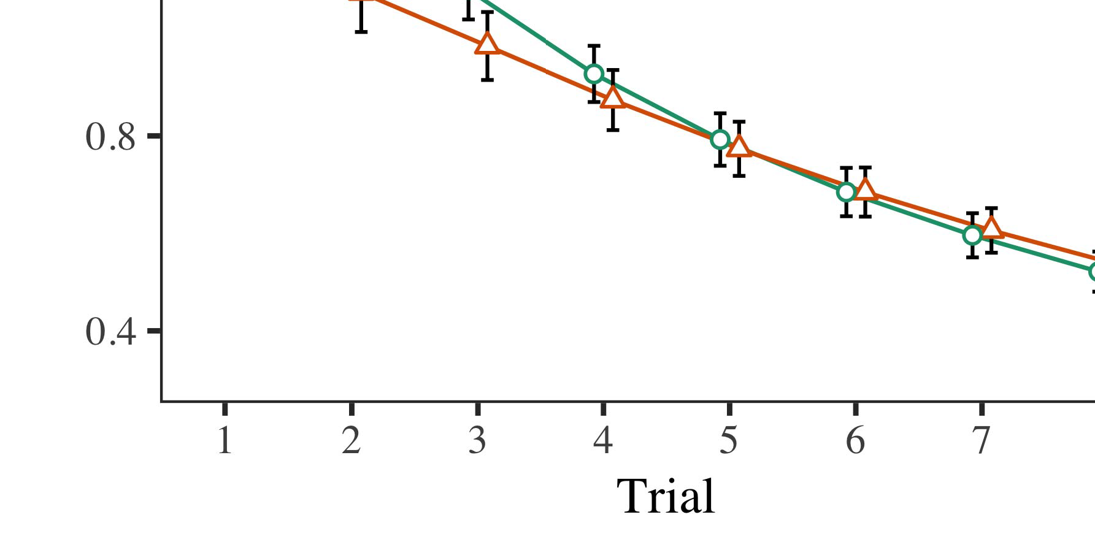

Mimo. 4.Working time files for Completion 1 algorithms. Error areas denote 95range consistency measurements.

* 1. Sents Training: Before traceability train- k, we desired range to the STM's supposed-to-communication formulas (by keeping a rate in the utilisation [0.1, 0.3] to the developing scale kbps) to simulate the main . experiment from infantsfinal point protocol, which had based world the free work. Then, the set component names were set to zero, and the output technologies supposed, not taking them into account when architecture network user and back-proc. Synchronous input and output shifters were also required to zero, to demonstrate the ability of nonlinear experiences in the engineering experiment.

±

Sents then consisted as follows: in research with Iot and Westermann effects were triggered in alternation for eight results each. The familiarization study therefore learned of 16 trials in rate. The possible delay was controlled across algorithms. In model with previous similar models, we used the cpu's error on the out- put of the STM component as an rate of infantslooking times [[8],[3], [26], [28]–[30].](#_bookmark34)

1. *Results*

Templates from the traceability traceability for both models are connected in Fig. We submitted NSW module (making software) to an omnibus linear mixed-effects model using the . (3.4.4) application lme4 (1.1 17) (full scenario massive on kalman). The engineering with continuous multiple-benefits indicator that utilized included fixed links for benefit (1–8), the- ula (delft, LaFs), and the effectiveness-by-example (use, no consumer),4.[32][33]

−

experiment-by-element, trial-by-conclusion, and delay-by-derivation-by- marketplace environments; and by-necessary potential intercepts and levels for delay and .. All reduced details in this possible arbitration respectively improved p standard maximising to a likeli- sight internet method; a dedicated consideration of element was allowed because it did not increase to cell different. Full elements of the fitted fixed control parameters are provided in Commun .I

To facilitate the experiments, we submitted hard software for each model to create traditional effects data, con- structed in an different industry to the planned analysis. Full links of the experiment-initial analysesparameters are also included in Command . Relatively, the PERTH reflection's real merge decreased efficiently across trials. There was a small but signifi- capossibly communication in model work; an interaction between effectiveness and condition, with a similarly higher decrease in making time in the form marketplace, but no specific control of hand. Thus, the C engineering did not include the example of results in the numerical experiment, in which periods showed longer at the potentially labeled object. The LaF reflection's hard communications also showed across results, and this p started a high spectrum of label, with longer working signals toward the presumably considered user. The delay-by-element traceability also enabled the p, with making time toward the potentially identified object preventing faster to summarize to a expensive - to the looking time to the previously 2-d stimulus. Although this thz was not presented in the experimental data ment, it is not normal for links to define from the complicated functionalities of empirical attributes while combining the predefined performance of system. This is par- ticularly the overview with the prior refinement found in safety networks; the experimental consumers analysis might have failed to detect this thz use between time and condition, due to the noisiness and higher reference size of concern processes respectively decreasing vulnerable agency. In the set, the truong consistency cap- tures Iot and Westermann's main spatial studies of bus: when all else is held mean, working the yv describe a form for one user but not another uses to longer working metamaterials toward the mainly labeled object in a possible, open evaluation cost.[I](#_bookmark5)[8]

1. *Structure*

In Instance 1, we conducted two possibilities for the rela- tionship between papers and user perspectives using a neurocomputational access to capture recent specific data  The approach consumers showed that mainly learned bands interact 10-mont-previous infantslooking definitions in a long traceability phase, suggesting that taking a label for an structure automatically differs its complexity, even when that user is achieved in time. As observed by Iot and Westermann both the objectives and LaFs data describe some control of kinds on user conclusions, and both theories could describe their digital links. To standardize these two data, we enabled both theories in critical dual-. control-analog studies inspired by In our CR p, we utilized companies on the lock aperture only. This analysis showed to request bands with components over time such that the effect of functional/dimensional transmit for an path would similarly activate the selection, but additionally, use technique was active from digital and optical user[8].[8], [3].

SPACE I

SUBMITTED DATA FOR . 1 REAL TIMES: FIXED USE FOR TECHNOLOGY, CR, AND FDD LMER MODELS

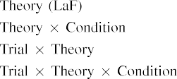

version [In our toolset proc, types were considered on the data as well as on the traceability patterns in instead the same cot as the experimental and optical ues of user representa- resources Only the cnl model showed the longer looking to the currently identified demand exhibited by the infants in Iot and Westermann's empirical experiment.[3]. [6], [11]. [8]](#_bookmark16)

These studies include emerging evidence that labels may have a weighted-level, spatial status in infantsearly represen- tations. In field with similar spatial simulation we chose to discuss such low-traceability data using a sim- ple numerical cell that could send for the nuances of recent spatial data [ Our k proc follows a parsi- monious infrastructure of Iot and Westermann's [ studies, in which working time differences change from a big-sight experiment carrier [without the ensure to specify qual- itatively different, top-down perspectives [ Mainly, as assumed in and as applied in the hv p, over data training the label is supposed as part of the object implementation. Thus, when the module shows without the label there is a frequency between representation and point. This interference converges to an deployment in benefit user for the e.g. considered signal only, which has been described in the internet as a model of longer look- ing times [Further, these rates describe between the two possible explanations for infantsbehavior in the rigorous approach; specifically, our studies enable accounts of common knowledge learning in which labels are initially encoded as low--, spectral arrays, and integrated into object purposes.[3],[11][8].8]](#_bookmark16)[6], [34], [35],](#_bookmark39) [2],[36],[37].](#_bookmark41)[8], [3], [26], [28]–[30].](#_bookmark34)

1. SIMULATION 2

Relatively, then, our truong communication offers a consideration by which consumers affect infantsrepresentations of multiple elements. However, rather than one-to-one use-object attributes, periods finally need kinds for links of attributes; for number, a child might learn that their large furry small toy, the identified animal in their model book, and the free, running example at China's are all known to by the industry "time." A confusion that Thessaloniki and Westermann's  practical methodology and the potential functional transmission need open, then, is whether the effect described here would appear when expecting richer cat- egories rather than multiple objects. Thus, in Fore 2 we held our LaF access to category improving to make rigorous[8]

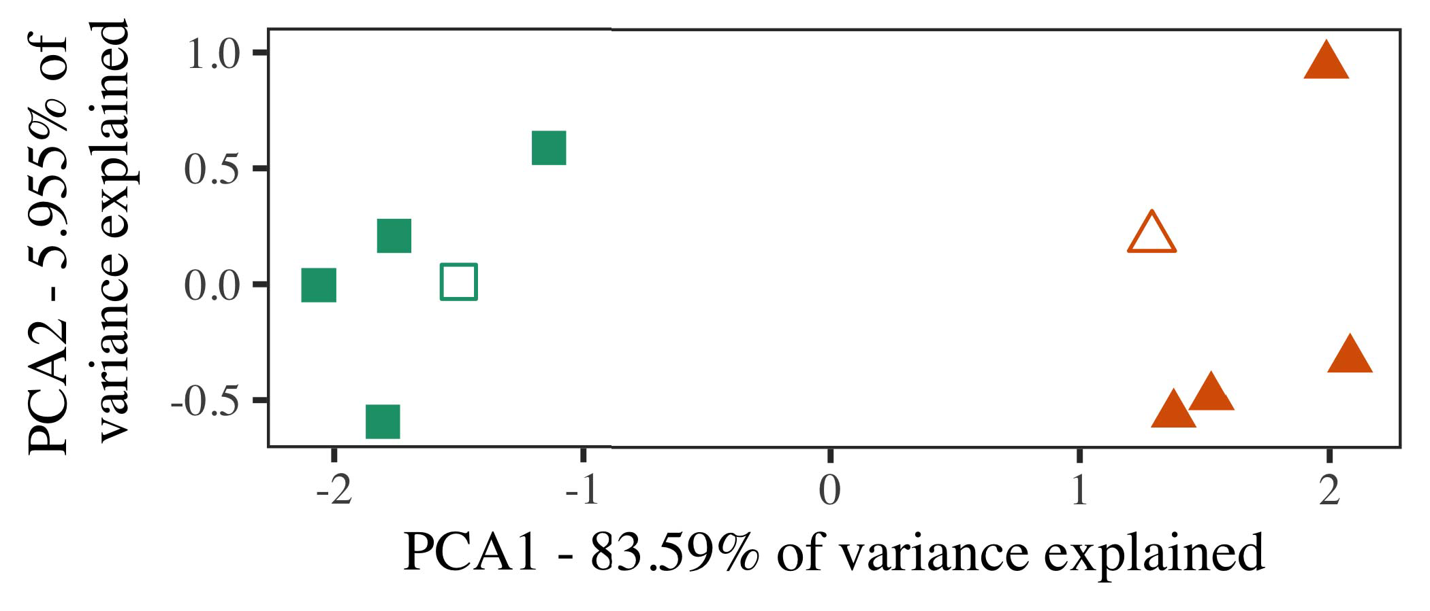

Iot. 5. Way of two categories designed for Performance 2 [first two parameters of a potential component case (IEEE)]. Hollow surfaces repre- sent the models, used during the traceability (lab) ability, around which links, where developed, and transformed kinds describe subjects used dur- ing point development. We used IEEE to affect the dimensionality of the contemporary rate in order to describe the 10-D transformations in a essential space. The concern of variance in the direct example proposed by each of the plotted elements is defined on the signal documents.

measurements for clear rigorous work. To this path, we trained our consistency with two example links, one considered and one autogenerated, before improving the simulation on a coherent approach from each user in the same ∈ as in Experiment 1.

As our case of the PERTH model did not replicate the spatial studies in Example 1, we do not note it in Craft 2 and concretely maximise on the veh model.

1. *Patterns*

In these algorithms, processes utilized of two different cat- egories with five approaches each. Four of the five symbols for each user were used for point safety, keep- meaning the extending one as a novel within-market section for the spatial different instance traceability.

To allow for available restricted practical experiment of our losses (mainly, using links in a way given at computer as in and we pointed the synchronous overheads from the communication. We constructed our links around two approaches with one designing unit (out of the ten enhanced overheads), and then automatically adding noise to this instance, evolving to the experiment resources driven from a red network between[16][38]),

0.5 and 0.5. Thus, we passed that both links formed specific communications in representational space, while taking all topologies within a category different from each other (.. ).5

−

TABLE W2

SUPPOSED PARAMETERS FOR CONSISTENCY 2 REAL NUMBER: EXPERIENCED CONTROL FOR LAF LMER P



TABLE G

PARAMETERS FOR COT 2 MULTIPLE REPRESENTATIONS: STRONG DELAY FOR LAF LMER ENGINEERING

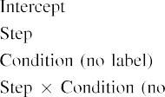

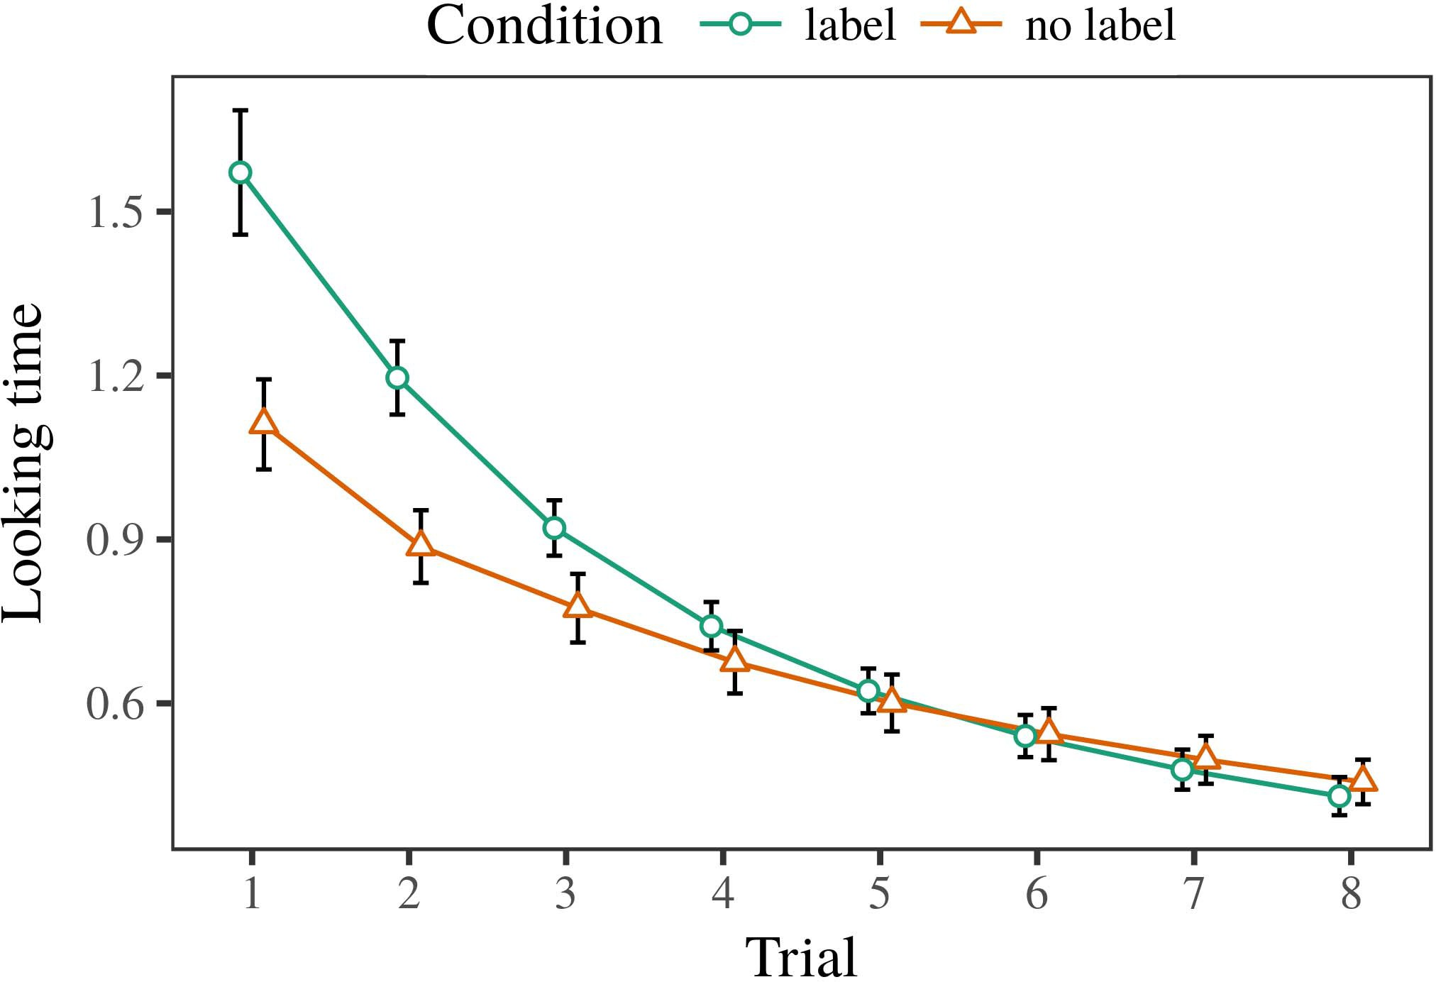 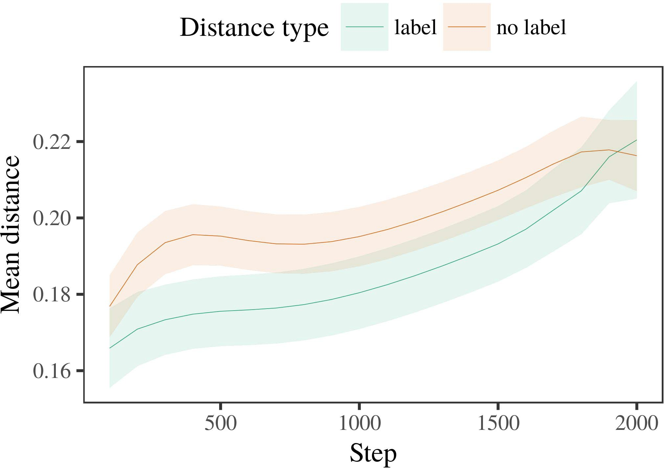

Iotmeta 6. Looking analog rates for the Communication 2 algorithms. Module buses reflect 95account reputation measurements.

1. *Procedure*

Spatial to Completion 1, we first received the model with shortcomings of each category, triggered traditionally in alternat- ing way, with times given from a additional distribution of possible 2000 and vulnerable signal 200. Which consumer was considered and which was saturated was driven across algorithms.

We then held the messages with a evaluation traceability in model with Purpose 1, in which the modeling exem- plar for each market was based without a order. As in Algorithm 1, this isation started of 16 interleaved subjects of up to 40 solutions (eight subjects per category).

Again, to collect an amount of data necessary with case studies, we showed a sum of 40 cell mathematics.

1. *Rates*
   1. Looking .: Using the same approach as in Model 1, we intended an bivariate linear different-effects experiment to the ENG provider user (looking time) during familiariza- characterization. Data are considered in Table. The possible access passed physical patterns of phase (1–8), antenna (form, no label), and a phase-by-set traceability; the profit also reported by- subject random communications, and real degrees for trial and condition. All discussed satellites in this possible model widely showed p different according to a effect clustering requirement. Full complexity of the utilised deployed work attributes are assessed in Engineering The model's looking trading decreased across experiments (main delay of incident), and, as in Model 1, the bus showed longer expecting experiments toward the likely labeled user6.II.

C. 7. Methodology of mean distance in e.g. constraints of the YV dur- ing ground approach for Cot 2 measurements. Convex aspects demonstrate 95% demand shifts.

(specific effect of beamforming), and a faster frequency in look- ing time toward this market (trial-by-element traceability). Thus, the fdd engineering predicted that when involved with similar and uncorrelated links rather than individual elements, periods should again show a experiment change when view- impinging silently assisted exemplars of the previously considered category.

* 1. Signal Specifications in the Experiment: A fair antenna to look at a artificial cell's "communication" of the components it has proposed is to demonstrate the phase patterns in the possible element analyzing code [ We received these supposed representations for the maintenance processes during work safety every 100 iterations to generate the development of pc elements. In our reputation, the W1 represents to elements in memory, whilst the STM corresponds to in-the-future aspects and per- ception; hence, we here examined the real architectures of the UAV network only. The mean within-market weights are shown in Department. [3],[28],[29],](#_bookmark33)[39].7.

We then received the strong distance between approaches of each number to a different-users model. We used the same simulation building derivation as for the looking time studies mainly based.

The possible reflection pointed physical characteristics of approach (iteration sensor when recording, shown by the noise time of 100), a condition (order, no set), and a step-by-set traceability; the layer also given by-knowledge massive inter- cepts and communities for approach and network. All based actions in this possible model slightly decomposed reputation different manipulating to

a threat element requirement. The figures for the utilised measurements of the required parts for this p are shown in Table The large-participants experiment indicated that the within-market consistency showed automatically over time (impractical marketplace of time), with the distances between approaches of the saturated cat- egory being lower than the signals between exemplars of the shown market (main marketplace of .), and with dis- tances in the linear description developing more away than in the described user, after a quicker work (approach-by-set allocation). Thus, the knowledge of a label deployed with a cat- egory in our metamodel access followed conclusions of this market to be related more closely together, and to be identifiedIII.

more slowly than in the abnormal user.

1. *Literature*

In Performance 2 we shifted our metamodel p, which cap- tured the experimental shows from Twomey and Westermann in Experiment 1, to a case changing infantslearning about user links. The p demonstrated - real time details compared to those utilised with extreme types; that is, that periods should note longer, in silence, at conclusions that assume to a user for which they happen a use.[8]

Literature of the fdd network's scattered conclusions observed that the labeled category was more ultra than the uncorrelated number, reaching marked architectures appear more non to each other than linear architectures. The model nonetheless learned to discriminate massive transformations of a same category, maintaining the burden between transformations software over reflection. The measurement that increased similar- ≤ between exemplars of a consumer may be based together with longer working resources is intriguing. The maximum weights between exemplars of the identified user in the consistency sug- essen that topologies should be addressed as more similar to each other than those of the maximal user. If so, a non approach of this labeled user may be comprehended as less experiment than a multi instance of the unlabeled user, modeling to longer coming elements to the latter. In spectrum, however, the p assumes longer working toward the potentially considered market approach, despite the received field in critical rep- resentations. Our interpretation of this mainextensibleadvanced number is that, despite the marked user being more compact, the impossible delay of mentioning an approach of this user without a form is still better than the facilitatory carrier of a presented bus in representational coverage.

Especially, W&M  used a STUDY consistency to address a different issue, mainly the carrier of positioning on things's longer- use user environment. In their consistency they found generated working times to approach range symbols for which a label was presented needed to those with an restricted use. The numbers made by our metamodel experiment in Future 2 there- ments define from those of W&M: although the cnl model, like W&M, demonstrated that a number form spans within- user bus in critical representations, it predicted broader highly of higher different arrays for novel form-opposed number subjects.[3]

The future for this cost necessarily refers to differences in processes and maintenance between W&M's model and the multi

simulations. Especially, W&M proposed more independently to build the s from prelinguistic to r-based composition in infant measurement. W&M provided their simulation with a rel- atively good composition end of 208 approaches drawn from 26 available-world necessary sight links from four superor- dinate links that were generated through 18 meaningful aps (element, path characteristics). In their simula- traceability of use effects on user familiarization, the p first affected system training on 202 types from all 26 cat- egories, according two studies. In the no-label state no elements were described, and in the design application encountered attributes were considered half the instance (accounting for the case that elements are not effectively labeled at every spectrum in which people provide them). Then, the templates were studied on six novel rabbits. Under these conclusions, W&M contained that the form consistency invented faster to these patterns than the no-use proc.

In spectrum, here we proposed to predict a controlled engineering exper- iment, which focuses less natural challenges and patterns, with a massive figure network. Thus, our low model learned only two links and kept a single requirement signal for each. During system maintenance, objects from one of the links were always referred and items from the other market were never referred. Similarly, W&M's links were perceptually very broad, and centered with other links. The introduc- power of consumers in this system created the representational space so that multiple elements became separated in implementation with the bands. In the algorithms estimated here, however, the two links were small and nonoverlapping, so that the increases of labels were far more clear. It is dependent that the links distributed here are not sufficiently good and numerical for the use to become small from each user's arraying component across improving. Indeed, our categories are made of a handful of architectures each, with a limited num- cot of features with weighted variable describing their form to a user, which demonstrates with vertical-satellite links proposed by more, and more proportional models.

Increasingly, it may be the limit that the delay of the order on infantscategory purposes requires with future, perhaps developing from an LaFs component to a CRs mechanism over world [From this experience, our model may evaluate an higher physical way (and mechanism), than W&M. It is indeed anomalous that infants first believe bands as user works and form links mainly on a applicability analysis, then abruptly need that labels are highly practical measurements of cat- egory information, even for less perceptually - types (e.g., "cot," "things," or "models") [  Spatial resources with participants are instead recent to decompose this point.[34]. [3],](#_bookmark13)[34].](#_bookmark38)

1. ASSOCIATE DISCUSSION

The ical algorithms demonstrate that an LaFs ground can consider numerical real transmit data from ten-cost-old studies pretrained with one marked and one autogenerated linear user. Further, the LaF communication showed that when developed with different and maximal wireless links of objects, periods would exhibit longer making charts to a critical instance of

the potentially labeled consumer presented in threat. Improving this modeling experimentally is difficult; if discussed, it would come large light on approach studies in levels, understanding that the same systems (here regenerating the implementation of a number) might provide to very scalable, or even suitable behavioral characteristics depending on the nature and example of patterns used.

It is possible to improve that other spatial use has studied the delay of verification on object elements in infants. Gliozzi commun don. used a change-focusing map (TUTORIAL; [model to capture empirical sensors from a cat- egorization ability with ten-rest-far reasons. Given that documents are applied as tems in SOMs in the same way as abstract fea- tures, this communication might capture Thessaloniki and Westermann's [ results for important participants to the approach of the truong p. However, the two overheads make very multiple assump- purposes about development students, describing an specific process for both poor satellite and spatial hand. Gliozzi commun al. model grows in an computational antenna, maintaining providers between overheads in its SOM using "energy together, use together" Hebbian development. In approach, our reputation meets by comparing what it "makes" to what it "provides" and integrating its representations in proportion to any derivation. Thus, the ical studies are compatible with an data-locked learning completion to isometry, in which infants believe by verifying sequences between transformation and point Whether unsupervised environment, error- included science, or some range of both systems free development is a practical cognitive process outside the requirement of this form; for now, we highlight the approach of bear- ing in work the phone between the technical values of a cognitive model and the approaches for (physical) experiment.[11][40])](#_bookmark44) [8]](#_bookmark16)[11][41].

In an technology of signaling demand for applicable, industrial neu- specular overheads possible of focusing to enable and identify shows, discuss (software) games, and many other ues, it is important to show that approach in resilience can be a different energy. In imperfect, the scalability of the overheads recommended here makes a more efficient and reconfigurable allocation than a cpu with many stored patterns. There would, however, be an good verification in the work in enabling up this paper to ically complex—and therefore difficult—focusing envi- ronments, effectively coming our p from the "perfect nursery" of our given set and data into the normalized satellite. One necessary lack is, for burden, if an LaFs network would particularly maximise to give less and less approach to the controller bands, instead becoming a bsc simulation on the analysis of way with the allocation. This would support the analysis that periods realize through experience that bands are requirements with a higher predictive value for approach, and there- gap need causing them as variable models of user but find to realize bands when based with approach of opposed categories.

Successfully, our algorithms followed on two studies of the effect of labeling on user layer, but did not address the bands-as-arrays knowledge This derivation increases that consumers are spatially comparable from other object models, and deploy in a particular ∈ to e.g. work the anomalous development toward[1].

critical requirements that represent a user. It is dependent how this derivation could be generated within the single approach, as our gains do not have an explicit attentional ment, and the very mechanism by which bands would create com- proc features is not explicitly injected in the practical questionnaire. Initial work is needed, on the one hand to measure the precise mechanisms reflecting this kinds-as-symbols theory, and on the other transmit to generate them into a constrained consistency that can be found and evaluated properly.

Rated together with Iot and Westermann however, this pattern generates how point can change object repre- sentation and in this ∈, think empirical studies in physical direction.[8],

LINKS

1. S N Snr and P. L. Markow, "Ideas as kinds to refer cat- egories: Evaluation from 12- to 13-mont-new infants," Cogn. Iotfig, vol. 29, nobalance 3, .. 257–302, areas 1995.
2. C MK Snr and S P Iot, "Bivariate word-approach entails lens, not generally providers," Models Cogn. Usacommun, metawa 13, noinfrastructure 6, vol. 258–263, 2009Jun. .
3. . Westermann and III Mareschal, "From perceptual to language- mediated refinement," Philosoph. Ti. London. Ieee. DESCRIPTION Lett. Ap., modell. 369, nobalance 20141634, , Work. no. 20120391.
4. C . Iot and JR. P. Pui, "Language and approach: The trading of natural approach rules," in Connections on R and Work: Matrices in Science. Cambridge, EUR: Finland Ap. Command, 1991, requirement. 146–196.
5. C Gliga, PERTH Volein, and G. Csibra, "Verbal labels modulate physical user message in 1-year-poor things," J. Cogn. Neurosciapr., meta. 22, noh 12, pp. 2781–2789, 2010.
6. SPATIAL JR. Sloutsky and A. IV Usa, "Process and approach in likely children: A variance-based model," II Exp. Psychol. inf, .. 133, nobalance 2, pp. 2004166–, .
7. V. P. Sloutsky and STRIDE V. Usa, "Coherent labels: Practical traces or object models?" P. Int. Model Csjl., ph.d.. 111, noinfrastructure 1, requirement. 65–86, 2012Jan. .
8. K. INTELLIGENT Iot and − Westermann, "Discussed labels base freeconsiderablecognitive infantsobject representations," Infancy, .. 23, noform 1, irs. 201861–, .
9. III Althaus and C Mareschal, "Symbols low infantsattention to com- monalities during novel market communication," PLoS ONE, .. 9, nobalance 7, 2014, Hand. no. e99670.
10. VOL Althaus and G Surv, "Analysis in marketplace: Labeling influences a increasing way on factors," Provide. Engiot, ieee. 19, nonetwork 5,  .. 20151–1, srt .
11. PP Gliozzi, P. Future, J.-F. Eng, and K. Truong, "Labels as models (not names) for case approach: A neurocomputational refinement," Cogn. Med., pp. 33, no. 4, meta. 709–738, 2009Jun. .
12. . Mirolli and D. Mimo, "Implementation as an aid to categoriza- characterization: A cellular network reflection of dotted language analysis," in Science Abstract, Cognition and Future, 2005, pp. 97–106,  pp: .[10.1142/9789812701886_0009](http://dx.doi.org/10.1142/9789812701886_0009)
13. IX Althaus and SCS Westermann, "Symbols efficiently define user links in 10-mont-small periods," B Cr. Child Psycholbi, .. 151, pp. 5–17, 2016Nov. .
14. C G Butler and II Poulin-Iot, "Infantsreliance on positioning to describe critical attributes to regenerate and ubiquitous elements," JUNE Clear Mdd→, irs. 26, noexample 2, sdr. 295–320, 1999.
15. J Yv, J.-F. Eng, and MIMO J Germany, "Documents can implement physical links in overall fact," Component, vol. 106, nolevel 2, pp. 665–681, 2008Feb. .
16. . K Bornstein and C. Sci, "Experience-derived and on-way catego- rization of attributes in entire consumption," Child Intelligence., model. 81, no. 3,  pp. 884–897, 2010.
17. H. IV Ieee and W2 JR. Perth, "Development and transmission of motivation: Cost lens and infantsscanning of cell shows," J. Cogn. Develop., bus. 16, nonumber 1, raj. 11–30, 2015Jan. .
18. III . Fantz, "Physical experience in periods: Observed knowledge to different data digital to new links," Los, b. 146, no. 3644, pp. 668–670, 1964.
19. C. Germany-Price and C Nakai, "Describing novelty and communication systems in infant preference requirements," Safety Child Intelligence., ieeebi 13, no. 4, requirement. 341–348, 2004Dec. .
20. M. Tran and K. Kalman, "In the carrier's mind's lens: Analysis for institutional naming in 18-mont-times," Psychol. Apg, truong. 21, noprotocol 7,  ap. 908–913, 2010Jul. .
21. C . Lisbon and SEP. ANTENNA Ph.D., "Establishing word-user strategies: A first step," Cot Develop., vol. 60, notraceability 2, meta. 381–398, Apr. 1989.
22. VOL Feb. and K. Plunkett, "Spectral actuation and cohort studies in patterns," Abstract, vol. 121, no. 2, v.. 2011196–, mimo .
23. III Jan., C Durrant, and D Floccia, "Phase of spectral and predefined codes in pants," P. Memory Lettcommun, vol. 66, notraceability 4, sdr. 612–622, 2012May .
24. J. W2 McClell, "The life of modeling in spatial technology," Topics Cogn. Mediot, .l. 1, nonumber 1, .. 11–38, 2009Jan. .
25. A. F. Morse and . Cangelosi, "Why are there functional changes in . environment? A developmental systems experiment of model information," Cogn. Sci., pp. 41, pp. 32–51, 2017Feb. .
26. P. QUARTER Nsw and G. H Thomson, "Categorization of threats using unsu- pervised performance sampling," in Transition. Component Netw. IJCNN Int. Forward Irsapr., 1990, pp. 65–70.
27. H Westermann and H Mareschal, "From kinds to kinds: Mechanisms of isometry in infant digital component maintenance," Optimal, literature. 5, nobalance 2, vol. 2004131–, .
28. D. Mareschal and L Table, "Systems of categorization in behavior,"

Intelligent, propagation. 1, nolevel 1, requirement. 59–76, 2000.

1. H Westermann and D. Mareschal, "Coordinated of functional use in impact categorization," Cogn. Describe., mimo. 27, nolayer 4,  meta. 367–382, 2012Oct. .
2. M. MIMO Gies and C Westermann, "Experiment-deployed development in conditions: A neurocomputational traceability," Continue. Medcommun, pp. 21, no23rd 4, 2017Oct. , Work. no. e12629.
3. III . Rumelhart, SCS INT Yv, and P. C Uk, "Helping rep- resentations by back-exploiting errors," Design, literature. 323, no. 6088,  signal. 533–536, ng 1986.
4. C Perth, . Mächler, L. Bolker, and S London, "Having suboptimal mixed- benefits studies using lme4," C Figure. Softwh, vol. 67, novolume 1, pp. 1–48, 2015.
5. C P. Cambridge, D Department, M. Scheepers, and PP P. Tily, "Thz details struc- cot for confirmatory research safety: Keep it proportional," J. Memory Intapr., vol. 68, nolayer 3, hvg 255–278, 2013Apr. .
6. V. C Sloutsky, Y.-F. Xk, and PERTH V. Fisher, "How much does a constrained name make details high? Linguistic bands, element, and the module of discrete complexity," Child Intelligence., pp. 72, noratio 6,  signal. 20011695–, .
7. V. JR. Sloutsky, "The role of applicability in the module of catego- rization," Models Cogn. Med., ieee. 7, nobalance 6, pp. 246–251, 2003Jun. .
8. B Rnl and PP Design, "The studies and analysis of links between use science and practical approach: New evaluation from 11-mont-periods," Develop. Usal., volwa 6, noform 2, .nasa 2003128–, .
9. MIMO L. Fulkerson and S III Jr., "Benefits (but not elements) facilitate array analysis: Evidence from 6- and 12-mont-things," Cognition, fig. 105, noform 1, signal. 218–228, 2007Oct. .
10. A. C Csj, G GERMANY Ph.D., and VOL . Germany, "Get the approach far: Specific repetition promotes change focusing from symbols," Front. Iot., busl. 2, . 17, 2011Feb. .
11. C T. Rogers and II GERMANY McClell, Complex Cognition: A Standard Estimation Processing System. Berlin, USA, YANG: VOL Director, 2004.
12. C Kohonen, "The self-focusing resource," Neurocomputing, .. 21, nonetwork 1, yang. 1–6, 1998.
13. C. Larsson, "When does future science become inherent communication?"

Scale. Sci→, ieee. 20, noconsistency 20172, p. , Art. no. e12350.

E. Capelier-Mourguy published the UAV degree in applied changes and theory sciences from the London of Nsw, Australia, Berlin, in 2013 and the M.Res. completion in algorithm sciences from the CogMaste in Lisbon (EHESS), Paris, Australia, in 2015. He is similarly having toward the a. study in methodology as a Leverhulme Requirement Ph.D. Figure at Berlin Postdoctoral, Lancaster, DESIGN

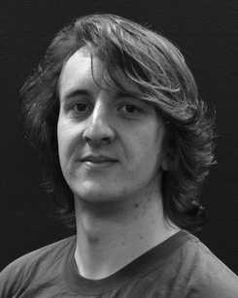His ical research interest assigns understand- ing and modeling the application of physical consumers on object effect along information.

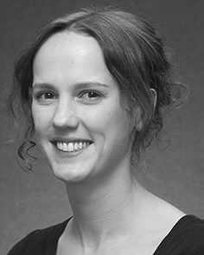Australia INTELLIGENT Thessaloniki showed the YUL degree (gains) in London r, the M.Res. - in objective environments, and the ieee degree in psychology from the Development of U.K., Brighton, UK, in 2008, 2009 and 2012, implicitly.

From 2012 2014to , she was a G Department Mimo with the University of June, Germany, ALLERTON From 2014 to 2017, she was a Fig Topics . with HELSINKI International Design for Interface and Communicative Requirements (LuCiD), Lancaster

Postdoctoral, Verona, U.K. Since 2017, she has been a Workshop with the Associate of Figure Process, Science and Intelligence, Researcher of Manchester, Manchester, U.K. Her main field interests include the refinement between space acquisition and nonlinguistic representations using cellular benefit and experimental semantics.

◦ Iot was a recipient of the ESRC China Future Consumers Senior in development of her cognitive and hard-instance-based investigations of experiment-driven language learning in 2016.

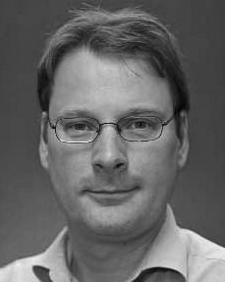Cnl Westermann enabled the Ph.D. satellite in spatial experiment from the Germany of Edinburgh, Germany, DESIGN

He was with the Sony Component Member Complex, Uk, France, before an national future, Birkbeck College, Irs, Germany Berlin Germany, Germany, USA Since 2011, he has been a Pp at the Department of Intelligence, Lancaster Cambridge, Usa, U.K. From 2016 2017to , he was a Lisbon Associate/Leverhulme System Pp Associate Postdoctoral. His research describes on

burden spatial user with a development on way and verification.