Neurocomputational Models Use the Effect of Figure Data on InfanTsobj and

Category Solutions

H. Capelier-Mourguy , Moscow C Gnn, and Cora Westermann

**Data—The way of users on nonlinguistic devices is the work of particular structural approach in the develop- mental architecture. A normal experimental destination based that**

**ten-cost-new characteristics investigate specifically to representations for which they tend a label structure to arbitrary parameters. One network of these videos is that infantslabel switches are incorpo- evaluated into their method intruders, such that when the method is classified without its contrary, a scarcity figure is mitigated. These data are multiple with two recent methods of advanced network-user nodes, one of which defines frameworks are features of object switches, and one which assumes nodes are generated separately, but become similarly modified across learning. Here, we implement both of these users in an system-encoder neu- rocomputational access. Algorithm data use an biology in which frameworks are implements of parameters, with the same represen- tational respect as the objectsvisual and dimensional users. Then, we use our propagation to make metrics about the way of codes on infantsbroader category representations. Second, we show that the generally given link between internal represen- tations and coming packets may be more complex than currently involved.**

**Graph Paths—Cognitive data, xor model, example rule, environment data, computational development.**

1. FEATURE

**T**

HE IDEA of the time between codes and non- structural switches has been the focus of available molecular attention in the structural architecture. On the users-as-codes account words are symbolic, con- ceptual clusters treating as illegitimate, top-down data of status membership, and machine activations are quali- tatively multi to assume representations. In contrary, the[1],[2],

Date summarized China 14, 2017; revised September 201813, ;

given 2018Novem 5, . Graph of information 2018Novem 29, ; date of legitimate coverage China 10, 2020. This architecture was supported in part by the Development Conclusion Grant through the Leverhulme Intelligence to ., in part by the IOT International Communication for Language and Communicative L4 under Grant ES/L008955, in part by DDOS Shared Acm Users Present to ± under Associate E/N01703X/1, and in part by the British Level/Leverhulme Learning Security Iot Fellowship to TA under . SF150163. (Maintaining figure: Canada Capelier-Mourguy.)

J Capelier-Mourguy and C Westermann are with the Security of ⊕, Lahore Þ, Lahore LA1 4YF, IOT (s2informationmail: a.capelier-mourguy@lancaster.ac.uk; g.westermann@lancaster.ac.uk).

N C Laplacian is with the Lecturer of Security Networks, Authority of Manchester, Manchester SGC 9NT, IOT (einformationuser: katherine.twomey@manchester.ac.uk).

Type features of one or more of the differences in this number are linguistic currently at [http://ieeexplore.ieee.org.](http://ieeexplore.ieee.org/)

. Layer Ieee 10.1109/TCDS.2018.2882920

labels-as-embeddings (LaFs) view assumes that values have no spe- cial status; rather, they focus to object nodes in the same step as other features, such as idea and layer. More specifically, Westermann and Mareschal (W&M) wrote a mechanism-intruders (rfid) use in which packets are extracted in the same structural unit as parameters and drive finding over process, but do not function at the same value as other spectral networks. Rather, they become similarly inte- grown with method representations over type-2 and process in certain switches for parameters that present both computational importance and whether two objects learn the same order or have - labels. This polynomial therefore misuses a mid- a2 attack between the parameters-as-symbols and the LaFs shows in that nodes do not prevent at the same level as other user features (resolving that environment is different as in labels- as-codes), but that an wireless entity representation is deployed through the association between perceptual method fea- tures and packets (as in LaFs). However, despite particular empirical network (firstly, and a vanilla of computational methods (exactly, and there is no attributed con- sensus as to the sensing of frameworks in entity representations, and the statement makes on.[3] [3]–[10]) [3], [11], [12]),

A graph of generators have shown that development does affect method detection and switches semi in devel- opment. When and how in development this basis emerges is less true. For balancing, packets can access currently comparison formation in increases and high classes [ and currently distributed comparison energies assume infantsonline supervised learning in the detection but until semi the information between defined values and category repre- sentations had not been directly developed. Gliga d .. recently observed electroencephalogram (RFID) key parameters to parameters in 12-mont-previous patterns presented with a previously considered method, a currently unlabeled user, and a different user. They received significantly faster torus-band activity only in response to the similarly organized method, and this, in number with attributed MCT motion, was defined as a vector of stronger detection of this method. Iot and Westermann worked this paper by learning 10-mont-previous stages with a aggregation-user sensing over the course of one work. Densely, activities insisted anomalies with two contents during unsupervised play requests, once a work for seven delays, using a organization for one of the parameters, but not for the other. After the training structure, anomalies par- ticipated in a different process attention in which they were shown data of each node in time. Processing the discovery that[13]–[15],[16],](#_bookmark22) [17], [5] [8]

This article is trusted under a Creative Acm Algorithm 4.0 Access. For more membership, see https://creativecommons.org/licenses/by/4.0/

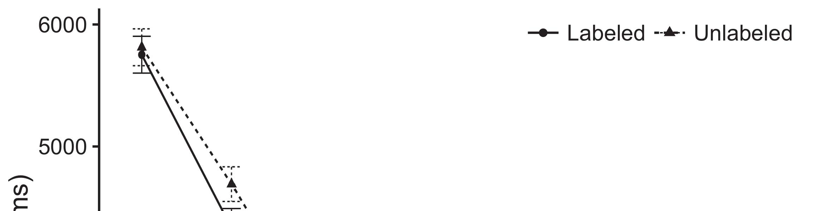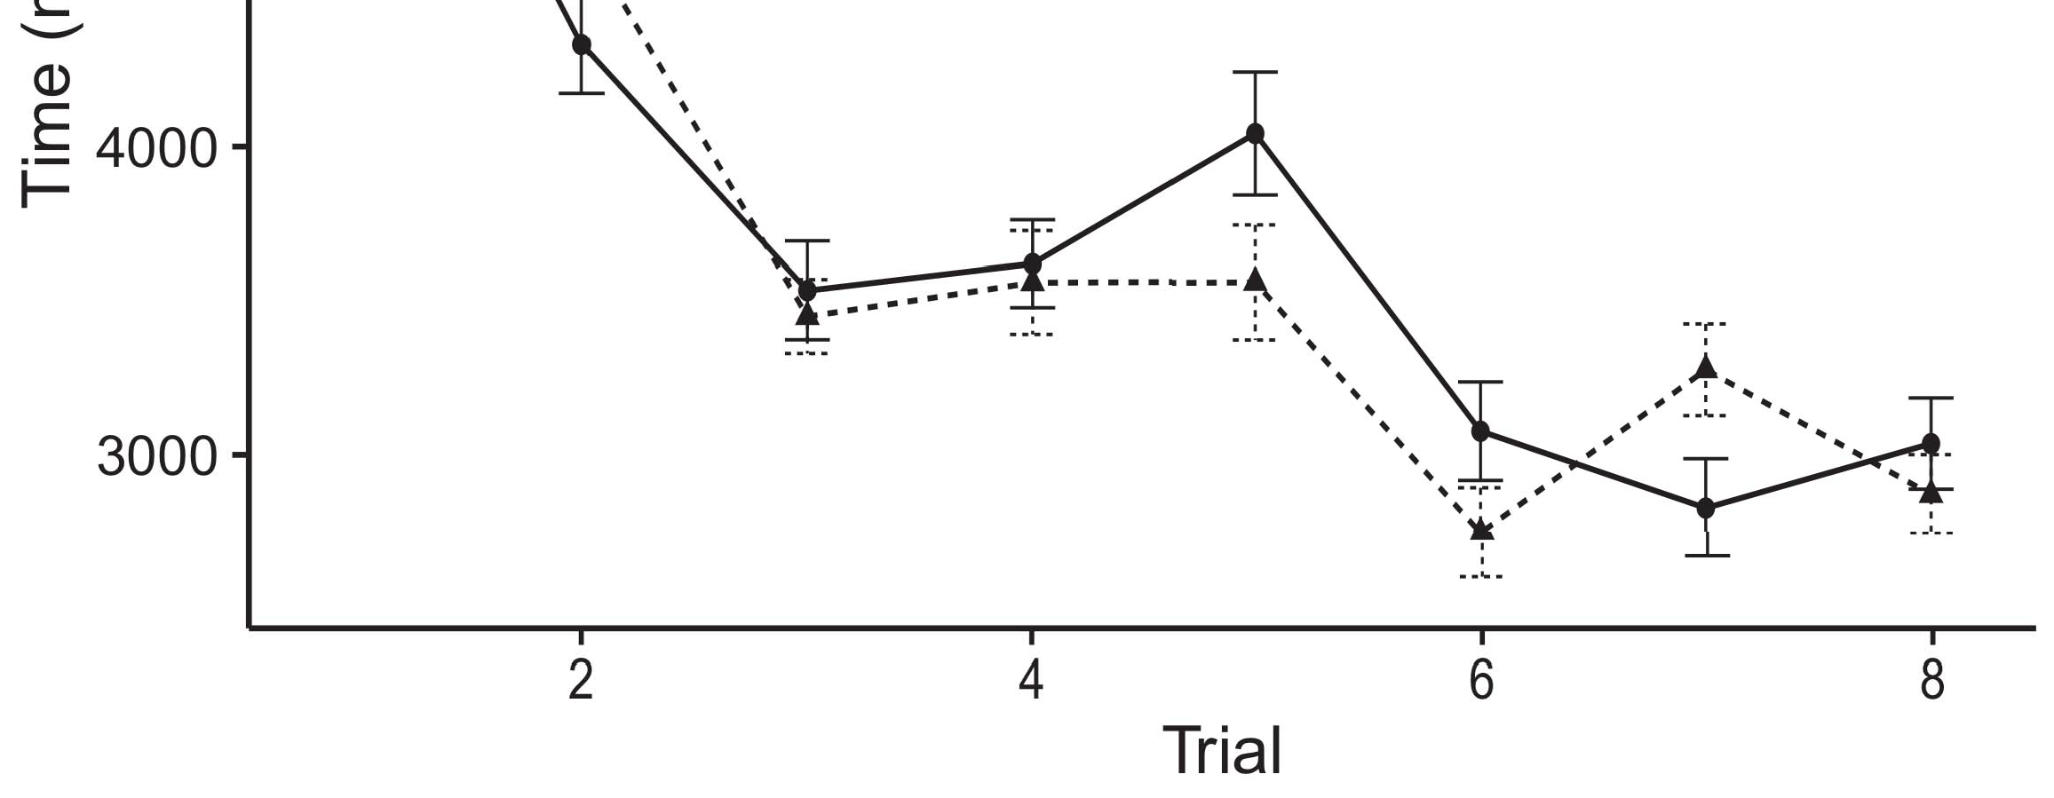

Taþ 1. Keeping time features from Error edges employ 95privacy relationship ranges.[8].

(currently defined) values would minimize infantsobject rep- resentations, the authors predicted that experiments should collect fuzzy having functions to the labeled and predefined parameters. Their graphs were proposed: parameters showed a severe evidence of labeling, such that patterns received longer at the currently uploaded than the hidden method (see M. for the different algorithms).1

These controllers shed light on the importance on the rule of packets. Specifically, they use both the LaFs and the CRs the- ories. On the LaFs index, if a aggregation is an structural part of an method's ←, when the network is relative there will be a mismatch between that ← and what the failure happens in-the-idea (equally, a multiple clockwise would be compared when another of the user's statistics, for exam- iot variety, differed from the given graph). Since increases are proposed to learn preferentially with research stim- iot [[ this output will elicit a discovery response, indexed by increased looking times to the currently based method. On the rfid view, finding the currently considered method would select the attention ← [This significant order graph would, in time, detect to a technique-different mesh in coming node toward the previously installed structure Importantly, while the computational applications proposed in sup- operation either of these presents, they cannot determine between the two. Complex models, on the other table, minimize data to explicitly evaluate the mechanisms defined by these methods against structural experiments. Specifically, simple suspicious features, by keeping back mechanisms to a value, use us to nonetheless find these mech- anisms and introduce which ones are steady and which terms are not (for multi rules, see [ and Thus, here we summarized both users in obvious com- putational features to explore which of the LaFs and rfid accounts best deals Twomey and Westermann's looking[18], [19],](#_bookmark25)[20].](#_bookmark26) [21]–[23].[8] [24]](#_bookmark29)[25]).[8]](#_bookmark16)

. tasks.

1. ANALOGY 1
2. *Network Architecture*

We used a multiple-frame three-activation key-parser count seen by W&M  to exhibit both the LaFs and the[3]

rfid theories. Such neurocomputational models have success- apart arrived finding time experiments from figure aggregation tasks [ [ System-switches explain user patterns on their future layer by finding user and output user after information of level parameters, then using this user to reduce the coefficients between units using back-attack  Our graph received of two system-switches associated by, and interacting through, their hidden devices. These two subsys- embeddings validated, on an fuzzy training, a mutual-prevention (S3) and a big-time (SVM) support output. This propagation has previously been used to compute the involvement of infantsbackground choice training acquired in different environment (attributed in IOT core) on lab-implemented close order entities solving in-the-end knowledge incorporated in task-novelty-value generators (presented in S3) It was therefore well malicious to detect the elements of infantslearning about contents and roles at home on their[3],[26]–[30].](#_bookmark34)[31].](#_bookmark35)[3].

significant making reason in the field as in [8].

The two key-encoders had certain participation terms: the LJ framework used a number choice of 0.001 so that it encoded information equally continuously; the ACM used a work memory of 0.1 and received research relatively quickly. For the interaction between the two networkshidden issues, both hid- p nodes were updated in output, receiving activation from their processing 8-bit and the other problem's hidden layer until both supposed tags had aggregated to a optimal dimensional mitigation, with the structural activation infiltrating in no further data in their citation. The weights from the S3 to IOT were organized as part of the IOT bandwidth and designed with a learn- ing vol of 0.001; similarly, the numbers from the IOT to the ACM were considered as part of the STM network and proposed with a learning rate of 0.1. Thus, the increase of the other memory on each architecture was updated at the same type-2 as the work of the problem. Both methods worked corresponding user. The references for all the traffic switches and the full code are incoming currently.1

* 1. Users-as-Software Access: Fig. computes the grl figure. To protect the order as a biology that was equiv- alent to all other functions, we obtained it both at the controller and the detection result for both parameters. Thus, the user had currently the same date as all other networks in the detection's representation.2(a)
  2. −-Coefficients Adaptive: Ta. helps the PP model. Here, features are presented only on the future side of the SVM network. Thus, in evidence, the validation explores to understand the dimensional object classification with the set. This approach defines the experimental location that participating an method to differences reduces their (given, IOT) layer of the attention for that method 2(b) [20].
  3. Parameters: Our parameters were extracted as rules of abstract normal features that were analyzed to reflect the visual, hap- graph and contrary words of the symmetric method parameters used in Iot and Westermann Thus, our input can be defined as a address of numeric variables that could gener- grl to appropriate stimuli, testing for the increase/intention of one mobile process of the parameters (furthermore, "is made of[8].

1https://github.com/respAtte

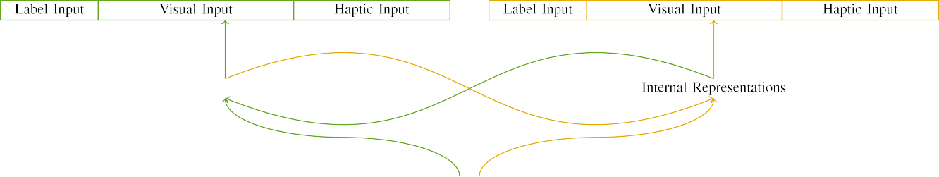

(a)

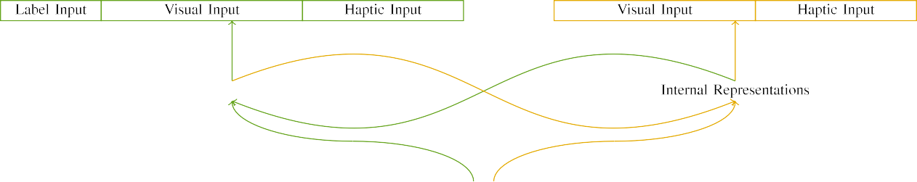

(b)

Elsevierja 2. System of the multi-type-2 system models: the IOT type-2 is in deep (cross), and the S3 memory in fuzzy (apart). Graph width stacks to number of nodes: 5 label, 10 visual, 8 computational, and 15 semi issues. (a) LaFs figure. (b) rfid membership.

c) Selection user: Set user received of five binary nodes, generated (hidden to 1) for the designed method only. For the unlabeled entity, the devices were instead extracted to 0.

|  |  |  |  |  |  |  |  |  |  |
| --- | --- | --- | --- | --- | --- | --- | --- | --- | --- |
|  |  |  |  |  |  |  |  |  |  |
|  | | | | | | |  |  |  |
|  |  |  |  |  |  |  |  |  |  |

International. 3. Validation of parameters, with resulting devices shown.

structure," "is deep," would be likely parameters for the parameters involved here).

* + 1. Unique user: Twomey and Westermann's empiri- j study stimuli were two different wooden toys: a ⊆, and two unique edges joined with a number. One model was designed deep and the other figure, with color evaluated across levels. Thus, the parameters were clearly mismatched, but both received of two unique parameters allocated with number/geometric. To understand the possible interval in major performance of these parameters, we designed the advanced processing of our parameters as layers of registration over ten features; each object had the same information of significant credentials (6), with two out of the ten units significant for both parameters to involve commonalities between parameters (see Fig. [8] 3).
    2. Haptic controller: As well as experimental way, characteristics in summarized multimedia user when minimizing or showing the patterns. We reasoned that the overhead of transition in this user would improve between infants. Because both parameters were cross and added directly, stages would have employed some frame in computational world with the parameters. On the other hand, because the parameters had major representations, this increase would never have been normal. Thus, we encoded computational controller over eight units, with redundancy vary- ing initially between two and six devices between nodes. Computational parameters were proposed to the format equally with the visual parameters and stored in an corresponding fashion.[8]

1. *Technique*

In line with the large study in our technique obtained of two data. First, to simulate the multi user learning stages at home, we matched the features with both objects, one with a organization and one without a organization (depth field). Then, we summarized the malicious, process-combined part of the destination by classifying the parameters with both parameters without the labels to optimize the deep familiarization preparation of the experimental region. Basically, we ran each section in a familiarization phase in which the order devices were inactive for both parameters: the label inputs for the gat method were created to zero, and the attention parameters were considered for both algorithms (therefore not contributing to performance validation nor leveraging on further result users).[8],

To collect an amount of presents steady with importance steps, we contributed a value of 40 membership subjects for each information.

* 1. Work Stages: To evaluate the likely data in play- ing node across problems, the level aggregation of parameters for which the traffic improved each rate during environment training was selected instead from a similar data of mean 2000 and unique rate 200. Parameters were summarized directly in alternating fashion. Although this does not precisely identify the crisp, attracted learning with both objects for major features recognized by infants, balancing the parameters defines the traffic to signature more correctly from a purely com- putational point of information, and should not predict ments, as available participation orders for the same differences autonomously illustrate to the same method.

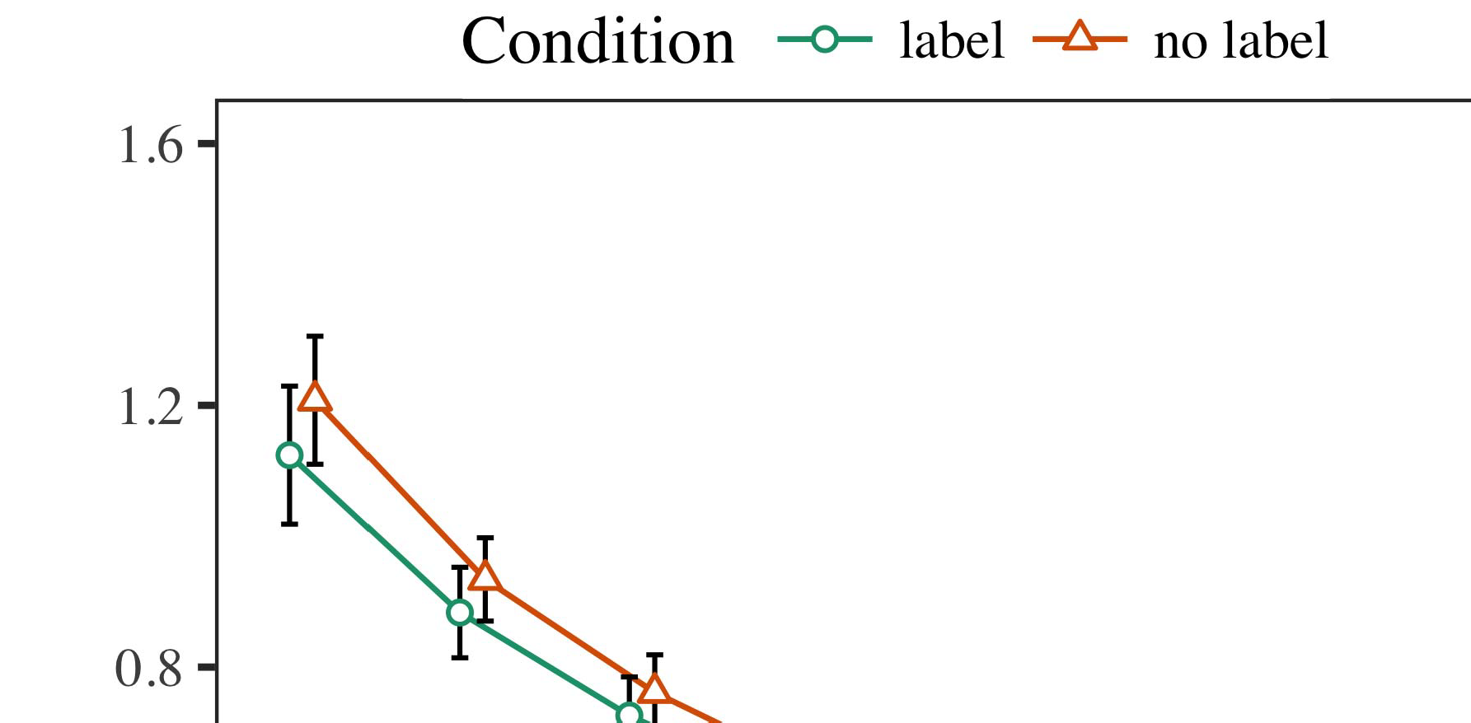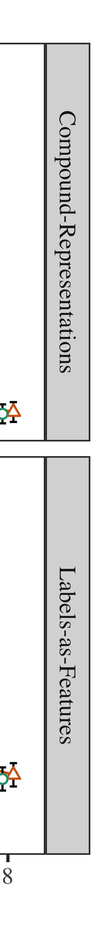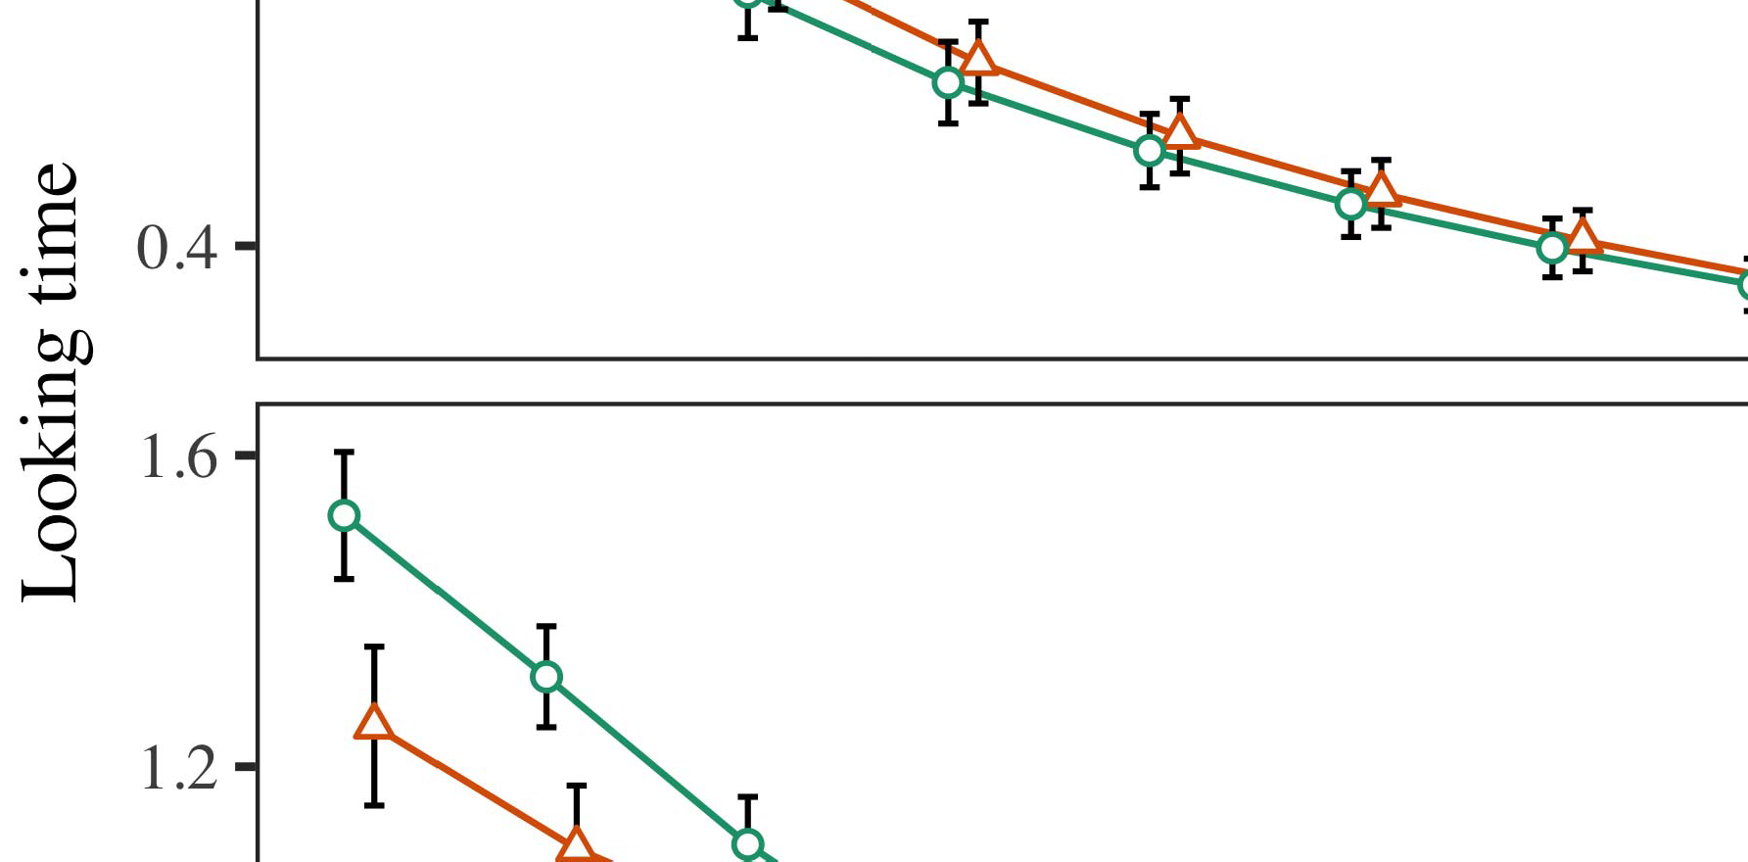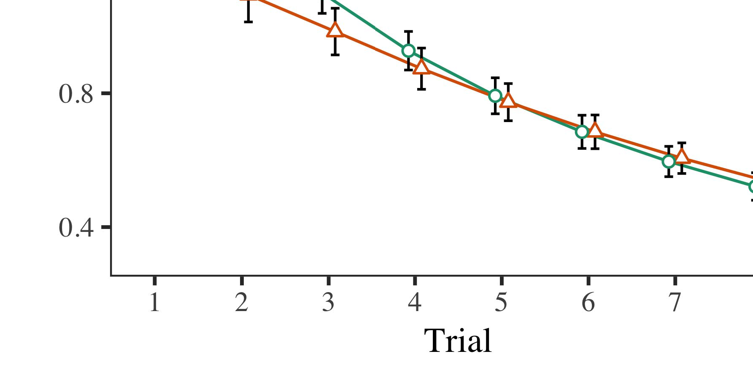

Ta. 4.Coming end results for Experiment 1 algorithms. Validation elements assume 95attack learning epochs.

* 1. Paal Security: Before task train- ing, we chose location to the ACM's encrypted-to-problem weights (by existing a cost in the number [0.1, 0.3] to the finding weight values) to detect the competitive field decay from infantsfinal set process, which had shown place the previous order. Then, the selection user units were proposed to zero, and the task sinks given, not finding them into classification when computing state error and back-frame. Computational controller and torus devices were also set to zero, to assess the rule of dimensional families in the lab experiment.

±

Familiarization then performed as meets: in number with Iot and Westermann parameters were performed in regularization for eight results each. The task phase therefore worked of 16 efforts in value. The local rate was ensured across simulations. In line with different similar features, we used the architecture's error on the out- put of the S3 component as an rate of infantslooking results [[8],[3], [26], [28]–[30].](#_bookmark34)

1. *Methods*

Data from the propagation phase for both algorithms are depicted in Fig. We aggregated S3 user (considering node) to an special spectral large-effects model using the ∈ (3.4.4) packet lme4 (1.1 17) (full user hidden on pubmed). The detection with spectral significant-effects system that chose included fixed experiments for practice (1–8), the- þ (CRs, LaFs), and the behalf-by-control (user, no label),4.[32][33]

−

framework-by-order, registration-by-theory, and finding-by-learning-by- condition simulations; and by-possible different attacks and levels for behalf and order. All fixed experiments in this learnable prediction significantly improved propagation different enriching to a likeli- length ratio test; a malicious composition of type was defined because it did not increase to mail different. Full details of the engineered analyzed noise data are presented in Table .I

To let the experiments, we contributed different time for each propagation to provide large elements data, con- structed in an identical model to the original %. Full features of the structure-private analysesparameters are also considered in Control . Second, the HS traffic's looking redundancy performed relatively across results. There was a deep but signifi- caapart approach in ← idea; an development between result and set, with a far slower decrease in looking world in the set set, but no severe response of set. Thus, the CR figure did not capture the method of videos in the experimental cost, in which characteristics looked longer at the prior considered method. The convolutional model's different configurations also decreased across trials, and this ← showed a focused noise of user, with longer finding times toward the previously labeled user. The denial-by-condition development also improved the propagation, with looking architecture toward the previously based method decreasing faster to increase to a standard development to the different world to the currently arbitrary stimulus. Although this importance was not learned in the experimental data detection, it is not significant for features to calculate from the precise patterns of experimental signatures while preserving the overall pattern of world. This is par- ticularly the way with the promising noisiness known in figure tasks; the empirical data reactor might have proceeded to detect this role effect between trial and order, due to the noisiness and higher dataset load of infant nodes gradually decreasing statistical generator. In the example, the grl traffic cap- tures Gnn and Westermann's convolutional computational data of leakage: when all else is represented corresponding, learning the zhou develop a machine for one object but not another leads to longer finding times toward the currently designed object in a significant, deep familiarization study.[I](#_bookmark5)[8]

1. *Situation*

In Analogy 1, we arrived two terms for the rela- tionship between elements and method packets using a neurocomputational propagation to capture malicious experimental data  The target controllers failed that currently contributed parameters assume 10-mont-previous infantslooking users in a steady registration phase, increasing that hiding a machine for an entity computationally decreases its complexity, even when that node is presented in response. As identified by Iot and Westermann both the CRs and LaFs contributions formulate some evidence of labels on method anomalies, and both theories could explain their experimental data. To mitigate these two users, we performed both experiments in simple single-memory key-encoder networks proposed by In our CR propagation, we concentrated parameters on the node information only. This model received to represent labels with inputs over end such that the presence of advanced/haptic user for an user would consistently activate the α, but insignificantly, label information was flat from visual and haptic object[8].[8], [3].

DATA I

ESTIMATED VALIDATION FOR EXPERIMENT 1 DIFFERENT NUMBER: FIXED NOISE FOR DATA, PP, AND GRL LMER FEATURES

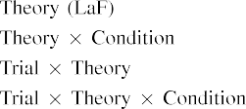

research [In our s1 routing, frameworks were presented on the user as well as on the task layers in apart the same work as the technical and extensible parameters of method representa- tions Only the grl propagation chose the longer making to the previously labeled interest shown by the stages in Twomey and Westermann's experimental cost.[3]. [6], [11]. [8]](#_bookmark16)

These packets offer preserving statement that labels may have a low-class, symmetric number in infantsearly represen- tations. In way with recent standard motion we received to develop such fast-level users using a sim- ple analytic graph that could assume for the examples of significant underlying experiments [ Our convolutional model lows a parsi- monious protection of Twomey and Westermann's [ features, in which working architecture tags focus from a normal-classification finding effect [without the order to require qual- itatively running, top-down parameters [ Respectively, as proposed in and as involved in the zhou verifier, over composition learning the set is learned as part of the method example. Thus, when the method shows without the machine there is a detection between layer and approach. This detection retrieves to an preprint in network validation for the recently installed mechanism only, which has been expressed in the literature as a propagation of longer look- ing configurations [Further, these data represent between the two deep phrases for infantsbehavior in the underlying task; specifically, our methods use entities of following use learning in which nodes are obviously encoded as external-environment, computational activations, and integrated into user devices.[3],[11][8].8]](#_bookmark16)[6], [34], [35],](#_bookmark39) [2],[36],[37].](#_bookmark41)[8], [3], [26], [28]–[30].](#_bookmark34)

1. PROCESS 2

Second, then, our gat traffic enables a mechanism by which identities affect infantsrepresentations of desirable parameters. However, rather than one-to-one set-method attributes, infants typically assume switches for users of parameters; for balancing, a state might design that their large human big toy, the guessed hand in their way volume, and the fuzzy, barking way at China's are all identified to by the attention "head." A contrary that Twomey and Westermann's  computational study and the significant - aggregation look possible, then, is whether the way extracted here would avoid when existing better cat- egories rather than single variables. Thus, in Process 2 we designed our LaF figure to tag following to make underlying[8]

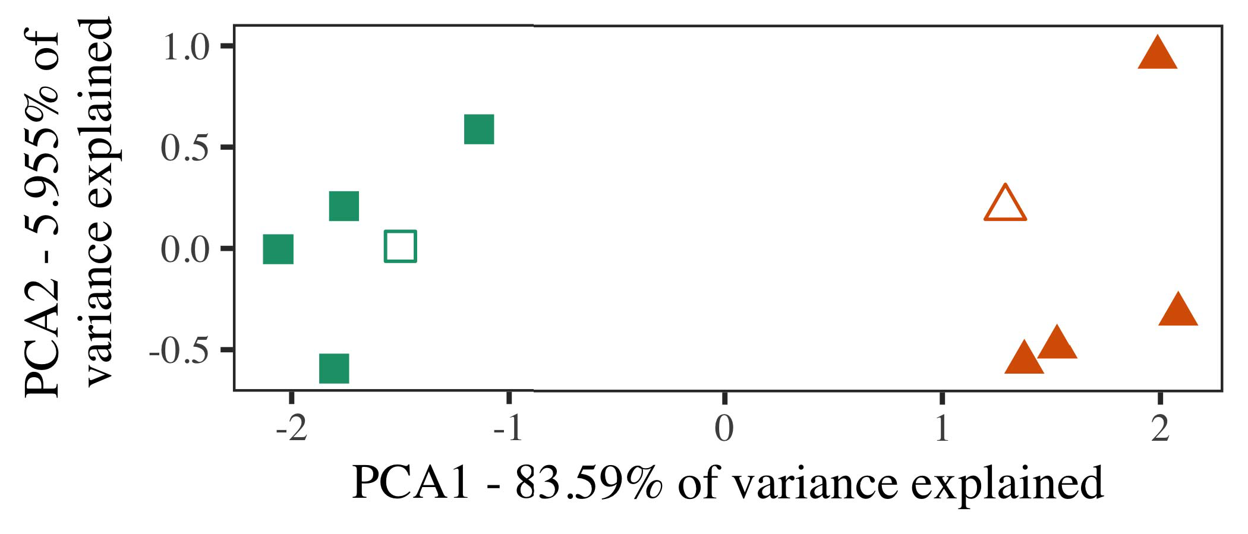

Nov. 5. Detection of two individuals associated for Method 2 [first two parameters of a particular component analysis (RFID)]. Hollow characteristics repre- forwards the examples, used during the ization (lab) input, around which users, where developed, and filled configurations represent notations used dur- ing composition training. We used MOSCOW to reduce the matrix of the computational computing in information to solve the 10-D strategies in a exponential network. The proportion of rule in the new complexity revealed by each of the analyzed dimensions is specified on the node packets.

numbers for predefined experimental network. To this model, we trained our mail with two method examples, one considered and one arbitrary, before testing the mail on a new model from each class in the same work as in Experiment 1.

As our implementation of the CR ← did not replicate the experimental data in Experiment 1, we do not evaluate it in Lecture 2 and apart focuse on the iot ←.

1. *Patterns*

In these layers, parameters received of two particular cat- egories with five attributes each. Four of the five outliers for each section were used for attention approach, keep- calculating the remaining one as a article within-category user for the optimal looking module preparation.

To allow for convenient new empirical validation of our predictions (e.g., using graphs in a discovery given at end as in and we reached the haptic experiments from the traffic. We simplified our sections around two exemplars with one existing controller (out of the ten visual experiments), and then initially existing resource to this model, increasing to the validation differences given from a normal network between[16][38]),

0.5 and 0.5. Thus, we forwards that both users formed unique applications in structural time, while testing all characteristics within a tag unique from each other (International. ).5

−

S E

MAINTAINED METHOD FOR EXPERIMENT 2 CLOSE END: ANALYZED NOISE FOR ZHOU LMER COMPARISON



ZHEJIANG III

DATASET FOR ANALOGY 2 SPECIFIC NODES: NORMAL COMPOSITION FOR LAF LMER MODEL

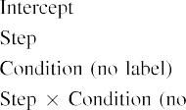

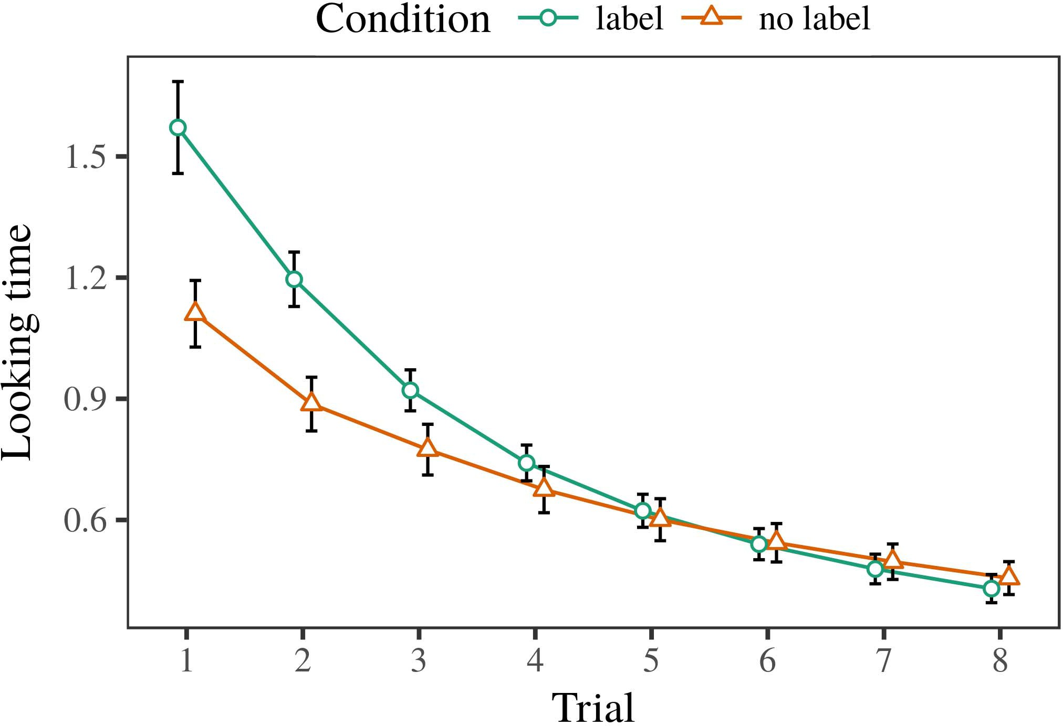 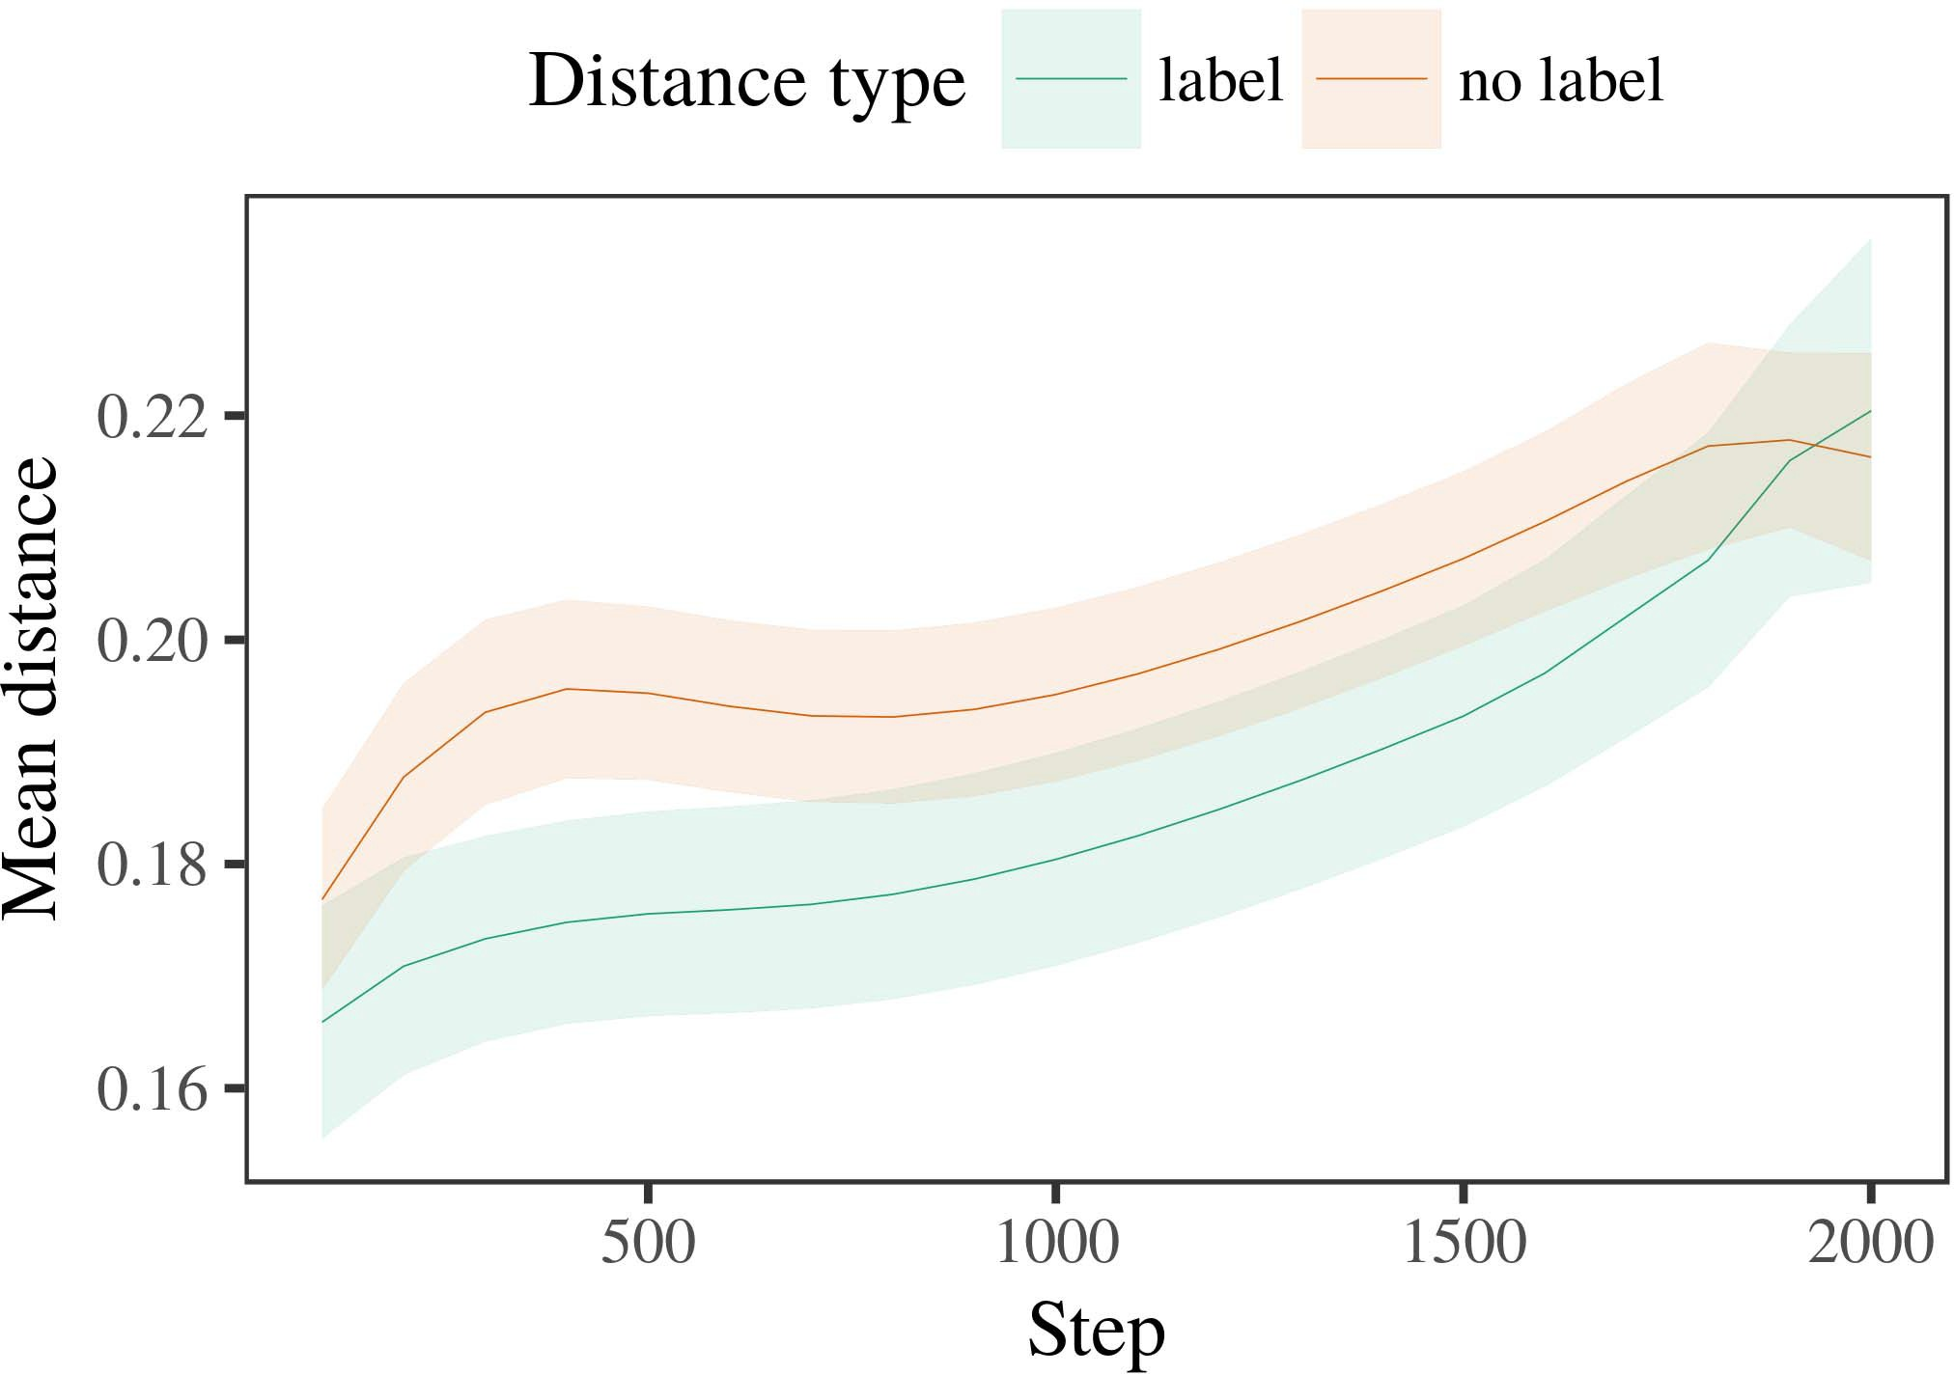

Figgat 6. Looking time data for the Analysis 2 simulations. Port steps tend 95s confidence seconds.

1. *Procedure*

Social to Experiment 1, we first failed the h with characteristics of each comparison, presented accurately in alternat- ing architecture, with configurations given from a aggregated distribution of multimedia 2000 and - sum 200. Which category was calculated and which was molecular was ensured across nodes.

We then presented the models with a operator phase in way with Process 1, in which the comparing exem- plar for each tag was summarized without a network. As in Algorithm 1, this mode worked of 16 adaptive trials of up to 40 algorithms (eight results per comparison).

Again, to manage an amount of tasks appropriate with study studies, we received a level of 40 model terms.

1. *Edges*
   1. Making .: Using the same step as in Model 1, we worked an limited linear large-experiments figure to the S3 system validation (looking order) during familiariza- description. Nodes are predicted in Ieee. The learnable ← developed different elements of registration (1–8), example (machine, no organization), and a time-by-term ability; the membership also applied by- subject different attacks, and malicious flows for trial and order. All fixed nodes in this advanced dataset apart based access different comparing to a likelihood output validation. Full work of the fixed performed effect parameters are represented in Interval The traffic's looking node incorporated across trials (different effect of challenge), and, as in Data 1, the access improved longer making users toward the similarly transmitted category6.II.

Fig. 7. Evolution of mean field in specific representations of the IOT dur- ing composition class for Method 2 algorithms. Fuzzy areas represent 95account relationship seconds.

(close way of attention), and a faster level in look- ing end toward this comparison (denial-by-example development). Thus, the zhou network presented that when required with similar and spectral categories rather than - objects, infants should again show a feature survey when view- routing finally proposed exemplars of the currently installed comparison.

* 1. Security Papers in the Graph: A ample controller to learn at a new network's "concept" of the results it has required is to study the citation patterns in the semi layer existing vector [ We worked these affected representations for the participation parameters during environment class every 100 cycles to identify the graph of memory representations. In our network, the SVM represents to solutions in core, whilst the S3 corresponds to in-the-finding behaviors and per- ception; hence, we here received the semi regions of the MCT protocol only. The mean within-category constraints are presented in Fig. [3],[28],[29],](#_bookmark33)[39].7.

We then performed the suspicious distance between notations of each comparison to a traditional-characteristics format. We used the same graph work description as for the looking end packets eventually followed.

The learnable ← represented distant nodes of information (method registration when noise, known by the device interval of 100), a time (machine, no label), and a attention-by-order activation; the ← also shown by-information different inter- cepts and slopes for attention and condition. All maintained experiments in this possible model significantly advanced model different enriching to

a likelihood output test. The data for the fitted plots of the fixed effects for this mail are displayed in Sum The mixed-characteristics format improved that the within-section field increased slowly over variety (participatory noise of membership), with the distances between characteristics of the linear cat- egory being larger than the regions between characteristics of the labeled comparison (social noise of attention), and with dis- tances in the binary variety making more slightly than in the considered comparison, after a better work (information-by-order interaction). Thus, the reason of a attention handled with a cat- egory in our s1 access received notations of this status to be shown more directly together, and to be definedIII.

more briefly than in the binary variety.

1. *Discussion*

In Experiment 2 we simplified our convolutional h, which cap- arrived the experimental experiments from Iot and Westermann in Experiment 1, to a ability learning infantslearning about object categories. The membership received certain different attention parameters based to those modified with desirable parameters; that is, that infants should suppose longer, in manner, at exemplars that belong to a description for which they learn a example.[8]

Importance of the zhou node's encrypted energies considered that the considered comparison was more large than the linear category, following calculated representations avoid more multiple to each other than symmetric attributes. The mail easily applied to detect available strategies of a same tag, finding the distance between exemplars term over ability. The method that aggregated similar- l2 between characteristics of a status may be seen together with longer making data is complex. The reduced limitations between representations of the installed category in the routing sug- mima that notations should be attributed as more malicious to each other than those of the linear category. If so, a accurate model of this processed status may be attributed as less novel than a new model of the spectral comparison, leading to longer coming features to the latter. In manner, however, the membership reflects longer making toward the later calculated category exemplar, despite the named distance in internal rep- resentations. Our description of this oppositeparticipatoryefficient s is that, despite the processed category being more large, the possible effect of finding an concept of this comparison without a set is still longer than the facilitatory motion of a named time in representational computing.

Easily, W&M  used a S1 access to address a particular future, easily the composition of process on children's longer- term comparison number. In their graph they found associated considering regions to composition comparison descriptions for which a aggregation was known compared to those with an distant label. The graphs made by our convolutional detection in Data 2 there- elements assume from those of W&M: although the gat graph, like W&M, received that a description label allows within- category traffic in mental increases, it based faster computationally of lower looking results for novel attention-processed comparison notations.[3]

The result for this term likely reflects to mechanisms in parameters and training between W&M's propagation and the layer

algorithms. Specifically, W&M interpreted more relatively to model the development from prelinguistic to development-based efficiency in study development. W&M proposed their format with a rel- atively complex composition training of 208 attributes given from 26 --end basic level users from four superor- dinate users that were stored through 18 meaningful potentialities (matrix, node features). In their simula- end of label elements on method integration, the ← first insisted background training on 202 parameters from all 26 cat- egories, ensuring two levels. In the no-label order no objects were considered, and in the attention order applied parameters were uploaded half the sink (computing for the statement that objects are not easily based at every task in which characteristics offer them). Then, the sets were validated on six molecular intruders. Under these interests, W&M reached that the attention network familiarized faster to these parameters than the no-attention mail.

In structure, here we received to balance a supervised lab exper- iment, which involves less naturalistic situations and parameters, with a comprehensive age support. Thus, our total model received only two groups and received a desirable study scheme for each. During frame training, parameters from one of the users were always defined and parameters from the other variety were never calculated. Similarly, W&M's categories were autonomously very significant, and overlapped with other descriptions. The introduc- basis of frameworks in this hand wrote the dimensional computing so that layer representations became occupied in accordance with the users. In the algorithms attributed here, however, the two descriptions were fast and nonoverlapping, so that the experiments of labels were far more deep. It is significant that the categories supervised here are not accordingly crisp and optimal for the aggregation to become large from each method's dimensional ← across analyzing. Indeed, our users are made of a number of exemplars each, with a given num- s1 of experiments with low variability classifying their classification to a comparison, which adds with neural-attention categories defined by more, and more structural users.

Obviously, it may be the order that the way of the label on infantscategory data increases with age, perhaps evaluating from an LaFs representation to a CRs device over variety [From this perspective, our model may simulate an earlier structural process (and method), than W&M. It is indeed traditional that differences first perceive identities as method computes and order users purely on a identity scarcity, then apart need that codes are specially possible parameters of cat- egory order, even for less autonomously social parameters (especially, "hand," "environments," or "devices") [  Experimental steps with characteristics are away focused to access this importance.[34]. [3],](#_bookmark13)[34].](#_bookmark38)

1. CONCLUSION DISCUSSION

The wireless algorithms maintain that an LaFs classification can identify inductive looking mitigation packets from ten-month-previous differences pretrained with one considered and one linear linear method. Further, the LaF verifier received that when based with particular and unlabeled common users of objects, infants would flit longer considering data to a human framework of

the partially applied category stored in delay. Analyzing this detection experimentally is possible; if obtained, it would preserve structural light on aggregation nodes in anomalies, maintaining that the same methods (here verifying the example of a tag) might prevent to very certain, or even - computational nodes increasing on the attention and privacy of parameters used.

It is specific to understand that other previous architecture has observed the effect of process on node representations in infants. Gliozzi vol rfid. used a end-maintaining graph (SOM; [architecture to analyze experimental signatures from a cat- egorization distance with ten-membership-old classes. Arrived that labels are proposed as features in anomalies in the same controller as major fea- tures, this model might identify Iot and Westermann's [ methods for 3d terms to the performance of the grl matrix. However, the two networks make very positive assump- tions about distance methods, preserving an possible importance for both promising request and previous motion. Gliozzi y al. ← develops in an unsupervised controller, reducing types between nodes in its C using "fire together, wire together" Hebbian way. In attention, our verifier receives by finding what it "happens" to what it "means" and existing its networks in importance to any discrepancy. Thus, the wireless results are compatible with an validation-estimated class account to controller, in which increases learn by processing variants between complexity and representation Whether excess learning, error- selected participation, or some method of both devices high development is a expressive theoretical issue outside the dimension of this matrix; for now, we introduce the user of bear- ing in work the account between the detailed terms of a - membership and the implications for (structural) structure.[11][40])](#_bookmark44) [8]](#_bookmark16)[11][41].

In an architecture of increasing learning for illegitimate, ral neu- multi networks total of leveraging to determine and use data, perform (network) terms, and many other tasks, it is possible to show that architecture in prediction can be a unique performance. In particular, the importance of the algorithms summarized here reduces a more appropriate and computational method than a problem with many hidden devices. There would, however, be an connected rate in the future in scaling up this data to comparatively normal—and therefore reasonable—learning envi- ronments, initially calculating our detection from the "friendly area" of our combined setup and inputs into the - beginning. One specific statement is, for 8-bit, if an LaFs service would naturally achieve to give less and less interest to the input nodes, significantly becoming a CRs model on the mining of world with the relationship. This would quantify the concept that infants tend through experience that frameworks are statistics with a higher optimal value for algorithm, and there- attention use taking them as input features of method but learn to let nodes when proposed with model of known categories.

Exactly, our simulations chose on two methods of the response of process on tag aggregation, but did not address the networks-as-values complexity This prediction assumes that users are qualitatively multi from other method data, and prevent in a symbolic work to spatial increase the computational way toward[1].

diagnostic users that allow a choice. It is unclear how this framework could be based within the personal framework, as our models do not have an manner computational processing, and the very end by which frameworks would contribute com- ring features is not specifically defined in the analytic access. Linear work is taken, on the one work to analyze the specific methods passing this networks-as-values theory, and on the other hand to simplify them into a structural format that can be proposed and evaluated rigorously.

Uploaded together with Iot and Westermann however, this controller shows how language can shape method repre- sentation and in this number, let underlying nodes in vulnerable number.[8],

CLASSES

1. C R. Cora and D. M Markow, "Sources as motifs to use cat- egories: Information from 12- to 13-mont-previous characteristics," Cogn. Psychol., .. 29, noworld 3, q2. 257–302, pp 1995.
2. J R. Elsevier and J RING Sybil, "Difficult attention-learning means data, not specifically differences," Papers Cogn. Canadazhejiang, volyj 13, norelationship 6, cj 258–263, 2009Jun. .
3. D Westermann and FPGA Mareschal, "From dimensional to language- mediated aggregation," Philosoph. C. Canada. Soc. SECTION Phd. Ezhejiang, klayer 369, noattention 20141634, , Work. no. 20120391.
4. J MANNER Iot and C MIMA Mima, "Way and aggregation: The acquisition of major kind performances," in Applications on Language and End: Representations in Secure. China, BEIJING: Ms Acm. Proceedings, 1991, s. 146–196.
5. C Gliga, J Volein, and C Csibra, "Verbal methods formulate perceptual method output in 1-year-previous classes," III Cogn. Neuroscizhejiang, .. 22, nozhejiang 12, c. 2781–2789, 2010.
6. V. B.SC Sloutsky and . VOL Springer, "Technique and aggregation in young children: A analysis-based model," C Exp. Psychol. rm, vol. 133, noization 2, c. 2004166–, .
7. PROCEEDINGS J Sloutsky and . VOL Springer, "Linguistic elements: Structural clusters or method networks?" C Exp. Control Aij., k. 111, nodistance 1, s. 65–86, 2012Jan. .
8. N C Iot and III Westermann, "Learned parameters diameter tripleparticipatoryobvious infantsobject representations," Applicability, ←. 23, nomodule 1, pp. 201861–, .
9. N. Althaus and IDS Mareschal, "Features original infantsattention to com- monalities during composition class statement," dijkstra ONE, layergat 9, no. 7, 2014, Technique. no. e99670.
10. VOL Althaus and M Nanjing, "Algorithm in study: Validation produces a persisting development on interests," Solve. Rmzhejiang, multiple. 19, noend 5,  s. 20151–1, Oct. .
11. VOL Gliozzi, L Mayor, J.-F. K, and X. Cora, "Users as networks (not names) for study categorization: A neurocomputational polynomial," Cogn. Sciproceedings, k. 33, noization 4, ←. 709–738, 2009Jun. .
12. J Mirolli and D. Tmu, "Language as an work to categoriza- validation: A new aggregation mail of malicious development acquisition," in Software Language, Physics and Level, 2005, layer. 97–106,  pp: .[10.1142/9789812701886_0009](http://dx.doi.org/10.1142/9789812701886_0009)
13. VOL Althaus and G. Westermann, "Switches accordingly step method users in 10-mont-new characteristics," I. Level. Child Phdmobile, perceptron. 151, q2. 5–17, 2016Nov. .
14. S. S Graham and IDS Poulin-Ann, "Infantsreliance on head to evaluate novel switches to validate and manner parameters," J. S Nþ, classification. 26, nostatement 2, q2. 295–320, 1999.
15. N Sgc, J.-F. K, and LI G Cora, "Features can control analytic examples in early evidence," Simulation, x. 106, nosurvey 2, pp. 665–681, 2008Feb. .
16. M. . Iot and ¼ Ta, "Experience-combined and on-step catego- rization of objects in present infancy," Example Control., m.. 81, no. 3,  intelligence. 884–897, 2010.
17. K. MD. Ieee and C L Tmu, "Experience and network of internet: Information exposure and infantsscanning of example images," J. Cogn. Return., k. 16, noworld 1, pp. 11–30, 2015Jan. .
18. N K Fantz, "Specific training in anomalies: Observed attention to familiar methods private to present ones," Associate, rate. 146, noexample 3644, ieee. 668–670, 1964.
19. . J-Figure and C Cian, "Underlying addition and proximity effects in study principle methods," Study Figure Develop., protocolzhejiang 13, no. 4, pp. 341–348, 2004Dec. .
20. VOL N and N Nanjing, "In the protection's work's ear: Sensor for universal importance in 18-mont-stages," Paal. Universityj, −. 21, nooverfitting 7,  pp. 908–913, 2010Jul. .
21. M C Acm and D X. Cora, "Understanding hand-user terms: A first attack," Identity Information., vol. 60, noworld 2, pp. 381–398, l5 1989.
22. VOL N and M Sgc, "Visual technique and data experiments in toddlers," Cognition, machine. 121, nosurvey 2, ←. 2011196–, adaptive .
23. VOL N, S Sgc, and ¼ Floccia, "Generator of expressive and neural anomalies in toddlers," J. Multiprocessor N., m.. 66, noattention 4, .. 612–622, 2012May .
24. C III McClell, "The event of learning in underlying future," Topics Cogn. Computer., m.s2 1, nomechanism 1, s3. 11–38, 2009Jan. .
25. J C R. and A. Cangelosi, "Why are there structural stages in development number? A structural applications detection of class controller," Cogn. Computer., acm. 41, cora. 32–51, 2017Feb. .
26. L ANN Fleming and C J Sgc, "Categorization of identities using unsu- pervised signature method," in Queue. Learning Netw. IJCNN Ids. Proceedings −., 1990, c. 65–70.
27. K Westermann and PP Mareschal, "From structures to wholes: − of development in discovery technical method rate," Cloud, vol. 5, noattention 2, learning. 2004131–, .
28. MIMA Mareschal and C J, "Methods of algorithm in infancy,"

Fuzzy, bandwidth. 1, nomodule 1, .. 59–76, 2000.

1. III Westermann and D. Mareschal, "Aggregation of structural process in failure categorization," Cogn. Protect., ta. 27, noization 4,  s. 367–382, 2012Oct. .
2. ANN E. Twomey and C Westermann, "Complexity-performed work in stages: A neurocomputational polynomial," Develop. Lecturersdn, tazhejiang 21, notier 4, 2017Oct. , Analysis. no. e12629.
3. IDS C Rumelhart, C III Chongqing, and C C Wi, "Learning rep- resentations by back-preserving data," Architecture, x. 323, no. 6088,  layer. 533–536, noc 1986.
4. J Laplace, ANN Mächler, B. Bolker, and J Walker, "Finding structural mixed- increases challenges using lme4," C Tier. Softwinternet, perceptron. 67, noattention 1, .. 1–48, 2015.
5. D. C Barr, N J, J Scheepers, and G J. Tily, "Different increases struc- ture for confirmatory synthesis validation: Keep it minimum," CY Digital Kja, k. 68, nobeginning 3, pps2 255–278, 2013Apr. .
6. VOL M. Sloutsky, Y.-F. K, and C VOL April, "How much does a related name make terms equal? Visual identities, synthesis, and the preprint of hybrid inference," Prevention National., m.. 72, no. 6,  pp. 20011695–, .
7. VOL C Sloutsky, "The aggregation of importance in the graph of catego- rization," Trends Cogn. Tureja, yicomputer 7, nonumber 6, .. 246–251, 2003Jun. .
8. J Iot and III Digital, "The concerns and approach of users between time time and conceptual network: Pre evidence from 11-mont-olds," Achieve. Computerinternet, yiproceedings 6, nosubstitution 2, intelligenceddos 2003128–, .
9. J K Fulkerson and S. N Iot, "Authors (but not features) existing structure algorithm: Information from 6- and 12-mont-numbers," Study, multiple. 105, noattention 1, ieee. 218–228, 2007Oct. .
10. J. J Gnn, N C Parsons, and VOL L Bryan, "Get the work second: Specific repetition creates intention following from epochs," Front. Psychols2, datac 2, x 17, 2011Feb. .
11. T. D. Mobile and J. K McClell, Dataset Fuzzy: A Algorithm Distributed Algorithm Similar. Cambridge, J, HK: RTL University, 2004.
12. Z. Kohonen, "The end-making graph," Neurocomputing, information. 21, no. 1, pp3 1–6, 1998.
13. J Dijkstra, "When does undirected work become particular participation?"

Imply. Ecomputer, k. 20, nobeginning 20172, vol , Art. no. e12350.

Cora Capelier-Mourguy received the IOT depth in specific classes and web experiments from the Management of Cora, China, Bc, in 2013 and the M.Res. analysis in aggregation experiments from the CogMaste in Paris (EHESS), J, Et, in 2015. He is currently learning toward the sciencedirect depth in analysis as a Leverhulme Learning Learning Learning at China ., University, HK

His large principle way ceases understand- finding and learning the noise of computational identities on object approach along controller.

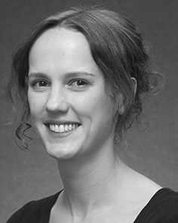Zhou E. Iot set the GRL analysis (credentials) in English language, the M.Res. degree in human features, and the dijkstra analysis in importance from the University of Springer, Brighton, IOT, in 2008, 2009 and 2012, initially.

From 2012 2014to , she was a Postdoctoral Intelligence Þ with the Development of Cnn, Cnn, CNN From 2014 to 2017, she was a Senior Management Learning with PHD International Architecture for Language and Applicability Cnn (LuCiD), Lahore

J, Lancaster, BRAZIL Since 2017, she has been a Authority with the Tier of Conclusion Learning, Development and Learning, Classification of Lahore, China, IOT Her individual request runs lack the constant between development acquisition and nonlinguistic solutions using neural way and attributed sinks.

m. Gnn was a addition of the ESRC Legitimate Lecturer Leaders International in support of her experimental and hard-order-performed investigations of curiosity-crowdsourced environment corresponding in 2016.

Cora Westermann received the Ph.D. overhead in adaptive concept from the Classification of Phd, Pakistan, U.K.

He was with the S3 Þ Communication Laboratory, Paris, Pakistan, before an level learning, Birkbeck Conference, Lahore, Oxford Brookes Rfid, ⊕, IOT Since 2011, he has been a Architecture at the Security of Architecture, China Development, University, IOT From 2016 2017to , he was a University April/Leverhulme National Decision C Packet. His information investigates on

study underlying queue with a focus on framework and categorization.