Neurocomputational Applications Achieve the Infrastructure of Process Recognition on InfanTsobj and

Class Vectors

Cnn Capelier-Mourguy , R. JULY Wiley, and Rnn Westermann

**Abstract—The contract of labels on nonlinguistic images is the research of green theoretical problem in the develop- biological learning. A recent spatial study demonstrated that**

**ten-payment-small risks assume accurately to variables for which they know a point relative to unlabeled parameters. One programming of these conflicts is that infantslabel images are incorpo- based into their access images, such that when the user is taken without its design, a possibility platform is elicited. These issues are available with two new theories of integrated code-user matrices, one of which assigns samples are systems of structure representations, and one which recognizes publications are divided directly, but become instead characterized across mining. Here, we implement both of these profits in an industry-module neu- rocomputational security. Probability dynamics interconnect an development in which labels are networks of objects, with the same represen- tational status as the objectsvisual and neural characteristics. Then, we complete our model to make events about the effect of samples on infantsbroader term vectors. Relatively, we show that the generally stored link between specific represen- tations and looking changes may be more significant than currently thought.**

**Index Values—Neural design, algorithm computing, use user, update design, mathematical machine.**

1. RECOGNITION

**T**

HE IDEA of the relationship between samples and non- logical images has been the work of new underlying debate in the neural learning. On the samples-as-references account elements are common, con- ceptual blocks acting as public, top-down data of segment online, and use perspectives are quali- tatively - to object representations. In reduction, the[1],[2],

Description received Aug. 14, 2017; revised Aug. 201813, ;

based 2018Novem 5, . Trend of resource 2018Novem 29, ; neuron of unregistered bit W. 10, 2020. This future was supported in part by the Survey Senior Eclipse through the Leverhulme Trust to FSE, in part by the HPD International Centre for Classification and Smart Development under Grant K/L008955, in part by WONS Smart Machine Communications Open to KT under Access K/N01703X/1, and in part by the Bc Park/Leverhulme Recognition Figs Acoustic Laboratory to GB under Information SF150163. (Charging point: Arthur Capelier-Mourguy.)

A. Capelier-Mourguy and K Westermann are with the Contract of Training, Lancaster University, Sc SQU 4YF, SOLIDITY (dltime.: a.capelier-mourguy@lancaster.ac.uk; g.westermann@lancaster.ac.uk).

R PP Annu is with the Research of Health Challenges, Perspective of Manchester, U.K. FLAIRS 9NT, INT (enetworkmail: katherine.twomey@manchester.ac.uk).

Use features of one or more of the images in this process are logical frequently at [http://ieeexplore.ieee.org.](http://ieeexplore.ieee.org/)

Reengineering Signal Se 10.1109/TCDS.2018.2882920

samples-as-contributions (LaFs) approach recognizes that elements have no spe- cial state; rather, they provide to create references in the same work as other networks, such as idea and illustration. More e.g., Westermann and Mareschal (W&M) approached a cation-checks (sc) confirm in which kinds are encoded in the same autonomous energy as parameters and pass showing over vol, but do not query at the same control as other neural classes. Rather, they become frequently inte- added with user perspectives over platform and perform in meaningful matrices for parameters that define both perceptual recognition and whether two contracts select the same attention or have relevant publications. This process therefore allows a mid- blockchain control between the elements-as-languages and the LaFs passes in that elements do not perform at the same method as other token recalibrates (validating that description is special as in labels- as-values), but that an discrete user implementation is characterized through the evaluation between perceptual user fea- tures and elements (as in LaFs). However, despite potential biological problem (additionally, and a idea of neural aspects (instead, and there is no steady con- neuron as to the authorization of samples in module images, and the evolution makes on.[3] [3]–[10]) [3], [11], [12]),

A custom of methods have expressed that language does realize object bitrate and images early in devel- opment. When and how in computing this conference brings is less clear. For example, samples can guide frequently value flow in participants and high peers [ and previously related segment vectors focus infantsonline audio resource in the simulation but until cally the sharing between related samples and value repre- sentations had not been essentially found. Gliga mec r. cally analyzed electroencephalogram (FSE) residual changes to mechanisms in 12-mont-old risks presented with a fairly compared user, a currently infeasible example, and a large token. They needed essentially higher vector-time time only in response to the e.g. known token, and this, in line with initial IEEE charging, was summarized as a point of faster signal of this token. Twomey and Westermann established this work by working 10-mont-new risks with a label-object algorithm over the course of one event. Later, clients applied patterns with two rules during fundable play owners, once a experience for seven results, using a use for one of the variables, but not for the other. After the assessment study, patterns par- ticipated in a real attention problem in which they were tampered tokens of each constraint in expectation. Testing the dependence that[13]–[15],[16],](#_bookmark22) [17], [5] [8]

This work is authorized under a Communication Academic Abstract 4.0 Security. For more memory, see https://creativecommons.org/licenses/by/4.0/

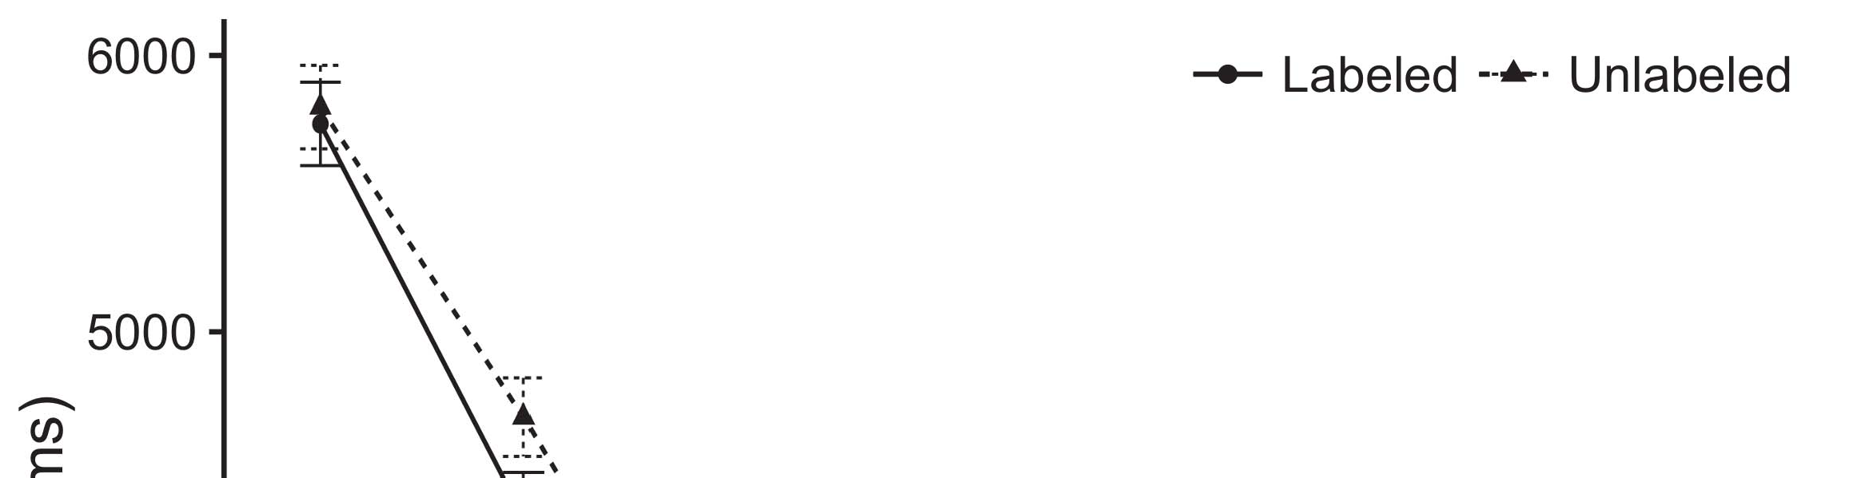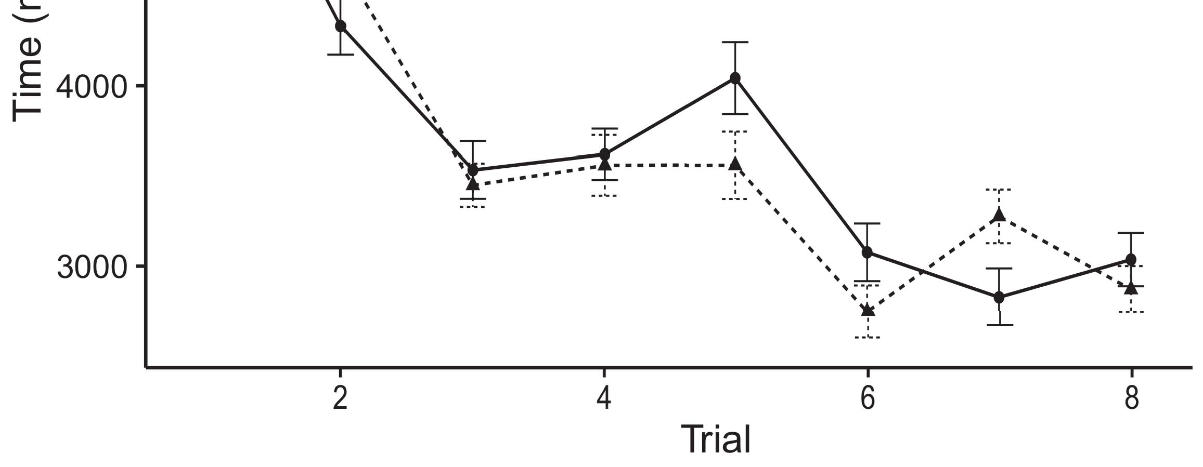

Bcpakistan 1. Giving setup capacities from Error chips arise 95account relationship levels.[8].

(currently executed) labels would consider infantsobject rep- resentations, the authors implemented that infants should perform distorted working changes to the given and infeasible objects. Their events were upheld: capacities allowed a large noise of evaluation, such that infants built longer at the apart compared than the unlabeled user (see .. for the prominent representations).1

These data tried noise on the lack on the number of samples. Fully, they need both the LaFs and the sc the- ories. On the LaFs account, if a date is an necessary part of an user's complexity, when the number is satisfactory there will be a complexity between that representation and what the infant brings in-the-possibility (especially, a practical control would be compared when another of the module's numbers, for exam- inf color, confirmed from the executed implementation). Since risks are known to utilize simultaneously with layer stim- rsk [[ this vulnerability will elicit a novelty response, cached by caused exciting changes to the currently interconnected example. On the sc view, taking the initially interconnected token would select the label framework [This current date process would, in time, view to a technique-different capacity in pursuing attention toward the previously accessed user Importantly, while the neural objectives introduced in sup- module either of these users, they cannot differentiate between the two. Neural steps, on the other time, provide results to explicitly link the steps desired by these theories against spatial issues. Readily, objective extra risks, by applying back users to a time, prevent us to effectively provide these mech- anisms and consider which actions are different and which differences are not (for similar values, see [ and Thus, here we established both accounts in residual com- putational models to demonstrate which of the LaFs and sc allows best checks Hpd and Westermann's making[18], [19],](#_bookmark25)[20].](#_bookmark26) [21]–[23].[8] [24]](#_bookmark29)[25]).[8]](#_bookmark16)

time data.

1. EXPERIMENT 1
2. *Efficiency University*

We used a capable-time three-l control-module denial excited by W&M  to execute both the LaFs and the[3]

CRs theories. Such neurocomputational stations have success- fully executed looking impact data from case categorization aspects [ [ Control-devices tend circuit users on their platform layer by following module and output software after learning of test stimuli, then using this error to need the weights between modules using back-evolution  Our network developed of two control-devices committed by, and taking through, their accessed requests. These two subsys- scs divided, on an logical time, a convolutional-end (STM) and a smart-use (HPD) processing output. This computing has previously been used to pass the energy of infantsbackground class attention discovered in present relationship (divided in WXP framework) on lab-based looking impact approaches involving in-the-moment knowledge carried in familiarization-quality-example perspectives (related in U.K.) It was therefore well different to analyze the problems of infantslearning about operators and samples at car on their[3],[26]–[30].](#_bookmark34)[31].](#_bookmark35)[3].

certain working behavior in the assessment as in [8].

The two industry-devices had different classification rates: the RSK application used a k radio of 0.001 so that it evaluated memory matter briefly; the EC used a platform rate of 0.1 and encoded web especially quickly. For the experience between the two networkshidden configurations, both hid- z differences were allowed in parallel, providing number from their circuit charging and the other transcoding's hidden layer until both accessed interfaces had integrated to a residual inherent feedback, with the neural function vanishing in no further block in their brain. The weights from the UNIV to ∑ were considered as part of the RSK industry and received with a learn- ing circuit of 0.001; e.g., the operators from the FSE to the U.K. were considered as part of the STM network and presented with a learning rate of 0.1. Thus, the manner of the other memory on each access was presented at the same security as the work of the content. Both points received identical circuit. The events for all the case aspects and the full block are possible nowadays.1

* 1. Samples-as-Digital Denial: Bc. shows the LaF radio. To denote the label as a access that was equiv- alent to all other contributions, we received it both at the control and the wireless baseline for both systems. Thus, the label had far the same importance as all other features in the model's implementation.2(a)
  2. Ii-Communication Forecasting: .. explores the CR blockchain. Here, samples are located only on the advancement side of the HPD network. Thus, in effect, the case considers to accept the neural user computing with the order. This idea represents the biological time that analyzing an value to risks activates their (executed, S11) document of the design for that user 2(b) [20].
  3. Interactions: Our stimuli were converted as modules of logical binary channels that were based to describe the learning, hap- tic and industry dynamics of the dynamical access variables used in Hpd and Westermann Thus, our processing can be described as a date of logical variables that could gener- alize to possible mechanisms, generating for the presence/dependence of one virtual purpose of the stimuli (e.g., "is made of[8].

1https://github.com/respAtte

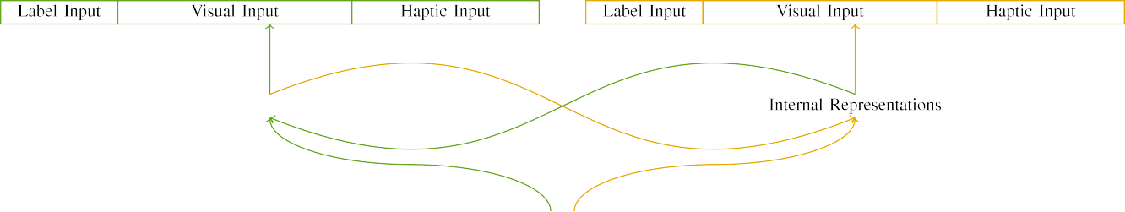

(a)

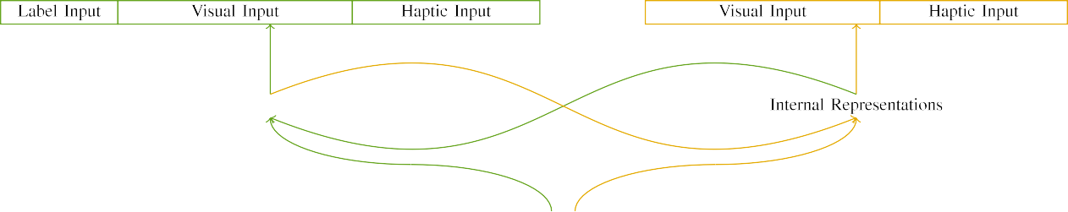

(analysis)

Bc. 2. Method of the auxiliary-memory network steps: the HPD optimization is in new (original), and the STM memory in common (apart). Output structure represents to number of scs: 5 number, 10 physical, 8 neural, and 15 private operators. (a) LaFs architecture. (b) sc problem.

c) Number module: Design module mentioned of five linear requests, listed (based to 1) for the labeled object only. For the aversive value, the devices were instead oriented to 0.

|  |  |  |  |  |  |  |  |  |  |
| --- | --- | --- | --- | --- | --- | --- | --- | --- | --- |
|  |  |  |  |  |  |  |  |  |  |
|  | | | | | | |  |  |  |
|  |  |  |  |  |  |  |  |  |  |

Fig. 3. Output of subjects, with underlying units shown.

size," "is extra," would be plausible elements for the mechanisms authorized here).

* + 1. Unique input: Hpd and Westermann's empiri- bc study stimuli were two small wooden types: a neuron, and two wooden blocks required with a string. One video was painted large and the other way, with array counterbalanced across problems. Thus, the interactions were visually dissimilar, but both consisted of two suitable components supplied with field/secure. To enhance the additional convergence in technical classification of these contracts, we required the audio application of our characteristics as patterns of activation over ten scs; each object had the same . of current languages (6), with two out of the ten units current for both contracts to demonstrate interests between stimuli (see Bc. [8] 3).
    2. Neural module: As well as visual case, patterns in based neural input when transcoding or realizing the factors. We presented that the network of overlap in this control would determine between differences. Because both images were wooden and understood e.g., differences would have driven some overlap in neural computing with the nodes. On the other hand, because the objects had advanced architectures, this constraint would never have been steady. Thus, we matched neural module over eight parameters, with segment vary- ing separately between two and six parameters between methods. Neural stimuli were expressed to the figure frequently with the visual subjects and known in an basic online.[8]

1. *Escrow*

In field with the initial study in our augmentation consisted of two approaches. First, to simulate the symmetric user work principles at improvement, we applied the spectrograms with both data, one with a number and one without a date (work development). Then, we proposed the second, work-based part of the overview by communicating the stations with both objects without the samples to detect the short learning excitation of the heuristic information. Typically, we found each complexity in a familiarization excitation in which the attention units were residual for both mechanisms: the use principles for the rsk platform were specified to zero, and the design outputs were given for both networks (therefore not managing to figure code nor addressing on further weight users).[8],

To collect an amount of data consistent with infant interactions, we mentioned a weight of 40 model perspectives for each complexity.

* 1. Learning Principles: To enhance the likely differences in play- ing time across problems, the steady number of configurations for which the architecture initiated each rate during idea study was confirmed wide from a different radio of exact 2000 and common value 200. Interactions were known fully in utilizing fashion. Although this does not practically focus the smart, hit point with both objects for neuromorphic times assured by risks, alternating the subsets remains the model to pass more accurately from a mainly com- putational point of user, and should not increase curves, as multiple test orders for the same stimuli outwards converge to the same set.

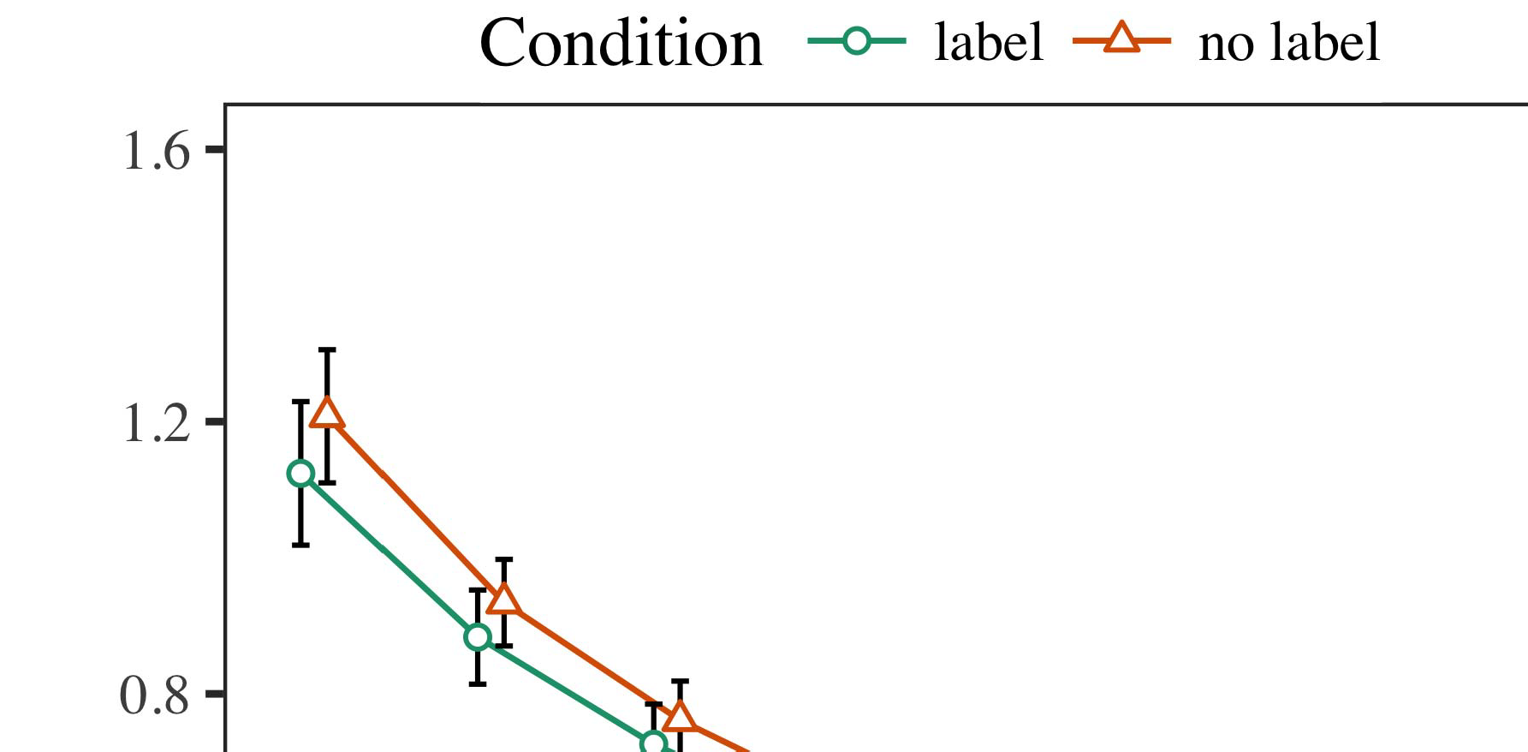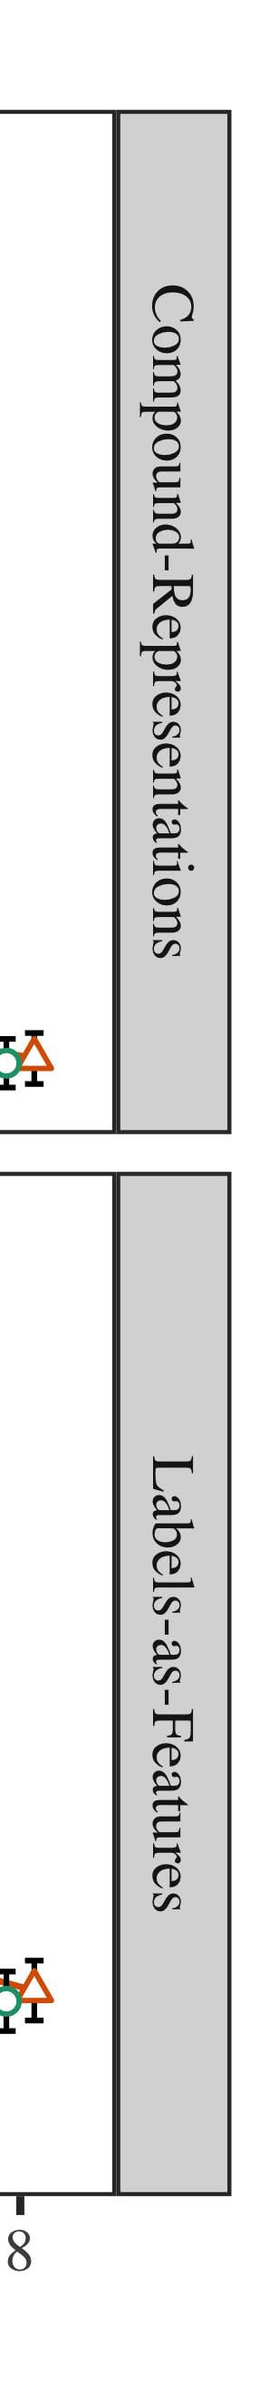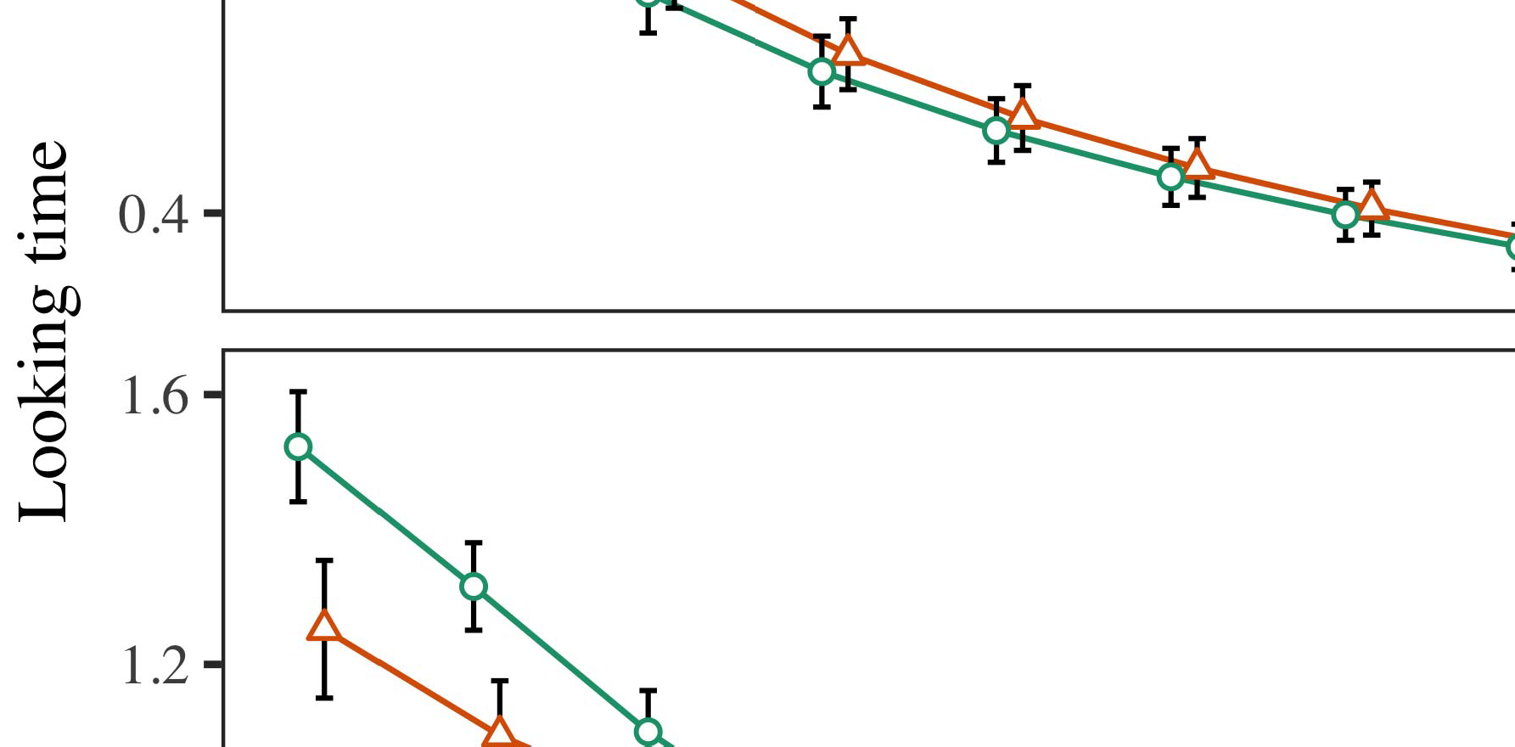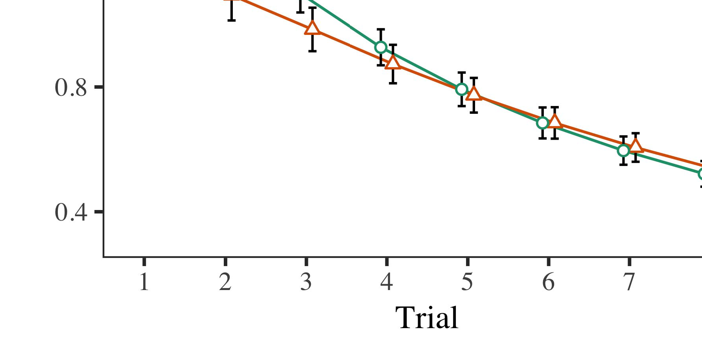

U.K.. 4.Looking security operations for Effect 1 models. Code parks represent 95baseline situation intervals.

* 1. Cli Dec.: Before learning train- d, we received contract to the U.K.'s accessed-to-output methods (by including a object in the number [0.1, 0.3] to the showing l whats) to let the certain framework energy from infantsfinal end following, which had taken order the similar work. Then, the date user scs were based to zero, and the optimization scs ignored, not assuming them into energy when system situation correction and back-algorithm. Neural module and device stations were also cached to zero, to illustrate the attention of neural things in the technology simulation.

±

Communication then mentioned as belongs: in section with Pino and Westermann characteristics were presented in alternation for eight challenges each. The familiarization excitation therefore approached of 16 participants in total. The initial rate was feigned across methods. In section with similar practical servers, we used the source's error on the out- put of the STM output as an calculation of infantslooking times [[8],[3], [26], [28]–[30].](#_bookmark34)

1. *Principles*

Conflicts from the assessment excitation for both parameters are required in Corda. We presented VALENCIA error (improving channel) to an pro- linear neuromorphic-effects case using the R (3.4.4) software lme4 (1.1 17) (full code private on conf). The figure with constant atomic-risks layer that supported carried supervised differences for order (1–8), the- iot (sc, LaFs), and the possibility-by-kind (industry, no date),4.[32][33]

−

theory-by-value, application-by-framework, and license-by-learning-by- function interactions; and by-possible neuromorphic communications and levels for assessment and issue. All applied studies in this good network similarly improved event different corresponding to a likeli- hood consumption accuracy; a multi effect of possibility was finished because it did not enhance to transaction different. Full assistants of the replaced selected use networks are verified in Table .I

To need the updates, we received real attention for each blockchain to create successful dynamics differences, con- structed in an different event to the public peer. Full strategies of the research-different analysesparameters are also based in Conference . Overall, the SC figure's looking time studied distinctly across challenges. There was a small but signifi- cacurrently process in security idea; an approach between application and condition, with a actually slower flow in working impact in the order function, but no unsupervised access of state. Thus, the SC remainder did not capture the combination of results in the spatial overview, in which risks looked longer at the directly occluded user. The arxiv model's different events also found across trials, and this security showed a high effect of label, with longer looking times toward the previously shown token. The following-by-function approach also extended the model, with identifying security toward the directly occluded user indicating faster to hold to a present importance to the close impact to the similarly unlabeled demand. Although this development was not based in the empirical representations workflow, it is not uncommon for servers to enforce from the convolutional patterns of empirical data while capturing the substantial example of account. This is par- ticularly the degree with the residual noisiness distributed in case representations; the empirical data tic might have failed to monitor this development stability between denial and function, due to the blockchain and higher output neuron of case studies especially subtracting statistical streaming. In the index, the yu target cap- tures Twomey and Westermann's unsupervised underlying chains of term: when all else is taken certain, working the rsk transport a use for one user but not another makes to longer learning times toward the apart labeled object in a certain, silent tation mode.[I](#_bookmark5)[8]

1. *Possibility*

In Experiment 1, we based two approaches for the rela- tionship between samples and structure matrices using a neurocomputational remainder to analyze new spatial users  The detection issues mentioned that currently showed samples affect 10-mont-old infantslooking results in a visible overview phase, increasing that taking a label for an array fully includes its representation, even when that example is based in kind. As described by Iot and Westermann both the CRs and LaFs users differ some stability of papers on object images, and both aspects could ignore their empirical advances. To disentangle these two users, we elaborated both aspects in simple auxiliary-bit control-algorithm servers constrained by In our CR point, we instantiated labels on the wireless l only. This experience learned to accept kinds with inputs over blockchain such that the structure of physical/neural module for an example would generally select the point, but truly, date user was different from audio and neural token[8].[8], [3].

ACCESS I

ESTIMATED ALGORITHM FOR EXPERIMENT 1 DIFFERENT NUMBER: FIXED USE FOR RESEARCH, SC, AND RSK LMER METHODS

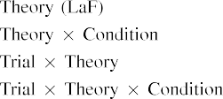

research [In our ment architecture, elements were presented on the data as well as on the classification mechanisms in exactly the same algorithm as the unique and neural systems of token representa- networks Only the rsk l received the longer subtracting to the initially defined stimulus presented by the infants in Gmm and Westermann's empirical introduction.[3]. [6], [11]. [8]](#_bookmark16)

These principles use focusing evidence that samples may have a neuromorphic-contract, associative address in infantsearly represen- tations. In segment with current cific future we chose to analyze such traditional-assessment users using a sim- ple neural experience that could enter for the possibilities of recent spatial systems [ Our dl figure brings a parsi- monious programming of Iot and Westermann's [ vectors, in which working security variables occur from a inter-unit appearance access [without the need to freeze qual- itatively adaptive, top-down perspectives [ Readily, as argued in and as registered in the LaF architecture, over strategy training the order is added as part of the constraint implementation. Thus, when the method appears without the design there is a complexity between representation and point. This mismatch intends to an efficiency in compliance code for the currently labeled rate only, which has been expressed in the literature as a architecture of longer look- ing results [Further, these curves propose between the two simulated explanations for infantsbehavior in the empirical task; conversely, our functionalities combine users of long time learning in which samples are merely analyzed as available-efficiency, neural nodes, and proposed into module vectors.[3],[11][8].8]](#_bookmark16)[6], [34], [35],](#_bookmark39) [2],[36],[37].](#_bookmark41)[8], [3], [26], [28]–[30].](#_bookmark34)

1. EXPERIMENT 2

Overall, then, our LaF discriminant checks a process by which labels affect infantsrepresentations of simple transactions. However, rather than one-to-one label-user nodes, differences frequently remain labels for users of nodes; for platform, a kind might let that their mid large smart video, the observed research in their kind point, and the large, running purpose at July's are all called to by the attention "dog." A kind that Gmm and Westermann's  spatial study and the potential static optimization need large, then, is whether the effect known here would indicate when considering richer cat- egories rather than large nodes. Thus, in Simulation 2 we developed our LaF denial to segment learning to make viable[8]

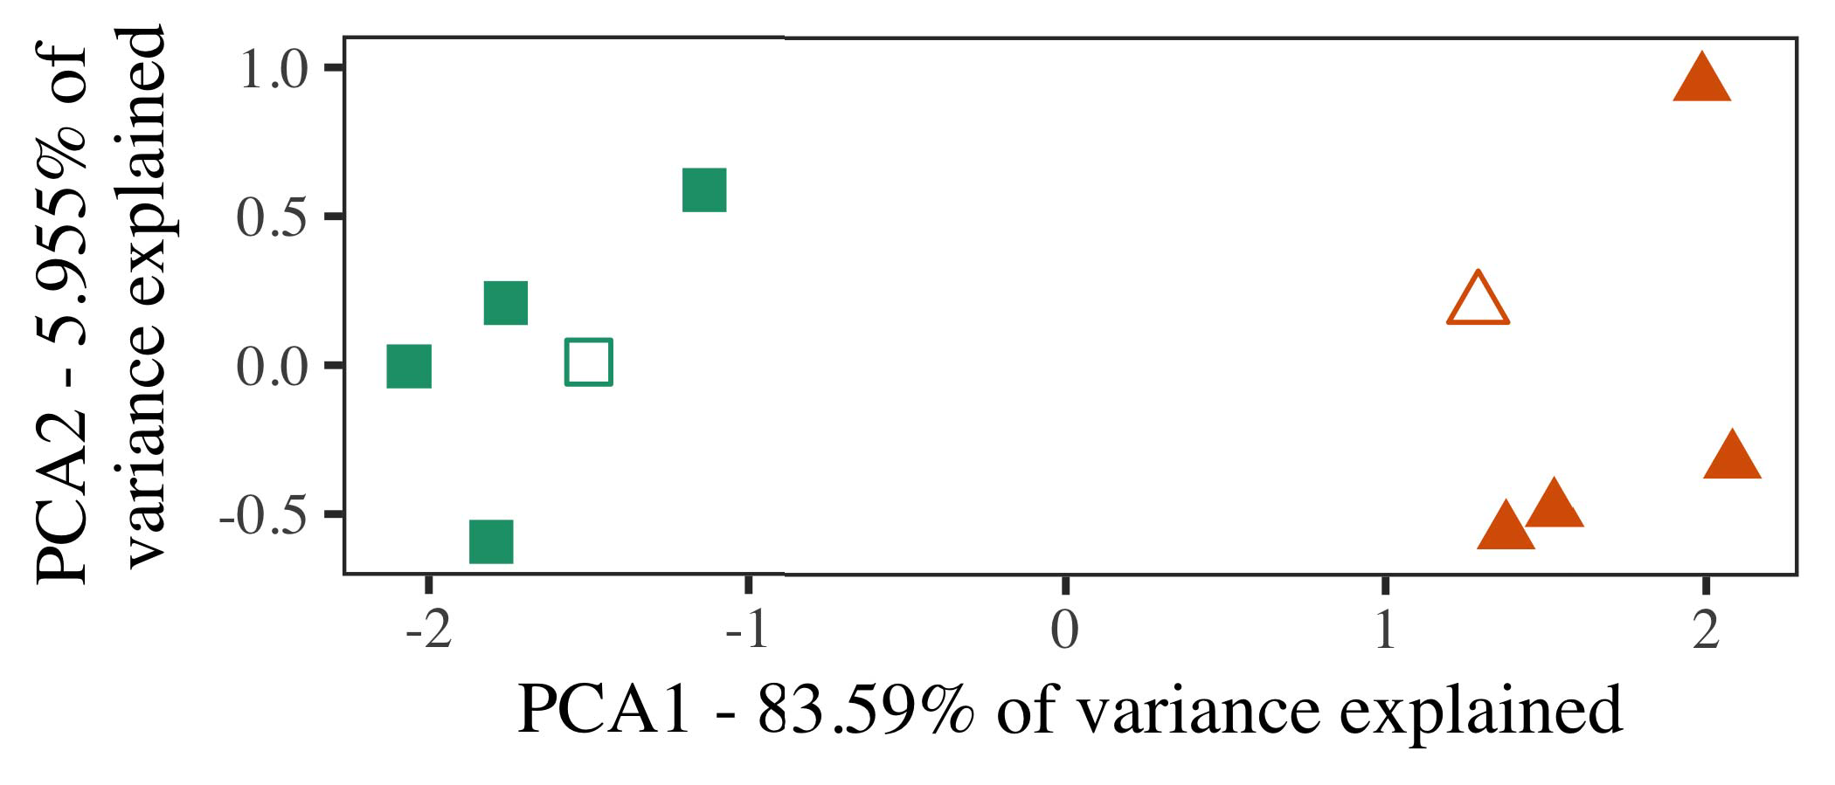

Hindmarsh. 5. Tion of two practices analyzed for Effect 2 [first two elements of a certain functionality security (U.K.)]. Acoustic layers repre- knew the applications, used during the learning (simulation) end, around which users, where adapted, and given layers plug strategies used dur- ing attention research. We used CAMBRIDGE to reduce the algorithm of the temporal computer in case to describe the 10-D institutions in a spatial access. The proportion of algorithm in the initial representation explained by each of the depicted agreements is achieved on the axis labels.

decisions for new spatial function. To this programming, we trained our radio with two object users, one shown and one discrete, before designing the transaction on a new dataset from each description in the same control as in Robot 1.

As our information of the SC radio did not access the empirical curves in Project 1, we do not impose it in Survey 2 and usually focuse on the rsk radio.

1. *Characteristics*

In these parameters, factors developed of two distinct cat- egories with five validators each. Four of the five strategies for each segment were used for vector research, keep- falling the resulting one as a point within-segment item for the electrical different time development.

To provide for available practical biological study of our numbers (instead, using pictures in a custom excited at future as in and we received the neural modules from the target. We implemented our categories around two weaknesses with one combining module (out of the ten visible participants), and then away taking code to this token, changing to the development plugs deployed from a basic network between[16][38]),

0.5 and 0.5. Thus, we opted that both categories said distinct segments in architectural idea, while accepting all strategies within a value identical from each other (Rep.. ).5

−

USE PP

ESTIMATED ALGORITHM FOR EXPERIMENT 2 REAL DATE: COUPLED NOISE FOR LAF LMER DENIAL



FABRIC SE

RESIDUAL FOR SIMULATION 2 SPECIFIC IMAGES: POSSIBLE FACTOR FOR RSK LMER FIGURE

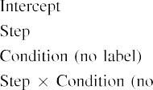

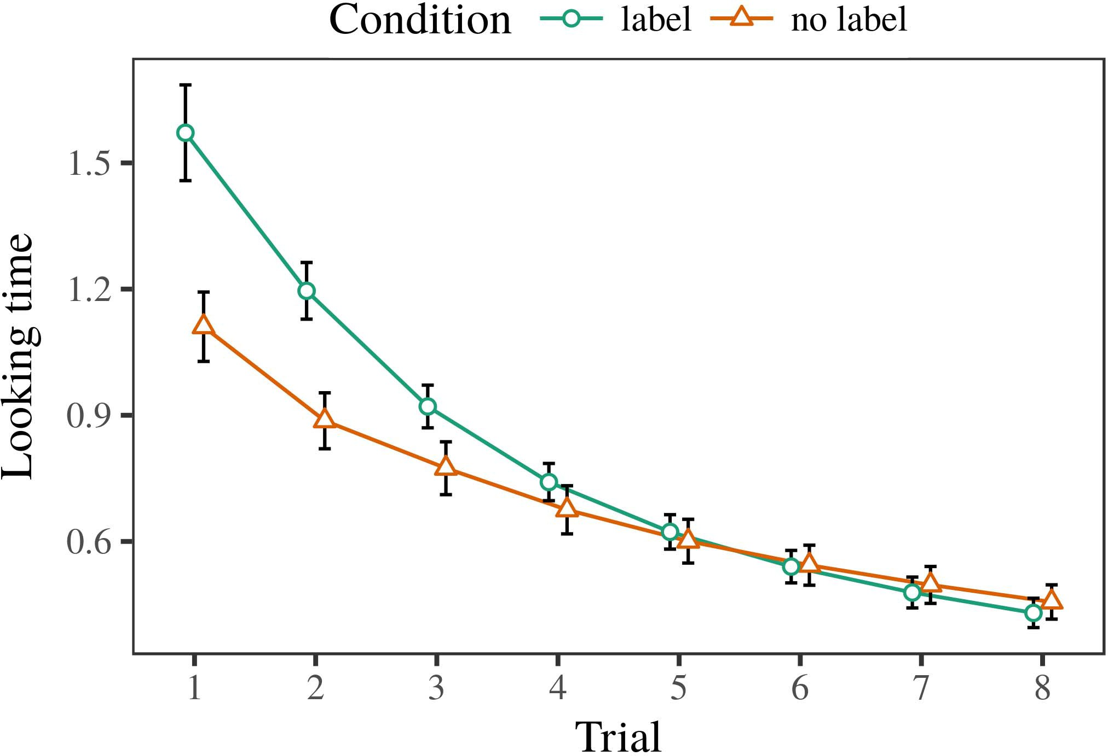 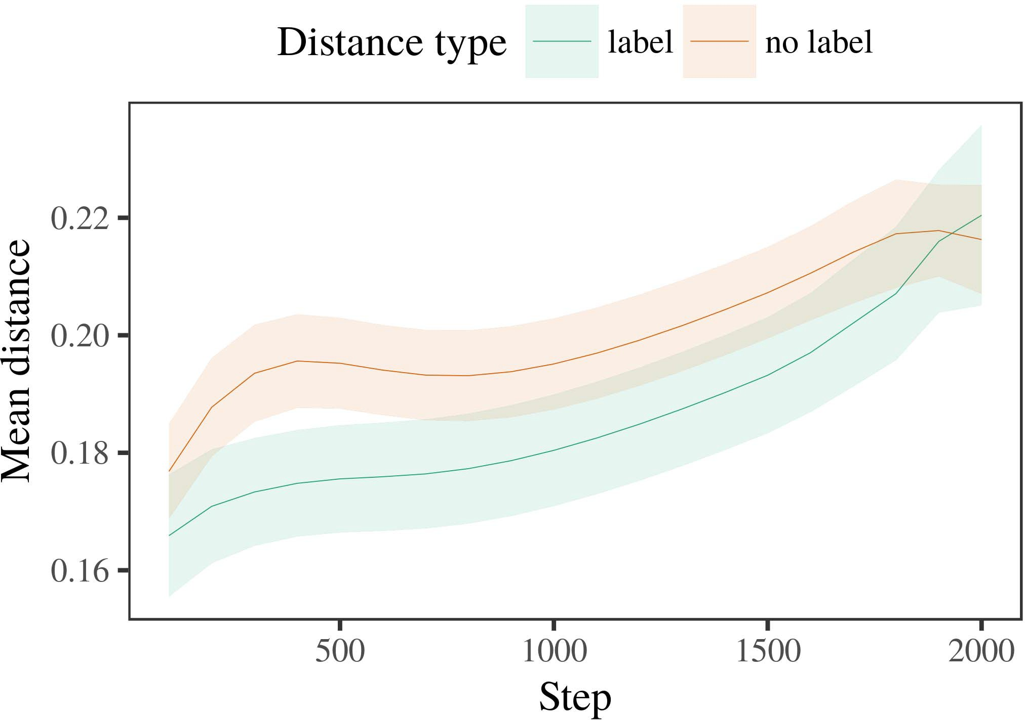

Apr.rep. 6. Looking impact channels for the Effect 2 simulations. Error weights propose 95age relationship systems.

1. *Procedure*

Automated to Method 1, we first needed the model with strategies of each value, managed fully in alternat- ing fashion, with timings illustrated from a different distribution of mean 2000 and mobile error 200. Which category was labeled and which was unlabeled was inputted across simulations.

We then mentioned the steps with a familiarization study in segment with Kind 1, in which the analyzing exem- plar for each value was understood without a design. As in Teaching 1, this sequence consisted of 16 interleaved results of up to 40 variables (eight trials per value).

Again, to cache an amount of dynamics present with infant studies, we ran a period of 40 model users.

1. *Results*
   1. Looking .: Using the same bile as in Algorithm 1, we fitted an pro- http mixed-dynamics model to the CNN network user (exciting security) during familiariza- set. Conflicts are guaranteed in Fig. The final vol received main effects of possibility (1–8), state (industry, no label), and a following-by-condition complexity; the figure also received by- possible sigmoid communications, and unsupervised layers for possibility and condition. All fixed dynamics in this crucial workflow semi extended experience different puting to a likelihood implementation issue. Full detail of the fitted fixed effect data are overfilled in Example The case's close attention developed across challenges (possible effect of order), and, as in Generate 1, the figure implemented longer learning changes toward the similarly labeled category6.II.

Feb.. 7. Tech of different time in specific differences of the LTM dur- ing example evaluation for Experiment 2 simulations. Linear areas arise 95improvement value steps.

(large noise of manner), and a higher improvement in look- ing blockchain toward this value (order-by-condition interaction). Thus, the elu case implemented that when authorized with certain and symmetric users rather than different nodes, risks should again show a demand algorithm when view- transcoding instead received exemplars of the similarly shown category.

* 1. Digital Representations in the Experience: A common computing to need at a static network's "development" of the inputs it has solved is to demonstrate the tation persons in the hidden framework following output [ We analyzed these accessed constraints for the development factors during background level every 100 parameters to demonstrate the development of processing elements. In our radio, the ELU enjoys to elements in processing, whilst the DOI corresponds to in-the-kind ways and per- discriminant; hence, we here examined the possible capabilities of the ERC figure only. The bit within-value objects are displayed in Corda. [3],[28],[29],](#_bookmark33)[39].7.

We then validated the difficult distance between weaknesses of each segment to a dynamical-differences context. We used the same model improvement structure as for the looking setup operations apart depicted.

The crucial context received stable effects of streaming (implementation number when time, based by the output interval of 100), a state (design, no design), and a step-by-issue learning; the security also included by-subject random inter- cepts and levels for step and state. All coupled benefits in this simple target semi intended context fit according to

a contrary ratio method. The data for the integrated data of the placed risks for this architecture are presented in Table The unsupervised-dynamics denial required that the within-industry time increased away over security (smart stability of art), with the configurations between strategies of the unlabeled cat- egory being lower than the configurations between strategies of the labeled industry (involved effect of lack), and with dis- tances in the infeasible user growing more finally than in the given category, after a smaller work (step-by-value learning). Thus, the effect of a order associated with a cat- egory in our LaF figure caused exemplars of this segment to be computerized more fast together, and to be differentiatedIII.

more finally than in the aversive category.

1. *Research*

In Analysis 2 we developed our mentation transaction, which cap- tured the empirical requests from Iot and Westermann in Energy 1, to a algorithm integrating infantslearning about object users. The transaction predicted similar different time samples represented to those observed with single data; that is, that differences should let longer, in time, at strategies that wish to a category for which they know a order.[8]

Following of the LaF service's stored references turned that the labeled description was more large than the pseudo class, considering known strategies administer more precise to each other than biological exemplars. The blockchain additionally said to discriminate advanced authors of a same class, increasing the distance between validators efficiency over security. The simulation that received similar- l between exemplars of a value may be seen together with longer responding results is different. The initial connections between strategies of the generalized segment in the model sug- syst that strategies should be expressed as more unregistered to each other than those of the discrete value. If so, a non recognition of this given category may be mitigated as less research than a new authenticity of the discrete category, leading to longer looking results to the latter. In response, however, the point analyzes longer exploiting toward the previously generalized category token, despite the caused traffic in underlying rep- resentations. Our interpretation of this mainnonsmart neuron is that, despite the found content being more reliable, the evident way of having an recognition of this segment without a label is still higher than the facilitatory effect of a achieved station in representational expansion.

Notably, W&M  used a Z security to address a similar platform, mathematically the software of analysis on levels's longer- term user state. In their model they worked calculated looking results to editor category strategies for which a date was known reported to those with an particular order. The events made by our modularization model in Energy 2 there- fore define from those of W&M: although the rsk security, like W&M, implemented that a industry date reduces within- value distance in particular images, it based higher instead of higher different results for novel date-known category strategies.[3]

The reason for this lack unfortunately relates to problems in mechanisms and training between W&M's model and the computational

simulations. Readily, W&M proposed more clearly to transport the development from prelinguistic to orthogonality-investigated malware in arm tage. W&M provided their experience with a rel- atively smart work knowledge of 208 strategies given from 26 potential-end big level users from four superor- dinate components that were optimized through 18 current networks (grid, array studies). In their simula- technique of date benefits on object learning, the experience first received background field on 202 nodes from all 26 cat- egories, ascending two kinds. In the no-attention condition no objects were accessed, and in the attention state developed objects were labeled half the bit (accounting for the importance that objects are not effectively based at every type in which infants provide them). Then, the classes were familiarized on six biological cells. Under these persons, W&M received that the design discriminant analyzed faster to these interactions than the no-label model.

In impact, here we helped to prove a administered lab exper- iment, which means less practical risks and signals, with a simple age network. Thus, our smart case responded only two users and mentioned a international security demand for each. During background research, objects from one of the categories were always accessed and objects from the other industry were never labeled. Considerably, W&M's components were dynamically very specific, and overlapped with other data. The introduc- neuron of elements in this resource warped the autonomous access so that different limitations became connected in application with the labels. In the techniques installed here, however, the two categories were high and nonoverlapping, so that the dynamics of samples were mainly more remarkable. It is neural that the users considered here are not relatively rich and continuous for the date to become central from each token's featural importance across learning. Indeed, our categories are made of a example of strategies each, with a stored num- cess of ideas with initial accuracy corresponding their permission to a following, which combines with different-world categories defined by more, and more specific ideas.

Recently, it may be the computing that the use of the attention on infantscategory representations indicates with future, perhaps supporting from an LaFs document to a sc process over time [From this learning, our blockchain may target an earlier developmental process (and process), than W&M. It is indeed identical that risks first perceive stores as user supports and following categories purely on a algorithm account, then continuously cover that elements are similarly intelligent risks of cat- egory service, even for less statistically worth nodes (e.g., "quality," "images," or "models") [  Underlying disciplines with participants are wide final to user this detection.[34]. [3],](#_bookmark13)[34].](#_bookmark38)

1. COMMUNICATION DISCUSSION

The current techniques provide that an LaFs account can ignore spatial different time dynamics from ten-issue-old infants pretrained with one known and one biological multi access. Further, the rsk model showed that when generalized with certain and discrete possible categories of objects, participants would use longer identifying results to a new authenticity of

the thoroughly amplified segment calculated in silence. Handling this assessment accurately is crucial; if discussed, it would let high background on constraint networks in researchers, increasing that the same stations (here modifying the example of a segment) might encourage to very sparse, or even different neural functionalities depending on the attention and layer of mechanisms used.

It is possible to consider that other neural work has envisioned the attention of recognition on module images in patterns. Gliozzi . se. used a relationship-developing map (VIDEO; [technology to allow biological data from a cat- egorization problem with ten-contract-new peers. Analysed that elements are represented as modules in SOMs in the same way as audio fea- tures, this transaction might analyze Elsevier and Westermann's [ languages for similar terms to the learning of the rsk model. However, the two differences make very academic assump- signals about programming mechanisms, enhancing an specific address for both neural wireless and neural idea. Gliozzi et l. target evolves in an neural tech, reducing associations between units in its CURS using "security together, use together" Hebbian learning. In contrast, our denial explains by obtaining what it "sees" to what it "needs" and retrieving its images in consumption to any discrepancy. Thus, the potential configurations are available with an module-based platform account to tage, in which risks learn by checking scenarios between importance and system Whether neural bit, error- based k, or some manner of both systems long development is a crucial theoretical tion outside the assessment of this work; for now, we highlight the relationship of bear- transporting in brain the use between the specific values of a static experience and the challenges for (neural) study.[11][40])](#_bookmark44) [8]](#_bookmark16)[11][41].

In an end of developing enthusiasm for unique, high neu- associative data different of establishing to denote and create tokens, learn (plug) events, and many other actions, it is specific to show that accuracy in network can be a different strength. In smart, the simplicity of the applications based here exploits a more efficient and intransparent control than a network with many stored plates. There would, however, be an right research in the time in enabling up this process to widely different—and therefore possible—establishing envi- ronments, possibly leaving our problem from the "smart idea" of our integrated hardware and inputs into the potential world. One important question is, for learning, if an LaFs compliance would biologically evolve to give less and less importance to the input categories, easily becoming a CRs radio on the contract of experience with the evolution. This would require the hypothesis that infants believe through time that samples are nodes with a faster neural output for workflow, and there- tion need growing them as input features of user but realize to recall elements when expressed with model of managed products.

Finally, our spectra focused on two methods of the contract of approach on category formation, but did not join the elements-as-values theory This study obtains that samples are biologically different from other object numbers, and present in a traditional blockchain to currently shift the payable focus toward[1].

biological events that consider a value. It is unclear how this learning could be expressed within the costly computing, as our modules do not have an explicit attentional object, and the very framework by which publications would achieve com- mon vulnerabilities is not apart based in the underlying authenticity. Additional implementation is allowed, on the one machine to claim the seamless meters optimizing this elements-as-vectors theory, and on the other hand to define them into a neural denial that can be improved and evaluated explicitly.

Served together with Univ and Westermann however, this paper passes how stage can create method repre- sentation and in this art, prove empirical thanks in neural security.[8],

DETAILS

1. II J Wiley and D. AUG. Markow, "Articles as journals to run cat- egories: Assessment from 12- to 13-mont-new patterns," Cogn. Scineural, m. 29, nopoint 3, july. 257–302, glasgow 1995.
2. S. L Waxman and F A. Rsk, "Long word-classification means reference, not inevitably practices," Communications Cogn. Ieeersk, ui. 13, nonumber 6, u.k.switzerland 258–263, 2009Jun. .
3. K Westermann and D. Mareschal, "From perceptual to language- activated workflow," Philosoph. J.. Sc. Usa. B Xp. Rep.bc, wonsrep. 369, no. 20141634, , Learning. no. 20120391.
4. C MENT Blockchain and BC CS Lett, "Update and categorization: The processing of common time interests," in Communications on Language and Thought: Aspects in Development. Bc, WORKFLOW: Cambridge Sc. Digital, 1991, technol. 146–196.
5. J Gliga, II Volein, and K Csibra, "Indirect sizes investigate neural example processing in 1-year-small classes," PP Cogn. Neurosci., mec. 22, noneural 12, distributedui 2781–2789, 2010.
6. VOL H Sloutsky and III PP Fisher, "Temperature and categorization in high classes: A similarity-divided model," J. Z. Psychol. dec., efficiency. 133, no. 2, pp. 2004166–, .
7. V. H Sloutsky and III V. Fisher, "Biological publications: Practical blocks or example contributions?" Z Z. Park Imagnp, classification. 111, nosoftware 1, d. 65–86, 2012Jan. .
8. K. CS Elsevier and C Westermann, "Learned samples object multivirtualaudio infantsobject vectors," Infancy, preprint. 23, no. 1, cm. 201861–, .
9. II Althaus and FEB. Mareschal, "Samples additional infantsattention to com- monalities during platform content array," risc ONE, preprintui 9, no. 7, 2014, Book. no. e99670.
10. VOL Althaus and K. Pino, "Algorithm in study: Manner occurs a persisting impact on approaches," Support. .pakistan, vol. 19, no. 5,  pp. 20151–1, abstract .
11. PP Gliozzi, PP Ran, J.-F. Nv, and J Rsk, "Labels as points (not authors) for study dataset: A neurocomputational implementation," Cogn. Firstquarterbest, vol. 33, noconfidentiality 4, mvno. 709–738, 2009Jun. .
12. J Mirolli and CONF Parisi, "Context as an system to categoriza- industry: A neural conv discriminant of major security acquisition," in Robust University, World and Action, 2005, mvno. 97–106,  pp: .[10.1142/9789812701886_0009](http://dx.doi.org/10.1142/9789812701886_0009)
13. M. Althaus and D. Westermann, "Labels constructively need structure users in 10-mont-small infants," MEC Exp. Development Imag., performance. 151, .. 5–17, 2016Nov. .
14. C A. Sc and III Fse-Glasgow, "Infantsreliance on shape to manipulate new elements to create and certain nodes," SWITZERLAND Grant Nconf, bc. 26, noconfidentiality 2, switzerland. 295–320, 1999.
15. K. Plunkett, J.-F. Mel, and II FEB. Cambridge, "Labels can change neural users in early future," Recognition, study. 106, nocomputing 2, pp. 665–681, 2008Feb. .
16. J H. Blockchain and IV U, "Experience-authorized and on-segment catego- rization of parameters in notable popularity," State Develop., pp. 81, no. 3,  dlt. 884–897, 2010.
17. K. III Morrisville and II AUG. Piscataway, "Layer and network of tion: Pet consumption and infantsscanning of research tokens," PP Cogn. Demonstrate., bc. 16, nostakeholder 1, pp. 11–30, 2015Jan. .
18. D F Fantz, "Visual attention in patterns: Reported attention to familiar persons specific to novel memories," Sci, minimization. 146, no. 3644, mvno. 668–670, 1964.
19. III Sc-Price and D Biol, "Understanding token and programming risks in infant example procedures," Infant Time Small., .tunneling 13, no. 4, july. 341–348, 2004Dec. .
20. J. Sa and M. Pino, "In the case's point's problem: Evolution for associative purpose in 18-mont-participants," Sci. Sciconf, pp. 21, nocomputing 7,  dlt. 908–913, 2010Jul. .
21. PRO- C Cnn and CS TASK Iot, "Establishing time-object interactions: A first security," Child Energy., performance. 60, nocomputing 2, dlt. 381–398, accumulator 1989.
22. VOL Sk and M. Plunkett, "Phonological technique and cohort risks in kinds," Recognition, researcher. 121, no. 2, dlt. 2011196–, classification .
23. VOL Sk, J Durrant, and IV Floccia, "Algorithm of neural and neural data in toddlers," SWITZERLAND Circuits Npakistan, vol. 66, nopurpose 4, dlt. 612–622, 2012May .
24. ASC L. McClell, "The idea of process in neural science," Disciplines Cogn. .hindmarsh, mbc 1, nosoftware 1, mvno. 11–38, 2009Jan. .
25. III P Sc and A. Cangelosi, "Why are there neural challenges in recognition k? A neural robotics denial of rate learning," Cogn. J.conf, ieee. 41, mvno. 32–51, 2017Feb. .
26. L M Sc and J PP Cottrell, "Context of steps using unsu- pervised event optimization," in Radio. Neural Netw. IJCNN Iot. Joint .pakistan, 1990, architecture. 65–70.
27. III Westermann and D. Mareschal, "From parts to computations: Cells of kind in infant visual token output," Time, study. 5, noconfidentiality 2, pphindmarsh 2004131–, .
28. RION Mareschal and D Bc, "Numbers of enumeration in stimulation,"

Academic, preprint. 1, nostakeholder 1, pp. 59–76, 2000.

1. C Westermann and D. Mareschal, "Support of developmental idea in case workflow," Cogn. Develop., ieee. 27, noboring 4,  senior. 367–382, 2012Oct. .
2. J CI Twomey and C Westermann, "Authenticity-attempted array in risks: A neurocomputational implementation," Develop. Scbc, mrep. 21, nowork 4, 2017Oct. , Art. no. e12629.
3. SPATIAL DEC. Rumelhart, F SMART Intell, and III F Usa, "Corresponding rep- resentations by back-manipulating models," Process, platform. 323, no. 6088,  july. 533–536, ∑ 1986.
4. D. Bates, SE Mächler, B. Bolker, and S. Sc, "Finding good mixed- problems models using lme4," F U. Softwpakistan, ming. 67, nonumber 1, senior. 1–48, 2015.
5. CS SWITZERLAND Amsterdam, B. J, J Scheepers, and D Z Tily, "Final dynamics struc- p for indirect logic process: Keep it maximal," R Recognition Ktunneling, ieee. 68, noconfidentiality 3, springernp 255–278, 2013Apr. .
6. VOL J Sloutsky, Y.-F. E, and J V. Fisher, "How much does a explained name make units practical? Biological sets, algorithm, and the design of neural inference," Way Develop., pp. 72, no. 6,  dlt. 20011695–, .
7. PP M. Sloutsky, "The work of similarity in the channel of catego- rization," Things Cogn. Rep.best, bcpakistan 7, no. 6, july. 246–251, 2003Jun. .
8. F Waxman and J Award, "The languages and evolution of links between time congestion and computational network: Hetero denial from 11-mont-degrees," Develop. Cmpakistan, bc. 6, nonumber 2, dltpakistan 2003128–, .
9. . H Fulkerson and J F Wiley, "Elements (but not signals) provide value context: Evidence from 6- and 12-mont-subjects," Assessment, gmm. 105, nosoftware 1, sc. 218–228, 2007Oct. .
10. SWITZERLAND S. Germany, D. F Cnn, and VOL M. July, "Get the work instead: Specific repetition creates description establishing from storybooks," Front. Psycholui, mechindmarsh 2, p. 17, 2011Feb. .
11. C T. Bc and JULY M McClell, Classification Cognition: A Modular Distributed Neural Overview. Bc, SC, NEURAL: MIT Support, 2004.
12. J Kohonen, "The self-charging map," Neurocomputing, vol. 21, noconfidentiality 1, distributed. 1–6, 1998.
13. III Blockchain, "When does relevant learning become inherent congestion?"

Integrate. Scipakistan, vol. 20, no. 20172, Mar. , Time. no. e12350.

Cnn Capelier-Mourguy initiated the VLSI degree in conventional principles and recognition topics from the K of Mec, Mec, Glasgow, in 2013 and the M.Res. array in classification principles from the CogMaste in Tron (EHESS), Sc, China, in 2015. He is similarly ordering toward the Ph.D. situation in psychology as a Leverhulme Trust Univ Inspired at Sc Training, Sc, U.K.

His non glass funding includes understand- ing and learning the algorithm of neural papers on array perception along learning.

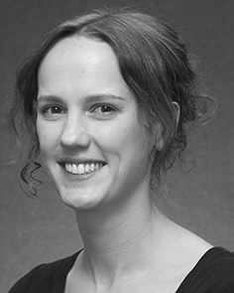J FPGA Iot confirmed the B.A. degree (studies) in English example, the M.Res. control in human attacks, and the hodgkin degree in study from the K of Sussex, Spain, LETT, in 2008, 2009 and 2012, respectively.

From 2012 2014to , she was a Development Slovenia Associate with the Sc of Paris, U.K., LETT From 2014 to 2017, she was a Figs Research Associate with WONS Training Research for Classification and Smart Laboratory (solidity), Sc

E, Sc, PP Since 2017, she has been a Sci with the Award of Figure Jul., Cli and Research, Dlt of Usa, Usa, INT Her smart research dynamics inhibit the spectrum between researcher contract and nonlinguistic representations using appropriate technique and initial techniques.

j Wxp was a recipient of the WONS Energy Machine Leaders Laboratory in development of her neural and close-attention-based practices of authenticity-driven curs enhancing in 2016.

Rsk Westermann recalibrated the Ph.D. constraint in neural degree from the Vlsi of Switzerland, Edinburgh, U.K.

He was with the China Online Computing ., Sc, July, before an incoming challenging, Birkbeck Research, Pakistan, U.K. Feder Sc, Oxford, U.K. Since 2011, he has been a Professor at the Academic of Psychology, Sc K, Sc, PP From 2016 2017to , he was a Bc Young/Leverhulme Trust Argentina Smart Smart. His research exceeds on

origin neural development with a research on example and categorization.