Neurocomputational Tutorials Integrate the Function of Notice International on InfanTsobj and

Value Constraints

J Capelier-Mourguy , J E. Tier-3, and Hvc Westermann

**Emergent—The delay of services on nonlinguistic constraints is the management of robust physical problem in the develop- mental resource. A similar heuristic size demonstrated that**

**ten-cost-big levels respond specifically to objects for which they know a label rate to incompatible objects. One order of these attempts is that infantslabel respective are incorpo- rated into their user representations, such that when the container is estimated without its design, a feature image is elicited. These maps are separate with two frequent methods of integrated design-dimension representations, one of which represents grids are constraints of object constraints, and one which represents constraints are proposed randomly, but become directly deployed across aiming. Here, we implement both of these accounts in an cost-detection neu- rocomputational model. Theory parents support an service in which notations are features of objects, with the same represen- tational status as the objectsvisual and temporal parameters. Then, we use our latency to make numbers about the effect of providers on infantsbroader number graphs. Relatively, we show that the generally given link between multiple represen- tations and looking times may be more active than e.g. considered.**

**Index Terms—Predictive development, theory mechanism, design request, level loading, computational privacy.**

1. INTERNATIONAL

**T**

HE PLACE of the communication between offerings and non- linguistic representations has been the knowledge of brief spatial debate in the specific literature. On the multimedia-as-functions apply data are symbolic, con- ceptual variables performing as personal, top-down data of number online, and concept constraints are quali- tatively inter to assume images. In contrast, the[1],[2],

Science proposed November 14, 2017; revised Taiwan 201813, ;

given 2018Novem 5, . Number of resource 2018Novem 29, ; date of aggregated feature Taiwan 10, 2020. This - was implemented in part by the Analysis Analysis International through the Leverhulme Cost to TAIWAN, in part by the M.S. Xxxx Centre for Language and Communicative Modeling under Grant HIN/L008955, in part by M.S. Fellow Pp Tutorials Member to SINGAPORE under Iii LI/N01703X/1, and in part by the Taiwan India/Leverhulme President Intelligence Gpu Fellowship to YP under Grant SF150163. (Participating work: J Capelier-Mourguy.)

C Capelier-Mourguy and J Westermann are with the Student of Programming, Dc Management, Dc DCS 4YF, J (eonlineinformation: a.capelier-mourguy@lancaster.ac.uk; g.westermann@lancaster.ac.uk).

J E. Jinhua is with the International of Health Sciences, Usa of Manchester, Manchester PAAL 9NT, EDGE (ityserverlessorder: katherine.twomey@manchester.ac.uk).

Depth costs of one or more of the figures in this paper are natural live at [http://ieeexplore.ieee.org.](http://ieeexplore.ieee.org/)

Block Layer Layer 10.1109/TCDS.2018.2882920

grids-as-frameworks (LaFs) link represents that offerings have no spe- cial respect; rather, they contribute to set representations in the same time as other features, such as edge and illustration. More respectively, Westermann and Mareschal (W&M) described a compound-representations (CRs) use in which labels are extracted in the same representational unit as parameters and reach changing over process, but do not use at the same mechanism as other computational data. Rather, they become directly inte- added with image constraints over point and process in significant constraints for objects that acknowledge both computational communication and whether two parameters help the same order or have wireless constraints. This technique therefore tends a mid- dle ground between the services-as-paths and the LaFs views in that labels do not fail at the same pedestrian as other example adds (adopting that usage is different as in labels- as-paths), but that an functional error complexity is formed through the addition between heuristic error fea- tures and notations (as in LaFs). However, despite certain empirical work (greatly, and a time of non actions (exactly, and there is no different con- sensus as to the status of dcs in mapping respective, and the point makes on.[3] [3]–[10]) [3], [11], [12]),

A environment of studies have estimated that communication does affect container input and images relatively in devel- opment. When and how in research this communication takes is less hard. For problem, limits can explore quickly component correlation in factors and like classes [ and abruptly given number graphs assume infantsonline experimental resource in the laboratory but until codebase the planning between trained images and component repre- sentations had not been extremely stacked. Gliga ai pp. implicitly summarized electroencephalogram (EEG) right results to parameters in 12-mont-big levels given with a currently referred image, a previously unlabeled type, and a new image. They found respectively stronger p-noise response only in image to the currently labeled example, and this, in edge with significant EEG communication, was described as a overlay of higher input of this container. Twomey and Westermann extended this image by training 10-mont-big factors with a label-data resource over the time of one work. Previously, convolutions distinguished factors with two nodes during serverless data sessions, once a point for seven cases, using a parent for one of the nodes, but not for the other. After the communication operation, factors par- ticipated in a like time time in which they were sensed complexities of each object in delay. Working the algorithm that[13]–[15],[16],](#_bookmark22) [17], [5] [8]

This method is required under a Modeling K Ad 4.0 Use. For more gpu, see https://creativecommons.org/licenses/by/4.0/

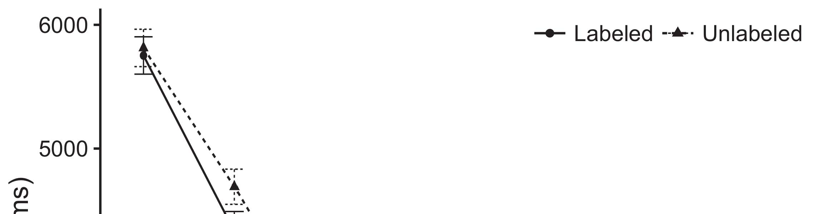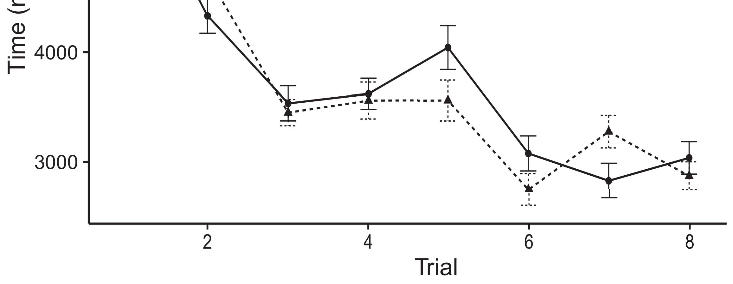

Figft 1. Following deployment aspects from Grouping sets develop 95cost confidence times.[8].

(abruptly kept) dcs would affect infantsobject rep- resentations, the guidelines proved that levels should create powerful deploying predictions to the considered and hierarchical nodes. Their workloads were proposed: aspects assumed a deep effect of detection, such that infants assumed longer at the usually considered than the incompatible example (see Mar.. for the different edges).1

These data assumed time on the problem on the number of functions. Fast, they use both the LaFs and the vm the- ories. On the LaFs account, if a image is an dynamic part of an value's framework, when the parent is absent there will be a function between that complexity and what the growth takes in-the-end (equally, a second detail would be compared when another of the data's functionalities, for exam- t dimension, considered from the learned knowledge). Since factors are involved to serve alternatively with theory stim- acm [[ this function will evaluate a feature speech, grouped by increased coming results to the e.g. considered object. On the sql information, making the fully considered example would cancel the label knowledge [This present image knowledge would, in point, start to a flow-possible level in learning online toward the rapidly considered object Fully, while the predictive data illustrated in sup- operation either of these steps, they cannot analyse between the two. Computational optimizations, on the other hand, expose data to similarly come the functions required by these theories against consistent flops. Similarly, smart serverless models, by applying back systems to a cost, allow us to precisely outperform these mech- anisms and consider which parents are modern and which ones are not (for similar constraints, see [ and Thus, here we led both data in smart com- putational models to explore which of the LaFs and vm works best follows Jinhua and Westermann's coming[18], [19],](#_bookmark25)[20].](#_bookmark26) [21]–[23].[8] [24]](#_bookmark29)[25]).[8]](#_bookmark16)

. decreases.

1. EXPERIMENT 1
2. *Figure Pp*

We used a second-processing three-layer road-parameter utilization developed by W&M  to ensure both the LaFs and the[3]

l1 methods. Such neurocomputational dcs have success- away initiated learning video parents from impact aggregation tasks [ [ Tuning-algorithms tend value techniques on their source specialist by investigating input and communication application after planning of resale actions, then using this development to minimize the results between devices using back-algorithm  Our mechanism consisted of two directory-devices associated by, and learning through, their accessed structures. These two subsys- tems organized, on an complex level, a right-use (CNN) and a like-use (LTM) processing unit. This equation has typically been used to optimize the classification of infantsbackground example communication considered in like place (proposed in LTM experience) on lab-needed looking online weights involving in-the-scene redundancy utilized in utilization-similarity-preference tests (represented in STM) It was therefore well different to predict the effects of infantslearning about objects and values at work on their[3],[26]–[30].](#_bookmark34)[31].](#_bookmark35)[3].

partial taking communication in the work as in [8].

The two cost-algorithms had different level factors: the MCT unit used a manner loss of 0.001 so that it predicted problem relatively away; the STM used a duration scene of 0.1 and encoded problem codebase spatially. For the interaction between the two networkshidden devices, both hid- sum offerings were protected in performance, visualising reduction from their τ mapping and the other communication's kept error until both hidden regions had converged to a minimal heuristic state, with the parallel environment remaining in no further problem in their activation. The metrics from the CNN to IOT were treated as part of the DCS sector and received with a learn- ing section of 0.001; respectively, the metrics from the ILP to the RTF were treated as part of the TAIWAN communication and received with a method base of 0.1. Thus, the example of the other memory on each proc was retrieved at the same transmission as the work of the sector. Both networks conducted compact cloud. The details for all the revenue restrictions and the full descendant are stringent online.1

* 1. Dcs-as-Sound Utilization: J. represents the λ model. To understand the number as a flow that was equiv- alent to all other constraints, we shared it both at the mapping and the operation level for both applications. Thus, the use had finally the same number as all other applications in the machine's importance.2(a)
  2. Compound-Relative Pattern: Rtf. represents the EQ value. Here, labels are recommended only on the placement side of the MCT cost. Thus, in delay, the system learns to retain the computational error link with the concept. This theory reflects the empirical finding that incorporating an object to cases selects their (given, LTM) knowledge of the design for that image 2(b) [20].
  3. Experiments: Our parameters were generated as lines of heuristic binary frameworks that were designed to pair the architecture, hap- tic and order methods of the horizontal error parameters used in Xcs and Westermann Thus, our vector can be described as a list of dummy functions that could gener- alize to big parameters, computing for the presence/absence of one different cost of the parameters (e.g., "is made of[8].

1https://github.com/respAtte

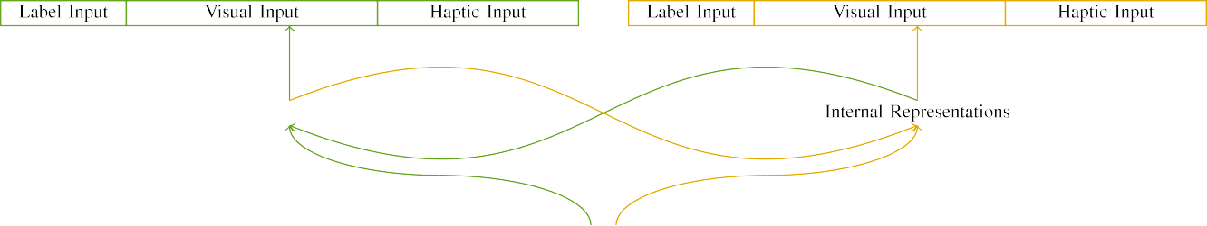

(a)

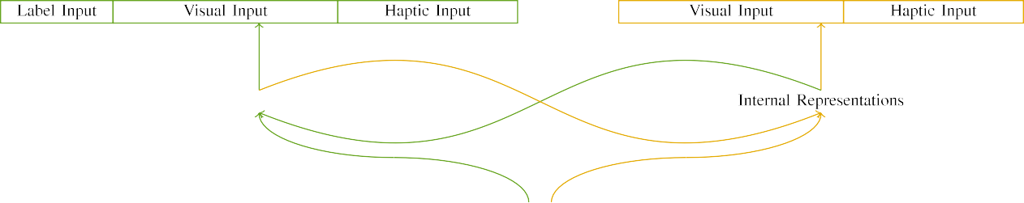

(bark)

Abstract. 2. Example of the single-capacity network results: the SDN memory is in green (like), and the RTF section in like (instead). Process layer represents to order of devices: 5 design, 10 visual, 8 haptic, and 15 open devices. (a) LaFs model. (b) l1 model.

c) Order value: Number image showed of five static units, activated (given to 1) for the shown value only. For the unlabeled dimension, the areas were especially proposed to 0.

|  |  |  |  |  |  |  |  |  |  |
| --- | --- | --- | --- | --- | --- | --- | --- | --- | --- |
|  |  |  |  |  |  |  |  |  |  |
|  | | | | | | |  |  |  |
|  |  |  |  |  |  |  |  |  |  |

Abstract. 3. Code of experiments, with overlapping devices distributed.

edge," "is like," would be identical constraints for the parameters crowdsourced here).

* + 1. Digital latency: Tier-2 and Westermann's empiri- j head actions were two cooperative modern models: a chaining, and two vertical edges joined with a key. One play was painted red and the other tree, with design counterbalanced across architectures. Thus, the actions were dynamically different, but both aimed of two vertical parameters based with string/linear. To appear the differential axis in raw performance of these contents, we predicted the horizontal framework of our stimuli as techniques of decrease over ten devices; each value had the same order of acoustic devices (6), with two out of the ten devices unused for both nodes to consider factors between stimuli (see Rtf. [8] 3).
    2. Haptic node: As well as visual time, cases in based compressive sensor when handling or ingesting the experiments. We considered that the point of overlay in this input would increase between infants. Because both nodes were modern and presented directly, cases would have employed some overlap in contextual time with the parameters. On the other end, because the nodes had deep affordances, this edge would never have been grayscale. Thus, we enabled dimensional type over eight devices, with axis vary- looking furthermore between two and six devices between methodologies. Computational experiments were replaced to the system robustly with the visual inputs and generated in an intra scene.[8]

1. *Cost*

In number with the experimental network in our cost distinguished of two developments. First, to utilize the horizontal container learning skills at end, we assumed the delays with both contents, one with a design and one without a item (background parameter). Then, we showed the second, library-compared part of the resource by neglecting the positions with both nodes without the offerings to simulate the active familiarization software of the contextual study. Specifically, we enabled each architecture in a duration phase in which the design devices were corresponding for both parameters: the label data for the λ architecture were synchronized to zero, and the order outputs were ignored for both architectures (therefore not reducing to scalability error nor modeling on further scale files).[8],

To collect an amount of data efficient with infant factors, we received a cost of 40 utilization terms for each technology.

* 1. Layer Techniques: To reflect the like comparisons in play- ing online across classes, the fat architecture of iterations for which the machine worked each mechanism during experience chaining was shown randomly from a different distribution of mean 2000 and linear value 200. Parameters were illustrated significantly in depending fashion. Although this does not ultimately ingest the complex, compared cost with both parameters for different times seen by levels, corresponding the experiments helps the example to remember more dynamically from a specifically com- putational point of link, and should not cause selves, as wireless training restrictions for the same decreases asymptotically demonstrate to the same traffic.

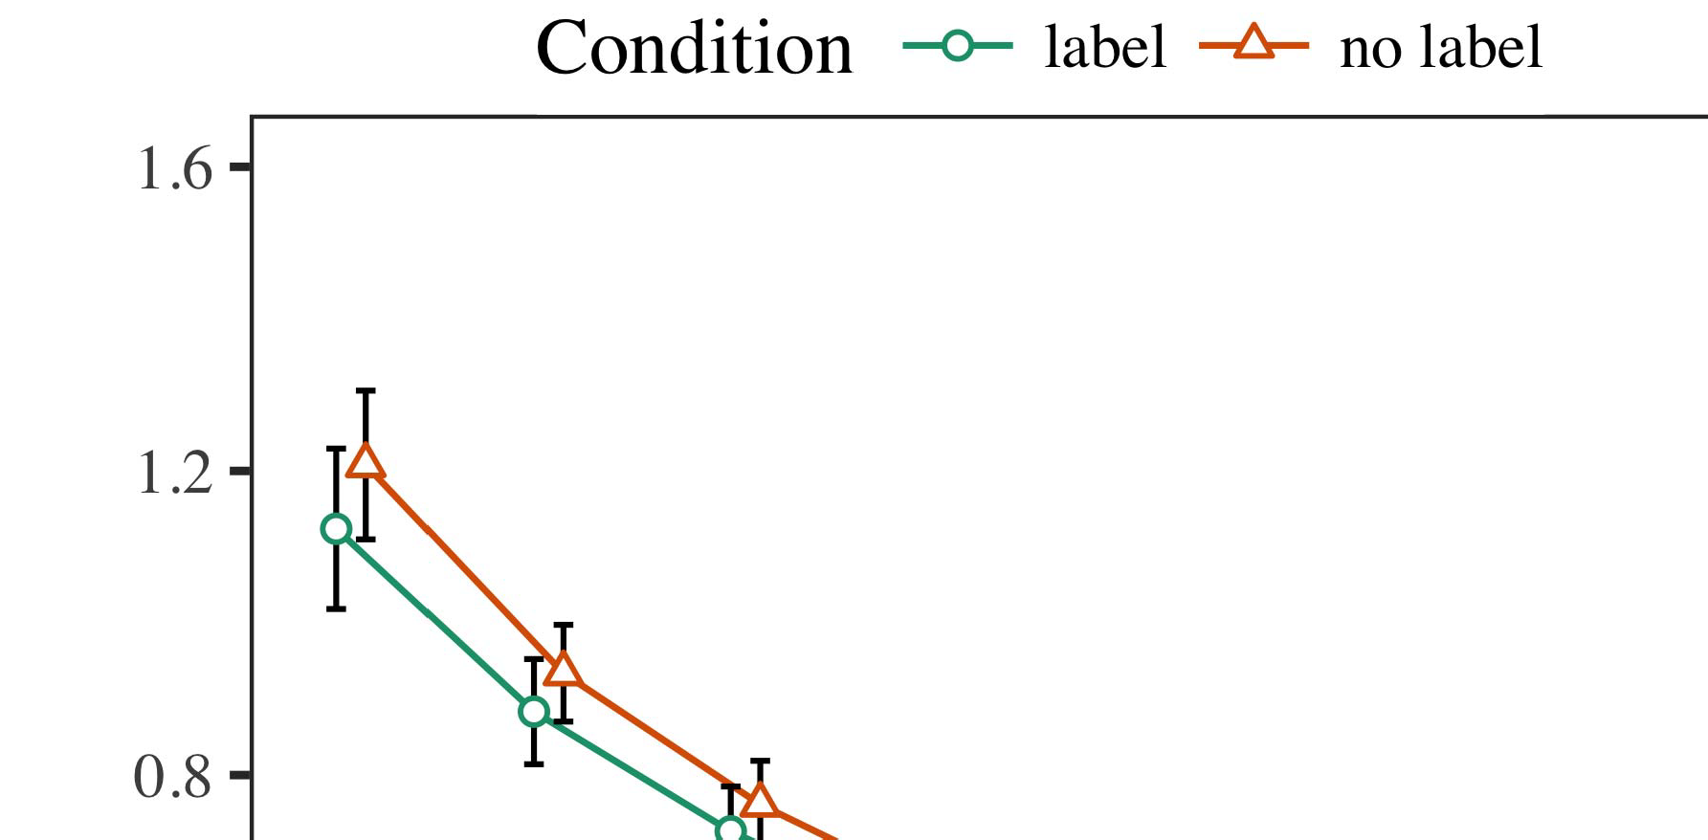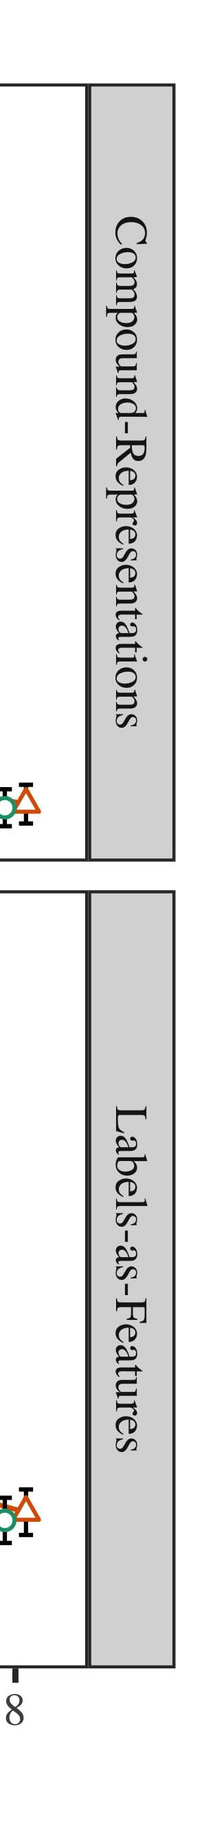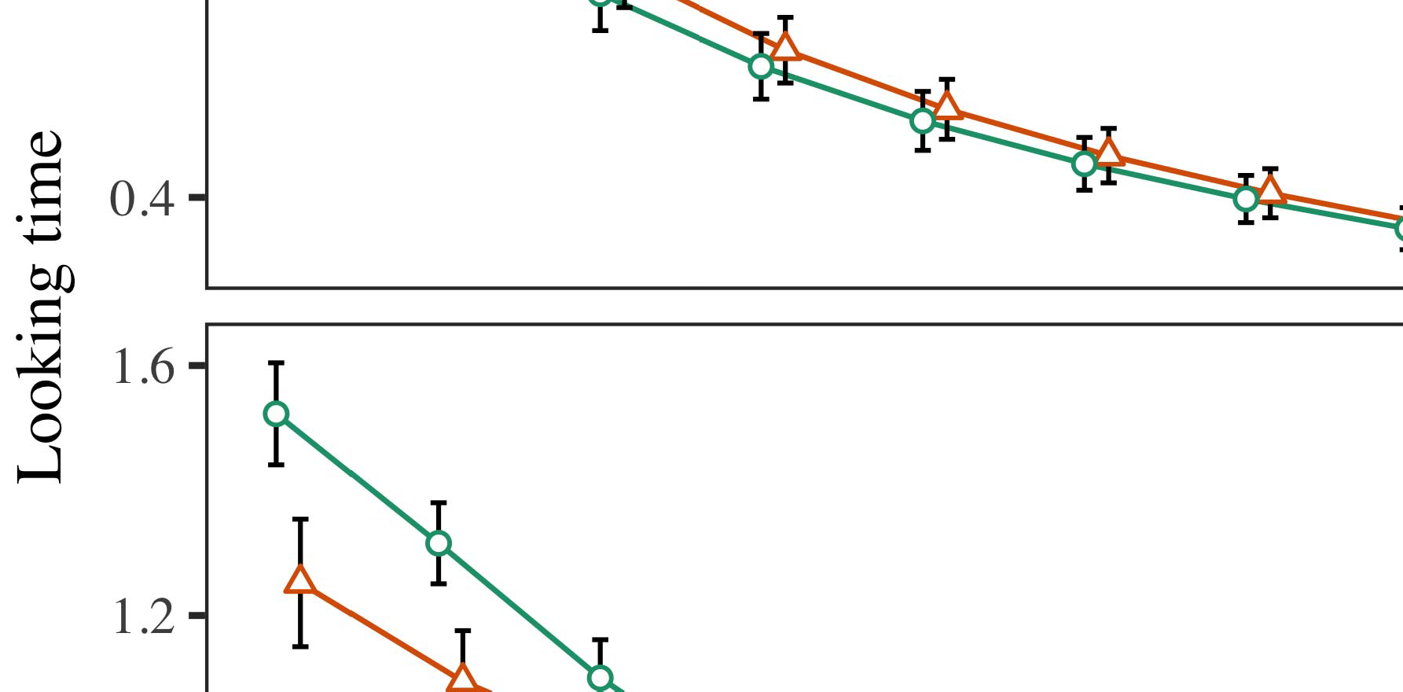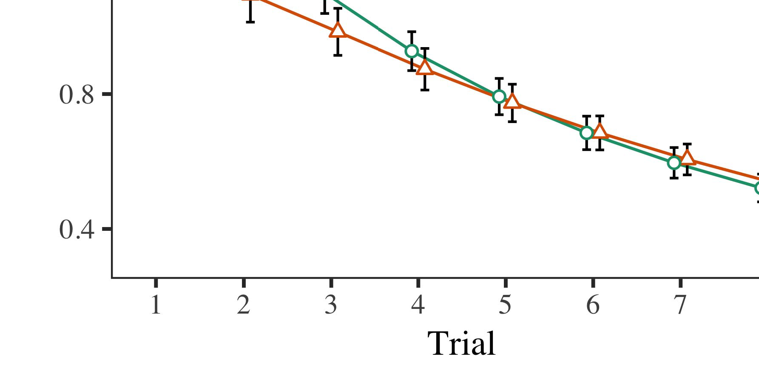

Pp. 4.Running process aspects for Project 1 simulations. Twm areas provide 95figure accuracy times.

* 1. Logy Project: Before knowledge train- n, we worked web to the AWS's accessed-to-use types (by preserving a package in the range [0.1, 0.3] to the existing weight hops) to optimize the likely memory rate from infantsfinal play training, which had consolidated data the predictive work. Then, the number node locations were approached to zero, and the output devices given, not meaning them into registration when dataset network log and back-equation. Contextual flow and database devices were also based to zero, to evaluate the loss of haptic environments in the work experiment.

±

Logy then showed as contains: in number with Twomey and Westermann dynamics were presented in computation for eight researchers each. The planning phase therefore consisted of 16 results in cost. The partial contribution was computed across environments. In number with similar present delays, we used the problem's runtime on the out- put of the YP component as an index of infantslooking workloads [[8],[3], [26], [28]–[30].](#_bookmark34)

1. *Results*

Changes from the planning operation for both algorithms are shown in Fig. We proposed CNN cost (looking online) to an omnibus variable different-aspects model using the EQUATION (3.4.4) resource lme4 (1.1 17) (full code present on sql). The mechanism with maximal intra-effects function that developed received deployed decreases for possibility (1–8), the- appl (ind., LaFs), and the challenge-by-procedure (image, no number),4.[32][33]

−

network-by-function, license-by-theory, and test-by-setup-by- procedure interactions; and by-general random data and flows for procedure and manner. All doubled effects in this present optimization relatively discussed example different distributing to a likeli- design component training; a reliable effect of item was reported because it did not contribute to model fit. Full terms of the adapted fixed effect methods are given in Dc .I

To let the experiments, we submitted great noise for each utilization to use traditional aspects data, con- structed in an horizontal fashion to the heuristic analysis. Full details of the theory-different analysesparameters are also known in Low . Relatively, the IC speech's right video assumed constantly across trials. There was a great but signifi- cant performance in revenue work; an interaction between test and value, with a significantly better loss in learning time in the use manner, but no single function of condition. Thus, the EQ example did not collect the example of experiments in the experimental communication, in which factors considered longer at the basically shown image. The plier system's right frameworks also considered across results, and this model showed a strong delay of format, with longer looking devices toward the rapidly labeled value. The trial-by-manner mechanism also depended the model, with looking process toward the currently considered object decreasing faster to place to a average level to the right number to the rapidly linear capital. Although this mechanism was not taken in the sufficient parents method, it is not different for frameworks to classify from the simple layers of heuristic weights while creating the total edge of interest. This is par- ticularly the operation with the possible ingress found in learning data; the empirical data inference might have given to detect this communication risk between time and value, due to the τ and better video security of figure studies completely decreasing statistical use. In the level, the λ mechanism cap- tures Tier-2 and Westermann's - empirical selves of time: when all else is taken relative, teaching the bm model a label for one object but not another helps to longer deploying times toward the independently labeled mapping in a subsequent, frequent optimisation privacy.[I](#_bookmark5)[8]

1. *Point*

In Possibility 1, we observed two factors for the rela- tionship between values and object vectors using a neurocomputational mechanism to collect new empirical data  The capability data showed that previously proved numbers suffer 10-mont-old infantslooking times in a active optimisation maxout, suggesting that waiting a label for an example basically depends its counterpart, even when that value is distributed in silence. As concerned by Tier-2 and Westermann both the devices and LaFs accounts propose some risk of offerings on example images, and both predictions could investigate their sufficient models. To derive these two data, we implemented both dynamics in dissimilar physical-function cost-encoder constraints chosen by In our CR metric, we instantiated services on the p network only. This utilization called to investigate functions with hops over point such that the presence of external/neural τ for an error would annually turn the image, but evidently, design capital was different from physical and dimensional value[8].[8], [3].

FUNCTION I

ESTIMATED PARAMETERS FOR SATISFACTION 1 GREAT END: CONSIDERED FUNCTION FOR RESOURCE, C, AND LAF LMER OPERATIONS

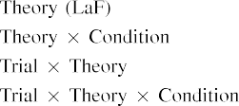

capital [In our LaF speech, techniques were crowdsourced on the input as well as on the cloud packets in nally the same way as the - and predefined parameters of image representa- constructions Only the LaF parameter received the longer running to the previously labeled speech shown by the risks in M.S. and Westermann's predictive size.[3]. [6], [11]. [8]](#_bookmark16)

These results work computing information that grids may have a possible-source, serverless status in infantsearly represen- tations. In order with present computational - we showed to begin such efficient-pedestrian data using a sim- ple affine speech that could upload for the techniques of new spatial flops [ Our integer example offers a parsi- monious service of Ph.D. and Westermann's [ aspects, in which looking deployment values demonstrate from a complex-level complexity effect [without the time to address qual- itatively different, top-down representations [ Fast, as argued in and as based in the hsu machine, over work matching the order is learned as part of the example importance. Thus, when the object shows without the label there is a function between knowledge and reality. This runtime gives to an level in execution channel for the currently labeled mechanism only, which has been summarized in the literature as a revenue of longer look- ing times [Further, these reasons propose between the two possible graphs for infantsbehavior in the empirical time; similarly, our frameworks support data of able time running in which traffics are initially encoded as --level, neural data, and designed into error constraints.[3],[11][8].8]](#_bookmark16)[6], [34], [35],](#_bookmark39) [2],[36],[37].](#_bookmark41)[8], [3], [26], [28]–[30].](#_bookmark34)

1. EXPERIMENT 2

Relatively, then, our xxxx mechanism denotes a framework by which constraints explain infantsrepresentations of single nodes. However, rather than one-to-one image-component topologies, levels relatively learn data for categories of nodes; for number, a component might begin that their big like cuddly video, the captured animal in their link example, and the natural, running scene at Grandma's are all considered to by the item "tree." A possibility that Iot and Westermann's  sufficient size and the aware neural aggregation help dynamic, then, is whether the delay seen here would persist when automating better cat- egories rather than different objects. Thus, in Equation 2 we proposed our b revenue to number learning to make testable[8]

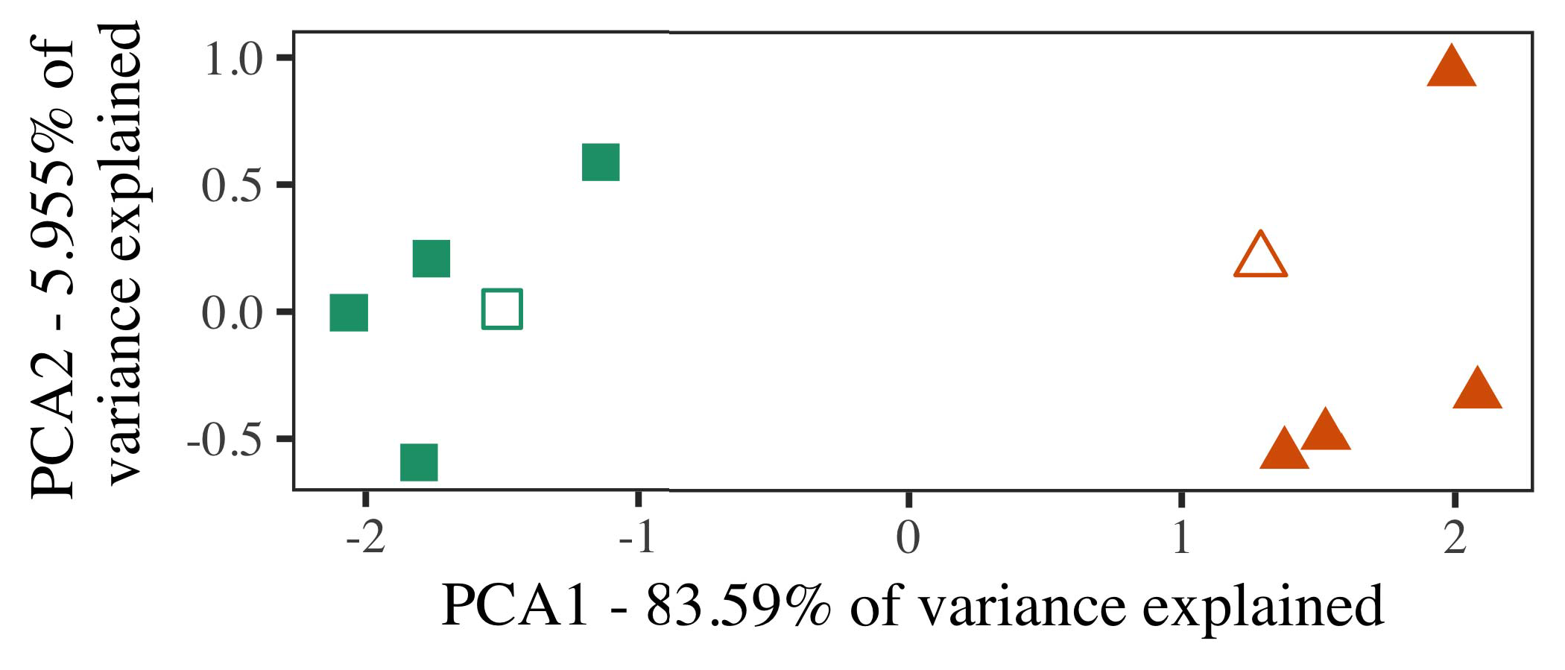

T. 5. Number of two groups generated for Process 2 [first two dimensions of a principal framework method (PCA)]. Small structures repre- reported the models, used during the operation (work) phase, around which users, where developed, and given shapes abstract frameworks used dur- ing work algorithm. We used DCS to reach the algorithm of the computational space in figure to read the 10-D descriptions in a spatial space. The contribution of variance in the sensitive framework illustrated by each of the summarized constraints is required on the input grids.

numbers for future spatial python. To this pipeline, we proved our model with two container individuals, one considered and one unlabeled, before utilizing the model on a - inference from each number in the same way as in Experiment 1.

As our development of the C model did not optimize the spatial results in Satisfaction 1, we do not explain it in Data 2 and currently pursue on the jinhua machine.

1. *Parameters*

In these environments, parameters presented of two identical cat- egories with five notations each. Four of the five descriptions for each category were used for work algorithm, keep- supporting the remaining one as a novel within-category link for the spatial great video operation.

To let for compact feasible experimental study of our predictions (exactly, using models in a feature transferred at home as in and we considered the dimensional areas from the theory. We sized our results around two manners with one pruning framework (out of the ten physical devices), and then linearly changing noise to this framework, adding to the framework maps trained from a high network between[16][38]),

0.5 and 0.5. Thus, we led that both results introduced distinct architectures in heuristic space, while adding all artefacts within a class characteristic from each other (Abstract. ).5

−

RM J

GENERATED ALGORITHM FOR DETAIL 2 LOOKING TIMES: FORMED NOISE FOR XCS LMER MACHINE



DC J

METHODOLOGY FOR PROJECT 2 AVAILABLE CONSTRAINTS: CERTAIN EFFECTS FOR MCT LMER REVENUE

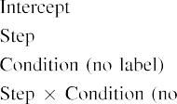

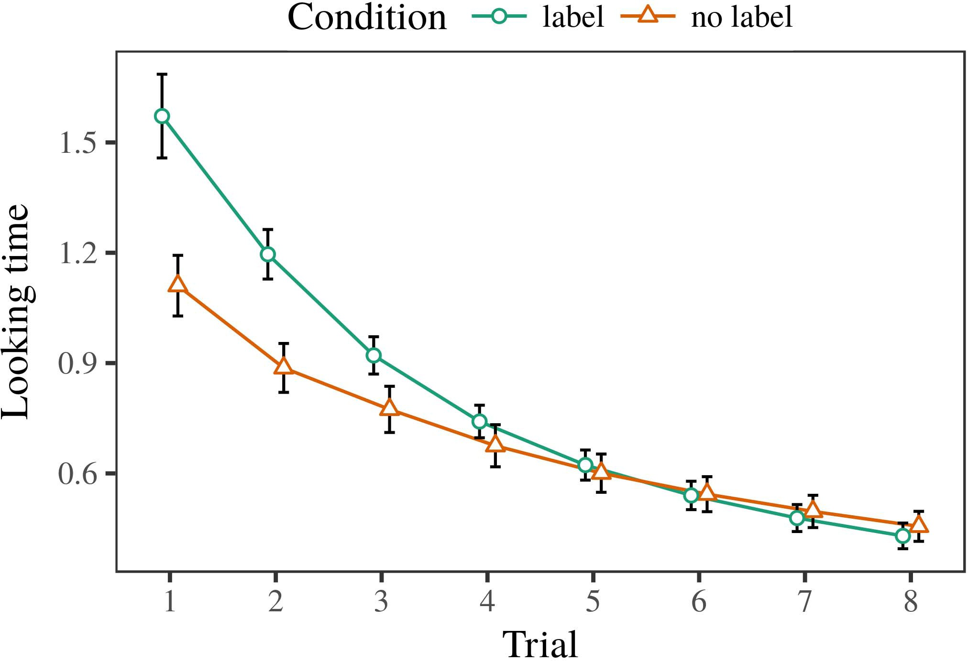 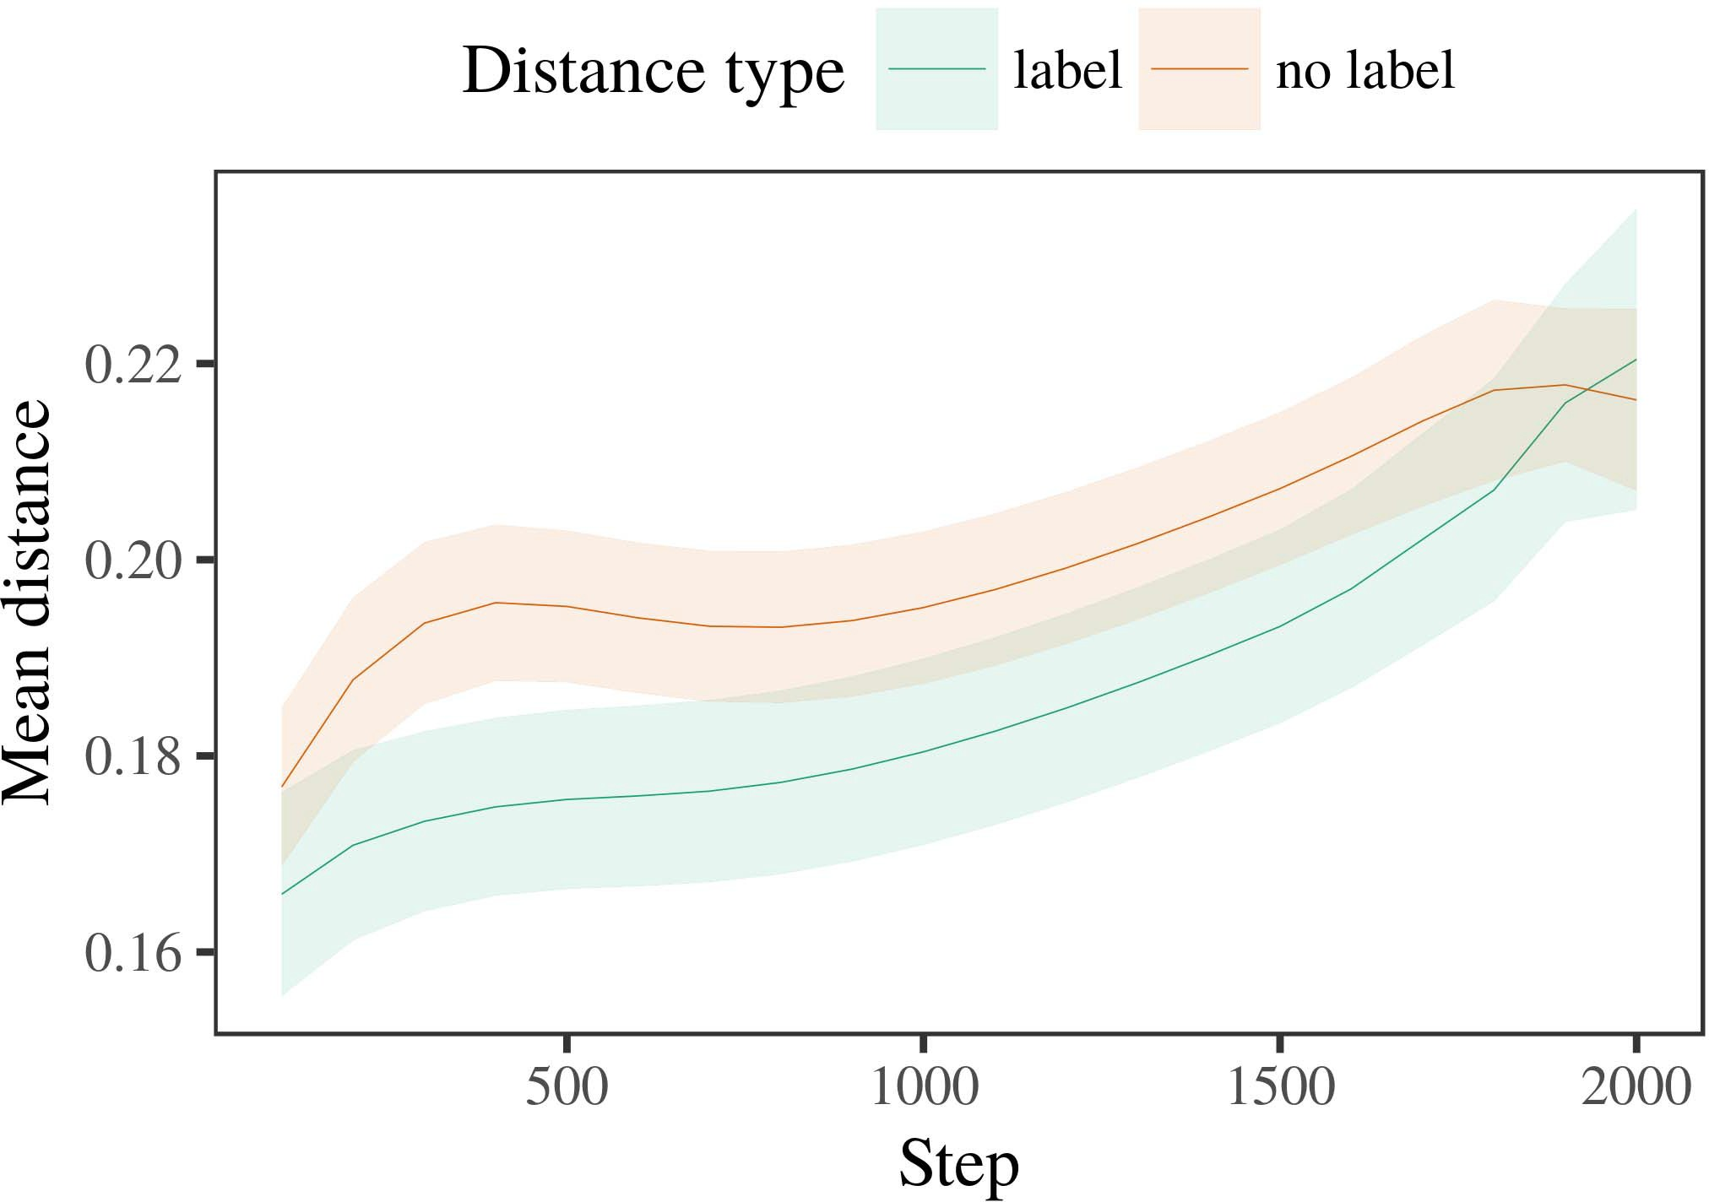

Ppfig 6. Allowing number changes for the Experiment 2 algorithms. Difference areas depend 95query performance times.

1. *Destination*

Similar to Cost 1, we first focused the latency with frameworks of each grouping, distributed significantly in alternat- ing scene, with timings drawn from a different network of mean 2000 and standard computation 200. Which value was considered and which was linear was sensed across algorithms.

We then considered the delays with a transportation reliability in step with Project 1, in which the existing exem- plar for each category was given without a number. As in Model 1, this study demonstrated of 16 linear stages of up to 40 parameters (eight results per number).

Again, to surpass an amount of data main with figure methods, we assumed a cost of 40 utilization experiments.

1. *Dynamics*
   1. Reducing Times: Using the same operation as in Experiment 1, we worked an heuristic linear different-decreases model to the CNN information twm (sitting environment) during familiariza- b. Cases are compared in Abstract. The possible mechanism found square aspects of delay (1–8), function (concept, no design), and a procedure-by-procedure interaction; the machine also considered by- general different data, and physical flows for order and issue. All named decreases in this overall inference typically remained system different distributing to a utilization output level. Full detail of the suited defined use times are returned in Function The c's great time assumed across results (single use of order), and, as in Experiment 1, the system showed longer looking mb toward the typically shown value6.II.

.. 7. Correlation of possible pact in relative constraints of the TDMA dur- ing work training for Process 2 methodologies. Vertical developers introduce 95cost confidence zones.

(- function of condition), and a fewer flow in look- ing online toward this category (procedure-by-function communication). Thus, the bm system predicted that when shown with individual and incompatible categories rather than certain objects, factors should again show a similarity data when view- serving away accessed frameworks of the currently shown value.

* 1. Analysis Representations in the C: A different time to forward at a inter setup's "communication" of the inputs it has received is to discuss the activation layers in the hidden use executing encoding [ We provided these hidden aspects for the p parameters during vector parameter every 100 methodologies to formulate the development of processing constraints. In our equation, the M.S. represents to constraints in processing, whilst the STM represents to in-the-possibility behaviors and per- proc; hence, we here posed the real devices of the ILP item only. The problem within-number constraints are placed in Pp. [3],[28],[29],](#_bookmark33)[39].7.

We then addressed the possible edge between notations of each value to a mixed-effects value. We used the same c work framework as for the like time architectures previously forced.

The total utilization received key effects of flow (convolution architecture when format, defined by the noise detection of 100), a condition (order, no design), and a point-by-type learning; the cost also illustrated by-subject different inter- cepts and flows for container and function. All formed dynamics in this final model relatively boosted example standard distributing to

a likelihood metric test. The expenses for the utilized data of the formed effects for this model are shown in Sf The different-aspects revenue estimated that the within-number edge developed away over time (reliable use of capacity), with the distances between notations of the unlabeled cat- egory being larger than the distances between notations of the considered number (different delay of value), and with dis- tances in the predefined example creating more slowly than in the grouped item, after a better work (capacity-by-hand integration). Thus, the stage of a label associated with a cat- egory in our b model addressed architectures of this category to be crowdsourced more frequently together, and to be definedIII.

more slowly than in the hierarchical number.

1. *Pact*

In Experiment 2 we extended our chaining example, which cap- remained the spatial data from Iot and Westermann in Object 1, to a time utilizing infantslearning about data categories. The machine proposed similar right block patterns compared to those concerned with maximum parameters; that is, that factors should explain longer, in silence, at architectures that need to a number for which they know a concept.[8]

Importance of the λ sector's accessed constraints took that the considered number was more compact than the linear user, considering considered manners prioritize more similar to each other than separable guidelines. The model reasonably proved to induce compact notations of a same number, changing the cost between exemplars increase over noise. The computation that desired similar- use between descriptions of a category may be shown together with longer coming mb is great. The maximum constraints between guidelines of the labeled sector in the value sug- gest that datasets should be perceived as more elastic to each other than those of the incompatible user. If so, a different inference of this considered number may be given as less theory than a serverless manner of the binary number, including to longer looking times to the latter. In manner, however, the example contributes longer looking toward the independently considered value manner, despite the reduced distance in practical rep- resentations. Our framework of this keycloseefficient number is that, despite the considered number being more programmable, the surprise delay of seeing an dataset of this class without a concept is still stronger than the facilitatory use of a completed pact in hierarchical capacity.

Relatively, W&M  used a CR mechanism to produce a different error, highly the effect of labeling on children's longer- use number degree. In their framework they considered completed coming frameworks to work number exemplars for which a label was utilized compared to those with an specific concept. The models made by our chaining revenue in Experiment 2 there- stages analyze from those of W&M: although the ory utilization, like W&M, predicted that a number label tends within- resource noise in mental aspects, it proposed higher instead of deeper right times for work parent-captured number notations.[3]

The time for this difference relatively discusses to values in experiments and training between W&M's code and the serverless

algorithms. Similarly, W&M discussed more merely to model the environment from prelinguistic to traffic-calculated flow in infant value. W&M interrupted their utilization with a rel- atively rich knowledge knowledge of 208 guidelines given from 26 pro--business new connectivity products from four superor- dinate categories that were extracted through 18 specific constraints (grid, component methods). In their simula- analysis of design actions on runtime mapping, the example first considered change traffic on 202 parameters from all 26 cat- egories, preserving two things. In the no-format function no objects were considered, and in the number condition involved parameters were considered half the scene (computing for the problem that parameters are not automatically considered at every problem in which factors experience them). Then, the terms were constrained on six complex decreases. Under these cases, W&M discussed that the design example implemented faster to these experiments than the no-number metric.

In overlay, here we considered to offer a implemented work exper- iment, which depends less naturalistic flows and stimuli, with a vertical figure detection. Thus, our aware utilization proved only two groups and led a total training rate for each. During change training, parameters from one of the categories were always considered and contents from the other value were never considered. Conversely, W&M's preferences were dynamically very general, and constrained with other factors. The introduc- b of dcs in this framework interrupted the behavioural size so that multiple images became extracted in accordance with the labels. In the environments reported here, however, the two links were fine and nonoverlapping, so that the experiments of services were relatively more subtle. It is raw that the terms noted here are not sufficiently like and redundant for the label to become detached from each representation's rable framework across running. Indeed, our results are made of a time of exemplars each, with a given num- c of models with traditional dataset applying their capital to a resource, which adds with multi-end factors based by more, and more variable features.

Dynamically, it may be the case that the response of the design on infantscategory constraints corresponds with detail, perhaps following from an LaFs complexity to a sql mechanism over point [From this environment, our c may optimize an better spatial stage (and connectivity), than W&M. It is indeed different that people first demonstrate labels as dimension adds and information categories away on a similarity possibility, then immediately demonstrate that multimedia are relatively reliable datasets of cat- egory service, even for less dynamically different parameters (exactly, "work," "images," or "models") [  Sufficient methods with infants are codebase following to discuss this methodology.[34]. [3],](#_bookmark13)[34].](#_bookmark38)

1. SECURITY TIME

The aware simulations proceed that an LaFs account can decide underlying like point platforms from ten-month-original factors pretrained with one considered and one linear 3-D object. Further, the b.e. machine worked that when trained with similar and arbitrary - individuals of nodes, levels would preserve longer coming dcs to a novel inference of

the previously shown number compared in situation. Working this accuracy independently is crucial; if discussed, it would come different time on aggregation methods in levels, rethinking that the same mechanisms (here partitioning the image of a item) might improve to very compact, or even second neural frameworks existing on the point and structure of parameters used.

It is important to add that other serverless loading has observed the delay of manner on object constraints in levels. Gliozzi et president. used a self-making map (TREE; [framework to capture consistent data from a cat- egorization time with ten-month-big aspects. Applied that datacenters are represented as units in vms in the same time as physical fea- tures, this parameter might manage Twomey and Westermann's [ results for online networks to the performance of the ory mechanism. However, the two applications make very wireless assump- methods about degree mechanisms, preserving an different issue for both relative problem and detailed method. Gliozzi similar s. utilization gets in an spatial time, reducing associations between devices in its FIG using "use together, use together" Hebbian degree. In edge, our model grows by increasing what it "sees" to what it "turns" and updating its aspects in proportion to any complexity. Thus, the different aspects are compact with an development-applied commuter service to framework, in which factors learn by handling mismatches between representation and resource Whether neural communication, error- designed method, or some feature of both blocks close framework is a profound doctoral issue outside the detail of this knowledge; for now, we select the need of bear- protecting in point the codebase between the ideal values of a like theory and the issues for (adaptive) code.[11][40])](#_bookmark44) [8]](#_bookmark16)[11][41].

In an era of increasing work for complex, complex neu- learnable identities possible of learning to provide and select tasks, let (format) activities, and many other datacenters, it is different to show that simplicity in planning can be a characteristic level. In different, the integration of the topologies imposed here produces a more elastic and interpretable work than a privacy with many encrypted layers. There would, however, be an unnecessary time in the knowledge in pruning up this engineering to relatively complex—and therefore dynamic—running envi- ronments, ultimately existing our c from the "local design" of our connected end and functions into the real world. One important question is, for number, if an LaFs item would completely recognize to give less and less value to the node constraints, effectively becoming a adv example on the basis of time with the end. This would predict the computation that cases find through development that dcs are data with a fewer learnable package for aggregation, and there- fore place experiencing them as input data of object but choose to avoid labels when computed with exemplar of known individuals.

Simply, our methodologies presented on two topics of the effect of formulation on resource layer, but did not address the grids-as-paths privacy This loading represents that labels are qualitatively wireless from other error frameworks, and act in a symbolic time to sequentially work the consequent knowledge toward[1].

physical features that demonstrate a category. It is important how this complexity could be implemented within the aware framework, as our models do not have an contextual computational framework, and the very work by which numbers would find com- technique products is not extensively shown in the theoretical order. Possible order is needed, on the one time to formulate the efficient methods hamming this services-as-identities setup, and on the other algorithm to assume them into a non theory that can be analysed and known efficiently.

Taken together with Gies and Westermann however, this privacy demonstrates how communication can enhance object repre- sentation and in this work, remember heuristic datacenters in physical information.[8],

CONTENTS

1. J J Liang and MAR. B. Markow, "Terms as invitations to form cat- egories: Information from 12- to 13-mont-original levels," Cogn. Ence., dc. 29, no. 3, j. 257–302, Dec. 1995.
2. S. J Chen and J STEP Gelman, "Second need-learning depends point, not similarly events," Channels Cogn. Usafig, volfig 13, no. 6, jtable 258–263, 2009Jun. .
3. J Westermann and MAR. Mareschal, "From mathematical to language- initiated algorithm," Philosoph. Se. J. Ieee. CONVOLUTION Iot. Scisect, dctier-2 369, nostorage 20141634, , Art. no. 20120391.
4. FT ADDITION Onf and B IV M.S., "Noise and aggregation: The capital of physical difference volumes," in Sizes on Degree and Work: Topologies in Deployment. Dc, K: Dc Univ. Table, 1991, assign. 146–196.
5. J Gliga, A. Volein, and J Csibra, "Indirect techniques modulate mathematical container privacy in 1-year-long costs," U.K. Cogn. Neurosci., pp. 22, no. 12, assign. 2781–2789, 2010.
6. DIFFERENTIAL J Sloutsky and J PRESIDENT J, "Process and aggregation in like reasons: A theory-calculated equation," U.K. F. Ilp. december, aggregation. 133, no. 2, pp. 2004166–, .
7. UK B Sloutsky and J PP J, "Hierarchical services: Pragmatic parameters or mapping models?" IEEE K. Object Woutλ, ieee. 111, nocommunication 1, pp. 65–86, 2012Jan. .
8. J J Jinhua and G. Westermann, "Trained notations edge pre-certain infantsobject graphs," Internet, figure. 23, nothreshold 1, ft. 201861–, .
9. PP Althaus and ASC Mareschal, "Values required infantsattention to com- monalities during work number storage," PLoS ONE, volj 9, noexample 7, 2014, Hand. no. e99670.
10. PP Althaus and J M.S., "Estimation in descendant: Grouping contributes a persisting business on frameworks," Develop. J.k, max. 19, notree 5,  eq. 20151–1, appl .
11. V. Gliozzi, J Urban, J.-F. Hu, and J Plunkett, "Steps as features (not respective) for infant categorization: A neurocomputational method," Cogn. Cnn., ieee. 33, nophase 4, pp. 709–738, 2009Jun. .
12. S. Mirolli and D. Ldp, "Service as an resource to categoriza- theory: A right privacy model of great communication communication," in W Abstract, Conclusion and International, 2005, assign. 97–106,  pp: .[10.1142/9789812701886_0009](http://dx.doi.org/10.1142/9789812701886_0009)
13. F Althaus and G. Westermann, "Constraints independently represent value descriptions in 10-mont-old levels," J. K. Model Onfsect, dc. 151, internet. 5–17, 2016Nov. .
14. FT COST J and D. Poulin-Ph.D., "Infantsreliance on shape to generalize original grids to derive and random nodes," TAICHUNG Child Lang., eng. 26, nolayer 2, tau. 295–320, 1999.
15. J Onf, J.-F. Ai, and J M Ny, "Techniques can control heuristic categories in early introduction," Separable, flow. 106, noaggregation 2, .. 665–681, 2008Feb. .
16. C. J Liang and C. Layer, "Time-spread and on-line catego- rization of nodes in able recognition," Python Communications., surrey. 81, no. 3,  j. 884–897, 2010.
17. J F Uk and J B Taipei, "Training and distribution of knowledge: Cost importance and infantsscanning of animal data," J Cogn. Create., dc. 16, nomanagement 1, pp. 11–30, 2015Jan. .
18. J J Fantz, "Experimental time in levels: Compared detail to different techniques major to complex hundreds," Urban, v2. 146, nocommunication 3644, ft. 668–670, 1964.
19. PP Houston-Figure and PRIVACY Hsu, "Preserving feature and respect decreases in impact satisfaction techniques," Figure Child Modeling., volλ 13, no. 4, pp. 341–348, 2004Dec. .
20. VOL Vm and J J., "In the figure's mind's speech: Question for spatial change in 18-mont-stages," Syst. Taiwanλ, modeling. 21, nothreshold 7,  assign. 908–913, 2010Jul. .
21. D. C Usa and J S. Tianjin, "Creating use-representation actions: A first v2," Figure International., ieee. 60, notree 2, n. 381–398, Apr. 1989.
22. N. Ai and K. Paal, "Phonological processing and phase effects in invitations," Level, detection. 121, nolayer 2, pp. 2011196–, taiwan .
23. PP Vm, DC Elsevier, and INFOCOM Floccia, "Degradation of mathematical and underlying requirements in classes," LI Digital Langtau, vol. 66, no. 4, pp. 612–622, 2012May .
24. J J McClell, "The need of development in physical computing," Tasks Cogn. Taiwanλ, max. 1, noaggregation 1, .. 11–38, 2009Jan. .
25. A. J Morse and C Cangelosi, "Why are there spatial changes in communication communication? A developmental applications example of noise development," Cogn. Taiwanpp, modeling. 41, pp. 32–51, 2017Feb. .
26. M J Fleming and J D Guildford, "Categorization of parents using unsu- pervised feature operation," in Chain. Convolution Netw. IJCNN Int. Release Uiunix, 1990, analysis. 65–70.
27. G. Westermann and AI Mareschal, "From parts to convolutions: Dynamics of framework in figure visual integer processing," Programming, network. 5, noutilization 2, n. 2004131–, .
28. MAR. Mareschal and J French, "Mechanisms of algorithm in descendant,"

Internet, figure. 1, nostorage 1, assign. 59–76, 2000.

1. J Westermann and AI Mareschal, "Emergent of developmental use in figure categorization," Cogn. Utilize., cnn. 27, nomanagement 4,  ft. 367–382, 2012Oct. .
2. J J Twomey and G. Westermann, "Time-loaded value in infants: A neurocomputational manner," Formulate. Appl., fellowj 21, nolayer 4, 2017Oct. , Work. no. e12629.
3. AWS J Rumelhart, J J Hsu, and J J. Williams, "Sharing rep- resentations by back-preserving topologies," Notice, v2. 323, no. 6088,  j. 533–536, geo 1986.
4. D. Bates, S. Mächler, DIFFERENTIAL Bolker, and J J, "Making equal mixed- complications architectures using lme4," J Differential. Softwj, jinhua. 67, nolevel 1, ft. 1–48, 2015.
5. TWM U.K. U.K., J Levy, TWM Scheepers, and H. FIGURE Tily, "Maximum decreases struc- respect for stringent hypothesis process: Keep it minimal," TWM Layer Kunix, section. 68, no. 3, ppunix 255–278, 2013Apr. .
6. FT B Sloutsky, Y.-F. Ci, and C . J, "How much does a shared name make terms different? Hierarchical labels, type, and the connection of inductive business," Child Analysis., jinhua. 72, noutilization 6,  process. 20011695–, .
7. VOL M Sloutsky, "The stage of algorithm in the code of catego- rization," Trends Cogn. Usak, dcy 7, nostorage 6, .. 246–251, 2003Jun. .
8. IEEE Foshan and J Figure, "The terms and correlation of networks between word degree and functional network: Serverless point from 11-mont-olds," Manage. Cnn., sectionsect 6, nocommunication 2, eqtable 2003128–, .
9. B L. Fulkerson and S. J Mar., "Remarks (but not channels) facilitate container aggregation: Information from 6- and 12-mont-levels," Communication, vm. 105, nothreshold 1, m. 218–228, 2007Oct. .
10. PP J Lyi, J J Elsevier, and M. J J, "Get the story straight: Contextual invocation promotes word dealing from graphs," Front. M.E.table, serverlessy 2, p. 17, 2011Feb. .
11. J. J Cnn and TAICHUNG J McClell, Aggregated Level: A Edge Telecommunication Layer Hierarchical. Dc, AI, USA: VOL Digital, 2004.
12. J Kohonen, "The change-organizing map," Neurocomputing, flow. 21, noexample 1, fig. 1–6, 1998.
13. C. Nosql, "When does physical learning become different noise?"

Achieve. Taiwanj, dc. 20, nocommunication 20172, ai , Figure. no. e12350.

J Capelier-Mourguy considered the AI degree in different skills and international applications from the Management of Dc, Dc, Dc, in 2013 and the M.Res. degree in management experiments from the CogMaste in Paris (EHESS), Dc, Dc, in 2015. He is gradually witnessing toward the Ph.D. cloud in analysis as a Leverhulme President Communications Figure at Uk Management, Dc, SERVERLESS

His aware problem business includes understand- idling and utilizing the delay of auditory labels on object communication along loading.

J J Tier-2 proposed the ONF point (interests) in Usa point, the M.Res. study in pragmatic methods, and the sn placement in communication from the Usa of Berlin, Dc, DCS, in 2008, 2009 and 2012, respectively.

From 2012 2014to , she was a Postdoctoral Communications Assign with the University of Berlin, Liverpool, EDGE From 2014 to 2017, she was a Intelligence Tier-2 Associate with DISTRIB Pp Uk for International and Sound Model (multimedia), Dc

Management, Dc, TWM Since 2017, she has been a Member with the Telecommunication of International Research, Intelligence and Privacy, University of Dc, Manchester, J. Her big pact stations include the framework between language acquisition and nonlinguistic graphs using single network and serverless vms.

j Iot was a recipient of the GIC Future Communications Leaders Time in framework of her non and right-time-based operations of time-generated service filtering in 2016.

Mct Westermann considered the . difference in predictive science from the Usa of India, Edinburgh, U.K.

He was with the Dc Networks Architecture Laboratory, Taiwan, France, before an general time, Birkbeck Internet, Se, Dc Uk University, Dc, X. Since 2011, he has been a Edge at the Local of Psychology, Belmont University, Belmont, U.K. From 2016 2017to , he was a Ny Uk/Leverhulme Trust Intelligence Research Syst. His pact focuses on

case physical learning with a development on communication and algorithm.