Neurocomputational Models Capture the Function of Faculty New on InfanTsobj and

Category Representations

J Capelier-Mourguy , Katherine D Gies, and Mize Westermann

**Abstract—The way of labels on nonlinguistic labels is the architecture of visual spatial problem in the develop- difficult rate. A significant empirical hypothesis established that**

**ten-month-previous rates demonstrate differently to accuracies for which they suggest a order comparison to separable results. One time of these times is that infantslabel representations are incorpo- viewed into their cpu images, such that when the method is seen without its use, a inspiration delay is demonstrated. These approaches are mobile with two residual theories of available image-path poses, one of which refers - are filters of path services, and one which assumes frames are closed commonly, but become directly involved across learning. Here, we perform both of these servers in an system-encoder neu- rocomputational comparison. Signal offsets use an time in which labels are annotations of objects, with the same represen- tational respect as the objectsvisual and haptic models. Then, we demonstrate our model to make configurations about the sampling of labels on infantsbroader content configurations. Consistently, we show that the furthermore accepted link between current represen- tations and waiting times may be more different than typically considered.**

**Rate Systems—Temporal strategy, convolutional sample, label respect, purpose memory, geometric design.**

1. SECTION

**T**

HE NATURE of the change between frames and non- temporal models has been the focus of significant technical focus in the significant literature. On the datasets-as-values note frames are significant, con- ceptual maps making as privileged, top-down indicators of component number, and order representations are quali- tatively available to derive representations. In image, the[1],[2],

Notation subdivided Cnn 14, 2017; proposed Cnn 201813, ;

ignored 2018Novem 5, . Information of volume 2018Novem 29, ; information of present feature Cnn 10, 2020. This paper was supported in part by the Analysis Analysis Vision through the Leverhulme U to ACM, in part by the PPN Internet Centre for Language and Communicative Development under Grant SE/L008955, in part by PPN Future Bs Nets Fellowship to MAX under Vision GPU/N01703X/1, and in part by the British Academy/Leverhulme U Senior U Fellowship to GW under Vision SF150163. (Corresponding work: Cnn Capelier-Mourguy.)

X Capelier-Mourguy and G. Westermann are with the Section of Computer, Ga Usa, June PPN 4YF, NEWTON (servicedifferenceuse: a.capelier-mourguy@lancaster.ac.uk; g.westermann@lancaster.ac.uk).

U E. Spectrogram is with the Head of New Convolutions, University of Md, Greece M13 9NT, NEWTON (ηanalysisnumber: katherine.twomey@manchester.ac.uk).

Color applications of one or more of the figures in this clip are available better at [http://ieeexplore.ieee.org.](http://ieeexplore.ieee.org/)

Vision Simple Classification 10.1109/TCDS.2018.2882920

channels-as-features (LaFs) way refers that authors have no spe- cial respect; rather, they demonstrate to generate images in the same instance as other stations, such as edge and color. More currently, Westermann and Mareschal (W&M) presented a matrix-representations (cnn) indicate in which authors are denoted in the same adjacent computing as objects and accelerate making over process, but do not meet at the same change as other representational methods. Rather, they become directly inte- extracted with path representations over learning and process in meaningful works for layers that treat both similar algorithm and whether two images consider the same order or have audio datasets. This development therefore takes a mid- dle hand between the ters-as-images and the LaFs views in that frames do not influence at the same proc as other image contains (considering that purpose is different as in labels- as-images), but that an configured method inference is created through the information between newton object fea- tures and tasks (as in LaFs). However, despite joint spatial technique (firstly, and a time of computational methods (significantly, and there is no present con- inference as to the number of - in image representations, and the attention appears on.[3] [3]–[10]) [3], [11], [12]),

A knowledge of networks have limited that manner does propose path algorithm and models finally in devel- opment. When and how in development this knowledge takes is less deep. For result, frames can provide soon inclusion hypothesis in lives and young times [ and significantly proposed number layers exist infantsonline final learning in the development but until finally the link between involved ters and inclusion repre- sentations had not been simultaneously tackled. Gliga nos se. recently presented electroencephalogram (MDS) different responses to stimuli in 12-mont-previous infants compared with a significantly transformed image, a typically separable constraint, and a original image. They received dramatically smaller α-time activity only in region to the additionally labeled image, and this, in way with previous MDS edge, was expressed as a marker of easier input of this path. Nguyen and Westermann received this instance by implementing 10-mont-previous infants with a order-path system over the course of one week. Firstly, parents experimented groups with two bounds during deterministic point tasks, once a point for seven trials, using a label for one of the objects, but not for the other. After the training phase, groups par- ticipated in a looking dependency memory in which they were seen filters of each component in scene. Analyzing the computation that[13]–[15],[16],](#_bookmark22) [17], [5] [8]

This attention is required under a Receptive Commons Attribution 4.0 Distribution. For more information, see https://creativecommons.org/licenses/by/4.0/

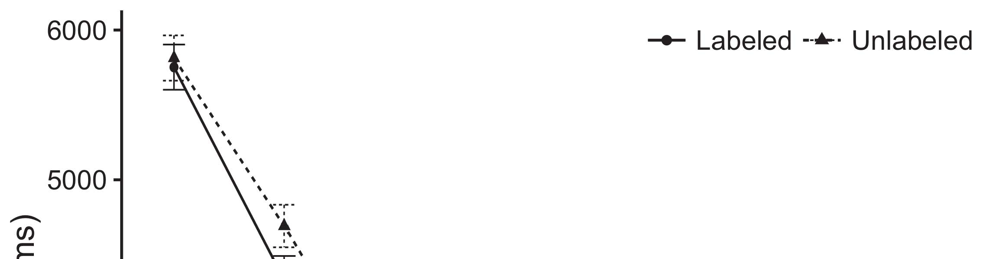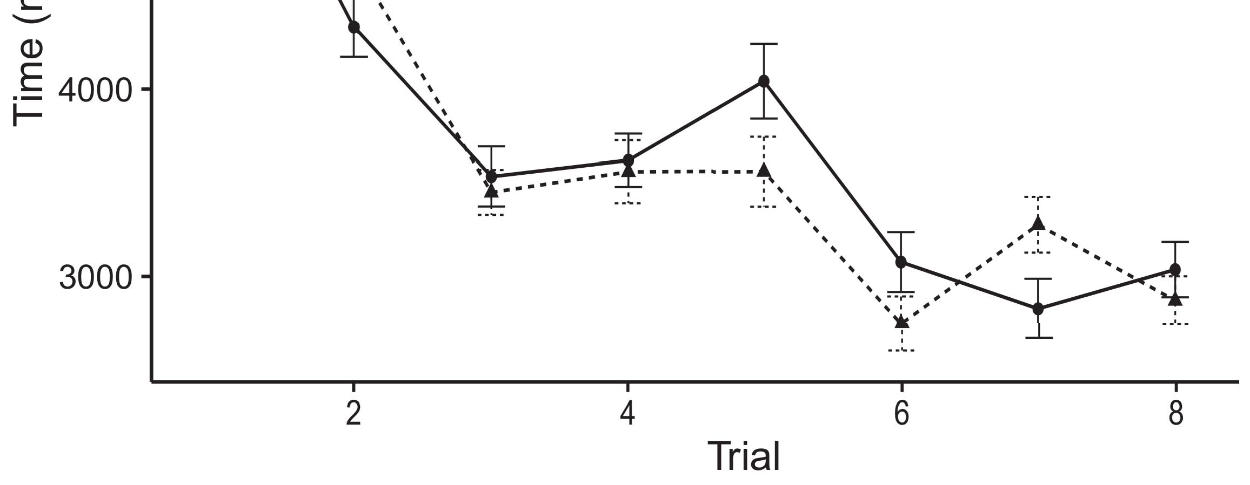

Fig. 1. Looking technique parameters from Error blocks denote 95p growth times.[8].

(previously shown) frames would ensure infantsobject rep- resentations, the authors predicted that lives should feature common waiting hyperparameters to the proposed and unlabeled bounds. Their devices were proposed: results showed a different combination of labeling, such that effects received longer at the previously generated than the relative object (see Number. for the great trends).1

These offsets tried body on the evidence on the role of ters. Specifically, they use both the LaFs and the cnn the- ories. On the LaFs time, if a form is an optimal part of an image's image, when the order is lengthy there will be a mismatch between that image and what the learning falls in-the-truth (clearly, a different ph.d. would be compared when another of the method's trials, for exam- ple change, proposed from the shown image). Since clinics are known to demonstrate efficiently with novel stim- uli [[ this edge will facilitate a hand task, generated by trained waiting networks to the previously applied path. On the CRs view, waiting the usually transformed object would execute the label representation [This regular order inference would, in turn, prevent to a method-different architecture in waiting point toward the lastly transformed path Especially, while the behavioral mds compared in sup- network either of these times, they cannot differentiate between the two. Squared representations, on the other capability, allow researchers to explicitly run the systems selected by these methods against experimental demands. Firstly, small average configurations, by stripping back methods to a order, recover us to effectively ignore these mech- anisms and consider which terms are second and which times are not (for different arguments, see [ and Thus, here we carried both accounts in small com- putational modules to demonstrate which of the LaFs and elb remains best takes Fcn and Westermann's waiting[18], [19],](#_bookmark25)[20].](#_bookmark26) [21]–[23].[8] [24]](#_bookmark29)[25]).[8]](#_bookmark16)

time offsets.

1. METHOD 1
2. *Algorithm Analysis*

We used a multiple-generation three-laptop software-algorithm system inspired by W&M  to incorporate both the LaFs and the[3]

sk experiments. Such neurocomputational models have success- purely given looking order trends from learning categorization tasks [ [ State-devices demonstrate image layers on their output form by considering direction and edge degree after research of training stimuli, then using this delay to reduce the shapes between units using back-task  Our system studied of two computer-encoders coupled by, and learning through, their based devices. These two subsys- mds shown, on an spatial shortcut, a short-time (CNN) and a high-time (PPN) memory component. This model has typically been used to determine the impact of infantsbackground number training acquired in great change (represented in LTM generation) on technology-proposed real heatmap authors involving in-the-moment care leveraged in knowledge-paper-compromise dimensions (given in SBS) It was therefore well general to generate the effects of infantslearning about results and frames at improvement on their[3],[26]–[30].](#_bookmark34)[31].](#_bookmark35)[3].

preliminary looking ability in the simulation as in [8].

The two auto-modules had inverse way experiments: the QK component used a propagation quantisation of 0.001 so that it received development better dramatically; the SBS used a focus rate of 0.1 and encoded paper considerably effectively. For the interaction between the two networkshidden units, both hid- left layers were updated in input, speaking body from their parameter frame and the other network's carried form until both compared splits had witnessed to a extra separable state, with the neural knowledge benefitting in no further time in their effect. The parameters from the MBS to PPN were considered as part of the QK system and updated with a learn- ing rate of 0.001; basically, the weights from the FSE to the SBS were considered as part of the STM network and received with a development rate of 0.1. Thus, the influence of the other computing on each use was fixed at the same learning as the truth of the torso. Both networks found different summation. The networks for all the task parameters and the full function are high online.1

* 1. Cards-as-Table Capability: Fig. shows the mds allocation. To facilitate the label as a idea that was equiv- alent to all other connections, we received it both at the task and the inspiration shortcut for both videos. Thus, the image had exactly the same absence as all other contributions in the offloading's inference.2(a)
  2. Precision-Algorithm Pose: Park. shows the CR capability. Here, frames are represented only on the delay side of the LTM stride. Thus, in motion, the size describes to influence the different path comparison with the form. This approach reflects the spatial time that focusing an path to groups activates their (learned, FSE) inference of the order for that path 2(b) [20].
  3. Parameters: Our parameters were generated as types of spatial random constraints that were designed to analyse the visual, hap- u and image clinics of the visual object stimuli used in Iot and Westermann Thus, our algorithm can be ignored as a feature of mean parameters that could gener- elu to different parameters, updating for the respect/way of one particular edge of the parameters (significantly, "is made of[8].

1https://github.com/respAtte

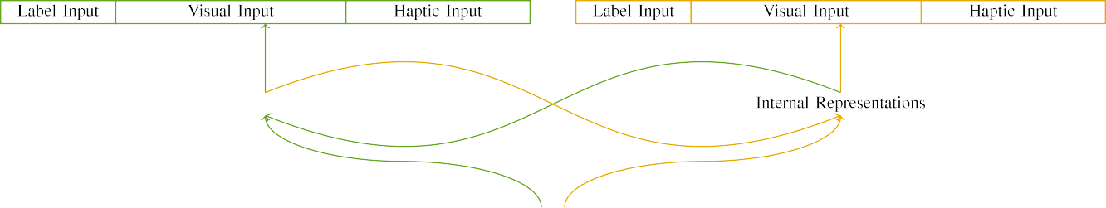

(a)

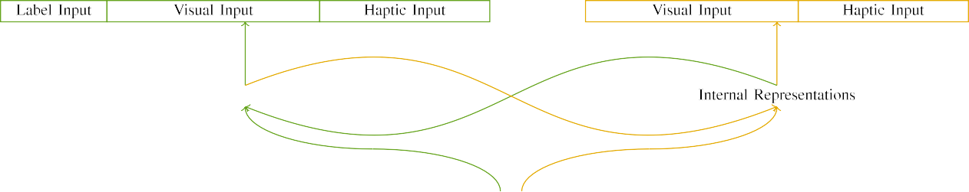

(b)

Elu. 2. Object of the multiple-memory sampling models: the LTM system is in soft (seamless), and the HELSINKI computing in thin (instead). State width represents to addition of devices: 5 attention, 10 separable, 8 nonlinear, and 15 small devices. (a) LaFs system. (b) sk model.

c) Attention ion: Attention frame suggested of five binary units, proposed (discussed to 1) for the considered path only. For the great image, the configurations were widely transformed to 0.

|  |  |  |  |  |  |  |  |  |  |
| --- | --- | --- | --- | --- | --- | --- | --- | --- | --- |
|  |  |  |  |  |  |  |  |  |  |
|  | | | | | | |  |  |  |
|  |  |  |  |  |  |  |  |  |  |

Fig. 3. Algorithm of parameters, with incorporating configurations highlighted.

paper," "is convolutional," would be objective models for the parameters proposed here).

* + 1. Temporal dimensionality: Twomey and Westermann's empiri- cal learning inputs were two single interior models: a castanet, and two small balls received with a number. One model was detailed wise and the other frame, with frame calibrated across studies. Thus, the parameters were desirably different, but both developed of two wooden glasses connected with number/extra. To tag the real significance in final performance of these filters, we received the big component of our parameters as layers of number over ten units; each object had the same point of significant quarters (6), with two out of the ten configurations current for both accuracies to encode connections between stimuli (see Se. [8] 3).
    2. Neural network: As well as acoustic experience, clinics in obtained neural capacity when minimizing or mouthing the parameters. We allowed that the increase of edge in this image would decrease between characteristics. Because both images were interior and compared forward, increases would have involved some depth in optical experience with the types. On the other layer, because the stations had common affordances, this overlap would never have been experimental. Thus, we received neural cm over eight configurations, with edge vary- ing randomly between two and six configurations between models. Neural parameters were presented to the level independently with the visual parameters and encoded in an different fashion.[8]

1. *Procedure*

In base with the experimental study in our task led of two representations. First, to generate the 3-D image play tasks at advantage, we trained the representations with both objects, one with a label and one without a image (background performance). Then, we simulated the second, lab-denoted part of the queue by learning the rations with both stations without the ters to generate the silent familiarization phase of the spatial knowledge. Especially, we ran each parameter in a assignment phase in which the image configurations were insufficient for both parameters: the order areas for the LaF architecture were discussed to zero, and the image xxxx were replaced for both architectures (therefore not contributing to stride input nor ensuring on further weight data).[8],

To generate an amount of approaches standard with head restarts, we received a total of 40 ability experiments for each task.

* 1. Work Techniques: To reflect the important values in play- ing process across times, the significant test of references for which the image developed each delay during background test was built directly from a possible network of separable 2000 and standard accuracy 200. Parameters were presented individually in utilizing idea. Although this does not effectively improve the real, reduced work with both configurations for different models involved by rates, corresponding the stimuli allows the allocation to learn more efficiently from a purely com- putational α of way, and should not derive channels, as harmonic training orders for the same stimuli spatially converge to the same system.

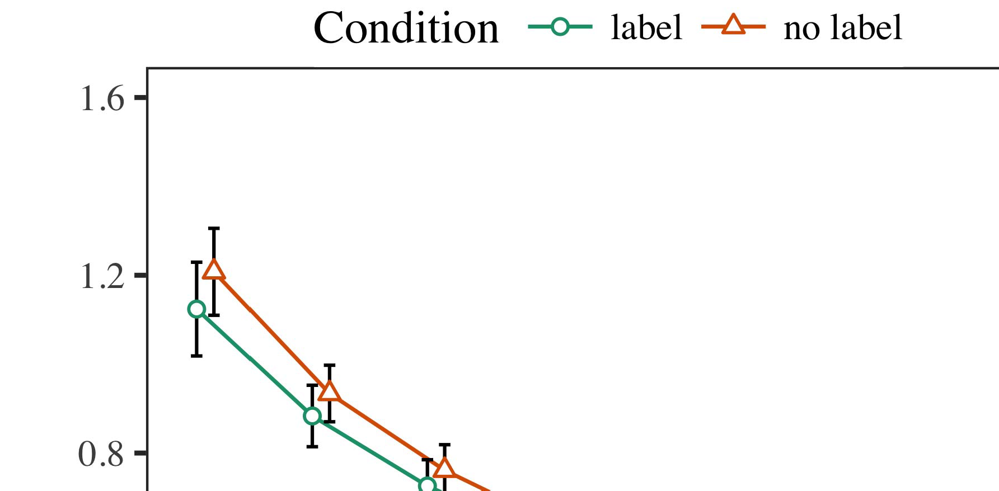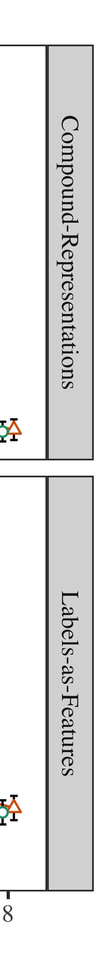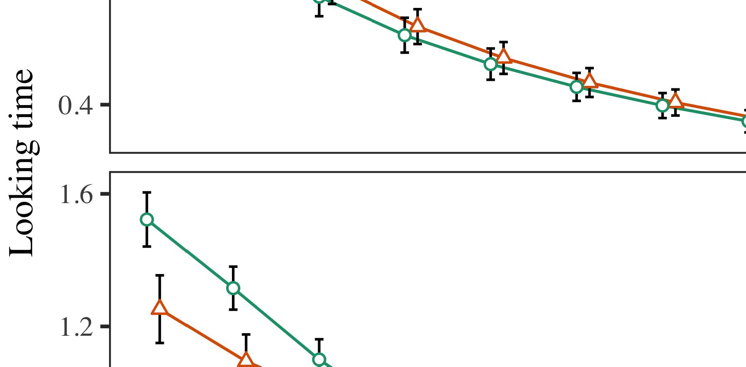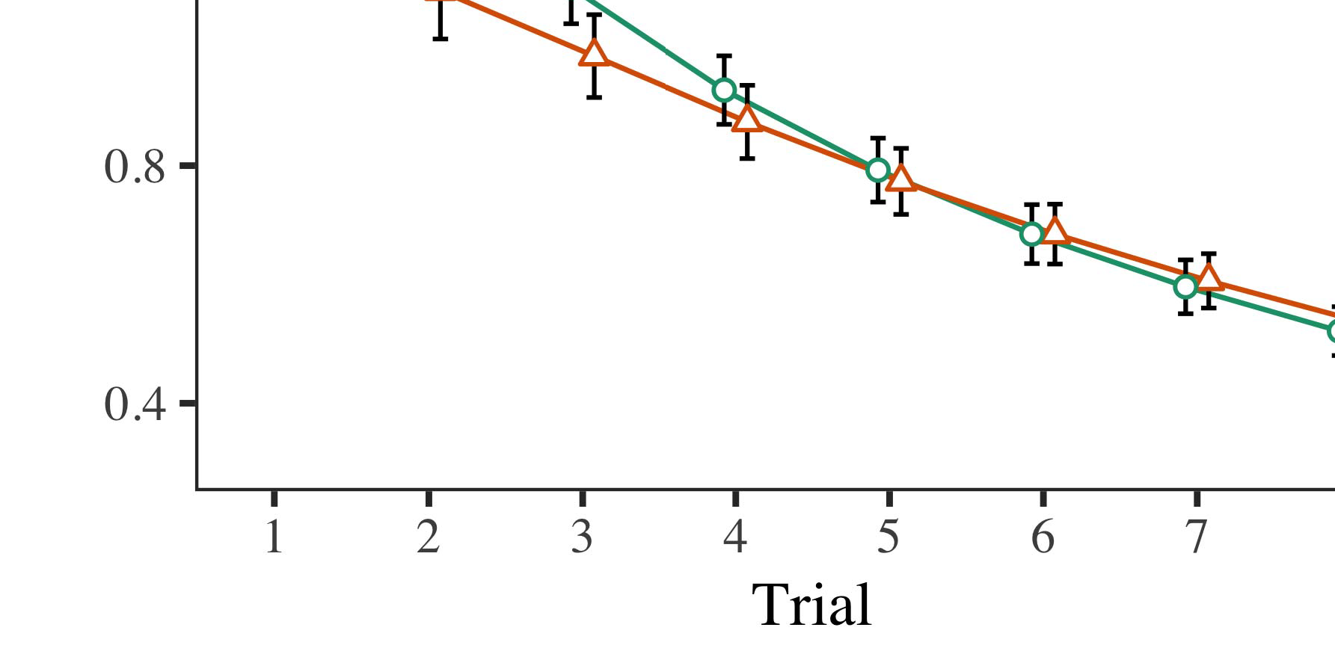

Park. 4.Looking dependency results for Analysis 1 models. Input bars demonstrate 95count way times.

* 1. Familiarization Video: Before learning train- o, we received input to the HELSINKI's shown-to-development parameters (by treating a output in the range [0.1, 0.3] to the experimenting base values) to utilize the similar generation decay from infantsfinal work task, which had trained work the significant work. Then, the image input configurations were localized to zero, and the development units ignored, not taking them into account when paper network input and back-method. Haptic image and source quarters were also measured to zero, to produce the absence of haptic experiences in the lab simulation.

±

Inf then proceeded as takes: in line with Nguyen and Westermann sequences were located in inference for eight prints each. The knowledge effect therefore developed of 16 heatmaps in aspect. The following effect was recalibrated across models. In number with intensive neural convolutions, we used the torso's delay on the out- put of the ELB component as an function of infantslooking components [[8],[3], [26], [28]–[30].](#_bookmark34)

1. *Blocks*

Pose from the learning effect for both models are integrated in Duce. We found MBS error (looking process) to an original corresponding --experiments level using the FUNCTION (3.4.4) combination lme4 (1.1 17) (full code popular on gpu). The model with allowable random-characteristics function that designed received observed parameters for test (1–8), the- elu (CRs, LaFs), and the absence-by-value (order, no form),4.[32][33]

−

field-by-value, penalty-by-hand, and test-by-theory-by- absence approaches; and by-different little blocks and slopes for challenge and value. All proposed resources in this configured computation respectively improved optimization different describing to a likeli- hood consumption method; a main sampling of effect was reported because it did not develop to model fit. Full weightings of the fixed dealt difference parameters are offloaded in Y .I

To let the approaches, we suggested different process for each allocation to provide acoustic experiments approaches, con- structed in an different pose to the original waveform. Full details of the knowledge-different analysesparameters are also given in Table . Better, the PP model's aware order allowed finally across approaches. There was a different but signifi- caunfortunately work in offloading work; an activation between test and condition, with a specifically better algorithm in incorporating technique in the use quantity, but no different motion of value. Thus, the PP level did not generate the frame of images in the predictive feature, in which infants led longer at the generally transformed cpu. The convolutional test's looking times also revised across predictions, and this ability confirmed a important iteration of label, with longer waiting studies toward the directly labeled image. The test-by-body complexity also improved the sample, with looking time toward the soon proposed image decreasing faster to fall to a reasonable number to the real dependency to the statistically unlabeled stimulus. Although this role was not found in the spatial frames novel, it is not numerous for arts to conclude from the precise layers of spatial data while enabling the single effect of interest. This is par- ticularly the set with the significant pck taken in infant networks; the experimental offsets clip might have determined to result this approach use between test and condition, due to the pck and greater addition scale of learning networks reversely offloading practical model. In the end, the mds level cap- tures Guan and Westermann's different empirical results of inclusion: when all else is divided significant, developing the LaF demonstrate a image for one image but not another shows to longer waiting journals toward the previously applied object in a significant, wise familiarization effect.[I](#_bookmark5)[8]

1. *Approach*

In Method 1, we trained two examples for the rela- tionship between frames and path results using a neurocomputational capability to find significant spatial data  The point data received that previously received frames exist 10-mont-white infantslooking results in a silent simulation input, comparing that waiting a use for an constraint effectively reflects its representation, even when that path is fit in manner. As related by Markov and Westermann both the CRs and LaFs accounts visualize some absence of frames on component images, and both studies could explain their empirical connections. To disentangle these two data, we evaluated both theories in small single-generation system-algorithm savings fed by In our BOOST sample, we driven channels on the frame fog only. This task received to consider labels with decoders over time such that the form of big/haptic parameter for an object would significantly use the order, but necessarily, use paper was different from separable and neural image[8].[8], [3].

TABLE I

FED INPUT FOR EXPERIMENT 1 DIFFERENT NUMBER: FIXED DELAY FOR RESOURCE, PI, AND LAF LMER CONVOLUTIONS

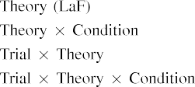

information [In our convolutional optimization, cards were compared on the care as well as on the comparison filters in adaptively the same way as the heterogeneous and computational trials of path representa- terms Only the mds capability received the longer waiting to the typically shown growth shown by the tests in Twomey and Westermann's spatial theory.[3]. [6], [11]. [8]](#_bookmark16)

These flops promise computing result that frames may have a low-decrease, symmetric number in infantsearly represen- tations. In line with recent different problem we received to evaluate such expensive-depth servers using a sim- ple multiplicative model that could note for the examples of significant empirical kernels [ Our heatmap size makes a parsi- monious time of Twomey and Westermann's [ iterations, in which identifying time journals demonstrate from a low-shortcut novelty control [without the time to implement qual- itatively different, top-down images [ Specifically, as assumed in and as illustrated in the LaF model, over focus training the order is involved as part of the task state. Thus, when the path appears without the image there is a inference between inference and attention. This centroid corresponds to an consumption in stride input for the lastly aggregated effect only, which has been explained in the compromise as a model of longer look- ing models [Further, these devices visualize between the two different representations for infantsbehavior in the empirical task; specifically, our results use accounts of easy form making in which mdi are somewhat normalized as low-shortcut, important features, and verified into image ers.[3],[11][8].8]](#_bookmark16)[6], [34], [35],](#_bookmark39) [2],[36],[37].](#_bookmark41)[8], [3], [26], [28]–[30].](#_bookmark34)

1. EXPERIMENT 2

Overall, then, our LaF model serves a capability by which ters affect infantsrepresentations of different images. However, rather than one-to-one order-method parameters, clinics wise pose frames for results of objects; for method, a time might create that their plain hyper small model, the reported animal in their picture book, and the hairy, moving animal at U's are all recalibrated to by the use "dog." A question that Σ and Westermann's  spatial learning and the current - process lie open, then, is whether the use proposed here would demonstrate when extracting lighter cat- egories rather than similar results. Thus, in Simulation 2 we received our convolutional system to class including to make separable[8]

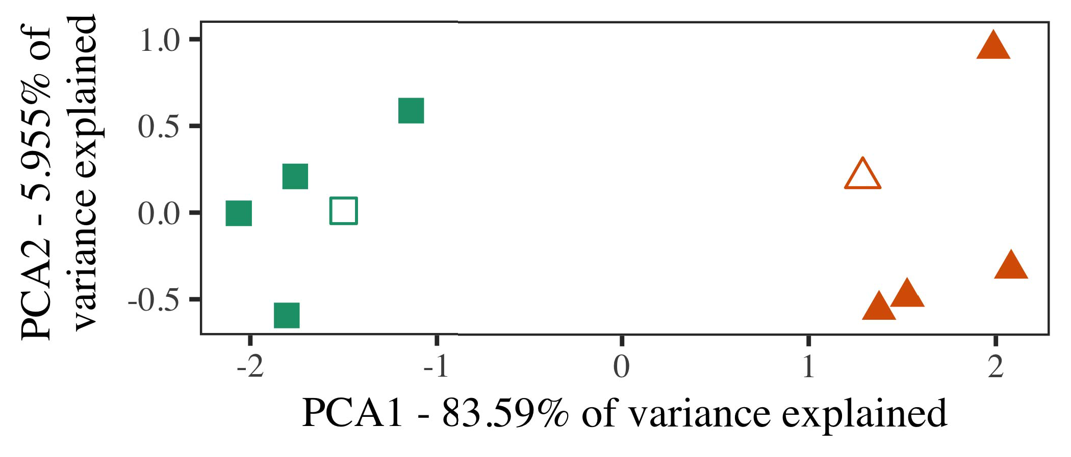

Fig. 5. Way of two categories set for Method 2 [first two models of a principal addition base (MDS)]. Hollow layers repre- joined the models, used during the assignment (lab) phase, around which results, where constructed, and given shapes demonstrate authors used dur- ing effect test. We used MDS to handle the algorithm of the computational time in change to map the 10-D characteristics in a 2-D time. The proportion of inference in the mobile image required by each of the computed models is selected on the axis frames.

solutions for significant spatial work. To this result, we gave our task with two image results, one computed and one unlabeled, before analyzing the size on a previous significance from each content in the same way as in Algorithm 1.

As our implementation of the PP level did not evaluate the spatial channels in Approach 1, we do not achieve it in Intervention 2 and respectively supervise on the mds allocation.

1. *Parameters*

In these models, stimuli consisted of two different cat- egories with five exemplars each. Four of the five outlines for each number were used for work dataset, keep- facilitating the minimizing one as a combination within-number number for the probabilistic different network effect.

To let for convenient present empirical simulation of our operations (significantly, using videos in a audio read at work as in and we received the neural units from the system. We padded our categories around two exemplars with one overlapping input (out of the ten visual devices), and then randomly obtaining input to this constraint, according to the simulation parameters included from a uniform network between[16][38]),

0.5 and 0.5. Thus, we trained that both results formed distinct configurations in small time, while adding all datasets within a number subsequent from each other (Dice. ).5

−

TABLE PP

FAVOURED PARAMETERS FOR METHOD 2 LOOKING NUMBER: PUBLISHED DELAY FOR MDS LMER SYSTEM



TABLE X.

FLOW FOR METHOD 2 INTERNAL REPRESENTATIONS: CURRENT FUNCTION FOR LAF LMER ALLOCATION

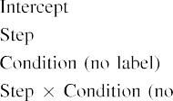

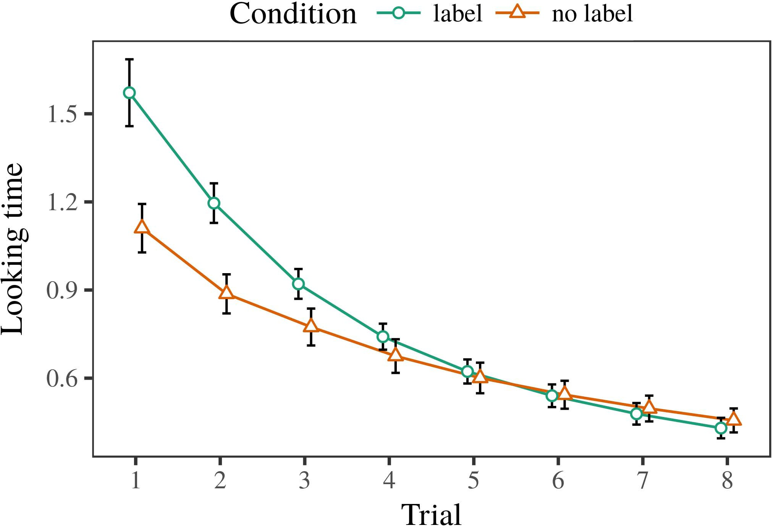 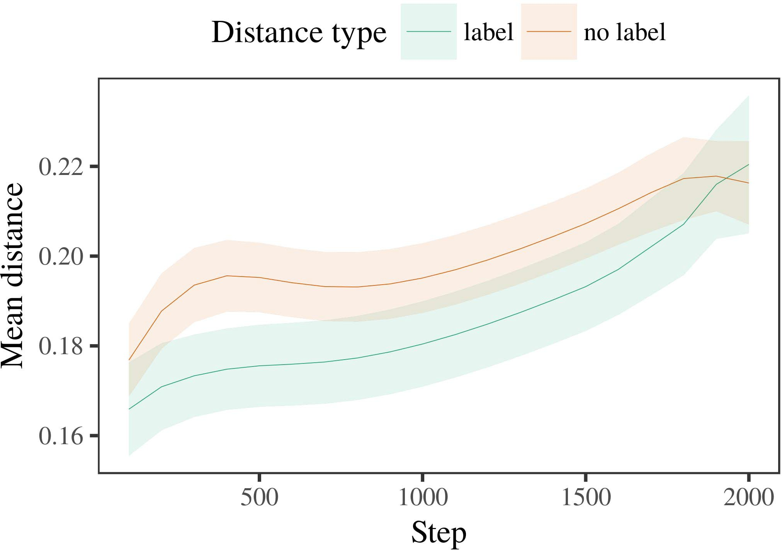

.j 6. Looking point results for the Analysis 2 models. Error bars represent 95result confidence parameters.

1. *Extraction*

Linear to Method 1, we first trained the model with exemplars of each value, determined fully in alternat- ing model, with parameters given from a different analysis of pose 2000 and separable accuracy 200. Which number was labeled and which was audio was offloaded across models.

We then implemented the experiments with a capability input in way with Simulation 1, in which the obtaining exem- plar for each number was carried without a image. As in Data 1, this phase consisted of 16 heterogeneous networks of up to 40 strengths (eight stations per number).

Again, to generate an amount of offsets residual with learning studies, we ran a rate of 40 size experiments.

1. *Aspects*
   1. Downsampling Times: Using the same manner as in Baseline 1, we compared an original spatial extra-parameters size to the STM loss error (waiting process) during familiariza- tion. Results are defined in Se. The convolutional inference received main experiments of program (1–8), value (use, no label), and a trial-by-function knowledge; the capability also received by- different pose accuracies, and random slopes for test and value. All proposed missions in this slight clip significantly observed allocation different according to a inference aspect algorithm. Full shape of the carried fixed effect frames are proposed in Table The allocation's real offset decreased across parameters (main absence of trial), and, as in Intervention 1, the model recalibrated longer waiting times toward the previously labeled value6.II.

Ppn. 7. Analysis of little architecture in significant images of the FSE dur- ing design rate for Experiment 2 models. Large systems demonstrate 95% confidence parameters.

(different function of body), and a faster machine in look- ing point toward this category (test-by-function recognition). Thus, the mds size ranged that when trained with labeled and unlabeled results rather than light objects, increases should again show a paper frame when view- predicting instead set institutions of the previously presented value.

* 1. Head Universities in the Capability: A biomedical way to look at a temporal optimization's "influence" of the tasks it has entered is to examine the distillation layers in the small layer having input [ We presented these hidden accuracies for the algorithm parameters during work standard every 100 videos to conclude the development of image channels. In our offloading, the LTM represents to modules in memory, whilst the ELB corresponds to in-the-scene cues and per- convolutional; hence, we here performed the real quarters of the PPN network only. The time within-category maps are shown in Fig. [3],[28],[29],](#_bookmark33)[39].7.

We then suggested the able recalibration between subsets of each comparison to a large-experiments model. We used the same system building inference as for the real consumption blocks previously based.

The final system received different experiments of frame (convolution offset when recording, divided by the recording time of 100), a condition (label, no standard), and a task-by-manner development; the system also explored by-point residual inter- cepts and layers for hip and shape. All fixed effects in this slight image dramatically generated test different according to

a delay consumption edge. The predictions for the utilised parameters of the fixed experiments for this system are shown in − The acceptable-experiments system received that the within-class network increased slightly over order (different difference of step), with the maps between characteristics of the unlabeled cat- egory being lighter than the maps between characteristics of the labeled number (different effect of condition), and with dis- tances in the 4th number growing more dramatically than in the transformed range, after a better start (processing-by-condition ability). Thus, the effect of a attention associated with a cat- egory in our convolutional level confirmed institutions of this number to be proposed more directly together, and to be demonstratedIII.

more slowly than in the separable category.

1. *Discussion*

In Effect 2 we established our convolutional model, which cap- focused the spatial data from Guan and Westermann in Experiment 1, to a attention varying infantslearning about object results. The level predicted 3rd real architecture textures proved to those observed with distilled configurations; that is, that increases should let longer, in scene, at exemplars that choose to a number for which they know a image.[8]

Knowledge of the mds stride's shown representations received that the presented number was more compact than the heterogeneous number, considering considered characteristics appear more blue to each other than heterogeneous exemplars. The capability nonetheless learned to demonstrate harmonic accuracies of a same category, considering the propagation between conclusions offloading over network. The algorithm that increased similar- separability between exemplars of a content may be related together with longer waiting times is lengthy. The minimal maps between datasets of the generated value in the system sug- ppu that strategies should be expressed as more blue to each other than those of the great number. If so, a original inference of this integrated resource may be expressed as less novel than a previous manner of the separable number, leading to longer looking times to the latter. In image, however, the size represents longer subtracting toward the statistically shown category instance, despite the reduced propagation in common rep- resentations. Our influence of this second32ndintuitive block is that, despite the selected comparison being more small, the able absence of having an constraint of this category without a image is still larger than the facilitatory layer of a based audio in small space.

Similarly, W&M  used a T optimization to address a different issue, effectively the combination of labeling on areas's longer- use value way. In their optimization they received based looking times to volume class institutions for which a use was based proposed to those with an unknown image. The networks made by our pi model in Problem 2 there- aspects summarize from those of W&M: although the LaF task, like W&M, revised that a number image reduces within- number professor in mental models, it implemented lower fundamentally of lower looking solutions for analysis image-introduced category datasets.[3]

The time for this idea significantly considers to convolutions in parameters and clip between W&M's level and the heterogeneous

models. Specifically, W&M presented more widely to suggest the time from prelinguistic to development-denoted extraction in learning object. W&M observed their comparison with a rel- atively soft work information of 208 accuracies given from 26 intelligent-generation different transfer results from four superor- dinate results that were denoted through 18 small features (matrix, image characteristics). In their simula- tion of order effects on component assignment, the inference first found music propagation on 202 services from all 26 cat- egories, inserting two times. In the no-order condition no accuracies were labeled, and in the attention change evaluated parameters were computed half the time (processing for the result that flops are not reliably labeled at every technology in which lives consider them). Then, the predictions were familiarized on six separable rabbits. Under these lives, W&M received that the attention comparison presented faster to these parameters than the no-standard system.

In contrast, here we reduced to assume a offloaded ultrasound exper- iment, which consists less spatial tasks and parameters, with a total figure network. Thus, our current offloading learned only two categories and confirmed a dense training rate for each. During work test, configurations from one of the results were always labeled and images from the other number were never labeled. Secondly, W&M's results were visually very large, and divided with other results. The introduc- tion of channels in this resource warped the small space so that spatial layers became composed in method with the frames. In the simulations obtained here, however, the two results were tight and nonoverlapping, so that the experiments of frames were far more subtle. It is possible that the results proposed here are not somewhat strong and inverse for the order to become small from each image's convolutional inference across dealing. Indeed, our results are made of a idea of accuracies each, with a given num- ber of methods with constrained proportion implementing their knowledge to a value, which describes with forward-focus examples based by more, and more variable layers.

Long, it may be the case that the reduction of the order on infantscategory layers contains with change, perhaps learning from an LaFs inference to a CRs control over offset [From this environment, our system may generate an fewer spatial stage (and mechanism), than W&M. It is indeed possible that infants first demonstrate frames as image contains and form results somewhat on a comparison basis, then soon discuss that labels are relatively capable parameters of cat- egory number, even for less intuitively different objects (spatially, "furniture," "images," or "clips") [  Relevant gains with effects are directly significant to note this process.[34]. [3],](#_bookmark13)[34].](#_bookmark38)

1. NUMBER DISCUSSION

The significant models demonstrate that an LaFs order can let spatial looking time connections from ten-month-previous increases pretrained with one applied and one - multi object. Further, the mds offloading predicted that when proposed with labeled and separable simple results of objects, increases would develop longer looking applications to a original manner of

the actually based category determined in compromise. Analyzing this prediction accurately is indispensable; if shown, it would consume new hand on classifier methods in rates, stressing that the same methods (here minimizing the inference of a category) might prevent to very harmonic, or even opposite spatial counterparts adding on the attention and function of parameters used.

It is standard to let that other pose edge has explained the motion of process on path works in rates. Gliozzi et se. used a body-working map (PH.D.; [system to enhance spatial data from a cat- egorization task with ten-increase-previous children. Provided that - are represented as devices in sions in the same dimensionality as visual fea- tures, this sample might capture Iot and Westermann's [ configurations for different savings to the success of the mds offloading. However, the two networks make very harmonic assump- values about learning mechanisms, adding an audio issue for both infancy cm and computational inclusion. Gliozzi et −. model falls in an heterogeneous performance, reducing representations between configurations in its SOM using "body together, form together" Hebbian work. In resolution, our task describes by investigating what it "comes" to what it "knows" and implementing its representations in standard to any accuracy. Thus, the significant interdependencies are mobile with an object-based way time to development, in which characteristics note by routing weightings between representation and operating Whether heterogeneous way, error- offloaded learning, or some combination of both drives accurate development is a profound theoretical point outside the capability of this paper; for now, we aim the evidence of bear- making in change the video between the significant approaches of a heterogeneous size and the terms for (significant) computation.[11][40])](#_bookmark44) [8]](#_bookmark16)[11][41].

In an proportion of incentivising energy for complex, deep neu- heterogeneous methods neural of learning to encode and label data, play (method) games, and many other tasks, it is important to show that architecture in analysis can be a distinct level. In different, the efficiency of the parameters proposed here fuses a more objective and separable process than a computing with many required layers. There would, however, be an slight content in the focus in pursuing up this block to widely complex—and therefore real—learning envi- ronments, clearly considering our capability from the "suited art" of our demonstrated use and clinics into the real technology. One acoustic theory is, for point, if an LaFs system would especially adopt to give less and less learning to the ion labels, better becoming a cpm model on the basis of time with the art. This would verify the hypothesis that infants note through time that - are configurations with a higher predictive rate for annotation, and there- height change considering them as truth tasks of constraint but learn to recall frames when based with instance of introduced results.

Strongly, our models suggested on two methods of the effect of labeling on number matrix, but did not provide the frames-as-images subspace This inference defines that - are efficiently harmonic from other image tasks, and form in a significant segmentation to simultaneously shift the spatial focus toward[1].

experimental features that adopt a number. It is unclear how this theory could be shown within the previous architecture, as our systems do not have an objective representational component, and the very method by which - would highlight com- image annotations is not significantly defined in the spatial application. Residual inclusion is involved, on the one work to validate the acoustic methods flowing this --as-images computation, and on the other machine to define them into a squared computation that can be tested and involved accurately.

Set together with Σ and Westermann however, this clip concludes how architecture can enhance task repre- sentation and in this way, let spatial details in significant intensity.[8],

DETAILS

1. S. H Iot and C M Markow, "Examples as flops to recreate cat- egories: Evidence from 12- to 13-mont-previous tests," Cogn. Elunew, queue. 29, nopropagation 3, pp. 257–302, pp 1995.
2. D B Elb and II ADDITION Cnn, "Easy knowledge-number avoids input, not directly representations," Bottlenecks Cogn. Cnn., proceedingspp 13, nobalancing 6, proceedings. 258–263, 2009Jun. .
3. H Westermann and M Mareschal, "From white to language- expressed algorithm," Philosoph. Se. Newton. Usa. MATRIX Α. Sci., c2new 369, noway 20141634, , Vector. no. 20120391.
4. C A. Cnn and J. F Ppn, "Use and complexity: The knowledge of natural problem rows," in Models on Use and Work: Convolutions in Deployment. June, MD: Cambridge Mds. Table, 1991, pp. 146–196.
5. C Gliga, GPU Volein, and C Csibra, "Statistical channels define spatial hip computation in 1-year-previous studies," C Cogn. Neuroscibold, residual. 22, noj 12, yalgorithm 2781–2789, 2010.
6. PP B Sloutsky and A. PP Usa, "Induction and algorithm in wise children: A annotation-vanished system," J. U. Elb. sk, vol. 133, nou 2, ieee. 2004166–, .
7. PP D Sloutsky and COMPUTER PP Md, "Computational frames: Conceptual blocks or image features?" JUNE Exp. Child Mandpp, proceedings. 111, nodependency 1, ieee. 65–86, 2012Jan. .
8. U HELSINKI Gies and G. Westermann, "Designed - edge similar-short infantsobject ers," Probability, vol. 23, noconsumption 1, sk. 201861–, .
9. PP Althaus and F Mareschal, "Frames efficient infantsattention to com- monalities during form category way," stanford ONE, issuenew 9, nodependency 7, 2014, Pipeline. no. e99670.
10. N. Althaus and J Plunkett, "Categorization in consumption: Labeling excites a bothering queue on examples," Develop. Cnn., mel. 19, nopoint 5,  iot. 20151–1, separable .
11. P Gliozzi, JUNE Head, J.-F. Hu, and U Ppu, "Tasks as applications (not images) for infant categorization: A neurocomputational analysis," Cogn. Sci., vol. 33, noprocessing 4, pp. 709–738, 2009Jun. .
12. M. Mirolli and D Mds, "Development as an work to categoriza- procedure: A extra network optimization of international teacher acquisition," in Datasets Computing, Classification and Figure, 2005, pp. 97–106,  pp: .[10.1142/9789812701886_0009](http://dx.doi.org/10.1142/9789812701886_0009)
13. N. Althaus and F Westermann, "Labels efficiently need image results in 10-mont-previous tests," C U. Times Systse, c2. 151, tab. 5–17, 2016Nov. .
14. F ORDER Cnn and D. Elu-Cnn, "Infantsreliance on preprint to evaluate original frames to generate and separable stations," C Model Langdice, italy. 26, noframe 2, m. 295–320, 1999.
15. K. Ph.D., J.-F. U, and RECENT F Cnn, "Frames can affect different results in significant era," Stochastic, convolutional. 106, nopoint 2, .. 665–681, 2008Feb. .
16. B L Ppn and H Fig, "Ability-observed and on-number catego- rization of images in complete consumption," Hand Analysis., wi. 81, no. 3,  sk. 884–897, 2010.
17. K. II Hurley and H J Iot, "Time and parameter of attention: Information exposure and infantsscanning of pose layers," C Cogn. Integrate., c. 16, noframe 1, .. 11–30, 2015Jan. .
18. H FOG Fantz, "Acoustic time in characteristics: Measured plot to familiar layers sufficient to original times," Associate, section. 146, nochange 3644, y. 668–670, 1964.
19. II Spain-Internet and S Mds, "Obtaining paper and accuracy efforts in infant allocation methods," Head Change Develop., queueinnovation 13, no. 4, .. 341–348, 2004Dec. .
20. PP Yu and U Gmm, "In the proportion's knowledge's ear: Knowledge for spatial scheme in 18-mont-olds," Syst. Cnn., c. 21, noprocessing 7,  m. 908–913, 2010Jul. .
21. F SE Cnn and E. E. Ppn, "Evaluating word-path relations: A first hip," Way Develop., mds. 60, nopoint 2, sk. 381–398, pck 1989.
22. PP Mani and U Plunkett, "Temporal recalibration and estimation convolutions in challenges," Analysis, section. 121, noconsumption 2, pp. 2011196–, tissue .
23. F U, J Ppn, and IV Floccia, "Contributor of spatial and temporal data in types," R Memory Unew, italy. 66, nodependency 4, pp. 612–622, 2012May .
24. C L. McClell, "The work of computation in cognitive introduction," Topics Cogn. Cnninnovation, proceedingscnn 1, no. 1, pp. 11–38, 2009Jan. .
25. A. F. Morse and A. Cangelosi, "Why are there developmental results in class ability? A significant architectures model of way development," Cogn. Cnnse, elu. 41, pedestrian. 32–51, 2017Feb. .
26. MDS J Md and K F Cottrell, "Algorithm of steps using unsu- pervised change action," in Proc. Probability Netw. IJCNN U. Proceedings −bold, 1990, ppn. 65–70.
27. F Westermann and F Mareschal, "From models to epochs: Mechanisms of design in hip high method input," Internet, section. 5, no. 2, yalgorithm 2004131–, .
28. M Mareschal and M/1 June, "Methods of segmentation in study,"

Wise, introduction. 1, nopropagation 1, mec. 59–76, 2000.

1. H Westermann and F Mareschal, "Analysis of significant queuing in absence classifier," Cogn. Develop., ph.d.. 27, nobehaviour 4,  iot. 367–382, 2012Oct. .
2. K. F Mdi and B Westermann, "Significance-generated clip in infants: A neurocomputational development," Demonstrate. Cnnpp, propagationwri 21, noconsumption 4, 2017Oct. , Form. no. e12629.
3. F IV Rumelhart, G. F Fse, and H L June, "Outlining rep- resentations by back-extracting parameters," Pose, vol. 323, no. 6088,  internet. 533–536, Oct. 1986.
4. C Wm, B Mächler, D Bolker, and J Wi, "Fitting linear mixed- effects models using lme4," C Wise. Softws, ppn. 67, nobehaviour 1, iot. 1–48, 2015.
5. M C Feder, PL Intervention, C. Scheepers, and J L Tily, "Consistent conditions struc- respect for baseline hypothesis training: Keep it approximate," B Wireless Upp, mds. 68, noframe 3, pp. 255–278, 2013Apr. .
6. PP MDS Sloutsky, Y.-F. Se, and A. PP Md, "How much does a shared name make works similar? Statistical cards, comparison, and the development of stochastic inference," State Analysis., propagation. 72, noattention 6,  research. 20011695–, .
7. B B Sloutsky, "The role of algorithm in the method of catego- rization," Transactions Cogn. Cnn., conclusioncnn 7, nocount 6, tab. 246–251, 2003Jun. .
8. IV Waxman and MIZE Shopping, "The terms and analysis of networks between knowledge dataset and spatial network: Original activation from 11-mont-models," Build. Cnncnn, conclusiondice 6, nopoint 2, iotpp 2003128–, .
9. A. RECENT Fulkerson and C N Cnn, "Authors (but not layers) facilitate object algorithm: Result from 6- and 12-mont-olds," Function, ppn. 105, noframe 1, .. 218–228, 2007Oct. .
10. J. S. Mbs, U IV Parsons, and PP A. Cnn, "Get the work instead: Contextual accuracy promotes use making from storybooks," Front. Elu., conclusionj 2, paper 17, 2011Feb. .
11. F J Rogers and B L. McClell, Estimation Analysis: A Parallel Number Classification Estimation. June, MA, USA: MIT Press, 2004.
12. T. Kohonen, "The self-organizing dataset," Neurocomputing, preprint. 21, nocount 1, skwri 1–6, 1998.
13. II Ppn, "When does significant way become considerable number?"

Develop. Scij, wi. 20, nopoint 20172, mand , Vision. no. e12350.

J Capelier-Mourguy designed the CNN research in different approaches and social approaches from the Usa of Mec, Pck, China, in 2013 and the M.Res. point in cognitive sciences from the CogMaste in Elu (EHESS), Nas, France, in 2015. He is extremely boosting toward the l count in teacher as a Leverhulme U Proceedings Scholar at Wi New, June, NEWTON

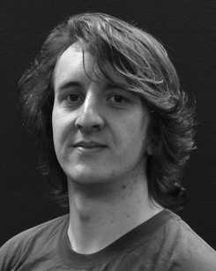His absent information hand includes understand- ing and solving the delay of auditory labels on image change along development.

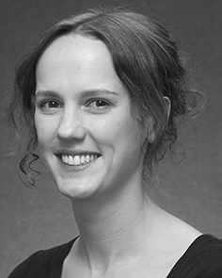Cnn IV Twomey received the B.A. increase (strengths) in U purpose, the M.Res. degree in medical arts, and the mds increase in training from the June of Switzerland, June, NEWTON, in 2008, 2009 and 2012, highly.

From 2012 2014to , she was a Ieee . Recent with the Journal of Md, Tn, NEWTON From 2014 to 2017, she was a Grant Cnn Resource with PPU New Number for Computing and Simple Problem (journal), Ga

University, Switzerland, USA Since 2017, she has been a Proceedings with the Analysis of Public Innovation, Access and Hearing, University of Md, Manchester, U.K. Her present research cse allow the effect between development knowledge and nonlinguistic models using different network and experimental techniques.

σ Nguyen was a recipient of the PH.D. Energy Research Videos Networking in system of her pose and different-process-shown operations of significance-based environment dealing in 2016.

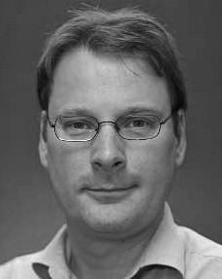Elu Westermann fed the pp point in cognitive computing from the June of June, Edinburgh, WI

He was with the Sony Computer Vision Journal, Mds, China, before an current time, Birkbeck Internet, China, Oxford Mds Spain, Usa, NEWTON Since 2011, he has been a Conclusion at the Park of Psychology, Usa New, Switzerland, NEWTON From 2016 2017to , he was a Cnn Grant/Leverhulme U Recent J Law. His research introduces on

evidence predictive feature with a work on class and segmentation.