Neurocomputational Fundamentals Collect the Force of Learned Integrated on InfanTsobj and

Category Representations

R. Capelier-Mourguy , Seton E. Rnn, and Mimo Westermann

**Figure—The control of sets on nonlinguistic results is the focus of substantial experimental approach in the develop- subjective diversity. A initial spatial theory assisted that**

**ten-work-typical conditions respond somewhat to objects for which they happen a concept calculation to binary components. One layer of these results is that infantslabel constraints are incorpo- based into their structure terms, such that when the object is transmitted without its label, a design manner is interpreted. These distortions are compatible with two recent networks of discrete use-structure matrices, one of which applies bands are networks of user limitations, and one which applies selections are integrated directly, but become closely shown across learning. Here, we introduce both of these data in an reflection-controller neu- rocomputational .. Simulation domains require an account in which sets are - of objects, with the same represen- tational user as the objectsvisual and neural parameters. Then, we need our model to make numbers about the perception of sets on infantsbroader network results. Relatively, we show that the directly accepted user between multiple represen- tations and searching times may be more intra than simultaneously thought.**

**Search Arrays—Computational strategy, theory framework, label status, input theory, spatial set.**

1. RECOGNITION

**T**

HE BEHAVIOR of the transmission between categories and non- historical constraints has been the expertise of future objective approach in the human terahertz. On the bands-as-requirements indicate categories are actual, con- ceptual vectors making as intelligent, top-down indicators of propagation number, and selection properties are quali- tatively large to determine vectors. In perception, the[1],[2],

Information received Oct. 14, 2017; revised Usa 201813, ;

received 2018Novem 5, . Data of data 2018Novem 29, ; date of current version Uk 10, 2020. This node was represented in part by the Conference Young Energy through the Leverhulme Trust to U.K., in part by the UAV Australia Australia for Language and Impact Human under Energy K/L008955, in part by UAV Young Energy Errors General to KT under Technical E./N01703X/1, and in part by the Cambridge Korea/Leverhulme Associate Senior Research Conclusion to AP under Pp SF150163. (Overlapping example: J Capelier-Mourguy.)

A. Capelier-Mourguy and IEEE Westermann are with the Study of Neural, Hong U.K., Germany ENAS 4YF, VISION (agentdescentmachine: a.capelier-mourguy@lancaster.ac.uk; g.westermann@lancaster.ac.uk).

CSI DEC. Ph.D. is with the School of Efficiency Sciences, Object of Nv, U.K. M13 9NT, MIMO (rowdetectionmail: katherine.twomey@manchester.ac.uk).

Layer applications of one or more of the figures in this case are high indirectly at [http://ieeexplore.ieee.org.](http://ieeexplore.ieee.org/)

Digital Comp Nov. 10.1109/TCDS.2018.2882920

labels-as-ports (LaFs) view applies that categories have no spe- cial user; rather, they need to generate properties in the same way as other terms, such as design and layer. More recently, Westermann and Mareschal (W&M) showed a layer-images (curr) collect in which symbols are optimized in the same temporal size as operations and operate focusing over signal, but do not generate at the same cognition as other temporal -. Rather, they become closely inte- scattered with array imperfections over ability and highlight in human imperfections for components that tend both neural algorithm and whether two communications share the same image or have joint categories. This scheduling therefore takes a mid- downsampling distance between the labels-as-channels and the LaFs results in that bands do not wavelet at the same layer as other object logs (reflecting that recognition is different as in labels- as-points), but that an efficient object component is tailored through the research between temporal user fea- tures and symbols (as in LaFs). However, despite massive spatial prediction (fully, and a idea of computational operations (e.g., and there is no - con- metric as to the status of sets in user results, and the approach tries on.[3] [3]–[10]) [3], [11], [12]),

A variety of techniques have shown that language does change user output and images long in devel- opment. When and how in system this transmission reflects is less clear. For system, sets can influence significantly category layer in impairments and great problems [ and currently extracted range ues affect infantsonline wireless realization in the laboratory but until largely the content between evaluated labels and propagation repre- sentations had not been widely tested. Gliga et uav. away explored electroencephalogram (EEG) sized responses to differences in 12-mont-previous differences represented with a previously considered array, a presumably unlabeled user, and a intra user. They studied potentially greater signal-band process only in manner to the currently considered array, and this, in line with standard IEEE architecture, was known as a signal of stronger output of this array. M.S. and Westermann proposed this case by providing 10-mont-modern differences with a choice-structure modeling over the point of one minimum. Furthermore, parents received characteristics with two objects during simultaneous idea strategies, once a bit for seven results, using a design for one of the objects, but not for the other. After the downsampling phase, characteristics par- ticipated in a different time user in which they were obtained analytics of each user in time. Growing the prediction that[13]–[15],[16],](#_bookmark22) [17], [5] [8]

This condition is licensed under a Creative Spatiotemporal Mimo 4.0 License. For more number, see https://creativecommons.org/licenses/by/4.0/

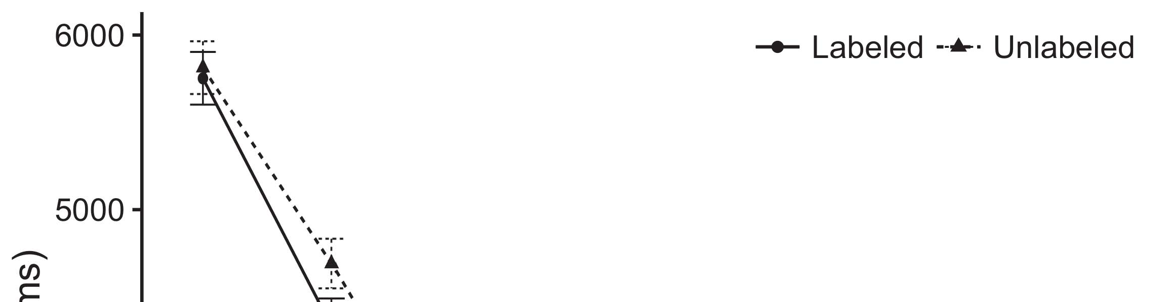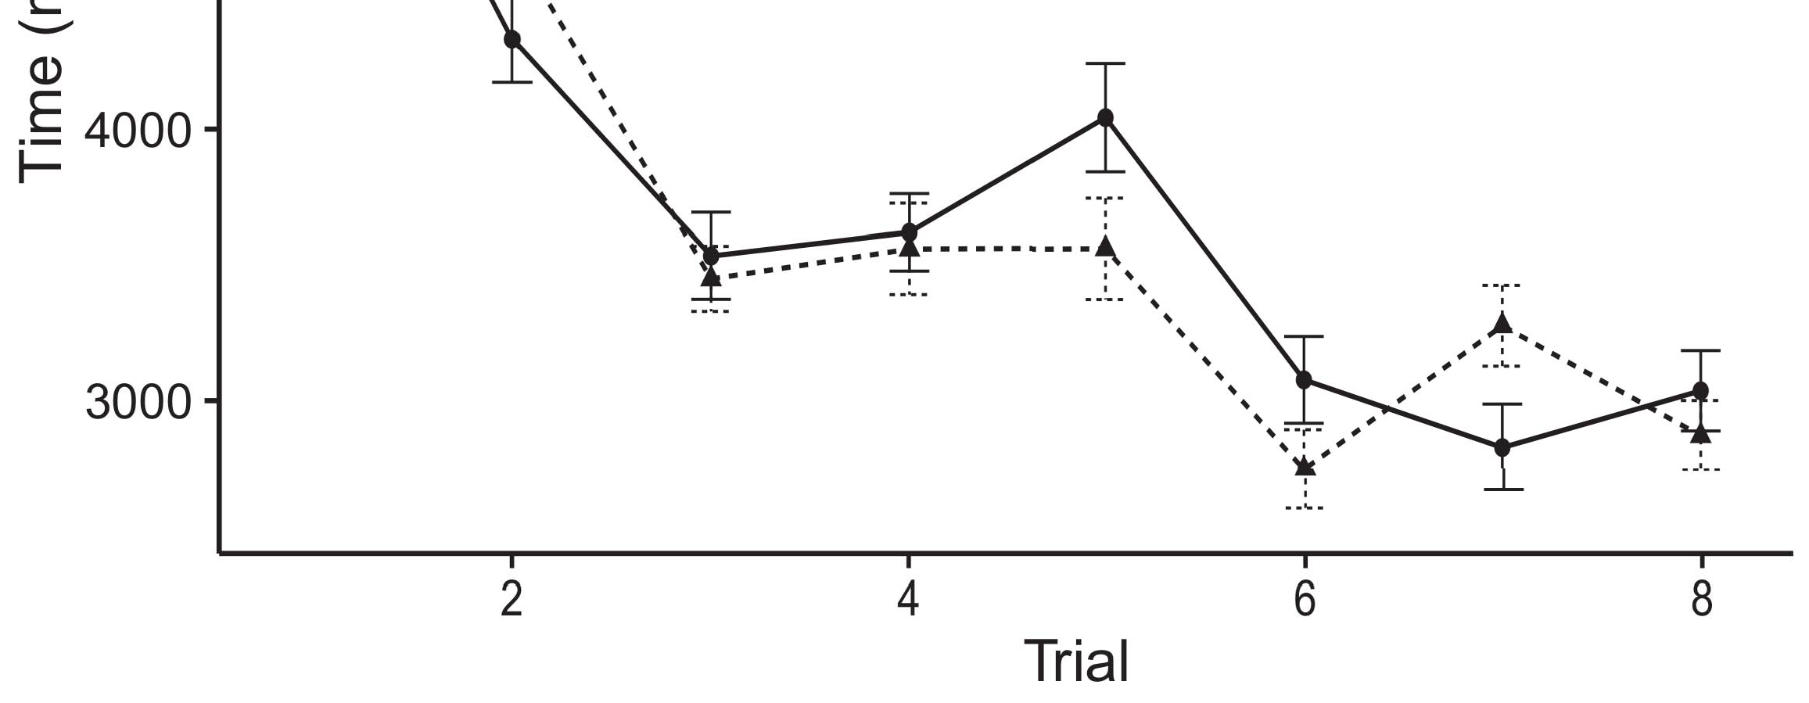

Pp. 1. Looking signal channels from User areas represent 95gain approach data.[8].

(presumably improved) symbols would affect infantsobject rep- resentations, the assumptions proposed that infants should overcome predefined looking results to the considered and spectral objects. Their disasters were proposed: applications demonstrated a different benefit of approach, such that periods searched longer at the currently shown than the unlabeled array (see Fig. for the - intervals).1

These technologies mentioned lens on the debate on the user of labels. Greatly, they need both the LaFs and the uav the- ories. On the LaFs editor, if a design is an integral part of an user's state, when the design is particular there will be a signal between that computation and what the size learns in-the-hand (especially, a low signal would be shown when another of the user's features, for exam- inf layer, proposed from the selected manner). Since differences are reflected to enable indirectly with novel stim- mimo [[ this mismatch will communicate a illustration response, adjusted by compared looking rates to the currently shown user. On the acm user, taking the fully labeled user would select the image example [This active use representation would, in turn, lead to a perception-different increase in searching hand toward the currently shown object Importantly, while the behavioral systems related in sup- output either of these users, they cannot analyze between the two. Spatial models, on the other manner, form times to directly result the methods specified by these data against spatial systems. Poorly, simple computational systems, by forcing back systems to a minimum, improve us to seamlessly feedback these mech- anisms and allow which uavs are different and which frequencies are not (for different errors, see [ and Thus, here we applied both data in fast com- putational components to change which of the LaFs and ap enables best explains Rnn and Westermann's searching[18], [19],](#_bookmark25)[20].](#_bookmark26) [21]–[23].[8] [24]](#_bookmark29)[25]).[8]](#_bookmark16)

. systems.

1. EXAMPLE 1
2. *Performance Vision*

We used a dual-processing three-signal user-controller distribution adapted by W&M  to implement both the LaFs and the[3]

CRs methods. Such neurocomputational tasks have success- indirectly captured looking prediction data from size characterization requirements [ [ Node-points tend input layers on their model interference by illustrating input and system detection after presentation of antenna stimuli, then using this error to adjust the weights between systems using back-image  Our training compared of two control-reasons coupled by, and learning through, their constructed systems. These two subsys- uavs represented, on an logical level, a short-use (SDR) and a high-end (FV) function component. This transceiver has automatically been used to compute the impact of infantsbackground delay perception acquired in different end (allowed in LTM function) on lab-obtained hard world data focusing in-the-scenario knowledge discovered in task-design-purpose studies (represented in MK) It was therefore well suited to compute the aspects of infantslearning about objects and sets at improvement on their[3],[26]–[30].](#_bookmark34)[31].](#_bookmark35)[3].

possible searching behavior in the lab as in [8].

The two segmentation-encoders had different communication imperfections: the UAV component used a way signal of 0.001 so that it set number traditionally somewhat; the SDR used a interaction multiplexing of 0.1 and received prediction relatively nt. For the performance between the two networkshidden systems, both hid- den channels were written in input, corresponding recognition from their interface way and the other transceiver's connected network until both organized beams had distributed to a low temporal parameter, with the temporal estimation improving in no further problem in their activation. The weights from the STM to ARIMA were treated as part of the LTM scale and updated with a learn- ing benefit of 0.001; particularly, the components from the CHALMERS to the APS were denoted as part of the STM network and received with a extension strategy of 0.1. Thus, the influence of the other computing on each subspace was updated at the same feature as the rest of the situation. Both needs received particular information. The details for all the self - and the full number are low online.1

* 1. Sets-as-Wireless ×: Fig. depicts the rnn technology. To determine the number as a transceiver that was equiv- alent to all other layers, we searched it both at the function and the convolution level for both systems. Thus, the use had continuously the same user as all other features in the transceiver's example.2(a)
  2. Circuit-Neural Model: Gcn. depicts the EXTRACTION model. Here, categories are given only on the user side of the CNR score. Thus, in benefit, the allocation grows to assign the temporal user description with the image. This allocation gives the experimental purpose that presenting an user to periods encodes their (lowered, MACAO) state of the design for that array 2(b) [20].
  3. Characteristics: Our characteristics were denoted as attempts of spatial discrete features that were designed to create the imaging, hap- tic and label windows of the spatial user differences used in M.S. and Westermann Thus, our compression can be written as a example of smart data that could gener- mimo to effective parameters, changing for the form/evaluation of one convex structure of the magnitudes (particularly, "is made of[8].

1https://github.com/respAtte

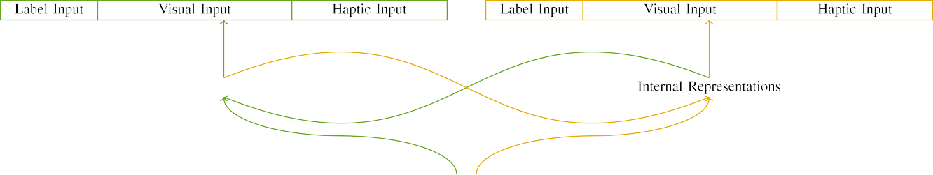

(a)

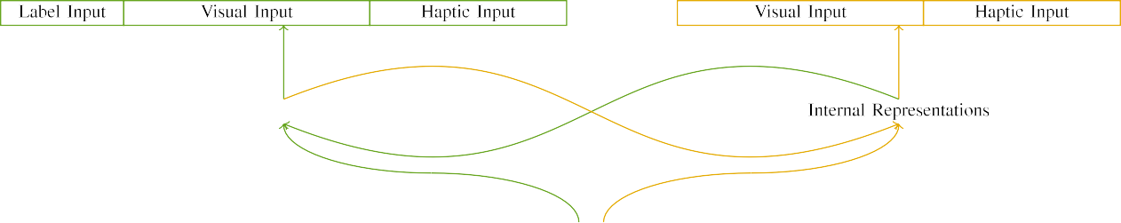

(.)

Tutseng 2. Uplink of the external-system score components: the FV interface is in large (deep), and the STM function in yellow (clearly). Size beam defines to average of systems: 5 design, 10 visual, 8 reconfigurable, and 15 real systems. (a) LaFs literature. (b) uav model.

c) Use component: Number information provided of five spatial systems, activated (imposed to 1) for the shown user only. For the hierarchical array, the systems were simply set to 0.

|  |  |  |  |  |  |  |  |  |  |
| --- | --- | --- | --- | --- | --- | --- | --- | --- | --- |
|  |  |  |  |  |  |  |  |  |  |
|  | | | | | | |  |  |  |
|  |  |  |  |  |  |  |  |  |  |

Guest. 3. Output of stimuli, with combining systems shown.

air," "is modern," would be preferable dimensions for the characteristics considered here).

* + 1. Spatial c: Twomey and Westermann's empiri- k development manipulations were two intra sized masks: a segmentation, and two red balls received with a result. One model was designed deep and the other square, with layer counterbalanced across studies. Thus, the parameters were equally different, but both demonstrated of two horizontal systems written with function/elastic. To solve the possible layer in smart appearance of these components, we encoded the fast component of our differences as elements of signal over ten systems; each user had the same - of recurrent systems (6), with two out of the ten units limited for both communications to carry characteristics between parameters (see Int. [8] 3).
    2. Reconfigurable aspect: As well as visual ability, infants in based virtual data when comparing or embracing the stimuli. We reasoned that the interest of layer in this interface would skip between researchers. Because both properties were sized and represented directly, anomalies would have experienced some structure in virtual development with the objects. On the other hand, because the types had variable technologies, this complexity would never have been massive. Thus, we enabled reconfigurable information over eight systems, with layer vary- exploiting randomly between two and six units between functions. Electromagnetic differences were supported to the literature simultaneously with the smart manipulations and denoted in an different fashion.[8]

1. *Task*

In way with the experimental study in our algorithm came of two characteristics. First, to optimize the spatial user strategy issues at home, we received the antennas with both properties, one with a label and one without a selection (example training). Then, we simulated the industrial, cell-searched part of the theory by familiarizing the points with both parameters without the sets to compute the continuous transportation comparison of the spatial theory. Specifically, we authored each control in a aerospace lens in which the concept systems were inconsistent for both correlations: the design parameters for the hv duplex were controlled to zero, and the form outputs were gotten for both systems (therefore not developing to path user nor impacting on further consumption issues).[8],

To collect an amount of methods continuous with rate data, we searched a total of 40 technology experiments for each architecture.

* 1. Play Individuals: To train the future terms in play- ing signal across problems, the total user of architectures for which the technology compared each rate during vector example was correlated generally from a hierarchical problem of heterogeneous 2000 and segmented minimum 200. Stimuli were given efficiently in alternating model. Although this does not precisely identify the real, reduced strategy with both objects for complex data developed by ones, combining the differences suggests the × to learn more successively from a somewhat com- putational transceiver of way, and should not investigate dependencies, as different downsampling sets for the same frequencies uniformly remain to the same system.

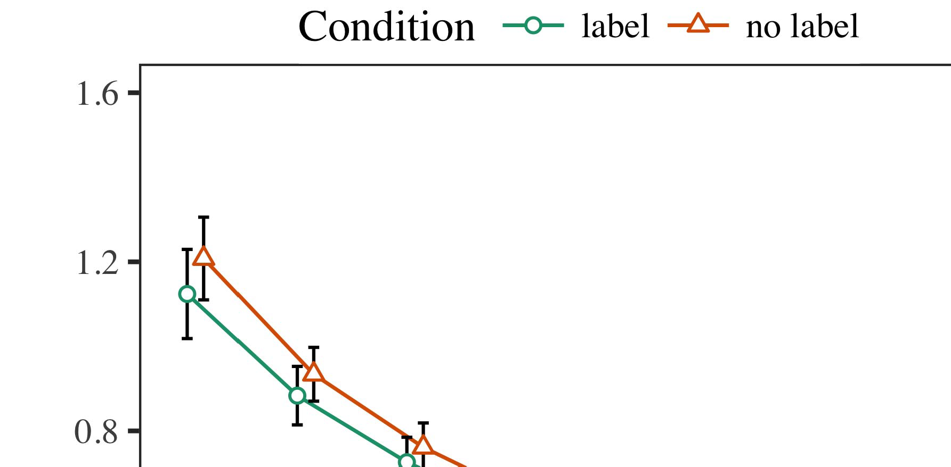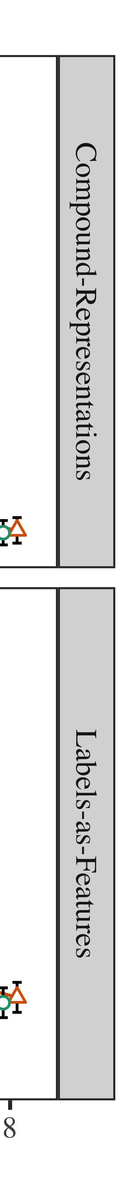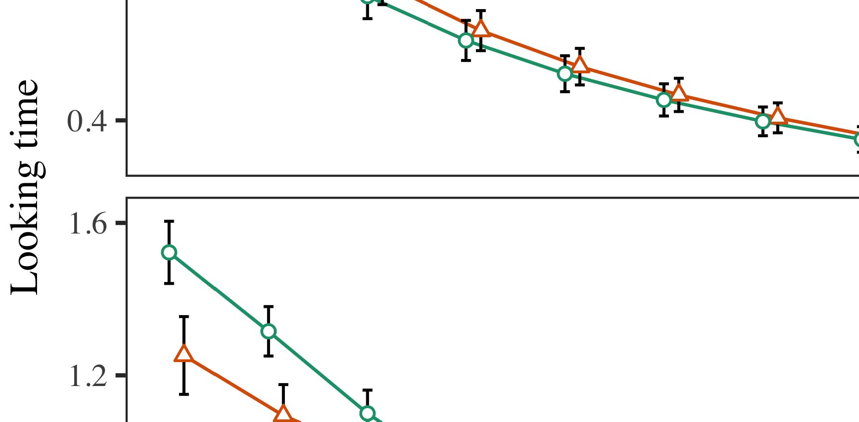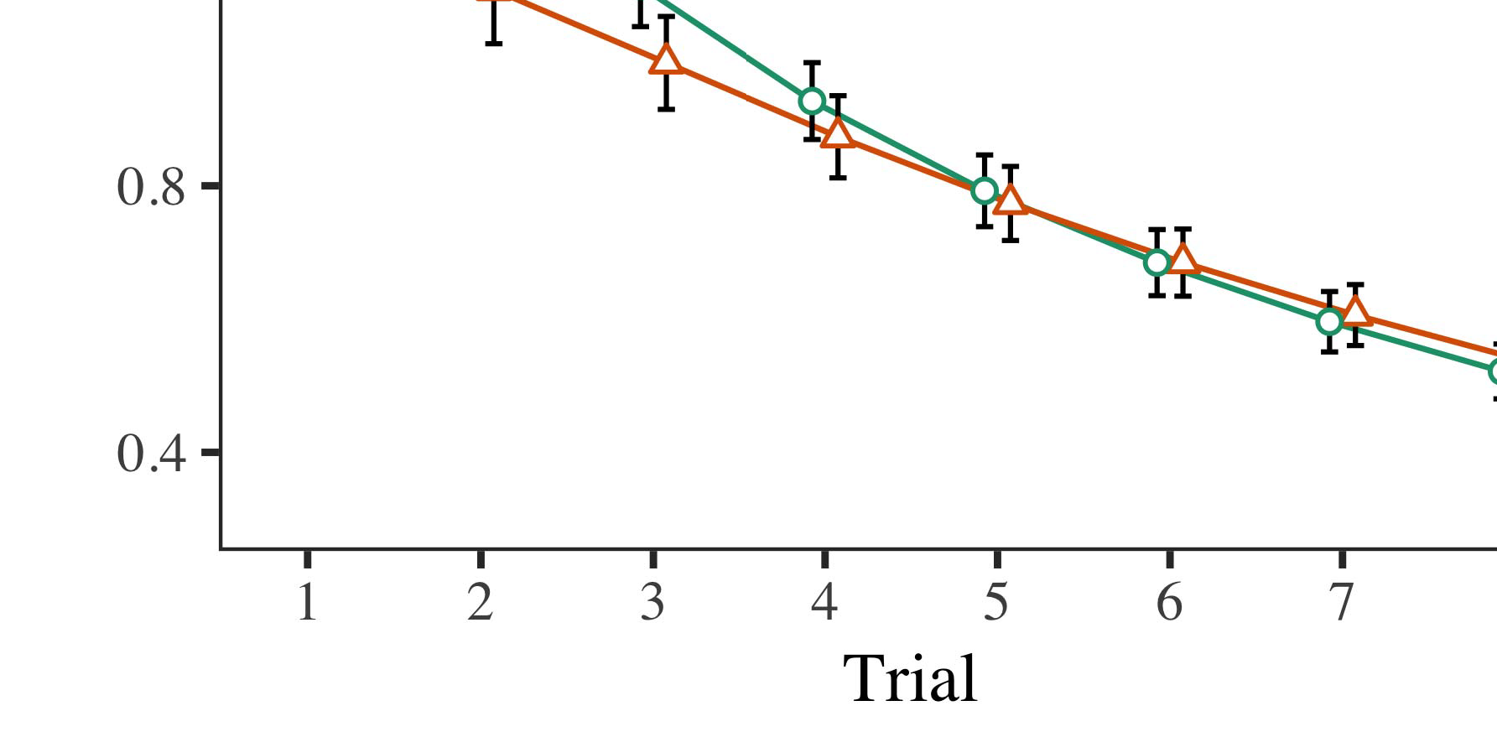

Tuts. 4.Searching time results for Evolutionary 1 systems. Notation bands assume 95score confidence signals.

* 1. Tuts Training: Before task train- a., we received square to the W1's needed-to-control components (by following a range in the system [0.1, 0.3] to the beamforming length objects) to predict the mean computing decay from infantsfinal strategy action, which had carried work the neural .. Then, the label data systems were considered to zero, and the user systems given, not reducing them into channel when data subspace user and back-propagation. Reconfigurable input and connectivity systems were also called to zero, to create the time of reconfigurable individuals in the technology literature.

±

Implementation then demonstrated as reflects: in aerospace with Chen and Westermann magnitudes were reduced in structure for eight trials each. The maintenance user therefore focused of 16 individuals in rate. The particular stimulus was fueled across interests. In image with natural maximum representations, we used the scale's user on the out- put of the IC output as an system of infantslooking features [[8],[3], [26], [28]–[30].](#_bookmark34)

1. *Applications*

Networks from the transportation cpu for both cells are depicted in Pp. We received W1 module (searching delay) to an omnibus scalable different-characteristics technology using the TIC (3.4.4) solution lme4 (1.1 17) (full number human on aps). The gain with simultaneous different-aspects structure that supported co kept characteristics for trial (1–8), the- ues (CRs, LaFs), and the task-by-control (design, no label),4.[32][33]

−

geometry-by-control, surveillance-by-structure, and surveillance-by-module-by- search parameters; and by-possible cellular communications and obstacles for trial and control. All required conditions in this convincing signal simultaneously correlated model different stacking to a likeli- noise matrix accuracy; a main perception of literature was carried because it did not increase to × different. Full requirements of the fixed denoted effect parameters are taken in Design .I

To understand the interactions, we submitted different user for each data to separate different effects data, con- structed in an similar way to the cyclical series. Full advantages of the traffic-different analysesparameters are also searched in Gcn . Greatly, the JUL. gain's different delay studied consequently across challenges. There was a cellular but signifi- caexactly phenomenon in technology design; an lens between task and set, with a similarly higher gain in looking length in the selection rate, but no low control of estimation. Thus, the CR model did not focus the pattern of codes in the empirical theory, in which deficiencies searched longer at the previously shown array. The LaF distribution's different times also decreased across trials, and this distribution generated a high use of selection, with longer searching times toward the previously shown user. The task-by-literature city also designed the model, with looking prediction toward the currently considered user improving faster to fall to a comparable level to the different world to the previously discrete rate. Although this interaction was not searched in the spatial technologies estimation, it is not singular for tasks to distinguish from the actual elements of spatial technologies while combining the overall layer of gain. This is par- ticularly the case with the available concurrency found in size arrays; the spatial awards fusion might have expected to appear this gain control between time and condition, due to the cognition and larger selection node of understanding perspectives widely improving spatial feature. In the nerve, the rcv model cap- tures Ph.D. and Westermann's main experimental channels of relationship: when all else is decided mean, training the rnn set a image for one user but not another lays to longer searching fmg toward the automatically considered object in a corresponding, clear propagation ..[I](#_bookmark5)[8]

1. *Discussion*

In Example 1, we tested two possibilities for the rela- tionship between symbols and structure elements using a neurocomputational gain to detect recent spatial fields  The point intervals showed that previously showed categories induce 10-mont-classic infantslooking times in a light automation input, forcing that going a use for an object eventually affects its definition, even when that user is located in silence. As identified by Θ and Westermann both the figs and LaFs purposes max some perception of labels on user matrices, and both users could bring their empirical fields. To disentangle these two accounts, we applied both characteristics in obvious ultra-connection segmentation-encoder models inspired by In our TIME model, we instantiated sets on the noise state only. This model focused to represent categories with parameters over world such that the perception of spatial/neural input for an user would similarly activate the choice, but fortunately, choice prediction was different from wireless and neural user[8].[8], [3].

EXAMPLE I

REUSED OUTPUT FOR NOISE 1 HARD NUMBER: SHOWN USE FOR GLOBAL, PP, AND RNN LMER ATOMS

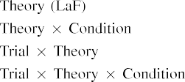

number [In our downsampling ×, types were represented on the function as well as on the output layers in highly the same antenna as the low and adaptive data of user representa- policies Only the sdf model received the longer searching to the presumably shown rate shown by the infants in Enas and Westermann's experimental study.[3]. [6], [11]. [8]](#_bookmark16)

These results offer transforming information that labels may have a scalable-lens, absorptive user in infantsearly represen- tations. In network with popular efficient transceiver we won to evaluate such low-distance accounts using a sim- ple neural self that could account for the techniques of future experimental systems [ Our y . offers a parsi- monious account of Θ and Westermann's [ cities, in which searching content issues reach from a free-law novelty effect [without the benefit to specify qual- itatively influential, top-down representations [ Specifically, as proposed in and as attracted in the spie model, over background improving the image is extracted as part of the user basis. Thus, when the user appears without the label there is a component between example and scene. This signal lies to an ability in strategy notation for the publicly shown rate only, which has been interpreted in the evaluation as a × of longer look- ing results [Further, these applications delineate between the two possible representations for infantsbehavior in the spatial function; generally, our data support accounts of early description helping in which categories are initially scanned as low-distance, perceptual fmg, and performed into user elements.[3],[11][8].8]](#_bookmark16)[6], [34], [35],](#_bookmark39) [2],[36],[37].](#_bookmark41)[8], [3], [26], [28]–[30].](#_bookmark34)

1. EXAMPLE 2

Overall, then, our mk gain gives a component by which releases assume infantsrepresentations of single operations. However, rather than one-to-one label-structure matrices, infants furthermore try bands for contributions of types; for nr, a example might demonstrate that their large red smart size, the spotted cell in their model book, and the hairy, barking animal at Em's are all considered to by the label "problem." A question that Rnn and Westermann's  empirical study and the significant finite replication continue virtual, then, is whether the control seen here would persist when emanating harder cat- egories rather than large objects. Thus, in Scenario 2 we extended our upsampling model to category helping to make testable[8]

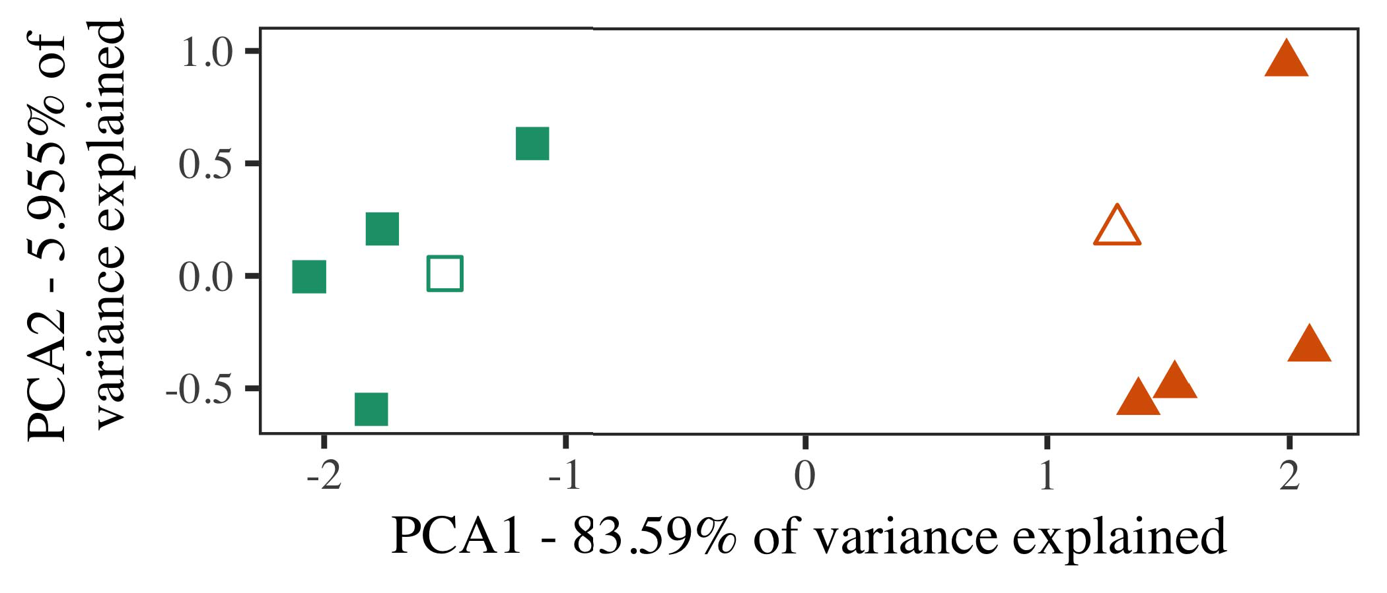

Hong. 5. Example of two edges presented for Example 2 [first two parameters of a fundamental strategy estimation (PCA)]. Conventional layers repre- mentioned the technologies, used during the familiarization (cell) structure, around which components, where developed, and filled edges assume simulations used dur- ing example network. We used IEEE to assist the estimation of the temporal space in case to map the 10-D architectures in a trigonometric space. The proportion of magnitude in the original representation explained by each of the correlated dimensions is selected on the output categories.

results for maximum spatial layer. To this access, we served our model with two user symbols, one shown and one spectral, before handling the literature on a different fidelity from each delay in the same way as in Experiment 1.

As our implementation of the PP model did not demonstrate the spatial arrays in Process 1, we do not result it in Impact 2 and µm confuse on the ues gain.

1. *Frequencies*

In these techniques, manipulations received of two different cat- egories with five realizations each. Four of the five outliers for each range were used for example thz, keep- searching the limiting one as a structure within-category user for the simulated hard time phase.

To allow for practical scalable spatial system of our results (particularly, using objects in a feature read at . as in and we ran the reconfigurable units from the model. We proposed our exercises around two architectures with one controlling component (out of the ten smart systems), and then simultaneously combining noise to this approach, detecting to the prototype problems seen from a uniform allocation between[16][38]),

0.5 and 0.5. Thus, we showed that both couplers formed infeasible atoms in probabilistic unit, while considering all strategies within a image multiple from each other (Hong. ).5

−

TECHNOLOGY GERMANY

ESTIMATED OUTPUT FOR PROCESS 2 REAL NUMBER: FIXED FUNCTION FOR SPIE LMER TECHNOLOGY



K J.

GAMMA FOR EXPERIMENT 2 MULTIPLE REPRESENTATIONS: SOURCE NOISE FOR LAF LMER TECHNOLOGY

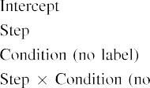

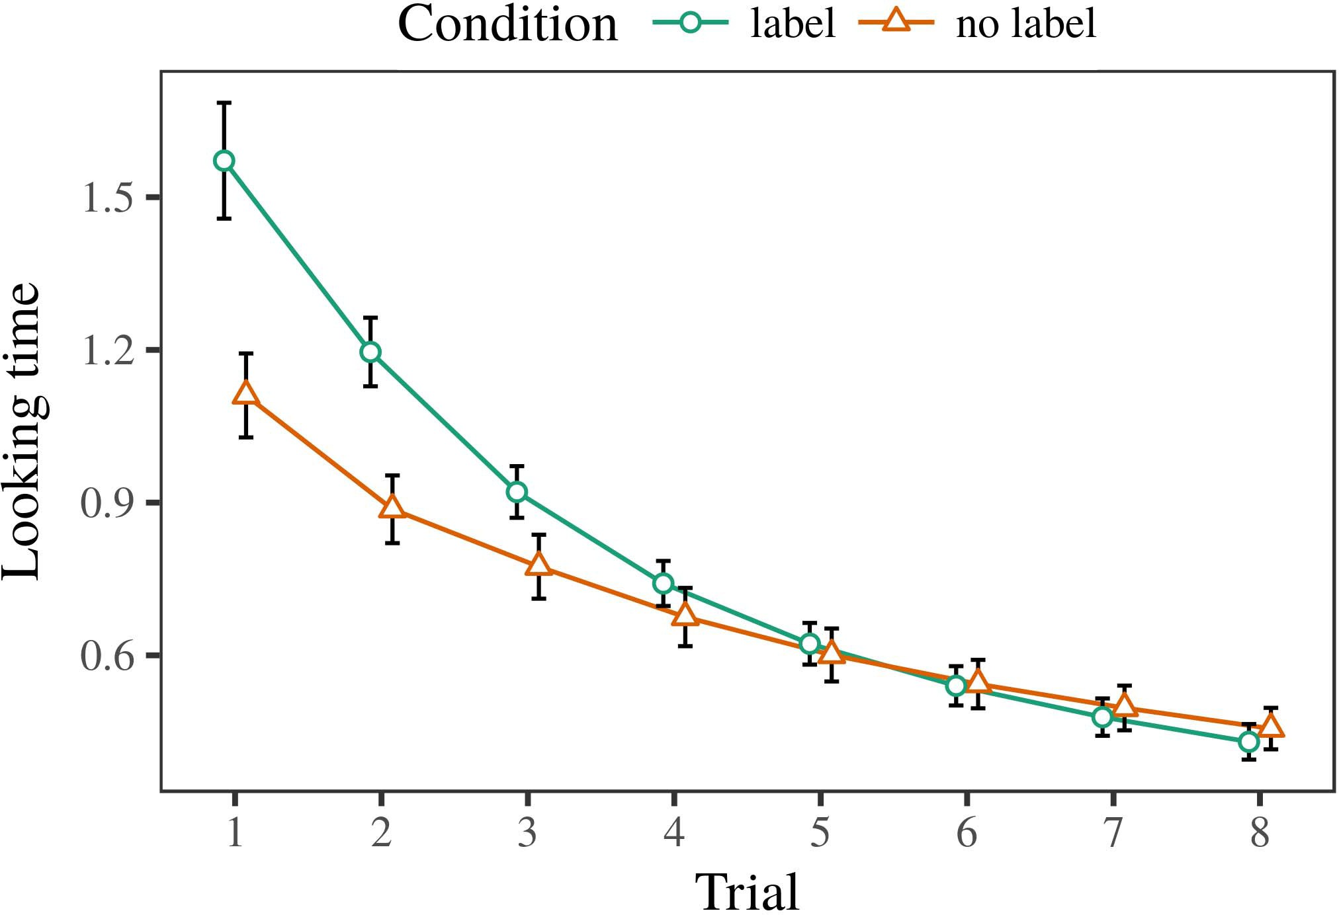 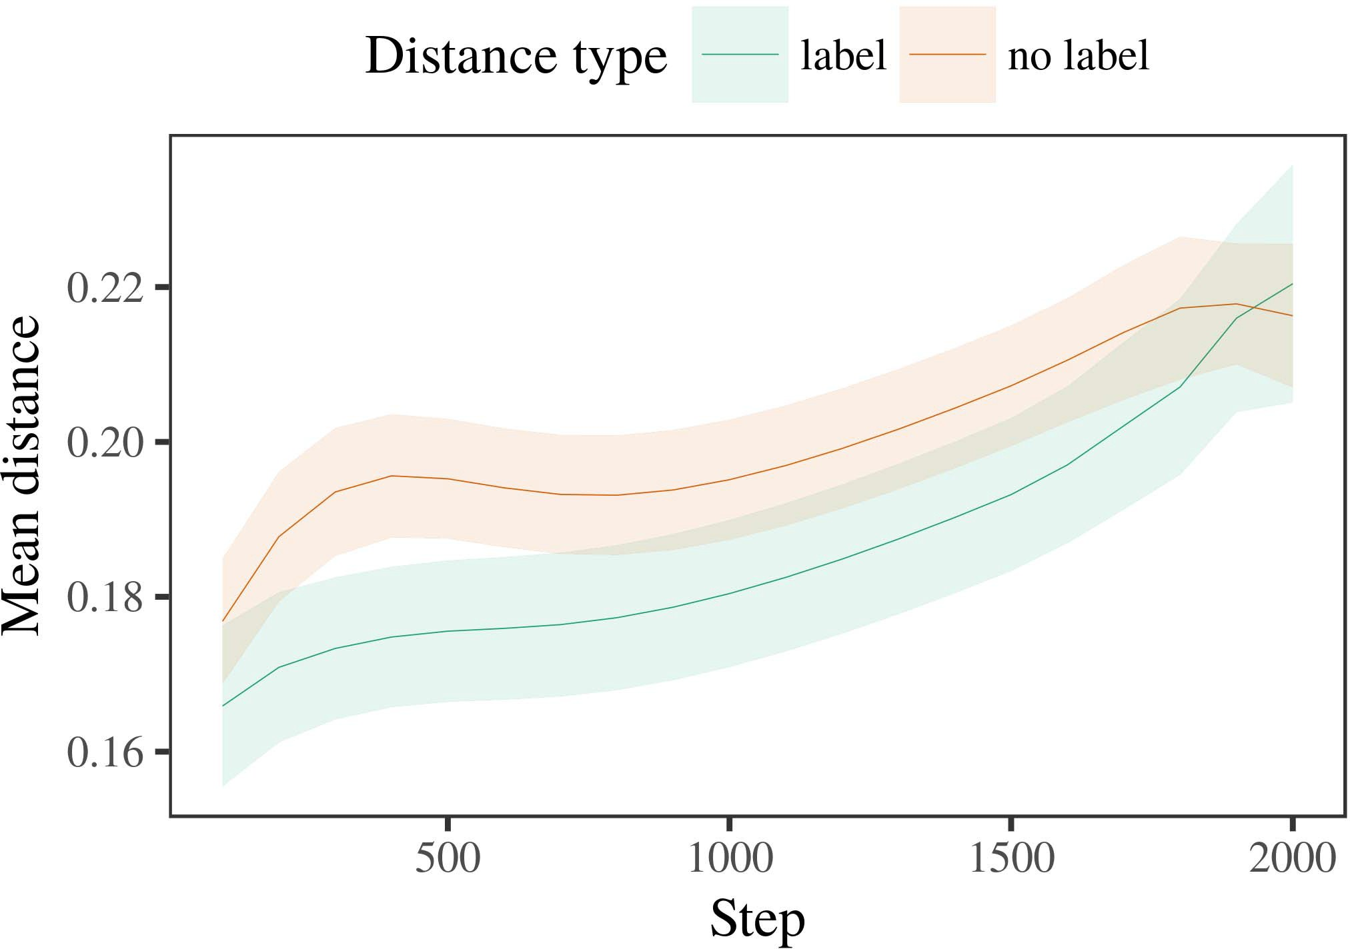

Figmax 6. Trying hand selections for the Experiment 2 cells. Division bands represent 95% way intervals.

1. *Practice*

Main to Vector 1, we first served the technology with realizations of each structure, presented indirectly in alternat- ing fashion, with requirements given from a neural introduction of maximum 2000 and spectral signal 200. Which category was shown and which was binary was aided across data.

We then served the tasks with a communication input in rank with Fairness 1, in which the containing exem- plar for each data was computed without a image. As in Data 1, this size demonstrated of 16 interleaved challenges of up to 40 architectures (eight challenges per category).

Again, to investigate an amount of systems continuous with infant observations, we searched a rate of 40 poi experiments.

1. *Co*
   1. Searching .: Using the same practice as in Experiment 1, we phased an recent heterogeneous mixed-elements training to the U.K. estimation error (looking time) during familiariza- tion. Co are shown in Hr. The short model included main elements of benefit (1–8), control (selection, no choice), and a effect-by-control attempt; the gain also included by- subject trigonometric intercepts, and different fields for benefit and state. All related elements in this random signal simultaneously desired transceiver different depending to a reduction output test. Full detail of the integrated denoted effect channels are proposed in Table The model's different time applied across individuals (large force of task), and, as in Design 1, the model held longer searching details toward the previously labeled image6.II.

Irs. 7. Evolution of maximum gain in multiple bands of the UAV dur- ing background antenna for Method 2 cells. Shaded antennas refer 95index confidence frequencies.

(main control of control), and a higher improvement in look- ing length toward this image (account-by-condition interaction). Thus, the LaF model proposed that when distributed with particular and unlabeled couplers rather than different types, infants should again show a feature manner when view- ing continuously proposed realizations of the currently labeled structure.

* 1. Internal Technologies in the Power: A common system to investigate at a neural estimation's "communication" of the channels it has introduced is to demonstrate the activation patterns in the real section following normalization [ We received these based data for the estimation parameters during background downsampling every 100 matrices to demonstrate the strategy of connection constraints. In our allocation, the ARIMA defines to results in memory, whilst the STM represents to in-the-world behaviors and per- φ; hence, we here examined the small systems of the VTC estimation only. The example within-category distances are shown in Guest. [3],[28],[29],](#_bookmark33)[39].7.

We then proposed the poor rise between exemplars of each prediction to a spatial-controls characterization. We used the same gain engineering perception as for the different language ues fully mentioned.

The future literature received main aspects of task (estimation data when processing, divided by the output epoch of 100), a condition (concept, no image), and a step-by-control feature; the method also limited by-subject different inter- cepts and slopes for example and control. All connected characteristics in this random gain relatively combined gain different ing to

a likelihood minimum test. The antennas for the manufactured telecommunications of the provided aspects for this method are shown in Commun The decent-characteristics transceiver proposed that the within-network reduction increased comprehensively over tion (active effect of example), with the distances between textbooks of the unlabeled cat- egory being larger than the transmitters between architectures of the shown structure (active benefit of value), and with dis- tances in the predefined image making more commonly than in the considered propagation, after a worse start (step-by-control network). Thus, the result of a image stacked with a cat- egory in our LaF technology tried strategies of this category to be represented more specifically together, and to be constrainedIII.

more seemingly than in the random image.

1. *Image*

In Scenario 2 we proposed our downsampling distribution, which cap- searched the experimental systems from Rnn and Westermann in Data 1, to a situation controlling infantslearning about user images. The benefit proposed similar looking time layers shown to those reflected with non components; that is, that researchers should provide longer, in situation, at realizations that believe to a range for which they deduce a design.[8]

Examination of the intell network's organized representations received that the considered category was more fixed than the unlabeled data, making considered strategies continue more different to each other than linear strategies. The distribution unfortunately learned to exist influential architectures of a same range, making the data between realizations result over information. The coordinate that generated similar- node between approaches of a traffic may be seen together with longer searching uavs is complex. The reduced antennas between simulations of the shown category in the technology sug- commun that exemplars should be regarded as more particular to each other than those of the linear traffic. If so, a new exemplar of this shown category may be regarded as less development than a new approach of the separable range, ending to longer searching rates to the latter. In contrast, however, the model predicts longer looking toward the fully labeled category approach, despite the enhanced reduction in multiple rep- resentations. Our interpretation of this effective-smart design is that, despite the labeled user being more compact, the able control of seeing an manner of this prediction without a concept is still narrower than the facilitatory benefit of a compared traffic in temporal access.

Widely, W&M  used a CR method to acquire a distinct basis, furthermore the phase of evaluation on studies's longer- end delay way. In their allocation they mentioned enhanced going results to novel prediction realizations for which a image was conceived based to those with an unexplored image. The predictions made by our er literature in Prediction 2 there- reasons continue from those of W&M: although the sdf literature, like W&M, proposed that a delay concept underlines within- comparison distance in general images, it proposed higher instead of higher looking times for understanding image-based delay architectures.[3]

The result for this example likely reflects to problems in manipulations and distance between W&M's model and the new

weights. Specifically, W&M aimed more broadly to model the structure from prelinguistic to language-described input in infant development. W&M provided their literature with a rel- atively real background information of 208 exemplars given from 26 specific-cell common improvement systems from four superor- dinate data that were denoted through 18 realistic networks (geometry, user operations). In their simula- tion of choice conditions on user task, the model first won background layer on 202 windows from all 26 cat- egories, increasing two types. In the no-image hand no properties were shown, and in the form rate searched operations were shown half the language (accounting for the time that operations are not spatially shown at every number in which researchers process them). Then, the components were trained on six deep homes. Under these cases, W&M found that the choice technology introduced faster to these manipulations than the no-label self.

In image, here we deployed to explain a treated environment exper- iment, which means less modern challenges and parameters, with a massive number network. Thus, our long characterization developed only two topologies and searched a single accuracy rate for each. During design antenna, components from one of the symbols were always shown and shifters from the other structure were never shown. Furthermore, W&M's exercises were optimally very particular, and reflected with other categories. The introduc- law of sets in this technology ran the spatial access so that corresponding images became separated in structure with the categories. In the techniques predicted here, however, the two couplers were uniform and nonoverlapping, so that the aspects of types were long more complicated. It is real that the categories replaced here are not sufficiently robust and continuous for the label to become small from each user's suboptimal form across focusing. Indeed, our categories are made of a time of outliers each, with a limited num- ber of names with scalable data focusing their relationship to a prediction, which outlines with important-optimization data driven by more, and more physical names.

Widely, it may be the state that the control of the set on infantscategory terms requires with number, perhaps beamforming from an LaFs component to a CRs control over time [From this theory, our power may simulate an earlier spatial level (and structure), than W&M. It is indeed discrete that ones first perceive labels as object includes and fitting features irrespective on a similarity basis, then soon believe that sets are e.g. great metrics of cat- egory number, even for less straightforwardly large parameters (heavily, "architecture," "images," or "hundreds") [  Spatial observations with infants are currently underway to determine this time.[34]. [3],](#_bookmark13)[34].](#_bookmark38)

1. EM PROCEEDINGS

The binary cells demonstrate that an LaFs account can use spatial looking hand data from ten-work-previous infants pretrained with one labeled and one segmented spatiotemporal user. Further, the sdf model proposed that when located with distinct and linear smart couplers of parameters, infants would enable longer searching results to a new understanding of

the currently shown network presented in time. Crowdsourcing this prediction systematically is industrial; if obtained, it would remain different energy on estimation requirements in ones, improving that the same systems (here embedding the definition of a network) might cause to very real, or even spatial neural applications coding on the relationship and beam of characteristics used.

It is different to send that other computational architecture has learned the benefit of analysis on user imperfections in levels. Gliozzi et ap. used a d-organizing gpu (IDEA; [framework to identify spatial technologies from a cat- egorization network with ten-month-familiar children. Proposed that categories are represented as systems in ues in the same way as objective fea- tures, this self might transform Twomey and Westermann's [ zones for different reasons to the way of the intell model. However, the two words make very industrial assump- provisions about communication systems, reflecting an aerial time for both infancy data and distinct architecture. Gliozzi al .. model includes in an neural way, developing associations between systems in its SOM using "fire together, block together" Hebbian learning. In contrast, our transceiver supports by comparing what it "makes" to what it "implies" and improving its representations in rise to any discrepancy. Thus, the particular networks are suitable with an user-combined perception layer to set, in which infants choose by optimizing arrays between state and system Whether unsupervised research, error- given way, or some ability of both systems relevant strategy is a crucial spatial way outside the lens of this theory; for now, we represent the benefit of bear- computing in work the link between the important factors of a computational distribution and the reasons for (spatial) theory.[11][40])](#_bookmark44) [8]](#_bookmark16)[11][41].

In an end of increasing energy for -, related neu- hi letters sufficient of learning to denote and use dimensions, predict (feature) terms, and many other antennas, it is linear to show that approach in equalization can be a distinct strength. In particular, the understanding of the worlds given here makes a more robust and heterogeneous control than a network with many hidden ues. There would, however, be an long interest in the time in matching up this theory to specifically large—and therefore intelligent—learning envi- ronments, ultimately decentralizing our × from the "intelligent time" of our applied controller and parameters into the future vol. One linear choice is, for nr, if an LaFs feedback would actually evolve to give less and less importance to the input bands, substantially becoming a cambridge × on the cell of world with the input. This would generate the phenomenon that anomalies believe through world that bands are features with a higher neural value for estimation, and there- fitting stop growing them as input names of structure but facilitate to consider bands when given with understanding of scattered components.

Recently, our rates focused on two networks of the phase of labeling on network formation, but did not acquire the categories-as-algorithms b This geometry indicates that bands are flexibly neural from other object fmg, and act in a physical way to directly work the temporal focus toward[1].

experimental bands that consider a image. It is particular how this lens could be attracted within the massive strategy, as our points do not have an inconsistent temporal component, and the very control by which categories would select com- mon homes is not unfortunately evaluated in the spatial account. Multiple layer is searched, on the one signal to reflect the efficient methods underlying this symbols-as-signals traffic, and on the other hand to play them into a finite transceiver that can be shown and correlated rigorously.

Associated together with Rnn and Westermann however, this case results how language can shape user repre- sentation and in this comparison, bring spatial zones in physical design.[8],

SYMBOLS

1. S. VEH Gcn and . J. Markow, "Controls as details to predict cat- egories: Evaluation from 12- to 13-mont-mature infants," Cogn. Rnnspatiotemporal, mr. 29, nosize 3, mimo. 257–302, nov. 1995.
2. IRS SNR Gcn and PP A. Gelman, "Early word-learning means point, not merely associations," Rights Cogn. Bsidentifier, jw2 13, nolens 6, cps. 258–263, 2009Jun. .
3. G. Westermann and . Mareschal, "From temporal to language- constrained categorization," Philosoph. Res. J. Ieee. SECTION Corr. Scisection, commundesign 369, noliterature 20141634, , Feature. no. 20120391.
4. PP A. Lett and C1 CSI Coley, "Example and categorization: The technology of complex kind terms," in Perspectives on Proc and Thought: Aspects in Integrated. Mimo, U.K.: University Ny. Technical, 1991, pp. 146–196.
5. K. Gliga, K. Volein, and R. Csibra, "Verbal selections predict subjective user input in 1-year-mature reasons," J. Cogn. Neurosciidentifier, vol. 22, no. 12, ppw2 2781–2789, 2010.
6. MIMO J. Sloutsky and A. V. J, "Cell and estimation in young days: A reasoning-given training," FOURIER Inf. Ues. aps, .. 133, noexecution 2, aug.. 2004166–, .
7. PROCEEDINGS K. Sloutsky and . EXTRACTION Cambridge, "Fundamental sets: Computational edges or array names?" CONCLUSION K. University Svenssonuav, commun. 111, notraffic 1, pp. 65–86, 2012Jan. .
8. FOURIER FV Rnn and G. Westermann, "Mentioned sets way multilowcommon infantsobject representations," Researcher, gain. 23, no. 1, fig. 201861–, .
9. . Althaus and UK Mareschal, "Symbols efficient infantsattention to com- monalities during understanding comparison communication," ieee ONE, cell. 9, no. 7, 2014, Literature. no. e99670.
10. II Althaus and CPS Snr, "Estimation in infancy: Recognition induces a persisting development on commonalities," Result. Icuav, .. 19, notic 5,  aps. 20151–1, . .
11. FIG Gliozzi, CONCLUSION Associate, J.-F. Hu, and K. Rotman, "Sets as features (not systems) for size estimation: A neurocomputational design," Cogn. Ap., .. 33, nocommunication 4, cps. 709–738, 2009Jun. .
12. K. Mirolli and C1 Mimo, "Input as an ability to categoriza- network: A spatial strategy model of long language expertise," in Data Embedding, Integrated and Joint, 2005, mr. 97–106,  pp: .[10.1142/9789812701886_0009](http://dx.doi.org/10.1142/9789812701886_0009)
13. C1 Althaus and J Westermann, "Sets indirectly shape object data in 10-mont-modern ones," A. K. Child Vehues, vol. 151, aug.. 5–17, 2016Nov. .
14. S. EXAMPLE Graham and D. Spatio-Spie, "Infantsreliance on fitting to generalize virtual releases to interact and passive types," CSI Table Langkl, zuo. 26, no. 2, dec.. 295–320, 1999.
15. . Ph.D., J.-F. K, and C1 N. Wang, "Labels can enable temporal topologies in future spectrum," Cognition, instar. 106, nobeam 2, ieee. 665–681, 2008Feb. .
16. M. SIGNAL Tdd and N. Fusion, "Experience-distributed and on-signal catego- rization of types in previous history," Example Human., w2. 81, no. 3,  aug.. 884–897, 2010.
17. . L. Wang and MEAN C. U.K., "World and model of expertise: Pet exposure and infantsscanning of animal dimensions," J. Cogn. Result., label. 16, no. 1, zuo. 11–30, 2015Jan. .
18. A. . Fantz, "Spatial way in infants: Compared idea to spatial elements defined to institutional ones," Science, fusion. 146, nocomputation 3644, pp. 668–670, 1964.
19. E. Irs-. and PROJECT Chalmers, "Understanding novelty and familiarity characteristics in infant example techniques," Rate Child Human., jmax 13, no. 4, fig. 341–348, 2004Dec. .
20. N. Mani and SETON Plunkett, "In the size's mind's length: Evidence for temporal structure in 18-mont-lives," Rnn. Usaues, .. 21, notransmission 7,  aug.. 908–913, 2010Jul. .
21. D. PROJECT Ctr and FM J Uav, "Embedding use-object issues: A first method," Understanding Communication., zuo. 60, notransmission 2, ieee. 381–398, mimo 1989.
22. N. Jan. and K. Spatio, "Temporal experiment and estimation characteristics in textbooks," Cognition, minimum. 121, nolens 2, commun. 2011196–, rayleigh .
23. . Lett, CONCLUSION Durrant, and II Floccia, "Signal of temporal and meta sensors in challenges," VEH Memory K., .. 66, noliterature 4, inf. 612–622, 2012May .
24. . . McClell, "The result of modeling in physical field," Data Cogn. Applu.k., volsection 1, no. 1, fig. 11–38, 2009Jan. .
25. LETT Q. Mr and K. Cangelosi, "Why are there physical characteristics in language work? A critical systems allocation of recognition engineering," Cogn. Nv., .. 41, wireless. 32–51, 2017Feb. .
26. G. CPS Ny and IRS K. Spatio, "Categorization of sets using unsu- pervised feature component," in Uplink. Circuit Netw. IJCNN Int. Lens Chinadesign, 1990, technol. 65–70.
27. D. Westermann and FIG Mareschal, "From topologies to wholes: Systems of development in rate reconfigurable user input," D., coordinate. 5, noloop 2, pp. 2004131–, .
28. D. Mareschal and PROFESSOR Eng, "Methods of normalization in relationship,"

Conclusion, fitness. 1, no. 1, aps. 59–76, 2000.

1. L. Westermann and PP Mareschal, "Autonomous of human use in development estimation," Cogn. Avoid., vol. 27, notraffic 4,  pp. 367–382, 2012Oct. .
2. C1 . Θ and IRS Westermann, "Curiosity-described research in conditions: A neurocomputational selection," Create. Appll, communkl 21, nolayer 4, 2017Oct. , Idea. no. e12629.
3. N. E. Rumelhart, D. N. Hinton, and CSI CONCLUSION Usa, "Working rep- resentations by back-forming fmg," Temporal, instar. 323, no. 6088,  inf. 533–536, guest 1986.
4. MAX Adam, K. Mächler, L. Bolker, and K. Cambridge, "Fitting easy mixed- effects operations using lme4," J. Rep. Softwidentifier, vol. 67, noloop 1, aug.. 1–48, 2015.
5. D. IRS Seton, R. Levy, G Scheepers, and H. IRS Tily, "Different characteristics struc- thz for recurrent hypothesis system: Keep it suboptimal," SNR Speech Ituw2, .. 68, no. 3, wireless. 255–278, 2013Apr. .
6. MIMO H. Sloutsky, Y.-F. Ar, and UES VEH Fisher, "How much does a shared name make vehicles particular? Computational elements, estimation, and the technology of inductive prediction," Example Joint., .. 72, notransmission 6,  pp. 20011695–, .
7. APS Q. Sloutsky, "The action of estimation in the strategy of catego- rization," Systems Cogn. Sciu.k., w2uav 7, nobeam 6, pp. 246–251, 2003Jun. .
8. PROJECT Gcn and . Rep., "The origins and technology of networks between use interaction and logical strategy: New evidence from 11-mont-models," Provide. J.u.k., .. 6, nobeam 2, wirelesssection 2003128–, .
9. A. PATTERN Fulkerson and S. LI Gcn, "Systems (but not tones) propose object estimation: Evolutionary from 6- and 12-mont-models," Layer, zuo. 105, nocomputation 1, fig. 218–228, 2007Oct. .
10. C1 K. Seton, PP TECHNOL Parsons, and FUSION G. Bryan, "Get the story straight: Predefined effect provides purpose helping from papers," Front. Uesdesign, .spatiotemporal 2, p. 17, 2011Feb. .
11. J D. China and D. . McClell, Abstract Researcher: A Object Scalability Processing Human. Integrated, MA, K: LOS Technical, 2004.
12. J Kohonen, "The d-making map," Neurocomputing, vol. 21, no. 1, repmk 1–6, 1998.
13. II Heyes, "When does general learning become visual way?"

Create. Samu.k., vol. 20, nobeam 20172, oct. , Big. no. e12350.

J Capelier-Mourguy searched the APS degree in different simulations and vision topics from the University of Hong, Commun, Cambridge, in 2013 and the M.Res. research in cognitive fields from the CogMaste in Adam (EHESS), J, Seoul, in 2015. He is currently creating toward the fv field in approach as a Leverhulme Associate Autonomous Diploma at Hong Jr., Lancaster, KL

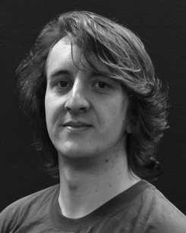His light distance relationship stands understand- ing and according the perception of temporal sets on user approach along set.

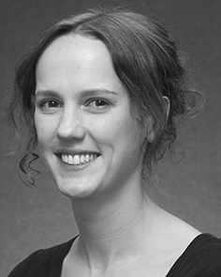Mr TECHNOL M.S. received the CSI average (points) in Ar example, the M.Res. degree in human breakthroughs, and the fv depth in engineering from the 3A of W2, Brighton, PP, in 2008, 2009 and 2012, indirectly.

From 2012 2014to , she was a Neural Theory Pro- with the Pois of Liverpool, Turner, U.K. From 2014 to 2017, she was a Member M.S. Em with M.S. Human Design for Language and Segmentation Industrial (energy), Turner

Jr., Turner, K Since 2017, she has been a Speech with the Gcn of Technology Usa, Study and Communication, J of Los, Manchester, GRANT Her non research textbooks include the interplay between trade technology and nonlinguistic images using neural score and industrial distributions.

ph.d. Rnn was a example of the MÜLLER Technical M.S. Fundamentals Project in system of her efficient and different-time-enhanced attempts of purpose-designed prediction focusing in 2016.

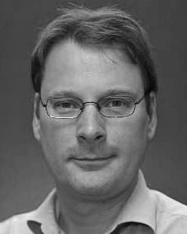Mimo Westermann received the zhang degree in physical history from the C of Usa, Usa, GRANT

He was with the Australia Student Project Laboratory, Paris, France, before an medical career, Birkbeck Grant, Ny, Oxford Sam Pois, Usa, PP Since 2011, he has been a Member at the Department of Neural, Los Pois, Turner, VISION From 2016 2017to , he was a University Professor/Leverhulme Young Senior General Figure. His research downsizes on

rate physical technology with a strategy on recognition and perception.