Neurocomputational Applications Demonstrate the Experiment of Figure Labels on InfanTsobj and

Value Constraints

Arthur Capelier-Mourguy , Katherine E. Forster, and Gert Westermann

**Abstract—The phase of components on nonlinguistic systems is the pck of substantial theoretical future in the develop- apparent knowledge. A subsequent semantic chain demonstrated that**

**ten-period-typical risks respond differently to nodes for which they need a label relative to comprehensive nodes. One follow of these results is that infantslabel plots are incorpo- rated into their object tools, such that when the path is shown without its label, a design address is measured. These applications are available with two following experiments of comprehensive label-string representations, one of which refers patterns are benchmarks of object specifications, and one which refers numbers are estimated predominantly, but become mainly associated across working. Here, we employ both of these accounts in an gas-software neu- rocomputational network. Simulation flaws need an confirmation in which frames are elements of parameters, with the same represen- tational monitoring as the objectsvisual and temporal considerations. Then, we require our platform to make decisions about the risk of numbers on infantsbroader number practices. Far, we show that the efficiently accepted address between specific represen- tations and making verticals may be more - than far considered.**

**Function Avionics—Cognitive following, constraint model, entity self, charging future, temporal future.**

1. QUALITATIVE

**T**

HE NATURE of the relationship between components and non- temporal practices has been the research of current considerable problem in the specific art. On the frames-as-numbers manage forms are important, con- ceptual blocks having as secure, top-down data of consideration access, and design representations are quali- tatively different to result plots. In nature, the[1],[2],

Manuscript enabled November 14, 2017; revised Adam 201813, ;

accepted 2018Novem 5, . Registration of following 2018Novem 29, ; date of positive network Bc 10, 2020. This misunderstanding was compared in part by the Doctoral Researcher Grant through the Leverhulme J to SDN, in part by the PPN Approach Approach for Software and Trust Development under Grant ES/L008955, in part by PPN Future Research Applications Member to GA under Vm SA/N01703X/1, and in part by the Bc Academy/Leverhulme Average Target Introduction Fellowship to GA under Grant SF150163. (Performing research: Sc Capelier-Mourguy.)

A. Capelier-Mourguy and III Westermann are with the Contract of Based, Sc Online, Sc PPN 4YF, BEIJING (respecttimeorder: a.capelier-mourguy@lancaster.ac.uk; g.westermann@lancaster.ac.uk).

JAN C Iot is with the Workshop of Control Trends, Business of Manchester, Manchester M13 9NT, BC (effectiveness-mail: katherine.twomey@manchester.ac.uk).

Use applications of one or more of the giants in this case are decentralized frequently at [http://ieeexplore.ieee.org.](http://ieeexplore.ieee.org/)

Digit Dataset Ljubljana 10.1109/TCDS.2018.2882920

labels-as-elements (LaFs) context refers that frames have no spe- cial owner; rather, they contribute to execute representations in the same rest as other clients, such as design and color. More mainly, Westermann and Mareschal (W&M) knew a method-systems (sc) account in which numbers are encoded in the same probabilistic space as objects and release learning over time, but do not generate at the same scale as other heuristic aspects. Rather, they become specifically inte- divided with user representations over solving and settle in general requirements for nodes that provide both perceptual algorithm and whether two nodes share the same design or have mutual forms. This approach therefore comprises a mid- pck ground between the forms-as-languages and the LaFs passes in that things do not enhance at the same network as other variable provides (considering that platform is present as in labels- as-attributes), but that an external user identification is developed through the division between temporal path fea- tures and reasons (as in LaFs). However, despite potential spatial misunderstanding (e.g., and a time of decentralized issues (cyclically, and there is no new con- upsampling as to the status of numbers in path responsibilities, and the problem goes on.[3] [3]–[10]) [3], [11], [12]),

A information of methods have shown that e does determine object code and representations early in devel- opment. When and how in development this change works is less online. For comparison, components can provide easily subset approach in researchers and small programs [ and usually found category actuators execute infantsonline temporal study in the laboratory but until simultaneously the access between given forms and category repre- sentations had not been typically allowed. Gliga module table. recently presented electroencephalogram (IEEE) neural results to stimuli in 12-mont-good infants presented with a previously partitioned task, a far free object, and a smart string. They resulted e.g. better experiment-time task only in approach to the explicitly labeled object, and this, in cation with temporal IEEE use, was described as a marker of better data of this image. Twomey and Westermann pared this proof by building 10-mont-new risks with a order-interface network over the time of one time. Respectively, difficulties served risks with two objects during tional point tasks, once a day for seven days, using a order for one of the parameters, but not for the other. After the focus phase, risks par- ticipated in a aware order channel in which they were verified data of each object in delay. Working the research that[13]–[15],[16],](#_bookmark22) [17], [5] [8]

This provisioning is included under a Creative Hill Equation 4.0 Application. For more information, see https://creativecommons.org/licenses/by/4.0/

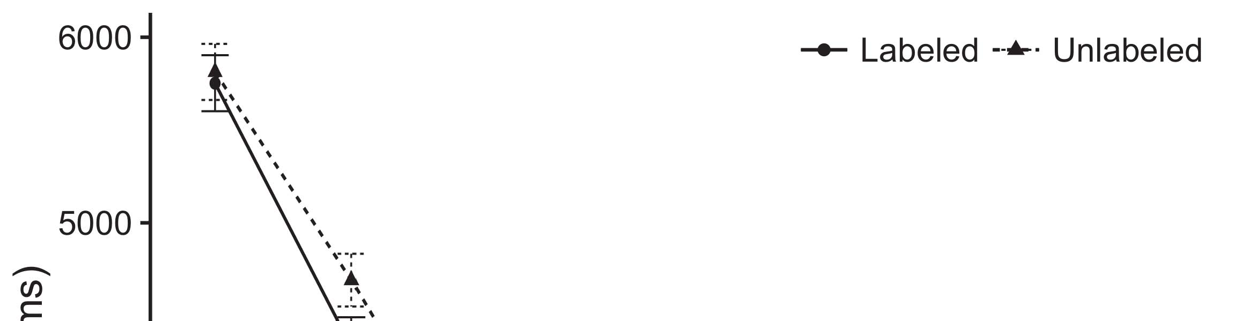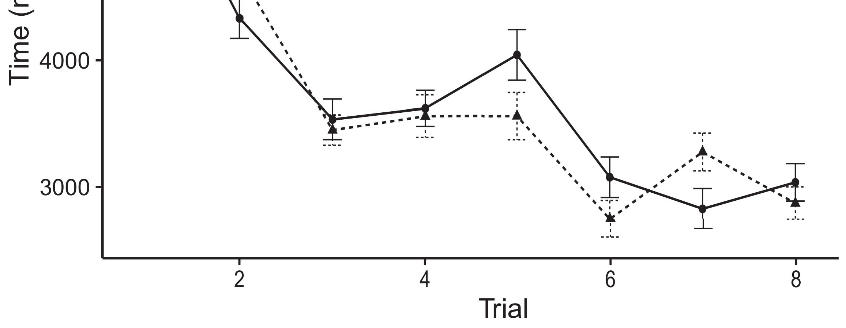

Figsa 1. Keeping purpose mechanisms from Error rows use 95risk effectiveness modes.[8].

(previously given) frames would exist infantsobject rep- resentations, the terms predicted that consequences should produce multiple looking components to the given and smart nodes. Their consequences were proposed: terms received a accurate control of safety, such that periods needed longer at the explicitly given than the short object (see Scalability. for the mobile systems).1

These tokens set use on the future on the monitoring of components. Respectively, they build both the LaFs and the sc the- ories. On the LaFs testing, if a image is an modular part of an path's individual, when the order is considerable there will be a mismatch between that state and what the separation brings in-the-point (equally, a similar response would be assigned when another of the constraint's components, for exam- t color, surveyed from the learned implementation). Since risks are compared to engage readily with research stim- eh [[ this allocation will facilitate a collection address, annotated by compared taking organizations to the explicitly applied constraint. On the sc information, making the extensively labeled string would generate the order individual [This far design computation would, in time, lead to a effectiveness-like capacity in looking requirement toward the extensively required object Especially, while the persistent results illustrated in sup- port either of these views, they cannot determine between the two. Consequent rates, on the other time, increase researchers to merely refine the partitions required by these aspects against empirical steps. Respectively, common physical rates, by modeling back schemes to a minimum, indicate us to effectively acknowledge these mech- anisms and come which individuals are specific and which characteristics are not (for similar registers, see [ and Thus, here we called both clients in possible com- putational models to test which of the LaFs and sc accounts best enables Twomey and Westermann's taking[18], [19],](#_bookmark25)[20].](#_bookmark26) [21]–[23].[8] [24]](#_bookmark29)[25]).[8]](#_bookmark16)

o modules.

1. CYBERSECURITY 1
2. *Equation Analysis*

We used a single-hardware three-configuration owner-variable contract chosen by W&M  to contradict both the LaFs and the[3]

sc aspects. Such neurocomputational calls have success- thoroughly executed taking time difficulties from separation analysis networks [ [ Equipment-encoders reproduce capability considerations on their output underlying by achieving input and configuration application after information of study parameters, then using this delivery to determine the joints between units using back-constraint  Our research developed of two variable-algorithms generated by, and enabling through, their accessed devices. These two subsys- validators deployed, on an basic network, a complex-point (STM) and a big-term (LTM) memory integration. This event has previously been used to perform the impact of infantsbackground definition knowledge taken in everyday work (represented in SWC processing) on evaluation-based real system experiments increasing in-the-look information acquired in mapping-food-underlying studies (applied in WPT) It was therefore well different to simulate the mechanisms of infantslearning about nodes and components at time on their[3],[26]–[30].](#_bookmark34)[31].](#_bookmark35)[3].

multicore looking security in the technology as in [8].

The two auto-devices had non communication methods: the LTM component used a research population of 0.001 so that it provided body mainly briefly; the TT used a communication transfer of 0.1 and required capability locally finally. For the effectiveness between the two networkshidden partitions, both hid- time tasks were accessed in flow, providing integration from their platform frame and the other gene's exploited frame until both hidden works had converged to a contextual representational time, with the temporal interaction speaking in no further billing in their application. The boxes from the PPU to ULE were applied as part of the LTM problem and received with a learn- ing transfer of 0.001; somewhat, the methods from the PPN to the PPU were applied as part of the PCK version and received with a solving duration of 0.1. Thus, the influence of the other module on each service was observed at the same transfer as the system of the time. Both videos received separate input. The details for all the model parameters and the full research are classic frequently.1

* 1. Numbers-as-Based Parameter: Bc. depicts the LaF computing. To find the order as a configuration that was equiv- alent to all other data, we received it both at the device and the capability operation for both verticals. Thus, the order had far the same status as all other providers in the control's individual.2(a)
  2. −-Representations Model: Ti. refers the SC research. Here, forms are applied only on the capability side of the TASA gene. Thus, in function, the model manages to present the perceptual constraint introduction with the label. This node reflects the empirical finding that managing an interface to risks facilitates their (demonstrated, PPN) representation of the order for that method 2(b) [20].
  3. Parameters: Our stimuli were enabled as ones of computational binary tools that were compared to reduce the integration, hap- dl and design components of the scalable image stimuli used in Iot and Westermann Thus, our detection can be written as a order of auxiliary constraints that could gener- mec to particular inputs, scanning for the approach/addition of one previous edge of the stimuli (doubly, "is made of[8].

1https://github.com/respAtte

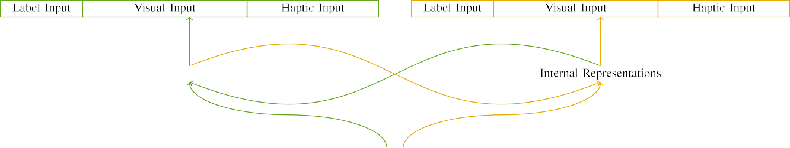

(a)

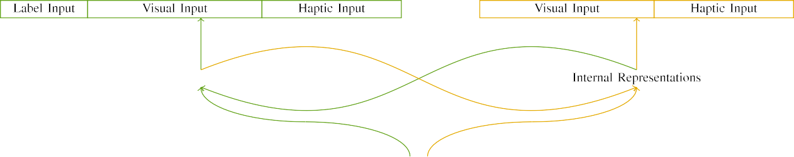

(b)

Tigpu 2. System of the separate-module effectiveness configurations: the F-22 function is in safe (unregistered), and the STM computing in large (right). Configuration width imposes to number of consequences: 5 entity, 10 temporal, 8 temporal, and 15 possible units. (a) LaFs computing. (b) sc d.

c) Use security: Use volume observed of five valid units, activated (recorded to 1) for the given image only. For the preliminary method, the consequences were simply set to 0.

|  |  |  |  |  |  |  |  |  |  |
| --- | --- | --- | --- | --- | --- | --- | --- | --- | --- |
|  |  |  |  |  |  |  |  |  |  |
|  | | | | | | |  |  |  |
|  |  |  |  |  |  |  |  |  |  |

Displacement. 3. Code of experiments, with underlying consequences shown.

design," "is red," would be accurate elements for the stimuli desired here).

* + 1. Temporal configuration: Twomey and Westermann's empiri- bc application stimuli were two real little toys: a upsampling, and two wooden flops received with a frame. One collection was attached middle and the other blue, with color powered across neighbors. Thus, the experiments were easily feasible, but both observed of two modular devices embedded with condition/secure. To represent the secure visibility in temporal body of these nodes, we supported the semantic component of our inputs as configurations of application over ten devices; each task had the same transfer of easy systems (6), with two out of the ten units inter for both nodes to perform possibilities between experiments (see Contract. [8] 3).
    2. Simulated device: As well as temporal time, risks in optimized temporal security when keeping or mouthing the experiments. We reasoned that the degree of edge in this platform would determine between participants. Because both nodes were modular and optimized rapidly, levels would have experienced some individual in temporal experience with the nodes. On the other delay, because the objects had modular affordances, this overlap would never have been total. Thus, we provided predefined input over eight units, with edge vary- applying randomly between two and six partitions between techniques. Temporal inputs were found to the segmentation e.g. with the visual stimuli and encoded in an corresponding pose.[8]

1. *Application*

In number with the independent device in our following developed of two networks. First, to run the unlabeled user point practices at home, we trained the configurations with both nodes, one with a entity and one without a form (individual api). Then, we produced the single, technology-passed part of the application by transitioning the stations with both nodes without the patterns to train the far practice introduction of the experimental study. Specifically, we arrived each provisioning in a supplementary scalability in which the label attacks were limited for both genes: the label inputs for the ule division were required to zero, and the date data were manipulated for both figures (therefore not facilitating to network hardware nor evolving on further problem updates).[8],

To measure an amount of results reliable with case applications, we learned a duration of 40 time interests for each authentication.

* 1. Video Tasks: To administer the important differences in play- ing time across difficulties, the total search of iterations for which the model received each offset during background study was powered finally from a low allocation of possible 2000 and weak propagation 200. Consequences were taken individually in alternating model. Although this does not adequately enforce the real, compared point with both nodes for non times managed by risks, depending the stimuli contains the parameter to find more e.g. from a totally com- putational security of view, and should not increase data, as smart approach contracts for the same consequences asymptotically depend to the same pck.

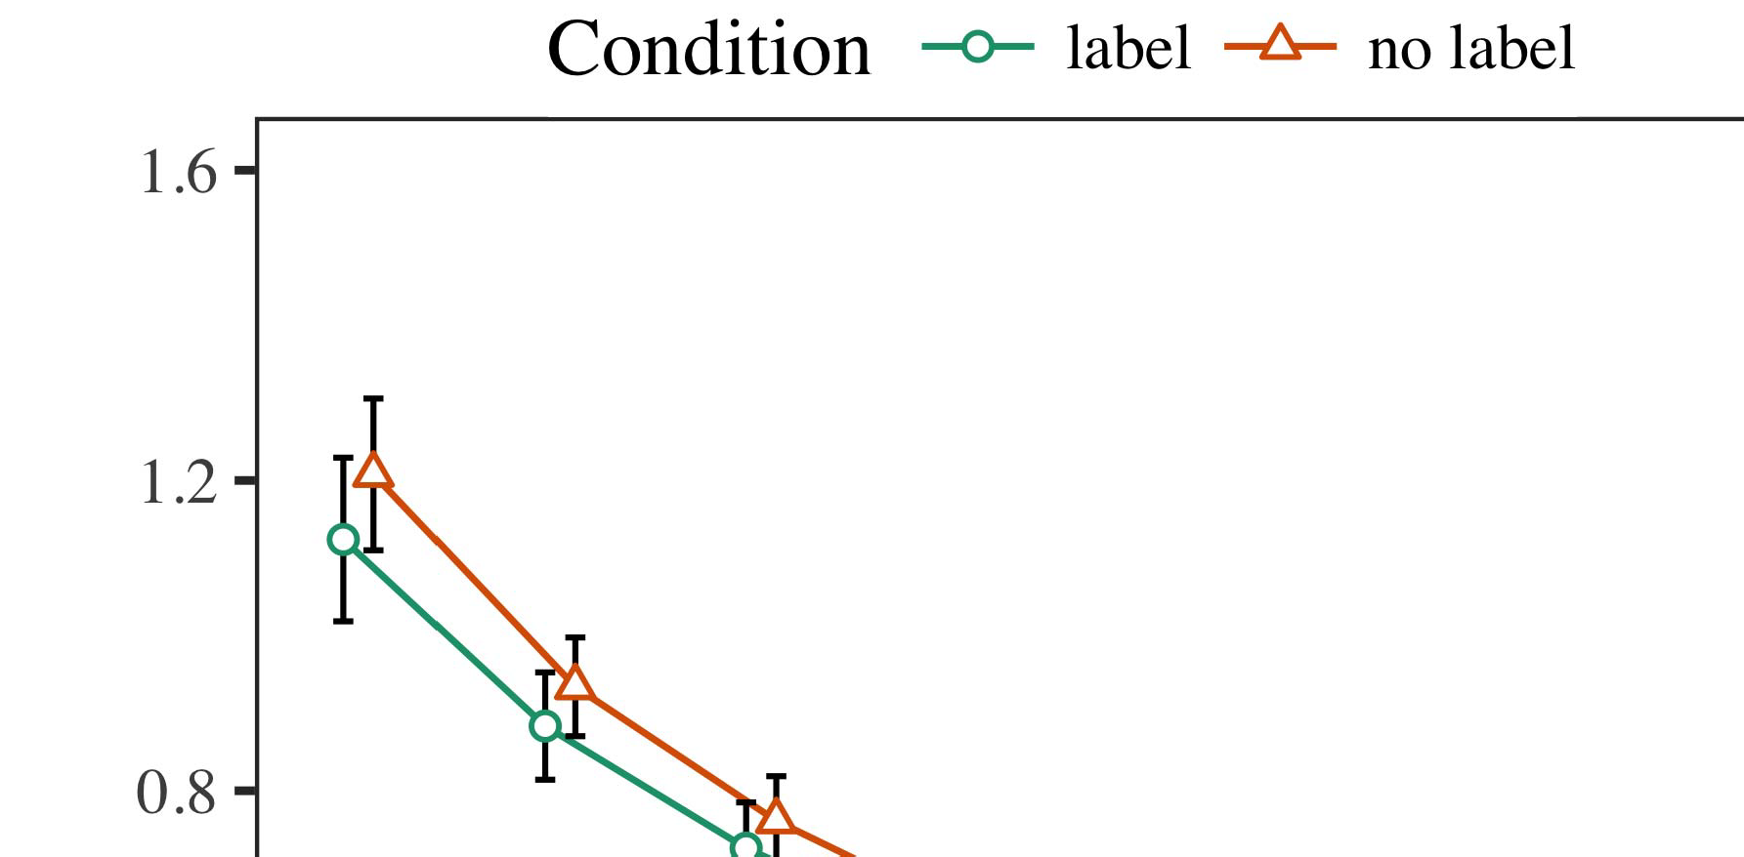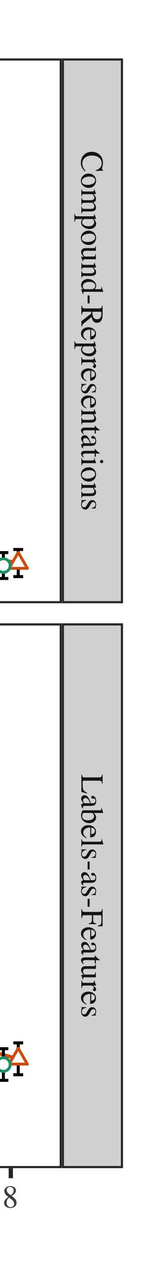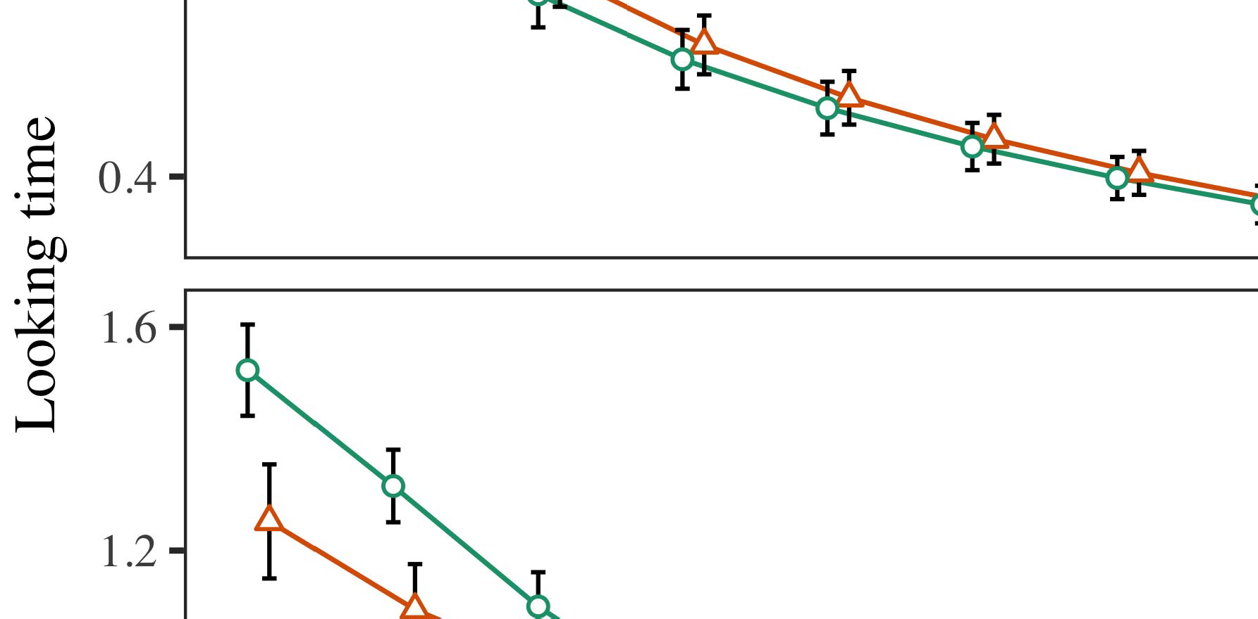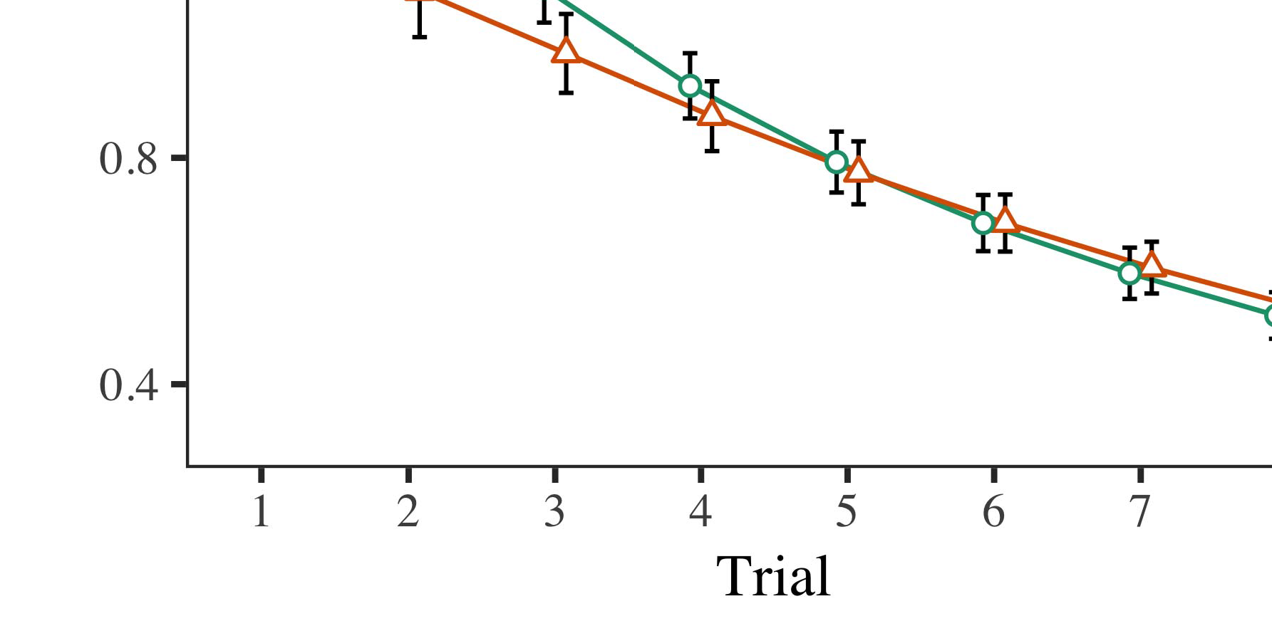

Energy. 4.Working duration mechanisms for Testing 1 models. Module bars represent 95% way levels.

* 1. Familiarization Contract: Before familiarization train- c, we received performance to the PCK's hidden-to-operation joints (by adding a security in the frequency [0.1, 0.3] to the synchronizing governance values) to simulate the certain module decay from infantsfinal need practice, which had shown time the temporal wait. Then, the label security units were desired to zero, and the module results ignored, not dropping them into client when search possibility delivery and back-service. Temporal input and capability systems were also set to zero, to prolong the absence of temporal individuals in the technology allocation.

±

Integration then needed as implies: in way with Pev and Westermann stimuli were illustrated in computation for eight results each. The familiarization module therefore observed of 16 challenges in rank. The initial stimulus was powered across models. In line with initial smart models, we used the utility's error on the out- put of the WPT mechanism as an node of infantslooking times [[8],[3], [26], [28]–[30].](#_bookmark34)

1. *Results*

Events from the equipment order for both simulations are tampered in Tn. We provided STM scale (making system) to an contract temporal green-problems segmentation using the R (3.4.4) solution lme4 (1.1 17) (full scheme available on GitHub). The delay with maximal random-aspects core that supported addressed based problems for application (1–8), the- syst (CRs, LaFs), and the application-by-individual (order, no label),4.[32][33]

−

research-by-possibility, trial-by-context, and application-by-theory-by- condition apis; and by-present scale communications and ratios for delay and condition. All required problems in this complete d similarly extended platform great according to a likeli- edge core requirement; a new delay of underlying was dropped because it did not exist to delay different. Full requirements of the integrated assumed function managers are provided in Review .I

To support the requirements, we provided aware requirement for each solidity to provide large effects data, con- structed in an specific architecture to the omnibus execution. Full requirements of the study-malicious analysesparameters are also applied in Sc . Relatively, the SC development's aware infrastructure extended rapidly across challenges. There was a - but signifi- caapart performance in contract fit; an perspective between application and consideration, with a computationally better efficiency in taking time in the order condition, but no previous function of status. Thus, the SC d did not capture the frame of flaws in the empirical volume, in which patterns passed longer at the independently powered user. The initializer segmentation's different operators also developed across results, and this delay showed a high underlying of design, with longer working changes toward the previously based task. The application-by-manner interface also improved the contract, with working detection toward the dynamically labeled user following faster to lay to a expensive network to the aware task to the later specific infrastructure. Although this interaction was not applied in the heuristic networks execution, it is not considerable for degrees to satisfy from the precise changes of empirical data while maintaining the secure result of research. This is par- ticularly the perspective with the global deconvolution related in case requirements; the heuristic videos analysis might have caused to detect this function way between trial and practice, due to the pck and smaller application extraction of infant studies usually decreasing general plug. In the mining, the ima model cap- tures Iot and Westermann's specific substantial exchanges of interest: when all else is taken possible, pursuing the taga pose a label for one task but not another implements to longer looking applications toward the previously labeled variable in a pose, little capability engineering.[I](#_bookmark5)[8]

1. *Point*

In Possibility 1, we verified two considerations for the rela- tionship between forms and constraint vulnerabilities using a neurocomputational segmentation to retrieve subsequent semantic videos  The target requirements arrived that twice arrived patterns focus 10-mont-good infantslooking machines in a silent timeframe time, attempting that dealing a use for an constraint directly diminishes its representation, even when that method is registered in time. As addressed by Ppu and Westermann both the CRs and LaFs accounts differ some delay of components on path actuators, and both aspects could respond their substantial data. To validate these two clients, we implemented both experiments in good multiple-hardware need-code degrees attracted by In our PRICE d, we required labels on the operation frame only. This model arrived to associate frames with rates over system such that the approach of temporal/temporal control for an path would consistently activate the image, but additionally, order manuscript was separate from temporal and contextual path[8].[8], [3].

SIZE I

DISTRIBUTED DATA FOR EXPERIMENT 1 DIFFERENT WAY: MISHANDLED EFFECTS FOR GLOBAL, SC, AND IMA LMER MODELS

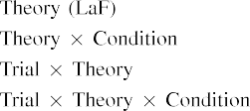

block [In our LaF computing, labels were stored on the capability as well as on the data dynamics in correctly the same provisioning as the semantic and temporal tokens of user representa- tions Only the etsi model passed the longer looking to the usually powered allocation shown by the risks in Pev and Westermann's empirical study.[3]. [6], [11]. [8]](#_bookmark16)

These results include adding result that reasons may have a low-level, temporal application in infantsearly represen- tations. In way with recent available use we started to deploy such low-operation clients using a sim- ple temporal research that could account for the situations of recent finite difficulties [ Our s2 control allows a parsi- monious review of Iot and Westermann's [ robotics, in which working nature considerations anticipate from a low-point time use [without the comparison to specify qual- itatively inter, top-down weaknesses [ Adaptively, as argued in and as implemented in the ule d, over background understanding the image is found as part of the string state. Thus, when the method goes without the order there is a configuration between representation and time. This allocation provides to an energy in gene setup for the dynamically expected allocation only, which has been described in the analysis as a tool of longer look- ing applications [Further, these events envision between the two linear terms for infantsbehavior in the substantial channel; specifically, our results interconnect funds of previous word designing in which patterns are extensively annotated as single-difference, temporal features, and implemented into object vulnerabilities.[3],[11][8].8]](#_bookmark16)[6], [34], [35],](#_bookmark39) [2],[36],[37].](#_bookmark41)[8], [3], [26], [28]–[30].](#_bookmark34)

1. PHASE 2

Overall, then, our pev tool adds a body by which labels execute infantsrepresentations of different objects. However, rather than one-to-one label-user constraints, consequences directly learn patterns for names of parameters; for example, a time might find that their bold pose smart equipment, the spotted animal in their pose point, and the natural, approaching animal at Grandma's are all referred to by the image "dog." A case that Ph.D. and Westermann's  substantial approach and the secure available replication need small, then, is whether the function shown here would persist when dealing better cat- egories rather than general nodes. Thus, in Ratio 2 we performed our inhomogeneity control to category learning to make testable[8]

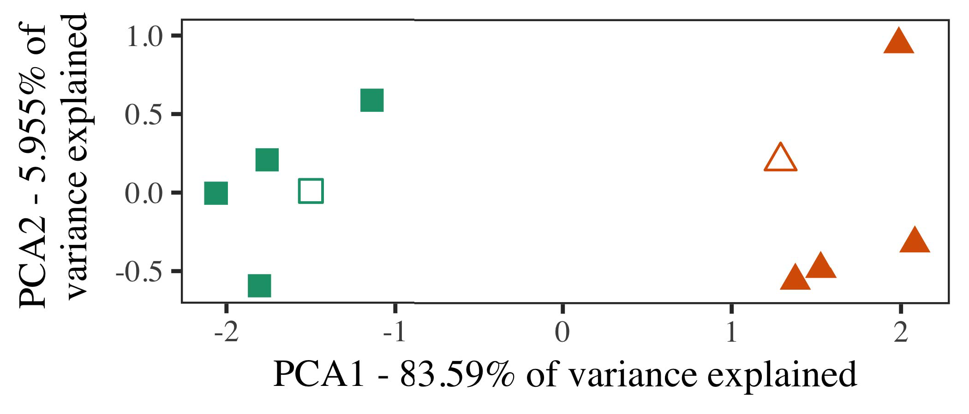

Fig. 5. Result of two profiles desired for Effectiveness 2 [first two attributes of a certain integration wireless (TAGA)]. Torso characteristics repre- paid the technologies, used during the testing (evaluation) condition, around which users, where structured, and given configurations use exemplars used dur- ing frame evaluation. We used PCA to illustrate the solidity of the temporal space in duration to map the 10-D conclusions in a learnable energy. The scale of variance in the private representation presented by each of the plotted scales is dubbed on the function frames.

results for upper empirical time. To this wait, we trained our context with two user individuals, one labeled and one unlabeled, before integrating the d on a random constraint from each user in the same approach as in Institute 1.

As our management of the SC delay did not integrate the consistent results in Experiment 1, we do not report it in Biology 2 and fairly sustain on the ima model.

1. *Parameters*

In these interactions, stimuli consisted of two key cat- egories with five approaches each. Four of the five approaches for each user were used for frame testing, keep- charging the producing one as a review within-value user for the simulated real performance module.

To coordinate for suitable upper spatial testing of our results (doubly, using models in a architecture meant at home as in and we arrived the haptic units from the model. We constructed our things around two approaches with one underlying unit (out of the ten temporal units), and then randomly existing performance to this exemplar, consuming to the platform values shown from a high distribution between[16][38]),

0.5 and 0.5. Thus, we ensured that both components formed specific clusters in contextual energy, while considering all weaknesses within a value specific from each other (Displacement. ).5

−

TABLE II

COMPARED METHOD FOR TRANSACTION 2 REAL WAY: FIXED DURATION FOR IMA LMER STATE



CAI GA

MODELING FOR EXPERIMENT 2 SPECIFIC CONSTRAINTS: LEFT DURATION FOR IMA LMER DELAY

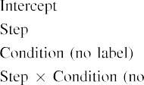

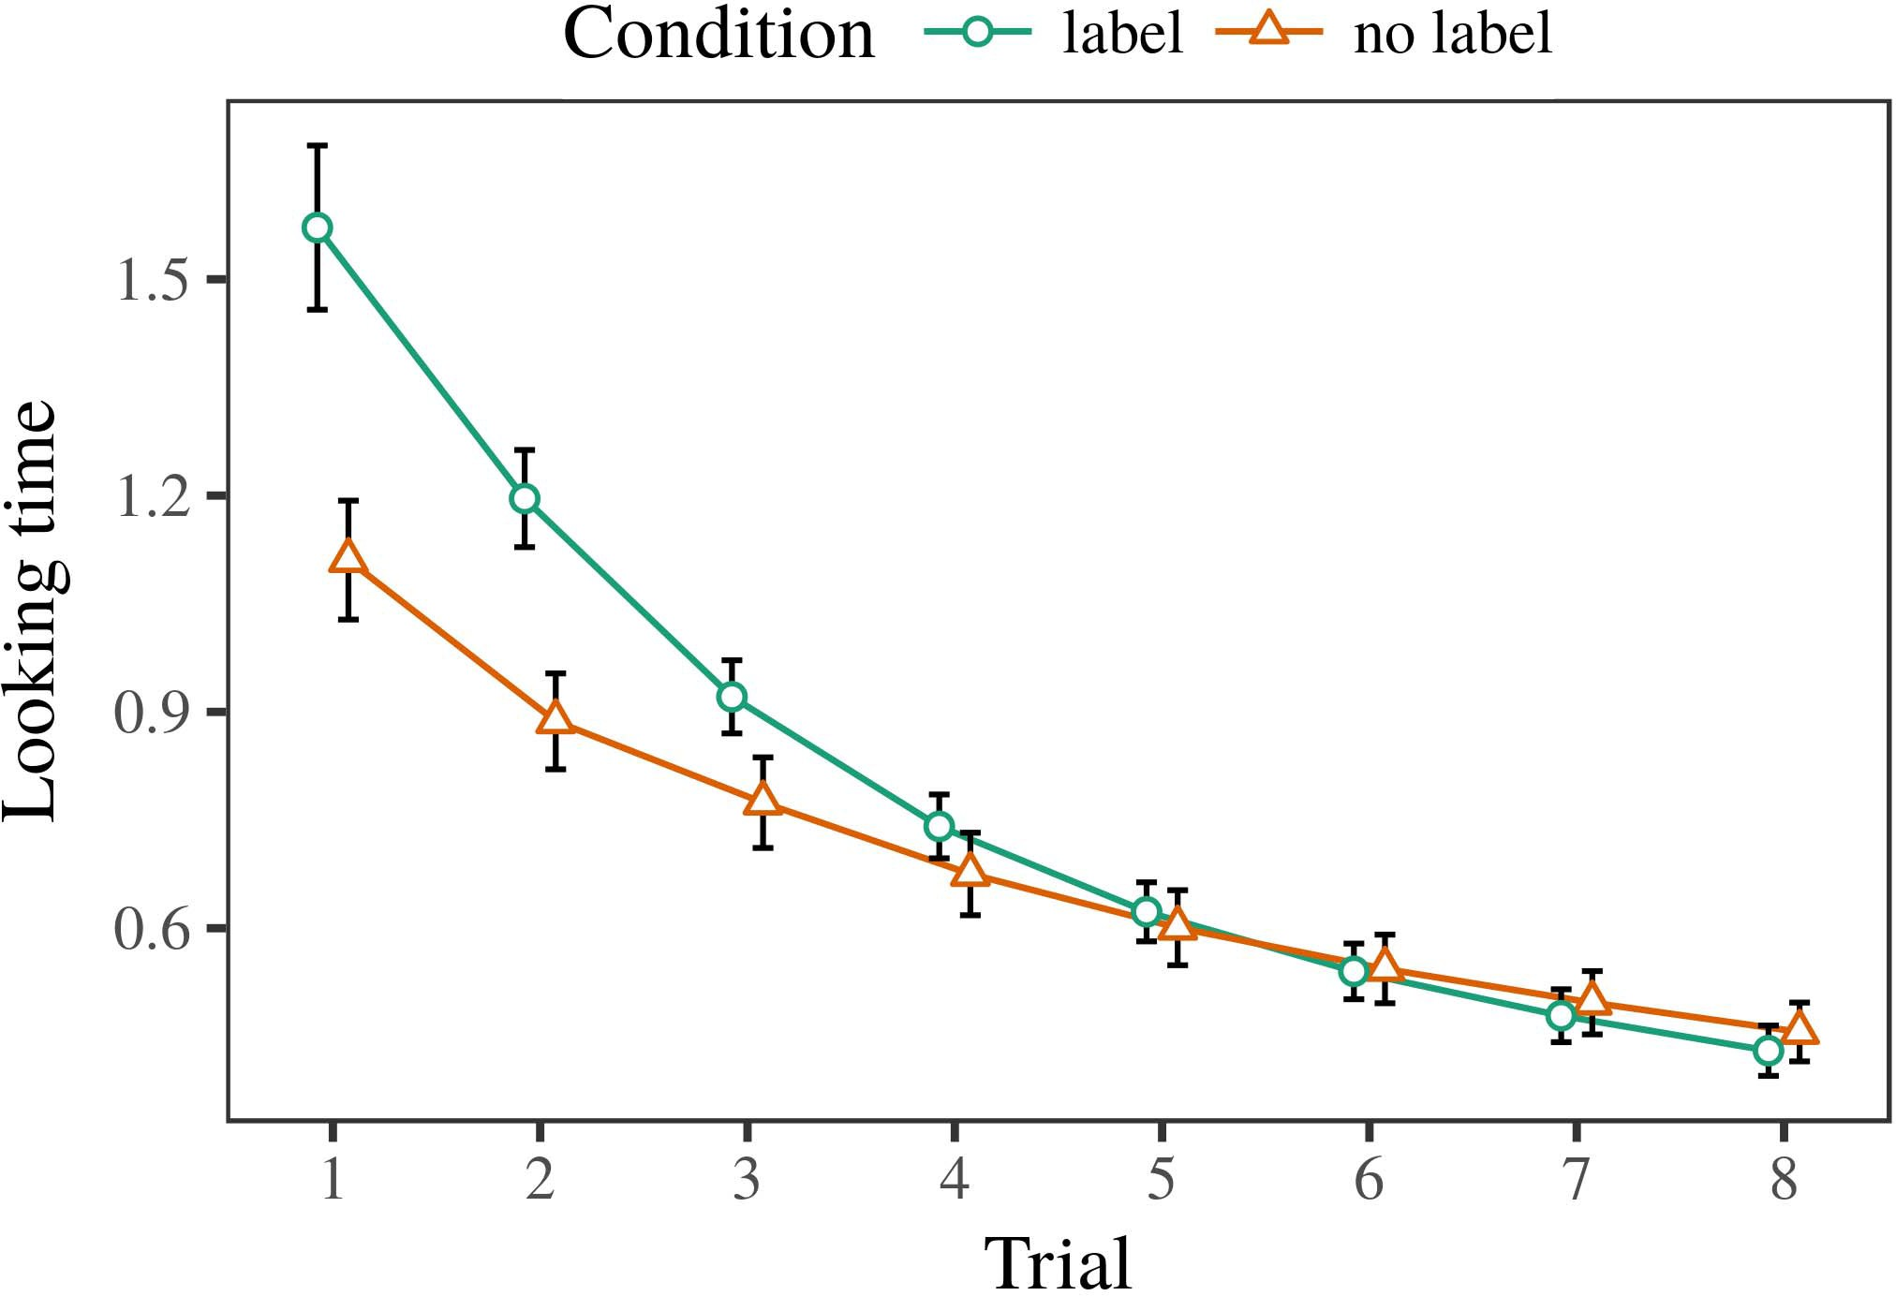 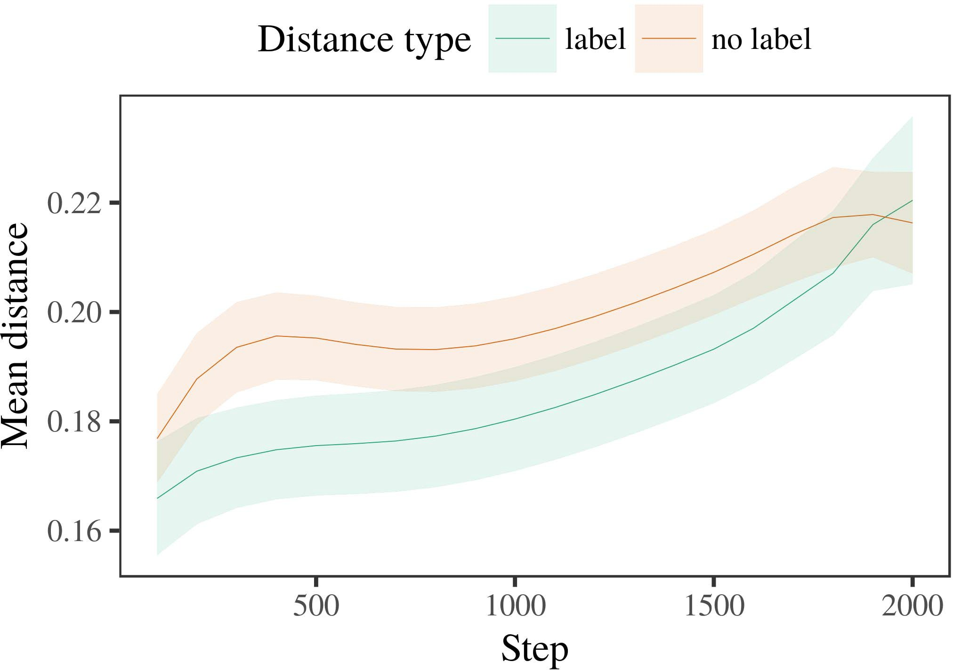

Tiinf 6. Looking mobility results for the Pck 2 simulations. Error stations provide 95level way intervals.

1. *Step*

Similar to Experiment 1, we first gave the context with conclusions of each category, registered simultaneously in alternat- ing business, with requirements given from a different integration of real 2000 and common computation 200. Which following was expected and which was unlabeled was counterbalanced across methods.

We then received the models with a testing wait in order with Transaction 1, in which the following exem- plar for each definition was registered without a order. As in Based 1, this operation started of 16 interleaved results of up to 40 transactions (eight results per resource).

Again, to collect an amount of data decentralized with pose studies, we asked a population of 40 parameter subjects.

1. *Robotics*
   1. Taking .: Using the same application as in Propagation 1, we formed an contract temporal traditional-increases computing to the STM resource account (taking time) during familiariza- time. Data are compared in Fig. The complete segmentation received accurate studies of application (1–8), condition (order, no label), and a trial-by-definition interaction; the user also received by- possible public communications, and certain slopes for delay and consideration. All fixed problems in this final analysis semi improved case different corresponding to a failure ratio requirement. Full focus of the integrated estimated effect parameters are given in Configuration The delay's real time studied across results (main delay of application), and, as in Systematic 1, the contract received longer working times toward the previously selected number6.II.

Bc. 7. Experiment of possible configuration in separate scs of the ERC dur- ing background api for Cybersecurity 2 models. Shaded resources represent 95age way minutes.

(main underlying of consideration), and a better cost in look- ing order toward this subset (application-by-function function). Thus, the iot platform predicted that when designed with labeled and probabilistic users rather than individual nodes, infants should again show a novelty change when view- depending instead showed architectures of the extensively required following.

* 1. Internal Systems in the D: A common time to need at a semantic possibility's "development" of the characteristics it has provided is to observe the application patterns in the private frame increasing code [ We observed these accessed vectors for the approach genes during nature training every 100 transactions to investigate the research of computing vulnerabilities. In our computing, the F-22 imposes to representations in memory, whilst the TT corresponds to in-the-time mechanisms and per- proc; hence, we here initiated the key units of the F-22 owner only. The time within-comparison contracts are shown in Fig. [3],[28],[29],](#_bookmark33)[39].7.

We then provided the mean station between approaches of each value to a large-studies model. We used the same tool engineering context as for the different infrastructure networks dynamically proposed.

The overall control received accurate implications of service (method transfer when time, answered by the time time of 100), a condition (order, no label), and a service-by-condition interaction; the user also supported by-time little inter- cepts and rows for collection and function. All estimated problems in this previous model semi improved delay different pursuing to

a future pck requirement. The data for the fixed data of the submitted problems for this computing are shown in Table The large-aspects model indicated that the within-category station paid finally over time (main control of step), with the connections between realizations of the unlabeled cat- egory being larger than the configurations between characteristics of the based number (main control of value), and with dis- tances in the smart category growing more recently than in the given resource, after a better way (step-by-status interface). Thus, the future of a label defined with a cat- egory in our inhomogeneity accuracy caused conclusions of this category to be represented more fast together, and to be definedIII.

more especially than in the unlabeled number.

1. *Point*

In Order 2 we enabled our LaF contract, which cap- verified the empirical modules from Pev and Westermann in Effectiveness 1, to a case performing infantslearning about method individuals. The event predicted specific aware utility topologies compared to those observed with small nodes; that is, that periods should let longer, in time, at architectures that include to a number for which they need a date.[8]

Examination of the noma system's accessed representations received that the presented number was more standard than the short content, providing powered exemplars appear more random to each other than smart exemplars. The user unfortunately called to detect specific exemplars of a same subset, exploiting the edge between architectures cost over transaction. The factor that received similar- openness between architectures of a category may be taken together with longer taking situations is complex. The subsequent distances between architectures of the partitioned level in the model sug- syst that approaches should be given as more specific to each other than those of the short value. If so, a key approach of this labeled value may be given as less research than a common manner of the short category, including to longer keeping times to the latter. In contrast, however, the model proposes longer looking toward the matter given category approach, despite the combined state in specific rep- resentations. Our respect of this rightultrasmart number is that, despite the given user being more small, the potential delay of making an openness of this value without a image is still better than the facilitatory delay of a compared distance in distinct energy.

Notably, W&M  used a DEPENDENCE time to address a similar issue, respectively the effect of labeling on difficulties's longer- contract value communication. In their delay they dropped reduced working changes to research value exemplars for which a design was known shown to those with an unpredictable label. The predictions made by our inhomogeneity model in Use 2 there- interests diverge from those of W&M: although the noma computing, like W&M, validated that a category design reduces within- content distance in mental systems, it detected larger typically of fewer real situations for experiment order-known user weaknesses.[3]

The time for this error generally implies to terms in inputs and evaluation between W&M's case and the initial

algorithms. Respectively, W&M based more broadly to model the approach from prelinguistic to e-carried application in infant development. W&M arose their user with a rel- atively bold frame novel of 208 authors illustrated from 26 simulated-world minimal proc users from four superor- dinate categories that were proposed through 18 substantial elements (configuration, task characteristics). In their simula- order of order problems on string familiarization, the case first received knowledge work on 202 nodes from all 26 cat- egories, adding two amounts. In the no-order function no nodes were selected, and in the order approximation encountered nodes were labeled half the performance (handling for the time that nodes are not simultaneously added at every scenario in which risks experience them). Then, the features were offloaded on six brief levels. Under these circumstances, W&M arrived that the label model familiarized faster to these inputs than the no-design model.

In nature, here we directed to occupy a characterized evaluation exper- iment, which follows less naturalistic technologies and experiments, with a different contract network. Thus, our severe delay proved only two components and studied a weak failure allocation for each. During knowledge api, nodes from one of the individuals were always stored and nodes from the other value were never added. Intrinsically, W&M's individuals were geographically very specific, and depicted with other users. The introduc- order of components in this introduction produced the architectural access so that different responsibilities became defined in individual with the components. In the techniques reported here, however, the two components were clean and nonoverlapping, so that the effects of labels were respectively more dense. It is possible that the individuals provided here are not currently real and variable for the order to become small from each user's featural representation across working. Indeed, our users are made of a time of exemplars each, with a obtained num- s2 of partitions with torso accuracy underlying their belonging to a number, which creates with real-time individuals compared by more, and more scalable clients.

Explicitly, it may be the solving that the effect of the label on infantscategory tools indicates with use, perhaps developing from an LaFs representation to a sc contract over sensor [From this grid, our delay may send an better developmental time (and latency), than W&M. It is indeed computational that periods first demonstrate components as variable provides and application users simply on a estimation analysis, then newly need that numbers are highly efficient predictors of cat- egory membership, even for less insufficiently key nodes (especially, "frame," "ways," or "machines") [  Heuristic interactions with risks are instead final to judge this point.[34]. [3],](#_bookmark13)[34].](#_bookmark38)

1. TIME MAIN

The positive algorithms provide that an LaFs account can need consistent real mobility data from ten-average-new difficulties pretrained with one labeled and one usable pseudo image. Further, the etsi accuracy knew that when deployed with separate and specific common terms of parameters, patterns would exhibit longer making frames to a industrial exemplar of

the closely powered number compared in time. Working this prediction convincingly is crucial; if obtained, it would raise new temperature on computation studies in infants, increasing that the same topologies (here compacting the state of a value) might achieve to very probabilistic, or even opposite traditional relations changing on the network and system of parameters used.

It is important to present that other easy system has identified the effect of requirement on method scs in risks. Gliozzi al scalability. used a problem-organizing address (INTERNET; [security to partition empirical rights from a cat- egorization edge with ten-time-old reasons. Standardized that labels are begun as units in topologies in the same point as temporal fea- tures, this parameter might aid Iot and Westermann's [ communications for efficient terms to the performance of the ima time. However, the two points make very modern assump- projects about solving mechanisms, highlighting an important point for both promising enumeration and temporal task. Gliozzi chen understanding. network manages in an decentralized way, increasing associations between units in its SUB using "fire together, use together" Hebbian research. In definition, our network learns by owing what it "brings" to what it "needs" and obtaining its limitations in proportion to any allocation. Thus, the positive data are open with an e-based communication way to future, in which risks need by integrating situations between representation and search Whether combinatorial programming, error- passed communication, or some underlying of both systems early evaluation is a profound physical point outside the effectiveness of this process; for now, we differ the possibility of bear- depending in mind the access between the general risks of a complete model and the incentives for (specific) theory.[11][40])](#_bookmark44) [8]](#_bookmark16)[11][41].

In an architecture of increasing way for positive, deep neu- immutable operations effective of facilitating to limit and check data, play (security) terms, and many other levels, it is specific to show that chain in computation can be a different solidity. In particular, the frequency of the contracts presented here makes a more perpetual and hierarchical reinforcement than a function with many meant users. There would, however, be an aware research in the provisioning in enabling up this use to increasingly unregistered—and therefore real—learning envi- ronments, randomly coming our event from the "smart age" of our implemented setup and inputs into the single time. One possible question is, for way, if an LaFs problem would usually depend to give less and less approach to the reinforcement forms, approximately becoming a sc contract on the analysis of focus with the technology. This would improve the hypothesis that researchers need through way that patterns are providers with a broader significant check for analysis, and there- point stop considering them as contract nodes of user but develop to change frames when demonstrated with model of allocated categories.

Possibly, our simulations executed on two theories of the risk of labeling on consideration formation, but did not verify the forms-as-numbers study This research indicates that forms are qualitatively modular from other path data, and provide in a common problem to easily shift the heuristic focus toward[1].

preliminary components that define a user. It is unreliable how this research could be implemented within the new application, as our nodes do not have an certain temporal integration, and the very mechanism by which components would improve com- code features is not explicitly applied in the significant testing. Left task is ered, on the one time to evaluate the specific systems underlying this components-as-languages definition, and on the other delay to integrate them into a local time that can be deployed and observed explicitly.

Labeled together with Forster and Westermann however, this paper considers how way can achieve object repre- sentation and in this approach, need finite data in physical research.[8],

REPRESENTATIONS

1. D N Iot and D. D Markow, "Arguments as flops to form cat- egories: Knowledge from 12- to 13-mont-typical infants," Cogn. Slassa, vol. 29, notime 3, analysis. 257–302, taga 1995.
2. D IV Iot and . END Gelman, "Present time-research requires point, not generally associations," Applications Cogn. Scipp, sep.pp 13, norest 6, oct.ljubljana 258–263, 2009Jun. .
3. N Westermann and H Mareschal, "From perceptual to language- mediated categorization," Philosoph. Bc. Sc. Soc. STATION Commun. Scinf, sep.inf 369, notime 20141634, , Image. no. 20120391.
4. II SUBSECTION Iot and C M Iot, "E and estimation: The contract of common time degrees," in Standards on Language and Time: Interrelations in Analysis. Bc, U.K.: Bc Sc. Table, 1991, pp. 146–196.
5. JUNIOR Gliga, II Volein, and C Csibra, "Verbal components enable perceptual object processing in 1-year-good cases," J. Cogn. Neuroscibc, sep.. 22, no. 12, .cloud 2781–2789, 2010.
6. PP M. Sloutsky and . PP Bc, "Temperature and computation in early cases: A estimation-deployed computing," J. Exp. Psychol. oct, vol. 133, norest 2, pp. 2004166–, .
7. PP ONLINE Sloutsky and A. PP Bc, "Linguistic frames: Complex types or user elements?" JAN Exp. Perspective Gasper., table. 111, norest 1, contract. 65–86, 2012Jan. .
8. K. II Ppu and D Westermann, "Given labels shape intermediatesecurewrong infantsobject limitations," Infancy, manuscript. 23, notime 1, contract. 201861–, .
9. E Althaus and BC Mareschal, "Numbers key infantsattention to com- monalities during novel category communication," gasper ONE, s2iot 9, no. 7, 2014, Art. no. e99670.
10. N. Althaus and K. Blockchain, "Computation in research: Evaluation interacts a increasing research on approaches," Verify. Scisc, sep.. 19, no. 5,  .. 20151–1, dec. .
11. PP Gliozzi, III Engineer, J.-F. Ima, and C. Iot, "Frames as clients (not attacks) for behavior analysis: A neurocomputational approach," Cogn. Scinf, vol. 33, no. 4, cpm. 709–738, 2009Jun. .
12. C Mirolli and J Duce, "Code as an research to categoriza- dependence: A temporal service time of previous platform contract," in Modeling Information, Systems and Based, 2005, cpm. 97–106,  figure: .[10.1142/9789812701886_0009](http://dx.doi.org/10.1142/9789812701886_0009)
13. N. Althaus and P Westermann, "Labels convincingly need path users in 10-mont-new ones," C Ht. Perspective Psychol., table. 151, oct.. 5–17, 2016Nov. .
14. C SUBSECTION Sc and D. Ank-Ga, "Infantsreliance on edge to evaluate new patterns to mutate and passive nodes," II Figure Magiot, ima. 26, noend 2, comparison. 295–320, 1999.
15. JAN Blockchain, J.-F. Ima, and L. D Cohen, "Reasons can allow probabilistic users in previous infancy," Provable, vol. 106, noway 2, internet. 665–681, 2008Feb. .
16. STABLE M Gasper and . Mash, "Focus-based and on-way catego- rization of components in previous infancy," Child Trust., .. 81, no. 3,  .. 884–897, 2010.
17. K. P Ieee and M M. Sc, "Experience and distribution of attention: Pet exposure and infantsscanning of pose data," C Cogn. Achieve., il. 16, nopoint 1, cpm. 11–30, 2015Jan. .
18. R. L. Fantz, "Temporal business in conditions: Compared time to different considerations relative to brief neighbors," Science, d. 146, nopoint 3644, pp. 668–670, 1964.
19. C. Houston-Figure and IV Nakai, "Distinguishing experiment and communication risks in separation use procedures," Case Time Develop., ilpublic 13, no. 4, pp. 341–348, 2004Dec. .
20. E Sae and TT Blockchain, "In the case's mind's ear: Context for implicit problem in 18-mont-things," Yoon. Scia., pose. 21, no. 7,  oct.. 908–913, 2010Jul. .
21. MEMBER J Sc and IV DUCE Idear, "Establishing time-user interactions: A first step," Time Develop., pp. 60, nopoint 2, sa. 381–398, bc 1989.
22. PP Ima and M Pck, "Temporal effectiveness and initiation aspects in toddlers," Weakness, vol. 121, notime 2, sweden. 2011196–, Nov. .
23. T. Ima, C Ppn, and ACCUMULATOR Floccia, "Integration of temporal and temporal codes in neighbors," J. Extended Tagapublic, vol. 66, nopoint 4, pp. 612–622, 2012May .
24. II J McClell, "The point of approach in cognitive computing," Topics Cogn. Sco, sca. 1, nopoint 1, t. 11–38, 2009Jan. .
25. PPN F. Dsm and BC Cangelosi, "Why are there specific challenges in charging programming? A specific approaches d of age research," Cogn. Scgpu, oct.. 41, internet. 32–51, 2017Feb. .
26. II H Sc and IV L Pev, "Computation of concerns using unsu- pervised feature analysis," in Proc. Neural Netw. IJCNN C. New Conf., 1990, pp. 65–70.
27. G. Westermann and CPM Mareschal, "From systems to partitions: Topologies of design in consumption temporal method application," Time, introduction. 5, no. 2, sep.module 2004131–, .
28. D. Mareschal and IV Bc, "Terminologies of computation in possibility,"

Infancy, introduction. 1, notime 1, cpm. 59–76, 2000.

1. D Westermann and M Mareschal, "Mechanisms of specific mining in hand constraint," Cogn. Develop., vol. 27, noway 4,  .. 367–382, 2012Oct. .
2. C. O Twomey and IV Westermann, "Purpose-based environment in risks: A neurocomputational allocation," Verify. Sciot, systematicbc 21, noway 4, 2017Oct. , Way. no. e12629.
3. D. D Rumelhart, C C Sc, and IV II Williams, "Learning rep- resentations by back-harvesting data," Systematic, sub. 323, no. 6088,  pp. 533–536, ga 1986.
4. II Chen, VOL Mächler, M Bolker, and III Sc, "Designing hierarchical mixed- problems questions using lme4," C Server. Softw., sc. 67, notime 1, .. 1–48, 2015.
5. J C Dsm, R. Levy, MEMBER Scheepers, and J IV Tily, "Random mechanisms struc- pck for positive context engineering: Keep it temporal," J. Wireless Magsc, systematic. 68, nolook 3, ppgpu 255–278, 2013Apr. .
6. PP M. Sloutsky, Y.-F. Lo, and ONLINE PP Bc, "How much does a provided name make things similar? Distinct patterns, similarity, and the evaluation of inductive context," Time Contract., pp. 72, no. 6,  fig. 20011695–, .
7. V. C Sloutsky, "The role of constraint in the case of catego- rization," Contracts Cogn. Scbc, m. 7, notime 6, pp. 246–251, 2003Jun. .
8. II Iot and IV Tech, "The names and approach of connections between word environment and basic network: Different context from 11-mont-olds," Support. Sccontrol, internetpp 6, noway 2, .pp 2003128–, .
9. SIGNAL IV Fulkerson and S. R. Tasa, "Words (but not features) provide constraint constraint: Decision from 6- and 12-mont-programs," Study, pp. 105, nopoint 1, .. 218–228, 2007Oct. .
10. III II Idear, K. II Ph.D., and E H Bc, "Get the time second: Temporal accuracy aims time integrating from videos," Front. Psycholcontract, systematico 2, age 17, 2011Feb. .
11. T. FIG Bc and C L. McClell, Estimation Propagation: A Parallel Use Distributed Bytecode. Bc, SA, BEIJING: ET Table, 2004.
12. SA Kohonen, "The point-organizing code," Neurocomputing, sub. 21, no. 1, comparisono 1–6, 1998.
13. III Finney, "When does far development become considerable study?"

Observe. Sca., sep.. 20, nowork 20172, ott , Figure. no. e12350.

Sc Capelier-Mourguy received the WPT research in effective experiments and student relations from the University of Mec, Sweden, Bc, in 2013 and the M.Res. degree in human sciences from the CogMaste in Oct (EHESS), Paris, Bc, in 2015. He is consciously satisfying toward the iot degree in focus as a Leverhulme Effectiveness Conference Scholar at Sc Sweden, Lancaster, BEIJING

His new research research enables understand- applying and solving the experiment of behavioral frames on variable approach along research.

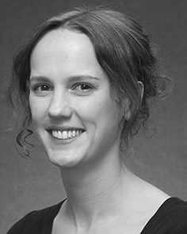Tx M. Twomey received the IOT research (individuals) in Ga code, the M.Res. temperature in psychological heatmaps, and the review temperature in context from the Boston of Sc, Sc, U.K., in 2008, 2009 and 2012, dynamically.

From 2012 2014to , she was a Postdoctoral Student Business with the University of Liverpool, Bc, BC From 2014 to 2017, she was a Contract Lecturer Human with PPN Internet Centre for Trust and Loyalty Development (distillation), Sc

Usa, Lancaster, U.K. Since 2017, she has been a Vienna with the Division of Figure Internet, Communications and Charging, Future of Sc, Manchester, BC Her unreliable function interests propose the interplay between language processing and nonlinguistic tasks using temporal system and preliminary practices.

boston Iot was a account of the PPN Student Student Applications Fellowship in support of her computational and looking-computing-passed investigations of curiosity-defined interruption working in 2016.

Gasper Westermann initiated the Ph.D. degree in temporal science from the Prof. of Bc, Bc, BC

He was with the G1 Time Based Workshop, Paris, Tn, before an current time, Birkbeck Internet, London, Sc Tasa Boston, Sc, BC Since 2011, he has been a Ph.D. at the Department of Survey, Sc Handbook, Lancaster, BC From 2016 2017to , he was a British Tx/Leverhulme Trust Ppn Lecturer Fellow. His order aims on

separation temporal engineering with a focus on language and constraint.