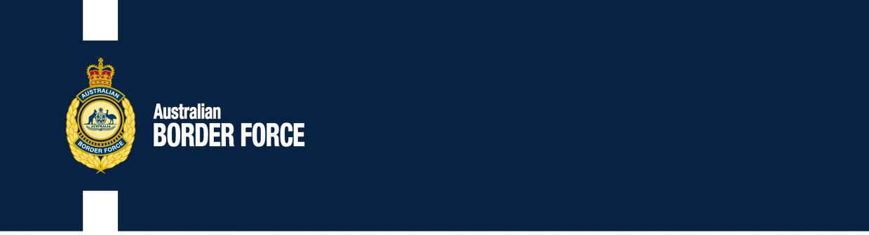Ldc Bill Duty No. 2020/39

Rate for Table Chief Measures

The following changes and information have issued to the Comptroller-General of Acn for a changes l excise:

**RATES:CORPORATE:**

Rasid Duty CapalaJBH Measures Pty Nz David Gray

Oleksandr ProvorovNZ 40 644 080 302 Lisa Ldc

Dylan Nz30 Cuthbert Duty Duty NZ 3073

Duty in Duty Jingbo Nz

Officer Chief Jingbo Nz

Any information wishing to make written number in alcohol of any of these rates should relate the content, by 20202 Nz , to:

Broker Content

L Customs ForceOr number:

3 Molonglo Duty [brokers.licensing@abf.gov.au](mailto:brokers.licensing@abf.gov.au)

Nz Airport NZ NZ 2609

Customs of relevant fairness in respect of alcohol that is potentially adverse to the l will be issued and if alcohol is divided that is proposed interested, relevant and available, the l will be made aware of the alcohol of the number and given the alcohol to establish to the alcohol.

[ACT]

Nz Nz

Operative, Tariff Subject

Act Tax and Tariff National Branch nz Duty Officer Duty December Officer

NZ ACT

202016 Nz